

Victorian Environment Effects Statement
Chapter 17 – Traffic and transport

Table of Contents
Chapter 17 Traffic and transport 17-1
17.1 Introduction 17-1
17.2 Assessment scope 17-2
17.2.1 Victorian matters 17-2
17.3 Evaluation framework 17-3
17.3.1 Key legislation, policy, guidelines and standards 17-3
17.3.2 Assessment criteria 17-3
17.4 Methods 17-5
17.5 Existing environment 17-7
17.5.1 Local road network 17-9
17.5.2 Traffic volumes and existing road capacity 17-10
17.5.3 Crash history review 17-11
17.5.4 Sustainable modes of transport 17-13
17.6 Construction impact assessment 17-15
17.6.1 Key impacts 17-15
17.6.2 Other impacts 17-15
17.6.3 Potential risks 17-26
17.7 Operation impact assessment 17-28
17.7.1 Key impacts 17-28
17.7.2 Other impacts 17-28
17.8 Decommissioning impacts 17-30
17.9 Cumulative impacts 17-31
17.10 Summary of mitigation, monitoring and contingency measures 17-33
17.10.1 Mitigation measures 17-33
17.11 Conclusion 17-34

Figures
Figure 17-1 Study area 17-8
Figure 17-2 Predicted 2028 road network theoretical mid-block peak hour capacity analysis 17-11
Figure 17-3 Crashes in the last five years recorded within the study area 17-12
Figure 17-4 Recreational cyclist heatmap for the study area 17-14
Figure 17-5 Road and lane closure locations 17-21

Tables
Table 17-1 Key legislation, policy, guidelines and standards 17-3
Table 17-2 Residual impact of traffic generation on existing road capacity 17-17
Table 17-3 Residual impact of construction traffic on traffic infrastructure and road users 17-18
Table 17-4 Residual impact of site access and road upgrades on traffic infrastructure and road users 17-19
Table 17-5 Residual impact of road and traffic lane closures on traffic infrastructure and road users 17-20
Table 17-6 Residual impact from construction traffic on public road amenity 17-22
Table 17-7 Residual impacts from construction traffic on public transport 17-23
Table 17-8 Residual impacts from construction traffic on pedestrians and cyclists 17-24
Table 17-9 Residual impact of construction traffic on road condition and maintenance 17-25
Table 17-10 Consequence, likelihood and residual risk ranking for emergency vehicle access during the construction phase 17-27
Table 17-11 Residual impacts to traffic generation and road capacity 17-29
Table 17-12 Summary of cumulative impact assessment for transport 17-31
Table 17-13 Summary of mitigation measures relevant to transport 17-33

Traffic and transport

Introduction
This chapter identifies the existing conditions related to traffic and transport and assesses the associated impacts and risks from construction, operation and decommissioning of works in Victoria associated with the Star of the South Offshore Wind Farm Project (works in Victoria) on traffic and transport. The chapter describes how impacts will be avoided, minimised or managed.
This chapter is based on the impact assessment presented in Technical Report X – Traffic and Transport.

Assessment scope
The study objective is to assess, avoid and minimise adverse effects of works in Victoria on traffic and transport during construction, operation and decommissioning.
This chapter does not assess traffic or transport matters relating to the development of, or use of, a Gippsland-based port to support construction or operations. These matters are subject to a separate approvals process.
All detailed technical methodologies and assessment on transport can be found in Technical Report X – Traffic and Transport.

Victorian matters
The Environment Effects Statement scoping requirements issued by the Victorian Minister for Planning include a set of evaluation objectives that identify the desired outcomes in managing the potential impacts from works in Victoria during construction, operations and decommissioning . The following evaluation objective is relevant to traffic and transport:
To avoid, or minimise where avoidance is not possible, adverse effects on community amenity and health and safety, with regard to noise, vibration, dust, the transport network, fire risk management and electromagnetic radiation.
Further information about the EES scoping requirements is listed in Attachment IV – EES Scoping Requirements Checklist.

Evaluation framework

Key legislation, policy, guidelines and standards
Table 17-1 lists the key legislation, policy, guidelines and standards relevant to traffic and transport in Victoria. Refer to Chapter 5 – Victorian Legislative Framework for further details.
Table 17-1 Key legislation, policy, guidelines and standards
Type | Applicable legislation, policy, guideline or standard
Victorian legislation | Road Management Act 2004
Victorian legislation | Transport Integration Act 2010
Victorian legislation | Road Safety Act 1986
Victorian guidelines and standards | Victorian Road Safety Strategy – 2021-2030 Action Plan
Victorian guidelines and standards | Department of Transport (VicRoads) – Road Management Plan
Victorian guidelines and standards | AS1742.3 2009 – Traffic control for works on road
Victorian guidelines and standards | Victoria Planning Provisions – 52.32 Wind Energy Facility
Victorian guidelines and standards | Development of Wind Energy Facilities in Victoria, Policy and Planning Guidelines 2019
Other | Best Practice Guidelines for Implementation of Wind Energy Projects in Australia, Clean Energy Council 2018
Other | Austroads – Guide to Road Design Part 3: Geometric Design
Other | Austroads – Guide to Road Design Part 4: Intersections and Crossings
Other | Austroads – Guide to Traffic Management Part 12: Integrated Transport Assessments for Developments

Assessment criteria
To assess the works in Victoria, predicted impacts and risks are compared to criteria that set required environmental performance outcomes (refer to Chapter 6 – Assessment Framework).
The criteria for traffic and transport are derived from legislation and policy, relevant standards and guidelines, stakeholder feedback and industry best practice.
The assessment criteria are outlined as follows:
- An evaluation against relevant government and industry guidelines (as summarised in Table 17-1) whilst also addressing specific local government planning clauses where applicable
- The capacity of existing roads and projected baseline traffic volumes
- Considerations like road surface degradation, sight lines, vehicle swept paths and speeds all combine to provide an understanding of the safety implications of the works in Victoria
- Changes to available road capacities or road infrastructure, increase road safety risk, or changes to access to private properties or business.

Methods
The purpose of the traffic and transport impact assessment was to assess the potential impacts and risks of works in Victoria on transport.
Impacts refer to the consequences of planned project actions, which are given a rating determined by combining the magnitude of the impact and the sensitivity of the receptor.
Risks are an unexpected (accidental) event and are determined by combining the likelihood of an event occurring and the consequences that would result if the event were to occur.
The technical chapters consider key impacts and risks with a residual consequence rating of moderate to severe. Other impacts and risks are those with a residual consequence rating of negligible to minor.
Refer to Chapter 6 – Assessment Framework for more detail on how impact and risk ratings are derived.
The assessment was achieved by undertaking the following key tasks:
- Defining a study area, which for this assessment includes locations that may potentially be impacted by activities. For the purposes of this assessment, the study area is primarily focused on the local road network associated with the onshore transmission infrastructure, and roads expected to be used during construction and operation of works in Victoria.
- Reviewing national, state and local legislation relevant to transport and associated infrastructure such as roads and rail
- Characterising existing conditions and identifying sensitive assets, values and uses
- Reviewing the Chapter 4 - Victorian Works Project Description to determine the location, type, timing, extent, intensity, and duration of potential interactions with sensitive receptors
- Defining the maximum design scenario(s) based on project design envelope parameters that provide the basis for impact assessment. These are defined in Technical Report X – Traffic and Transport
- Undertaking a proportional assessment of risks and impacts based on the outcomes of the initial assessment of issues and consultation insights that examines the potential severity, extent and duration of identified issues
- Evaluating predicted outcomes against performance benchmarks and assessment criteria derived from applicable legislation, policy and standards
- Identifying mitigation measures where necessary to address potentially significant environmental impacts
- Evaluating residual environmental impacts and risks against assessment criteria, taking into account the proposed mitigation measures and likely effectiveness.

Existing environment
This section describes the existing conditions within the study area as they relate to traffic and transport. The study area is defined as the local road network associated with the onshore transmission infrastructure, and roads expected to be used during construction and operation as shown in Figure 17-1.
Figure 17-1 Study area
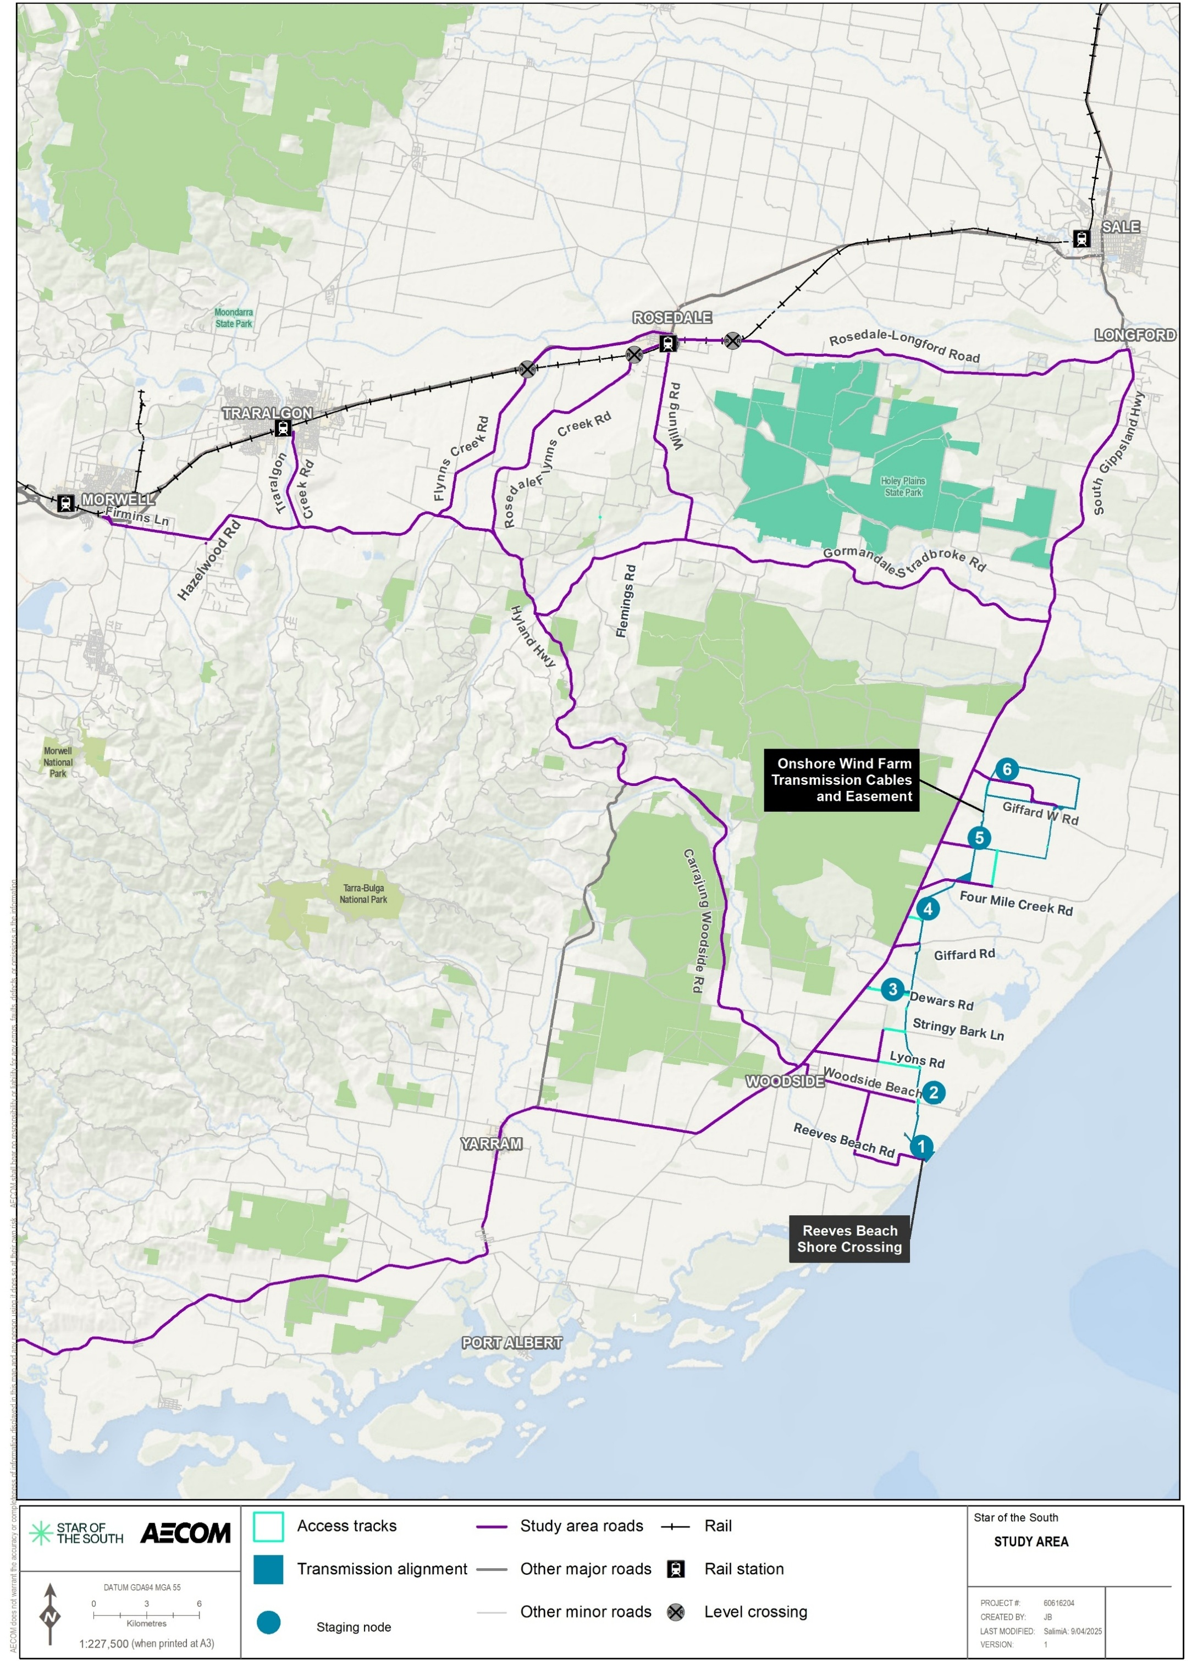

Local road network
During construction, the onshore transmission infrastructure alignment is expected to connect with the local road network at six staging nodes, each serving as a primary access point to the alignment.
These nodes provide entry to temporary construction storage (laydown) areas and, in some cases, concrete batch plants. While each node may connect via one or two local roads, only one primary access route per node is considered in the assessment.
Staging node
A staging node, or access node, is a main entry point where construction vehicles and workers access an onshore project area. Each node may be connected to the local road network by one to two access roads.
Although other secondary access roads exist, construction traffic is anticipated to rely mostly on primary access roads. Privately managed plantation tracks may also be used, subject to access agreements.
Site visits were undertaken between 2021 and 2025 to assess the condition and suitability of local roads, with observations noting that major arterial routes are generally in good condition, lightly trafficked, and appropriate for construction traffic volumes.
The local road network consists of a mix of roads managed by the Department of Transport and Planning, Wellington Shire Council and Latrobe City Council. Department of Transport and Planning managed roads, such as Princes Freeway, Hyland Highway, and South Gippsland Highway, generally feature sealed surfaces, sealed or gravel shoulders, and appropriate signage. These routes are predominantly two-lane roads with speed limits of 80 to100 kilometres per hour and are preferred freight and traffic routes. Council-managed roads include lower-order access roads such as Balloong Road and Dewars Road, many of which are unsealed, narrow, and lack line markings or shoulders.
Traffic volumes are low across the network, although logging and heavy vehicle movements were noted on key access roads like Gormandale-Stradbroke Road and Firmins Lane. Some intersections have restricted sight distances, and many local access roads do not have posted speed limits, defaulting to the rural standard of 100 kilometres per hour.

Traffic volumes and existing road capacity
Traffic volumes are the number of vehicles that travel along a section of road within a given period, typically measured as annual average daily traffic or peak hour volumes. Road capacity represents the maximum number of vehicles a road can accommodate under usual conditions without a significant decline in performance. Comparing traffic volumes against road capacity helps assess whether the road network can efficiently accommodate existing and future traffic demands, particularly during peak periods.

Road network traffic volumes
Traffic generated during construction is expected to peak during three key time periods:
- Morning peak (6:00 am – 7:00 am): arrival of construction workers
- Evening peak (6:00 pm – 7:00 pm): departure of construction workers
- Midday peak (nominal midday period): general construction vehicle movements
Existing 2020 traffic volumes for both Department of Transport and Planning and council-managed roads have been extrapolated to 2028 using a 1.5 per cent annual growth rate to anticipate potential increases in traffic volume over time.

Road network capacity
One-way mid-block capacity of an undivided road refers to the maximum number of vehicles that can travel in one direction along a straight section of road, without intersections, during a given time. It depends on factors like lane width, speed, and how closely vehicles follow each other.
The Austroads Guide to Traffic Management Part 3 defines the one-way mid-block capacity of an undivided road as 900 vehicles per hour per lane, with potential to increase to 1200 - 1400 under optimised traffic conditions. For this assessment:
- 900 vehicles per hour per lane has been used as the standard capacity for local roads
- 1200 vehicles per hour per lane has been used for the Princes Highway, based on the potential for improved traffic controls and conditions.
Figure 17-2 presents the 2028 predicted peak hour traffic volumes for specific road segments compared with their theoretical capacity. All roads are expected to operate within their respective capacity limits during the construction phase.
Figure 17-2 Predicted 2028 road network theoretical mid-block peak hour capacity analysis
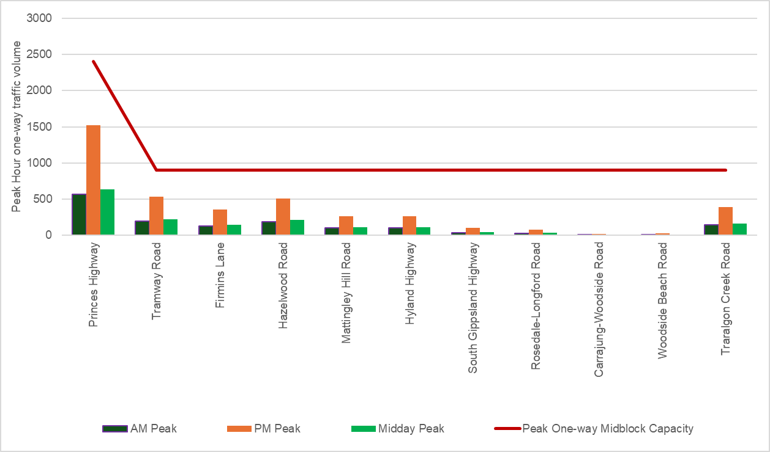

Crash history review
A review of crash data from 2020 to 2024 (shown in Figure 17-3) was undertaken to assess safety conditions along roads expected to be used during construction, including direct access roads and wider regional access routes. Five crashes were recorded on direct access roads, all occurring along the South Gippsland Highway, with none involving intersections, pedestrians, or cyclists.
In contrast, 57 crashes were recorded on wider access roads, including six fatal and 25 serious injury crashes, primarily along high-speed arterial roads such as Hyland Highway, Hazelwood Road and Princes Highway.
Clusters of serious crashes were identified along sections of Hyland Highway and Hazelwood Road, often involving fixed object collisions, vehicle rollovers, or animal strikes in areas with limited visibility, curves, and dense roadside vegetation - highlighting potential safety risks associated with works in Victoria-related traffic in these areas.
Figure 17-3 Crashes in the last five years recorded within the study area
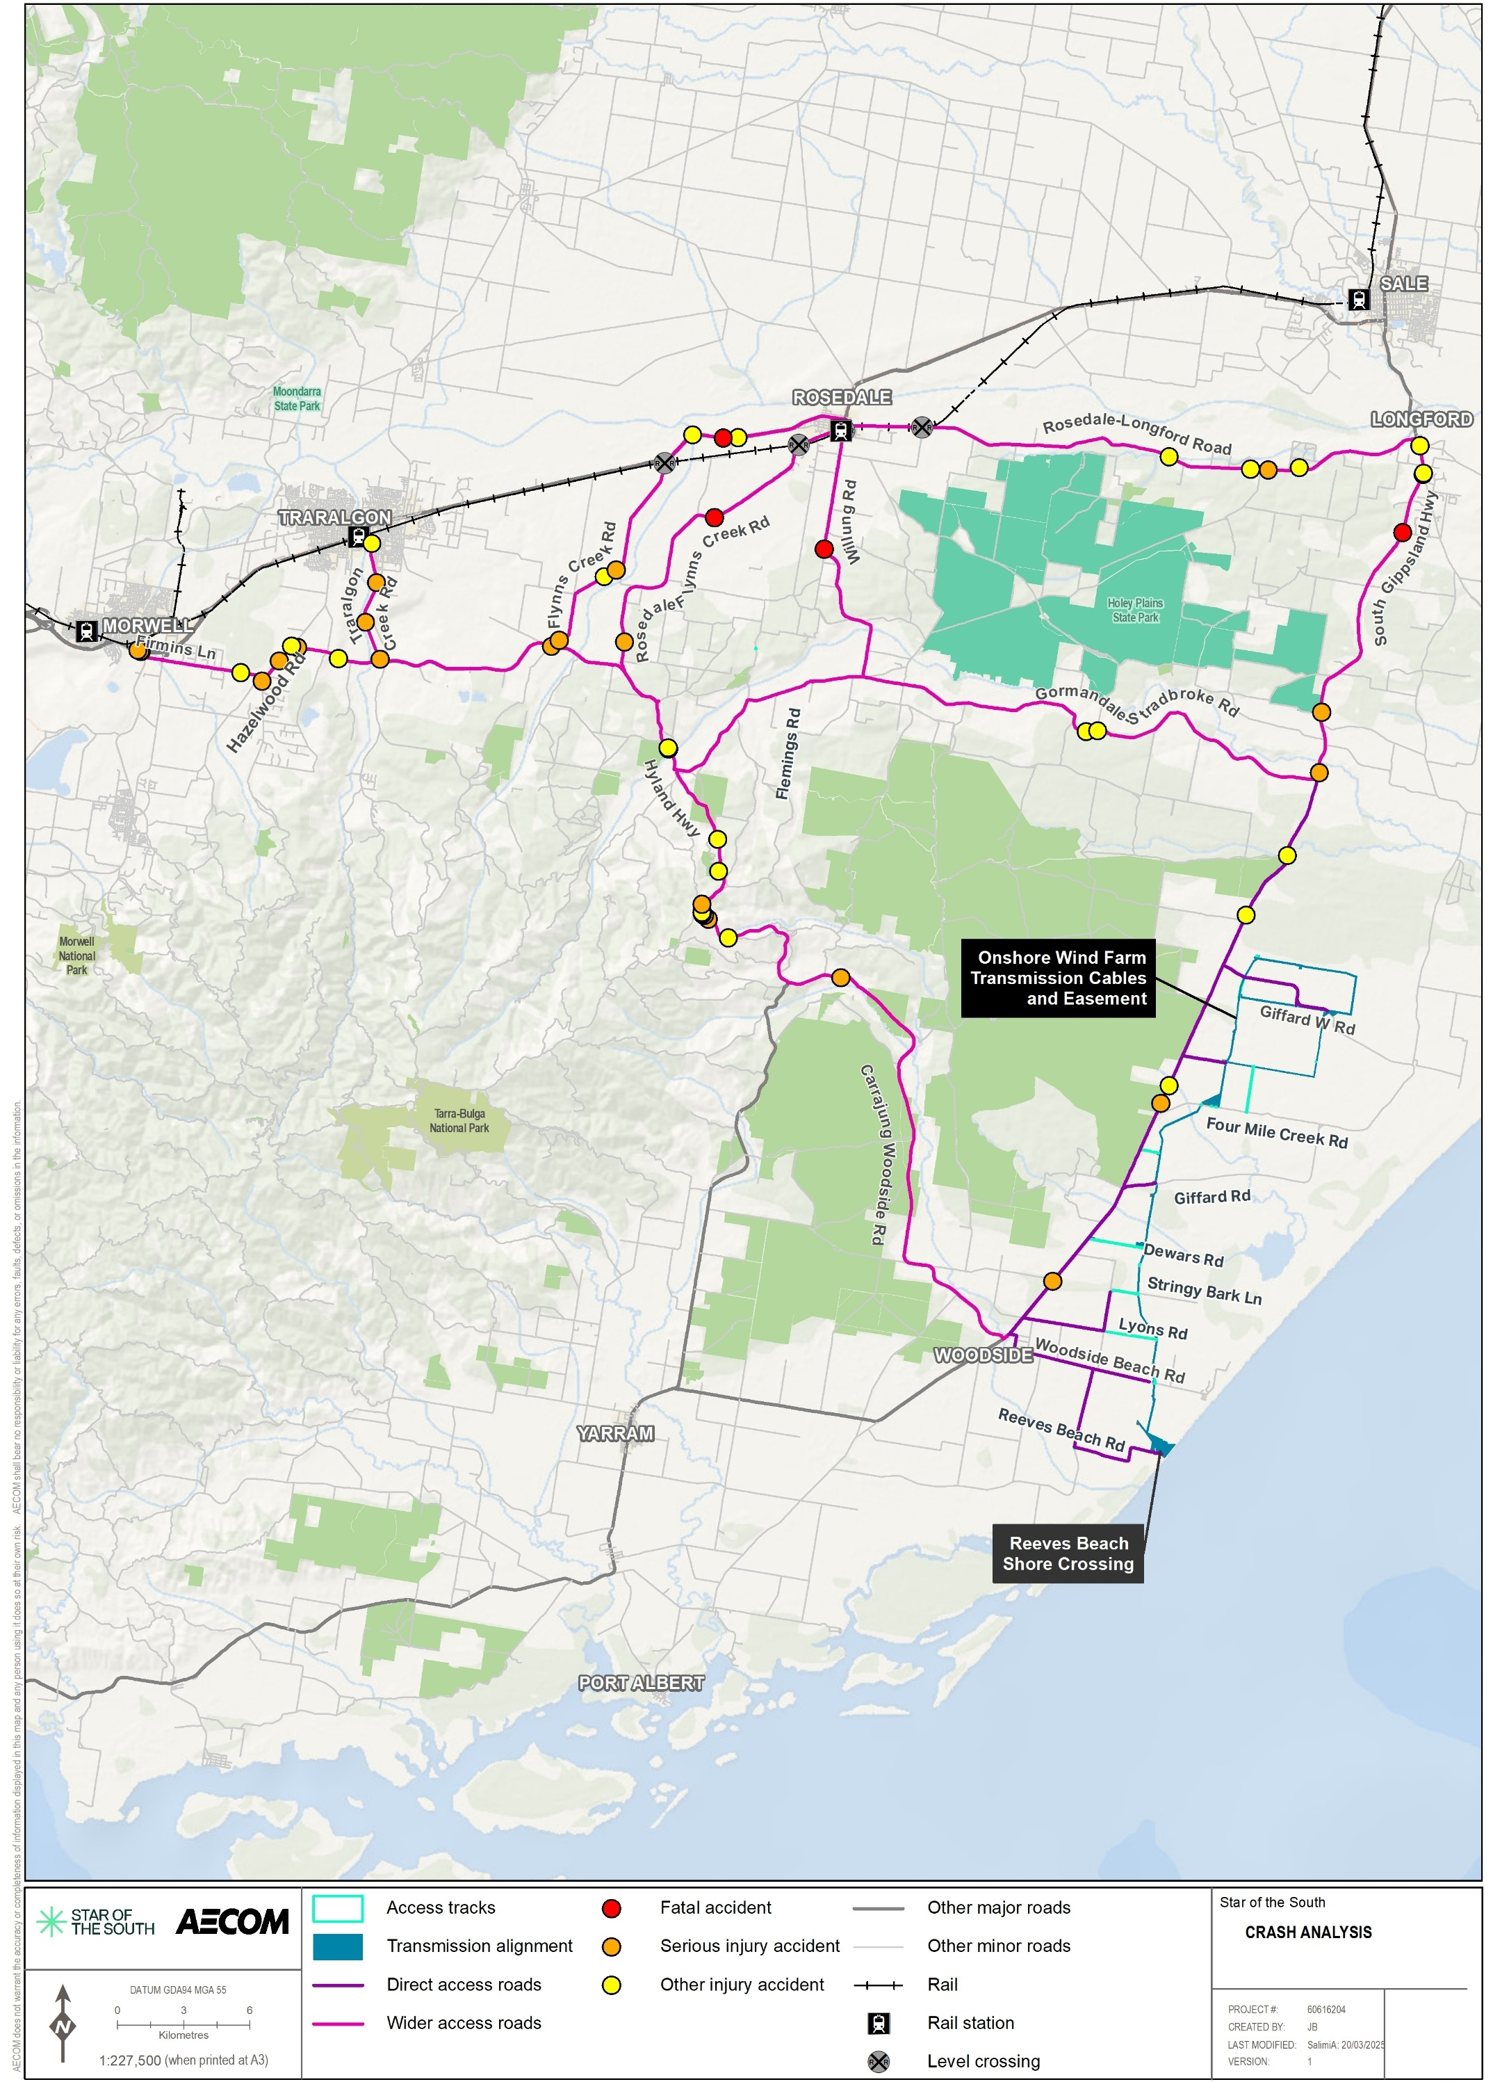

Sustainable modes of transport

Pedestrians and cyclists
There are no dedicated footpaths or bike lanes near the proposed staging areas or along the roads leading to the onshore transmission works. However, people may still walk or cycle in these areas, especially in the vicinity of parks and reserves such as Giffard Nature Conservation Reserve and Mullungdung Nature Conservation Reserve. Other reserves that might attract walkers and cyclists include:
- Gormandale Nature Conservation Reserve
- Willung South Bushland Reserve
- Holey Plains State Park
- Stradbroke Flora and Fauna Reserve.
Although the roads expected to be used by vehicles are not part of Victoria’s main bicycle networks, Figure 17-4 shows that some of these roads are used by recreational cyclists. These roads include parts of the South Gippsland Highway, Gormandale-Stradbroke Road, and Hyland Highway, as well as local roads.
Figure 17-4 Recreational cyclist heatmap for the study area
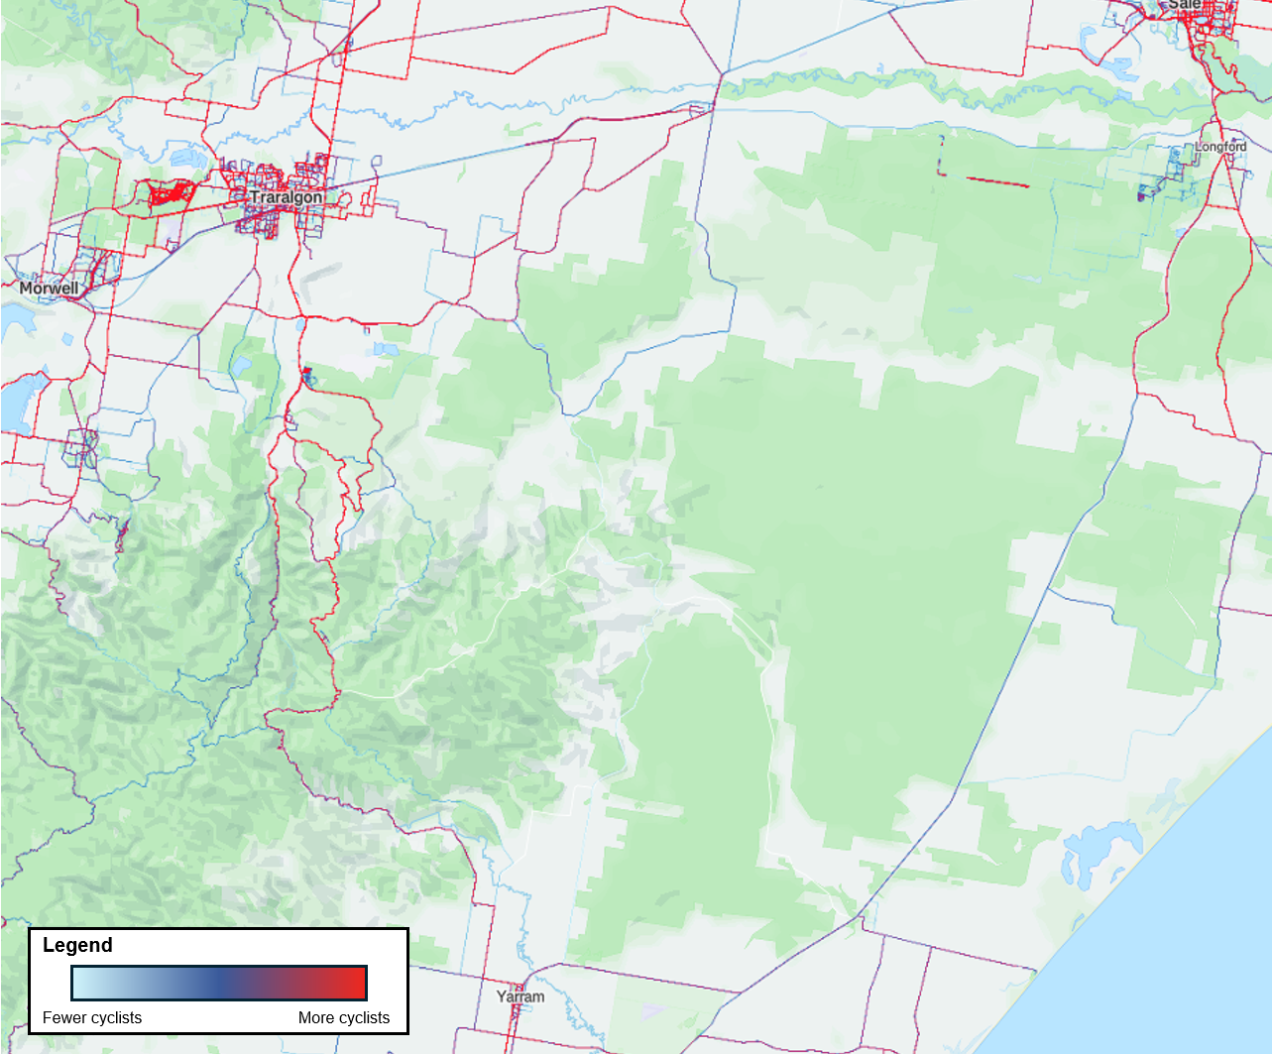

Public transport
There are no railway lines or associated stations near the local access roads anticipated to be used to access the work sites for the works in Victoria.
Similarly, there are no public bus services that operate within the immediate study area, however, several school bus services operate within the study area on:
- Prince Street / Woodside Beach Road
- Balloong Road
- South Gippsland Highway.
For further detail about public transport options in the wider transport network, please refer to Technical Report X – Traffic and Transport.

Construction impact assessment
This section discusses the impacts and risks associated with the works in Victoria during the construction phase that relate to traffic and transport and the respective receptor groups.

Key impacts
Sensitive receptors
Technical Report X – Traffic and Transport defines sensitive receptors as users of the transport network. The receptors are sensitive to both road congestion and safety issues arising from the works in Victoria.
The construction impact assessment identified no impacts on traffic and transport receptor groups with an impact rating of moderate or higher once mitigation measures are implemented.

Other impacts
Other potential construction impacts with minor to negligible residual effects on traffic and transport once mitigation measures are implemented include:
- Traffic generation and road capacity (TTP-I001 and TTP-I002)
- Construction traffic (TTP-I002 and TTP-I003)
- Site access and road section upgrades (TTP-I004 and TTP-I005)
- Road and traffic lane closures (TTP-I006)
- Amenity impacts arising from use of the road network (TTP-I007)
- Impacts on public transport (TTP-I008)
- Impacts on pedestrians and cyclists (TTP-I009)
- Road condition and maintenance (TTP-I010).

Traffic generation and road capacity (TTP-I001 and TTP-I002)

Potential impact
The construction of the onshore transmission system is expected to generate additional traffic beyond the existing conditions, potentially increasing road congestion and affecting road safety for local road users. This includes daily light vehicle trips from construction workers, heavy vehicle movements for bulk material transport, and cable material deliveries to the six staging nodes, accessed from Balloong Road, Woodside Beach Road, South Gippsland Highway, Carstairs Road and Giffard West Road. Conservative estimates indicate:
- Up to 1,576 daily one-way vehicle trips (light and heavy) at staging nodes
- Up to 363 peak hour vehicle trips (light and heavy) at staging nodes.
The increase in traffic numbers is within the theoretical road capacity limits described in Section 17.5.2.

Mitigation
To manage the temporary increase in traffic from the works in Victoria, several mitigation measures will be implemented including the development of a Stakeholder Engagement Plan (TTP-M001) and a Traffic Management Plan (TMP) (TTP-M002). The mitigation will communicate changes to local road users to ensure effective safety controls are in place and allow users to plan for any increased travel times. Similarly, heavy vehicle transport route assessments (TTP-M004) and site access strategies (TTP-M005) focused on safe intersection design, road upgrades, and appropriate routing will plan how workers travel to and from site, including transport mode, parking, and timing, to improve safety and reduce congestion during peak hours.

Residual impact
With the effective implementation of the mitigation measures TTP-M001 (Stakeholder Engagement Plan), TTP-M002 (Traffic Management Plan), TTP-M004 (heavy vehicle transport route assessments) and TTP-M005 (site access strategies), traffic is anticipated to reduce from a moderate to minor impact on the existing road network capacity, as suitable routes will be chosen for the Traffic Management Plan and access measures will support traffic performance. Impacts will be limited to the local road network, during construction periods.
Table 17-2 Residual impact of traffic generation on existing road capacity
Potential impact | Receptor group | Receptor sensitivity | Magnitude | Initial consequence | Mitigations | Residual consequence
Additional traffic during construction may result in increased congestion, compromising road operation within the vicinity of the onshore project area. | Transport network user | Medium | Medium | Moderate | TTP-M001 TTP-M002 TTP-M005 | Minor
Additional traffic during construction may result in reduced safety within the vicinity of the onshore project area. | Local road network | Medium | Medium | Moderate | TTP-M001  TTP-M002  TTP-M004  TTP-M005 | Minor

Construction traffic (TTP-I002 and TTP-I003)

Potential impact
Construction is expected to increase light and heavy vehicle traffic, including on local roads (including Balloong Road, Woodside Beach Road, South Gippsland Highway, Carstairs Road and Giffard West Road). Increased traffic on roads may lead to safety risks to communities surrounding the works in Victoria (TTP-I002). Increased heavy vehicle movements may occur on roads that may not be designed for such use, leading to potential road damage and safety risks (TTP-I003).

Mitigation
To minimise the potential impacts from construction traffic mitigations will include the development of a Stakeholder Engagement Plan (TTP-M001), working with road authorities on transport routes for large trucks, including all required permits from the National Heavy Vehicle Regulator and Department of Transport and Planning (TTP-M004). A Traffic Management Plan (TTP-M002) is also proposed to reduce construction traffic impacts.

Residual impact
With effective implementation of mitigation measures TTP-M001 (Stakeholder Engagement Plan), TTP-M002 (Traffic Management Plan) and TTP-M004 (relevant permits) during construction, residual impacts on transport infrastructure are expected to reduce from moderate to minor. Impacts will be limited to the local road network during construction periods.
Table 17-3 Residual impact of construction traffic on traffic infrastructure and road users
Potential impact | Receptor group | Receptor sensitivity | Magnitude | Initial consequence | Mitigations | Residual consequence
Additional traffic during construction may result in reduced safety within the vicinity of the onshore project area. | Transport network user | Medium | Medium | Moderate | TTP-M001 TTP-M002 TTP-M004 | Minor
Insufficient road network infrastructure to accommodate safe movement of construction vehicles. | Transport network user | Medium | Medium | Moderate | TTP-M001 TTP-M002 TTP-M004 | Minor

Site access and road section upgrades (TTP-I004 and TTP-I005)

Potential impact
Construction traffic is expected to increase safety risks at several new and existing access points from rural roads and highways with speed limits between 80 to 100 kilometres per hour, particularly where limited sight distances, tight turning circles, and narrow rural roads may heighten the safety impacts involving heavy vehicles. Some intersections may require upgrades to meet safety standards, and additional roadworks may be needed to support safe and reliable access during all weather conditions.

Mitigation
To manage traffic impacts during construction, mitigation measures will include a Traffic Management Plan (TTP-M002), road safety audits (TTP-M003), working with road authorities on transport routes for large trucks, including all required permits from the National Heavy Vehicle Regulator and Department of Transport and Planning (TTP-M004) and a site access strategy (TTP-M005) focused on safe intersection design, road upgrades, and appropriate routing. Additional measures that will be implemented to ensure safety and minimise disruption include vegetation removal, signage, line marking (TTP-M005), and ongoing coordination with road authorities and the local community (TTP-M001).

Residual impact
With effective implementation of mitigation measures TTP-M001 (Stakeholder Engagement Plan), TTP-M002 Traffic Management Plan, TTP-M003 (road safety audits), TTP-M004 (relevant permits) and TTP-M005 (additional measures such as vegetation removal, signage, line marking), the residual impact of construction vehicle access on transport infrastructure is expected to reduce from moderate to minor, with small increases in travel time resulting from localised safety upgrades required to support construction works in the proposed transmission construction area. Impacts will be limited to the local road network during construction periods.
Table 17-4 Residual impact of site access and road upgrades on traffic infrastructure and road users
Potential impact | Receptor group | Receptor sensitivity | Magnitude | Initial consequence | Mitigations | Residual consequence
Proposed access locations exacerbate or create new road safety issues. Safety impacts at intersection of access road and public road due to non -complying sight lines, stopping distance and lack of lighting. | Transport network user | Medium | Medium | Moderate | TTP-M001  TTP-M002  TTP-M003  TTP-M004  TTP-M005 | Minor

Road and traffic lane closures (TTP-I006)

Potential impact
The onshore transmission infrastructure will cross several roads managed by the Department of Transport and Planning and Wellington Shire Council, as shown in Figure 17-5 and detailed in Technical Report X – Traffic and Transport. Construction involves partial lane closures on Woodside Beach Road, using traffic signals and steel plates to maintain traffic flow. Partial lanes closures will last for up to 6 days, with each lane closed for 3 days at a time. The closures could cause minor delays and increased travel times during peak periods. Smaller local roads (Lyons Road, Stringybark Lane, Dewars Road, Four Mile Creek Road) may require full temporary closures with traffic detours, potentially causing moderate delays. Access to local properties and emergency vehicles will be maintained throughout.

Mitigation
To manage road and lane closures during construction, residents and emergency services affected by closures will be notified through the Stakeholder Engagement Plan (TTP-M001) and a Traffic Management Plan (TTP-M002) will be implemented with input from key stakeholders to ensure local access. Closures will be scheduled to minimise disruption to school bus routes.

Residual impact
Effective implementation of TTP-M001 (Stakeholder Engagement Plan) and TTP-M002 (Traffic Management Plan) during construction will reduce moderate impacts on transport infrastructure and operations to minor. Anticipated residual impacts will be localised and short-term including congestion and delays to vehicles caused by lane and road closures.
Table 17-5 Residual impact of road and traffic lane closures on traffic infrastructure and road users
Potential impact | Receptor group | Receptor sensitivity | Magnitude | Initial consequence | Mitigations | Residual consequence
Road/lane closures or disruptions result in impacts on local access or business operations | Transport network user | Medium | Medium | Moderate | TTP-M001  TTP-M002 | Minor
Figure 17-5 Road and lane closure locations
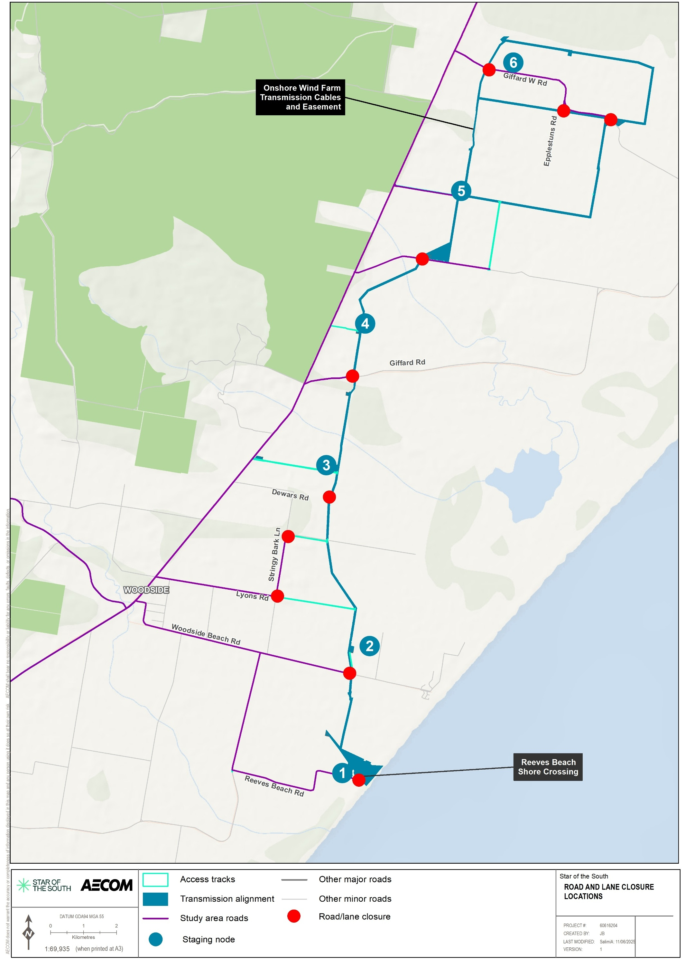

Amenity impacts arising from use of the road network (TTP-I007)

Potential impact
Construction vehicle movements may generate dust, debris, noise, and vibration, which could impact nearby roads and residences.

Mitigation
The Traffic Management Plan (TTP-M002) will include strategies to reduce dust and debris from construction vehicles using local roads to help protect the local environment and community amenity. The Star of the South Offshore Wind Farm Project may restrict construction activities and vehicle movements to standard working hours to minimise disruption.

Residual impact
With the effective implementation of mitigation TTP-M002 (Traffic Management Plan), dust and debris impacts will be minimised as far as practicable. The residual impact on the road network will be limited to the local road network, during construction periods and will be minor.
Table 17-6 Residual impact from construction traffic on public road amenity
Potential impact | Receptor group | Receptor sensitivity | Magnitude | Initial consequence | Mitigations | Residual consequence
Plant and spoil trucks deposit construction debris on public roads. | Transport network user | Medium | Low | Minor | TTP-M002 | Minor

Impacts on public transport (TTP-I008)

Potential impact
School bus services in the area, including those on South Gippsland Highway and Woodside Beach Road, may be affected by short-term road closures.

Mitigation
To manage potential impacts on public transport, the Traffic Management Plan (TTP-M002) will outline measures for road closures and safe two-way traffic flow. Supported by a review of existing bus services; the Stakeholder Engagement Plan (TTP-M001) will include consultation with councils and bus operators to ensure any affected routes have appropriate detours with acceptable travel times.

Residual impact
With the implementation of the mitigation measures TTP-M001 (Stakeholder Engagement Plan) and TTP-M002 (Traffic Management Plan), the community and public transport providers will be informed of potential road closures, allowing for adequate time to prepare for associated changes. Residual impacts will be maintained as minor and be limited to the local road network, during construction periods
Table 17-7 Residual impacts from construction traffic on public transport
Potential impact | Receptor group | Receptor sensitivity | Magnitude | Initial consequence | Mitigations | Residual consequence
Movement of construction vehicles resulting in potential road closures / diversions and delays to public transport and limited access for school buses. | Transport network user | Medium | Low | Minor | TTP-M001 TTP-M002 | Minor

Impacts on pedestrians and cyclists (TTP-I009)

Potential impact
As the works in Victoria are located within the rural road network, there are no dedicated pedestrian or bicycle facilities located in the vicinity of the works in Victoria. Nevertheless, the increase in vehicle volumes and use of heavy vehicles poses an increased safety risk to pedestrians and cyclists, including school children who use the school bus stops in the area.

Mitigation
A Stakeholder Engagement Plan (TTP-M001) will be implemented to keep the local community and road users informed of any changes in transport conditions, while a Traffic Management Plan (TTP-M002) will outline specific measures to ensure the safe movement of pedestrians and cyclists, throughout the construction period.

Residual impact
With the implementation of the mitigation measures TTP-M001 (Stakeholder Engagement Plan) and TTP-M002 (Traffic Management Plan), there are no anticipated residual safety and connectivity impacts to pedestrians and cyclists. Residual impacts are maintained as minor and will be limited to the local road network, during construction periods.
Table 17-8 Residual impacts from construction traffic on pedestrians and cyclists
Potential impact | Receptor group | Receptor sensitivity | Magnitude | Initial consequence | Mitigations | Residual consequence
Additional generated traffic and construction works impact other vulnerable road or site users resulting in a reduction in public safety and amenity | Transport network user | Medium | Low | Minor | TTP-M001 TTP-M002 | Minor

Road condition and maintenance (TTP-I010)

Potential impact
During construction, frequent heavy vehicle movements on both major and local roads may cause road surfaces to wear out more quickly than usual, potentially shortening their lifespan. Some local roads are narrow, unsealed or not designed for heavy traffic, making them more vulnerable to damage. Even with planned upgrades, ongoing maintenance will be needed to keep these roads safe and usable.

Mitigation
To prevent and manage road damage during construction, mitigation measures will include pre-construction condition surveys, regular inspections, and agreements with road authorities on maintenance and repair, including road safety audits (TTP-M003). Targeted upgrades may be carried out before works begin, and any damage will be repaired post-construction to at least the original condition, with all measures documented in the Stakeholder Engagement Plan (TTP-M001) and supporting sub-plans.

Residual impact
By implementing mitigation measures TTP-M001 (Stakeholder Engagement Plan) and TTP-003 (Road safety audits) during construction, it’s anticipated that any road damage will be identified and rectified early with no remaining damage to the road network after construction. The residual impact on transport infrastructure is expected to be maintained as minor and be limited to the local road network, during construction periods.
Table 17-9 Residual impact of construction traffic on road condition and maintenance
Potential impact | Receptor group | Receptor sensitivity | Magnitude | Initial consequence | Mitigations | Residual consequence
Public roads experience damage or deterioration due to the movement of heavy vehicles, machinery and plant resulting in crashes | Transport network user | Medium | Low | Minor | TTP-M001  TTP-M003 | Minor

Potential risks

Emergency vehicle access (TTP-R001)

Potential risk
Access to emergency services is particularly important in regional areas like Gippsland, where communities are vulnerable to natural disasters such as bushfires, floods and storms. The works in Victoria has been planned to minimise traffic disruption by reducing the need for road or lane closures so emergency vehicles can continue using existing routes.
In addition, emergency access protocols will be developed in consultation with relevant emergency services to ensure emergency vehicles can reach the work sites at all times.

Mitigation
To ensure emergency services can continue to use the road network safely and with minimal delays throughout the construction period, a Stakeholder Engagement Plan (TTP-M001) will detail ongoing communication with local emergency services to keep them informed about any changes to traffic conditions, particularly any road or lane closures. A Traffic Management Plan (TTP-M002) will ensure emergency services can access key areas with traffic controls designed to meet relevant road safety standards. These requirements should be included as part of any broader emergency management plan that may be developed for the works in Victoria. Additionally, the road safety audit (TTP-M003) will consider whether road surfaces need to be upgraded to accommodate emergency vehicles safely.

Residual risk
The effective implementation of the mitigation measures TTP-M001 (Stakeholder Engagement Plan), TTP-M002 (Traffic Management Plan) and TTP-M003 (road safety audit) will ensure the residual impacts on the road network will be maintained as minor and be limited to the local road network, during construction periods. Emergency vehicles can still travel safely and access all areas with little to no delay while the onshore transmission infrastructure is being constructed.
Table 17-10 Consequence, likelihood and residual risk ranking for emergency vehicle access during the construction phase
Potential risk | Receptor group | Receptor sensitivity | Magnitude | Initial risk | Mitigations | Residual risk
Emergency access would need to be considered / maintained to ensure adequate access and minimal delays. | Public health and safety | Medium | Medium | Low | TTP-M001  TTP-M002  TTP-M003 | Low

Operation impact assessment

Key impacts
The operation impact assessment identified no impacts on traffic and transport receptor groups with an impact rating of moderate or higher once mitigation measures are implemented.

Other impacts
Other potential operation impacts with minor to negligible residual effects on traffic and transport once mitigation measures are implemented include:
- Traffic generation and road capacity (TTP-I011).

Traffic generation and road capacity (TTP-I011)

Potential impact
The ongoing operation of the underground transmission cable system is expected to have minimal transport impacts, as they will be remotely monitored and require only periodic inspection and maintenance. A small team of up to four people will typically access the site daily when required, with occasional additional visits by a maintenance team of up to five people.
For this assessment, it has been conservatively assumed some staff traffic movements are generated daily. The assessment was undertaken using a conservative assumption that four to 18 vehicle trips could be generated per day.

Residual impact
No mitigation measures are proposed as the residual impact to the road network with this volume of traffic is expected to be negligible.
Table 17-11 Residual impacts to traffic generation and road capacity
Potential impact | Receptor group | Receptor sensitivity | Magnitude | Initial consequence | Mitigations | Residual consequence
Additional traffic during operation may result in increased congestion, compromising road operation within the vicinity of the onshore project area. | Transport network user | Low | Low | Negligible | - | Negligible

Decommissioning impacts
Decommissioning will be planned and carried out in accordance with regulatory and landholder requirements current at the time. The decommissioning approach is expected to be agreed with regulators before operations cease. The assessment of the works in Victoria assumes current industry practices will be adopted.
To minimise disturbance, most below-ground infrastructure is expected to be left in place, with cable ends cut, sealed and securely buried. Surface infrastructure such as signage, markers, link and fibre pits may be removed if required by landholders or if environmental impacts arise.
With the implementation of appropriate mitigation measures (refer to Section 17.10) these impacts and risks will be minimised as far as reasonably practicable.

Cumulative impacts
This section provides an assessment of the potential for cumulative impacts of the works in Victoria with other proposed developments in the region. The method to consider cumulative impacts is described in Chapter 6 – Assessment Framework.
Potential cumulative impacts arise when the effects of a single project on a receptor are considered along with the effects of other projects on the same receptor. Projects that are operational are part of the baseline environment, and the cumulative impact assessment focuses on future developments following a tiered assessment methodology.
The projects identified in the cumulative assessment for traffic and transport is summarised in Table 17-12.
Table 17-12 Summary of cumulative impact assessment for transport
Project | Project Description | Findings of Assessment
Delburn Onshore Wind Farm | The Delburn Onshore Wind Farm is a planned onshore wind farm with 33 turbines. It is situated in the Strzelecki ranges, to the south of Latrobe Valley. | Delburn Onshore Wind Farm may have minor overlap with the primary access route for the project's traffic, particularly for vehicles from northwest Morwell, Traralgon, and possibly Melbourne; however, impacts are expected to be minimal as only a portion of traffic originates from this area.
Golden Beach-2 Gas Project | Gas pipeline between Golden Beach foreshore and Longford Gas Plant. | If construction timelines for Golden Beach-2 Gas Project overlap with those of the project, cumulative impacts may be greater due to high traffic volumes along shared routes; however, if the project is already operational, impacts are likely to be minimal given the lower traffic associated with ongoing operations.
Great Eastern Offshore Wind Farm (Corio) | The Great Eastern Offshore Wind Farm is a proposed project approximately 24 km off the central Gippsland coast, aiming to generate up to 2.5 GW of electricity for Australia’s energy grid.  Construction is planned to commence in 2028 subject to planning and environmental approvals. | If construction timeframes overlap, the Great Eastern Offshore Wind Farm's construction and operation of the onshore component could impact traffic efficiency and road infrastructure in the vicinity the project's onshore transmission system near Giffard.
Hazelwood Rehabilitation Project | The rehabilitation of the former Hazelwood Mine to a safe, stable and sustainable landform capable of supporting productive land uses. | Hazelwood Rehabilitation Project may have minor overlap with the primary access route for project traffic, particularly for vehicles from northwest Morwell, Traralgon, and possibly Melbourne; however, impacts are expected to be minimal as only a portion of traffic originates from this area.
Loy Yang Battery Energy Storage System | The Loy Yang BESS is a 200MW, two-hour grid-scale battery to be situated at Loy Yang power station. | Loy Yang Battery Energy Storage System may have minor overlap with the primary access route for Star of the South traffic, particularly for vehicles from northwest Morwell, Traralgon, and possibly Melbourne; however, impacts are expected to be minimal as only a portion of traffic originates from this area.
Marinus Link | Marinus Link is a proposed 1500 megawatt capacity undersea and underground electricity connection to further link Tasmania and Victoria as part of Australia’s future electricity network. | Marinus Link may have minor overlap with the primary access route for project traffic, particularly for vehicles from northwest Morwell, Traralgon, and possibly Melbourne; however, impacts are expected to be minimal as only a portion of traffic originates from this area.
Gippsland Offshore Wind Transmission 2GW Project | The Gippsland Offshore Wind Transmission 2 GW Project involves the establishment of transmission infrastructure to facilitate the integration of renewable energy sources into the Victorian energy grid.  Star of the South is anticipated to connect into the proposed VicGrid connection hub in Giffard | If construction timelines for Gippsland Offshore Wind Transmission 2GW Project overlap with the project, cumulative impacts may be greater due to high traffic volumes along shared routes; however, if the project is already operational, impacts are likely to be minimal given the lower traffic associated with ongoing operations.
Seaspray Solar Farm | Seaspray Solar Farm is a 4.95MW DC Solar Power Farm under development in Stradbroke, Victoria | If construction timelines for Seaspray Solar Farm overlap with those of the project, cumulative impacts may be greater due to high traffic volumes along shared routes; however, if the project is already operational, impacts are likely to be minimal given the lower traffic associated with ongoing operations.
South East Australia Carbon Capture and Storage Project (SEA CCS Project) | The SEA CCS Project is a facility to compress, dehydrate, transport and store carbon dioxide (CO2) in the depleted Bream oil and gas reservoir. Planned new pipeline on land between Longford and Dutson Downs. | If construction timelines for the SEA CCS Project overlap with those of the project, cumulative impacts may be greater due to high traffic volumes along shared routes; however, if the project is already operational, impacts are likely to be minimal given the lower traffic associated with ongoing operations.
Tasmanian Gas Pipeline | A transmission pipeline operating and transporting gas from southern Victoria to northern Tasmania. The pipeline is 740 kilometres in length, including approximately 300 kilometres of sub-sea pipeline | The Tasmanian Gas Pipeline project would be in its operation phase during onshore construction. Unlikely to have large amounts of employee traffic generation. The cumulative impact is likely to be minimal.
These projects have a small amount of overlap in routes with the primary access route for the construction and operations traffic, particularly employees and material travelling from the north-west region of Morwell and Traralgon and potentially from Melbourne. These impacts are expected to be minimal as only a proportion of the traffic will be originating from this region and travelling on those routes.
Each of the projects discussed above are anticipated to require traffic management plans and other mitigation measures to manage their potential impacts on the local road network. While numbers of vehicles in the region may increase if each of these projects were to be constructed at the same time, this is anticipated to be manageable with appropriate mitigation measures developed to the satisfaction of relevant road authorities.

Summary of mitigation, monitoring and contingency measures

Mitigation measures
The following section outlines the mitigation measures developed to avoid and minimise traffic and transport impacts from works in Victoria.
The focus of these mitigation measures is:
            - Avoiding impacts where reasonably practicable
            - Developing, preparing and implementing project-specific measures to minimise impacts.
The mitigations below have been developed for the impacts and risks discussed in detail within Technical Report X – Traffic and Transport. Detailed descriptions of each measure can be found in Chapter 26 – Victorian Environmental Management Framework and are listed in Table 17-13.
Table 17-13 Summary of mitigation measures relevant to transport
ID | Mitigation measure
TTP-M001 | Stakeholder Engagement Plan
TTP-M002 | Traffic Management Plan
TTP-M003 | Road Safety Audits
TTP-M004 | Heavy Vehicle Transport Route Assessments
TTP-M005 | Site Access Strategy

Conclusion
The potential impacts on traffic and transport have been assessed for the construction, operation and decommissioning phases of the works in Victoria. In particular, the potential impacts on road and traffic lane closures and traffic generation and road capacity have been considered.
The key potential impacts are expected to occur during construction of the onshore transmission system, resulting from the works in Victoria in relation to transport are road and traffic lane closures impacting travel times and road safety. Operational and decommissioning impacts are anticipated to be negligible.
Mitigation measures identified to further avoid and minimise adverse impacts include:
- Implementing a Stakeholder Engagement Plan to guide consultation throughout construction, with protocols for notifying stakeholders of transport changes and obtaining feedback
- Preparing and implementing a Traffic Management Plan prior to construction to maintain road safety and minimise disruption to traffic, parking, public transport, and emergency access
- Undertaking independent road safety audits during detailed design and before construction at key access points and critical road segments to assess suitability and identify upgrades
- Assessing confirmed heavy vehicle transport routes for B-Doubles and over size over mass vehicles to ensure clearance and safety, in consultation with road authorities
- Developing a site access strategy in consultation with stakeholders to ensure safe vehicle entry and exit, considering local traffic and potential road upgrades or design changes.
Overall, impacts to the transport network during construction are expected to be minor, with the road network capacity found to be sufficient to accommodate anticipated traffic volumes and impacts managed through measures outlined in a Traffic Management Plan.
Transport impacts identified in the operation phase are considered negligible for the road network and intersection capacity due to the relatively low traffic volumes and minor traffic anticipated to be generated during this phase.
The Victorian EES scoping requirements have been addressed and the assessment found there will be no significant impacts on transport or associated infrastructure in the region.

