

Victorian Environment Effects Statement
Chapter 25 – Commercial and recreational fisheries in Victorian waters

Table of Contents
Chapter 25 Commercial and recreational fisheries in Victorian waters 25-1
25.1 Introduction 25-1
25.2 Assessment scope 25-2
25.2.1 Victorian Matters 25-2
25.3 Evaluation framework 25-3
25.3.1 Key legislation, policy, guidelines and standards 25-3
25.3.2 Assessment criteria 25-3
25.4 Methods 25-5
25.4.1 Consultation 25-7
25.5 Existing environment 25-9
25.5.1 Regional context 25-9
25.5.2 Conservation values and sensitivities 25-9
25.5.3 Physical environment 25-10
25.5.4 Fisheries 25-11
25.5.5 Fish 25-29
25.6 Assessment context 25-30
25.6.1 Receptor groups 25-30
25.6.2 Co-existence 25-30
25.7 Construction impacts 25-32
25.7.1 Key impacts 25-32
25.7.2 Other impacts 25-32
25.7.3 Potential risks 25-37
25.8 Operation impacts 25-40
25.8.1 Key impacts 25-40
25.8.2 Other impacts 25-40
25.8.3 Potential risks 25-44
25.9 Decommissioning impacts 25-46
25.9.1 Potential impacts and risks 25-46
25.10 Cumulative Impacts 25-47
25.11 Summary of mitigation, monitoring and contingency measures 25-49
25.11.1 Mitigation measures 25-49
25.11.2 Monitoring and contingency measures 25-50
25.12 Conclusion 25-51

Figures
Figure 25-1 Fisheries study area 25-6
Figure 25-2 Shark gillnet fishery spatial extent and intensity (2018-2022) 25-13
Figure 25-3 Commonwealth trawl fishery spatial extent and intensity (2018-2022) 25-14
Figure 25-4 Commonwealth Danish seine fishery spatial extent and intensity (2018-2022) 25-15
Figure 25-5 Commonwealth Southern Squid Jig fishery spatial extent and intensity (2018-2022) 25-16
Figure 25-6 Commonwealth Trawl Sector squid catch spatial extent and intensity (2018-2022) 25-17
Figure 25-7 Victorian Ocean (General) Fishery actively fished area by reporting grid (2018-2023) 25-19
Figure 25-8 Victorian Trawl (Inshore) Fishery actively fished area by reporting grid (2018-2023) 25-20
Figure 25-9 Victorian Purse-seine (Ocean) Fishery actively fished area by reporting grid (2018-2023) 25-21
Figure 25-10 Victorian Purse Rock Lobster Fishery actively fished area by reporting grid (2018-2023) 25-22
Figure 25-11 Victorian Scallop (Ocean) Fishery actively fished area by reporting grid (2018-2023) 25-24
Figure 25-12 Victorian Wrasse (Ocean) Fishery actively fished area by reporting grid (2018-2023) 25-25
Figure 25-13 Victorian Octopus Fishery and Permit Fishery actively fished area by reporting grid (2018-2023) 25-26
Figure 25-14 Map of vessel sightings during marine aerial surveys, 2021 25-28
Figure 25-15 Star of the South coexistence hierarchy 25-31

Tables
Table 25-1 Key legislation, policy, guidelines and standards 25-3
Table 25-2 Commonwealth and Victorian commercial fisheries relevant to the offshore project area for the Star of the South Offshore Wind Farm Project 25-11
Table 25-3 Species targeted by commercial fisheries that were frequently recorded during baseline surveys 25-29
Table 25-4 Residual impacts from the physical presence of construction vessels and infrastructure 25-34
Table 25-5 Residual impacts from reduced availability of fish due to low impact construction activities 25-35
Table 25-6 Residual impacts from reduced availability of fish due to noise emissions from piling and construction vessels 25-37
Table 25-7 Consequence, likelihood and residual risk ranking for hydrocarbon release due to collision of a vessel during the construction phase 25-38
Table 25-8 Consequence, likelihood and residual risk ranking for the introduction and establishment of invasive marine species 25-39
Table 25-9 Residual impact from physical presence of maintenance vessels and infrastructure 25-42
Table 25-10 Residual impact ranking from reduced availability of fish due to habitat modification, power generation and maintenance operations for commercial and recreational fishers. 25-44
Table 25-11 Summary of cumulative impact assessment for commercial and recreational fishing 25-48
Table 25-12 Summary of mitigation measures relevant to commercial and recreational fishing in Victorian waters 25-49
Table 25-13 Monitoring and contingency measures relevant to commercial and recreational fishing in Victorian waters 25-50

Commercial and recreational fisheries in Victorian waters

Introduction
This chapter summarises the existing conditions related to commercial and recreational fishing and assesses the impacts and risks associated with the construction, operation and decommissioning of works in Victoria associated with the Star of the South Offshore Wind Farm Project (works in Victoria) on commercial and recreational fishing.
This chapter and impact assessment is for the proposed works that would occur within Victorian waters described in Chapter 4 - Victorian Works Project Description. The Star of the South Offshore Wind Farm Project is located within Commonwealth waters and Victorian coastal waters where commercial and recreational fishing are recognised as an important socio-economic value.
This chapter is based on the impact assessment presented in Technical Report N – Commercial and Recreational Fisheries.
Other chapters and modelling that relate to or inform the commercial and recreational fisheries assessment include:
Chapter 20 – Social
Chapter 21 – Business and Tourism
Chapter 23 – Victorian Marine Environment
Attachment II – Consultation Report
Technical Report Attachment I – Underwater Noise Modelling
Technical Report Attachment II – Oil Spill Modelling Summary

Assessment scope
The study objective for commercial and recreational fishing is to identify the existing conditions related to commercial and recreational fishing and assess potential impacts and risks associated with the construction, operation and decommissioning of the works in Victoria on commercial and recreational fishers.
All detailed technical methodologies and assessment of commercial and recreational fisheries can be found in Technical Report N – Commercial and Recreational Fisheries. While this chapter discusses impacts from the works and infrastructure in the offshore export cable area within Victorian waters, the ratings for each receptor group have been derived from the works and impacts associated with the whole offshore project area for the Star of the South Offshore Wind Farm Project and are therefore highly conservative.

Victorian Matters
The EES scoping requirements issued by the Victorian Minister for Planning include a set of evaluation objectives that identify the desired outcomes in managing the potential impacts of works in Victoria during construction, operation and decommissioning. The following EES scoping requirements evaluation objective is relevant to the assessment of impacts to commercial and recreational fisheries:
- To avoid and minimise adverse effects on land use, social fabric of the community, local infrastructure, and local businesses and tourism during construction, operation and decommissioning of the project.
Further information about the EES scoping requirements is listed in Attachment IV – EES Scoping Requirements Checklist.

Evaluation framework

Key legislation, policy, guidelines and standards
Table 25-1 lists the key legislation, policy, guidelines and standards relevant to commercial and recreational fisheries in Victoria. Refer to Chapter 5 – Victorian Legislative Framework for further details.
Table 25-1 Key legislation, policy, guidelines and standards
Type | Applicable legislation, policy, guideline or standard
International conventions/guidance | International Convention for the Conservation of Southern Bluefin Tuna
Victorian legislation | Environment Effects Act 1978 (Vic)
Victorian legislation | Environment Protection Act 2017 (Vic)
Victorian legislation | Environment Protection Regulations 2021 (Vic)
Victorian legislation | Fisheries Act 1995 (Vic)
Victorian legislation | Fisheries Regulations 2019 (Vic)
Victorian legislation | Flora and Fauna Guarantee Amendment Act 2019 (Vic)
Victorian legislation | Heritage Act 2017 (Vic)
Victorian legislation | Marine and Coastal Act 2018 (Vic)
Victorian legislation | Marine Safety Act 2010 (Vic)
Victorian legislation | National Parks Act 1975 (Vic)
Victorian legislation | Pollution of Waters by Oils and Noxious Substances Act 1986 (Vic)
Victorian legislation | Pollution of Waters by Oil and Noxious Substances Regulations 2022 (Vic)
Victorian guideline | Ministerial guidelines for assessment of environmental effects under the EE Act (2023)
Industry | Seafood Industry Australia (SIA) Ocean Access Position Paper, May 2023
Industry | Commonwealth Shark and Trawl Industry (SETFIA) Submission: Offshore renewable energy infrastructure area proposal: Southern Ocean Region off VIC and SA, August 2023
Industry | Seafood Industry Victoria (SIV) Marine Development Policy, February 2024

Assessment criteria
To assess works in Victoria, predicted impacts and risks are compared to criteria that set required environmental performance outcomes (refer to Chapter 6 – Assessment Framework).
The criteria for commercial and recreational fisheries are derived from legislation and policy, relevant standards and guidelines, stakeholder feedback and industry best practice.
The assessment criteria relevant to commercial and recreational fisheries are:
- Recreational fishers can continue fishing in the project area and interference with their activities is not greater than is reasonably necessary for the completion of the project
- Project vessel activities are compliant with relevant project procedures and maritime law relating to navigation and safety at sea
- Fishing stakeholders are provided with information that enables them to make an informed assessment of the possible consequence of the project on their function, interests or activities
- Fishing stakeholders have sufficient time and opportunity to comment on the project including raising of objections or claims
- Fishing stakeholders are provided advance notification of construction and maintenance activities for planning of fishing activities
- Potentially affected commercial fishers are provided with an agreed process for claiming compensation for loss of catch or displacement
- Potentially affected commercial fishers are provided opportunity to participate in project activities
- Recreational fishers can continue fishing in the project area and interference with their activities is not greater than is reasonably necessary for the completion of the project
- Commercial fishers can continue fishing in the project area if it is safe and practical for them to do so
- The size of demarcation areas and safety and protection zones will be minimised to only what is necessary for the safety of personnel and marine users and the protection of infrastructure
- Only project vessels that are a low biosecurity risk enter the offshore wind farm area and the offshore export cable area
- There are no significant effects on fish stocks resulting in a change in stock status.

Methods
The purpose of the commercial and recreational fisheries impact assessment was to assess the potential impacts and risks of the works in Victoria on commercial and recreational fisheries.
Impacts refer to the consequences of planned project actions, which are given a rating determined by combining the magnitude of the impact and the sensitivity of the receptor.
Risks are an unexpected (accidental) event and are determined by combining the likelihood of an event occurring and the consequences that would result if the event were to occur.
The technical chapters consider key impacts and risks with a residual rating of moderate to severe. Other impacts and risks are those with a residual rating of negligible to minor.
Refer to Chapter 6 – Assessment Framework for more detail on how impact and risk ratings are derived.
The assessment was achieved by undertaking the following key tasks:
- Defining a study area in which fishing activities may be impacted by the works in Victoria, which includes the offshore wind farm area, the offshore export cable area, and the area in which construction noise may temporarily affect fish (refer Figure 25-1)
- Reviewing national, state and local legislation relevant to commercial and recreational fisheries
- Identifying Matters of National Environmental Significance under the EPBC Act using the Department of Climate Change Energy, the Environment and Water Protected Matters Search Tool and listed species under the FFG Act, Commonwealth and Victorian management plans and policies, published scientific and grey (non-peer reviewed) literature
- Reviewing available catch and effort data for Commonwealth and Victorian fisheries that are legally able to operate within the offshore project area for the Star of the South Offshore Wind Farm Project
- Fish surveys during 2021-2023 to provide baseline information of the fish community within and around the Star of the South Offshore Wind Farm Project area (described in Chapter 23 - Victorian Marine Environment)
- Consulting with commercial fishing and recreational fishing stakeholders (refer Section 25.4.1).
Figure 25-1 Fisheries study area
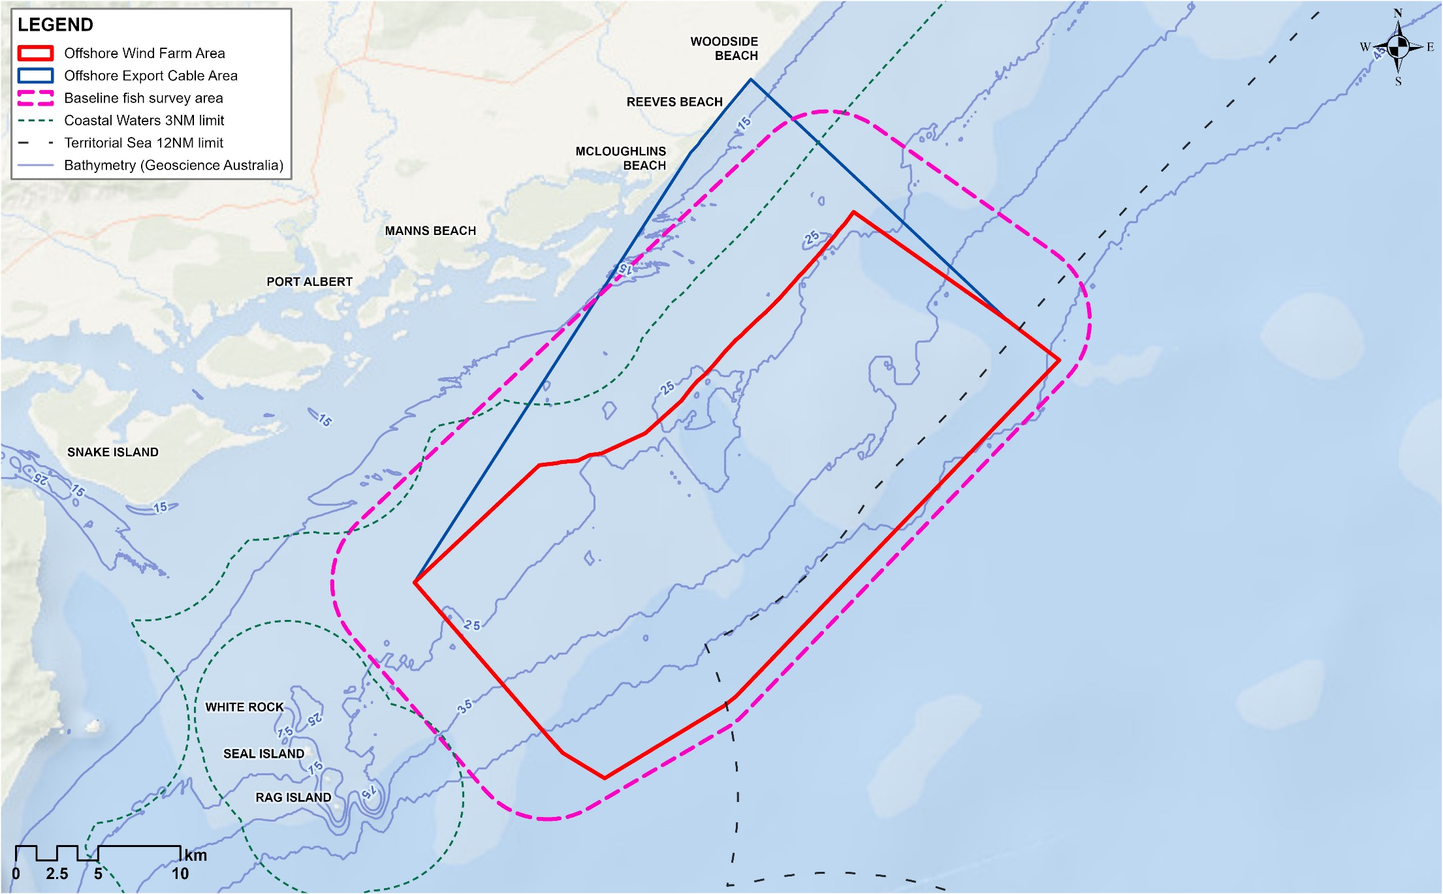

Consultation
Consultation with fishing stakeholders has been a key focus and input to the Star of the South Offshore Wind Farm Project since 2018. Star of the South has shared project information and updates and consulted broadly to collect data and feedback. Star of the South has used information collected to design and deliver site investigations (including baseline fish surveys), shape the Star of the South’s approach to engagement and communication of information, and inform design and environmental assessments.
Recognising early that the fishing sector is complex with disparate stakeholders and a wide range of perspectives, Star of the South appointed a Fishing Liaison Officer in 2021 to lead proactive and specialised engagement and ensure a thorough understanding of past, current and potential future fishing activities.
Star of the South has engaged with a wide range of fishing stakeholders, including:
- Industry representatives and peak bodies for commercial and recreational fishing
- Individual commercial fishers – primarily based in Lakes Entrance, Port Welshpool, Port Albert and Port Franklin, with a few also based in San Remo and Geelong
- Individual recreational fishers, fishing clubs and fishing retail businesses in Gippsland
- Fisheries regulatory bodies and research agencies.

Engagement activities
Engagement with the commercial fishing sector included:
- Direct contact with industry representatives and concession holders to share Star of the South Offshore Wind Farm Project information and build an understanding of existing conditions and issues, including through letters, emails, phone calls, port visits and meetings
- Information sessions in Lakes Entrance, Port Welshpool and Port Franklin
- Correspondence to and surveys of licence holders through Seafood Industry Vicotria and the Victorian Fisheries Association
- A workshop with fishing industry representatives to present preliminary field work and assessment findings and discuss potential mitigations
- Provision of Star of the South Offshore Wind Farm Project information as it relates to fishing, including fact sheets and videos
- Participation in Seafood Directions 2019, 2022 and 2024 to build broad industry awareness of offshore wind and the Star of the South Offshore Wind Farm Project, including delivering a keynote address on coexistence challenges and opportunities for offshore wind energy and commercial fishing in 2024.
Engagement with recreational fishing stakeholders included:
- Surveys at boat ramps and online to collect data on existing conditions and understand issues
- A workshop with fishing industry representatives to present preliminary field work and assessment findings and discuss potential mitigations
- Presentations to local fishing clubs
- Provision of Star of the South Offshore Wind Farm Project information as it relates to fishing, including fact sheets and videos, via the Star of the South website, social media, monthly e-news, and by providing hard copies to local fishing retail stores, fishing clubs and at local fishing competitions
- Local community information sessions and attendance at events such as the Port Welshpool Sea Days Festival, Tarwin Lower Lifestyle Festival and South Gippsland Game Fishing Club Snapper and Gummy competition
- Involvement in statewide events such as the Melbourne Boat Show and VFA Ultimate Fishing Expo and an interview on fishing podcast Wind Against Tide
- Community Advisory Group, with members from coastal communities with an interest in fishing.
Refer to Chapter 7 – Community Engagement for more detail about how Star of the South has communicated and engaged with fishing stakeholders.

Key issues
Key issues raised through consultation are discussed in Chapter 7 – Community Engagement and Technical Report N – Commercial and Recreational Fisheries.
Recreational fishers are primarily concerned with changed conditions that could affect fishing, particularly access to and around the offshore wind farm. There is broad understanding of the need to avoid major construction activities and an expectation of access during operations.
Commercial fishers' concerns are more varied and are linked to their ability to continue viable generational family businesses in the context of increasing competition for ocean space, and the stress and pressure on individual small operators. There is a clear desire to continue fishing with as little change as possible. Access, safety, adaption, uncertainty, impacts to target fish species, new opportunities and mental health concerns are key matters raised.

Existing environment
This section describes the existing conditions within the study area as they relate to commercial and recreational fishing in Victoria. The study area is defined as areas in which commercial fishers may potentially be impacted by the works in Victoria.
For this chapter, the primary study area is the offshore export cable area within three nautical miles of the coast. This is where the majority of activities and potential impacts to fishing and target fish species may occur within Victorian waters. This area may include localised restrictions to access or specific activities to support safety during construction, operation and decommissioning.

Regional context
The offshore project area for the Star of the South Offshore Wind Farm Project is located in the Southeast Shelf Transition bioregion of the South-east Marine Region. The continental shelf is relatively broad and shallow and marine waters are strongly influenced by several currents that run through and nearby the shelf, bringing both warm and cool currents. The coastline consists of long sandy beaches interspersed with rocky headlands and several coastal lagoons.

Conservation values and sensitivities
Fish species protected under Victorian and Commonwealth legislation are described in Technical Report C: Fish and Invertebrates. These include fisheries species such as Blue Warehou (Seriolella brama) and School Shark (Galeorhinus galeus) which are listed as Conservation Dependent under the EPBC Act. These species are known to occur within the offshore project area for the Star of the South Offshore Wind Farm Project and may be targeted or captured as by-catch by commercial and recreational fishers.

Physical environment

Benthic habitat
The benthic habitat in and around the offshore export cable area within Victorian waters is mostly made up of soft sandy sediments (91.9 per cent coverage) that are often moved around by strong tides and storm waves. There are small patches of high-profile rocky reef (6.8 per cent coverage) that support medium to high density macroalgae (such as seaweed) and animals that filter food from the water. There is a small amount of patchy seagrass (1.2 per cent coverage) which consists of FFG listed Tasman Grass-wrack (Heterozostera tasmanica). Further detail can be found in Chapter 23 – Victorian Marine Environment.

Currents and tides
The eastern Victorian coastline is impacted by the east Australian current, which is a warm, saline current that is strongest in summer, flowing south and often deflecting westward off Gippsland. In winter, the south Australian current transports dense, salty water eastward from the Great Australian Bight through Bass Strait, aided by prevailing westerly and south-westerly winds. Along the Gippsland Basin, currents tend to flow parallel to the coast, but strong north-easterly winds can occasionally halt or reverse coastal flow. Further detail can be found in Chapter 23 – Victorian Marine Environment.

Waves
Bass Strait is a high-energy environment frequently exposed to storms and significant wave heights, driven mainly by strong west to southwest winds. Storms can occur several times a month, typically producing waves of three to four metres, and occasionally exceeding six metres.
The offshore wind farm area is exposed to swell from the southwest through southeast and locally generated wind waves from all directions. Wave disturbance to the seabed is likely to be frequent in shallow parts of the offshore wind farm area but may only occur during extreme storm conditions in deeper offshore areas. Further detail can be found in Chapter 23 – Victorian Marine Environment.

Fisheries

Commercial fisheries
There are 21 commercial fisheries that overlap the offshore project area for Star of the South Offshore Wind Farm Project.
This section provides a summary of the active fisheries which reported effort in or near the offshore project area for Star of the South Offshore Wind Farm Project over the 20 years up to 2021. These active fisheries coexist with other uses of the marine environment, including marine parks for conservation, the offshore oil and gas industry, research, and recreational fishing. Shared use of the ocean is cited by the commercial fishing industry as a key pressure facing the sector, alongside climate change impacts in the form of changes to species distribution and abundance.
More detailed description of each fishery is provided in Technical Report N – Commercial and Recreational Fisheries.
While the remaining nine fisheries can legally fish in the offshore project area for Star of the South Offshore Wind Farm Project, they did not do so in the 20 years up to 2021. This is typically because the area does not provide favourable conditions for those fisheries and/or effort is being focused on more productive or well-located fishing grounds. In some instances, such as for the Giant Crab and Sea Urchin fishery, there are currently no licences to operate.
Table 25-2 Commonwealth and Victorian commercial fisheries relevant to the offshore project area for the Star of the South Offshore Wind Farm Project
Overlap with offshore wind farm area | Commonwealth-managed fisheries | Victorian-managed fisheries  (including permits)
Can legally fish within the offshore wind farm area and do so | - Southern and Eastern Scalefish and Shark Fishery (SESSF):  - Commonwealth Trawl Sector (CTS)  - Shark Gillnet and Shark Hook Sectors (SGSHS)  - Southern Squid Jig Fishery | - Ocean (General) Fishery  - Trawl (Inshore) Fishery  - Purse Seine (Ocean) Fishery  - Rock Lobster (Eastern Zone) Fishery  - Scallop (Ocean) Fishery  - Wrasse (Ocean) Fishery  - Small Sales Commercial Permit  - Octopus (Central Zone) Permit  - General (Commercial) Permit
Can legally fish within the offshore wind farm area but did not do so between 2001 and 2021 | - Southern Bluefin Tuna Fishery (SBTF)  - Eastern Tuna and Billfish Fishery (ETBF)  - Eastern Skipjack Tuna Fishery (ESTF)  - Small Pelagic Fishery (SPF)  - SESSF Scalefish Hook Sector | - Abalone (Central Zone) Fishery  - Bait (General) Fishery  - Giant Crab Fishery (currently no licences)  - Sea Urchin Fishery (currently no licences)

Commonwealth Shark Gillnet and Shark Hook Sectors
The Shark Gillnet and Shark Hook Sector is part of the Southern and Eastern Scalefish and Shark Fishery, and it extends from the New South Wales border through to the West Australian border. This sector uses demersal gillnet and longline equipment to target Gummy Shark (Mustelus antarcticus) but also catches various bycatch species such as Elephant Fish (Callorhinchus milii) and sawsharks. The Southern and Eastern Scalefish and Shark Fishery has the highest historic fishing effort in the offshore wind farm area, with 48 different vessels recording effort between 2001 and 2021. The actively fished area is 140,304 square kilometres, with 0.4 per cent overlapping the offshore wind farm area. Between five and 13 vessels have fished in this area between 2001 and 2021. The offshore wind farm area is close to areas of high fishing intensity (refer Figure 25-2).

Commonwealth Trawl Sector
The Commonwealth Trawl Sector is part of the Southern and Eastern Scalefish and Shark Fishery, and it extends from Sydney southwards around Tasmania to South Australia. This sector uses midwater and demersal otter board trawl and Danish seine methods to target species including pink ling (Genypterus blacodes), blue grenadier (Macruronus novaezelandiae), flathead and silver warehou (Seriolella punctata). The actively fished otter trawl area does not overlap the offshore wind farm area (refer Figure 25-3). The actively fished Danish seine area covers 58,428 square kilometres with 0.5 per cent overlapping the offshore wind farm area (refer Figure 25-4). Seven vessels have recorded effort in the offshore wind farm area between 2001 and 2021.

Commonwealth Southern Squid Jig Fishery
The Southern Squid Jig Fishery extends from South Australia through Tasmania, Victoria and New South Wales to southern Queensland. This sector uses the jigging method to target Gould's Squid (Nototodarus gouldi) in depths of 60 to 120 metres. Squid is also caught in the Commonwealth Trawl Sector by demersal trawling. The actively fished area does not overlap the offshore wind farm area (refer Figure 25-5 and Figure 25-6). Only one vessel has reported fishing within the offshore wind farm area between 1999 and 2020.

Figure 25-2 Shark gillnet fishery spatial extent and intensity (2018-2022)
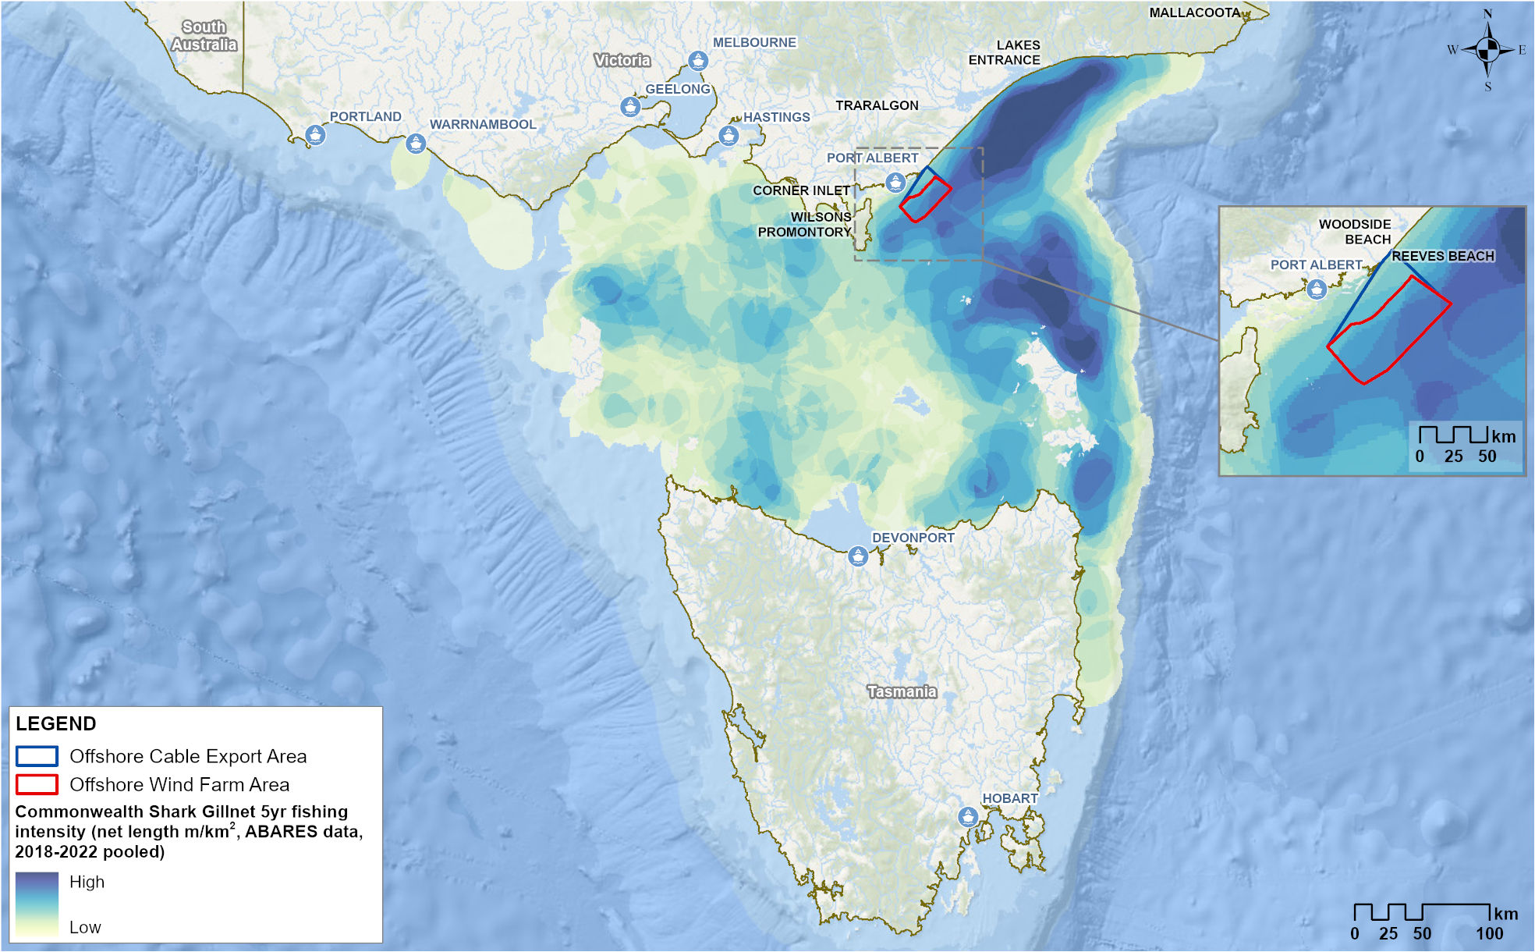
Figure 25-3 Commonwealth trawl fishery spatial extent and intensity (2018-2022)
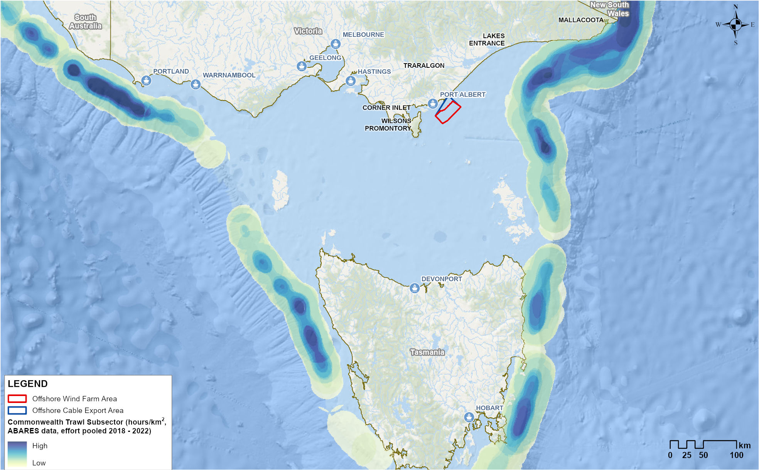
Figure 25-4 Commonwealth Danish seine fishery spatial extent and intensity (2018-2022)
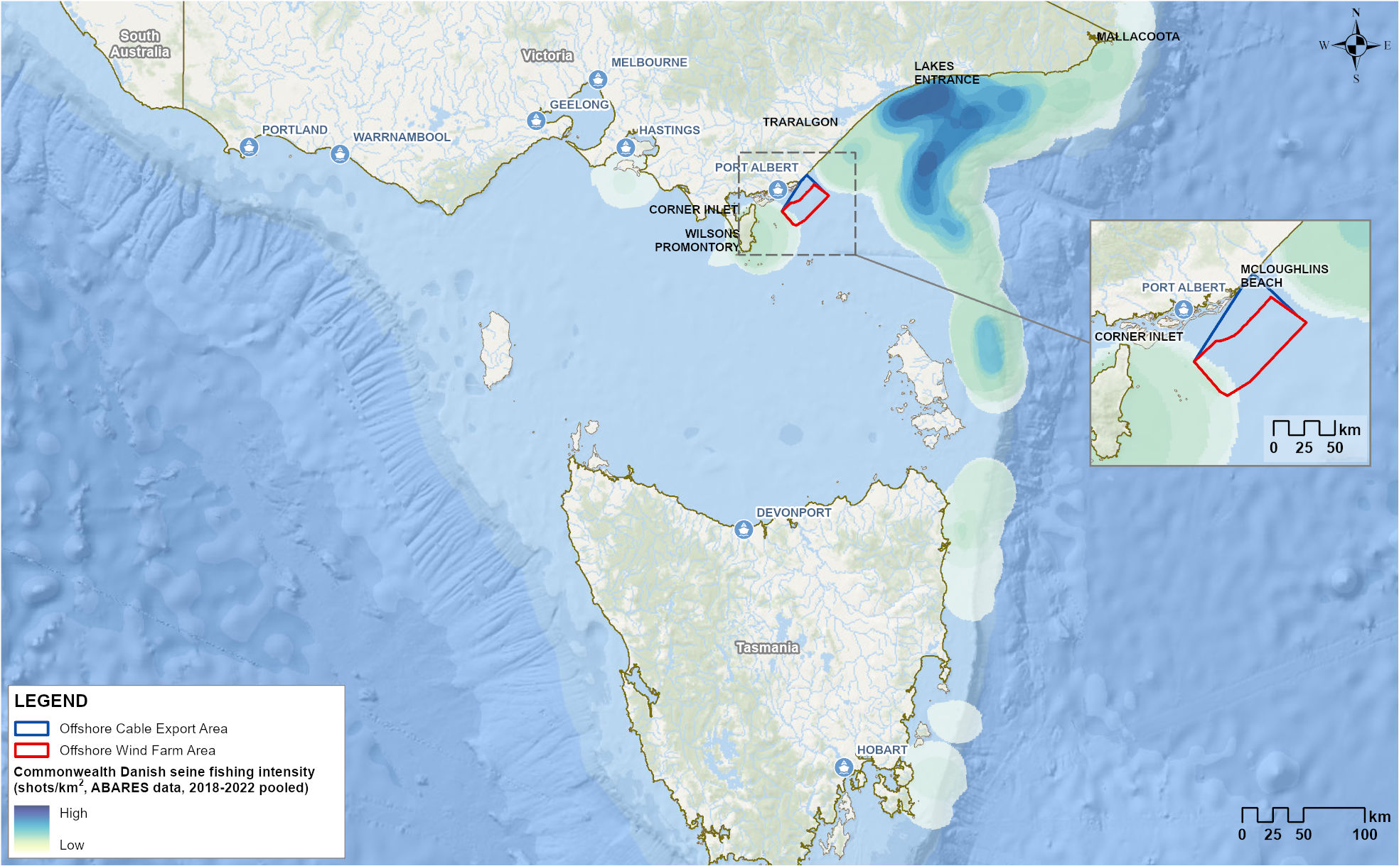
Figure 25-5 Commonwealth Southern Squid Jig fishery spatial extent and intensity (2018-2022)
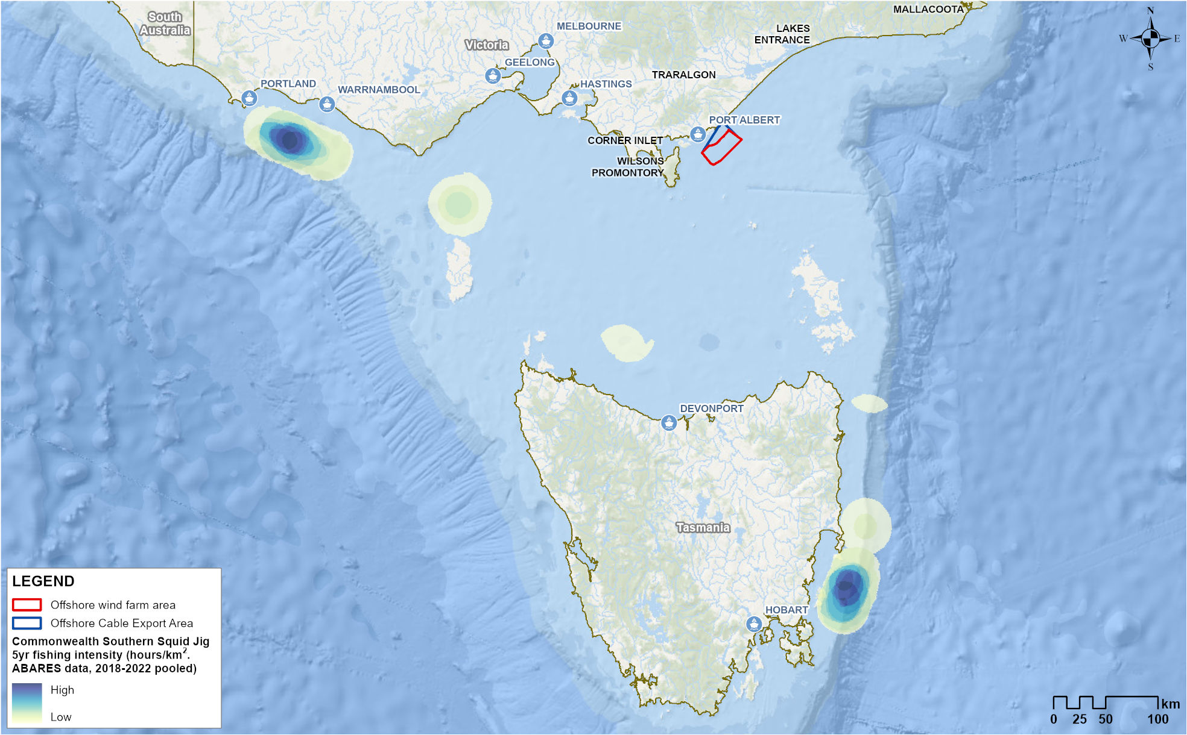
Figure 25-6 Commonwealth Trawl Sector squid catch spatial extent and intensity (2018-2022)
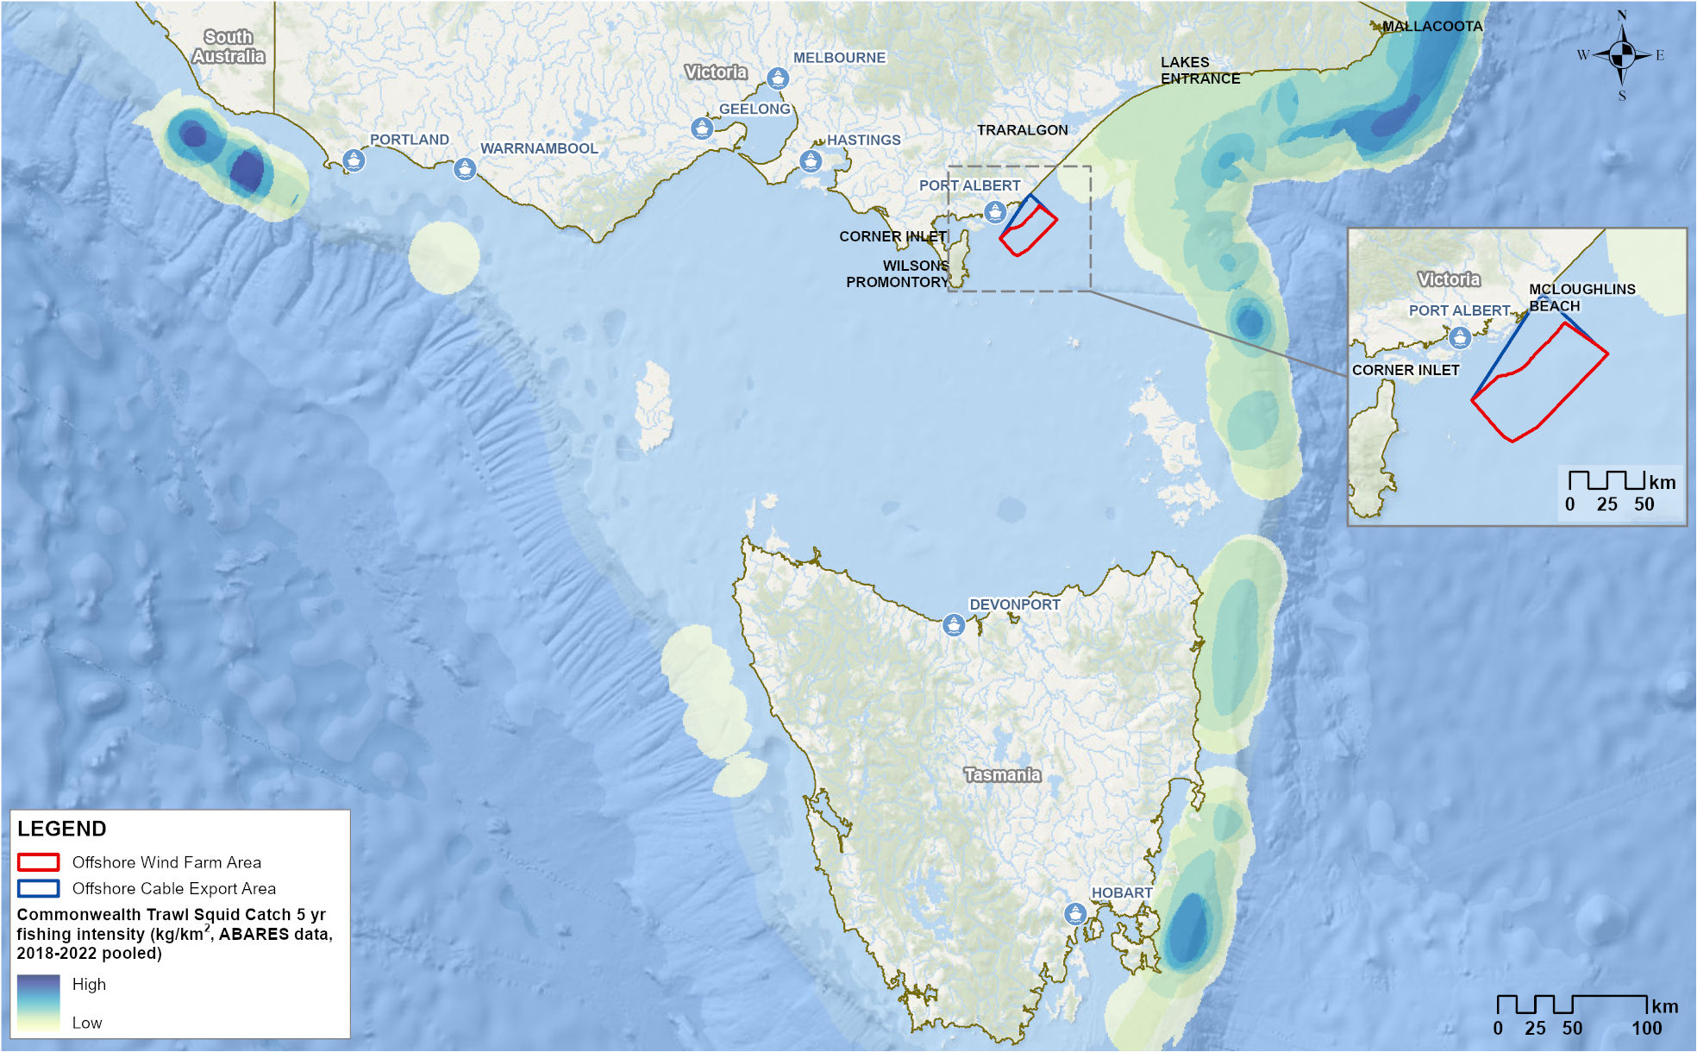

Victorian Ocean (General) Fishery
The Ocean Fishery extends the length of Victoria, with 129 licences. Fishing methods include line (dropline, longline, handline), dip net, bait traps, octopus traps, landing nets, gaffs, seine nets, mesh nets and bait pumps. Catches in the sector mostly comprise snapper, octopus and Gummy Shark. The actively fished area is 22,434 square kilometres with 1.2 per cent overlapping the offshore wind farm area (refer Figure 25-7). One to two licence holders have reported catches of snapper in any one year since 2014.

Victorian Trawl (Inshore) Fishery
The Victorian Trawl (Inshore) Fishery extends the length of Victoria, with 52 licenses of which most are not active. Using otter-board trawls, this fishery targets crustaceans (Eastern King (Melicertus plebejus) and School Prawns (Metapenaeus macleaya)), and to a lesser extent bugs, crabs and limited finfish. The actively fished area is 10,889 square kilometres, with 1.8 per cent overlapping the offshore wind farm area (refer Figure 25-8). One to two licence holders have reported fishing in or near the area since 1999.

Victorian Purse-Seine (Ocean) Fishery
The Purse-Seine (Ocean) Fishery extends the length of Victoria, with one license. The license holder operates out of Lakes Entrance. Species caught include Sandy Sprat (Hyperlophus vittatus), Australian Sardine (Sardinops sagax), unspecified shark, snapper, Australian Anchovy (Engraulis australis), Blue Mackerel (Scomber australasicus) and Australian Salmon (Arripis trutta). The actively fished area of this sector is 4,077 square kilometres, with 5.3 per cent of this area overlapping the offshore wind farm area (refer Figure 25-9). The licence holder has recorded as many as ten fishing days in or near the offshore wind farm area in any one year.

Victorian Rock Lobster Fishery (Eastern Zone)
The Victorian Rock Lobster Fishery extends along the Victorian coast and out into Commonwealth water, with 47 licences available. It is separated into two zones (eastern and western) and the eastern zone overlaps the offshore wind farm area. Baited pots are used to target the Southern Rock Lobster (Jasus edwardsii). Most of the catch comes from the western zone. The actively fished area is 36,827 square kilometres, with 0.7 per cent overlapping the offshore wind farm area (refer Figure 25-10). One to three licence holders reported fishing in or near the offshore wind farm area between 2001 and 2018, with a decrease in catch evident since 2014.

Figure 25-7 Victorian Ocean (General) Fishery actively fished area by reporting grid (2018-2023)
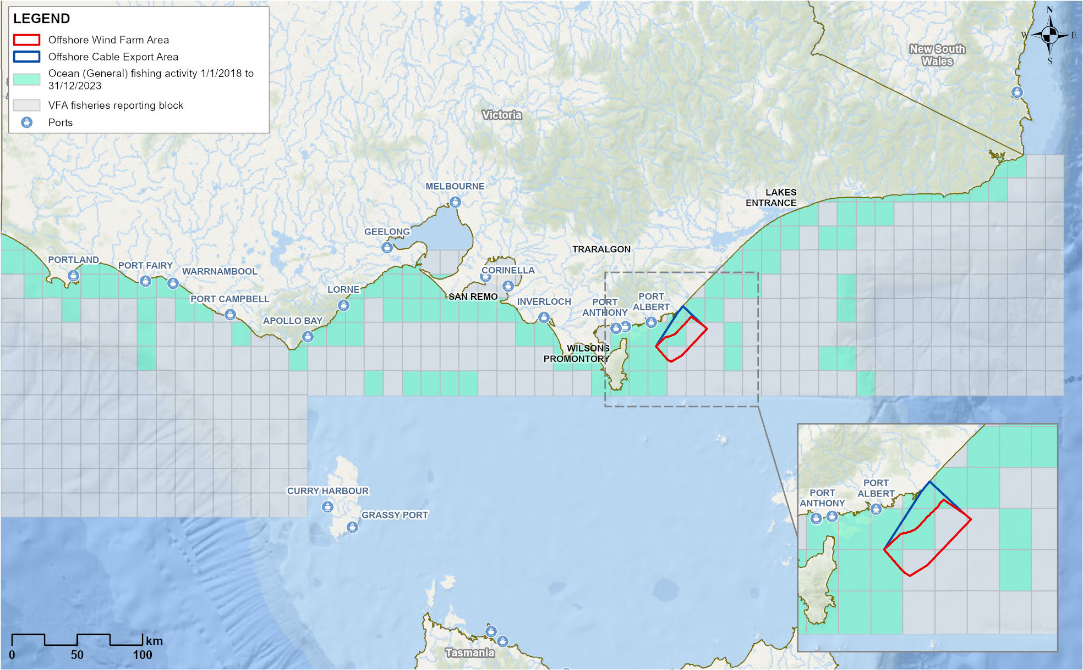
Figure 25-8 Victorian Trawl (Inshore) Fishery actively fished area by reporting grid (2018-2023)
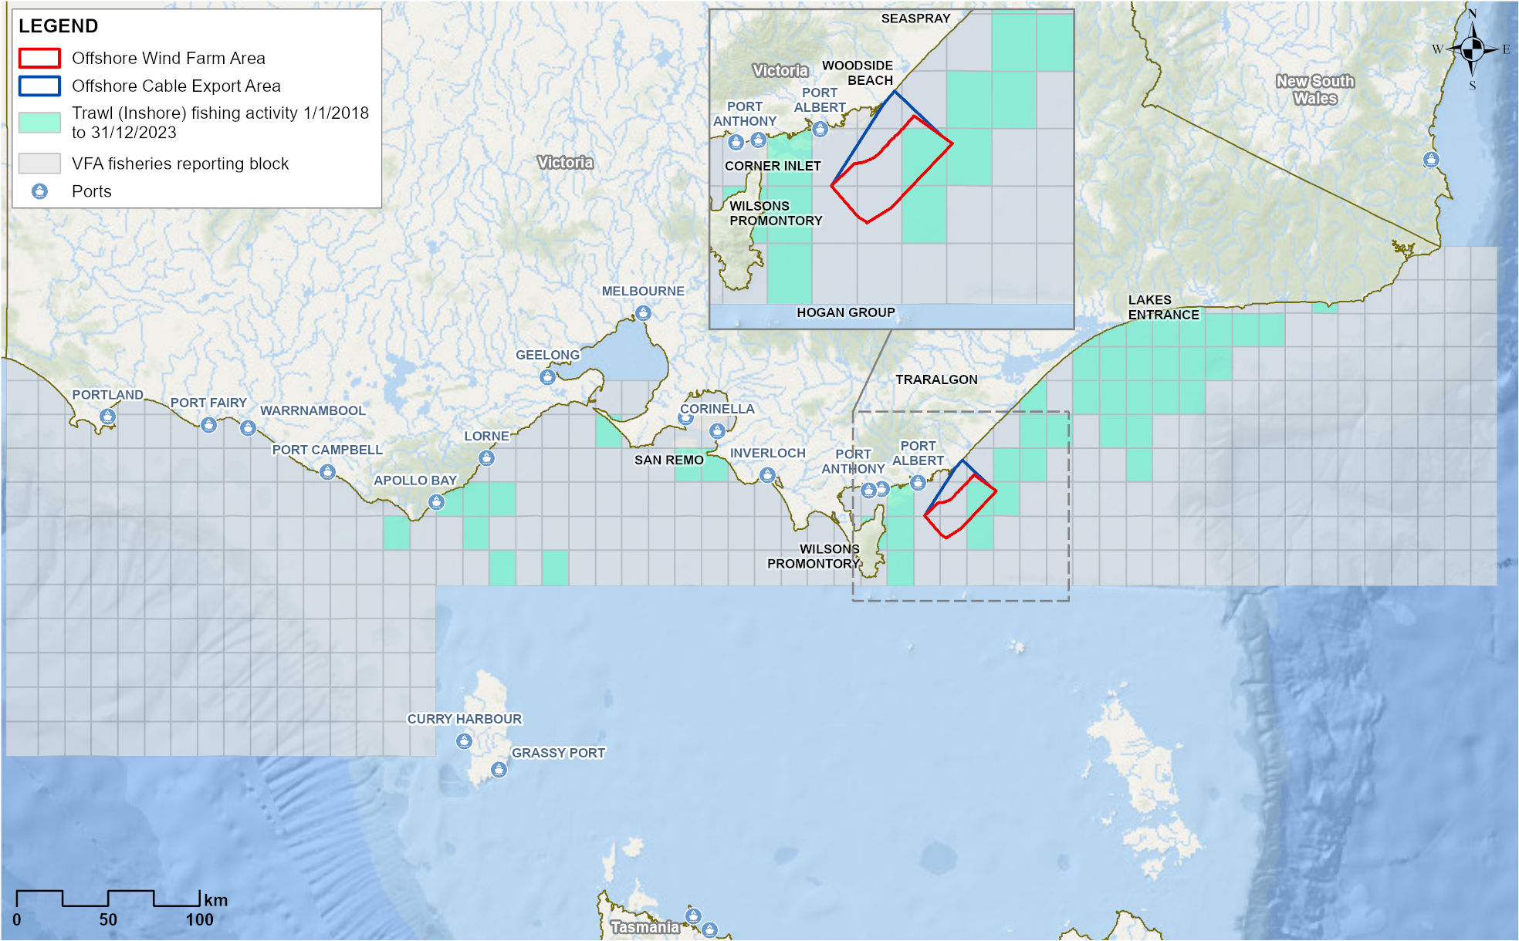
Figure 25-9 Victorian Purse-seine (Ocean) Fishery actively fished area by reporting grid (2018-2023)
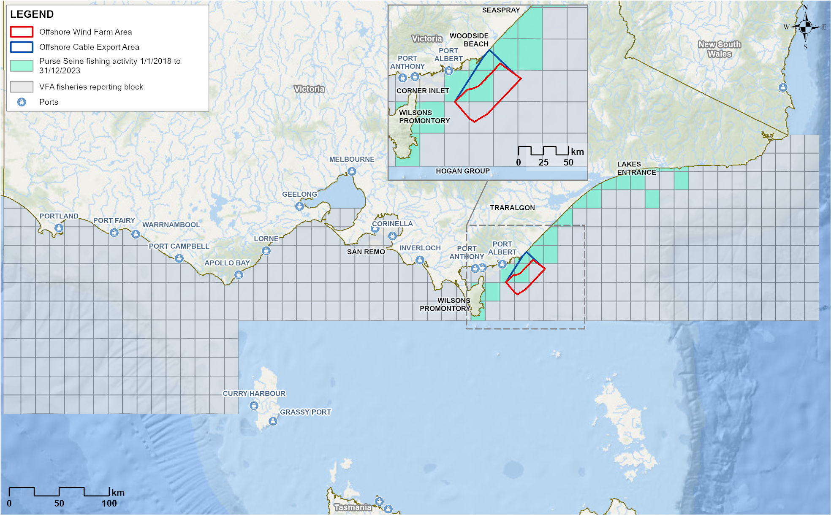
Figure 25-10 Victorian Purse Rock Lobster Fishery actively fished area by reporting grid (2018-2023)
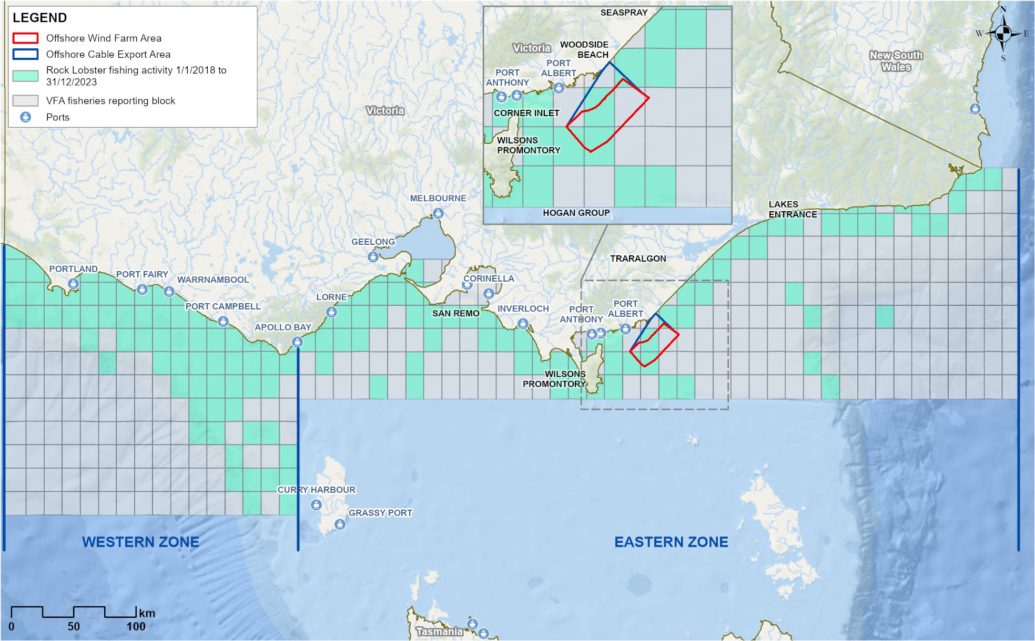

Victorian Scallop (Ocean) Fishery
The Scallop (Ocean) Fishery extends along the Victorian coastline and out to 20 nautical miles offshore, with 89 licences shared between 40 licence holders. The main target species is the Commercial Scallop (Pecten fumatus), mostly fished from Lakes Entrance and Port Welshpool using the scallop dredge method. The actively fished area is 2,482 square kilometres, with 8.8 per cent overlapping the offshore wind farm area (refer Figure 25-11). The last record of effort in reporting grids that overlap the offshore wind farm area was in 2008 when 47 days of fishing were reported.
The Scallop Fishery is unique in its ‘boom and bust’ nature. It is subject to temporary closures due to low stock to allow for recovery and a total allowable commercial catch (TACC) is set annually. A small scallop bed, called the ‘Clonmel’ bed, is located within the offshore wind farm area. The Clonmel bed is closed to commercial fishing, although surveys have recorded growth over recent years and it could be reopened if it reaches a commercially viable level.

Victorian Wrasse (Ocean) Fishery
The Wrasse (Ocean) Fishery extends along the Victorian coastline and out to 20 nautical miles offshore. There are 23 Wrasse Fishery access licences, however most of the catch is taken by eight licence holders. Hook and line is the main fishing method used to target Bluethroat (Notolabrus tetricus) and Purple Wrasse (Notolabrus fucicola). The actively fished area is 10,377 square kilometres, with 0.4 per cent overlapping the offshore wind farm area (refer Figure 25-12). One licence holder has reported effort in the offshore wind farm area in any one year since 2014.

Victorian Octopus (Permit) Fishery
The Octopus Fishery extends along the Victorian coastline and out to 20 nautical miles offshore. It is managed within three zones; the eastern is established with 11 licences, the central and western zones are exploratory and managed with temporary permits. The fishery uses purpose-built unbaited traps to target Pale Octopus (Octopus pallidus), with Maori Octopus (Macroctopus maorum) and Gloomy Octopus (Octopus tetricus) also taken. The actively fished area of the central zone is 2,498 square kilometres with 23.3 per cent overlapping the offshore wind farm area (refer Figure 25-13). A small area of the eastern zone (approximately 1.8 square kilometres) also overlaps the eastern corner of the offshore wind farm area. Consultation has confirmed that exploratory octopus occurs within the offshore wind farm zone.
Figure 25-11 Victorian Scallop (Ocean) Fishery actively fished area by reporting grid (2018-2023)
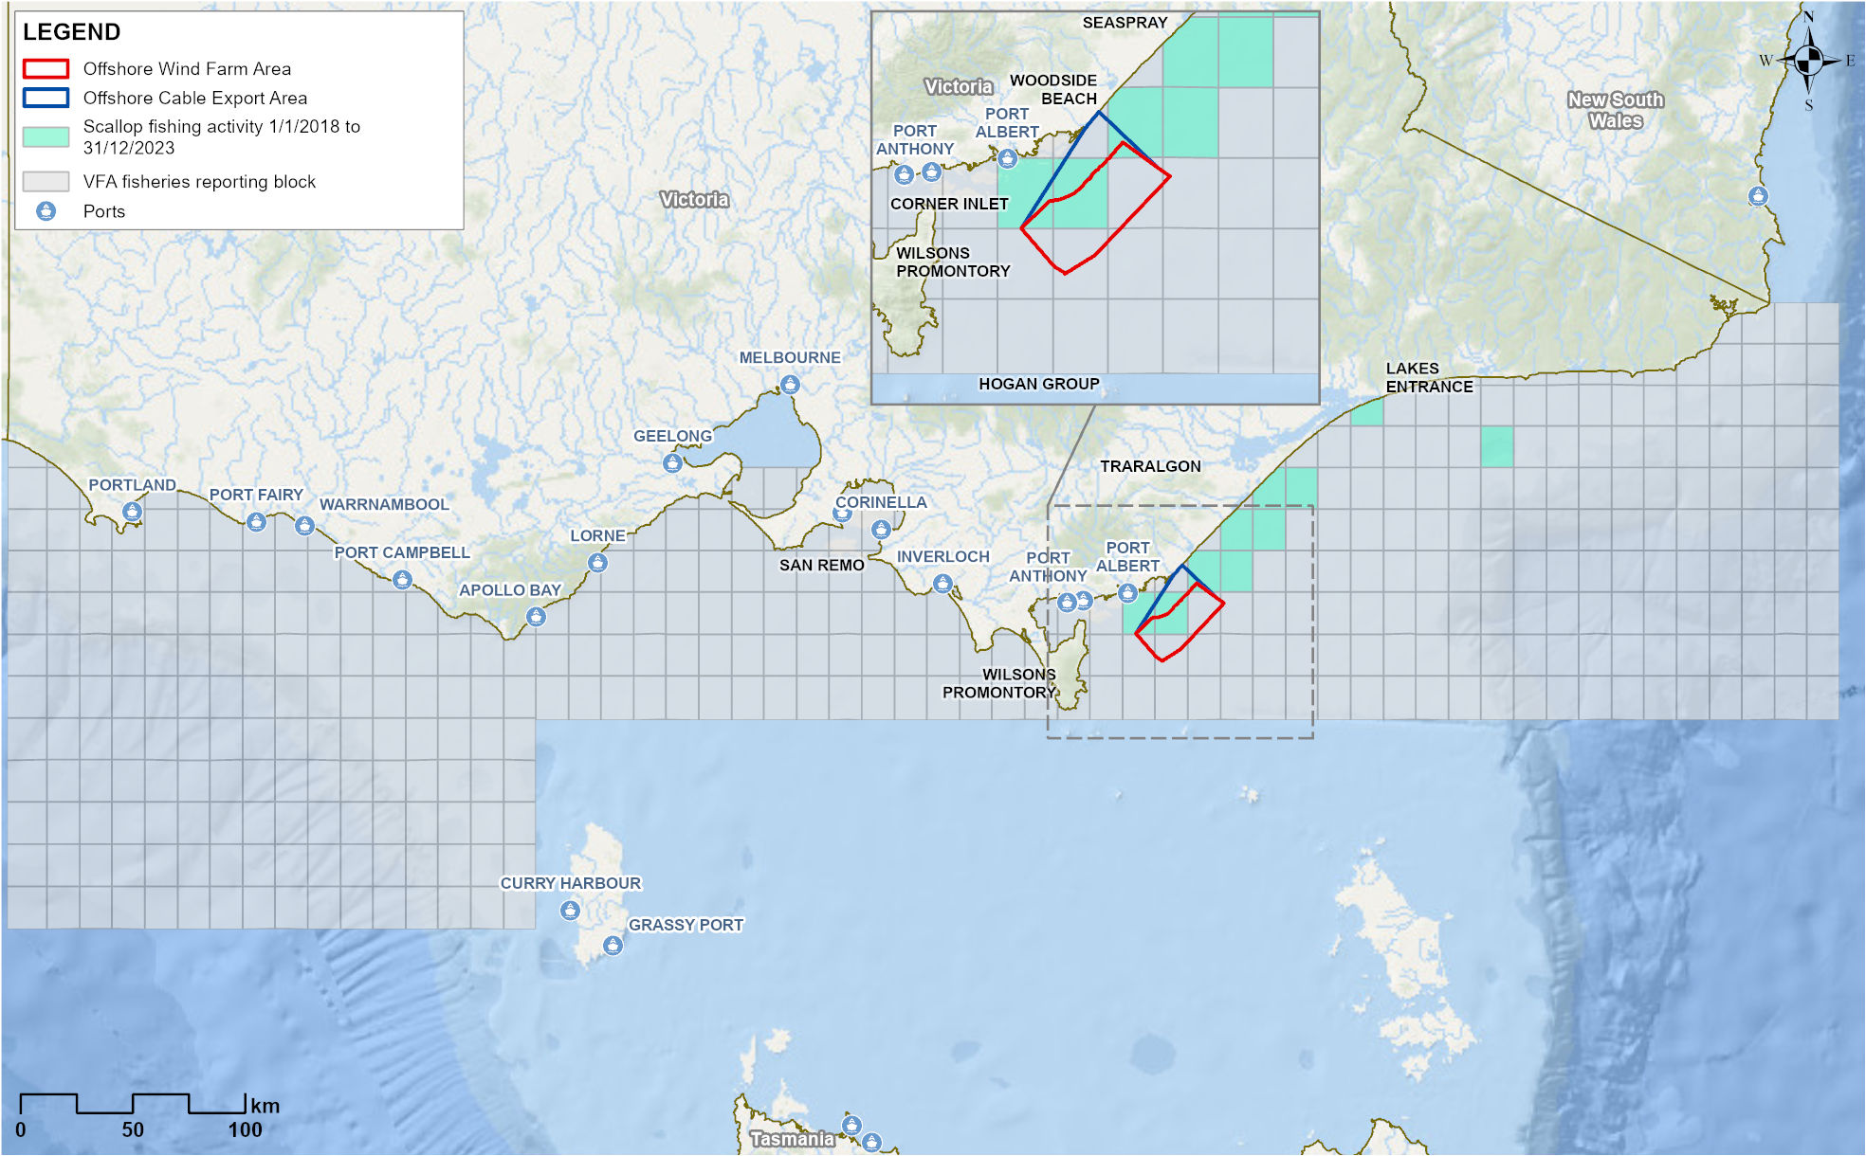
Figure 25-12 Victorian Wrasse (Ocean) Fishery actively fished area by reporting grid (2018-2023)
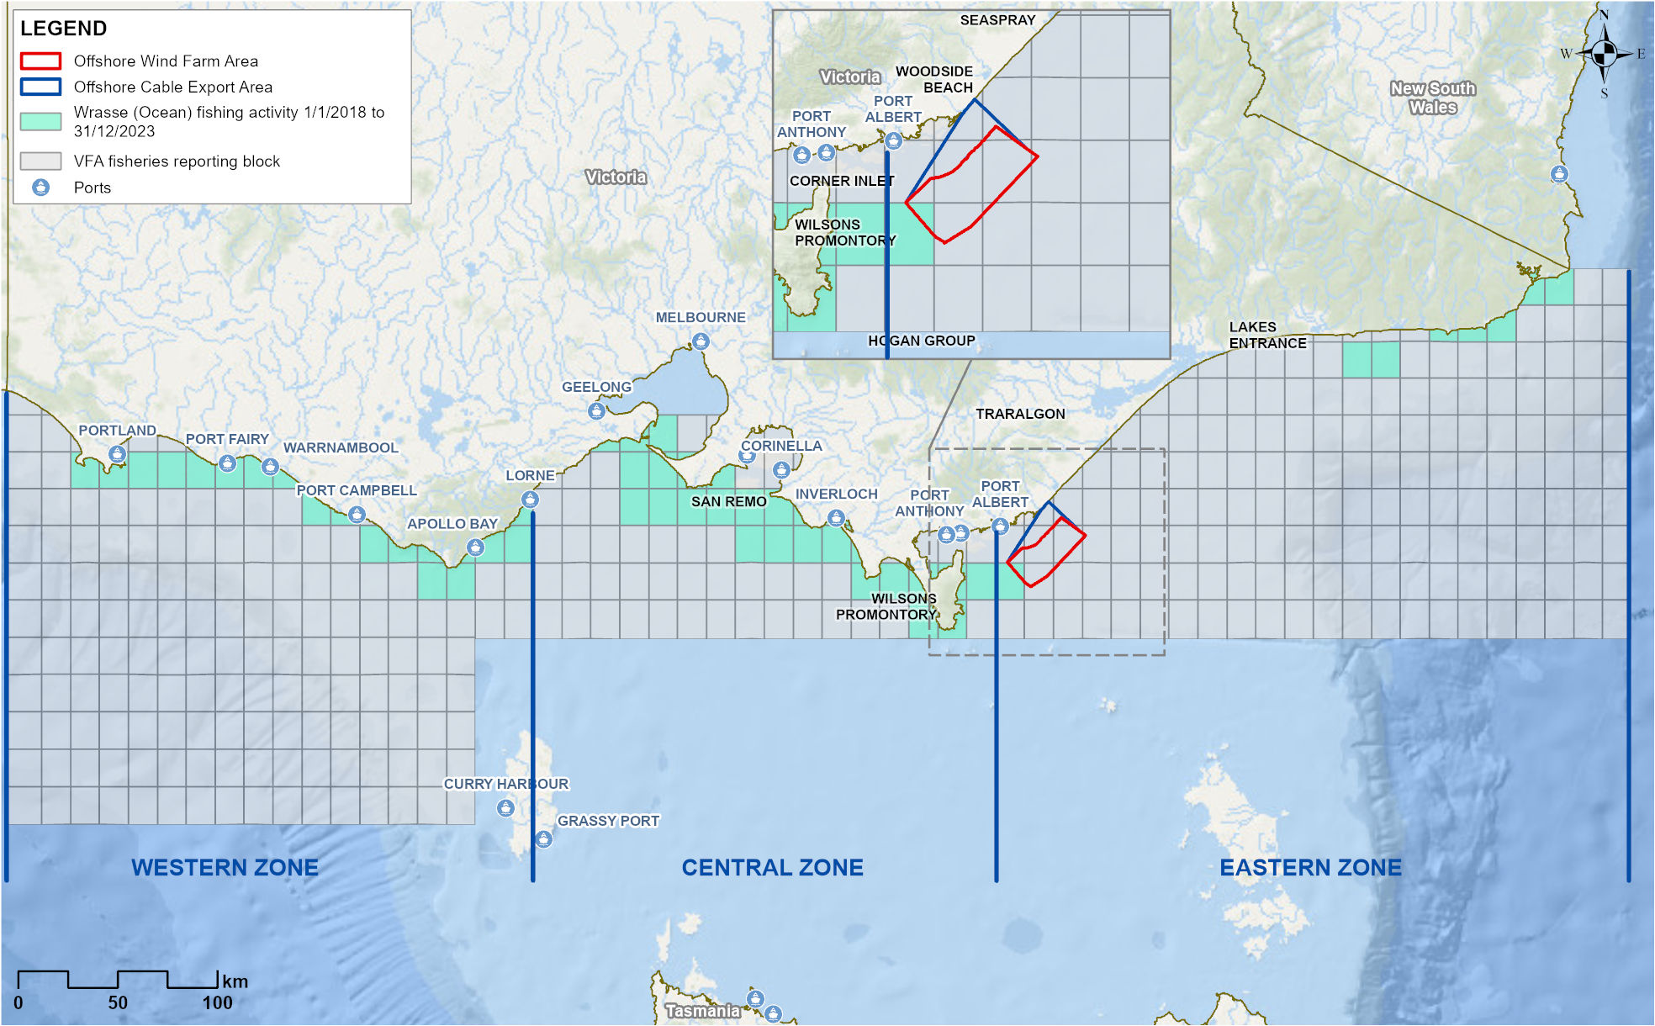
Figure 25-13 Victorian Octopus Fishery and Permit Fishery actively fished area by reporting grid (2018-2023)
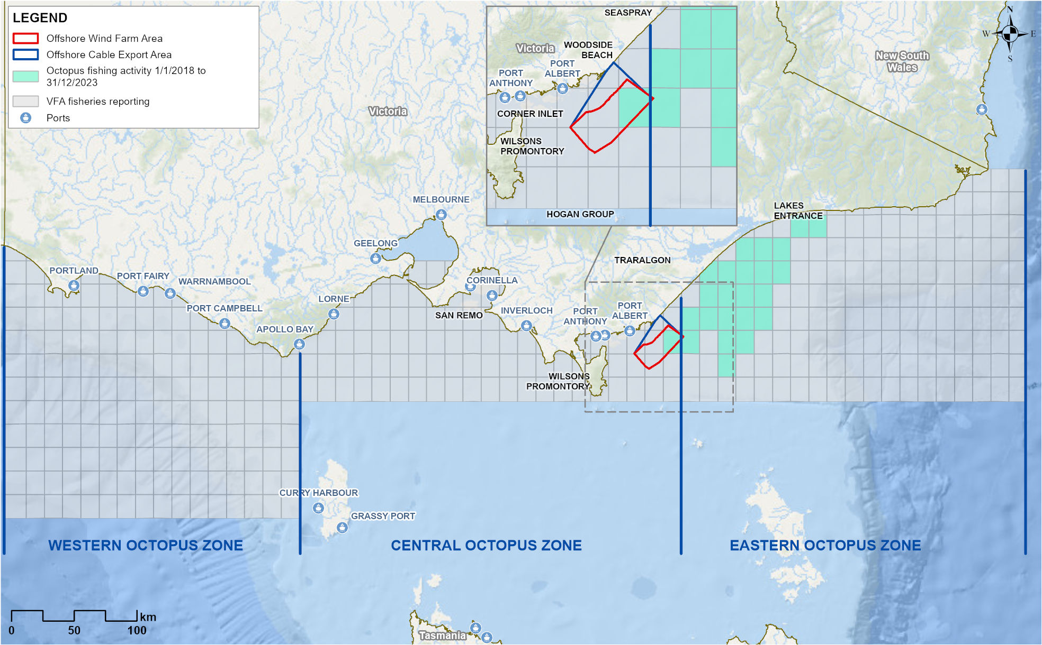

Recreational and charter fisheries
Recreational fishing is a popular activity in Gippsland lakes, rivers, beaches and offshore. The marine species targeted include snapper, King George Whiting (Sillaginodes punctatus), flathead, Gummy Sharks, bream, Australian Salmon and kingfish. Several fishing clubs are active across Gippsland.
Charter fishing and private vessels can access boat ramps at Port Albert, Port Welshpool, McLoughlins Beach and Manns Beach, with Port Albert and Port Welshpool being the most used.
Consultation with recreational fishers has confirmed that fishing occurs within the offshore wind farm area, although less so than in more sheltered areas closer to shore, within Corner Inlet and around the island chains east of Wilsons Promontory. Fishing in the offshore wind farm area is limited by distance / travel time, weather (less than 15 knots) and vessel size (at least 5.5 metres).
The main months for offshore recreational fishing are October to April, with peaks over summer holidays and long weekends, although some report fishing at other times of year if weather permits.
Aerial surveys undertaken as part of the Star of the South’s marine environment survey program identified that recreational fishing activity appears to focus on the south western quarter of the offshore wind farm area (refer Figure 25-14), which is closest to available boat ramps.
Figure 25-14 Map of vessel sightings during marine aerial surveys, 2021
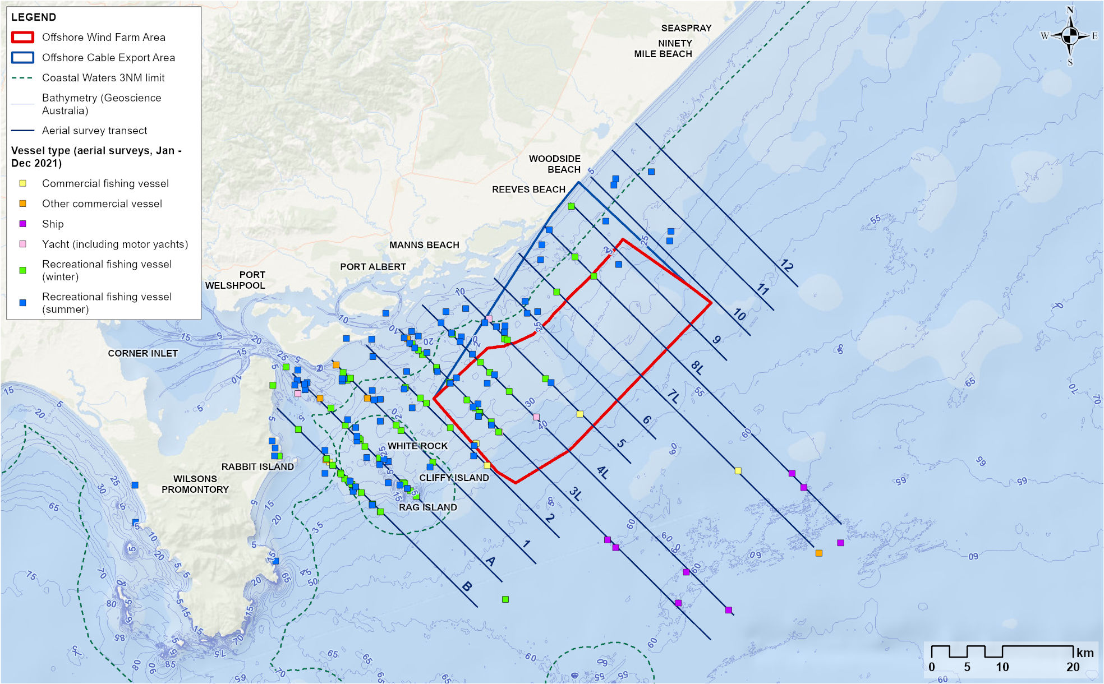

Fish
Baseline fish surveys within the study area, noting this extends well beyond Victorian coastal waters, recorded 169 species, including 30 species of sharks and rays, 108 species of bony fish and 31 species of invertebrates. Of these 169 species, 50 are targeted or retained by commercial fisheries and 48 by recreational fishers (noting overlap between the two). A further 52 species are of minor fisheries importance (potentially retained). Common target species present within the offshore wind farm area are listed in Table 25-3.
Analysis of survey data shows that depth and habitat are important predictors of species richness and overall fish abundance in winter and summer. In both seasons, species richness was highest in reef areas and lowest in sand habitat, whereas overall abundance was higher over mixed sediments, pavement with veneer and reef habitats; and lower over sand and sand with patchy epibiota habitats. Individual species exhibited a range of depth, habitat and seasonal preferences.
Seven invertebrate taxa targeted by commercial or recreational fishers were sampled during the surveys – Balmain Bug (Ibacus peronii), Commercial and Doughboy Scallops (Mimachlamys asperrima), Gould’s Squid, Southern Calamari (Sepioteuthis australis), Southern-keeled Octopus (Octopus Berrima) and Maori Octopus. The Giant Cuttlefish (Ascarosepion apama) may also be retained. The most common invertebrate species were the Pale Octopus, Southern Calamari and Giant Cuttlefish.
Further detail about fish can be found in Chapter 23 – Victorian Marine Environment.
Table 25-3 Species targeted by commercial fisheries that were frequently recorded during baseline surveys
Common name
- Australian Angelshark | - Commercial Scallop | - Snapper
- Broadnose Shark | - Baitfish (Clupeidae) | - Snook (Shortfin Pike)
- Common Sawshark | - Blue-throat Wrasse | - Southern Sand Flathead
- Elephantfish | - Eastern School Whiting | - Tiger Flathead
- Gummy Shark | - Jackass Morwong | - Toothy Flathead
- Gould's Squid | - King George Whiting | - Trevally

Assessment context

Receptor groups
The key receptor groups used to identify and assess potential impacts and risks to commercial and recreational fisheries assessment are:
- Commercial fishers using ‘restrictive’ fishing methods
- Commercial fishers using ‘non-restrictive’ fishing methods
- Charter fishing operators
- Recreational fishers on private vessels.
For the purposes of this assessment, commercial fishing receptors have been categorised by the manoeuvrability of fishing gear used, as this factor is most likely to influence potential impacts.
- Restrictive fishing methods are those that, when deployed, restrict vessel manoeuvrability. For example, gillnet, octopus pot mainlines, purse-seine, Danish seine, and longlines.
- Non-restrictive fishing methods are those that, when deployed, do not or minimally restrict vessel manoeuvrability and present a lower risk of entanglement with infrastructure. For example, hook and line and lobster pots.
Depending on the decisions and risk assessment of individual fishers, some fishing methods could be defined as either ‘restrictive’ or ‘non-restrictive’. While this assessment conservatively assumes that commercial fishers using ‘restrictive’ methods are more likely to be impacted than those using ‘non-restrictive’, it is important to note that no specific fishing methods are explicitly excluded.

Co-existence
Star of the South has sought to enable coexistence with fisheries by avoiding and mitigating impacts throughout Star of the South’s development. The avoidance of highly productive fishing grounds (based on early consultation and analysis of catch and effort data), popular recreational fishing areas and sensitive ecological features that provide fish habitat were key factors in initial site selection. The early development and design refinement to date, including site selection, is described further in Chapter 3 – Victorian Works Project Development.
Star of the South is committed to coexistence and will continue to work with commercial and recreational fishers and their representatives during detailed design and construction planning to avoid or mitigate any barriers to continued fishing in the area. Star of the South’s coexistence hierarchy was first discussed with commercial fishers in 2021 and is used to guide development and decisions which lead to better coexistence outcomes (refer Figure 25-15).
Star of the South’s commitment to coexistence and compensation is outlined in Appendix C to Technical Report N – Commercial and Recreational Fisheries.
Figure 25-15 Star of the South coexistence hierarchy
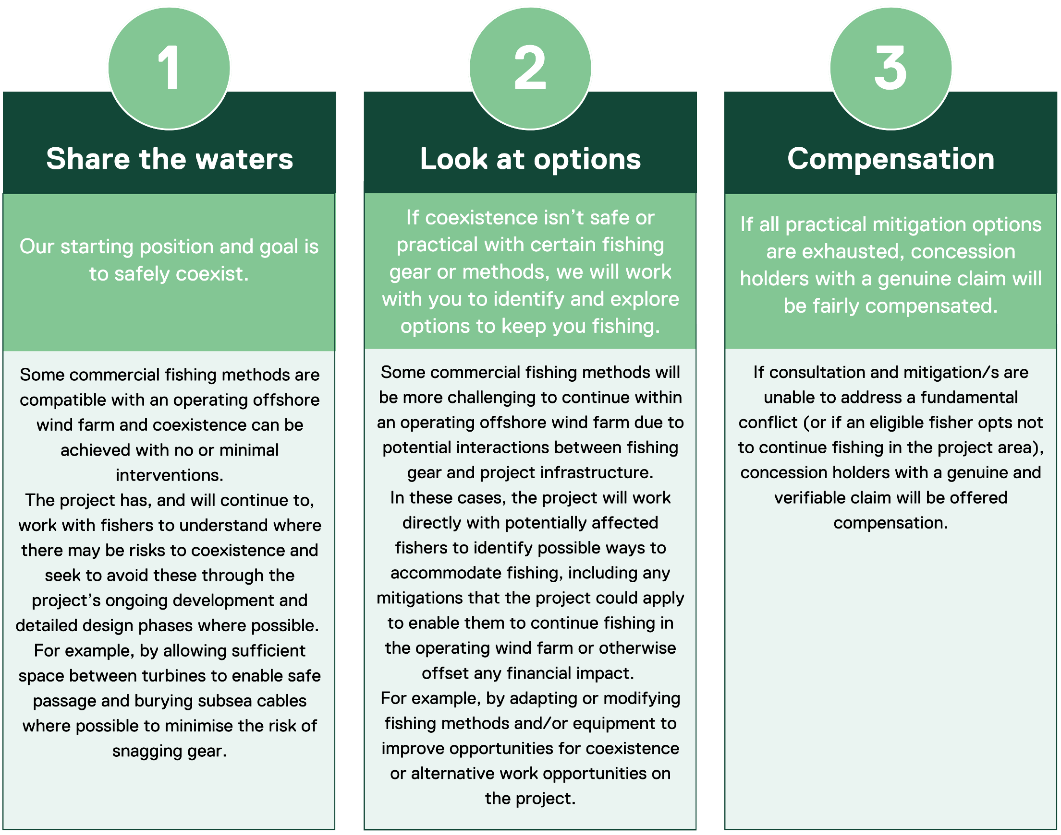

Construction impacts
This section discusses impacts and risks associated with the works in Victoria during the construction phase that relate to commercial and recreational fisheries and the respective receptor groups within Victorian waters (up to three nautical miles from the shore).
Note that while the section discusses direct impacts and risks within Victorian waters and therefore only within the offshore export cable area, the ratings for each receptor group have been derived from activities and impacts associated with the whole offshore project area for the Star of the South Offshore Wind Farm Project and are therefore highly conservative.

Key impacts
The construction impact assessment identified no impacts on commercial and recreational fisheries receptor groups with an impact rating of moderate or higher once mitigation measures are implemented.

Other impacts
Other potential construction impacts with a minor to negligible residual effects on commercial and recreational fisheries once mitigation measures are implemented included:
- Physical presence of construction vessels and infrastructure (CRF-I001)
- Reduced availability of fish due to low impact construction activities (CRF-I002)
- Reduced availability of fish due to noise emissions from piling and construction vessels (CRF-I003).

Physical presence of construction vessels and infrastructure (CRF-I001)

Potential impact
Infrastructure within Victorian waters comprises up to eight export cables which cross the shore underground at Reeves Beach. Installation of the cables will occur progressively and involves the use of a large cable installation vessel and support vessels. Vessel activity offshore of Reeves Beach is expected intermittently over 27 months to support cable shore crossing works.
Non-project vessels will be asked to keep a safe distance from construction areas and vessels, in line with maritime safety laws. Construction areas will be demarcated with buoys and monitored by escort vessels. Should the cables be ‘wet stored’ (laid on the seabed prior to burial) certain activities (such as anchoring) would be restricted in the immediate vicinity until the cable is buried.
These activities may temporarily restrict access to commercial and recreational fishing grounds.
For commercial fishers (restrictive and non-restrictive) this could result in a temporary loss of fishing grounds and loss of catch or displacement to other areas. Associated impacts to catches depends on the timing and location of construction relative to seasonal fishing practices, which can vary depending on characteristics of the target species. Before mitigations, initial impacts to commercial fishers range from negligible to moderate (refer Table 25-4). Mitigation measures to reduce these impacts are described further in this section.
Charter and recreational fishers are mobile and adaptive in their fishing patterns, target a range of species, and have access to alternative high-quality fishing grounds that are easily accessed (for example, Corner Inlet, the Cliffy Island chain and inshore waters). Before mitigations, initial impacts to this group are assessed as negligible (refer Table 25-4).

Mitigation
A comprehensive Communications and Stakeholder Engagement Plan will be implemented to keep fishers informed about construction activities so they can plan accordingly (OFF-M22), including the distribution of Notice to Mariners (OFF-M10) and other communications.
Commercial fishing vessels and crew will be prioritised for work opportunities on the Star of the South Offshore Wind Farm Project (CRF-M09) to provide an alternative or additional source of income during the construction phase. Potential work opportunities may include escort vessel duties, environmental monitoring or surveys and will be subject to vessel and safety standards.

Residual impacts
With consultation before works commence, appropriate notifications in place and the localised and short duration of restrictions, detouring around cable laying activity and fishing in alternative areas will likely represent a minor nuisance to commercial and recreational fishing. With mitigations, initially rated negligible to moderate impacts are reduced to negligible for all receptor groups (refer Table 25-4).
Table 25-4 Residual impacts from the physical presence of construction vessels and infrastructure
Potential impact | Receptor group | Receptor sensitivity | Magnitude | Initial consequence | Mitigations | Residual consequence
Loss of fishing ground | Commercial fishers (using restrictive methods) | Medium | Medium | Moderate (C) | CRF-M09  CRF-M08 | Negligible (E)
Loss of fishing ground | Commercial fishers (using non-restrictive methods) | Low | Negligible | Negligible (E) | CRF-M09  CRF-M08 | Negligible (E)
Loss of fishing ground | Charter fishing operators | Low | Low | Negligible (E) | CRF-M09  CRF-M08 | Negligible (E)
Loss of fishing ground | Recreational fishers on private vessels | Low | Negligible | Negligible (E) | CRF-M09  CRF-M08 | Negligible (E)
Loss of catch | Commercial fishers (using restrictive methods) | Medium | Low | Minor (D) | CRF-M09  CRF-M08 | Negligible (E)
Loss of catch | All other receptor groups | Low | Negligible | Negligible (E) | CRF-M09  CRF-M08 | Negligible (E)
Increased operating costs | Commercial fishers (using restrictive methods) | Low | Low | Negligible (E) | CRF-M09  CRF-M08 | Negligible (E)
 | All other receptor groups | Low | Negligible | Negligible (E) | CRF-M09  CRF-M08 | Negligible (E)
Displacement to other fishing areas and increased interactions with other fishers | Commercial fishers (using restrictive methods) | Medium | Low | Minor (D) | CRF-M09  CRF-M08 | Negligible (E)
 | Commercial fishers (using non-restrictive methods) | Low | Low | Negligible (E) | CRF-M09  CRF-M08 | Negligible (E)
 | All other receptor groups | Low | Negligible | Negligible (E) | CRF-M09  CRF-M08 | Negligible (E)
Loss of prospectivity (the harvest potential of an area) | Commercial fishers who can legally operate within the offshore wind farm area | Low | Negligible | Negligible (E) | CRF-M09  CRF-M08 | Negligible (E)
Decreased fishing license/quota value | Commercial fishers who can legally operate within the offshore wind farm area | Low | Negligible | Negligible (E) | CRF-M09  CRF-M08 | Negligible (E)

Reduced availability of fish due to low impact construction activities (CRF-I002)

Potential impact
The assessment considers potential impacts to commercial and recreational fisheries from low impact construction activities disrupting target fish species. Low impact construction activities include site preparation, cable laying and cable burial activities, as well as associated vessel light emissions and discharges. The potential consequences for fisheries are loss of catch and displacement to other fishing areas resulting in increased interactions with other fishers.
The impact of these construction activities is expected to have a negligible impact on fish, limited to minor behavioural changes (as described in Chapter 23 – Victorian Marine Environment). As such, the initial consequences for all fisheries receptors is also negligible (refer Table 25-5).

Mitigation
The implementation of a comprehensive Stakeholder Communication Plan (OFF-M22) will ensure that fishers know where construction activity is occurring, enabling them to make informed decisions about where and when to fish to avoid disruption.

Residual impact
The initial and residual impacts are negligible and do not require mitigation.
Table 25-5 Residual impacts from reduced availability of fish due to low impact construction activities
Potential impact | Receptor group | Receptor sensitivity | Magnitude | Initial consequence | Mitigations | Residual consequence
Loss of catch | Commercial fishers | Medium | Negligible | Negligible | - | Negligible
Loss of catch | All other receptor groups | Low | Negligible | Negligible | - | Negligible
Displacement to other fishing areas and increased interactions with other fishers | All receptor groups | Low | Negligible | Negligible | - | Negligible

Reduced availability of fish due to noise emissions from piling and construction vessels (CRF-I003)

Potential impact
The assessment considers potential impacts to commercial and recreational fisheries from the effects of underwater noise on target fish species. The main source of underwater noise in Victorian waters will be from cable lay vessels using dynamic positioning (thrusters to hold the vessel in place). The potential consequences for fisheries are loss of catch and displacement to other fishing areas resulting in increased interactions with other fishers.
The impact of underwater noise on mobile fish will be mainly behavioural, with individuals expected to move away from the noise source. As disruption will be temporary and localised, impacts to fish populations have been assessed as negligible. Fisheries targeting mobile species may experience a temporary redistribution of fish away from areas where cable installation is taking place.
The area expected to be impacted by construction noise is very small compared to the broader area actively fished by commercial and recreational fishers and both groups will be able to continue fishing in alternative areas unaffected by construction noise. As such, the initial consequences of lost catch due to displacement are assessed as negligible (refer Table 25-6).

Mitigation
The effects of this impact on commercial and recreational fisheries will be minimised through mitigation measures proposed for CRF-I001 (refer Section 25.7.2.1).

Residual impact
With mitigation measures in place the residual consequence is negligible for all receptor groups (Table 25-6).

Table 25-6 Residual impacts from reduced availability of fish due to noise emissions from piling and construction vessels
Potential impact | Receptor group | Receptor sensitivity | Magnitude | Initial consequence | Mitigations | Residual consequence
Loss of catch | Commercial fishers | Medium | Low | Minor | CRF-M08  CRF-M09 | Negligible
Loss of catch | All other receptor groups | Low | Negligible | Negligible | CRF-M08  CRF-M09 | Negligible
Displacement to other fishing areas and increased interactions with other fishers | All receptor groups | Low | Negligible | Negligible | CRF-M08  CRF-M09 | Negligible

Potential risks
All potential risks on commercial and recreational fisheries identified from the construction phase have a residual risk rating of low or very low. These risks include:
- Hydrocarbon release due to collision of a vessel (CRF-R001)
- Introduction and establishment of invasive marine species (CRF-R002).

Hydrocarbon release due to collision of a vessel (CRF-R001)
In the unlikely event of a vessel collision that results in an oil spill, fish targeted by commercial and recreational fishers may be exposed to small amounts of oil in the water. The potential consequences for fisheries are loss of catch, decreased saleability of commercial catch due to actual or perceived contamination, and displacement to other fishing areas.
Hydrocarbon release modelling indicates that the risk to fisheries is highly dependent on prevailing metocean conditions, but it is likely that the area and duration of effects from an individual spill will be localised and short-term relative to the extent of actively fished areas and the duration of fishing seasons (see Technical Report Attachment II – Oil Spill Modelling Summary Report).

Mitigation
This risk will be mitigated by procedures that regulate vessel activity and ensure compliance with maritime legislation (VES-M01, VES-M04 and SNV-M05), thereby reducing the likelihood of vessel collision. In the rare event that a spill occurs, the spatial and time scale of impacts would be minimised by rapid and effective implementation of a spill response plan (SPL-M02).

Residual risk
With mitigation measures in place, the likelihood of an oil spill occurring is rare and the residual risks are very low to low (Table 25-7).
Table 25-7 Consequence, likelihood and residual risk ranking for hydrocarbon release due to collision of a vessel during the construction phase
Potential impact | Receptor group | Receptor sensitivity | Initial consequence | Initial likelihood | Initial risk rating | Mitigations | Residual risk rating
Hydrocarbon release due to collision of a vessel | Commercial fishers | Medium | Moderate | Rare | Low | - | Low
Hydrocarbon release due to collision of a vessel | Recreational fishers on private vessels | Low | Minor | Rare | Very Low | - | Very Low
Hydrocarbon release due to collision of a vessel | Charter fishing operators | Low | Minor | Rare | Very Low | - | Very Low

Introduction and establishment of invasive marine species (CRF-R002)

Potential risk
Newly installed infrastructure provides bare hard substrates that can be colonised by epifaunal and mobile species. If colonised by invasive marine species, impacts to target species of fisheries importance could occur through direct effects of predation or competition, or indirect effects like habitat change. A potential consequence to commercial and recreational fisheries is lost catch due to decline in abundance of target species.
Vessels arriving from both overseas and domestic ports could transport invasive marine species to Victorian waters.

Mitigation
The likelihood of the risk occurring is rare as vessels will comply with relevant biosecurity legislation and guidelines (VES-M05) that manages discharges of ballast water, ensures vessels are confirmed to be a low biosecurity risk before approval to enter the offshore project area of the Star of the South Offshore Wind Farm Project and Corner Inlet, and ensures the vessels have biosecurity clearance to enter Australia.

Residual risk
The initial and residual risk rating is assessed as low for commercial fishers and very low for recreational fishers and charter fishing operators.
Table 25-8 Consequence, likelihood and residual risk ranking for the introduction and establishment of invasive marine species
Potential impact | Receptor group | Receptor sensitivity | Initial consequence | Initial likelihood | Initial risk rating | Mitigations | Residual risk rating
Introduction and establishment of invasive marine species | Commercial fishers | Medium | Moderate | Rare | Low | - | Low
Introduction and establishment of invasive marine species | Charter fishing operators | Low | Minor | Rare | Very Low | - | Very Low
Introduction and establishment of invasive marine species | Recreational fishers on private vessels | Low | Minor | Minor | Very Low | - | Very Low

Operation impacts
This section discusses the impacts and risks associated with the works in Victoria during the operation phase that relate to commercial and recreational fisheries and the respective receptor groups.

Key impacts
The operation impact assessment identified no impacts on commercial and recreational fisheries receptor groups with an impact rating of moderate or higher once mitigation measures are implemented.

Other impacts
Other potential operation impacts with a minor to negligible residual effects on commercial and recreational fisheries once mitigation measures are implemented included:
- Physical presence of maintenance vessels and infrastructure (CRF-I004)
- Reduced availability of fish due to habitat modification, power generation and maintenance operations (CRF-I005)
- Increased commercial and/or recreational fishing interest (CRF-I006).

Physical presence of maintenance vessels and infrastructure (CRF-I004)

Potential impact
There will be limited impacts in operation as infrastructure will be located entirely below the sea floor. Export cables will be buried at a target depth of one metre. No access restrictions are proposed, however fishers may be asked to avoid certain activities (such as anchoring or trawling) directly over the export cables if required for safety and to avoid damage to the cables, consistent with current practices around the existing Basslink Interconnector cable.
Day-to-day operations will involve smaller vessel trips between the operation port and the offshore wind farm, however only a very small number to the export cable area. Major maintenance within the export cable area requiring the use of large construction vessels will be infrequent.
Potential impacts are loss of fishing grounds along the cable routes, which may lead to loss of catch and displacement to other fishing areas.

Mitigation
Subsea cables will be buried (EMI-M01) and monitoring of the burial depth (MEMP-M09) will ensure that cables remain buried to avoid entanglement and damage to the cable. A lost gear claims process for commercial fishers will be in place throughout the operation phase to help manage any accidental hook ups with gear.
The following initial mitigation measures will assist all fishers to navigate the export cable area safely and to make informed decisions about whether it is safe to fish in certain areas of Victorian waters:
- A comprehensive Communications and Stakeholder Engagement Plan will be implemented to keep fishers informed about operation and maintenance activities and any possible hazards so they can plan accordingly (OFF-M22), including the distribution of Notice to Mariners (OFF-M10) and other communications.
- Charting of the final export cable on navigational charts will provide accurate information about the location of installed infrastructure (SNV-M09).

Residual impact
With mitigation measures in place, residual impacts to all groups are negligible as shown in Table 25-9.

Table 25-9 Residual impact from physical presence of maintenance vessels and infrastructure
Potential Impact | Receptor | Receptor sensitivity | Magnitude | Initial Consequence | Mitigation | Final Consequence
Loss of fishing ground | Commercial fishers (using restrictive methods) | Medium | Medium | Moderate (C) | CRF-M09  CRF-M08 | Negligible (E)
Loss of fishing ground | Commercial fishers (using non-restrictive methods) | Low | Negligible | Negligible (E) | CRF-M09  CRF-M08 | Negligible (E)
Loss of fishing ground | Charter fishing operators | Low | Low | Negligible (E) | CRF-M09  CRF-M08 | Negligible (E)
Loss of fishing ground | Recreational fishers on private vessels | Low | Negligible | Negligible (E) | CRF-M09  CRF-M08 | Negligible (E)
Loss of catch | Commercial fishers (using restrictive methods) | Medium | Low | Minor (D) | CRF-M09  CRF-M08 | Negligible (E)
Loss of catch | All other receptor groups | Low | Negligible | Negligible (E) | CRF-M09  CRF-M08 | Negligible (E)
Increased operating costs | Commercial fishers (using restrictive methods) | Low | Low | Negligible (E) | CRF-M09  CRF-M08 | Negligible (E)
 | All other receptor groups | Low | Negligible | Negligible (E) | CRF-M09  CRF-M08 | Negligible (E)
Displacement to other fishing areas and increased interactions with other fishers | Commercial fishers (using restrictive methods) | Medium | Low | Minor (D) | CRF-M09  CRF-M08 | Negligible (E)
 | Commercial fishers (using non-restrictive methods) | Low | Low | Negligible (E) | CRF-M09  CRF-M08 | Negligible (E)
 | All other receptor groups | Low | Negligible | Negligible (E) | CRF-M09  CRF-M08 | Negligible (E)
Loss of prospectivity (the harvest potential of an area) | Commercial fishers who can legally operate within the offshore wind farm area | Low | Negligible | Negligible (E) | CRF-M09  CRF-M08 | Negligible (E)
Decreased fishing license/quota value | Commercial fishers who can legally operate within the offshore wind farm area | Low | Negligible | Negligible (E) | CRF-M09  CRF-M08 | Negligible (E)

Reduced availability of fish due to habitat modification, power generation and maintenance operations (CRF-I005)

Potential impact
The assessment considers how the works in Victoria during the operation phase may affect commercial and recreational fisheries through changes in fish availability, either from habitat modification or from power generation and maintenance operations.
Potential impacts from power generation and maintenance operations are underwater noise from maintenance vessels and electromagnetic fields from cables buried in or covered on the seabed. Chapter 23 – Victorian Marine Environment finds that impacts on fish during operations would be negligible to minor, as effects would be highly localised and limited to the behaviour of individual fish near the vessels or cable.

Mitigation
The effects of this impact on commercial fishing will be minimised through mitigation measures proposed for CRF-I004 (refer Section 25.8.2.1), being cable burial and the communication of infrastructure locations.

Residual impact
With the implementation of mitigation measures, residual consequences for all fishery receptors is negligible (Table 25-10).

Table 25-10 Residual impact ranking from reduced availability of fish due to habitat modification, power generation and maintenance operations for commercial and recreational fishers.
Potential impact | Receptor group | Receptor sensitivity | Magnitude | Initial consequence | Mitigations | Residual consequence
Loss of catch | Commercial fishers (using restrictive methods) | Medium | Low | Minor | CRF-M08  CRF-M09 | Negligible
Loss of catch | All other receptor groups | Negligible | Low | Negligible | CRF-M08  CRF-M09 | Negligible
Displacement to other fishing areas and increased interactions with other fishers | Commercial fishers (using restrictive methods) | Medium | Low | Minor | CRF-M08  CRF-M09 | Negligible
 | All other receptor groups | Low | Low | Negligible | CRF-M08  CRF-M09 | Negligible

Potential risks
All potential direct risks to commercial and recreational fisheries that could arise from the works in Victoria during the operation phase have a risk rating of either low or very low. These risks include:
- Hydrocarbon release from collision of a vessel (CRF-R003)
- Introduction and establishment of invasive marine species (CRF-R005).

Hydrocarbon release from collision of a vessel (CRF-R003)
The assessment of a hydrocarbon release from the collision of a vessel during the operation phase has been conservatively assessed as the same as during construction, although the likelihood of occurrence is even more rare considering vessels will generally be fewer in number and more manoeuvrable than construction vessels, with very few accessing the export cable area. See Section 25.7.3.1 and Table 25-7 for the assessment.

Introduction and establishment of invasive marine species (CRF-R005)
Risks relating to the introduction and establishment of invasive marine species during the operation phase has been conservatively assessed as the same as during construction, although there is a significantly lower likelihood of occurrence because of the locally sourced, smaller and less frequent vessels used during operations, with very few accessing the export cable area. See Section 25.7.3.2 and Table 25-8 for the assessment.

Decommissioning impacts

Potential impacts and risks
Decommissioning is expected to involve similar types and numbers of vessels and equipment as the construction phase. Requirements at the time will determine the scope of decommissioning activities and impacts. The anticipated duration is up to three years.
A Marine Decommissioning Management Plan (DEC-M01) will be developed prior to decommissioning to assess the potential impacts from the final agreed methodologies of removing offshore infrastructure.

Cumulative Impacts
This section provides an assessment of the potential for cumulative impacts of the works in Victoria with other proposed developments in the region. The method to consider cumulative impacts is described in Chapter 6 – Assessment Framework.
Potential cumulative impacts arise when the effects of a single project on a receptor are considered along with the effects of other projects on the same receptor. Projects that are operational are part of the baseline environment, and the cumulative impact assessment focuses on future developments following the tiered assessment methodology.
The single project identified in the cumulative assessment for commercial and recreational fisheries is summarised in Table 25-11.
The cumulative impacts of the Star of the South Offshore Wind Project and Great Eastern Offshore Wind are predicted to be negligible for fisheries following the application of defined initial and final mitigation measures. These mitigation measures are particularly important for commercial fishers using restrictive fishing methods as they may be more sensitive to cumulative impacts if multiple offshore wind farms are established in the Gippsland area.

Table 25-11 Summary of cumulative impact assessment for commercial and recreational fishing
Project | Project Description | Findings of Assessment
Great Eastern Offshore Wind project by Corio Generation | The Great Eastern Offshore Wind project is a referred offshore wind farm located 24 km off the coast, adjacent to and offshore of the Star of the South offshore wind farm area.  Potential landfall areas are still being considered, but the referred project area does not include the Reeves Beach shore crossing.  Up to 172 fixed foundation wind turbines, eight offshore sub-stations and associated infrastructure in operation, generating up to 2.5 GW of electricity.  Construction is proposed from 2028 and operations from 2032. | Based on available EPBC Act referral documents (2024/10088) potential impacts for cumulative impact assessment on commercial and recreational fishing receptor groups include:  Five Commonwealth and eight state-managed fisheries have been active at some level in the vicinity of the Great Eastern Offshore Wind Farm project area between 2003- 2022. The available data indicates only low fishing intensity/effort by these fisheries in the area, except for the Shark Gillnet Subsector of the SESSF. With this fishery the site overlaps an area of ‘high’ fishing intensity, the offshore cable envelope overlaps with a small area of ‘high’ fishing intensity and a large portion of ‘medium’ fishing intensity, and the nearshore cable enveloped overlaps with an area of ‘low’ fishing intensity. Referral documents also state that recreational fishing occurs within the offshore wind farm site and cable envelopes.  Referral documents describe the following preliminary assessment of potential impacts on fisheries/fishers by the Great Eastern project:  Various impacts to fish including those targeted by fishers (seabed disturbance, loss of habitat, underwater noise emissions during the construction and operation phases, electromagnetic field emissions from cables during the operation phase, discharge of sewage and food waste by vessels during all project phases, and light emissions from vessels during all project phases). As assessed in Technical Report C – Fish and Invertebrates, for no species are there predicted to be significant population-level impacts resulting from the cumulative effect of impacts from the Star of the South Offshore Wind Farm Project and other projects.  Physical presence of project infrastructure at sea in Victorian coastal waters (construction, operation and decommissioning phases).  Physical presence of project vessels in Victorian coastal waters (construction, operation and decommissioning phases).  Artificial habitat creation (foundations, scour protection) (construction and operation).  Unplanned event – introduction of invasive marine species (biofouling, ballast water) (construction, operation and decommissioning).  Unplanned event – dropped objects and waste from vessels (construction, operation and decommissioning).  Unplanned event – fuel/chemical spills (e.g. minor deck spill, refuelling spill, or vessel collision resulting in a major spill incident) (construction, operation and decommissioning).  The assessment of potential adverse cumulative impacts assumes that none will occur for impacts predicted to have a negligible final consequence level for the Star of the South Offshore Wind Farm Project. It is assumed that the Great Eastern project would apply similar mitigations to those proposed by Star of the South, given the projects are of a similar type and scale.

Summary of mitigation, monitoring and contingency measures

Mitigation measures
The following section outlines the mitigation measures to avoid and minimise commercial and recreational fisheries impacts from works in Victorian waters.
The focus of these mitigation measures is:
- Avoiding impacts where possible
- Developing, preparing and implementing specific measures to minimise impacts.
The mitigations below have been developed for the impacts and risks discussed in this chapter and Technical Report N – Commercial and Recreational Fisheries and for inter-related matters such as fish and benthic ecology. Detailed descriptions of each measure can be found in Chapter 26 – Victorian Environmental Management Framework and are listed in Table 25-12.
Table 25-12 Summary of mitigation measures relevant to commercial and recreational fishing in Victorian waters
ID | Mitigation measure
OFF-M03 | Demarcation areas
OFF-M10 | Notice to Mariners
OFF-M12 | Safety and protection zones
OFF-M22 | Stakeholder consultation
EMI-M01 | Depth of cable burial
VES-M01 | Vessel operations framework
VES-M04 | Vessel movement controls
VES-M05 | Vessel biosecurity controls
VES-M03 | Marine coordination centre
SPL-M02 | Spill Response Plan
SNV-M09 | Charting of final layout on navigational charts
CRF-M08 | Compensation for impacted commercial fishers
CRF-M09 | Opportunities for work on the project
DEC-M01 | Marine Decommissioning Management Plan

Monitoring and contingency measures
The monitoring and contingency measures that are proposed to assess commercial and recreational fisheries impacts associated with the works in Victoria are listed in Table 25-13. Detailed descriptions of each measure can be found in Chapter 26 – Victorian Environmental Management Framework.
Table 25-13 Monitoring and contingency measures relevant to commercial and recreational fishing in Victorian waters
ID | Monitoring measure
MEMP-M09 | Cable Burial survey and monitoring

Conclusion
Assessment of potential adverse impacts to fishers were predicted to be negligible across all impact pathways.
Potential impacts on commercial, recreational and charter fisheries have been assessed for the construction, operation and decommissioning phases of the works in Victoria.
The potential impacts relate to the physical presence of vessels and infrastructure, changes in fish availability, habitat modification and potential increases in fishing interest. Two potential risk pathways for potential accidents were also assessed, relating to hydrocarbon release from a vessel collision and the introduction of invasive marine species.
Initial mitigation measures are expected to reduce the residual impacts on fisheries to negligible or minor levels for most activities. These mitigations include stakeholder notification of project activities in Victorian waters, management of project vessel activities in Victorian waters, burial of cables and charting of installed infrastructure, amongst others.
With these mitigation measures in place, the assessment found that overall residual impacts on fishers are negligible to minor, and residual risks are low to very low, consistent with the assessment criteria.
The cumulative impacts of the Star of the South Offshore Wind Farm Project and Great Eastern Offshore Wind were assessed to be negligible.
Overall, findings of these assessments confirm the impacts and risks are acceptable and meet the assessment criteria and EES guidelines.

