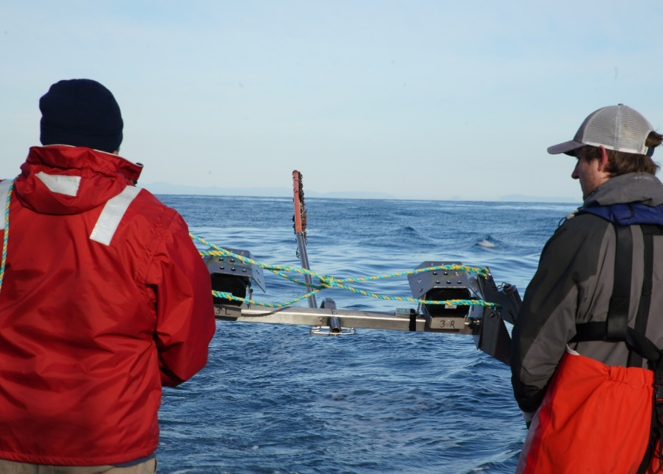

Commonwealth Environmental Impact Statement
Attachment III – Construction Underwater Noise Management Framework

Table of Contents
1 Introduction 1-1
1.1 Purpose 1-1
1.2 Scope 1-2
1.3 Objectives 1-2
2 EPBC Act obligations and OEI Act Management Plans 2-3
2.1 Environmental approvals 2-3
2.2 Interface between EPBC Act and the OEI Act 2-3
3 Monitoring and adaptive management framework 3-6
3.1 Environmental management system 3-6
3.2 Environmental outcomes 3-8
3.3 Adaptive management processes and performance criteria 3-9
4 Adaptive management procedures 4-13
4.1 Overview 4-13
4.2 Pre-construction adaptive management procedure 4-13
4.2.1 Overview 4-13
4.2.2 Modelling 4-16
4.2.3 Triggers for adaptive management 4-16
4.2.4 Adaptive management measures 4-16
4.2.5 Statement of effectiveness 4-17
4.3 In-field noise verification adaptive management procedure 4-17
4.3.1 Overview 4-17
4.3.2 Triggers for adaptive management 4-20
4.3.3 Adaptive management measures 4-20
4.3.4 Statement of effectiveness 4-20
4.4 Precaution zone management procedure – pile driving 4-21
4.4.1 Overview 4-21
4.4.2 Pre-start up surveillance 4-25
4.4.3 Soft starts and ramp up 4-25
4.4.4 Continuous surveillance 4-25
4.4.5 Stop Work Procedure 4-26
4.4.6 Night and Low Visibility Conditions Procedure 4-26
4.4.7 Greater abundance of key species triggers 4-27
4.4.8 Adaptive management measures 4-27
4.4.9 Statement of effectiveness 4-28
4.5 Precaution Zone Management Procedure – dynamic positioning vessels operating in the Southern Right Whale reproductive biologically important area 4-28
4.5.1 Overview 4-28
4.5.2 Pre start up marine fauna surveillance 4-30
4.5.3 Continuous surveillance 4-30
4.5.4 Vessel management responses 4-30
4.5.5 Adaptive management triggers 4-30
4.5.6 Southern Right Whales persist in the reproductive biologically important area - adaptive management 4-31
4.5.7 Statement of effectiveness 4-31
4.6 Offsets for significant residual impacts 4-32
5 Marine fauna detection platforms 5-33
5.1 Marine fauna observers 5-33
5.1.1 Overview 5-33
5.2 Passive acoustic monitoring 5-36
5.2.1 Overview 5-36
5.3 Infrared imaging 5-37
5.3.1 Overview 5-37
5.3.2 Training 5-37
6 Roles and responsibilities 6-38
7 Reporting and record keeping 7-39
7.1 Internal reporting and record keeping 7-39
7.1.1 Marine fauna reporting 7-39
7.1.2 Incident reporting 7-40
7.2 External reporting and compliance reporting 7-40
7.2.1 Notifiable and recordable incidents 7-40
7.2.2 Compliance reporting 7-40
8 Audit and review cycle 8-41

Figures
Figure 2-1 Interface between the EPBC Act and OEI Act - Source Guideline - Environmental management regulation for offshore renewables (N-04403-GL2231) 2-5
Figure 3-1 The project's environmental management system process 3-7
Figure 3-2 Outline of the hierarchy of documents to be developed and implemented to ensure the environmental outcomes for underwater noise management are met 3-8
Figure 4-1 Monitoring and adaptive management framework – Pre-construction modelling 4-15
Figure 4-2 Monitoring and adaptive management procedure for infield noise verification 4-19
Figure 4-3 Precaution zones (pile driving) for marine fauna showing a larger precaution zone for endangered whales and a relatively smaller precaution zone for small fauna groups such as turtles, pinnipeds and dolphins. 4-23
Figure 4-4 Monitoring and adaptive management procedure for pile driving operations 4-24
Figure 4-5 Monitoring and adaptive management procedure for vessel operations within the Southern Right Whale reproduction biologically important area between the months of May and September 4-29
Figure 5-1 Example of the position of scout vessels to provide surveillance across a specific observation zone for the Wind Project Training 5-34
Figure 5-2 Example of the position of scout vessels and passive acoustic monitoring instruments to provide surveillance across a specific observation zone for the South Fork Wind project designed to detect marine mammals and turtles 5-35

Tables
Table 3-1 Environmental outcomes for construction underwater noise management 3-9
Table 3-2 Overview of adaptive management processes and performance criteria 3-11
Table 4-1 Options to be considered in response to triggering performance criteria of the pre-construction modelling procedure 4-17
Table 4-2 Adaptive management options based on in-field noise verification results 4-20
Table 4-3 Noise effects criteria used to inform the precaution zones for pile driving for relevant taxa 4-22
Table 4-4 Noise effects criteria used to inform the precaution zones for installation vessels on dynamic positioning for Southern Right Whale and Blue Whale 4-28
Table 4-5 The scope of potential offsets to be detailed in an offsets plan should this be required 4-32
Table 6-1 Key roles and responsibilities 6-38

Attachment III – Construction Underwater Noise Management Framework

Introduction

Purpose
The purpose of the Construction Underwater Noise Management Framework is to outline the underwater noise monitoring and management measures that will be implemented during the construction phase of the Star of the South Offshore Wind Farm Project (the project). It is designed to reduce the impacts and risks of the project to an acceptable level and achieve environmental outcomes in accordance with the assessment criteria described in Technical Report D – Marine Mammals and Turtles and the relevant regulatory requirements.
This Construction Underwater Noise Management Framework is not intended to document the marine fauna management and monitoring requirements at the level of detail needed for operations and implementation. Rather, it provides the governance framework for detailed monitoring and management plans and operational procedures that will be developed once the final project design parameters are determined. This framework integrates with the project’s Environmental Management Framework (EIS, Chapter 23), and proposed Environmental Management System and Compliance Plan.
Consistent with requirements set out in the project's Environmental Protection and Biodiversity Conservation Act 1999 (EPBC Act) Environmental Impact Statement (EIS) assessment guidelines, the purpose of the Construction Underwater Noise Management Framework is to detail:
              - adequate monitoring regimes and defined trigger levels that will prompt further management and/or remediation actions to prevent unacceptable impacts to protected matters occurring
              - the management strategies that will be implemented if mitigation and management measures are insufficient and/or ineffective.
              - who is responsible for such measures and the extent of their responsibility.
The framework also outlines the interface between EPBC Act obligations and Offshore Electricity Infrastructure Act 2021 (OEI Act) management plan requirements.

Scope
This Construction Underwater Noise Management Framework is specific to underwater noise management and applies to marine mammals and marine turtles and to the project’s construction phase (pile driving and vessel activities).
The presence, distribution, abundance and behaviour of the cetacean, pinniped and marine turtle species found within the project area and surrounds are described in the Technical Report D – Marine Mammals and Turtles.
The technical report provides detail on the environment that may be affected along with a robust evaluation of environmental impacts and risks to protected marine fauna from underwater noise. These predictions of environmental impact from underwater noise have informed the design of the monitoring and management measures outlined in this Construction Underwater Noise Management Framework. Adaptive management for impact and risk pathways other than underwater noise are not within the scope of this framework.
The Construction Underwater Noise Management Framework outlines a high-level monitoring and management framework only and the detailed management procedures needed to manage underwater noise to meet environmental outcomes for the project will be developed once detailed project design has been completed and the zones of potential impact are refined. As such, detailed marine fauna management procedures are subsidiary documents and are outside the scope of this document.

Objectives
The objectives of this monitoring and adaptive management framework are:
- Describe the high-level monitoring and adaptive management measures necessary to protect marine mammals and turtles from the potential impacts of underwater noise generated by the project and ensure environmental outcomes are met
- Describe the high-level adaptive management procedures required to validate the effectiveness of mitigation measures to inform the need for adaptive management responses
- Outline roles and responsibilities that are key to the successful implementation of this framework
- Provide a high-level overview of the audit, monitoring and review processes that will be in place to assure compliance with the underwater noise environmental management requirements of the project.

EPBC Act obligations and OEI Act Management Plans

Environmental approvals
A delegate for the Commonwealth Minister for the Environment determined that the project has the potential to have significant impact on the environment (as set out in notice dated 2nd June 2020) and is required to be assessed under the EPBC Act. The action was determined to have potential significant impacts on the following matters of national environmental significance:
- Listed threatened species and communities
- Listed migratory species
- The environment in Commonwealth marine areas.
This Construction Underwater Noise Management Framework is written to meet the objectives and environmental protection outcomes of the EPBC Act.

Interface between EPBC Act and the OEI Act
Section 115(1)(c) of the OEI Act creates a link between the EPBC Act and OEI Act frameworks (Figure 2-1). This link establishes how the licence holder must comply with obligations under the EPBC Act including approval conditions and management requirements resulting from assessments of controlled actions under the EPBC Act.
The OEI Act regulations require a management plan to describe the measures that will be implemented to comply with the EPBC Act obligations. These measures must be described in the OEI Act management plan in sufficient detail to enable compliance monitoring and verification. An EPBC Act obligation in relation to the project is likely to be in the form of approval conditions arising from the Part 9 assessment under the EPBC Act and assessment of the EIS. Conditions may be outcomes based, prescriptive, administrative or systems based. The OEI Act management plan must describe approval requirements and demonstrate how they will be met. Specifically, the management plan will need to describe how the licence holder will implement, monitor, audit and record compliance with the relevant EPBC Act obligations and identify and manage non-conformance in a timely manner.
The offshore electricity infrastructure regime allows the Offshore Infrastructure Regulator (OIR) to monitor the licence holder’s performance in implementing the measures set out in an OEI Act management plan to address EPBC Act obligations. It provides for continuous improvement over time by enabling new information or technologies to be adopted. The ongoing monitoring and assurance measures set out in an OEI management plan together with regulator inspections will ensure ongoing compliance with EPBC Act obligations designed to ensure that project impacts continue to be managed to acceptable levels.
This Construction Underwater Noise Management Framework sets out the environmental management measures to manage underwater noise impacts on marine mammals and turtles. These are likely to become ‘obligations’ that can be further detailed in the OEI management plan in a manner that is enforceable and can be monitored for compliance.
Following the final definition of the project and prior to construction, the necessary detailed Marine Mammals and Turtles Monitoring and Management Plan will be developed to meet EPBC Act obligations. The Marine Mammals and Turtles Monitoring and Management Plan is likely to become an ‘action plan’ imposed through approval conditions that will need to be developed to the satisfaction of the Department of Climate Change, Energy Environment and Water (DCCEEW).

Figure 2-1 Interface between the EPBC Act and OEI Act - Source Guideline - Environmental management regulation for offshore renewables (N-04403-GL2231)
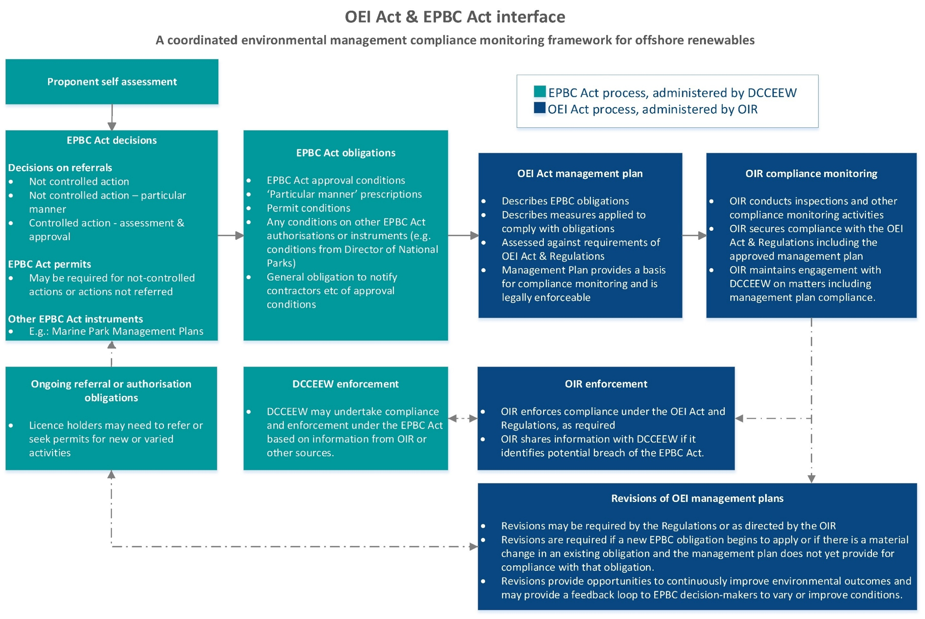

Monitoring and adaptive management framework

Environmental management system
During construction, operation and decommissioning, the project's environmental management system provides a structured approach to environmental management in line with ISO 14001:2015. It provides the framework for ensuring management measures are incorporated into a system that facilitates compliance monitoring and continuous improvement for environmental performance. This is done through the plan, do, check, act process that includes developing and implementing management measures, compliance and performance monitoring, corrective action and management review (Figure 3-1). In relation to underwater noise management during construction, the following elements will be integrated into the environmental management system:
- Environmental approval requirements
- Environmental outcomes
- Performance criteria
- Process for managing compliance (compliance plan)
- Preventative control measures
- Monitoring requirements
- Adaptive management triggers and response measures
- Review and improvement.
The detailed control measures that will be developed as part of this Construction Underwater Noise Management Framework will be incorporated into the project's environmental management system, as the Marine Mammals and Turtles Monitoring and Management Plan.

Figure 3-1 The project's environmental management system process
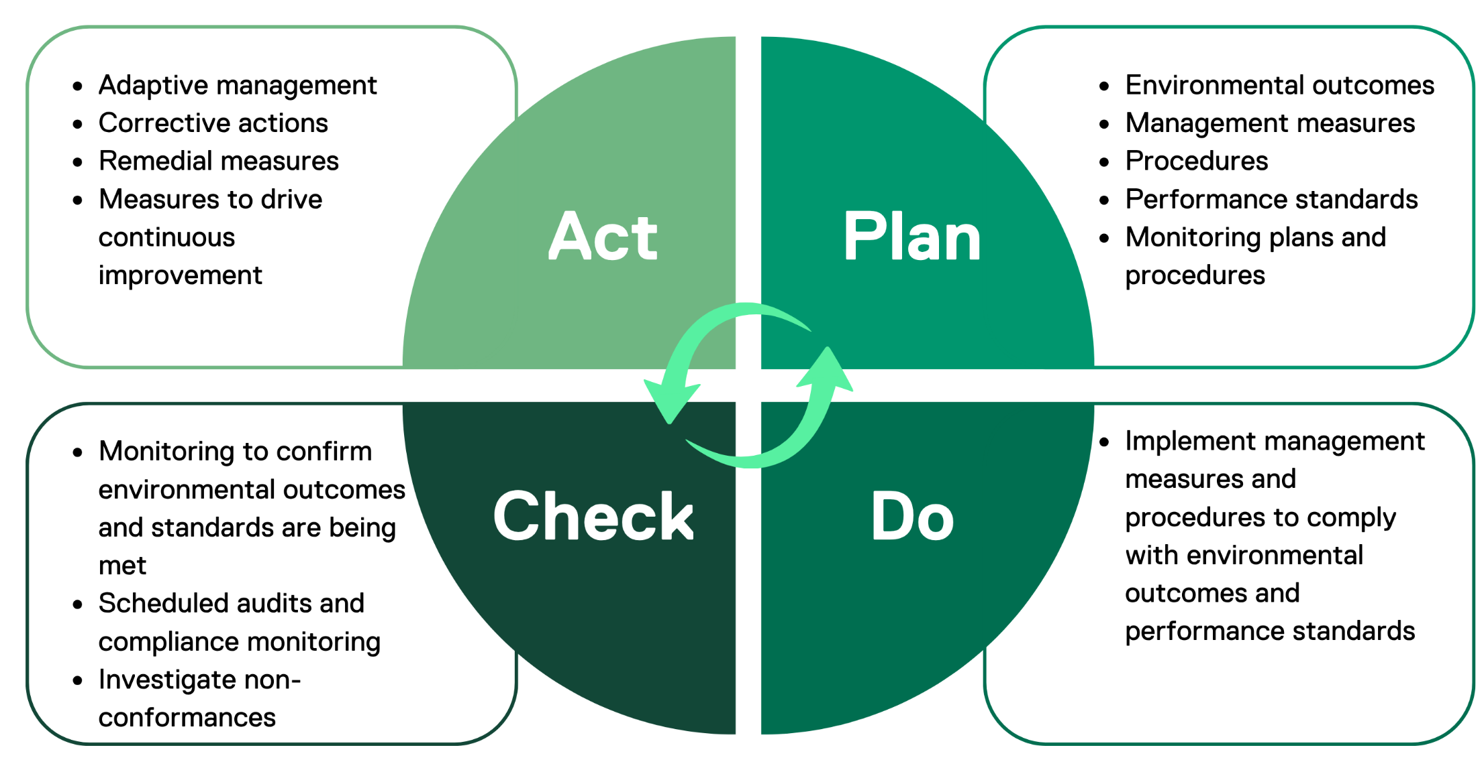
This Construction Underwater Noise Management Framework provides a high-level overview of the monitoring and management approach for underwater noise impacts on marine fauna.
Once the final project design is complete and prior to construction, additional subsidiary documentation will be developed. This includes a detailed Marine Mammals and Turtles Monitoring and Management Plan detailing operational procedures to be used by personnel responsible for implementing management requirements. Figure 3-2 outlines the proposed structure of documentation.
The final plan produced prior to construction will have regard to any best practice guidance on managing underwater noise and defined underwater noise thresholds currently being drafted by the Department of Climate Change, Energy, Environment and Water.

Figure 3-2 Outline of the hierarchy of documents to be developed and implemented to ensure the environmental outcomes for underwater noise management are met

A The detailed Marine Mammals and Turtles Monitoring and Management Plan will be developed prior to the OEI Act management plan submission. It will be a key management measure in the OEI management plan and able to be inspected by the OIR prior to construction.
Further details on the project Environmental Management Framework can be found in Chapter 23 – Commonwealth Environmental Management Framework. This document details the governance framework for managing the environmental effects of the project and includes accountabilities for the implementation of management plans during construction, operation and decommissioning of the project.

Environmental outcomes
Environmental outcomes set the level of environmental performance that must be met to achieve the acceptable level of impact. They must be clear, measurable and achievable. The environmental outcomes for this management framework are drawn from the assessment criteria (refer to Technical Report D – Marine Mammals and Turtles), relevant statutory instruments such as threatened species recovery plans and have been established to prevent significant residual impacts on marine mammals and turtles (Table 3-1).
The environmental outcomes reflect an acceptable level of environmental performance that is demonstrated to be appropriate through the environmental impact assessment process. The environmental outcomes for construction underwater noise impacts on marine fauna are provided in Table 3-1 (also found in Technical Report D – Marine Mammals and Turtles). They are the outcomes to be met through the monitoring and adaptive management processes in procedures documented in this framework document.
Table 3-1 Environmental outcomes for construction underwater noise management
Environmental outcomes
EO 2 - No significant loss of or adverse effects on important migratory, foraging or breeding habitat or a decrease in the availability or quality of habitat to the extent that a population is likely to decline for marine mammal or turtle species during all stages of the project.
EO 4 – Anthropogenic noise will be managed such that:
- Any Blue Whale continues to use biologically important areas without injury and is not displaced from a foraging area
- It does not prevent any Southern Right Whale from using biologically important areas or habitat critical to the survival of a species or cause auditory impairment.
- Actions within and adjacent to Southern Right Whale biologically important areas or habitat critical to survival are undertaken such that the risk of behavioural disturbance is demonstrably minimised.

Adaptive management processes and performance criteria
Adaptive management procedures have been developed to determine when additional or revised management measures are required during project implementation, in response to monitoring and other new information. This is important for ensuring environmental outcomes for underwater noise impacts continue to be achieved.
For the project, adaptive management measures include the use of predictive noise modelling and noise level verification activities to inform decisions on the size of precaution zones and the level of marine mammal surveillance effort required to allow effective detection over the entirety of the defined precaution zones. Management measures may also be adapted in response to results of marine fauna monitoring to ensure management measures account for the actual behaviour and distribution of species observed in the precaution zones.
Performance criteria are the statements of performance of the adaptive management process that must be met to demonstrate effectiveness in achieving the environmental outcome. Performance criteria that relate to each adaptive management procedure are provided in Table 3-2.
Performance criteria must be clear, measurable and time specific to enable the environmental management of the project to be monitored, evaluated, reviewed and improved. Performance criteria can be revised based on new information such as new science, noise abatement technologies, monitoring results, regulatory requirements and guidance.
Several key considerations apply to demonstrating a conservative and effective approach and to assist with interpretation and implementation of this management framework.
- The procedures detailed within this framework have been developed to manage impacts primarily associated with construction activities. Detailed operations and decommissioning plans will be developed prior to project commissioning and detailed in OEI Act management plans. Future operational and decommissioning marine fauna management plans will be subject to the learnings from the construction phase and will be developed to ensure environmental outcomes are met.
- Precaution zones and applicable noise effect thresholds for different fauna groups (Table 4-3 and Table 4-4) will be finalised prior to the commencement of construction and will be informed by pre-construction modelling (see Figure 4-3). Refinements to precaution zones will be made, if required, pending the results of in situ noise verification measurements.
- As a precautionary measure, the same conservative management measures will be applied to all detected Southern Right Whale, regardless of whether they are sighted as individuals or cow-calf pairs.
- Where a large whale cannot be positively identified but may be a listed endangered species based on the advice of the marine fauna observers, it will be assumed that the whale is a Southern Right Whale or Blue Whale and the management procedures for these species will apply.
- Detailed operational plans will be developed to enable seamless implementation and be used as the basis of inductions and training for vessel crew, marine fauna observation and passive acoustic monitoring operators.
- Detailed procedures will be developed to demonstrate how precaution zones will be adequately surveyed and to ensure that sufficient marine fauna detection effort is applied to inform management responses. This will be developed as part of the Marine Mammals and Turtles Monitoring and Management Plan which will be in place prior to the commencement of construction activities.
Table 3-2 Overview of adaptive management processes and performance criteria
Adaptive management measures | Performance criteria | Compliance records
Post-approval, preconstruction underwater noise modelling and adaptive management procedure (Section 4.2) | Prior to the commencement of construction activities:  - Underwater noise modelling is undertaken to predict the zones of effect from underwater noise generating activities using final project definition parameters.  - A precaution zone management procedure is developed prior to construction activities in response to modelling results to ensure:  - Precaution zones for relevant fauna groups are refined based on the noise modelling results and relevant threshold limits and guidelines at the time of modelling  - Marine fauna surveillance measures will continuously and effectively detect marine fauna within precaution zones.  - Modelling results provide an accurate basis for determining the exclusion zone distance required between pile driving operations and the Southern Right Whale reproductive biologically important area boundary to ensure received noise level is equal to or less than 140 dB SPL (M-weighted) between May to September, or Australian regulation or guideline criteria if applicable. | - Modelling results / modelling report  - Final detailed project design  - Detailed precaution zone management procedure  - Southern Right Whale reproductive biologically important area pile driving exclusion zone procedure.
In-field noise verification procedure (Section 4.3) | For a series of representative pile installation locations early in the installation phase (within 3 months from commencement of the first pile installation):  - Precaution zone sizes are refined based on measured noise levels early in the construction phase  - Pile driving exclusion distance from the Southern Right Whale reproductive biologically important area boundary is refined based on measured noise levels to ensure received noise level is equal to or less than 140 dB SPL between May to September or Australian regulation or guideline criteria if applicable.  - Sufficient marine fauna detection effort for revised precaution zones confirmed through the Marine Fauna Monitoring Plan  - In field noise verification undertaken by appropriately qualified and experienced personnel. | - In field noise measurement report  - Refined precaution zone management procedure (if required)  - Records demonstrating analysis of sufficient detection effort across the precaution zone  - Marine Mammals and Turtles Monitoring and Management Plan  - Southern Right Whale reproductive biologically important area pile driving exclusion zone procedure.
Precaution zone management procedure – pile driving (Section 4.4) | For the duration of pile driving activities:  - The precaution zone will be continuously and effectively monitored to detect marine fauna  - Management actions to be implemented in a timely manner as required by the operational procedures  - Marine fauna observation operators to be appropriately qualified and experienced  - Passive acoustic monitoring operators to be appropriately qualified and experienced  - Passive acoustic monitoring equipment is suitable to detect all relevant vocalising species and estimate their range from the noise source subject to development of a detailed Marine Mammals and Turtles Monitoring and Management Plan. | - Precaution zone management procedure  - Marine fauna observation logs  - Vessel logs  - Compliance monitoring reports  - Decision records for adaptive management
Precaution zone management procedure – dynamic positioning vessels operating in the Southern Right Whale reproductive biologically important area (Section 4.5) | For the duration of vessel installation activities:  - The precaution zone will be continuously and effectively monitored to detect marine fauna  - Management actions to be implemented in a timely manner as required by the procedure  - Marine fauna observation operators to be appropriately qualified and experienced | - Precaution zone management procedure  - Marine fauna observation logs  - Vessel logs  - Compliance monitoring reports  - Detailed monitoring plan  - Decision records for adaptive management

Adaptive management procedures

Overview
This section provides the high-level monitoring and management processes that will form the basis for the detailed Marine Mammals and Turtles Monitoring and Management Plan and operational procedures which will be developed prior to construction once final project design parameters are determined. These measures will ensure environmental outcomes will be met and provide for continuous improvement by allowing the adoption of best technologies available at the time of construction. The OEI Act management plan will outline each management measure and require the integration of processes, practices and procedures into the project management system to ensure effective implementation to meet EPBC Act obligations.

Pre-construction adaptive management procedure

Overview
Pre-construction modelling will be undertaken based on detailed final designs of the foundations, selection of vessels, and use of best available noise abatement systems. Prior to the completion of geotechnical investigations and given the rapid evolution of noise abatement system technologies, it is prudent to defer final modelling until project conditions and latest available technologies are confirmed and the most effective outcomes can be achieved. The final design will consider the mitigation hierarchy and project outcomes during the development of the detailed design, before undertaking specific modelling. The foundation design completed to date seeks to adapt proven offshore wind technologies to local conditions while avoiding and minimising significant risks of harm to the environment, so far as reasonably practical (Chapter 3 - Project Development, Appendix A - Foundation Options Assessment). At present the parameters used in the modelling for the environmental impact assessment are detailed in the Technical Report D – Marine Mammals and Turtles.
The purpose of this pre-construction adaptive management procedure is to model the noise effect ranges using final project design parameters including pile locations, installation techniques, adopted noise abatement system, hammer energy, pile specifications and more accurate geotechnical data. The modelling results will be used to confirm the size of the precaution zones that will be monitored using appropriate marine fauna detection techniques (see Section 5) and to trigger management action to reduce sound exposure when fauna are detected.
These zones will be designed to prevent auditory impairment and behavioural disturbance to Blue Whale and Southern Right Whale and minimise the risk of hearing impairment in other species. An effective marine fauna surveillance regime will need to be in place for the precaution zones (see Section 4.4).
The pre-construction adaptive management process provides confidence that the defined environmental outcomes for marine mammals and turtles will be met, including more protective outcomes for listed endangered species. In particular, the procedure will include a focus on ensuring Blue Whales can continue to use biologically important areas without injury and will not be displaced from a foraging area.
Further, preconstruction noise modelling will be used to refine management measures to ensure noise levels at the boundary of the Southern Right Whale reproductive biologically important area will be equal to or less than 140dB SPL (M-weighted), or Australian regulation or guideline criteria if applicable, during the reproduction season. This measure will provide confidence that underwater noise will not prevent any Southern Right Whale from using biologically important areas or habitat critical to the survival or cause auditory impairment (either temporary threshold shift or permanent threshold shift) consistent with the environmental outcomes for this species.
Figure 4-1 provides an overview of the pre-construction adaptive management procedure including the decision criteria and adaptive management approach needed to ensure environmental outcomes and corresponding performance criteria are met.

Figure 4-1 Monitoring and adaptive management framework – Pre-construction modelling
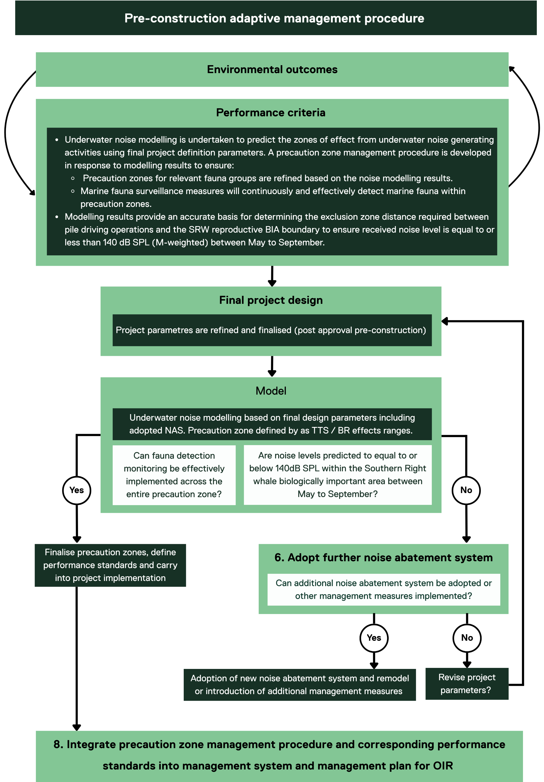

Modelling
Pre-construction underwater noise modelling will be undertaken using a rigorous and scientifically robust process using experienced underwater noise third party providers. Source levels used will be reliable and a model will be selected that is able to predict effects ranges for species based on best practice underwater noise effects criteria. Site specific geotechnical data will be used to inform the geo-acoustic properties and model assumptions and limitations will be transparently documented.
Mobile receptor modelling results will be used to inform the precaution zone management procedure and set the spatial extent of the precaution zones for both pile driving and installation vessel operations (see Sections 4.4 and 4.5 respectively). Model results will also be used to provide confidence that pile driving will be managed such that noise levels associated with the final project parameters do not exceed 140dB SPL (M-weighted), or Australian regulation or guideline criteria if applicable, at the boundary of the Southern Right Whale reproductive biologically important area during May to September, consistent with the performance criteria.

Triggers for adaptive management
The following adaptive management triggers will be used to determine whether adaptive management is required prior to the commencement of construction:
- The precaution zone derived from pre-construction modelling cannot be realistically and effectively monitored to provide a high level of confidence that marine fauna will be detected across the extent of the zone
- Noise levels generated by inshore pile driving operations are predicted to be higher than 140dB SPL (M-weighted), or Australian regulation or guideline criteria if applicable, between May to September in the Southern Right Whale reproductive biologically important area.

Adaptive management measures
If one or both of the adaptive management triggers are met, the actions in Table 4-1 will be evaluated and adopted, and a revised assessment will be undertaken to demonstrate that environmental outcomes can be met. Adaptive management options Star of the South will consider include examples provided in Table 4-1.

Table 4-1 Options to be considered in response to triggering performance criteria of the pre-construction modelling procedure
Project design and scheduling parameters | Noise abatement systems
- Revisit foundation design including pile diameter  - Consider timing and scheduling of piling closest to Southern Right Whale reproductive biologically important area outside of reproductive season (May to September)  - Reduce hammer energy | - Alternative pile hammers that reduce the peak noise level  - Additional noise mitigation technologies available at the time  - Additional bubble curtains  - Sound dampers and resonators that can be installed around the source (for example, hydrosound dampener)

Statement of effectiveness
These measures will be effective as they will provide contemporary and reliable modelling results informed by final project design parameters. Modelling results will enable the mitigation hierarchy to be applied if the adaptive management triggers are met, providing confidence that corrective action can be taken prior to construction to ensure environmental outcomes are achieved. Where additional noise abatement systems are adopted or the project parameters are refined, repeat modelling will take place to confirm that performance criteria can be met. This procedure provides a pre-construction safety net which can be inspected and reviewed by regulators prior to the commencement of construction.

In-field noise verification adaptive management procedure

Overview
The purpose of the in-field noise verification procedure is to validate model outputs and confirm that the noise levels / zones of effect correspond appropriately to the precaution zone defined in the pre-construction phase. It enables decisions to be made to reduce or increase precaution zone size based on results and identifies when additional mitigation measures, such as further noise abatement systems, may be required.
Noise level verification will take place on a representative number of pile driving locations (approximately 4 to 6) based on geo-acoustic properties, pile design and water depth. Additional noise level verification sites can be adopted should noise verification studies indicate significant underpredictions from modelled predictions.
Noise measurements will be in accordance with ISO 18406:2017 Underwater acoustics — Measurement of radiated underwater sound from percussive pile driving. This standard outlines the methodologies, procedures and measurement systems for assessing radiated underwater noise generated during percussive pile driving. This standard will be used to develop a detailed in-field measurement survey design including hydrophone placement, distance from the source for near and far field measurements, hydrophone validation, sampling rate, data processing and metrics.
Details of the infield noise verification study will be included in the Marine Mammals and Turtles Monitoring and Management Plan developed prior to construction. Figure 4-2 provides an overview of the in-field noise verification adaptive management procedure including the decision criteria and adaptive management approach needed to ensure environmental outcomes and corresponding performance criteria will be met.

Figure 4-2 Monitoring and adaptive management procedure for infield noise verification
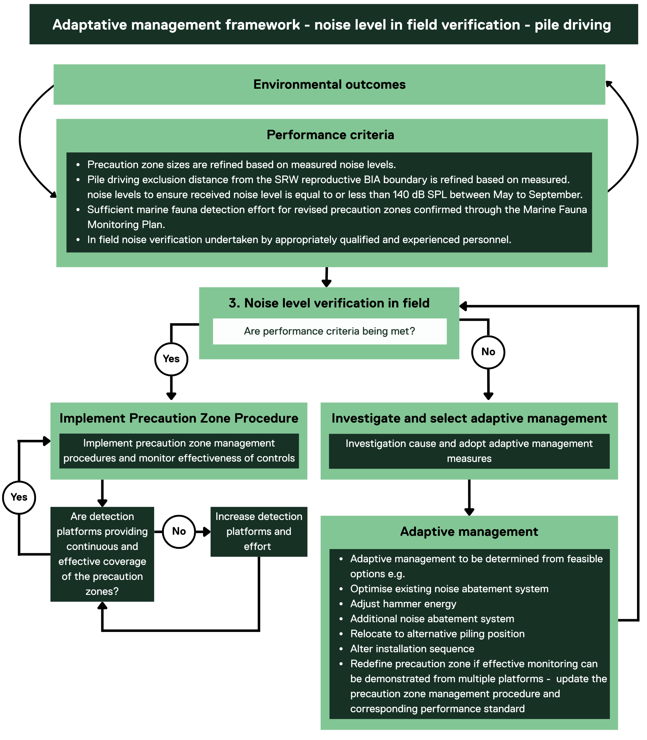

Triggers for adaptive management
In-field noise measurements will determine whether adaptive management is required. The triggers for adaptive management are:
- Noise levels at the precaution zone boundary are significantly higher than the relevant noise effect thresholds (Table 4-3)
- Noise levels generated by inshore pile driving operations exceed 140 dB SPL, or Australian regulation or guideline criteria if applicable, at the Southern Right Whale reproductive biologically important area boundary between May to September.

Adaptive management measures
If one or both adaptive management triggers are reached, adaptive management options in Table 4-2 must be considered and adopted.
Table 4-2 Adaptive management options based on in-field noise verification results
Engineering | Administrative
- Optimise existing noise abatement system through modifications (adjust water volume in modified hammer, managing air flow, optimising bubble curtain geometry and spacing between curtains, bubble curtain maintenance through installation campaign, vessel handling and compressor management)  - Adjust hammer energy  - Consider additional noise abatement system s that have been deemed feasible in the pre-construction phase | - Refine precaution zone based on the in-situ measurements so that the precaution zone minimises the risk of temporary threshold shift and behavioural disturbance.  - Consider timing and scheduling of piling closest to Southern Right Whale reproductive biologically important area outside of reproductive season (May to September)

Statement of effectiveness
This measure will ensure precaution zone sizes are appropriate through targeted noise measurements at representative piling locations and that the noise abatement system is effective. Ensuring that noise levels do not exceed 140 dB SPL (M-weighted), or Australian regulation or guideline criteria if applicable, at the boundary of the Southern Right Whale reproductive biologically important area is considered highly effective as this is a conservative noise effects threshold that provides a high level of confidence that noise levels will not cause behavioural disturbance to Southern Right Whale in the habitat critical to survival for this species.
The noise abatement systems available as contingency measures would be those evaluated during the environmental impact assessment process and the pre-construction phase and have been deemed technically feasible.
The adaptive management measures will be selected based on specific circumstances of the site, the infield noise measurements and the feasible options. The revised precaution zone option can only be used if there is adequate justification and evidence that the revised zone can be effectively monitored through suitable detection platforms and methods. If the precaution zones cannot be effectively monitored, the size cannot be increased and alternative adaptive management measures will need to be adopted to reduce received noise levels and precaution zone sizes to an area that can be realistically and effectively monitored.

Precaution zone management procedure – pile driving

Overview
The purpose of the precaution zone management procedure is to ensure there is effective monitoring and management over the area within which auditory impairment for marine fauna may occur in relation to pile driving. Specific zones will be defined based on pre-construction modelling (see Section 4.2) and refined based on in-field noise verification results (see Section 4.3). Table 4-3 defines the criteria for precaution zones based on animal sensitivity and noise effects criteria. It is understood that the Australian Government is currently developing guidelines for underwater noise. The noise effects criteria will be updated to align with these guidelines if they are applicable to the project.

Table 4-3 Noise effects criteria used to inform the precaution zones for pile driving for relevant taxa
Taxa | Noise effects criteria | Justification
Blue Whale and Southern Right Whale | Pile driving - 168 SEL24h (dB re 1 μPa².s (temporary threshold shift) or Australian regulation or guideline criteria if applicable. | Recognises the increased sensitivity of Blue Whale and Southern Right Whale to underwater noise impacts given overlap with biologically important areas for important life stages and conservation status.
All other whales | 183 SEL24h (dB re 1 μPa².s) (permanent threshold shift) or Australian regulation or guideline criteria if applicable. | Prevents injury and permanent hearing impairment and reduces risk of temporary threshold shift by preventing close range exposure for non-endangered whales that will be moving through the area and thus limiting their exposure to cumulative noise. Given the animals are likely to be moving through the area, any temporary threshold shift effects are likely to be recoverable.
Pinnipeds | 185 SEL24h (permanent threshold shift) or 100m radius – whichever is larger or Australian regulation or guideline criteria if applicable. | Pinnipeds are a higher frequency fauna group and most pile driving energy is below their hearing range.  There are practical limitations for detecting pinnipeds at sea due to small size and precaution zones have accounted for this limitation.  Precaution zones are designed to prevent permanent hearing impairment and minimise the risk of temporary threshold shift and behavioural response.
Dolphins | 201 SEL24h (dB re 1 μPa².s) (permanent threshold shift) or 100m radius – whichever is larger or Australian regulation or guideline criteria if applicable. | Dolphins are a higher frequency fauna group and most pile driving energy is below their hearing range.  There are practical limitations for detecting dolphins at sea due to small size and precaution zones have accounted for this limitation.  Precaution zones are designed to prevent permanent hearing impairment and minimise the risk of temporary threshold shift and behavioural response.
Marine turtles | 204 SEL24h (dB re 1 μPa².s) (permanent threshold shift) or 100m radius – whichever is larger or Australian regulation or guideline criteria if applicable. | Prevents noise exposure at permanent hearing impairment thresholds.  Practical limitations for detecting them at sea due to small size  No biologically important areas identified. Animals exposed to noise are highly likely to be transient and move through the area.

Figure 4-3 Precaution zones (pile driving) for marine fauna showing a larger precaution zone for endangered whales and a relatively smaller precaution zone for small fauna groups such as turtles, pinnipeds and dolphins.
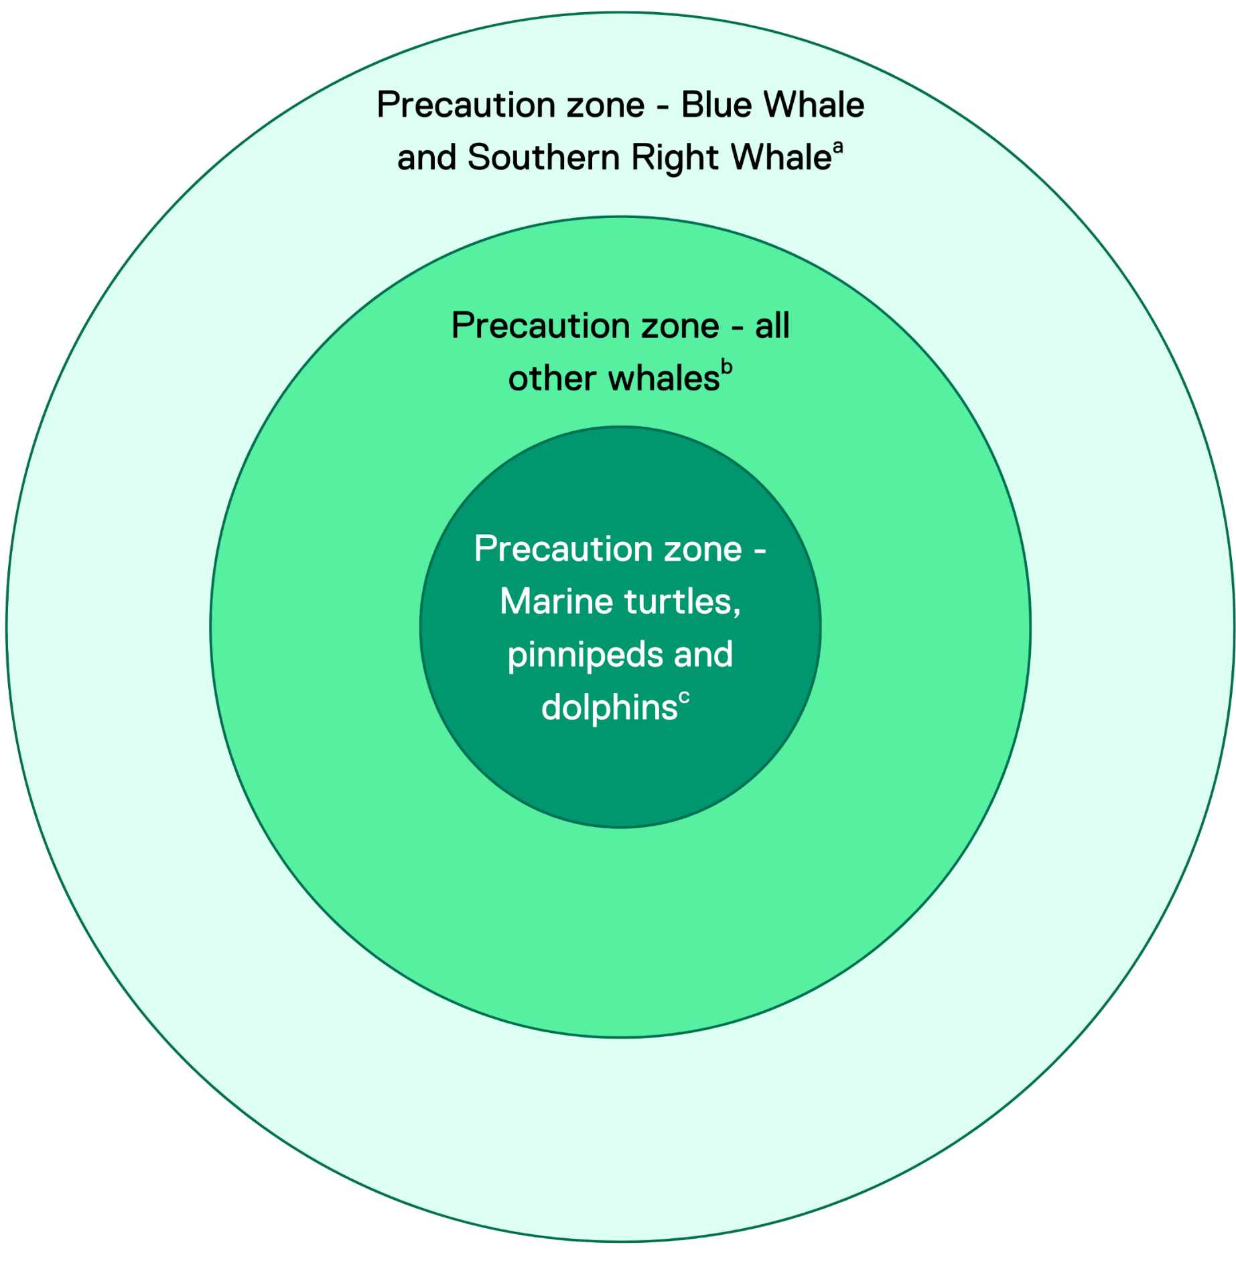
a: Final zone size will be determined based on temporary threshold shift effect range from pre-construction modelling (pile driving) or Australian regulation or guideline criteria if applicable.
b: Final zone size will be determined by permanent threshold shift effect range from pre-construction modelling (cumulative) or Australian regulation or guideline criteria if applicable.
c: Final zone size will be determined by permanent threshold shift effect range from pre-construction modelling (cumulative) or 100 m, whichever is greatest or Australian regulation or guideline criteria if applicable.

Figure 4-4 Monitoring and adaptive management procedure for pile driving operations
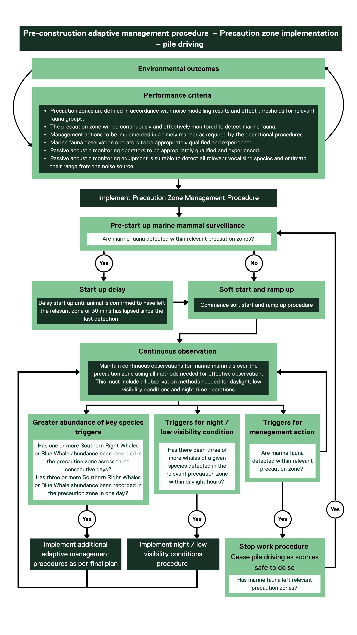

Pre-start up surveillance
A 30 minute pre-startup marine fauna surveillance period will apply to the precaution zones (Figure 4-4) before the commencement of the soft start procedure at each piling location with sufficient trained and experienced marine fauna observation operators to ensure coverage of the precaution zones and supplemented by a passive acoustic monitoring array (see section 5.2).
Surveillance must be undertaken by dedicated and trained marine fauna observers and passive acoustic monitoring operators. During the pre-start up surveillance period marine fauna observation and passive acoustic monitoring operators must maintain reliable surveillance across the entire precaution zone (for example, 360 degrees). If relevant marine fauna are detected within the precaution zones, soft start procedures will not commence until the animal has been confirmed to have moved outside the precaution zone or 30 minutes have lapsed since the last sighting. A pre-startup surveillance operational procedure will be developed prior to construction.

Soft starts and ramp up
The project will implement soft start and ramp-up of hammer energy measures at the commencement of each impact pile driving activity for both monopile and jacket pile foundations during the construction phase. The soft start will involve the implementation of lower hammer energies at the beginning of the piling sequence before the energy input applied by the hammer is ‘ramped up’ (increased) over time to the level required to safely and efficiently drive the pile to target depth.
Soft start and ramping up of energy during piling are aimed at discouraging marine mammals and turtles from remaining in close proximity to the noise source and reduce the number of individuals potentially occurring within auditory impairment ranges. Each piling event would commence with a minimum of 10 minutes at 10 per cent of the maximum hammer energy, followed by a gradual ramp-up for at least 20 minutes up to 80 per cent of the maximum hammer energy for all pile driving activities. A detailed soft start operational procedure will be developed prior to construction.

Continuous surveillance
During pile driving operations, continuous marine fauna surveillance is required across the precaution zones to determine whether the ‘Stop Work’ procedure (Section 4.4.5) or additional management measures are required.
The precaution zones will be under continuous surveillance (visual and acoustic) during all pile driving operations (low power and full operations). The size of the precaution zones will be refined in response to pre-construction noise modelling and in-field noise verification around representative piling locations. Multiple detection platforms will be employed where necessary to ensure full coverage of the precaution zones and reliable detection of marine mammals to inform management decisions in accordance with the precaution zone management procedure. A detailed Marine Mammals and Turtles Monitoring and Management Plan will be developed to plan detection effort, resources and detection coverage of precaution zones.
If piling is paused for operational reasons, marine fauna observations will continue and if marine fauna are detected within respective precaution zones, re-commencement is to take place in line with the soft start procedure.
If marine fauna within the scope of this procedure are observed within the precaution zone, the Stop Work Procedure will to be implemented.

Stop Work Procedure
If marine fauna are detected within the relevant precaution zone (Table 4-3) for each species, pile driving should cease or hammer energy reduced to the lowest feasible level when safe to do so.
The pile driving operation must not resume until the animal has moved out of the precaution zone or has not been sighted for 30 minutes. Following this, operations may resume following the stop work procedure that will be developed prior to construction.

Night and Low Visibility Conditions Procedure
If three or more whales are detected within the relevant precaution zone (Table 4-3) on any day initiating a shutdown event, piling activities will cease (as soon as safe to do so) during non-daylight hours. Piling can recommence in daylight hours the following day and night operations can continue that night as long as less than three shutdown events are observed during daylight hours. This measure sets out a clear trigger to cease night operations when effective night / low visibility monitoring is not available or validated, and listed endangered whale species have been detected during the preceding day or good visibility conditions. There may be times where piling has commenced during the day and it is not safe to immediately cease piling at sunset, when this trigger has been met. In this event, piling will cease as soon as safe to do so. A night and low visibility operational procedure will be developed prior to construction

Greater abundance of key species triggers
Triggers for additional management measures are proposed for observations of repeated or greater abundances of key species, to adapt and initiate further controls.
The following adaptive management triggers will be in place during construction and installation of turbine foundations, these will be further refined during the development of the final plan:
- One or more Southern Right Whales or Blue Whale abundance recorded in the precaution zone across three consecutive days
- Three or more Southern Right Whales or Blue Whale abundance recorded in the precaution zone in one day
These triggers will initiate additional adaptive management measures such as the examples provided in the Section below.

Adaptive management measures
Additional adaptive management measures during pile driving operations may be required to ensure environmental outcomes continue to be met and will be further developed in the final plan. Example options for additional measures include:
- Larger precaution zones that can be realistically managed
- Long range surveys
- Increased observation platforms and/or methods
- Increased marine fauna observations
- Additional noise abatement systems
- Marine Coordination Centre notifications to all project vessels on the presence of identified Southern Right Whales or Blue Whale
- Noise abatement system modifications.

Statement of effectiveness
The Precaution Zone - Pile Driving Procedure is designed to ensure that impacts on marine mammals and turtles are managed to minimise the risk of acoustic impairment and biologically significant disturbance. This will be achieved by collecting robust data prior to construction to inform updated modelling (Section 4.2), and during construction (section 4.3), to refine the precaution zones to ensure effectiveness for all fauna groups. Marine fauna detection efforts will also be scaled up when needed to ensure reliable detection and mitigation.
Adaptive management triggers and adaptive management measures mean that the project will be continuously reviewed and that new or modified management measures can be adopted to ensure environmental outcomes are met.

Precaution Zone Management Procedure – dynamic positioning vessels operating in the Southern Right Whale reproductive biologically important area

Overview
For dynamic positioning vessels operating within the Southern Right Whale reproductive biologically important area between the months of May and September, the Precaution Zone Management Procedure (Figure 4-5) will be applied. The exact size of the precaution zone will be defined using applicable noise thresholds during the implementation of the pre-construction modelling procedure (Section 4.2). To avoid doubt, this procedure applies to the construction phase, for vessels operating on dynamic positioning in the Southern Right Whale reproductive biologically important area (May to September).
Table 4-4 Noise effects criteria used to inform the precaution zones for installation vessels on dynamic positioning for Southern Right Whale and Blue Whale
Taxa | Noise effects criteria | Justification
Blue Whale and Southern Right Whale | Installation vessels on dynamic positioning – distances to be informed by applicable noise thresholds. | Vessel activities managed to prevent the disruption of biologically important behaviours in the Southern Right Whale reproductive biologically important area. Applicable noise thresholds to be determined prior to construction and applied in reproductive Southern Right Whale biologically important area if Southern Right Whale are present.

Figure 4-5 Monitoring and adaptive management procedure for vessel operations within the Southern Right Whale reproduction biologically important area between the months of May and September
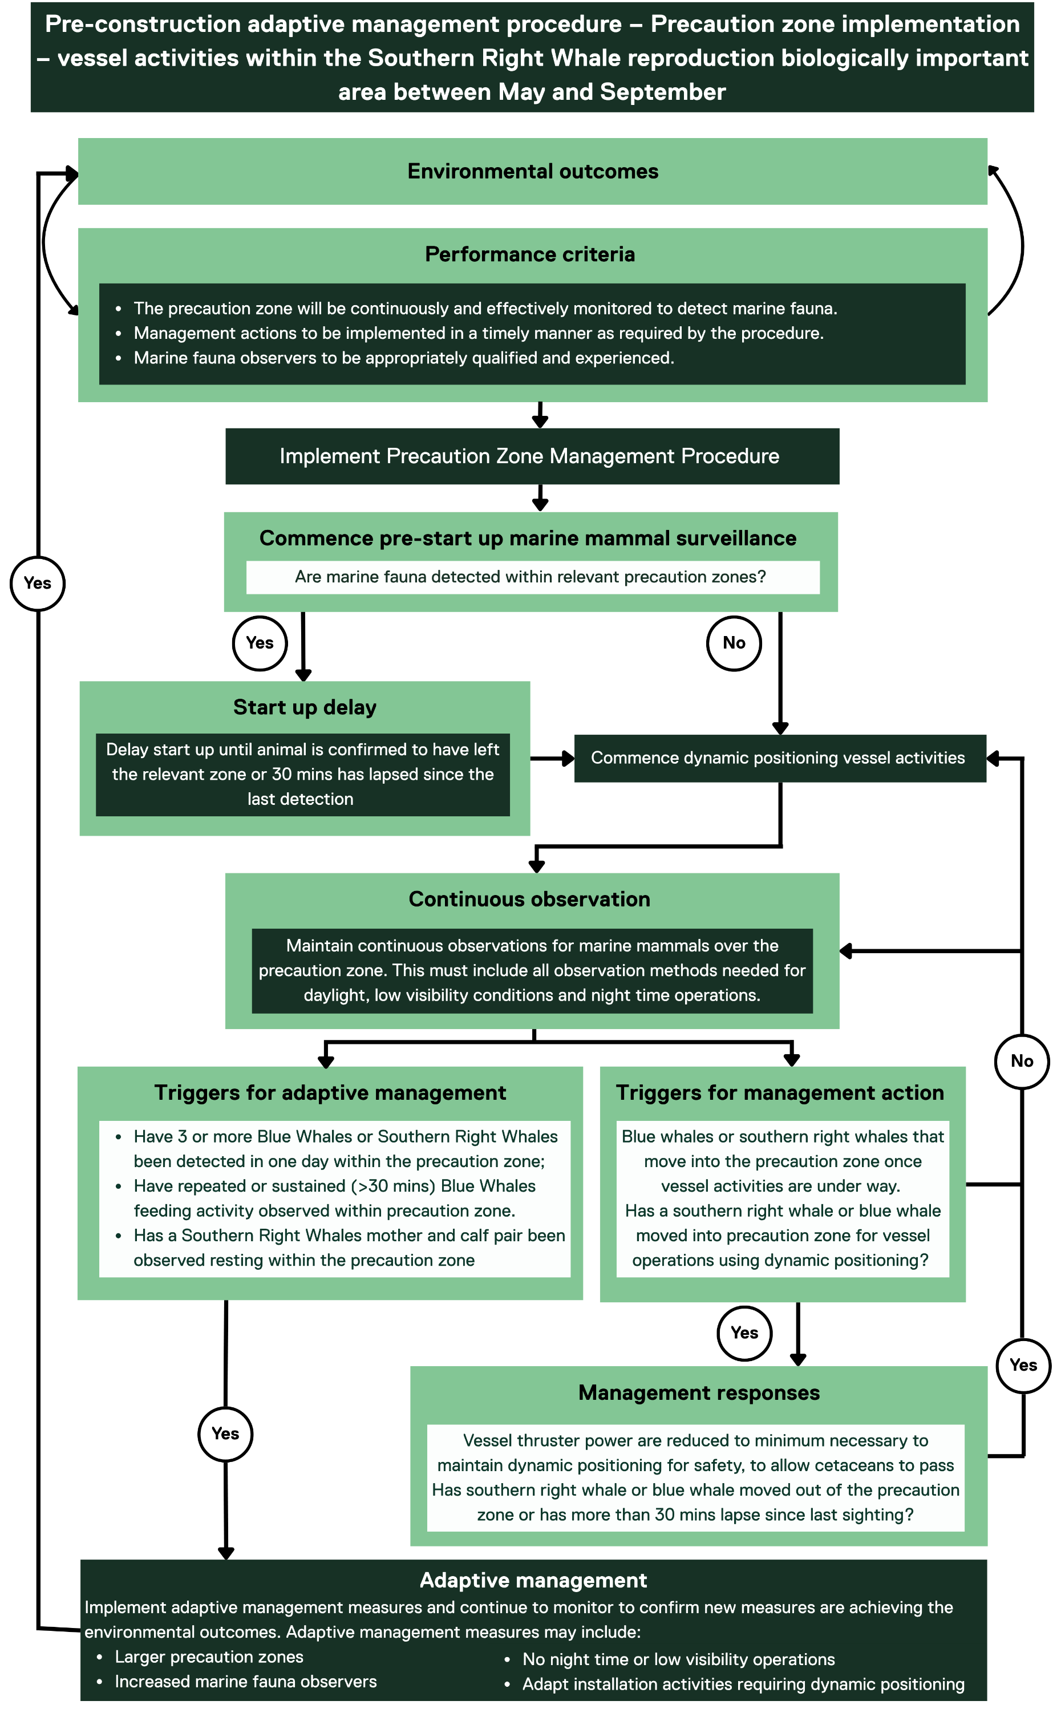

Pre start up marine fauna surveillance
A pre-start marine fauna surveillance period will apply to the precaution zone for Southern Right Whale and Blue Whale before the commencement of dynamically positioned vessel operation associated with wind farm construction (such as cable installations) within the Southern Right Whale reproductive biologically important area.
Surveillance must be undertaken by dedicated and trained marine fauna observers. During the pre-start up surveillance period marine fauna observation operators must maintain reliable surveillance across the entire precaution zone (for example, 360 degrees). If a marine mammal is detected within the precaution zones, the dynamic positioning vessel activity will not commence until the animal has been confirmed to have moved outside the precaution zone or 30 minutes has lapsed since the last sighting.

Continuous surveillance
During vessel activities continuous surveillance will be made over the precaution zone whilst under dynamic positioning within the Southern Right Whale reproductive biologically important area to determine whether management actions are required. This surveillance will be undertaken to provide confidence that marine mammals can be detected within the precaution zone.

Vessel management responses
If a Southern Right Whale or Blue Whale is detected within the precaution zone during vessel operations using dynamic positioning, the following action will take place:
- Vessel thruster power is reduced to minimum necessary to maintain dynamic positioning for safety to allow cetaceans to pass, when it is safe to do so
- Alert the Marine Coordination Centre that a Southern Right Whale or Blue Whale has been identified, so that this can be notified to other project vessels operating in the offshore project area.
Once the Southern Right Whale or Blue Whale is confirmed to have moved outside the precaution zone, or more than 30 minutes has lapsed since the last sighting, normal dynamic positioning operations can recommence.

Adaptive management triggers
Adaptive management triggers for vessel operations on dynamic positioning as per Figure 4-5 are:
- Three or more Blue Whale or Southern Right Whale been detected in one day within the precaution zone
- Repeated or sustained (more than 30 minutes) Blue Whale feeding activity is observed by qualified marine fauna observation operators within or adjacent to the precaution zone for blue whales
- A Southern Right Whale mother and calf pair are observed resting by qualified marine fauna observation operators within or adjacent to the construction precaution zone for Southern Right Whale.

Southern Right Whales persist in the reproductive biologically important area - adaptive management
Adaptive management measures in response to the marine fauna observations will be subject to an evaluation and may include:
- Larger precaution zones
- Increased marine fauna observers on vessels
- No low visibility operations
- Adapt installation activities requiring dynamic positioning.

Statement of effectiveness
The vessel management procedure is effective as it ensures that vessel operations will not commence if Southern Right Whale or Blue Whale are in the precaution zones therefore preventing auditory impairment and substantially reducing the risk of biologically significant behavioural disturbance.
If a Southern Right Whale or Blue Whale enters the precaution zone while vessel activities are underway, thruster power will be reduced to minimum safe levels to maintain dynamic positioning allowing for the cetaceans to pass, when safe to do so, before returning to normal dynamic positioning operations.
Adaptive management triggers and responses will ensure that the impacts and management measures are continuously reviewed and improved to provide ongoing assurance that environmental outcomes will be met.

Offsets for significant residual impacts
The exceedance of an environmental outcome signifies that significant residual impacts may have been realised. Offsets for significant residual impacts are required once all other mitigation options in accordance with the mitigation hierarchy are exhausted.
In line with Department of Climate Change, Energy, Environment and Water's Environmental Offsets Policy, offsets will be developed to deliver an overall conservation outcome that improves or maintains the viability of the aspect of the environment that is protected by national environment law and affected by the proposed action. At present, significant residual impacts are not predicted and therefore a detailed offsets program has not been developed.
In the event that offsets are required, it is most likely these will be required for Blue Whales or Southern Right Whales based on conservation status and the highest potential risk of significant residual impacts. As such, if offsets are required, they will be developed to address potential significant residual impacts from biologically significant disturbance and will focus on compensatory measures that assist in implementing key aspects of the statutory recovery plans for these species. Examples of measures to be considered in an offset strategy are outlined in Table 4-5.
Table 4-5 The scope of potential offsets to be detailed in an offsets plan should this be required
Species | Recovery plan aspect | Example of offsets
Blue Whales | Action Area B.2 Investigating population structure  Action Are B.3 Describing spatial and temporal distribution and defining biologically important areas  Action Area A2 Assessing and addressing anthropogenic noise | Contribution to the development of cost-effective methods to determine population abundance and trends for the pygmy and Antarctic Blue whale subspecies.  Contribution to research on the substructure within Antarctic Blue whales.  Contribution to research on further identification and refinement of biologically important areas for breeding and foraging and migratory pathways between breeding and feeding grounds  Contribution to research into the impacts of anthropogenic noise on Blue Whales during foraging
Southern Right Whales | Action Area A3 - Understand impacts of climate variability and anthropogenic climate change on the species biology and population recovery  Action Area A5 – Assess, manage and mitigate impacts of anthropogenic underwater noise | Contribution to research to understand the effects of anthropogenic climate change on environmental conditions, including the impacts on prey availability in high latitude foraging areas and links with Southern Right Whale foraging ecology, health, and population demographics (reproductive success).  Contribution to research to improve understanding and characterisation of marine soundscapes, including the application of new technologies for data processing, within Southern Right Whale biologically important areas to facilitate quantification of anthropogenic noise in the marine soundscape.

Marine fauna detection platforms
For each of the management procedures in Section 4, there will need to be sufficient marine mammal detection effort potentially across multiple platforms to reliably detect animals across the full extent of the precaution zones. This section provides a high-level overview of the key considerations for ensuring effective and sufficient marine mammal surveillance.

Marine fauna observers

Overview
Marine fauna observers are responsible for observing / detecting marine mammals and other marine fauna within designated precaution zones. Marine fauna observers scan the surface of the ocean searching for marine mammal cues, such as respirations (a blow), body parts (dorsal fin, back on the surface), splashes and other indications of disturbance (footprint left on the surface after the marine mammal submerges).
Visual observation platforms can be in many different forms such as in the air e.g. planes, on land or from a vessel (installation and scout vessels). In recent years unmanned aerial vehicles have also been used for surveying and monitoring marine mammals. Traditional visual monitoring methods are restricted to daylight hours, and often limited by weather conditions such as sea state, fog and glare. To allow for monitoring at night and in poor weather conditions, passive acoustic monitoring is often used and infrared imaging is increasing in its application. Marine fauna observers will take photos where possible to record species identifications. Visual and passive acoustic monitoring approaches are well understood to provide best results when used together.
Marine fauna observers will be deployed across potentially multiple visual observation platforms including the installation vessels, bubble curtain vessels and scout vessels to enable effective surveillance across the precaution zones. During operations pile driving there will be two marine fauna observers at a minimum on the installation vessel and, where required, a minimum of one dedicated marine fauna observer on other observation platforms at strategic vantage points to provide full coverage of the precaution zones.
To manage fatigue, marine fauna observers will not be required to complete more than 12 hours of observations per day, exceed four consecutive watch hours on duty and should typically have a sufficient break between watches or work shifts.
Figure 5-2 provides an example of the positioning of marine fauna observers and passive acoustic monitoring detection devices for the South Fork Windfarm off the coast of New York in the United States. This project provides a good comparison as the marine fauna observation and passive acoustic monitoring detection was required for similar species (Northern Right Whales) and in a similar oceanic environment to the project. A detailed surveillance plan will be designed following pre-construction modelling (see Section 4.2) and refined following in field noise verification (see Section 4.3).
Figure 5-1 Example of the position of scout vessels to provide surveillance across a specific observation zone for the Wind Project Training
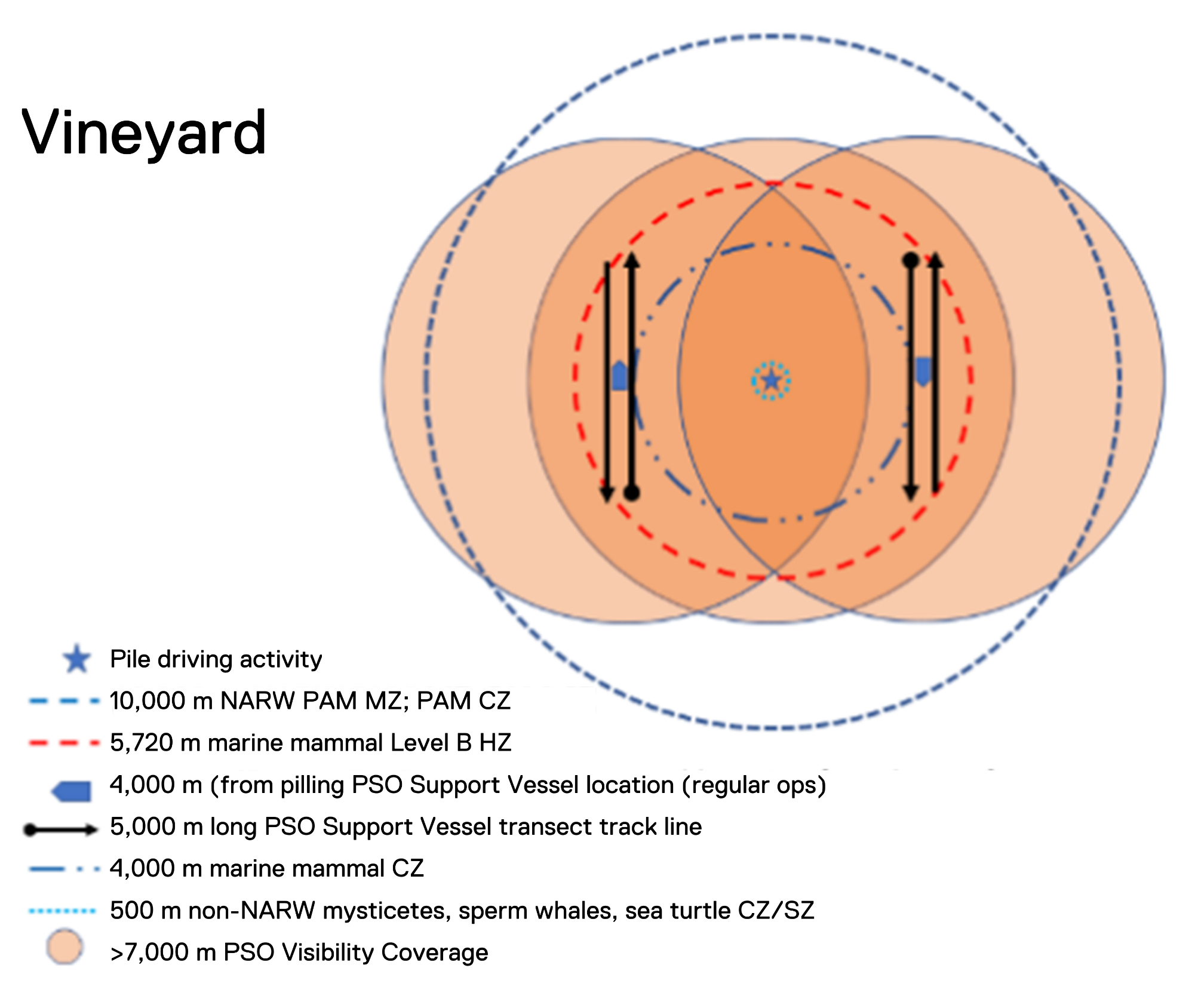

Figure 5-2 Example of the position of scout vessels and passive acoustic monitoring instruments to provide surveillance across a specific observation zone for the South Fork Wind project designed to detect marine mammals and turtles
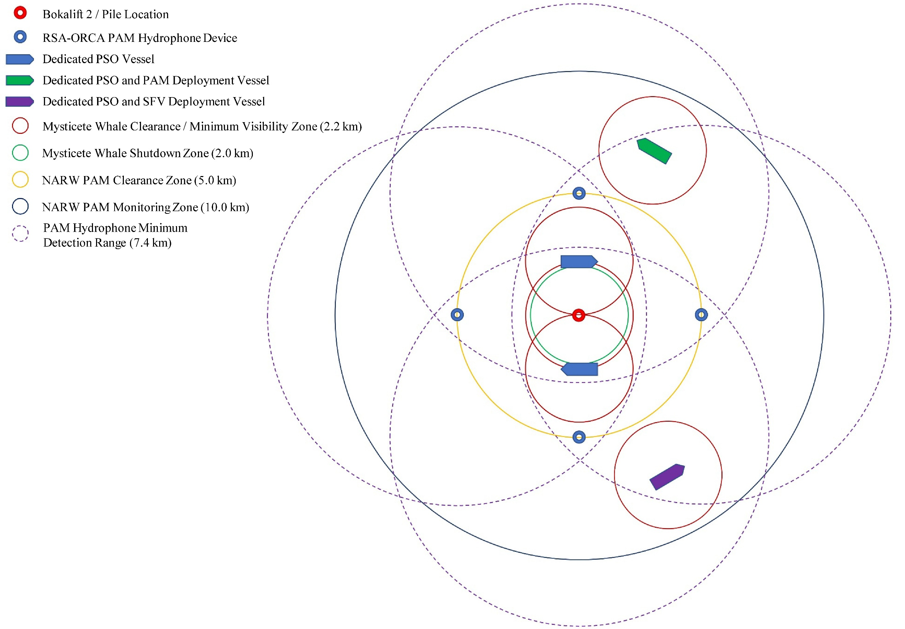

Passive acoustic monitoring

Overview
Passive acoustic monitoring is a non-invasive technique used to detect vocally active marine mammals for the purpose of informing mitigation measures. This method can complement visual surveys by extending detection capabilities beyond daylight hours and through poor visibility conditions.
Visual and passive acoustic monitoring are frequently used in combination to enhance the likelihood of detecting marine fauna, particularly during offshore activities. When passive acoustic monitoring is used alongside visual observation, it is essential to establish clear communication protocols between passive acoustic monitoring and marine fauna observers to ensure effective coordination and data sharing.
Traditional passive acoustic monitoring systems involve fixed, moored underwater recorders that must be recovered for data analysis, offering insights into long-term trends in species distribution. More recently, advances in technology have enabled data transmission directly from underwater devices to onshore receivers, removing the need for equipment retrieval and allowing for more timely analysis.
Fixed systems such as direct cabling and moored buoys operate similarly to traditional passive acoustic monitoring setups, with species detection constrained to the vicinity of the recorder. In contrast, mobile platforms like ocean gliders offer broader spatial coverage, moving through the water to detect species across a wider area. Due to their versatility, ocean gliders may be well suited to the needs of the project.
In the United States, agencies such as the Bureau of Ocean Energy Management and the National Oceanic and Atmospheric Administration have established minimum standards for the use of passive acoustic monitoring systems in offshore wind energy development. These guidelines will inform the design and implementation of the passive acoustic monitoring surveillance procedure that will work in conjunction with the precaution zone management procedure, unless more appropriate Australian guidelines are issued. This detailed marine fauna surveillance plan will be developed prior to the commencement of construction activities (see Section 4.2) and refined following the infield verification results (see Section 4.3).

Infrared imaging

Overview
Infrared imaging (thermal imaging) uses an electro-optical imaging sensor to detect temperature differences between the exhalation or body of a warm blooded marine mammal in contrast to the cold surface water of the ocean. Similar to other visual monitoring methods, detection is dependent on the animal surfacing. For whales, infrared imaging is best at detecting a blow or the blowhole of the exhaling animal (temperature difference ranging from 0.2 to 4.1 degrees relative to the surrounding environment), while detection of the body of the animal can be unreliable (temperature difference to surrounding environment ranging from 0.0 to 1.0 degrees).
Infrared systems can be mounted on a vessel or a plane. Rotating line scanners provide the greatest coverage of an area with a 360 degree field of view. When deployed on a vessel, rotating line scanners have successfully detected blows from large whales at distances of five to eight kilometres, and up to three to five kilometres for smaller cetaceans.
The potential inclusion of infrared technologies to be used in tandem with passive acoustic monitoring detections during non-daylight hours will be detailed in a Marine Mammal and Turtles Monitoring and Management Plan prior to the commencement of construction activities.

Training
Professional training in both infrared thermography and marine mammal monitoring will be a requirement for undertaking surveillance. Key training needs for the use and interpretation of infrared technologies include the ability to interpret marine mammal heat signatures in dynamic marine environments as well as proficient experience in camera operation and maintenance. It is likely that marine fauna observers will be trained in the use of these systems and the automated detection of mammals by scanning infrared cameras will supplement visual observations.

Roles and responsibilities
As part of the environmental management system for the project, clear roles and responsibilities will be assigned to key personnel who will have the mandate to ensure effective and proficient implementation of this framework prior to construction.
Roles will have clear accountabilities for individuals and teams and a training program will be in place to ensure all personnel understand communication lines within internal teams and with contractors. Key roles and responsibilities have been assigned to project staff in Table 6-1 below. These roles and responsibilities will be refined prior to construction once construction teams have been established, vessels have been contracted, marine fauna observers and passive acoustic monitoring operators have been contracted and the a Marine Mammal and Turtles Monitoring and Management Plan has been developed. Details of roles and responsibilities will also be required in the OEI Act management plan.
Table 6-1 Key roles and responsibilities
Role | Responsibility
Project Director | Accountable for implementation of this Marine Mammal and Turtles Monitoring and Management Plan.
Project Environment Lead | Responsible for the environmental compliance in relation to the regulatory approvals and Marine Mammals and Turtles Monitoring and Management Plan for the project. Ensuring it is adequately incorporated into the project environmental management system.
Vessel masters | Ensure all vessel crew and third-party contractors work in accordance with the Marine Mammals and Turtles Monitoring and Management Plan and subsidiary documentation, including fauna observation and recording requirements.
Marine fauna observers | Ensure adherence to the Marine Mammals and Turtles Monitoring and Management Plan, and responsible for monitoring the precaution zones for marine fauna and initiating management measures when triggers are met.
Passive acoustic monitoring operators | Ensure adherence to the Marine Mammals and Turtles Monitoring and Management Plan, and responsible for monitoring the passive acoustic data for the presence of vocalising marine fauna and initiating management measures when triggers are met.

Reporting and record keeping
The reporting arrangements cover two main purposes:
- Internal reporting and record keeping for effective implementation of this framework and subsidiary documents and management of incidents
- External reporting for incidents and compliance.

Internal reporting and record keeping

Marine fauna reporting
A daily report will be generated informed by inputs from the marine fauna observation and passive acoustic monitoring operator report that outlines any observations / detections, interactions and mitigation actions taken. The report will contain the following information as a minimum:
- Name, qualifications and experience of the marine fauna observation and passive acoustic monitoring operators on board
- The location, date and start time of works
- The location, times and reasons when observations were hampered by poor visibility or high winds
- The location, time and distance of any marine mammal or turtle sighting, including, where possible:
  - the species
  - the corresponding method of detection (visual or passive acoustic monitoring)
  - the number of individuals, including distinction between adults vs juveniles where possible
  - the behaviour observed, where possible
- The location and time of any Start-up Delay, Soft Start and Stop Work Procedures instigated as a result of marine mammal or turtle sightings
- Details of any incidents (notifiable and recordable) (Section 7)
- The location, date and time of completion of the works each day.

Incident reporting
The Project Environment Lead will be responsible for investigation of any incidents and ensuring appropriate internal reporting and records of any incidents are kept and maintained. Internal incident reporting will involve detailing records of both notifiable and recordable incidents. This will be detailed in the project Compliance Plan and integrated into the environmental management system. Details of incident reporting will be detailed in the OEI Act management plan.

External reporting and compliance reporting

Notifiable and recordable incidents
A licence holder must notify the Offshore Infrastructure Regulator of an incident as soon as practicable after the licence holder becomes aware that an event consistent with the types of incidents specified in Section 161 of the OEI Act regulations has occurred. Under the OEI Act regulations, events relevant to this framework that would constitute notifiable incidents are defined as:
- An incident that (i) arose in connection with the licence activities carried out in the Commonwealth offshore area; and (ii) resulted, or has the potential to result, in a contravention for the licence holder’s obligations under the Environment Protection and Biodiversity Conservation Act 1999.
In determining what events may constitute a notifiable incident, consideration will be given to the above definition in combination with the legislative requirements and guidance set out within relevant Acts, policies, procedures and systems. Detail of notifiable incidents will be included in the Compliance Plan, OEI Act management plan and incorporated into the project’s environmental management system.
Incident reports will be supplied to the Offshore Infrastructure Regulator in accordance with regulatory requirements.

Compliance reporting
Annual reports on the environmental performance of the project will be provided to the Department of Climate Change, Energy, Environment and Water and/or the Offshore Infrastructure Regulator as required. All compliance requirements will be detailed in the project’s Compliance Plan.
Details of notifiable and recordable incidents will be detailed in the OEI Act management plan.

Audit and review cycle
Environmental performance will be reviewed in several ways to ensure the project remains in accordance with the detailed Compliance Plan:
- Environmental outcomes, performance criteria and the requirements of the Marine Mammals and Turtles Monitoring and Management Plan and subsidiary documents are met
- Mitigation measures are effective in reducing the environmental impacts and risks of the activity to an acceptable level
- Any additional, or increased, impacts or risks are identified, evaluated and managed.
A pre-mobilisation audit will be undertaken prior to commencement of the project activities. The audit will consist of reviewing all management plans relevant to the project, including all environmental monitoring and management requirements.
This audit will incorporate assurance checks for training and awareness activities, responsibilities of those onboard relevant vessels, and activity specific induction. Any corrective actions required will be implemented and recorded prior to the commencement of construction activities.
An audit of the Marine Mammals and Turtles Monitoring and Management Plan will be carried out in accordance with the Environmental Management Framework (as detailed in Chapter 23 – Commonwealth Environmental Management Framework) following the commencement of project construction, with the purpose of assessing the implementation of the control measures and all requirements. It will evaluate the following:
- Compliance with all requirements detailed in the Marine Mammals and Turtles Monitoring and Management Plan
- Mitigation measures are in place and being implemented effectively
- Review of the performance criteria to be implemented against the environmental outcomes is being undertaken and has determined that they are effective, and the requirements are being met
- Monitoring commitments and recording are being undertaken as appropriate
- The roles and responsibilities of each personnel are suitable and being met, as demonstrated by operations which are carried out in compliance with the requirements of the Marine Mammals and Turtles Monitoring and Management Plan and that the provisions are up to date (contact details, etc.).
Throughout the construction period, smaller ‘sub-audits’ of the contents of the Marine Mammals and Turtles Monitoring and Management Plan will be carried out, as appropriate. Sub-audits will focus on the particular sections of the Marine Mammals and Turtles Monitoring and Management Plan relating to the sub-audit ‘trigger’ (such as, the implementation of adaptive management measures triggers an audit of adaptive management measures).
A post campaign review will be undertaken upon completion of project construction to review compliance against relevant environmental objectives and associated performance criteria and the requirements of the Marine Mammals and Turtles Monitoring and Management Plan. The findings of the post construction campaign review will inform the plans for subsequent project phases.
Findings and recommendations obtained through the auditing process will be distributed to the relevant parties in order to undertake the appropriate actions. If an audit relates to a topic that had previously been raised by a relevant person, an updated response will be prepared and provided to the relevant person.

