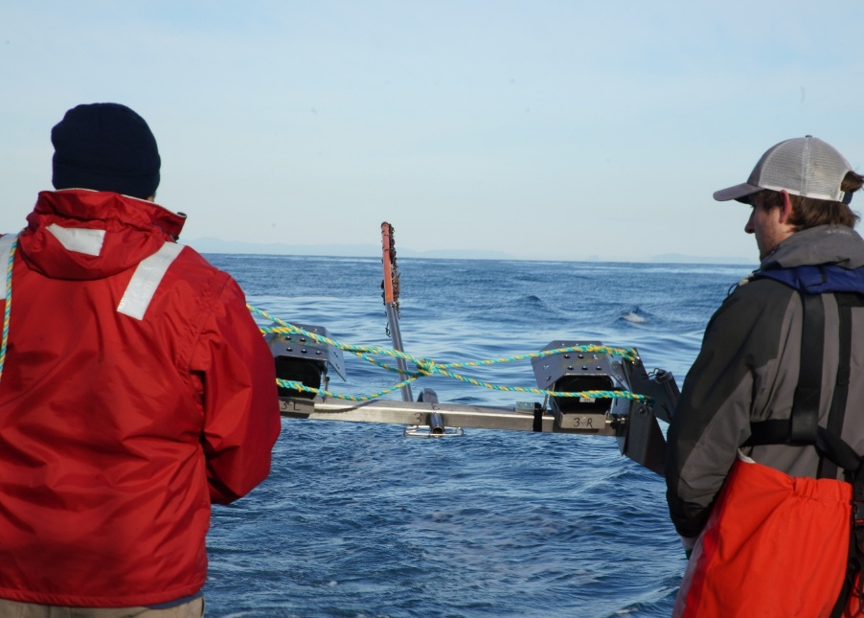

Commonwealth Environmental Impact Statement
Chapter 1 - Environmental Impact Statement introduction
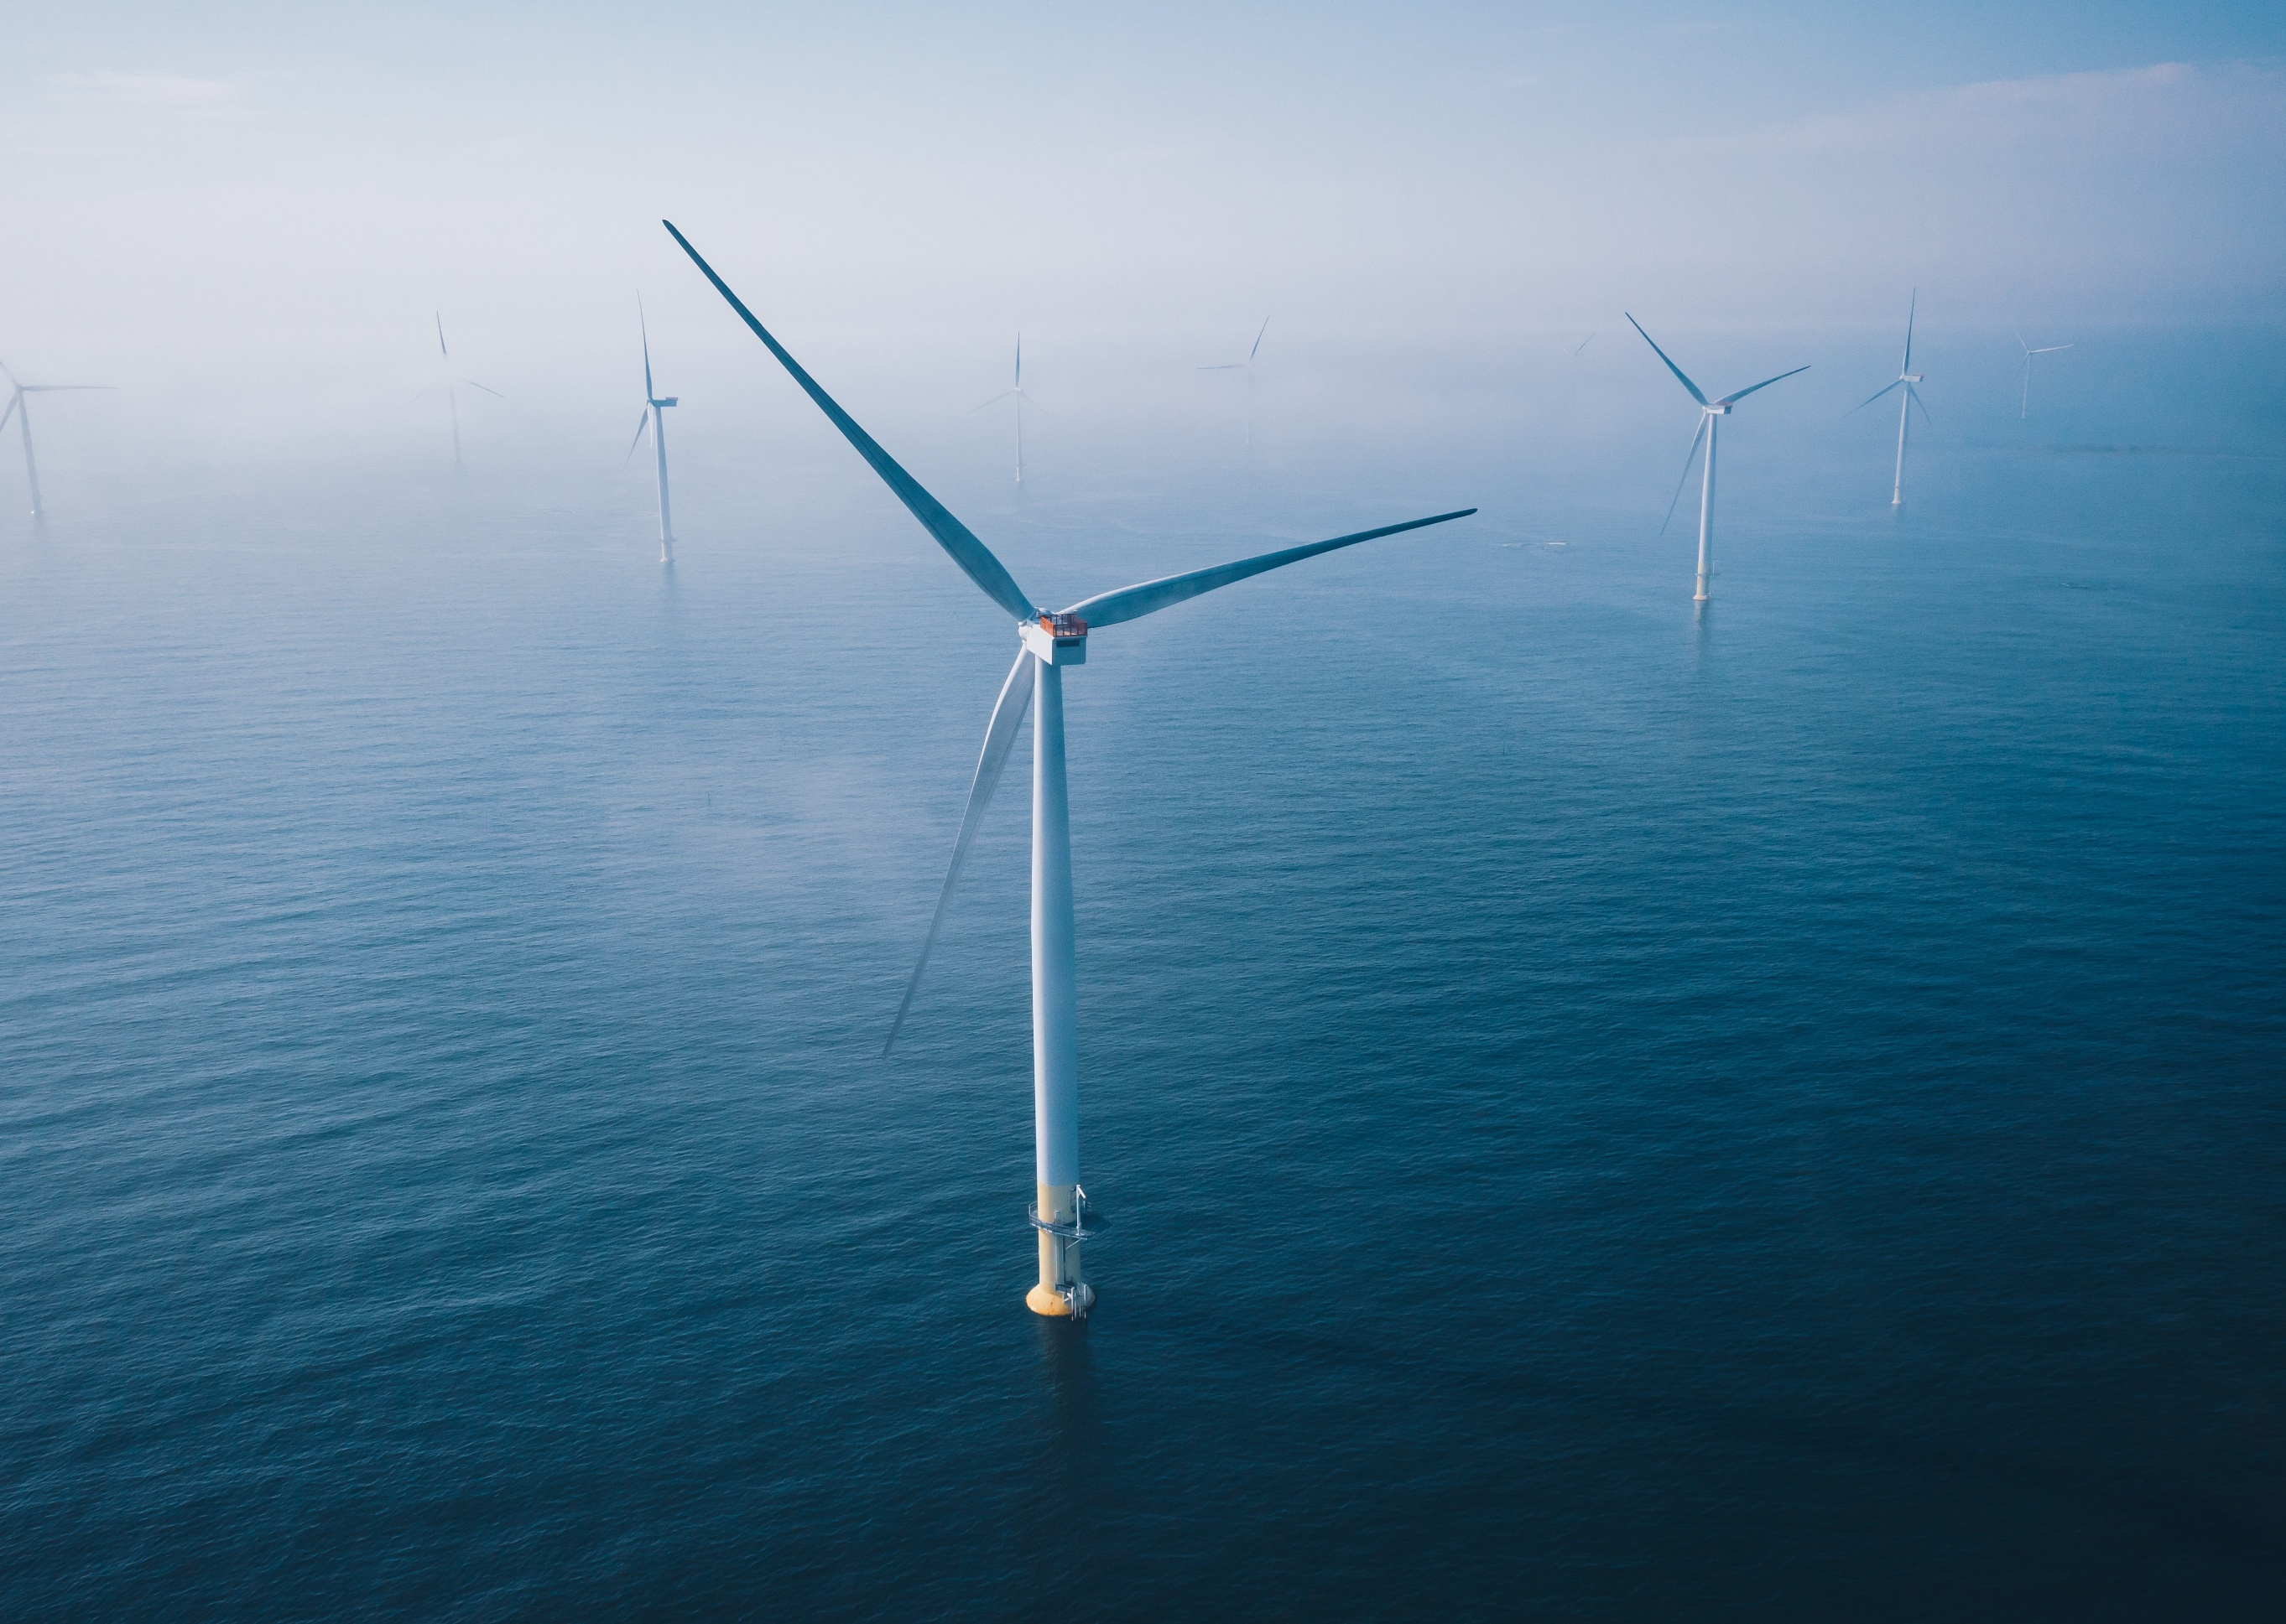
Table of Contents
Chapter 1 Environmental Impact Statement introduction 1-1
1.1 Project context 1-4
1.1.1 Background 1-4
1.1.2 Project objectives 1-5
1.1.3 Project development 1-6
1.2 Project overview 1-7
1.2.1 Offshore wind farm infrastructure 1-7
1.2.2 Offshore transmission infrastructure 1-7
1.2.3 Shore crossing infrastructure 1-7
1.2.4 Onshore transmission infrastructure 1-8
1.2.5 Ports 1-8
1.3 Project delivery 1-9
1.3.1 Proponent 1-9
1.3.2 Project timeline 1-9
1.3.3 Consultation 1-10
1.4 Assessment and approvals pathway 1-11
1.4.1 Requirement for an EIS 1-11
1.4.2 Role of the assessment 1-12
1.4.3 EIS guidelines 1-13
1.5 Assessment overview and mitigations 1-14
1.5.1 Assessment approach 1-14
1.5.2 Environmental Management Framework 1-14
1.6 Assessment structure 1-15

Figures
Figure 1-1 Project context 1-2
Figure 1-2 Project components 1-3
Figure 1-3 Offshore wind project timeline 1-10
Figure 1-4 Environmental impact assessment document structure 1-16

Tables
Table 1-1 EIS chapter descriptions 1-17

Environmental Impact Statement introduction
Star of the South Wind Farm Pty Ltd (ABN 71 623 105 091), as Trustee for the Star of the South Trust (ABN 68 239 717 297), (Star of the South) is the proponent for the Star of the South Offshore Wind Farm Project (the project), Australia’s most advanced offshore wind farm. The project is located in Commonwealth waters off the coast of Gippsland, as shown in Figure 1-1, and will connect to the electricity network via the proposed VicGrid connection hub in Giffard. For further details on the project's components, refer to Section 1.2.
The project represents a significant opportunity to diversify Australia's energy resources. As Australia’s ageing coal fleet retires, new sources of power are needed to address the anticipated gap in electricity generation. The project will address this gap, by harnessing Bass Strait’s strong, consistent winds and delivering significant amounts of clean, reliable power to the grid starting in 2032. With a capacity of up to 2.2 gigawatts (GW), the project can meet approximately 20 per cent of Victoria’s current electricity demand, enough to power around 1.2 million homes annually.

Figure 1-1 Project context
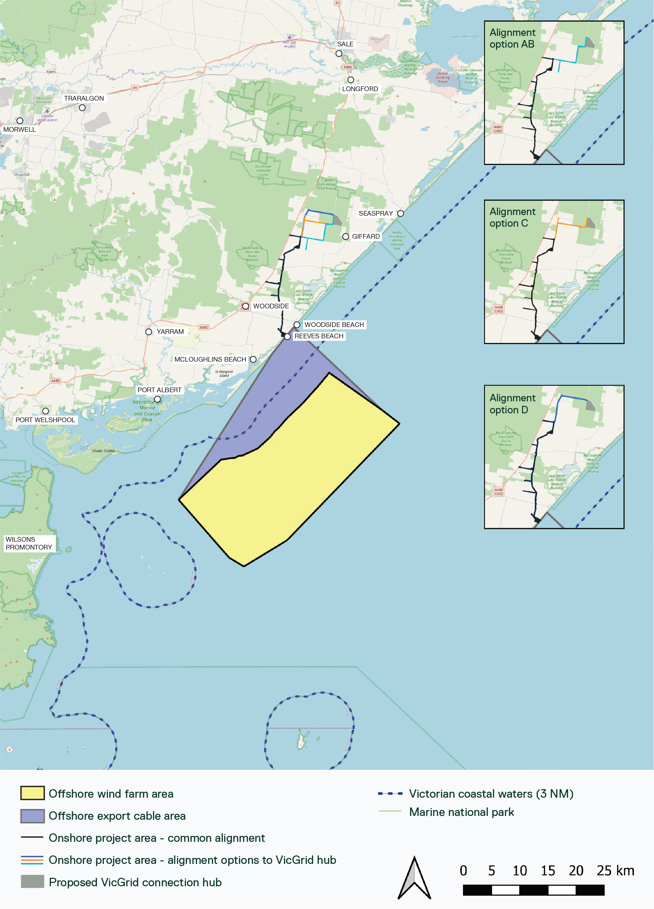
The project comprises an offshore wind farm and supporting transmission infrastructure to generate and transfer power to the grid. As shown in Figure 1-2, the project's primary components include:
- Up to 147 fixed-bottom offshore wind turbines located within Commonwealth waters
- Inter-array cables connecting the turbines to up to five offshore substations located within Commonwealth waters
- Offshore export cables located within Commonwealth waters and Victorian coastal waters
- A shore crossing and underground cable system connecting to the existing electricity network.
Figure 1-2 Project components
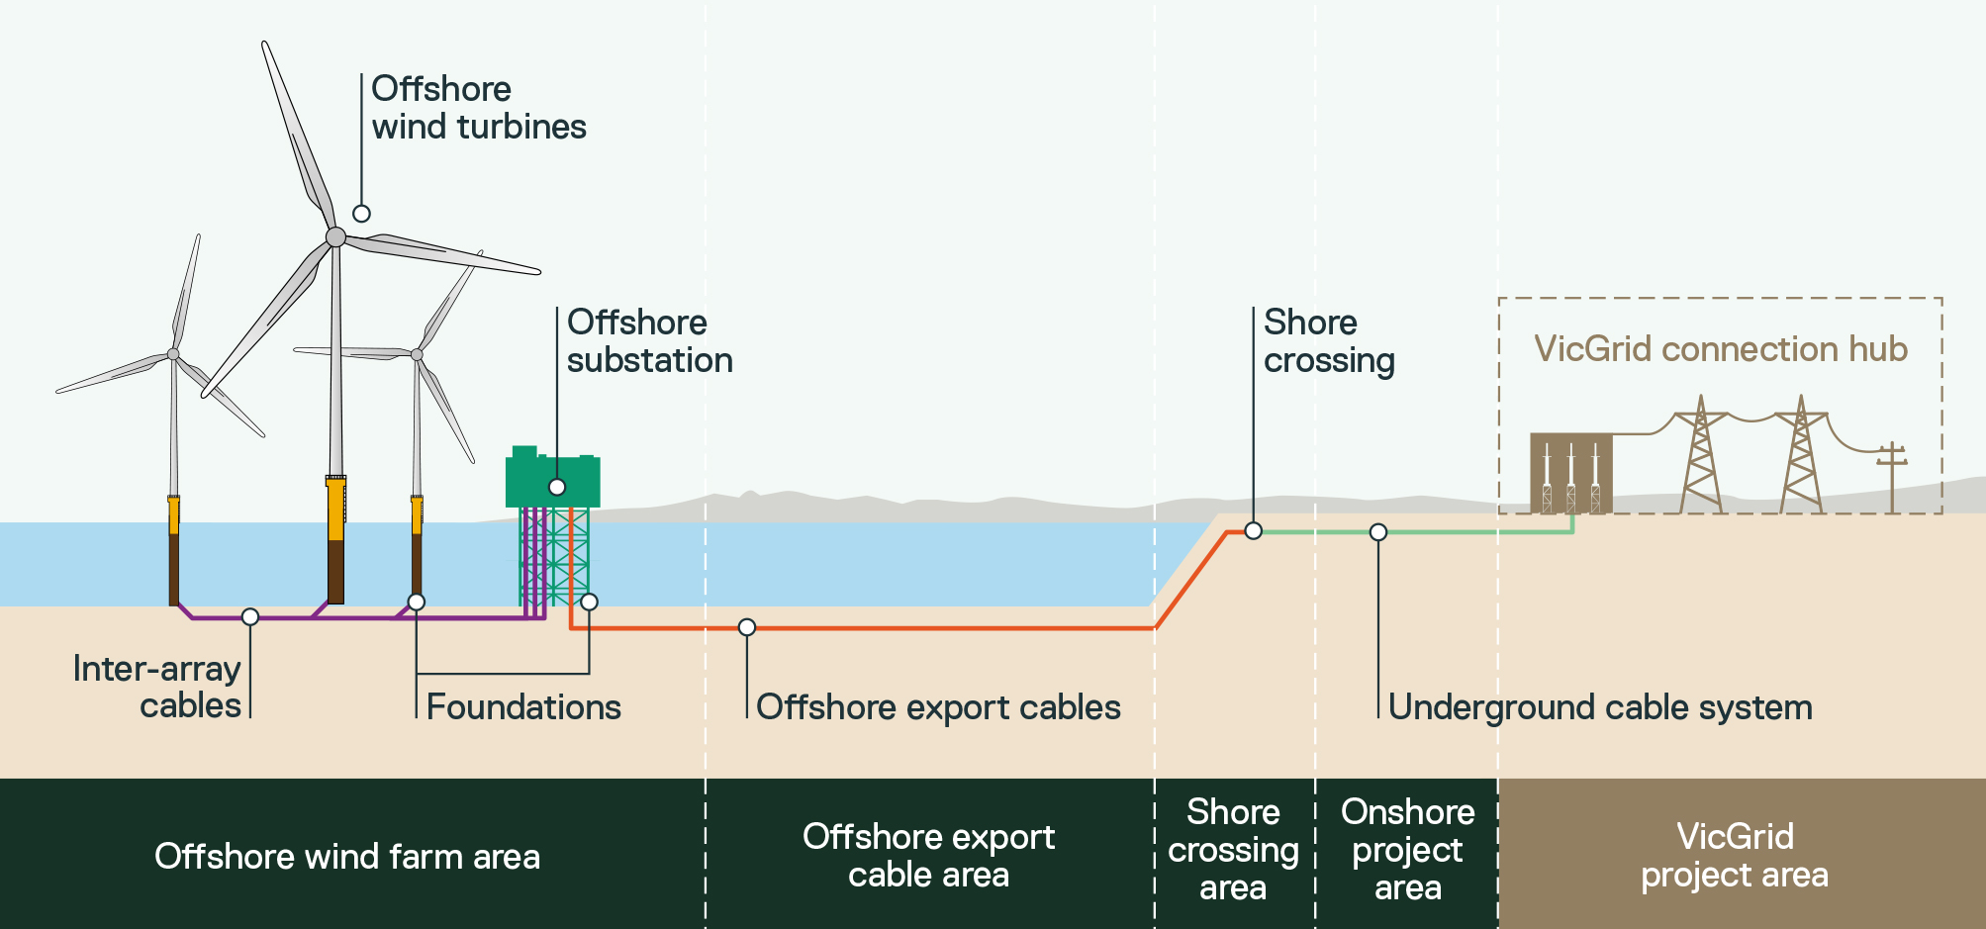
A delegate of the Commonwealth Minister for the Environment and Water has determined the project is a controlled action (as set out in a notice dated 2 June 2020) and must be assessed and approved under the Environment Protection and Biodiversity Conservation Act 1999 (Cth) (EPBC Act) through an Environmental Impact Statement (EIS).
The Victorian Minister for Planning has determined the project requires an Environment Effects Statement (EES) for project activities within the Victorian jurisdiction (as set out in a notice dated 11 May 2020) under the Environment Effects Act 1978 (Vic) (EE Act).
This chapter provides an overview of the project and outlines the purpose and structure of the EIS (the assessment) within the Commonwealth jurisdiction. Any matters relating to the Victorian jurisdiction can be found within the Victorian EES for the project.

Project context

Background
Australia’s existing power generation assets, such as coal plants, are reaching end of life. New generation and supporting infrastructure is required to ensure Australians continue to have access to secure and reliable power.
Australia and Victoria have established emissions reduction targets – these commitments and policies are guiding Australia’s energy transition, including the need for renewable energy.
Australia is a party to the Paris Agreement, a legally binding international treaty on climate change that entered into force in 2016. In support of this commitment the Commonwealth Government, through the Climate Change Act 2022 (Cth), has pledged to reduce greenhouse gas emissions by 62 – 70 per cent below 2005 levels by 2035 and achieve net-zero emissions by 2050.
Victoria has legislated renewable energy targets through the Renewable Energy (Jobs and Investment) Act 2017 (Vic). This requires achieving 65 per cent renewable energy by 2030 and at least 2 GW of offshore wind by 2032. Separately, the Climate Change Act 2017 (Vic) commits Victoria to achieving net-zero greenhouse gas emissions by 2045.
Wind power is a renewable energy source that will play a significant role in achieving the Commonwealth's and Victoria's climate and renewable energy targets. As of October 2024, Victoria was home to 42 onshore wind farms, mainly in the state’s west (DEECA, 2025).
With more than 13,000 turbines installed in oceans globally, countries such as Denmark, Germany and the United Kingdom host mature offshore wind industries, with offshore wind expanding in markets like China, Taiwan and the United States of America (IRENA, 2021).
Globally, offshore wind installations have more than doubled in recent years, from 34.5 gigawatts (GW) in 2020 to 83 GW in 2025 (GWEC, 2025). Australia is yet to capitalise on its abundant offshore wind resources. Average wind speeds along Australia’s south-eastern coast can reach up to 10 metres per second, ideal conditions for offshore wind like those in the European North Sea, where offshore wind is well-established (Blue Economy CRC, 2021).
The project, located 10 to 40 kilometres off the coast of Gippsland, features high mean wind speeds and shallow water depths, avoids key environmental sites, reduces land conflicts and is located close to the existing grid, making it a critical renewable energy solution for Australia.

Project objectives
Project objectives guide project outcomes and help maintain a consistent approach to design and assessment. They assist in decision-making when refining project design elements and form the key pillars for the project’s assessment. The objectives align with Australia’s decarbonisation goals, Victoria's renewable energy targets and the need for a sustainable offshore wind industry.
The project’s objectives are to:
- Deliver a significant, secure and reliable source of large-scale renewable electricity to meet Victoria’s offshore wind generation target of 2 GW by 2032 and progress towards Australia's legislated net-zero emissions by 2050 target.
- Adapt proven offshore wind technologies to local conditions while avoiding and minimising significant risks of harm to the environment, so far as reasonably practicable.
- Develop and deliver the project in consultation with Traditional Owners and local communities.
Delivering a project that aligns with these objectives will realise a host of benefits. This includes meeting approximately 20 per cent of Victoria’s electricity demand, enough to power around 1.2 million homes annually. The project will also support key legislated targets and policies, including:
- The Commonwealth Government's commitment to reduce greenhouse gas emissions by 62 – 70 per cent below 2005 levels by 2035
- The Commonwealth Government’s Net Zero Plan to achieve a fair, orderly and efficient transition to net zero that builds on Australia’s strengths and ensures all Australians benefit
- Victoria’s renewable energy target of 65 per cent renewable energy by 2030 and net zero emissions by 2045
- The Victorian Government’s Local Jobs First Policy and the Latrobe Valley Supply Chain Transition Program, as well as other initiatives which aim to provide opportunities for Gippsland workers and businesses in sunset industries, such as the offshore oil and gas and coal sectors, by creating jobs and ongoing investment.

Project development
The Commonwealth Government granted Star of the South an exploration licence in 2019 and a feasibility licence in 2024 to undertake site investigations off the coast of Gippsland. The feasibility licence area defines the boundary of the offshore wind farm, as shown in Figure 1-1. This area is also referred to throughout the assessment as the offshore wind farm area.
Offshore wind project development involves advancing project designs from a conceptual stage to detailed design over the course of a planning phase. Since its inception, the project's design has undergone progressive review and refinement in line with environmental assessments, engineering constraints and community and stakeholder feedback. These efforts have also considered project objectives, as well as relevant legislative and policy requirements, and identified potential effects on the surrounding environment. Star of the South has developed a project description, which defines the project for environmental impact assessment and approval purposes. Further details about the project development process are provided in Chapter 3 – Project Development. The project description is provided in Chapter 4 – Project Description.
The project description is based on a ‘project design envelope’ approach. This allows for a range of options to be assessed, rather than a single, fixed proposal (for example, minimum and maximum turbine heights). It ensures the impacts of all options are considered, while maintaining flexibility for ongoing project refinement and innovation. This is a suitable approach for complex infrastructure projects, like offshore wind, that have long development timeframes and often continue evolving during detailed design, procurement and construction. This approach is further described in Chapter 6 – Assessment Framework.

Project overview
The project involves the construction, operation and decommissioning of an offshore wind farm and supporting transmission infrastructure to generate and transfer power into the grid.
The offshore wind farm will be installed within a 586-square-kilometre offshore wind farm area, located approximately 10 to 40 kilometres off the coast of Gippsland, in water depths of up to 55 metres. The offshore wind farm will transmit electricity via offshore substations and offshore export cables to shore via a shore crossing, and an underground cable system will connect the project to the proposed VicGrid connection hub in Giffard.

Offshore wind farm infrastructure
The project’s offshore wind farm infrastructure primarily consists of:
- Up to 147 fixed-bottom offshore wind turbines
- Potential transition pieces that secure the turbines to monopile foundations fixed to the seabed
- High voltage alternating current inter-array cables connecting the turbines to offshore substations.

Offshore transmission infrastructure
The project’s offshore transmission infrastructure primarily consists of:
- Up to five offshore substations, installed on either piled jacket or monopile foundations, to collect power for export to shore
- Up to eight high voltage alternating current offshore export cables connecting to the underground cable system onshore via the shore crossing.

Shore crossing infrastructure
The project’s shore crossing infrastructure primarily consists of:
- Up to eight ducted cable crossings under the intertidal zone and dune system, installed via trenchless construction methods
- Up to eight onshore transition joints installed between the offshore export cables and the underground cable system onshore.

Onshore transmission infrastructure
The project’s onshore transmission infrastructure primarily consists of:
- A high voltage alternating current underground cable system approximately 30 kilometres in length.

Ports
Star of the South is considering multiple candidate ports to support the project’s construction and operations. No single port, or combination of ports, has been selected, and the exact role of individual ports has not yet been determined. Port selection is dependent on a range of design, environmental, commercial and supply chain factors, which are subject to ongoing investigation.
Star of the South is not the responsible proponent for any port developments or upgrades, so they do not form part of the project’s assessment. These works are subject to separate planning and approval processes.

Project delivery

Proponent
The proponent is a limited liability company and is developing the project in its role as trustee for the Star of the South Trust. The ownership of the proponent is shared between Copenhagen Infrastructure IV (CI IV) and its associated trust entities, the project founders and United Super Pty Ltd as trustee for Construction and Building Unions Superannuation Fund (CBUS). The proponent has expertise in delivering large-scale offshore wind projects and possesses an in-depth understanding of the Australian market and relevant regulatory requirements.
Copenhagen Infrastructure Partners (CIP) is the fund manager for CI IV. CIP is a multinational fund management company headquartered in Denmark, specialising in investments into greenfield energy infrastructure projects globally. CIP currently has eleven funds representing different investment strategies with a total combined commitment of approximately EUR $33 billion from more than 150 institutional investors, primarily pension funds, life insurance companies and family offices. Current investments under CIP’s management include a wide range of energy infrastructure assets, including offshore wind, onshore wind, offshore power transmission, biomass and energy-from-waste, and solar PV investments. CIP’s focus in Australia is on large-scale renewable energy infrastructure in both storage and generation capacity that reduces power prices and CO² emissions, whilst improving energy efficiency and increasing Australia’s grid stability.

Project timeline
Figure 1-3 provides an indicative timeline for a typical offshore wind project. Typically, it takes six to 10 years to develop an offshore wind project. Following feasibility assessments, and assuming approvals are obtained in the next few years, the project is expected to commence construction later this decade and be operational from 2032 onwards. The project's operational life is anticipated to be approximately 30 years, after which it will be decommissioned.
Figure 1-3 Offshore wind project timeline
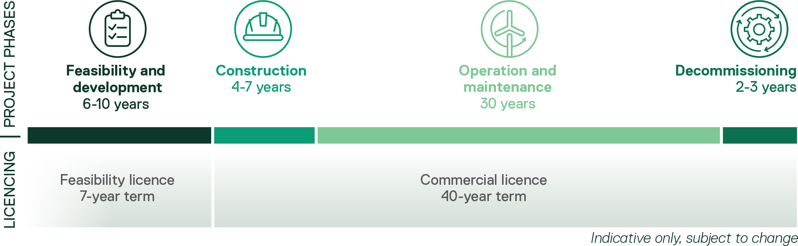

Consultation
The project is founded on the belief that community and stakeholder involvement results in better project outcomes. Consultation plays a vital role in project development, assessment and execution. It helps build an understanding of the local area and community views.
Star of the South has sought to:
- Inform communities and stakeholders (including impacted landholders) about the project, the assessment process and opportunities for participation
- Help people understand the project and provide feedback
- Involve people in the project development process to identify potential concerns, gather local insights and gain feedback on measures to address concerns
- Use and respond to the feedback received.
Consultation has been a core activity since the project's inception and will continue throughout every phase of the project. Star of the South began early discussions with Gippsland communities and interested stakeholders in 2017. Formal consultation commenced in 2019, as more information on project design and the assessment process became available. Relevant stakeholders were involved at the right time to provide input and inform decision-making. Both online and in-person consultations have been undertaken, including presentations, meetings, information sessions, webinars, community events, surveys, social research and contact with visitors to Star of the South's Gippsland office in Yarram.
Star of the South’s comprehensive approach to consultation is detailed further in Chapter 7 – Community Engagement and Attachment II – Consultation Report.

Assessment and approvals pathway
The project is located within both Commonwealth and Victorian jurisdictions and is subject to planning and environmental assessment and approval under Commonwealth and Victorian legislation.
As the offshore wind farm, the main component of the project, is proposed within Commonwealth waters, the assessment approach cannot be accredited under the Assessment Bilateral Agreement between the Commonwealth and State of Victoria.
Any matters relating to the Victorian jurisdiction, including the requirement for the EES can be found within the Victorian EES for the project.

Requirement for an EIS
The EPBC Act is Commonwealth legislation that establishes a legal framework to protect and manage nationally and internationally important flora, fauna, ecological communities and heritage places, collectively referred to as matters of national environmental significance (MNES). If a project has the potential to result in a significant impact on MNES, it is referred to the Commonwealth Minister for the Environment and Water to determine if the project is a controlled action.
Star of the South referred the project to the Minister under the EPBC Act in May 2020. The referral included a description of potentially significant impacts on MNES based on a preliminary assessment. On 2 June 2020, a delegate of the Minister determined the project was likely to have a significant impact on MNES protected under Part 3 of the EPBC Act and, therefore, constitutes a controlled action. As such, the project's potential impacts need to be assessed and documented within an EIS.
The MNES relevant to the project include:
- The ecological character of declared Ramsar wetlands
- Listed threatened species and communities
- Listed migratory species
- The environment in Commonwealth marine areas.
Star of the South submitted a variation to the original proposal described in the 2020 EPBC Act referral to the Commonwealth in May 2025 to allow for assessment of changed project elements. The Commonwealth accepted the referral variation on 9 July 2025.
Details of the project description assessed within the EIS are provided in Chapter 4 Project Description.

Role of the assessment
The assessment is required to provide a detailed description of the project and its potential environmental impacts within the Commonwealth jurisdiction. This enables the Commonwealth Minister for the Environment and Water to assess the project’s potential for significant impacts.
Under the EPBC Act, Star of the South prepares and provides the EIS to the Commonwealth Minister for the Environment and Water to make an informed decision on whether to approve the project, approve the project subject to specific conditions or disapprove the project.
The purpose of the EIS is to describe the project and assess the potential environmental impacts and risks that may occur as a result of project works, providing mitigation measures through which adverse impacts can be avoided or minimised so far as reasonably practicable. Specifically, the EIS:
- Describes the project, the existing environment that may be affected by the project and the protected MNES that may be affected by the project
- Identifies the project's potential effects on the existing environment and protected MNES
- Provides information on proposed mitigation measures to address potential impacts
- Identifies management measures to address uncertainties and risks
- Describes how the principles of ecologically sustainable development have been applied
- Informs the EPBC Act approval.
Further information on the assessment process and the statutory approvals required for the project are provided in Chapter 5 – Commonwealth Legislative Framework.

EIS guidelines
The responsible decision-making Minister issues terms of reference to guide the assessment, referred to as EIS guidelines for the Commonwealth assessment. These define guidelines that outline the project and impact information to be presented in the EIS.
Star of the South has coordinated Commonwealth requirements through technical studies and engaged with government agencies through a Technical Reference Group throughout the assessment process.
EIS guidelines ensure that an EIS:
- Includes the appropriate content to enable stakeholders and Ministers to understand the environmental consequences of a project and ensure it meets EPBC Act objectives
- Is set out in a manner that clearly presents the required information and is written so that any conclusions that are reached can be independently addressed
- Identifies all relevant project impacts and assesses them in accordance with applicable Commonwealth policies and guidelines
- Provides information on proposed safeguards and mitigation measures to address potential impacts.
The EIS guidelines for the project state that the EIS should primarily focus on the MNES that are relevant to the project (as listed in Section 1.4.1).
The EIS has been prepared to address the project's EIS assessment guidelines which detail the specific matters to be investigated. A table indicating where the EIS assessment guidelines are addressed is attached in Attachment V – EIS Guidelines Checklist.

Assessment overview and mitigations

Assessment approach
To address the key issues identified in the EIS guidelines, Star of the South commissioned 26 specialist technical reports to evaluate the potential environmental effects associated with the project’s construction, operation and decommissioning.
The technical reports assessed how potential adverse environmental effects could be avoided, minimised and mitigated. The framework used for the technical reports is described in Chapter 6 – Assessment Framework.

Environmental Management Framework
The assessment presents mitigation measures that are based on technical specialist advice, legislative requirements and local and global practices to address any identified significant effects within the Commonwealth jurisdiction. Where appropriate, the project's design incorporates the proposed mitigation measures, which will be implemented in accordance with the project's Commonwealth Environmental Management Framework (EMF).
The EMF is a framework for addressing the project’s environmental requirements. Derived from the project’s statutory approvals, it includes safeguards and mitigation measures to manage potential adverse effects.
The mitigation measures set out in the Commonwealth EMF represent the project’s environmental commitments, which will be given effect through the relevant statutory approvals, including approval under the EPBC Act. These commitments will be included in management plans such as construction and operation environmental management plans and other subordinate management plans, and incorporated into management plans under the Offshore Electricity Infrastructure Act 2021 (Cth).
The mitigation measures will inform the conditions administered by relevant statutory authorities, which Star of the South and its contractors will be responsible for implementing.
The proposed Commonwealth EMF and mitigation measures are presented in Chapter 23 – Commonwealth Environmental Management Framework

Assessment structure
The assessment documentation consists of four parts:
- EIS Summary document: Provides a concise non-technical summary of the assessment of the entire project and enables the reader to navigate to the technical reports and chapters. The document also directs the public to where submissions on the project can be made during the public exhibition phase..
- Commonwealth Environmental Impact Statement: The main body of the EIS, containing chapters on the technical disciplines considered as part of the assessment. The chapters present the potential positive and adverse impacts of the project and describe how environmental and social effects will be avoided or mitigated so far as reasonably practicable. The introductory chapters of the EIS (Chapters 1-7) contain the rationale for the project, a project development overview, a detailed project description, the legislative and assessment frameworks and a review of the community engagement undertaken for the project.
- Technical reports: Contains supporting documents or technical reports relating to independent specialist studies, investigations and analyses. These provide the basis for the EIS chapters.
- Attachments and appendices: Supporting documents that inform the EIS but are not technical reports.
Figure 1-4 and Table 1-1 summarises the structure and contents of the EIS.
Figure 1-4 Environmental impact assessment document structure
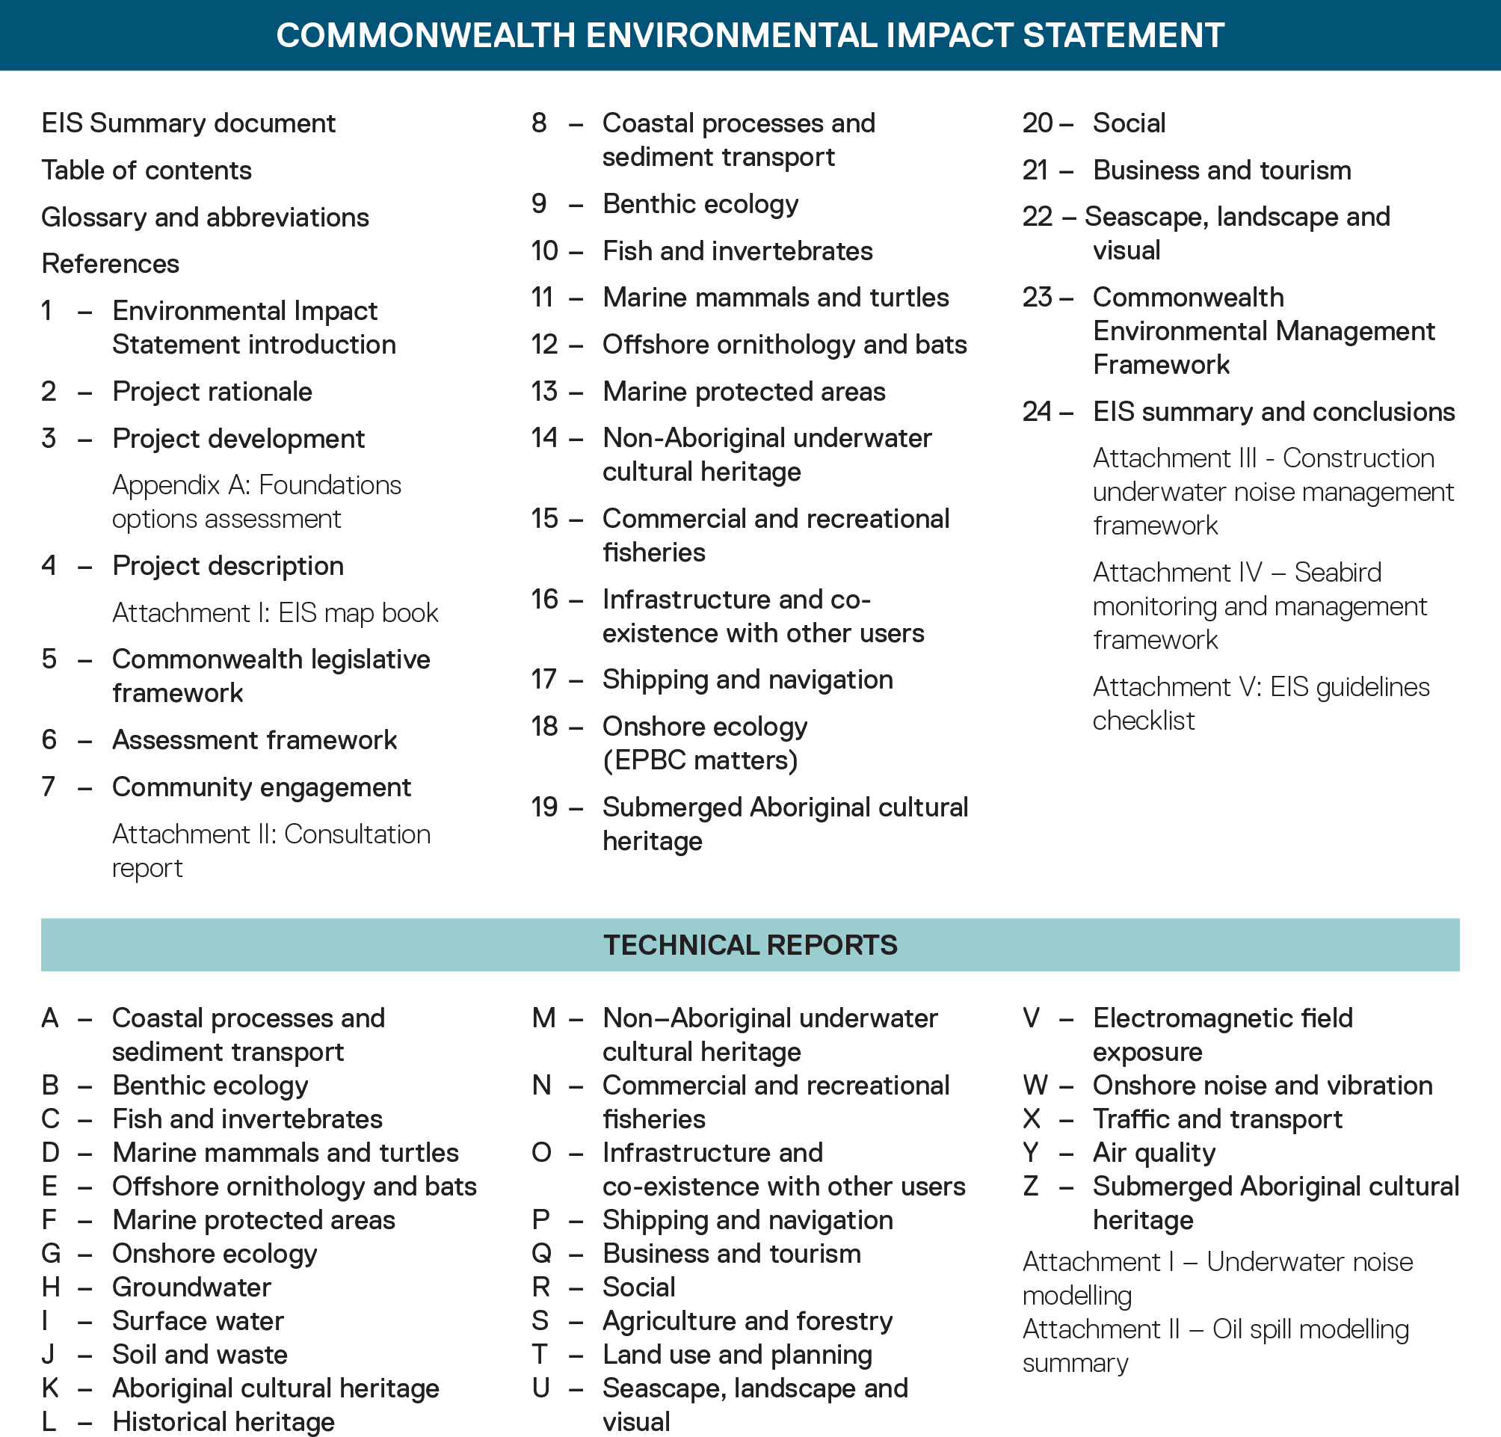

Table 1-1 EIS chapter descriptions
Chapter / reference |  | Content and matters addressed
EIS summary document |  | A concise non-technical summary of the project and key issues, including details of the EIS exhibition, public submission process and availability of EIS documentation.
Table of contents |  | A table outlining all documents in the EIS.
Glossary and abbreviations |  | A table listing key terms and abbreviations used throughout the documentations.
References |  | List of references used throughout the documentation.
Chapter 1 | EIS Introduction | Introduces the project and outlines the purpose and structure of the impact assessment.
Chapter 2 | Project Rationale | Provides the rationale for the project and describes project alternatives considered.
Chapter 3 | Project Development | Describes how the project was developed, including how key components were identified and alternatives considered.
Chapter 4 | Project Description | Describes the proposed project, including construction, operations and decommissioning.
Chapter 5 | Commonwealth legislative Framework | Summarises the assessment process and the key approvals required for the project with consideration to the relevant local, State and Commonwealth government legislation and policies.
Chapter 6 | Assessment Framework | Provides an overview of the environmental impact assessment framework applied to assess and characterise the significance of residual environmental impacts.
Chapter 7 | Community Engagement | Summarises communication and consultation activities undertaken throughout preparation of the assessment, issues raised and how they are being addressed.
Chapter 8 | Coastal Processes and Sediment Transport | Identifies the existing conditions related to coastal processes and sediment transport and assesses impacts and risks associated with the construction, operation and decommissioning of the project on these processes.
Chapter 8 | Benthic Ecology | Identifies the existing conditions related to benthic ecology (organisms living on the ocean floor, including sub-surface layers), and assesses impacts and risks associated with the construction, operation and decommissioning of the project on benthic ecology.
Chapter 10 | Fish and Invertebrates | Identifies the existing conditions in terms of fish and invertebrates and assesses impacts and risks associated with the construction, operation and decommissioning of the project on the respective receptor groups.
Chapter 11 | Marine Mammals and Turtles | Identifies the existing conditions of marine mammals and turtles and assesses impacts and risks associated with the construction, operation and decommissioning of the project.
Chapter 12 | Offshore Ornithology and Bats | Identifies the existing conditions of offshore ornithology and bats and assesses impacts and risks associated with the construction, operation and decommissioning of the project on the respective shorebirds, seabirds and Bass Strait migrants.
Chapter 13 | Marine Protected Areas | Identifies the existing conditions related to Commonwealth marine protected areas and assesses impacts and risks associated with the construction, operation and decommissioning of the project on Commonwealth marine protected areas.
Chapter 14 | Non-Aboriginal Underwater Cultural Heritage | Summarises the potential impacts on non-Aboriginal underwater cultural heritage from the construction, operation and decommissioning of the project and describes how impacts will be avoided, minimised or managed.
Chapter 15 | Commercial and Recreational Fisheries | Identifies the existing conditions related to commercial and recreational fishing and assesses impacts and risks associated with the construction, operation and decommissioning of the project on commercial and recreational fishing.
Chapter 16 | Infrastructure and Co-Existence with Other Users | Identifies the existing conditions related to infrastructure and other users and assesses impacts and risks associated with the construction, operation and decommissioning of the project. Infrastructure and other users as described in this chapter covers the petroleum industry, research, aviation, radar and communications systems, submarine power cables and vessels.
Chapter 17 | Shipping and Navigation | Identifies the existing conditions related to shipping and navigation and assessed impacts and risks associated with the construction, operation and decommissioning of the project on shipping and navigation.
Chapter 18 | Onshore Ecology (EPBC Matters) | Characterises the existing ecological communities and listed species under the EPBC Act. Describes measures to avoid, mitigate, manage or offset potential impacts to flora and fauna, including threatened species and vegetation communities, and describes the assessed residual impacts.
Chapter 19 | Submerged Aboriginal Cultural Heritage | Summarises the potential impacts to submerged Aboriginal cultural heritage values.
Chapter 20 | Social | Identifies the existing conditions related to the potential social impacts of the project and assessed social effects and impacts associated with the construction, operation and decommissioning of the project on communities. The existing environment in relation to the social impact assessment includes coastal areas and settlements, Wilsons Promontory, Reeves Beach campground, recreational boating and fishing and rural areas that the project traverses.
Chapter 21 | Business and Tourism | Identifies the existing conditions related to the business and tourism sectors within the local and regional study areas in Gippsland and assesses impacts and risks associated with the construction, operation and decommissioning of the project on the business and tourism sectors.
Chapter 22 | Seascape, Landscape and Visual | Identifies the existing conditions related to seascape, landscape, and visual amenity and assesses impacts and risks associated with the construction, operation and decommissioning of the project on seascape, landscape, and visual amenity values.
Chapter 23 | Commonwealth Environmental Management Framework | Sets out the environmental management framework to be implemented for the project, including mitigation measures.
Chapter 24 | EIS Summary and Conclusions | Provides a concise summary assessing the potential impacts of the project against the EIS guidelines, principles of ecologically sustainable development, objects of the EPBC Act and impacts on matters of national environmental significance as set out in the EIS assessment guidelines.
Attachment I | EIS map book | A map series that displays the key components from the offshore wind farm area to the onshore transmission, as described in Chapter 4 - Project Description.
Attachment II | Consultation Report | Provides further details about communication and engagement activities and outcomes for the project, in addition to the summary provided in Chapter 7 – Community Engagement.
Attachment III | Construction Underwater Noise Management Framework | Identifies the framework of controls and management measures for underwater noise impacts during the construction phase of the project.
Attachment IV | Seabird Monitoring and Management Framework | Identifies the framework for developing operational monitoring and management measures for the collision risk impact pathway.
Attachment V | EIS Guidelines Checklist | Provides a checklist of where the EIS guidelines requirements are addressed throughout the EIS documentation.

