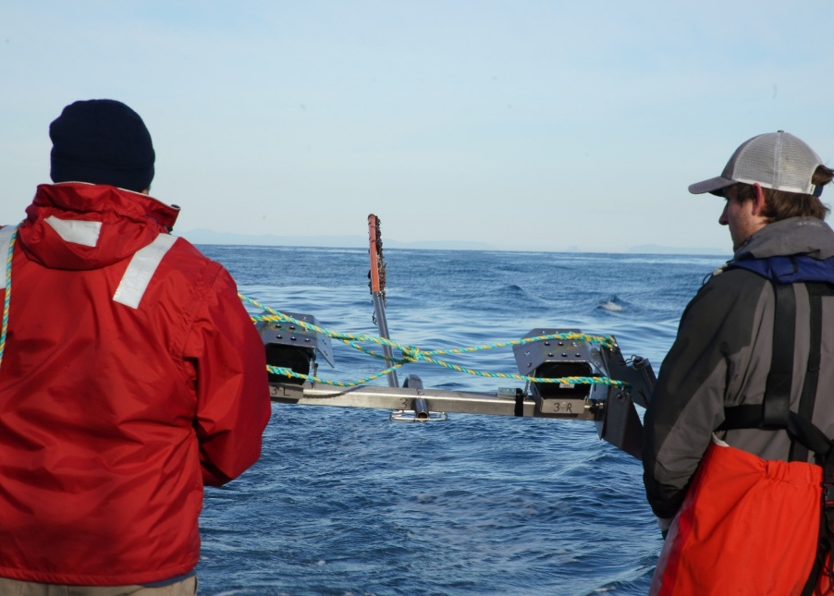

Commonwealth Environmental Impact Statement
Chapter 11 – Marine mammals and turtles
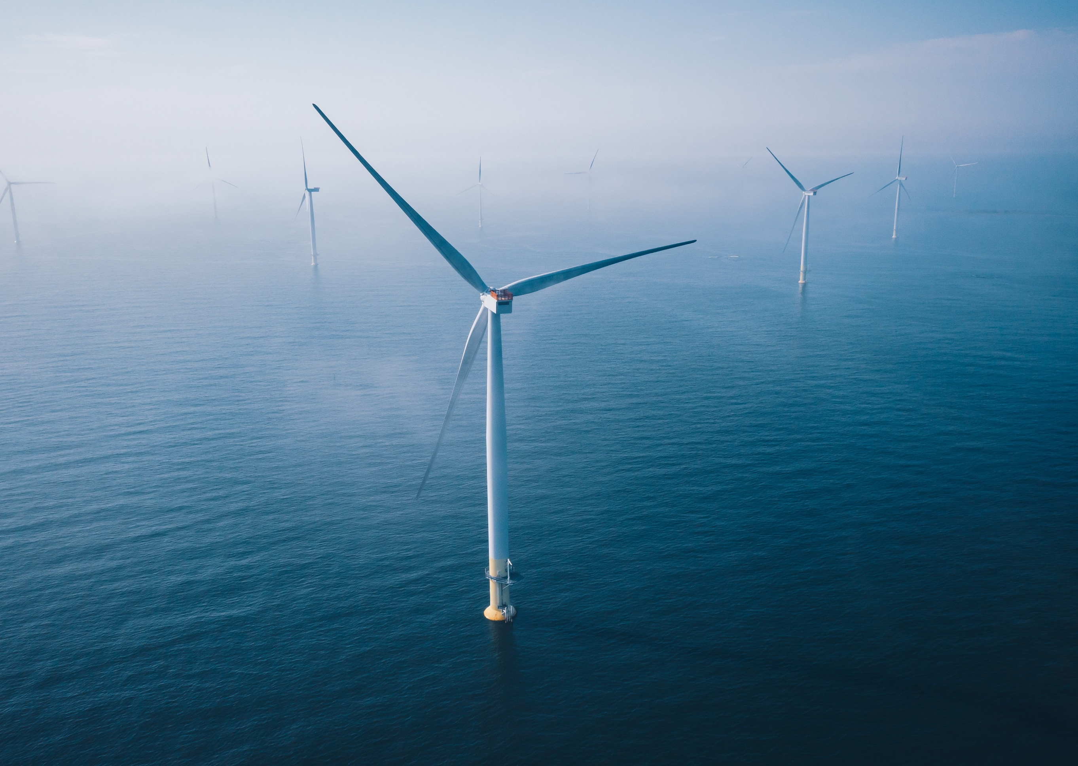
Table of Contents
Chapter 11 Marine mammals and turtles 11-1
11.1 Introduction 11-1
11.2 Assessment scope 11-2
11.2.1 Commonwealth matters 11-2
11.3 Evaluation framework 11-4
11.3.1 Key legislation, policy, guidelines and standards 11-4
11.3.2 Assessment criteria 11-4
11.4 Methods 11-6
11.5 Existing environment 11-8
11.5.1 Regional overview 11-10
11.5.2 Marine mammal and turtle species 11-14
11.5.3 Receptor groups for assessment 11-38
11.6 Construction impacts 11-41
11.6.1 Key impacts 11-41
11.6.2 Other impacts 11-41
11.6.3 Potential risks 11-62
11.7 Operation impacts 11-67
11.7.1 Key impacts 11-67
11.7.2 Other impacts 11-67
11.7.3 Potential risks 11-72
11.8 Decommissioning impacts 11-74
11.8.1 Potential impacts and risks 11-74
11.9 Cumulative Impacts 11-75
11.9.1 Conclusion 11-76
11.10 Summary of mitigation, monitoring and contingency measures 11-78
11.10.1 Mitigation measures 11-78
11.10.2 Monitoring measures 11-79
11.11 Conclusion 11-80

Figures
Figure 11-1 Marine mammal and turtle study area 11-9
Figure 11-2 Likelihood of productivity hotspots seasonally between June 2002 and August 2014 in the Gippsland region. 11-11
Figure 11-3 Blue Whale foraging biologically important area and sightings in south-eastern Victorian waters from the Victorian Biodiversity Database, DEECA, Atlas of Living Australia and CSIRO 11-17
Figure 11-4 Southern Right Whale biologically important areas and sightings in south-eastern Victorian waters from the Victorian Biodiversity Database, DEECA and Atlas of Living Australia, CSIRO 11-20
Figure 11-5 Humpback Whale sightings data and tracking data for Bass Strait 11-23
Figure 11-6 Common Dolphin sightings and indicative group density during visual aerial surveys (December 2019 to December 2021) 11-28
Figure 11-7 Bottlenose Dolphin indicative group density during visual aerial surveys (December 2019 to December 2021) 11-30
Figure 11-8 Proportional time-spent-in-area (5 × 5 kilometre grid cells)/habitat use by tagged adult female Australian Fur Seal from Kanowna Island in A) winter (mid- to late lactation) 2020 (n=18) and B) spring (post-weaning) 2020 (n=3) - from project tracking data 11-34
Figure 11-9 Proportional time-spent-in-area (5 × 5 kilometre grid cells)/habitat use by tagged adult female Australian Fur Seal from Rag Island from 2021 to 2022 during A) winter (mid- to late lactation, 10 individuals), B) spring (post-weaning, 10 individuals) and C) summer (early lactation, 4 individuals) as - from project tracking data 11-35
Figure 11-10 Proportional time-spent-in-area (5 × 5 kilometres grid cells)/habitat use by tagged adult female New Zealand fur seal from Kanowna Island from 2021 to 2022 during A) winter (mid- to late lactation, 10 individuals), B) spring (post-weaning, 5 individuals) and C) summer (early lactation, 4 individuals) - from project tracking data 11-37

Tables
Table 11-1 Key legislation, policy, guidelines and standards relevant to marine mammals and turtles 11-4
Table 11-2 Receptor groups for the impact and risk assessment, including the species that fall under each group, their conservation status and occurrence in the offshore project area. 11-40
Table 11-3 Marine mammal and turtle functional hearing groups (Southall et al., 2007; 2019; NMFS, 2024). 11-43
Table 11-4 Sound exposure thresholds for marine mammal and turtle functional hearing groups to impulsive noise sources (impact piling) 11-45
Table 11-5 Sound exposure thresholds for marine mammal and turtle functional hearing groups to continuous noise sources (vessels) 11-45
Table 11-6 Mobile receptor exposure ranges (ER95%) in kilometres to permanent threshold shift, temporary threshold shift and behavioural response thresholds for Blue Whale, Southern Right Whale, Humpback Whale and Minke whale (Antarctic and Dwarf combined) to cumulative (multiple strike) noise exposure from impact pile driving of a monopile and pin pile foundations 11-48
Table 11-7 Mobile receptor exposure ranges (ER95%) in kilometres to permanent threshold shift, temporary threshold shift and behavioural response (120 dB re1 µPa) thresholds for blue whales, southern right whales and humpback whales to dynamic positioning vessel noise in winter 11-49
Table 11-8 Mitigation and monitoring measures for impacts associated with construction piling and vessel noise during the construction phase 11-56
Table 11-9 Residual impacts associated with underwater noise during construction 11-59
Table 11-10 Residual impacts associated with routine discharge 11-60
Table 11-11 Residual impacts associated with sediment disturbance and sediment plumes 11-61
Table 11-12 Residual impacts associated with artificial light emissions 11-61
Table 11-13 Residual impacts associated with changes in prey distribution and abundance 11-62
Table 11-14 Consequence, likelihood and residual risk ranking associated with a vessel strike during the construction phase 11-64
Table 11-15 Consequence, likelihood and residual risk ranking associated with an accidental release of hydrocarbons during the construction phase 11-65
Table 11-16 Consequence, likelihood and residual risk ranking associated with debris escape leading to entanglement or ingestion during the construction phase 11-66
Table 11-17 Consequence, likelihood and residual risk ranking associated with accidental discharges during the construction phase 11-67
Table 11-18 Residual impacts associated with underwater noise during operations 11-69
Table 11-19 Residual impacts associated with the physical presence of operational wind turbines 11-72
Table 11-20 Residual impacts associated with electromagnetic interference during the operation phase 11-73
Table 11-21 Projects assessed and summary of cumulative impacts 11-76
Table 11-22 Mitigation measures relevant to marine mammals and turtles 11-79
Table 11-23 Monitoring and contingency measures relevant to marine mammals and turtles 11-80

Marine mammals and turtles

Introduction
This chapter summarises the existing conditions related to marine mammals and turtles and assesses the impacts and risks associated with the construction, operation and decommissioning of the Star of the South Offshore Wind Project (the project) on marine mammals and turtles. The chapter describes how impacts will be avoided, minimised or managed.
Marine mammals include animals such as whales, dolphins and seals.
This chapter is based on the impact assessment presented in Technical Report D – Marine Mammals and Turtles and draws upon aspects from the following technical reports:
- Technical report A – Coastal Processes and Sediment Transport
- Technical Report B – Benthic Ecology
- Technical Report C – Fish and Invertebrates
- Technical Report P – Shipping and Navigation.
Other chapters and modelling that relate to or inform the marine mammals and turtles assessment include:
Chapter 3 – Project Development, Appendix A – Foundations Options Assessment
Attachment III – Construction Underwater Noise Management Framework
Technical Report Attachment I – Underwater Noise Modelling
Technical Report Attachment II – Oil Spill Modelling Summary

Assessment scope
The study objectives for marine mammals and turtles are to:
- Determine and present criteria sourced from relevant legislation and guidance documents (including bioregional plans and species recovery plans), industry best practice, stakeholder expectations, and relevant standards against which potential impacts and risks will be assessed
- Assess, and propose the measures that will be used to avoid and mitigate potential adverse effects on marine mammals and turtles (including listed threatened and migratory species), their prey species and habitats, supported by assessments of fish and invertebrates, benthic ecology and coastal processes
- Undertake an evaluation of the significance of potential effects against pre-defined criteria and significant impact guidelines (including the acceptability of impacts in relation to key management / recovery plans and guidance documents)
- Propose the monitoring that will be used to verify impact predictions and describe the adaptive management measures that will be implemented, if required, to ensure impacts are within the levels predicted and therefore meet environmental protection goals.
All detailed technical methodologies and assessment on marine mammals and turtles can be found in Technical Report D – Marine Mammals and Turtles.

Commonwealth matters
The project's EIS guidelines inform the preparation of the EIS to enable the Commonwealth Minister for the Environment to make an informed decision on whether to approve the project under the Environment Protection Biodiversity Conservation Act 1999 (Cth) (EPBC Act).
The key aspects of the EIS guidelines directly relevant to marine mammals and turtles are:
- Section 2.6 – Description of the protected matters
  - 2.6.2 – Listed marine species, migratory species, threatened species and ecological communities.
    - Marine, migratory and threatened species and ecological communities’ abundance, distribution and site fidelity at the proposed development site and in areas that may be impacted by the development, and known habitat utilisation or requirements, including biologically important areas and habitat critical to the survival of the species
    - Usage of the project area by listed species in regional context including, but not limited to migratory pathway, breeding and foraging behaviours
    - The predicted temporal and spatial variability in occurrence of listed species within the onshore or offshore project area and in areas that may be impacted by the project
    - Relevant identified threats to the survival, habitat utilisation, site fidelity and essential life functions of listed species, including foraging, breeding or migratory behaviours, and past and projected trends and existing threats to the condition of habitat.
- Section 2.7.4 – Marine mammal collision
  - The EIS must also include an assessment on the impact on listed threatened and migratory marine mammals as a result of collision with vessels
  - Characterising the numbers, migratory pathways and foraging behaviours of the marine mammals likely to occur in the vicinity of the wind farm, which will require scientifically robust studies over different seasons, including at-sea observations.
- 2.8 – Proposed avoidance, management and mitigation measures
  - 2.8.1 – Environmental Management Plans.
Further information about the EIS guidelines is provided in Attachment V – EIS Guidelines Checklist.

Evaluation framework

Key legislation, policy, guidelines and standards
Table 11-1 lists the key legislation, policy, guidelines and standards relevant to marine mammals and turtles.
Table 11-1 Key legislation, policy, guidelines and standards relevant to marine mammals and turtles
Type | Applicable legislation, policy, guideline or standard
International conventions/guidance | Convention on the Conservation of Migratory Species of Wild Animals 1979 (Bonn Convention)
International conventions/guidance | IALA Recommendation R0139 The Marking of Man-made Offshore Structures 2021 (IALA, 2021b)
International conventions/guidance | International Convention for the Prevention of Pollution from Ships 1973 (MARPOL)
International conventions/guidance | United Nations Convention on Biological Diversity 1992
Commonwealth Government | Offshore Electricity Infrastructure Act 2021 (Cth)
Commonwealth Government | Environment Protection and Biodiversity Conservation Act 1999 (Cth)
Commonwealth Government | Environment Protection and Biodiversity Conservation Regulations 2000 Part 8 (EPBC Regulations)
Commonwealth Government | Protection of the Sea (Prevention of Pollution from Ships) Act 1983 (Cth)

Assessment criteria
To assess the project, predicted impacts and risks are compared to criteria that set required environmental performance outcomes (refer Chapter 6 – Assessment Framework).
The criteria for marine mammals and turtles are derived from legislation and policy, relevant standards and guidelines, stakeholder feedback and industry best practice.
The assessment criteria relevant to marine mammals and turtles are:
- The project will not compromise biological diversity or the productivity of the environment, and a precautionary approach is applied
- The project will be managed so that residual impacts and/or risks are not inconsistent with the objectives of the Blue Whale Conservation Management Plan (EPBC Act), including the requirements of the relevant action areas defined within the plan:
  - Action Area A.2: Assessing and addressing anthropogenic noise. Specifically, anthropogenic noise will be managed so that Blue Whales (Balaenoptera musculus) can continue to utilise biologically important areas without injury and will not be displaced from their foraging areas
  - Action Area A.4: Minimising vessel collisions.
- The project will be managed such that residual impacts and/or risks are not inconsistent with the objectives of the National Recovery Plan for the Southern Right Whale (DCCEEW, 2024), including the requirements of the relevant action areas defined within the plan:
  - Action Area A5: Assess, manage and mitigate impacts to Southern Right Whales (Eubalaena australis) from anthropogenic underwater noise. Specifically, that anthropogenic noise will be managed so that it does not prevent any Southern Right Whale from utilising biologically important areas or habitat critical to the survival of the species or cause auditory impairment
  - Action Area A6: Manage, minimise and mitigate the threat of vessel strike.
- The project will not have a significant impact on threatened (endangered and vulnerable) species as defined in the Matters of National Significance Significant impact guidelines 1.1
- The project will be managed to prevent vessel strikes with marine fauna
- The project will be managed to prevent pollution from routine and/or accidental discharges to the marine environment
- The project will not have a significant impact on migratory species as defined in the Matters of National Significance Significant impact guidelines 1.1
- The project will not have a significant impact on Commonwealth marine areas as such term is defined in section 24 of the EPBC Act.

Methods
The purpose of the marine mammals and turtles impact assessment is to assess the potential impacts and risks of the project on marine mammals and turtles.
Impacts refer to the consequences of planned project actions, which are given a rating determined by combining the magnitude of the impact and the sensitivity of the receptor.
Risks are an unexpected (accidental) event and are determined by combining the likelihood of an event occurring and the consequences that would result if the event were to occur.
The technical chapters consider key impacts and risks with a residual consequence rating of moderate to severe. Other impacts and risks are those with a residual consequence rating of negligible to minor.
Refer to Chapter 6 – Assessment Framework for more detail on how impact and risk ratings are derived.
The marine mammals and turtles assessment was achieved by:
- Reviewing relevant national, state and local legislation
- Performing a comprehensive literature review to identify marine mammal and turtle species that may be present in the study area, including records from Atlas of Living Australia and Victorian Biodiversity Atlas. This review also helped identify relevant biologically important areas for key life stages (such as migration, calving, breeding, feeding and aggregation), key habitats and associations and known/potential migratory routes. This included the examination of:
  - Peer-reviewed scientific papers and studies
  - Databases such as the EPBC Act Protected Matters Search Tool
  - Publications from relevant international, Commonwealth and state organisations
  - Relevant international, Commonwealth and Victorian management plans and policies
  - Other resources detailed in Technical Report D – Marine Mammals and Turtles
- Conducting a series of field studies to obtain information on the presence and behaviours of marine mammal and turtle species and establish the baseline environment to inform the impact assessment. The field studies included:
  - Visual aerial surveys: A total of 54 visual surveys from a small aeroplane were conducted over 2.5 years, with a survey frequency of once per month for the first six months, then twice monthly thereafter. Survey transects covered the spatial extent of the offshore wind farm area, an area further offshore, an area off Loch Sport east of the offshore wind farm area, and four transects on the western side of Wilsons Promontory
  - Passive acoustic monitoring: Three hydrophones were positioned across the offshore wind project area and two in deeper waters (55 to 60 metres) to monitor for sound-producing marine mammals (such as singing whales) every 15 minutes over a two year period. Automated and manual verification allowed for species identification from specific calls
  - Satellite tracking of fur seals: Satellite tags were deployed on adult female Australian fur seals (Arctocephalus pusillus) and New Zealand fur seals (Arctocephalus forsteri) at two breeding colonies in proximity to the offshore wind farm area - Rag Island and Kanowna Island. At both islands, tags were deployed on ten Australian fur seals and ten New Zealand fur seals. Data was collected over two years at Rag Island, and one year at Kanowna Island due to the existence of historical tracking data on Australian fur seal and New Zealand fur seal which could be used to inform baseline studies. Together, these data helped form at-sea distribution probability models that predict the relative usage of the offshore project area by species
  - Population counts and body condition assessment of fur seals: Estimates of Australian fur seals and New Zealand fur seals population sizes were made at their respective colonies on Kanowna Island and Rag Island, along with an assessment of the animals' condition
  - Other sightings data: Several other marine mammal and turtle sightings in the wider Gippsland Basin were collated to provide additional context to the observed distribution of marine mammals and turtles. These included incidental observations from other marine ecology baseline surveys (fish, seabird and benthic boat-based surveys, acoustic logger deployment/retrieval trips, seabird island land surveys and shorebird land surveys), seabird aerial surveys, Wildlife Coast Cruises sightseeing boat tours and Southern Right Whale sightings from the Statewide Integrated Flora and Fauna Team.
Further information on these field studies (marine ecological survey program) can be found in Technical Report D – Marine Mammals and Turtles. The assessment also draws on information from underwater noise modelling (Technical Report Attachment I – Underwater Noise Modelling) and a simulation of hydrocarbon releases (Technical Report Attachment II – Oil Spill Modelling Summary).

Existing environment
This section describes the existing conditions within the study area as they relate to marine mammals and turtles. The study area for the marine mammals and turtles consists of the following components:
- The offshore project area made up of the offshore export cable area and the offshore wind farm area
- The offshore project area plus a 10-kilometre buffer around the area, which together served as the primary location for the marine ecology baseline surveys (notated as the Marine Mammal Study Area in Figure 11-1)
- A 100-kilometre buffer around the offshore project area. This buffer provides a broader context for the site-specific data and encompasses a subset of marine ecology survey program baseline surveys with broader study areas. It also allows for an assessment of potential impact pathways that extend beyond the boundary of the offshore project area where direct impacts could occur (for example, noise), and was used to understand the breeding areas, foraging ranges, and migration patterns of certain species. Lastly, this broader regional area represents the maximum extent within which cumulative impacts could be expected.
Figure 11-1 Marine mammal and turtle study area
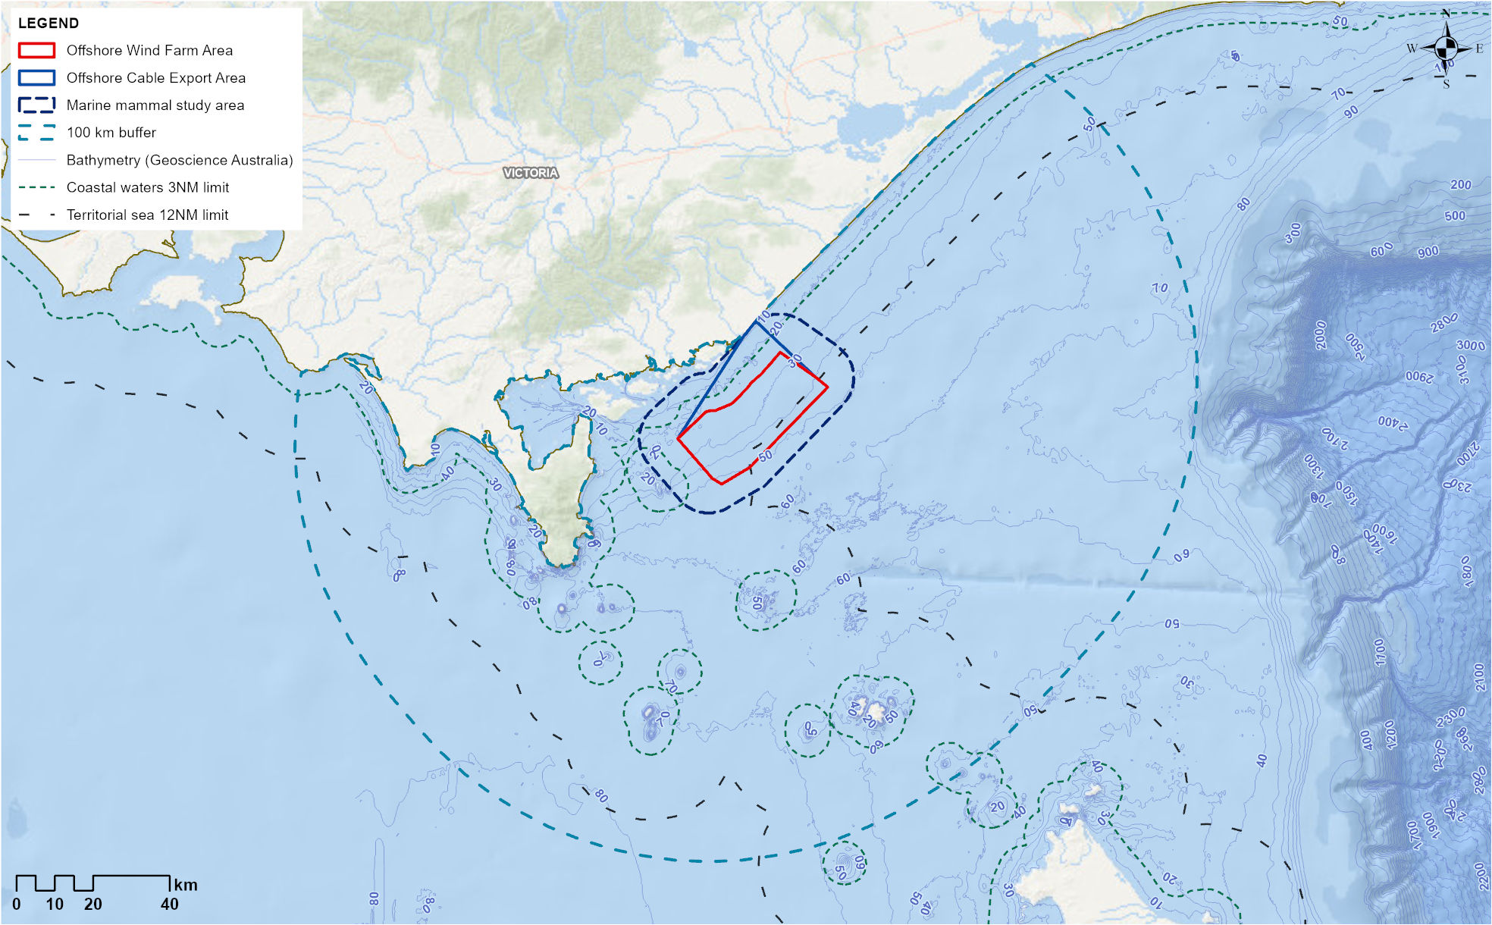

Regional overview

Physical processes
The marine processes characterising the offshore wind farm area and the surrounding marine environment are summarised in this section and described in more detail in Technical Report A – Coastal Processes and Sediment Transport.
During the winter, the eastern Victorian coastline is impacted by the South Australian Current, which transports dense, salty water eastward from the Great Australian Bight through Bass Strait. The winter months also bring cold, nutrient-rich subantarctic surface water into the Bass Strait from the south.
During the summer, the East Australian Current is at its strongest, moving warm, relatively salty water southward. A north-east, poleward-flowing current occurs along the inner shelf of the Gippsland Basin, while an extension of the Eastern Australian Current flows to the south of Gabo Island off Mallacoota, resulting in the formation of large-scale eddies along the eastern shelf slope. The wave activity throughout Bass Strait is typically driven by the strong prevailing westerly winds, resulting in a high wave-energy environment.
The three major currents that flow into the Bass Strait and Gippsland Basin – the South Australian Current, subantarctic surface water and the East Australian Current – influence local marine ecosystems by bringing different levels of nutrients, temperature and salinity into the region's waters and influencing local processes such as upwelling. Consequently, the productivity of the region changes as nutrient and chlorophyll levels peak from winter to spring each year, providing enhanced levels of productivity in the area.
Upwelling is when cold, nutrient-rich water from the depths of the ocean rises to the surface. This increases productivity as the nutrients support the growth of plankton, which form the base of the ocean food web.
Ocean productivity mainly refers to the production of organic matter by phytoplankton (single-celled plants), which attracts zooplankton (multicellular animals), a major food source for most marine mammals. Productivity can be assessed through satellite imagery of chlorophyll a, the primary pigment used by phytoplankton for photosynthesis. As illustrated in Figure 11-2, which shows seasonal productivity hotspots in the Gippsland region, the offshore wind farm area has some of the lowest likelihoods of productivity in the region (white box 1). There is also a clear distinction between the productivity within the offshore wind farm area and the hotspot areas of upwelling (white box 2) and shelf edges (white box 3).
Figure 11-2 Likelihood of productivity hotspots seasonally between June 2002 and August 2014 in the Gippsland region.
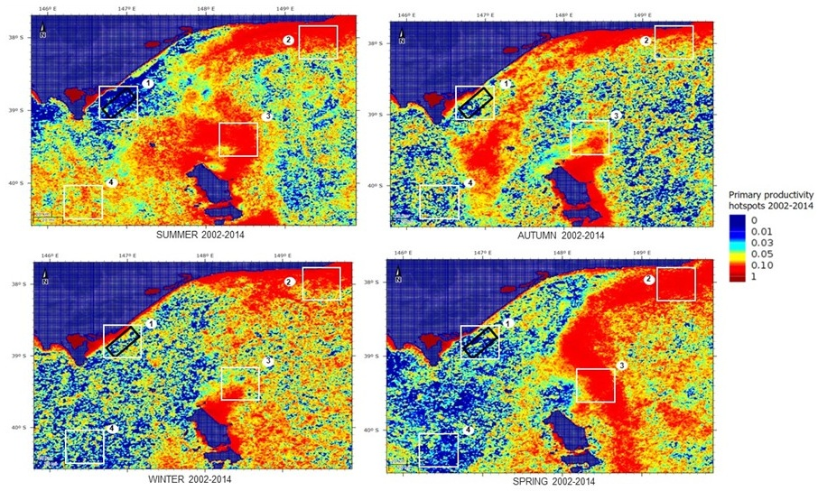
The black box indicates the offshore wind farm area. White numbered boxes in each panel represent: 1) the offshore wind farm area and its surroundings, 2) Upwelling east of Eden, 3) eastern Bass Strait continental shelf waters and 4) central Bass Strait shelf waters (data was sourced from seamapaustralia.org).

Anthropogenic uses and underwater noise
Anthropogenic uses (human-driven activities) within the offshore wind farm area and Bass Strait include oil and gas extraction, shipping and commercial and recreational fishing activities. The region is also used for recreational and tourism activities, including cruising, whale watching and diving. While current faunal extractive activities mainly involve fishing, the region has a history of commercial sealing and whaling, which led to the overexploitation of numerous marine mammal species in the nineteenth century, particularly the Southern Right Whale. Even though these activities have been banned for decades, their impacts are still evident in the reduced population numbers of some species.
Given the uses of the regional area, there is a variety of associated existing marine noise sources, including shipping activity, noise associated with the petroleum facilities, seismic survey signals, wind noise, various biological noise sources (for example, snapping shrimp) and flow noise due to the high seabed currents. Underwater noise monitoring recorded a range of natural, physical and anthropogenic noise across the offshore project area, and wind speed was found to be the primary driver of baseline low-level ambient noise. For example, noise with a frequency of 1,000 hertz increased from approximately 55 decibels (equivalent to human perception of noise levels of a quiet office) at a seven-knot wind speed to approximately 78 decibels (equivalent to human perception of noise levels of a busy road) at a 22-knot wind speed.
Underwater noise monitoring also showed that several large vessels (a median of 2.7 per day) transit through each day, affecting baseline noise levels for approximately two to three hours per ship, which equates to six to nine hours of daily ship noise. Seismic survey signals were also detected, with the potential for this source to continue intermittently in the future for oil and gas and/or carbon capture and storage projects. Refer to Technical Report Attachment I – Underwater Noise Modelling for further details on existing anthropogenic and environmental noise.

Conservation areas

Beagle Marine Park
Beagle Marine Park is a national marine park located approximately 20 kilometres south of the offshore wind farm area. It is a shallow-water reserve surrounding a collection of Bass Strait islands, including the islands of Kent Group National Park and the Hogan and Curtis Island groups. Major conservation values associated with the park include that it is an important migration and resting-on-migration area for Southern Right Whales as well as an important foraging area for Australian fur seals and Killer Whales (Orcinus orca). The marine park is within the foraging biologically important area for Blue Whales and the known distribution biologically important area of Southern Right Whales.

Wilsons Promontory Marine National Park
Wilsons Promontory Marine National Park, Victoria’s largest marine protected area, is located approximately 25 kilometres from the offshore wind farm area. It encompasses several offshore islands of the Anser Group (Anser Island, Kanowna Island, Wattle Island and Anderson Islets), which support several colonies of Australian fur seals. Kanowna Island, for example, is one of four Australian fur seal breeding colonies in Victoria. From October to April, Humpback Whales and Southern Right Whales may pass through the park while migrating from the cold Antarctic waters to their calving grounds off the Australian coast.

Corner Inlet Marine National Park
Corner Inlet Marine National Park is located within the sheltered waters of Corner Inlet behind Wilsons Promontory Marine National Park, approximately 25 kilometres from the offshore wind farm area. Seals and dolphins are known to be present in the shallow protected waters of the park and historical sightings of Southern Right Whales have been reported.

Ninety Mile Beach Marine National Park
Ninety Mile Beach Marine National Park, located approximately 26 kilometres from the offshore wind farm area, is a large, subtidal sandy expanse that is characteristic of the area. The park has a sandy bottom with intermittent reef areas and waters that reach depths of approximately 30 metres. Marine mammals are not commonly sighted in this area.

Marine mammal and turtle species
A thorough understanding of the marine mammal and turtle species potentially occurring within the offshore wind farm area was developed through field surveys (refer to Section 11.4.4) and a comprehensive literature review. Key findings from these efforts include:
- A total of 19 marine mammals and turtle species that may occur within or migrate through the marine mammal study area were identified using the Department of Climate Change, Energy, Environment and Water's Protected Matters Search Tool, including 14 cetacean (whale and dolphin) species, two pinniped (seal, sea lion and walrus) species and three marine turtle species.
- Eleven of the 19 species identified by the Protected Matters Search Tool were identified in the field surveys, in addition to four cetacean species that the Protected Matters Search Tool did not identify. The visual aerial surveys recorded a total of 882 sightings, identifying up to 7,066 individual marine mammals.
- Visual aerial surveys identified nine marine mammal species and one turtle species. These were the Common Dolphin (Delphinus delphis), Bottlenose Dolphin (Tursiops truncatus), Humpback Whale (Megaptera novaeangliae), Southern Right Whale, Dwarf Minke Whale (Balaenoptera acutorostrata), Bryde's Whale (Balaenoptera edeni), Pygmy Blue Whale (Balaenoptera musculus brevicauda), Killer Whale, a single fur seal and a single Leatherback Turtle (Dermochelys coriacea). Most of these sightings (87.6 per cent) were outside of the offshore wind farm area, however this assessment assumes that all species may use the area.
- Acoustic recordings identified Humpback Whale, Dwarf Minke Whale, Antarctic Minke Whale (Balaenoptera bonaerensis), Australian (Eastern Indian Ocean) Pygmy Blue Whale and New Zealand Pygmy Blue Whale vocalisations and the ‘spot’ call.
- The offshore wind farm area and its surroundings overlap with biologically important areas for two whale species: 1) a foraging biologically important area for the Blue Whale and 2) reproduction (approximately May to September) and migration (approximately April to October) biologically important areas for the Southern Right Whale. Additionally, a migration biologically important area for the Humpback Whale commences north-east of the offshore wind farm area, starting at Eden, New South Wales, extending north along the coastline to as far as Bundaberg, Queensland. Biologically important areas for marine turtles are not found in the area.
The relevant species mentioned above are further discussed below with reference to their conservation status, previous observation records from various databases, general behaviour and their prevalence during baseline surveys.

Blue Whale
Blue Whales (Balaenoptera musculus), the largest of all whale species, are found in every ocean except the Arctic Ocean. There are two recognised subspecies of Blue Whale in the Southern Hemisphere: the Antarctic Blue Whale (Balaenoptera musculus intermedia, often referred to as the 'true' Blue Whale) and the Pygmy Blue Whale (Balaenoptera musculus brevicauda). Both subspecies are protected under national and state legislation. They are listed as Endangered and Migratory under the EPBC Act and are managed under the Blue Whale Conservation Management Plan. In Victoria, the Blue Whale is listed as Threatened under the Flora and Fauna Guarantee Act 1988 (Vic) (FFG Act).
The offshore wind farm area lies within the eastern boundary of the Blue Whale foraging biologically important area (Figure 11-3). Blue Whale sightings in Gippsland, based on a search of several databases, have been low; however, this could also reflect low observation effort. Historical sightings of the Antarctic Blue Whale were most likely sightings of Pygmy Blue Whales.

Antarctic Blue Whale
Antarctic Blue Whales are found along the western and southern coast of Australia, as well as the west coast of South Africa, Namibia and Angola. Their presence in Australian waters varies. While Antarctic Blue Whale calls have been recorded off Portland (480 kilometres west of the offshore wind farm area), it is unlikely that this species occurs in the offshore wind farm area, as the Gippsland region lies at the extreme end of their known range. Despite the lack of Antarctic Blue Whale vocalisations and observations during field surveys, for the proposed mitigation measures all Blue Whales are treated the same.

Pygmy Blue Whale
In Australian waters, the Pygmy Blue Whale subspecies is further divided into two populations - the Australian (Eastern Indian Ocean) Pygmy Blue Whale and the New Zealand Pygmy Blue Whale, which are differentiated by their songs.
A single Blue Whale was recorded in deeper waters beyond the offshore wind farm area during visual surveys. While it could not be identified to the subspecies level, it is suspected to be a Pygmy Blue Whale. Acoustic recordings detected New Zealand Pygmy Blue Whale calls on a single day in April 2020 and sporadically from May 2021 to February 2022 (0.39 per cent of time at the deepest hydrophone). No Australian (Eastern Indian Ocean) Pygmy Blue Whale calls were detected in acoustic recordings in 2020, however, in 2021 - calls were detected sporadically from May to June and again in September (0.12 per cent of time at the deepest hydrophone), with peak presence in June.
All detections of the Pygmy Blue Whale song (both subspecies) were for short periods (a few hours to days), and there was no evidence that either subspecies persisted in the area. A relationship has been identified between the presence of Blue Whales and upwelling, as these animals tend to feed primarily in areas of high-density krill patches. As the offshore wind farm area is not an upwelling site and is low in productivity (Figure 11-2), the area may only be used by Blue Whales transiting between the Bonney Upwelling and the Upwelling east of Eden. A previous study in 2015 and 2016 found that of the 13 tagged adult Pygmy Blue Whales in the Bonney Upwelling region, none moved east of Wilsons Promontory Marine National Park towards the offshore wind farm area. Pygmy Blue Whales tend to occupy deeper waters along the shelf edge.
Therefore, while it is possible for Pygmy Blue Whales to be present in the offshore wind farm area and surrounding waters, their presence is likely to be limited to occasional transient individuals, pairs or small pods, possibly in late-autumn to winter, as indicated by the baseline survey data.

Figure 11-3 Blue Whale foraging biologically important area and sightings in south-eastern Victorian waters from the Victorian Biodiversity Database, DEECA, Atlas of Living Australia and CSIRO
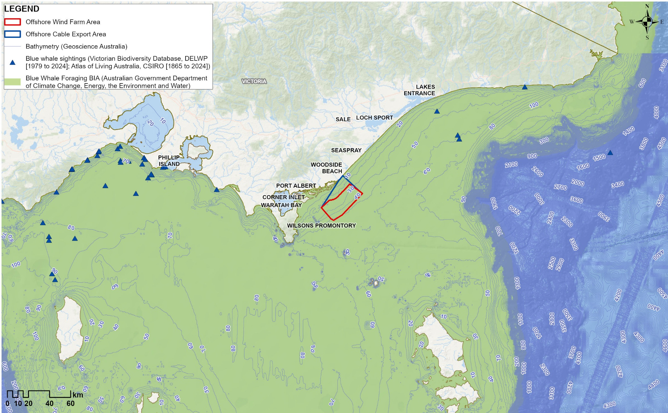

Southern Right Whale
Southern Right Whales migrate annually from southern feeding grounds in the subantarctic to northern coastal aggregation grounds to breed, calve and rest during the Austral winter. In Australia, Southern Right Whales are divided into eastern and western subpopulations or management units. The eastern subpopulation is found along the south-eastern coast, as far south as Tasmania but rarely further north than Sydney. The western subpopulation occurs predominantly between Cape Leeuwin in Western Australia and Ceduna in South Australia, where some exchange between populations may occur. Southern Right Whales are listed as Endangered and Migratory under the EPBC Act, as Threatened under the Flora and Fauna Guarantee Act 1998 (FFG Act) and are managed under the Southern Right Whale National Recovery Plan.
Records of Southern Right Whales from monitoring programs off the Victorian coast since 1985 indicate that the highest densities (aggregation grounds) occur far west of the offshore wind farm area at Portland, Port Fairy, Warrnambool, Port Campbell and Peterborough. Anecdotal sightings include areas around the Wilsons Promontory coast and inside Corner Inlet, as well as scattered observations in inshore coastal areas adjacent to the offshore wind farm area, including Port Albert, McLoughlin’s Beach and Woodside Beach (Figure 11-4).
The offshore wind farm area and adjacent coastal waters are not a recognised aggregation area for Southern Right Whales. However, the offshore project area overlaps with biologically important areas for migration and reproduction (Figure 11-4), with the reproduction biologically important area being identified as 'habitat critical to survival' by the species' national recovery plan. The reproduction biologically important area encompasses Australian coastline from Bundaberg, Queensland, to north of Bunbury, Western Australia, including the Gippsland coast, and extends out to three kilometres from the coastline (as the species favours shallow waters near the coastline when travelling to calving grounds). The migration biologically important area is larger, extending from the south-west corner of Western Australia (Cape Naturaliste) to the border of New South Wales and Victoria, encompassing the entire Economic Exclusion Zone and the continental shelf limits south of Tasmania.
Such expansive biologically important areas exist for the Southern Right Whale mainly due to the history of whaling for the species in the 1800s. Population numbers are low, and their high age at maturity (an average of nine years) and low fecundity (reproductive potential) mean recovery is a slow process. For example, a recent population estimate for the eastern subpopulation was 268 individuals, which is estimated to be increasing at a rate of 4.7 per cent per year. Climate variability and change is considered the highest current threat to the eastern population.
No Southern Right Whales were observed in the offshore wind farm area during field surveys. However, five Southern Right Whales (two female and calf pairs and an unaccompanied adult) were observed along the coastal transect, and a third female and calf pair were sighted in deeper offshore waters (approximately 40 kilometres from the coast), reportedly travelling west.
These Southern Right Whales were sighted in June and July (north-east of the offshore wind farm area along the coastal transect) and September (in deeper offshore waters), which aligns with the timing of arrival and departure at aggregation grounds. Through photographs, one adult was identified as a known breeding female from the western subpopulation, suggesting that Gippsland can provide a habitat for individuals from both subpopulations. No certain calls of Southern Right Whales were identified in the acoustic monitoring as part of baseline surveys.
Southern Right Whales could occur in the offshore wind farm area and surrounding waters, most likely between March and December (particularly May to November), which has been accounted for in this assessment. However, given the known movement of photo-identified animals and lack of resights of Southern Right Whales, it is unlikely that they persist in the area.
Figure 11-4 Southern Right Whale biologically important areas and sightings in south-eastern Victorian waters from the Victorian Biodiversity Database, DEECA and Atlas of Living Australia, CSIRO
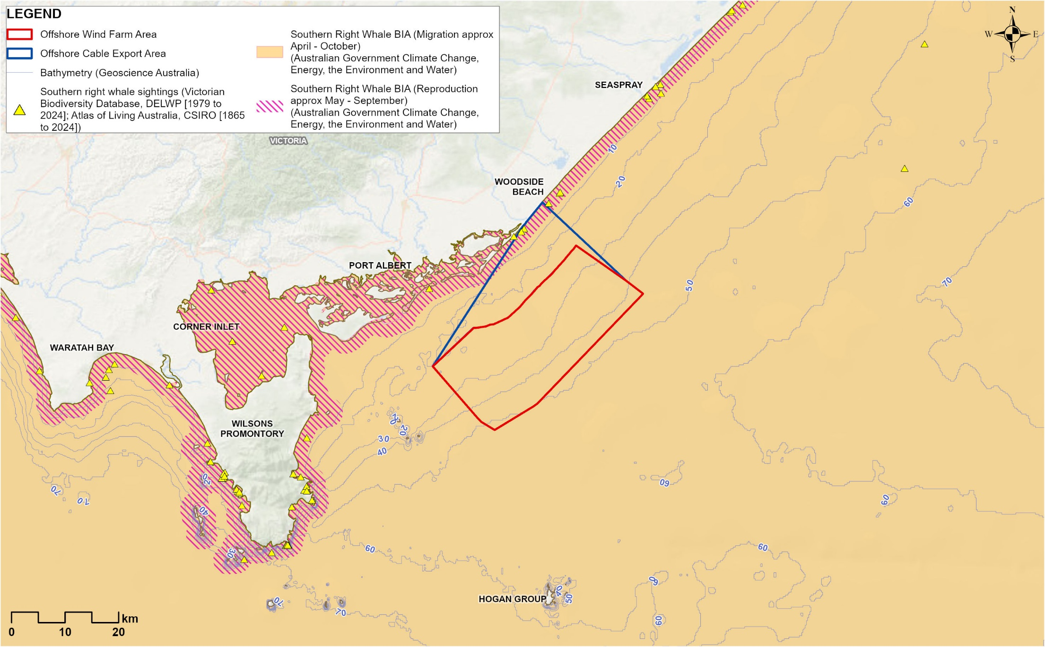

Humpback Whale
Humpback Whales occupy all oceans globally. Two populations of Humpback Whales are found in Australian waters – the western population, known as Breeding Stock D, and the eastern population, known as Breeding Stock E. The species is listed as ‘migratory’ under the EPBC Act.
Humpback Whales from the eastern population migrate annually along the east coast of Australia to calving grounds off north Queensland from April to August (northward migration) and then return to southern waters from September to December (southward migration). The migration biologically important area for the species does not overlap with the offshore wind farm area, beginning at Eden, New South Wales and extends north along the eastern coastline to Bundaberg, Queensland. Relative to the offshore wind farm area, the main migratory route of the eastern population is east of Bass Strait (Figure 11-5). However, based on database records, there are consistent sightings of the species off Gippsland in June and off Wilsons Promontory (approximately 45 kilometres west of the offshore wind farm area) from July to the end of October. This population is estimated to consist of 40,000 individuals.
Humpback Whales were the most observed whale species during field surveys, with observations in April and from June to December. A total of 314 Humpback Whales were sighted during 179 sighting events, with a maximum of 52 individuals observed in a single survey in October. An increased number of sightings occurred between September and November, during the southward migration, when they tend to travel closer to shore with calves compared to the northward migration. In October and November 2020, 11 and five Humpback Whale calves were sighted, respectively. In underwater noise recordings, the presence of Humpback Whales was greatest in October. Humpback Whales were also observed feeding on 14 occasions, outside of the offshore wind farm area. The eastern population is known to feed opportunistically during migration.
Humpback Whales, including calves, were present more frequently in the offshore wind farm area during their southern migration (September to early December) than their northern migration (April to August), but have the potential to be in the area for both migration journeys.
Figure 11-5 Humpback Whale sightings data and tracking data for Bass Strait
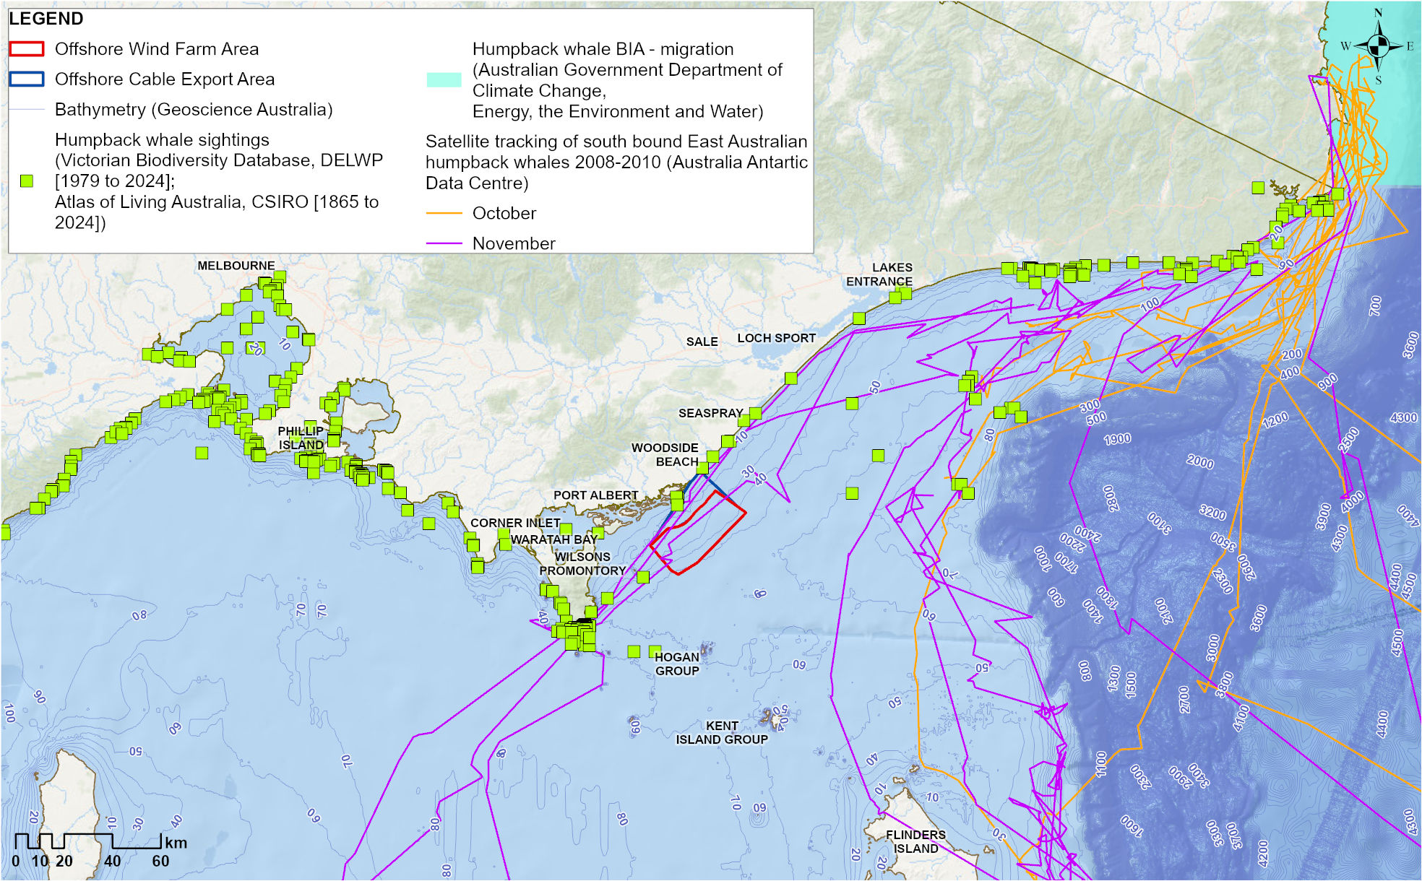
Source Andrews-Goff et al. (2018)

Other mysticetes (baleen whales)

Sei Whale
Mysticetes are baleen whales that have baleen plates (instead of teeth) in their mouths to strain tiny food like krill and plankton from the water.
Sei Whales (Balaenoptera borealis) can be found in most oceans globally, ranging from polar to tropical latitudes, and tend to inhabit deep offshore waters. Little is known about their breeding or migratory behaviour in Australia, with recorded sightings occurring west of the offshore wind farm area in the Bonney Upwelling region.
Sei Whales are not expected to occur within the offshore wind farm area due to its shallow water depths (up to 53 metres) and because there were no visual sightings or acoustic detections of Sei Whales during baseline field surveys. For this assessment, the Sei Whale has been considered in a receptor group with other mysticetes that are unlikely to be, but could be, present.

Fin Whale
Fin Whales (Balaenoptera physalus) occur globally and usually inhabit offshore waters, as they are rarely sighted in inshore coastal areas. To date, there are no records of Fin Whales in Victoria, with the closest observations and vocal presence detected in the deep waters of the Bonney Upwelling region. Tuncurry (approximately 900 kilometres north of the offshore wind farm area) and sections of the Tasmanian coast (approximately 500 kilometres south-west of the offshore wind farm area) are suggested as their key travelling zones.
From this information, Fin Whales may pass offshore of the Gippsland Declared Area on their migration routes north and south along the East Coast of Australia. However, there are no records of Fin Whale sightings within the region, and none were observed or acoustically detected during baseline field surveys. They are not expected to occur within the offshore wind farm area due to its shallow water depths (up to 53 metres). For this assessment, the Fin Whale has been considered in a receptor group with other mysticetes that are unlikely to be, but could be, present.

Dwarf Minke Whale
The Dwarf Minke Whale is a subspecies of the Common Minke Whale (Balaenoptera acutorostrata) that inhabits all oceans, including tropical and polar waters, and is known to aggregate at the northern Great Barrier Reef between March and October. Satellite tracking data suggest that some individuals traverse Bass Strait, and they may occupy shallower waters between four and 200 metres deep.
During baseline field surveys, three solitary Dwarf Minke Whales were observed outside the offshore wind farm area during visual aerial surveys in April, May and August, and a ‘like Dwarf Minke Whale’ was sighted in September. A solitary Dwarf Minke Whale was sighted near the offshore wind farm area during opportunistic boat-based surveys in April, and Wildlife Coast Cruises recorded two sightings of Dwarf Minke Whales – one sighting with three individuals in August and another sighting with one individual in September. Dwarf Minke Whale vocalisations were detected in acoustic recordings between March and November, with peak occurrence seaward of the offshore wind farm area during late April to late May. The appearance of Dwarf Minke Whale calls was sporadic and in deeper waters, never lasting more than a few days, indicating that whales traversed the area relatively quickly.
Given the few Dwarf Minke Whales observed during several years of baseline surveys, it is not likely that the offshore wind farm area provides important habitat for this species. Their presence is expected to be limited to occasional transient individuals or small groups in waters along the seaward boundary of the area and further offshore. For this assessment, the Dwarf Minke Whale has been considered in a receptor group with other mysticetes that are unlikely to be, but could be, present.

Antarctic Minke Whale
Antarctic Minke Whales (Balaenoptera bonaerensis) primarily occur in offshore and pelagic habitats throughout the Southern Hemisphere.
Antarctic Minke Whale calls were recorded sporadically between July and March, with peak vocal activity from late August to late September, and primarily detected near the eastern boundary of the offshore wind farm area. While typically expected to be in Antarctic waters from January to March, some individual calls were detected during this period. Most calls appeared to come from a single whale, with the occasional presence of up to three singers. There was one potential visual sighting in June 2021, classified as a ‘like Antarctic Minke Whale’, seaward of the offshore wind farm area in around 45 metres of water depth.
While Antarctic Minke Whales are known to occur in Australian waters, their distribution patterns and seasonal presence are uncertain. Given the acoustic detections recorded and as only one individual was observed over approximately two and a half years of surveys, it is not likely that the offshore wind farm area provides important habitat for this species. The presence of Antarctic Minke Whales is expected to be limited to occasional transient individuals or small groups, predominantly in deeper waters seaward of the offshore wind farm area. For this assessment, the Antarctic Minke Whale has been considered in a receptor group with other mysticetes that are unlikely to be, but could be, present.

Bryde's Whale
Bryde's Whales (Balaenoptera edeni) occur in both inshore and offshore waters (depths of 12 to 200 metres), spanning temperate to tropical regions. Unlike other mysticetes, Bryde's Whales do not undertake large-scale migrations to productive high-latitude waters; instead, they forage in less productive temperate to tropical waters.
This species is not well surveyed in Australia and multiple databases indicate that there have been very few sightings off Victoria over the past century, with most being of stranded individuals. A single Bryde's Whale was sighted in October 2020 during visual aerial surveys, just outside the surf zone in coastal waters. In 2022, a probable Bryde's Whale was also sighted in the shallow waters of Ninety Mile Beach and reported in a local newspaper.
The offshore wind farm area is not expected to provide critical habitat for populations of this species; however, there is the potential for Bryde's Whales to be present in or near the area. This would likely be in the form of occasional transient individuals or small groups. For this assessment, the Bryde's Whale has been considered in a receptor group with other mysticetes that are unlikely to be, but could be, present.

Pygmy Right Whale
Pygmy Right Whales (Caperea marginata) are found in temperate and subantarctic waters, at both deep oceanic and inshore locations. Little is known about the species’ migratory patterns. The majority of sightings in Victorian coastal waters have occurred near Portland, approximately 500 kilometres west of the offshore wind farm area, which aligns with the species’ primary association with productive upwelling areas. Between 1986 and 2006 on the eastern coast of Victoria, in closer proximity to the offshore wind farm area, just five Pygmy Right Whale sightings were recorded, all of which were carcasses.
The Protected Matters Search Tool predicts that foraging, feeding or related behaviour may occur within the offshore wind farm area due to the presence of suitable habitat. There were no sightings of Pygmy Right Whales during the baseline field surveys, and given the low number of sightings in Victoria, it is unlikely that Pygmy Right Whales are present in the area. Using a conservative approach, this assessment considered the Pygmy Right Whale in a receptor group with other mysticetes that are unlikely to be, but could be, present.

Odontocetes

Common Dolphin
Odontocetes are toothed whales that include species like dolphins, Killer Whales, and Sperm Whales. Unlike baleen whales, odontocetes have teeth for catching prey like fish and squid, and they use echolocation (sound-based navigation) to find food and move around underwater.
Short-beaked Common Dolphins (Delphinus delphis), referred to in this chapter as Common Dolphins, are a globally abundant species, widely distributed from tropical to cool temperate waters. While they can be found in coastal waters, they are generally considered an offshore species known to inhabit productive open ocean shelf and pelagic waters. Genetic analyses indicate six distinct populations in south/south-east Australia, one of which is located east of Wilsons Promontory.
Common Dolphins were the most abundant marine mammal species observed during baseline field surveys. They were sighted during every month of the year, with a total of 2,789 individuals observed across 166 sightings. Visual sightings of Common Dolphins were lowest closest to shore and increased with depth (Figure 11-6). The mean group size was 17 individuals, although large pods of around 300 individuals were sighted on two occasions in approximately 60 to 65 metres water depth offshore and north-east of the offshore wind farm area (Figure 11-6).
As such, Common Dolphins are likely to be present in waters offshore of the offshore wind farm area year-round and may also be present in the offshore wind farm area year-round.
Figure 11-6 Common Dolphin sightings and indicative group density during visual aerial surveys (December 2019 to December 2021)
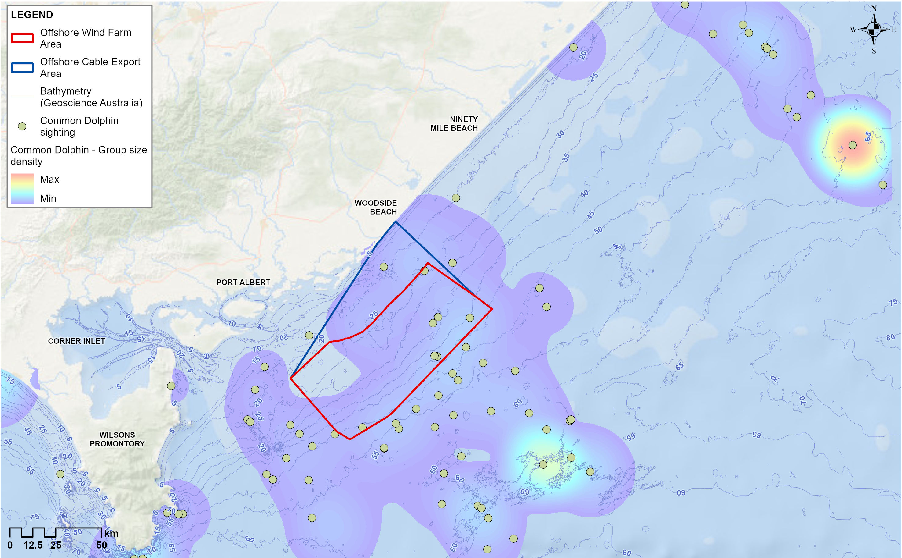

Bottlenose Dolphins (common and Indo-Pacific)
Bottlenose Dolphins (Tursiops sp.) have a global distribution in tropical to temperate waters and can be found in a wide range of habitats, including coastal, estuarine, pelagic and oceanic waters. Two species of Bottlenose Dolphin are currently recognised - the common Bottlenose Dolphin (including the Burrunan Dolphin (Tursiops australis)) that prefers offshore waters, and the Indo-Pacific Bottlenose Dolphin (Tursiops aduncus) that frequents inshore, shallower areas.
Bottlenose Dolphins were the second most abundant marine mammal species observed during visual aerial surveys with 1,950 individuals observed across 187 sightings. Estimated density was highest north-east of the offshore wind farm area and closer to the coast and decreased further from the coast (Figure 11-7). The mean group size was 10 individuals, though larger pods of around 50 to 70 individuals were sighted on six occasions.
Bottlenose Dolphins may be present in the offshore wind farm area year-round, with a higher potential presence in the first half of the year
Figure 11-7 Bottlenose Dolphin indicative group density during visual aerial surveys (December 2019 to December 2021)
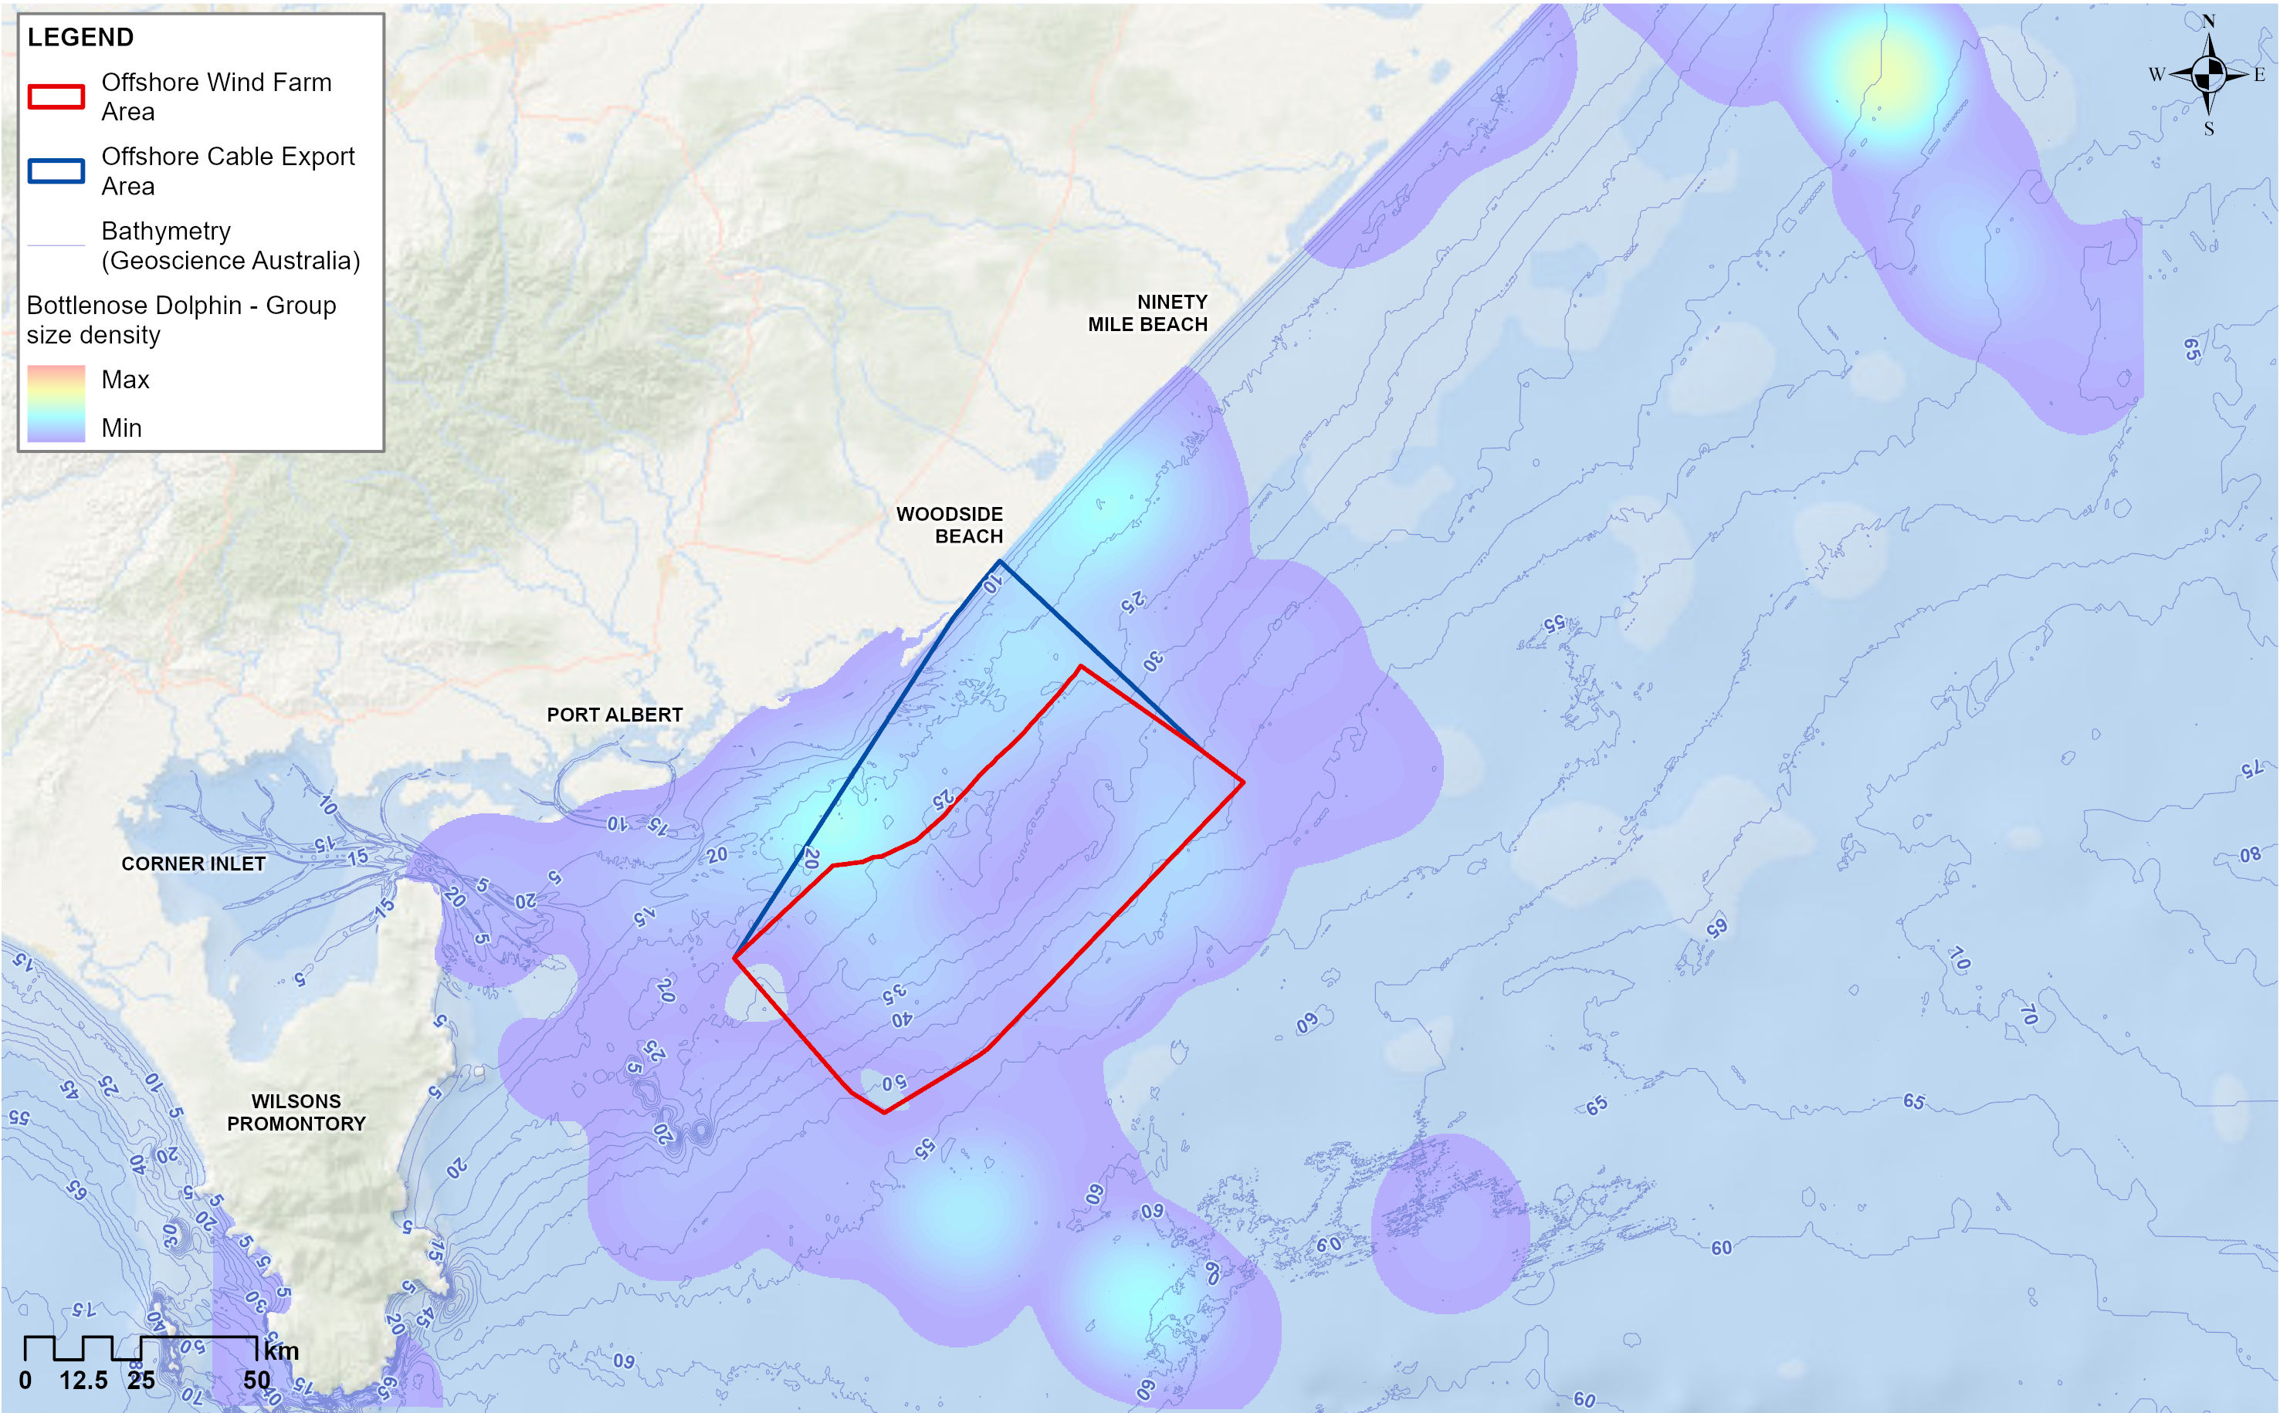

Striped Dolphin
Striped Dolphins (Stenella coeruleoalba) are known to inhabit pelagic and oceanic waters (deeper than 1,000 metres) and are most frequently found in warm tropical and temperate waters where the sea surface temperature exceeds 25 degrees Celsius. As such, the offshore wind farm area is not expected to be important for the Striped Dolphin; however, two ‘like Striped Dolphins’ were observed just outside the north-east corner of the area in September 2021, reportedly feeding amongst a group of Common Dolphins and near feeding Humpback Whales.
Given the shallow water depths of the offshore wind farm area, the presence of Striped Dolphins is expected to be limited to highly occasional individuals. For this assessment, the Striped Dolphin has been considered in a receptor group with other odontocete dolphins that could be present.

Risso's Dolphin
Risso's Dolphins (Grampus griseus) occur in all habitats from coastal to oceanic waters with a strong preference for warm temperate waters of the continental shelf at depths of 180 to 200 metres. From the Victorian Biodiversity Atlas database, only two have been recorded near the offshore wind farm area, both of which were stranded individuals.
There were no visual sightings of Risso's Dolphins during baseline surveys. Dolphin whistles were detected in underwater noise recordings, though they were not identified down to the species level. For this assessment, the Risso's Dolphin has been considered in a receptor group with other odontocete dolphins that could be present.

Killer Whale
Killer Whales (Orcinus orca) have been reported in all Australian state and territory waters, with an increase in sightings off southern Australia. They are most common in cold, deep waters but are also often observed along the continental slope and shelf, particularly near seal colonies.
There are no known aggregations or migratory routes of Killer Whales in Victorian waters. However, historical sightings have been reported to peak in mid-winter (June to July), and their home range is suggested to extend into New South Wales, thereby potentially including the offshore wind farm area. Two Killer Whales were sighted during visual aerial surveys in July.
Killer Whales may be present in the offshore wind farm area, but their presence is expected to be limited to occasional transient individuals or small groups. For this assessment, the Killer Whale has been considered in a receptor group with other odontocete dolphins that could be present.

False Killer Whale
False Killer Whales (Pseudorca crassidens) have a global distribution and are found in deep tropical and temperate pelagic waters. In Australia, strandings have been reported in every state. While there have been no live sightings of False Killer Whales in the Gippsland or broader Victorian region, a stranding was reported at Port Albert, adjacent to the offshore wind farm area.
Although False Killer Whales were predicted to be potentially present by the Protected Matters Search Tool, there were no visual sightings or acoustic detections of False Killer Whales during baseline field surveys. For the assessment, the False Killer Whale has been considered in a receptor group with other odontocete dolphins that could be present.

Pinnipeds (seals)
Based on databases and baseline field surveys, the Australian fur seal and New Zealand fur seal are highly likely to occur in the offshore wind farm area and its surroundings.

Australian Fur Seal
Australian fur seal are endemic to southeastern Australia, with breeding restricted to the continental shelf of Bass Strait between mainland Australia and Tasmania. A total of 10 established Australian fur seal breeding colonies are restricted to islands in the Bass Strait, with the largest being west of Wilsons Promontory Marine National Park. The nearest breeding colonies to the offshore wind farm area are Rag Island (approximately 12.5 kilometres south-west of the offshore wind farm area) and Kanowna Island (approximately 50 kilometres south-west of the offshore wind farm area).
Adult female Australian fur seal are critical to population success due to their role in pup rearing. Both males and females primarily forage within Bass Strait, with a high overlap in foraging areas and a strong reliance on benthic (seafloor) feeding. Some variation in foraging range occurs seasonally, particularly among adult males and juveniles. Using data from the satellite tags and population counts, the behaviour and spatial use of the Kanowna Island and Rag Island colonies and their population size is characterised as follows:
Kanowna Island colony
Foraging trips from adult females were predominantly within central Bass Strait (Figure 11-8), with some individuals resting at haul-out locations and other colonies. None of the tracked Australian fur seal individuals from Kanowna Island entered the offshore wind farm area, and the broad dispersed nature of their habitat use during foraging trips suggests the area does not represent an important foraging zone for the population at this colony (Figure 11-8).
The observed annual pup production of Australian fur seal at Kanowna Island was within the range (1,575 to 2,913) of previously reported numbers for the site, although there is large annual variability. Using this population estimate and tracking data, at-sea density models were developed. The estimated number of Australian fur seal from Kanowna Island in the offshore wind farm area at any given time ranged from 3.0 to 3.5 individuals.
Rag Island colony
Rag Island is located approximately 12.5 kilometres south-west of the offshore wind farm area. Ten females were tagged and monitored from 2020 to 2021, and another 10 from 2021 to 2022, providing the first data of this kind for this colony.
Foraging trip durations and distances are similar to the Kanowna colony; however, there is repeated travel parallel and close to the coastline. All Australian fur seal tagged in 2020 travelled through the offshore wind farm area at least once, with five doing so regularly. In 2021, six of the 10 tagged individuals travelled regularly through the area (Figure 11-9). These movements and habitat use, particularly to the north-east of Rag Island, are associated with sea floor infrastructure. Australian fur seal are known to frequent manmade infrastructure in the Bass Strait, with pipelines and cable routes being the most common.
This population has shown substantial growth in numbers since 2003, with an estimated 637 pups and a colony size of 3,497 individuals in 2022. Using this population estimate and tracking data, at-sea density models were developed. The estimated maximum number of Australian fur seal from Rag Island in the offshore wind farm area during mid-lactation ranged from 145 to 173 individuals. This is likely to be an overestimate because male adults were included in the estimate, but were not tracked; however, they are likely to forage in deeper waters away from the area, as seen in other colonies.
Figure 11-8 Proportional time-spent-in-area (5 × 5 kilometre grid cells)/habitat use by tagged adult female Australian Fur Seal from Kanowna Island in A) winter (mid- to late lactation) 2020 (n=18) and B) spring (post-weaning) 2020 (n=3) - from project tracking data
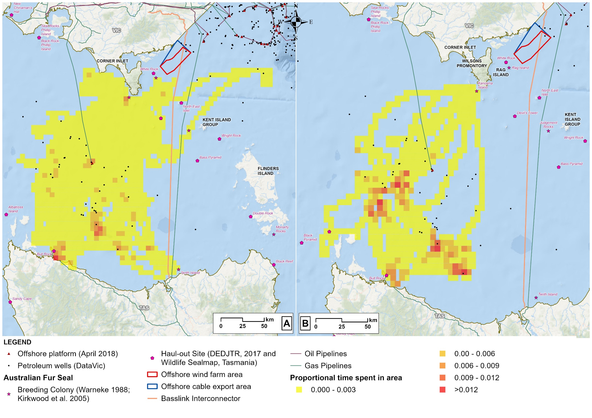
Figure 11-9 Proportional time-spent-in-area (5 × 5 kilometre grid cells)/habitat use by tagged adult female Australian Fur Seal from Rag Island from 2021 to 2022 during A) winter (mid- to late lactation, 10 individuals), B) spring (post-weaning, 10 individuals) and C) summer (early lactation, 4 individuals) as - from project tracking data
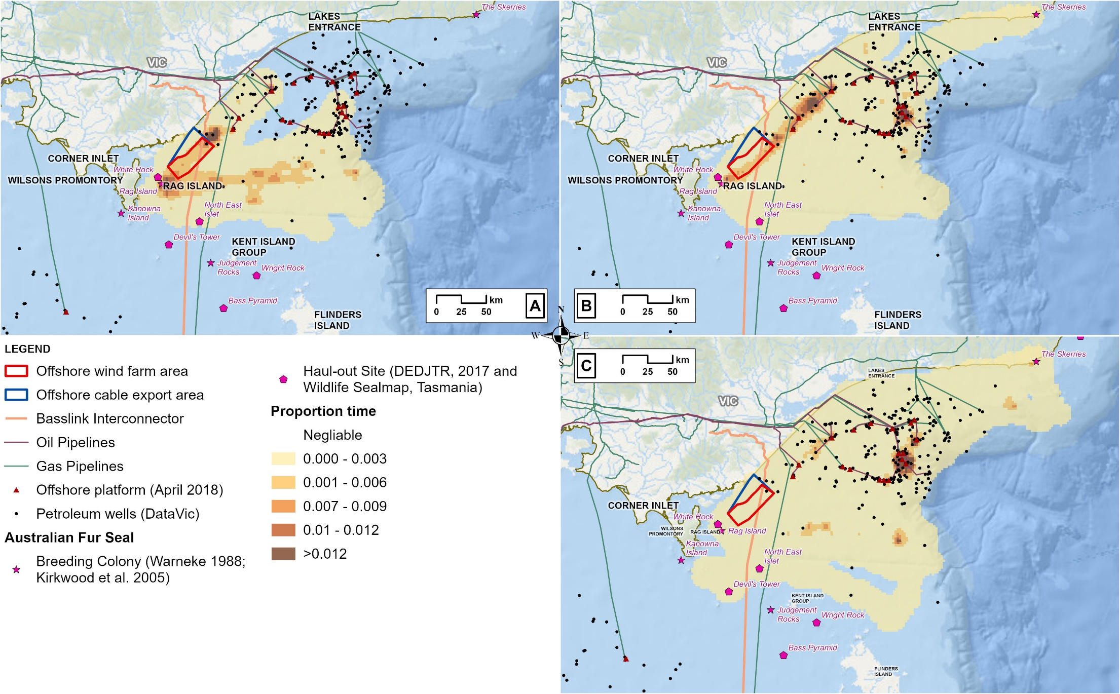

New Zealand Fur Seal
New Zealand fur seal, also known as long-nosed fur seals, have a widespread distribution from the New Zealand and Australian subantarctic islands to temperate northern New Zealand and southern Australia. While most of their breeding sites are outside Victoria, lower-density breeding areas are present in the vicinity of the offshore wind farm area at Kanowna Island. This species has a vulnerable listing under the FFG Act.
The species differ from Australian fur seal as they are epipelagic (surface layer) foragers, predominantly feeding on pelagic fish. As such, they have different foraging distributions from the Australian fur seal despite sharing haul-out sites. At the Kanowna Island colony, New Zealand fur seal foraging ranges over a much greater area than the Australian fur seal, predominantly exploiting waters to the east and south-east of the colony. This was reflected by the individuals tagged, who rarely crossed the offshore wind farm area except briefly during winter (Figure 11-10).
Population counts indicate a continued slow increase in numbers in the region since New Zealand fur seal were first observed in the late 1990s. The current Bass Strait New Zealand fur seal population size is still substantially less than the estimated pre-sealing levels; therefore, colony sizes and the establishment of new (recolonised) areas are likely to continue to increase. Population counts during 2021 indicated 16 pups and an estimated colony size of 56 individuals. Using this population estimate and tracking data, at-sea density models were developed. The model predicted fewer than 0.45 total individuals within the offshore wind farm area at any given time, suggesting the area and its surroundings do not represent important foraging habitats for New Zealand fur seal from Kanowna Island.
Figure 11-10 Proportional time-spent-in-area (5 × 5 kilometres grid cells)/habitat use by tagged adult female New Zealand fur seal from Kanowna Island from 2021 to 2022 during A) winter (mid- to late lactation, 10 individuals), B) spring (post-weaning, 5 individuals) and C) summer (early lactation, 4 individuals) - from project tracking data
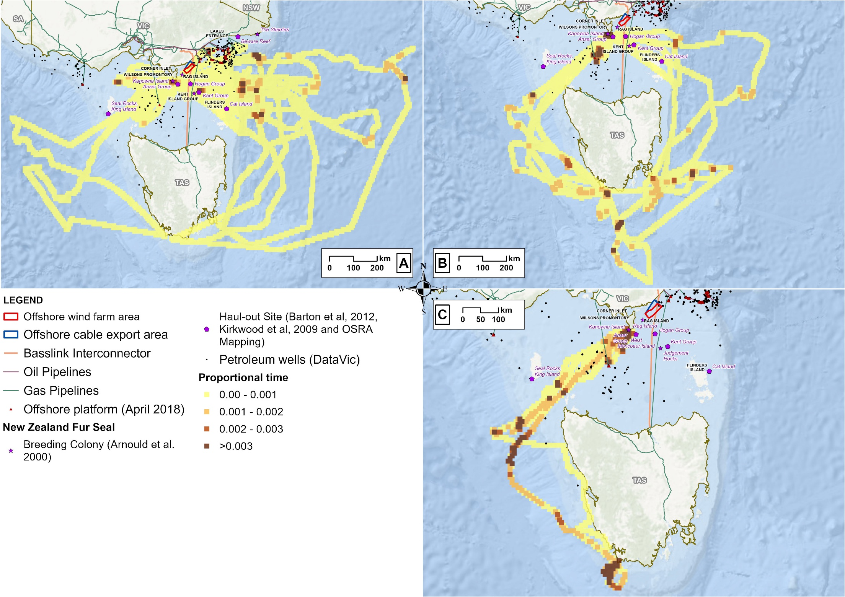

Marine turtles

Leatherback Turtle
Leatherback Turtles feed in coastal waters around central eastern Australia (Sunshine Coast in Queensland to central New South Wales), south-east Australia (Tasmania, Victoria, and eastern South Australia) and south-western Australia, but spend most of their time travelling far distances and foraging in temperate coastal and open ocean areas. Nesting occurs in the Northern Territory during December and January and in other tropical countries towards the equator.
Bass Strait is reportedly a foraging area for Leatherback Turtles, with individuals concentrating in areas where productivity is higher. Databases indicate that, between 1961 and 2024, 49 Leatherback Turtle sightings were recorded in Victoria, of which 18 were in Gippsland. Baseline field surveys observed one ‘likely’ Leatherback Turtle off the western side of Wilsons Promontory in April 2023.
Considering these observations and their Endangered listing under the EPBC Act, the Leatherback Turtle is considered to have the potential to be present in and around the offshore wind farm area and has been included in this assessment as part of the marine turtle receptor group.

Loggerhead Turtle
Loggerhead Turtles are globally distributed. In Australia, they breed in areas that are generally confined to the coastlines of southern Queensland and north-western Western Australia. They forage in the waters of all coastal states and territories, but are uncommon in South Australia, Tasmania and Victoria. There are 13 records of Loggerhead Turtles in Victoria between 1961 and 2024, and a single individual (with a probable species identification) was recorded in January 2021 during seabird aerial surveys. Considering these observations and their Endangered listing under the EPBC Act, the Loggerhead Turtle is considered to have the potential to be present in and around the offshore wind farm area and has been included in this assessment as part of the marine turtle receptor group.

Green Turtle
Green Turtles are distributed in subtropical and tropical waters around the world. In Australia, they are predominantly found off the coastlines of the Northern Territory, Queensland and Western Australia, with limited numbers in Victoria, New South Wales and South Australia. Breeding occurs within these warmer regions, and they very rarely venture further than 1,000 kilometres to forage.
There were 19 sightings of Green Turtles reported in Victoria between 1961 and 2024, but none were recorded during the baseline field surveys. Nevertheless, considering historical observations and its Vulnerable listing under the EPBC Act, the Green Turtle is considered to have the potential to be present in and around the offshore wind farm area and has been included in this assessment as part of the marine turtle receptor group.

Receptor groups for assessment
The receptor groups defined for this assessment comprise three standalone species and four broader groups, as detailed in Table 11-2.
Table 11-2 Receptor groups for the impact and risk assessment, including the species that fall under each group, their conservation status and occurrence in the offshore project area.
Receptor group | Species included | EPBC Act listed | FFG Act listed | Biologically Important Area | Recovery plan/ Conservation advice | Presence in Protected Matters Search Tool | Records in Victoria (VBA or ALA) | Presence in project baseline field surveys
Blue Whale | Blue Whale (Balaenoptera musculus) including Antarctic Blue Whale (B. m. intermedia) and Pygmy Blue Whale (B. m brevicauda, EIO and NZ populations) | EN, Mi, ce | EN | Foraging | ✓ (recovery plan) | ✓ | ✓ | ✓
Southern Right Whales | Southern Right Whale (Eubalaena australis) | EN, Mi, ce | EN | Migration/ Reproduction | ✓ (recovery plan) | ✓ | ✓ | ✓
Humpback Whales | Humpback Whale (Megaptera novaeangliae) | Mi, ce |  |  |  | ✓ | ✓ | ✓
Other mysticetes | Sei Whale (Balaenoptera borealis) | V, Mi, ce |  |  | ✓ (conservation advice) | ✓ | ✓
Other mysticetes | Fin whale (Balaenoptera physalus) | V, Mi, ce |  |  | ✓ (conservation advice) | ✓ | ✓
Other mysticetes | Dwarf Minke Whale (Balaenoptera acutorostrata) | ce |  |  |  |  | ✓ | ✓
Other mysticetes | Antarctic Minke Whale (Balaenoptera bonaerensis) | Mi, ce |  |  |  |  |  | ✓
Other mysticetes | Bryde's Whale (Balaenoptera edeni) | Mi, ce |  |  |  | ✓ | ✓ | ✓
Other mysticetes | Pygmy Right Whale (Caperea marginata) | Mi, ce |  |  |  | ✓ | ✓ | ✓
Odontocete dolphins | Common Dolphin (Delphinus delphis) | ce |  |  |  | ✓ | ✓ | ✓
Odontocete dolphins | Indo-Pacific Bottlenose Dolphin (Tursiops aduncus) | ce |  |  |  | ✓ | ✓
Odontocete dolphins | Bottlenose Dolphin (Tursiops truncatus) | ce |  |  |  | ✓ | ✓ | ✓
Odontocete dolphins | Striped Dolphin (Stenella coeruleoalba) | ce |  |  |  |  | ✓ | ✓ (ID not confirmed)
Odontocete dolphins | Risso's Dolphin (Grampus griseus) | ce |  |  |  | ✓ | ✓
Odontocete dolphins | Killer Whale (Orcinus orca) | Mi, ce |  |  |  | ✓ | ✓ | ✓
Odontocete dolphins | False Killer Whale (Pseudorca crassidens) | ce |  |  |  | ✓ | ✓
Pinnipeds | Australian Fur Seal (Arctocephalus pusillus) | Ma |  |  |  | ✓ | ✓ | ✓
Pinnipeds | New Zealand Fur Seal (Arctocephalus forsteri) | Ma | V |  |  | ✓ | ✓ | ✓
Marine turtles | Leatherback Turtle (Dermochelys coriacea) | EN, Mi, Ma | CE |  | ✓ (recovery plan) | ✓ | ✓ | ✓ (ID not confirmed)
Marine turtles | Loggerhead Turtles (Caretta caretta) | EN, Mi, Ma |  |  | ✓ (recovery plan) | ✓ | ✓ | ✓
Marine turtles | Green Turtle (Chelonia mydas) | V, Mi, Ma |  |  | ✓ (recovery plan) | ✓ | ✓
VBA = Victorian Biodiversity Atlas, ALA = Atlas of Living Australian
EPBC Act listing abbreviations: EN = endangered, V = vulnerable, Mi = migratory, Ma = marine, ce = cetacean
FFG Act listing abbreviations: EN = endangered, V = vulnerable

Construction impacts
This section discusses the impacts and risks associated with the project’s construction that relate to marine mammals and turtles and the respective receptor groups.

Key impacts
The construction impact assessment identified no impacts to marine mammals and turtle receptor groups with a residual consequence rating of moderate or higher.

Other impacts
Other potential construction impact pathways with minor to negligible impacts on marine mammals and turtles include:
- Underwater noise emissions (MMT-I001)
- Routine discharge (MMT-I002)
- Seabed disturbance and sediment plumes (MMT-I003)
- Artificial light emissions (MMT-I004)
- Changes in prey distribution and abundance (MMT-I005).

Underwater noise emissions (MMT-I001)
This section provides an understanding of potential underwater noise impacts from both pile driving activities for the installation of wind turbine monopile foundations, offshore substation jacket foundations and the use of dynamic positioning vessels (which use thrusters to maintain position) for installation activities.

Underwater noise and marine mammal and turtle thresholds
Marine mammals, particularly cetaceans, rely heavily on sound for behaviours such as communication, foraging, navigation and predator avoidance. Sound travels faster underwater, and it serves as one of their key sensory tools.
To understand noise in the ocean, the following measurements are used:
- Frequency indicates how high or low a sound is, such as the difference between a deep whale call (low frequency) and a high-pitched dolphin whistle (high frequency). It is measured in hertz (Hz) or kilohertz (kHz, equivalent to 1,000 Hz). Low frequencies travel further underwater than high frequencies
- Decibels (dB) measure how loud a sound is. However, as sound behaves differently in water than in air, sound pressure is used, which is measured in decibels relative to one micro-Pascal (dB re 1 μPa).
Marine mammals use different frequencies and are sensitive to different decibel levels, meaning they have their own hearing range and sensitivity. Therefore, relative to the intensity, duration and frequency of a noise source, underwater noise can affect marine mammals in the following ways:
- Permanent Threshold Shift refers to a hearing threshold shift that does not return to the pre-exposure level and is considered an injury as a result of noise exposure.
- Temporary Threshold Shift refers to a hearing threshold shift that is temporary and recoverable. In marine mammals, the onset level and growth of temporary threshold shift are frequency-specific.
- Behavioural responses such as avoidance of important habitats, changes in swimming or disruption of feeding. This is generally challenging to quantify as it can be very context-specific.
- Masking effects, which occur when noise overlaps with the frequencies marine mammals use to communicate or detect prey, making it harder for them to hear important sounds.
As marine mammals differ in their hearing capabilities, absolute hearing sensitivity and their frequency band of hearing, broad functional hearing groups can be created. For the assessment, the relevant groups are low frequency cetaceans, high frequency cetaceans and otariid pinnipeds (in water) (Table 11-3).
Table 11-3 Marine mammal and turtle functional hearing groups (Southall et al., 2007; 2019; NMFS, 2024).
Functional hearing group | Generalised hearing range
Low frequency cetaceans | - This group includes all mysticete (baleen) whales. There have been no direct measurements of hearing sensitivity for any of these species.  - The estimated audible frequency hearing range is 7 Hz to 36 kHz.  - Blue Whales and Southern Right Whales are included in this group.
High frequency cetaceans | - This group includes most delphinid species (for example, Bottlenose Dolphin, Common Dolphin and Killer Whale), beaked whales and Sperm Whales.  - The estimated audible frequency hearing range is 150 Hz to 160 kHz.
Otariid pinnipeds  (in water) | - Otariid pinnipeds refers to sea lions and fur seals.  - The estimated audible frequency hearing range (in water) is 60 Hz to 68 kHz.
Marine turtles | - The estimated audible hearing range is 50 Hz to 16 kHz.

Project activities – noise sources
Offshore construction activities will produce underwater noise above background levels, including the emission of impulsive and continuous noise. Impulsive sounds are typically short-duration, single or repetitive, and may show a large change in amplitude over their time course, such as impact piling for the installation of monopile foundations. Continuous noise during construction is produced by vessels and vibro-piling (if used) for the installation of monopile foundations.
The dominant sources of noise during the construction phase are anticipated to be foundation pile driving and vessel noise while using dynamic positioning. These are described as follows:
- Pile driving (also called impact piling) is a technique that involves a large weight being dropped or driven (hammered) on top of a pile to push it into the seabed. The pile is repeatedly driven until it reaches the target depth. The number of blows required to achieve the target depth is influenced by seabed type, pile size and pile driving methods. In the event of pile refusal (where pile driving is not effective), drilling may be used to overcome the refusal before piling recommences. Noise from drilling operations (non-impulsive sound) is less than that from pile driving activities (impulsive sound).
- Dynamic positioning vessels use thrusters to maintain exact vessel position during construction activities. These vessels are likely to be used for foundation, subsea cable (inter-array, interlink and export) and scour protection installation.

Underwater noise modelling approach
Underwater noise modelling studies have been conducted to understand how underwater noise from the project may impact marine mammals and turtles. The process is summarised at a high level below and details can be found in Attachment I – Underwater Noise Modelling Summary Report.
            - Potential underwater noise from construction activities was quantified using two key sound metrics:
  - Peak sound pressure level (PK), which measures the highest per-pulse sound energy released and reflects the intensity of a single noise event (measured in dB re 1 μPa).
  - Sound exposure level (SEL24h), which represents the total accumulated sound energy an individual may be exposed to from the activity over a 24-hour period, accounting for both the intensity and duration of exposure (measured in dB re 1 μPa². s).
            - Sound pressure and exposure levels (PK and SEL24h) were quantified for the functional hearing groups in Table 11-3. These numbers help understand when impulsive (Table 11-4) and continuous (Table 11-5) noise levels from construction may cause the onset of behavioural responses, permanent threshold shift and temporary threshold shift for each receptor group. The SEL24h levels were frequency-weighted to account for what each species can hear based on their hearing sensitivity. As Southern Right Whales may be at increased susceptibility to elevated underwater noise, precaution has been added to their sound exposure thresholds.
Table 11-4 Sound exposure thresholds for marine mammal and turtle functional hearing groups to impulsive noise sources (impact piling)
Functional hearing group | Behavioural response | Permanent threshold shift onset |  | Temporary threshold shift onset
Functional hearing group | SPL (dB re 1 μPa) | PK  (dB re 1 μPa) | Weighted SEL24h (dB re 1 μPa².s) | PK  (dB re 1 μPa) | Weighted SEL24h (dB re 1 μPa².s)
Low frequency cetaceans | 160 (unweighted) | 222 | 183 | 216 | 168
Southern Right Whale female and calf pairs | 140 (weighted*)
High frequency cetaceans | 160 (unweighted) | 230 | 193 | 224 | 178
Otariid pinnipeds (in water) | 160 (unweighted) | 230 | 185 | 224 | 170
Marine turtles | 166 (unweighted) | 230 | 184 | 224 | 169
* Southern Right Whales may be at increased susceptibility to elevated underwater noise; therefore, precaution has been added.
Table 11-5 Sound exposure thresholds for marine mammal and turtle functional hearing groups to continuous noise sources (vessels)
Functional hearing group | Behavioural response | Permanent threshold shift onset | Temporary threshold shift onset
Functional hearing group | Unweighted SPL  (dB re 1 μPa) | Weighted SEL24h  (dB re 1 μPa².s) | Weighted SEL24h  (dB re 1 μPa².s)
Low frequency cetaceans | 120 | 197 | 177
Hight frequency cetaceans | 120 | 201 | 181
Otariid pinnipeds (in water) | 120 | 199 | 179
Marine turtles | - | 220 | 200
            - Using noise data quantified for construction activities and the sound exposure levels for each functional hearing group, underwater modelling was used to simulate construction activities at different locations across the offshore wind farm area. This provided a maximum predicted effect range (as a distance from the source) for which behavioural response, permanent threshold shift and temporary threshold shift thresholds of the different groups would be exceeded. This modelling was conducted for a variety of scenarios, as discussed in the following section.
It should be noted that underwater noise modelling includes a significant degree of conservatism and is likely to over-estimate noise levels. Key inputs or model features that contribute to over estimation of noise include conservative noise effect thresholds, the use of the largest pile diameters, upper hammer energy levels in each depth layer, upper estimates of total pile duration and hammer strikes, and the use of the worst-case season (winter).

Underwater noise modelling scenarios
A series of underwater noise modelling rounds were conducted for a variety of scenarios using parameters relevant to different foundation types, construction methods, noise abatement systems, location depth, seasonality and modelling methods that account for animal behaviour. Scenarios included:
- Modelling 'static' receptors: Assessing the underwater noise effect ranges from impact piling of wind turbine monopile foundations and offshore substation jacket foundations (single and four pin piles) at different depths in the offshore wind farm area on 'static' receptors. The use of static receptors is a highly conservative assumption that marine mammals and turtles remain stationary for 24 hours in the impact area during the noise-generating activity. This results in an over estimation of the likely exposure of animals to noise.
A Double Big Bubble Curtain releases two rings of bubbles around an activity, acting like a sound shield. When construction noise reaches the bubble walls it is scattered and reduced before it can travel further.
A Hydro Sound Dampener is a physical curtain made of materials that absorb or block some of the sound before it spreads through the water.
The effectiveness of noise abatement systems for impact piling was assessed including the use of a Double Big Bubble Curtain, a Hydro Sound Dampener and the combination of the two. Results indicate that the combination of both mitigations resulted in smaller predicted effect ranges, although was only marginally more effective than the Double Big Bubble Curtain alone.
- Modelling mobile receptors: As it is highly unlikely animals will remain stationary for 24 hours within the area during construction, modelling taking movement into account was conducted for the Blue Whale, Southern Right Whale, Humpback Whale and Minke Whale. Mobile receptor modelling uses the Animat model, which accounts for the likely behaviour of the animal during exposure to underwater noise. By using best available behavioural data for each species (for example, diving and foraging depth, swim speed and surface times), the model provides a more realistic picture of noise effect ranges.
- Modelling vibro-piling: A pile installation method called vibro-piling was also modelled. Vibro-piling vibrates the pile into the seabed rather than hammering and avoids the higher impulsive noise from impact pile driving. Results indicate noise effect ranges were larger for vibro-piling, likely due to lack of data on its effectiveness in combination with noise mitigation technologies as it is a new technology. Therefore, this method was not considered further in the assessment. The proposed Underwater Noise Management Framework (Attachment III – Construction Underwater Noise Management Framework) includes a process to conduct modelling closer to construction and select the optimal pile installation technology at the time.
- Modelling vessel noise: Assessing the underwater noise effect ranges from dynamic positioning vessels at a shallow and deep location in the offshore wind farm area, on static receptors and mobile receptors for the sensitive low frequency cetaceans. This modelling used a newly available vessel source noise level from a surrogate vessel that was measured during operations in the Gippsland region.
For detail on the modelling scenarios and their outcomes see Technical Report D – Marine Mammals and Turtles and Technical Report Attachment I – Underwater Noise Modelling.

Underwater noise modelling results
This section presents the outcomes of underwater noise modelling, using the predicted worst-case effect ranges for low frequency cetacean species (the most noise-sensitive group) during winter (the season in which noise propagation is greatest).
Table 11-6 presents the worst-case modelling for monopile installation (both shallow and deepest locations) and pin pile installation (both single pin and four piles installed in a single day). Final modelled noise ranges for installation vessels using dynamic positioning at an intermediate and deep site in the offshore wind farm area are presented in Table 11-7.
Results for other groups and noise propagation during summer can be found in Technical Report D – Marine Mammals and Turtles and Technical Report Attachment I – Underwater Noise Modelling.
Table 11-6 Mobile receptor exposure ranges (ER95%) in kilometres to permanent threshold shift, temporary threshold shift and behavioural response thresholds for Blue Whale, Southern Right Whale, Humpback Whale and Minke whale (Antarctic and Dwarf combined) to cumulative (multiple strike) noise exposure from impact pile driving of a monopile and pin pile foundations
Species | Sound exposure threshold | Shallow Monopile (21 m) | Deepest Monopile (51 m) | Single pin pile | Four pin piles
Blue Whale | Permanent threshold shift onset | - | 0.06 | 0.62 | 1.08
Blue Whale | Temporary threshold shift onset | 4.60 | 0.86 | 6.61 | 10.50
Blue Whale | Behavioural response | 5.20 | 2.08 | 2.27 | 2.15
Southern Right Whale | Permanent threshold shift onset | - | - | 0.51 | 1.46
Southern Right Whale | Temporary threshold shift onset | 1.49 | 0.37 | 4.73 | 7.65
Southern Right Whale | Behavioural response (160 dB unweighted) | 4.49 | 1.48 | 2.14 | 2.13
Southern Right Whale | Behavioural response cow/calf pairs (140 dB weighted) | 5.68 | 2.41 | 8.21 | 8.23
Humpback Whale | Permanent threshold shift onset | 0.20 | - | 0.78 | 1.54
Humpback Whale | Temporary threshold shift onset | 4.27 | 1.43 | 6.26 | 8.97
Humpback Whale | Behavioural response | 4.79 | 1.84 | 2.27 | 2.28
Minke whale | Permanent threshold shift onset | - | - | - | 0.02
Minke whale | Temporary threshold shift onset | 1.42 | 0.08 | 3.40 | 4.66
Minke whale | Behavioural response | 4.68 | 1.83 | 2.24 | 2.16

Table 11-7 Mobile receptor exposure ranges (ER95%) in kilometres to permanent threshold shift, temporary threshold shift and behavioural response (120 dB re1 µPa) thresholds for blue whales, southern right whales and humpback whales to dynamic positioning vessel noise in winter
Species | Sound exposure threshold | Intermediate (29.7 metres) | Deep (51.4 metres)
Blue Whale | Permanent threshold shift onset | - | -
Blue Whale | Temporary threshold shift onset | 0.21 | 0.15
Blue Whale | Behavioural response | 11.6 | 7.79
Southern Right Whale | Permanent threshold shift onset | - | -
Southern Right Whale | Temporary threshold shift onset | 1.09 | 1.00
Southern Right Whale | Behavioural response | 10.8 | 7.87
Humpback Whale | Permanent threshold shift onset | - | -
Humpback Whale | Temporary threshold shift onset | 0.77 | 0.83
Humpback Whale | Behavioural response | 10.8 | 7.82
Minke whale | Permanent threshold shift onset | - | -
Minke whale | Temporary threshold shift onset | 0.02 | 0.02
Minke whale | Behavioural response | 10.8 | 7.20

Impact assessment for mysticetes
Baleen whales are low frequency cetaceans and include the Southern Right Whale, Blue Whale and Humpback Whale, along with the other mysticetes detailed in Section 11.5.2. These species are considered to have a high sensitivity rating to the impacts of underwater noise.

Southern Right Whale
Baseline survey data suggests the biologically important area for Southern Right Whale reproduction nearby the offshore wind farm area is unlikely to be an important calving area. There were few resights of individuals in the area, suggesting low levels of persistence, and no social sounds were recorded, suggesting the area is more likely being used for resting and slow travel.
A conservative behavioural response threshold (frequency weighted) was applied to assess the potential for disturbance to Southern Right Whale mother / calf pairs from impact piling for monopile foundations. Results indicate that behavioural responses could occur within approximately 5.68 kilometres (Table 11-6), the onset of permanent threshold shift within 50 metres, and temporary threshold shift within 1.49 kilometres, none of which overlap with the biologically important area for reproduction (Table 11-6). In the unlikely event that individuals remained static for a 24-hour period, temporary threshold shift could be experienced within nine kilometres.
Behavioural responses of cow / calf pairs to pin pile installation for jacket (substation) foundations could be experienced within 8.21 kilometres (Table 11-6) and behavioural disturbance could be experienced up to 10.8 kilometres when vessels are piling and using dynamic positioning at the same time (Table 11-6). In the unlikely event that individuals remained static for a 24-hour period, temporary threshold shift could be experienced within twelve kilometres. As these distances could overlap with the reproductive biologically important area, a targeted mitigation measure will be used to ensure that Southern Right Whales are not exposed to noise levels greater than the behavioural noise threshold for cow / calf pairs (140 dB SPL) within the reproductive biologically important area between May to September (UWN-M05). Where reasonably practicable Star of the South will avoid installing the export cable within the reproduction biologically important area between May and September (UWN-M15).
There is potential for Southern Right Whales to migrate through the offshore wind farm area outside of the reproductive biologically important area. As a mitigation to prevent hearing impairment or behavioural disturbance of these animals, the area potentially affected by noise across all depths will be monitored by marine fauna observers to initiate stop works procedures where required (UWN-M06 and UWN-M10, see mitigations in Table 11-8). Adaptive management measures (UWN-M14) will be in place in the event that behaviour, occurrence or abundance is different to what has been predicted (see Attachment III – Construction Underwater Noise Management Framework).
With mitigation measures in place, the disturbed area is very small compared to the broad area of potential migratory habitat and any localised avoidance is not expected to have a significant impact to Southern Right Whales.

Blue Whale
The project lies within the eastern boundary of the Blue Whale foraging biologically important area. Monitoring / mitigation measures have been designed in line with the species' conservation management plan.
Baseline survey data indicates that the offshore wind farm area is not important foraging habitat for Blue Whales. Both observations and acoustic monitoring suggest Blue Whales do not persist in the area, with occasional migratory individuals present during late autumn and winter.
Mobile receptor modelling, that incorporates species specific movement behaviour, indicates that individuals could experience permanent threshold shift within 60 metres or temporary threshold shift within 4.6 kilometres from impact piling of monopiles (Table 11-5). The temporary threshold shift range is slightly higher for pin pile installation at 6.61 kilometres (Table 11-6). Behavioural disturbance could be experienced up to 11.6 kilometres when vessels are both piling and using dynamic positioning at intermediate depths, decreasing to 7.79 kilometres in deeper sections.
The presence of Blue Whales is likely to be limited to occasional migratory individuals. As a mitigation to prevent hearing impairment or behavioural disturbance of these animals, the area potentially affected by noise across all depths will be monitored by marine fauna observers to initiate stop works procedures where required (UWN-M06 and UWN-M10, see mitigations in Table 11-8). Adaptive management measures (UWN-M14) will also be in place if behaviour, occurrence or abundance is different to what has been predicted (see Attachment III – Construction Underwater Noise Management Framework).
With potential avoidance ranges being small compared to the amount of habitat available, and considering the species prefers deeper waters, any avoidance of the noise source is not expected to impact critical behaviours.

Humpback Whale
Humpback Whales migrate up and down the east coast of Australia mainly during winter and spring. There are no biologically important areas for the species close to the offshore project area. The area potentially affected by noise from the project is not likely to affect biologically important behaviour. Monitoring and mitigation measures for the species have been designed to prevent permanent threshold shift and minimise the risk of temporary threshold shift and behavioural disturbance.
Mobile receptor modelling indicates that permanent threshold shift, temporary threshold shift and behavioural effect ranges for Humpback Whales in shallower sections of the offshore wind farm area are around 200 metres, 4.27 kilometres and 4.79 kilometres from impact piling, respectively, with these ranges decreasing in deeper waters (Table 11-6). Permanent threshold shift onset from the installation of a single pin pile is slightly higher at around 780 metres (Table 11-6).
As a mitigation to prevent hearing impairment, the permanent threshold shift range from piling across all depths will be monitored by marine fauna observers to initiate stop works procedures where required (UWN-M06, UWN-M10) to ensure no permanent injury to Humpback Whales. The potentially noise affected area equates to a very small proportion of the species' entire migration corridor (Humpback Whales, including calves, were present more frequently in the offshore wind farm area during their southern migration (September to early December) than their northern migration (April to August), but have the potential to be in the area for both migration journeys.
Figure 11-5) and therefore pile driving activities will not cause a barrier to migration.

Other mysticetes
There are no biologically important areas for other mysticetes in proximity to the offshore wind farm area, and there are low numbers of historical sightings in the region. However, monitoring and mitigation measures will be undertaken in accordance with Attachment III – Construction Underwater Noise Management Framework to prevent hearing impairment and minimise the risk of temporary threshold shift and behavioural disturbance to other mysticetes.
Mobile receptor modelling (based on the Minke Whale) indicates that individuals could experience permanent threshold shift and temporary threshold shift within 20 metres and 1.42 kilometres from impact piling, respectively (Table 11-6). As a mitigation to prevent hearing impairment, the permanent threshold shift range from piling across all depths will be monitored by marine fauna observers to initiate stop works procedures where required (UWN-M06, UWN-M10).
The offshore wind farm area and surrounding waters do not represent important breeding, resting, migrating or foraging habitat for other mysticetes, and it is assumed that any presence in the area is sporadic and primarily in deep water outside the exposure thresholds.

Impact assessment for odontocetes
Odontocetes are high frequency cetaceans and include Bottlenose Dolphins, Common Dolphins, Striped Dolphins, and Killer Whales. There are no biologically important areas for dolphins or Killer Whales near the offshore wind farm area, and no listing advice or recovery plans. All species have been grouped together for this assessment. Detailed modelling outputs for exposure thresholds related to this group can be found in Technical Report D – Marine Mammals and Turtles and Technical Report Attachment I - Underwater Noise Modelling.
Evidence from offshore wind farms in other countries suggests that dolphins tend to avoid pile driving activities then return a few days after the activity ceases. This avoidance behaviour may diminish over time as odontocetes can habituate to noise, as seen in overseas offshore wind farm construction periods and the progressive habituation of Harbour Porpoises (Phocoena phocoena). While the response of Killer Whales to impulsive noise remains uncertain, it is plausible that their behaviour is similar to that of other dolphins.
Static modelling indicates that the onset of temporary threshold shift for high frequency odontocetes from a single pin pile installation for jackets could occur within 60 metres of the source, noting that permanent threshold shift thresholds were not reached within the 20 metre resolution of the model for piling at all depths. Based on experience from other offshore wind farms, it is highly unlikely that any odontocete would remain within 60 metres of a pile-driving site for a 24-hour period and therefore, the onset of permanent threshold shift or temporary threshold shift is not considered probable. Behavioural responses could occur within 5.64 kilometres in shallow water and 2.72 kilometres in deep water, although these ranges are conservative, particularly if habituation occurs.
Static modelling indicates that the onset of permanent threshold shift and temporary threshold shift for high frequency odontocetes from vessel noise using dynamic positioning could occur within 20 metres and 160 metres, respectively. Given the transient nature of odontocetes, it is unlikely they would remain within 160 metres of a vessel for a 24-hour period. As a result, the predicted permanent threshold shift and temporary threshold shift thresholds are not expected to be reached.

Impact assessment for pinnipeds
Pinnipeds, including Australian fur seals and New Zealand fur seals, are less sensitive to the noise associated with pile driving compared to groups like the baleen whales. The Australian fur seal and New Zealand fur seal have breeding colonies in proximity to the offshore wind farm area. Tracking data indicates that Australian fur seals from the Rag Island colony occur regularly throughout the offshore wind farm area and surrounding waters when travelling to foraging grounds in the north-east. In contrast, the offshore wind farm area and surrounding waters do not represent important foraging habitat for Australian fur seals or New Zealand fur seals from Kanowna Island - they are therefore expected to occur less frequently.
Evidence from offshore wind farms overseas suggests that seals may avoid areas around pile driving activities but could return a few hours after the activity ceases. As such, fur seals are expected to behaviourally avoid piling noise and are considered highly unlikely to move within 50 metres of a pile driving location or remain there for a 24-hour period to be subject to the onset of temporary threshold shift, noting that permanent threshold shift thresholds were not reached within the 20-metre resolution of the model for piling at all depths. The extent of behavioural impacts is less than 5.6 kilometres during monopile impact piling, which is less than the distance to the nearest fur seal colony at Rag Island (approximately 12.5 kilometres), and therefore pile driving is not expected to impact occupancy of this colony, or the further afield Kanowna Island colony.
It is highly unlikely that a fur seal would remain within 140 metres of a vessel for a 24-hour period and therefore permanent threshold shift and temporary threshold shift onset from vessel noise are not expected. Furthermore, while behavioural effects may occur, particularly for Australian fur seals at Rag Island, fur seals are likely to become accustomed to vessel noise given their existing exposure to nearby shipping lanes.

Impact assessment for marine turtles
While there have been few studies on the hearing sensitivity of marine turtles, they do not appear to use sound for communication; however, they may use sound for navigation, locating prey, avoiding predators and general environmental awareness. During baseline surveys, a single Loggerhead Turtle (probable species identification) was recorded in January, and a single ‘likely’ Leatherback Turtle was recorded in April. Given this, in addition to low historical sightings and the lack of critical habitats (nesting beaches) and biologically important areas in the region, marine turtles are only expected to occur rarely and transiently within the offshore wind farm area.
There is a low probability of turtles being present within the offshore wind farm area and remaining there for 24 hours within permanent threshold shift (1.37 kilometres) and temporary threshold shift (8.71 kilometres) ranges from a single pin pile impact driving location, or within temporary threshold shift (40 metres) ranges from a vessel using dynamic positioning. While noise behavioural responses would be short term, such as altered swimming or diving, any effects are unlikely to impact important behaviours or be significant at a population level.

Mitigation measures for underwater noise
A comprehensive suite of mitigation measures will be implemented to reduce exposure to underwater noise and potential impacts for all marine mammals and turtle species (and other marine species). These mitigations have been developed focusing on proven technologies and measures and drawing on global experience and learnings from projects such as Vineyard Wind 1 and Empire Wind 1 in the United States that have successfully implemented mitigation measures for similar low frequency cetaceans.
Because the offshore wind farm area overlaps the biologically important areas for the Blue Whale and Southern Right Whales, more stringent mitigation measures have been proposed for these species to ensure they are not subject to hearing impairment or behavioural disturbance within these important areas, in line with the species' National Recovery Plan.
The mitigation measures are designed to complement one another, so that visual observations from marine fauna observers are accompanied by noise monitoring to detect the presence of marine mammals, which subsequently informs operational procedures in the field to commence or pause piling or adapt measures. These are detailed in see Attachment III – Construction Underwater Noise Management Framework.
The commitment to use the best available noise abatement techniques will ensure that the latest and most appropriate technology is used to reduce noise at the source, and/or within the near-field environment, at the time of construction. This maintains the ability for the project to adopt emerging noise reduction methods that may become available in coming years.
The full list of mitigation measures specific to underwater noise are described in Table 11-8. Further details are provided in Attachment III – Construction Underwater Noise Management Framework.
Table 11-8 Mitigation and monitoring measures for impacts associated with construction piling and vessel noise during the construction phase
Mitigation ID | Mitigation / management measure | Description
UWN-M01 | Piling soft start procedure | Soft start and ramp-up of hammer energy measures will be used at the start of each impact pile driving activity for both monopile and jacket pile foundations. This involves using lower hammer energies at the beginning of the piling sequence before the energy input applied by the hammer is ‘ramped up’ (increased) over time to the required higher levels.  Soft start and ramping up of energy during piling aims to discourage wildlife from remaining near the noise source and reduce the number of individuals within hearing impairment ranges.  Each piling event would start with a minimum of 10 minutes at 10% of the maximum hammer energy, followed by a gradual ramp-up for at least 20 minutes up to 80% of the maximum hammer energy for all pile driving activities.
UWN-M03 | Noise abatement system | The best available noise abatement system at the time of construction will be used. It must meet the noise level limit (refer UWN-M04) and be suitable for the water depths, metocean conditions, pile size and vessels, as detailed in the Construction Underwater Noise Management Framework.  Currently the project's noise abatement system includes a double big bubble curtain. To ensure its efficacy, Star of the South will have a double big bubble curtain management procedure in place that involves hose drilling, testing and flushing, visual assessments of bubbles, connection maintenance, compressor pressure monitoring, metocean monitoring and reporting to ensure that piling only occurs while the double big bubble curtain is functional.
UWN-M04 | Noise level limit for pile driving activities | Piling activities will be managed to ensure that the noise level at set distances are equal to, or less than, those defined in the pre-construction modelling as per the Construction Underwater Noise Management Framework.
UWN-M05 | Southern Right Whale Reproductive biologically important area limit | Piling activities will be managed to ensure that Southern Right Whales are not exposed to noise levels greater than 140 dB SPL (impulsive piling) when within the reproduction biologically important area between May-September.  Where reasonably practicable, piles on the offshore side of the offshore wind farm area (further away from the reproduction biologically important area) will be installed between May-September and inshore piles between October-April (when whales are less likely to be present). If this is not reasonably practicable, management controls on piling operations will be as per the monitoring and adaptive management procedure for pile driving operations in the Construction Underwater Noise Management Framework (Section 4.4).
UWN-M06 | Marine fauna observers | Sufficient marine fauna observation operators and vessels will deployed to ensure visible coverage of the precaution zone (as defined in the Construction Underwater Noise Framework) based on the final round of modelling, as per the Construction Underwater Noise Framework.  Any crew used as marine fauna observers will be appropriately trained.  All marine fauna observers will be suitably qualified and experienced in accordance with EPBC Act PS 2.1.
UWN-M07 | Passive acoustic monitoring | Passive acoustic monitoring systems will be used to support the detection of vocalising whale species that are not easily observed at the surface and during low visibility conditions (including nighttime).  Long range detection methods and real time systems will be investigated.  All passive acoustic monitoring operators will be qualified and experienced.
UWN-M08 | Pre-start-up marine mammal surveillance | A 30 minute pre-start whale surveillance period will apply before commencement of the soft start procedure at each piling location. Sufficient trained and experienced marine fauna observers will be deployed to ensure coverage of the precaution zone, supported by a passive acoustic monitoring array.
UWN-M09 | Start-up delay procedure | If marine fauna are detected within the relevant species-specific precaution zone of a piling location, start-up will be delayed until it/they are confirmed to have left the zone or 30 minutes after the last detection.
UWN-M10 | Operations procedure | Species specific precaution zones will be under continuous surveillance (visual and acoustic) during all pile driving operations. The size of the precaution zones will be refined in response to pre-construction noise modelling and in-field noise verification around representative piling locations.  If piling is paused for operational reasons, marine fauna observations will continue and if marine fauna are detected within the precaution zone, re-start will be delayed until the precaution zone is clear. Once the precaution zone is clear for 30 minutes, soft start procedures will recommence.
UWN-M11 | Stop work procedure | If marine fauna are detected within the relevant precaution zone for each species, pile driving will cease or hammer energy be reduced to the lowest feasible level when safe to do so.  Pile driving will not resume until the animal has moved out of the precaution zone or has not been sighted for 30 minutes. Following this, piling will resume in accordance with the stop work procedure (to be developed prior to construction).
UWN-M12 | Night-time monitoring | Although piling is not planned to occur at night, there is the potential for daytime piling to run over into the evening or nighttime. Effective detection of whales at night will be achieved through a combination of passive acoustic monitoring and 360 degree scanning thermal infra-red cameras (or similar) on support vessels, ensuring coverage of the precaution zone.  Whale detections at night will trigger the mitigation measures outlined in UWN-M09, UWN-M10 and UWN-M11 above.
UWN-M13 | Night-time and low visibility procedures | If three or more whales are detected within the relevant precaution zone on any day, piling activities will cease (as soon as safe to do so) during non-daylight hours, in the event that no effective nighttime detection is available.  Piling will recommence in daylight hours the following day, and night operations can continue as long as less than three shutdown events are observed within the precaution zone during daylight hours.
UWN-M14 | Adaptive management procedure for whales | An adaptive management procedure will be implemented if behaviour, occurrence or abundance is different to the predictions used for noise management, as detailed in the Construction Underwater Noise Management Framework.  Examples of behavioural triggers include:  - Three or more Southern Right Whales or Blue Whales are recorded in the precaution zone  - Repeated or sustained (>30 minutes) blue whale feeding is observed within or adjacent to the precaution zone  - A Southern Right Whale mother and calf pair are observed resting by within or adjacent to the precaution zone.  Examples of potential adaptive management include:  - Larger precaution zones that can be realistically managed  - Long range surveys  - Increased observation platforms and/or methods  - Increased coverage marine fauna observers  - Additional noise abatement systems  - Modified noise abatement systems.
UWN-M15 | Installation of export cable within Southern Right Whale biologically important area | If reasonably practicable, Star of the South will avoid installing export cables within the Southern Right Whale reproduction Biologically Important Area between May-September.  If this is not reasonably practicable, and a Southern Right Whale is detected by a marine fauna observer, dynamic positioning will be powered down to the lowest possible safe setting and not powered up again until at least 30 minutes has elapsed since the most recent sighting.  This measure is designed to limit operations during periods when there is a higher likelihood of Southern Right Whale presence in the area.

Residual impacts
Following the implementation of mitigation measures, the magnitude of impact to Blue Whales, Southern Right Whales, Humpback Whales and other mysticetes is decreased from medium to negligible and the initial consequence rating is reduced from major to a residual consequence of minor, with any impacts unlikely to significantly affect the behaviour, migration, foraging and / or survival rates of the species (Table 11-9).
The sensitivity of odontocetes, pinnipeds and marine turtles to underwater noise is considered low, and the small thresholds mean the magnitude is considered low. As a result, the initial and residual impact on this group of species is considered negligible (Table 11-9).
Table 11-9 Residual impacts associated with underwater noise during construction
Potential impact | Receptor | Receptor sensitivity | Magnitude | Initial consequence | Mitigation | Residual consequence
Hearing impairment, masking and behavioural disturbance | Blue Whale  Southern Right Whale  Humpback Whale  Other mysticetes | High | Medium | Major | UWN-M01, UWN-M03,  UWN-M04, UWN-M05,  UWN-M06, UWN-M07,  UWN-M08, UWN-M09,  UWN-M10, UWN-M11,  UWN-M12, UWN-M13,  UWN-M14, UWN-M15 | Minor
Hearing impairment, masking and behavioural disturbance | Odontocetes  Pinnipeds  Marine Turtles | Low | Low | Negligible | UWN-M01, UWN-M03,  UWN-M04, UWN-M06,  UWN-M08, UWN-M09,  UWN-M10, UWN-M11,  UWN-M12, UWN-M14 | Negligible

Routine discharge (MMT-I002)

Potential impact
Normal vessel operations entail routine discharges of small volumes of liquids and solids. This could impact marine mammals and turtles through a decline in water quality and presents a very low risk of introducing non-indigenous marine species, as discussed and assessed in Chapter 9 – Benthic Ecology and Chapter 10 – Fish and Invertebrates.

Mitigation
Potential vessel discharge impacts will be mitigated with a vessel operation framework (VES-M01), which will adhere to the International Convention for the Prevention of Pollution from Ships (MARPOL). As a precaution, a restriction on routine discharges within the Southern Right Whale reproduction biologically important area between May and September has been adopted to ensure no impact while this species may be present. No discharges will occur if a marine mammal or turtle is observed within 500 metres of a vessel (VES-M08).

Residual impact
Considering these mitigation measures, and that controlled levels of discharge will be rapidly diluted by waves and currents, impacts related to routine discharges are expected to be localised, intermittent and short-term. As such, initial and residual impacts to marine mammals and turtles are negligible (Table 11-10).
Table 11-10 Residual impacts associated with routine discharge
Potential impact | Receptor | Receptor sensitivity | Magnitude | Initial consequence | Mitigation | Residual consequence
Reduced water quality leading to changes in fauna behaviour/health | All marine mammals and turtles | Low | Negligible | Negligible | VES-M01  VES-M08 | Negligible

Seabed disturbance and sediment plumes (MMT-I003)

Potential impact
Construction activities involving seabed preparation, cable installation, piling, and vessel activities may disturb the seabed and create sediment plumes (elevated concentrations of suspended sediment). Depending on the activity, sediment plumes may extend beyond the immediate construction area. Sediment dispersion modelling indicates concentrations of five milligrams per litre expanding to an area of 0.7 square kilometres during cable trenching and 16.6 square kilometres during drilling (if required due to pile refusal). The high-energy wave and current environment within the offshore project area means that conditions are likely to return to normal within hours (for cable trenching) or several tidal cycles (for drilling).
For most marine mammals these impacts are not expected to be significant because the species and their habitats are widespread. Species most likely to be affected are benthic foragers (including the Australian fur seal, Loggerhead Turtle and Green Turtle) as the suspended sediment may settle over benthic habitat. This form of habitat disturbance is also a potential impact to dolphins.

Residual impacts
Any sediment disturbance is expected to be localised, small scale and temporary, as discussed and assessed in Chapter 9 – Benthic Ecology. As such, initial and residual impacts to marine mammals and turtles are negligible (Table 11-11).
Table 11-11 Residual impacts associated with sediment disturbance and sediment plumes
Potential Impact | Receptor | Receptor sensitivity | Magnitude | Initial consequence | Mitigation | Residual consequence
Reduced water quality leading to changes in fauna behaviour/health | Odontocetes – dolphins  Pinnipeds – Australian fur seal  Marine turtles | Low | Negligible | Negligible | - | Negligible

Artificial light emissions (MMT-I004)

Potential impact
During construction, artificial light may be emitted from vessels and buoys, increasing light levels in otherwise relatively dark areas. Under the National Light Pollution Guidelines for Wildlife, impacts should be considered up to 20 kilometres from the light source for important habitats, including nesting beaches for marine turtles. Nesting habitats do not occur in proximity to the offshore wind farm area, and marine turtle presence in the area and surrounding waters is expected to be limited to highly occasional, transient individuals.

Mitigation
Potential light emission impacts will be minimised by adhering to the National Light Pollution Guidelines for Wildlife and limiting light sources, including colour and light spill, where it is safe to do so (LIT-M01).

Residual impact
Artificial light emissions will be very localised. Initial and residual impacts to marine turtles and all other receptor groups are negligible (Table 11-12).
Table 11-12 Residual impacts associated with artificial light emissions
Potential impact | Receptor | Receptor sensitivity | Magnitude | Initial consequence | Mitigation | Residual consequence
Change in fauna behaviour | Marine turtles | Low | Negligible | Negligible | LIT-M01 | Negligible

Changes in prey distribution and abundance (MMT-I005)

Potential impact
Marine mammals and turtle prey species include krill, other invertebrates (including benthic invertebrates) and pelagic fish species (such as pelagic baitfish). Impacts on the distribution and abundance of these prey species during construction could indirectly impact marine mammals and turtles, particularly those that forage within the offshore wind farm area or nearby areas. Given that the offshore wind farm area and surrounding waters are not likely to provide foraging habitat for the Southern Right Whale, the species was excluded from this impact pathway.
The assessment of construction impacts on the prey species of marine mammals and turtles in Chapter 9 – Benthic Ecology and Chapter 10 – Fish and Invertebrates identified that all impacts are of a negligible to minor consequence level. Considering the broad distribution of these marine prey species and the extensive foraging grounds of all receptor groups, any change in prey distribution and abundance in the offshore wind farm area is likely to have a negligible impact.

Residual impact
Initial and residual impacts are considered negligible for the less sensitive pinnipeds and other mysticetes, and minor for the medium sensitive Blue Whale, Humpback Whale, odontocete-dolphins and Leatherback Turtle due to their conservation value and/or potential foraging levels within the region (Table 11-13).
Table 11-13 Residual impacts associated with changes in prey distribution and abundance
Potential impact | Receptor | Receptor sensitivity | Magnitude | Initial consequence | Mitigation | Residual consequence
Reduced habitat and water quality, leading to a change in prey distribution and abundance (indirect impact) | Blue Whale  Humpback Whale  Odontocete – dolphins  Marine turtles – Leatherback Turtle | Medium | Low | Minor | - | Minor
 | Other mysticetes  Pinnipeds | Low | Low | Negligible | - | Negligible

Potential risks
All potential risks to marine mammals and turtles that could arise from the project’s construction have a risk rating of either low or very low. These risks include:
- Vessel strike (MMT-R001)
- Accidental hydrocarbon release (MMT-R002)
- Debris escape leading to entanglement or ingestion (MMT-R003)
- Accidental discharges (MMT-R004)

Vessel strike (MMT-R001)

Potential risk
Construction will involve high levels of vessel activity within the offshore wind farm area and along transit routes to and from ports, presenting the risk of collision with marine mammals and turtles.
The risk of vessel strike is not unique to the project, given the large number of vessels already operating in the area. For example, around 300 ships pass through a major shipping lane (approximately 12.5 kilometres south of the offshore wind farm area), each month (see Chapter 17 – Shipping and Navigation). Overall, the projected increase in construction vessel traffic above existing levels is expected to be low, however, increases in vessel traffic is expected within the offshore wind farm area and Corner Inlet (where ports that the project may use are located), particularly for crew transfer vessels.

Mitigation
The risk of vessel strikes for all marine mammals and turtles will be reduced through the following mitigation measures:
- Speed restrictions for all vessels transiting between Corner Inlet ports (Barry Beach Marine Terminal or Port Anthony) and the offshore project area during all project phases (VES-M04)
- All project vessels will implement and adhere to no-approach and caution zones for whales, dolphins and seals (VES-M06)
- Crew on all project vessels will be trained to identify large baleen whales at sea, understand guideline distances and speeds and be on watch during voyage to the offshore project area for strike awareness and avoidance purposes (VES-M09)
- Vessel movement corridors will be used for vessels transiting to and from the offshore wind farm area where practicable (VES-M04)
- Propeller guards will be used on project vessels where practicable (VES-M07)
- If a Blue Whale or Southern Right Whale is sighted, the precaution zone will be increased to 500 metres, and the vessel speed reduced to five knots within the precaution zone (VES-M11)
- Project vessels working on the export cable within the Southern Right Whale reproduction biologically important area will maintain a speed of less than 10 knots during peak calving months of May to September during all project phases (VES-M10).

Residual risk
With mitigation measures in place, the likelihood of this risk occurring is reduced from unlikely to rare. However, as the receptor sensitivity was rated as high due to the Blue Whale and Southern Right Whale species' conservation value, initial and residual risk ratings for both species remains low. For all other receptor groups vessel strike risk ratings reduce from low to very low (refer Table 11-14).
Table 11-14 Consequence, likelihood and residual risk ranking associated with a vessel strike during the construction phase
Potential risk | Receptor | Receptor sensitivity | Consequence | Likelihood | Initial risk rating | Mitigation | Residual risk rating
Vessel strike leading to direct injury/mortality | Blue Whale | High | Moderate | Unlikely | Low | VES-M09  VES-M11 | Low
Vessel strike leading to direct injury/mortality | Southern Right Whale | High | Minor | Unlikely | Low | VES-M09  VES-M10  VES-M11 | Low
Vessel strike leading to direct injury/mortality | Humpback Whale  Other mysticetes | Medium | Minor | Unlikely | Low | VES-M09 | Very low
Vessel strike leading to direct injury/mortality | Odontocete – dolphins  Pinnipeds  Marine turtles | Low | Negligible | Rare | Low | VES-M09 | Very low

Accidental hydrocarbon release (MMT-R002)

Potential risk
While this is a very low likelihood event, if it were to occur marine mammals and turtles could be impacted through direct contact causing temporary skin irritation, or by inhaling volatile compounds when surfacing to breathe. Animals that feed near the surface, such as Humpback Whales, New Zealand fur seal and dolphins, could ingest contaminated prey.

Mitigation
The likelihood of this risk occurring will be further reduced by a range of mitigation measures, including those that regulate vessel activity (VES-M01, VES-M03, VES-M04 and SNV-M07), vessel refuelling (SPL-M01) and offshore substation maintenance and design (SPL-M03). In the rare event that a spill occurs, impacts will be minimised by spill response plans (SPL-M02) which ensure an effective and timely response.

Residual risk
In summary, the likelihood of an accidental hydrocarbon release occurring is rare. If it were to occur, any effects to individual marine mammals and turtles are expected to be minimal and unlikely to have population-level impacts. Therefore, the initial and residual risk ratings are considered low for all marine mammals and turtles (refer Table 11-15).
Table 11-15 Consequence, likelihood and residual risk ranking associated with an accidental release of hydrocarbons during the construction phase
Potential impact | Receptor | Receptor sensitivity | Consequence | Likelihood | Initial risk rating | Mitigation | Residual risk rating
Oiling, toxicity | All marine mammals and turtles | Medium | Moderate | Rare | Low | VES-M01  VES-M03  VES-M04  SNV-M07  SPL-M01  SPL-M02  SPL-M03 | Low

Debris escape leading to entanglement or ingestion (MMT-R003)

Potential risk
Marine debris comprises solid, non-biodegradable floating materials (like plastic) disposed of or lost at sea from either shipping or offshore installations during construction of the project. Marine debris has the potential to impact marine mammals and turtles through entanglement or ingestion.
Humpback Whales, pinnipeds and marine turtles are the most susceptible to entanglement and so their sensitivity to this risk pathway is rated medium (Table 11-16). However, marine debris is not a risk unique to the project. It is already managed under the Commonwealth’s Threat abatement plan for the impacts of marine debris on the vertebrate wildlife of Australia’s coasts and ocean (Commonwealth of Australia, 2018).

Residual risk
This risk will be further reduced through standard industry vessel management practices (OFF-M01 and VES-M01) that limit the loss of marine debris. With these practices in place, residual risk ratings are considered low for the more sensitive and abundant Humpback Whale and pinniped groups, and very low for all other receptors, including the more sensitive marine turtles, because of their limited occurrence in the offshore wind farm area and its surroundings (Table 11-16).
Table 11-16 Consequence, likelihood and residual risk ranking associated with debris escape leading to entanglement or ingestion during the construction phase
Potential impact | Receptor | Receptor sensitivity | Consequence | Likelihood | Initial risk rating | Mitigation | Residual risk rating
Entanglement or ingestion leading to injury or mortality | Humpback Whale | Medium | Negligible | Unlikely | Low | - | Low
Entanglement or ingestion leading to injury or mortality | Blue Whale  Southern Right Whale | Low | Negligible | Unlikely | Very low | - | Very low
Entanglement or ingestion leading to injury or mortality | Other mysticetes  Odontocetes - dolphins | Low | Negligible | Unlikely | Very low | - | Very low
Entanglement or ingestion leading to injury or mortality | Marine turtles | Medium | Minor | Rare | Very low | - | Very low
Entanglement or ingestion leading to injury or mortality | Pinnipeds | Medium | Minor | Unlikely | Low | - | Low

Accidental discharges (MMT-R004)

Potential risk
Vessels will routinely discharge small volumes of liquids and solids, as assessed in Section 11.6.2.2. This risk considers accidental discharges beyond acceptable volumes and concentrations which could impact marine mammals and turtles through changes in water quality.

Mitigation
While standard industry measures mean the likelihood of this risk occurring is very low (VES-M-01), in the rare event of an accidental discharge, a spill response plan will be in place to minimise any impact, including monitoring of ecological impacts (SPL-M02).

Residual risk
This risk has been assessed as having the same consequence level discussed in Section 11.6.2.2. With the additional mitigation measure in place, the initial and residual risk rating for all marine mammals and turtles is considered very low (Table 11-17).
Table 11-17 Consequence, likelihood and residual risk ranking associated with accidental discharges during the construction phase
Potential impact | Receptor | Receptor sensitivity | Consequence | Likelihood | Initial risk rating | Mitigation measures | Residual risk rating
Reduced water quality leading to changes in fauna behaviour / health | All marine mammals and turtles | Medium | Minor | Rare | Very low | VES-M01  SPL-M02 | Very low

Operation impacts
This section discusses the impacts and risks associated with the project's operation that relate to marine mammals and turtles and their designated receptor groups.

Key impacts
The operation impact assessment identified no impacts to marine mammals and turtles with a residual consequence of moderate or higher.

Other impacts
Other potential operation impacts with minor to negligible effects on marine mammals and turtles include:
- Underwater noise emissions (MMT-I001)
- Physical presence of offshore wind turbines – attraction, barrier effects or displacement (MMT-I005)
- Electromagnetic interference (MMT-I006)
- Changes in prey abundance and distribution (MMT-I007).

Underwater noise emissions (MMT-I001)

Potential impact
During operation, continuous underwater noise is produced by operational wind turbines and by vessels performing maintenance activities. Operational wind turbines generate low-level continuous underwater noise, primarily from the rotation of turbine blades and associated mechanical equipment. Mechanical noise associated with these machines (gearbox, brake, control electronics) is mainly transmitted into the water as vibration through the foundations.
This noise is typically low in frequency and intensity. Studies from offshore wind projects in other countries have shown that operational turbine noise levels are often indistinguishable from the natural background noise at distances beyond a few hundred metres, especially in areas with strong ocean currents, wave action or other ambient sound sources (such as shipping traffic), all of which are present in Bass Strait.
There are no direct measurements to suggest that the source levels of noise emitted from an operating wind farm exceed 145 dB re 1 μPa, and all measurements suggest that received levels drop to less than 120 dB re 1 μPa at 100 metres. Regular turbine maintenance will help prevent mechanical issues (for example, excess vibration) that could contribute to unnecessary underwater noise (UWN-M02).
The assessment of impacts from vessel noise on marine mammals and turtles during the operation phase is based on that described in Section 11.6.2.1 for the construction phase. However, this is conservative as the use of dynamic positioning vessels will be much less frequent.

Mitigation
Mitigation measures to ensure vessels remain a safe distance from marine mammals and turtles (see Section 11.6.3.1) will further reduce the risk of any significant impacts from vessel noise.

Residual impacts
Underwater noise emissions from the project during the operation phase is not considered a concern for marine mammals and turtles. Any masking effects would only occur to whales when they transit through the offshore wind farm area, and any impacts would not extend as far as the Southern Right Whale reproduction biologically important area. Residual impacts to receptor groups are minor for the more auditory sensitive baleen whales and negligible for the odontocetes, pinnipeds and turtles (Table 11-18).
Table 11-18 Residual impacts associated with underwater noise during operations
Potential impact | Receptor | Receptor sensitivity | Magnitude | Initial consequence | Mitigation | Residual consequence
Hearing impairment, change in fauna behaviour, including displacement and masking | Blue Whale  Southern Right Whale  Humpback Whale  Other mysticetes | Medium | Low | Minor | - | Minor
 | Odontocetes – dolphins  Pinnipeds  Marine turtles | Low | Low | Negligible | - | Negligible

Physical presence of project infrastructure – attraction, barrier effects or displacement (MMT-I005)

Potential impact
The physical presence of project infrastructure, including foundations, scour protection and cable protection may increase levels of hard substrate, potentially driving ecological changes to the local environment. This could influence marine mammals and turtles by either attracting them to infrastructure, disrupting their natural movement patterns (barrier effects) or causing them to avoid the area (displacement).

Attraction
Investigations in the Northern Hemisphere have identified that some seal species are attracted to offshore wind farms because of increased food resources provided by the structures (often referred to as the ‘reef effect’). In the Gippsland region, tagged Australian fur seal have shown high visitation rates to artificial infrastructures associated with oil and gas. Such attraction by the project and the creation of artificial habitat is considered to have a negligible consequence for pinnipeds (Table 11-19).

Barrier effects and displacement
Many marine mammals undertake annual migrations during which they could encounter project infrastructure, which may lead them to alter or lengthen their migratory journey (barrier effect). Alternatively, any resident species in the offshore wind farm area may start to avoid the area, thereby losing habitat (displacement).
The majority of whale and turtle species observed during baseline surveys did not frequent the offshore wind farm area or surrounding waters for extended periods, suggesting the area is not important for foraging. As shown in Figure 11-2, the offshore project area is not a hot spot for primary productivity (and associated bait fish). Dolphins are less likely to be displaced, as they can easily travel between individual wind turbines, similarly to the Harbour Porpoise in offshore wind farms in the Northern Hemisphere.
The migratory pathway of the Humpback Whale may overlap with the offshore wind farm area. However, based on data gathered during baseline surveys, Humpback Whale density is greatest outside the area, with concentrations highest offshore during the northern migration, and to the north-east of the offshore wind farm area during the southern migration. Satellite tag data also suggests that many Humpback Whales use waters far east of the area when migrating. With such a wide spatial use of the Gippsland region waters during migration, and the ability to take other migratory routes, barrier or displacement effects are expected to be minimal for this species.

Residual impacts
Overall, the number of wind turbines and their spacing (a minimum distance of 1,065 metres between turbines) will allow marine mammals to travel between them. Any effects to individuals are expected to be minimal and unlikely to have population-level impacts. Impacts associated with displacement and barrier effects are considered to have a negligible initial and residual consequence for all marine mammals and turtles (Table 11-19).

Monitoring
It is not expected that any barrier effects will be observed due to the scale of whale movement and distance between turbines. The offshore wind farm area is not blocking any migratory route, and migration of Southern Right Whales is most likely alongshore. Nonetheless, there remains some residual uncertainty about how some species, such as the Blue Whale, Southern Right Whale and Humpback Whale, will respond to an offshore wind farm as there are limited examples globally or research studies to draw definitive conclusions from.
Post-construction monitoring will be conducted during maintenance activities (MEMP-M02) to provide a unique long-term database of marine mammal and turtle use of the region to help better understand the extent to which species adapt to the introduction of the offshore wind farm (refer to Section 11.10.2 for further detail).

Table 11-19 Residual impacts associated with the physical presence of operational wind turbines
Potential impact | Receptor | Receptor sensitivity | Magnitude | Initial consequence | Mitigation | Residual consequence
Attraction of fauna | Pinnipeds | Low | Low | Negligible | - | Negligible
Displacement and barrier effects for fauna | All marine mammals and turtles | Low | Low | Negligible | - | Negligible
Creation of artificial habitat | Pinnipeds | Low | Low | Negligible | - | Negligible

Electromagnetic interference (MMT-I006)

Potential impact
Electromagnetic fields are generated by the flow of current passing through power cables from both electric fields and magnetic fields. As some species can detect electric and/or magnetic fields, additional electromagnetic fields could interfere with their natural processes and behaviour. Refer to Chapter 10 – Fish and Invertebrates for a more detailed explanation of electromagnetic fields.
The intensity of electromagnetic fields rapidly decreases with distance from the source, and it has been suggested that species like Bottlenose Dolphins would have to be within a few metres of an offshore export cable to detect an electromagnetic field. Electromagnetic fields are not expected to affect pelagic marine mammals that rarely encounter the seabed, and so these species have not been considered further in the assessment.
Studies show that juvenile and adult marine turtles rely on the Earth's magnetic field for long-range navigation, and it is suggested that they are capable of sensing magnetic fields from subsea cables. While the marine turtle receptor group may therefore be susceptible to electromagnetic fields, data from baseline surveys suggest that the offshore wind farm area and surrounding waters will be infrequently visited by transient adult individuals.
While no evidence of magnetosensitivity has been reported for fur seals, the foraging nature of Australian fur seal (benthic foragers) and their known attraction to subsea cables in the Bass Strait suggest this species could be exposed to electromagnetic fields from the project’s cables. Studies on offshore wind farms in other countries have not identified any effects on the behaviour of seals.

Mitigation
Considering that the strength of electromagnetic fields rapidly weakens with distance from the source, impacts will be mitigated by burying the export cables at a minimum target depth of one metre, (EMI-M01 and SNV-M04), providing a protective distance between the cables and marine mammals and turtles. Where burial is not possible, cables will be protected by concrete mattresses or rock armour up to 5.0 meters wide and 1.5 metres high (with a minimum of 0.3 metres for both width and height).

Residual impacts
With the implementation of mitigation measures, the magnitude of impact is low and initial and residual consequences are considered negligible for marine turtles and Australian fur seal (Table 11-20).
Table 11-20 Residual impacts associated with electromagnetic interference during the operation phase
Potential impact | Receptor | Receptor sensitivity | Magnitude | Initial consequence | Mitigation | Residual consequence
Change in fauna behaviour | Australian fur seal (benthic foragers)  Marine turtles | Low | Low | Negligible | EMI-M01  SNV-M04 | Negligible

Changes in prey abundance and distribution (MMT-I007)
The impacts of potential changes in prey abundance and distribution during the operation phase have been assessed as the same as those described for the construction phase in Section 11.6.2.5. This may be conservative however, as prey abundance could increase during the operation phase due to factors such as the reef effect to the benefit of some marine mammal and turtle species.

Potential risks
All potential risks to marine mammals and turtles that could arise from the project’s operation have a risk rating of either low or very low and are the same as those assessed for the construction phase in Section 11.6.3. These risks include:
- Vessel strike (MMT-R001)
- Accidental hydrocarbon release (MMT-R002)
- Debris escape leading to entanglement or ingestion (MMT-R003)
- Accidental discharges (MMT-R004).

Vessel strike (MMT-R001)
Risks of collision between project vessels and marine mammals or turtles during the operation phase have been assessed as the same as those described for the construction phase (see Section 11.6.3.1). This is conservative as the size of the vessels and the number of vessel movements will be less during operation, meaning potential risk of vessel strike will likely be lower.

Accidental hydrocarbon release (MMT-R002)
Risks of an accidental hydrocarbon release during the operation phase have been assessed as the same as those described for the construction phase (see Section 11.6.3.2). This is a conservative approach as the likelihood of these risks occurring is lower due to reduced vessel activity during operation. Refer to Section 11.6.3.2 for the assessment and mitigation measures.

Debris escape leading to entanglement or ingestion (MMT-R003)
Risks of debris escape leading to entanglement or ingestion during the operation phase have been assessed as the same as those described for the construction phase (see Section 11.6.3.3). This is a conservative approach as the likelihood of these risks occurring is lower due to reduced vessel activity during operation. Refer to Section 11.6.3.3 for the assessment and mitigation measures.

Accidental discharges (MMT-R004)
Risks of accidental discharges during the operation phase have been assessed as the same as those described for the construction phase (see Section 11.6.3.4). This is a conservative approach as the likelihood of these risks occurring is lower due to reduced vessel activity during operation. Refer to Section 11.6.3.4 for the assessment and mitigation measures.

Decommissioning impacts

Potential impacts and risks
The main objective of decommissioning is to leave a safe, stable and non-polluting environment, and to minimise impacts during the removal of infrastructure.
Decommissioning is expected to involve similar types and numbers of vessels and equipment as the construction phase. Requirements at the time will determine the scope of decommissioning activities and impacts. The anticipated duration is up to three years.
Indicative activities include:
- Removing offshore substation topsides and foundations to just below the seabed
- Removing offshore wind turbines, transition pieces and monopiles to just below the seabed
- Removing scour protection where possible and appropriate to do so
- Retaining offshore cables in situ
- Returning the seabed to baseline conditions as far as reasonably practicable
- Decommissioning will be managed under approved management plans, prepared in accordance with relevant laws and policies in place at the time of decommissioning.
A Marine Decommissioning Management Plan (DEC-M01) will be developed prior to decommissioning to assess the potential impacts from the final agreed methodologies of removing offshore infrastructure.

Cumulative Impacts
This section provides an assessment of the potential for cumulative impacts of the project with other proposed developments in the region. The method to consider cumulative impacts is described in Chapter 6 – Assessment Framework.
Potential cumulative impacts arise when the effects of a single project on a receptor are considered alongside the effects of other projects on the same receptor. Projects that are operational are part of the baseline environment, and the cumulative impact assessment focuses on future developments following the tiered assessment methodology.
The projects identified in the cumulative assessment for marine mammals and turtles is summarised in Table 11-21 below.
Table 11-21 Projects assessed and summary of cumulative impacts
Project | Project description | Findings of assessment
Offshore wind farm projects
Great Eastern Offshore Wind Farm (Corio Generation) | This proposed project is located immediately adjacent to the southeast of the offshore wind farm area, 25-40 kilometres from Reeves Beach. The project includes up to 172 fixed foundation wind turbines with a maximum blade tip height of 375 metres, eight offshore substations and associated infrastructure in operation, generating up to 2.5 gigawatts of electricity. Construction is expected to occur from 2028 to 2032, followed by a 30-year operational period. | Impacts from the Great Eastern Offshore Wind Farm on marine mammals and turtles as a result of underwater noise are expected to be similar to those discussed for the project. This establishes the potential for cumulative impacts from underwater noise emissions during construction to mysticetes that transit either east or west along the Gippsland coastline. As such, should Great Eastern Offshore Wind Farm proceed, it will be important for liaison between the two wind farm projects to assess and mitigate potential cumulative impacts from noise emissions via a simultaneous operations protocol (SIMOPS plan), if they are occurring at the same time.  It is expected that Great Eastern Offshore Wind Farm will manage underwater noise so that impacts will be consistent with the blue whale and southern right whale recovery plans, that is, no behavioural disturbance that prevents feeding, breeding or migrating within biologically important areas, and in accordance with the significant impact guidelines for matters of national environmental significance for humpback whales and other mysticetes, therefore. Therefore there would not be any significant disturbance to marine fauna from both wind farms combined.

Project | Project description | Findings of assessment
Offshore wind farm feasibility surveys
Gippsland Offshore Wind Farm Marine Survey Investigations (Ørsted) | A feasibility licence area that is offshore from the project, in part 2 of the Gippsland Declared Area. Based on the EPBC referral, marine survey investigations are proposed to occur intermittently for eight years, including geophysical and geotechnical investigations. The survey area overlaps with the south and east of the project as it covers the transmission cable route. | The probability of a temporal overlap is low as marine survey investigations would occur on a short-term (weeks to a few months) and intermittent (survey equipment will not be operating continuously) basis over eight years.  Ørsted predicts that residual impacts will be of minor significance, given its commitment to implementing environmental protection measures to ensure that field work does not cause environmental harm. It is expected that this will include mitigation measures to ensure there is no behavioural disturbance to Blue Whales or Southern Right Whales or hearing impairment to other mysticetes; therefore, there would not be a cumulative effect for these species. Given this, the potential for cumulative impacts is predicted to be negligible.
Gippsland Skies Offshore Wind Project marine survey investigations | A feasibility licence area that is in part 3 of the Gippsland Declared Area but the survey area from the EPBC referral indicates overlap with the south and west of the project. Geophysical and geotechnical investigations have been notionally proposed to commence from 2028 to 2032. | With respect to the geotechnical investigations there is the potential for direct spatial and temporal overlap with the project's construction phase. On the expectation that environmental protection measures will be implemented to prevent impacts from underwater noise to baleen whales, the cumulative contribution of the Gippsland Skies Offshore Wind Project marine survey investigations is predicted to be negligible.
Transmission projects
Marinus Link | The Marinus Link project involves the installation of two 750-megawatt subsea electricity interconnector cables 250 kilometres across Bass Strait between Waratah Bay in Victoria (on the other side of Wilsons Prom) and Burnie in Tasmania, approximately 50 kilometres south-west of the Star of the South Offshore. Construction is expected to begin in 2026 and be completed by 2030. | The Marinus Link EES commits to the development of species-specific management plans that will be implemented to mitigate noise impacts. These plans are expected to include provisions that seek to identify and avoid the coincidence of noise-generating activities within behavioural disturbance ranges.  Noting the limited potential for temporal overlaps during the project’s respective construction phases (a maximum of 12 months) and in expectation of the implementation of environmental protection measures to avoid impacts from underwater noise, the contribution of the of the Marinus Link project to a cumulative impact is predicted to be negligible.

Conclusion
Star of the South will effectively manage the project's noise-generating activities. As such, contributions to cumulative impacts to baleen whales during construction are expected to be minor and not significant or inconsistent with any species recovery plan. The Marine Mammal and Turtle Environmental Management Plan will include steps and procedures for the identification of concurrent activities at the time of project works and how these will be managed in the event of an overlap.
Star of the South will be able to determine, prior to works starting, if there is the potential for overlap in timing between activities with other offshore wind developers or other industries, such as the petroleum industry, via government websites (National Offshore Petroleum Safety and Environmental Management Authority and Offshore Infrastructure Regulator websites) on which approvals, including proposed timeframes, are published, and through ongoing consultation with other infrastructure and users of the marine environment.
As a result, the residual consequence for cumulative underwater noise impacts for Blue Whale, Southern Right Whale, Humpback Whale and other mysticetes is minor. All other impact pathways identified for the project are localised and/or temporary and are therefore considered to have limited potential to have a cumulative impact with other projects.

Summary of mitigation, monitoring and contingency measures

Mitigation measures
The following section outlines the mitigation measures developed to avoid and minimise impacts on marine mammals and turtles within the offshore project area. The focus of these mitigation measures is:
- Avoiding impacts where reasonably practicable
- Developing, preparing and implementing project-specific measures to minimise impacts.
The mitigations below have been developed for the impacts and risks discussed in detail within Technical Report D - Marine Mammals and Turtles. Detailed descriptions of mitigations can be found in Chapter 23 – Commonwealth Environmental Management Framework are listed in Table 11-22.
Table 11-22 Mitigation measures relevant to marine mammals and turtles
Mitigation ID | Mitigation measure and description
EMI-M01 | Depth of cable burial
LIT-M01 | Infrastructure light management
OFF-M02 | Marine debris minimisation
OFF-M04 | Low toxicity marine drilling fluids
SNV-M04 | Cable burial risk assessment
SNV-M07 | Vessel Passage Plan
SPL-M01 | Refuelling and resupply limitations
SPL-M02 | Spill response plan
SPL-M03 | Maintenance of offshore substation transformers
UWN-M01 | Piling soft start procedure
UWN-M02 | Maintenance of turbines
VES-M01 | Vessel operations framework
VES-M03 | Marine coordination centre
VES-M04 | Vessel movement controls
VES-M05 | Vessel biosecurity controls
VES-M06 | Vessel collision – marine mammals
UWN-M03 | Noise abatement system
UWN-M04 | Noise level limit for pile driving activities and model validation
UWN-M05 | Southern Right Whale reproductive biologically important area Limit
UWN-M06 | Marine Fauna Observers
UWN-M07 | Passive acoustic monitoring
UWN-M08 | Pre-start-up marine mammal surveillance
UWN-M09 | Start-up delay procedure
UWN-M10 | Operations procedure
UWN-M11 | Stop work procedure
UWN-M12 | Night-time monitoring
UWN-M13 | Night-time and low visibility procedures
UWN-M14 | Adaptive management procedure for whales
UWN-M15 | Installation of export cable within Southern Right Whale biologically important area
VES-M08 | Vessel discharge controls
VES-M09 | Vessel crew environmental induction
VES-M10 | Restricted speed in Southern Right Whale reproduction biologically important area
VES-M11 | Adaptive management procedure for Southern Right Whales and Blue Whales
DEC-M01 | Marine Decommissioning Management Plan

Monitoring measures
The monitoring and contingency measures proposed to assess impacts associated with the project are listed in Table 11-23. Detailed descriptions of each measure can be found in Chapter 23 – Commonwealth Environmental Management Framework.
Table 11-23 Monitoring and contingency measures relevant to marine mammals and turtles
Monitoring ID | Monitoring measure
MEMP-M01 | Piling noise monitoring
MEMP-M02 | Marine mammal and turtle monitoring - maintenance
MEMP-M04 | Marine mammal and turtle monitoring - operations
MEMP-M10 | Marine mammal and turtle monitoring - construction and decommissioning

Conclusion
This chapter identifies the existing conditions related to marine mammals and turtles and assesses impacts and risks associated with the construction, operation and decommissioning of the project on the designated receptor groups.
While the offshore wind farm area is not a key area for marine mammal species, the area overlaps with a Blue Whale foraging biologically important area and Southern Right Whale reproduction and migration biologically important areas. Additionally, numerous Humpback Whales were observed through project baseline surveys and are known to migrate up the coast in the region.
Potential impacts
- The assessment identified underwater noise from piling during construction as a pathway with the potential to have a substantial impact on certain marine mammals if unmitigated. Using underwater noise modelling, this was assessed as follows:
  - The species groups most likely to be affected by underwater noise emissions are low frequency baleen whales, as the noise generated by offshore wind farm construction activities and vessels using dynamic positioning overlaps with the spectral range of hearing and vocalisations of these species. Of particular concern are the Blue Whale and Southern Right Whale, which have biologically important areas that may overlap with the pile driving noise footprint. These threatened species are protected by recovery plans under the EPBC Act.
  - An extensive suite of mitigation measures is proposed for underwater noise from piling and vessels, such as optimising piling procedures, including the hammer energy used; implementing soft start procedures; using the best available noise abatement systems; using noise modelling monitoring and verification; employing visual and acoustic whale detection methods that trigger operational procedures to prevent hearing impairment or behavioural disturbance; and implementing adaptive management procedures if real world events differ from the assumptions or modelling parameters that informed the assessment. Further, where reasonably practicable Star of the South will avoid installing the export cable within the reproduction biologically important area within the months of May to September to mitigate impacts of underwater noise from vessels.
  - Implementation of the above mitigation measures will ensure anthropogenic noise in biologically important areas for Southern Right Whales and Blue Whales will be managed so that any Blue Whale continues to use the area without injury and is not displaced, that Southern Right Whales are not prevented from using the area or subject to auditory impairment. Effects on other low frequency baleen whales, cetaceans, pinnipeds and turtles will be limited to short-term behavioural disturbance to individuals, and there will be no population-level impacts on any species.
- The assessment identified that all other impact pathways are likely to have limited effects on marine mammals and turtles. These included potential impacts associated with the physical presence of operational offshore wind turbines, which could potentially attract certain species of marine fauna and their prey, create barriers to migration or breeding events, or result in the displacement of marine fauna due to changes in habitat. Likewise, the potential impacts from electromagnetic interference, routine vessel discharge, seabed disturbance and sediment plumes, artificial light and changes in prey abundance and distribution were all considered minor to negligible.
Potential risks
- The assessment identified vessel strikes leading to the injury or mortality of marine mammals as a pathway that could be a risk for certain species, particularly threatened species with low population numbers. Vessel strike risk can be avoided by adhering to legislative requirements in relation to approach zones and vessel speeds for marine mammals. Additional restrictions on vessel speeds during offshore export cable installation will be implemented while working in the Southern Right Whale reproduction biologically important area between May and September, and dynamic positioning thrusters will be powered down to a minimum safe level if a member of the species is observed.
The assessment identified other low likelihood risks, including accidental hydrocarbon release, debris escape leading to entanglement or ingestion and accidental discharges. With the implementation of appropriate vessel management plans and procedures to manage simultaneous operations to prevent vessel collisions and minimise the risk of hydrocarbon spills, along with vessel accident prevention procedures to avoid unplanned discharges or equipment loss, potential impacts to marine mammals and turtles are extremely unlikely to the extent that populations are significantly affected.

Marine Mammal and Turtle Monitoring and Management Plan
- A Marine Mammal and Turtle Monitoring and Management Plan will be developed before the start of offshore construction activities, and outline the key monitoring, management and mitigation measures that will be implemented to ensure no significant impacts on marine mammals and turtles, and that the project does not interfere with the recovery of any threatened species. Importantly, the plan will adopt a flexible approach that acknowledges the rapid innovation occurring in offshore wind farm construction, mitigation and monitoring technologies. This flexibility ensures that the best available technologies at the time of construction and operation can be implemented on the project.
- A construction Underwater Noise Management Framework (refer to Attachment III – Construction Underwater Noise Management Framework) has been produced to demonstrate how Star of the South will deliver and execute the extensive range of mitigation measures required to ensure the project's impacts are effectively mitigated and environmental outcomes are achieved.
Overall, the assessment has determined that the impacts and risks are acceptable and meet the assessment criteria and respective EIS guidelines.

