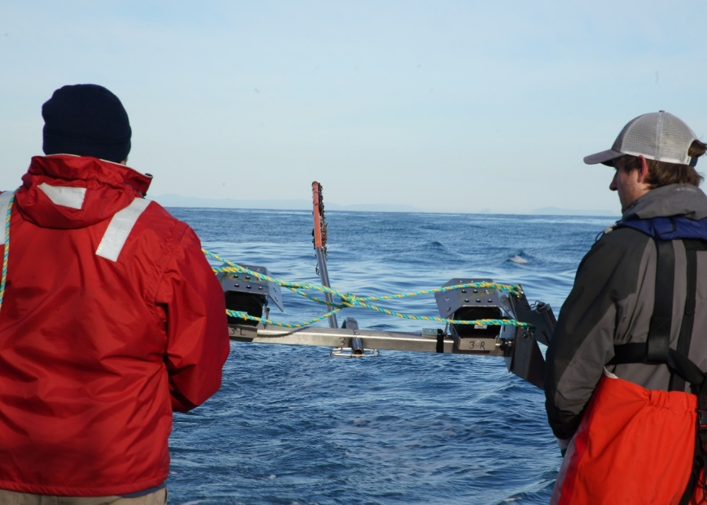
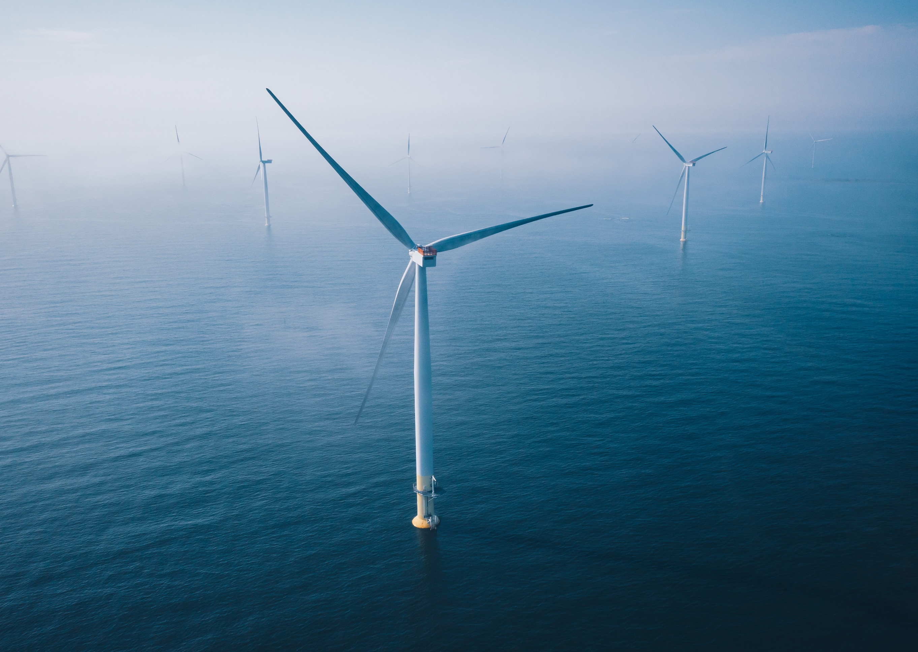

Commonwealth Environmental Impact Statement
Chapter 12 – Offshore ornithology and bats
B
Table of Contents
Chapter 12 Offshore ornithology and bats 12-1
12.1 Introduction 12-1
12.2 Assessment scope 12-2
12.2.1 Commonwealth matters 12-2
12.3 Evaluation framework 12-4
12.3.1 Key legislation, policy, guidelines and standards 12-4
12.3.2 Assessment criteria 12-4
12.4 Methods 12-6
12.4.1 Species included for assessment 12-7
12.5 Existing environment 12-9
12.5.1 Regional overview 12-11
12.5.2 Seabirds 12-12
12.5.3 Shorebirds 12-29
12.5.4 Bass Strait migrants 12-33
12.6 Construction impacts 12-37
12.6.1 Key impacts 12-37
12.6.2 Other impacts 12-37
12.6.3 Potential risks 12-46
12.7 Operation impacts 12-50
12.7.1 Key Impacts 12-50
12.7.2 Other impacts 12-50
12.7.3 Potential risks 12-63
12.8 Decommissioning impacts 12-85
12.8.1 Potential impacts and risks 12-85
12.9 Cumulative Impacts 12-85
12.10 Summary of mitigation, monitoring and contingency measures 12-88
12.10.1 Mitigation measures 12-88
12.10.2 Monitoring and contingency measures 12-89
12.11 Conclusion 12-91

Figures
Figure 12-1 Offshore ornithology and bats study area 12-10
Figure 12-2 Shannon Diversity Index values for the offshore wind farm area and nearby Bass Canyon area. Error bars represent 95 per cent confidence intervals. 12-13
Figure 12-3 Biologically Important Areas (biologically important areas) for Shy Albatross and Buller’s Albatross. 12-16
Figure 12-4 Biologically important areas for Common Diving-Petrel and Short-tailed Shearwater. 12-19
Figure 12-5 The environment that may be affected by artificial lighting within the offshore wind farm area. 12-38
Figure 12-6 Collision risk modelling - estimated annual collision rates for shy-type albatross in response to wind turbines with different air gaps. 12-79

Tables
Table 12-1 Key legislation, policy, guidelines and standards relevant to offshore ornithology and bats 12-4
Table 12-2 Seabird species carried through for assessment and information regarding their legislative listing, predominant occurrence in the region, the number of individuals (n) observed in the offshore wind farm area (OWFA) and Bass Canyon during the baseline surveys, number of flight height measurements (n), median flight height (metres above sea level) and the impact and risk pathways that each species were assessed for. 12-25
Table 12-3 Shorebird species carried through for assessment and information regarding their legislative listing, predominant occurrence in the region, the number of individuals observed in shorebird surveys and the shore related impact and risk pathways that each species were assessed for. 12-32
Table 12-4 Summary of Bass Strait Migrant species and their likelihood of regular passage through the offshore project area 12-35
Table 12-5 Residual impacts associated with artificial light emissions during the construction phase 12-40
Table 12-6 Residual impacts associated with trenchless cable installation activities during the construction phase 12-41
Table 12-7 Residual impacts associated with the physical presence of vessels and construction activity during the construction phase 12-42
Table 12-8 Residual impacts associated with underwater noise during the construction phase 12-44
Table 12-9 Residual impacts associated with seabed disturbance and sediment plumes during the construction phase 12-45
Table 12-10 Residual impacts associated with routine discharges during the construction phase 12-46
Table 12-11 Consequence, likelihood and residual risk ranking associated with physical presence of construction vessels and propeller injury during the construction phase 12-47
Table 12-12 Consequence, likelihood and residual risk ranking associated in the event of a hydrocarbon release from collision of a project vessel during construction phase 12-48
Table 12-13 Consequence, likelihood and residual risk ranking associated with entanglement or ingestion during the construction phase 12-49
Table 12-14 Residual impacts associated with artificial light emissions during the operations phase 12-52
Table 12-15 Residual impacts associated with displacement of seabirds from the physical presence of operational turbines during the operations phase 12-56
Table 12-16 Residual impacts associated with the physical presence of operational turbines creating a barrier effect during the operations phase 12-58
Table 12-17 Residual impact associated with physical presence of operational turbines and infrastructure attracting birds during the operations phase 12-59
Table 12-18 Residual impact associated with the physical presence of vessels and maintenance activity during the operations phase 12-60
Table 12-19 Residual impacts associated with underwater noise during the operations phase 12-62
Table 12-20 Residual impact associated with electromagnetic interference during the operations phase 12-63
Table 12-21 Summary of worst-case collision risk modelling results 12-77
Table 12-22 Summary of worst-case collision risk modelling results for the air gaps tested. 12-80
Table 12-23 Consequence, likelihood and residual risk ranking associated with collisions with operational turbines 12-81
Table 12-24 Projects assessed for cumulative impacts 12-86
Table 12-25 Summary of mitigation measures relevant to offshore ornithology and bats 12-88
Table 12-26 Proposed approach to monitoring and adaptive management relevant to key species and potential impact and risk pathways. 12-90

Offshore ornithology and bats

Introduction
This chapter summarises the existing conditions related to offshore ornithology and bats and assesses impacts and risks associated with the construction, operation and decommissioning of the Star of the South Offshore Wind Farm (the project) on offshore ornithology and bats. The chapter describes how impacts will be avoided, minimised or managed.
Offshore ornithology and bats refers to the study of shorebirds, seabirds, bats and Bass Strait migratory birds that routinely migrate between Tasmania and mainland Australia and may pass through the project area on migration.
This chapter is based on the impact assessment presented in Technical Report E – Offshore Ornithology and Bats.
Other chapters and modelling that relate to or inform the offshore ornithology and bat assessment include:
Chapter 9 – Benthic Ecology
Chapter 13 – Marine Protected Areas
Chapter 17 – Shipping and Navigation
Chapter 18 – Onshore Ecology (EPBC matters)
Technical Report Attachment I – Underwater Noise Modelling
Technical Report Attachment II – Oil Spill Modelling Summary

Assessment scope
The study objective for offshore ornithology and bats is to:
- Determine and present criteria, sourced from relevant legislation and guidance documents, industry best practice, stakeholder expectations, and relevant standards, against which potential impacts will be assessed
- Assess potential adverse effects on seabirds, shorebirds and Bass Strait migrants (including listed threatened and migratory species), their prey species and habitats supported by assessments of fish and invertebrates, benthic ecology and coastal processes, and advise on how the project could avoid and mitigate those adverse effects
- Evaluate the significance of potential effects against pre-defined criteria and significant impact guidelines (including the acceptability of impacts in relation to key management / recovery plans and guidance documents)
- Identify any mitigation or management measures that may be required to further reduce residual significant potential impacts
- Identify the need for ongoing monitoring to confirm the scale of actual impacts and subsequent adaptive management measures that may be needed to further reduce impacts if approaching or exceeding the acceptable level if detected by monitoring.
All detailed technical methodologies and assessment on offshore ornithology and bats can be found in Technical Report E – Offshore Ornithology and Bats.

Commonwealth matters
The project's EIS guidelines inform the preparation of the EIS to enable the Commonwealth Minister for the Environment to make an informed decision on whether or not to approve the project under the EPBC Act.
The aspects of the EIS guidelines directly relevant to offshore ornithology and bats are:
- Section 2.3 – Description of the proposed action and evaluation framework
- Section 2.5 – Description of the environment
- Section 2.6.2 – Listed marine species, migratory species, threatened species and ecological communities
- Section 2.7 – Relevant Impacts
- Section 2.7.4 – Avifauna and marine mammal collision
- 2.7.5. – Barrier effects of offshore infrastructure
Further information about the EIS guidelines is listed in Attachment V – EIS Guidelines Checklist.

Evaluation framework

Key legislation, policy, guidelines and standards
Table 12-1 lists the key legislation, policy, guidelines and standards relevant to offshore ornithology and bats.
Table 12-1 Key legislation, policy, guidelines and standards relevant to offshore ornithology and bats
Type | Applicable legislation, policy, guideline or standard
International conventions/guidance | IALA International Association of Marine Aids to Navigation and Lighthouse Authorities Recommendation R0139 The Marking of Man-made Offshore Structures 2021 (IALA 2021b)
International conventions/guidance | International Convention for the Prevention of Pollution from Ships 1973 (MARPOL)
International conventions/guidance | International conventions/agreements on migratory species
International conventions/guidance | Ramsar Convention on Wetlands
International conventions/guidance | The Agreement on the Conservation of Albatross and Petrels (ACAP)
Commonwealth Government | Biosecurity Act 2015
Commonwealth Government | Environment Protection and Biodiversity Conservation Act 1999
Commonwealth Government | Offshore Electricity Infrastructure Act 2021
Commonwealth Government | Protection of the Sea (Prevention of Pollution from Ships) Act 1983
Commonwealth Government | Sea Installations Act 1987

Assessment criteria
To assess the project, predicted impacts and risks are compared to criteria that set required environmental performance outcomes (refer Chapter 6 – Assessment Framework).
The criteria for offshore ornithology and bats are derived from legislation and policy, relevant standards and guidelines, stakeholder feedback and industry best practice.
The assessment criteria relevant to offshore ornithology and bats is summarised below:
- Health productivity and diversity of the environment is not compromised as a result of the project
- Project and monitoring activities will not result in invasive species becoming established that are harmful to offshore ornithology species nor introduce diseases that may cause the species to decline
- The project will not modify, destroy, fragment, isolate or disturb an important or substantial area of habitat such that an adverse impact on marine ecosystem functioning or integrity in a Commonwealth Marine Area
- The project will not modify, destroy, remove, isolate or decrease the availability or quality of habitat to the extent that the species is likely to decline
- Artificial light will be managed so that wildlife is not disrupted within, nor displaced from, important habitats and can undertake critical behaviours such as foraging, reproduction and dispersal (hereafter National Light Pollution Guidelines)
- The project will not interfere substantially with the recovery of the species (Matters of National Environmental Significance Significant Impact Guidelines 1.1)
- The project will not have a significant impact on the environment in a Commonwealth Marine Area (Matters of National Environmental Significance Significant Impact Guidelines 1.1)
- Oil or fuel spills will be managed in accordance with an oil pollution emergency response plan so that birds are not disrupted within, nor displaced from, important habitats and are able to undertake critical behaviours such as foraging, reproduction and dispersal.
Detailed assessment criteria for all relevant species are presented in Technical Report E – Offshore Ornithology and Bats.

Methods
The purpose of the offshore ornithology and bats impact assessment is to assess the potential impacts and risks of the project on offshore ornithology and bats.
Impacts refer to the consequences of planned project actions, which are given a rating determined by combining the magnitude of the impact and the sensitivity of the receptor.
Risks are an unexpected (accidental) event and are determined by combining the likelihood of an event occurring and the consequences that would result if the event were to occur.
The technical chapters consider key impacts and risks with a residual consequence rating of moderate to severe. Other impacts and risks are those with a residual consequence rating of negligible to minor.
Refer to Chapter 6 – Assessment Framework for more detail on how impact and risk ratings are derived.
The offshore ornithology and bats impact assessment involved:
- A review of relevant national, state and local legislation
- A comprehensive desktop / literature review of previous species records from a range of biodiversity databases, including those from DEECA, DCCEEW, BirdLife Australia, Atlas of Living Australia, Tasmanian Government Department of Natural Resources and a summary dataset of pelagic birds observed during over 500 days of monthly at-sea surveys spanning a four-decade period on either side of Bass Strait (Bonney Coast and eastern Tasmania)
- Consultation and expert elicitation provided by a variety of subject matter experts
- Dedicated field surveys from 2020-2022 as part of the project's marine ecology survey program. The objective of the surveys was to identify the existing conditions of the offshore project area relevant to seabirds, shorebirds and Bass Strait migrants
- The marine ecology survey program consisted of the following survey methods:
  - Monthly digital aerial surveys for 26 months from aeroplanes equipped with light detection and ranging to quantify bird flight heights
  - Boat-based visual surveys including observer estimates of flight heights
  - Boat-based and colony-based biologging with GPS tags and altimeters to measure fine-scale behaviour and flight heights
  - Shore-based surveys of Ninety Mile Beach and associated coastal shorebird habitat
  - Shorebird migration departure surveys within the Corner Inlet Ramsar site to document the behaviour and movements of trans-equatorial migratory shorebirds departing on migratory flights. Shorebird departure surveys were undertaken in autumn months across the two years
  - Population monitoring and estimates for local breeding colonies
  - Opportunistic sightings during other surveys.

Species included for assessment

Bird groups
For the purpose of documenting the existing conditions of the offshore project area and assessing the potential impacts of the project, groups of birds were defined as:
- Seabirds that are wholly or substantially dependent on the marine environment and may use the offshore project area
- Shorebirds, including resident and international migratory species, that may fly through and/or use habitat in the offshore project area
- Bass Strait migrants which encompass birds and bats that routinely migrate between Tasmania and mainland Australia and may pass through the project area on migration passages.

Species screening process
Considering the broad diversity and transient nature of bird species in Australia, a risk-based approach was employed to determine which bird species were included or excluded for assessment. This allowed for appropriate focus to be given to those species and pathways where active mitigation and/or management may be required. A summary of the steps taken were:
            - Based on the marine ecology survey program and long-term monitoring data of seabirds in the Bass Strait, species were first given a ‘likelihood of occurrence’ score representing the probability of the species occurring in the offshore project area. Species with a negligible to low likelihood of occurrence in the offshore project area were screened out while those with a medium to high likelihood of occurrence, or those observed in the offshore project area, were carried forward for assessment. There were exceptions to these exclusions with certain species of high conservation value, including Orange-bellied Parrot, Swift Parrot, and Blue-winged Parrot, carried forward for assessment despite having a negligible to low likelihood of occurrence
            - All species carried forward were assessed for potential impacts and risks from the project
            - Detailed levels of assessment were undertaken where the initial predicted consequence level to the population (prior to additional mitigation) was moderate, major or severe.
See Table 12-2 and Table 12-3 for a list of species and the potential impact / risk pathways carried through for assessment. See Technical Report E – Offshore Ornithology and Bats for a list of all species considered.

Existing environment
This section describes the existing conditions within the study area, as they relate to offshore ornithology and bats. The study area is defined as the following:
- The offshore export cable area including the landfall area (intertidal, beach and dune zones) and multiple other beaches for shorebird surveys
- The offshore project area, consisting of the offshore export cable area and offshore wind farm area, plus a five-kilometre buffer
- The regional offshore area including the broader marine environment of eastern Bass Strait and the continental shelf edge approximately 120 to 150 kilometres east-northeast of the offshore project area. This area is known as the Bass Canyon and used as a regional reference area to provide a wider context for the site-specific data. Existing data from the Bonney Coast region off Portland was also used to provide wider context.
- Shore bird migration departure survey area at Corner Inlet.

Figure 12-1 Offshore ornithology and bats study area
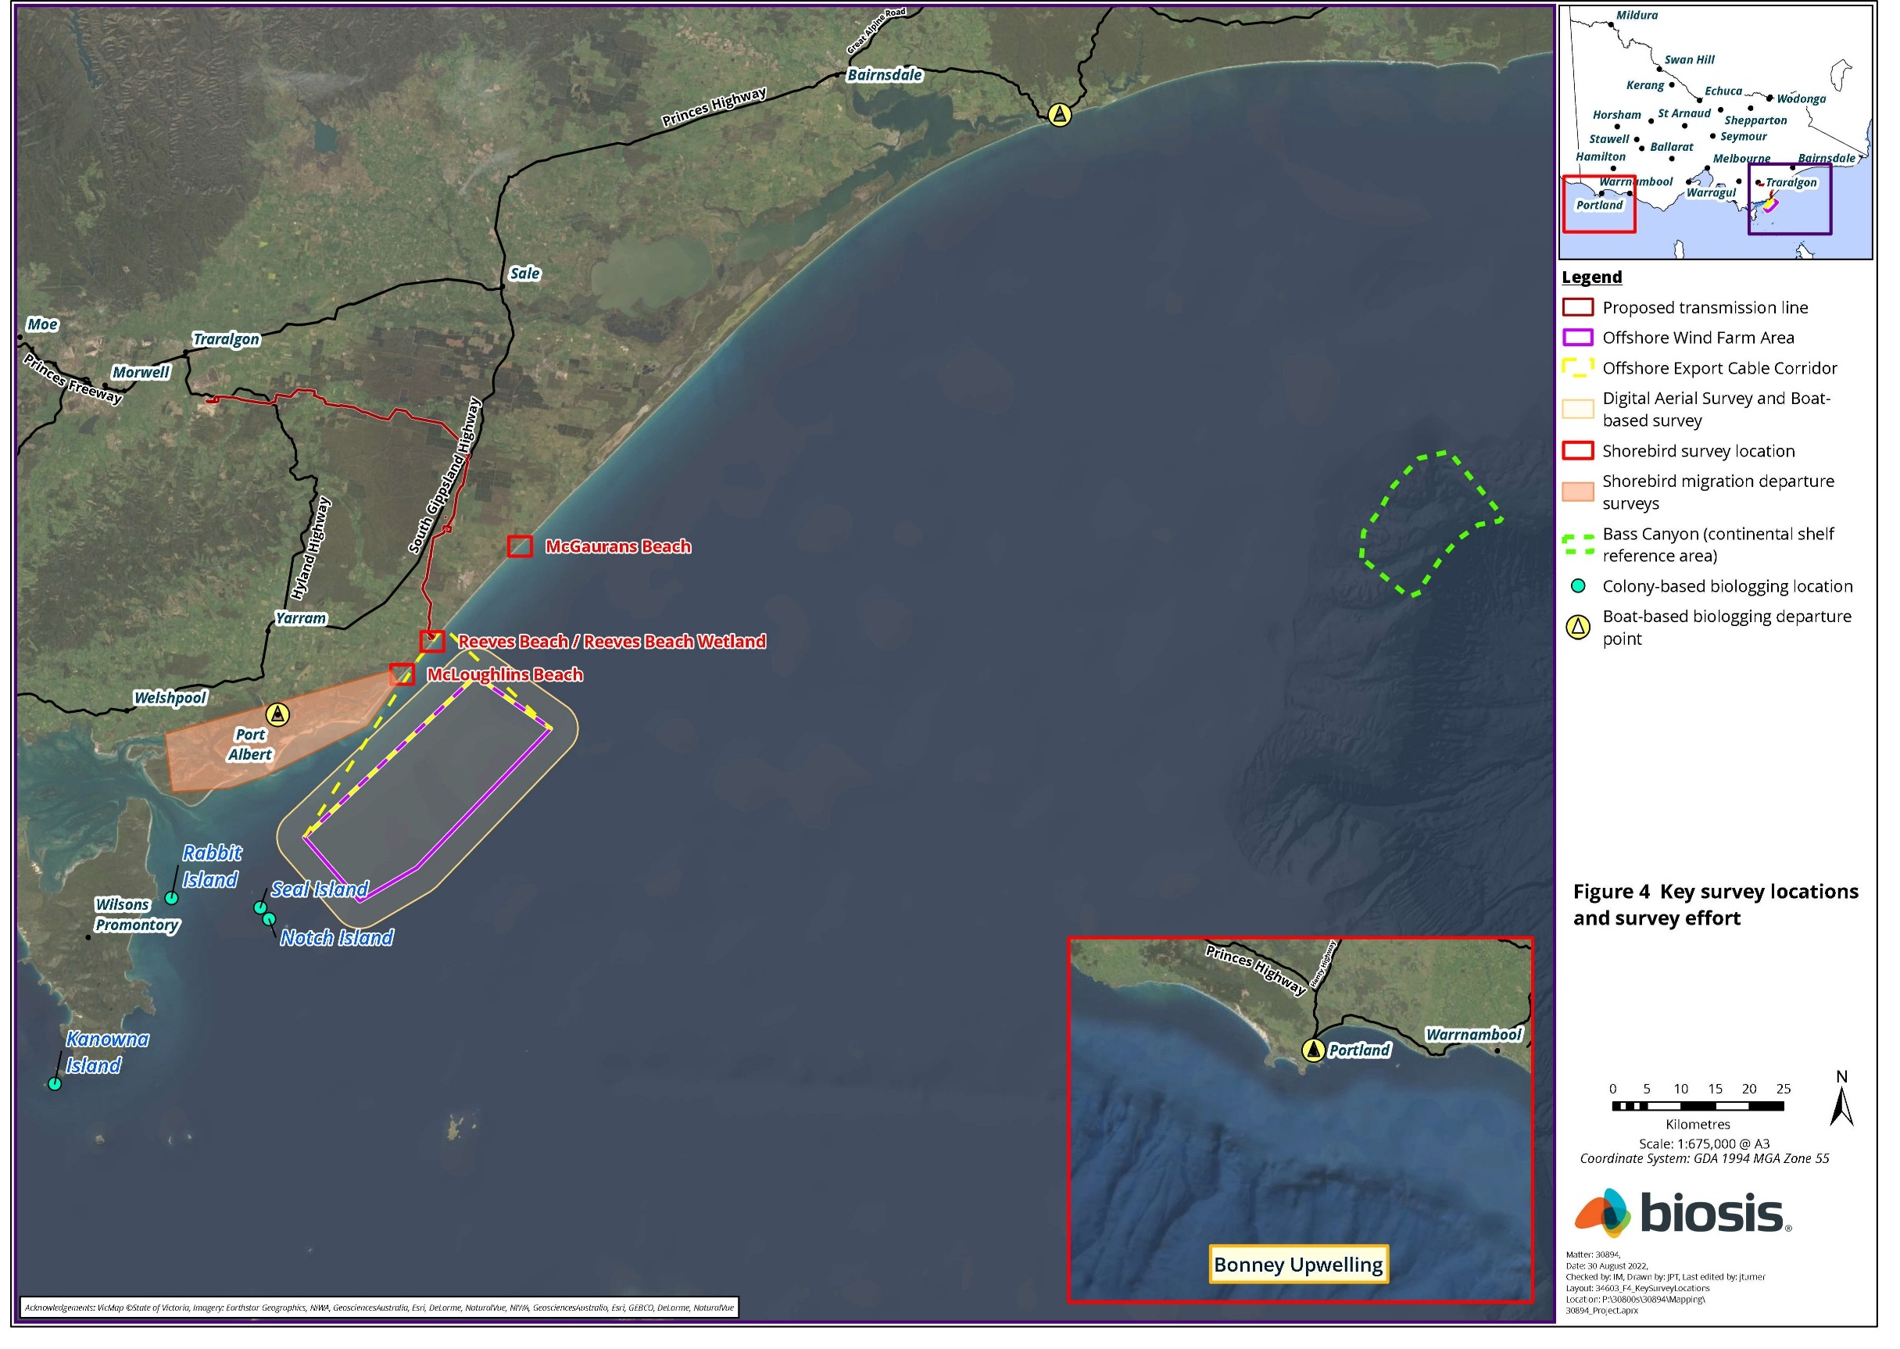

Regional overview

Coastal and inshore subregion
The coastal and inshore subregion of southeastern Victoria comprises vital shorebird habitats, including Ramsar-listed sites such as Corner Inlet and Gippsland Lakes. Corner Inlet supports extensive intertidal mudflats, with 50 per cent of Victoria’s winter migratory shorebirds known to occur there. Gippsland Lakes, a key wetland system, sustains 86 waterbird species, of which 23 per cent are migratory shorebirds. Jack Smith Lake, Seaspray, and Ninety Mile Beach provide additional shorebird habitats, although species diversity is lower at Ninety Mile Beach. Together, these areas are situated along the East Asian-Australasian Flyway.

Offshore subregion
Victorian offshore waters support 84 seabird species, with 69 being non-breeding visitors or vagrants. These include northern hemisphere migrants, species migrating to and from Antarctic and subantarctic regions, and birds dispersing from distant breeding areas such as New Zealand. Some species use the waters seasonally, while others are present year-round. Bass Strait is a crucial seabird habitat, supporting at least 18 breeding species, some of which contribute significantly to Australia’s total breeding populations. Beagle Marine Park, covering 2,928 square kilometres in Bass Strait, includes critical foraging and breeding areas for numerous seabirds, such as albatrosses, penguins, and petrels.

Bass Strait islands
Bass Strait is a key region for Australian seabirds, supporting a large proportion of the total breeding population for at least 11 species, with the most abundant being the Little Penguin, Short-tailed Shearwater, Fairy Prion and Common Diving-Petrel. Islands in the area support many of these species. The Seal Island Group, located within the Seal Islands Wildlife Reserve, consists of uninhabited granite islands about 10 kilometres southwest of the offshore wind farm area. Surrounding Wilsons Promontory, a chain of loose islands extends to the North Bass Strait Islands of Tasmania, including the Furneaux islands. The Furneaux island group comprises around 100 islands, with Flinders Island being the largest. A summary of offshore islands within 100 kilometres of the offshore wind farm area and their documented presence of breeding seabird species can be found in Table 12-2 of the Technical Report E – Offshore Ornithology and Bats.

Seabirds

Regional context
The seabird species that were identified in the surveys off south-eastern Victoria fall under the following orders:
- Procellariiformes (tubenoses) – includes albatrosses, petrels, storm-petrels and shearwaters
- Charadriiformes – includes terns and gulls (under the Laridae family) and jaegers and skuas (under the Stercorariidae family)
- Sphenisciformes – includes the Little Penguin, the only penguin species that breeds in continental Australia.
A total of 50 seabird species were identified during the marine ecology survey program - 35 were recorded in the offshore wind farm area and 44 were found in the Bass Canyon. Of these, 29 species were identified in both sites, with six species found exclusively in the offshore wind farm area and 15 species in the Bass Canyon. Overall, there were significantly fewer species found in the offshore wind farm area compared to the Bass Canyon site. See Table 12-2 for details of observed seabird species, including their EPBC Act and/or FFG status, numbers observed during the project’s marine ecology survey program and flight height recordings.
Mean monthly seabird abundance in the offshore wind farm area ranged from 95 to 6,912 individual seabirds per calendar month. This large range was predominantly driven by the most abundant species, the Short-tailed Shearwater, with up to 11,243 individuals counted in a single boat-based survey in February 2021. A Shannon Diversity Index analysis, which is a measure of biodiversity that combines both species richness and abundance, was significantly lower (two-fold) in the offshore wind farm area compared to the Bass Canyon site (Figure 12-2). From this survey data and long-term monitoring records of areas in the Bass Strait (south-east Tasmania and Bonney Coast), the offshore wind farm area does not appear to be a key area for seabirds.
Figure 12-2 Shannon Diversity Index values for the offshore wind farm area and nearby Bass Canyon area. Error bars represent 95 per cent confidence intervals.
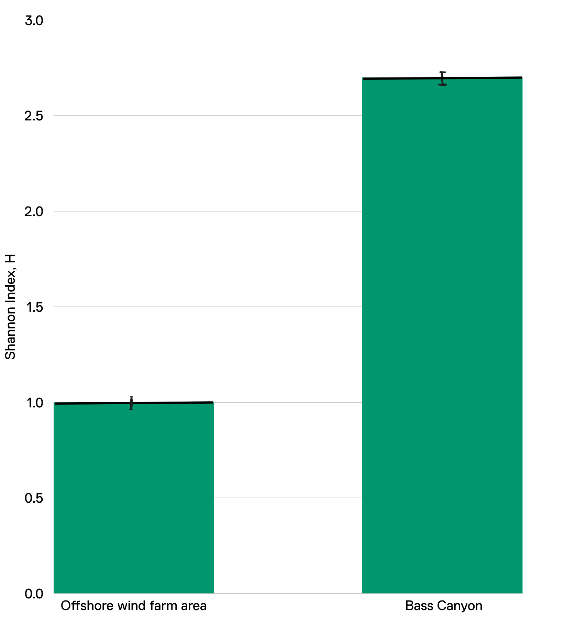
Shannon Diversity Index (H) is a measure of biodiversity that combines species richness and abundance.

Key species
This section provides further discussion of key seabird species in Table 12-2 taken forward for assessment, including those species that breed locally and/or were recorded within the offshore project area during the baseline surveys. This was done to ensure appropriate focus for the remainder of the report on those species that had a medium or high likelihood of occurrence or have evidence of being present in or using the offshore project area.

Little Penguin
The Little Penguin, the words smallest penguin species, has breeding sites located near the offshore wind farm area that include Seal (11 kilometres), Notch (11 kilometres) and Rabbit (21 kilometres) islands. The species is not listed as threatened in Australia or Victoria, and its conservation status globally is considered Least Concern. Evidence from tagging studies of individuals from the abovementioned breeding sites is that the overall foraging habitat for this species encompasses a broad area, with individuals foraging in discrete areas during the breeding season and expanding their foraging range during the non-breeding period. Within the non-breeding period, their foraging area may overlap with the offshore wind farm area, but this is unlikely to be the case during breeding.

Wandering Albatross
The Wandering Albatross Diomedea exulans (including the group of sub-species; Snowy Albatross D. exulans, Tristan Albatross D. dabbenena, Antipodean Albatross D. antipodensis antipodensis and Gibson’s Albatross D. antipodensis gibsoni) is a large dynamic soaring seabird with a circumpolar distribution. This species complex is listed as Migratory and Vulnerable under the EPBC Act and Critically Endangered under the FFG Act, largely because of the threat of mortality associated with fisheries. While the offshore project area is located within a foraging biologically important area of the Wandering Albatross, their presence within the offshore wind farm area is likely to be infrequent, with individuals generally restricted to deeper waters of the outer shelf and associated with areas near fronts or upwelling. Three Wandering Albatross were detected across 21 surveys conducted within the offshore project area.

Black-browed Albatross
The species is listed as Migratory, and Vulnerable under the EPBC Act and FFG Act. Their breeding is confined to subantarctic islands but after breeding, a northward migration into the continental shelf of Victoria is possible, although at this time they can be widely distributed across southern Australia. The offshore project area is located within a foraging biologically important area for Black-browed Albatross. Across all surveys, 63 Black-browed Albatross were observed in the offshore project area with a median flight height of 10 metres above sea level from 28 measurements. Tracking of an individual during the marine ecology survey program in 2021 showed a median flight height of 3.14 metres from 2,927 flight height measurements.

Indian Yellow-nosed Albatross
The species is listed as Migratory and Vulnerable under the EPBC Act and endangered under the FFG Act. They predominantly frequent and forage in Western Australian waters as breeding occurs on several islands throughout the southern Indian Ocean. However, the offshore project area occurs within a foraging biologically important area for the species, and a total of 27 Indian Yellow-nosed Albatross were recorded in the offshore project area across surveys, suggesting the species is also prevalent in eastern Bass Strait. The median flight height of seven individuals was five metres above sea-level.

Shy-type Albatross
The Shy Albatross and the White-capped Albatross are very difficult to tell apart and are generally grouped together as shy-type albatross.
The Shy Albatross is the only albatross endemic to Australia (it only breeds in Australia) and is listed as Migratory and Endangered under the EPBC Act and FFG Act, with population numbers mainly impacted by mortalities associated with fisheries. The species breeds on three islands off the Tasmanian coast (Albatross Island, Mewstone and Pedra Blanca), of which the nearest is more than 260 kilometres from the offshore project area (Figure 12-3). Breeding pairs alternate or forage together during nesting periods, and this typically occurs within 200 to 500 kilometres of the breeding site, primarily over the continental shelf off the west of Tasmania and Bass Canyon. Juveniles mainly forage to the west of the breeding islands, while the foraging range of post-breeding adults can extend further north into New South Wales, with the offshore project area occurring within a foraging biologically important area for the species (Figure 12-3).
Endemic means that an organism, in this case bird, is only found and/or breeds in a specific place and nowhere else in the world.
The White-capped Albatross is endemic to offshore islands in New Zealand, where adults typically remain during breeding. The species is considered more mobile than Shy Albatross and is known to forage in south-eastern Australia right across to South African waters.
A total of 387 shy-type albatross were recorded at the offshore project area over two years and a further 800 at the Bass Canyon site, with fewer sightings per month at the offshore project area. Observations that allowed identification to species level determined that the majority of these were White-capped Albatross. From 346 flight height measurements, the median flight height was eight metres above sea level and biologging data from one individual yielded a mean flight height of six metres, with a maximum flight height of 16.6 metres from 529 measurements.

Figure 12-3 Biologically Important Areas (biologically important areas) for Shy Albatross and Buller’s Albatross.
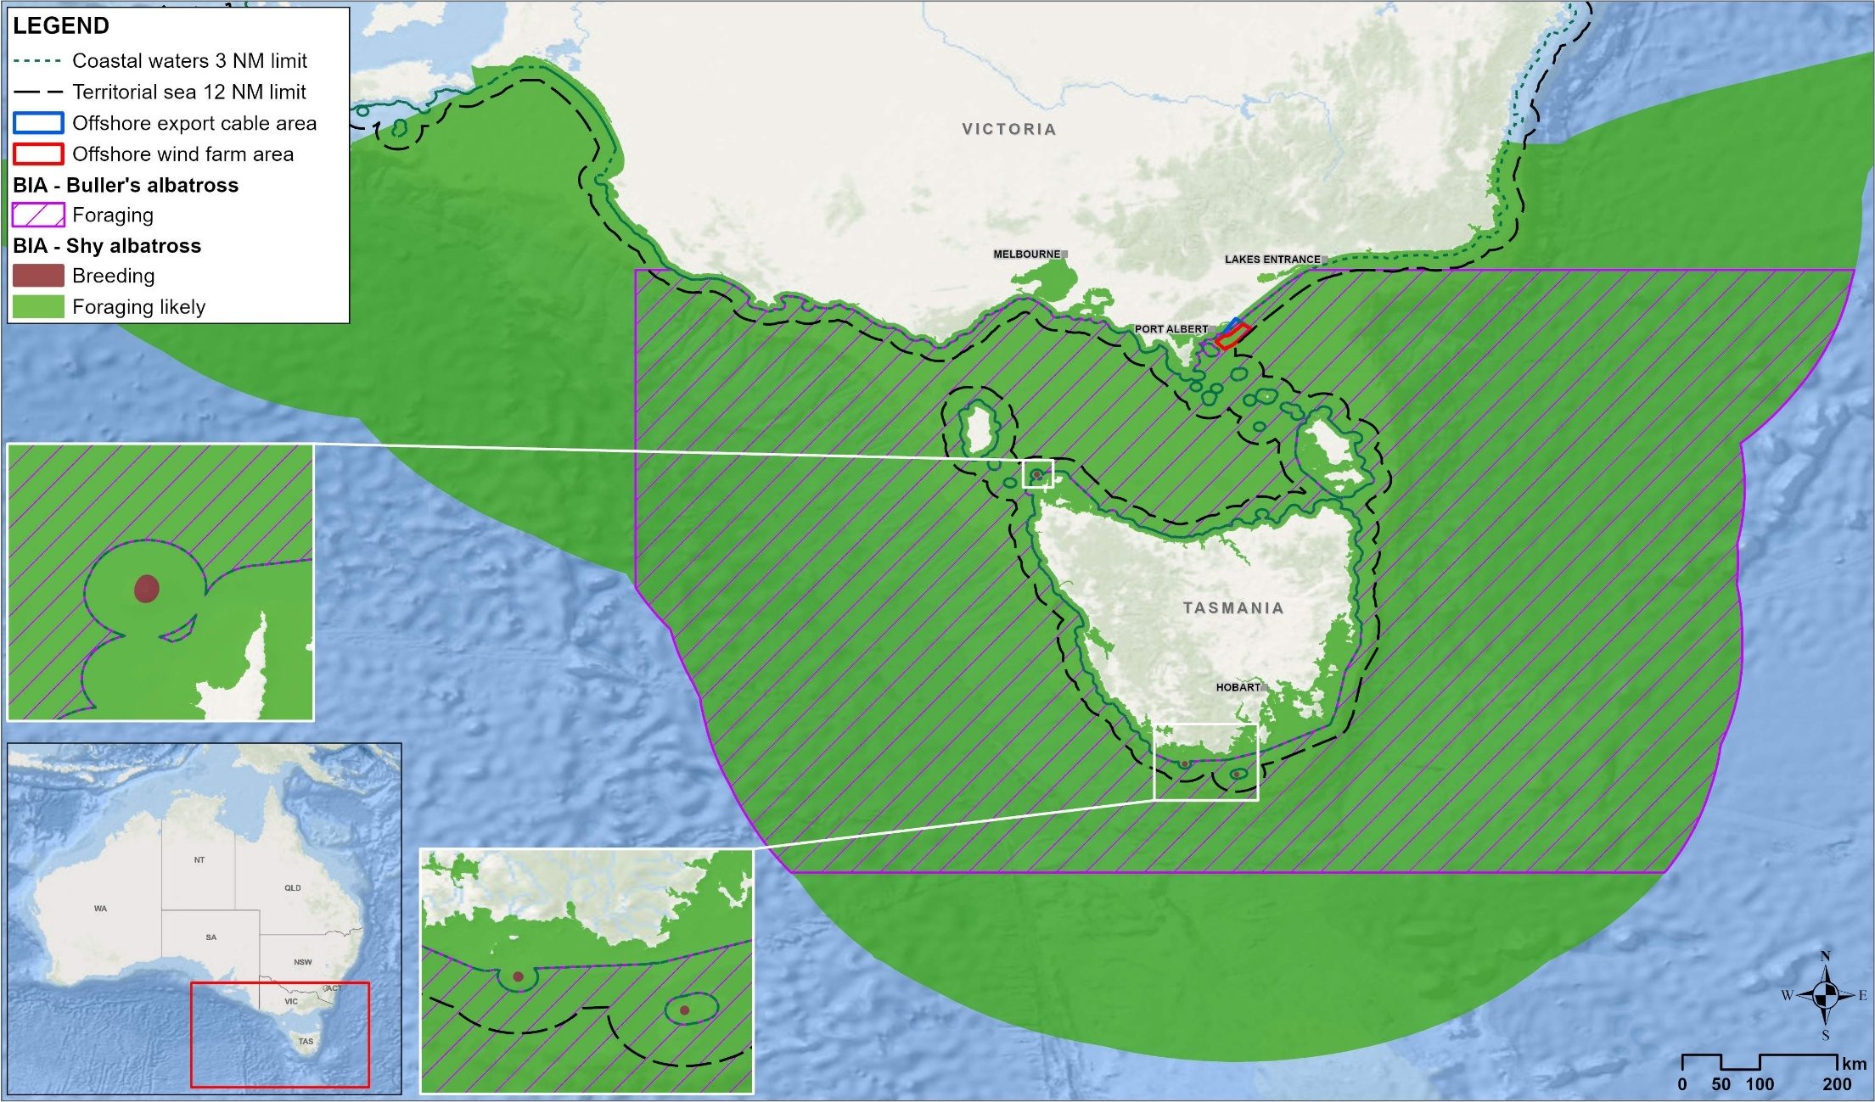

Southern Buller’s Albatross
The species is listed as Migratory and Vulnerable under the EPBC Act and endangered under the FFG Act. During breeding, adults forage predominantly over shelf and shelf-slope environments to the south of New Zealand but may disperse to Australian waters and the Tasman Sea outside the breeding season. While records show that they mainly frequent eastern Tasmania, the offshore project area is located within their foraging biologically important area (Figure 12-3).
Six individuals were recorded in the offshore project area during surveys and a further 12 in the Bass Canyon. Flight heights could be estimated from six of these birds, which ranged from 3 to 20 metres and a median of six metres above sea level. This data suggests they could have an occasional presence within the inshore waters of the offshore project area.

Southern and Northern Giant-Petrels
The Northern Giant-Petrel is listed as Marine and Vulnerable under the EPBC Act, and the Southern Giant-Petrel is listed as Marine and Endangered under the EPBC Act. Both species are listed as endangered under the FFG Act. The breeding distribution of both species is southerly, in the sub-Antarctic, but foraging can occur inshore, particularly by males. Juvenile birds from both species are generally more widely dispersed all-year round and may complete several circumnavigations of the Southern Ocean before their first return to the colony. During two years of study, 16 giant-petrels were observed within the offshore project area and a further 12 in the Bass Canyon and where species identification was possible, all were Northern Giant-Petrels. Flight heights for 12 giant-petrels and Northern Giant-Petrels combined ranged from 1 to 30 metres with a median of eight metres above sea-level.

Fairy Prion
This species occurs in large numbers and does not have a threatened listing under the FFG Act. The offshore project area lies within the broad breeding and non-breeding foraging range of the Fairy Prion, with a portion of the Bass Strait population breeding on several islands nearby including Seal and Notch Island. Only 30 Fairy Prions were recorded in the area during the two-year marine ecology survey program, while 397 individuals were observed at the Bass Canyon. Therefore, the offshore project area is not considered an area of particular significance to the species. Over one million flight height recordings from 17 GPS tagged individuals indicated that mean flight heights were 2.64 metres above sea-level, while from 21 aerial and boat-based observations, median flight heights were two metres above sea-level.

Antarctic Prion
This species is listed as Marine under the EPBC Act but has no other listing status. While it has an overall favourable conservation position, populations are thought to be declining. A small number (50 individuals) of unidentified Prion species were recorded within the offshore project area during marine ecology survey program, but identification to species level was not possible. Flight heights for these unidentified Prion species ranged from 0 to 2.8 metres above sea level. While there were no positive identifications of the species, they were assessed to have a medium likelihood of occurring in the offshore project area.

Common Diving-Petrel
The species is not listed as threatened in Victoria or nationally, however, the population trend is thought to be declining. The offshore project area is located near some of their breeding biologically important areas as they breed on several islands in Victoria around Wilson’s Promontory, including Seal and Notch islands. During non-breeding, foraging may occur in the offshore project area which overlaps with their foraging biologically important area (Figure 12-4). A total of 29 individuals were recorded within the offshore project area during surveys and flight heights from 150,000 measurements of 23 GPS-tagged individuals ranged from 0-20 metres above sea level with a mean of 1.8 metres.

Figure 12-4 Biologically important areas for Common Diving-Petrel and Short-tailed Shearwater.
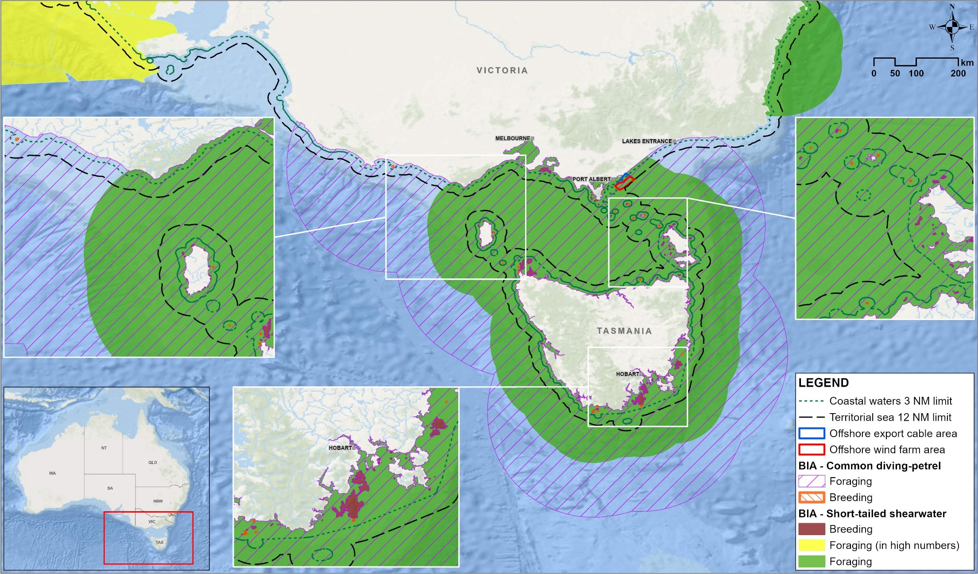

Other petrel species
The Providence Petrel, Soft-plumaged Petrel, Gould’s Petrel, White-headed Petrel, White-chinned Petrel, and Cape Petrel are known to occur in eastern Bass Strait waters. All of these are EPBC Act listed Marine species, while both White-chinned and Westland Petrel are also listed as Migratory. In addition, Soft-plumaged Petrel and Gould’s Petrel are listed under the EPBC Act as Vulnerable and Endangered, respectively. All species except for Westland Petrel were either recorded in the offshore project area in small numbers or were identified as having a medium to high likelihood of occurrence, although these small numbers suggest that the area is not an important foraging habitat for these birds.

Fluttering and Hutton’s Shearwaters
Both Fluttering and Hutton’s Shearwaters are listed under the EPBC Act as Marine species but are not listed as Migratory or Threatened. While neither species breeds near the offshore wind farm area (breeding occurs in New Zealand), the two species comprised approximately 15 per cent of all bird records obtained during the marine ecology survey program. A total of 3082 Fluttering Shearwater and 794 Hutton’s Shearwaters were recorded in the offshore wind farm area across the two years of surveys, with an additional 3965 records where the species were indistinguishable. From 367 collective boat and aerial observations of flight heights, median flight heights were four and 4.5 metres above sea level for the Fluttering Shearwater and Hutton’s Shearwater, respectively.

Short-tailed Shearwater
The Short-tailed Shearwater is the most abundant seabird species in Australia and is listed as Migratory under the EPBC Act. While the species is currently assessed as having a favourable conservation status globally, there are concerns regarding climate change and fishing impacts on population numbers. The offshore project area lies within the species’ foraging biologically important area (Figure 12-4). A proportion of the large Bass Strait population, estimated to be over 4.99 million individuals, breed on islands off Wilsons Promontory, the closest of which include Seal Island, Cliffy Island, Notch Island, and Rag Island, approximately 10−12 kilometres from the offshore wind farm area. Outside of the breeding season, they undertake a trans-equatorial migration to the Northern Pacific Ocean over the autumn to winter period (April to Sep).
During the two years of baseline studies, 19,524 Short-tailed Shearwaters were recorded within the offshore wind farm area. From 809 flight height estimates, the median flight height was four metres above sea level.

Other shearwater species
Several other shearwater species including Sooty, Flesh-footed, Wedge-tailed, and Buller’s are known to occur in Victorian waters. The Sooty Shearwater, one of the larger shearwater species, is listed as Marine and Migratory and as of 30 October 2022 is under EPBC Act Threatened listing assessment. The offshore project area does not lie within a biologically important area for any of these species.
All species were observed during the marine ecology survey program in the offshore project area and Bass Canyon area, except Buller’s Shearwater which was only seen in Bass Canyon. This included small numbers of Sooty Shearwaters (n=101), Wedge-tailed Shearwaters (n=8) and Flesh-footed Shearwaters (n=2) in the offshore project area, with median flight heights of five, three and three metres above sea-level.

Storm-petrel species
Three species of storm-petrel are known to occur regularly in Australian waters, namely White-faced, Grey-backed and Wilson’s Storm-Petrels. The White-faced Storm-Petrel is listed as Endangered in Victoria under the FFG Act. The species breeds on several islands extending from Western Australia to New South Wales, including Mud Island in Port Phillip Bay and Gabo Island off Mallacoota in Victoria. Wilson’s Storm-Petrel is listed as Migratory under the EPBC Act and is considered one of the world’s most abundant seabirds, although the Australian breeding population is limited to small numbers breeding on Heard and Bishop islands. The Grey-backed Storm-Petrel is not listed as Threatened in Victoria or nationally, and breeds on a number of sub-Antarctic islands, including Macquarie Island.
Low numbers of White-faced Storm-Petrel (n=25) and Wilson’s Storm Petrel (n=10) were recorded in the offshore project area during surveys. In contrast, 321 White-faced Storm-Petrel and 222 Wilson’s Storm Petrel were recorded in the Bass Canyon. From 34 collective flight estimates across these species, the median flight height was one metre above sea level. Overall, the inner shelf waters of Bass Strait, including the offshore wind farm area, are not considered an important foraging habitat for storm-petrels.

Australasian Gannet
The Australasian Gannet is not listed as Threatened in Victoria or nationally, and currently has a favourable conservation status globally, with population numbers recently documented as rising. Breeding occurs at numerous colonies in Australia and New Zealand, and those nearest to the offshore wind farm area are 200 kilometres to the west. Foraging during breeding generally occurs close to breeding sites but outside of the breeding season, gannets are known to traverse much greater distances.
These were one of the most regularly recorded seabirds within the offshore wind farm area, consisting largely of non-breeding individuals. A total of 2,179 individuals were recorded in the offshore project area, and 114 individuals were recorded at the Bass Canyon. Across 513 flight height measurements, median flight height was 15.7 metres above sea level.

Black-faced cormorant
The species is not listed as Threatened at either the national or state level and is a species that breeds exclusively in Australia. The offshore wind farm area is not recognised as a biologically important area for Black-faced Cormorant, although one of their largest breeding colonies is situated at Notch Island, 11 kilometres south-west of the offshore project area. Individuals from this colony were recorded using the offshore project area during the marine ecology survey program. From 24 GPS tagged individuals, inshore areas, particularly within Corner Inlet, had the highest degree of foraging activity that only occurred during daylight hours which aligns with the species’ proposed benthic-foraging strategy. A total of 478 individuals were recorded in the offshore project area, while only two were recorded in the Bass Canyon, demonstrating nearshore waters are most important for this species. Based on 213 flight height observations during boat and aerial surveys, their median flight height was two metres above sea level. From the 24 GPS-tagged individuals, 95 per cent of flights were at heights below 30 metres, although occasional heights up to 88 metres were recorded.

Skuas and jaegers
All three species of jaegers (Arctic, Pomarine, and Long-tailed Jaeger) are listed as Migratory under the EPBC Act and have favourable conservation statuses. They breed in the Arctic and undertake trans-equatorial migrations, crossing Australian waters between October and April. Similarly, the Brown Skua breeds in regions surrounding either the Arctic or Antarctic but is not listed under the EPBC Act. A total of 73 Arctic Jaeger, 14 Brown Skua, and seven Pomarine Jaegers were recorded within the offshore project area during the marine ecology survey program. Based on 88 collective flight height observations, the median flight heights for these three species ranged between 12 and 15 metres above sea-level.

Gull species
Three species of gull commonly occur along the coastal and offshore waters of Victoria, namely Silver Gull, Pacific Gull, and Kelp Gull – all listed as Marine species under the EPBC Act with favourable conservation statuses. The Silver Gull has a breeding distribution spanning most of the Australian coastline and various inland locations, while the Pacific and Kelp gulls are more limited to coastal environments. Gulls are typically generalist foragers and scavenge around other seabirds and mammals.
A total of 197 Pacific Gulls were observed within the offshore project area and their median flight height from 157 estimates was 20 metres above sea level. Two Kelp Gulls (with no flight height measurements) and 87 Silver Gulls were recorded in the offshore project area, with a median flight height of 15 metres above sea-level from 33 measurements.

Greater Crested Tern
The species is listed as Migratory under the EPBC Act and currently has a favourable population status globally, which is assumed stable. The nearest biologically important area for the species is approximately 400 kilometres north of the offshore wind farm area and breeding has historically occurred at Mud Island, Phillip Island and Corner Inlet (Clonmel Island and Boxbank) – the latter being 10 kilometres from the offshore project area. Breeding adults forage close to their chicks (within 40 kilometres) and disperse further (up to 1,000 kilometres) after the breeding season.
A total of 1,111 individuals were recorded in the offshore project area during the two years of surveys, while 165 were observed in the Bass Canyon. The median flight height from 727 boat and aerial based measurements was 17 metres above sea-level.

Other tern species
Several additional coastal tern species including Little Tern, Australian Fairy Tern (hereafter Fairy Tern), Caspian Tern, White-fronted Tern, and Common Tern have the potential to occur within the offshore project area, and are listed as follows:
- The Little Tern, Fairy Tern, and Caspian Tern are listed as Marine and Migratory and have a threatened listing under either the EPBC Act or FFG Act.
- The Little Tern and Caspian Tern are both listed under the FFG Act as Critically Endangered and Vulnerable, respectively.
- The Fairy Tern is listed under the EPBC Act as Vulnerable and as Critically Endangered under the FFG Act.
- The White-fronted Tern is listed as Marine, while the Common Tern is listed as Marine and Migratory under the EPBC Act.
The nearest biologically important area for Fairy Tern and Caspian Tern is in South Australia, approximately 900 kilometres away from the offshore wind farm area. The nearest biologically important area for White-fronted Tern is associated with the southern Furneaux island group, approximately 200 kilometres south-east of the offshore wind farm area. The nearest biologically important area for Little Tern is in Western Australia and there are no biologically important areas declared for the Common Tern which breeds in Asia.
During the marine ecology survey program, Greater Crested Terns were the most common tern species with 1,111 observed in the offshore wind farm area and 165 in Bass Canyon. From 727 flight height measurements, the median flight height was 17 metres above sea-level.
One hundred terns, identified to be either Little or Fairy Terns, were observed in the offshore wind farm area and from a collective 14 flight height measurements, their median flight was approximately 15 metres above sea level.
Four Caspian Terns, nine Common Terns and six White-fronted Terns were observed in the offshore project area along with 106 unidentified terns with a collective median flight height of 12 metres above sea level.

Table 12-2 Seabird species carried through for assessment and information regarding their legislative listing, predominant occurrence in the region, the number of individuals (n) observed in the offshore wind farm area (OWFA) and Bass Canyon during the baseline surveys, number of flight height measurements (n), median flight height (metres above sea level) and the impact and risk pathways that each species were assessed for.
Assessed impact and risk pathways key:  1 = Physical presence: Trenchless cable installation methods activities & shore crossing  2 = Physical presence: construction vessels & activity  3 = Artificial light emissions (construction phase)  4 = Underwater noise (all project phases)  5 = Seabed disturbance & sediment plumes  6 = Routine discharges (construction & operations)  7 = Physical presence of construction & decommissioning vessels: propeller injury  8 = Unplanned hydrocarbon release: oil spill & toxicity (all project phases)  9 = Trash or debris leading to entanglement or ingestion (construction & decommissioning) | 10 = Physical presence of operational turbines: displacement  11 = Physical presence of operational turbines: barrier effects  12 = Physical presence of operational turbines & infrastructure: attraction  13 = Artificial light emissions (operations phase)  14 = Electromagnetic interference  15 = Physical presence of operational turbines: turbine collision  16 = Artificial light emissions (decommissioning phase)  17 = Physical presence of de-construction vessels: noise & vibration disturbance  18 = Seabed disturbance: increased turbidity
Common name | Scientific name | EPBC Act | FFG Act | Occurrence | Number of individuals (n) |  | Flight heights |  | Assessed impact and risk pathways
 |  |  |  |  | OWFA | Bass Canyon | Measurement (n) | Median (m) | 1 | 2 | 3 | 4 | 5 | 6 | 7 | 8 | 9 | 10 | 11 | 12 | 13 | 14 | 15 | 16 | 17 | 18
Little Penguin | Eudyptula  minor |  |  | Yearly | 789 | 25 | - | - |  | X |  | X | X | X | X | X | X | X | X |  |  | X | X | X |  | X
Wandering Albatross | Diomedea  exulans | VU, Mi | cr | Jul-Oct | 3 | 9 | - | - |  | X |  |  |  | X |  | X | X | X | X |  |  |  | X | X
Southern Royal Albatross | Diomedea  epomophora | VU, Mi | cr | Jul-Oct | - | 6 | - | - |  | X |  |  |  | X |  | X | X
Black-browed Albatross | Thalassarche melanophris | VU, Mi | vu | Yearly | 63 | 18 | 28 | 10 |  | X |  |  |  | X |  | X | X | X | X |  |  |  | X | X
Campbell Albatross | Thalassarche  impavida | VU, Mi |  | Yearly | - | 4 | - | - |  | X |  |  |  | X |  | X | X
Indian Yellow-nosed Albatross | Thalassarche  carteri | VU, Mi | en | Yearly | 27 | 6 | 7 | 5 |  | X |  |  |  | X |  | X | X | X | X |  |  |  | X | X
Shy-type Albatross | Thalassarche  cauta | EN, Mi | en | Yearly | 387 | 800 | 346 | 8 |  | X |  |  |  | X |  | X | X | X | X |  |  |  | X | X
Southern Bullers Albatross | Thalassarche  bulleri | VU, Mi | en | Jan-Aug | 6 | 12 | 5 | 6 |  | X |  |  |  | X |  | X | X | X | X |  |  |  | X | X
Southern Giant-Petrel | Macronectes  giganteus | EN, Mi | en | Apr-Sep | - | - | - | - |  | X |  |  |  | X |  | X | X | X | X |  |  |  | X | X
Northern Giant-Petrel | Macronectes  halli | VU, Mi | en | Apr-Sep | 12 | 12 | 12 | 8 |  | X |  |  |  | X |  | X | X | X | X |  |  |  | X | X
Fairy Prion | Pachyptila  turtur |  |  | Yearly | 30 | 397 | 21 | 2 |  | X | X |  |  | X |  | X | X | X | X |  | X |  | X | X
Antarctic Prion | Pachyptila  desolata |  |  | Apr-Oct | 0 | 1 | 1 | 1 |  | X | X |  |  | X |  | X | X |  |  |  | X |  | X | X
Common Diving-Petrel | Pelecanoides  urinatrix |  |  | Jan-Dec | 29 | 3 | 13 | 0.5 |  | X | X | X | X | X |  | X | X | X | X |  | X |  |  | X |  | X
Soft-plumaged Petrel | Pterodroma  mollis | VU |  | Nov-Apr | 1 | 1 | 0 | - |  | X | X |  |  | X |  | X | X |  |  |  | X |  | X | X
White-headed Petrel | Pterodroma  lessonii |  |  | Aug-Dec | 1 | 1 | 0 | - |  | X | X |  |  | X |  | X | X |  |  |  | X |  | X | X
Gould's Petrel | Pterodroma  leucoptera | EN |  | Nov-Apr | 0 | 1 | 0 | - |  | X | X |  |  | X |  | X | X |  |  |  | X |  | X | X
Providence Petrel | Pterodroma  solandri |  |  | Mar-Nov | 0 | 80 | 2 | 13 |  | X | X |  |  | X |  | X | X |  |  |  | X |  | X | X
Cape Petrel | Daption  capense |  |  | Jun-Nov | 1 | 1 | 0 | - |  | X | X |  |  | X |  | X | X |  |  |  | X |  | X | X
White-chinned Petrel | Procellaria  aequinoctialis | Mi |  | Jan-Mar | 0 | 290 | 1 | 2 |  | X | X |  |  | X |  | X | X | X | X |  | X |  |  | X
Fluttering Shearwater | Puffinus  gavia | Mi |  | Mar-Aug | 3082 | 439 | 265 | 4 |  | X | X | X |  | X |  | X | X | X | X |  | X |  | X | X
Hutton's Shearwater | Puffinus  huttoni |  |  | Feb-Mar, Aug-Sep | 794 | 60 | 102 | 4.5 |  | X | X | X |  | X |  | X | X | X | X |  | X |  | X | X
Wedge-tailed Shearwater | Ardenna  pacifica | Mi |  | Apr-Sep | 8 | 804 | 83 | 3 |  | X | X | X |  | X |  | X | X | X | X |  | X |  | X | X
Sooty Shearwater | Ardenna  grisea | Mi |  | Sep-May | 101 | 30 | 50 | 5 |  | X | X | X |  | X |  | X | X | X | X |  | X |  | X | X
Short-tailed Shearwater | Ardenna  tenuirostris | Mi |  | Sep-Apr | 19524 | 502 | 809 | 4 |  | X | X | X |  | X |  | X | X | X | X |  | X |  | X | X
Flesh-footed Shearwater | Ardenna  carneipes | Mi |  | Sep-May | 2 | 176 | 13 | 3 |  | X | X |  |  | X |  | X | X | X | X |  | X |  |  | X
Buller's Shearwater | Ardenna  bulleri |  |  | Oct-Apr | 0 | 9 | 0 | - |  | X | X |  |  | X |  | X | X |  |  |  | X |  | X | X
Wilson's Storm-Petrel | Oceanites  oceanicus | Mi |  | Sep-Jun | 10 | 222 | 4 | 1 |  | X | X |  |  | X |  | X | X |  |  |  | X |  | X | X
Grey-backed Storm-Petrel | Garrodia  nereis |  |  | Apr-Oct | 0 | 157 | 0 | - |  | X | X |  |  | X |  | X | X |  |  |  | X |  | X | X
White-faced Storm-Petrel | Pelagodroma  marina |  | en | Sep-May | 25 | 321 | 30 | 1 |  | X | X |  |  | X |  | X | X | X | X |  | X |  |  | X
Australasian Gannet | Morus  serrator |  |  | Yearly | 1279 | 114 | 513 | 16 |  | X |  | X | X | X |  | X | X | X | X |  |  |  | X | X |  | X
Great Cormorant | Phalacrocorax  carbo |  |  | Yearly | - | - | - | - |  | X |  |  |  | X |  | X | X |  |  |  |  | X | X
Little Black Cormorant | Phalacrocorax  sulcirostris |  |  | Yearly | - | - | - | - |  | X |  |  |  | X |  | X | X |  |  | X |  | X | X
Black-faced Cormorant | Phalacrocorax fuscescens |  |  | Yearly | 478 | 2 | 213 | 2 |  | X |  | X | X | X |  | X | X | X | X | X |  | X | X |  | X | X
Pied Cormorant | Phalacrocorax  varius |  |  | Yearly | 8 | 0 | 0 | - |  | X |  |  | X | X |  | X | X | X |  | X |  | X | X |  |  | X
Little Pied Cormorant | Microcarbo  melanoleucos |  |  | Yearly | - | - | - | - |  | X |  | X | X | X |  | X | X | X | X | X |  | X | X |  |  | X
Brown Skua | Stercorarius  antarcticus |  |  | Mar-Nov | 14 | 5 | 11 | 12 |  | X |  |  | X | X |  | X | X |  |  |  |  |  | X | X
Arctic Jaeger | Stercorarius  parasiticus | Mi |  | Sep-Apr | 73 | 23 | 70 | 12 |  | X |  |  | X | X |  | X | X |  |  |  |  |  | X | X
Pomarine Jaeger | Stercorarius  pomarinus | Mi |  | Sep-Apr | 7 | 6 | 5 | 15 |  | X |  |  | X | X |  | X | X |  |  |  |  |  | X | X
Silver Gull | Chroicocephalus novaehollandiae |  |  | Yearly | 87 | 42 | 33 | 15 | X | X |  |  | X | X |  | X | X | X | X |  |  |  | X | X
Kelp Gull | Larus  dominicanus |  |  | Yearly | 2 | 0 | 0 | - |  | X |  |  |  | X |  | X | X | X | X |  |  |  | X | X
Pacific Gull | Larus  pacificus |  |  | Yearly | 197 | 32 | 157 | 20 |  | X |  |  | X | X |  | X | X | X | X |  |  |  | X | X
Caspian Tern | Hydroprogne  caspia | Mi | vu | Yearly | 4 | 0 | 1 | 35 |  | X |  |  | X | X |  | X | X | X | X |  |  |  | X | X |  | X
White-fronted Tern | Sterna  striata |  |  | Mar-Oct | 6 | 0 | 5 | 12 |  | X |  |  | X | X |  | X | X | X | X |  |  |  | X | X
Greater Crested Tern | Thalasseus bergii | Mi |  | Yearly | 1111 | 165 | 727 | 17 | X | X |  |  | X | X |  | X | X | X | X | X |  |  | X | X |  | X
Little Tern | Sternula  albifrons | Mi | cr | Yearly | 45 | 0 | 9 | 15 | X | X |  |  | X | X |  | X | X | X | X |  |  |  | X | X |  | X
Fairy Tern | Sternula  nereis nereis | VU | cr | Yearly | 55 | 0 | 5 | 14 | X | X |  |  | X | X |  | X | X | X | X |  |  |  | X | X
Common Tern | Sterna  hirundo | Mi |  | Sep-Apr | 9 | 0 | 5 | 5 |  | X |  |  | X | X |  | X | X | X | X |  |  |  | X | X

Shorebirds
Shorebirds off south-eastern Victoria are categorised as either resident or migratory and depending on the species, they may use bodies of freshwater, estuaries, beaches, and/or the intertidal zone.
Shorebird species that have a high likelihood of occurring in the offshore project area and were carried forward for assessment are in Table 12-3, all of which are listed as Marine species under the EPBC Act. The Hooded Plover is the single resident shorebird species listed as Vulnerable on both EPBC and FFG Acts.
All international migratory shorebirds are listed as Migratory under the EPBC Act as well as the Convention on the Conservation of Migratory Species of Wild Animals (also known as the CMS or the Bonn Convention) and bilateral migratory bird agreements with Japan (JAMBA), China (CAMBA) and the Republic of Korea (ROKAMBA).
For all shorebird species including those with a low likelihood of occurrence in the offshore project area, see Technical Report E – Offshore Ornithology and Bats.

Habitat use, site fidelity and flight behaviours of shorebirds

Resident shorebirds
Resident shorebirds may be largely confined to localised areas of suitable habitat year-round, such as a single estuary, shallow wetland, or ocean beach. Some movements between discrete habitat areas may occur, such as movements between foraging sites and roosts, but local flights are generally confined to their preferred area of habitat. For example, genetic sampling of Hooded Plover illustrate that they breed locally, while a 40-year dataset on the movement patterns of Australian Pied Oystercatchers showed that around 70 per cent of marked birds were not reported outside their marked region.
Resident shorebird flight direction and heights in Corner Inlet were also captured to account for birds commuting within the local area and assess whether transitory local flights might be conducted offshore leading to potential interactions with the offshore wind farm area. Surveys recorded 95 flight measurements, in which the majority were in a westerly to south-westerly direction and below 40 metres. All flights were within the inlet, meaning that there is very low likelihood of resident shorebirds interacting with the offshore wind farm area on a day-to-day basis.

Migratory shorebirds
Migratory shorebirds include the trans-equatorial migrants (like Bar-tailed Godwit, Red-necked Stint and Sanderling) that breed in the northern hemisphere and move down into Australia during their non-breeding season along the East Asian-Australasian Flyway (EAAF). Similarly, the Double-banded Plover is a trans-Tasman migrant, that breeds in New Zealand, but a portion of the population spends the non-breeding season in eastern Australia. Studies of migratory shorebirds indicate that individuals from various species arrive and depart from the same coastal locations of south-eastern Australia year after year, and that they move very little between locations while in Australia.
Substantial aggregations and migratory departures of some species are known to occur from islands of Nooramunga to the north-west of the offshore project area. Dedicated surveys to document departure flights and behaviours of migratory shorebird species within this region (see Figure 12-1) successfully documented five departure events, summarised as:
- A flock of 55 Sanderling were observed departing in a north-westerly direction, with the flock reaching an altitude of approximately 1,000 metres before being lost from sight
- A flock of 46 Grey Plover were observed departing in a westerly direction, climbing beyond 200 metres altitude before the flock was lost from sight
- Three events were of Bar-tailed Godwit flocks, with the number of individuals per flock ranging from 250 to 390 and flight directions being variable. Flight heights could be determined for two of these Bar-tailed Godwit events, and in both cases, the flocks were observed climbing to an altitude of approximately 1,000 metres before being lost from sight.
From these surveys, migratory shorebird species within Corner Inlet demonstrate similar behaviours as species from overseas in that departure flights entail rapid climbing rates reaching altitudes up to 600-2,000 metres above sea level. Flight directions tend to be in a north-westerly direction. For further details on the known migration and movement behaviour of regularly occurring species in Corner Inlet and Tasmania, see Technical Report E – Offshore Ornithology and Bats.

Shorebird habitat at Ninety Mile Beach
The values of beach habitat for shorebirds (and coastal seabirds) at three positions of Ninety Mile Beach were characterised by a year-long survey program, and findings are summarised as follows:
- The surveys documented a total of 40 bird species, including 11 shorebirds, two terns, two gulls, and three other seabirds. Of the 11 shorebirds (see Table 12-3), the Hooded Plover (31 observations), Red-capped Plover (190 observations) and Masked Lapwing (32 observations) were some of the most abundant.
- At Reeves Beach, where the export cable shore crossing is proposed to be built, the Hooded Plover was observed and breeding behaviour was not detected.
- In one survey, a flock of 120 Red Knots were observed in transit, possibly between Corner Inlet and Jack Smith Lake, both of which are known locations that the species inhabits.
- Although the different surveyed beaches form part of the same coastline, they varied greatly in shorebird species richness which perhaps reflects their differing levels of disturbance. More species were found to occur at McLoughlins Beach (33 species) than Reeves Beach (14 species) and McGaurans Beach (18 species), with the latter two being more accessible to the public and more prone to disturbance.

Shorebird use of the offshore wind farm area
Other than the potential for occasional long-distance flights transiting through the area (for example, birds that spend their non-breeding period in Tasmania), the marine environment of the offshore project area, including the offshore wind farm area where turbines would be located, is not suitable habitat for migratory shorebirds.
No shorebirds were recorded in the offshore wind farm area during extensive baseline studies, except for a single Ruddy Turnstone during a boat-based survey, although noting that methods were less suitable for detecting shorebird migrations at high altitudes. Overall, small scale local movements may occur through the offshore wind farm area, however, their occurrence is likely to be extremely low.

Table 12-3 Shorebird species carried through for assessment and information regarding their legislative listing, predominant occurrence in the region, the number of individuals observed in shorebird surveys and the shore related impact and risk pathways that each species were assessed for.
 | Assessed impact and risk pathways key:  1 = Physical presence: Trenchless cable installation methods & shore crossing  2 = Physical presence: construction vessels & activity | 3 = Routine discharges  4 = Unplanned hydrocarbon release: oil spill & toxicity  5 = Trash or debris leading to entanglement or ingestion
Common name | Scientific name | EPBC Act | FFG Act | Predominant seasonal presence | Individuals recorded (shorebird survey) | Assessed impact and risk pathways
 |  |  |  |  |  | 1 | 2 | 3 | 4 | 5
Australian Pied Oystercatcher | Haematopus longirostris |  |  | Year round | 7 | X | X | X | X | X
Masked Lapwing | Vanellus miles |  |  | Year round | 32 | X | X | X | X | X
Banded Lapwing | Vanellus tricolor |  |  | Year round | - | X | X | X | X | X
Pacific Golden Plover | Pluvialis fulva | Mi | vu | Nov-Feb | 6 |  | X | X | X | X
Hooded Plover | Thinornis cucullatus | VU | vu | Year round | 31 | X | X | X | X | X
Double-banded Plover | Charadrius bicinctus | Mi |  | Mar-Jul | 54 | X | X | X | X | X
Red-capped Plover | Charadrius ruficapillus |  |  | Year round | 190 |  | X | X | X | X
Black-fronted Dotterel | Elseyornis melanops |  |  | Year round | - | X | X | X | X | X
Common Sandpiper | Actitis hypoleucos | Mi | vu | Oct-Feb | 1 |  | X | X | X | X
Red-necked Stint | Calidris ruficollis | Mi |  | Nov-Feb | 58 | X | X | X | X | X
Red Knot | Calidris canutus | Mi, VU | en | Oct-Feb | 120 | X | X | X | X | X
Ruddy Turnstone | Arenaria interpres | Mi, VU | en | Oct-Feb | 1
Sanderling | Calidris alba | Mi |  | Nov-Feb | 5 | X | X | X | X | X
Pied Stilt | Himantopus leucocephalus |  |  | Year round | 46 | X | X | X | X | X

Bass Strait migrants
A key consideration to the impact assessment were Bass Strait migrants. Bass Strait migrants include birds and bats that routinely migrate between Tasmania and mainland Australia and could pass through the offshore project area on migration voyages. The likelihood of these species interacting with the offshore wind farm area were determined from existing data and literature and expert judgement (including BirdLife Australia specialists, DEECA staff, species Recovery Teams and other ornithologists) on their migratory pathways, including the locations in which they arrive at and depart from mainland Australia. The terrestrial bird species that are known to migrate between Tasmania and mainland Australia are listed in Table 12-4.
The consensus view from expert elicitation was that the offshore wind farm area is not likely to form an important portion of the routes of most of these species - they are considered more likely to arrive at and depart Victoria from promontories and to follow chains of islands. For this reason, the likelihood of their occurrence is ascribed as ‘low’ in Table 12-4, unless they have been recorded within the offshore project area during the marine ecology survey program, in which case they are noted as ‘recorded’.
The impact assessment focuses on species and impact pathways that could lead to significant effects or result in long-term changes to population viability. As such, numerous Bass Strait migrant species listed in Table 12-4 were not carried through for assessment beyond the screening process because available data and expert elicitation about their migration routes provides sufficient evidence to exclude the possibility of them routinely migrating through the offshore wind farm area. This includes species such as the Tasmanian Morepork (Ninox novaeseelandiae leucopsis, also known as the Tasmanian Boobook) and Orange Bellied Parrot (Neophema chrysogaster). Detailed descriptions of all Bass Strait migrants can be found in Technical Report E – Offshore Ornithology and Bats, including information as to why many species, including Tree Martin and Grey Fantail, were not taken through for assessment.
Further information and assessment for risk of collision with turbines during migration is provided for White-throated Needletail, Swift Parrot, Blue-winged Parrot and White-striped Free-tailed Bat for reasons described below.

White-throated Needletail
The White-throated Needletail is listed as Vulnerable under the EPBC and FFG Acts and Migratory under the EPBC Act. White-throated Needletails depart breeding areas (eastern Siberia, north-eastern China and Japan) between August and October and travel south through China and Japan, migrating east of Borneo. Individuals usually arrive in Victoria and Tasmania from December onwards, with records peaking in March, and being an aerial species, they are almost constantly on the move while in Australia. Their travel routes likely extend across island chains throughout Bass Strait as they are more often observed over wooded areas.
A total of 55 White-throated Needletails were recorded at McLoughlins Beach and Reeves Beach Wetland during shorebird surveys in 2020 and 11 individuals were recorded within the offshore wind farm area during designated monthly boat-based surveys and digital aerial surveys at a median flight height of 13.63 metres, (range of 3.6 to 20 metres). However, they are adapted to fly at substantially greater heights and have been recorded in Victoria at altitudes greater than 1,200 metres.

Swift Parrot
The Swift Parrot occurs as a single migratory population and is listed as Critically Endangered under the EPBC and FFG Acts, with an active recovery plan in place. They breed in eastern Tasmania during late spring and summer and migrate north across Bass Strait in autumn to over-winter in southern and central Victoria, and eastern NSW. Their migration movements are not tightly synchronised, and current evidence suggests their routes may be concentrated on the relatively shorter crossings of open water, between King Island and Cape Otway and the Furneaux island group and Wilsons Promontory. Based on this, the offshore wind farm area is unlikely to be within the migration routes of the species, but two individuals were recorded incidentally onshore at Reeves Beach during the shorebird surveys of the marine ecology survey program.

Blue-winged Parrot
The Blue-winged Parrot is listed as Vulnerable and is covered under provisions for marine species under the EPBC Act. The species is a partial migrant with populations that breed in Tasmania and the south-eastern mainland. The Tasmanian population breeds between October and January, and the majority migrate to the mainland in autumn (March and April) to overwinter, returning to Tasmania in spring (September). From information available on the migratory population, it is probable that individuals use Wilsons Promontory for migration departure and arrival with some bird’s island hopping. If any migratory birds pass through the offshore wind farm area, it would likely involve a small proportion of the population, occurring no more than twice per year. A total of 15 Blue-winged Parrots were recorded at McGaurans Beach during shorebird surveys in winter months of July and August 2020.

White-striped Free-tailed bat
The White-striped Free-tailed Bat is the largest and most widely distributed of Australia’s free-tail bats, occurring across southern Australia. The species has been documented as a vagrant to Tasmania, and their calls have been recorded offshore on Kanowna Island. It is plausible that White-striped Free-tailed Bats may occasionally move through the offshore wind farm area, and there are anecdotal reports of bats reaching offshore oil and gas facilities in Bass Strait, though no formal records exist. However, given the species is commonly occurring and widespread, any bats moving through the offshore wind farm area are likely to represent a very small proportion of the total population.
Table 12-4 Summary of Bass Strait Migrant species and their likelihood of regular passage through the offshore project area
Common name | Scientific name | EPBC Act | FFG Act | Likelihood of regular passage through offshore project area | Observations from  marine ecology survey program surveys
Waterbirds | Anatidae  (multiple species) |  |  | Low, nomadic | Australian Shelduck  Tadorna tadornoides (1 offshore wind farm area)  Black Swan  Cygnus atratus (10 offshore wind farm area)
Eurasian Coot | Fulica atra |  |  | Negligible
Spotless Crake | Porzana tabuensis |  |  | Negligible
Brown Goshawk | Accipiter fasciatus |  |  | Negligible
Swamp Harrier | Circus approximans |  |  | Recorded | 7 (4 onshore, 3 offshore wind farm area)
Swift Parrot | Lathamus discolor | CR | cr | Low | 2 (all onshore)
Orange-bellied Parrot | Neophema chrysogaster | CR | cr | Negligible
Blue-winged Parrot | Neophema chrysostoma | VU |  | Low | 15 (all onshore)
Tasman Morepork | Ninox novaeseelandiae |  |  | Negligible
Fan-tailed Cuckoo | Cacomantis flabelliformis |  |  | Low
Pallid Cuckoo | Cacomantis pallidus |  |  | Low
Horsfield’s Bronze-cuckoo | Chalcites basalis |  |  | Low
Shining Bronze-cuckoo | Chalcites lucidus |  |  | Low
Fork-tailed Swift | Apus pacificus | Mi |  | Low
White-throated Needletail | Hirundapus caudacutus | VU | vu | Recorded | 66 (55 onshore, 11 offshore wind farm area)
Black-faced Cuckoo-shrike | Coracina novaehollandiae |  |  | Low
Welcome Swallow | Hirundo neoxena |  |  | Recorded | 8 (all offshore wind farm area)
Tree Martin | Petrochelidon nigricans |  |  | Medium
Flame Robin | Petroica phoenicea |  |  | Recorded | 1 (all offshore wind farm area)
Pink Robin | Petroica rodinogaster |  |  | Low
Satin Flycatcher | Myiagra cyanoleuca | Mi |  | Low
Grey Fantail | Rhipidura albiscarpa |  |  | Medium
Striated Pardalote | Pardalotus striatus |  |  | Low
Dusky Woodswallow | Artamus cyanopterus |  |  | Low
White-browed Woodswallow | Artamus superciliosus |  |  | Low
Silvereye | Zosterops lateralis |  |  | Recorded | 2 (all offshore wind farm area)
Nankeen Kestrel | Falco cenchroides |  |  | Low
White-striped Free-tailed Bat | Austronomus australis |  |  | Low
Eastern Bent-wing Bat | Miniopterus orianae oceanensis |  | cr | Low
Grey-headed Flying-fox | Pteropus poliocephalus | VU | vu | Low

Construction impacts
This section discusses the impacts and risks associated with the construction of the project that relate to offshore ornithology and bats and the respective receptor groups.

Key impacts
The construction impact assessment identified no key impacts with a moderate to severe residual consequence to offshore ornithology and bats.

Other impacts
Other potential construction impacts with minor to negligible residual consequence to offshore ornithology and bats include:
- Artificial light emissions (OOB-I006, OOB-I007, OOB-I008)
- Physical presence: trenchless cable installation activities and shore crossing (OOB-I001)
- Physical presence of vessels and offshore construction activity (OOB-I002)
- Underwater noise (OOB-I010, OOB-I011, OOB-I012)
- Seabed disturbance and sediment plumes (OOB-I013, OOB-I014)
- Routine discharges (OOB-I015).

Artificial light emissions (OOB-I006, OOB-I007, OOB-I008)

Potential impact
During construction, light will be emitted from project vessels, navigational lights on cardinal buoys and newly installed project infrastructure which may increase light levels in otherwise darker areas of the offshore project area. Under DCCEEW’s National Light Pollution Guidelines for Wildlife, a light impact assessment should consider important habitat for listed species sensitive to light within 20 kilometres of the light source, producing a mappable ‘environment that may be affected’ (Figure 12-5). The 20-kilometre threshold provides a nominal distance at which artificial light impacts should be considered, not necessarily the distance at which mitigation will be necessary, and is a precautionary limit based on observed effects of sky glow on fledgling seabirds grounded in response to artificial light 15 kilometres away.
Figure 12-5 The environment that may be affected by artificial lighting within the offshore wind farm area.
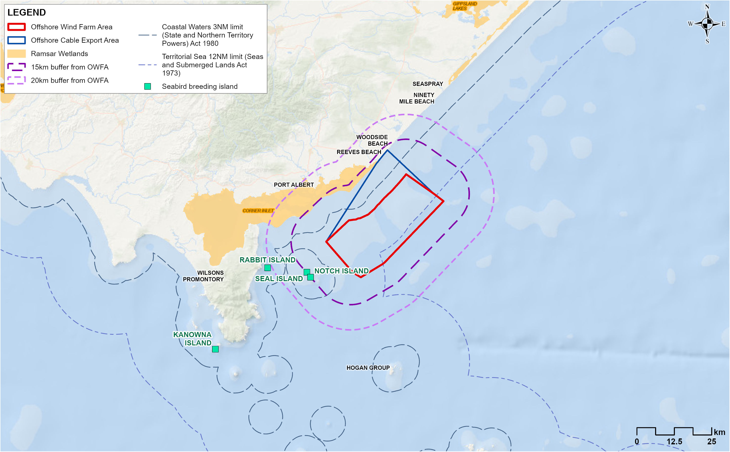
Artificial light has the potential to attract and/or disorient birds which may cause collision, entrapment, stranding, grounding (also known as ‘fallout’), interfere with navigation (such as being drawn off course) or may cause some species to avoid areas (a form of displacement). Certain events like fallout may occur under specific meteorological conditions such as poor visibility due to fog, precipitation, and low wind speeds or at specific time periods such as when fledglings leave their burrows for the first time. Based on international and regional evidence, the bird groups most likely to be impacted by artificial lighting in the offshore wind farm area are burrow-nesting shearwaters, petrels, prions and storm-petrels.
Of these bird groups, the initial consequence of artificial light emissions was considered medium for Fairy Prion and Common Diving Petrel because these are light-sensitive, locally breeding species found at Notch and Seal islands. Likewise, an initial consequence rating of medium was given to Short-tailed Shearwater, Hutton’s Shearwater and Fluttering Shearwater because of their sensitivity to light and their high seasonal abundance in the offshore wind farm area. Initial consequences for all other burrow-nesting species were assessed as minor.

Mitigation and monitoring
To mitigate the impacts of artificial light on seabirds, wind farm and vessel lighting during all phases of the project will be managed in accordance with the National Light Pollution Guidelines for Wildlife (LIT-M01). This includes minimising light spill, avoiding the use of long wavelength light sources, avoiding the use of blue, violet or ultra-violet wavelengths and keeping lighting to the minimum requirement for safe passage when personnel are not required to be working in the area.
Additionally, a Light Management Procedure will be implemented to manage any bird attraction and groundings as a final mitigation for project vessels (LIT-M02). This procedure will be detailed in the Seabird Monitoring and Management Plan (MEMP-M03), discussed further in Section 12.10.2.

Residual impact
Following the implementation of mitigation measures, the magnitude of the impact was reduced to low for all burrow-nesting species and residual impacts were assessed as minor (Table 12-5) as impacts are expected to be short-term and/or intermittent with only a temporary disruption of the behaviour and function of a proportion of medium-sensitivity species, with no impact on population viability.
Table 12-5 Residual impacts associated with artificial light emissions during the construction phase
Potential Impact | Receptor | Receptor sensitivity | Magnitude | Initial consequence | Mitigation/ monitoring | Residual Consequence
Change in fauna behaviour - attraction to light, disorientation and potential fallout/grounding | Short-tailed Shearwater  Common Diving-Petrel  Fairy Prion  Fluttering Shearwater  Hutton’s Shearwater  Sooty Shearwater | Medium | Medium | Moderate | LIT-M01  LIT-M02  VES-M01  VES-M04 | Minor
 | Flesh-footed Shearwater  Wedge-tailed Shearwater  White-chinned Petrel  Grey-faced Petrel  White-faced Storm-petrel  Wilson’s Storm-petrel  Antarctic Prion  Grey-backed Storm-petrel  Providence Petrel  Gould's petrel  Buller's shearwater  Cape Petrel  White-headed petrel  Soft-plumaged petrel | Medium | Low | Minor | LIT-M01  LIT-M02  VES-M01  VES-M04 | Minor
 | White-striped Free-tail Bat  Eastern Bent-wing Bat | Medium | Negligible | Negligible | LIT-M01  LIT-M02  VES-M01  VES-M04 | Negligible

Physical presence: trenchless cable installation activities and shore crossing (OOB-I001)
Construction of the shore crossing at Reeves Beach could disturb shorebirds and coastal seabirds (specifically terns and gulls) due to machinery noise, vibration, activities of vessels, and presence and activities of people and vehicles. Note, activities and species inland of the dunes are considered in Technical Report G and Chapter 18 – Onshore Ecology (EPBC matters).
This could impact beach nesting, roosting and foraging for a small number of shorebirds, including the EPBC Act listed Hooded Plover. However, Reeves Beach is a high wave energy, narrow beach habitat with easy and common public and vehicular access, resulting in limited opportunities for roosting, foraging and/or nesting for birds. This was reflected by the low species richness and abundance of birds at Reeves Beach identified in the shorebird surveys.
Therefore, trenchless cable installation activities will be localised and over a short duration in an area set behind the sand dune system. As such, initial and residual impact ratings are considered negligible for all coastal species and shorebirds (Table 12-6), and no additional mitigation measures are considered necessary.
Table 12-6 Residual impacts associated with trenchless cable installation activities during the construction phase
Potential Impact | Receptor | Receptor sensitivity | Magnitude | Initial consequence | Mitigation | Residual consequence
Change in fauna behaviour | Hooded Plover  Red Knot  Double-banded Plover  Red-necked Stint  Sanderling  Pied Oystercatcher  Masked Lapwing  Banded Lapwing  Black-fronted Dotterel  Pied Stilt  Greater Crested Tern  Fairy Tern  Little Tern  Silver Gull | Low | Low | Negligible | OFF-M01  OFF-M02  OFF-M03  LIT-M01 | Negligible

Physical presence of vessels and offshore construction activity (OOB-I002)
During construction of the wind farm, birds may experience localised and temporary disturbance due to the presence and visual effects of vessels and construction equipment, and airborne noise associated with construction (see Chapter 17 – Shipping and Navigation for detail on vessel routes and activity). Impacts to different bird groups have been assessed as follows:
- Shorebirds - important breeding, roosting and/or feeding sites for shorebirds are located to the north and northeast of the entrance channel to Corner Inlet. These species are not expected to be impacted by additional vessels travelling through Corner Inlet as vessels will use prescribed shipping routes between construction feeder ports and the project area, and within Corner Inlet (VES-M04), thereby traversing and operating in areas that are not important for shorebirds.
- Pelagic seabirds - habitat usage of the offshore wind farm area does not suggest that the site supports a specific area of highly productive or limited foraging habitat. These species have ample capacity to preferentially select undisturbed areas, and in most cases are expected to remain away from the immediate zones of construction activities and localised vessel activities.
- Coastal seabirds - Black-faced Cormorants are predicted to be most sensitive to disturbance based on data from similar species overseas and their occurrence within the offshore wind farm area during the winter breeding season and directly post-breeding. Likewise, Little Penguins may also be sensitive to disturbance as chick-rearing adults from Rabbit Island are known to forage around the entrance to Corner Inlet, and those from Seal Island make use of the offshore wind farm area for foraging during the non-breeding period. However, any exposure to vessels will be of short duration, occurring within a localised area relative to the potential foraging habitat of the species. Individual elements of construction will have short durations and will only affect birds in the direct vicinity of these activities.
Overall, following initial mitigations including the use of prescribed shipping routes (VES-M04), disturbance to seabirds using the area is expected to be low. Residual impacts to the Black-faced Cormorant and Little Penguin are considered minor, and residual impacts for all other relative species is considered negligible (Table 12-7).
Table 12-7 Residual impacts associated with the physical presence of vessels and construction activity during the construction phase
Potential Impact | Receptor | Receptor sensitivity | Magnitude | Initial consequence | Mitigation | Residual Consequence
Change in fauna behaviour including displacement | Black-faced Cormorant  Little Penguin | Medium | Low | Minor | VES-M03  VES-M04  LIT-M01 | Minor
Change in fauna behaviour including displacement | All other seabird and shorebird species | Low | Negligible | Negligible | VES-M03  VES-M04  LIT-M01 | Negligible

Underwater noise (OOB-I010, OOB-I011, OOB-I012)

Potential impact
Dynamic positioning thrusters are like underwater fans that help a ship stay in one spot or move precisely, even when wind, waves, or currents try to push it around.
Construction of the offshore project will produce underwater noise levels above background levels from activities like impact piling for turbine foundations and from the use of vessels that use dynamic positioning thrusters. This could impact species that predominantly forage underwater, such as the Little Penguin, and those seabirds that occasionally dive into the ocean, such as the Short-tailed Shearwater.
Receptor sensitivity for Little Penguin was assessed as medium as, despite the species being broadly distributed with large foraging ranges and seasonally present in the offshore wind farm area, they have some sensitivity to underwater noise given the time they spend in the water. Likewise, sensitivity for Short-tailed Shearwater was assessed as medium as they are known to dive below 50 metre depths and tend to dive often when foraging. The potential exposure of all other diving birds will be substantially limited by the frequency and duration of their dives – their sensitivity is considered low.
Underwater noise modelling was conducted to assess how far noise may travel from piling and dynamic positioning vessels, and the distance from the noise source that birds may experience a temporary threshold shift, a permanent threshold shift or a behavioural shift. To mitigate the impact of underwater noise from piling, Star of the South will implement the best available noise abatement systems, such as a double big bubble curtain and/or a hydro sound damper (UWN-M02). These systems were incorporated into underwater noise modelling which is detailed in Technical Report Attachment I – Underwater Noise Modelling.
Permanent Threshold Shift (PTS) refers to a hearing threshold shift that does not return to the pre-exposure level and is considered an injury from noise exposure.
Temporary Threshold Shift (TTS) refers to a hearing threshold shift that is temporary and recoverable.
Modelling indicated that for penguins and diving seabirds, permanent threshold shift onset thresholds were not reached during piling operations, for either the installation of a monopile or four jacket structure pin piles. For monopiles, temporary threshold shift onset was not reached, however, for single and four jacket pin piles, predicted noise ranges to temporary threshold shift were 50 metres and 160 metres, respectively. Modelling predicted that penguins and diving seabirds could experience permanent threshold shift onset within 20 metres of DP vessels, and temporary threshold shift could occur within 140 metres, and would need to remain within these respective impact ranges for 24 hours for the onset of threshold shifts to occur.
These threshold distances indicate that the impact of underwater noise on penguins and diving seabirds is localised, and it is highly unlikely that individuals will be within proximity of piling and vessel noise impact ranges. Birds are likely to move away from the area because of general construction noise of vessels and preparing equipment. As an additional mitigation measure, soft start piling procedures (UWN-M01) will provide birds in the nearby area with gradual warning of incoming noise, giving them time to move away from or avoid the area.
After implementation of mitigations, the extent of underwater noise impacts is anticipated to be localised and to take place over the medium term. As such, the magnitude of impact is considered negligible and therefore residual impacts on the Little Penguin, Short-tailed Shearwater and all other diving seabirds are considered negligible (Table 12-8).
Table 12-8 Residual impacts associated with underwater noise during the construction phase
Potential Impact | Receptor | Receptor sensitivity | Magnitude | Initial consequence | Mitigation | Residual consequence
Change in fauna behaviour, TTS, PTS | Little Penguin  Short-tailed Shearwater | Medium | Low | Minor | UWN-M01  UWN-M02  VES-M04 | Negligible
Change in fauna behaviour, TTS, PTS | Black-faced Cormorant  Little Pied Cormorant  Common Diving-Petrel  Australasian Gannet  Fluttering Shearwater  Hutton’s Shearwater  Sooty Shearwater  Wedge-tailed Shearwater  Flesh-footed Shearwater  White-chinned Petrel | Low | Negligible | Negligible | UWN-M01  UWN-M02  VES-M04 | Negligible

Seabed disturbance and sediment plumes (OOB-I013, OOB-I014)

Potential impact
Seabed preparations, cable installation, foundation drilling and vessel activities may cause small-scale disturbances to benthic habitats and clouds of re-suspended particles known as sediment plumes. This may decrease water clarity which could impact Little Penguins and diving seabirds by reducing their ability to detect prey when foraging underwater.
Sediment dispersion modelling indicated that sediment plumes of five milligrams per litre may travel 9.5 kilometres from the piling activity and dissipate within four subsequent tidal cycles (see Chapter 9 – Benthic Ecology). These impacts are expected to have a negligible consequence for pelagic fish which form the prey of most seabirds (see Chapter 10 – Fish and Invertebrates).
Considering impacts from seabed disturbance and sediment plumes are expected to be of localised spatial extent, intermittent and medium-term duration, residual consequences are considered minor for swimming and diving seabirds and negligible for all other coastal seabirds (Table 12-9).
Table 12-9 Residual impacts associated with seabed disturbance and sediment plumes during the construction phase
Potential Impact | Receptor | Receptor sensitivity | Magnitude | Initial consequence | Mitigation | Residual consequence
Change in water quality (turbidity/ sediment plumes)  Change in fauna behaviour, including displacement | Little Penguin  Short-tailed Shearwater  Black-faced Cormorant  Little Pied Cormorant  Pied Cormorant  Common Diving-Petrel  Australasian Gannet  Greater Crested Tern | Medium | Low | Minor | - | Minor
 | Silver Gull  Pacific Gull  Caspian Tern  Little Tern  Australian Fairy Tern  Common Tern  White-fronted Tern  Arctic Jaeger  Pomarine Jaeger  Brown Skua | Low | Low | Negligible | - | Negligible

Routine discharges (OOB-I015)

Potential impact
Routine discharges from large vessels may cause changes to water quality in the immediate vicinity of the vessel over a period of hours which could temporarily affect seabirds through impacts on prey items such as fish.
This will be mitigated by a vessels operations framework that will ensure vessels manage their routine discharges in line with the International Convention for the Prevention of Pollution from Ships (MARPOL) (VES-M01).
Impacts related to routine discharges are expected to be of low spatial extent, intermittent and short-term duration. As activities will only occur in a small proportion of the total offshore project area at any one time, it is expected that there will be no disruption of bird behaviour with no impact on population viability. Initial and residual impacts are considered negligible for all shorebirds and seabirds (Table 12-10).
Table 12-10 Residual impacts associated with routine discharges during the construction phase
Potential Impact | Receptor | Receptor sensitivity | Magnitude | Initial consequence | Mitigation | Residual consequence
Routine discharges leading to a change in water quality, affecting fauna behaviour | All seabirds and shorebirds | Low | Low | Negligible | VES-M01 | Negligible

Potential risks
All potential risks on offshore ornithology and bats identified from the construction phase have a residual risk rating of low or very low. These risks include:
- Physical presence of construction vessels: propellor injury (OOB-R001)
- Unplanned hydrocarbon release (oil spill and toxicity) (OOB-R002, OOB-R003)
- Marine debris leading to entanglement or ingestion (OOB-R004).

Physical presence of construction vessels: propellor injury (OOB-R001)

Potential risk
Construction of the wind farm will involve increased vessel movements between Gippsland ports, and the offshore project area and within the offshore project area. The use of vessels that have propellers has the potential to increase the exposure of Little Penguins to vessel collision and propeller injury. Propellers will be limited mainly to local vessels that may potentially be used for marine surveys, guard vessels or other support vessel roles, but most project vessels, including crew transfer vessels, are likely to use waterjet thrusters, which do not pose a threat to Little Penguins.
The mouth of Corner Inlet is an important foraging area for the species, particularly those from Rabbit Island, and the offshore wind farm area overlaps a part of their foraging habitat particularly in winter months (noting that annual use rates are highly variable). Therefore, it can be expected that vessels would traverse through waters used by Little Penguins and considering that data from Western Australia suggests they are sensitive to propellor injury from recreational boat strikes, the initial risk rating for the species is considered medium (Table 12-11).
To mitigate this risk and reduce the potential for serious trauma and/or mortality associated with propeller injury, where practicable, propeller guards will be installed on propeller-powered vessels used for the project transiting to and from ports within Corner Inlet (VES-M07). These guards will provide a physical barrier that prevents direct contact with the propeller blades.
Following the application of this mitigation measure, the likelihood of a propellor strike occurring reduces to rare and the consequence becomes negligible. Residual risk to the Little Penguin is considered very low (Table 12-11).
Table 12-11 Consequence, likelihood and residual risk ranking associated with physical presence of construction vessels and propeller injury during the construction phase
Event (ID no.) | Receptor | Receptor sensitivity | Consequence | Likelihood | Initial risk rating | Mitigation | Residual risk rating
OOB-R001 | Little Penguin | Medium | Moderate | Possible | Medium | VES-M04  VES-M07 | Very Low

Unplanned hydrocarbon release (oil spill & toxicity) (OOB-R002, OOB-R003)

Potential risk
Accidental release of hydrocarbons could occur from spills on deck reaching the environment, at sea re-fuelling accidents and the maximum credible scenario of a vessel collision (albeit a highly unlikely event). This could impact seabirds through direct physical injury and toxicity or through indirect impacts on prey species.
Oil spill modelling (see Technical Report Attachment II – Oil Spill Modelling Summary Report) indicates that any unmanaged and unmitigated oil spill from the offshore wind farm would likely drift relatively small distances (less than 50 kilometres) as floating oil before concentrations reduced below one gram per square metre (averaged over areas of 0.16 kilometres squared). While the direction of travel would be predominantly parallel to the coast, if a spill were to occur to the southern inshore boundary of the offshore wind farm area, there would be some potential for oil to strand and accumulate on shorelines with a less than two percent probability of this occurring in Corner Inlet, Nooramunga Marine and Coastal Park and at the Seal Islands.
If a spill occurred, shorebird and seabird species that are year-round residents (Australasian Gannets, Little Penguins and Greater Crested Tern) would have greater potential for exposure than seasonal migrants. All species have a high sensitivity because they have limited ability to adapt behaviour, therefore affecting survival and reproduction rates, particularly for adult birds. Despite the likelihood of an oil spill being very rare, it would affect a larger area than the offshore project area and persist over the medium-term so the initial risk rating is considered medium.
Numerous initial mitigation measures that are standard practice in the highly professional offshore commercial industry would ensure that a hydrocarbon release from vessel collision is an extremely unlikely event (VES-M01) including during refuelling of vessels (SPL-M01). A marine coordination centre will manage movements of project vessels to and from the offshore project area (VES-M03) and project vessels will use defined shipping routes between ports and within Corner Inlet if safe to do so (VES-M04). To mitigate the risk of a spill from substations, offshore substations will be regularly maintained and inspected (SPL-M03). In the rare event a spill occurs, impacts would be minimised by the development of a spill response plan (SPL-M02) that would ensure rapid and effective response to a hydrocarbon release.
With these mitigations in place, the residual risk rating is considered very low for all seabird and shorebirds (Table 12-12).
Table 12-12 Consequence, likelihood and residual risk ranking associated in the event of a hydrocarbon release from collision of a project vessel during construction phase
Event (ID no.) | Receptor | Receptor sensitivity | Consequence | Likelihood | Initial risk rating | Mitigation | Residual Risk Rating
OOB-R002 OOB-R003 | All seabirds and shorebirds | High | Major | Rare | Medium | SPL-M01  SPL-M02  SPL-M03  VES-M01  VES-M03  VES-M04 | Very low

Marine debris leading to entanglement or ingestion (OOB-R004)

Potential risk
Marine debris, recognised as a key threatening process under the EPBC Act, includes floating plastics that may originate from commercial shipping and offshore installations. Seabirds are most likely to be affected by the ingestion of floating plastics although other sublethal effects like chemical toxicity can occur.
As the project will comply with the ‘Threat abatement plan for the impacts of marine debris on the vertebrate wildlife of Australia’s coasts and ocean’ (OFF-M02), these risks will be avoided and therefore the initial and residual risk ratings for all seabirds and shorebirds is considered very low (Table 12-13).
Table 12-13 Consequence, likelihood and residual risk ranking associated with entanglement or ingestion during the construction phase
Event (ID no.) | Receptor | Receptor sensitivity | Consequence | Likelihood | Initial risk rating | Mitigation measure | Residual Risk Rating
OOB-R004 | All seabirds and shorebirds | Low | Negligible | Unlikely | Very low | OFF-M02  VES-M01 | Very low

Operation impacts
This section discusses the impacts and risks associated with the operation of the project that relate to seabirds and shorebirds and the respective receptor groups.

Key Impacts
The operation impact assessment identified no impacts with a moderate or higher residual consequence for offshore ornithology and bats.

Other impacts
Other potential operation impacts with residual minor to negligible effects on offshore ornithology once initial mitigation measures are implemented include:
- Artificial light emissions (OOB-I006, OOB-I007, OOB-I008).
- Physical presence of operational turbines: displacement (OOB-I003)
- Physical presence of operational turbines: barrier effects (OOB-I004)
- Physical presence of operational turbines and infrastructure: attraction (OOB-I005)
- Physical presence of maintenance vessel activity (OOB-I002)
- Underwater noise (OOB-I010, OOB-I011)
- Routine discharges (OOB-I015)
- Electromagnetic interference (OOB-I016).

Artificial light emissions (OOB-I007, OOB-I008, OOB-I009)

Potential impact
The impact of artificial light during the operation phase will be similar to that during construction (Section 12.6.2), although the predominant light sources will be those on installed turbines and offshore substations which form the focus of this assessment. Any potential impacts on seabirds arising from vessel lighting at night will be substantially lower than the construction phase, given the lower frequency of vessel numbers as well as reduction in activity expected at night.
Details regarding the types of lights used on wind turbine generators and offshore substations can be found in Chapter 4 – Project Description and summarised as:
- Static yellow lights on the turbines around the offshore wind farm periphery and on the substations will be used for marine navigational safety
- Flashing red lights on all infrastructure will be used for aviation awareness purposes, and static green lights will be activated during occasional helicopter use
- Low intensity white light, using hooded down lights, visible from 150 metres will be installed on all turbines and on each side of the substations and operated during periods of maintenance only.
Lower light intensity, red colouration, and flashing lights are recommended as mitigation measures to reduce the effects of lighting on seabirds at colonies and migratory birds in the marine environment. As such, the project’s lighting design is not expected to impact terrestrial migrants or bats such as the White-striped Free-tailed Bat, and based on available evidence, are likely to have minimal effects on seabirds.
However, as described for construction (Section 12.6.2), receptor sensitivity for all burrow-nesting petrels, shearwaters, Fairy Prions and storm-petrel species to vessel lighting was assessed as medium due to the sensitivity of these species to bright white lights that are likely to be present on vessels. Even though vessel activity will be lower, unmitigated, the initial consequence for these species is moderate (Table 12-14).
To mitigate the effects of artificial light on seabirds, as described for construction (Section 12.6.2), wind farm and vessel lighting during all phases of the project will comply with National Light Pollution Guidelines for Wildlife (LIT-M01). Furthermore, the light management procedure will be implemented during operations to manage any bird attraction and groundings as a final mitigation for project vessels (LIT-M02).
Following the implementation of mitigation measures, residual impacts for all burrow-nesting species are assessed as minor (Table 12-14) as impacts are expected to be short-term and/or intermittent with only a temporary disruption of the behaviour and function of a proportion of high or medium-sensitivity species, with no impact on population viability.
Table 12-14 Residual impacts associated with artificial light emissions during the operations phase
Potential Impact | Receptor | Receptor sensitivity | Magnitude | Initial consequence | Mitigation | Residual consequence
Wind turbines and infrastructure:  Changes in fauna behaviour - attraction to light, disorientation, and potential fallout/grounding | Short-tailed Shearwater  Fluttering Shearwater  Hutton’s Shearwater Common Diving  Fairy Prion | Medium | Medium | Moderate | LIT-M01  LIT-M02  VES-M01 | Minor
 | Flesh-footed Shearwater  Sooty Shearwater  Wedge-tailed Shearwater  White-chinned Petrel  Grey-faced Petrel  White-faced Storm-petrel Gould’s Petrel  Buller’s Shearwater  Cape Petrel  White-headed Petrel  Soft-plumaged Petrel  Antarctic Prion  Wilson’s Storm-petrel  Grey-backed Storm-petrel  Providence Petrel | Low | Low | Negligible | LIT-M01  LIT-M02  VES-M01 | Negligible

Physical presence of operational turbines – displacement (OOB-I003)
The presence of operational turbines may lead to displacement, which refers to the avoidance of an area by birds. In the context of wind farms, displacement has been defined as a reduced number of birds occurring within or immediately adjacent to an offshore wind farm. For this assessment, displacement includes both birds on the water and those in flight and considers the potential for seabirds to be permanently displaced from the offshore wind farm area, as well as the loss of foraging habitat.
International studies were used as a basis to decide which Australian seabirds, transiting through the project area, may be vulnerable to displacement due to the operation of the turbine array. General trends from these studies are that sensitivity to displacement varies among species and locations and that turbine spacing (and density) and bird behaviour / habitat use are key factors influencing species’ vulnerability.
In addition to information from overseas studies, displacement is best understood by looking at its potential impact on the overall bird population and comparing it to the amount of similar habitat available to the species without the area occupied by the offshore project area. Relative to the wide geographic distributions and feeding habitats of all Australian seabird species, the offshore project area is small, and it does not contain any key resources that are not widely available elsewhere for any species.
Numerous species were considered to have a low sensitivity to displacement because overseas examples suggest they have a very low vulnerability to displacement, and they are seldom present in the offshore project area and/or predominantly feed and occupy more offshore or inshore regions. As such, initial and residual consequences for these species were considered Negligible and are listed in Table 12-15.
Species with a medium sensitivity to displacement include the Australasian Gannet, Black-faced Cormorant and Greater Crested Tern, as well as the albatross and giant petrel groups. These are discussed in more detail below.

Australasian Gannet
The Australasian Gannet could be sensitive to displacement as studies in the UK and Europe have reported displacement effects for a related species, the Northern Gannet (Morus bassanus). However, these studies found high variation in the displacement of the species between different offshore wind farms and from an analysis of different variables, showed that displacement rates vary according to season, distance between wind turbines, density of wind turbines, distance from shore and the overall wind farm size. For example, higher levels of displacement for the related species overseas were found when the average maximum distance between wind turbines was less than 900 metres and where density increased to more than 2.7 turbines per square kilometre.
While there is some uncertainty about how the Australasian Gannet will respond to an offshore wind farm installation, the project’s minimum distance between wind turbines (1062 metres) and density of turbines (0.25 wind turbines per square kilometre) may have a lower potential displacement rate compared to the high-density installations in Europe.
The offshore wind farm area is also beyond the typical foraging range of incubating and chick-rearing adults from breeding colonies, therefore any potential displacement of breeding birds during the breeding season is likely to be low. While post-breeding adults and juveniles from Australia and New Zealand are known to disperse and forage widely over the continental shelf, including Bass Strait, the width of the continental shelf immediately adjacent to the offshore wind farm area is greater than 120 kilometres. Thus, the offshore wind farm area is proportionately a very small area compared to their extensive foraging habitat.
The receptor sensitivity for Australasian Gannet was assessed as medium as they have low levels of conservation protection but are a species identified as potentially being sensitive to displacement. However, as discussed above, the behaviour of this species is unlikely to be significantly affected by the physical presence of offshore wind infrastructure, with no anticipated impact on population viability. As such, initial and residual consequences to the species is considered minor (Table 12-15).

Black-faced Cormorant
The Black-faced Cormorant has a nearby breeding colony on Notch Island, 11 kilometres south-west of the offshore wind farm area. Their presence in the area was recorded year-round but were most abundant between May and November, which coincides with the breeding period. Furthermore, biologging data indicates that the offshore wind farm area is used routinely by some individuals for foraging when rearing chicks. Outside of the breeding season, the species has a relatively larger foraging area, with a tagged individual venturing as far as 320 kilometres from Notch Island. As such, any potential displacement effects could have the greatest impact on the species during the breeding period.
However, while the Black-faced Cormorant is potentially sensitive to displacement, based on similar species in Europe, it is quite possible the species may also be attracted to offshore wind farm infrastructure. This is evidenced by the attraction of the species to offshore oil and gas platforms in the Bass Strait. A similar species, the Great Cormorant (Phalacrocorax carbo), was also found to be strongly attracted to offshore wind farms in Europe raising the possibility that similar trends may prevail for the Black-faced Cormorant.
Receptor sensitivity for Black-faced Cormorant was assessed as medium as they are a species identified as potentially being sensitive to displacement, at least initially. However, it is expected that there will be limited disruption of bird behaviour with no impact on population viability and as such, the initial and residual consequence level for Black-faced Cormorant was assessed as minor (Table 12-15).

Greater Crested Tern
The Greater Crested Tern is a relatively common species in nearshore and shelf waters within the region and was observed in all months during surveys (one to 55 individuals on any one survey). The closest breeding sites are located on the Corner Inlet barrier islands, Box Bank and Clonmel Island, but breeding locations and nesting success is highly variable among years. Chick-rearing adults may forage within 40 kilometres from their colony while outside the breeding season they may disperse within 420 kilometres and up to 1,000 kilometres away. Therefore, in years that breeding occurs at Corner Inlet, the offshore wind farm area would be within foraging range and the potential for displacement impacts would be greatest if the species is sensitive to displacement.
The closely related Sandwich Tern (Thalasseus sandvicensis) has been recorded inside offshore wind farms relatively often overseas, with studies demonstrating they spend less time in farms with high wind turbine densities (1.6 to 3.37 turbines per square kilometre). As such, the project’s maximum design of up to 147 turbines, with minimum spacing of 1,062 metres and a resulting density of 0.25 wind turbines per square kilometre may be sufficiently large such that individuals are not displaced and continue to forage within the array. There is also the possibility the species could be attracted to the operational wind farm rather than being displaced by it.
Receptor sensitivity for Greater Crested Tern was assessed as medium owing to their moderate levels of conservation protection and a species that is potentially sensitive to displacement. However, it is expected that there will be limited disruption of bird behaviour with no impact on population viability and thus, initial and final consequence for the species is minor (Table 12-15).

Albatrosses and giant petrels
The Shy-type Albatross was frequently encountered in the offshore project area although this area represents a very small part of the Shy Albatross biologically important area, and a small area of the foraging habitat for Shy Albatross and White-capped Albatross. As the Shy Albatross breeds and forages near their colonies in Pedra Branca rock islet and Albatross Island during breeding, displacement effects are not expected during the breeding season. Furthermore, while Shy Albatross individuals, particularly those from Pedra Branca, may use the shelf waters off eastern Victoria, including the offshore project area, the shelf waters off southern and eastern Australia are considered the primary foraging habitat of the species. Indeed, the limited numbers of albatrosses and petrels that were tagged as part of the marine ecology survey program moved to distant locations within 24 to 48 hours of being tagged, suggesting they are transient. Thus, the presence of operational turbines leading to displacement is unlikely to have any significant impact on individual birds, nor the population.
No other species of albatross or giant petrel breed in Victorian waters. While the offshore project area overlaps a biologically important area for Wandering Albatross, Black-browed Albatross, Campbell Albatross, Indian Yellow-nosed Albatross, Shy Albatross, White-capped Albatross and Southern Buller’s Albatross, the foraging habitats of these species are extremely large, as evidenced by the extensive biologically important areas allocated for these species (Figure 12-3). Furthermore, deeper waters near the shelf edge are more important habitats for albatrosses, illustrated by many of the species’ higher relative abundance at the Bass Canyon reference site. Only small numbers of giant petrel were recorded during the marine ecology survey program (12 Northern Giant Petrels).
Receptor sensitivity for albatrosses and giant petrels is assessed as medium as they comprise a group of birds with moderate to high conservation protection. However, as the offshore project area represents a very small, low quality foraging habitat for the group, and their residence time within the offshore project area is likely to be low, limited displacement effects are anticipated, with limited predicted disruption to behaviour and no impact on population viability. As such, the initial and residual consequence level for these species is considered minor (Table 12-15).
Table 12-15 Residual impacts associated with displacement of seabirds from the physical presence of operational turbines during the operations phase
Potential Impact | Receptor | Receptor sensitivity | Magnitude | Initial consequence | Mitigation | Residual consequence
Displacement of foraging birds (loss of available habitat) | Australasian Gannet  Black-faced Cormorant  Greater Crested Tern | Medium | Low | Minor | - | Minor
Displacement of foraging birds (loss of available habitat) | Little Penguin  Pied Cormorant  Little Pied Cormorant  Caspian Tern  Common Tern  White-fronted Tern  Silver Gull  Pacific Gull  Kelp Gull  Little Tern  Australian Fairy Tern | Low | Low | Negligible | - | Negligible
Displacement of foraging birds (loss of available habitat) | Fairy Prion  Short-tailed Shearwater  Flesh-footed Shearwater  Sooty Shearwater  Fluttering Shearwater  Hutton’s Shearwater  Wedge-tailed Shearwater  White-chinned Petrel  Grey-faced Petrel  Common Diving-petrel  White-faced Storm-petrel | Low | Low | Negligible | - | Negligible
Displacement of foraging birds (loss of available habitat) | Shy Albatross  White-capped Albatross  Black-browed Albatross  Indian Yellow-nosed Albatross  Northern Giant-Petrel  Southern Giant-Petrel  Wandering Albatross  Southern Buller’s Albatross | Medium | Low | Minor | - | Minor

Physical presence of operational turbines: barrier effects (OOB-I004)
Barrier effects occur when offshore wind farms alter the natural flight paths of birds, causing them to divert around turbines rather than flying through or over them. A key distinction between barrier effects and displacement is that birds experiencing barrier effects typically travel longer distances (to some point beyond the wind farm such as during migration) and do not intend to forage or use the wind farm site itself, but some area beyond it. These impacts can lead to increased energy use, particularly during the breeding season when birds must regularly return to nests.
For most species in the project area, such as the Australasian Gannet and Greater Crested Tern, barrier effects are expected to be minimal due to the wind farm’s wide turbine spacing and the birds’ access to extensive flyway areas. Likewise, barrier effects are expected to be minimal for Bass Strait and trans-equatorial migratory birds, and the Double Banded Plover migrating from New Zealand because, although any behavioural avoidance of the offshore wind farm would increase energetic costs, these additional distances are likely to be minute compared with the overall journey of their long-distance migration.
For all species, the magnitude of the impact was assessed as low because barrier effects leading to increased energetic expenditure are likely to be minor, and it is likely there will be limited disruption of bird behaviour with no impact at the population level. Accordingly, the initial and residual consequence level was assessed as negligible (Table 12-16).

Table 12-16 Residual impacts associated with the physical presence of operational turbines creating a barrier effect during the operations phase
Potential Impact | Receptor | Receptor sensitivity | Magnitude | Initial consequence | Mitigation | Residual consequence
Barrier effects to migrating birds (leading to energetic effects) | Black-faced Cormorant Greater Crested Tern  Australasian Gannet  Little Penguin  Little Pied Cormorant  Caspian Tern  Common Tern  White-fronted Tern  Silver Gull  Pacific Gull  Kelp Gull  Little Tern  Australian Fairy Tern  Short-tailed Shearwater  Flesh-footed Shearwater  Sooty Shearwater  Fluttering Shearwater  Hutton’s Shearwater  Wedge-tailed Shearwater  White-chinned Petrel  Grey-faced Petrel  Common Diving-Petrel  Fairy Prion  White-faced Storm-petrel  Shy Albatross  White-capped Albatross  Black-browed Albatross  Indian Yellow-nosed Albatross  Northern Giant-Petrel  Southern Giant-Petrel  Wandering Albatross  Southern Buller’s Albatross | Low | Low | Negligible | - | Negligible
 | Double-banded Plover  Bar-tailed godwit  Curlew Sandpiper  Far Eastern Curlew  Grey Plover  Red Knot  Red-necked Stint  Common Greenshank  Great Knot  Greater Sand Plover  Lesser (Mongolian) Sand Plover  Grey-tailed Tattler  Latham's Snipe  Pacific Golden Plover  Ruddy Turnstone  Sanderling  Sharp-tailed Sandpiper  Whimbrel | Low | Low | Negligible |  | Negligible

Physical presence of operational turbines and infrastructure: attraction (OOB-I005)

Potential impact
Investigations in the northern hemisphere have demonstrated that some species of birds may be attracted to offshore wind farms due to increased food resources and/or perching opportunities provided by the infrastructure.
It is likely that cormorants, Australasian Gannets, Greater Crested Terns and, to a lesser extent, gulls will be attracted to the wind farm if structures offer roosting opportunities. Increased prey abundance such as fish could also attract species like the Little Penguin (see Chapter 10 – Fish and Invertebrates).
Part of the Seabird Monitoring and Management Plan (MEMP-M03) will include monitoring of substations, where reasonably practicable, during routine maintenance to document any roosting behaviours and ideally prevent seabirds from establishing permanent roosts or breeding on offshore infrastructure.
While behaviour may be affected because of attraction to offshore wind infrastructure, the opportunities for roosting or foraging are not expected to have a significant impact on seabird species. The magnitude of the impact is expected to be of medium spatial extent, however it is anticipated that there will be limited disruption of bird behaviour with no impact on population viability. As such, initial and residual consequence levels were assessed as minor (Table 12-17).
Table 12-17 Residual impact associated with physical presence of operational turbines and infrastructure attracting birds during the operations phase
Potential Impact | Receptor | Receptor sensitivity | Magnitude | Initial consequence | Mitigation | Residual consequence
Roosting on offshore structure | Greater Crested Tern  Black-faced Cormorant  Australasian Gannet  Little Pied Cormorant  Pied Cormorant  Little Black Cormorant  Silver Gull  Pacific Gull | Low | Medium | Minor | MEMP-M03 | Minor

Physical presence of maintenance vessel activity (OOB-I002)

Potential impact
The impact of the physical presence of maintenance vessels during operations is the same as that discussed for construction (see section 12.6.3 for detail), but at a lesser scale considering vessel traffic will be substantially lower than the construction phase. Helicopters could be used in emergencies or for crew transfers during operations, but any potential disturbance of ornithological receptors is likely to be highly localised and of limited duration.
Following initial mitigations that control vessel activity, including the use of prescribed shipping routes (VES-M04) and a marine coordination centre (VES-M03), disturbance to the seabirds utilising the area is expected to be low. Residual impacts are considered minor for Black-faced Cormorant and Little Penguin, as they frequently forage within the ocean and are therefore more sensitive to vessel activity. Residual impacts to all other seabirds and shorebirds are considered negligible (Table 12-18).
Table 12-18 Residual impact associated with the physical presence of vessels and maintenance activity during the operations phase
Potential Impact | Receptor | Receptor sensitivity | Magnitude | Initial consequence | Mitigation | Residual Consequence
Change in fauna behaviour including displacement | Black-faced Cormorant  Little Penguin | Medium | Low | Minor | VES-M03  VES-M04  LIT-M01 | Minor
Change in fauna behaviour including displacement | All other seabird and shorebird species | Low | Low | Negligible | VES-M03  VES-M04  LIT-M01 | Negligible

Underwater noise (OOB-I010, OOB-I011)
During operations, underwater noise may be produced from operational turbines and the use of maintenance vessels that use dynamic positioning.

Operational turbine noise
Operational wind turbines can generate low-level, continuous underwater noise primarily from rotating turbine blades and associated mechanical equipment. Mechanical noise associated with the gearbox, brake and control electronics of the turbines is mainly transmitted into the water as vibration through the foundation. Overall, underwater noise from turbines is typically low in frequency and intensity, and studies from overseas offshore wind farms have shown that operational noise levels from wind turbines are often indistinguishable from natural background noise at distances beyond a few hundred metres, especially in areas with strong ocean currents, wave action, or other ambient sound sources such as shipping traffic.
From underwater noise monitoring during the ecology surveys for marine mammals, it was estimated that ship noise was present somewhere in the offshore project area for an average of six to nine hours per day (see Chapter 11 – Marine Mammals and Turtles). Considering the presence of this noise in the area already, operational turbine noise is unlikely to be unique for Little Penguins, Short-tailed Shearwaters and other less-frequent diving seabirds.

Vessel noise
As discussed in Section 12.6.2.4, underwater noise modelling predicted that penguins and diving seabirds could experience permanent threshold shift onset within 20 metres from a vessel using dynamic positioning while temporary threshold shift could occur within 140 metres from the vessel, if individuals were to remain within those ranges for 24 hours. Given these impacts are very localised and that Little Penguins, Short-tailed Shearwaters and other diving seabirds are unlikely to remain within proximity of an operational dynamic positioning vessel for extended periods of time, diving seabirds are unlikely to be impacted by vessel noise during maintenance operations.
The initial and residual consequence for Little Penguins and Short-tailed Shearwaters is considered to be minor as these species are more sensitive because they are frequently underwater, while the initial and residual consequence for all other diving birds is negligible (Table 12-19).

Table 12-19 Residual impacts associated with underwater noise during the operations phase
Potential Impact | Receptor | Receptor sensitivity | Magnitude | Initial consequence | Mitigations | Residual consequence
Change in fauna behaviour, TTS, PTS | Little Penguin  Short-tailed Shearwater | Medium | Low | Minor | - | Minor
Change in fauna behaviour, TTS, PTS | Black-faced Cormorant  Little Pied Cormorant  Common Diving-Petrel  Australasian Gannet  Fluttering Shearwater  Hutton’s Shearwater  Sooty Shearwater  Wedge-tailed Shearwater  Flesh-footed Shearwater  White-chinned Petrel | Low | Negligible | Negligible | - | Negligible

Routine discharges (OOB-I015)
Descriptions of routine vessel discharges into the marine environment and their potential impacts on seabirds and shorebirds during construction are provided in section 12.6.2.6. Since vessel activity will be significantly lower during the operational phase compared to construction, the potential impacts during operation are conservatively assumed to be the same as those assessed for the construction phase.

Electromagnetic interference (OOB-I016)
Electromagnetic fields are generated by the flow of current passing through power cables from both electric and magnetic fields. As such, the alternating current within export and inter-array cables will likely generate electromagnetic fields higher than naturally occurring levels. For a detailed description of electromagnetic fields, see Chapter 10 – Fish and Invertebrates.
The Little Penguin is the only species with potential capacity to be directly exposed to electromagnetic fields at regular frequency, given it is a flightless bird that forages and undertakes movements via swimming and is known to use the offshore project area. Similarly, Black-faced Cormorants and Short-tailed Shearwaters were commonly recorded in surveys and frequently dive so have some potential to be exposed to electromagnetic fields while diving, although this is substantially less than penguins.
There is also potential for electromagnetic fields to indirectly affect prey species like fish, but minor impacts are anticipated to be restricted to site-attached and benthic species (see Chapter 10 – Fish and Invertebrates), and not the pelagic species that are predominant seabird prey.
As all inter-array and export cables will be buried in the seabed or covered by rock (EMI-M01), electromagnetic fields higher than natural levels will only occur in close proximity to the cables and the impact is therefore localised and considered to have a low magnitude. Initial and residual consequences for Little Penguins, Short-tailed Shearwaters and all relevant cormorant species are considered negligible (Table 12-20).
Table 12-20 Residual impact associated with electromagnetic interference during the operations phase
Potential Impact | Receptor | Receptor sensitivity | Magnitude | Initial consequence | Mitigation | Residual consequence
Change in fauna behaviour from electromagnetic interference | Little Penguin  Black-faced Cormorant  Little Black Cormorant  Pied Cormorant  Great Cormorant  Little Pied Cormorant  Short-tailed Shearwater | Low | Low | Negligible | EMI-M01 | Negligible

Potential risks
Potential risks to offshore ornithology and bats that could arise from the Project’s operation include:
- Physical presence of operational turbines: turbine collision (OOB-R005)
- Physical presence of construction vessels: propellor injury (OOB-R001)
- Unplanned hydrocarbon release (oil spill & toxicity) (OOB-R002, OOB-R003).

Physical presence of operational turbines: turbine collision (OOB-R005)
Bird mortality due to collisions with wind turbines is one of the main ecological concerns associated with wind farms. This primarily involves a bird being struck by a moving rotor blade that when rotating, occupy an area termed the rotor swept area.
Advancements in technology are improving the understanding of seabird flight patterns, behavioural responses and the risk of collision with turbines. For example, from 2020-2021, a monitoring study of seabird collisions and behaviour was conducted at the Aberdeen Offshore Wind Farm in Scotland using two turbine mounted radar-camera units and a thermal sensor with artificial intelligence technology. From 10,000 videos of birds at the 11-turbine offshore wind farm, across a variety of weather conditions, not a single collision or near-miss was recorded for the species monitored; Northern Gannet (Morus bassanus), Black-legged Kittiwake (Rissa tridactyla), Herring Gull (Larus argentatus), Lesser Black-backed Gull (Larus fuscus) and Great Black-backed Gull (Larus marinus). These results revealed clear avoidance behaviour of the species, despite nearly all their flight heights falling within the heights of the turbine rotor swept area (approximately 26 to 190 metres above the water level).
Air gap refers to the space between the water level and the tip of the turbine blade (or start of the rotor swept area). Star of the South has increased the project's air gap from an original 25 metres to 35 metres to reduce bird collision risk by creating more space for birds to safely fly and forage.

Collision risk modelling
This assessment considers the potential for collision events that cause significant effects at a population level. Considering there are no examples of offshore wind farms and bird collisions in Australia, the assessment relied on collision risk modelling which is a global tool used to assess the risk of bird collisions with turbines. The collision risk model was used to estimate the number of potential annual collisions of each species with operational turbines by considering certain input parameters. A conservative approach was adopted for most input parameters to over-estimate, rather than underestimate, risk. The input parameters are:
- Flight frequency - total annual flights in the offshore wind farm area for each species collected during the marine ecology survey program
- Flight heights - flight height distribution for each species based on boat-based and LiDAR flight height measurements during the marine ecology survey program
- Avoidance rates - refers to the capacity for a species to avoid a collision at a micro level (by avoiding a single blade), a meso-level (by avoiding a single turbine) and a macro-level (by avoiding the whole wind farm) level. While for northern hemisphere seabird species these rates are more established, with no offshore wind farms in Australia less is known of the potential avoidance ability of Australian seabird species. Therefore, conservative ‘worst case’ avoidance rates of 0.980 were used for most species, which assumes that every 1 in 50 flights will result in an individual colliding with a turbine. For species that are considered to have a moderate or high avoidance capacity based on peer reviewed literature, respective rates of 0.985 and 0.995 were used, which assumes 1 in 66.6 and 1 in 200 flights will result in a collision, respectively
- Body size - total length of each species
- Flight speed - average flight speed of each species. Where different speeds had been reported in the literature, the lowest speed was used as a precautionary measure
- Diel activity - number of hours of flight activity per day for each species as this is the period in which individuals would be at risk of encountering turbines. Where there was limited information of site-specific data for this aspect, conservative assumptions were adopted
- Site-specific population estimates - as the ‘flight frequency’ input metric to the model is the number of flights, it is necessary to incorporate an estimate of the number of individuals making the flights to obtain an output measured as the number of individuals-at-risk. It is evident that individual birds make multiple flights within the site during the course of a year and the number of individuals making use of the site within a given period are fewer than the accumulated number of their flights. This was conservatively calculated as the maximum counts of each species obtained from the offshore wind farm area and/or the broader region from boat-based surveys and fauna databases such as eBird. These estimates were then rounded up and multiplied by ten to get the final site-specific population estimate.
Using this data, and the parameters of the potential wind farm design and turbine specifications (see modelling scenarios below), the model quantified the number of potential annual collisions for each species. Each species’ worst case annual collision rates were then compared to the species’ estimated Australian and New Zealand population size to assess the potential, proportional population-effects of turbine collisions from the project (see Table 12-22).

Modelling scenarios
Modelling was undertaken on two different wind farm design scenarios - 113 large turbines and 147 smaller turbines to establish the realistic worst-case figures for the assessment. Results showed that for all species, the option of 113 large turbines poses a higher collision risk than the option of 147 smaller turbines. For most species, the model results for the two options are quite close with a difference of less than one potential collision per annum. The assessment therefore refers to worst case collision estimates from the 113 large turbines hereafter, unless specified otherwise. Comparisons of potential collisions between the two design scenarios can be found in Technical Report E – Offshore Ornithology and Bats.
As the height at which birds fly has a profound effect on the risk of turbine collision, the wind turbine air gap has a significant influence on the probability of collisions. For this reason, collision risk modelling was also conducted for scenarios of turbines with air gaps of 25 metres, 30 metres, 35 metres and 40 metres above the lowest astronomical tide. Results from this modelling are presented in Table 12-22 and guided Star of the South to committing to an air gap of 35 metres, which is discussed in the 'mitigation measures' section.

Potential risk
Collision risk modelling was conducted for the species carried forward for assessment and outputs are presented in Table 12-21. Summarised assessments are provided below for species with at least ten observations in the field from boat-based survey data or LiDAR with an associated flight height and density estimate. Southern Buller’s Albatross and White-throated Needletail had less than ten observations but were still assessed in more detail because of their conservation importance.
The following section summarises the collision risk assessment for key species and refers to, where possible, their flight heights, presence in the offshore wind farm area, a conservative worst-case number of collisions per annum from the collision risk model and what this risk presents in terms of their overall Australian and New Zealand population numbers.

Shy-type Albatross
Shy Albatross and White-capped Albatross are very similar looking species, collectively referred to as shy-type albatross. A total of 387 shy-type albatross were recorded in the offshore project area over the two-year marine ecology survey program and a further 800 in the Bass Canyon site. Observations that permitted identification to species level determined that the majority of these were White-capped Albatross. Identifying the exact age-structure of individuals was not possible.
From a substantial number of flight height observations (n=346), these birds were shown to fly close to the sea surface with a median flight height of eight metres above sea-level. Ninety-five per cent of all observations were below 30 metres, but 18 records (4.7 per cent) were made of birds flying at between 30 to 40 metres above sea level with only five of those at rotor swept height (1.3 per cent). Further, biologging for the single shy-type albatross (but probable White-capped Albatross) tracked as part of the marine ecology survey program showed that the mean flight height was 6.4 metres above sea level and the maximum flight height was 16.6 metres from 529 data points.

Shy Albatross
Expert elicitation concluded that 20 to 50 per cent of shy-type albatross observations in the offshore project area can be allocated as Shy Albatross. Therefore, as the flight frequency input parameter for the collision risk model, the worst-case scenario was used in that 50 per cent of observed shy-type albatross were deemed the Shy Albatross. This is a precautionary approach as, for example, out of 96 Shy Albatross tracked from Albatross Island (308 trips) across seven consecutive years (2013 to 2019), no individuals traversed the Gippsland offshore declared area. Furthermore, the estimated Australia and New Zealand population of Shy Albatross is 31,600 versus a population of 775,000 for White-capped Albatross, so based on these numbers the Shy Albatross would only proportionally represent approximately four per cent of the combined Shy-type population.
The collision risk model indicated that a conservative worst-case collision rate for Shy Albatross was an estimated 4.31 collisions per annum. This would equate to 0.01 per cent of the total Australia and New Zealand Shy Albatross population potentially affected by collisions each year (Table 12-21) which is not considered to be an ecologically significant proportion of the population. While it was not possible to separate these collision rates for each breeding colony, individuals from the Pedra Branca may have a higher incidence of interaction with the offshore project area compared with the Shy Albatross from Albatross Island breeding colony.
Receptor sensitivity for Shy Albatross was assessed as high due to its Endangered status under the EPBC Act and unknown ability to adapt behaviourally to wind turbine installations. While collision risk modelling predicted only a small number of individuals (worst-case) may be affected annually, the species’ vulnerability to declines in adult survival, due to late maturity and low fecundity, contributed to a medium risk magnitude, a major consequence rating and an unlikely likelihood of occurrence. Thus, the assessment considers the collision risk for Shy Albatross is medium (Table 12-23) and the species will be a key species in post-construction monitoring (MEMP-M03, see section 12.10.2).

White-capped Albatross
From expert elicitation, 50 to 90 per cent of shy-type albatross observations in the offshore project area were allocated to the White-capped Albatross. Therefore, as the flight frequency input parameter for the collision risk model, the worst-case scenario was used in that 90 per cent of observed shy-type albatross were deemed the White-capped Albatross. This is a precautionary approach considering the waters off south-east Australia form a relatively minor component of the species' distribution.
The collision risk model indicated that a conservative worst-case collision rate for White-capped Albatross was an estimated 7.75 collisions per annum. This would equate to 0.00001 per cent of the total Australian and New Zealand White-capped Albatross population potentially affected by collisions each year which is not considered to be an ecologically significant proportion of the population.
Receptor sensitivity for White-capped Albatross was assessed as medium, reflecting its current EPBC Act status as Vulnerable and uncertainty around the species’ ability to adapt its behaviour around wind turbine installations.
Given their slow life history (late maturity and low reproductive rates), reduced adult survival can increase population vulnerability. The risk magnitude was considered medium, with potential effects occurring over a medium spatial scale and across the long operational life of the project. While collision risk modelling predicted only a small number of individuals would be affected annually, the potential consequence was rated as moderate, with the likelihood of a population-level impact considered unlikely. Thus, the assessment considers the collision risk for White-capped Albatross is low (Table 12-23).

Black-browed Albatross
The Black-browed Albatross was only occasionally recorded in the offshore project area and in relatively small numbers (63 observations over two years), with flight heights concentrated close to the sea-surface (median of 10 metres above sea level). With no empirical basis to assign avoidance rates, the conservative worst-case scenario from collision risk modelling indicated 0.67 collisions may occur per annum which is proportionally inconsequential for their overall population (Table 12-21).
Receptor sensitivity for Black-browed Albatross was assessed as medium due to the current EPBC Act conservation status being Vulnerable. Although relatively few individuals of this species may occur within the offshore project area, the risk magnitude was assessed as medium due to its potential to persist over a medium spatial and long temporal scale. While the consequence is considered moderate, collision risk modelling predicted only a small number of individuals may be affected annually, therefore the likelihood of a population-level impact is considered rare. Overall, collisions present a Low initial risk for the species (Table 12-23).

Indian Yellow-nosed Albatross
The Indian Yellow-nosed Albatross had a low presence in the offshore project area (27 observations over two years), and although only seven flight height observations were made, these were concentrated close to the sea-surface (median of 5 metres above sea level). Adopting a conservative worst-case scenario, collision risk modelling indicated 0.24 collisions may occur per annum which is proportionally inconsequential for their overall population (Table 12-21).
Receptor sensitivity for Indian Yellow-nosed Albatross was assessed as medium due to the current EPBC Act conservation status of Vulnerable. Although relatively few individuals of this species occur within the offshore project area, the risk magnitude was assessed as medium due to its potential to persist over a medium spatial and long temporal scale. While the consequence is considered moderate, only a small number of individuals may be affected annually, therefore the likelihood of a population-level impact is considered rare. Overall, collisions present a low initial and residual risk for the species (Table 12-23).

Southern Buller’s Albatross
Southern Buller’s Albatross within the offshore wind farm area was limited to six individuals across the two-year marine ecology survey program suggesting the species rarely uses the area. From the five flight height estimates, the range was 3 to 20 metres above sea-level. Largely due to their low occurrence, collision risk modelling indicated a worst-case scenario of 0.21 collisions per annum (Table 12-21).
Receptor sensitivity for Southern Buller’s Albatross was assessed as medium mainly due to the current EPBC Act conservation status of Vulnerable. While the predicted number of individuals affected annually is low, the impact was assessed as medium in magnitude, with a moderate consequence rating and a rare likelihood of population-level effects, resulting in a low initial and residual risk for the species (Table 12-23).

Giant-Petrels
During two years of surveys, 16 Giant-Petrels were observed within the offshore project area, but it was not possible to distinguish between northern and southern species in all cases. The median flight heights for giant-petrels were eight metres above sea-level (range of 1 to 30 metres).
Sensitivity for giant-petrels was assessed as medium. While these species have moderate levels of conservation protection under the EPBC Act, they were observed in relatively small numbers within the offshore project area, noting reductions in adult survival can increase population vulnerability due to their slow life history (late maturity and low reproductive capacity). The impact magnitude was assessed as medium, occurring over a medium spatial scale and long-term duration, with only a small number of individuals predicted to be affected annually. Given the low likelihood of population-level effects, the consequence was rated moderate and the overall initial and residual risk was considered low (Table 12-23).

Greater Crested Tern
The Greater Crested Tern is a broadly distributed species and had a high frequency in the offshore project area (1,111 observations over two years). Their general flight heights (median of 17 metres above sea level) were approximately half that of the air gap (35 metres above sea level), with two per cent of observations above 80 metres. The species was assigned a low avoidance capacity, and under this assumption, the collision risk model predicted a conservative worst-case scenario of 49.18 collisions per year, equating to 0.01 per cent of the overall Australia and New Zealand population (Table 12-21) which is not considered to be an ecologically significant proportion of the population.
Greater Crested Tern was assessed as having medium sensitivity due to potential collision risk, despite its low conservation status and low likelihood of nocturnal exposure to turbines. The magnitude of impact was considered medium over a medium spatial and long temporal scale but predicted collision rates are negligible compared to natural mortality and unlikely to affect the population (minor in consequence and rare in likelihood). Overall, collisions present a low initial and residual risk for the species (Table 12-23).

Australasian Gannet
Australasian Gannets were commonly recorded in the offshore project area (1279 observations over two years), with 95 per cent of all flight records below 33 metres and a mean flight height of 15.7 metres above sea level. From international data for the Northern Gannet, the Australian Gannet’s close relative, a high avoidance capacity was assigned. Under this assumption, collision risk modelling indicated a conservative worst-case rate of 22.97 collisions per annum, equating to 0.02 per cent of the overall Australia and New Zealand population (Table 12-21) which is not considered to be an ecologically significant proportion of the population.
Australasian Gannet was assessed as having medium sensitivity due to its seasonal abundance and potential susceptibility to collision risk. However, worst-case collision estimates are negligible compared to natural mortality and are not expected to result in ecologically significant impacts. The impact magnitude was considered medium, but with a minor consequence and rare likelihood, collisions present a low initial and residual risk for the species (Table 12-23).

Fluttering and Hutton’s shearwater
Fluttering Shearwater and Hutton’s Shearwater were commonly recorded during surveys in the offshore project area (3082 and 794 observations, respectively). Of all their collective flight height records, not a single measurement was higher than 25 metres with a mean flight height of less than 4.5 metres for both species. Despite the flight heights of the Fluttering and Hutton’s shearwater being recorded within the air gap, conservative collision risk modelling indicated a worst-case potential for approximately 25.48 collisions and 6.55 collisions per annum, respectively (Table 12-21).
Fluttering and Hutton’s shearwaters were assessed as having low sensitivity due to their low to moderate conservation status, seasonal abundance, and low collision risk based on flight height. The impact magnitude was considered medium over a medium spatial and long temporal scale but predicted collision rates are minimal and not expected to affect population viability. With a minor consequence, rare likelihood, and negligible population-level impact, the overall initial and residual collision risk for both species was assessed as very low (Table 12-23).

Short-tailed Shearwater
Short-tailed Shearwater was the most abundant species recorded in the offshore project area (19,524 observations) and from 809 flight height recordings across tagging and observational methods, their median flight height was four metres above sea level. The conservative worst-case result from collision risk model suggests 19.77 collisions per annum (Table 12-21) which is not considered to be an ecologically significant proportion of the population.
Short-tailed Shearwater was assessed as having low sensitivity due to its conservation status, seasonal abundance, and low collision risk based on flight height. The magnitude of impact was considered low over a medium spatial and long temporal scale, with predicted collision rates far lower than natural mortality and unlikely to affect the population (consequence was rated minor and the likelihood rare). Overall, collisions present a very low initial and residual risk for the species (Table 12-23).

Sooty Shearwater
A total of 101 Sooty Shearwaters were recorded in the offshore project area during project surveys, with a median flight height of 5 metres above sea level. Under the conservative worst-case scenario, collision risk modelling predicted 0.23 collisions per year, or 1 every four years (Table 12-21) which is not considered to be an ecologically significant proportion of the population.
Sooty Shearwater was assessed as having low sensitivity due to low use of the offshore project area and typical flight heights below the rotor swept area. The impact magnitude was considered medium, but with minimal predicted collisions and no expected population-level effects (a minor consequence and rare likelihood), the overall initial and residual risk of collision was assessed as very low (Table 12-23).

Fairy Prion
Thirty Fairy Prions were observed in the offshore project area during two years of surveys. The most compelling flight height data was from 17 tagged individuals across two years (producing over one million recordings) which showed mean flight heights were 2.64 metres above sea-level, 95 per cent of flights were less than nine metres and secondary peaks in flight heights ranged from 25 to 30 metres. The collision risk precautious assumed that 24 per cent of an individual’s flights would be at or above 35 metres, leading to the potential for 14.23 collisions per annum. This would unlikely have a significant effect on the functioning of the population at any spatial scale (Table 12-21).
Fairy Prion was assessed as having low sensitivity due to its low conservation status, low numbers in the offshore project area, and typical flight heights below the air gap. With a low impact magnitude, minimal predicted collisions, a minor consequence, and rare likelihood of population-level effects, the overall initial and residual risk of collisions for the species is considered very low (Table 12-23).

Black-faced Cormorant
Black-faced Cormorants were commonly recorded in the offshore project area (478 observations) and there is a breeding colony of the species on Notch Island, east of the offshore project area. Of flights recorded (213 measurements), three per cent were at or above 35 metres from the sea-surface with a median flight height of 2 metres. Collision risk modelling indicated a conservative worst-case collision rate of 5.92 per annum, which would unlikely have a significant effect on regional or Australian / global populations (Table 12-21).
The Black-faced Cormorant was assessed as having low sensitivity due to its low numbers in the offshore project area and typical flight heights below the rotor-swept area. While the impact magnitude was considered medium over a medium spatial and long-term scale, predicted annual collisions are minimal and orders of magnitude less than natural losses and deaths. With a moderate consequence rating, rare likelihood of population-level effects, and very low collision numbers, the overall initial and residual risk of collisions for the species is considered very low (Table 12-23).

Pacific Gull
Pacific Gulls were recorded with moderate frequency in the offshore project area (197 observations) and from 157 flight height records, their median flight height was 20 metres above sea-level. Based on data from the species’ close relative in the northern hemisphere, the Great Black-backed Gull (Larus marinus) and Lesser Black-backed Gull (Larus fuscus), the Pacific Gull is likely to demonstrate a moderate capacity to avoid turbine collisions. Not a single collision has been recorded for related gull species at the Aberdeen Offshore Wind Farm in Scotland and at the more recent at-turbine monitoring of the TetraSpar Demonstrator Floating Wind Farm in Norway. Nonetheless, the precautionary collision risk model indicated a worst-case risk of 5.26 collisions per annum, equating to 0.05 per cent of the overall Australia and New Zealand population which is not considered to be an ecologically significant proportion of the population (Table 12-21).
The Pacific Gull was conservatively assessed as having medium sensitivity due to its presence in moderate numbers within the offshore project area and its relatively small local population size, which may increase vulnerability to collision risk. However, modelling predicted that only a small number of individuals would be affected annually, with collision rates far lower than natural mortality and not expected to result in population-level impacts. The impact magnitude was considered medium, with a moderate consequence, rare likelihood, and a resulting residual risk of collisions for the species being considered low (Table 12-23).

Silver Gull
A total of 87 Silver Gulls were recorded within the offshore project area, with a median flight height of 15 metres above sea-level based on 33 observations from digital aerial and boat-based surveys. The modelled worst-case collision risk for the species was 1.35 collisions per year (Table 12-21).
Silver Gull was assessed as having low sensitivity due to its low numbers in the offshore project area and typical flight heights below the air gap. With a medium impact magnitude, minimal predicted collisions, a moderate consequence, and rare likelihood of population-level effects, the overall initial and residual risk was assessed as very low (Table 12-23).

Jaegers and skuas
A total of 73 Arctic Jaeger, 7 Pomarine Jaeger and 14 Brown Skua were observed in the offshore wind farm area, and from 86 flight height measurements across the three species, their median flight heights ranged from 12 to 15 metres above sea-level. These species are considered to have a moderate avoidance capacity based on data from overseas. The modelled worst-case collision risk indicated that 0.33 Arctic Jaeger, 0.27 Pomarine Jaeger and 1.73 Brown Skua may be impacted per annum (Table 12-21), which is not considered to be an ecologically significant proportion of the respective populations. With predicted collisions far below natural mortality, a minor consequence, and a rare likelihood of population-level impact, the initial and residual risk was assessed as very low (Table 12-23).

Little Tern
Forty-five Little Terns were recorded during project surveys, with a median flight height of 15 metres and a modelled worst-case collision risk of 1.69 birds per year (Table 12-21) which is not considered to be an ecologically significant proportion of the population. The species was assessed as having low sensitivity due to its low numbers in the offshore project area, and the impact magnitude was considered medium, though only a very small number of individuals are expected to be affected annually. With predicted collisions far below natural mortality, a minor consequence, and a rare likelihood of population-level impact, the initial and residual risk was assessed as very low (Table 12-23).

White-throated Needletail
The White-throated Needletail, a long-distance migrant species, is vulnerable to collision with onshore wind turbines as they are mostly found around forest habitat. Their presence was low in the offshore project area (11 observations), of which median flight heights were 13.63 metres (range of 3.6 to 20 metres). Worst-case collision risk modelling indicated 0.81 collisions per annum which is unlikely to have a significant impact on populations (Table 12-21).
Sensitivity for White-throated Needletail was precautionarily assessed as medium due to its known vulnerability to turbine collisions onshore, despite only small numbers occurring within the offshore project area. The predicted worst-case collision risk is very low and not expected to result in population-level effects, resulting in a minor consequence, unlikely likelihood, and an overall low initial and residual risk (Table 12-23).

Qualitative assessments
The Swift Parrot and Blue-winged Parrot were not observed offshore, but qualitative assessments are presented below given their threatened conservation status under the EPBC Act. For explanations of all other qualitative assessments, including those for resident shorebirds, trans-equatorial migratory shorebirds (Victorian and Tasmanian), Double-banded Plover, White-striped Free-tailed Bat and the Anatidae family (swans, geese and ducks), see Technical report E – Offshore Ornithology and Bats.
Swift Parrot
Two Swift Parrots were recorded in woodland habitat behind Reeves Beach on one occasion in April 2020 during shorebird surveys. It is still not known whether Swift Parrots primarily migrate across Bass Strait by using the larger islands and promontories to reduce the lengths of open-water crossings or fly directly across Bass Strait.
Despite evidence indicating the species is not likely to fly over the offshore wind farm area, in the absence of definitive information it is conservative to consider there is a very low possibility that a small portion of the Swift Parrot population could migrate through the offshore wind farm area. Receptor sensitivity for the Critically Endangered Swift Parrot was assessed as medium, with a medium risk magnitude over a limited area and long duration but affecting only a small number of individuals. While the overall consequence was considered moderate, population-level impacts are considered highly unlikely, resulting in both initial and residual risk levels being considered low (Table 12-23).

Blue-winged Parrot
Blue-winged Parrots were recorded at McGaurans Beach during shorebird surveys in July and August 2020. As these sightings occurred in winter, they could represent either non-breeding south-east Australian mainland birds or overwintering Tasmanian birds. The migration pathway and movement specifics of this species are poorly understood, and despite evidence indicating the species is not likely to fly over the offshore wind farm area, it is conservative to consider there is a very low possibility that a small portion of the migratory population may traverse the offshore wind farm area. Receptor sensitivity for the Blue-winged Parrot was assessed as medium, with a medium risk magnitude over a limited area and long duration but affecting only a small number of individuals. While the overall consequence was considered moderate, population-level impacts are considered highly unlikely, resulting in both initial and residual risk levels being considered low (Table 12-23).
Table 12-21 Summary of worst-case collision risk modelling results
Species | Avoidance capacity | Worst case collisions  (per annum) | Australia and NZ population estimate | Worst case Population Proportion  (% per annum)
Species with ≥10 records
Shy-type Albatross | Unknown | 8.61 | - | -
Shy Albatross  (50% of Shy-type) | Unknown | 4.31 | 31,600 | 0.01
White-capped Albatross  (90% of Shy-type) | Unknown | 7.75 | 775,000 | 0.00
Black-browed Albatross | Unknown | 0.67 | 424,000 | 0.00
Yellow-nosed Albatross | Unknown | 0.24 | 95,000 | 0.00
Australasian Gannet | High | 22.97 | 106,000 | 0.02
Black-faced Cormorant | Unknown | 5.92 | 36,776 | 0.02
Fairy Prion | Unknown | 14.23 | 2,500,000 | 0.00
Short-tailed Shearwater | Unknown | 31.65 | 23,000,000 | 0.00
Fluttering Shearwater | Unknown | 27.38 | 200,000 | 0.01
Hutton's Shearwater | Unknown | 7.03 | 500,000 | 0.00
Fluttering/Hutton's Shearwater | Unknown | 7.45 | 500,000 | 0.00
Sooty Shearwater | Unknown | 0.23 | 10,006,500 | 0.00
Greater Crested Tern | Low | 49.18 | 133,166 | 0.01
Little Tern | Low | 1.69 | 127,000 | 0.00
Silver Gull | Moderate | 1.35 | 255,154 | 0.00
Pacific Gull | Moderate | 5.26 | 11,000 | 0.05
Species with <10 records
Buller's Albatross | Unknown | 0.21 | 133,600 | 0.00
White-faced Storm-Petrel | Unknown | 4.35 | 860,000 | 0.00
White-headed Petrel | Unknown | 0.03 | 18,000 | 0.00
Wedge-tailed Shearwater | Unknown | 0.03 | 100,000 | 0.00
Little/Fairy Tern | Low | 0.55 | 7,450 | 0.01
Caspian Tern | Low | 0.25 | 3,918 | 0.00
White-fronted Tern | Low | 0.17 | 12,500 | 0.00
Common Tern | Low | 0.15 | 2,250 | 0.00
Arctic Jaeger | Moderate | 0.33 | 400,000 | 0.00
Pomarine Jaeger | Moderate | 0.27 | 400,000 | 0.00
Brown Skua | Moderate | 1.73 | 26,000 | 0.00
White-throated Needletail | Moderate | 0.81 | 41,000 | 0.00

Mitigation measures
As discussed in Chapter 4 – Project Description, the project had an original air gap of 25 metres. However, the collision risk modelling indicated that this design measure produced a greater risk of bird collisions as shown in Table 12-22. In response, Star of the South has committed to an increased air gap of 35 metres, to mitigate the potential collision risk for seabirds.
Comparing modelled collisions with a 35-metre air gap versus a 25-metre air gap, a reduction in collision risk occurred for all species, but this reduction was particularly evident for Shy-type Albatross (72 per cent reduction, see Figure 12-6), Crested Tern (67 per cent reduction), Australasian Gannet (58 per cent reduction) and Black-faced Cormorant (70 per cent reduction). All details of these modelling comparisons and the effectiveness of increasing the air gap can be found in Technical Report E – Offshore Ornithology and Bats.
Figure 12-6 Collision risk modelling - estimated annual collision rates for shy-type albatross in response to wind turbines with different air gaps.
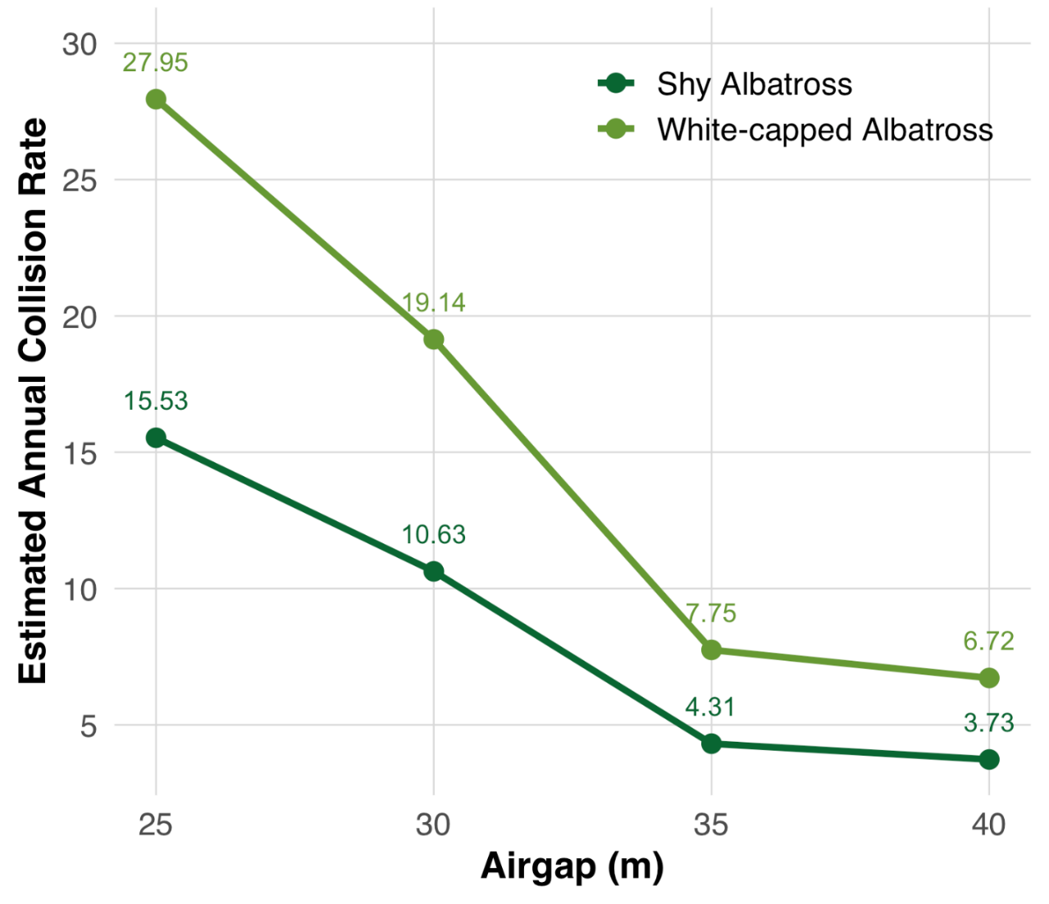

Monitoring measures
A Seabird Monitoring Management Plan will be developed prior to construction and will include monitoring of seabirds in the offshore wind farm area (MEMP-M03). This monitoring will be specifically targeted at the behavioural responses of species to operational turbines and will be used to provide confidence in collision risk model inputs used in the assessment to maintain relevance of the modelling to the operational wind farm and provide confidence that risks are maintained at an acceptable level. The monitoring will particularly focus on observed listed threatened species utilising the offshore wind farm area. This is discussed in further detail in section 12.10.2.
Table 12-22 Summary of worst-case collision risk modelling results for the air gaps tested.
Species | Worst case collisions (per annum)
Species | 25 metre air gap | 30 metre air gap | 35 metre air gap
Species with ≥10 records
Shy-type Albatross | 31.05 | 21.27 | 8.61
Shy Albatross  (50% of Shy-type) | 15.53 | 10.63 | 4.31
White-capped Albatross  (90% of Shy-type) | 27.95 | 19.14 | 7.75
Black-browed Albatross | 2.44 | 1.67 | 0.67
Yellow-nosed Albatross | 0.88 | 0.60 | 0.24
Australasian Gannet | 55.24 | 40.96 | 22.97
Black-faced Cormorant | 20.09 | 11.99 | 5.92
Fairy Prion | 14.68 | 14.45 | 14.23
Short-tailed Shearwater | 45.87 | 34.80 | 31.65
Fluttering Shearwater | 30.49 | 27.82 | 27.38
Hutton's Shearwater | 7.83 | 7.14 | 7.03
Fluttering/Hutton's Shearwater | 8.30 | 7.57 | 7.45
Sooty Shearwater | 0.26 | 0.23 | 0.23
Greater Crested Tern | 152.16 | 96.70 | 49.18
Little Tern | 5.28 | 3.34 | 1.69
Silver Gull | 1.39 | 1.37 | 1.35
Pacific Gull | 13.79 | 9.36 | 5.26
Species with <10 records
Buller's Albatross | 0.76 | 0.52 | 0.21
White-faced Storm-Petrel | 4.49 | 4.42 | 4.35
White-headed Petrel | 0.03 | 0.03 | 0.03
Wedge-tailed Shearwater | 0.04 | 0.03 | 0.03
Little/Fairy Tern | 1.71 | 1.09 | 0.55
Caspian Tern | 0.78 | 0.49 | 0.25
White-fronted Tern | 0.52 | 0.33 | 0.17
Common Tern | 0.47 | 0.30 | 0.15
Arctic Jaeger | 0.43 | 0.38 | 0.33
Pomarine Jaeger | 0.35 | 0.31 | 0.27
Brown Skua | 1.79 | 1.76 | 1.73
White-throated Needletail | 0.84 | 0.82 | 0.81

Residual risk
The residual risk of turbine collisions for all assessed species is in Table 12-23 below.
Table 12-23 Consequence, likelihood and residual risk ranking associated with collisions with operational turbines
Event (ID no.) | Receptor | Receptor sensitivity | Consequence | Likelihood | Initial risk rating | Mitigation | Residual risk rating
Collison Risk (OOB-R005) | Shy Albatross | High | Major | Unlikely | Medium | - | Medium
Collison Risk (OOB-R005) | White-capped Albatross | Medium | Moderate | Unlikely | Low | - | Low
Collison Risk (OOB-R005) | Black-browed Albatross  Indian Yellow-nosed Albatross  Northern giant Giant-Petrel  Southern Giant-Petrel  Wandering Albatross  Southern Buller’s Albatross  Gibson's albatross  Amsterdam albatross  Antipodean albatross  Tristan albatross  Campbell albatross  Gould’s Petrel | Medium | Moderate | Rare | Low |  | Low
Collison Risk (OOB-R005) | Sooty Shearwater  Soft-plumaged Petrel | Low | Minor | Rare | Very Low | - | Very Low
Collison Risk (OOB-R005) | Short-tailed Shearwater  Fluttering Shearwater  Hutton’s Shearwater  Wedge-tailed Shearwater  Fairy Prion  Buller’s Shearwater  Cape Petrel  White-headed Petrel  Antarctic Prion  Wilson’s Storm-petrel  Grey-backed Storm-petrel  Providence Petrel  Common Diving Petrel | Low | Minor | Rare | Very Low | - | Very Low
Collison Risk (OOB-R005) | Great Cormorant  Little Black Cormorant  Black-faced Cormorant  Pied Cormorant  Little Pied Cormorant | Low | Minor | Rare | Very Low | - | Very Low
Collison Risk (OOB-R005) | Australasian Gannet  Greater Crested Tern  Pacific Gull | Low | Moderate | Rare | Low | - | Low
Collison Risk (OOB-R005) | Little Tern  Fairy Tern | Low | Minor | Rare | Very Low |  | Very Low
Collison Risk (OOB-R005) | Silver Gull  Kelp Gull  Caspian Tern  Little Tern  Fairy Tern  Common Tern  White-fronted Tern  Greater Crested Tern  Little Penguin  Arctic Jaeger  Pomarine Jaeger  Brown Skua  White-striped Free-tailed Bat | Low | Minor | Rare | Very Low | - | Very Low
Collison Risk (OOB-R005) | Swift Parrot  Blue-winged Parrot | Medium | Minor | Unlikely | Low | - | Low
Collison Risk (OOB-R005) | White-throated Needletail | Medium | Minor | Unlikely | Low | - | Low
Collison Risk (OOB-R005) | Double-banded Plover | Medium | Moderate | Unlikely | Low | - | Low
Collison Risk (OOB-R005) | Populations overwintering in Victoria
Collison Risk (OOB-R005) | Bar-tailed godwit  Curlew Sandpiper  Grey Plover  Red Knot  Red-necked Stint  Common Greenshank  Great Knot  Greater Sand Plover  Lesser (Mongolian) Sand Plover  Grey-tailed Tattler  Latham's Snipe  Pacific Golden Plover  Ruddy Turnstone  Sharp-tailed Sandpiper | Medium | Minor | Rare | Very Low | - | Very Low
Collison Risk (OOB-R005) | Far Eastern Curlew  Whimbrel | Medium | Moderate | Rare | Low | - | Low
Collison Risk (OOB-R005) | Populations overwintering in Tasmania
Collison Risk (OOB-R005) | Bar-tailed godwit  Common Greenshank  Curlew Sandpiper  Great Knot  Greater Sand Plover  Latham's Snipe  Red Knot  Sharp-tailed Sandpiper  Whimbrel | Medium | Minor | Rare | Very Low | - | Very Low
Collison Risk (OOB-R005) | Far Eastern Curlew  Red-necked Stint  Ruddy Turnstone  Sanderling | Medium | Minor | Rare | Low | - | Low

Physical presence of maintenance vessels: propellor injury (OOB-R001)
The risk of propellor injury from the physical presence of maintenance vessels during operations is equivalent to those discussed for construction in section 12.6.3.1. Vessel activity will be significantly lower during the operational phase compared to construction, but the potential risks of propellor injury during operations are conservatively assumed to be the same as those assessed for the construction phase. See section 12.6.3.1 for the relative assessment.

Unplanned hydrocarbon release (oil spill & toxicity) (OOB-R002, OOB-R003)
The risk of an unplanned hydrocarbon release affecting seabirds and shorebirds during the operational phase is considered equivalent to that assessed for the construction phase (see Section 12.6.3.2).
However, the overall likelihood of such events is lower during operations due to several factors – operational vessels carry significantly smaller volumes of oil and fuel, no refuelling vessels will be required, fuel-powered construction equipment will be used only occasionally for major repairs and there will be fewer movements of large vessels. Although operational substations will be present, unlike during construction, they pose a very low risk of spillage. Risks are conservatively assumed to be the same as during construction, and all relevant regulatory prevention and management measures outlined in section 12.6.3.2 will continue to apply during operations. See section 12.6.3.2 for the relative assessment.

Decommissioning impacts

Potential impacts and risks
The decommissioning activities are conservatively assumed to impact the same receptors at the same or lesser magnitude and scale as construction operations.
A Marine Decommissioning Management Plan (DEC-M01) will be developed prior to decommissioning to assess the potential impacts from the final agreed methodologies of removing offshore infrastructure.

Cumulative Impacts
This section provides an assessment of the potential for cumulative impacts of the project with other proposed developments in the region. The method to consider cumulative impacts is described in Chapter 6 – Assessment Framework.
Potential cumulative impacts arise when the effects of a single project on a receptor are considered alongside the effects of other projects on the same receptor. Projects that are operational are part of the baseline environment, and the cumulative impact assessment focuses on future developments following the tiered assessment methodology.
The projects identified in the cumulative assessment for offshore ornithology and bats is summarised in Table 12-24.

Table 12-24 Projects assessed for cumulative impacts
Project | Project description | Findings of assessment
Great Eastern Offshore Wind Farm (Corio Generation) | Located immediately adjacent to the southeast of the offshore wind farm area, 25 to 40 kilometres from Reeves Beach. The project includes up to 172 fixed foundation wind turbines with a maximum blade tip height of 375 metres, eight offshore substations and associated infrastructure in operation, generating up to 2.5 GW of electricity. Construction is expected to occur from 2028 to 2032, followed by a 30-year operational period. | Impact pathways assessed for CIA on ornithology and bats receptor groups were:  Vessel operations: artificial light emissions  Underwater noise leading to a change in fauna behaviour, including displacement or TTS in hearing  Physical presence of operational turbines - displacement  Physical presence of operational turbines resulting in bird strike in significant numbers leading to a population level effect  Short-tailed shearwater, Fluttering Shearwater, Hutton's Shearwater, Common Diving-Petrel and Fairy Prion were identified as being species most sensitive to artificial lighting and due to their relative abundance in the offshore wind farm area and/or the proximity of breeding island. Vessel and infrastructure lighting from Great Eastern Offshore Wind Farm present a possibility of cumulative impacts with the project on these species. Considering these project-wide mitigations and management measures, and that the consequence rating for the abovementioned sensitive species was minor, the cumulative impact for artificial light emissions is considered minor.  An increase in the number of vessels (specifically DP) and piling activities have the potential to increase underwater noise and reduce potential foraging habitat for the Little Penguin where there is temporal overlap in construction projects. However, given the distance offshore and the distance in which Little Penguins are known to forage, underwater noise impacts are likely to be lower compared with the Star of the South project activities and cumulative impacts are predicted to be negligible.  An increase in the number of offshore wind farms within the Gippsland Declared Area has the potential to reduce the extent of seabird foraging habitat if individuals avoid a wind farm array. The cumulative impact was assessed as minor for Shy-type albatrosses, and negligible cumulative impacts for Greater Crested Tern and Australasian Gannets. As a principally benthic forager, the Black-faced Cormorant is restricted in the depth at which it can forage and water depths within much of the Great Eastern Offshore Wind Farm site are likely too deep for foraging, limiting any cumulative displacement effects on the species.  Collision risk modelling completed for Star of the South indicated the seabirds with the highest flights at risk of collisions with turbines were Greater Crested Tern, Australasian Gannet, Short-tailed Shearwater and Fluttering Shearwater. Species presence and abundance data is not available to inform collision risk modelling for Great Eastern Offshore Wind Farm, and it is not appropriate to apply collision risk model results from the Star of the South due to differences in seabird microhabitat use.
Gelliondale Onshore Wind Farm (Synergy Wind Pty Ltd) | A proposed renewable energy facility with up to 13 wind turbines and ancillary infrastructure including an energy storage system and substation. It is located inshore of the offshore wind farm area and it is possible that the construction and operations phase of the project may overlap with the project. The scale and location are very different to Star of the South, however, there is a cumulative risk potential of turbine collision for the White-throated Needletail. | Impact pathways assessed for CIA on ornithology and bats receptor groups were:  - Physical presence of operational turbines resulting in bird strike in significant numbers leading to a population level effect

Summary of mitigation, monitoring and contingency measures

Mitigation measures
The following section outlines the mitigation measures developed to avoid and minimise impacts on the offshore ornithology and bats in the project area.
The focus of these mitigation measures is:
- Avoiding impacts where reasonably practicable
- Developing, preparing and implementing project-specific measures to minimise impacts.
Detailed descriptions of each measure can be found in Chapter 23 – Commonwealth Environmental Management Framework and are listed in Table 12-25.
Table 12-25 Summary of mitigation measures relevant to offshore ornithology and bats
Mitigation ID | Mitigation measure
VES-M01 | Vessel operations framework
SPL-M02 | Spill response plan
SPL-M03 | Maintenance of offshore substation transformers
VES-M03 | Marine coordination centre
VES-M04 | Vessel movement controls
OFF-M05 | Shore crossing methodology
OFF-M02 | Marine debris minimisation
OFF-M04 | Low toxicity marine drilling fluids
LIT-M01 | Infrastructure light management
LIT-M02 | Vessel Artificial Light Management
EMI-M01 | Depth of cable burial
UWN-M01 | Piling soft start procedure
UWN-M03 | Noise Abatement System (NAS)
VES-M07 | Propellor guards
DEC-M01 | Marine Decommissioning Management Plan

Monitoring and contingency measures
The measures that are proposed to monitor offshore ornithology and bat impacts associated with the project includes the development of a Seabird Monitoring and Management Plan (MEMP-M03) before construction that targets the pathways and species in Table 12-26.
The Seabird Monitoring and Management Framework has been developed (see Chapter 23 – Commonwealth Environmental Management Framework, Attachment IV – Seabird Monitoring and Management Framework) and will be further developed into the Seabird Monitoring and Management Plan. The document provides the overarching framework that will guide the monitoring and adaptive management of the operational offshore wind farm with respect to collision risk, because from the assessment in section 12.7.3.1, this is the principal residual risk pathway for seabirds associated with the operation of the wind farm.
Seabird monitoring will be undertaken within the offshore wind farm area and surrounding buffer areas using a multiple-lines-of-evidence approach to assess a range of bird behaviours under varying weather conditions. Monitoring will address uncertainty of key behaviours including whether specific bird species exhibit avoidance behaviour across the broader wind farm area and how species respond to individual turbines at a close range.
This monitoring data will inform the need for adaptive management measures that include updating and rerunning the collision risk model to verify that predictions of the EIS for collision risk during operations (section 12.7.3.1) remain within acceptable levels and to determine whether additional management actions, or compensatory / offset measures, are required. See Chapter 23 – Commonwealth Environmental Management Framework, Attachment IV – Seabird Monitoring and Management Framework for more detail.

Table 12-26 Proposed approach to monitoring and adaptive management relevant to key species and potential impact and risk pathways.
Impact / risk pathway | Key focus species | Proposed monitoring approach
Artificial lighting - seabird fallout on vessels | - Short-tailed Shearwater  - Hutton’s Shearwater  - Fluttering Shearwater  - Fairy Prion  - Common Diving Petrel | Routine observations on vessels operating at night. Bird handling procedures will be developed in the event birds are attracted to lights coupled with triggers for additional mitigations where necessary.
Turbine collision | Listed threatened species observed utilising the offshore wind farm area | In field monitoring during operations — focusing on avoidance behaviour at varying spatial scales within the wind farm using a multiple-lines of evidence approach where necessary.  Adaptive management built in and triggered by early monitoring results.

Conclusion
This chapter has identified the existing conditions related to offshore ornithology and bats and has assessed impacts and risks associated with the construction, operation and decommissioning of the project on the range of existing shorebird, seabird and Bass Strait migrant species.
Existing environment
Highlights of the existing environment derived from the extensive ecological surveys and literature reviews were:
- 35 species of seabirds were observed within the offshore wind farm area during surveys. While numerous conservation important species were observed in the offshore wind farm area, such as shy-type albatross, their numbers were relatively low compared to observations in other reference sites suggesting the offshore project area is not an important environment for them. From tagging studies, the offshore wind farm area was used by locally breeding coastal species including the Australasian Gannet, Black-faced Cormorant and Little Penguin
- Of the shorebirds recorded, Hooded Plover, Red-capped Plover, and Masked Lapwing were the most frequently encountered species, but each were present in small numbers. Very few EPBC Act-listed threatened and migratory shorebird species were found to occur at the beaches proposed to be the location of the shore crossing
- Only five of the many known Bass Strait migrant species were observed in the offshore project area in small numbers during two years of surveys. The offshore project area does not fall within the main migratory corridor between Tasmania and Victoria for conservation important species such as the orange bellied parrot.
Potential impacts
The assessment identified artificial light emissions as a pathway which may have a moderate impact on certain seabirds if unmitigated. This was assessed as follows:
- During all phases of the project, artificial light has the potential to change bird behaviour through attraction to light, leading to disorientation and potential fallout or grounding
- The species most likely to be impacted by artificial lighting in the offshore environment are the burrow-nesting shearwaters, petrels, prions and storm-petrels
- Mitigation measures, specifically, lighting management measures, routine monitoring on vessels and a handling program for grounded birds (on vessels) will be used to minimise impacts to burrow-nesting seabirds at sea. Implementation of these measures will ensure that any effects of artificial lighting will be limited to infrequent and highly localised instances.
The assessment identified that all other impact pathways are likely to have limited effects on birds. These included potential impacts associated with displacement and barrier effects by turbines, trenchless cable installation, physical presence of vessels, underwater noise, seabed disturbance, routine discharges, attraction to turbines and electromagnetic interference.
Potential risks
The assessment identified and addressed the following risk pathways with a medium initial risk for certain species:
- Vessel activities leading to propeller injury or death. During all phases of the project, the Little Penguin may be at risk of propellor injury from vessels due to the species' limited flying capacity. However, with the application of well tested mitigations where necessary, such as propeller guards on vessels operating in sensitive areas, the risk of injury or death is very low
- Vessel-to-vessel collision leading to unplanned hydrocarbon release. While the likelihood of this occurring is extremely rare, it could potentially have consequences for seabirds in terms of oiling of feathers and toxicity from spilled hydrocarbons. However, with the implementation of appropriate vessel management plans and procedures to manage simultaneous operations including around fishing activities, the risk is very low. Oil spill response plans will be developed and implemented in the event of a major spill to limit the impact to marine fauna and the environment
- Physical presence of operational wind turbines resulting in bird collisions. The seabirds with the greatest number of collisions with turbines were the Greater Crested Tern, Australasian Gannet, Short-tailed Shearwater and Fluttering Shearwater. However, collision risk modelling suggests that collisions rates for these species would be no greater than natural mortality rates and would therefore have no impact on population viability.
Under a worst-case scenario, Shy Albatross conservatively had a predicted 0.43 to 4.31 collisions per annum (representing 0.01 per cent of the Australia and New Zealand population), while White-capped Albatross ranged from 0.78 to 7.75 collisions (0.001 per cent of the Australia and New Zealand population). Despite these numbers being small, the risk rating remains medium for Shy Albatross given their conservation value.
The biggest mitigation for bird collision risk has been to raise the air gap of the wind turbines from 25 metres to 35 metres. This design change alone has significantly reduced the potential for bird collision for most of the species at risk.
Seabird Monitoring and Management Plan (SMMP)
A Seabird Monitoring and Management Plan will be developed and include monitoring and management measures of impacts and risks including those associated with artificial light emissions and turbine collisions. This will include adaptive actions to be taken if project monitoring results demonstrate that acceptable levels of impact are close to being exceeded and no further mitigations are available and practicable for deployment.
Overall, findings of the assessment indicates that the project, inclusive of the implemented mitigations, is unlikely to have a significant impact on seabirds, shorebirds and Bass Strait migrants, including listed threatened, migratory species, nor the Commonwealth marine environment in which they occur.

