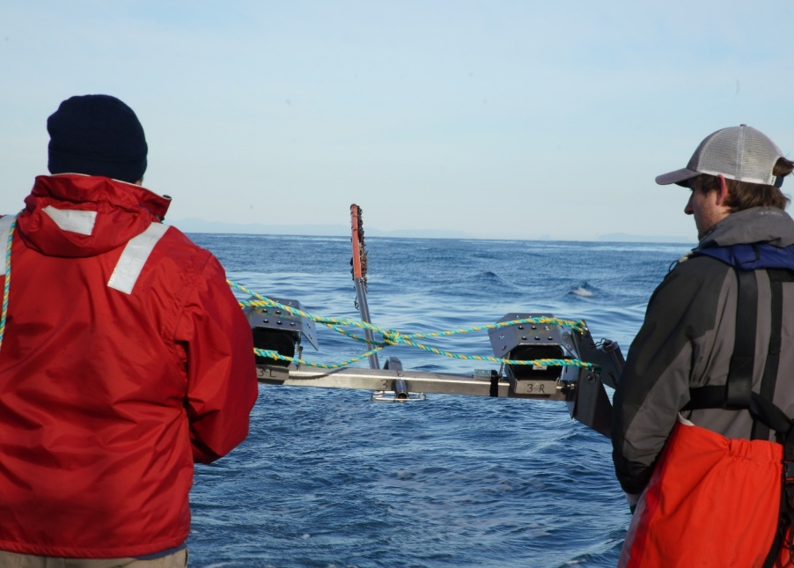

Commonwealth Environmental Impact Statement
Chapter 13 – Marine protected areas
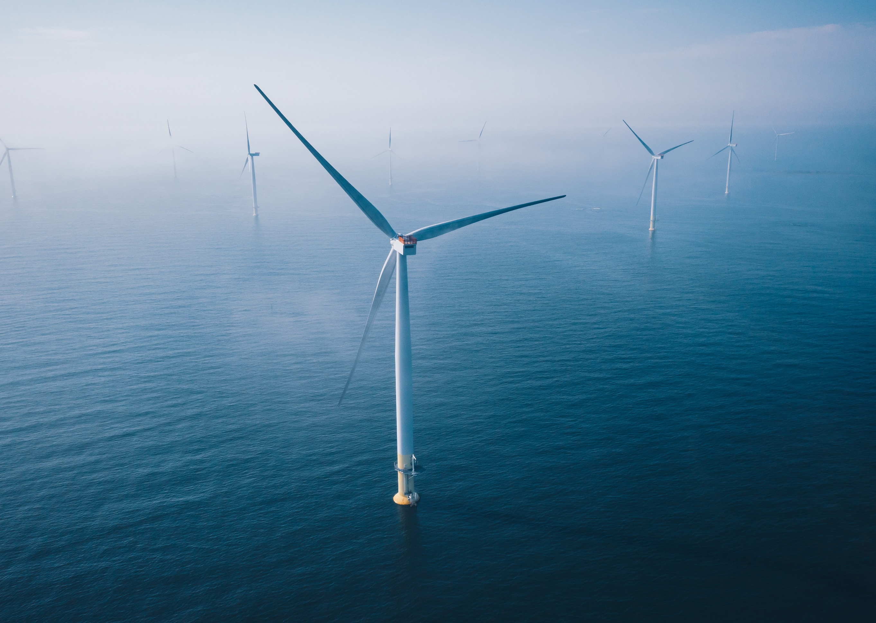
Table of Contents
Chapter 13 Marine protected areas 13-1
13.1 Introduction 13-1
13.2 Assessment scope 13-2
13.2.1 Commonwealth matters 13-2
13.3 Evaluation framework 13-4
13.3.1 Key legislation, policy, guidelines and standards 13-4
13.3.2 Assessment criteria 13-4
13.4 Methods 13-5
13.5 Existing environment 13-6
13.5.1 Corner Inlet Ramsar site 13-8
13.5.2 Beagle Australian Marine Park 13-9
13.6 Corner Inlet Ramsar site impact assessment 13-11
13.6.1 Construction impacts and risks 13-11
13.6.2 Operation impacts and risks 13-15
13.7 Beagle Australian Marine Park impact assessment 13-18
13.7.1 Construction impacts 13-18
13.7.2 Operation impacts 13-21
13.8 Decommissioning impacts 13-22
13.9 Cumulative impact assessment 13-23
13.10 Summary of mitigation, monitoring and contingency measures 13-26
13.10.1 Mitigation measures 13-26
13.10.2 Monitoring measures 13-27
13.11 Conclusion 13-28

Figures
Figure 13-1 Marine protected areas in relation to the offshore project area 13-7

Tables
Table 13-1 Key legislation, policy, guidelines and standards 13-4
Table 13-2 Ramsar Convention criterion met by Corner Inet 13-8
Table 13-3 Components of the Corner Inlet Ramsar site and associated values 13-9
Table 13-4 Construction impact pathways and residual consequence ratings relevant to respective values of the Corner Inlet Ramsar site 13-12
Table 13-5 Construction risk pathways and residual risk ratings relevant to respective values of the Corner Inlet Ramsar site 13-14
Table 13-6 Operation impact pathways and residual consequence ratings relevant to respective values of the Corner Inlet Ramsar site 13-16
Table 13-7 Operation risk pathways and residual risk ratings relevant to respective values of the Corner Inlet Ramsar site 13-17
Table 13-8 Construction impact pathways and residual consequence ratings relevant to respective values of the Beagle Australian Marine Park. 13-19
Table 13-9 Construction risk pathways and residual consequence ratings relevant to respective values of the Beagle Australian Marine Park. 13-21
Table 13-10 Summary of assessments on cumulative impacts on Corner Inlet Ramsar site and Beagle Australian Marine Park. 13-23
Table 13-11 Mitigation measures relevant to Marine Protected Areas 13-26
Table 13-12 Monitoring measures relevant to the marine protected area assessment 13-27

Marine protected areas

Introduction
This chapter identifies the existing conditions related to Commonwealth marine protected areas and assesses impacts and risks associated with the construction, operation and decommissioning of the Star of the South Offshore Wind Farm Project (the project) on marine protected areas. The chapter describes how impacts will be avoided, minimised or managed.
This chapter is based on the impact assessment presented in Technical Report F – Marine Protected Areas.
Other chapters and modelling that relate to or inform this assessment include:
Chapter 8 – Coastal Processes and Sediment Transport
Chapter 9 – Benthic Ecology
Chapter 10 – Fish and Invertebrates
Chapter 11 – Marine Mammals and Turtles
Chapter 12 – Offshore Ornithology and Bats
Chapter 14 – Non-Aboriginal Underwater Cultural Heritage
Chapter 21 – Business and Tourism
Technical Report Attachment I – Underwater Noise Modelling Summary
Technical Report Attachment II – Oil Spill Modelling Summary

Assessment scope
The study objective for Commonwealth marine protected areas is to summarise the potential impacts and risks associated with the project on marine protected areas in the region.
Marine protected areas are designated areas of ocean, sea or great lakes that are protected by law for their environmental, cultural, biodiversity or natural resource value. Marine protected areas within the region that are relevant to the assessment are:
- Ramsar wetlands: sites recognised under the Ramsar Convention of Wetlands as being representative, rare or unique wetlands, or wetlands that are important for conserving biological diversity.
- Australian Marine Parks (AMPs): protected areas between 3 to 200 nautical miles from shore that are representative marine habitats created to protect and maintain biodiversity and ecological processes through management of sustainable activities. AMPs are managed by Parks Australia.
The focus of this chapter is on Commonwealth marine protected areas that have the potential to be impacted by the project and are relevant to the assessment and include the Corner Inlet Ramsar site and Beagle Australian Marine Park.
All detailed technical methodologies and assessment on marine protected areas can be found in Technical Report F – Marine Protected Areas.

Commonwealth matters
The EIS guidelines for the project inform the preparation of the EIS about the relevant impacts of the project to enable the Commonwealth Minister for the Environment to make an informed decision on whether to approve the project under the EPBC Act.
The aspects of the EIS guidelines that are directly relevant to marine protected areas are:
- Section 2.6 – Description of protected matters, particularly section 2.6.1 Ramsar Wetlands
- Section 2.7 – Relevant impacts, particularly:
  - d) predictions (including modelling) of any changes to the physio-chemical status of Corner Inlet Ramsar site (including turbidity and suspended sediment changes) during the construction, operation and decommissioning stages of the action and i) Predictions of the extent, severity and persistence of impacts of the action on existing marine benthic habitats and communities and the biota they support (e.g. mammals, reptiles, marine plants, fish and invertebrates), and evaluating how these impacts affect marine ecological integrity and functioning, for the Commonwealth Marine Area as well as any marine protected areas that may be affected.
Further information about the EIS guidelines is listed in Attachment V – EIS Guidelines Checklist.

Evaluation framework

Key legislation, policy, guidelines and standards
Table 13-1 lists the key legislation, policy, guidelines and standards relevant to marine protected areas.
Table 13-1 Key legislation, policy, guidelines and standards
Type | Applicable legislation, policy, guideline or standard
International conventions/guidance | IMO Guidelines for the reduction of underwater noise from commercial shipping to address adverse impacts on marine life (MEPC, 2014)
International conventions/guidance | International Convention for the Prevention of Pollution from Ships 1973 (MARPOL)
International conventions/guidance | International conventions/agreements on migratory species
International conventions/guidance | Ramsar Convention on Wetlands
Commonwealth legislation | Environment Protection and Biodiversity Conservation Act 1999 (EPBC Act)
Commonwealth legislation | Environment Protection and Biodiversity Conservation Regulations 2000
Commonwealth legislation | Biosecurity Act 2015
Commonwealth legislation | Offshore Electricity Infrastructure Act 2021
Commonwealth legislation | Protection of the Sea (Prevention of Pollution from Ships) Act 1983
Commonwealth legislation | Underwater Cultural Heritage Act 2018
Commonwealth legislation | Protection of the Sea (Harmful Antifouling Systems) Act 2006

Assessment criteria
To assess the project, predicted impacts and risks are compared to criteria that set required environmental performance outcomes (refer Chapter 6 – Assessment Framework).
The criteria for marine protected areas are derived from legislation and policy, relevant standards and guidelines, stakeholder feedback and industry best practice.
The assessment criteria relevant to marine protected areas are:
- Ramsar wetlands - The project will have no measurable impact on the ecological values of the Corner Inlet Ramsar site, as defined with the Ecological Character Description for the site, and the EPBC Act significant impact criteria for wetlands of international importance.
- Australian Marine Parks - The project will have no measurable impact on the conservation values of the Beagle Australian Marine Park.

Methods
The purpose of the marine protected areas impact assessment is to assess the potential impacts and risks on marine protected areas.
Impacts refer to the consequences of planned project actions, which are given a rating determined by combining the magnitude of the impact and the sensitivity of the receptor.
Risks are an unexpected (accidental) event and are determined by combining the likelihood of an event occurring and the consequences that would result if the event were to occur.
The technical chapters consider key impacts and risks with a residual consequence rating of moderate to severe. Other impacts and risks are those with a residual consequence rating of negligible to minor.
Refer to Chapter 6 – Assessment Framework for more detail on how impact and risk ratings are derived.
The marine protected areas impact assessment involved:
- Identifying all relevant Commonwealth and Victorian marine protected areas located within or near the offshore project area that could be affected by the project. This included reviewing relevant national, state and local legislation and international treaties and conventions
- Identifying the environmental (and other values) of the relevant protected areas. These were defined based on information presented in management plans relevant to the conservation and/or management of the marine protected area, and for the Corner Inlet Ramsar site, based on the Ecological Character Description (ECD) and Ramsar Information Sheet
- Evaluating the potential impacts and risks to each value from the construction, operation and decommissioning of the project, using the outcomes of the dedicated chapters that assessed project activities on the associated values (for example, species or habitat). Where no plausible impact pathway was identified between the project activities and a value, that value was not carried forward for further assessment.

Existing environment
This section describes the existing conditions within the study area as they relate to marine protected areas. The study area is defined as the area covering Commonwealth marine protected areas including Ramsar wetlands and Australian Marine Parks with the potential to be impacted by the project.
The offshore project area does not directly overlap with any Commonwealth marine protected areas. However, there are two Commonwealth marine protected areas within region that are relevant to the assessment. These are shown in Figure 13-1 and include:
- Corner Inlet Ramsar site
- Beagle Australian Marine Park.
Figure 13-1 Marine protected areas in relation to the offshore project area
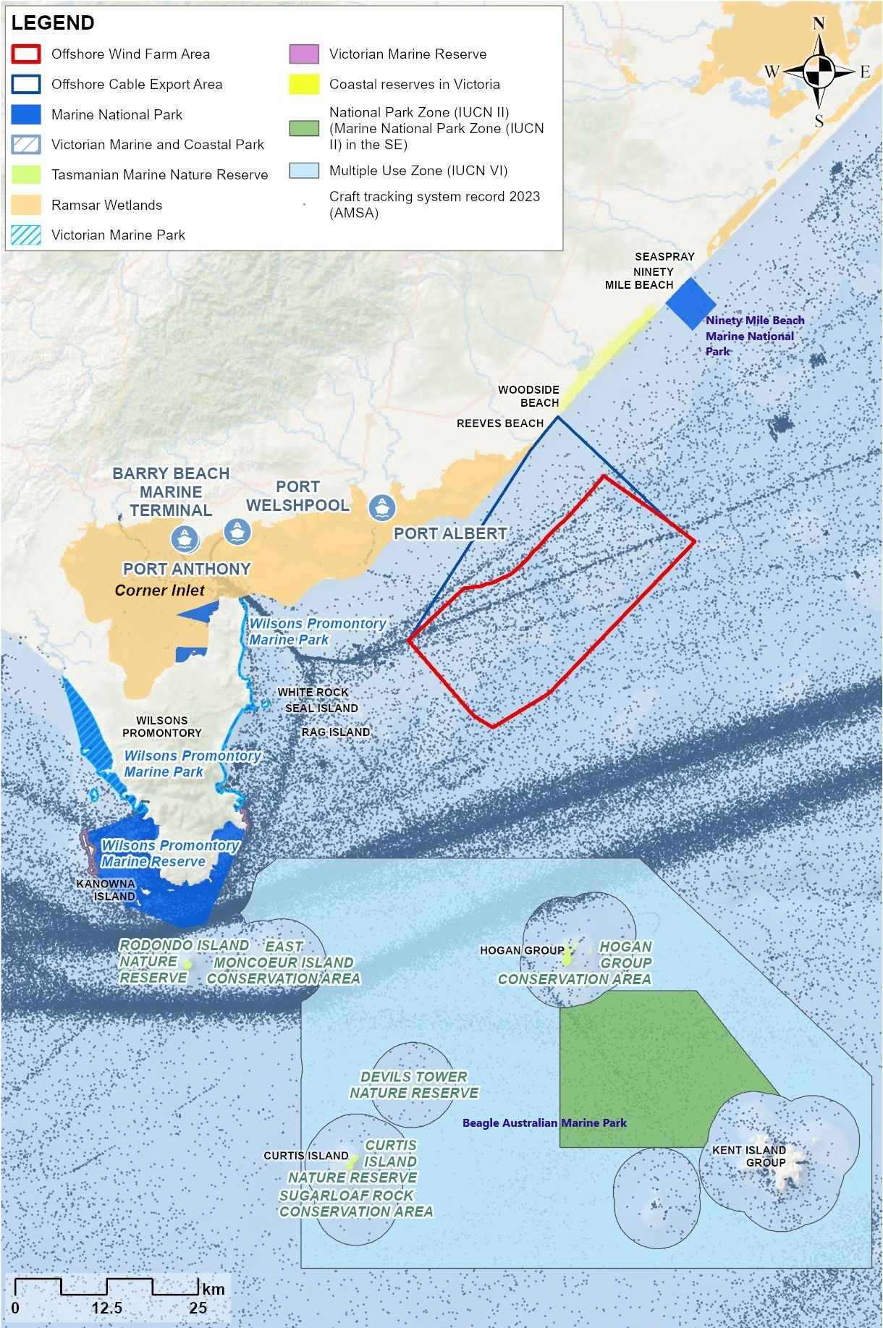

Corner Inlet Ramsar site
Corner Inlet Ramsar site covers an area of about 67,186 hectares and is approximately seven kilometres west of the offshore wind farm area at its nearest point (Figure 13-1). The Ramsar site encompasses the Corner Inlet Marine and Coastal Park, most of Nooramunga Marine and Coastal Park and the Port of Corner Inlet. Numerous ports are located within the boundaries of the Ramsar site, including Port Anthony, Barry Beach Marine Terminal, Port Franklin, Port Welshpool and Port Albert. Port Anthony or Barry Beach Marine Terminal are expected to be used by the project for construction management and throughout the operation phase.
The Corner Inlet Ramsar site is the most southerly marine embayment and intertidal system of mainland Australia. It has a diverse range of wetland habitats in a near-natural state. The site has recorded many flora and fauna species, supporting approximately 390 species of indigenous flora, 160 species of indigenous terrestrial fauna and 390 species of marine invertebrate, along with various marine mammals. The site also supports nine species listed under the EPBC Act, including five vulnerable, one endangered and three critically endangered.
Corner Inlet was recognised as a Ramsar site in 1982 due to its condition, biological diversity, and significance to many migratory shorebirds (DELWP, 2022). The site is rated protected area category II (National Park) under the International Union for Conservation of Nature (IUCN). Corner Inlet is listed as a Ramsar site as it meets six out of nine Ramsar criteria under the Ramsar Convention, summarised in Table 13-2.
Table 13-2 Ramsar Convention criterion met by Corner Inet
Ramsar Convention Criterion | Ecological character description
Criterion 1: Wetland types | The site contains 14 wetland types, as well as non-wetland habitat types. A description of the wetland types along with the wetland features of the Corner Inlet Ramsar site are provided in Technical Report F – Marine Protected Areas.
Criterion 2: Threatened species and communities | The site regularly supports eight fauna species listed as threatened under the EPBC Act and/or the IUCN Red List.  The site supports a threatened ecological community, Coastal Saltmarsh, listed as ‘vulnerable’ under the EPBC Act which provides important habitat for a wide range of fauna species and important foraging and roosting habitat for migratory shorebirds, terrestrial birds, bats, and frogs.
Criterion 4: Support of critical life stages and refuge from adverse conditions | The site is of notable importance to bird species, with up to 35 species listed under Australia’s bilateral migratory bird agreements (JAMBA, CAMBA, ROKAMBA) and the Bonn Convention for conservation of migratory species.
Criterion 5: Regularly supports 20,000 or more waterbirds | Based on annual counts from 1986 to 2017, the site supports more than 20,000 shorebirds for every year.
Criterion 6: Regularly supports 1 per cent of a water bird species | Based on data from 1981 to 2015, the site regularly supports more than one per cent of the world populations of eight species of waterbird.
Criterion 8: Important spawning ground, migration path or source of food for fish stocks | The shallow coastal habitats and riverine, swamp and lake habitats of the Corner Inlet Ramsar site provide important spawning, nursery, feeding grounds and migratory pathways for numerous fish species.
The ecological character description for the Corner Inlet Ramsar site provides a description of the Ramsar site’s critical and supporting components, processes and services/benefits. The relevant values of the site that have been carried through for assessment were derived from these critical components, processes and services and are summarised in Table 13-3.
Table 13-3 Components of the Corner Inlet Ramsar site and associated values
Component type | Component detail | Values assessed
Critical components | - Several Wetland mega-habitats  - Abundance and diversity of water birds | - Seagrass  - Saltmarsh  - Mangrove  - Permanent shallow marine waters  - Waterbird abundance
Critical processes | - Waterbird breeding – important breeding sites are found on the sand barrier islands | - Waterbird breeding
Critical services/ benefits | - Nationally threatened fauna species (seven species of Palaearctic migratory waders, Hooded Plover, and Australian Grayling)  - Fisheries resource values: important fish habitats, feeding areas, recruitment areas, dispersal and migration and spawning sites for species of direct and indirect fisheries significance | - Threatened birds  - Threatened fish  - Fish

Beagle Australian Marine Park
The Beagle Australian Marine Park covers an area of 2,928 square kilometres and is located 20 kilometres south of the offshore wind farm area (see Figure 13-1). The Beagle Australian Marine Park lies within the South-east Marine Park Network, encompassing the waters surrounding offshore islands groups and structures including Kent Island Group, Hogan Island group, Curtis Island group, Southwest Island, Moncoeur Islands and Devil’s Tower. The marine park sits between the southeast point of Wilsons Promontory and Flinders Island in Bass Strait and ranges in depth from 50 to 70 metres.
The Beagle Australian Marine Park is a continental shelf marine park, and its major conservation values are attributed to the ecosystems, communities and diversity of habitats associated with the Southeast Shelf transition area and thought to be representative of central Bass Strait. The area is an important migration and resting area for the Southern Right Whale (Eubalaena australis) and an important foraging area for the Australian Fur Seal (Arctocephalus pusillus doriferus), numerous protected seabird species and the White Shark (Carcharodon carcharias). The marine park is also within the foraging biologically important area for Blue Whales (Balaenoptera musculus), White Sharks and several albatross and petrel species, as well as the migratory biologically important area of Southern Right Whales.
The marine park is classified as a multiple-use zone (IUCN VI), allowing for a range of activities. Vessels can transit freely and recreational activities, including fishing, are permitted. However, the area faces various human-induced pressures from nearby construction, mining, and fishing activities. Additionally, climate change-related impacts, such as rising sea levels and increasing sea temperatures, pose further challenges to the park’s conservation.
The area holds cultural significance for several Aboriginal communities. Until approximately 10,000 years ago, the area now covered by the park was dry land, forming part of the land bridge between Victoria and Tasmania, where Indigenous peoples lived and travelled. The park also contains two historic shipwrecks, the Eliza Davies and the SS Cambridge. No impact pathway from project activities was identified for these heritage values.
Values assessed for Beagle Australian Marine Park are based on the relevant conservation values and uses discussed above, and are:
- Shelf rocky reefs and hard substrates
- Threatened species (Blue Whale (foraging), Southern Right Whale (migration), White Shark (foraging) and seabirds (foraging))
- Fur seal foraging
- Fish
- Commercial and recreational fishing.

Corner Inlet Ramsar site impact assessment

Construction impacts and risks
This section discusses the impacts and risks associated with the project’s construction that relate to the Corner Inlet Ramsar site and respective values (receptor groups).

Key impacts
The construction impact assessment identified no impacts on Corner Inlet Ramsar site receptor groups with an impact rating of moderate or higher once mitigation measures have been implemented.

Other impacts
Other potential construction impacts with minor to negligible consequence on Corner Inlet Ramsar site receptor groups once mitigation measures are implemented include:
- Underwater noise - transiting vessels
- Physical disturbance – transiting vessels
- Artificial light emissions - transiting vessels.

Underwater noise - transiting vessels
The assessment considered the potential for transiting vessels in Corner Inlet to impact fish species from underwater noise. Underwater noise from transiting vessels will yield exposure ranges much smaller than those modelled for project construction activities and construction vessels. The area of potential disturbance is also extremely small. As such, impacts to threatened fish species, including Australian Grayling (Prototroctes maraena), and other fish species that may spawn or migrate through Corner Inlet Ramsar site from underwater noise from transiting vessels is expected to be negligible (Table 13-4).

Physical disturbance – transiting vessels
The assessment considered the potential for the physical presence of transiting vessels in Corner Inlet to impact bird species and their breeding.
Important waterbird breeding, roosting and/or feeding sites are located to the north and northeast of the Corner Inlet entrance channel on the sandy points and inner shores of the barrier islands – Clonmel Island, Box Bank and Dream Island. Transiting vessel traffic to/from Barry Beach (Toora Channel) or Port Albert (Port Albert Channel) should not affect beach nesting or roosting habitats as vessels are required to respect posted speed limits and not stray from identified navigational channels. All vessels operating in Corner Inlet will have a Vessel Passage Plan (SNV-M07) that manages safe navigation to the ports and use of navigational channels.
As vessels will be transiting in defined navigational channels that are not important for waterbird foraging, roosting, or nesting, exposure to increased vessel traffic is expected to have a negligible impact on migratory and resident waterbird species (Table 13-4).

Artificial light emissions - transiting vessels
The assessment considered the potential for artificial light emissions from transiting vessels in Corner Inlet to impact bird and fish species. Given that vessels will not be transiting through important waterbird foraging, roosting, or nesting habitats, artificial light is expected to have a negligible impact on waterbird species (Table 13-4). Any potential impact to fish, including the more sensitive surface-dwelling species that are attracted to light, is expected to be temporary and negligible as the vessels will be transiting and not stationary (Table 13-4). In addition, project vessels will comply with National Light Pollution Guidelines for Wildlife, to minimise light spill from vessel (LIT-M01).
Table 13-4 Construction impact pathways and residual consequence ratings relevant to respective values of the Corner Inlet Ramsar site
Potential impact | Corner Inlet Ramsar site value
Potential impact | Seagrass | Intertidal flats | Saltmarsh | Mangrove | Permanent shallow marine waters | Waterbird abundance | Waterbird breeding | Threatened birds | Threatened fish | Fish
Underwater noise – vessels transiting | - | - | - | - | - | - | - | - | Negligible | Negligible
Physical disturbance and artificial light emissions – transiting vessels | - | - | - | - | - | Negligible | Negligible | Negligible | Negligible | Negligible

Potential risks
All potential risks on Corner Inlet Ramsar site receptor groups that could arise from the project have a risk rating of very low to low, and include:
- Invasive marine species – transiting vessels
- Accidental hydrocarbon spill
- Contaminated surface water – shore crossing.

Invasive marine species – transiting vessels
The assessment considered invasive marine species from transiting vessels in Corner Inlet as a potential risk to fish.
Crew transfer vessels and service operation vessels will use modern antifouling technology and follow the Australian best practice Anti-fouling and In-Water Cleaning Guidelines. This risk will be mitigated through vessels complying with relevant biosecurity legislation and guidelines (VES-M05) that manages discharges of ballast water and ensures vessels are confirmed to be a low biosecurity risk before entering Australia or commencing work on the project.
Considering these mitigations (summarised in Chapter 9 – Benthic Ecology), there is a very low residual risk of the introduction of invasive marine species in the Corner Inlet Ramsar site. Therefore, invasive species are considered a very low residual risk for all relevant values (Table 13-5).

Accidental hydrocarbon spill - vessel grounding or collision
The assessment considered an accidental hydrocarbon spill from the grounding or collision of a vessel in Corner Inlet as a potential risk to the seabed, marine flora and fauna, water birds and fishery resources. The types of vessels operating within Corner Inlet will be small to medium sized commercial vessels that are highly manoeuvrable.
This risk will be mitigated through a range of procedures that regulate vessel activity (VES-M01, SPL-M02 and SNV-M05), reducing the likelihood of any vessels colliding. In the rare event that a spill occurs, impacts will be minimised by spill response plans (SPL-M02) developed to ensure rapid and effective response to a hydrocarbon release.
With mitigation measures in place (summarised in Chapter 9 – Benthic Ecology), the likelihood of an accidental hydrocarbon spill is rare and therefore the residual risk to the habitat values of Corner Inlet are very low, and low for relevant fish and bird values (Table 13-5).

Contaminated surface water – shore crossing
The assessment considered contaminated surface water from the shore crossing construction as a potential risk to seagrass, intertidal flats and saltmarsh habitats in Corner Inlet.
The shore crossing construction site at Reeves Beach is adjacent to a small, unnamed waterway that creates a hydrological connection between Freshwater Swamp (1.2 kilometres north of the shore crossing site) and the Corner Inlet Ramsar site at the mouth of Bruthen Creek (six kilometres south of the shore crossing site). The waterway is fed by runoff from adjacent agricultural land and is seasonally dry. Potential impacts on surface water quality in the construction area could lead to downstream impacts on sedimentation and water quality in the Ramsar site.
Management of runoff (SUM-M003 and SUM-M005) to ensure that pollution does not adversely affect waterways is standard practice on projects of this nature and scale. With implementation of these measures at the shore crossing construction site, impacts to downstream water quality at the Corner Inlet Ramsar site are not expected and residual risk is considered very low for the relevant habitat values (Table 13-5).
Table 13-5 Construction risk pathways and residual risk ratings relevant to respective values of the Corner Inlet Ramsar site
Potential risk | Corner Inlet Ramsar site value
Potential risk | Seagrass | Intertidal flats | Saltmarsh | Mangrove | Permanent shallow marine waters | Waterbird abundance | Waterbird breeding | Threatened birds | Threatened fish | Fish
Introduction and establishment of invasive marine species | - | - | - | - | - | - | - | - | Very low | Very low
Accidental hydrocarbon spill within Corner Inlet Ramsar site | Very low | Very low | Very low | Very low | - | Low | Low | Low | Low | Low
Contaminated surface water from shore crossing construction site flowing to the Corner Inlet Ramsar site | Very low | Very low | Very low | - | - | - | - | - | - | -

Operation impacts and risks
This section discusses the impacts and risks associated with the operation of the project that relate to Corner Inlet Ramsar site and the respective values.

Key impacts
The operation impact assessment identified no impacts with a residual consequence to Corner Inlet Ramsar site receptor groups of moderate or higher.

Other impacts
Other potential operation impacts with minor to negligible consequence to Corner Inlet Ramsar site receptor groups include:
- Changes in coastal processes – physical presence of infrastructure
- Vessel disturbance – transiting vessels.

Changes in coastal processes – physical presence of infrastructure
The assessment considered the potential for changes in coastal processes from the physical presence of project infrastructure to impact the coastal sections of Corner Inlet, of which the relevant values are seagrass and permanent shallow marine waters.
Coastal processes and sediment transport modelling indicate that any changes to waves, wind, currents, longshore sediment transport, onshore-offshore sediment transport and aeolian sediment transport from the project would either be nil or indistinguishable from natural variation and climate-change effects. Considering this, and that characteristics of the open coast of the Ramsar site are considered relatively resilient to both climate change impacts and project impacts due to the abundant sediment supply from Corner Inlet and Wilsons Promontory, residual impacts to values range from minor for sensitive seagrass to negligible for permanent shallow marine waters (Table 13-6).

Physical disturbance – transiting vessels
This has been assessed the same as for the construction phase. See Section 13.6.1 for the assessment.
Table 13-6 Operation impact pathways and residual consequence ratings relevant to respective values of the Corner Inlet Ramsar site
Potential impact | Corner Inlet Ramsar site value
Potential impact | Seagrass | Intertidal flats | Saltmarsh | Mangrove | Permanent shallow marine waters | Waterbird abundance | Waterbird breeding | Threatened birds | Threatened fish | Fish
Changes in coastal processes – physical presence of infrastructure | Minor | - | - | - | Negligible | - | - | - | - | -

Potential risks
The potential risks associated with the operation phase are:
- Invasive marine species – transiting vessels
- Accidental hydrocarbon spill
- Bird collision risk – operation of turbines.

Invasive marine species – transiting vessels
This has been assessed the same as for the construction phase, noting that this is conservative as the number of vessel movements will be significantly reduced during the operation phase. See Section 13.6.1.3.1 for the assessment.

Accidental hydrocarbon spill
This has been assessed the same as for the construction phase. See Section 13.6.1.3.2 for the assessment.

Bird collision risk – operation of turbines
The assessment considered collisions with operational turbines as a potential risk for waterbirds in Corner Inlet.
It is unlikely that resident waterbirds will be exposed to the risk of collisions as they are effectively confined to coastal environments, and they are not known to fly through the offshore wind farm area. It is unlikely that trans-equatorial migratory species, including threatened species, will be exposed to the risk of collisions because they are predominantly inshore diurnal foragers and available evidence indicates little risk of exposure during migration based on their migratory flight heights and pathways over mainland Australia.
Findings of the collision risk model indicated that there were no threatened or migratory seabirds or waterbird species for which the residual collision risk would result in a significant decline in the population or impede the recovery of any species. Residual risk ranges from low to very low depending on the species (Table 13-7). See Chapter 12 – Offshore Ornithology and Bats.
A Seabird Monitoring Management Plan will be developed prior to construction and will include monitoring of seabirds in the offshore wind farm area (MEMP-M03). This monitoring will be specifically targeted at the behavioural responses of species to operational turbines and will be used to validate collision risk model inputs used in the assessment to maintain relevance of the modelling to the operational wind farm and provide confidence that risks are maintained at an acceptable level.
Table 13-7 Operation risk pathways and residual risk ratings relevant to respective values of the Corner Inlet Ramsar site
Potential risk | Corner Inlet Ramsar site value
Potential risk | Seagrass | Intertidal flats | Saltmarsh | Mangrove | Permanent shallow marine waters | Waterbird abundance | Waterbird breeding | Threatened birds | Threatened fish | Fish
Bird collisions with offshore wind turbines | - | - | - | - | - | Low to Very low | Low to Very low | Low to Very low | - | -

Beagle Australian Marine Park impact assessment

Construction impacts
This section discusses the impacts and risks associated with the project’s construction that relate to Beagle Australian Marine Park and the respective values (receptor groups).

Key impacts
The construction impact assessment identified no impacts on Beagle Australian Marine Park receptor groups with an impact rating of moderate or higher once mitigation measures have been implemented.

Other Impacts
The construction impact assessment identified the following other impacts on Beagle Australian Marine Park receptor groups:
- Underwater noise – transiting vessels
- Artificial light emissions - transiting vessels.

Underwater noise – transiting vessels
Construction feeder ports, such as Bell Bay (Tasmania) and Geelong (Victoria), may be used to support large project vessels which may result in construction vessels transiting the Beagle Australian Marine Park during the construction period. Therefore, the assessment the considered the potential for transiting vessels to impact threatened species and foraging seals.
It is unlikely that underwater noise generated by transiting vessels would yield exposure ranges that could impact noise sensitive marine fauna species given that the vessels would be moving through and would not be stationary at any time. Vessel noise would not be new to the area as vessels often transit through the park (see Figure 13-1). As such, impacts from underwater noise from transiting vessels passing through Beagle Australian Marine Park are expected to be negligible (Table 13-8).

Artificial light emissions – transiting vessels
The Beagle Australian Marine Park includes biologically important areas for the foraging of six seabird species, noting that these areas extend well beyond the park (refer to Technical Report E – Offshore Ornithology and Bats). While seabirds could be attracted by artificial lighting from vessels transiting through the park.
To mitigate this potential impact, vessel lighting during all phases of the project will be managed in accordance with the National Light Pollution Guidelines for Wildlife (LIT-M01). This includes minimising light spill, avoiding the use of long wavelength light sources, avoiding the use of blue, violet or ultra-violet wavelengths and keeping lighting to the minimum requirement.
Residual impacts from lighting from transiting vessels is expected to have a negligible impact on seabirds (Table 13-8).
Table 13-8 Construction impact pathways and residual consequence ratings relevant to respective values of the Beagle Australian Marine Park.
Potential impact | Beagle Australian Marine Park value
Potential impact | Shelf rocky reefs and hard substrates | Threatened species | Fur seal foraging | Fish | Recreational fishing
Underwater noise and artificial light emissions from transiting vessels | - | Negligible | Negligible | - | -

Potential risks
The potential risks associated with the construction phase are:
- Invasive marine species – transiting vessels
- Accidental hydrocarbon spill
- Vessel strike with marine mammals.

Invasive marine species – transiting vessels
The assessment considered invasive marine species from transiting vessels in Beagle Australian Marine Park as a potential risk to shelf rocky reefs and hard substrates, fish and recreational fishing.
The likelihood of invasive marine species being introduced and establishing within the Beagle Australian Marine Park from transiting vessels is rare. Project vessels will apply best-practice biofouling and ballast water management practices (discussed in Section 13.6.1.3.1) to minimise the risk of translocating invasive marine species. The residual risk is very low for all assessed values (Table 13-9).

Accidental hydrocarbon spill
The assessment considered an accidental hydrocarbon spill from the collision of a vessel in the offshore wind farm area as a potential risk to the Beagle Australian Marine Park values.
With a range of mitigation measures that will regulate vessel activity (discussed in Section 13.6.1.3.2), the likelihood of a collision and spill occurring is considered rare. Modelling of a hydrocarbon spill from the collision of large construction vessels in the offshore wind farm area during the construction phase of the project predicted less than a two per cent probability of contact of oil (entrained or dissolved) in the Beagle Australian Marine Park. As such, the residual risk is considered very low for all assessed values (Table 13-9).

Vessel strike with marine mammals
The assessment considered the potential for transiting vessels to come into contact with marine fauna (strike) as a potential risk to the marine mammal values of Beagle Australian Marine Park.
While vessels could occasionally encounter Southern Right Whales or Blue Whales depending on the season, the risk of a vessel strike will be minimised through the implementation of vessel speed restrictions and best practice measures for monitoring marine fauna (VES-M06) (see Chapter 11 – Marine Mammals and Turtles). As such, the residual risk is considered very low for all respective threatened species (Table 13-9).
Table 13-9 Construction risk pathways and residual consequence ratings relevant to respective values of the Beagle Australian Marine Park.
Potential risk | Beagle Australian Marine Park value
Potential risk | Shelf rocky reefs and hard substrates | Threatened species | Fur seal foraging | Fish | Recreational fishing
Introduction and establishment of invasive marine species | Very low | - | - | Very low | Very low
Accidental hydrocarbon spill | Very low | Very low | Very low | Very low | Very low
Vessel strike | - | Very low | - | - | -

Operation impacts
Impacts and risks from transiting vessels to Beagle Australian Marine Park are not applicable to the operations phase of the project as vessels are not expected to transit through the area during this phase.
The Beagle Australian Marine Park is twenty kilometres to the south of the offshore wind farm area and there is no credible impact pathway for the project to have any significant impact on the values of the Beagle Australian Marine Park in terms of hydrodynamics and coastal processes.

Decommissioning impacts
Decommissioning is expected to involve similar types and numbers of vessels and equipment as the construction phase. Requirements at the time will determine the scope of decommissioning activities and impacts. The anticipated duration is up to three years.
A Marine Decommissioning Management Plan (DEC-M01) will be developed prior to decommissioning to assess the potential impacts from the final agreed methodologies of removing offshore infrastructure.

Cumulative impact assessment
This section provides an assessment of the potential for cumulative impacts of the project with other proposed developments in the region. The method to consider cumulative impacts is described in Chapter 6 – Assessment Framework.
Potential cumulative impacts arise when the effects of a single project on a receptor are considered along with the effects of other projects on the same receptor. Projects that are operational are part of the baseline environment, and the cumulative impact assessment focuses on future developments following the tiered assessment methodology.
The assessment of potential adverse cumulative impacts on marine protected areas from the Star of the South project and the projects screened into the assessment is based upon the outcomes of the cumulative impact assessments undertaken for the relevant marine protected area environmental and/or socio-economic values within the relevant receptor technical reports (Technical Report A – Coastal Processes and Sediment Transport, B – Benthic Ecology, C – Fish and Invertebrates, D – Marine Mammals and Turtles and E – Offshore Ornithology and Bats). A detailed description of the relevant projects and the potential cumulative effects upon each of these receptor groups and relevant species is provided in these technical reports.
A summary of the cumulative impacts for assessed values of Corner Inlet Ramsar site and Beagle Australian Marine Park is provided in Table 13-10 below.
Table 13-10 Summary of assessments on cumulative impacts on Corner Inlet Ramsar site and Beagle Australian Marine Park.
Potential cumulative impact pathways | Other relevant projects | Relevant values | Project alone residual consequence / risk | Findings of assessment of cumulative impacts
Corner Inlet Ramsar site
Underwater noise from vessels transiting (construction and operation) | - Great Eastern Offshore Wind project | - Threatened fish  - Fish | Negligible | Negligible. During all project phases the final consequence of underwater noise from transiting project vessels is predicted to be negligible for all fish receptor groups. No further assessment of cumulative impacts is required.
Transiting vessel presence: Artificial light emissions and physical disturbance (construction and operation) | - Great Eastern Offshore Wind Farm | - Waterbird breeding | Minor | Minor. Unmitigated, there is the potential for numerous individuals to be impacted because of light attraction and, potentially grounding on vessels, particularly during foggy conditions. However, with mitigations and management procedures in place, cumulative impacts to light-affected species are not predicted and the cumulative residual consequence is minor.
Changes to coastal processes (operation) | - Great Eastern Offshore Wind Farm | - Permanent shallow marine waters | Negligible | Negligible. The nature of cumulative impacts with Great Eastern Offshore Wind Farm is predicted to be like impacts from the project alone, but of greater magnitude. Nevertheless, the magnitude of likely cumulative impacts remains small relative to natural variation and the assessment found no change in residual impacts on relevant receptors.
Bird collision risk | - Great Eastern Offshore Wind Farm | - Threatened birds | Very low to Low | Insufficient information. Species presence and abundance data is not available to inform collision risk modelling for Great Eastern Offshore Wind project and may differ to the project due to differences in seabird microhabitat use. This will not be available until the Great Eastern Offshore Wind EIS is published. While cumulative impacts are possible, it is likely that collisions from the two projects combined would be orders of magnitude less than natural losses and deaths from other sources.
Beagle Australian Marine Park
Underwater noise from vessels transiting (construction) | - Great Eastern Offshore Wind Project  - Marinus Link cable installation and operation  - Gippsland Skies Offshore Wind Project marine surveys  - Gippsland Offshore Wind Farm marine survey investigations | - Threatened species  - Fur seal foraging | Negligible | Negligible. Effects from other projects would be unlikely to combine or accumulate, being localised and temporary.
Transiting vessel presence: Artificial light emissions and physical disturbance (construction) | - Great Eastern Offshore Wind Project  - Marinus Link cable installation and operation  - Gippsland Offshore Wind Farm marine survey investigations  - Gippsland Skies Offshore Wind Project marine surveys | - Threatened species | Negligible | Negligible. Effects from other projects would be unlikely to combine or accumulate, being localised and temporary.

Summary of mitigation, monitoring and contingency measures

Mitigation measures
The following section outlines the mitigation measures developed to avoid and minimise impacts on marine protected areas within the project area. The focus of these mitigation measures is:
- Avoiding impacts where reasonably practicable; and
- Developing, preparing and implementing project-specific measures to minimise impacts.
The mitigations below have been developed for the impacts discussed in detail within Technical Report F – Marine Protected Areas. Detailed descriptions of each measure can be found in Chapter 23 – Commonwealth Environmental Management Framework and are listed in Table 13-11.
Table 13-11 Mitigation measures relevant to Marine Protected Areas
ID | Mitigation measure and description
VES-M01 | Vessel Operations Framework
VES-M03 | Marine coordination centre
VES-M04 | Vessel movement controls
VES-M05 | Vessel biosecurity controls
VES-M06 | Vessel collision - marine mammals
SNV-M07 | Vessel Passage Plan
SPL-M01 | Refuelling and resupply limitations
SPL-M02 | Spill Response Plan
SPL-M03 | Offshore substation maintenance and design
SUM-M003 | Preventing fuel and chemical spills
SUM-M005 | Preventing pollution from trenchless waterway crossings
OFF-M02 | Marine debris minimisation
OFF-M04 | Low toxicity marine drilling fluids
OFF-M05 | Shore crossing methodology
LIT-M01 | Infrastructure light management
LIT-M02 | Vessel artificial light management
DEC-M01 | Marine Decommissioning Management Plan

Monitoring measures
The monitoring measures that are proposed for impacts associated with the project and those related to the marine protected area assessment are listed in Table 13-12. Detailed descriptions of each measure can be found in Chapter 23 – Commonwealth Environmental Management Framework.
Table 13-12 Monitoring measures relevant to the marine protected area assessment
Monitoring ID | Monitoring measure
MEMP-M03 | Seabird Monitoring and adaptive management

Conclusion
The purpose of this chapter is to assess the potential impacts and risks to Commonwealth marine protected areas arising from the construction, operation and decommissioning of the project, specifically the Corner Inlet Ramsar site and Beagle Australian Marine Park.
Most impacts and risks to the relevant values are related to project vessels passing through the protected areas when transiting to and from port facilities. No construction activities are planned within these marine protected areas.
The types of potential impacts identified and assessed relevant to the values of the marine protected areas were:
- Underwater noise from vessels transiting during all phases of the project
- Artificial light emission and physical disturbance from vessels transiting
- Changes to coastal processes.
The types of risks identified and assessed relevant to the values of the marine protected areas were:
- Introduction and establishment of invasive marine species
- Accidental hydrocarbon spill from vessels collisions
- Contaminated surface water from shore crossing construction site flowing into Corner Inlet
- Bird collision with turbines
- Vessel strike (with marine mammals).
The impact and risk assessments found that identified impacts ranged from minor to negligible and risks from low to very low. The key findings of these assessments are that, with the mitigation and monitoring measures applied, the project will have no measurable impact on the ecological character of Corner Inlet Ramsar site or the conservation values of Beagle Australian Marine Park.
The Commonwealth EIS guidelines have been addressed and there would be no significant impacts on Commonwealth marine protected areas.

