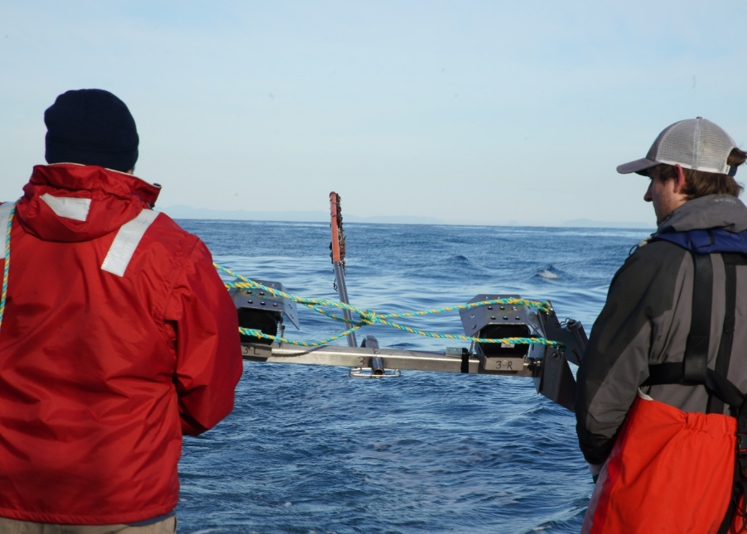


Commonwealth Environmental Impact Statement
Chapter 14 – Non-Aboriginal underwater cultural heritage
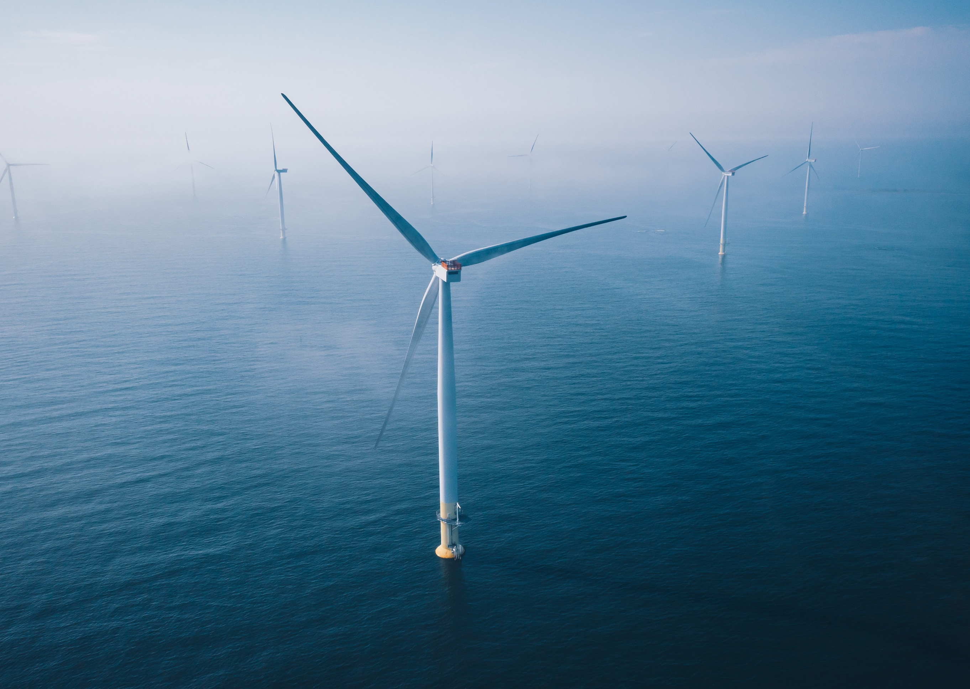

Table of Contents
Chapter 14 Non-Aboriginal underwater cultural heritage 1
14.1 Introduction 1
14.2 Assessment scope 2
14.2.1 Commonwealth matters 2
14.3 Evaluation framework 3
14.3.1 Key legislation, policy, guidelines and standards 3
14.3.2 Assessment criteria 3
14.4 Methods 5
14.5 Existing environment 7
14.5.1 Shipping and coastal traders 7
14.5.2 World Wars I and II 10
14.5.3 Summary of values within the study area 12
14.6 Construction impacts 17
14.6.1 Key impacts 17
14.6.2 Other impacts 17
14.6.3 Potential risks 21
14.7 Operation impacts 24
14.7.1 Key impacts 24
14.7.2 Other impacts 24
14.7.3 Potential risks 26
14.8 Decommissioning impacts 28
14.8.1 Potential impacts and risks 28
14.9 Cumulative impact assessment 29
14.10 Summary of mitigation, monitoring and contingency measures 30
14.10.1 Mitigation measures 30
14.11 Conclusion 31

Figures
Figure 14-1 Confirmed shipwreck sites in proximity to the study area 9
Figure 14-2 Unconfirmed shipwreck sites in proximity to or within the study area 10
Figure 14-3 Overlay of the study area with known ammunition dumps and a World War II air weapons range 12
Figure 14-4 Non-Aboriginal underwater cultural heritage within or near the study area 14
Figure 14-5 Potential underwater cultural heritage anomalies identified by geophysical survey data analysis 16

Tables
Table 14-1 Key legislation, policy, guidelines and standards 3
Table 14-2 Known shipwreck status and location in proximity to the offshore project area 15
Table 14-3 Residual impacts on potential non-Aboriginal underwater cultural heritage (seabed anomalies) during the construction phase 19
Table 14-4 Residual impacts to the wreck of the Sarah (1838) during the construction phase 21
Table 14-5 Residual risk on underwater cultural heritage from oil spills 22
Table 14-6 Residual impacts on seabed anomalies during the operation phase 25
Table 14-7 Residual impacts on the wreck of the Sarah (1838) during the operation phase 26
Table 14-8 Residual risk to non-Aboriginal cultural heritage from oil spills 26
Table 14-9 Projects assessed for cumulative impacts 29
Table 14-10 Mitigation measures relevant to non-Aboriginal underwater cultural heritage 30

Non-Aboriginal underwater cultural heritage

Introduction
This chapter summarises the existing conditions related to non-Aboriginal underwater cultural heritage and assesses the impacts and risks associated with the construction, operation and decommissioning of the Star of the South Offshore Wind Farm Project (the project) on non-Aboriginal underwater cultural heritage. The chapter describes how impacts will be avoided, minimised or managed.
Underwater cultural heritage value is recognised through Commonwealth and Victorian legislation, and policies are designed to protect these items as they provide a better understanding of the Gippsland and Bass Strait area's history and any changes in culture over time.
Non-Aboriginal underwater cultural heritage values include shipwrecks, unknown historical lost vessels, human remains and historical ordnance.
The chapter is based on the impact assessment presented in Technical Report M – Non-Aboriginal Underwater Cultural heritage.
This chapter excludes Aboriginal cultural heritage values, which is presented in Chapter 19 – Submerged Aboriginal Cultural Heritage.

Assessment scope
The study objective for non-Aboriginal underwater cultural heritage is to assess, avoid and mitigate potential adverse effects on non-Aboriginal underwater cultural heritage including shipwrecks and archaeological sites.
All detailed technical methodologies and assessment of non-Aboriginal underwater cultural heritage is presented in Technical Report M – Non-Aboriginal Underwater Cultural Heritage.

Commonwealth matters
The project's EIS guidelines inform the preparation of the EIS to enable the Commonwealth Minister for the Environment to make an informed decision on whether to approve the project under the EPBC Act.
The aspects of the EIS guidelines directly relevant to non-Aboriginal underwater cultural are:
- Section 2.7 (j) – Relevant impacts including the extent, severity and persistence of potential impacts to underwater cultural heritage (European and Indigenous).

Evaluation framework

Key legislation, policy, guidelines and standards
Table 14-1 lists the key legislation, policy, guidelines and standards relevant to non-Aboriginal underwater cultural heritage. Refer to Chapter 5 – Commonwealth Legislative Framework and Technical Report M – Non-Aboriginal Underwater Cultural Heritage for further details.
Table 14-1 Key legislation, policy, guidelines and standards
Type | Applicable legislation, policy, guideline or standard
International conventions / guidance | UNESCO Convention on the Protection of the Underwater Cultural Heritage 2001 and Annex  UNESCO Manual for Activities directed at Underwater Cultural Heritage: guidelines to the Annex of the UNESCO 2001 Convention (2013)
Commonwealth Government | Underwater Cultural Heritage Act 2018 (Cth)
Commonwealth Government | Environment Protection and Biodiversity Conservation Act 1999 (Cth)
Commonwealth Government | Assessing and Managing Impacts to Underwater Cultural Heritage in Australian Waters (2024)

Assessment criteria
To assess the project, predicted impacts and risks are compared to criteria that set required environmental performance outcomes (refer to Chapter 6 – Assessment framework).
These criteria for non-Aboriginal underwater cultural heritage are derived from legislation and policy, relevant standards and guidelines, stakeholder feedback and industry best practice.
The assessment criteria relevant to non-Aboriginal underwater cultural heritage are:
- The significance of the article in the course, evolution or pattern of history
- The significance of the article in relation to its potential to yield information contributing to an understanding of history, technological accomplishments or social developments
- The significance of the article in its potential to yield information about the composition and history of cultural remains and associated natural phenomena through the examination of physical, chemical or biological processes
- The significance of the article in representing or contributing to technical or creative accomplishments during a particular period
- The significance of the article through its association with a community in contemporary Australia for social, cultural or spiritual reasons
- The significance of the article for its potential to contribute to public education
- The significance of the article in possessing rare, endangered or uncommon aspects of history
- The significance of the article in demonstrating the characteristics of a class of cultural articles.

Methods
The purpose of the non-Aboriginal underwater cultural heritage impact assessment is to assess the potential impacts and risks of the project on non-Aboriginal underwater cultural heritage.
Impacts refer to the consequences of planned project actions, which are given a rating determined by combining the magnitude of the impact and the sensitivity of the receptor.
Risks are an unexpected (accidental) event and are determined by combining the likelihood of an event occurring and the consequences that would result if the event were to occur.
The technical chapters consider key impacts and risks with a residual consequence rating of moderate to severe. Other impacts and risks are those with a residual consequence rating of negligible to minor.
Refer to Chapter 6 – Assessment Framework for more detail on how impact and risk ratings are derived.
The non-Aboriginal underwater cultural heritage impact assessment involved:
- Defining a study area, which for the assessment is the offshore project area that comprises the offshore wind farm area and offshore export cable area
- Reviewing relevant national, state and local legislation relevant to the protection of underwater cultural heritage
- Characterising existing conditions and identifying sensitive assets, values and uses based on historical background information and preliminary geophysical surveys that indicate the location of potential heritage items on the seabed
- Reviewing the project's description (Chapter 4 – Project Description) to determine the location, type, timing, extent, intensity and duration of potential project interactions with identified or potential values
- Defining the maximum design scenario(s) based on project design envelope parameters that provide the basis for impact assessment. These are defined in Technical Report M – Non-Aboriginal Underwater Cultural Heritage
- Assessing impacts based on the outcomes of the initial risk assessment and consultation insights that examine the potential severity, extent and duration of identified impacts
- Evaluating predicted outcomes against performance benchmarks and assessment criteria derived from applicable legislation, policy and standards
- Identifying mitigation measures where necessary to address potentially significant environmental impacts
- Evaluating residual environmental impacts against assessment criteria, taking into account the proposed mitigation measures and their likely effectiveness.

Existing environment
This section describes the existing conditions within the study area as they relate to offshore non-Aboriginal underwater cultural heritage. The study area is defined as the offshore project area, which includes the wind farm area and the offshore export cable area.
Underwater cultural heritage receptors assessed for project are defined as: historical ships and shipwrecks, sunken aircraft and other vehicles, human remains, historical ordinance, and other underwater cultural heritage.

Shipping and coastal traders
European shipping activities along the Gippsland coast have occurred since 1770. From this time, numerous shipwrecks have been located along the coastline. A number of wrecks are recorded near or are thought to be near the study area.
The trading vessel Sydney Cove wrecked on Preservation Island, near Tasmania, in February 1797. The crew repaired a longboat for 17 sailors, which sailed to the mainland but wrecked in the surf at Ninety Mile Beach. The crew landed just north of the study area and three survivors made it to Sydney on foot, inspiring the first journeys by colonists south along the Gippsland coast. This included George Bass in January 1798, who described large seal colonies along the Victorian coast within his report, confirming the existence of a strait separating the mainland from Van Diemen’s Land (Tasmania).
Sealing and whaling vessels worked the coast of Victoria from the late 1790s. By 1820, a reported 1,800 sealers were working the coast and by the 1830s, the seal population had been all but wiped out.
In 1835, squatters from Tasmania crossed Bass Strait and settled around Port Phillip, and by early 1837, their camp had been officially renamed Melbourne. Regular sailing routes were established between Melbourne and Sydney for trading and passenger vessels. The colonial schooner Sarah was one such ship that sailed from Sydney to Port Phillip on 22 June 1838, with 26 people on board. The ship never arrived and by late August was feared lost. Around this time, the master of another ship, the Kate, reported seeing what he thought was a signal fire on Long Beach (likely Ninety Mile Beach). The wreck of the Sarah lies in shallow water somewhere off the beach at Woodside along Ninety Mile Beach and is expected to contain human remains.
In 1841, the steamship Clonmel, sailing from Sydney to Melbourne, wrecked on a sand bar and was abandoned near what is now known as Clonmel Island at the Port Albert entrance channel. Shortly thereafter, Port Albert started to be developed. As Gippsland became an agricultural area, livestock was shipped from Port Albert to Tasmania. Shipping traffic increased throughout the 1840s as the number of convicts sent to Tasmania grew. The approach to Port Albert was challenging due to shifting sand bars, which caused numerous groundings and wrecks. Examples include the Dew Drop, which wrecked in January 1849, and the Sylvanus, which was lost on a sand bar in July 1850.
The primary coastal transporters from 1870 to the 1930s were coastal traders, bulk cargo and passenger steamships that operated along Australia's east coast. In the era before radar and radio, accidents remained common. In 1878, the steamship Blackbird, transporting coal and passengers, went ashore on a sandbank approximately one mile off Ninety Mile Beach. While there was increasing competition for freight and passengers from the growing rail network in the late nineteenth and early twentieth centuries, shipping remained a popular method for longer distances. An overview of confirmed and unconfirmed shipwreck sites in relation to the study area is provided in Figure 14-1 and Figure 14-2.
Figure 14-1 Confirmed shipwreck sites in proximity to the study area
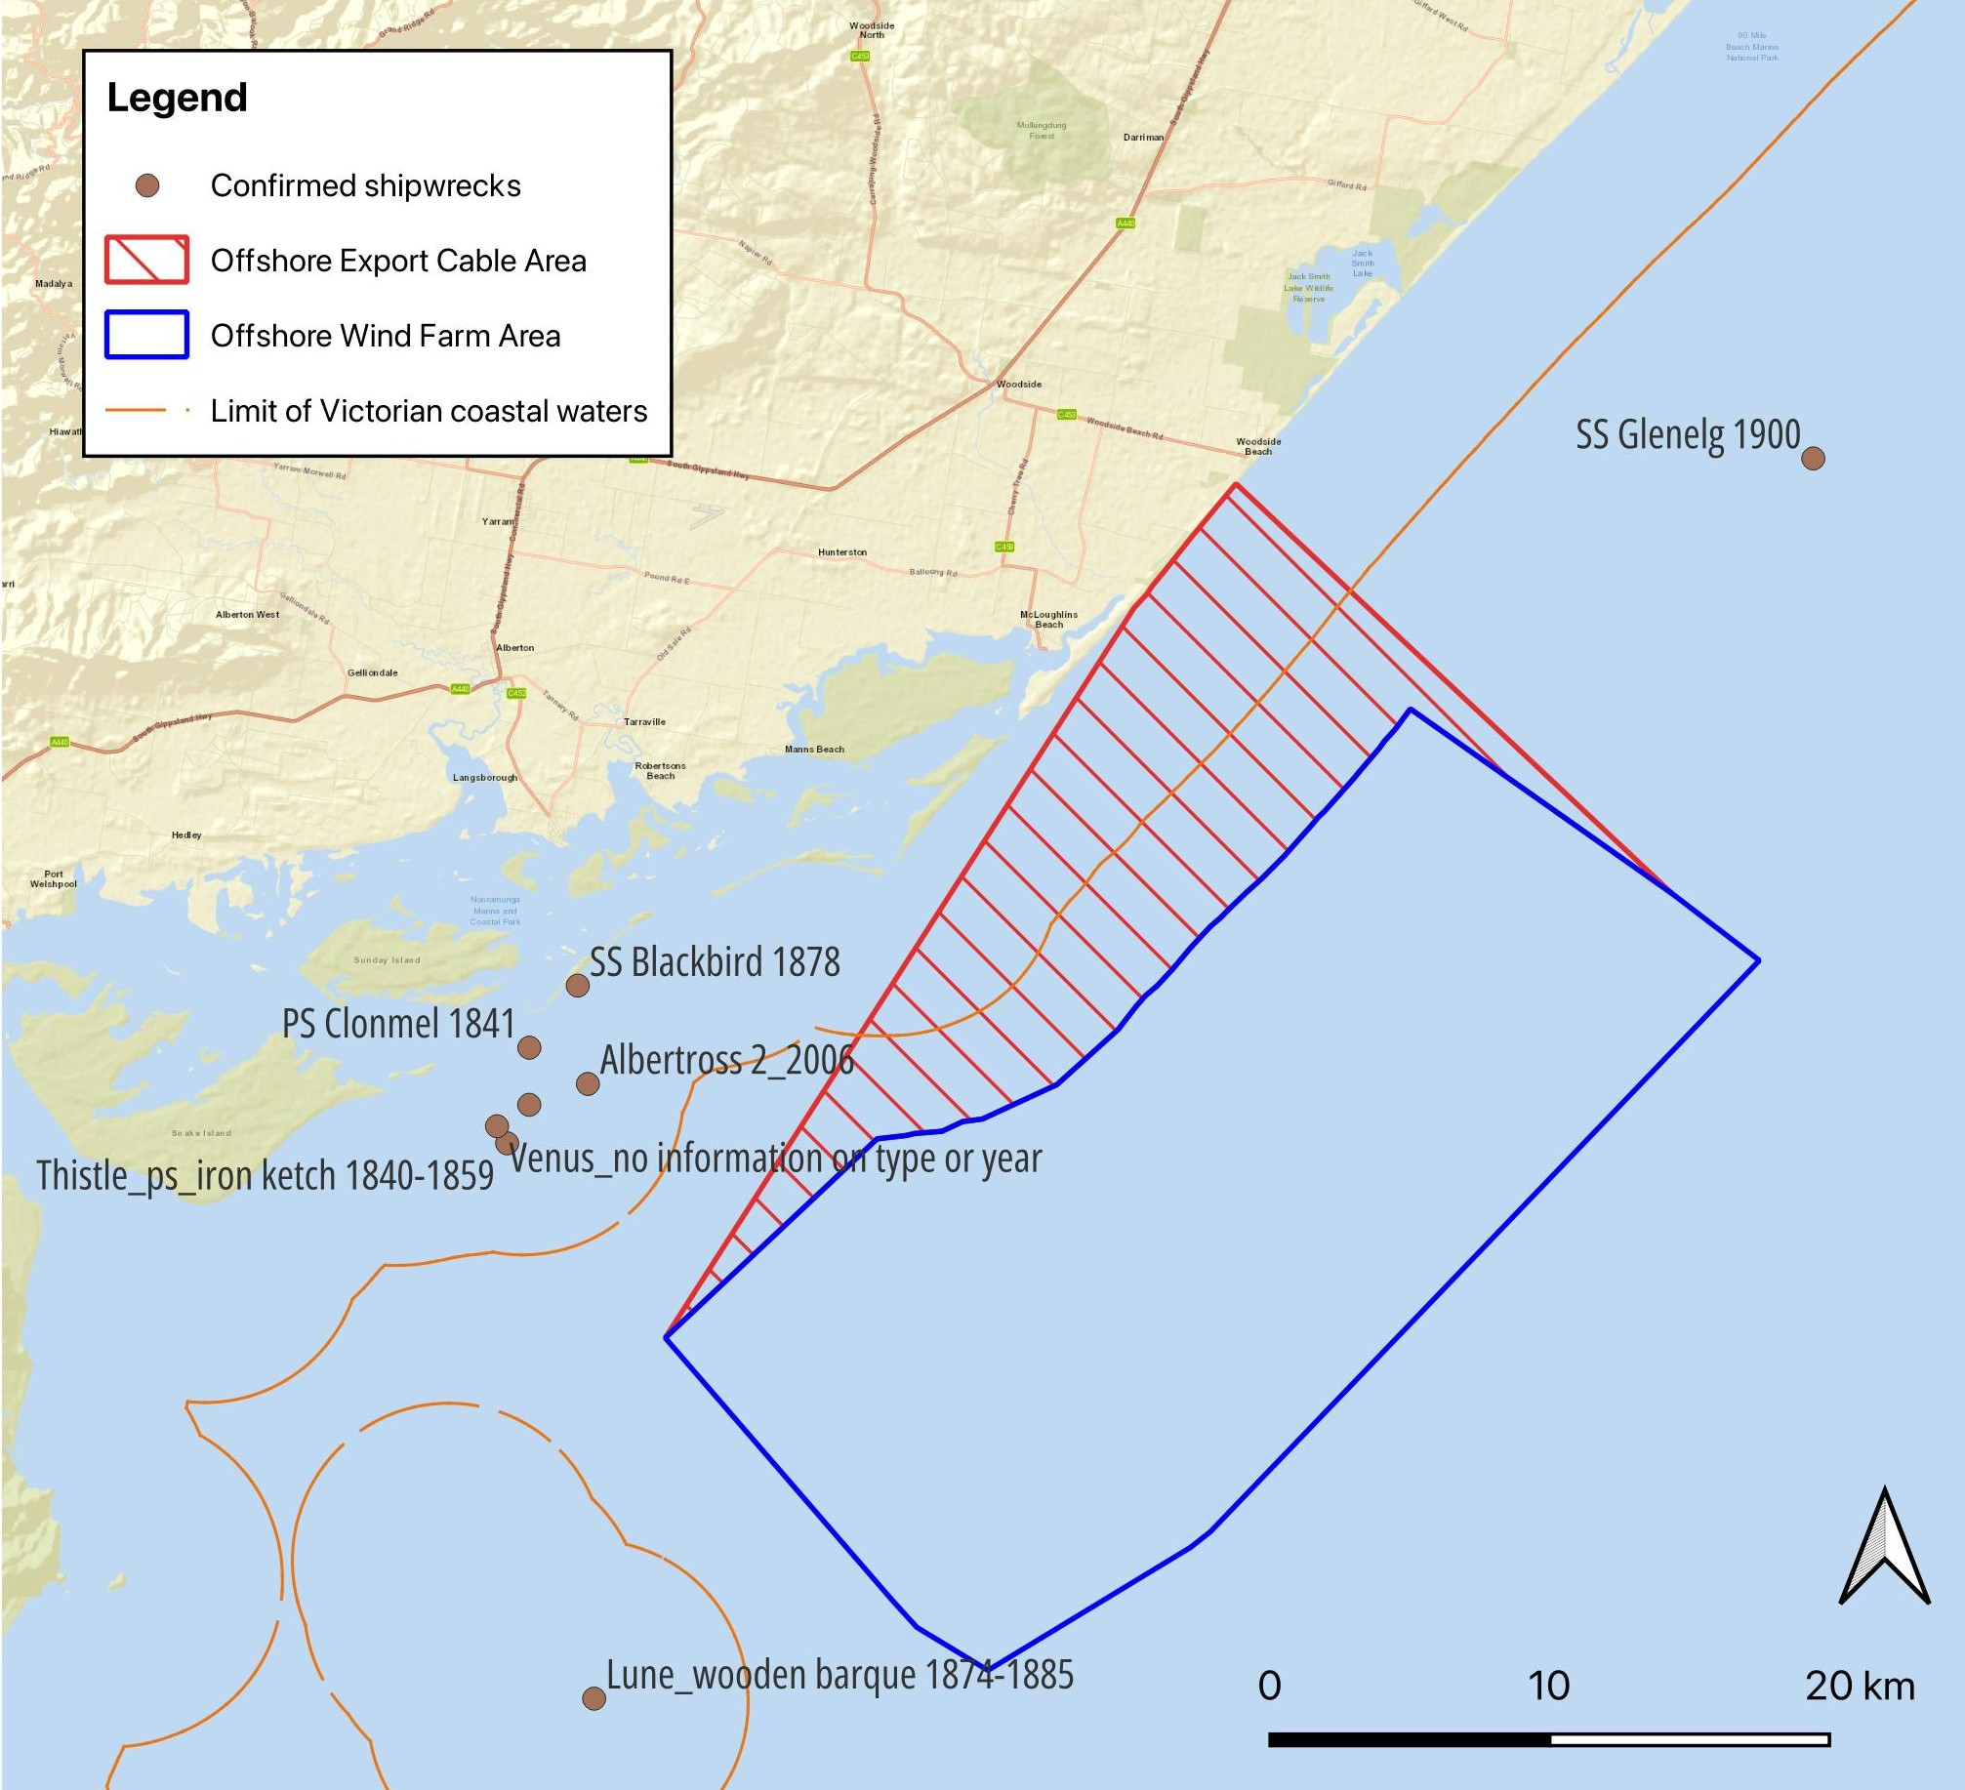

Figure 14-2 Unconfirmed shipwreck sites in proximity to or within the study area
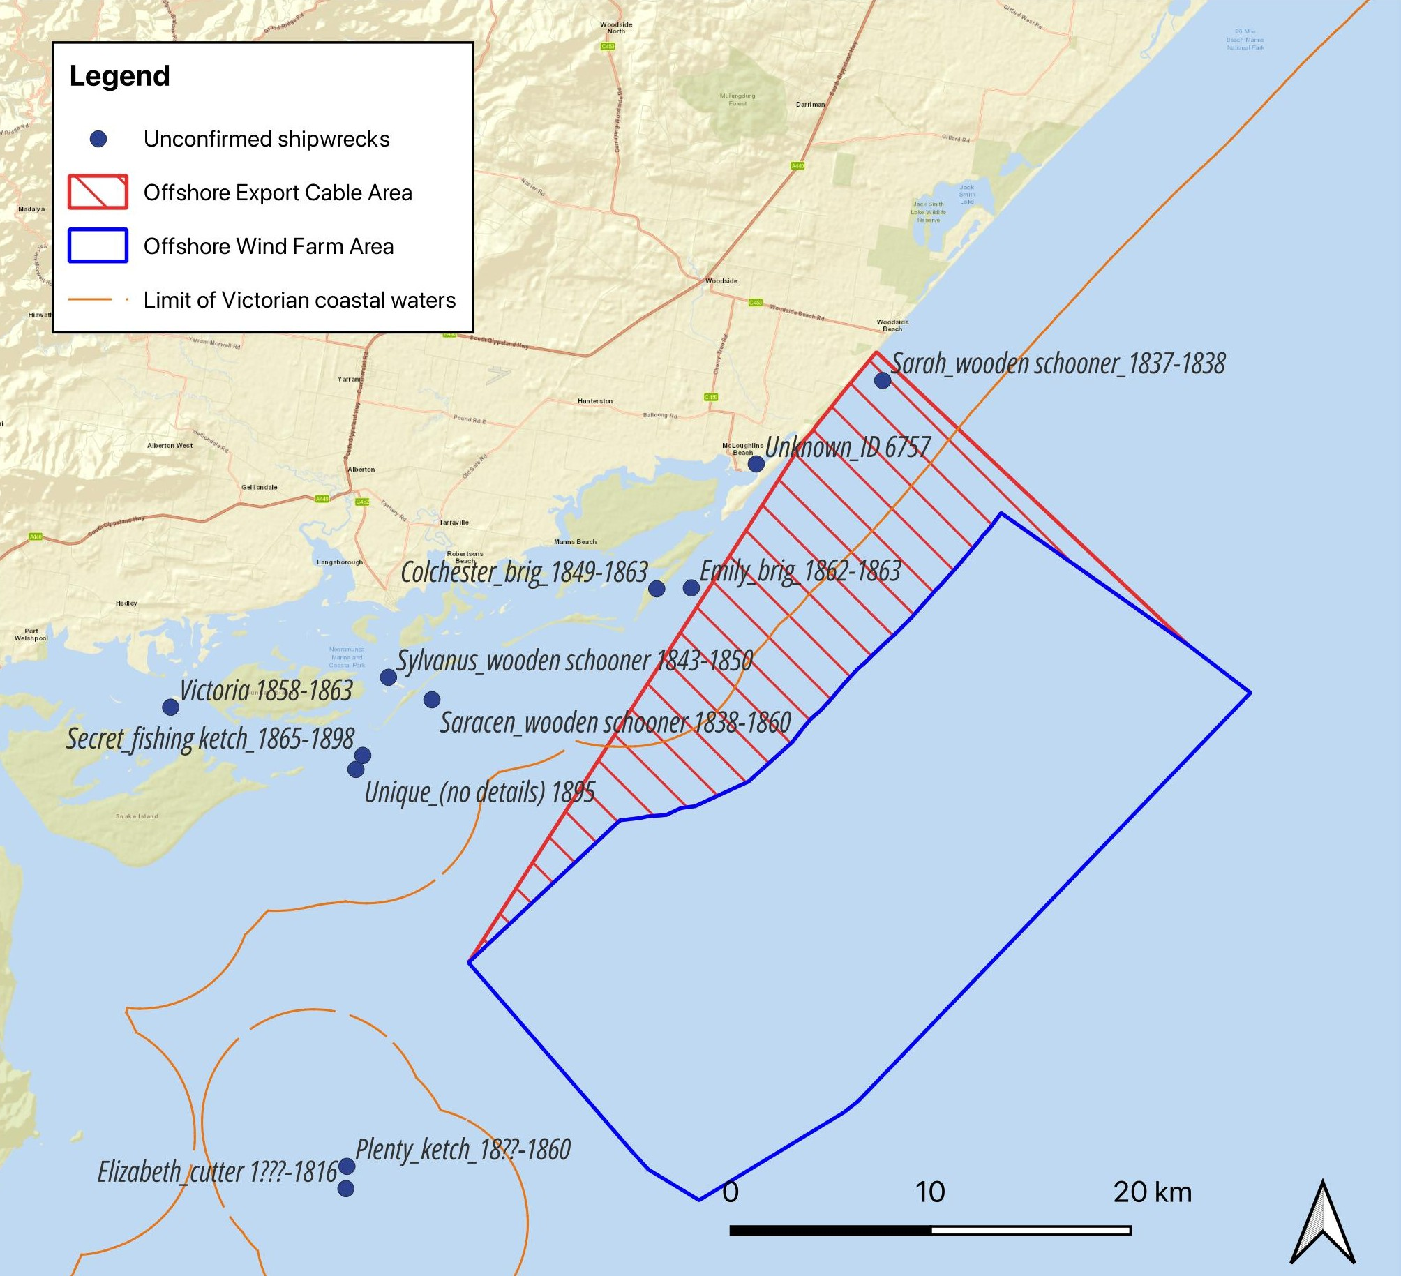

World Wars I and II
The outbreak of World War I interrupted the peak era of coastal shipping, as ships in Australian waters carrying resources such as coal and wheat, which were considered vital to the war effort, became enemy targets. The first ship believed to have been lost to enemy action was the SS Cumberland, a steel steamer, in July 1917 when she struck a sea mine laid by the German raider Wolff. The Cumberland was hit near Gabo Island, Victoria, but sank under tow back to Sydney near Wreck Bay, New South Wales.
German raiders were also active in Australian waters during World War II, along with Japanese submarine patrols, which began in 1942. The first ship to be lost in Australian waters during World War II was the SS Cambridge, which was sunk by a German sea mine near Wilsons Promontory National Park in November 1940. The mine was laid by the Passat, a Norwegian freighter captured by the German raider Pinguin and converted to lay mines.
In 1943, the Royal Australian Air Force constructed an airfield at East Sale in Gippsland for the training of bomber crews on Bristol Beaufort bombers and Lockheed Hudson aircraft. No evidence of sunken aircraft or other vehicles has been identified.
A portion of the study area overlaps with a known World War II air weapons range (Defence Site 364 Giffard), which indicates that historical ordnance may be located within the study area (Figure 14-3). The munitions fired were mostly 20-millimetre ball, but 20-millimetre high-explosive rounds may also have been fired. The inland range was also used for firing practice and bombing; therefore, bombs may have fallen into the sea during emergency drops within the study area.
Figure 14-3 Overlay of the study area with known ammunition dumps and a World War II air weapons range
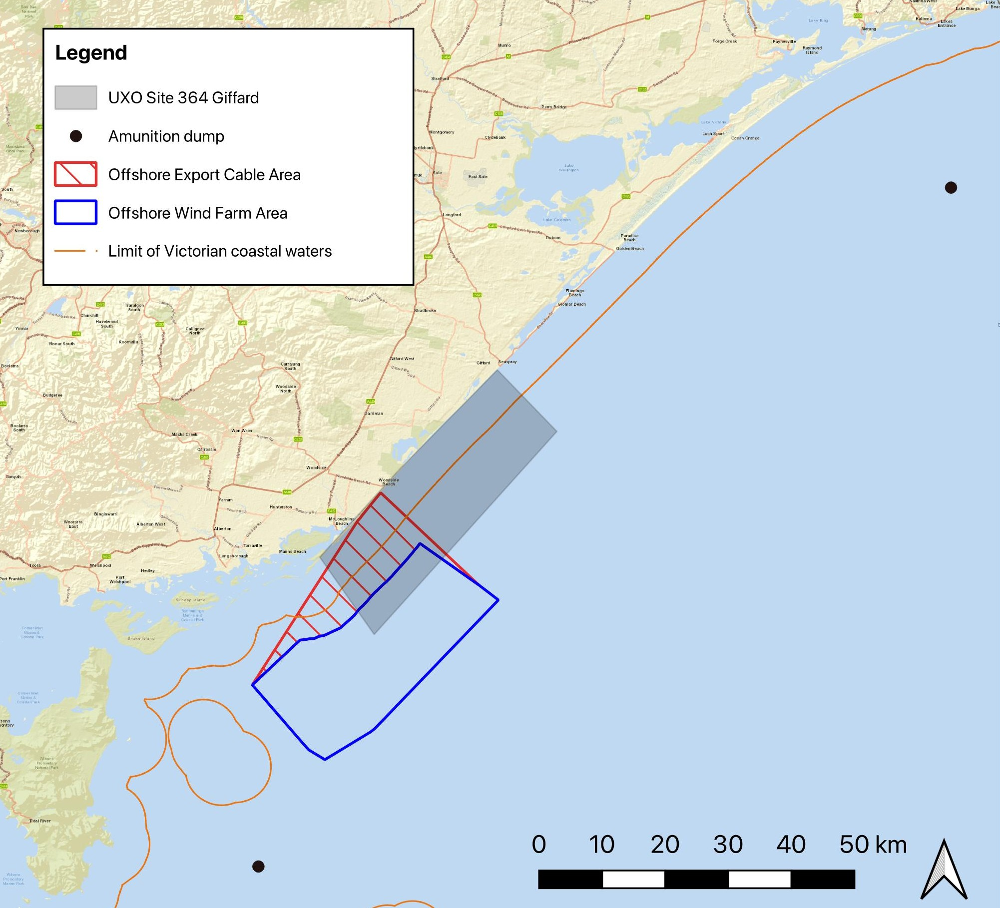

Summary of values within the study area
The non-Aboriginal underwater cultural heritage values within the study area have been determined through a review of available shipwreck databases, consultation with Heritage Victoria and geophysical surveys.
The identified non-Aboriginal underwater cultural heritage items are categorised as follows:
- Confirmed shipwreck sites near the study area
- Vessels listed as lost within or near the study area, but shipwrecks not yet found
- Vessels lost while travelling along the Gippsland coast
- Human remains
- Historical ordnance
- Other underwater cultural heritage
- Further unknown shipwrecks.
Other unidentified underwater cultural heritage items may be located within the study area. This will be further investigated through additional surveys and will necessitate ongoing consultation with maritime archaeologists throughout the life of the project.
Shipwrecks represent the largest category of underwater cultural heritage items that may be located within or near the study area. From database searches, 17 shipwrecks were identified as occurring or potentially occurring within or near the study area (Figure 14-4).
Figure 14-4 Non-Aboriginal underwater cultural heritage within or near the study area
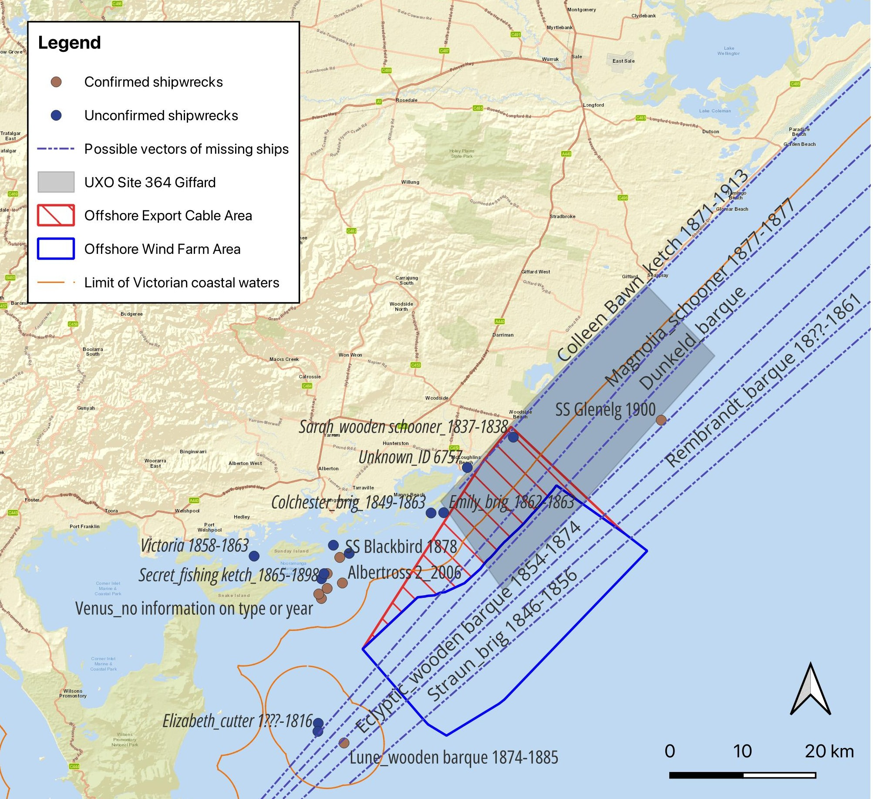
No confirmed historical shipwreck sites are located within the offshore project area. However, five are located between seven and nine kilometres of the project area. A list of known shipwrecks in proximity to the project area is included in Table 14-2. The colonial schooner Sarah is listed as lost within the offshore export cable area, although her location is not known and her presence has not yet been confirmed by site investigations.
Three additional unconfirmed shipwrecks are potentially located within five kilometres of the offshore project area. A further eight vessels are listed as lost along the Gippsland coast. These wrecks, as well as those of several unknown vessels (foreign ships, unlisted vessels and small coasting craft) could be located within the study area.
Table 14-2 Known shipwreck status and location in proximity to the offshore project area
Shipwreck status | Vessel name | Location
Confirmed | Nil | Nil
Confirmed | Albertross 2 | Between 7–9 km from the project area
Confirmed | Clonmel | Between 7–9 km from the project area
Confirmed | Thistle PS (iron ketch) | Between 7–9 km from the project area
Confirmed | Venus | Between 7–9 km from the project area
Confirmed | Blackbird (steamer) 1863 | Between 7–9 km from the project area
Listed as lost within or near the study area (not yet found) | Sarah (schooner) 1838 | Within cable corridor area
Listed as lost within or near the study area (not yet found) | Colchester | Within 5 km of the project area
Listed as lost within or near the study area (not yet found) | Emily (brig) | Within 5 km of the project area
Listed as lost within or near the study area (not yet found) | Unknown buried wreck (Britannia 1839) | Within 5 km of the project area
Listed as lost while travelling along the Gippsland coast (no further indication on potential location) | Colleen Bawn (ketch) | Unknown – potential to be within study area
 | Magnolia (schooner) Unknown – potential to be within study | Unknown – potential to be within study area
 | Dunkeld (barque) Unknown – potential to be within study | Unknown – potential to be within study area
 | Favourite (wooden barque) Unknown – potential to be within study | Unknown – potential to be within study area
The project's preliminary geophysical surveys investigated transects across the offshore wind farm area and a sub-section (phase one) of the offshore export cable area (Figure 14-5). The geophysical surveys identified 16 anomalies on the seabed that indicate potential underwater cultural heritage (Figure 14-5). These may represent sites, features, objects or items of human origin. Until further diagnostic assessment determines otherwise, they are treated with the same caution as confirmed items of underwater cultural heritage.
Figure 14-5 Potential underwater cultural heritage anomalies identified by geophysical survey data analysis
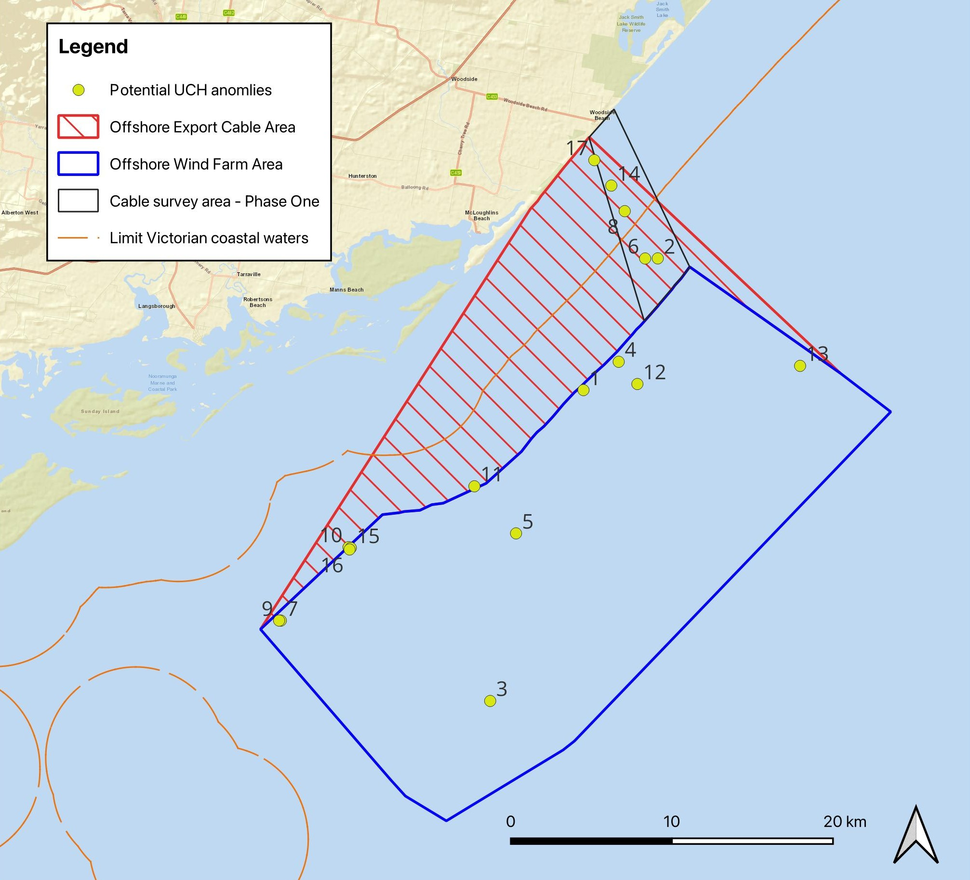
Sonar images and descriptions of potential underwater cultural heritage anomalies can be found in Technical Report M – Non-Aboriginal Underwater Cultural Heritage through the corresponding anomaly numbers in the figure.

Construction impacts
This section discusses impacts and risks associated with the project’s construction that relate to non-Aboriginal underwater cultural heritage and the respective receptor groups.

Key impacts
The construction assessment identified no impacts on non-Aboriginal underwater cultural heritage receptor groups with an impact rating of moderate or higher once mitigation measures are implemented.

Other impacts
Other potential construction impacts with minor to negligible effects on non-Aboriginal underwater cultural heritage once mitigation measures are implemented include:
- Impacts to underwater cultural heritage values identified as anomalies on the seabed
- Impacts to the 1838 wreck of the colonial schooner Sarah.

Construction impacts to potential non-Aboriginal underwater cultural heritage (anomalies on the seabed)

Potential impact
Anomalies on the seabed were identified through a phase one geophysical survey, conducted in 2020. This survey identified shapes on the seabed that could be an item of underwater cultural heritage value.
There is a potential for direct contact between project vessels and installation equipment and any underwater cultural heritage items located within the study area. The installation of offshore wind turbines and offshore substations, anchors dropped by barges, jack up work vessel legs, cable installation and seabed preparation directly or indirectly over an item of underwater cultural heritage could crush or dislodge parts of that item. Prior to construction a phase two geophysical survey will be undertaken to further characterise the seabed in more detail.
Indirect potential impacts during the construction phase can result from jetting, ploughing, trenching or anchoring works, as well as scouring through the addition or subtraction of an item on the seabed. These actions may redirect the flow of water currents and change the level of sediments such as sand. While sediment build-up can occur, these actions more often destabilise items of underwater cultural heritage, exposing them to new and increased rates of decay. Scouring also causes the removal of the protective anaerobic layer of sediment, providing access to marine borers and marine life, and results in higher levels of oxygen and salinity, which can increase chemical decay and expose surfaces to the abrasive influence of currents. While the extent of these impacts depends on the proximity to the introduced item, the size of the item, the direction of current flow and the strength of the current flow, they are expected to be limited to the offshore project area.

Mitigation
Prior to construction commencing, additional site investigations will be conducted to confirm the location and status of anomalies within or near the areas where project infrastructure will be installed or seabed disturbance is likely to occur. A range of survey methods may be used, such as high-resolution geophysical surveys, the use of remotely operated vehicles, photographic inspections and/or archaeological diving surveys (UMH-M001). The results of these surveys will be combined with the data from the phase one surveys to present a complete analysis of the seabed anomalies and to avoid and/or reduce through design and mitigation measures, any impacts on potential non-Aboriginal underwater cultural heritage.
An Underwater Cultural Heritage Management Plan (UMH-M003) will be prepared in consultation with the Commonwealth Department of Climate Change, Energy, the Environment and Water and Heritage Victoria in accordance with relevant Commonwealth and Victorian guidelines. The plan will outline the appropriate strategies, measures, monitoring briefs and protocols to mitigate potential impacts to any unknown, unrecorded and/or newly discovered underwater cultural heritage items.
If heritage items are identified in the offshore project area, measures will be implemented to ensure they are not materially affected. Specifically, exclusion zones will be implemented around all confirmed underwater cultural heritage items in the vicinity of project activities to ensure avoidance during construction (UMH-M002). These zones, if required, will be determined in consultation with the project's maritime archaeologist.
Assessment, monitoring and reporting protocols will be established to mitigate potential impacts to any unknown, unrecorded and/or newly discovered underwater cultural heritage items (UMH-M003). In the event that an impact to an underwater cultural heritage item is unavoidable, a program of site-specific archaeological investigation (aligned with the principles of the 2001 UNESCO Convention) will be undertaken. This will include methodology and research design approved by the appropriate authorities, such as Heritage Victoria (UMH-M004).

Monitoring
As part of the Underwater Cultural Heritage Management Plan (UMH-M003), site monitoring will be required for works taking place near confirmed underwater cultural heritage sites. The purpose of site monitoring is to avoid or minimise impacts to significant underwater cultural heritage items and monitor any changes to the site to determine if these are caused by project activities.

Residual impact
Proposed further phases of underwater cultural heritage assessment will provide more accurate information on items located within the study area. When the project's detailed design is finalised, specific areas of impact will be assessed and management measures implemented prior to construction commencing. With the implementation of the mitigation measures described above, impacts to underwater cultural heritage items are of negligible magnitude and not anticipated.
Table 14-3 Residual impacts on potential non-Aboriginal underwater cultural heritage (seabed anomalies) during the construction phase
Potential impact | Receptor group | Receptor sensitivity | Magnitude | Initial consequence | Mitigation | Residual consequence
Placement of turbines and substations; anchor and jack up barge leg placement in relation to offshore underwater cultural heritage items, as part of seabed preparation for and construction of turbines and substations, causing direct impact or indirect scouring destabilising item/s of underwater cultural heritage | Anomalies of high priority for further investigation | High | Very high | Severe | UMH-M002  UMH-M003  UMH-M004 | Minor
 | Anomalies of medium priority for further diagnostic investigation | Medium | High | Major | UMH-M002  UMH-M003  UMH-M004 | Negligible
 | Anomalies of low priority for further diagnostic investigation | Low | High | Minor | UMH-M002  UMH-M003  UMH-M004 | Negligible

Impacts to the wreck of the Sarah (1838)

Potential impact
The wreck of the colonial schooner Sarah is a significant historical and potential archaeological site listed on the Victorian Heritage Register (VHR # S607). The wreck may contain human remains. While the Sarah is the only listed underwater cultural heritage item potentially located within the study area, the location and state of conservation are not known. As the final locations of the project's offshore infrastructure have yet to be determined, it is conservatively assumed that the wreck could be located within the offshore export cable area and that it is substantially intact. As an early wooden vessel, her remains are most likely buried under sand, although items such as anchors could potentially have a surface presence.
A provisional assessment of the significance of the Sarah has been undertaken, which assumes that the site is present and in a reasonable state of conservation. Subject to the condition of the wreck, any remains of the schooner have the potential to be significant at a Commonwealth and Victorian level.
The potential construction phase impacts to the Sarah are the same as for other potential heritage items identified as anomalies on the seabed. However, this is the only site within the cable corridor area, so direct and indirect potential impacts would result from offshore export cable installation activities, and not turbine or offshore substation installation.

Mitigation
To mitigate potential impacts, measures outlined in the Underwater Cultural Heritage Management Plan (UMH-M003) will be implemented to avoid underwater cultural heritage items, including the Sarah, ensuring they are not materially affected (UMH-M001). Prior to construction commencing, further site investigations will confirm the locations and determine the status of anomalies within or close to the areas where project infrastructure will be installed or seabed disturbance associated with construction activities may occur. This includes anomalies that are likely to be the wreck of the Sarah to confirm her location and determine her heritage status (UMH-M001).

Residual impact
Proposed further phases of underwater cultural heritage assessment may provide more accurate information on the Sarah's location within the study area. When the project's detailed design is finalised, specific areas of impact will be assessed and incorporated into the Cultural Heritage Management Plan prior to construction commencing. It is expected that the mitigation measures described above can be implemented effectively, reducing the magnitude of potential impacts to negligible. As such, the Sarah is not expected to be impacted, refer Table 14-4.
Table 14-4 Residual impacts to the wreck of the Sarah (1838) during the construction phase
Potential impact | Receptor group | Receptor sensitivity | Magnitude | Initial consequence | Mitigation | Residual consequence
Cable jetting/ploughing/trenching or anchoring: direct impact or indirect scouring, destabilising items of underwater cultural heritage | Wreck of schooner Sarah (VHR #S607) | High | Very high | Severe | UMH-M002 | Minor

Potential risks
All potential risks on non-Aboriginal underwater cultural heritage identified from the construction phase have a residual risk rating of low or very low. These risks include:
- Oil spills

Oil spills

Potential risk
Oil spills from accidents, such as the collision of vessels, may have direct chemical effects on underwater cultural heritage and indirect effects on the protective marine life attached to its surfaces. The results of such contamination would be similar to other indirect impacts that remove the protective cover from these values, such as sand trapped by seagrass, which would subject an item to abrasion and the action of marine borers.
If an item is located in a shallow or intertidal zone, the oil may also cause a chemical reaction, leading to the degradation of the underwater cultural heritage item. The impacts would decrease with the depth of the site and the accompanying reduction in the concentration of contamination in the water.

Mitigation
This risk will be mitigated through a range of procedures that avoid a vessel collision occurring by regulating vessel activity (VES-M01), including measures such as a marine coordination centre (VES-M03) that manages simultaneous operations of project vessels. In the rare event that a spill occurs, there will be monitoring of the extent, depth and level of contamination near items of underwater cultural heritage, particularly at shallow-water sites (water depths below 15 metres), where wave action may increase the transfer of surface oil to the seabed level.

Residual risk
Following the implementation of mitigation measures, the likelihood of the risk occurring is rare and the residual risk to non-Aboriginal underwater cultural heritage from oil spills has been determined to be low and very low. Further detail on the residual impacts on underwater cultural heritage from oil spills is included in Table 14-5.
Table 14-5 Residual risk on underwater cultural heritage from oil spills
Potential risk | Receptor  group | Receptor sensitivity | Consequence | Likelihood | Initial consequence | Mitigation | Residual consequence
Oil spills resulting from project vessel collision or accidental spills could result in chemical reactions with underwater cultural heritage, death of seagrass or benthic marine life and loss of protective covering for underwater cultural heritage of marine growth or trapped sand; or exposure of the underwater cultural heritage object to sand abrasion | Anomalies of high priority for further investigation | High | Moderate | Rare | Low | Refer to VES-M001, VES-M003 | Low
 | Anomalies of medium priority for further investigation | Medium | Moderate | Rare | Low | Refer to VES-M001, VES-M003 | Low
 | Anomalies of low priority for further investigation | Low | Minor | Rare | Very Low | Refer to VES-M001, VES-M003 | Very Low
 | Wreck of schooner Sarah (SHR #607) | High | Moderate | Rare | Low | Refer to VES-M001, VES-M003 | Low

Operation impacts
This section discusses the impacts and risks associated with the operation of the project that relate to non-Aboriginal underwater cultural heritage and the respective receptor groups.

Key impacts
The assessment identified no significant impacts on non-Aboriginal underwater cultural heritage during the operation phase with a residual impact rating of moderate or higher once mitigation measures are implemented.

Other impacts
Other potential operation impacts with minor to negligible effects on non-Aboriginal underwater cultural heritage once mitigation measures are implemented include:
- Impacts to underwater cultural heritage values identified as anomalies on the seabed
- Impacts to the wreck of the colonial schooner Sarah (1838).

Anomalies on the seabed

Potential impact
During operation, potential impacts are related to vessels or barges, their leg and anchor placement and the movement of anchor chains interfering with non-Aboriginal underwater cultural heritage. To mitigate these impacts, measures will be implemented to avoid underwater cultural heritage items within the offshore project area to ensure they are not materially affected. This includes exclusion zones (UMH-M002) and site-specific archaeological investigation (UMH-M004). These measures are the same as those described in the construction phase in Section 0.

Residual impact
Proposed further phases of underwater cultural heritage assessment will provide more accurate information as to any anomalies located within the study area. It is expected that the mitigation measures described above can be implemented effectively, reducing the residual impact to anomalies on the seabed to minor and negligible. Further detail on the residual impacts on seabed anomalies is included in Table 14-6.
Table 14-6 Residual impacts on seabed anomalies during the operation phase
Potential impact | Receptor  group | Receptor sensitivity | Magnitude | Initial consequence | Mitigation | Residual consequence
Vessel or barge siting (anchor and jack-up barge leg placement): direct impact or indirect scouring destabilising item/s of underwater cultural heritage. | Anomalies of high priority for further investigation | High | Very high | Severe | UMH-M006 | Minor
 | Anomalies of medium priority for further diagnostic investigation | Medium | High | Major | UMH-M006 | Negligible
 | Anomalies of low priority for further diagnostic investigation | Low | High | Minor | UMH-M006 | Negligible

Impacts to the wreck of the Sarah (1838)

Potential impact
Potential impacts to the Sarah during the operation phase are the same as those for other anomalies on the seabed. While the location of the wreck is unconfirmed, it is likely to be within or near the offshore export cable area. As such, direct and indirect potential impacts may arise from cable maintenance activities and any associated works, including impacts related to vessels or barges, their leg and anchor placement and the movement of anchor chains.

Mitigation
Measures will be implemented to avoid underwater cultural heritage items, including the Sarah, to ensure they are not materially affected. This includes micro-siting and exclusion zones (UMH-M002) and site-specific archaeological investigation (UMH-M004). These measures are the same as those described to mitigate construction phase impacts in Section 0.

Residual impact
Proposed further phases of underwater cultural heritage assessment may provide more accurate information on the location of the Sarah, if it is within the study area. It is expected that the mitigation measures described above can be implemented effectively, reducing the residual impact to minor. Further detail on the residual impacts on the wreck of the Sarah is included in Table 14-7.
Table 14-7 Residual impacts on the wreck of the Sarah (1838) during the operation phase
Potential impact | Receptor  group | Receptor sensitivity | Magnitude | Initial consequence | Mitigation | Residual consequence
Vessel or barge siting (anchor and jack-up barge leg placement): direct impact or indirect scouring destabilising item/s of underwater cultural heritage. | Wreck of schooner Sarah (SHR #607) | High | Very high | Severe | UMH-M006 | Minor

Potential risks
Potential risks during operations to non-Aboriginal underwater cultural heritage include:
- Oil spills

Oil spills

Potential risk
The oil spill risk assessment described in Section 0 also applies to non-Aboriginal underwater cultural heritage in the operation phase. The oil spill management measures described in Section 0 would also apply to the operation phase. Following the implementation of mitigation measures, the residual risk to non-Aboriginal underwater cultural heritage from oil spills is determined to be low and very low. Further detail is included in Table 14-8.
Table 14-8 Residual risk to non-Aboriginal cultural heritage from oil spills
Potential risk | Receptor  group | Receptor sensitivity | Consequence | Likelihood | Initial consequence | Mitigation | Residual consequence
Oil spills resulting from project vessel collision or accidental spill could result in chemical reactions with underwater cultural heritage, death of seagrass or benthic marine life and loss of protective covering for  underwater cultural heritage of marine growth or trapped sand; or exposure of the underwater cultural heritage object to sand abrasion. | Anomalies of high priority for further investigation | High | Moderate | Rare | Low | Refer to VES-M01, VES-M03 | Low
 | Anomalies of medium priority for further investigation | Medium | Moderate | Rare | Low | Refer to VES-M01, VES-M03 | Low
 | Anomalies of low priority for further investigation | Low | Minor | Rare | Very Low | Refer to VES-M01, VES-M03 | Very Low
 | Wreck of schooner Sarah (SHR #607) | High | Moderate | Rare | Low | Refer to VES-M01, VES-M03 | Low

Decommissioning impacts

Potential impacts and risks
The decommissioning activities are conservatively assumed to impact the same receptors at the same or lesser magnitude and scale as construction operations.
A Marine Decommissioning Management Plan (DEC-M01) will be developed prior to decommissioning to assess the potential impacts from the final agreed methodologies of removing offshore infrastructure.

Cumulative impact assessment
This section provides an assessment of the potential for cumulative impacts of the project with other proposed developments in the region. The method to consider cumulative impacts is described in Chapter 6 – Assessment Framework.
Potential cumulative impacts arise when the effects of a single project on a receptor are considered alongside the effects of other projects on the same receptor. Projects that are operational are part of the baseline environment, and the cumulative impact assessment focuses on future developments following the tiered assessment methodology.
Table 14-9 Projects assessed for cumulative impacts
Project | Project description | Findings of assessment
Great Eastern Offshore Wind Project | The Great Eastern Offshore Wind Farm would be positioned along the southern boundary of the project. If the construction timetable overlaps, it would create strong cumulative impact. | There is slight overlap between Great Eastern Offshore Wind Project with the project’s offshore export cable area. Within this overlap of the cable route areas, there is a potential for cumulative impacts although this will depend on the final cable route for both projects and whether there are any items of non-Aboriginal underwater cultural heritage present.

Summary of mitigation, monitoring and contingency measures

Mitigation measures
The following section outlines the mitigation measures developed to avoid and minimise non-Aboriginal underwater cultural heritage impacts within the study area.
The focus of these mitigation measures is:
- Avoiding impacts where reasonably practicable
- Developing, preparing and implementing project-specific measures to minimise impacts.
The mitigations for the impacts and risks for non-Aboriginal cultural heritage are summarised in Table 14-10 and presented in detail within Technical Report M – Non-Aboriginal Underwater Cultural Heritage. Detailed descriptions of each measure can be found in Chapter 23 – Commonwealth Environmental Management Framework.
Table 14-10 Mitigation measures relevant to non-Aboriginal underwater cultural heritage
Mitigation ID | Mitigation measure and description | Phase
UMH-M001 | Pre-Construction Archaeological Investigation | Construction
UMH-M002 | Archaeological exclusion zones | Construction, operation and decommissioning
UMH-M003 | Underwater Cultural Heritage Management Plan | Construction
UHM-M004 | Site-specific archaeological investigation | Construction, operation and decommissioning
UMH-M005 | Underwater cultural heritage induction | Construction, operation and decommissioning
UMH-M006 | Unexpected finds protocol | Construction, operation and decommissioning
VES-M01 | Vessel Operations Framework | Construction, operation and decommissioning
VES-M03 | Marine coordination centre | Construction, operation and decommissioning
DEC-M01 | Marine Decommissioning Management Plan | Decommissioning

Conclusion
The potential impacts to non-Aboriginal underwater cultural heritage have been assessed for the construction, operation and decommissioning of the project. The potential receptors relating to non-Aboriginal underwater cultural heritage impacts include shipwrecks, unknown historical lost vessels, human remains and historical ordnance.
The following mitigation measures have been identified to avoid and minimise adverse impacts:
- Further non-Aboriginal underwater cultural heritage investigations (UMH-M001)
- Exclusion zones (UMH-M002)
- Underwater Cultural Heritage Management Plan (UMH-M003)
- Site-specific archaeological investigation (UHM-M004)
- Underwater cultural heritage induction (UMH-M005)
- Unexpected finds protocol (UMH-M006).
These measures will assist in determining the final location of offshore infrastructure to avoid direct and indirect impacts on non-Aboriginal underwater cultural heritage items. While the potential for effects on unidentified cultural heritage remains, implementing these measures reduces the likelihood of potential impacts, and any residual impacts are low to negligible.
In considering the EIS guidelines, the assessment found there would be no significant impacts on non-Aboriginal underwater cultural heritage values.
Star of the South has considered the potential for cumulative impacts with other proposed developments in the region as part of the assessment. While there is a potential for cumulative impacts within the overlap of the cable route areas between the project and a neighbouring offshore wind farm proposal, this will depend on the final cable route for both projects and whether there are any items of underwater cultural heritage present. With the implementation of the mitigation measures outlined in this chapter, the potential for impacts to non-Aboriginal underwater cultural heritage protected by the Underwater Cultural Heritage Act 2018 (Cth) would be minor to negligible, and the potential risks low to very low.

