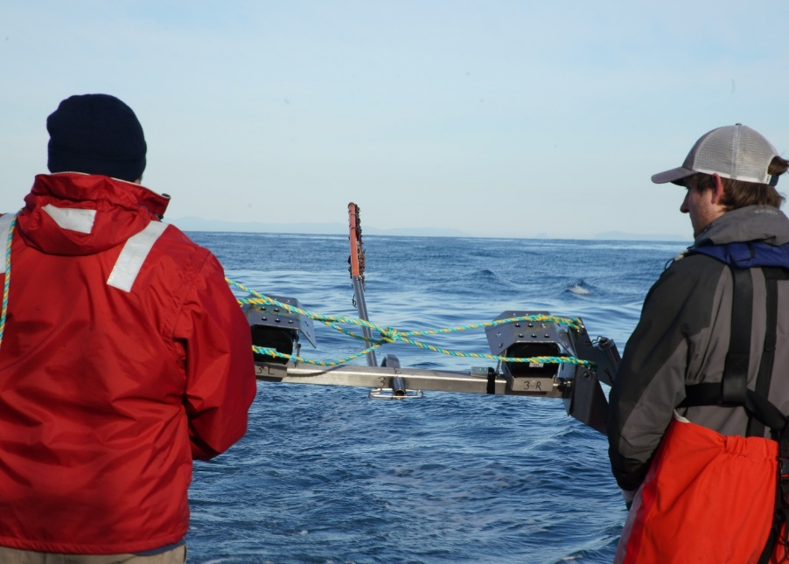

Commonwealth Environmental Impact Statement
Chapter 15 – Commercial and recreational fisheries
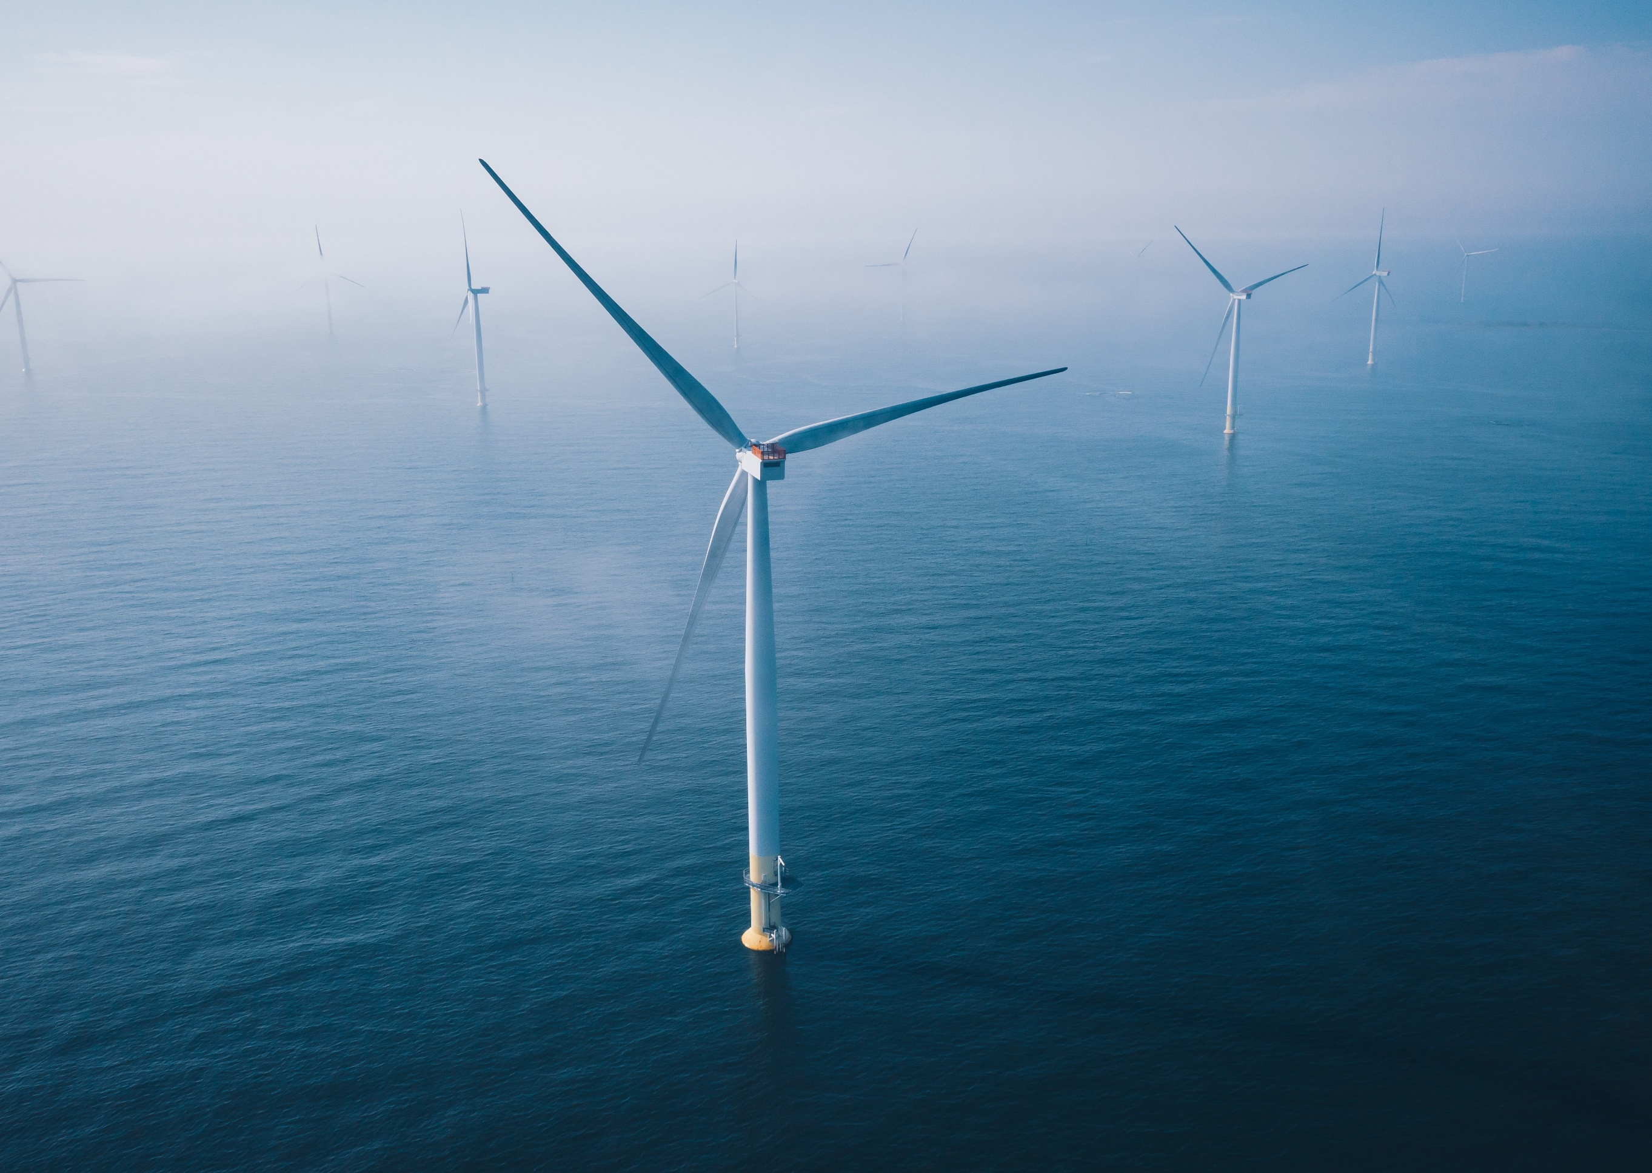
Table of Contents
Chapter 15 Commercial and recreational fisheries 1
15.1 Introduction 1
15.2 Assessment scope 2
15.2.1 Commonwealth matters 2
15.3 Evaluation framework 3
15.3.1 Key legislation, policy, guidelines and standards 3
15.3.2 Assessment criteria 3
15.4 Methods 5
15.4.1 Consultation 7
15.5 Existing environment 9
15.5.1 Regional context 9
15.5.2 Conservation values and sensitivities 9
15.5.3 Physical environment 9
15.5.4 Fisheries 10
15.5.5 Fish 29
15.6 Assessment context 30
15.6.1 Receptor groups 30
15.6.2 Coexistence 30
15.6.3 Safety and protection zones 32
15.7 Construction impacts 33
15.7.1 Key impacts 33
15.7.2 Other impacts 33
15.7.3 Potential risks 39
15.8 Operation impact assessment 42
15.8.1 Key impacts 42
15.8.2 Other impacts 42
15.8.3 Potential risks 50
15.9 Decommissioning assessment 53
15.9.1 Potential impacts and risks 53
15.10 Cumulative Impacts 54
15.11 Summary of mitigation, monitoring and contingency measures 56
15.11.1 Mitigation measures 56
15.11.2 Monitoring and contingency measures 57
15.12 Conclusion 58

Figures
Figure 15-1 Fisheries study area 6
Figure 15-2 Shark gillnet fishery spatial extent and intensity (2018-2022) 12
Figure 15-3 Commonwealth trawl fishery spatial extent and intensity (2018-2022) 14
Figure 15-4 Commonwealth Danish seine fishery spatial extent and intensity (2018-2022) 15
Figure 15-5 Commonwealth Southern Squid Jig fishery spatial extent and intensity (2018-2022) 16
Figure 15-6 Commonwealth Trawl Sector squid catch spatial extent and intensity (2018-2022) 17
Figure 15-7 Victorian Ocean (General) Fishery actively fished area by reporting grid (2018-2023) 18
Figure 15-8 Victorian Trawl (Inshore) Fishery actively fished area by reporting grid (2018-2023) 19
Figure 15-9 Victorian Purse-seine (Ocean) Fishery actively fished area by reporting grid (2018-2023) 21
Figure 15-10 Victorian Purse Rock Lobster Fishery actively fished area by reporting grid (2018-2023) 22
Figure 15-11 Victorian Scallop (Ocean) Fishery actively fished area by reporting grid (2018-2023) 23
Figure 15-12 Victorian Wrasse (Ocean) Fishery actively fished area by reporting grid (2018-2023) 25
Figure 15-13 Victorian Octopus Fishery and Permit Fishery actively fished area by reporting grid (2018-2023) 26
Figure 15-14 Map of vessel sightings during marine aerial surveys, 2021 28
Figure 15-15 Star of the South coexistence hierarchy 31
Figure 15-16 Typical gillnet and octopus pot mainline arbitrarily placed within the indicative offshore wind farm area layout in the direction of a typical set (50°) 44

Tables
Table 15-1 Key legislation, policy, guidelines and standards 3
Table 15-2 Commonwealth and Victorian commercial fisheries relevant to the offshore project area 11
Table 15-3 Species targeted by commercial fisheries that were frequently recorded during baseline surveys 29
Table 15-4 Residual impacts from the physical presence of construction vessels and project infrastructure 36
Table 15-5 Residual impacts from reduced availability of fish due to low impact construction activities 37
Table 15-6 Residual impacts from reduced availability of fish due to noise emissions from piling and construction vessels 39
Table 15-7 Consequence, likelihood and residual risk ranking for hydrocarbon release due to collision of a project vessel during the construction phase 40
Table 15-8 Consequence, likelihood and residual risk ranking for the introduction and establishment of invasive marine species 41
Table 15-9 Residual impact from physical presence of maintenance vessels and project infrastructure 46
Table 15-10 Residual impact ranking from reduced availability of fish due to habitat modification, power generation and maintenance operations for commercial and recreational fishers. 48
Table 15-11 Residual impact from increased commercial and/or recreational fishing interest during the operation phase 50
Table 15-12 Consequence, likelihood and residual risk ranking for hydrocarbon release due to collision of a project vessel on substations 51
Table 15-13 Summary of cumulative impact assessment for commercial and recreational fishing 54
Table 15-14 Summary of mitigation measures relevant to fish and invertebrates 56
Table 15-15 Monitoring and contingency measures relevant to commercial and recreational fishing 57

Commercial and recreational fisheries

Introduction
This chapter summarises the existing conditions related to commercial and recreational fishing and assesses the impacts and risks associated with the construction, operation and decommissioning of the Star of the South Offshore Wind Farm Project (the project). This chapter describes how impacts will be avoided, minimised or managed.
The project is located within the Commonwealth waters and Victorian coastal waters where commercial and recreational fishing are recognised as an important socio-economic value.
This chapter is based on the impact assessment presented in Technical Report N – Commercial and Recreational Fisheries.
Other chapters and modelling that relate to or inform this assessment include:
Chapter 8 – Coastal Processes and Sediment Transport
Chapter 9 – Benthic Ecology
Chapter 10 – Fish and Invertebrates
Chapter 17 – Shipping and Navigation
Chapter 20 – Social
Chapter 21 – Business and Tourism
Attachment II – Consultation Report
Technical Report Attachment I – Underwater Noise Modelling
Technical Report Attachment II – Oil Spill Modelling Summary

Assessment scope
The study objective for commercial and recreational fishing is to identify the existing conditions related to commercial and recreational fishing and assess potential impacts and risks associated with the construction, operation and decommissioning of the project on commercial and recreational fishers.
The assessment scope includes the biological and physical attributes relevant to commercial and recreational fishing within the offshore project area. Environmental values relevant to this scope are commercial and recreational fisheries as a socioeconomic value of the Commonwealth marine area.
All detailed methodologies and assessment of commercial and recreational fisheries can be found in Technical Report N – Commercial and Recreational Fisheries.

Commonwealth matters
The EIS guidelines for the project inform the preparation of the EIS to enable the Commonwealth Minister for the Environment to make an informed decision on whether to approve the project under the EPBC Act.
The aspects of the EIS guidelines directly relevant to commercial and recreational fisheries are:
- Section 2.7 – The extent, intensity and duration of impacts of the action on existing users of the marine environment
- Section 2.11.7 – Cumulative impacts
- Section 2.8 – Proposed avoidance, management and mitigation measures.
Further information about the EIS guidelines is listed in Attachment V – EIS Guidelines Checklist.

Evaluation framework

Key legislation, policy, guidelines and standards
Table 15-1 lists the key legislation, policy, guidelines and standards relevant to commercial and recreational fisheries. Refer to Chapter 5 – Commonwealth Legislative Framework for further details.
Table 15-1 Key legislation, policy, guidelines and standards
Type | Applicable legislation, policy, guideline or standard
International conventions/guidance | International Convention for the Conservation of Southern Bluefin Tuna
Commonwealth legislation | Biosecurity Act 2015 (Cth)
Commonwealth legislation | Environment Protection and Biodiversity Conservation Act 1999 (Cth)
Commonwealth legislation | Fisheries Management Act 1991
Commonwealth legislation | Navigation Act 2012
Commonwealth legislation | Offshore Electricity Infrastructure Act 2021 (Cth)
Commonwealth legislation | Protection of the Sea (Prevention of Pollution from Ships) Act 1983 (Cth)
Commonwealth legislation | Sea Installations Act 1987 (Cth)
Commonwealth legislation | Underwater Cultural Heritage Act 2018 (Cth)
Commonwealth legislation | Research Strategy 2024-2027 (National Offshore Petroleum Safety and Environmental Management Authority (NOPSEMA) & OIR)
Commonwealth legislation | Offshore renewables and interactions with fisheries (OIR 2023)
Commonwealth legislation | Key environmental factors for offshore wind farm environmental impact assessment under the Environment Protection and Biodiversity Conservation Act 1999 (DCCEEW 2023)
Commonwealth legislation | Biodiversity Conservation Act 1999 (DCCEEW 2023)
Industry | Seafood Industry Australia (SIA) Ocean Access Position Paper, May 2023
Industry | Commonwealth Shark and Trawl Industry (SETFIA) Submission: Offshore renewable energy infrastructure area proposal: Southern Ocean Region off VIC and SA, August 2023
Industry | Seafood Industry Victoria (SIV) Marine Development Policy, February 2024

Assessment criteria
To assess the project, predicted impacts and risks are compared to criteria that set required environmental performance outcomes (refer Chapter 6 – Assessment Framework).
Assessment criteria can be quantitative or qualitative and those relevant to commercial and recreational fisheries are as follows:
- Project vessel activities are compliant with relevant project procedures and maritime law relating to navigation and safety at sea
- Fishing stakeholders are provided with information that enables them to make an informed assessment of the possible consequence of the project on their function, interests or activities
- Fishing stakeholders have sufficient time and opportunity to comment on the project including raising of objections or claims
- Fishing stakeholders are provided advance notification of construction and maintenance activities for planning of fishing activities
- Potentially affected commercial fishers are provided with an agreed process for claiming compensation for loss of catch or displacement
- Potentially affected commercial fishers are provided opportunity to participate in project activities
- Recreational fishers can continue fishing in the project area and interference with their activities is not greater than is reasonably necessary for the completion of the project
- Commercial fishers can continue fishing in the project area if it is safe and practical for them to do so
- The size of demarcation areas and safety and protection zones will be minimised to only what is necessary for the safety of personnel and marine users and the protection of infrastructure
- Only project vessels that are a low biosecurity risk enter the offshore wind farm area and the offshore export cable area
- There are no significant effects on fish stocks resulting in a change in stock status.

Methods
The purpose of the commercial and recreational fisheries impact assessment is to assess the potential impacts of the project on fisheries.
Impacts refer to the consequences of planned project actions, which are given a rating determined by combining the magnitude of the impact and the sensitivity of the receptor.
Risks are an unexpected (accidental) event and are determined by combining the likelihood of an event occurring and the consequences that would result if the event were to occur.
The technical chapters consider key impacts and risks with a residual consequence rating of moderate to severe. Other impacts and risks are those with a residual consequence rating of negligible to minor.
Refer to Chapter 6 – Assessment Framework for more detail on how impact and risk ratings are derived.
The commercial and recreational fisheries impact assessment involved:
- Defining a study area in which fishing activities may be impacted by project activities, which includes the offshore wind farm area, the offshore export cable area, and the area in which construction noise may temporarily affect fish (refer Figure 15-1)
- Reviewing national, state and local legislation relevant to commercial and recreational fisheries
- Identifying matters of national environmental significance under the EPBC Act using the Department of Climate Change Energy, the Environment and Water Protected Matters Search Tool and listed species under the FFG Act, Commonwealth and Victorian management plans and policies, published scientific and grey (non-peer reviewed) literature
- Reviewing available catch and effort data for Commonwealth and Victorian fisheries that are legally able to operate within the offshore project area
- Fish surveys during 2021-2023 to provide baseline information of the fish community within and around the project area (described in Chapter 10 – Fish and Invertebrates)
- Consulting with commercial fishing and recreational fishing stakeholders (refer Section 15.4.1).

Figure 15-1 Fisheries study area
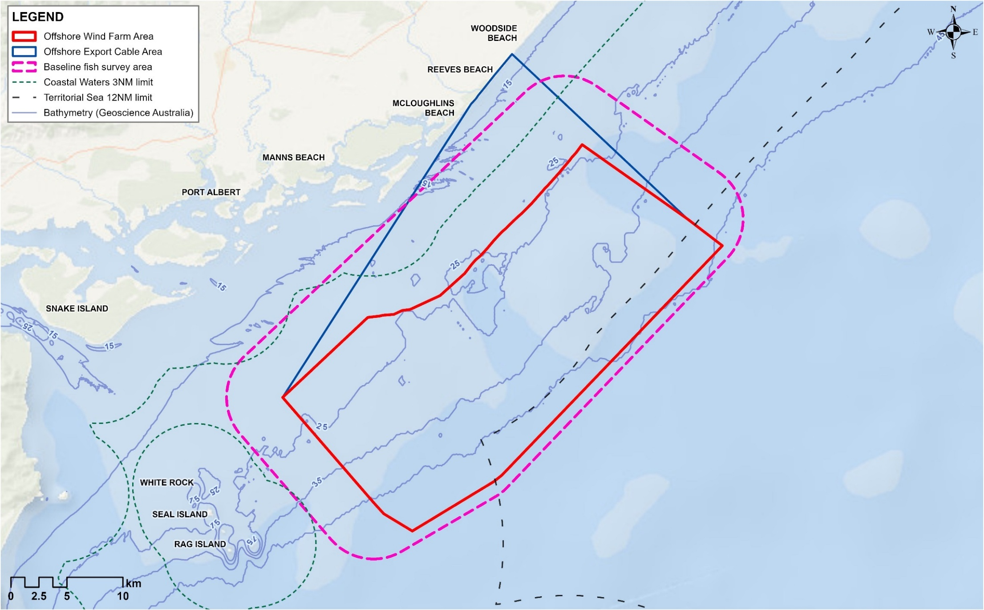

Consultation
Consultation with fishing stakeholders has been a key focus and input to the project since 2018. Star of the South has shared project information and updates, consulted broadly to collect data and feedback, and used information collected to design and deliver site investigations (including baseline fish surveys), shape the project’s approach to engagement and communication of information, inform project design and inform environmental assessments.
Recognising early that the fishing sector is complex with disparate stakeholders and a wide range of perspectives, Star of the South appointed a Fishing Liaison Officer in 2021 to lead proactive and specialised engagement and ensure a thorough understanding of past, current and potential future fishing activities.
Star of the South has engaged with a wide range of fishing stakeholders, including:
- Industry representatives and peak bodies for commercial and recreational fishing
- Individual commercial fishers – primarily based in Lakes Entrance, Port Welshpool, Port Albert and Port Franklin, with a few also based in San Remo and Geelong
- Individual recreational fishers, fishing clubs and fishing retail businesses in Gippsland
- Fisheries regulatory bodies and research agencies.

Engagement activities
Engagement with the commercial fishing sector included:
- Direct contact with industry representatives and concession holders to share project information and build an understanding of existing conditions and issues, including through letters, emails, phone calls, port visits and meetings
- Information sessions in Lakes Entrance, Port Welshpool and Port Franklin
- Correspondence to and surveys of licence holders through Seafood Industry Vicotria and the Victorian Fisheries Association
- A workshop with fishing industry representatives to present preliminary field work and assessment findings and discuss potential mitigations
- Provision of project information as it relates to fishing, including fact sheets and videos
- Participation in Seafood Directions 2019, 2022 and 2024 to build broad industry awareness of offshore wind and the project, including delivering a keynote address on coexistence challenges and opportunities for offshore wind energy and commercial fishing in 2024.
Engagement with recreational fishing stakeholders included:
- Surveys at boat ramps and online to collect data on existing conditions and understand issues
- A workshop with fishing industry representatives to present preliminary field work and assessment findings and discuss potential mitigations
- Presentations to local fishing clubs
- Provision of project information as it relates to fishing, including fact sheets and videos, via the project website, social media, monthly e-news, and by providing hard copies to local fishing retail stores, fishing clubs and at local fishing competitions
- Local community information sessions and attendance at events such as the Port Welshpool Sea Days Festival, Tarwin Lower Lifestyle Festival and South Gippsland Game Fishing Club Snapper and Gummy competition
- Involvement in statewide events such as the Melbourne Boat Show and VFA Ultimate Fishing Expo and an interview on fishing podcast Wind Against Tide
- Community Advisory Group, with members from coastal communities with an interest in fishing.
Refer to Chapter 7 – Community Engagement for more detail about how the project communicated and engaged with stakeholders.

Key issues
Key issues raised by through consultation are discussed in Chapter 7 – Community Engagement and Technical Report N – Commercial and Recreational Fisheries.
Recreational fishers are primarily concerned with changed conditions that could affect fishing, particularly access to and around the offshore wind farm. There is broad understanding of the need to avoid major construction activities and an expectation of access during operations.
Commercial fishers' concerns are more varied and are linked to their ability to continue viable generational family businesses in the context of increasing competition for ocean space, and the stress and pressure on individual small operators. There is a clear desire to continue fishing with as little change as possible. Access, safety, adaption, uncertainty, impacts to target fish species, new opportunities and mental health concerns are key matters raised.

Existing environment
This section describes the existing conditions within the study area as they relate to commercial and recreational fishing.

Regional context
The offshore project area is located in the Southeast Shelf Transition bioregion of the South-east Marine Region. The continental shelf is relatively broad and shallow and marine waters are strongly influenced by several currents that run through and nearby the shelf, bringing both warm and cool currents. The coastline consists of long sandy beaches interspersed with rocky headlands and several coastal lagoons.

Conservation values and sensitivities
Fish species protected under Victorian and Commonwealth legislation are described in Technical Report C – Fish and Invertebrates. These include fisheries species such as Blue Warehou (Seriolella brama) and School Shark (Galeorhinus galeus) which are listed as Conservation Dependent under the EPBC Act. These species are known to occur within the project area and may be targeted or captured as bycatch by commercial and recreational fishers.

Physical environment

Benthic habitat
The benthic habitat in and around the offshore project area is mostly made up of sandy soft sediments that are often moved around by strong tides and storm waves, along with elements of flat rock. Patches of reef are also distributed across the offshore wind farm area, primarily in water depths of 10 to 25 metres. Sediment types range from sand to sandy gravels. The benthic habitat supports a variety of epifauna, including sessile (such as sponges and corals) and mobile invertebrates (such as crabs, octopuses, and sea stars). Rocky reef areas support medium to high density macroalgae (seaweed) and animals that filter food from the water. Further detail can be found in Chapter 9 – Benthic Ecology.

Currents and tides
The eastern Victorian coastline is impacted by the east Australian current, which is a warm, saline current that is strongest in summer, flowing south and often deflecting westward off Gippsland. In winter, the South Australian Current transports dense, salty water eastward from the Great Australian Bight through Bass Strait, aided by prevailing westerly and south-westerly winds. Along the Gippsland Basin, currents tend to flow parallel to the coast, but strong north-easterly winds can occasionally halt or reverse coastal flow. Further detail can be found in Chapter 8 – Coastal Processes and Sediment Transport.

Waves
Bass Strait is a high-energy environment frequently exposed to storms and significant wave heights, driven mainly by strong west to southwest winds. Storms can occur several times a month, typically producing waves of three to four metres, and occasionally exceeding six metres. The offshore wind farm area is exposed to swell from the southwest through southeast and locally generated wind waves from all directions. Wave disturbance to the seabed is likely to be frequent in shallow parts of the offshore wind farm area but may only occur during extreme storm conditions in deeper offshore areas. Further detail can be found in Chapter 8 – Coastal Processes and Sediment Transport.

Fisheries

Commercial fisheries
There are 21 commercial fisheries that overlap the offshore project area.
This section provides a summary of the active fisheries which reported effort in or near the offshore project area over the 20 years up to 2021. These active fisheries coexist with other uses of the marine environment, including marine parks for conservation, the offshore oil and gas industry, research, and recreational fishing. Shared use of the ocean is cited by the commercial fishing industry as a key pressure facing the sector, alongside climate change impacts in the form of changes to species distribution and abundance.
More detailed description of each fishery is provided in Technical Report N – Commercial and Recreational Fisheries.
While the remaining nine fisheries can legally fish in the offshore project area, they did not do so in the 20 years up to 2021. This is typically because the area does not provide favourable conditions for those fisheries and/or effort is being focused on more productive or well-located fishing grounds. In some instances, such as for the Giant Crab and Sea Urchin fishery, there are currently no licences to operate.
Table 15-2 Commonwealth and Victorian commercial fisheries relevant to the offshore project area
Overlap with offshore wind farm area | Commonwealth-managed fisheries | Victorian-managed fisheries  (including permits)
Can legally fish within the offshore wind farm area and do so | - Southern and Eastern Scalefish and Shark Fishery (SESSF):  - Commonwealth Trawl Sector (CTS)  - Shark Gillnet and Shark Hook Sectors (SGSHS)  - Southern Squid Jig Fishery | - Ocean (General) Fishery  - Trawl (Inshore) Fishery  - Purse Seine (Ocean) Fishery  - Rock Lobster (Eastern Zone) Fishery  - Scallop (Ocean) Fishery  - Wrasse (Ocean) Fishery  - Small Sales Commercial Permit  - Octopus (Central Zone) Permit  - General (Commercial) Permit
Can legally fish within the offshore wind farm area but did not do so between 2001 and 2021 | - Southern Bluefin Tuna Fishery (SBTF)  - Eastern Tuna and Billfish Fishery (ETBF)  - Eastern Skipjack Tuna Fishery (ESTF)  - Small Pelagic Fishery (SPF)  - SESSF Scalefish Hook Sector | - Abalone (Central Zone) Fishery  - Bait (General) Fishery  - Giant Crab Fishery (currently no licences)  - Sea Urchin Fishery (currently no licences)

Commonwealth Shark Gillnet and Shark Hook Sectors
The Shark Gillnet and Shark Hook Sector is part of the Southern and Eastern Scalefish and Shark Fishery, and it extends from the New South Wales border through to the West Australian border. This sector uses demersal gillnet and longline equipment to target Gummy Shark (Mustelus antarcticus) but also catches various bycatch species such as Elephant Fish (Callorhinchus milii) and sawsharks. The Southern and Eastern Scalefish and Shark Fishery has the highest historic fishing effort in the offshore wind farm area, with 48 different vessels recording effort between 2001 and 2021. The actively fished area is 140,304 square kilometres, with 0.4 per cent overlapping the offshore wind farm area. Between five and 13 vessels have fished in this area between 2001 and 2021. The offshore wind farm area is close to areas of high fishing intensity (refer Figure 15-2).
Figure 15-2 Shark gillnet fishery spatial extent and intensity (2018-2022)
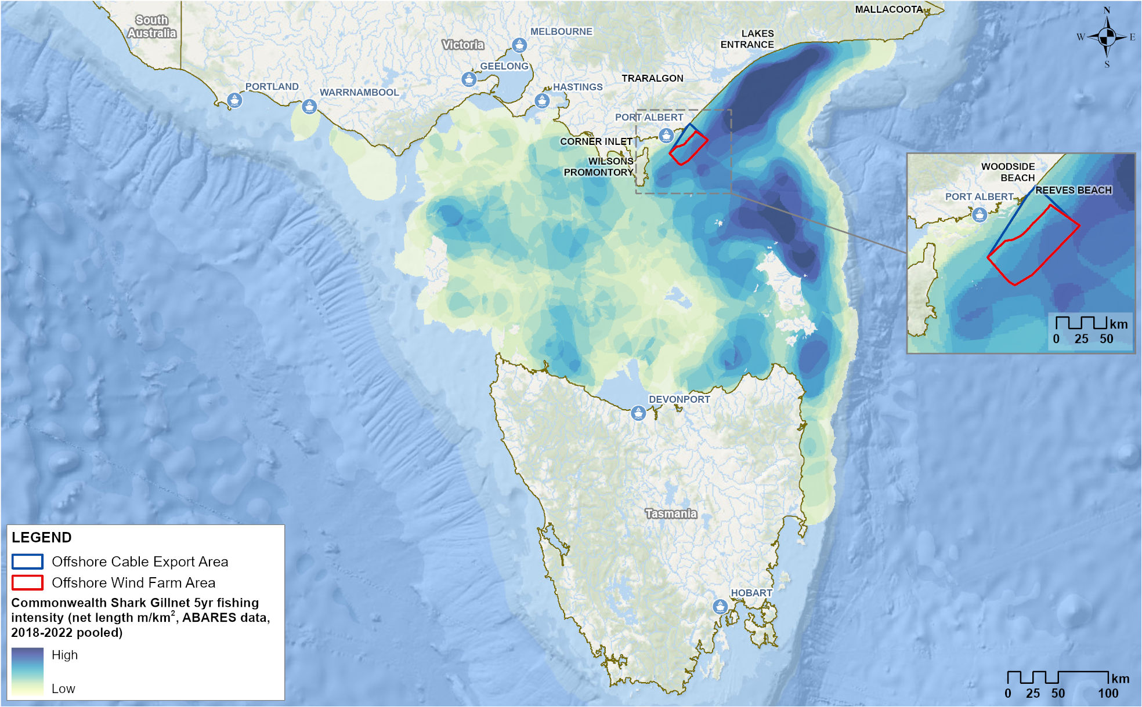

Commonwealth Trawl Sector
The Commonwealth Trawl Sector is part of the Southern and Eastern Scalefish and Shark Fishery, and it extends from Sydney southwards around Tasmania to South Australia. This sector uses midwater and demersal otter board trawl and Danish seine methods to target species including pink ling (Genypterus blacodes), blue grenadier (Macruronus novaezelandiae), flathead and silver warehou (Seriolella punctata). The actively fished otter trawl area does not overlap the offshore wind farm area (refer Figure 15-3). The actively fished Danish seine area covers 58,428 square kilometres with 0.5 per cent overlapping the offshore wind farm area (refer Figure 15-4). Seven vessels have recorded effort in the offshore wind farm area between 2001 and 2021.

Commonwealth Southern Squid Jig Fishery
The Southern Squid Jig Fishery extends from South Australia through Tasmania, Victoria and New South Wales to southern Queensland. This sector uses the jigging method to target Gould's Squid (Nototodarus gouldi) in depths of 60 to 120 metres. Squid is also caught in the Commonwealth Trawl Sector by demersal trawling. The actively fished area does not overlap the offshore wind farm area (refer Figure 15-5 and Figure 15-6). Only one vessel has reported fishing within the offshore wind farm area between 1999 and 2020.

Victorian Ocean (General) Fishery
The Ocean Fishery extends the length of Victoria, with 129 licences. Fishing methods include line (dropline, longline, handline), dip net, bait traps, octopus traps, landing nets, gaffs, seine nets, mesh nets and bait pumps. Catches in the sector mostly comprise snapper, octopus and Gummy Shark. The actively fished area is 22,434 square kilometres with 1.2 per cent overlapping the offshore wind farm area (refer Figure 15-7). One to two licence holders have reported catches of snapper in any one year since 2014.

Victorian Trawl (Inshore) Fishery
The Victorian Trawl (Inshore) Fishery extends the length of Victoria, with 52 licenses of which most are not active. Using otter-board trawls, this fishery targets crustaceans (Eastern King (Melicertus plebejus) and School Prawns (Metapenaeus macleaya)), and to a lesser extent bugs, crabs and limited finfish. The actively fished area is 10,889 square kilometres, with 1.8 per cent overlapping the offshore wind farm area (refer Figure 15-8). One to two licence holders have reported fishing in or near the area since 1999.
Figure 15-3 Commonwealth trawl fishery spatial extent and intensity (2018-2022)
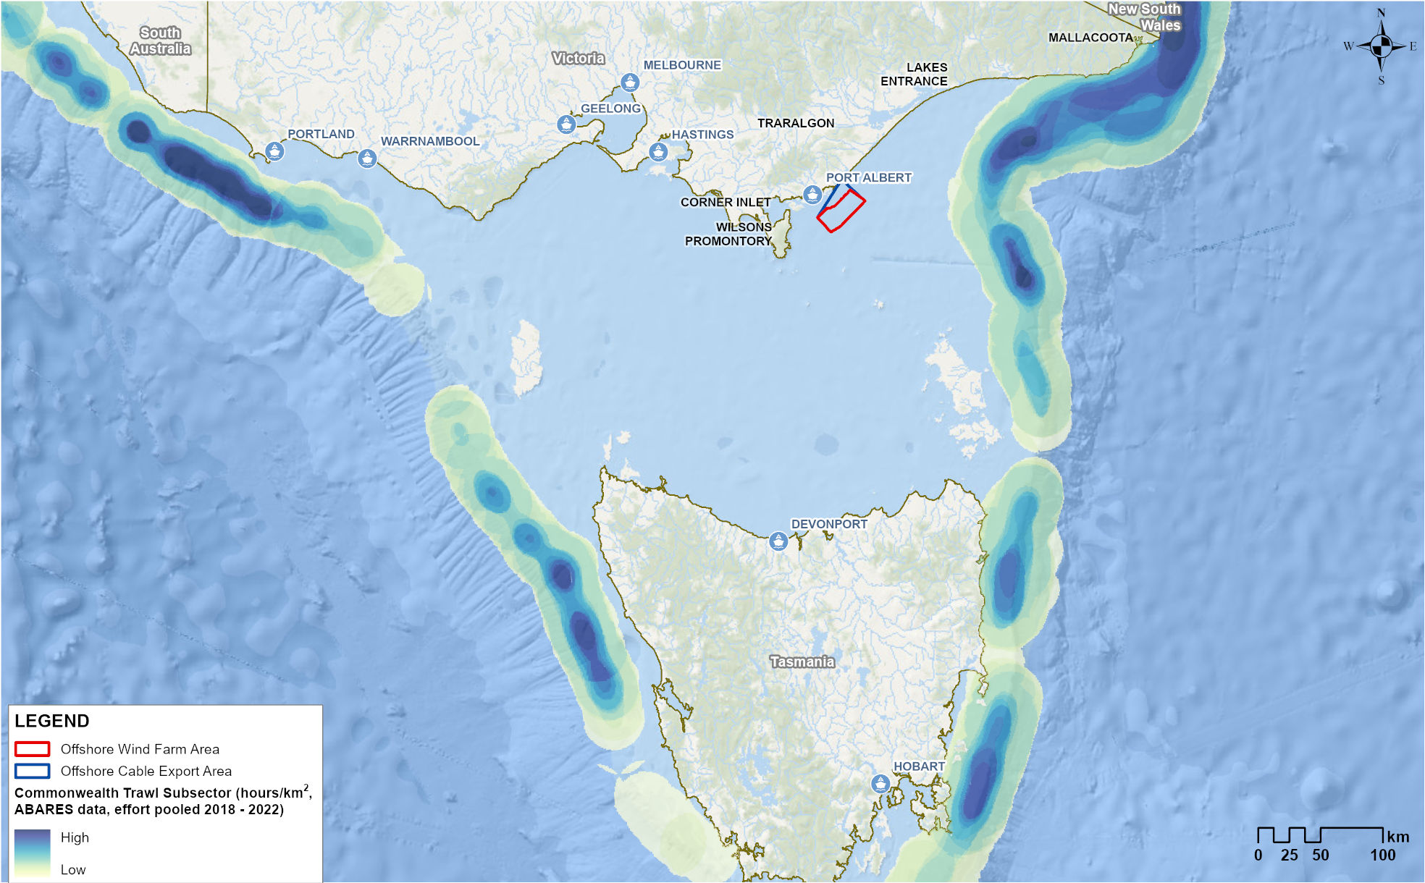
Figure 15-4 Commonwealth Danish seine fishery spatial extent and intensity (2018-2022)
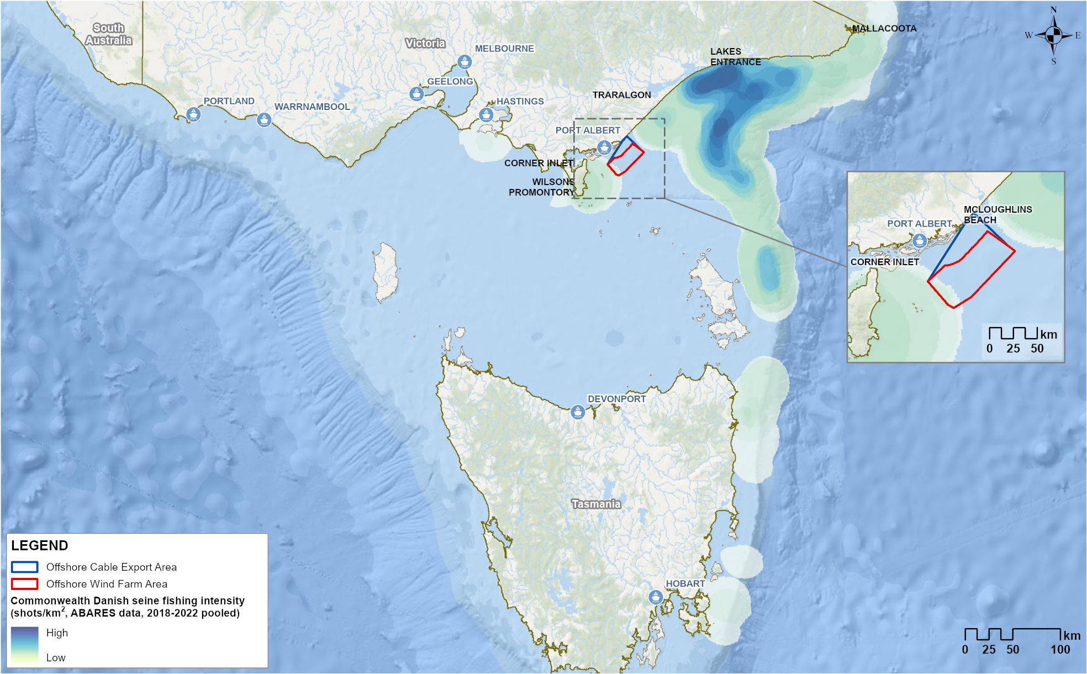
Figure 15-5 Commonwealth Southern Squid Jig fishery spatial extent and intensity (2018-2022)
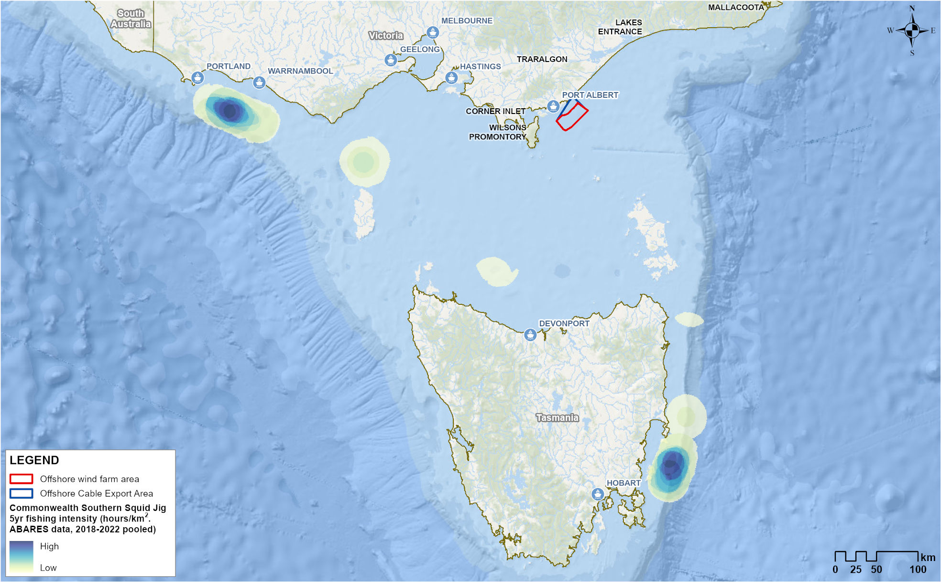
Figure 15-6 Commonwealth Trawl Sector squid catch spatial extent and intensity (2018-2022)
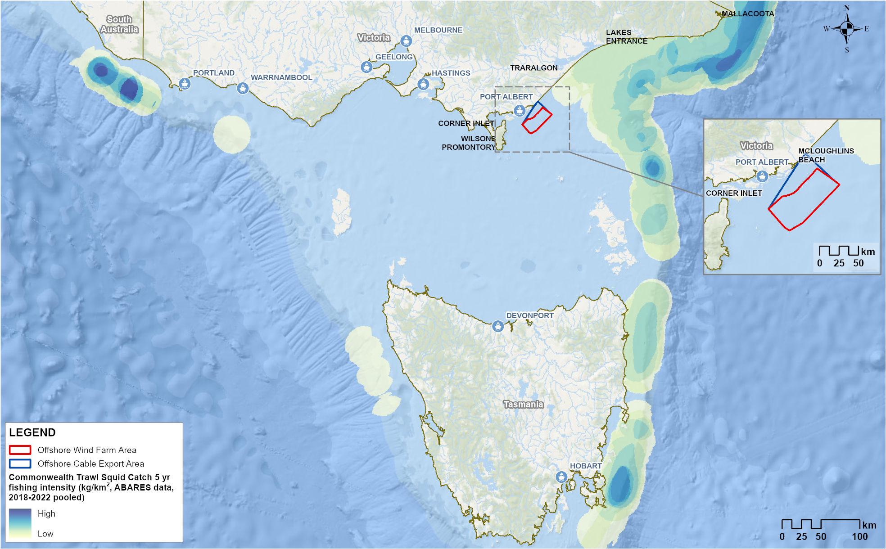
Figure 15-7 Victorian Ocean (General) Fishery actively fished area by reporting grid (2018-2023)
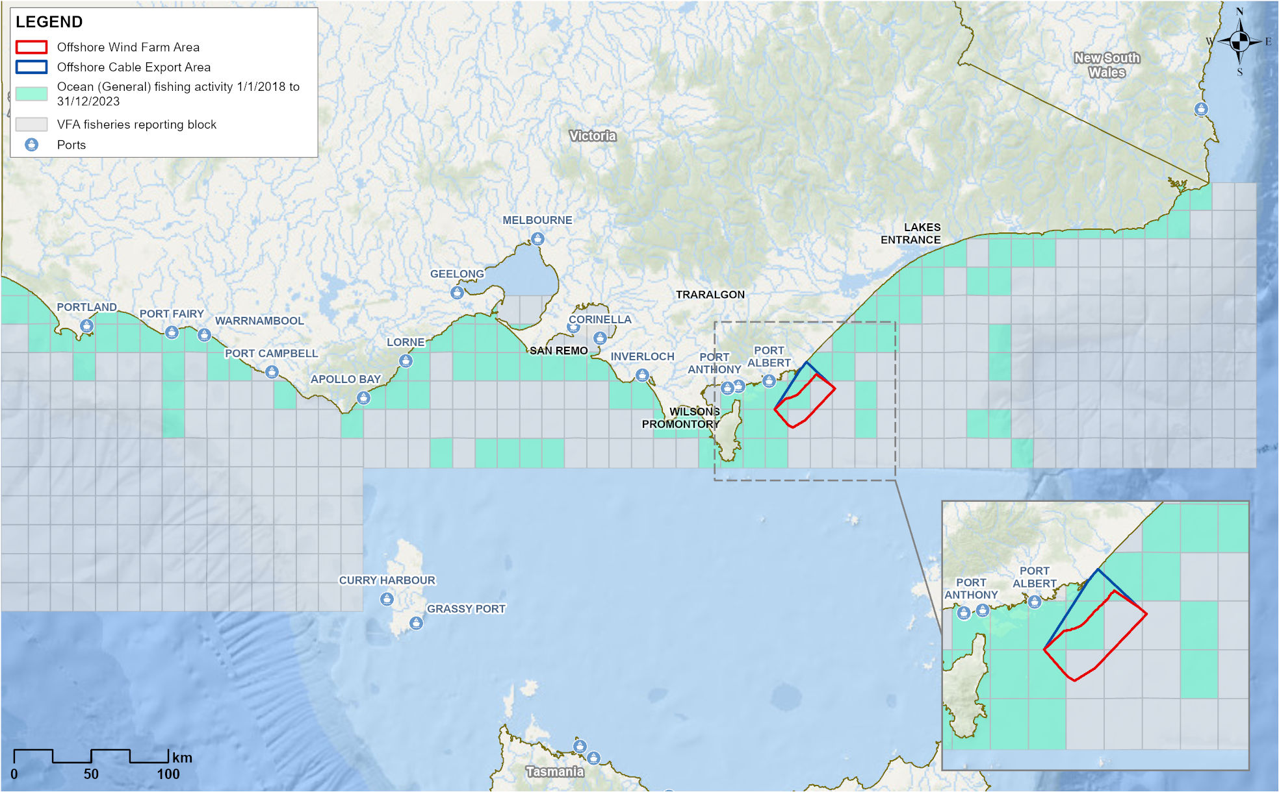
Figure 15-8 Victorian Trawl (Inshore) Fishery actively fished area by reporting grid (2018-2023)
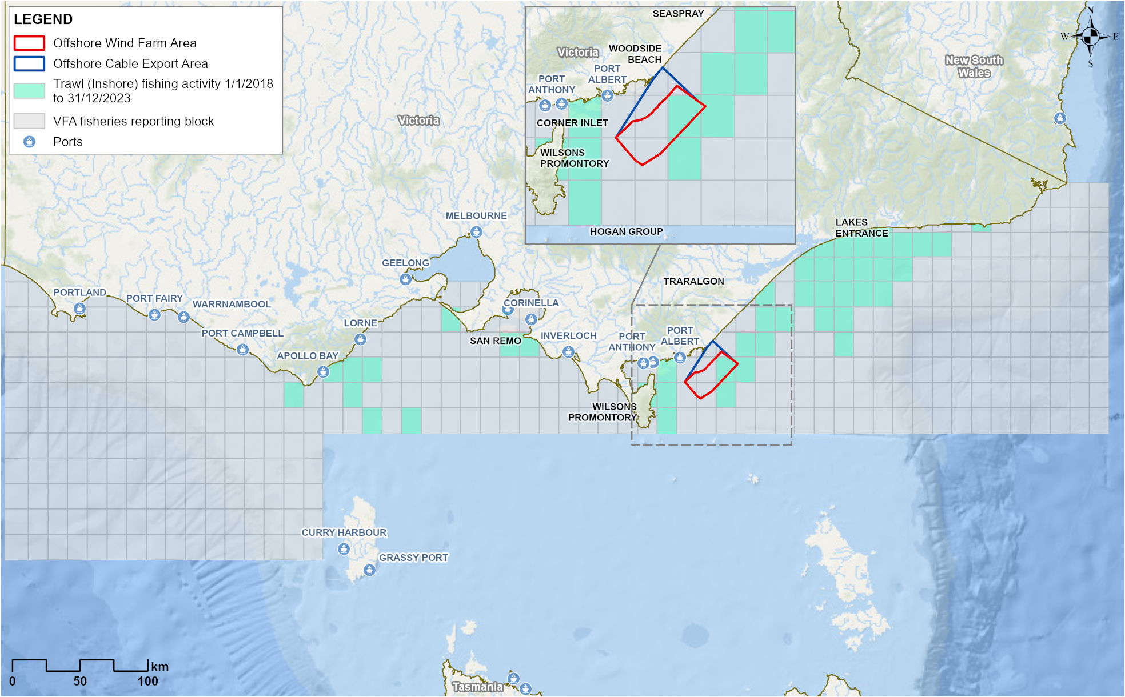

Victorian Purse-Seine (Ocean) Fishery
The Purse-Seine (Ocean) Fishery extends the length of Victoria, with one license. The license holder operates out of Lakes Entrance. Species caught include Sandy Sprat (Hyperlophus vittatus), Australian Sardine (Sardinops sagax), unspecified shark, snapper, Australian Anchovy (Engraulis australis), Blue Mackerel (Scomber australasicus) and Australian Salmon (Arripis trutta). The actively fished area of this sector is 4,077 square kilometres, with 5.3 per cent of this area overlapping the offshore wind farm area (refer Figure 15-9). The licence holder has recorded as many as ten fishing days in or near the offshore wind farm area in any one year.

Victorian Rock Lobster Fishery (Eastern Zone)
The Victorian Rock Lobster Fishery extends along the Victorian coast and out into Commonwealth water, with 47 licences available. It is separated into two zones (eastern and western) and the eastern zone overlaps the offshore wind farm area. Baited pots are used to target the Southern Rock Lobster (Jasus edwardsii). Most of the catch comes from the western zone. The actively fished area is 36,827 square kilometres, with 0.7 per cent overlapping the offshore wind farm area (refer Figure 15-10). One to three licence holders reported fishing in or near the offshore wind farm area between 2001 and 2018, with a decrease in catch evident since 2014.

Victorian Scallop (Ocean) Fishery
The Scallop (Ocean) Fishery extends along the Victorian coastline and out to 20 nautical miles offshore, with 89 licences shared between 40 licence holders. The main target species is the Commercial Scallop (Pecten fumatus), mostly fished from Lakes Entrance and Port Welshpool using the scallop dredge method. The actively fished area is 2,482 square kilometres, with 8.8 per cent overlapping the offshore wind farm area (refer Figure 15-11). The last record of effort in reporting grids that overlap the offshore wind farm area was in 2008 when 47 days of fishing were reported.
The Scallop Fishery is unique in its ‘boom and bust’ nature. It is subject to temporary closures due to low stock to allow for recovery and a total allowable commercial catch (TACC) is set annually. A small scallop bed, called the ‘Clonmel’ bed, is located within the offshore wind farm area. The Clonmel bed is closed to commercial fishing, although surveys have recorded growth over recent years and it could be reopened if it reaches a commercially viable level.
Figure 15-9 Victorian Purse-seine (Ocean) Fishery actively fished area by reporting grid (2018-2023)
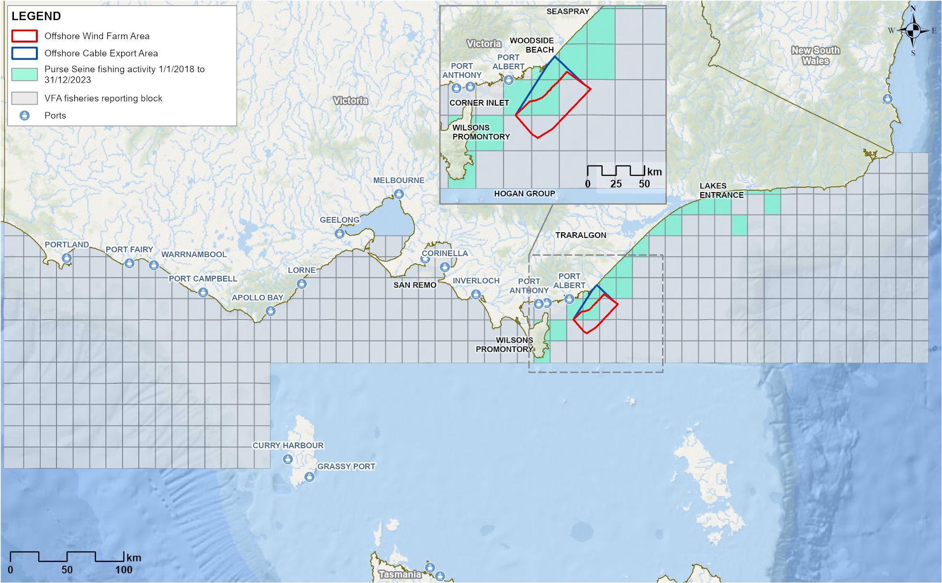
Figure 15-10 Victorian Purse Rock Lobster Fishery actively fished area by reporting grid (2018-2023)
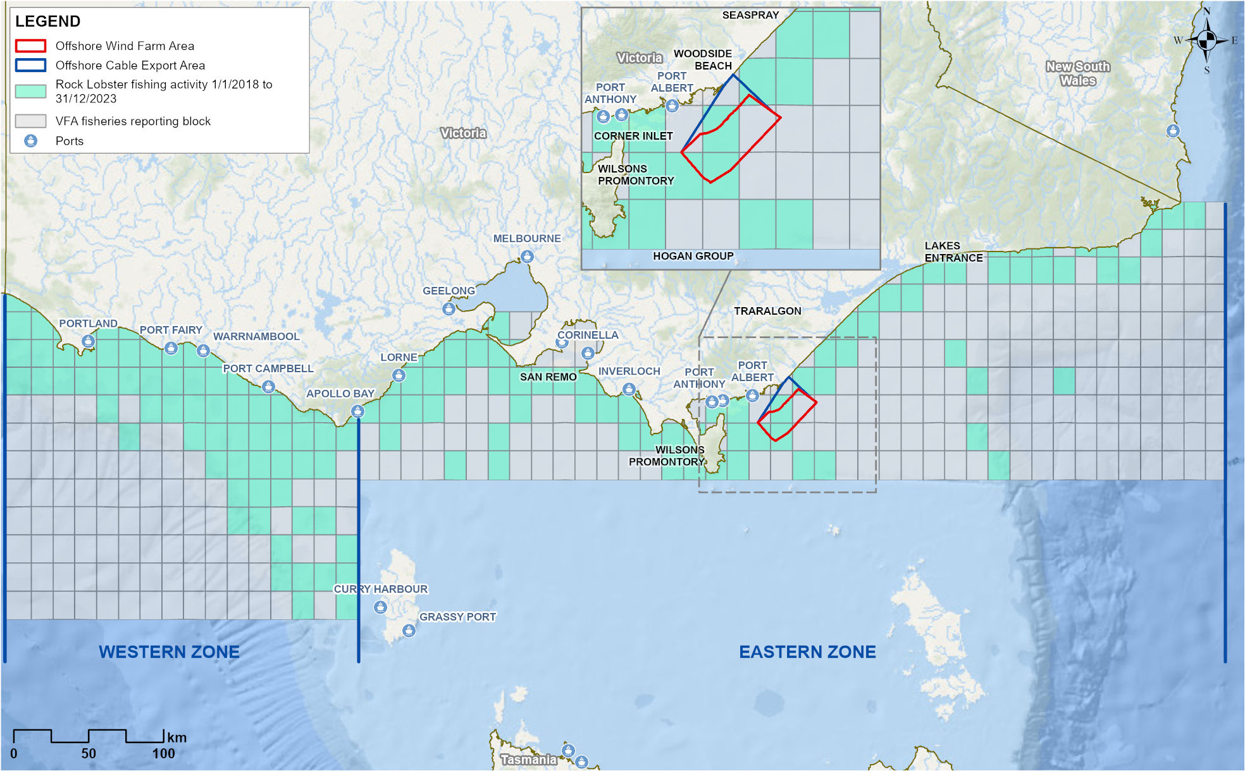
Figure 15-11 Victorian Scallop (Ocean) Fishery actively fished area by reporting grid (2018-2023)
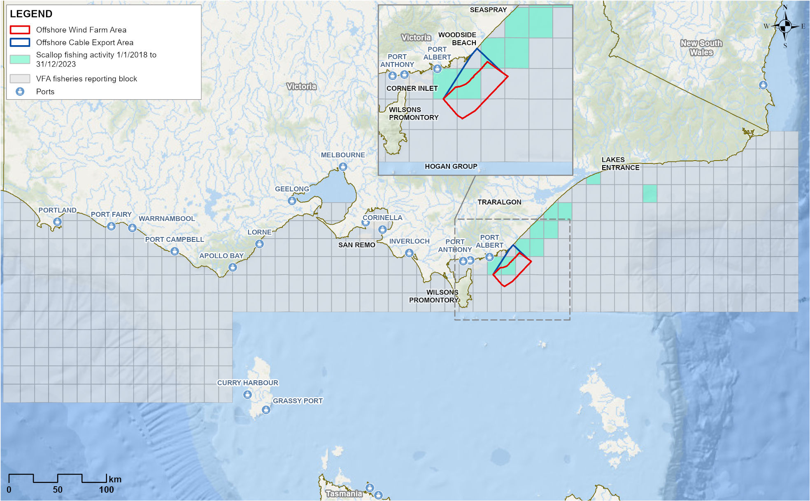

Victorian Wrasse (Ocean) Fishery
The Wrasse (Ocean) Fishery extends along the Victorian coastline and out to 20 nautical miles offshore. There are 23 Wrasse Fishery access licences, however most of the catch is taken by eight licence holders. Hook and line is the main fishing method used to target Bluethroat (Notolabrus tetricus) and Purple Wrasse (Notolabrus fucicola). The actively fished area is 10,377 square kilometres, with 0.4 per cent overlapping the offshore wind farm area (refer Figure 15-12). One licence holder has reported effort in the offshore wind farm area in any one year since 2014.

Victorian Octopus (Permit) Fishery
The Octopus Fishery extends along the Victorian coastline and out to 20 nautical miles offshore. It is managed within three zones; the eastern is established with 11 licences, the central and western zones are exploratory and managed with temporary permits. The fishery uses purpose-built unbaited traps to target Pale Octopus (Octopus pallidus), with Maori Octopus (Macroctopus maorum) and Gloomy Octopus (Octopus tetricus) also taken. The actively fished area of the central zone is 2,498 square kilometres with 23.3 per cent overlapping the offshore wind farm area (refer Figure 15-13). A small area of the eastern zone (approximately 1.8 square kilometres) also overlaps the eastern corner of the offshore wind farm area. Consultation has confirmed that exploratory octopus occurs within the offshore wind farm zone
Figure 15-12 Victorian Wrasse (Ocean) Fishery actively fished area by reporting grid (2018-2023)
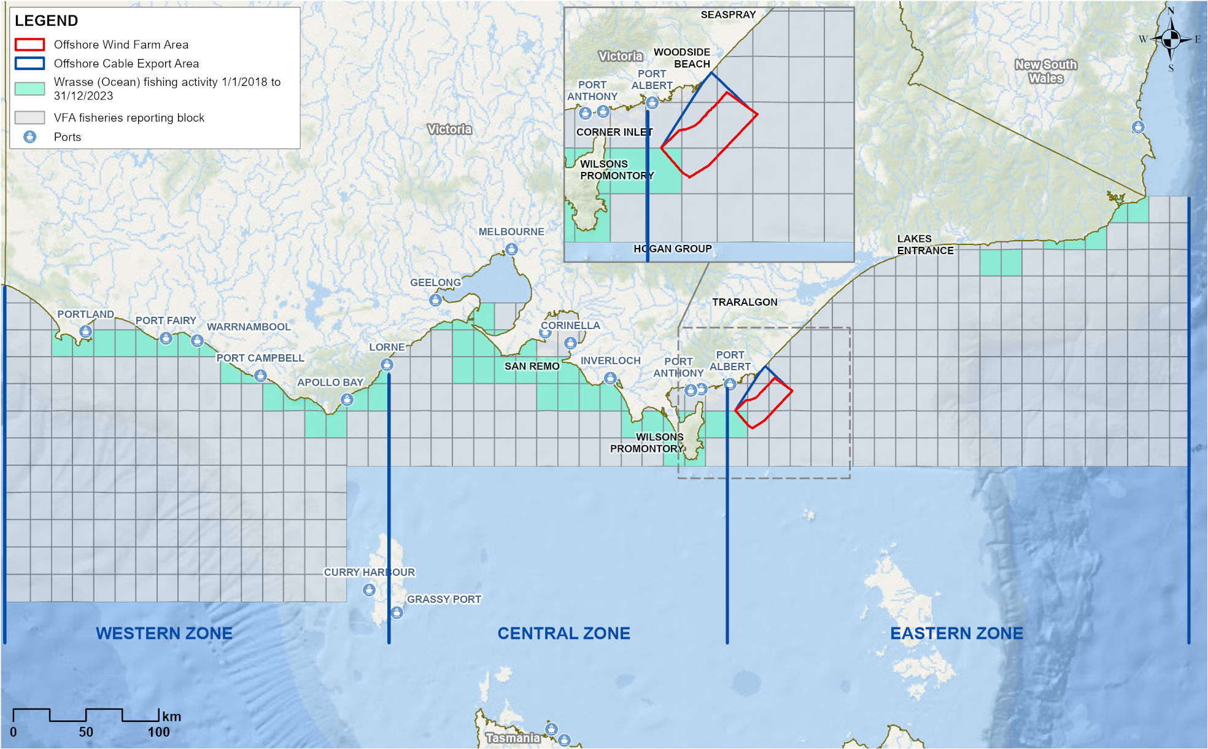
Figure 15-13 Victorian Octopus Fishery and Permit Fishery actively fished area by reporting grid (2018-2023)
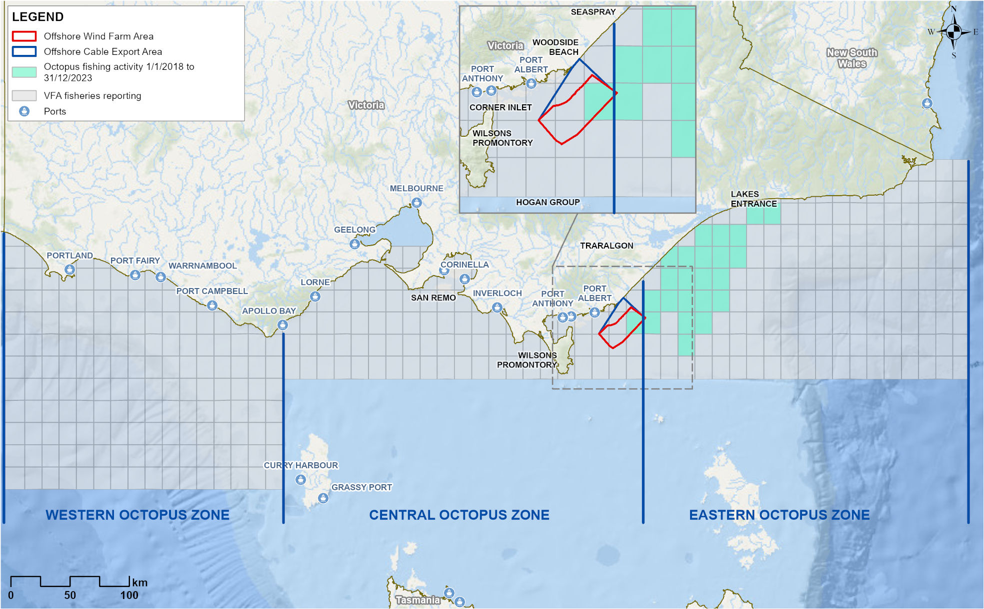

Recreational and charter fisheries
Recreational fishing is a popular activity in Gippsland lakes, rivers, beaches and offshore. The marine species targeted include snapper, King George Whiting (Sillaginodes punctatus), flathead, Gummy Sharks, bream, Australian Salmon and kingfish. Several fishing clubs are active across Gippsland.
In the project area, charter fishing and private vessels can access boat ramps at Port Albert, Port Welshpool, McLoughlins Beach and Manns Beach, with Port Albert and Port Welshpool being the most used.
Consultation with recreational fishers has confirmed that fishing occurs within the offshore wind farm area, although less so than in more sheltered areas closer to shore, within Corner Inlet and around the island chains east of Wilsons Promontory. Fishing in the offshore wind farm area is limited by distance / travel time, weather (less than 15 knots) and vessel size (at least 5.5 metres).
The main months for offshore recreational fishing are October to April, with peaks over summer holidays and long weekends, although some report fishing at other times of year if weather permits.
Aerial surveys undertaken as part of the project’s marine environment survey program identified that recreational fishing activity appears to focus on the western most side of the offshore wind farm area (refer Figure 15-14), which is closest to available boat ramps.
Figure 15-14 Map of vessel sightings during marine aerial surveys, 2021
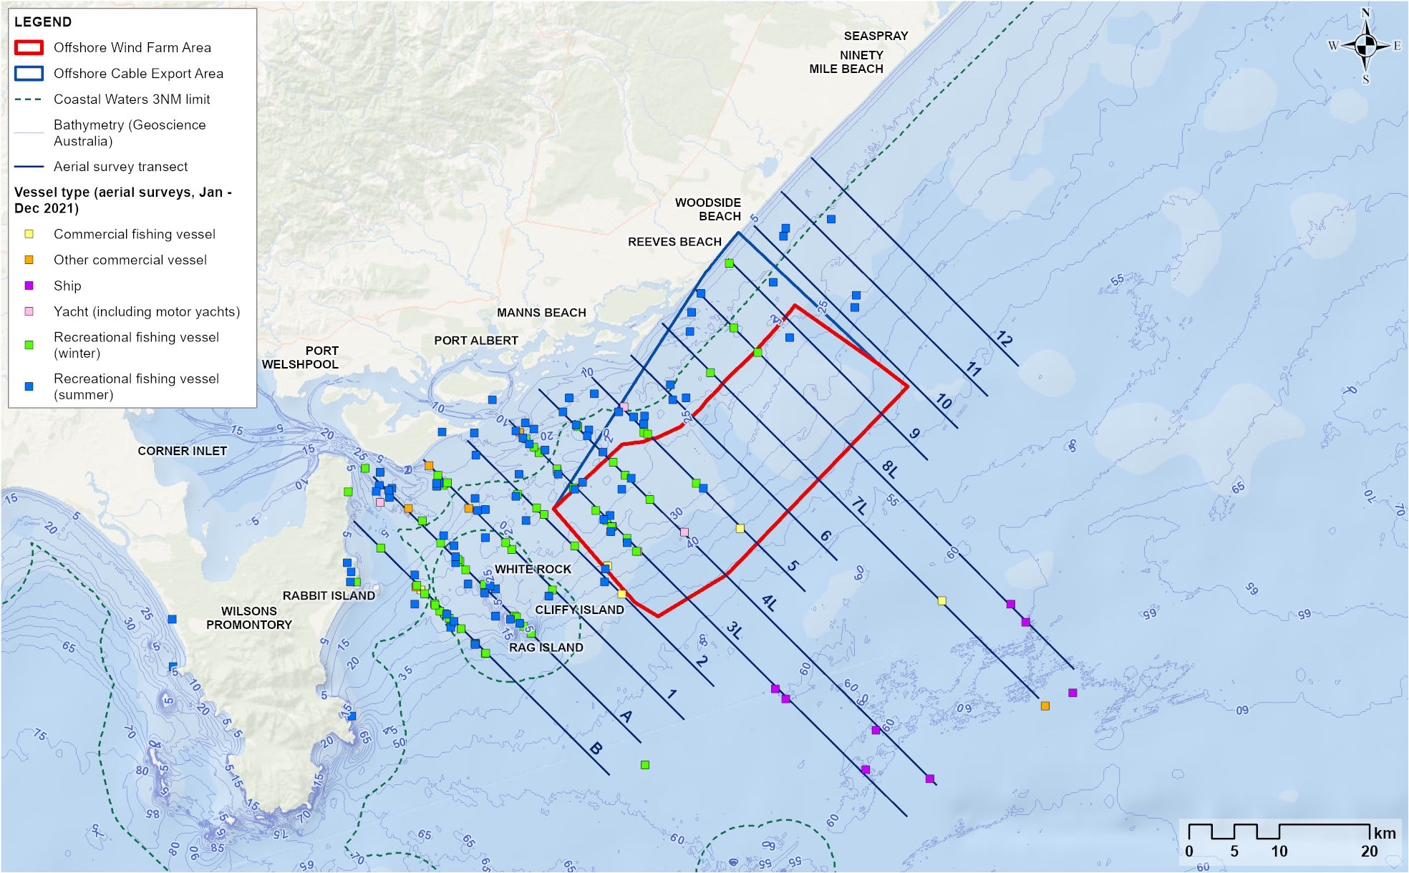

Fish
Baseline fish surveys within the study area recorded 169 species, including 30 species of sharks and rays, 108 species of bony fish and 31 species of invertebrates. Of these 169 species, 50 are targeted or retained by commercial fisheries and 48 by recreational fishers (noting overlap between the two). A further 52 species are of minor fisheries importance (potentially retained). Common target species present within the offshore wind farm area are listed in Table 15-3. Two species, School Shark and Blue Warehou, are listed under the EPBC Act as Conservation Dependent and are the focus of stock rebuilding management strategies.
Analysis of survey data shows that depth and habitat are important predictors of species richness and overall fish abundance in winter and summer. In both seasons, species richness was highest in reef areas and lowest in sand habitat, whereas overall abundance was higher over mixed sediments, pavement with veneer and reef habitats; and lower over sand and sand with patchy epibiota habitats. Individual species exhibited a range of depth, habitat and seasonal preferences.
Seven invertebrate taxa targeted by commercial or recreational fishers were sampled during the surveys – Balmain Bug (Ibacus peronii), Commercial and Doughboy Scallops (Mimachlamys asperrima), Gould’s Squid, Southern Calamari (Sepioteuthis australis), Southern-keeled Octopus (Octopus Berrima) and Maori Octopus. The Giant Cuttlefish (Ascarosepion apama) may also be retained. The most common invertebrate species were the Pale Octopus, Southern Calamari and Giant Cuttlefish.
Further detail about fish can be found in Chapter 10 – Fish and Invertebrates.
Table 15-3 Species targeted by commercial fisheries that were frequently recorded during baseline surveys
Common name
- Australian Angelshark | - Commercial Scallop | - Snapper
- Broadnose Shark | - Baitfish (Clupeidae) | - Snook (Shortfin Pike)
- Common Sawshark | - Blue-throat Wrasse | - Southern Sand Flathead
- Elephantfish | - Eastern School Whiting | - Tiger Flathead
- Gummy Shark | - Jackass Morwong | - Toothy Flathead
- Gould's Squid | - King George Whiting | - Trevally

Assessment context

Receptor groups
The key receptor groups used to identify and assess potential impacts and risks to commercial and recreational fisheries assessment are:
            - Commercial fishers using ‘restrictive’ fishing methods
            - Commercial fishers using ‘non-restrictive’ fishing methods
            - Charter fishing operators
            - Recreational fishers on private vessels.
For the purposes of this assessment, commercial fishing receptors have been categorised by the manoeuvrability of fishing gear used, as this factor is most likely to influence potential project impacts.
- Restrictive fishing methods are those that, when deployed, restrict vessel manoeuvrability. For example, gillnet, octopus pot mainlines, purse-seine, Danish seine, and longlines.
- Non-restrictive fishing methods are those that, when deployed, do not or minimally restrict vessel manoeuvrability and present a lower risk of entanglement with project infrastructure. For example, hook and line and lobster pots.
Depending on the decisions and risk assessment of individual fishers, some fishing methods could be defined as either ‘restrictive’ or ‘non-restrictive’. While this assessment conservatively assumes that commercial fishers using ‘restrictive’ methods are more likely to be impacted by the project and those using ‘non-restrictive’ less likely, it is important to note that no specific fishing methods are explicitly excluded.

Coexistence
The Offshore Electricity Infrastructure Act 2021 (OEI Act) operates under the principle of shared use of the offshore marine environment, recognising all users and balancing competing interests. The OEI Act states that offshore wind farm licence holders must not interfere with lawful fishing activities more than is necessary for the reasonable exercise of the rights and performance of the duties of the licence holder. Priority must be given to coexisting.
Star of the South has sought to avoid and mitigate impacts to fisheries throughout the project’s development. The avoidance of highly productive fishing grounds (based on early consultation and analysis of catch and effort data), popular recreational fishing areas and sensitive ecological features that provide fish habitat were key factors in initial site selection. The project’s early development and design refinement to date, including site selection, is described further in Chapter 3 – Project Development.
Star of the South is committed to coexistence and will continue to work with commercial and recreational fishers and their representatives during detailed design and construction planning to avoid or mitigate any barriers to continued fishing in the area. The project’s coexistence hierarchy was first discussed with commercial fishers in 2021 and is used to guide project development and decisions which lead to better coexistence outcomes (refer Figure 15-15).
Star of the South’s commitment to coexistence and compensation is outlined in Appendix C to Technical Report N – Commercial and Recreational Fisheries.
Figure 15-15 Star of the South coexistence hierarchy
Step / priority order | Project commitment | What this means
- Share the waters | Our starting position and goal is to safely coexist | Some commercial fishing methods are compatible with an operating offshore wind farm and coexistence can be achieved with no or minimal interventions.  The project has, and will continue to, work with fishers to understand where there may be risks to coexistence and seek to avoid these through the project’s ongoing development and detailed design phases where possible.  For example, by allowing sufficient space between turbines to enable safe passage and burying subsea cables where possible to minimise the risk of snagging gear.
- Mitigation | If coexistence isn’t safe or practical with certain fishing gear or methods, we will work with you to identify and explore options to keep you fishing | Some commercial fishing methods will be more challenging to continue within an operating offshore wind farm due to potential interactions between fishing gear and project infrastructure.  In these cases, the project will work directly with potentially affected fishers to identify possible ways to accommodate fishing, including any mitigations that the project could apply to enable them to continue fishing in the operating wind farm or otherwise offset any financial impact.  For example, by adapting or modifying fishing methods and/or equipment to improve opportunities for coexistence or alternative work opportunities on the project.
- Compensation | If all practical mitigation options are exhausted, concession holders with a genuine claim will be fairly compensated | If ​consultation and mitigation/s are unable to address a fundamental conflict (or if an eligible fisher opts not to continue fishing in the project area), concession holders with a genuine and verifiable claim will be offered compensation.

Safety and protection zones
The only legally enforceable restrictions within an offshore wind farm under the OEI Act are safety and protection zones. These zones are only approved by the Offshore Infrastructure Regulator following formal consultation and if there is a strong rationale for their use.
- Safety zones: Temporarily prohibits vessel access to a specific area, extending up to 500 metres around eligible infrastructure such as foundations and cables. Safety zones may be considered during construction, maintenance, or decommissioning activities to manage safety around active construction activities.
- Protection zones: Restricts or prohibits certain activities in a specific area longer term, extending up to 1,852 metres (one nautical mile) from eligible infrastructure such as cables. Protection zones may be considered during operation to prevent interactions with installed infrastructure.
The zones and their potential use on the project are described in Chapter 4 – Project Description.

Construction impacts
This section discusses the impacts and risks associated with the construction of the project that relate to commercial and recreational fishing and the respective receptor groups. Impacts refer to the residual effects of planned project actions, whereas potential risks arise when a project activity or activities could result in an unexpected (accidental) event.

Key impacts
The construction impact assessment identified no impacts with a residual consequence rating of moderate or higher to commercial and recreational fisheries.

Other impacts
Other potential construction impacts with a residual consequence rating of minimal to negligible impacts to commercial and recreational fisheries included:
- Physical presence of construction vessels and project infrastructure (CRF-I001)
- Reduced availability of fish due to low impact construction activities (CRF-I002)
- Reduced availability of fish due to noise from piling and construction vessels (CRF-I003).

Physical presence of construction vessels and project infrastructure (CRF-I001)

Potential impact
The installation of project infrastructure will occur progressively and involves the use of large installation and support vessels. For safety, non-project vessels will be asked to avoid construction areas, which will be demarcated and monitored by escort vessels.
The presence of construction vessels and installed infrastructure is expected to displace fishing activities from parts of the offshore project area at times. The level of impact will vary across the construction phase; being minimal at the start when no infrastructure is installed and progressively increasing as construction progresses and more infrastructure is installed. Sections of the offshore project area will be re-opened to other users as soon as possible after construction activity is completed and the area is made safe.
Temporary access restrictions in the vicinity of construction activities will impact all commercial and recreational fishers similarly. However, the ability to fish in sections of the offshore project area which remain open during the construction phase may depend on the type of fishing methods used.
Commercial fishers using restrictive fishing methods are most likely to experience challenges fishing amongst installed infrastructure during the construction phase due to greater potential for entanglement.
Commercial fishers using unrestrictive fishing methods are typically more flexible and agile in their operations and so are less likely to experience challenges fishing amongst installed infrastructure during the construction phase.
Potential impacts to commercial fishers include temporary loss of fishing grounds, loss of catch, increased operating costs (for example, travelling further to suitable fishing grounds) and displacement to other fishing areas leading to increased interaction with other fishers.
Given the low overall levels of historic fishing in the offshore wind farm area for most fisheries, impacts will be at an individual rather than a fishery level and will mainly affect individual commercial fishers who are active in the offshore wind farm area. The overall level of impact will depend on individual circumstances including the fishing method, specific equipment used and level of historic activity. Associated impacts to catches will depend on the timing and location of construction relative to seasonal fishing practices, which can vary depending on characteristics of the target species.
Before mitigations, initial impacts to commercial fishers range from negligible to moderate (refer Table 15-4). Mitigation measures to reduce these impacts are described further in this section.
Charter and recreational fishers use fishing methods that should be safe to deploy within sections of the offshore project area that remain open during the construction phase. These fishers are mobile and adaptive in their fishing patterns, target a range of species, and have access to alternative high-quality fishing grounds that do not require additional travel time (for example, Corner Inlet, the Cliffy Island chain and inshore waters).
Before mitigations, initial impacts for this receptor group are assessed as negligible (refer Table 15-4).

Mitigation
A comprehensive Communications and Stakeholder Engagement Plan will be implemented to keep fishers informed about construction activities so they can plan accordingly (OFF-M22), including the distribution of Notice to Mariners (OFF-M10) and other communications.
Safety zones and/or protection zones will be applied if required to protect the safety of workers and other marine users during construction and/or around any eligible infrastructure that may present a temporary hazard during construction (OFF-M03).
Compensation for impacted commercial fishers (CRF-M08) will be available in recognition of changed access and conditions during construction. Star of the South’s commitment to compensation is outlined in Appendix C to Technical Report N – Commercial and Recreational Fisheries.
Commercial fishing vessels and crew will be prioritised for work opportunities on the project (CRF-M09) to provide an alternative or additional source of income during the construction phase. Potential work opportunities may include escort vessel duties, environmental monitoring or surveys and will be subject to vessel and safety standards.

Residual impacts
The offshore project area is relatively lightly used by most commercial fisheries and by recreational and charter fishers, with alternative fishing grounds available. The effective implementation of mitigation measures will reduce initially rated negligible to moderate impacts to negligible (refer Table 15-4).

Table 15-4 Residual impacts from the physical presence of construction vessels and project infrastructure
Potential Impact | Receptor | Receptor sensitivity | Magnitude | Initial Consequence | Mitigation | Final Consequence
Loss of fishing ground | Commercial fishers (using restrictive methods) | Medium | Medium | Moderate (C) | CRF-M09  CRF-M08 | Negligible (E)
Loss of fishing ground | Commercial fishers (using non-restrictive methods) | Low | Negligible | Negligible (E) | CRF-M09  CRF-M08 | Negligible (E)
Loss of fishing ground | Charter fishing operators | Low | Low | Negligible (E) | CRF-M09  CRF-M08 | Negligible (E)
Loss of fishing ground | Recreational fishers on private vessels | Low | Negligible | Negligible (E) | CRF-M09  CRF-M08 | Negligible (E)
Loss of catch | Commercial fishers (using restrictive methods) | Medium | Low | Minor (D) | CRF-M09  CRF-M08 | Negligible (E)
Loss of catch | All other receptor groups | Low | Negligible | Negligible (E) | CRF-M09  CRF-M08 | Negligible (E)
Increased operating costs | Commercial fishers (using restrictive methods) | Low | Low | Negligible (E) | CRF-M09  CRF-M08 | Negligible (E)
Increased operating costs | All other receptor groups | Low | Negligible | Negligible (E) | CRF-M09  CRF-M08 | Negligible (E)
Displacement to other fishing areas and increased interactions with other fishers | Commercial fishers (using restrictive methods) | Medium | Low | Minor (D) | CRF-M09  CRF-M08 | Negligible (E)
 | Commercial fishers (using non-restrictive methods) | Low | Low | Negligible (E) | CRF-M09  CRF-M08 | Negligible (E)
 | All other receptor groups | Low | Negligible | Negligible (E) | CRF-M09  CRF-M08 | Negligible (E)
Loss of prospectivity (the harvest potential of an area) | Commercial fishers who can legally operate within the offshore wind farm area | Low | Negligible | Negligible (E) | CRF-M09  CRF-M08 | Negligible (E)
Decreased fishing license/quota value | Commercial fishers who can legally operate within the offshore wind farm area | Low | Negligible | Negligible (E) | CRF-M09  CRF-M08 | Negligible (E)

Reduced availability of fish due to low impact construction activities (CRF-I002)

Potential impact
The assessment considered potential impacts to commercial and recreational fisheries from low impact construction activities disrupting target fish species. Low impact construction activities include site preparation, cable laying and cable burial activities, as well as associated vessel light emissions and discharges. The potential consequences for fisheries are loss of catch and displacement to other fishing areas resulting in increased interactions with other fishers.
The impact of these construction activities is expected to have a negligible impact on fish, limited to minor behavioural changes (as described in Chapter 10 – Fish and Invertebrates). As such, the initial consequences for all fisheries receptors are also negligible (refer Table 15-5).

Mitigation
The implementation of a comprehensive Communications and Stakeholder Engagement Plan (OFF-M22) will ensure that fishers know where construction activity is occurring, enabling them to make informed decisions about where and when to fish to avoid disruption.

Residual impact
The initial and residual impacts are negligible and do not require mitigation.
Table 15-5 Residual impacts from reduced availability of fish due to low impact construction activities
Potential Impact | Receptor  Group | Receptor sensitivity | Magnitude | Initial consequence | Mitigation | Residual Consequence
Loss of catch | Commercial fishers | Medium | Negligible | Negligible | - | Negligible
Loss of catch | All other receptor groups | Low | Negligible | Negligible | - | Negligible
Displacement to other fishing areas and increased interactions with other fishers | All receptor groups | Low | Negligible | Negligible | - | Negligible

Reduced availability of fish due to noise emissions from piling and construction vessels (CRF-I003)

Potential impact
The assessment considers potential impacts to commercial and recreational fisheries from the effects of underwater noise on target fish species. The main sources of underwater noise will be from piling (to install turbine and substation foundations) and, to a lesser extent, dynamic positioning vessels (which use thrusters to hold their position). The potential consequences for fisheries are loss of catch and displacement to other fishing areas resulting in increased interactions with other fishers.
The impact of underwater noise on mobile fish will be mainly behavioural, with individuals expected to move away from the noise source. The average piling time per turbine foundation is estimated at two to 2.5 hours (up to a maximum of four hours). As disruption will be temporary and localised, impacts to fish populations are assessed as negligible.
Benthic invertebrates (crustaceans and bivalves) are less mobile and cannot easily avoid underwater noise. Underwater noise modelling indicates that mortality may occur if these invertebrates are within 20 metres of piling (refer Technical Report Attachment I – Underwater Noise Modelling). As impacts will be confined to a very localised area with a small number of individuals potentially affected, population-level impacts are expected to be negligible.
Fisheries targeting mobile species may experience a temporary redistribution of fish away from areas where piling is taking place. The area expected to be impacted by construction noise is very small compared to the broader area actively fished by commercial and recreational fishers and both groups will be able to continue fishing in alternative areas unaffected by construction noise. As such, the initial consequences of lost catch due to displacement are assessed as negligible (refer Table 15-6).
For commercial fishers targeting low-mobility invertebrate species, such as Balmain bugs and scallops, the initial consequences of lost catch from reduced availability of fish due to noise emissions from piling and construction vessels is assessed minor (refer Table 15-6).

Mitigation
The effects of this impact on commercial fishing will be minimised through mitigation measures proposed for CRF-I001 (refer Section 15.7.2.1), being compensation (CRF-M08) and ongoing opportunities for work on the project (CRF-M09).
Monitoring for underwater noise during construction (MEMP-M01, see Chapter 10 – Fish and Invertebrates) will also ensure noise during piling activities does not exceed specified levels.

Residual impact
By mitigating the source of the impact and its potential economic impact on commercial fishers, the residual consequence is reduced from negligible to minor down to negligible for all receptor groups (Table 15-6).
Table 15-6 Residual impacts from reduced availability of fish due to noise emissions from piling and construction vessels
Potential Impact | Receptor  Group | Receptor sensitivity | Magnitude | Initial consequence | Mitigation | Residual Consequence
Loss of catch | Commercial fishers | Medium | Low | Minor | CRF-M08  CRF-M09 | Negligible
Loss of catch | All other receptor groups | Low | Negligible | Negligible | CRF-M08  CRF-M09 | Negligible
Displacement to other fishing areas and increased interactions with other fishers | All receptor groups | Low | Negligible | Negligible |  | Negligible

Potential risks
All potential risks to commercial and recreational fisheries that could arise from the project’s construction have a risk rating of either low or very low. These risks include:
- Hydrocarbon release due to collision of a project vessel (CRF-R001)
- Introduction and establishment of invasive marine species (CRF-R002).

Hydrocarbon release due to collision of a project vessel (CRF-R001)

Potential risk
In the unlikely event of a project vessel collision that results in an oil spill, fish targeted by commercial and recreational fishers may be exposed to small amounts of oil in the water. The potential consequences for fisheries are loss of catch, decreased saleability of commercial catch due to actual or perceived contamination, and displacement to other fishing areas.
Hydrocarbon release modelling indicates that the risk to fisheries is highly dependent on prevailing metocean conditions, but it is likely that the area and duration of effects from an individual spill will be localised and short-term relative to the extent of actively fished areas and the duration of fishing seasons (see Technical Report Attachment II – Oil Spill Modelling Summary).

Mitigation
This risk will be mitigated by procedures that regulate vessel activity and ensure compliance with maritime legislation (VES-M01, VES-M04 and SNV-M05), thereby reducing the likelihood of vessel collision. In the rare event that a spill occurs, the spatial and time scale of impacts would be minimised by rapid and effective implementation of a Spill Response Plan (SPL-M02).

Residual risk
With mitigation measures in place, the likelihood of an oil spill occurring is rare and the residual risks are very low to low (Table 15-7).
Table 15-7 Consequence, likelihood and residual risk ranking for hydrocarbon release due to collision of a project vessel during the construction phase
Potential Risk | Receptor  Group | Receptor sensitivity | Initial consequence | Initial likelihood | Initial risk ranking | Mitigation | Residual risk ranking
Hydrocarbon release due to collision of a project vessel | Commercial fishers | Medium | Moderate | Rare | Low | - | Low
Hydrocarbon release due to collision of a project vessel | Recreational fishers on private vessels | Low | Minor | Rare | Very Low | - | Very Low
Hydrocarbon release due to collision of a project vessel | Charter fishing operators | Low | Minor | Rare | Very Low | - | Very Low

Introduction and establishment of invasive marine species (CRF-R002)

Potential risk
Newly installed infrastructure provides bare hard substrates that can be colonised by epifaunal and mobile species. If colonised by invasive marine species, impacts to species of fisheries importance could occur through direct effects of predation or competition, or indirect effects like habitat change. A potential consequence to commercial and recreational fisheries is lost catch due to decline in abundance of target species.
Vessels arriving from both overseas and domestic ports have the potential to transport invasive marine species to the offshore project area. Mitigations to address this risk are described over the page.

Mitigation
The likelihood of the risk occurring is rare as vessels will comply with relevant biosecurity legislation and guidelines (VES-M05) that manages discharges of ballast water, ensures vessels are confirmed to be a low biosecurity risk before approval to enter the offshore project area and Corner Inlet, and ensures the vessels have biosecurity clearance to enter Australia.

Residual risk
The initial and residual risk rating is assessed as low for commercial fishers and very low for recreational fishers and charter fishing operators.
Table 15-8 Consequence, likelihood and residual risk ranking for the introduction and establishment of invasive marine species
Potential Risk | Receptor  Group | Receptor sensitivity | Initial consequence | Initial likelihood | Initial risk ranking | Mitigation |  | Residual risk ranking
Introduction and establishment of invasive marine species | Commercial fishers | Medium | Moderate | Rare | Low |  | - | Low
Introduction and establishment of invasive marine species | Charter fishing operators | Low | Minor | Rare | Very Low |  | - | Very Low
Introduction and establishment of invasive marine species | Recreational fishers on private vessels | Low | Minor | Minor | Very Low |  | - | Very Low

Operation impact assessment
This section discusses the impacts and risks associated with the operation of the project that relate to commercial and recreational fisheries.

Key impacts
The operation impact assessment identified no impacts with a residual consequence to commercial and recreational fisheries of moderate or higher.

Other impacts
Other impacts from the project’s operation phase that were assessed with a negligible to minor consequence for all commercial and recreational fisheries receptor groups include:
- Physical presence of maintenance vessels and project infrastructure (CRF-I004)
- Reduced availability of fish due to habitat modification, power generation and maintenance operations (CRF-I005)
- Increased commercial and/or recreational fishing interest (CRF-I006).

Physical presence of maintenance vessels and project infrastructure (CRF-I004)

Potential impact
Once the offshore wind farm begins operating, the offshore project area will be open to other users including commercial and recreational fishers. Minimal (if any) access restrictions for fishers are anticipated, although protection zones prohibiting certain activities (for example, anchoring or trawling) may be applied around specific infrastructure, if required for safety.
Day-to-day operation will involve smaller vessel trips between the operation port and the offshore wind farm (up to 1,202 trips per year). Major maintenance activities requiring the use of large construction vessels and temporary safety zones are expected but will be infrequent.
The impact to commercial and recreational fisheries from the physical presence of maintenance vessels and project infrastructure during the operation phase are expected to be similar to the construction phase (refer to Section 15.7.2.1), noting that any impacts in this phase will be long-term, with the operational life of the project estimated at 30 years.
Commercial fishers using restrictive fishing methods are most likely to experience challenges fishing amongst installed infrastructure during the operation phase. It is possible that some fishers will not continue using methods such as gillnet, octopus mainline and purse-seine within the offshore wind farm area if the risk of damage to fishing equipment or entanglement is too high. Figure 15-16 shows the length of a typical gillnet and octopus pot mainline within the indicative maximum offshore wind farm layout, to illustrate the space required.
Potential impacts are loss of fishing grounds, loss of catch, increased operating costs (for example, travelling further to suitable fishing grounds) and displacement to other fishing areas leading to increased interaction with other fishers. Indirect impacts may include loss of prospectivity (the harvest potential of an area) and decreased fishing licence or quota value.
Consultation has identified that some fishers using these methods believe they can continue fishing in the offshore wind farm, depending on the final layout and cable burial depths, and are actively engaging with Star of the South to explore options that may enable fishing to continue. Star of the South will continue consulting with all potentially impacted commercial fishers through the detailed design of the project to understand and address potential barriers to fishing, in line with its commitment to coexistence (refer Section 15.6.2).
Figure 15-16 Typical gillnet and octopus pot mainline arbitrarily placed within the indicative offshore wind farm area layout in the direction of a typical set (50°)
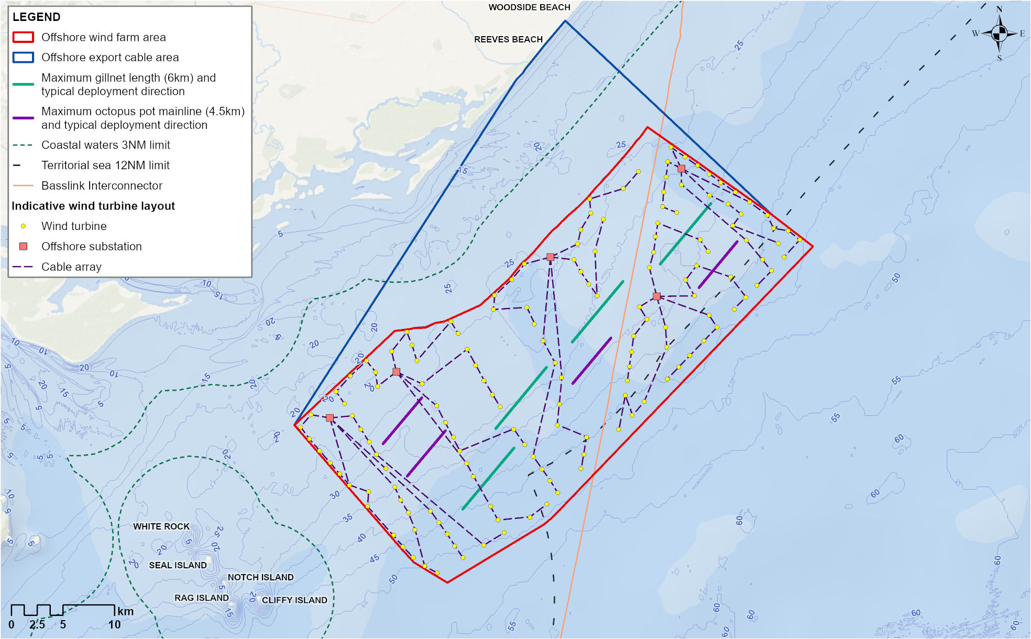
Before mitigations, initial impacts to commercial fishers using restrictive fishing methods range from negligible to moderate (refer Table 15-9).
Commercial fishers using unrestrictive fishing methods are typically more flexible and agile in their operations and so are less likely to experience challenges fishing amongst installed infrastructure during the operations phase. Likewise charter and recreational fishers use fishing methods that are safe to deploy within the offshore wind farm.
Before mitigations, initial impacts to commercial fishers using unrestrictive fishing methods and to charter and recreational fishers are negligible (refer Table 15-9).

Mitigation
Subsea cables will be buried (EMI-M01) and monitoring of the burial depth (MEMP-M09) will ensure that cables remain buried to avoid entanglement and damage to the cable. A lost gear claims process for commercial fishers will be in place throughout the operation phase to help manage any accidental hook ups with gear.
The following initial mitigation measures will assist fishers to navigate the wind farm safely and to make informed decisions about whether it is safe to fish in certain areas of the offshore project area:
- A comprehensive Communications and Stakeholder Engagement Plan will be implemented to keep fishers informed about operation and maintenance activities and any possible hazards so they can plan accordingly (OFF-M22), including the distribution of Notice to Mariners (OFF-M10) and other communications
- Safety zones and/or protection zones will be applied if required to protect the safety of workers and other marine users during major maintenance activities and/or around any eligible infrastructure that may present a hazard during operations (OFF-M03)
- Charting of the final wind farm layout on navigational charts will provide accurate information about the location of installed infrastructure (SNV-M09).
The coexistence hierarchy (refer Section 15.6.2) will be applied. Compensation (CRF-M08) will be available for any commercial fishers with a genuine claim who find they are unable (following detailed consultation and exploration of potential mitigations) to continue fishing within all or parts of the operating offshore wind farm area. Star of the South’s commitment to compensation is outlined in Appendix C to Technical Report N – Commercial and Recreational Fisheries.
Ongoing opportunities for work on the project (CRF-M09), such as supporting ongoing environmental monitoring and surveys, may also provide an alternative or additional source of income for commercial fishers during the operation phase, subject to vessel and safety standards.

Residual impact
With mitigation measures in place, residual impacts to all groups are negligible, as shown in Table 15-9.
Table 15-9 Residual impact from physical presence of maintenance vessels and project infrastructure
Potential Impact | Receptor | Receptor sensitivity | Magnitude | Initial Consequence | Mitigation | Final Consequence
Loss of fishing ground | Commercial fishers (using restrictive methods) | Medium | Medium | Moderate (C) | CRF-M09  CRF-M08 | Negligible (E)
Loss of fishing ground | Commercial fishers (using non-restrictive methods) | Low | Negligible | Negligible (E) | CRF-M09  CRF-M08 | Negligible (E)
Loss of fishing ground | Charter fishing operators | Low | Low | Negligible (E) | CRF-M09  CRF-M08 | Negligible (E)
Loss of fishing ground | Recreational fishers on private vessels | Low | Negligible | Negligible (E) | CRF-M09  CRF-M08 | Negligible (E)
Loss of catch | Commercial fishers (using restrictive methods) | Medium | Low | Minor (D) | CRF-M09  CRF-M08 | Negligible (E)
Loss of catch | All other receptor groups | Low | Negligible | Negligible (E) | CRF-M09  CRF-M08 | Negligible (E)
Increased operating costs | Commercial fishers (using restrictive methods) | Low | Low | Negligible (E) | CRF-M09  CRF-M08 | Negligible (E)
Increased operating costs | All other receptor groups | Low | Negligible | Negligible (E) | CRF-M09  CRF-M08 | Negligible (E)
Displacement to other fishing areas and increased interactions with other fishers | Commercial fishers (using restrictive methods) | Medium | Low | Minor (D) | CRF-M09  CRF-M08 | Negligible (E)
 | Commercial fishers (using non-restrictive methods) | Low | Low | Negligible (E) | CRF-M09  CRF-M08 | Negligible (E)
 | All other receptor groups | Low | Negligible | Negligible (E) | CRF-M09  CRF-M08 | Negligible (E)
Loss of prospectivity (the harvest potential of an area) | Commercial fishers who can legally operate within the offshore wind farm area | Low | Negligible | Negligible (E) | CRF-M09  CRF-M08 | Negligible (E)
Decreased fishing license/quota value | Commercial fishers who can legally operate within the offshore wind farm area | Low | Negligible | Negligible (E) | CRF-M09  CRF-M08 | Negligible (E)

Reduced availability of fish due to habitat modification, power generation and maintenance operations (CRF-I005)

Potential impact
The assessment considers how the project’s operation may affect commercial and recreational fisheries through changes in fish availability, either from habitat modification or from power generation and maintenance operations.
Potential impacts from power generation and maintenance operations are underwater noise from maintenance vessels and electromagnetic fields from cables buried in or covered on the seabed. Chapter 10 – Fish and Invertebrates finds that impacts during operations would be negligible to minor, as effects would be highly localised and limited to the behaviour of individual fish near the vessels or cable.
Habitat modification is also expected to be minimal. Only 0.06 per cent of the project area will be permanently modified from soft sediment to hard substrate. While this may affect species that prefer soft seabeds, vast areas of soft habitat will remain available both within and surrounding the offshore project area. There is also potential for the presence of hard substrate to have an ‘artificial reef effect’ resulting in greater abundance of many fish species targeted by commercial and recreational fisheries, which may benefit some fishers.
Artificial reef effect
Refers to the way offshore wind turbine foundations and associated infrastructure (such as scour protection) can act like artificial reefs, creating hard surfaces that attract marine life.
As a result, some fishers may benefit from increased fish aggregation around infrastructure, while others targeting soft-sediment species may experience reduced catch. Initial consequences for both fish and fisheries receptors are expected to be negligible to minor (Table 15-10) given the presence of alternative fishing areas with soft-sediment habitats.

Mitigation and monitoring
The effects of this impact on commercial fishing will be minimised through mitigation measures proposed for CRF-I004 (refer Section 15.8.2.1), being compensation (CRF-M08) and ongoing opportunities for work on the project (CRF-M09).
A monitoring program proposed for fish assemblages (MEMP-M07, see Chapter 10 – Fish and Invertebrates) will provide greater confidence in the predictions of negligible consequence for commercially and recreationally important fish species.

Residual impact
With the implementation of mitigation measures and monitoring, residual consequences for all fishery receptors is negligible (Table 15-10).
Table 15-10 Residual impact ranking from reduced availability of fish due to habitat modification, power generation and maintenance operations for commercial and recreational fishers.
Potential Impact | Receptor  Group | Receptor sensitivity | Magnitude | Initial consequence | Mitigation | Residual Consequence
Loss of catch | Commercial fishers (using restrictive methods) | Medium | Low | Minor | CRF-M08  CRF-M09 | Negligible
Loss of catch | All other receptor groups | Negligible | Low | Negligible | CRF-M08  CRF-M09 | Negligible
Displacement to other fishing areas and increased interactions with other fishers | Commercial fishers (using restrictive methods) | Medium | Low | Minor | CRF-M08  CRF-M09 | Negligible
 | All other receptor groups | Low | Low | Negligible | CRF-M08  CRF-M09 | Negligible

Increased commercial and/or recreational fishing interest (CRF-I006)

Potential impact
The assessment considers how a potential increase in fish abundance driven by the presence of project infrastructure could attract more fishers to the offshore project area.
Theoretically, increased fishing interest could result in reduced opportunities for recreational and charter operators through boat ramp congestion, loss of catch, increased interactions among fishers and displacement to other fishing areas. As this group is generally flexible in where they fish and as most recreational vessels have range and weather limitations that naturally limit overlap with the offshore wind farm and commercial fishing grounds, any impact is expected to be minor (Table 15-11).
Commercial fishers, although historically active at low levels in the offshore project area, are more sensitive to increased competition. Greater fishing interest could lead to increased interactions with other fishers (commercial, charter or recreational) or displacement, representing a medium magnitude impact and a moderate initial consequence for this group (Table 15-11) if the impact did materialise.

Mitigation
The effects of this impact on commercial fishing will be minimised through mitigation measures proposed for CRF-I004 (refer Section 15.8.2.1), being compensation for displacement (CRF-M08) and ongoing opportunities for work on the project (CRF-M09).

Residual risk
With the implementation of mitigation measures, residual consequences for all fishery receptors is negligible (Table 15-11).

Table 15-11 Residual impact from increased commercial and/or recreational fishing interest during the operation phase
Potential Impact | Receptor  Group | Receptor sensitivity | Magnitude | Initial consequence | Mitigation | Residual Consequence
Reduced fishing capacity of recreational fishers and charter fishing operators due to boat ramp congestion | All receptor groups | Low | Low | Negligible | CRF-M08  CRF-M09 | Negligible
Loss of catch | Commercial fishers | Medium | Low | Minor | CRF-M08  CRF-M09 | Negligible
Loss of catch | All other receptor groups | Low | Low | Negligible | CRF-M08  CRF-M09 | Negligible
Increased interactions among marine users within the offshore wind farm area | Commercial fishers | Medium | Medium | Moderate | CRF-M08  CRF-M09 | Negligible
 | All other receptor groups | Low | Low | Negligible | CRF-M08  CRF-M09 | Negligible
Displacement to other fishing areas | Commercial fishers | Medium | Medium | Moderate | CRF-M08  CRF-M09 | Negligible
Displacement to other fishing areas | All other receptor groups | Low | Low | Negligible | CRF-M08  CRF-M09 | Negligible

Potential risks
All potential risks commercial and recreational fisheries that could arise from the project’s operation phase have a risk rating of either low or very low. These risks include:
- Hydrocarbon release from collision of a project vessel (CRF-R003)
- Hydrocarbon release from collision of a project vessel on substations (CRF-R004)
- Introduction and establishment of invasive marine species (CRF-R005).

Hydrocarbon release from collision of a project vessel (CRF-R003)
The assessment of a hydrocarbon release from the collision of a project vessel during the operation phase has been conservatively assessed as the same as during construction, although the likelihood of occurrence is even more rare considering vessels will generally be fewer in number and more manoeuvrable than construction vessels. See Section 15.7.3.1 and Table 15-7 for the assessment.

Hydrocarbon release from collision of a project vessel on substations (CRF-R004)

Potential risk
The assessment considers a hydrocarbon release from the collision of a project vessel with a substation as a potential risk to commercial and recreational fisheries. Hydrocarbon release modelling indicates that, for the type and maximum quantity of hydrocarbons that would be involved in a substation collision, the extent and duration of such an event would be localised and short-term.

Mitigation
Mitigations will be implemented to regulate vessel activity, ensure compliance with maritime legislation (VES-M01, VES-M04 and SNV-M05) and enable rapid and effective response to a hydrocarbon release if it were to occur (SPL-M02).

Residual risk
With mitigations in place, residual risk for all fisheries receptor groups is very low (Table 15-12).
Table 15-12 Consequence, likelihood and residual risk ranking for hydrocarbon release due to collision of a project vessel on substations
Potential Risk | Receptor  Group | Receptor sensitivity | Initial consequence | Initial likelihood | Initial risk ranking | Mitigation | Residual risk ranking
Hydrocarbon release from collision of a project vessel on substations | Commercial fishers | Medium | Minor | Rare | Very Low | - | Very Low
 | Recreational fishers on private vessels | Low | Minor | Rare | Very Low | - | Very Low
 | Charter fishing operators | Low | Minor | Rare | Very Low | - | Very Low

Introduction and establishment of invasive marine species (CRF-R005)
Risks relating to the introduction and establishment of invasive marine species during the operation phase has been conservatively assessed as the same as during construction, although there is a significantly lower likelihood of occurrence because of the locally sourced, smaller and less frequent vessels used during operations. See Section 15.7.3.2 and Table 15-8 for the assessment.

Decommissioning assessment

Potential impacts and risks
The decommissioning activities are conservatively assumed to impact the same receptors at the same or lesser magnitude and scale as construction operations.
A Marine Decommissioning Management Plan (DEC-M01) will be developed prior to decommissioning to assess the potential impacts from the final agreed methodologies of removing offshore infrastructure.

Cumulative Impacts
This section provides an assessment of the potential for cumulative impacts of the project with other proposed developments in the region. The method to consider cumulative impacts is described in Chapter 6 – Assessment Framework.
Potential cumulative impacts arise when the effects of a single project on a receptor are considered alongside the effects of other projects on the same receptor. Projects that are operational are part of the baseline environment, and the cumulative impact assessment focuses on future developments following the tiered assessment methodology.
Based on the screening process, one project (Great Eastern Offshore Wind) was short-listed for assessment of cumulative impacts on commercial and recreational fisheries and are summarised in Table 15-13.
The cumulative impacts of the project and Great Eastern Offshore Wind are predicted to be negligible for fisheries following the application of defined initial and final mitigation measures. These mitigation measures are particularly important for commercial fishers using restrictive fishing methods as they may be more sensitive to cumulative impacts if multiple offshore wind farms are established in the Gippsland area.
Table 15-13 Summary of cumulative impact assessment for commercial and recreational fishing
Project | Project Description | Findings of Assessment
Great Eastern Offshore Wind project by Corio Generation | The Great Eastern Offshore Wind project is a referred offshore wind farm located 24 km off the coast, adjacent to and offshore of the Star of the South offshore wind farm area.  Potential landfall areas are still being considered.  Up to 172 fixed foundation wind turbines, eight offshore sub-stations and associated infrastructure in operation, generating up to 2.5 GW of electricity.  Construction is proposed from 2028 and operations from 2032. | Based on available EPBC Act referral documents (2024/10088) potential impacts for cumulative impact assessment on commercial and recreational fishing receptor groups include:  - Five Commonwealth and eight state-managed fisheries have been active at some level in the vicinity of the Great Eastern Offshore Wind Farm project area between 2003- 2022. The available data indicates only low fishing intensity/effort by these fisheries in the area, except for the Shark Gillnet Subsector of the SESSF. With this fishery the site overlaps an area of ‘high’ fishing intensity, the offshore cable envelope overlaps with a small area of ‘high’ fishing intensity and a large portion of ‘medium’ fishing intensity, and the nearshore cable enveloped overlaps with an area of ‘low’ fishing intensity. Referral documents also state that recreational fishing occurs within the offshore wind farm site and cable envelopes.  - Referral documents describe the following preliminary assessment of potential impacts on fisheries/fishers by the Great Eastern project:  - Various impacts to fish including those targeted by fishers (seabed disturbance, loss of habitat, underwater noise emissions during the construction and operation phases, electromagnetic field emissions from cables during the operation phase, discharge of sewage and food waste by project vessels during all project phases, and light emissions from project vessels during all project phases). As assessed in Technical Report C – Fish and Invertebrates, for no species are there predicted to be significant population-level impacts resulting from the cumulative effect of impacts from Star of the South and other projects.  - Physical presence of project infrastructure at sea (construction, operation and decommissioning phases).  - Physical presence of project vessels (construction, operation and decommissioning phases).  - Artificial habitat creation (foundations, scour protection) (construction and operation).  - Unplanned event – introduction of invasive marine species (biofouling, ballast water) (construction, operation and decommissioning).  - Unplanned event – dropped objects and waste from vessels (construction, operation and decommissioning).  - Unplanned event – fuel/chemical spills (e.g. minor deck spill, refuelling spill, or vessel collision resulting in a major spill incident) (construction, operation and decommissioning).  The assessment of potential adverse cumulative impacts assumes that none will occur for impacts predicted to have a negligible final consequence level for the project. It is assumed that the Great Eastern project would apply similar mitigations to those proposed by Star of the South, given the projects are of a similar type and scale.

Summary of mitigation, monitoring and contingency measures

Mitigation measures
This section outlines the mitigation measures to avoid and minimise impacts on commercial and recreational fisheries within the project area.
The focus of these mitigation measures is:
- Avoiding impacts where possible
- Developing, preparing and implementing project-specific measures to minimise impacts.
The mitigations listed in Table 15-14 have been developed for the impacts and risks discussed in this chapter and Technical Report N – Commercial and Recreational Fisheries and for inter-related matters such as fish and benthic ecology. Detailed descriptions of each measure can be found in Chapter 23 – Commonwealth Environmental Management Framework.
Table 15-14 Summary of mitigation measures relevant to fish and invertebrates
ID | Mitigation measure
OFF-M03 | Demarcation areas
OFF-M10 | Notice to Mariners
OFF-M12 | Safety and protection zones
OFF-M22 | Stakeholder consultation
EMI-M01 | Depth of cable burial
VES-M01 | Vessel operations framework
VES-M04 | Vessel movement controls
VES-M05 | Vessel biosecurity controls
VES-M03 | Marine coordination centre
SPL-M02 | Spill Response Plan
SPL-M03 | Maintenance of offshore substation transformers
SNV-M09 | Charting of final layout on navigational charts
CRF-M08 | Compensation for impacted commercial fishers
CRF-M09 | Opportunities for work on the project
DEC-M01 | Marine Decommissioning Management Plan

Monitoring and contingency measures
The monitoring and contingency measures that are proposed to assess potential impacts on commercial and recreational fisheries by the project are described in Table 15-15. Further detailed regarding these monitoring measures can be found in Chapter 23 – Commonwealth Environmental Management Framework.
Table 15-15 Monitoring and contingency measures relevant to commercial and recreational fishing
ID | Monitoring measure and description
MEMP-M09 | Cable Burial survey and monitoring

Conclusion
Potential impacts on commercial, recreational and charter fisheries have been assessed for the construction, operation and decommissioning phases of the project.
The potential impacts relate to the physical presence of project vessels and infrastructure, changes in fish availability, habitat modification and potential increases in fishing interest within the offshore wind farm area. Two potential risk pathways for potential accidents were also assessed, relating to hydrocarbon release from a vessel collision and the introduction of invasive marine species.
Initial mitigation measures are expected to reduce the residual impacts on fisheries to negligible or minor levels for most project activities. These mitigations include stakeholder notification of project activities, management of project vessel activities, and restricted access of third-party vessels to construction areas and project infrastructure, amongst others.
Potential impacts from the presence of project infrastructure, which were initially assessed as having moderate consequences for commercial fishers using restrictive fishing methods, will be managed through efforts to achieve coexistence, and the provision of compensation in the event that this is not safe or practical. Opportunities for commercial fishers to participate in project work, particularly in the construction phase, will also be made available.
With these mitigation measures in place, the assessment found that overall residual impacts on fishers are negligible to minor, and residual risks are low to very low, consistent with the assessment criteria.
The cumulative impacts of the project and Great Eastern Offshore Wind were assessed to be negligible.
Overall, findings of these assessments confirm the impacts and risks are acceptable and meet the assessment criteria and EIS guidelines.

