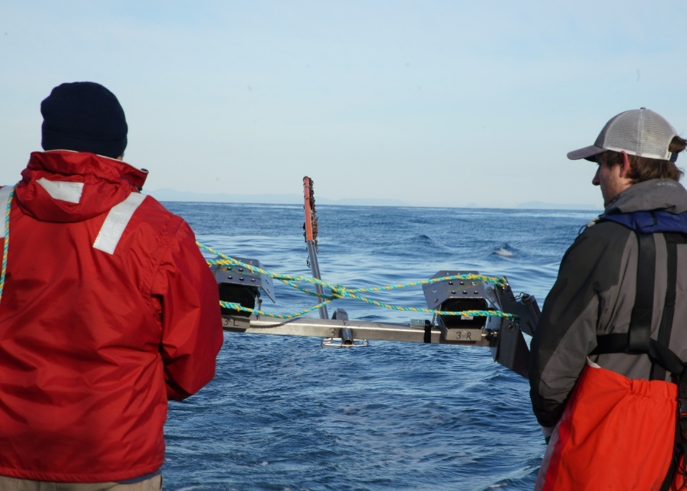

Commonwealth Environmental Impact Statement
Chapter 16 – Infrastructure and co-existence with other users
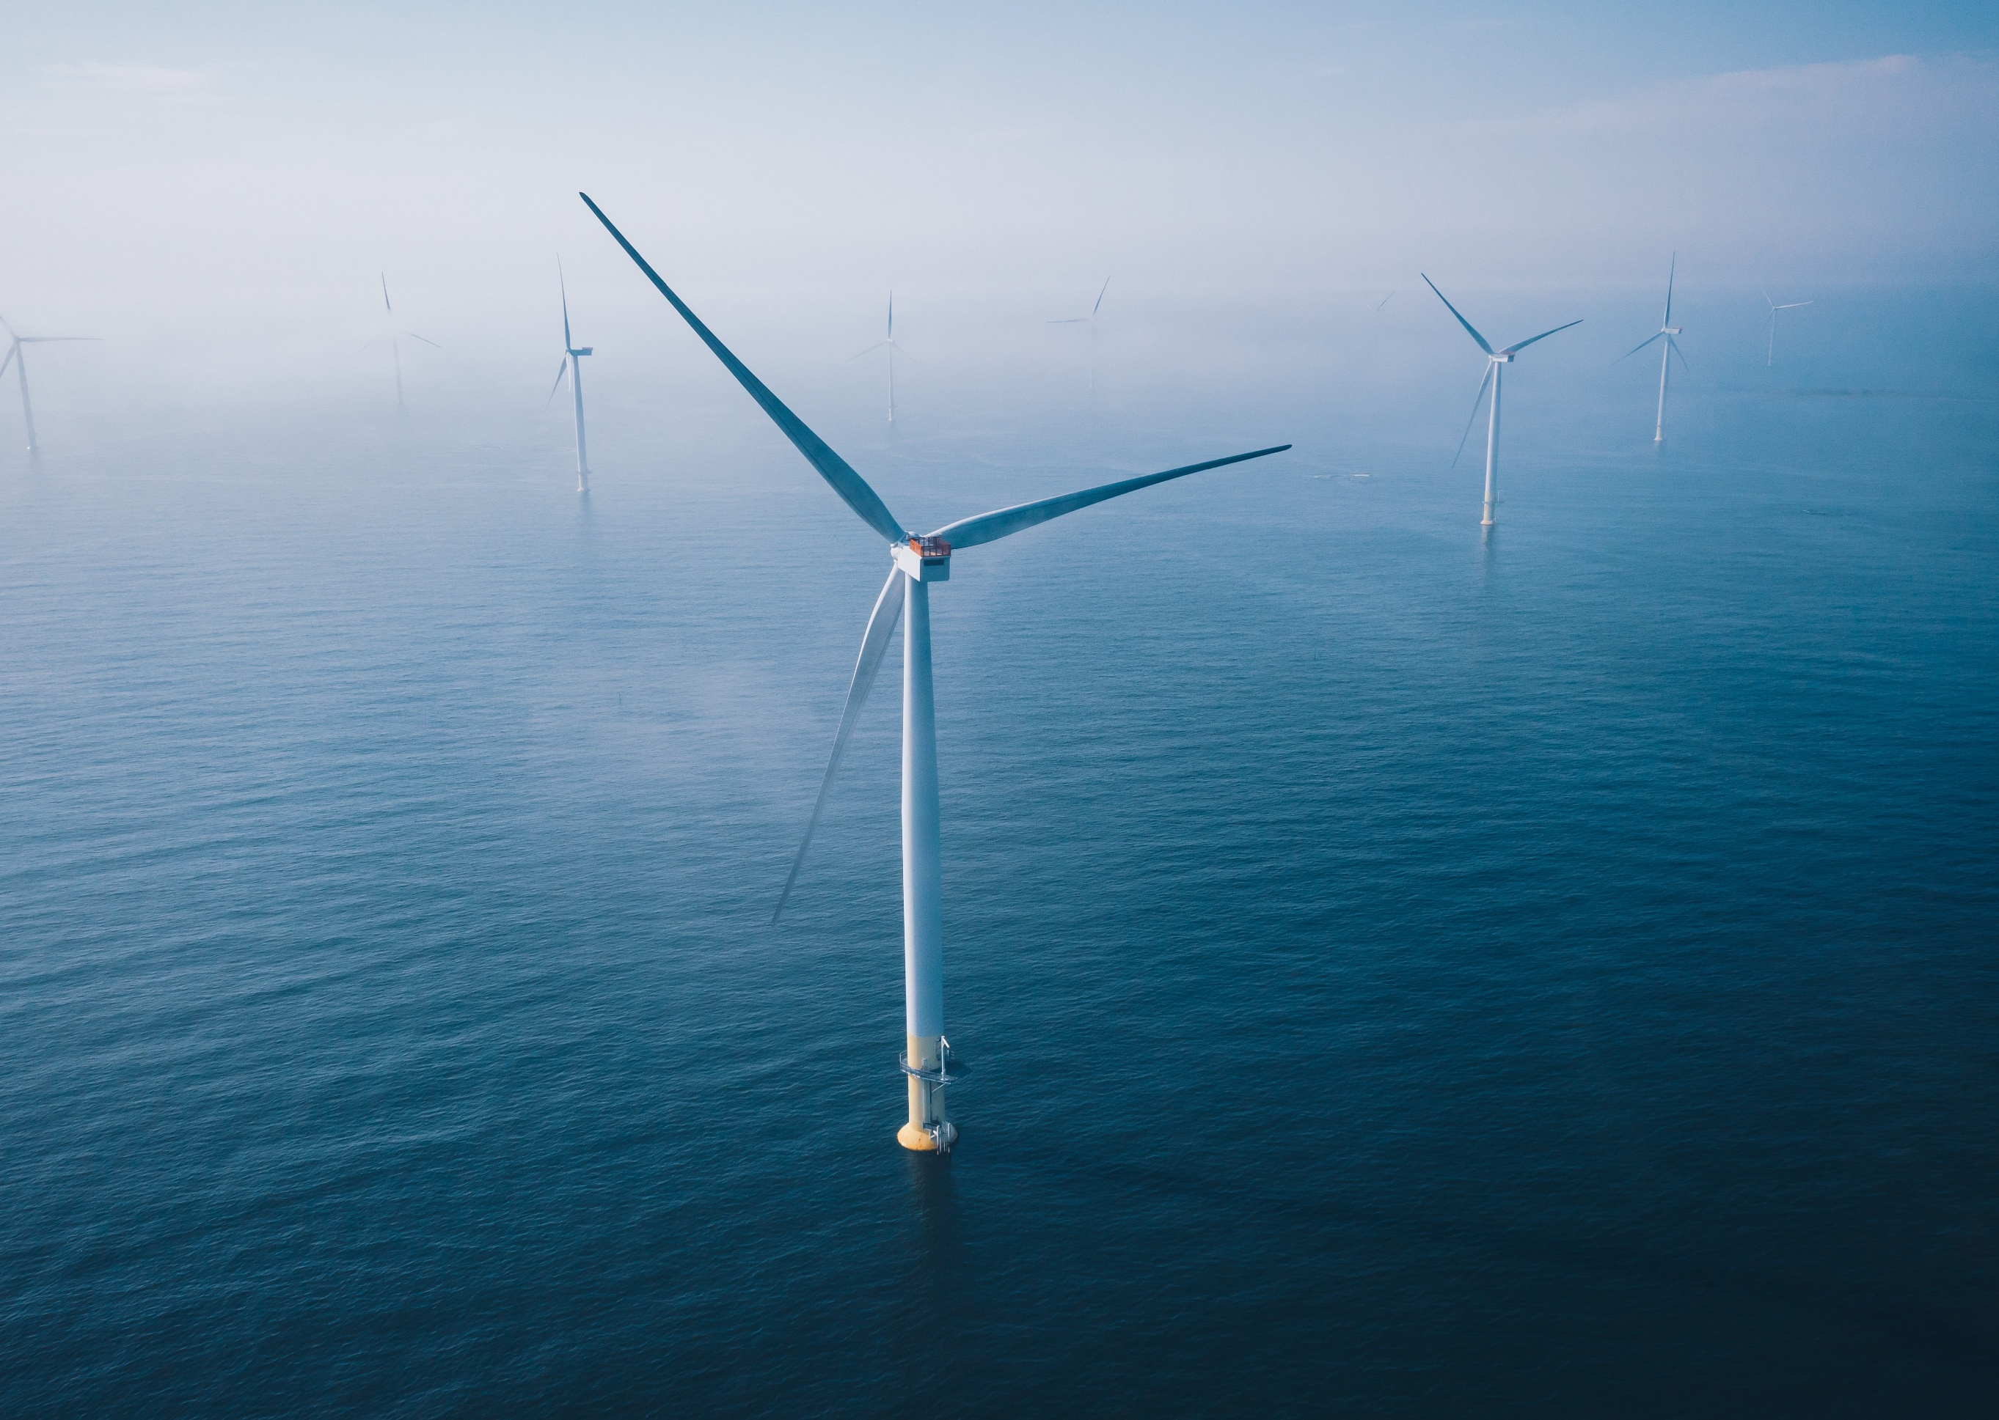
Table of Contents
Chapter 16 Infrastructure and co-existence with other users 16-1
16.1 Introduction 16-1
16.2 Assessment scope 16-2
16.2.1 Commonwealth matters 16-2
16.3 Evaluation framework 16-3
16.3.1 Key legislation, policy, guidelines and standards 16-3
16.3.2 Assessment criteria 16-3
16.4 Methods 16-5
16.5 Existing environment 16-6
16.5.1 Aviation 16-8
16.5.2 Radar 16-12
16.5.3 Other users 16-15
16.6 Construction impacts 16-17
16.6.1 Key impacts 16-17
16.6.2 Other impacts 16-17
16.6.3 Potential risks 16-22
16.7 Operation impacts 16-23
16.7.1 Key impacts 16-23
16.7.2 Other impacts 16-24
16.7.3 Potential risks 16-26
16.8 Decommissioning impacts 16-27
16.8.1 Potential impacts and risks 16-27
16.9 Cumulative impact assessment 16-28
16.10 Summary of mitigation, monitoring and contingency measures 16-30
16.10.1 Mitigation measures 16-30
16.10.2 Monitoring and contingency measures 16-31
16.11 Conclusion 16-32

Figures
Figure 16-1 Infrastructure and other users study areas 16-7
Figure 16-2 Aerodromes in the vicinity of the offshore project area 16-9
Figure 16-3 Grid areas overlapping with the offshore wind farm area and associated LSALT 16-11
Figure 16-4 Civil and Defence surveillance radar and meteorological radar installations 16-13

Tables
Table 16-1 Key legislation, policy, guidelines and standards 16-3
Table 16-2 Petroleum permits that overlap the offshore project area 16-15
Table 16-3 Residual impacts from underwater noise on divers during the construction phase 16-18
Table 16-4 Residual impacts from underwater noise on data quality during the construction phase 16-19
Table 16-5 Residual impacts from displacement of or interaction with non-project vessels during the construction phase 16-20
Table 16-6 Residual impacts from interference with submarine power cables during the construction phase 16-21
Table 16-7 Airspace features over the offshore project area infringed by project infrastructure 16-21
Table 16-8 Residual impacts from the displacement of or interaction with aircraft during the construction phase 16-22
Table 16-9 Residual impacts from the presence of turbines on radar, communications and meteorological equipment during the operation phase 16-24
Table 16-10 Residual impacts from the displacement of or interaction with non-project vessels during the operation phase 16-25
Table 16-11 Residual impacts from interference with submarine power cables during the operation phase 16-26
Table 16-12 Projects assessed for cumulative impacts on infrastructure and other users 16-28
Table 16-13 Mitigation measures relevant to infrastructure and other users 16-30
Table 16-14 Monitoring and contingency measures relevant to infrastructure and other users 16-31

Infrastructure and co-existence with other users

Introduction
This chapter summarises the potential impacts on infrastructure and other users due to the construction, operation and decommissioning of the Star of the South Offshore Wind Farm Project (the project). The chapter describes how impacts will be avoided, minimised or managed.
The chapter describes the potential impacts and risks to socio-economic values within the offshore project area as it is located within the Commonwealth Marine Area. These values include aviation, radar, communications systems, the petroleum industry (exploration, production, diving and related vessel activities), submarine power cables and research.
Shipping and navigation (specific to vessel movements) and commercial and recreational fisheries are addressed separately so are not included in this chapter.
This chapter is based on the impact assessment presented in Technical Report O – Infrastructure and Co-Existence with Other Users.
Other chapters and modelling that relate to or inform the infrastructure and co-existence with other users assessment include:
Chapter 15 - Commercial and Recreational Fisheries
Chapter 17 – Shipping and Navigation
Attachment II – Consultation Report
Technical Report Attachment I – Underwater Noise Modelling

Assessment scope
The objective for infrastructure and co-existence with other users is to identify the existing conditions and assess, avoid and minimise adverse impacts and risks during the construction, operation and decommissioning of the project.
All detailed technical methodologies and assessment on infrastructure and other users can be found in Technical Report O – Infrastructure and Co-Existence with Other Users.

Commonwealth matters
The project's EIS guidelines inform the preparation of the EIS to enable the Commonwealth Minister for the Environment to make an informed decision on whether to approve the project under the EPBC Act.
The aspects of the EIS guidelines directly relevant to infrastructure and other users are:
- Section 2.5 – Description of the environment, particularly historical and existing anthropogenic uses of the project site
- 2.7 (k) The extent, intensity and duration of impacts of the action on existing users of the marine environment (e.g. … commercial and defence aircraft).
Further information about the EIS guidelines is listed in Attachment V – EIS Guidelines Checklist.

Evaluation framework

Key legislation, policy, guidelines and standards
Table 16-1 lists the key legislation, policy, guidelines and standards relevant to infrastructure and other users. Refer to Chapter 5 – Commonwealth Legislative Framework and Technical Report O – Infrastructure and Co-Existence with Other Users for further details.
Table 16-1 Key legislation, policy, guidelines and standards
Type | Applicable legislation, policy, guideline or standard
Commonwealth Government | Airports Act 1996 (Cth)
Commonwealth Government | Australian Maritime Safety Authority Act 1990 (Cth)
Commonwealth Government | Defence Act 1903 (Cth)
Commonwealth Government | Environment Protection and Biodiversity Conservation Act 1999 (Cth)
Commonwealth Government | Navigation Act 2012 (Cth)
Commonwealth Government | Offshore Electricity Infrastructure Act 2021 (Cth)
Commonwealth Government | Offshore renewable energy infrastructure policy 2024 (Cth)
Commonwealth Government | Protection of the Sea (Prevention of Pollution from Ships) Act 1983 (Cth)
Commonwealth Government | Sea Installations Act 1987 (Cth)
Guidelines | Civil Aviation Safety Regulations, Part 139 Manual of Standards – Aerodromes, Chapter 11
Guidelines | National Airports Safeguarding Framework, Guideline D: Managing the Risk of Wind Turbine Farms as Physical Obstacles to Air Navigation (2012)
Guidelines | National Airports Safeguarding Framework, Guideline F: Managing the Risk of Intrusions into the Protected Operational Airspace of Airports (2012)
Guidelines | National Airports Safeguarding Framework, Guideline G: Protecting Aviation Facilities – Communication, Navigation and Surveillance (CNS) (2016)
Guidelines | Department of Transport and Planning (Vic), Planning Guidelines for Development of Wind Energy Facilities, 2023.

Assessment criteria
To assess the project, predicted impacts and risks are compared to criteria that set required environmental performance outcomes (refer to Chapter 6 – Assessment Framework).
The criteria for infrastructure and other users are derived from legislation and policy, relevant standards and guidelines, stakeholder feedback and industry best practice.
The assessment criteria relevant to infrastructure and other users are:
- A divers noise exposure from construction noise due to the project would not:
  - Interfere with diver communications
  - Exceed acceptable noise exposure levels
  - Induce discomfort
  - Place the diver at risk in any other way.
- Interference with other activities is not greater than is reasonably necessary for the completion of the project
- Project vessel activities are compliant with maritime law relating to navigation and safety
- Project aircraft activities are compliant with aviation law relating to navigation and safety.

Methods
The purpose of the offshore infrastructure and coexistence with other users impact assessment is to assess the potential impacts and risks of the project on infrastructure and other users.
Impacts refer to the consequences of planned project actions, which are given a rating determined by combining the magnitude of the impact and the sensitivity of the receptor.
Risks are an unexpected (accidental) event and are determined by combining the likelihood of an event occurring and the consequences that would result if the event were to occur.
The technical chapters consider key impacts and risks with a residual consequence rating of moderate to severe. Other impacts and risks are those with a residual consequence rating of negligible to minor.
Refer to Chapter 6 – Assessment Framework for more detail on how impact and risk ratings are derived.
The infrastructure and other users assessment involved:
- Defining a study area
- Reviewing relevant national, state and local legislation
- Conducting a comprehensive desktop review of all publicly available information sources, including geographic information, system layers of existing infrastructure, seismic and geophysical surveys, online approvals tracking systems and the Department of Defence website for information on restricted areas, to characterise existing conditions and identify sensitive assets, values and uses
- Analysing data from the project's surveys undertaken for other technical study areas, such as aerial and boat ramp surveys for small vessel use of the area
- Consulting more than 20 key agencies and other relevant stakeholders identified during the desktop review, including Commonwealth Government departments and agencies, aviation authorities, petroleum companies, meteorological service providers and research groups – see Technical Report O – Infrastructure and Co-Existence with Other Users for further details
- Drawing on information provided in other project assessments, including:
  - The Aviation Impact Assessment that evaluated potential impacts and risks to aviation safety, airspace use and airport operations (detailed in Technical Report O – Infrastructure and Co-Existence with Other Users)
  - Underwater noise modelling (refer to Technical Report Attachment I – Underwater Noise Modelling), which describes the levels and distances that underwater noise from piling may propagate.

Existing environment
This section describes the existing conditions within the study area as they relate to infrastructure and coexistence with other users. The primary study area comprises the offshore project area, which is the combination of the offshore wind farm area and offshore export cable area (see Figure 16-1). Four wider study areas were also defined to assist in assessing impacts that would occur outside the offshore project area:
- Aviation area, which consists of a 30-kilometre buffer around the offshore wind farm area
- Communication area, which consists of a 15-kilometre buffer around the offshore wind farm area
- Ensonified area, which represents the area where underwater noise from piling operations may be above the human health threshold at any point during construction. See Technical Report Attachment I – Underwater Noise Modelling for more detail
- Transiting vessel area, which consists of the sea surface area through which construction and operation vessels transit from ports used during construction and operations.
Bass Strait hosts numerous industries, infrastructure and other user groups. The groups that form the basis of the existing environment and are the receptor groups for the assessment include aviation, radar and communications systems, the petroleum industry (exploration, production and diving), submarine power cables, research and vessels.

Figure 16-1 Infrastructure and other users study areas
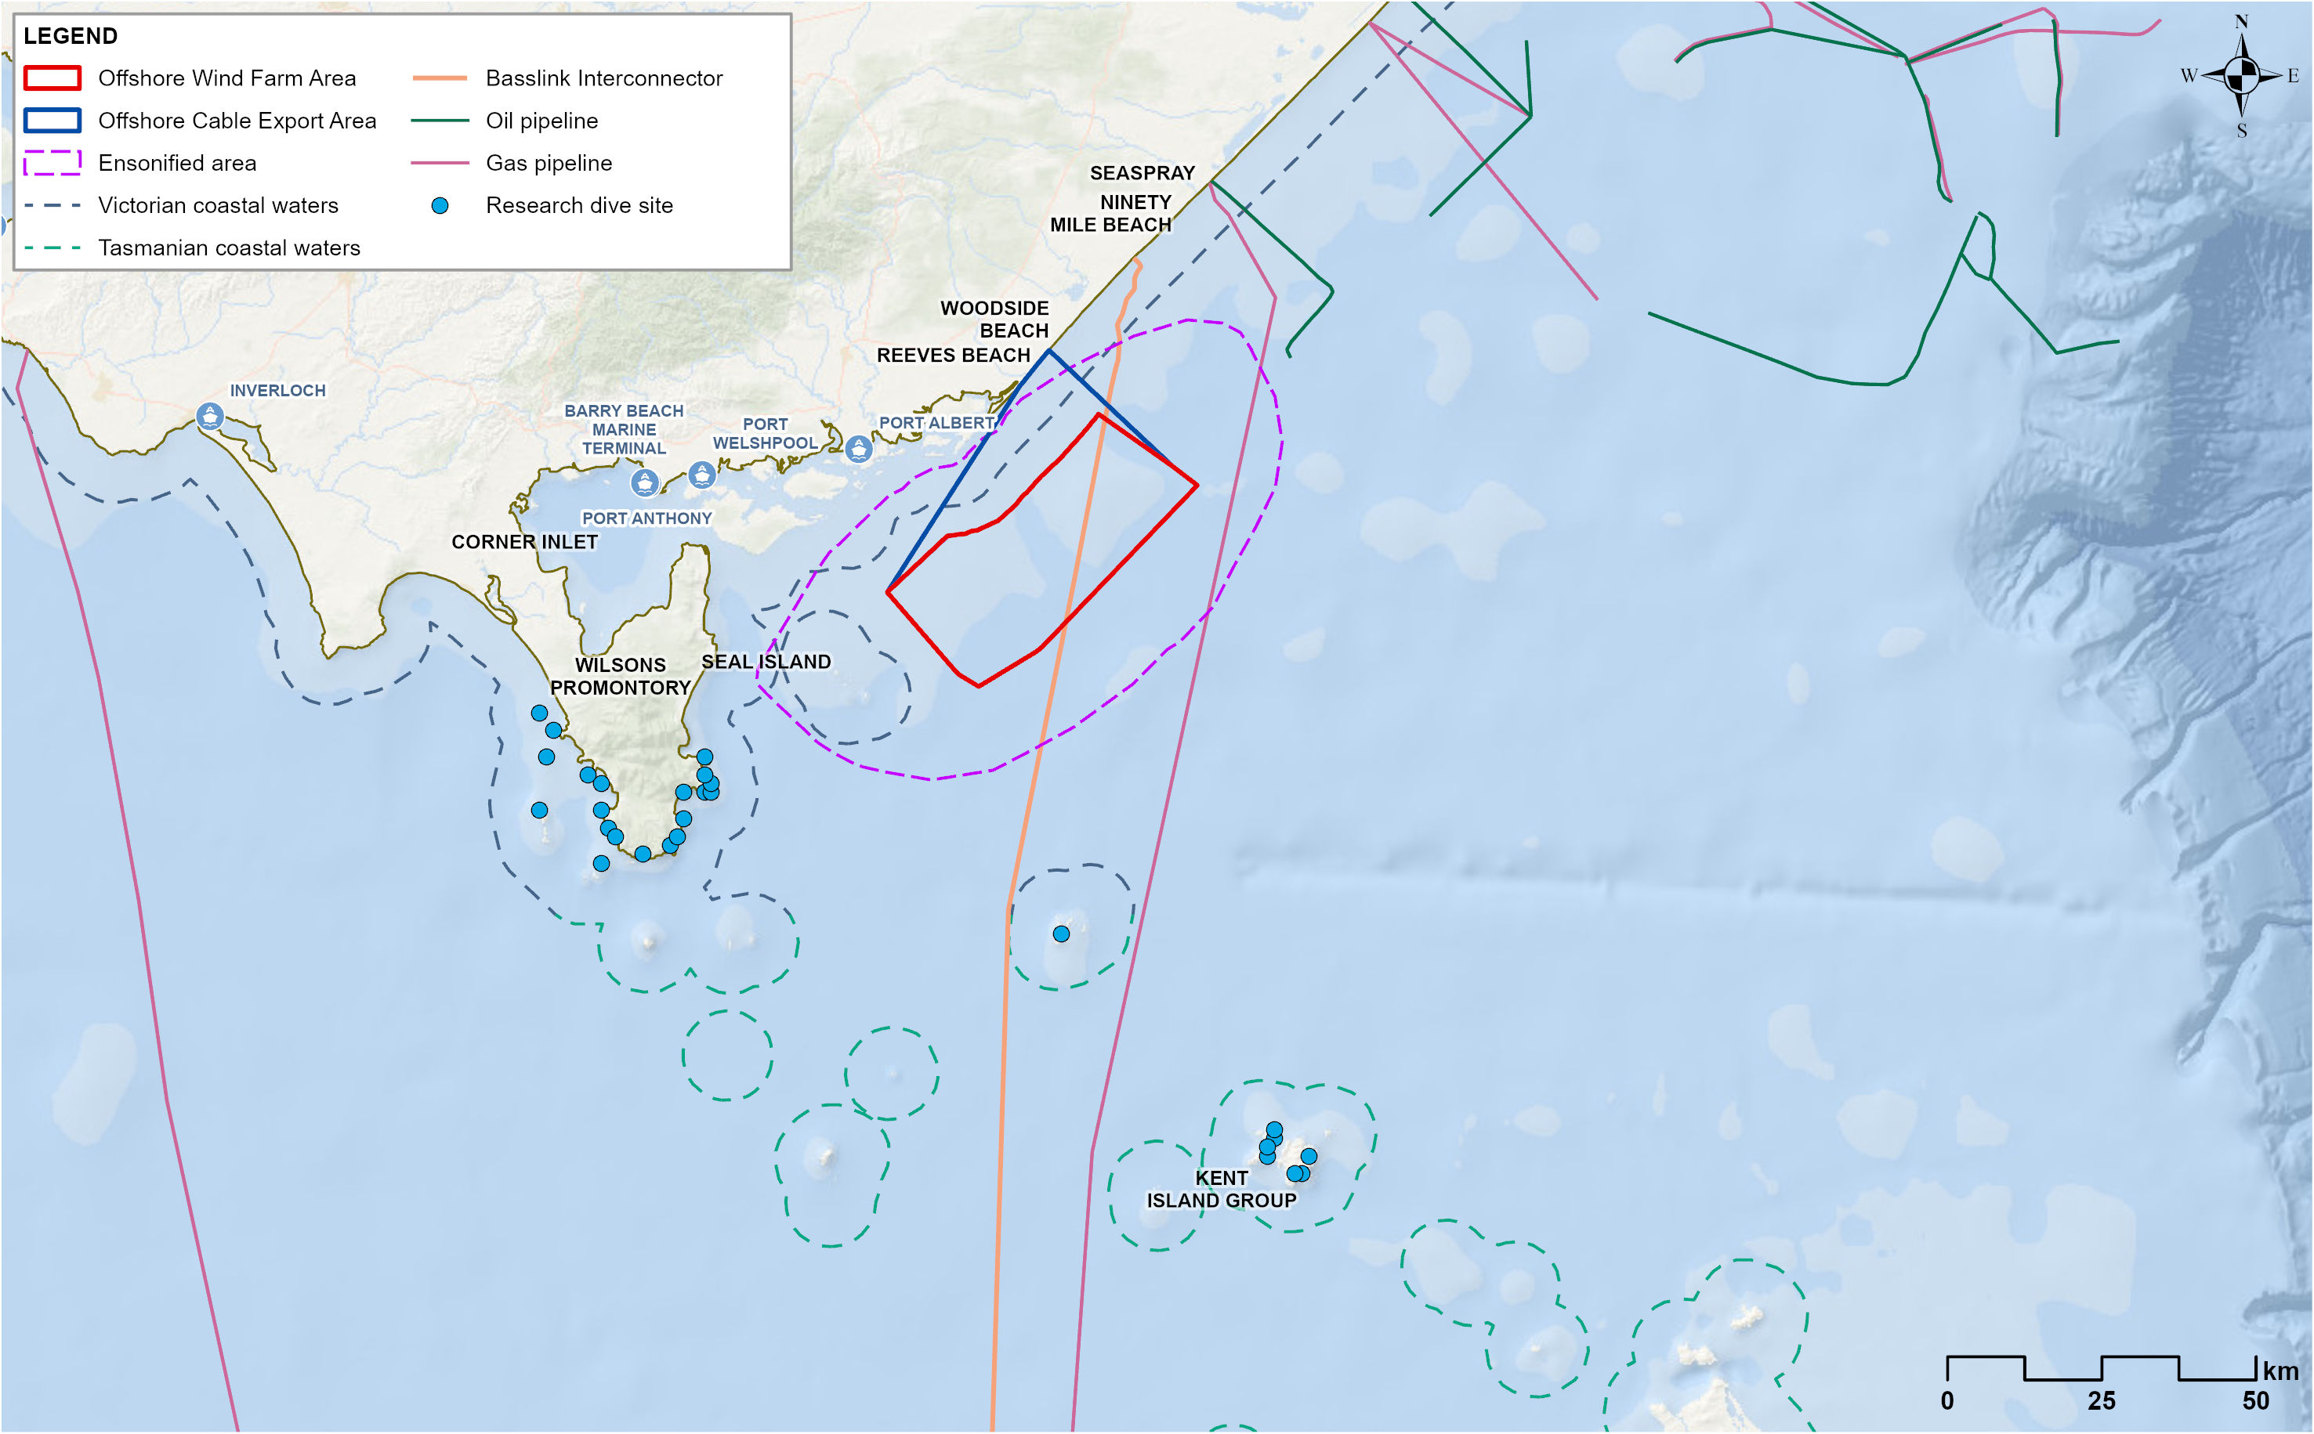

Aviation
This section presents the existing aviation environment above the offshore wind farm area where turbines with a maximum height of 350 metres (1,148 feet) will be located.

Civil
Yarram Registered Aerodrome is a civil aerodrome with one grass and one gravel runway approximately 13 kilometres from the offshore export cable area and 20 kilometres from the offshore wind farm area (Figure 16-2). The Yarram Aerodrome has a registered flight protection area (Procedures for Air Navigation Services – Aircraft Operations (PANS-OPS)) that overlaps a small portion of the offshore wind farm area. The current recommended minimum altitude when over the offshore wind farm area and approaching Yarram for landing is 1,800 feet and an optimal commencement and holding altitude of 2600 feet. As a protection buffer of 984 feet may be required over the small overlapping portion of the offshore wind farm area, turbines (plus the protection buffer) would intrude on the current Yarram approach altitude (approach code RNP RWY 27).
West Sale is a civil aerodrome approximately 59 kilometres from the offshore wind farm area. West Sale is 17 kilometres to the west of RAAF Base East Sale and is encompassed within the military restricted airspace of RAAF Base East Sale.
Helicopter operations for the decommissioning of the Esso Perch and Dolphin oil and gas facilities are not expected to overlap with the construction and operation of the project.

Defence
A lowest safe altitude (LSALT) is the lowest altitude at which it is considered safe to fly within a certain area.
The offshore project area is situated in the South-western Military Controlled Airspace of the RAAF Base East Sale. RAAF Base East Sale is primarily used for training and is located 58 kilometres from the offshore wind farm area (Figure 16-2). The airspace is separated into 16 training areas (A-H and S-Z), each area with a defined LSALT enforced under the Defence Act 1903. The offshore wind farm area is beneath training areas D, E, V and W. Turbines would not infringe the LSALT of D, E and W but would infringe area V which has an LSALT of 700 feet.

Figure 16-2 Aerodromes in the vicinity of the offshore project area
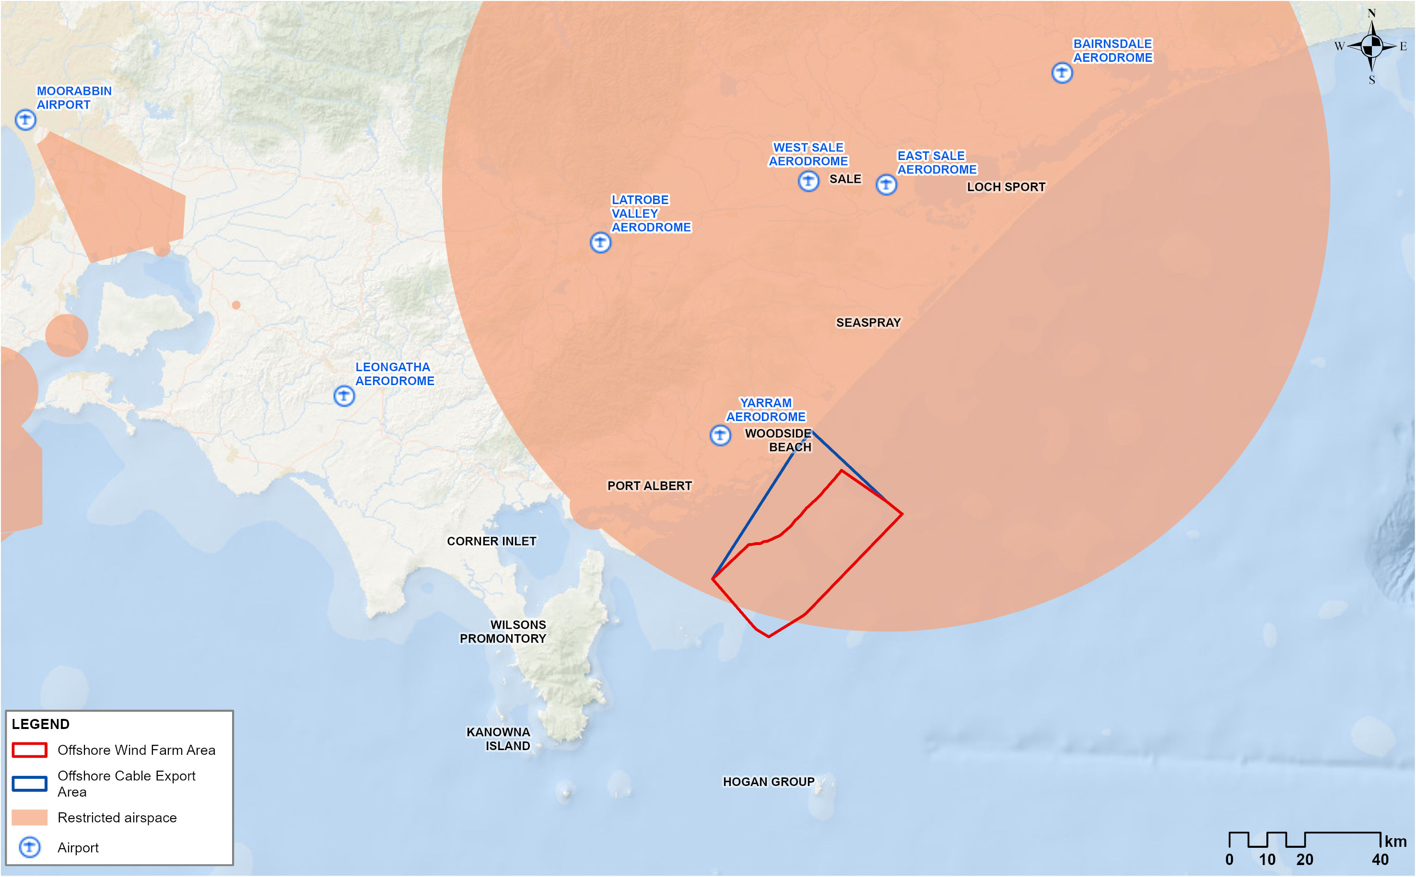

Grid LSALT
A Grid LSALT shows the lowest safe altitude to fly within a certain grid area (a one-degree by one-degree latitude and longitude grid). The Grid LSALT exists so pilots can fly without visual reference to the ground or water and allows for pilots with technical problems to descend to a low level that has a predetermined safety margin over obstacles.
The two grid areas (shown in Figure 16-3) that overlap the offshore wind farm area are:
- Grid West of 147 degree with a Grid LSALT height of 3,900 feet and a protection surface of 2900 feet that maximum turbine height (1,148 feet) would not infringe
- Grid East of 147 degree with a Grid LSALT height of 1900 feet and a protection surface of 900 feet that maximum turbine height (1,148 feet) would therefore infringe.

Figure 16-3 Grid areas overlapping with the offshore wind farm area and associated LSALT
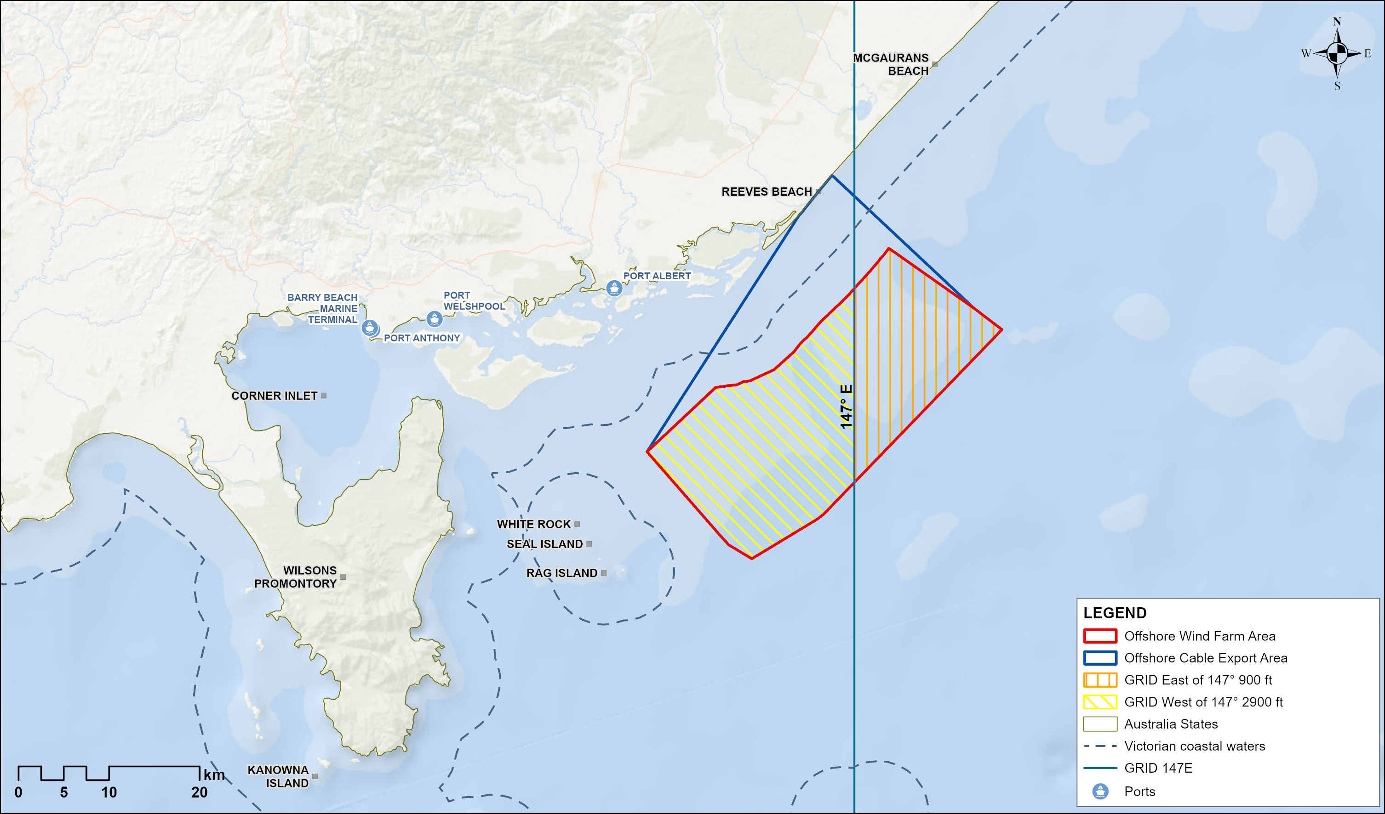

Search and rescue
In addition to civil and defence aviation, search and rescue operations are carried out in the region. These operations are coordinated by several parties, including the Australian Maritime Safety Authority’s Joint Rescue Coordination Centre, Defence’s Headquarters, Joint Operations Command, Safe Transport Victoria, the Australian Volunteer Coast Guard and Victoria Police. Historically, most incidents occurring in Gippsland and the Bass Strait are inshore or within inland waters, such as the Gippsland Lakes. A total of 10 incidents occurred in the offshore wind farm area between 2019 and 2022, all of which involved recreational vessels. During an operational mission, search and rescue aircraft are not constrained by the standard rules of the air, allowing them the flexibility to manoeuvre as required by the situation.

Radar
Communications and radar technology are used by several industries in the area, including aviation (civil and defence), search and rescue operations and meteorological services.

Aviation radar
Australia currently has two air traffic services providers: Airservices Australia and Defence. The airspace over the offshore project area is covered by three air traffic services sites, as shown in Figure 16-4. These include:
- RAAF Base East Sale: The base has a radar with a range of 120 nautical miles
- Mount Tassie Automatic Dependant Surveillance-Broadcast station: At ground level, the station has 20 nautical miles of coverage. At higher levels, coverage can exceed 250 nautical miles
- Gellibrand Hill radar: The Primary Surveillance Radar at this site has a range of 60 nautical miles, while the Secondary Surveillance Radar has a range of 256 nautical miles.
Figure 16-4 Civil and Defence surveillance radar and meteorological radar installations
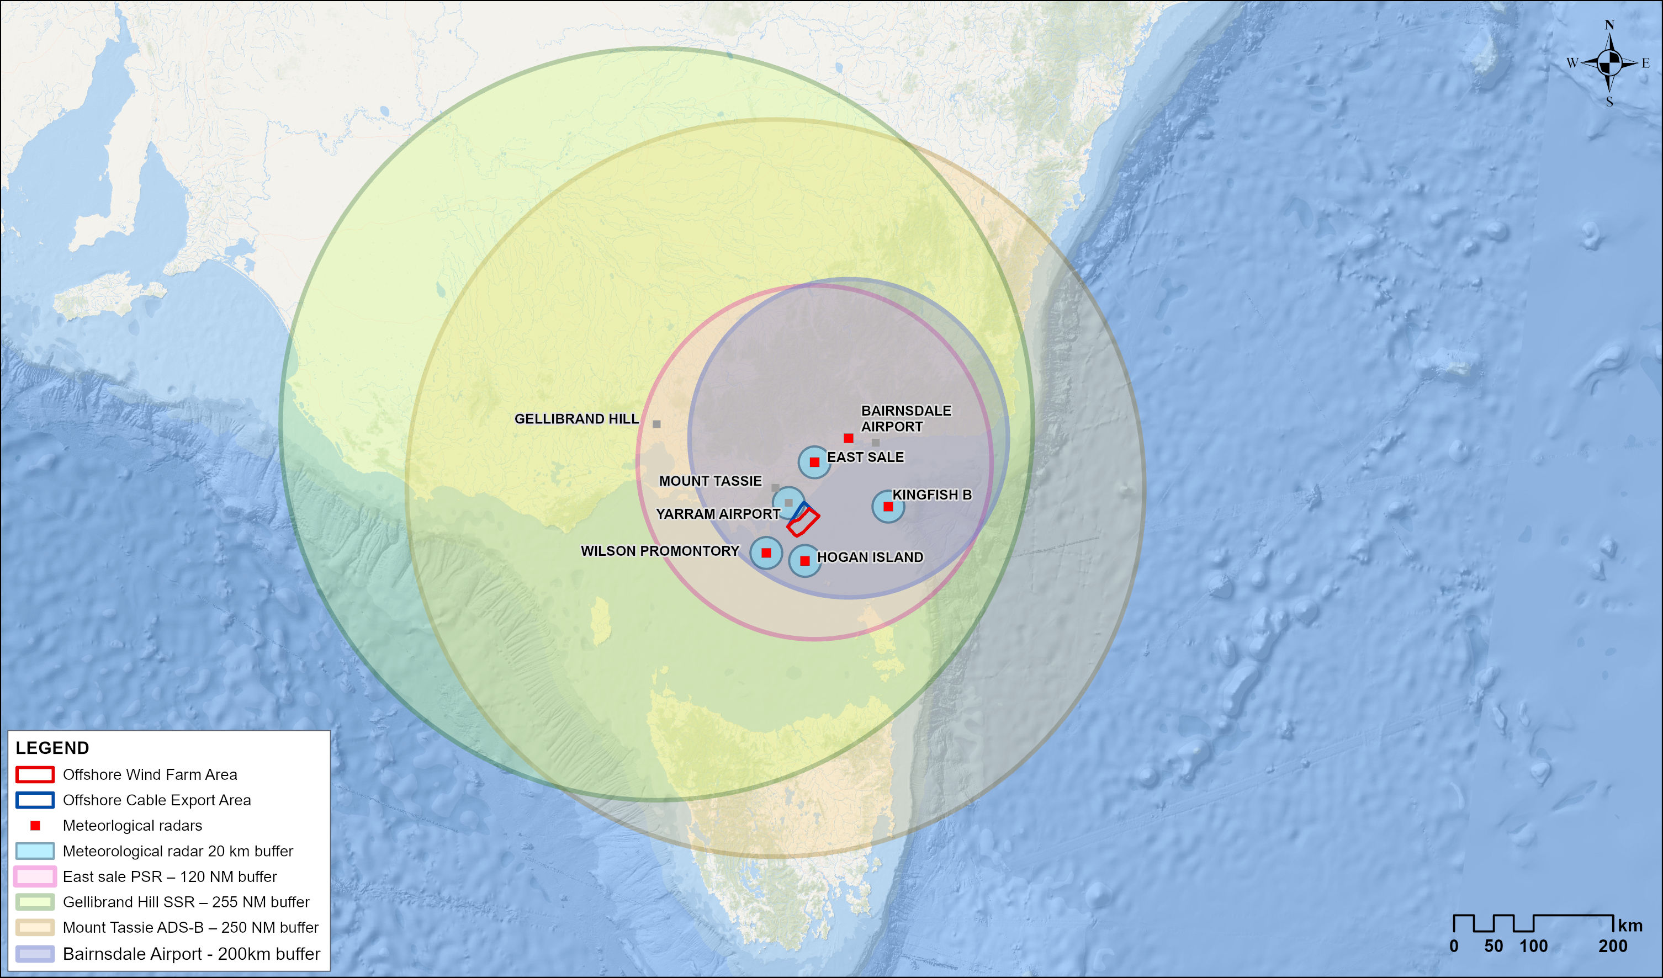

Search and rescue
The radar and communications equipment used by the Joint Rescue Coordination Centre, which co-ordinates marine and aviation search and rescue, includes the COSPAS-SARSAT search and rescue satellite system, which has satellites and ground receiving stations in Queensland and Western Australia.

Weather radar
The Bureau of Meteorology operates network stations across Australia and uses radar instruments for measuring wind speeds in the upper atmosphere (known as “wind finding” radar) and determining rain and storm activity (known as “weather watch” radar).
The closest weather stations to the offshore project area are located at Yarram Airport (20 kilometres away), Wilsons Promontory National Park (43 kilometres away), Hogan Island (36 kilometres away) and Kingfish B (91 kilometres away) (see Figure 16-4).

Petroleum exploration and production
The Gippsland Basin supports a well-established petroleum industry, with multiple petroleum wells found in the region. Most of these wells are operated by Esso Australia Resources, BHP Petroleum, OMV Australia and ExxonMobil.
No active petroleum wells are located within the offshore project area in either Commonwealth or Victorian waters although two abandoned exploration wells are located within the offshore wind farm area. There are several operating offshore platforms within the Gippsland Basin with associated pipelines and subsea facilities which require support vessels to transfer cargo and crew between platforms and from port and underwater maintenance activities that require the use of divers. Several Esso platforms and some Cooper Energy infrastructure are being readied for decommissioning which is expected to take several years to complete.
A single Commonwealth petroleum licence (a greenhouse gas assessment permit) and a single Victorian exploration permit overlap with the offshore project area (see Table 16-2). At least seven gas-condensate prospects have been identified throughout the Gippsland Basin which may attract future petroleum exploration including seismic surveys and exploration wells.
Table 16-2 Petroleum permits that overlap the offshore project area
Title operator | Jurisdiction | Permit type | Permit
The Crown in right of Victoria | Commonwealth | Greenhouse gas assessment permit | G-5-AP
Petro Tech Pty Ltd | Victorian | Exploration permit | VIC/P44(V)

Petroleum maintenance divers
Maintenance divers are required for the operating petroleum platforms. Dive operations are an approved activity under all operations and maintenance environment plans and, therefore, could be undertaken at any time permitted under that environment plan. Maintenance activities described in currently accepted environment plans are generally for one week every two to three years.

Other users

Submarine power cables
The Basslink Interconnector is a 370-kilometre bundled high voltage direct current power cable that connects the power grids of Victoria and Tasmania. It commenced operations in 2009. A 28-kilometre portion of the cable traverses the eastern part of the offshore project area as it travels from its Victorian shore crossing at McGaurans Beach to its landfall in Tasmania (Figure 16-1). Operations and maintenance activities for the Basslink Interconnector in the project area include cable recovery and laying activities from a special-purpose vessel and the potential use of divers.

Vessels
Vessel-based activities, including for petroleum exploration and production, defence, search and rescue operations and submarine power cable infrastructure maintenance, occur regularly within the Gippsland Basin.
Most of the vessels passing through the offshore project area are transiting to or from Barry Beach Marine Terminal and Port Anthony. Both ports experience a low level of vessel traffic due to their small capacity and limited access via Corner Inlet. While there are no designated defence maritime training areas within the project area, defence activities such as the transit of naval vessels, training exercises, hydrographic surveys, surveillance and enforcement and search and rescue operations have the potential to occur in the area.
Vessel activity associated with fishing is addressed in Chapter 15 – Commercial and Recreational Fisheries, and shipping and navigational risk related to vessel activity is addressed in Chapter 17 – Shipping and Navigation.

Research
No permanent scientific research stations are located within the project area. The closest permanent station is in Corner Inlet, which multiple institutions use, including the Department of Energy, Environment and Climate Action (DEECA), the Commonwealth Scientific and Industrial Research Organisation (CSIRO) and several universities.
Other research activities conducted within the offshore project area include those led by the Victorian Fisheries Authority, the Fisheries Research and Development Corporation, the Marine Mammal Foundation and the Integrated Marine Observing System.
Reef Life Survey, a long-term volunteer reef monitoring program, surveys 52 reef sites in the region each year using trained SCUBA divers. These sites do not overlap with the ensonified area of the project (Figure 16-1).

Construction impacts
This section discusses the impacts and risks associated with the project’s construction that relate to infrastructure and other users and the respective receptor groups.

Key impacts
The construction impact assessment identified no impacts on infrastructure and other users receptor groups with an impact rating of moderate or higher once mitigation measures are implemented.

Other impacts
Other potential construction phase impacts with minor to negligible effects on infrastructure and other users once mitigation measures are implemented include:
- Underwater noise impacts to divers (IOU-I01)
- Underwater noise impacts to data quality (IOU-I02)
- Displacement of or interaction with non-project vessels (IOU-I03)
- Interference with submarine power cables (IOU-I04)
- Displacement of or interaction with aircraft (IOU-I05).

Underwater noise impacts to divers (IOU-I01)

Potential impact
Underwater noise emissions generated by pile driving during the construction phase may impact the health and safety of underwater divers. A precautionary ensonified area was modelled based on where underwater noise from piling could be at or above levels that could impact divers and swimmers (see Technical Report Attachment I – Underwater Noise Modelling). The modelled area reaches a maximum of 23 kilometres beyond the offshore wind farm area. No research dive sites are located within the ensonified area; however, portions of subsea pipelines and cables traverse the area.

Mitigation
Importantly, in line with existing principles and guidelines for safe diving (for example, DMAC 12, Safe Diving Distance from Seismic Surveying Operations), pile driving and diving activities would not occur at the same time and place. Further, any piling and diving activities occurring in close proximity would be carefully managed. Lastly, maintenance dives for petroleum production pipelines and submarine power cables are infrequent and only expected to occur over the course of one week every two to three years.

Residual impact
Given the likelihood that diving activities would occur within the ensonified area during impact piling is small, and established industry standards and principles would be used, divers are not expected to be exposed to underwater noise emissions that would exceed acceptable levels. As such, impacts to divers are minor, and no additional mitigation measures have been identified (Table 16-3).
Table 16-3 Residual impacts from underwater noise on divers during the construction phase
Potential impact | Receptor group | Receptor sensitivity | Magnitude | Initial consequence | Mitigation | Residual consequence
Underwater noise impact to divers | Divers that operate within an area that is predicted to receive sound above the identified human health thresholds due to piling | Medium | Low | Minor | - | Minor

Underwater noise impacts to data quality (IOU-I02)

Potential impact
Underwater noise emissions generated by construction activities could impact research that measures or uses sound as a survey technique by reducing the quality or reliability of the data. This includes seismic surveys for petroleum exploration and geophysical surveys for offshore wind project.
At least one seismic or geophysical survey could occur within the region during the project's construction phase.

Mitigation
Consultation with stakeholders prior to and during piling will allow for seismic and geophysical survey operators to pre-plan surveys and conduct in-field survey management (OMU-M10).

Residual impact
It is expected the potential impacts to petroleum exploration and offshore wind activities from underwater noise are negligible (Table 16-4) and no additional mitigation measures have been identified.
Table 16-4 Residual impacts from underwater noise on data quality during the construction phase
Potential impact | Receptor group | Receptor sensitivity | Magnitude | Initial consequence | Mitigation | Residual consequence
Underwater noise impact to data quality | Petroleum exploration and geophysical surveys | Low | Low | Negligible | - | Negligible

Displacement of or interaction with non-project vessels (IOU-I03)

Potential impact
Displacement may occur from demarcation of areas within the offshore wind farm area, the use of safety zones, the presence of project vessels that have restricted ability to manoeuvre and the increasing presence of installed infrastructure as the construction period progresses.
Cable maintenance vessels for the Basslink Interconnector would be the most affected, given that their activities are location-specific; however, only a relatively small section (seven per cent) of the Basslink Interconnector is within the offshore project area. Whilst petroleum exploration and production, and Defence, have a low receptor sensitivity based on their ability to adapt operations during the construction period.

Mitigation
Consultation with the Basslink Interconnector operator will continue and Star of the South will develop an agreement detailing the design and installation method of cable crossings and relevant responsibilities (OMU-M11). This will be based on an approach to limit the number of project cable crossings within the offshore project area and limit associated vessel interactions. Additionally, a co-existence agreement with the Basslink Interconnector will be established for operations in overlapping areas. Given these measures and the relatively small section of the cable within the offshore project area, the residual impact is minor (Table 16-5).

Residual impact
Residual consequences are negligible for all other receptor groups and no additional mitigation measures have been identified.
Table 16-5 Residual impacts from displacement of or interaction with non-project vessels during the construction phase
Potential impact | Receptor  group | Receptor sensitivity | Magnitude | Initial consequence | Mitigation | Residual consequence
Displacement or interaction with vessels | Petroleum exploration | Low | Low | Negligible | - | Negligible
Displacement or interaction with vessels | Petroleum production | Low | Low | Negligible | - | Negligible
Displacement or interaction with vessels | Defence | Low | Low | Negligible | - | Negligible
Displacement or interaction with vessels | Submarine power cables | Medium | Negligible | Minor | - | Minor

Interference with submarine power cables (IOU-I04)

Potential impact
Construction activities have the potential to damage or interfere with submarine power cables by physically disturbing the seabed. A 28-kilometre section of the Basslink Interconnector traverses the offshore project area. In this area, the cable was laid in a soft sediment trench and has no rock armour protection. As such, construction activities that interact with the seabed have the potential to interact with the cable, which could cause damage.

Residual impact
Given the initial mitigation measures, such as a separation buffer (500 metres on either side) along the Basslink Interconnector, avoiding turbine and offshore substation installation in this area, limiting the number of cable crossings and coordinating operations with the Basslink Interconnector operator throughout the construction phase, impacts are considered to be minor (Table 16-6). No additional mitigation measures have been identified.
Table 16-6 Residual impacts from interference with submarine power cables during the construction phase
Potential impact | Receptor  group | Receptor sensitivity | Magnitude | Initial consequence | Mitigation | Residual consequence
Interference with submarine power cable | Submarine power cables | Medium | Low | Minor | - | Minor

Displacement of or interaction with aircraft (IOU-I05)

Potential impact
Construction activities have the potential to displace or interact with aircraft using the airspace over the offshore project area. Turbines with a maximum 350-metre height (at Lowest Astronomical Tide) will be installed in the offshore wind farm area using vessel-based cranes to hoist turbine components into place. Several features in the airspace over the offshore project area would be infringed by the turbines and associated construction equipment, as shown in Table 16-7.
Table 16-7 Airspace features over the offshore project area infringed by project infrastructure
Feature | Infringement
Grid East of 147° LSALT | Infringement of 900 feet of LSALT protection surface
PANS-OPS for Yarram Registered Aerodrome | Infringement of 1800 feet of approach area
RAAF Base East Sale training areas' LSALT | Infringement of training areas D and V of 700 feet of LSALT
The installation of turbines that infringe a Grid LSALT or a PANS-OPS surface contravenes the Airports Act 1996 (Cth). More specifically, the construction of a building or other structure that protrudes into a prescribed airspace is defined as a controlled activity under the Act, and a person must not carry out a controlled activity in relation to a prescribed airspace.

Mitigation
Through the implementation of mitigation measures, such as raising the height of the overlapping LSALT and redesigning a PANS-OPS runway approach space, this airspace infringement would be resolved.
Considering this, early engagement with the Civil Aviation Safety Authority and Airservices Australia and Defence about the project, including the indicative turbine layout, has been undertaken. Once the final wind farm layout has been determined, Star of the South will consult further with the Civil Aviation Safety Authority, Airservices Australia and the Department of Defence, and the following outcomes will be sought to mitigate impacts to the respective airspaces:
- Raising the LSALT protection surface of the Grid east of 147 degree to 2,200 feet (IOU-I01).
- Modifying the Yarram Aerodrome's approach PANS-OPS surface via a redesign of the PANS-OPS runway approach space (IOU-I02).
- Raising defence training areas D and V LSALT and/or consultation with Defence (IOU-I03).
The implementation of these permanent mitigation measures will result in the removal of respective airspace infringement. The Aviation Impact Assessment identified that none of these changes would alter how each airspace is currently used.

Residual impact
Considering the measures outlined above, the residual impact would be minor to negligible (Table 16-8).
Table 16-8 Residual impacts from the displacement of or interaction with aircraft during the construction phase
Potential impact | Receptor  group | Receptor sensitivity | Magnitude | Initial consequence | Mitigation | Residual consequence
Displacement or interaction with aircraft | Grid LSALT | High | Very high | Severe | IOU-I01 | Minor
Displacement or interaction with aircraft | Yarram PANS-OPS | High | Very high | Severe | IOU-I02 | Minor
Displacement or interaction with aircraft | Defence | High | Very high | Severe | IOU-I03 | Minor
Displacement or interaction with aircraft | Search and rescue | Low | Negligible | Negligible | - | Negligible

Potential risks
The assessment identified no potential construction risks for infrastructure and other users.

Operation impacts
This section discusses the impacts and risks associated with the operation phase of the project that relate to infrastructure and other users and the respective receptor groups.

Key impacts
The operation impact assessment identified a single impact to infrastructure and other users receptor groups with a residual consequence rating of moderate or higher:
- Turbine blade interference with radar, communications and meteorological equipment (IOU-09).

Turbine blade interference with radar, communications and meteorological equipment (IOU-09)

Potential impact
Project infrastructure in the offshore wind farm area during the operation phase has the potential to interfere with radar, communications and meteorological equipment. Turbines with a maximum height of 350 metres (at Lowest Astronomical Tide) will be present in the area for the life of the project (approximately 30 years). Radar signals can be reflected by the turbines' rotating blades, potentially affecting radar performance. This could cause interference to air traffic control communications, navigation and weather surveillance facilities.
Interference with radar signals would potentially impact the nearby civil facilities that use radar technology to facilitate air traffic control. There are eight civil facilities surrounding the offshore project area that fall within the communications study area. False radar returns across the offshore wind farm area can impair radar returns that defend against aircraft collisions. Impacts to air traffic control could affect civil aircraft operations.
Interference with radar signals could also impact nearby defence facilities that use radar technology to facilitate air traffic control. Department of Defence advice based on the latest project design indicates that the project’s turbines would be unlikely to impact the operational integrity of the nearby defence surveillance radar. As a result, impacts to air traffic control resulting in loss of life are not considered probable.
Weather radar could be similarly affected by the presence of the turbines. The turbines could potentially block the detection of weather beyond the offshore wind farm area and affect the ability to forecast weather conditions in Wilsons Promontory National Park. However, latest consultation with the Bureau of Meteorology on the revised project design indicates the potential for the project to impact the operation of the Bairnsdale weather radar is limited to a small area of the site overall.

Mitigation
Star of the South will work with CASA, Airservices Australia and impacted providers during development of a final wind farm layout to determine the need for aviation radar interference modelling and any mitigation to reduce or remove the level of radar interference caused by the operation of the wind farm (IOU-M04). The assessment will assist in determining which methods are most suitable for the project to avoid or minimise impacts. Star of the South will also continue consultation with the Department of Defence and submit the final turbine layout for review (IOU-M05). Additionally, once the turbine layout has been finalised, Star of the South will work with the Bureau of Meteorology to assess the need for an industry service interference modelling assessment to determine if mitigation measures are required, and an assessment will be conducted as necessary (IOU-M06).

Residual impact
Through these mitigation measures and ongoing consultation, the residual impacts to civil, weather and defence users are reduced to moderate (Table 16-9).
Table 16-9 Residual impacts from the presence of turbines on radar, communications and meteorological equipment during the operation phase
Potential impact | Receptor  group | Receptor sensitivity | Magnitude | Initial consequence | Mitigation | Residual consequence
Turbine blade interference with radar, communications and meteorological equipment | Civil radar | High | Very high | Severe | IOU-M04 | Moderate
 | Weather radar | High | Medium | Major | IOU-M05 | Moderate
 | Defence radar | High | Medium | Major | IOU-M06 | Moderate

Other impacts
Other potential operation phase impacts with minor to negligible impacts to infrastructure and other users once mitigation measures are implemented include:
- Displacement or interaction with non-project vessels (IOU-I06)
- Interference with submarine power cables (IOU-I07)
- Displacement of or interaction with aircraft (IOU-I08).

Displacement of or interaction with non-project vessels (IOU-I06)
The presence of up to 147 turbines, up to five offshore substations and operation and maintenance vessels in the offshore wind farm area during the operation phase has the potential to displace non-project vessels. The current users of the project area include non-project vessels associated with petroleum exploration and production (including carbon sequestration), defence vessels and maintenance vessels related to the Basslink Interconnector.
With the implementation of initial mitigation measures, such as the marine coordination centre (VES-M03) and Notices to Mariners (OFF-M10), and the ability of non-project vessels to adapt operations, the residual impact is considered to be minor to negligible (Table 16-10). No additional mitigation measures have been identified. For more detail regarding this impact see Chapter 17 – Shipping and Navigation.
Table 16-10 Residual impacts from the displacement of or interaction with non-project vessels during the operation phase
Potential impact | Receptor  group | Receptor sensitivity | Magnitude | Initial consequence | Mitigation | Residual consequence
Displacement or interaction with vessels | Petroleum exploration | Low | Low | Negligible | - | Negligible
Displacement or interaction with vessels | Petroleum production | Low | Low | Negligible | - | Negligible
Displacement or interaction with vessels | Defence | Low | Low | Negligible | - | Negligible
Displacement or interaction with vessels | Submarine power cables | Medium | Low | Minor | - | Minor

Interference with submarine power cables (IOU-I07)
Star of the South will be required to undertake operations and maintenance activities, potentially within close proximity to the section of the Basslink Interconnector that traverses the eastern part of the offshore wind farm area (Figure 16-1). Maintenance activities that interact with the seabed have the potential to damage this cable.
Given the initial mitigation measures, such as a separation buffer (500 metres on either side) along the Basslink Interconnector, avoiding turbine and offshore substation installation in this area, limiting the number of cable crossings and coordinating operations with the Basslink Interconnector operator throughout the operation phase, impacts are considered to be minor (Table 16-11). No additional mitigation measures have been identified.
Table 16-11 Residual impacts from interference with submarine power cables during the operation phase
Potential impact | Receptor  group | Receptor sensitivity | Magnitude | Initial consequence | Mitigation | Residual consequence
Interference with submarine power cables | Submarine power cables | Medium | Low | Minor | - | Minor

Displacement of or interaction with aircraft (IOU-I08)
This impact is assessed as the same for the construction phase of the project - see Section 16.6.2.5 for the assessment.

Potential risks
The assessment identified no potential operation risks for infrastructure and other users.

Decommissioning impacts

Potential impacts and risks
At the end of the project’s life, decommissioning activities will begin. The main objective of decommissioning is to leave a safe, stable and non-polluting environment, and to minimise impacts during the removal of infrastructure.
Decommissioning is expected to involve similar types and numbers of vessels and equipment as the construction phase. Requirements at the time will determine the scope of decommissioning activities and impacts.
A Marine Decommissioning Management Plan (DEC-M01) will be developed prior to decommissioning to assess the potential impacts from the final agreed methodologies of removing offshore infrastructure.

Cumulative impact assessment
This section provides an assessment of the potential for cumulative impacts of the project with other proposed developments in the region. The method to consider cumulative impacts is described in Chapter 6 – Assessment Framework.
Potential cumulative impacts arise when the effects of a single project on a receptor are considered along with the effects of other projects on the same receptor. Projects that are operational are part of the baseline environment, and the cumulative impact assessment focuses on future developments following the tiered assessment methodology.
The projects identified in the cumulative assessment for infrastructure and other users is summarised in Table 16-12.
Table 16-12 Projects assessed for cumulative impacts on infrastructure and other users
Project | Project description | Findings of assessment
Gippsland Skies Offshore Wind Project marine surveys (investigations) | Marine survey investigations to support the Gippsland Skies Offshore Wind Project (located 30 km south-west of Wilsons Promontory) are proposed in the Gippsland Basin from 2025 and include geophysical surveys, geotechnical surveys and boat-based ecological surveys. | Underwater noise impacts from both projects have the potential to impact on the same receptors as Star of the South. Concurrent underwater noise generating activities could increase the complexity of simultaneous operation planning required between projects. Therefore, the impact is considered minor, as it would be medium to large in scale, but over a short-term, whilst coordination between the projects and proposed infrastructure operators in the area will minimise disruption between operators.
Great Eastern Offshore Wind Farm (Corio Generation) | Located immediately adjacent to the southeast of the offshore wind farm area, 25 to 40 kilometres from Reeves Beach. The project includes up to 172 fixed foundation wind turbines with a maximum blade tip height of 375 metres, eight offshore substations and associated infrastructure in operation, generating up to 2.5 GW of electricity. Construction is expected to occur from 2028 to 2032, followed by a 30-year operational period. | Underwater noise  Great Eastern Offshore Wind is of a very similar scale and scope to Star of the South and expected to have similar impacts to receptors, being only a minor residual impact on diving activities and negligible residual impact on survey data quality. Cumulatively, simultaneous piling activities could increase the extent of the area impacted by underwater noise within the region, resulting in overlapping ensonified areas, and concurrent construction schedules would reduce the time between noisy activities, when other activities could occur.  Submarine power cables  Installation of offshore foundations and inter-array cables for the Great Eastern Offshore Wind project during construction, and maintenance of project assets during operations, can be expected have similar impacts to the Basslink Interconnector. Based on the ability of submarine power cable operators’ vessels to adapt operations, with a complex level of standard operational planning, the potential cumulative impact to submarine power cable operators is considered to be minor.  Aviation assets and airspace  As the Great Eastern Offshore Wind is located adjacent to the project, the projects overlap a similar airspace and therefore certain mitigations developed for the project are assumed to remove any impact from the Great Eastern Offshore Wind project. Military derived LSALTs may require adjustments for all projects, and relevant notice of large (over 100 metres) infrastructure or equipment to Civil aviation Safety Authority and Air Services Australia will be required by both projects. The cumulative impacts are considered moderate, being of a medium to large scale and long-term, but reversible at the end of operation. As outlined above, the projects can work with aviation operators who would be able to adapt operations through operational planning, where required.  Radar equipment and facilities  As the projects are similar in scope, cumulatively there is an increased extent of the potential impact on existing radar equipment and facilities during construction and operational phases, potentially including defence and weather radar. Star of the South will continue consultation with Defence and submit final turbine layout once determined and prior to construction commencing. Star of the South will also consult with Bureau of Meteorology when a final layout is known to assess the need, and if required, undertake an industry service interference modelling assessment to determine if mitigations would be required.  Industry vessels  The cumulative displacement and/or increased interaction with non-project vessels is expected to be minor. Further details can be found in Chapter 17 – Shipping and Navigation.

Summary of mitigation, monitoring and contingency measures

Mitigation measures
The following section outlines the mitigation measures developed to avoid and minimise impacts to infrastructure and co-existence with other users within the study area. The focus of these mitigation measures is firstly avoiding impacts where possible, and secondly, developing, preparing and implementing project-specific measures to minimise impacts to infrastructure and co-existence with other users.
The mitigations in Table 16-13 below are developed for the impacts and risks detailed in the chapter and within Technical Report O – Infrastructure and Co-Existence with Other Users. Detailed descriptions of each measure can be found in Chapter 23 – Commonwealth Environmental Management Framework.
Table 16-13 Mitigation measures relevant to infrastructure and other users
Mitigation ID | Mitigation measure
IOU-M01 | Consult with the Civil Aviation Authority and Airservices Australia
IOU-M02 | Consult with the Yarram Aerodrome
IOU-M03 | Consult with Department of Defence
IOU-M04 | Civil radar
IOU-M05 | Manage defence radar interference
IOU-M06 | Manage weather radar interference
OFF-M10 | Notice to Mariners
OFF-M12 | Safety and protection zones
UWN-M03 | Noise abatement system (NAS)
VES-M01 | Vessel operations framework
VES-M03 | Marine coordination centre
OMU-M10 | Petroleum exploration and offshore wind industry consultation
OMU-M11 | Basslink consultation
OMU-M12 | Basslink survey
OMU-M13 | Safe diving controls
OMU-M14 | Civil aviation safety regulations compliance
OMU-M15 | Turbine layout
OMU-M17 | Cable crossing agreement
OMU-M18 | Co-existence agreement (cable operators)
OMU-M19 | Co-existence agreement (carbon capture)
OMU-M20 | Infrastructure lighting - Aviation
DEC-M01 | Marine decommissioning management plan

Monitoring and contingency measures
The monitoring and contingency measures proposed to assess infrastructure and co-existence with other users impacts associated with the project are described in Table 16-14.
Table 16-14 Monitoring and contingency measures relevant to infrastructure and other users
Monitoring ID | Monitoring measure
OFF-M22 | Stakeholder consultation

Conclusion
This chapter identifies the existing conditions related to infrastructure and other users and assesses impacts and risks associated with the construction, operation and decommissioning of the project on the respective receptor groups.
The project area is located within Bass Strait, off the Gippsland coast, where numerous industries operate within the offshore project area and immediate surroundings. This includes the petroleum industry, research, aviation, radar and communications systems, submarine power cables and vessels.
Residual impacts associated with the construction, operation and decommissioning of the project on infrastructure and other users ranges from negligible to moderate after mitigation measures are applied, which includes turbine blade interference with radar, communications and meteorological equipment.
Key mitigation measures to reduce impacts include:
- Raising the height of the overlapping civil and Defence LSALT
- Redesigning the Yarram Aerodrome PANS-OPS runway approach space
- Conducting an industry service interference assessment if required
- Ongoing consultation with impacted radar providers and the Basslink Interconnector operator.
An assessment of cumulative impacts has also been undertaken for the project. The Great Eastern Offshore Wind was the main project with potential for cumulative impacts. Given the similarities of the two projects (spatial and temporal relevance), and assuming the Great Eastern Offshore Wind project will implement similar mitigation measures, it is expected any cumulative impacts that arise from concurrent activities will range from negligible to moderate on aviation assets and airspace.
Overall, the respective EIS guidelines have been met as the project will have minimal impact on infrastructure and other users, and ongoing consultation will be undertaken during all phases of the project to monitor, assess and respond to ongoing input and / or concerns.

