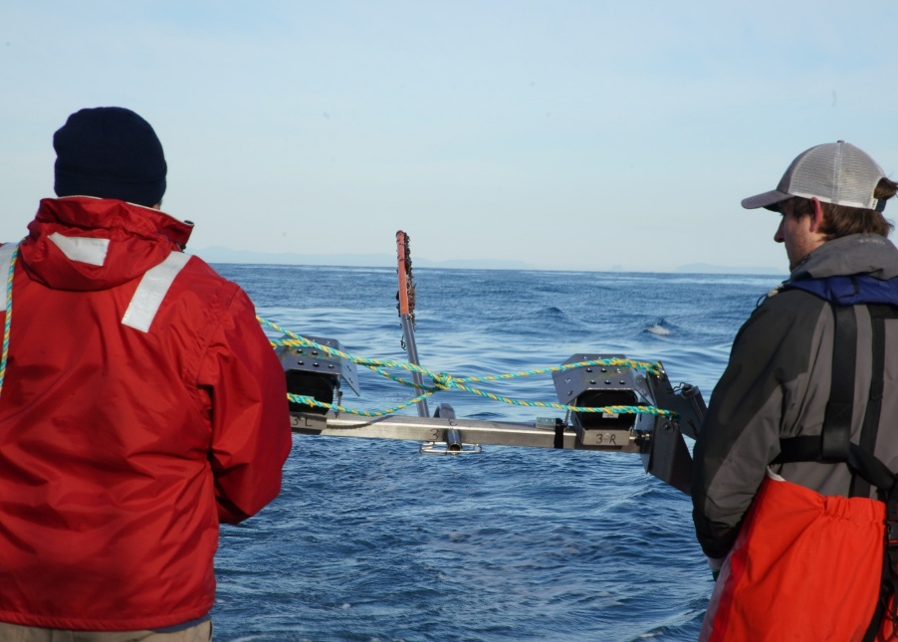

Commonwealth Environmental Impact Statement
Chapter 17 – Shipping and navigation
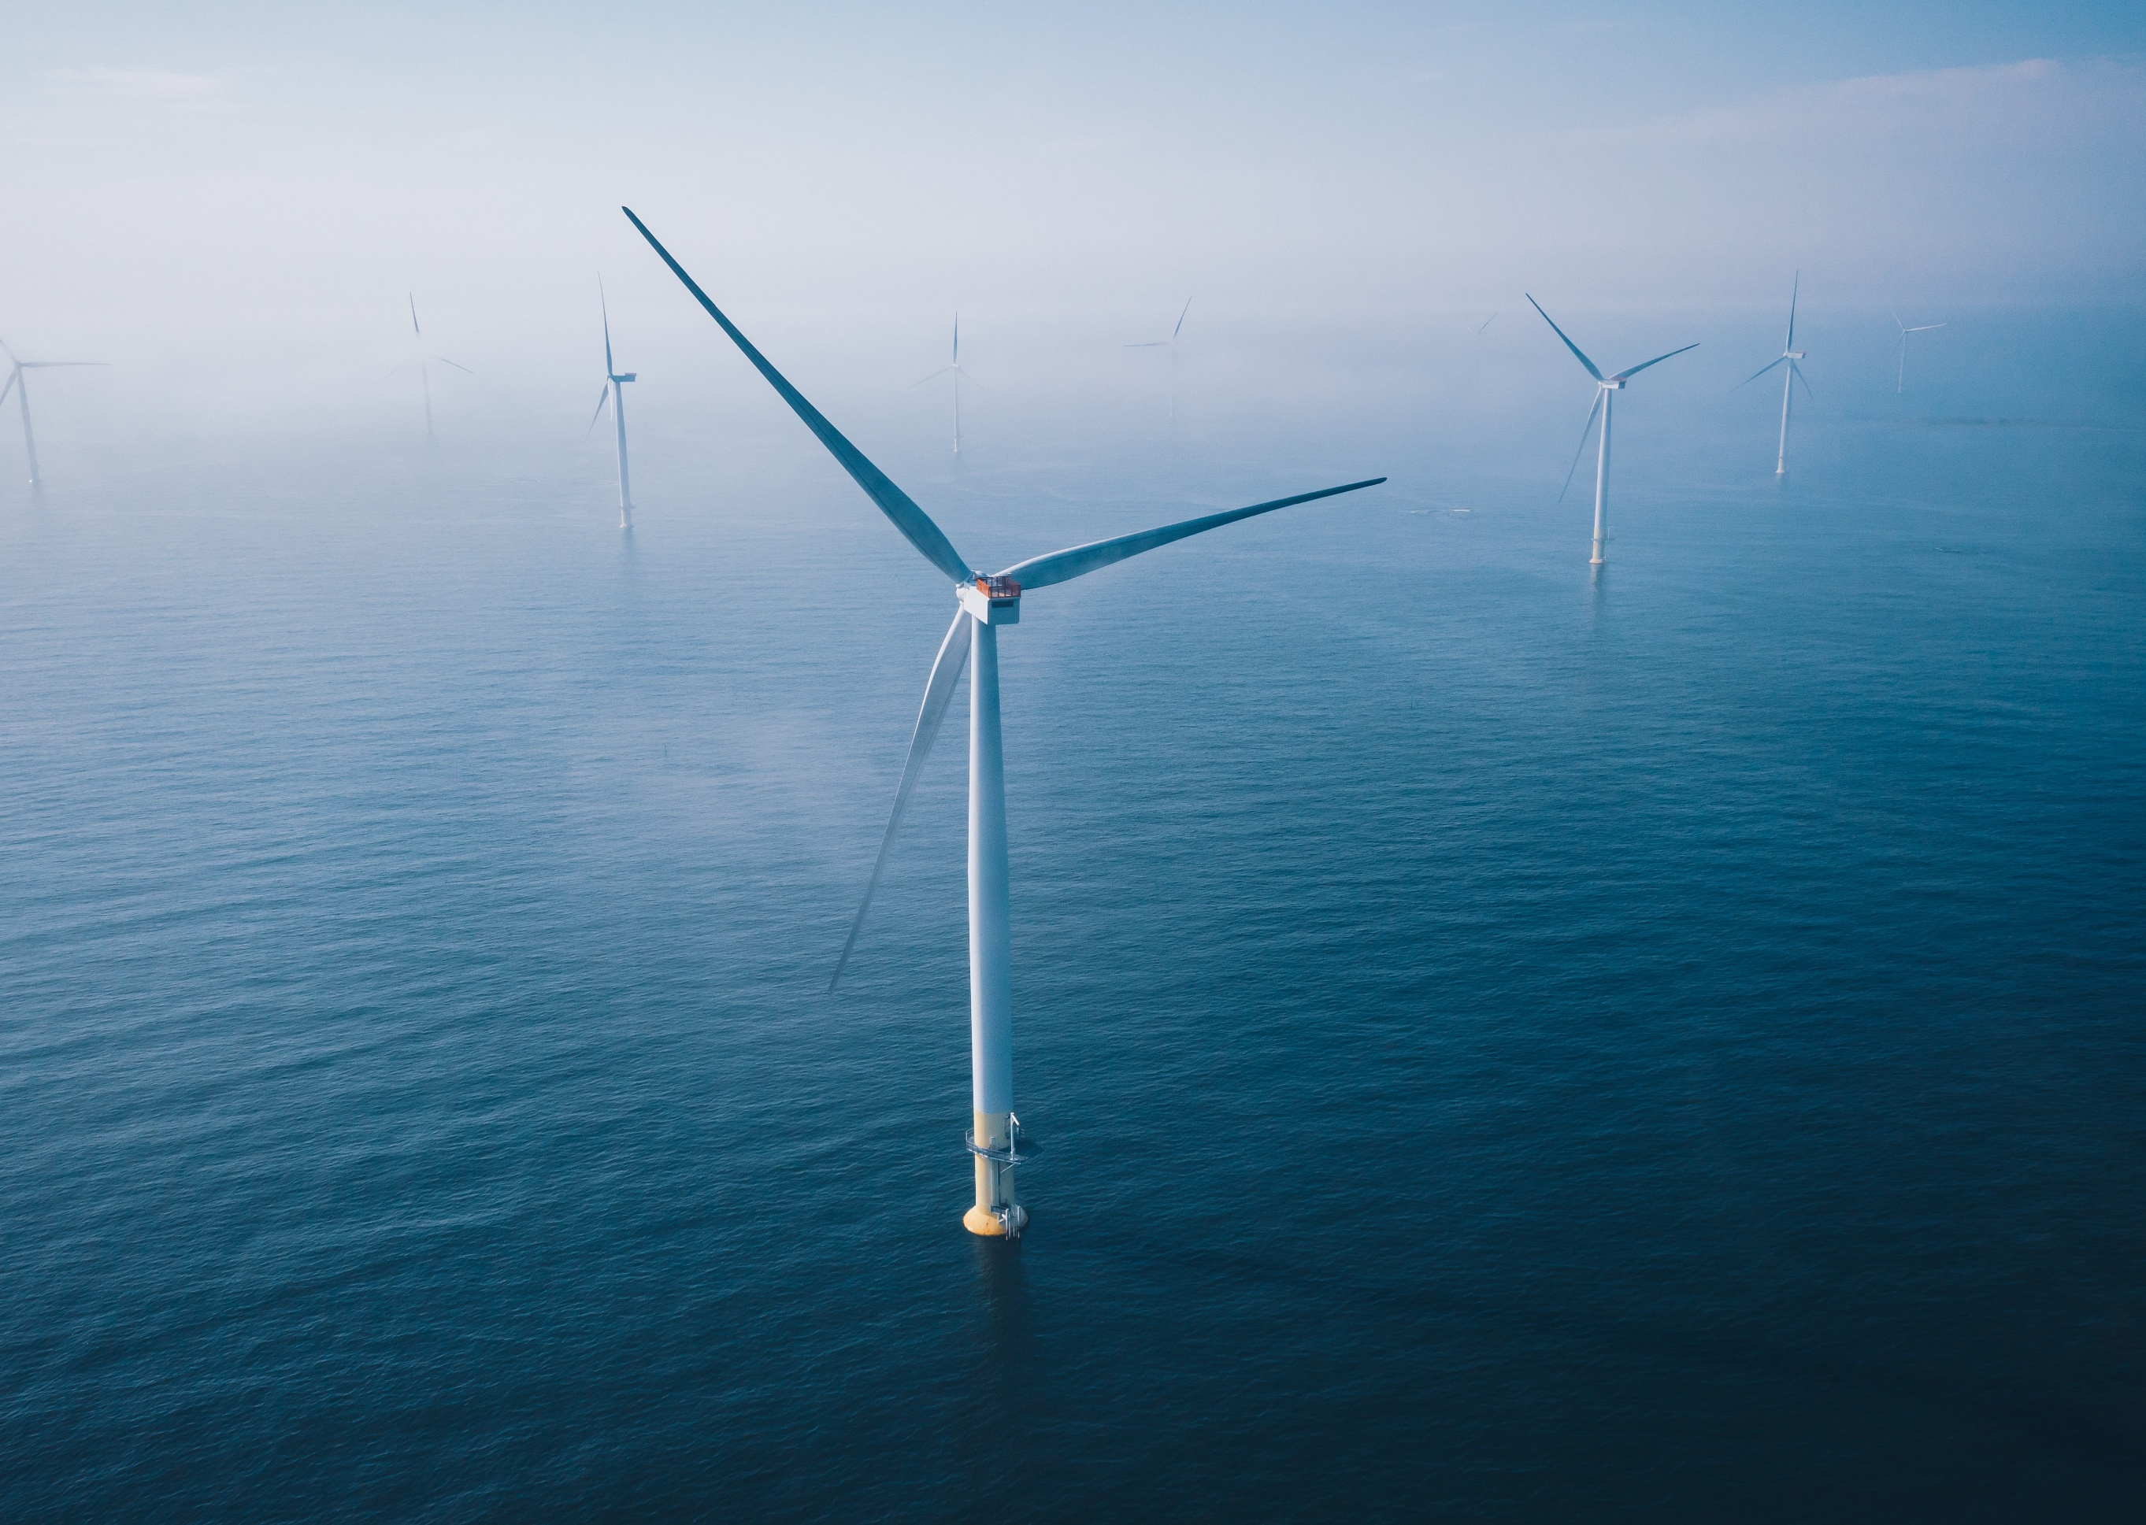
Table of Contents
Chapter 17 Shipping and Navigation 17-1
17.1 Introduction 17-1
17.2 Assessment scope 17-2
17.2.1 Commonwealth matters 17-2
17.3 Evaluation framework 17-3
17.3.1 Key legislation, policy, guidelines and standards 17-3
17.3.2 Assessment criteria 17-4
17.4 Methods 17-6
17.5 Existing environment 17-10
17.5.1 Physical environment 17-10
17.5.2 Shipping and navigation setting 17-10
17.5.3 Shipping and navigation receptors 17-20
17.6 Construction impacts 17-21
17.6.1 Key impacts 17-21
17.6.2 Other impacts 17-21
17.6.3 Potential risks 17-30
17.7 Operation impacts 17-31
17.7.1 Key impacts 17-31
17.7.2 Other impacts 17-31
17.7.3 Potential risks 17-38
17.8 Decommissioning impacts 17-39
17.8.1 Potential impacts and risks 17-39
17.9 Cumulative impact assessment 17-40
17.10 Summary of mitigation, monitoring and contingency measures 17-43
17.10.1 Mitigation measures 17-43
17.11 Conclusion 17-45

Figures
Figure 17-1 Shipping and navigation study area comprising all locations where the project may potentially impact shipping and navigation 17-9
Figure 17-2 Corner Inlet and Port Albert Port Boundary (adapted from Gippsland Ports, 2022) 17-12
Figure 17-3 Channels within the Port of Corner Inlet and Port Albert (Gippsland Ports, 2016b) 17-13
Figure 17-4 Shipping routes and traffic density in proximity to the offshore project area (AMSA, 2024) 17-15
Figure 17-5 Vessel incidents in Bass Strait (Safe Transport Victoria, 2022) 17-19
Figure 17-6 Extent of Great Eastern Offshore Wind Project in relation to Star of the South 17-42

Tables
Table 17-1 Key legislation, policy, guidelines and standards 17-3
Table 17-2 Assessment criteria for shipping and navigation 17-5
Table 17-3 Receptor groups for the shipping and navigation impact and risk assessment 17-20
Table 17-4 Residual impacts from the displacement of vessels during the construction phase 17-23
Table 17-5 Residual impacts from interaction with project vessels in the offshore project area during the construction phase 17-25
Table 17-6 Residual impacts from interaction with project infrastructure in the offshore wind farm area during the construction phase 17-26
Table 17-7 Residual impacts from interaction with offshore export and inter-array cables in the offshore project area during the construction phase 17-28
Table 17-8 Residual impacts from disruption and interaction with vessels in local ports during the construction phase 17-30
Table 17-9 Residual impacts from the displacement of vessels during the operation phase 17-32
Table 17-10 Residual impacts from interaction with project vessels in the offshore project area during the operation phase 17-33
Table 17-11 Residual impacts from interaction with project infrastructure in the offshore wind farm area during the operation phase 17-35
Table 17-12 Residual impacts from interaction with offshore export and inter-array cables in the offshore project area during the operation phase 17-36
Table 17-13 Residual impacts from interference with radar and navigation ability during the operation phase 17-37
Table 17-14 Residual impacts associated with the disruption and interactions with project vessels in local ports 17-38
Table 17-15 Projects assessed for cumulative impacts on shipping and navigation 17-41
Table 17-16 Mitigation measures relevant to shipping and navigation 17-43

Shipping and Navigation

Introduction
This chapter summarises the existing conditions related to shipping and navigation and assesses impacts and risks associated with the construction, operation and decommissioning of Star of the South Offshore Wind Farm Project (the project) on shipping and navigation.
Shipping and navigation form key socio-economic values of the Commonwealth Marine Area in which the project is located.
This chapter is based on the impact assessment presented in Technical Report P – Shipping and Navigation.
Other chapters that relate to or inform the shipping and navigation assessment include:
Chapter 8 – Coastal Processes and Sediment Transport
Chapter 10 – Fish and Invertebrates
Chapter 15 – Commercial and Recreational Fisheries
Attachment II – Consultation Report

Assessment scope
The study objective for shipping and navigation is to assess the existing conditions related to shipping and navigation and assess impacts associated with the construction, operation and decommissioning of the project on third-party shipping and navigation.
All detailed technical methodologies and assessment on shipping and navigation can be found in Technical Report P – Shipping and Navigation.
The shipping and navigation assessment examines the socio-economic values associated with the Commonwealth Marine Area, with a specific focus on the consequences of impeded freedom of navigation, displacement and increased risk of collision and allision. It considers the ability of vessels to safely operate within, or transit through, the offshore project area. The assessment evaluates potential impacts to current and future navigational uses, maritime safety, commercial shipping routes and access to ports, ensuring alignment with regulatory requirements and industry standards.
Environmental impacts and risks, such as a fuel spill due to vessel collision, are not included in the shipping and navigation assessment and can be found in Chapter 9 – Benthic Ecology.

Commonwealth matters
The project's EIS guidelines inform the preparation of the EIS to enable the Commonwealth Minister for the Environment to make an informed decision on whether to approve the project under the EPBC Act.
The aspects of the EIS guidelines relevant to shipping and navigation are:
- Section 2.2 (d) location of the action, including the ports likely to be used for serving the wind farm, and through which shipping movements to the wind farm will occur
- Section 2.3 Description of the action including details of associated works/activities, such as vessel movements
- Section 2.7 (k) The extent, intensity and duration of impacts of the action on existing users of the marine environment (e.g. commercial and recreational fishers, marine tourism, shipping and navigation, commercial and defence aircraft).
Further information about the EIS guidelines is listed in Attachment V – EIS Guidelines Checklist.

Evaluation framework

Key legislation, policy, guidelines and standards
Table 17-1 lists the key legislation, policy, guidelines and standards relevant to shipping and navigation. Refer to Chapter 5 – Commonwealth Legislative Framework and Technical Report P – Shipping and Navigation for further details.
Table 17-1 Key legislation, policy, guidelines and standards
Type | Applicable legislation, policy, guideline or standard
International conventions/guidance | United Nations Convention on the Law of the Sea 1982 (UNCLOS)
International conventions/guidance | International Convention for the Safety of Life at Sea 1974 (SOLAS)
International conventions/guidance | Convention on the International Regulations for Preventing Collisions at Sea 1972
International conventions/guidance | International Convention for the Prevention of Pollution from Ships 1973 (MARPOL)
International conventions/guidance | International Convention on Maritime Search and Rescue 1985
International conventions/guidance | International Maritime Organization (IMO), Ships' Routeing 2019 Edition
International conventions/guidance | IMO Resolution MSC.137(76) 2002
International conventions/guidance | IMO Resolution A.1106(29) 2015
International conventions/guidance | IMO MSC/Circ.1053 2002
International conventions/guidance | International Association of Marine Aids to Navigation and Lighthouse Authorities recommendation R0139 and Guideline G1162 The Marking of Man-made Offshore Structures 2021
International conventions/guidance | The Permanent International Association of Navigation Congresses (PIANC) Report No. 161, Interaction between Offshore Wind Farms and Maritime Navigation 2018
Commonwealth Government | Environment Protection and Biodiversity Conservation Act 1999 (Cth)
Commonwealth Government | Australian Maritime Safety Authority Act 1990 (Cth)
Commonwealth Government | Marine Safety (Domestic Commercial Vessel) National Law Act 2012 (Cth)
Commonwealth Government | Navigation Act 2012 (Cth)
Commonwealth Government | Offshore Electricity Infrastructure Act 2021 (Cth)
Commonwealth Government | Sea Installations Act 1987 (Cth)
Commonwealth Government | Environment Protection (Sea Dumping) Act 1981 (Cth)
Commonwealth Government | Australian Maritime Safety Authority's Policy on Offshore Renewable Energy Infrastructure
Victorian Government | Marine Safety Act 2010 (Vic)

Assessment criteria
To assess the project, predicted impacts and risks are compared to criteria that set required environmental performance outcomes (refer to Chapter 6 – Assessment Framework).
The criteria for shipping and navigation are derived from legislation and policy, relevant standards and guidelines, stakeholder feedback and industry best practice.
The assessment criteria relevant to shipping and navigation are outlined in Table 17-2.

Table 17-2 Assessment criteria for shipping and navigation
Receptor | Source of assessment criteria | Assessment criteria | Potential impacts / risks
Commonwealth marine area
All vessels | The works meet all safety, approval, regulatory and legal requirements, including (but not limited to):  International conventions United Nations Convention on the Law of the Sea (UNCLOS), the International Convention for the Safety of Life at Sea (SOLAS), Convention on the International Regulations for Preventing Collisions at Sea (COLREGS)  Navigation Act 2012 (Cth)  Marine Safety Act 2010 (Vic)  Offshore Energy Infrastructure Act 2021 (Cth)  Environmental Protection and Biodiversity Conservation Act 1999 (Cth)  The principles of Ecologically Sustainable Development (ESD)  Stakeholder communication, including the Ports and Waterways Safety Assessment. | Project vessels are compliant with maritime law relating to safety of navigation.  All phases of the project are consistent with the principles of Ecologically Sustainable Development, specifically:  - Decision‑making processes should effectively integrate both long‑term and short‑term economic, environmental, social and equitable considerations.  - The principle of inter-generational equity – that the present generation should ensure that the health, diversity and productivity of the environment is maintained or enhanced for the benefit of future generations.  - The project does not obstruct port entries.  - Stakeholders have sufficient time and opportunity to comment on the project, including the raising of objections or claims. | All potential project impacts addressed.
Commercial vessels (ships and other) | Permanent International Association of Navigation Congresses (PIANC) Guidelines (2018) | The project will not cause disruption or obstruction to known shipping channels.  Any disruption to ‘regular routes’ does not result in significant travel time or disruption to regular activity. | All potential project impacts addressed.
Commercial fishers and recreation vessels (fishers and boaters) | Stakeholder consultation outcomes | Construction, operation and decommissioning of the project will allow co-existence with commercial fishers and recreational users known to operate in the area.  Any disruption to ‘regular routes’ does not result in significant travel time or disruption to regular activity. | All potential project impacts addressed.
Emergency response vessels | Stakeholder consultation outcomes | Construction, operation and decommissioning of the project does not impede vessel-based search and rescue capability. | Project activities within the offshore project area may restrict the functioning of vessel-based emergency response capability.

Methods
The purpose of the shipping and navigation impact assessment is to assess the potential impacts and risks of the project on shipping and navigation.
Impacts refer to the consequences of planned project actions, which are given a rating determined by combining the magnitude of the impact and the sensitivity of the receptor.
Risks are an unexpected (accidental) event and are determined by combining the likelihood of an event occurring and the consequences that would result if the event were to occur.
The technical chapters consider key impacts and risks with a residual consequence rating of moderate to severe. Other impacts and risks are those with a residual consequence rating of negligible to minor.
Refer to Chapter 6 – Assessment Framework for more detail on how impact and risk ratings are derived.
The shipping and navigation impact assessment involved:
- Defining a study area. As shown in Figure 17-1, the study area comprises all locations where the project may potentially impact shipping and navigation and includes:
  - The offshore project area, comprising the offshore export cable area and the offshore wind farm area
  - Barry Beach Marine Terminal and Port Anthony, located within the Port of Corner Inlet and Port Albert, which Gippsland Ports manages
  - Two main shipping routes to the east of the offshore wind farm area and an unofficial inner route between the offshore wind farm area and the Gippsland coast
  - An area to be avoided (ATBA) encompassing oil and gas fields in the Bass Strait
  - Two traffic separation schemes (TSSs): Bass Strait TSS (TSS 2) and South of Wilsons Promontory TSS (TSS 1)
- Conducting a desktop / literature review to establish baseline information about shipping activities and navigational safety issues in the study area, including:
  - Data collected from academic research studies, project documentation, Australian statistical reports and databases on commercial shipping and marine traffic density. Key databases and literature were:
    - Australian Maritime Safety Authority (AMSA) automatic identification system (AIS) vessel location data
    - AMSA vessel incidents within Victoria and Bass Strait
    - Recreational vessel incidents within Bass Strait
    - Port statistics sourced from Ports Australia, Bureau of Infrastructure and Transport Research Economics and United Nations Conference on Trade and Development
- Reviewing guidelines and policies of International, Commonwealth and state maritime authorities and agencies
- Examining overseas experience in mitigating navigational safety risks involving offshore wind farms, and of the lessons learned, to identify solutions applicable to the Victorian and Australian context
- Consulting with maritime stakeholders including commercial fishers, recreational users and local port authorities
- Undertaking multi-agency navigational safety risk evaluation through targeted Ports and Waterways Safety Assessment (PAWSA, see method below) workshops
- Reviewing the outcomes of recreational fisher boat ramp surveys (see Chapter 15 – Commercial and Recreational Fisheries) to understand vessel activity in the region that may not have AIS. In addition, data on vessel presence in the offshore wind farm area and surrounding areas, acquired during visual aerial surveys (see Chapter 11 – Marine Mammals and Turtles) was taken into account
- Reviewing the project description to determine the location, type, timing, extent, intensity and duration of potential project interactions with sensitive receptors and assessing impacts and risks according to Chapter 6 – Assessment Framework.

PAWSA method
The PAWSA process involves the participation of professional waterway users with local expertise in navigation, waterway conditions and port safety. This method is globally accepted as a proven risk management tool and is endorsed by the International Maritime Organisation (IMO).
In line with the PAWSA method, major organisations involved in commercial shipping in Australia from the maritime industry, unions, marine safety governing bodies, oil and gas and ports were invited to participate in a two-day workshop, held on 24 October 2021 and 16 December 2021.
In preparation for the PAWSA workshop, two-dimensional and three-dimensional model simulations were performed to determine collision and allision risk. Collision risk is the risk of a vessel-to-vessel collision, and allision risk is the risk of a collision between a vessel and fixed structure. The simulations test the manoeuvrability and navigational safety margins of different vessel types and sizes under various scenarios (weather, traffic mix, safety), particularly when transiting inside the wind farm, with the highest possible number of project vessels present. All details of this simulation modelling are in Technical Report P – Shipping and Navigation.
Figure 17-1 Shipping and navigation study area comprising all locations where the project may potentially impact shipping and navigation
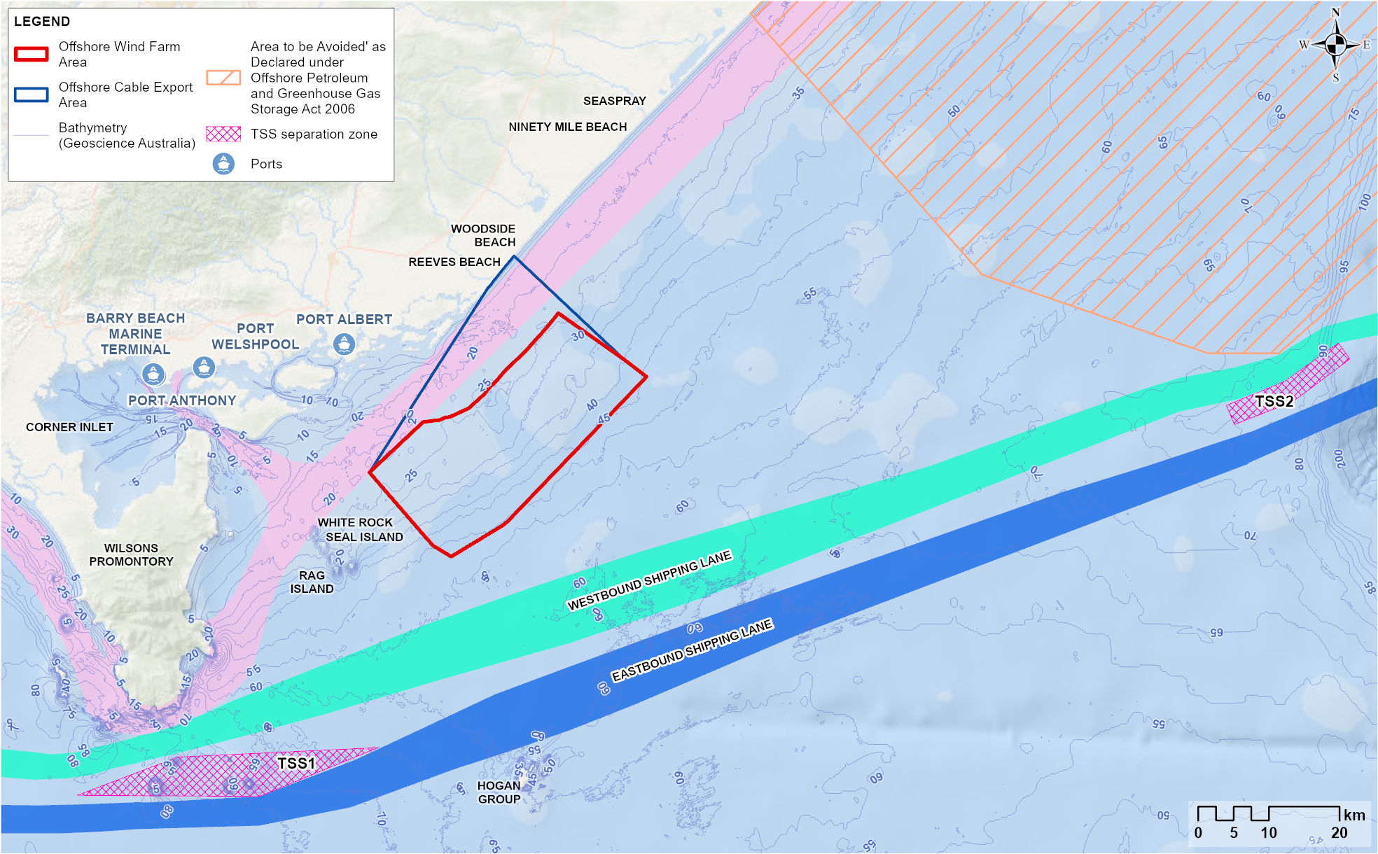

Existing environment
This section describes the existing conditions within the study area as they relate to shipping and navigation. The study area is defined as covering the offshore project area, two main shipping routes, an Area To Be Avoided (ATBA) encompassing oil and gas fields in the Bass Strait, an inner shipping route between the project and the Gippsland coast and the smaller ports proposed to be used for project vessels (Barry Beach Marine Terminal and Port Anthony) and the area between these ports and the offshore wind farm area.

Physical environment
Wind, waves and currents greatly influence vessel activity and impact vessel speed and control. Vessel movements require careful route planning and are timed with consideration of tidal phases, currents and flows. A detailed description of existing current, wind and wave conditions in the offshore project area can be found in Chapter 8 – Coastal Processes and Sediment Transport.

Shipping and navigation setting
An assessment of operational ports, shipping channels, navigational features, marine traffic, vessel activity and marine incidents within the study area and broader region was undertaken to characterise the existing shipping and navigation environment. The outcomes of this assessment are summarised in the subsections below.

Ports
The ports in and near the study area include major and local ports, with local ports shown in Figure 17-1.

Major ports
Major ports in the broader region (within 300 kilometres of the offshore wind farm area) include the Port of Hastings, the Port of Melbourne, the Port of Geelong (Victoria) and the Port of Bell Bay (Tasmania). Major ports currently in operation that are proposed to be used as construction feeder ports include Geelong Port and Port of Bell Bay. Shipping and navigation within and in the vicinity of major ports has not been assessed, as existing port management (such as harbour masters) will regulate vessel activity for the project and third-party vessels. Project vessels using these ports will adhere to maritime laws and use shipping channels between these ports and the offshore project area where appropriate.

Local ports
The closest ports to the project area are Port of Corner Inlet and Port Albert which are managed by Gippsland Ports (refer to Figure 17-2). Either Barry Beach Marine Terminal or Port Anthony, which are located within the Port of Corner Inlet, will be used by smaller support vessels during the project's construction and operation.
The Port of Corner Inlet and Port Albert are the largest of the regional Gippsland Ports, located within the Corner Inlet Ramsar Site approximately 9.5 nautical miles (17.6 kilometres) to the west of the offshore wind farm area (Figure 17-1). The ports encompass the waters east of Wilsons Promontory National Park, near Rabbit Island, to McLoughlins Beach at the western end of Ninety Mile Beach (refer to Figure 17-2 and Figure 17-3). There are several entrances to the ports, with the main access being the entrance channel.
Corner Inlet serves as a base for offshore and supply vessels that service regional oil and gas fields to the north-east of the offshore project area (Figure 17-1). Barry Beach Marine Terminal and Port Anthony are adjacent to each other within Corner Inlet and are privately owned and managed and currently used by the oil and gas service vessels.
Vessel traffic within Corner Inlet is primarily made up of commercial and recreational fishers, as well as commercial vessels using Barry Beach Marine Terminal and Port Anthony. Other users include charter operators, police, emergency services and marine services. The Toora Channel and Barry Beach Channel are restricted areas, which means permission is required to access these channels. Their use is predominantly limited to commercial operators.

Figure 17-2 Corner Inlet and Port Albert Port Boundary (adapted from Gippsland Ports, 2022)
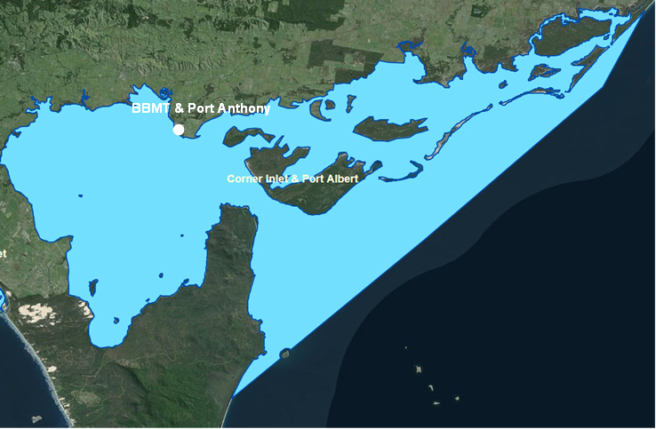

Figure 17-3 Channels within the Port of Corner Inlet and Port Albert (Gippsland Ports, 2016b)
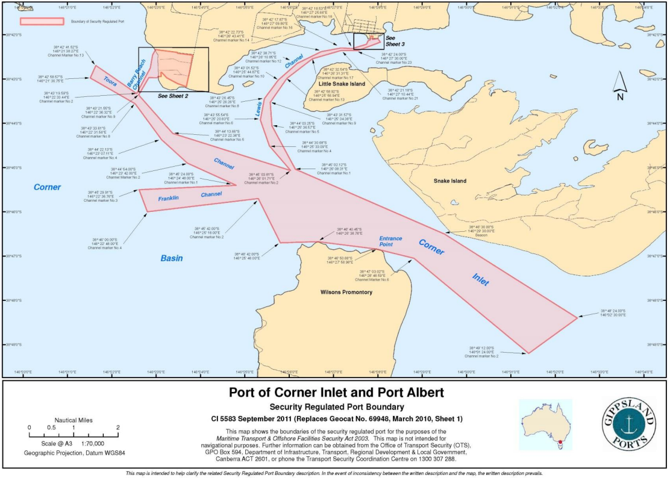

Shipping channels
Two main shipping channels near the offshore wind farm area, a westbound channel and an eastbound channel that follow the east coast of Australia, connect vessels between the major ports of Port of Melbourne and Port Botany, as shown in Figure 17-4. These east-west bound shipping channels, designated by the IMO, fall approximately 5.5 nautical miles (10.1 kilometres) to the south-east of the offshore project area and are used by large ships transiting down the Australian east coast.
An unofficial inner route between the offshore wind farm area and the Gippsland coast is also shown in Figure 17-1. This route is mainly used by small coastal commercial vessels, fishing vessels, oil and gas service vessels and recreational vessels (sailing and motorised).

Figure 17-4 Shipping routes and traffic density in proximity to the offshore project area (AMSA, 2024)
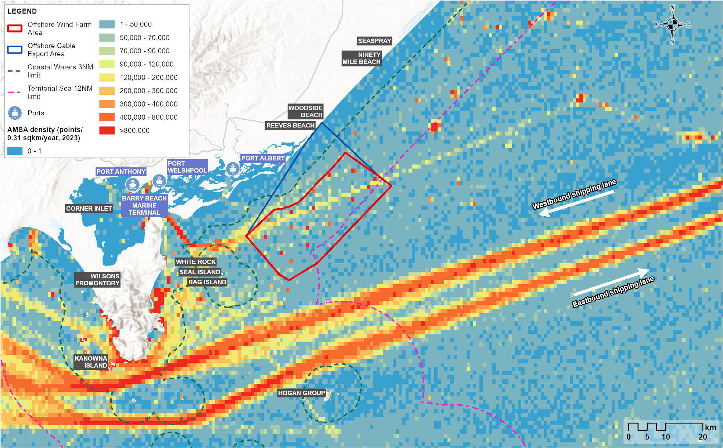
Note: this density map has been derived from AIS points for the year 2023. Each point represents an AIS vessel position, with the red areas representing the highest number of AIS points and therefore concentration of vessels.

Navigational features
Navigational features refer to features that influence how vessels navigate in the region. Key navigational features identified within the offshore project area include the Basslink Interconnector power cable and all those in the vicinity of the offshore project area are detailed in Technical Report P – Shipping and Navigation.

Traffic Separation Schemes
To ease congestion, assist traffic flow and prevent ships colliding at sea, two Traffic Separation Schemes (TSSs) have been adopted by the IMO and implemented in Bass Strait: Bass Strait TSS (TSS 2) and South of Wilsons Promontory TSS (TSS 1).
The Bass Strait TSS (TSS 2) is located in Commonwealth waters and has been designed for the protection of installations in the Bass Strait area and for the safety of shipping with the main shipping route along Australia's East Coast. It is located approximately 44 nautical miles (81 kilometres) from the offshore project area and the zone is illustrated in Figure 17-1.
The South of Wilsons Promontory TSS (TSS 1) is located in Victorian coastal waters and has been designed to ensure the safety of shipping in close proximity to nearshore islands. The start of the scheme is located approximately 8 nautical miles (15 kilometres) from the offshore project area and the zone is illustrated in Figure 17-1.

Areas to be avoided and safety zones
An area to be avoided (ATBA) of about 5,650 square kilometres is located approximately 74 kilometres north of the offshore project area (see Figure 17-1) and encompasses the Esso oil and gas facilities. Ships of more than 200 gross tonnage are required to avoid the ATBA, with the exception of those servicing the oil and gas fields.

Marine traffic in the study area
Vessel activity within the offshore project area is of low intensity. A snapshot of typical marine traffic density in the area, based on AIS data, is shown in Figure 17-4 and is summarised as follows:
- Large commercial ships make up the majority of vessels in the Bass Strait and are restricted to the major shipping channel located 5.5 nautical miles (10.18 kilometres) south-east of the offshore project area.
- Oil and gas service vessels travel from Barry Beach Marine Terminal and Port Anthony to the ATBA, transiting through the offshore wind farm area or using the inner route between the offshore wind farm area and the coast.
- Tourism charters tend to remain close to the islands around Wilsons Promontory National Park (Wilsons Promontory) for sightseeing, and cruise ships are infrequent.
- Commercial fishing occurs within the offshore project area, although less so than other areas within Bass Strait which are more productive.
- Recreational fishers and boaters predominantly remain in inshore waters unless the weather is good, and then they may travel further offshore into the offshore wind farm area.

Suitability for vessels
Strong currents and weather systems characterise the offshore project area and, more generally, the Bass Strait. The area is therefore considered more suitable for experienced mariners and larger vessels (ships), with small boats (less than 15 metres) generally restricted to the less exposed, inshore areas.

Marine incidents

Commercial vessels
A summary of marine incidents that have occurred within the region are as follows:
- Approximately 960 marine incidents were responded to in Victoria during 2020 and 2021. Within the Port Albert and Port Welshpool search and rescue units during these years, an average of 21 and 26 incidents were responded to annually, respectively.
- The majority of the reported commercial marine incidents between 2015 and 2019 occurred in the Port of Port Phillip, with the Bass Strait (northern and eastern) among the waterways recording the lowest number of marine incidents during this period. Most of the incidents within Gippsland or the Bass Strait occurred within inshore or inland waters; no serious incidents were recorded in the offshore project area.
- Based on data obtained from Safe Transport Victoria, 10 marine incidents (recreational vessels) occurred in the Bass Strait close to the offshore project area between July 2019 and June 2022 (Figure 17-5).
- In the context of the project, most of the incidents occurring in Gippsland or the Bass Strait are inshore or within inland waters, such as the Gippsland Lakes.

Figure 17-5 Vessel incidents in Bass Strait (Safe Transport Victoria, 2022)
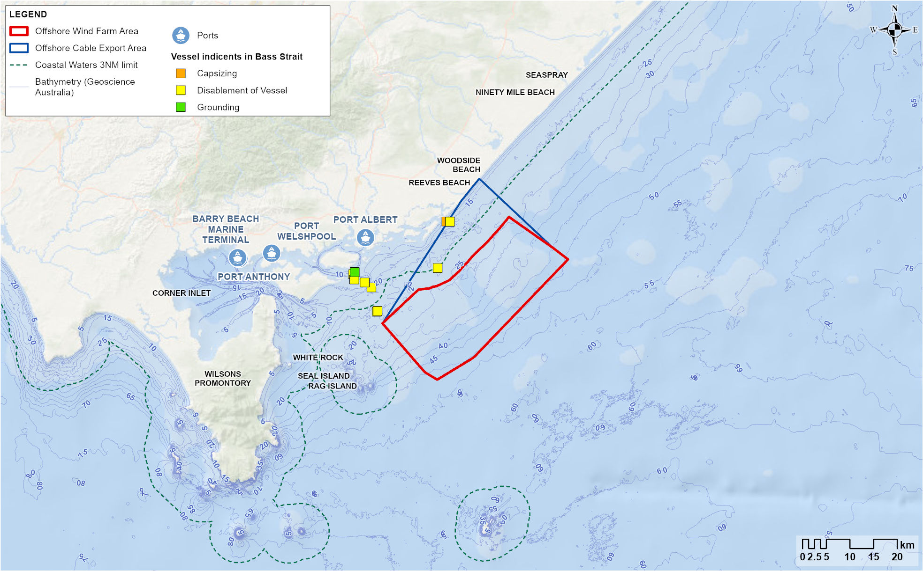

Recreational vessels
Consultation with Victorian maritime authorities undertaken to obtain information on non-AIS recreational vessels (including small fishing vessels) identified that:
- Recreational marine traffic is very seasonal, with three peak periods (March to May, September to November and December to February) experiencing heavier concentrations
- During peak times, as many as 250 to 300 recreational vessels can be on the water when weather conditions are good; most vessels tend to concentrate at Corner Inlet but stay clear of and dispersed from the shipping channels
- The concentration of recreational vessels, even during peak times, is not considered to be a navigation risk given that such vessels typically stay clear of the main channels used by commercial vessels.
Feedback provided by maritime authorities is outlined in Technical Report P – Shipping and Navigation.

Shipping and navigation receptors
Based on the existing shipping and navigation environment and the broad vessel types found in the study area, the receptor groups that form the impact and risk assessment are summarised in Table 17-3.
Table 17-3 Receptor groups for the shipping and navigation impact and risk assessment
Receptor group | Description
Commercial vessels (ships) | Vessels restricted to shipping channels that are generally greater than 100 metres long do not enter the offshore project area and have advanced navigational equipment (such as AIS) and low manoeuvrability.
Commercial vessels (other) | Vessels greater than 45 metres that enter the offshore wind farm area when transiting to oil and gas fields to the north of the offshore project area (Figure 17-4), have advanced navigational equipment and sound manoeuvrability. These vessels may also transit through the offshore export cable area on route to the oil and gas fields.
Commercial fishers | A small number of operators with vessel sizes generally less than 25 metres that enter the offshore wind farm area, may not always have AIS in use and have high manoeuvrability. The number of vessels fishing in the offshore wind farm area has fluctuated since 1990, ranging from two to 13.
Recreational fishers and boaters | Vessels are small, generally less than 15 metres and a small number of users do enter the offshore wind farm area on occasion during good weather conditions. These vessels tend not to have AIS or location capability and have high manoeuvrability.
Emergency response vessels | These vessels are a typical length of 24 metres with high manoeuvrability. They are required to enter the offshore wind farm area in the event of an emergency and have advanced navigational equipment (such as AIS).

Construction impacts
This section discusses the impacts and risks associated with the construction of the project that relate to shipping and navigation and the respective receptor groups. Impacts refer to the consequences of planned project actions, which are given a rating determined by combining the magnitude of the impact and the sensitivity of the receptor.
Potential risks arise when a project activity could result in an unexpected (accidental) event and are determined by combining the likelihood of an event occurring and the consequences that would result if the event were to occur. Refer to Chapter 6 – Assessment Framework for more detail on how impact and risk ratings are derived.

Key impacts
The construction impact assessment identified no significant impacts to shipping and navigation with a residual consequence rating of moderate or higher once mitigation measures are implemented.

Other impacts
Other potential construction phase impacts with negligible to minor residual consequences to shipping and navigation include:
- Increased travel time and distance (SNV-01)
- Interaction with project vessels in the offshore project area (SNV-02)
- Interaction with project infrastructure in the offshore wind farm area (SNV-03)
- Interaction with offshore export and inter-array cables in the offshore project area (SNV-04)
- Disruption and interaction with project vessels in ports (SNV-05).

Increased travel time and distance (SNV-01)

Potential impact
The construction phase is expected to last up to four years and 11 months and involves the installation of project infrastructure within the offshore wind farm area, the installation of offshore export cables in the offshore export cable area and associated vessel movements throughout the offshore project area. There will be project vessels that have a restricted ability to manoeuvre and an increasing presence of installed project infrastructure as the construction phase progresses. Access to certain areas will be temporarily limited for other vessels as the following measures will be implemented to ensure the safety of third-party vessels, project vessels and project infrastructure:
A cardinal buoy is a sea marker that indicates the position of a hazard and direction of safe travel.
- Demarcation of the offshore wind farm area potentially using cardinal buoys to show where construction is underway. A minimum 1,000-metre demarcation area around offshore export cable installation activities within the offshore export cable area (OFF-M03).
- The likely use of temporary safety zones or protection zones around infrastructure in Commonwealth waters (OFF-M12).
The assessment considers the potential impact of displacement, increasing travel time and distances for shipping and navigation receptors as they may need to deviate from their usual routes to avoid project infrastructure or vessels.

Mitigation
Initial mitigation measures will be implemented to reduce the impacts of third-party vessel displacement from the offshore project area during the construction phase. These include the use of consultation plans (OFF-M22), Notices to Mariners (OFF-M10), navigational aids (SNV-M02) and escort vessels to inform maritime operators of project construction schedules and the location of safety zones and demarcation buoys. These measures will ensure commercial and recreational vessels have adequate time to plan changed routes.

Residual impact
The initial and residual consequence of increased travel time and distance to these respective receptor groups is considered negligible.
Likewise, residual consequences for emergency response vessels are considered negligible. These vessels are not expected to be displaced from the offshore project area because they are small enough to safely navigate within the area, and in the event of an emergency will have right of way over project vessels with demarcation areas opened where safe to do so.
It is anticipated that commercial vessels transiting the offshore export cable area to access the oil and gas fields will still be able to use the inshore route during construction. Model simulations indicate that for vessels which currently transit the offshore wind farm area (on average three per week), a deviation to avoid it will add no more than seven minutes transit time. As such, residual consequence is considered negligible for all commercial vessels.
Refer to Table 17-4 for further information on residual impacts from the displacement of vessels during the construction phase.
Table 17-4 Residual impacts from the displacement of vessels during the construction phase
Potential impact | Receptor | Receptor sensitivity | Magnitude | Initial consequence | Mitigation | Residual consequence
Increased travel time and distance | Commercial vessels (ships) | Low | Negligible | Negligible | - | Negligible
Increased travel time and distance | Commercial vessels (other) | Low | Low | Negligible | - | Negligible
Increased travel time and distance | Commercial fishers | Medium | Negligible | Negligible | - | Negligible
Increased travel time and distance | Recreational fishers and boaters | Medium | Negligible | Negligible | - | Negligible
Increased travel time and distance | Emergency response vessels | Low | Negligible | Negligible | - | Negligible

Interaction with project vessels in the offshore project area (SNV-02)

Potential impact
During the construction phase, an average of 15 project vessels are anticipated to be within the offshore project area each day. Across the whole period, vessels are expected to make up to 8,320 roundtrips to and from ports, with 7,820 of these being made by smaller support vessels transiting from Barry Beach Marine Terminal or Port Anthony.
The assessment considers the potential impact of interactions between shipping and navigation receptors and project vessels in the offshore project area.
Project vessels will be managed by a marine coordination centre, likely to be based at a local port, which will ensure that disruption to third-party vessels is minimised (VES-M03). Marine coordination will include:
- Provision of project vessel routes to site
- Construction timetables
- 24/7 monitoring of vessel movements, helicopters and weather conditions within the construction area
- Detection, supervision and control of vessel traffic within the offshore project area, and to and from construction ports
- Provision of information to vessels to enable safe and efficient navigation.

Mitigation
Interaction with third-party vessels will be minimised through mitigation measures including consultation plans (OFF-M22), Notices to Mariners (OFF-M10), navigational aids (SNV-M02) and demarcation measures (OFF-M03) to communicate to vessels the areas that should be avoided. Escort vessels will ensure adherence with advisory passing distances to mitigate impacts to navigation during construction and may also safely move third-party vessels from areas that could present a risk to them.

Residual impact
With these measures in place, initial and residual consequences to most shipping and navigation receptors are considered negligible. As recreational fishers and boaters use less sophisticated navigational equipment, they are considered to have a higher sensitivity which results in a consequence rating of minor. Refer to Table 17-5 for further information on residual impacts from interaction with project vessels in the offshore project area during the construction phase.
Table 17-5 Residual impacts from interaction with project vessels in the offshore project area during the construction phase
Potential impact | Receptor | Receptor sensitivity | Magnitude | Initial consequence | Mitigation | Residual consequence
Increased vessel interactions within the offshore project area | Commercial vessels (ships) | Low | Negligible | Negligible | - | Negligible
 | Commercial vessels (other) | Low | Negligible | Negligible | - | Negligible
 | Commercial fishers | Medium | Negligible | Negligible | - | Negligible
 | Recreational fishers and boaters | High | Negligible | Minor | - | Minor
 | Emergency response vessels | Low | Negligible | Negligible | - | Negligible

Interaction with project infrastructure in the offshore wind farm area (SNV-03)

Potential impact
The assessment considers the potential impact of allision, which is a collision between a vessel and offshore infrastructure. The potential for allision to occur is highest towards the end of the construction phase when all project infrastructure has been installed and is most likely to occur due to a vessel mechanical failure or navigational error.

Mitigation
Demarcation buoys and safety zones will help to ensure that vessels remain a safe distance from infrastructure in the offshore wind farm area, thereby helping avoid allision. Results from the simulation modelling indicate the minimum spacing of 1,062 metres between wind turbines is sufficient for safe passing of vessels under 45 metres in all conditions including bad weather, crossing / passing traffic and at night, and even if vessels are not under control or sailing.
Further, consultation with the Australian Maritime Safety Authority (AMSA), Civil Aviation Safety Authority (CASA), and search and rescue (SAR) agencies (SNV-M11) will inform the final layout of infrastructure in the offshore project area.

Residual impact
Following these mitigation measures, initial and residual consequences to most shipping and navigation receptors are considered negligible. Residual consequences are considered minor for recreational fishers and boaters because they have a higher sensitivity to allision due to less sophisticated navigational equipment and may also lack adequate length of anchor rope and chain to effectively anchor in deeper (over 20 metres) waters to prevent allision in the event of an emergency. Refer to Table 17-6 for further information on residual impacts from interaction with project infrastructure in the offshore wind farm area during the construction phase.
Table 17-6 Residual impacts from interaction with project infrastructure in the offshore wind farm area during the construction phase
Potential impact | Receptor | Receptor sensitivity | Magnitude | Initial consequence | Mitigation | Residual consequence
Interaction with project infrastructure within the offshore wind farm area | Commercial vessels (ships) | Low | Low | Negligible | SNV-M11 | Negligible
 | Commercial vessels (other) | Low | Low | Negligible | SNV-M11 | Negligible
 | Commercial fishers | Medium | Negligible | Negligible | SNV-M11 | Negligible
 | Recreational fishers and boaters | High | Negligible | Minor | SNV-M11 | Minor
 | Emergency response vessels | Low | Negligible | Negligible | SNV-M11 | Negligible

Interaction with export and inter-array cables in the offshore project area (SNV-04)

Potential impact
The assessment considers the potential for shipping and navigation receptors to interact with offshore export and inter-array cables on the seabed through anchor snag. Cable interactions may be more likely to occur during the construction phase if cables are left on the seabed for extended periods (wet stored) before being buried or protected.
Anchor snag refers to when an anchor of a vessel gets caught on the seabed or on an object.

Mitigation
Offshore export and inter-array cables will be buried to a minimum depth of one and 0.6 metres, respectively. If they cannot be buried, cable protection such as rock armour or concrete mattresses will be installed. Cable protection will be designed to reduce the risk of snagging. A cable burial risk assessment will be undertaken during detailed design to determine safe burial depths for cables, considering vessel types and the density of activity in the area, fishing methods and substrate types (SNV-M04).
A minimum 1,000 metre demarcation area around offshore export cable installation activities is expected and this area will move with the progressive installation of cables on the seabed (OFF-M03). If cables are wet stored, temporary restrictions on anchoring and certain fishing activities in the vicinity of the cable will apply until they can be buried or protected, to avoid damage to the cables and/or other vessels.
To further mitigate potential impacts, appropriate charting of project infrastructure (including all cables) on the Australian Hydrographic Office nautical charts (SNV-M09), as well as publication of information via consultation plans (OFF-M22) and Notices to Mariners (OFF-M10), will ensure maritime users know where cables are located, allowing them to avoid these areas. Escort vessels will also be present during cable installation to further reduce the likelihood that a third-party vessel enters a demarcation area.

Residual impact
Following these mitigation measures, initial and residual consequences to most shipping and navigation receptors are considered negligible. Residual consequences are considered minor for recreational fishers and boaters as they have a high sensitivity rating due to their potential use of anchors in the shallower waters of the offshore export cable area. Refer to Table 17-7 for more information on residual impacts from interaction with project infrastructure in the offshore wind farm area during the construction phase.
Table 17-7 Residual impacts from interaction with offshore export and inter-array cables in the offshore project area during the construction phase
Potential impact | Receptor | Receptor sensitivity | Magnitude | Initial consequence | Mitigation | Residual consequence
Interaction with offshore export and inter-array cables within the offshore project area | Commercial vessels (ships) | Low | Negligible | Negligible | - | Negligible
 | Commercial vessels (other) | Low | Negligible | Negligible | - | Negligible
 | Commercial fishers | Medium | Negligible | Negligible | - | Negligible
 | Recreational fishers and boaters | High | Negligible | Minor | - | Minor
 | Emergency response vessels | Low | Negligible | Negligible | - | Negligible

Disruption and interaction with project vessels in local ports (SNV-05)

Potential impact
During construction, Star of the South will use a Gippsland-based port, either Barry Beach Marine Terminal or Port Anthony, for construction management vessels, including platform support vessels, remotely operated survey vessels and crew transfer vessels. Barry Beach Marine Terminal or Port Anthony are neighbouring ports accessed through Corner Inlet Channel, and then via the Barry Beach and Toora channels as shown in Figure 17-3. Commercial vessels (ships) and most installation vessels are too large to enter Corner Inlet.
Commercial fishing and recreational vessels within Corner Inlet may interact with project vessels. Vessel simulation results shows that the level of marine traffic (high and medium density) and mix of traffic (commercial, fishing and recreational vessels) allows for sufficient navigable space within the channel.
The Barry Beach and Toora channels are restricted areas and are used almost exclusively by commercial vessels and sometimes emergency vessels. Given the currently low movement of vessels within these channels (a daily average of two), the introduction of project vessels will substantially increase daily movements. Vessel simulations show that with prudent scheduling of shipping movements, even under medium density and high density marine traffic situations, there is sufficient navigable space for both current AIS vessels using the channel and proposed project vessels (up to eight per day during the construction phase).

Mitigation
To minimise impacts, project vessels will use defined shipping routes between construction feeder ports and the offshore project area, as well as within Corner Inlet (VES-M04), and will comply with relevant Australian and Victorian maritime regulations including obtaining a 'Certificate of Local Knowledge' if using Corner inlet (SNV-M05).
To mitigate potential effects of vessel traffic in port channels and to ensure consequence levels are kept low, a vessel passage plan for project vessels will be developed to manage vessels transiting to the ports and avoid congestion within the channels (SNV-M07). A passage plan is a comprehensive berth to berth guide which details the route transited, potential hazards and measures to ensure safe passage. This plan will ensure that scheduling of times for entering and exiting the port is actively managed to avoid congestion and choke points.
Star of the South will communicate project vessel corridors, so third-party vessels are aware of high-risk areas and likely numbers of project vessels, to reduce the risk of collision. Between the boundary of Port of Corner Inlet and the offshore project area, there is sufficient space for vessels to navigate freely, and no choke points are expected.

Residual impact
With these mitigation measures in place, the consequence to third party vessels resulting from increased vessel traffic is expected to range from minor to negligible for shipping and navigation receptor groups. Refer to Table 17-8 for residual impacts from disruption and interaction with vessels in local ports during the construction phase.
Table 17-8 Residual impacts from disruption and interaction with vessels in local ports during the construction phase
Potential impact | Receptor | Receptor sensitivity | Magnitude | Initial consequence | Mitigation | Residual consequence
Increased vessel interactions and congestion in local ports | Commercial vessels (ships) | Low | Negligible | Negligible | SNV-M07 | Negligible
Increased vessel interactions and congestion in local ports | Commercial vessels (other) | Low | Negligible | Negligible | SNV-M07 | Negligible
Increased vessel interactions and congestion in local ports | Commercial fishers | Medium | Negligible | Negligible | SNV-M07 | Negligible
Increased vessel interactions and congestion in local ports | Recreational fishers and boaters | High | Negligible | Minor | SNV-M07 | Minor
Increased vessel interactions and congestion in local ports | Emergency response vessels | Low | Negligible | Negligible | SNV-M07 | Negligible

Potential risks
The assessment identified no potential construction risks for shipping and navigation.

Operation impacts
This section discusses impacts and risks associated with the operations of the project that relate to shipping and navigation and the respective receptor groups.

Key impacts
The assessment identified no operation impacts with a residual consequence to shipping and navigation of moderate or higher once mitigation measures have been implemented.

Other impacts
Other potential operation phase impacts with negligible to minor residual consequences to shipping and navigation include:
- Increased travel time and distance (SNV-06)
- Interaction with project vessels in the offshore wind farm area (SNV-07)
- Interaction with project infrastructure in the offshore wind farm area (SNV-08)
- Interaction with offshore export and inter-array cables in the offshore project area (SNV-09)
- Interference with radar and navigation ability (SNV-10)
- Disruption and interaction with project vessels in local ports (SNV-011).

Increased travel time and distance (SNV-06)

Potential impact
During the operation phase, the presence of project infrastructure and maintenance activities may displace some vessels from previously used routes, which could lead to increased transit times and distances.
As large commercial ships are confined to the shipping lanes, they are unlikely to be impacted. For emergency, commercial fishing and recreational vessels under 45 metres, the 1,062-metre minimum spacing between turbines will allow for safe navigation through the offshore wind farm area. Star of the South supports shared use of the offshore area and will actively manage major maintenance activities to support the safety of third-party and maintenance vessels. This may involve the use of escort vessels or safety zones as detailed for construction in Section 17.6.2.
Commercial vessels transiting the offshore export cable area to access the oil and gas fields further north will be unimpeded. However, oil and gas supply vessels greater than 45 metres which occasionally transit the offshore wind fam area will need to deviate around the wind farm. The magnitude of this impact for this group is considered low (Table 17-9). Star of the South will engage with regulators and marine safety authorities to determine if formal restrictions for vessels above a particular size are required (SNV-M13).

Residual impact
As deviations around the wind farm will add no more than seven minutes to transit times, the residual consequence of this impact is considered negligible. Refer to Table 17-9 for residual impacts on increased travel time and distance during the operation phase.
Table 17-9 Residual impacts from the displacement of vessels during the operation phase
Potential impact | Receptor | Receptor sensitivity | Magnitude | Initial consequence | Mitigation | Residual consequence
Increased travel distance and time | Commercial vessels (ships) | Low | Negligible | Negligible | - | Negligible
Increased travel distance and time | Commercial vessels (other) | Low | Low | Negligible | - | Negligible
Increased travel distance and time | Commercial fishers | Medium | Negligible | Negligible | - | Negligible
Increased travel distance and time | Recreational fishers and boaters | Medium | Negligible | Negligible | - | Negligible
Increased travel distance and time | Emergency response vessels | Low | Negligible | Negligible | - | Negligible

Interaction with project vessels in the offshore wind farm area (SNV-07)

Potential impact
The assessment considers the potential for major maintenance campaigns during the operation phase to lead to increased interactions with third-party vessels in the offshore wind farm area. An increase in the risk of a third-party collision in the offshore export cable area is not assessed, as the increase in commercial vessel traffic due to the project in this area is negligible during the operation phase, and maritime law will apply to manage any interactions.

Mitigation
This impact and associated mitigations are assessed as the same as the construction phase discussed in Section 17.6.2. Consultation plans, Notices to Mariners, safety plans and navigational aids will keep all receptor groups informed of periodic maintenance activities. Project and third-party vessel compliance with maritime law, including COLREGS and SOLAS, will also reduce vessel interactions (VES-M01). Furthermore, the potential establishment of formal restrictions for vessels above a particular size around the offshore wind farm area during the operation phase will also ensure safe navigation (SNV-M13).

Residual impact
With these mitigation measures in place, the consequence to third party vessel interactions with project vessels in the offshore project area is considered to range from Minor to Negligible for shipping and navigation receptor groups. Refer to Table 17-10 for residual impacts on increased vessel interactions within the offshore project area.
Table 17-10 Residual impacts from interaction with project vessels in the offshore project area during the operation phase
Potential impact | Receptor | Receptor sensitivity | Magnitude | Initial consequence | Mitigation | Residual consequence
Increased vessel interactions within the offshore project area | Commercial vessels (ships) | Low | Negligible | Negligible | SNV-M13 | Negligible
 | Commercial vessels (other) | Low | Negligible | Negligible | SNV-M13 | Negligible
 | Commercial fishers | Medium | Negligible | Negligible | SNV-M13 | Negligible
 | Recreational fishers and boaters | High | Negligible | Minor | SNV-M13 | Minor
 | Emergency response vessels | Low | Negligible | Negligible | SNV-M13 | Negligible

Interaction with project infrastructure in the offshore wind farm area (SNV-08)

Potential impact
During the operation phase, project infrastructure will be established and therefore the assessment considered the potential impact of allision which refers to a collision between a vessel and offshore infrastructure.

Mitigation
The 1,062-metre minimum spacing between turbines will allow sufficient space for vessels under 45 metres to safely navigate through the offshore wind farm area, including in an emergency. Furthermore, a turbine blade clearance of 35 metres will minimise recreational vessel mast interaction with turbine blades (SNV-M03).
The offshore wind farm area and all project infrastructure, will be included on navigation charts (SNV-M09) and turbines and substations will be well lit for visibility and safe navigation (LIT-M03). When major maintenance activities are taking place, a temporary safety zone of up to 500 metres may be applied around infrastructure and will be communicated through Notices to Mariners and consultation bulletins.
Additional mitigation measures proposed to minimise the impact of interactions with project infrastructure include consultation with maritime stakeholders on the final layout design (SNV-M11) and the establishment of formal restrictions for vessels above a particular size if required (SNV-M13).

Residual impact
With these mitigation measures in place, the consequence of interactions with project infrastructure in the offshore project area during operations is considered negligible for most receptor groups. The consequence is considered minor for recreational fishers and boaters as these vessels may not have advanced navigational equipment. Refer to Table 17-11 for residual impacts on interaction with project infrastructure within the offshore wind farm area.
Table 17-11 Residual impacts from interaction with project infrastructure in the offshore wind farm area during the operation phase
Potential impact | Receptor | Receptor sensitivity | Magnitude | Initial consequence | Mitigation | Residual consequence
Interaction with project infrastructure within the offshore wind farm area | Commercial vessels (ships) | Low | Low | Negligible | SNV-M11 | Negligible
 | Commercial vessels (other) | Low | Low | Negligible | SNV-M11 | Negligible
 | Commercial fishers | Medium | Negligible | Negligible | SNV-M11 | Negligible
 | Recreational fishers and boaters | High | Negligible | Minor | SNV-M11 | Minor
 | Emergency response vessels | Low | Negligible | Negligible | SNV-M11 | Negligible

Interaction with offshore export and inter-array cables in the offshore project area (SNV-09)

Potential impact
The assessment considers the potential for vessels to interact with offshore export and inter-array cables on the seabed through anchor snagging or through electromagnetic interference with navigational equipment.

Mitigation
This impact is significantly reduced during the operation phase compared to construction (see Section 17.6.2) as cables will be buried or protected in accordance with the results of a cable burial risk assessment. Ongoing monitoring of cable position and depth below the seabed will ensure cables remain buried (MEMP-M09). All cables and cable protection will be clearly charted, and Notices to Mariners and other communication channels will ensure maritime users are aware of cable locations, enabling them to avoid these areas.
Electromagnetic fields generated by the project's cables are not expected to affect global positioning system or gyrocompass navigation of vessels, and while magnetic compasses could be influenced when in very close proximity to the cables, the impact at the surface is negligible.

Residual impact
Residual consequence levels for all shipping and navigation receptors are considered to range from minor to negligible. Refer to Table 17-12 for residual impacts on interaction for offshore export and inter-array cables within the offshore project area.
Table 17-12 Residual impacts from interaction with offshore export and inter-array cables in the offshore project area during the operation phase
Potential impact | Receptor | Receptor sensitivity | Magnitude | Initial consequence | Mitigation | Residual consequence
Interaction with offshore export and inter-array cables within the offshore project area | Commercial vessels (ships) | Low | Negligible | Negligible | - | Negligible
 | Commercial vessels (other) | Low | Negligible | Negligible | - | Negligible
 | Commercial fishers | Medium | Negligible | Negligible | - | Negligible
 | Recreational fishers and boaters | High | Negligible | Minor | - | Minor
 | Emergency response vessels | Low | Negligible | Negligible | - | Negligible

Interference with radar and navigation ability (SNV-10)

Potential impact
Radar (radio detection and ranging) involves ships emitting invisible radio waves, and when those waves hit something, like another ship, land, or a buoy, they bounce back (echo). By timing how long it takes for the echo to return, the radar reveals how far and in what direction the object is. This helps vessels navigate safely and avoid collisions, especially when visual navigation is difficult.
The assessment considers the potential for offshore wind turbines to interfere with a vessel's radar and navigation ability. Operational turbines have the potential to impact the performance of radars used for vessel navigation by interrupting the radio waves emitted by radar devices. Radars can be susceptible to degradation when they are located less than 1.5 nautical miles from turbines.

Mitigation
As the minimum turbine spacing is 1,062 metres (0.57 nautical miles), radar signals for vessels operating in the vicinity of the project could be degraded. Relevant mitigation measures which will assist navigation if radar is interrupted include consultation, Notice to Mariners, navigational aids and the marking of wind farm infrastructure on navigation charts.
Additional mitigation measures include consultation with maritime stakeholders on the final layout design (SNV-M11) and the establishment of formal restrictions for vessels above a particular size (SNV-M13), both of which are aimed at minimising interactions with project infrastructure.

Residual impact
With mitigation measures in place, the residual consequence levels to most shipping and navigation receptor groups are negligible. Residual consequence for recreational boaters and fishers is minor as this group is more sensitive because they can be more reliant on radar information for navigation, particularly in conditions of poor visibility. Refer to Table 17-13 for residual impacts on interference with radar and navigation ability.
Table 17-13 Residual impacts from interference with radar and navigation ability during the operation phase
Potential impact | Receptor | Receptor sensitivity | Magnitude | Initial consequence | Mitigation | Residual consequence
Interference with radar and navigation ability | Commercial vessels (ships) | Low | Negligible | Negligible | SNV-M11  SNV-M13 | Negligible
Interference with radar and navigation ability | Commercial vessels (other) | Low | Negligible | Negligible | SNV-M11  SNV-M13 | Negligible
Interference with radar and navigation ability | Commercial fishers | Medium | Negligible | Negligible | SNV-M11  SNV-M13 | Negligible
Interference with radar and navigation ability | Recreational fishers and boaters | High | Negligible | Minor | SNV-M11  SNV-M13 | Minor
Interference with radar and navigation ability | Emergency response vessels | Low | Negligible | Negligible | SNV-M11  SNV-M13 | Negligible

Disruption and interactions with project vessels in local ports (SNV-011)

Potential impact
Operation and maintenance activities will add up to seven vessel movements per day during the operation phase. The project's operation and maintenance port will be located at Barry Beach Marine Terminal or Port Anthony and will be accessed through Corner Inlet via the Toora Channel and Barry Beach Channel. There is existing industry traffic transiting to the oil and gas fields from these ports. As such, third-party vessels will be familiar with service vessels in the area.

Residual impact
Given the low number of third-party and project vessels expected during the operation phase and the proposed mitigation measures, including the Vessel Passage Plan (SNV-M07), the residual consequence of disruption and interactions with project vessels in local ports has been assessed as negligible to minor for all shipping and navigation receptor groups. Refer to Table 17-14 for residual impacts on disruptions and interactions with project vessels in ports.
Table 17-14 Residual impacts associated with the disruption and interactions with project vessels in local ports
Potential impact | Receptor | Receptor sensitivity | Magnitude | Initial consequence | Mitigation | Residual consequence
Disruption and interactions with project vessels in local ports | Commercial vessels (ships) | Low | Negligible | Negligible | SNV-M07 | Negligible
 | Commercial vessels (other) | Low | Negligible | Negligible | SNV-M07 | Negligible
 | Commercial fishers | Medium | Negligible | Negligible | SNV-M07 | Negligible
 | Recreational fishers and boaters | High | Negligible | Minor | SNV-M07 | Minor
 | Emergency response vessels | Low | Negligible | Negligible | SNV-M07 | Negligible

Potential risks
The assessment identified no potential operation risks for shipping and navigation.

Decommissioning impacts

Potential impacts and risks
The decommissioning activities are conservatively assumed to impact the same receptors at the same or lesser magnitude and scale as construction operations.
A Marine Decommissioning Management Plan (DEC-M01) will be developed prior to decommissioning to assess the potential impacts from the final agreed methodologies of removing offshore infrastructure.

Cumulative impact assessment
This section provides an assessment of the potential for cumulative impacts of the project with other proposed developments in the region. The method to consider cumulative impacts is described in Chapter 6 – Assessment framework.
Potential cumulative impacts arise when the effects of a single project on a receptor are considered along with the effects of other projects on the same receptor. Projects that are operational are part of the baseline environment, and the cumulative impact assessment focuses on future developments following the tiered assessment methodology.
The project identified in the cumulative assessment for shipping and navigation is summarised in Table 17-15.
Table 17-15 Projects assessed for cumulative impacts on shipping and navigation
Project | Project description | Findings of assessment
Great Eastern Offshore Wind Farm (Corio Generation) | Located immediately adjacent to the southeast of the offshore wind farm area, 25 to 40 kilometres from Reeves Beach. The project includes up to 172 fixed foundation wind turbines with a maximum blade tip height of 375 metres, eight offshore substations and associated infrastructure in operation, generating up to 2.5 GW of electricity. Construction is expected to occur from 2028 to 2032, followed by a 30-year operational period. | The Great Eastern Offshore Wind Project is similar in type and scale to Star of the South, with construction activities proposed to occur at a similar time. Consequently, it is expected to have similar impacts and there is potential for cumulative impacts from the displacement of vessels, physical barriers to shipping and navigation, and through increased vessel traffic in the Port of Corner Inlet and Port Albert.  Displacement of vessels  Commercial vessels (ships) will not be displaced due to the activities in the offshore wind farm areas given they are restricted to the major shipping channels. While the other receptors could be affected, given the location of the Great Eastern Offshore Wind Project being further offshore, and based on shipping routes and traffic patterns as shown in Figure 17-4, it is unlikely that an individual vessel will alter their diversion route, with vessels moving through the offshore wind farm area expected to divert to towards shore, and very little traffic traversing the Great Eastern Offshore Wind Project area.  During construction, in the unlikely event that timing of export cable installation overlapped for the two projects, vessels traversing along the coast may need to divert around both cable lay activities, however these diversions would be minimal in scale with Star of the South proposing a 1000 metre demarcation area around the cable lay activity and the Great Eastern Offshore Wind Project expected to apply similar controls.  Physical barriers to shipping and navigation  As the Great Eastern Offshore Wind Project is so similar to Star of the South, and assuming it will implement similar management measures, it is expected to also have negligible to minor impact as a physical barrier to shipping and navigation. Given the vessel traffic patterns shown in Figure 17-4 , it is anticipated that very few vessels will experience a cumulative impact on navigational safety due the presence of project vessels or infrastructure.  Increased vessel traffic in the Port of Corner Inlet and Port Albert  Project vessels for the Great Eastern Offshore Wind Project are also expected to use Barry Beach Marine Terminal and Port Anthony during construction and operation. Assuming the project uses a similar approach to Star of the South for logistics and vessel management, it is expected to also have negligible to minor impact as a physical barrier to shipping and navigation.  Cumulatively, the increase in vessel traffic could potentially be double if activities were to coincide, resulting in the potential for increased congestion and delays for third party vessels. Impacts would be reversible, and more noticeable over the medium-term during construction. It is less likely that cumulative impacts will arise during operations, when vessel movements in Barry Beach Marine Terminal and Port Anthony due to Star of the South and the Great Eastern Offshore Wind Project will be minimal.

Figure 17-6 Extent of Great Eastern Offshore Wind Project in relation to Star of the South
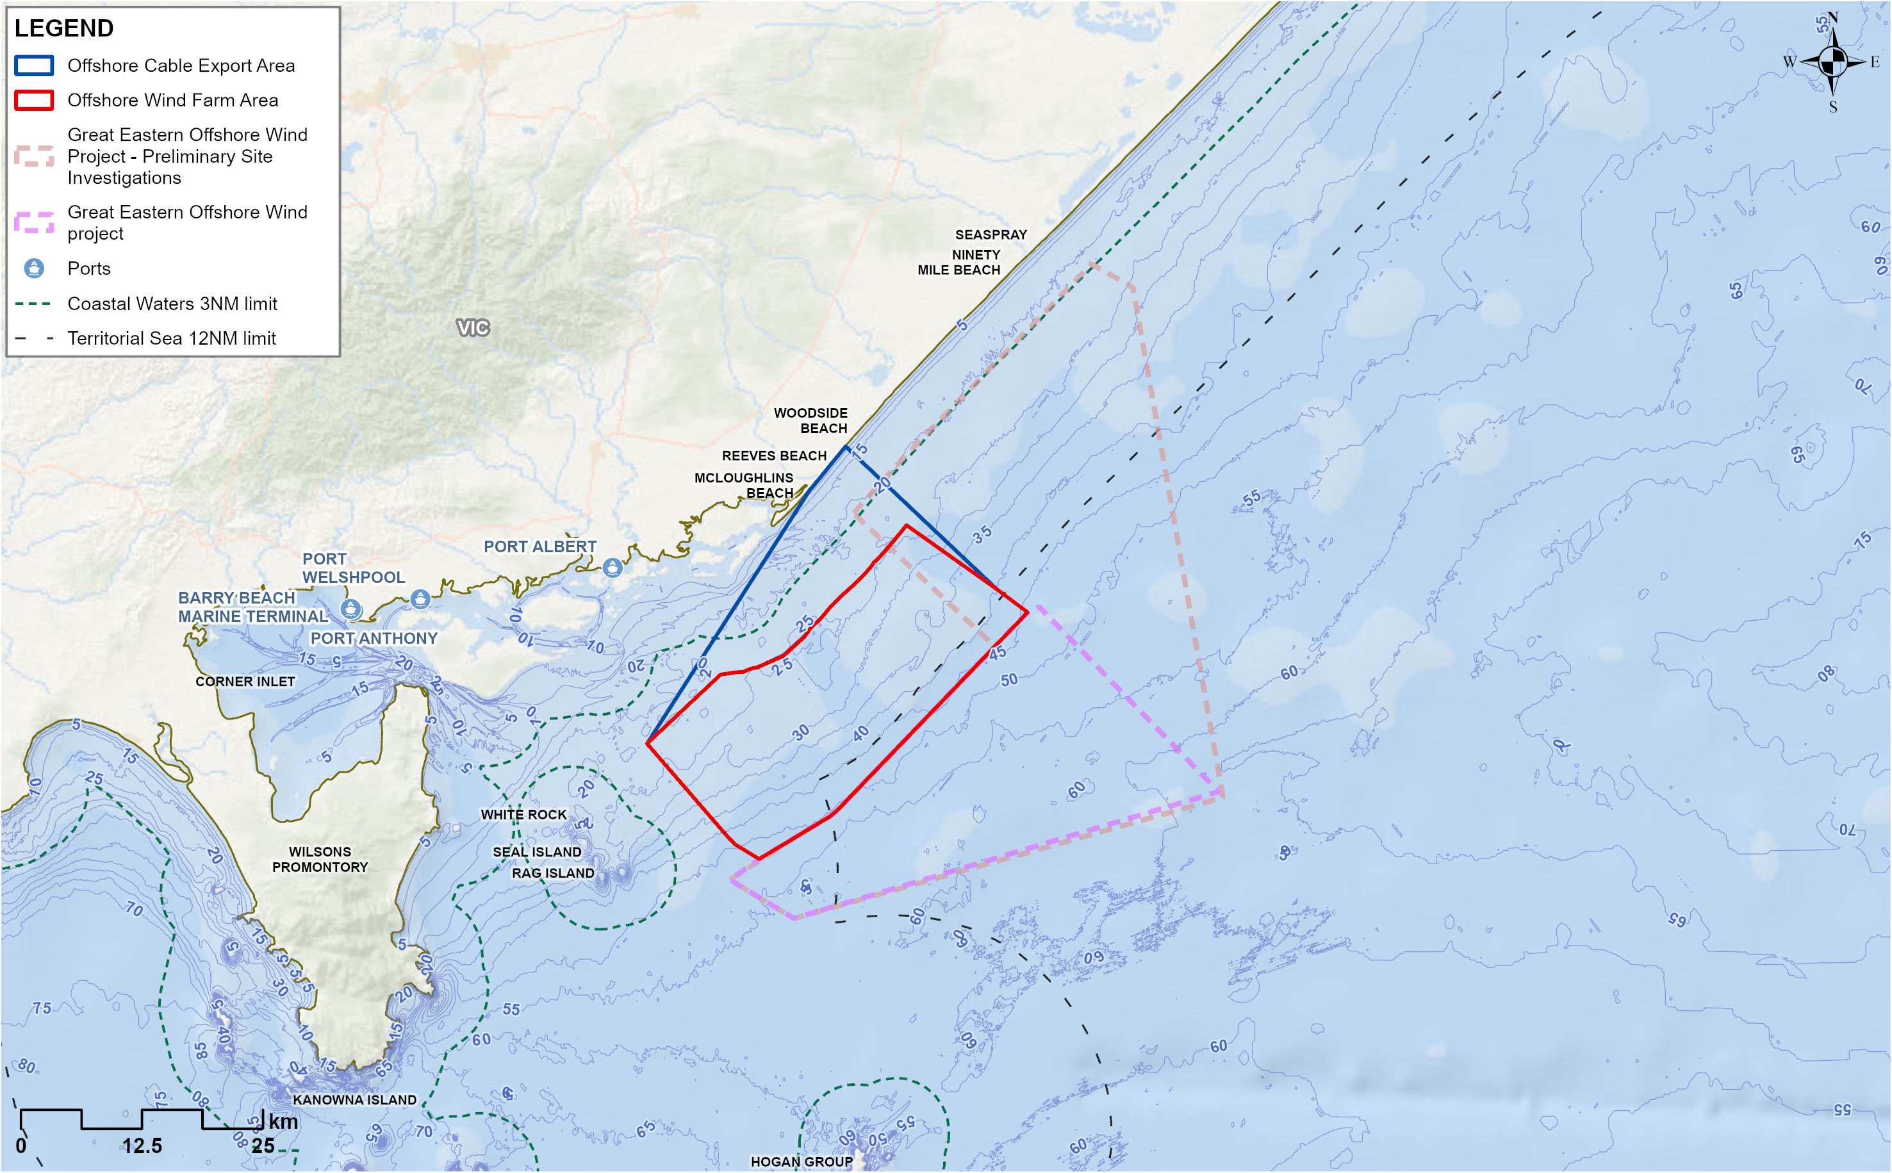

Summary of mitigation, monitoring and contingency measures

Mitigation measures
The following section outlines the mitigation measures developed to avoid and minimise impacts on shipping and navigation within the offshore project area.
The focus of these mitigation measures is:
- Avoiding impacts where possible
- Developing, preparing and implementing project-specific measures to minimise impacts.
The mitigations below have been developed for the impacts and risks discussed in detail within Technical Report P – Shipping and Navigation. Detailed descriptions of each measure can be found in Chapter 23 – Commonwealth Environmental Management Framework and are listed in Table 17-16.
Table 17-16 Mitigation measures relevant to shipping and navigation
Mitigation ID | Mitigation measure | Phase
OFF-M03 | Demarcation areas | Construction and Decommissioning
OFF-M12 | Safety and protection zones | Construction, Operation and Decommissioning
SNV-M02 | Navigational aids and lighting | Construction, Operation and Decommissioning
SNV-M03 | Minimum wind turbine generator air gap | Construction and Operation
SNV-M04 | Cable burial risk assessment | Construction
SNV-M05 | Project vessel safety requirements | Construction, Operation and Decommissioning
VES-M01 | Vessel Operations Framework | Construction, Operation and Decommissioning
VES-M04 | Vessel movement controls | Construction, Operation and Decommissioning
SNV-M07 | Vessel Passage Plan | Construction, Operation and Decommissioning
VES-M03 | Marine coordination centre | Construction and Operation
SNV-M09 | Charting of final layout on navigational charts | Construction
OFF-M22 | Stakeholder consultation | Construction, Operation and Decommissioning
SNV-M11 | Final layout design consultation | Construction
OFF-M10 | Notice to Mariners | Construction, Operation and Decommissioning
LIT-M03 | Operational light intensity – turbines and substations | Operation
SNV-M13 | Area to be avoided around the Offshore Wind Farm Area | Operation
MEMP-M09 | Cable survey and monitoring | Construction and Operation
DEC-M01 | A Marine Decommissioning Management Plan | Decommissioning

Conclusion
Potential impacts to shipping and navigation have been assessed for the construction, operation and decommissioning phases of the project.
Current vessel activity in the offshore project area is generally considered low along with the following key findings:
- Large commercial ships are restricted to the major shipping channel 5.5 nautical miles southeast of the offshore project area.
- Oil and gas service vessels transit from Barry Beach Marine Terminal to the area to be avoided, transiting the offshore wind farm area and using the inner route between the offshore wind farm area and the coast.
- Tourism charters mostly stick close to the islands around Wilsons Promontory for sightseeing and cruise ships are infrequent.
- Commercial fishing does occur within the offshore project area; however, in lower volumes than other more productive fishing grounds in Bass Strait.
- Recreational fishers and boaters predominately remain in inshore waters unless the weather is good where they may travel further offshore into the offshore wind farm area.
Potential impacts are similar for construction, operation and decommissioning. The main impacts relate to the presence of project vessels and fixed infrastructure. This may cause barriers to safe navigation, resulting in the potential for collision, allision and the need to deviate, increasing travel time and distance. All impacts are considered to be of minor or negligible consequence.
The location of offshore export and inter-array cables will be charted and communicated to mariners to reduce the likelihood of anchor snagging. A cable burial risk assessment will also ensure cables are buried to an appropriate depth or protected.
Smaller ports proposed to be used by the project within Corner Inlet currently experience low vessel traffic. Although the project will substantially increase the number of vessel movements, active management of vessels and adherence to safe passing distances will ensure that safety of navigation is maintained.
Mitigation measures for shipping and navigation primarily relate to the application of standard international and Commonwealth laws, regulations and guidelines, as well as best practice guidance for lighting and marking of offshore energy infrastructure and the publication of information. Key measures can be summarised as:
- Vessel traffic management
- Compliance with international and Commonwealth maritime legislation relevant to collision avoidance
- Compliance with lighting and marking guidelines and publication of Notices to Mariners
- Application of safety zones and demarcation areas where applicable.
- Stakeholder communication processes to notify third-party vessels of project activities
- Consultation with relevant authorities regarding the development of the final layout design
- Project design, including cable burial risk assessment, turbine spacing and minimum air gap for turbine blades.
A Project Safety Management Plan will be developed to address the health and safety impacts of collision or allision. Measures proposed in this report to manage navigation constraints and reduce collision / allision risk will also reduce health and safety risks by reducing the likelihood of an event occurring.
In considering the EIS guidelines, the assessment found there will be no significant impacts on shipping and navigation values.

