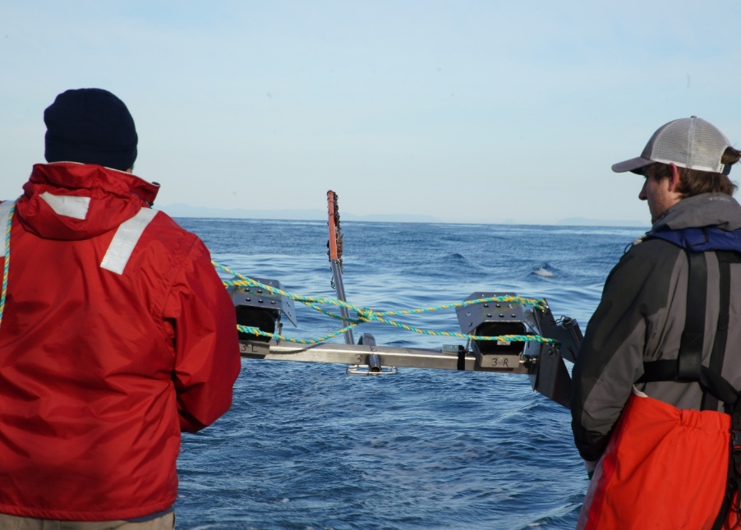

Commonwealth Environmental Impact Statement
Chapter 19 – Submerged Aboriginal cultural heritage

Table of Contents
Chapter 19 Submerged Aboriginal cultural heritage 19-3
19.1 Introduction 19-3
19.2 Assessment scope 19-4
19.2.1 Commonwealth matters 19-4
19.3 Evaluation framework 19-4
19.3.1 Key legislation, policy, guidelines and standards 19-4
19.3.2 Assessment criteria 19-5
19.4 Methods 19-7
19.5 Existing environment 19-9
19.5.1 Desktop research and terrestrial archaeological sensitivity model 19-9
19.5.2 Technical submerged palaeolandscape assessment 19-12
19.5.3 Offshore sensitivity assessment 19-20
19.6 Construction impacts 19-22
19.6.1 Key impacts 19-22
19.6.2 Potential risks 19-24
19.7 Operation impacts 19-25
19.7.1 Key impacts 19-25
19.7.2 Potential risks 19-27
19.8 Decommissioning assessment 19-28
19.9 Cumulative impact assessment 19-29
19.10 Summary of mitigation, monitoring and contingency measures 19-31
19.10.1 Mitigation measures 19-31
19.10.2 Monitoring and contingency measures 19-32
19.11 Conclusion 19-33

Figures
Figure 19-1 The study area and regional model area, defined for the purposes of terrestrial archaeological sensitivity modelling. 19-8
Figure 19-2 Terrestrial archaeological sensitivity model outputs 19-11
Figure 19-3 Locations of the geophysical (seismic lines) and geotechnical (borehole and cone penetration test) data used in the palaeolandscape assessment 19-13
Figure 19-4 Schematic landscape evolution model based on geophysical and geoarchaeological interpretation 19-19

Tables
Table 19-1 Key legislation, policy, guidelines and standards 19-5
Table 19-2 Depositional groupings recorded across the study area and their characteristics, with indication of priority status for targeted geoarchaeological recording. 19-15
Table 19-3 Criteria discriminating relevance of identified layers of sediment (seismic units) 19-16
Table 19-4 Summary of seismic units identified and their potential palaeolandscape interpretation, along with a tentative age for each unit. 19-17
Table 19-5 Summary of palaeolandscape features identified within the seismic units. 19-20
Table 19-6 Residual impacts associated with direct physical damage to submerged Aboriginal cultural heritage receptors 19-23
Table 19-7 Consequence, likelihood and residual risk ranking for the accidental physical damage to submerged Aboriginal cultural heritage receptors 19-24
Table 19-8 Residual impacts associated with indirect physical damage to submerged Aboriginal cultural heritage receptors 19-26
Table 19-9 Residual impacts associated with indirect physical damage to submerged Aboriginal cultural heritage receptors 19-27
Table 19-10 Findings of the cumulative impact assessment 19-29
Table 19-11 Summary of mitigation measures relevant to submerged Aboriginal cultural heritage 19-31
Table 19-12 Summary of monitoring and contingency measures relevant to submerged Aboriginal cultural heritage 19-32

Submerged Aboriginal cultural heritage

Introduction
This chapter summarises the existing conditions related to submerged Aboriginal cultural heritage and assesses the impacts and risks associated with the construction, operation and decommissioning of the Star of the South project (the project) on submerged Aboriginal cultural heritage within the Commonwealth jurisdiction. The chapter describes how impacts will be avoided, minimised or managed.
Submerged Aboriginal cultural heritage is recognised through policies that seek to protect features that can provide a better understanding of the history of the area and any changes over time.
The offshore project area would have been a terrestrial area during the period between 71,000 – 11,000 years ago, coinciding with currently known dates for the earliest human activity in Australia (65,000 years ago). During this time, the offshore project area would have formed part of a land bridge between Victoria and Tasmania. It's possible that the buried sediments below the existing seafloor of the offshore project area could hold potential archaeological values associated with Aboriginal cultural heritage, ancestral association or spiritual meaning.
This chapter is based on the impact assessment presented in Technical Report Z – Submerged Aboriginal Cultural Heritage. This chapter excludes non-Aboriginal underwater cultural heritage which is described and assessed in Chapter 14 – Non-Aboriginal Underwater Cultural Heritage.
Other chapters that relate to or inform the submerged Aboriginal cultural heritage assessment include:
Chapter 8 – Coastal Processes and Sediment Transport
Chapter 9 – Benthic Ecology
Chapter 14 – Non-Aboriginal Underwater Cultural Heritage
Chapter 22 – Seascape, Landscape and Visual

Assessment scope
The study objective for submerged Aboriginal cultural heritage is to assess, avoid and minimise potential effects on Submerged Aboriginal Cultural Heritage associated with construction, operation, and decommissioning of the project.
All detailed technical methodologies and assessment on submerged Aboriginal cultural heritage can be found in Technical Report Z – Submerged Aboriginal Cultural Heritage.
Star of the South recognises that assessing submerged Aboriginal cultural heritage presents some challenges and uncertainties with few practical examples in the Australian context. Star of the South will continue to be guided by Traditional Owner knowledge and emerging practices during the project's further development, construction and operation.

Commonwealth matters
The Environmental Impact Statement (EIS) guidelines for the project inform the preparation of the EIS to enable the Commonwealth Minister for the Environment to make an informed decision on whether to approve the project under the Environment Protection Biodiversity Conservation Act 1999 (EPBC Act).
The aspects of the EIS guidelines that are directly relevant to submerged Aboriginal cultural heritage are:
- Section 2.7 – Relevant impacts, particularly j) the extent, severity and persistence of potential impacts to underwater cultural heritage (European and Indigenous)
Further information about the EIS guidelines is listed in Attachment V – EIS Guidelines Checklist.

Evaluation framework

Key legislation, policy, guidelines and standards
Table 19-1 lists the key legislation, policy, guidelines and standards relevant to submerged Aboriginal cultural heritage within the Commonwealth jurisdiction.
Table 19-1 Key legislation, policy, guidelines and standards
Type | Applicable legislation, policy, guideline or standard
Commonwealth legislation | Environment Protection and Biodiversity Act 1999
Commonwealth legislation | Native Title Act 1993
Commonwealth legislation | Aboriginal and Torres Strait Islander Heritage Protection Act 1984
Commonwealth legislation | Underwater Cultural Heritage Act 2018
Guidelines | Draft Technical Guidelines on the Archaeological Assessment of First Nations Underwater Cultural Heritage in Commonwealth Waters (August 2024)
Guidelines | Sea Country: An Indigenous Perspective. The South-east Regional Marine Plan Assessment Reports. (National Ocean Office 2002)
Guidelines | A Guide to the Protected Zones Declared under the Underwater Cultural Heritage Act 2018. Department of the Environment and Energy. (last updated 2021)
Guidelines | Assessing and Managing Impacts to Underwater Cultural Heritage in Australian Waters: Guidelines on the application of the Underwater Cultural Heritage Act 2018 (June 2024)

Assessment criteria
To assess the project, predicted impacts and risks are compared to criteria that set required environmental performance outcomes (refer Chapter 6 – Assessment Framework).
The criteria for submerged Aboriginal cultural heritage are derived from legislation and policy, relevant standards and guidelines, stakeholder feedback and industry best practice.
The assessment criteria relevant to the Aboriginal cultural heritage study relate specifically to submerged cultural landscapes. Assessment criteria for assessing the cultural significance of a submerged Aboriginal cultural landscape were derived from the Burra Charter (2013) and the Underwater Cultural Heritage Act 2018, alongside consultation with Gunaikurnai Land and Waters Aboriginal Corporation to ensure the assessment reflects appropriate cultural perspectives and methodologies.
In line with the Burra Charter (2013), this assessment also considers cultural significance through the following four values:
- Aesthetic
- Historical
- Scientific (archaeological)
- Cultural (encompassing social and spiritual significance).
Importantly, and particularly in the case of submerged cultural landscapes, Aboriginal cultural heritage value is not limited to discrete, visible sites. It is more likely to include broader landscape-scale values, including submerged landforms such as palaeochannels (former waterways), strandplains (former dunes), and estuarine features. These may hold significance due to potential scientific / archaeological value, ancestral association or spiritual meaning. Aboriginal perspectives may prioritise intangible cultural connections, such as ancestral pathways or memory of Country, even where no material evidence is found.
A palaeolandscape is an ancient landscape that existed thousands or even millions of years ago, shaped by natural forces like rivers, glaciers, or sea-level changes. It’s like a buried snapshot of the Earth’s surface from the distant past, used by scientists to understand how environments and human life has changed over time.
Therefore, for the purpose of this assessment, and in line with current Victorian heritage practice, all identified or potential Aboriginal submerged cultural heritage places are assumed to be of high cultural significance unless Traditional Owner representatives advise otherwise.
An Aboriginal place is a location that holds cultural, spiritual, or historical importance to Aboriginal people. It could be a natural feature like a rock formation or waterhole, an archaeological site with artefacts, or a place where ceremonies, stories, or significant events took place.
Where scientific (archaeological) significance is considered, three key parameters are typically applied:
- Site / landform content – what is or may be present
- Site / landform condition – the integrity or level of disturbance
- Site / landform commonality – how rare or representative the site is.
These factors guided the archaeological assessment criteria, though interpretation may vary between practitioners and is always limited by the extent of available data, especially in submerged contexts where access is constrained. Crucially, scientific significance is not synonymous with cultural significance, which is defined by Traditional Owners and may derive from broader values, stories, or responsibilities to Country.

Methods
The purpose of the submerged Aboriginal cultural heritage impact assessment is to assess the potential impacts and risks of the project on submerged Aboriginal cultural heritage.
Impacts refer to the consequences of planned project actions, which are given a rating determined by combining the magnitude of the impact and the sensitivity of the receptor.
Risks are an unexpected (accidental) event and are determined by combining the likelihood of an event occurring and the consequences that would result if the event were to occur.
The technical chapters consider key impacts and risks with a residual consequence rating of moderate to severe. Other impacts and risks are those with a residual consequence rating of negligible to minor.
Refer to Chapter 6 – Assessment Framework for more detail on how impact and risk ratings are derived.
The assessment was achieved by undertaking the following key tasks:
- Defining a study area which for this assessment includes all locations that may potentially be impacted by project activities. The ‘study area’ comprises the offshore project area, inclusive of the offshore wind farm area and offshore export cable area (refer to Figure 19-1)
- Reviewing national, state and local legislation relevant to protection of conservation values
- Developing an onshore archaeological sensitivity model
- Undertaking a technical submerged palaeolandscape and offshore sensitivity assessment
- Undertaking a proportional assessment of risks and impacts based on the outcomes of the initial assessment of issues and consultation insights that examines the potential severity, extent and duration of identified issues
- Evaluating predicted outcomes against performance benchmarks and assessment criteria derived from applicable legislation, policy and standards
- Identifying mitigation measures where necessary to address potentially significant environmental impacts
- Evaluating residual environmental impacts and risks against assessment criteria, taking into account the proposed mitigation measures and likely effectiveness.
Figure 19-1 The study area and regional model area, defined for the purposes of terrestrial archaeological sensitivity modelling.
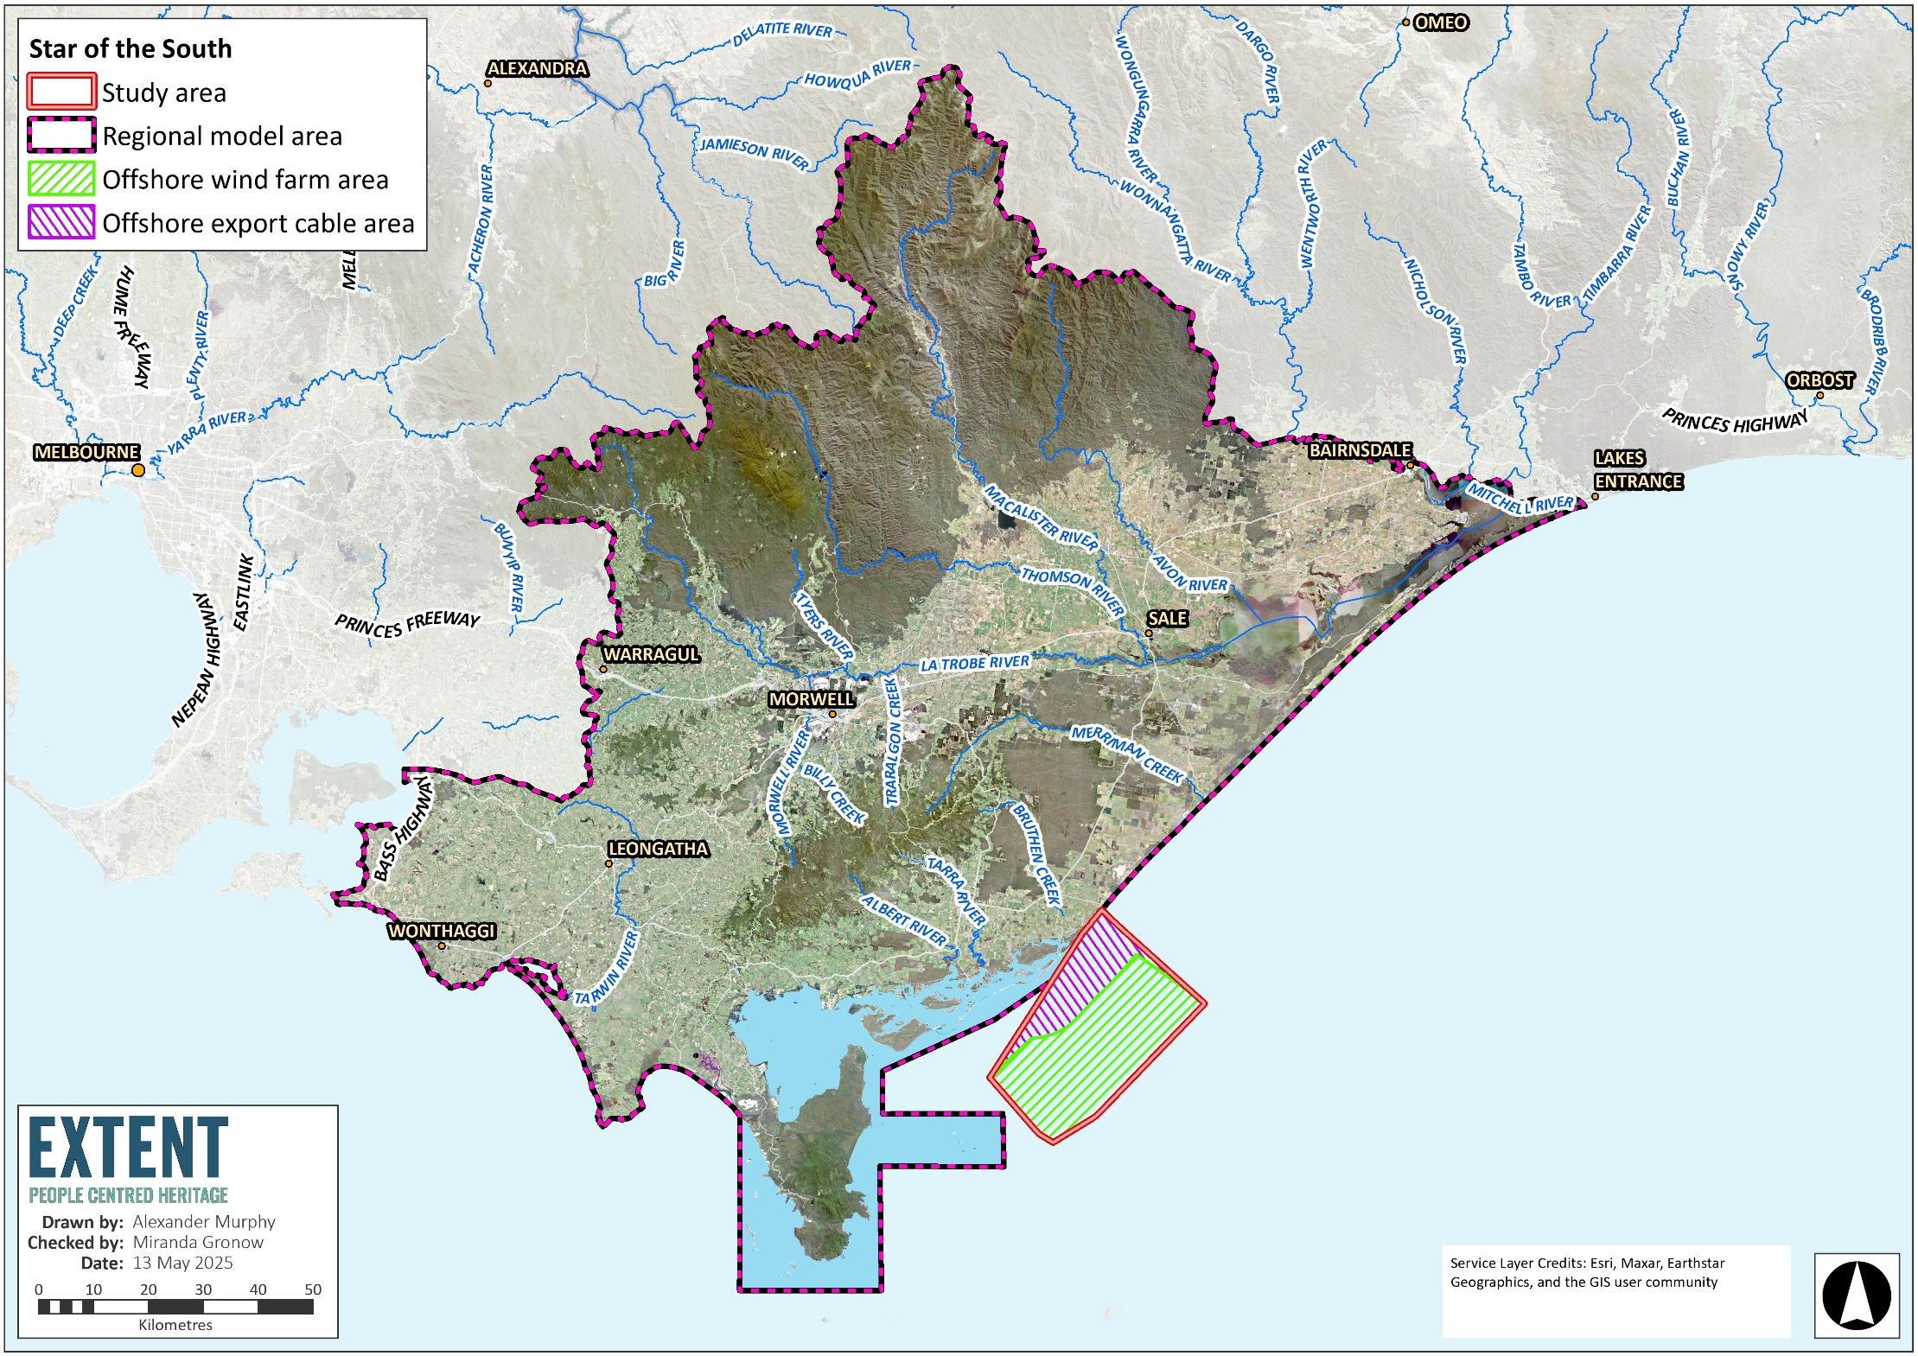
Note The study area is also the offshore project area.

Existing environment
This section describes the existing conditions within the study area, as they relate to submerged Aboriginal cultural heritage. The study area is defined as all locations that may potentially be impacted by project activities. The ‘study area’ comprises the offshore project area, inclusive of the offshore wind farm area and offshore export cable area (refer to Figure 19-1).

Desktop research and terrestrial archaeological sensitivity model
Desktop research was conducted to gain an understanding of the regional area's (see Figure 19-1) environmental context (landscape, geology, geomorphology, soils, climate, hydrology and vegetation), ethnohistory and existing Aboriginal place, to input into the terrestrial archaeological sensitivity model. Information regarding these components is in Technical Report Z – Submerged Aboriginal Cultural Heritage.
This information was used to understand whether the presence of Aboriginal archaeology in the regional area is related to certain landscape features. Environmental, geological, geomorphological and topographical data sets were mapped alongside the locations of each Aboriginal place to understand potential patterns in their distribution (a process termed Aboriginal place component patterning). The process included calculations of the distance from each Aboriginal place to the nearest watercourse and waterbody (lake, swamps, and areas prone to inundation), major road, shell middens and coastline. The density of Aboriginal place components was also assessed against geological units, geomorphological units and vegetation classes. All these results are detailed in Technical Report Z – Submerged Aboriginal Cultural Heritage.
A shell midden is an ancient pile of discarded shells left by Aboriginal people, showing where they gathered and ate shellfish in the past.
The results of the above analyses, along with archaeological reasoning, were used to develop the archaeological sensitivity model illustrated in Figure 19-2.
Based on the results of the predictive modelling, the following general predictive statements about the archaeological sensitivity of the regional model area can be made:
- Areas within 250 metres of any source of fresh water have been assessed to have a higher archaeological sensitivity because of a higher probability for the occurrence of Aboriginal archaeology.
- Areas within 200 metres of the coastline have been determined to have a higher archaeological sensitivity.
- Areas within 200 metres of a wetland, inclusive of its surrounding flora, has been assessed as having a higher archaeological sensitivity.
- Dune systems, especially transgressive dunes, have been assessed to have a higher archaeological sensitivity. It should be noted that the high densities of Aboriginal place components within dune landforms is partially due to these landforms having a high archaeological visibility, meaning that Aboriginal cultural heritage has been able to be observed during surface surveys in exposed areas such as blowouts.
- Other landforms such as terraces, fans, and flood plains, areas of basalt and volcanic flow, and areas with shore platforms have been assessed to have a higher archaeological sensitivity.
It should be noted that the model is primarily based on inductive reasoning from statistical analyses, with some deductive logic (for example, known patterns of land use from ethnohistorical sources or previous archaeological research) used to balance its results. As such, it does not seek to make claims about the significance of archaeological deposits or sites that might be identified outside of this method. Furthermore, the distribution and density of registered Aboriginal place components have been influenced by the location of modern-day development (such as roads) and the focus of previous archaeological surveys.

Figure 19-2 Terrestrial archaeological sensitivity model outputs
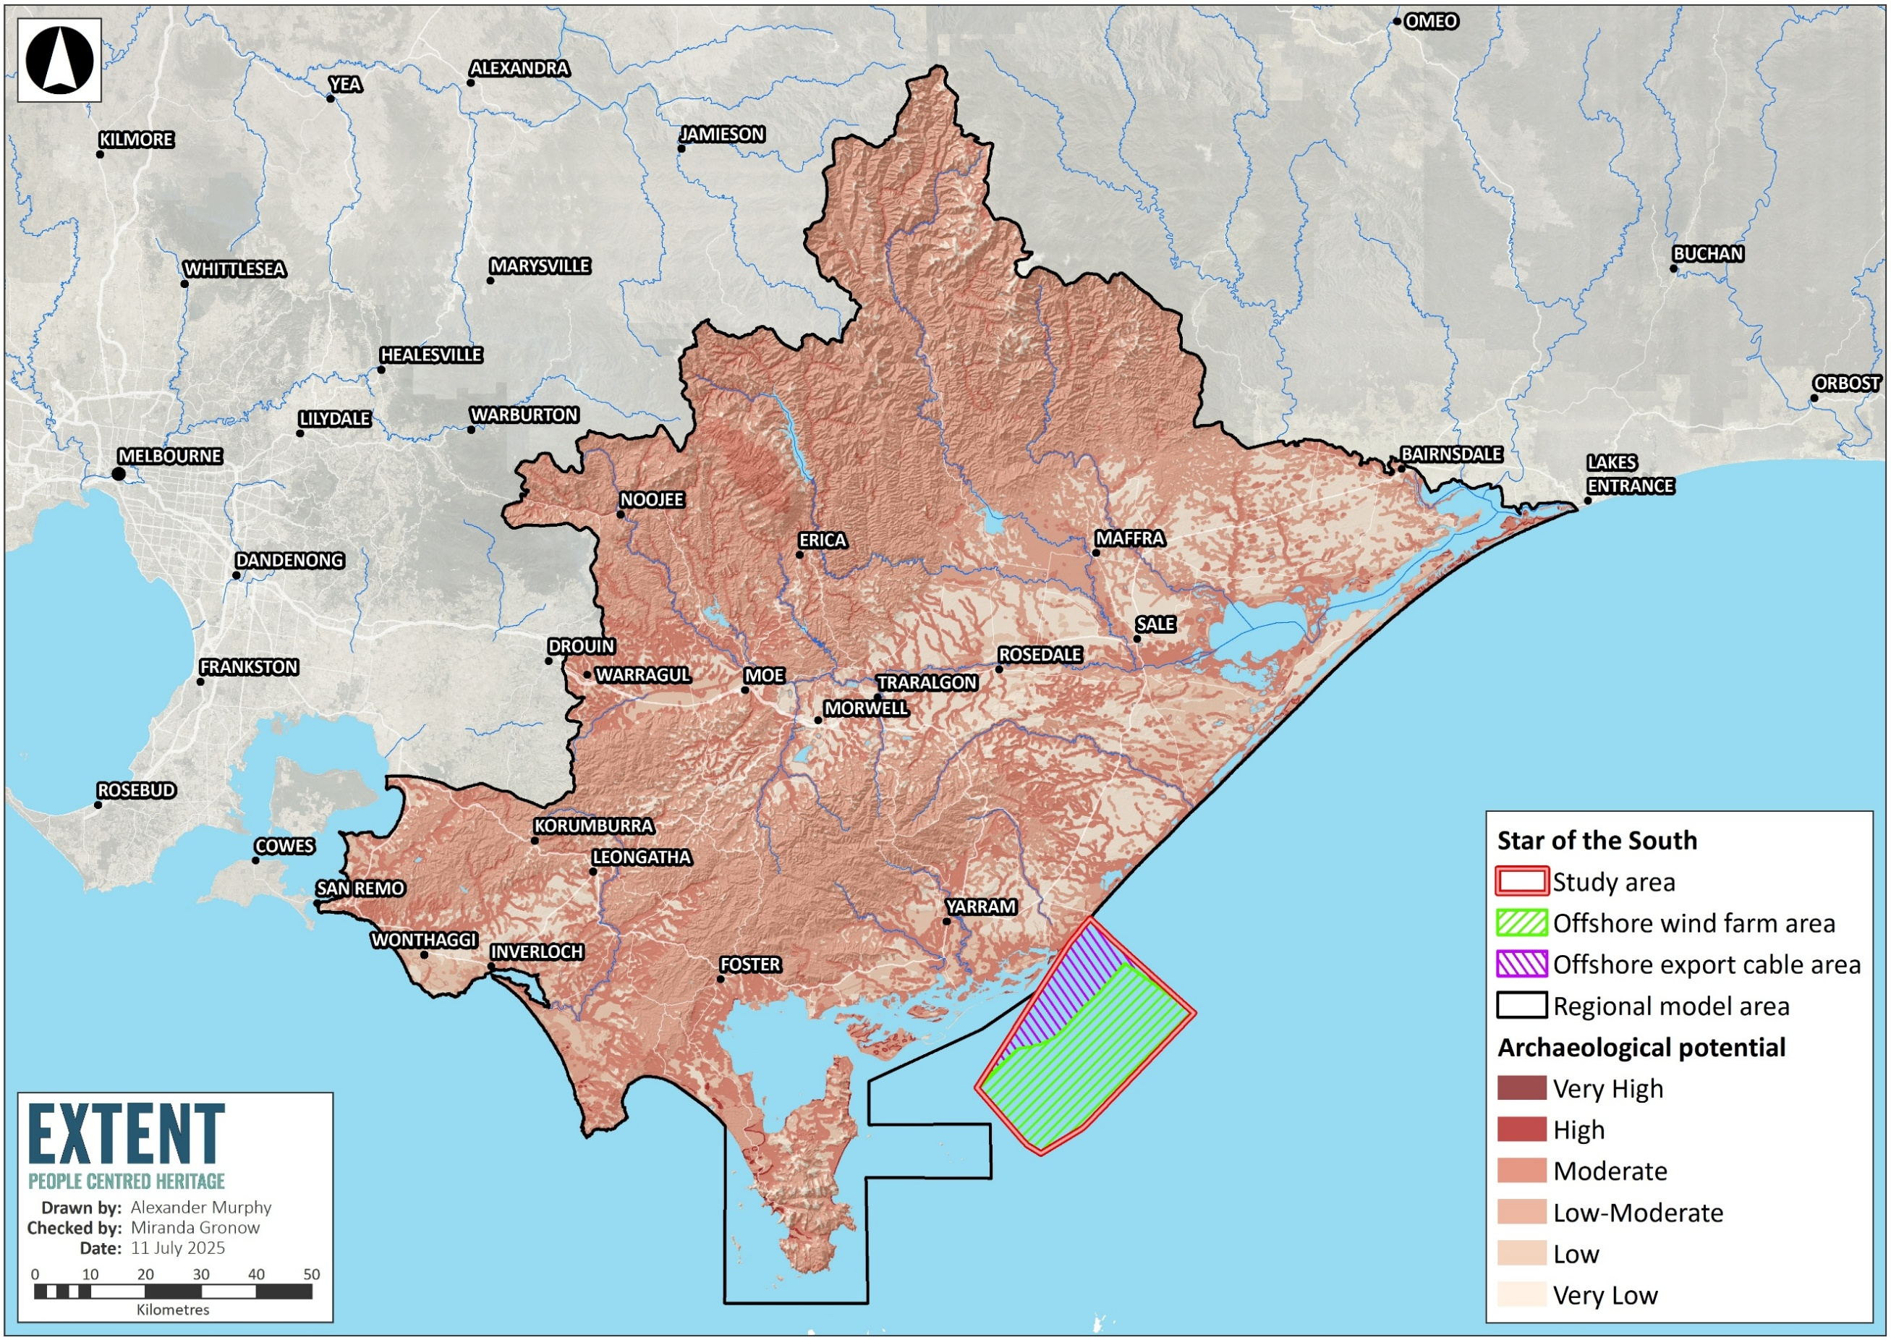

Technical submerged palaeolandscape assessment
The following section is based on the Submerged Palaeolandscape Assessment report in Appendix B of Technical Report Z – Submerged Aboriginal Cultural Heritage.

Regional geological setting
The Gippsland Basin, where the offshore project area is located, was formed during the breakup of Gondwana, with rifting occurring during the Late Jurassic and throughout the Early and Late Cretaceous, before switching to post-rift thermal subsidence. Using sea-level change data throughout the past 140,000 years and the offshore project area's present-day deepest value of 53 metres, it is estimated that the area may have last been out of water and continuously subaerially exposed (a terrestrial environment) somewhat 71,000 years ago up until the beginning of the Holocene approximately 11,000 years ago.
Palaeochannel is an ancient, now inactive river / stream channel that is often preserved as a buried deposit of sediments or a visible feature on the landscape, such as on a floodplain or terrace.
Palaeocoastline is an ancient coastline that existed in the past but has since been submerged, eroded, or shifted due to changes such as sea level.
From what is known of the Quaternary geology (developments over the last 2.58 million years) in the region, palaeochannels and ancient dunes within palaeocoastlines (marked by barrier systems, back barriers, dune islands, estuarine deposits and tidal creek networks) could be preserved beneath the overlaying sediments of the offshore project area.
The geoarchaeological assessment and the geophysical submerged palaeolandscape assessments were undertaken using datasets from the project's marine geotechnical and geophysical survey campaign in 2023. The positions of these surveys are shown in Figure 19-3 and discussed further in the following sections
Figure 19-3 Locations of the geophysical (seismic lines) and geotechnical (borehole and cone penetration test) data used in the palaeolandscape assessment
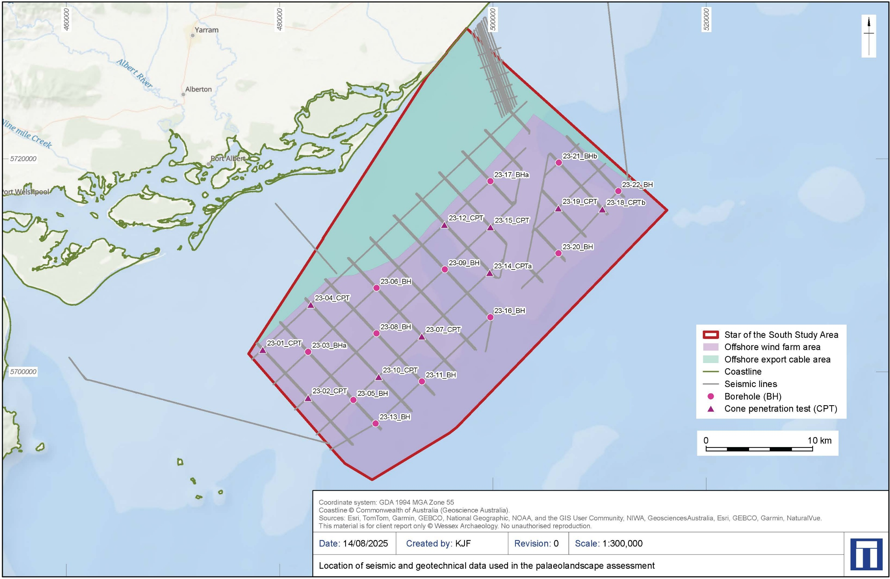

Geoarchaeological assessment
The geotechnical surveys aimed to investigate sediment characteristics which included 12 borehole locations (Figure 19-3), allowing seabed sediments to be continuously sampled and photographed between depths of 0.0 to 71.6 metres below the seabed. A trained geoarchaeologist reviewed the samples and photographs to identify sedimentary features including oxidised, organic and fine-grained deposits.
Geotechnical surveys are an investigation of the seabed. This entails methods like digging, drilling and testing soil and rock to understand the seabed's underlying properties.
The archaeological value of palaeoenvironmental material within sediments lies in its potential to provide dating evidence and information to reconstruct the palaeoenvironment, which informs the understanding of potential human use and occupation of the landscape. Organic-rich sediments are most likely to preserve archaeological material as they may be archives of former terrestrial, fluvial, marshland or coastal environments.
Seven broad geoarchaeological units were identified across the study area. Three of these potentially reflect deposits with moderate-high geoarchaeological potential for reconstructing submerged palaeolandscape features. High priority units were those which contained material reflective of former terrestrial environments and have the potential to contain preserved archaeological material. These comprise fine-grained deposits (silts and clays) and include organic material. Low priority units were those which contained material consistent with seabeds which are unlikely to contain preserved archaeological material.
Fine-grained sediments reflect low-energy deposition, where sediments are deposited without significant erosion as might occur within a floodplain or estuarine landscape. Given the depth of aggradation, they might reflect a long-lived depositional feature, such as a lake or pond, channel, or lagoon.
Such deposits were present within all boreholes, especially between 15 to 20 metres below seabed and are summarised in Table 19-2.

Table 19-2 Depositional groupings recorded across the study area and their characteristics, with indication of priority status for targeted geoarchaeological recording.
Depositional unit | Characteristics | Geoarchaeological priority
Seabed | Yellow-brown calcareous silty fine-coarse sand with frequent shell fragments at surface of seabed.Gravel is sometimes noted. | Low
Sand | Grey to greenish grey, generally dense to very dense, silty calcareous sand, with traces of shell fragments. Coral fragments are occasionally noted. | Low
Gravelly sand | Grey to greenish-grey sands with a significant coarse component and gravel-sized clasts. Clast-type not specified. | Low
"Shell gravel" | Dense to very dense greenish-grey poorly sorted fine to coarse gravelly sands. Angular to sub-rounded shell fragments. | Moderate
Fine grained deposits | Beds of silts and clays within fine sands; bedded silts, and high-strength clays. Bedding within fine grained units is sometimes noted, including clay laminae and partings within sand: sometimes 'pockets' of clay within fine sand are noted. | Moderate
Fine grained laminated deposits | Silty sand with thin silt laminae or clay laminae. Thinly laminated dark greenish grey clay. | Moderate
Fine-grained sediments with organic material | Fine-grained sediments within which an organic component (material/matter) has been recorded | High

Geophysical submerged palaeolandscape
The geophysical surveys aimed to:
Seismic data from geophysical surveys is equivalent to an ultrasound for the Earth. It uses sound waves and the way these waves reflect off the seabed can reveal the layers of sediment and rock hidden below.
- Identify distinct layers of sediment in the seismic data, referred to as seismic units
- Identify any palaeolandscape features, such as palaeochannels or relict coastal features, visible within the seismic units
- Build a conceptual model of the geological evolution of the study area to inform archaeological potential.
A seismic unit is a body of rock that can be distinguished and mapped in seismic data because it has consistent internal reflection patterns and is bounded above and below by seismic horizons (surfaces where the reflection character changes noticeably).
Five seismic units were identified in seismic data and in combination with the results from geoarchaeological assessment were interpreted geologically and stratigraphically (according to layers). Based on the conceptual geological evolution of the area, interpreted (discriminated) palaeolandscape features were assigned an archaeological discrimination, that are described in Table 19-3 below. These discriminations form the basis of the receptor groups for the impact and risk assessment.
Table 19-3 Criteria discriminating relevance of identified layers of sediment (seismic units)
Overview classification | Archaeological discrimination | Criteria
Palaeogeographic features | P1 | Feature of archaeological interest, either because of its palaeogeography or high potential for preserving archaeological or palaeoenvironmental material. Features are within stratigraphic units judged to be coeval with known human activity in the study area.
Palaeogeographic features | P2 | Feature of possible archaeological, geoarchaeological and palaeogeographic interest, because it has some potential for preserving archaeological, geoarchaeological, and palaeoenvironmental records. Features or strata may be of uncertain date or unclear formation.
Non-archaeological features | U2 | Known non-archaeological feature / Feature not of archaeological interest. Features may be extensively reworked, previously impacted, with poor or no survival of in situ archaeological or palaeoenvironmental data.

Four key horizons or sediment layer boundaries, plus the seabed, were identified based on distinct changes in reflection geometry, implying a change in depositional setting or a break in deposition and/or period of erosion. These four horizons separate the five seismic units identified in the geophysical survey data and are described in Table 19-4 below. Where geotechnical locations overlapped seismic survey lines, the geoarchaeological interpretation was combined to enhance the overall palaeolandscape interpretation.
Table 19-4 Summary of seismic units identified and their potential palaeolandscape interpretation, along with a tentative age for each unit.
Seismic unit | Top horizon | Base horizon | Palaeolandscape interpretation | Tentative age | Archaeological discrimination
5 | Seabed | H10 | Marine sediments, no palaeolandscape potential | 11,700 years ago, to present | P2
4 | H10 | H20 | Likely to comprise coastal, aeolian and fluvial/alluvial sediments with potential organic material | 80,000 to 11,700 years ago | P1
3 | H20 | H25 | May comprise fluvial sediments underneath marine sediments, with potential for organic material in lacustrine or estuarine units | Marine sediments –125,000 years ago or earlier  Terrestrial sediments –191,000 years ago or earlier | P2
2 | H25 | H30 | May comprise fluvial sediments underneath marine sediments, with potential for organic material in lacustrine or estuarine units | Marine sediments – 243,000 years ago or earlier  Terrestrial sediments –300,000 years ago or earlier | P2
1 | H30 | - | May comprise fluvial sediments underneath marine sediments, with potential for organic material in lacustrine or estuarine units | Marine sediments – 557,000 years ago or earlier  Terrestrial sediments – 374,000 years ago or earlier | P2

Palaeolandscape assessment summary
The archaeological assessment of the submerged palaeolandscape, based on geophysical and geotechnical data, has identified units within the seabed that record the cycles of sea level rise and fall. Within each seismic unit, specific morphologies (channels, depressions, and mounds) were identified as features that could hold archaeological significance (refer to Figure 19-4).
These potential paleolandscape features in each unit are in Table 19-5 and summarised as follows:
- Unit 4 sedimentary layers extensive across the study area correlates with palaeolandscape development thought to be associated with the period approximately 70,000 to 11,000 years ago and is judged to be of higher scientific value (P1, see Table 19-3) because of its higher potential for preserving archaeological or palaeoenvironmental material
- The base and top of unit 4 preserves landscape features identifiable within the geophysical data, including depressions, channels, and mounds, comprising:
  - 138 features of P1 discrimination, being of probable archaeological interest, either because of its palaeogeography or potential for preserving archaeological or palaeoenvironmental material
- Units 1, 2 and 3 are below unit 4, and undated. They also preserve the bases of channels but are more heavily eroded and may represent earlier phases of marine regression and transgression. These units may reflect palaeolandscape development prior to the current data of human activity in the region and are currently characterised as P2 features, comprising:
  - 20 features of P2 discrimination, being of possible archaeological interest due to their location within units 1, 2 or 3 and of unknown date.
Figure 19-4 Schematic landscape evolution model based on geophysical and geoarchaeological interpretation
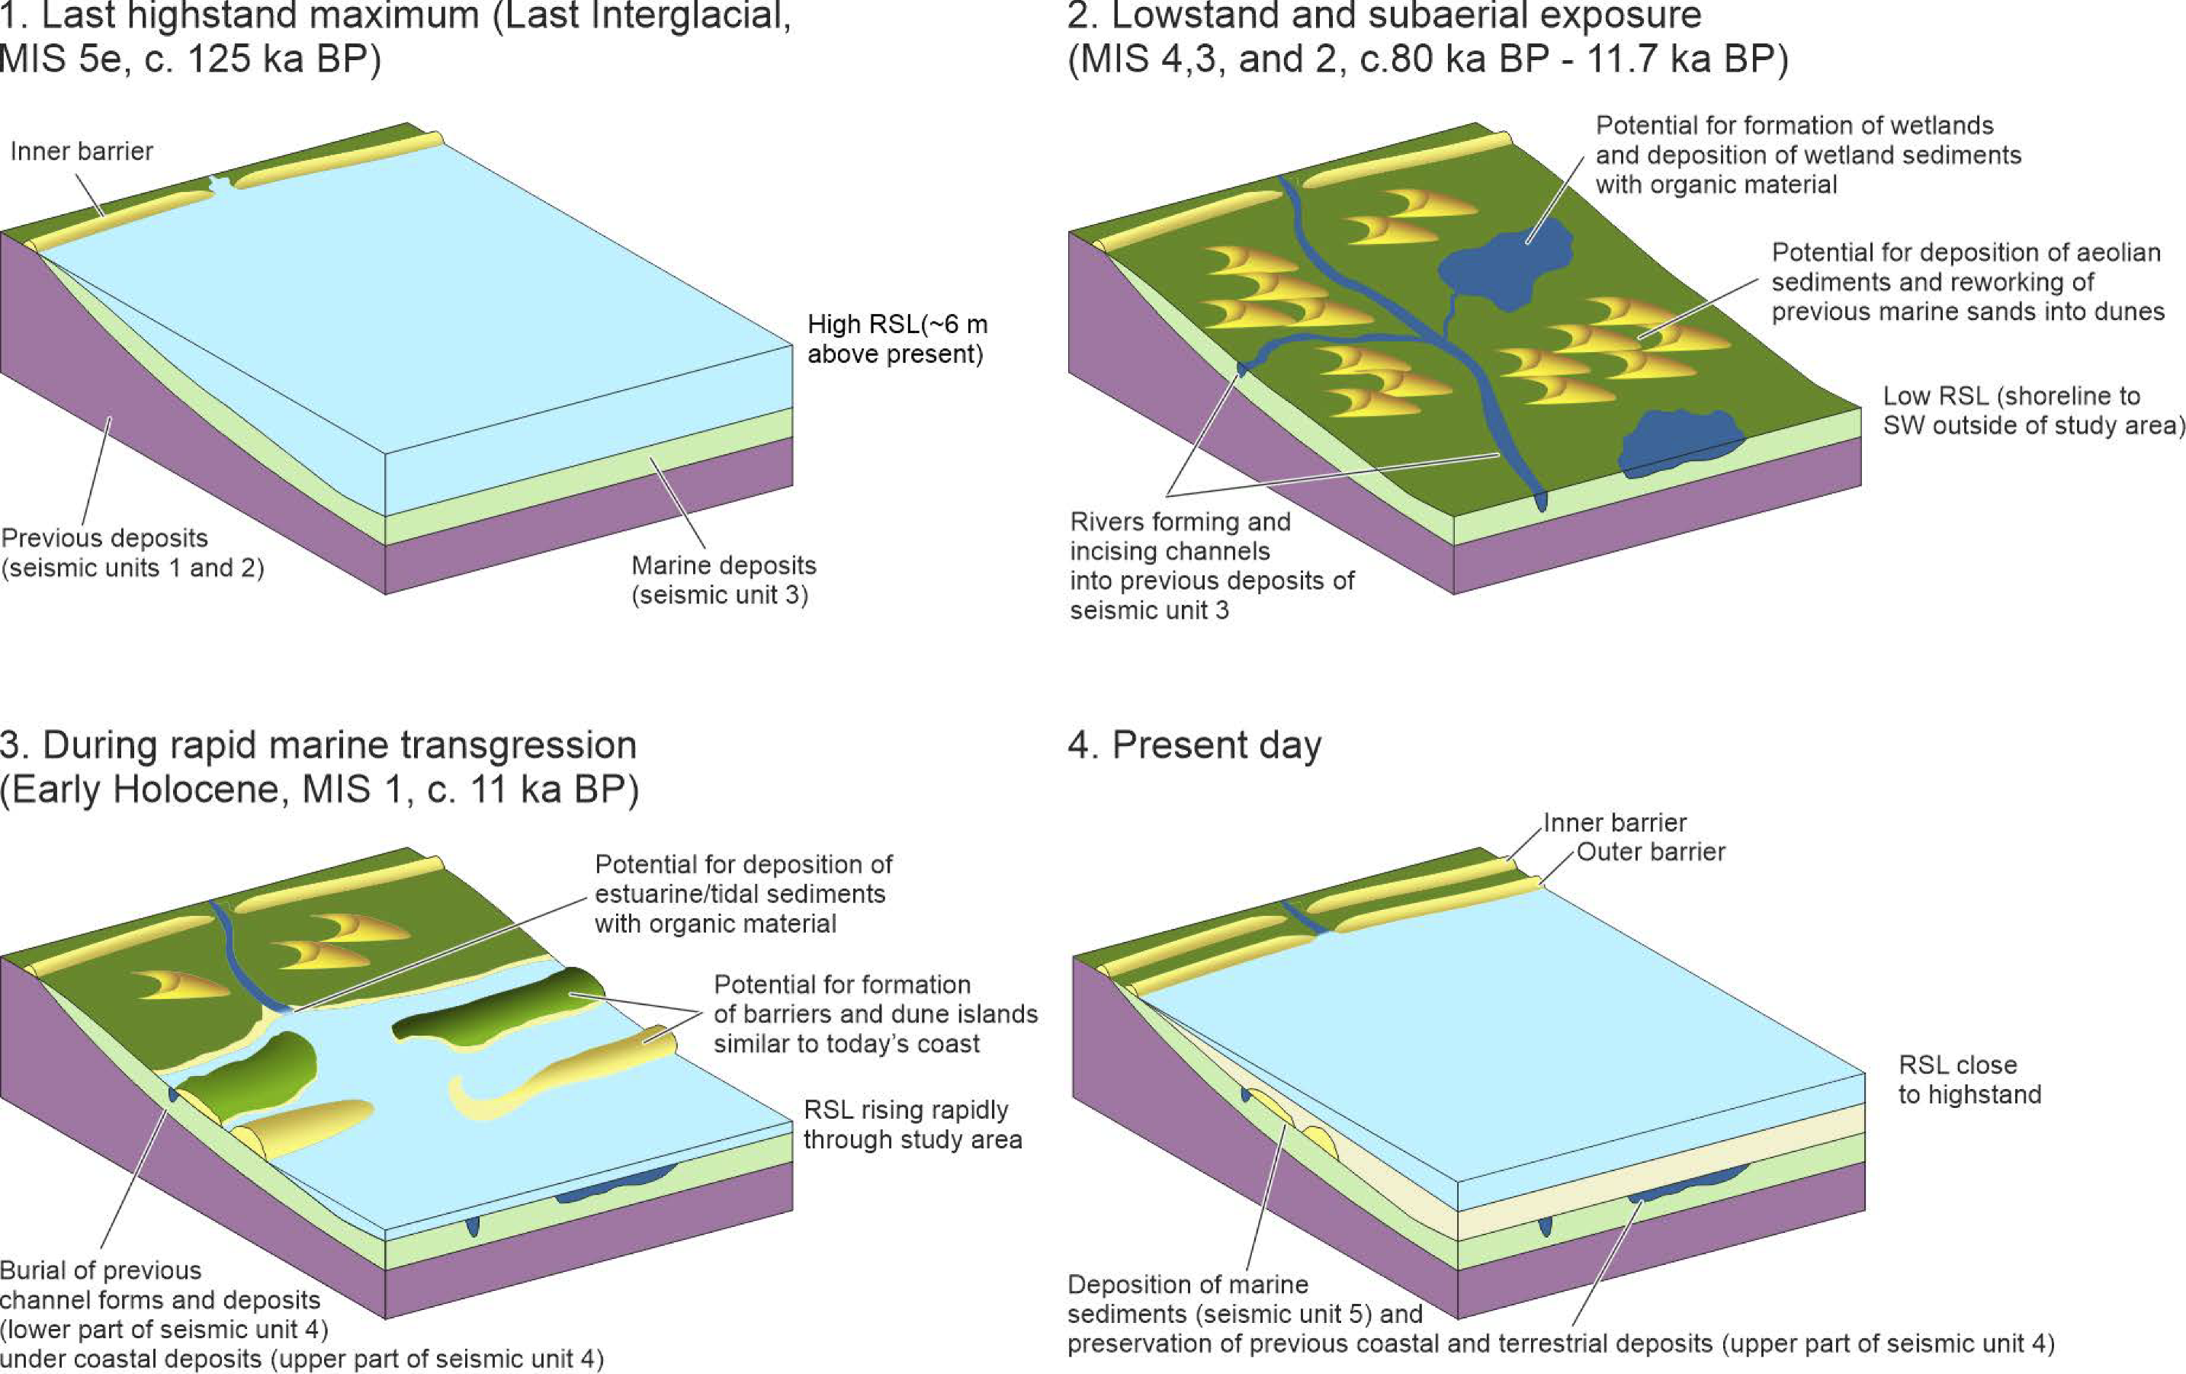
Table 19-5 Summary of palaeolandscape features identified within the seismic units.
Palaeolandscape feature classification | Definition | Seismic unit 1  (all P2) | Seismic unit 2  (all P2) | Seismic unit 3  (all P2) | Seismic unit 4  (all P1) | Seismic unit 5  (all P2)
Basin | A broad topographic low, broader than a depression feature, incising into strata below | 0 | 0 | 0 | 8 | 0
Depression | A topographic low which is not as broad as a basin feature incising into the strata below | 0 | 0 | 0 | 4 | 0
Mound | A topographic high, interpreted as preserved dunes or dune systems | 0 | 0 | 0 | 54 | 0
Palaeochannel | A channel feature incised into strata | 0 | 6 | 12 | 64 | 0
Palaeochannel / basin | A channel feature alongside a broader topographic depression, possibly related to the fluvial deposit, i.e., a flood plain | 0 | 1 | 1 | 6 | 0
Palaeochannel / gas chimney | A palaeochannel with a potential gas chimney identified | 0 | 0 | 0 | 1 | 0
Unit | The seismic units interpreted, ascribed potential based on their geological and stratigraphic interpretation | 1 | 1 | 1 | 1 | 1
Total |  | 1 | 8 | 14 | 138 | 1

Offshore sensitivity assessment
Current dates for the earliest human activity in Australia dates to around 65,000 years ago. During the whole of the period between 71,000 to 11, 000 years ago the offshore project area would have been a terrestrial area, with sea level fluctuating between 65 and 125 metres below current levels putting the coastline between approximately 35 km and 100 km to the southwest of the offshore project area. During this period the area would have been connected to Tasmania across a land bridge.
The offshore sensitivity assessment draws on results from the terrestrial archaeology sensitivity model (Section 19.5.1) which indicates the landforms and areas that Aboriginal people would have likely used in the past, based on a combination of statistical analysis of Aboriginal place component patterning and archaeological reasoning.
With this understanding, results from the technical assessment of the submerged palaeolandscape (Section 19.5.2) can be used as a potential indication for areas that could contain and preserve Aboriginal cultural heritage.
Landforms identified as having higher archaeological sensitivity on land were also identified within the marine geophysical data of the study area, specifically:
- Depressions, basins, and palaeochannel features representative of river channels, unidentified water-bodies and wetlands.
- Dunes and dune systems.
No Aboriginal archaeological site with original and undisturbed Aboriginal cultural heritage material has yet to be identified underwater around Australia. Investigations by the Deep History of Sea Country project off Murujuga in Western Australia are the first large-scale, in-depth investigations specifically aimed at locating submerged Aboriginal cultural heritage to have produced material culture from the seabed. The lithics found on the seabed off Murujuga demonstrate the potential for Aboriginal cultural material to be preserved in a relatively good condition underwater. However, these objects were found without clear stratigraphic or dateable contexts, and as a result questions remain about their origin and date.
The terrestrial model is based, in part, on archaeological data from the actual landform types, not just the underlying geology and geomorphology in isolation. There is currently no equivalent archaeological dataset for the pre-inundation, now-submerged, terrestrial landscapes around Australia’s coasts, so the actual potential for the preservation of archaeological material is currently still unknown. At present, no Aboriginal cultural heritage material has been identified by submerged landscape assessments in Australia.
As indicated above, there is potential for archaeological and palaeoenvironmental remains to be preserved within these palaeolandscape features listed in Table 19-5, and these features are broadly equivalent to landforms that were preferentially used by Aboriginal people in the terrestrial model.

Construction impacts
This section discusses the impacts and risks associated with the construction of the project that relate to submerged Aboriginal cultural heritage and the respective receptor groups.

Key impacts
Key impacts to submerged Aboriginal cultural heritage during the construction of the project are the direct physical damage to respective receptors (SACHI001).

Direct physical damage to submerged Aboriginal cultural heritage receptors (SCH-I001)

Potential impact
Construction activities including site preparation for cables and installation of cables, shore crossing works, foundation piling for offshore wind turbines and offshore substations, and vessel activities could directly damage submerged Aboriginal cultural heritage.
The potential impact from piling and trenching is higher as these activities could interact or pass through more than one palaeolandscape feature. The P1 receptors are considered to have a high sensitivity to this impact pathway given their greater preservation potential for ancient Aboriginal artefacts. As this impact pathway is considered to be of a medium magnitude and the receptor sensitivity considered high, initial consequence ratings for P1 receptors are considered Major (Table 19-6).

Mitigation
Impacts will be mitigated by undertaking an updated submerged palaeolandscape assessment, using further pre-construction geotechnical and geophysical survey campaign datasets (SCH-M001) and geoarchaeological assessment of geotechnical logs and samples (SCH-M002). The updated submerged palaeolandscape assessment will provide more resolution of potentially sensitive features and will be used to inform:
- An Underwater Cultural Heritage Management Plan (SCH-M004 and SCH-M008) with monitoring and contingency measures relating to both non-Aboriginal underwater cultural heritage and Submerged Aboriginal cultural heritage in Commonwealth Waters. An unexpected finds construction protocol will be developed to detail a process when encountering unexpected submerged Aboriginal cultural heritage (SCH-M006).

Residual impact
By implementing these mitigation measures, the magnitude of direct physical impacts on submerged Aboriginal cultural heritage receptors is reduced to a rating of low, ensuring that construction activities can proceed while safeguarding and respecting cultural values. As a result, residual impacts are considered moderate and minor for P1 and P2 receptors, respectively (Table 19-6).
Table 19-6 Residual impacts associated with direct physical damage to submerged Aboriginal cultural heritage receptors
Potential Impact | Receptor  Group | Receptor sensitivity | Magnitude | Initial consequence | Mitigation | Residual Consequence
Impact of direct physical damage to Submerged Aboriginal Cultural Heritage receptors | P1 | High | Medium | Major | SCH-M001 SCH-M002 SCH-M004 SCH-M005 SCH-M006 SCH-M008 | Moderate
 | P2 | Medium | Medium | Moderate | SCH-M001 SCH-M002 SCH-M004 SCH-M005 SCH-M006 SCH-M008 | Minor

Potential risks
A potential construction risk is the accidental physical damage to Submerged Aboriginal cultural heritage receptors (SCH-R001).

Risk of accidental physical damage to submerged Aboriginal cultural heritage receptors (SCH-R001)

Potential risk
Construction activities pose a risk of unexpected physical interactions between equipment and submerged cultural heritage receptors such as minor scarring and complete removal or destruction of parts of landscape features.

Mitigation
As an initial mitigation measure, an unexpected finds protocol construction would be developed to detail a process to follow when encountering unexpected submerged Aboriginal cultural heritage (SCH-M006) to minimise impacts.

Residual risk
With mitigation measures in place, the likelihood of the risk occurring is considered possible for both receptors, and with a moderate consequence for P1 and minor consequence for P2 receptors, the residual risk rating is considered medium for both groups (Table 19-7).
Table 19-7 Consequence, likelihood and residual risk ranking for the accidental physical damage to submerged Aboriginal cultural heritage receptors
Potential Risk | Receptor  Group | Receptor sensitivity | Initial likelihood | Consequence | Initial risk ranking | Mitigation | Residual risk ranking
Risk of accidental physical damage to Submerged Aboriginal Cultural Heritage receptors | P1 | High | Rare | Moderate | Low | SCH-M004 SCH-M005 SCH-M006 SCH-M008 | Low
 | P2 | Medium | Rare | Minor | Very low | SCH-M004 SCH-M005 SCH-M006 SCH-M008 | Very low

Operation impacts
This section discusses the impacts and risks associated with the operation of the project that relate to submerged Aboriginal cultural heritage.

Key impacts
Key impacts to submerged Aboriginal cultural heritage during the operation of the project include:
- Indirect physical damage to Submerged Aboriginal cultural heritage receptors (SCH-I002)
- Disturbance to seabed from anchoring of maintenance vessels (SCH-I003).

Indirect physical damage to submerged Aboriginal cultural heritage receptors (SCH-I002)

Potential impact
Altered hydrodynamics and coastal processes caused by the presence of installed infrastructure such as turbines and scour protection could lead to localised changes in sediment transport and seabed stability. These changes could potentially lead to indirect physical impacts to submerged Aboriginal cultural heritage, such as through removal of protective sediment coverage that reduces protection for buried receptors.
While some small-scale changes to the seabed may occur Technical Report A - Coastal processes and sediment transport, found that their magnitude is significantly less than the natural annual variability and were assessed as negligible magnitude in relation to Submerged Aboriginal Cultural Heritage. The extent of any changes to sediment movement is expected to be limited to the area immediately surrounding the infrastructure. The likelihood of exposing or destabilising submerged cultural heritage receptors beyond the construction footprint is minor to negligible.

Mitigation
As an initial mitigation measure, an unexpected finds protocol construction would be developed to detail a process to follow when encountering unexpected submerged Aboriginal cultural heritage (SCH-M006) to minimise impacts.

Residual impact
The magnitude of this impact pathway is low, therefore residual impacts are considered minor and negligible for the high sensitivity P1 and medium sensitivity P2 receptors, respectively (Table 19-8).
Table 19-8 Residual impacts associated with indirect physical damage to submerged Aboriginal cultural heritage receptors
Potential Impact | Receptor  Group | Receptor sensitivity | Magnitude | Initial consequence | Mitigation | Residual Consequence
Impact of indirect physical damage to Submerged Aboriginal cultural heritage receptors | P1 | High | Negligible | Minor | SCH-M001 SCH-M002 SCH-M004 SCH-M005 SCH-M006 SCH-M008 | Minor
 | P2 | Medium | Negligible | Negligible | SCH-M001 SCH-M002 SCH-M004 SCH-M005 SCH-M006 SCH-M008 | Negligible

Disturbance to seabed from anchoring of maintenance vessels (SCH-I003)

Potential impact
During maintenance activities, disturbance to the seabed from the anchoring of maintenance vessels within the offshore project area could impact submerged Aboriginal archaeological material occurring in shallower sediment layers.

Mitigation
Where disturbance does occur, impacts would be highly localised and short-term, but potentially irreversible for the specific receptor affected. If accidental impacts are observed to occur, an unexpected finds protocol would be triggered to identify steps for managing unexpected submerged Aboriginal archaeological material (SCH-M005).

Residual impact
The magnitude of this impact pathway is low therefore residual impacts are considered moderate and minor for the high sensitivity P1 and medium sensitivity P2 receptors, respectively (Table 19-9).
Table 19-9 Residual impacts associated with indirect physical damage to submerged Aboriginal cultural heritage receptors
Potential Impact | Receptor  Group | Receptor sensitivity | Magnitude | Initial consequence | Mitigation | Residual Consequence
Disturbance to seabed from anchoring of maintenance vessels within the spatial extent of the operation project parameters | P1 | High | Low | Moderate | SCH-M004 SCH-M005 SCH-M006 SCH-M008 | Moderate
 | P2 | Medium | Low | Minor | SCH-M004 SCH-M005 SCH-M006 SCH-M008 | Minor

Potential risks
A potential operation risk is the accidental physical damage to submerged Aboriginal cultural heritage receptors (SCH-R002).

Risk of accidental physical damage to submerged Aboriginal cultural heritage receptors (SCH-R002)

Potential risk
Similar to the construction phase, the risk of accidental physical damage to submerged Aboriginal cultural heritage receptors may also arise during operations (Section 19.6.2). The risk of physical damage may arise from unplanned seabed interaction outside of designated areas, for example navigational errors or the need to anchor in an unplanned position due to an emergency. This has been assessed the same as for during construction, with the same mitigation measures to be implemented, as described in Section 19.6.2.

Decommissioning assessment
Decommissioning is expected to involve similar types and numbers of vessels and equipment as the construction phase. Requirements at the time will determine the scope of decommissioning activities and impacts. The anticipated duration is up to three years.
A Marine Decommissioning Management Plan (DEC-M01) will be developed prior to decommissioning to assess the potential impacts from the final agreed methodologies of removing offshore infrastructure.
Note that following the removal of turbines, substations and foundations at decommissioning, any modification of the winds, waves and currents (assessed for the operation phase) would cease.

Cumulative impact assessment
This section provides an assessment of the potential for cumulative impacts of the project with other proposed developments in the region. The method to consider cumulative impacts is described in Chapter 6 – Assessment Framework.
Potential cumulative impacts arise when the effects of a single project on a receptor are considered alongside the effects of other projects on the same receptor. Projects that are operational are part of the baseline environment, and the cumulative impact assessment focuses on future developments following the tiered assessment methodology.
Only one project / action falls within the zone of influence and taken forward to the cumulative impact assessment, the marine survey investigations for Ørsted’s Gippsland Offshore Wind Farm.
The project identified in the cumulative impact assessment relevant to submerged Aboriginal cultural heritage is summarised in Table 19-10.
Table 19-10 Findings of the cumulative impact assessment
Project or action | Project description | Findings of assessment
Gippsland Offshore Wind Farm Marine Survey Investigations (Ørsted) | This EPBC referral is intended to cover the marine field investigations that include:  - marine geophysical (GP) and geotechnical (GT) surveys to be undertaken within the offshore marine environment. This will inform the impact assessments and approvals for the Project as well as the engineering design for the Project.  - marine surveys required to inform the impact assessments.  - wind measurement surveys using Floating LiDAR (buoy/uncrewed surface vessel (USV)) to establish turbine locations for optimum Annual Energy Production (AEP). | Spatial relevance: located across the Star of the South project area.  Temporal relevance: at the time of writing, the timings of the proposed surveys are unknown.  Potential cumulative risk pathway:  activities that directly interact with the seabed resulting in direct physical damage to submerged palaeolandscape features.
Direct and indirect physical damage to submerged palaeolandscape features will in most cases be limited by the location and extent of sensitive receptors, with most effects to be avoided due to the proposed mitigation measures.
Due to the spatially widespread nature of the Gippsland Offshore Wind Farm Marine Survey Investigations, cumulative impacts to the same site with cultural heritage value is unlikely. As the activities are likely to be localised and short term, there is limited chance for them to contribute to cumulative effects with the construction of the project.
Furthermore, for submerged Aboriginal cultural heritage receptors, with the implementation of embedded mitigation measures (including pre-construction geophysical surveys and geotechnical investigations, avoidance protocols, exclusion zones, and cultural heritage inductions for marine crews), it is unlikely for activities from both projects to lead to cumulative effects.

Summary of mitigation, monitoring and contingency measures

Mitigation measures
The following section outlines the mitigation measures developed to avoid and minimise impacts on the submerged Aboriginal cultural heritage within the project area
The focus of these mitigation measures is:
- Avoiding impacts where reasonably practicable, and
- Developing, preparing and implementing project-specific measures to minimise impacts.
The mitigations below have been developed for the impacts and risks discussed in detail within Technical Report Z – Submerged Aboriginal Cultural Heritage. Detailed descriptions of each measure can be found in Chapter 23 – Commonwealth Environmental Management Framework and are listed in Table 19-11.
Table 19-11 Summary of mitigation measures relevant to submerged Aboriginal cultural heritage
Measure ID | Mitigation measure
SCH-M001 | Detailed geotechnical and geophysical surveys to inform an updated Submerged Palaeolandscape Assessment, project design and mitigation.
SCH-M002 | Geoarchaeological assessment to clarify the geoarchaeological and palaeoenvironmental potential of geotechnical samples.
SCH-M004 | The preparation of an Underwater Cultural Heritage Management Plan with mitigation measures pertaining to both non-Aboriginal Underwater Cultural Heritage and Submerged Aboriginal Cultural Heritage in Commonwealth Waters.
SCH-M005 | Inductions for Submerged Aboriginal Cultural Heritage.

Monitoring and contingency measures
The monitoring and contingency measures that are proposed to assess submerged Aboriginal cultural heritage impacts associated with the project are summarised in Table 19-12 below.
Table 19-12 Summary of monitoring and contingency measures relevant to submerged Aboriginal cultural heritage
Measure ID | Monitoring or contingency measure
SCH-M006 | Unexpected finds protocols.
SCH-M008 | The preparation of an Underwater Cultural Heritage Management Plan with monitoring and contingency measures pertaining to both non-Aboriginal Underwater Cultural Heritage and Submerged Aboriginal Cultural Heritage in Commonwealth Waters.

Conclusion
A submerged Aboriginal cultural heritage assessment, including the development of a regional terrestrial sensitivity model and a submerged palaeolandscape assessment, identified potential submerged areas, embedded in geological layers, where Aboriginal cultural heritage could exist from historic times before the project area was inundated by the ocean. Landforms identified as having higher archaeological sensitivity within the study area included:
- Depressions, basins, and palaeochannel features representative of river channels, unidentified water-bodies and wetlands
- Dunes and dune systems.
The assessment did not identify any confirmed submerged Aboriginal cultural heritage sites within the project footprint. There is still potential for archaeological and palaeoenvironmental remains to be preserved within palaeolandscape features within the project area. These features are broadly equivalent to terrestrial landforms that were preferentially used by Aboriginal people.
Residual impacts and risks associated with direct and indirect physical impacts during the project's construction and operation phase were considered to be of moderate to minor consequence, and of medium risk, depending on the palaeolandscape's potential to hold archaeological material and possible submerged Aboriginal cultural value.
Mitigation measures include additional geotechnical and geophysical surveys of the project area which will undergo archaeological assessment to further enhance and refine the understanding of the submerged landscape and potential sites of submerged Aboriginal cultural heritage. The preparation of an Underwater Cultural Heritage Plan will specify mitigation measures pertaining to submerged Aboriginal cultural heritage in Commonwealth Waters.
In the unlikely event of an archaeological find or an accidental impact on a receptor, there will be an unexpected finds protocol to nominate the steps required to manage unexpected encounters with submerged Aboriginal cultural heritage. Contractor inductions will ensure that personnel are aware of their obligations to report and protect Aboriginal cultural heritage.
With the implementation of these mitigation measures, potential adverse impacts at local and regional scales associated with submerged Aboriginal cultural heritage have been minimised.

