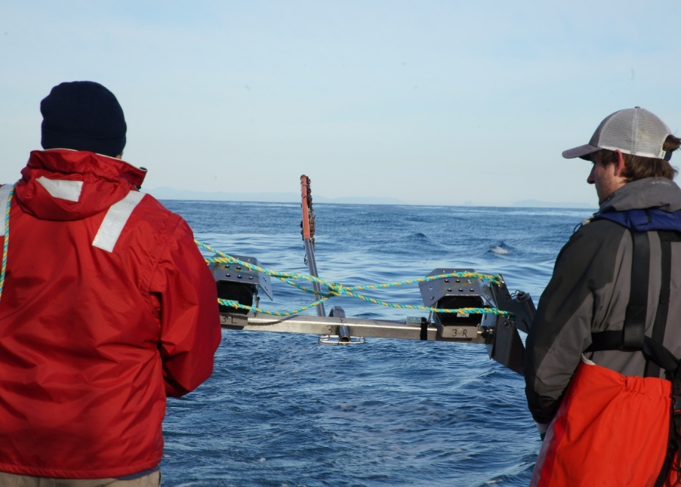

Commonwealth Environmental Impact Statement
Chapter 2 – Project rationale
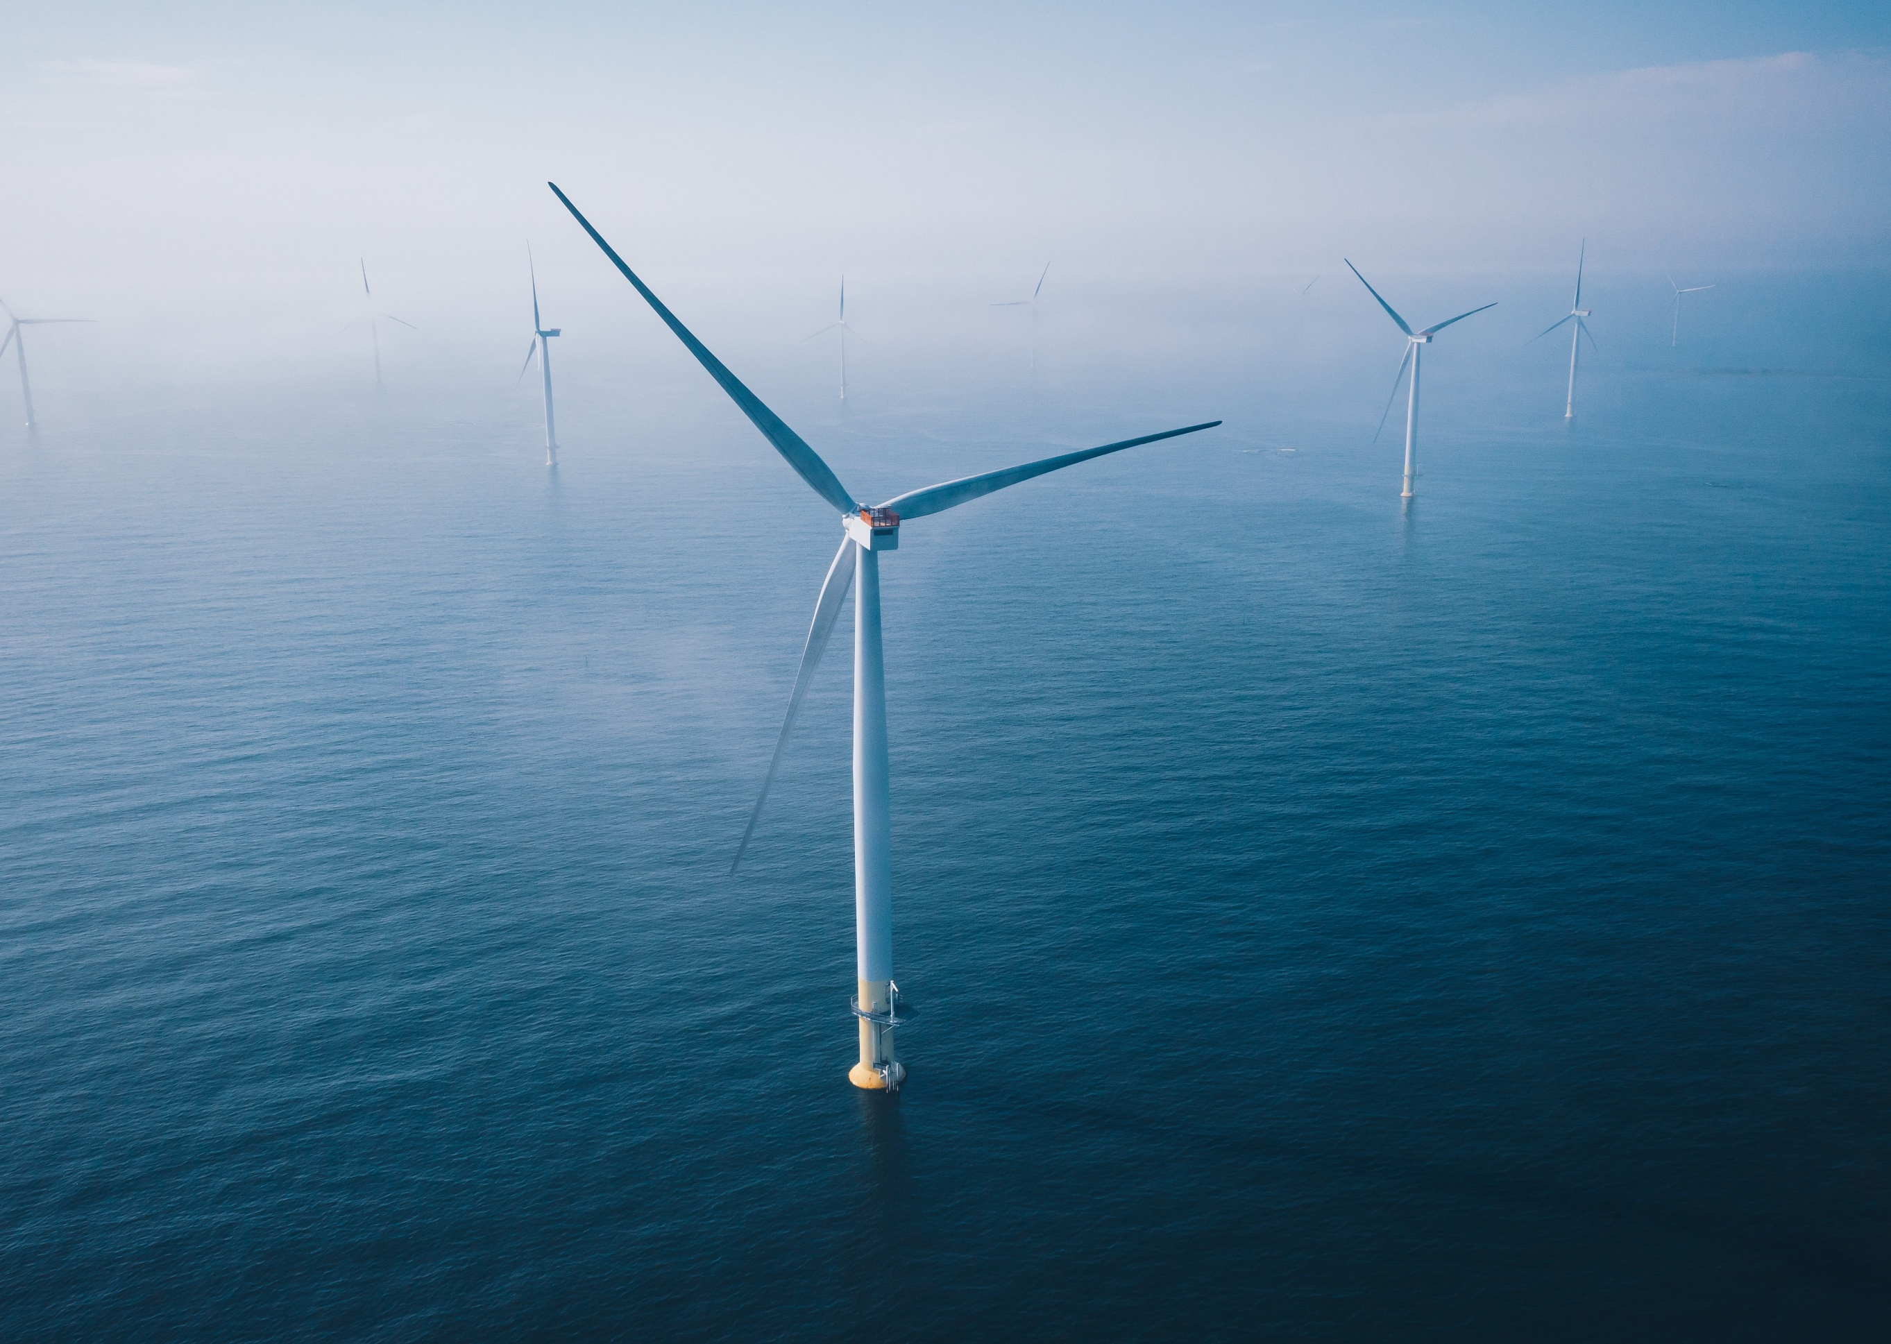
Table of Contents
Chapter 2 Project rationale 2-3
2.1 Introduction 2-3
2.1.1 Chapter overview and purpose 2-3
2.1.2 Key drivers for offshore wind 2-4
2.2 The need for offshore wind 2-6
2.2.1 A transforming energy system 2-6
2.2.2 Australia’s net-zero commitment 2-8
2.2.3 Victoria’s offshore wind opportunity 2-9
2.3 Government policies and objectives 2-11
2.4 Project objectives 2-16
2.5 Project benefits 2-17
2.5.1 Secure investment and strong commitment 2-17
2.5.2 A catalyst for offshore wind growth in Australia 2-18
2.5.3 New clean power delivered by 2032 2-18
2.5.4 Creating local jobs and opportunities 2-19
2.5.5 Community and stakeholder support for the project 2-21
2.6 Consideration of feasible alternatives 2-24

Figures
Figure 2-1 Evolution of offshore wind turbine technology 2-5
Figure 2-2 NEM coal capacity (GW, 2009 – 10 to 2049 – 50) 2-7
Figure 2-3 Offshore Wind Jobs Guide launch 2-21
Figure 2-4 Additional onshore wind required to meet 2035 capacity 2-27
Figure 2-5 Additional solar required to meet 2035 capacity 2-28
Figure 2-6 Megawatt capacity unlocked per kilometre of transmission line easement length 2-29
Figure 2-7 Net imports and exports of energy in Victoria with and without offshore wind 2-30

Tables
Table 2-1 Relevant government policies, strategies and plans 2-11
Table 2-2 Project objectives 2-16
Table 2-3 Project benefits 2-17

Project rationale

Introduction

Chapter overview and purpose
This chapter provides the rationale for the Star of the South Offshore Wind Farm Project (the project), demonstrating its role in Australia’s clean energy transition and alignment with Commonwealth and Victorian Government energy, climate and economic goals.
Offshore wind is one of the fastest-growing energy technologies globally. Installed capacity has more than doubled in recent years, from 34.5 gigawatts (GW) in 2020 to 83 GW in 2025 (GWEC, 2025). Today, more than 13,000 offshore wind turbines are operating across 20 countries. Since the first offshore wind farm was built in 1991, the technology has become an integral part of electricity networks in many advanced economies. In Denmark and the United Kingdom, for example, offshore wind now accounts for over 10 per cent of total installed generation capacity due to its ability to be deployed at scale, helping to offset the loss of retiring fossil fuel generation.
Australia has the fourth-highest technical potential for offshore wind worldwide. Star of the South’s early market analysis identified offshore wind as a critical solution to Australia’s predicted energy supply gap, driven by the faster-than-expected retirement of coal fired power stations and climate targets. Independent studies support this assessment (Victorian Government, 2022).
As ageing coal-fired power stations retire, more large-scale renewable energy solutions are required. Australia has an opportunity to harness some of the strongest offshore wind resources in the world (Briggs et al., 2021), to drive economic growth and jobs while supporting energy security and net zero targets.
Recognising Gippsland’s world-class offshore wind potential, the Commonwealth Government declared the region an offshore wind zone and the Victorian Government legislated offshore wind targets of 2 GW by 2032, 4 GW by 2035 and 9 GW by 2040, reinforcing Gippsland’s key role in Australia’s clean energy transition.
This chapter outlines:
- The need for offshore wind in Australia and how it aligns with legislated climate and renewable energy targets
- How the project is uniquely positioned to help achieve government climate and energy goals
- The project’s key benefits
- Feasible alternatives to the project.

Key drivers for offshore wind
- Energy security and reliability: Retiring coal-fired power stations and a looming energy supply gap highlight the need for new large-scale renewable energy sources to keep Australia and Victoria’s economies strong. Offshore wind is a secure and reliable source of power that is essential for maintaining energy security while reducing reliance on fossil fuels.
- Commitment to net-zero emissions: Australia has set targets to reduce greenhouse gas emissions by 62 – 70 per cent below 2005 levels by 2035 and achieve net-zero emissions by 2050. Victoria is aiming to reach net zero by 2045. Offshore wind will play a critical role in delivering on these commitments.
- Government policy alignment: Both the Commonwealth and Victorian Governments have established climate and renewable energy targets, including Victoria’s 95 per cent renewable energy target by 2035 and offshore wind target of 2 GW by 2032. These targets create a suitable policy environment for offshore wind, providing a pathway for investment and growth.
- World-class wind resource: Bass Strait’s strong and consistent winds will generate reliable and clean electricity at scale. A single rotation of an offshore wind turbine can power the average Australian home for 48 hours.
- Boosting the energy transition with less overall impact: Offshore wind projects can be developed at a greater scale than onshore projects, with taller turbines harnessing higher wind speeds to deliver more power to the grid (see Figure 2-1). As a mature technology, offshore wind is ready to deploy to offset the loss of coal-fired power stations. Additionally, offshore wind in Gippsland requires less transmission meaning fewer overall land conflicts.
- Regional jobs and investment: Offshore wind will generate significant economic benefits, creating thousands of manufacturing, construction and operations jobs in regions that have powered the nation for generations. With an established supply chain, a skilled workforce and existing transmission infrastructure, the Gippsland region is well-positioned to continue its tradition of powering the nation for decades to come.
Together, these drivers make offshore wind a crucial component of Australia’s transition to a clean and secure energy future, as discussed further in this chapter.
Figure 2-1 Evolution of offshore wind turbine technology
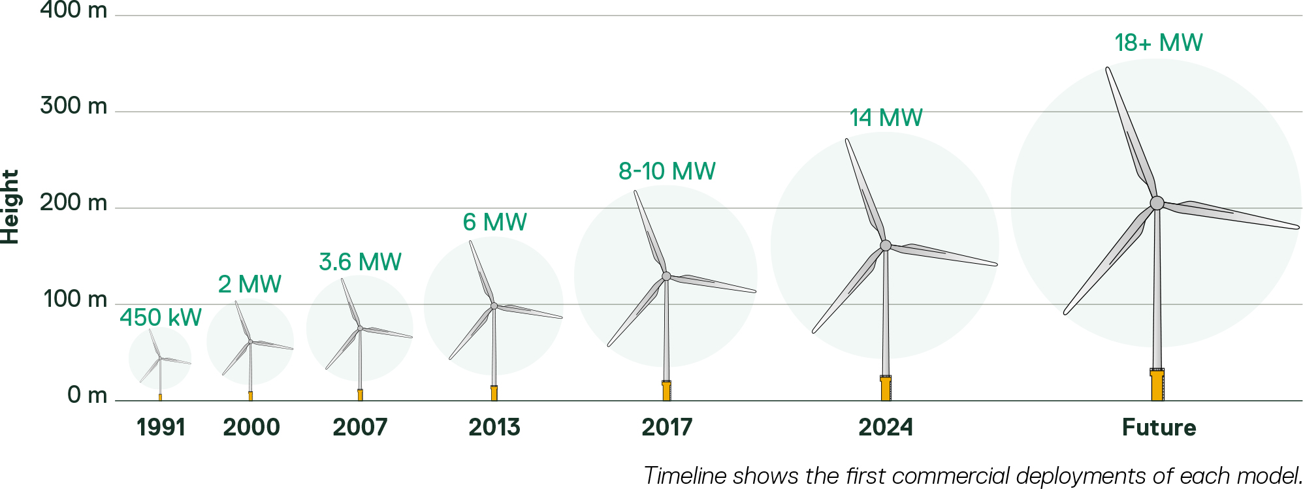

The need for offshore wind
Offshore wind is a reliable, large-scale clean energy source that complements onshore wind, solar and storage technologies. Since its emergence in the 1990s, offshore wind has expanded rapidly, becoming a key renewable energy source in the global clean energy transition. By 2030, total installed capacity is projected to increase to 285 GW (GWEC, 2025), making it one of the fastest-growing energy technologies worldwide.
Offshore wind is increasingly being recognised as critical to Australia’s energy security and reliability goals and to meet climate targets.
The Australian Energy Market Operator (AEMO) forecasts that by 2035, offshore wind will contribute five per cent of total energy generation in the National Electricity Market (NEM) - the interconnected power system spanning the eastern states of Australia, South Australia, and Tasmania. Offshore wind’s contribution is forecast to rise to 10 per cent by 2040, (AEMO, 2024). This underscores the need to kick-start Australia’s offshore wind industry this decade, ensuring replacement capacity is planned and permitted well in advance due to long lead times for procuring and installing offshore wind farms globally.

A transforming energy system
According to AEMO, coal-fired power stations are retiring at a rate two to three times faster than initially anticipated. All coal-fired power stations in the NEM are expected to retire by 2051; however, in its most likely future scenario, AEMO forecasts that approximately 90 per cent of the NEM’s coal fleet will retire by 2035, and the entire fleet is expected to retire by 2040 (see Figure 2-2). This rapid exit – more than 20 GW of capacity, equivalent to roughly half of Australia’s electricity consumption – creates an urgent need for new generation resources.
Figure 2-2 NEM coal capacity (GW, 2009 – 10 to 2049 – 50)
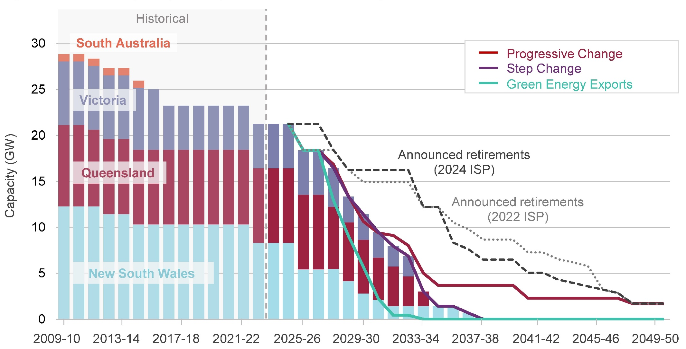
Source AEMO, 2024
Without timely investment in large-scale renewable energy projects, Australia will be left with limited electricity supply, which will severely impact energy security, increase prices and cause harm across Australia’s economy.
The Victorian Government is pursuing a diverse mix of renewable energy and storage solutions to ensure a reliable, affordable and secure electricity system. Over the past decade, significant investment in onshore wind and solar has expanded renewable capacity, helped stabilise prices, and supported regional jobs. In 2024, renewable energy – including wind, solar and hydropower –provided 40 per cent of Australia’s total electricity generation (Clean Energy Council, 2024). However, relying solely on onshore renewables or a single technology poses risks to the system, such as reduced supply during evenings when solar production declines or during prolonged periods of low wind conditions onshore. By integrating offshore wind into the energy mix, Victoria will further diversify its energy sources and avoid over-reliance on imports from other states, ensuring greater self-sufficiency and enabling the state to continue supporting the NEM.
Further discussion on offshore wind’s role in diversifying the energy mix is provided in Section 2.7, which discusses feasible alternatives, including expanding onshore renewable energy resources.

Australia’s net-zero commitment
Countries across the globe, including Australia, are taking steps to combat climate change and minimise the worst impacts of a rapidly heating planet. The United Nations Intergovernmental Panel on Climate Change warns that without adequate action, the planet faces severe climate change risks, including more frequent and severe droughts, heatwaves and rainfall (IPCC, 2022). Australia’s National Climate Risk Assessment provides further insights into direct impacts to the nation’s communities and broader economy because of climate change (Australian Government, 2025).
Australia is a party to the Paris Agreement, a legally binding international treaty on climate change that entered into force in 2016. In support of this commitment, the Commonwealth Government has pledged to reduce greenhouse gas emissions by 62 – 70 per cent below 2005 levels by 2035 and achieve net-zero emissions by 2050.
Delivering on these targets depends on a rapid transition to renewable energy. Current efforts are underpinned by nationwide actions to:
- Accelerate the use, storage and transmission of renewable energy through a diverse range of sources
- Shift consumer reliance away from traditional fossil-fuel energy to renewable energy sources to electrify households and personal vehicles
- Decarbonise heavy industries
- Minimise the environmental and biodiversity impacts of the clean energy transition.
To meet these targets, AEMO develops and publishes the Integrated System Plan (ISP). The ISP is the roadmap for the most significant transition of the NEM in 25 years: a shift away from ageing coal-fired power generation while tripling installed generation capacity to meet future demand. The 2024 ISP (AEMO, 2024) confirms that renewable energy connected with transmission and distribution, firmed with storage and backed up by gas-powered generation, is the lowest-cost way to supply households and businesses with electricity as Australia transitions to a net-zero economy.
Further details on how the Commonwealth Government is working to achieve net zero are provided in Section 2.4.

Victoria’s offshore wind opportunity
Australia has extensive untapped offshore wind resources, with coastal waters offering strong and consistent wind speeds that are high by both Australian and international standards. The potential energy output from these winds exceeds that of onshore wind and solar in Victoria, positioning offshore wind as key to the state’s renewable energy future (AEMO, 2024).
Recognising this potential, the Commonwealth Minister for Climate Change and Energy declared an area off Gippsland, Victoria, as suitable for offshore renewable energy on 19 December 2022. The Gippsland Declared Area is one of six priority zones identified for offshore wind development in Commonwealth waters. Its suitability for offshore wind farms is underpinned by excellent offshore wind capacity, proximity to existing transmission infrastructure and access to major energy demand centres (DCCEEW, 2025).
Electricity generated by offshore wind projects located in the Gippsland Declared Area will be transmitted to the electricity network via the shared transmission line that VicGrid is developing. This part of the network has the largest available capacity in Victoria and currently services all operational coal-fired power stations in the state. Leveraging this existing infrastructure minimises the need for new transmission projects, avoiding costs and environmental impacts.
The Climate Change Act 2017 (Vic) commits Victoria to achieving net-zero greenhouse gas emissions by 2045 through the development of a low-emissions community and economy. Victoria is leading Australia’s clean energy transition with ambitious offshore wind targets enshrined in legislation by the Renewable Energy (Jobs and Investment) Act 2017. In 2024, it became the first state to legislate offshore wind goals of at least 2 GW by 2032, 4 GW by 2035 and 9 GW by 2040. These commitments align with Victoria’s broader targets of 65 per cent renewable electricity generation by 2030 and 95 per cent by 2035. Offshore wind is a key pillar of the state’s energy transition strategy – Cheaper, Cleaner, Renewable: Our Plan for Victoria’s Electricity Future (2024) – alongside initiatives such as the Victorian Transmission Investment Framework, renewable energy and storage targets, and the Gas Substitution Roadmap.
Beyond delivering clean and reliable energy, offshore wind presents a significant economic opportunity for Victoria, with the potential to generate $1.6 billion in economic activity and create over 10,000 jobs within the next decade. Jobs would be concentrated in regions that need new industry the most, such as Gippsland, where the decline of fossil fuel production is expected to impact local economies. Offshore wind can also support a just transition for fossil fuel workers by using their transferable skills and supporting upskilling programs.
Globally, the offshore wind sector is growing rapidly, with larger project capacities making it an increasingly competitive resource. The International Energy Agency now ranks offshore wind as one of the ‘big three’ renewable energy sources, alongside onshore wind and solar (Briggs et al., 2021).
With international competition for investment and supply chain capacity intensifying, delays in advancing projects could put billions of dollars of potential investment at risk in Australia, and increase energy prices. Advancing offshore wind without delay will enable Victoria to secure these benefits, maintain energy security and deliver on its climate and renewable energy commitments.

Government policies and objectives
The project represents an important step in Australia’s transition toward a net-zero future. The project aligns with Commonwealth and Victorian Government policies aimed at lowering emissions, increasing renewable energy supply, supporting regional communities and economies and securing Australia’s energy resilience.
Table 2-1 Relevant government policies, strategies and plans
Government policies, strategies and plans | Details
Energy and transmission | Relevance to the assessment
National Energy Transformation Partnership (2022) | The National Energy Transition Partnership (2022) is a framework for Commonwealth, state and territory governments to work together on reforms to help transform Australia’s energy system to achieve net zero by 2050. Six priority themes guide the partnership, including ‘Planning for adequate energy generation and storage’. The partnership is intrinsically linked to other government policies and priorities, including the Capacity Investment Scheme, Rewiring the Nation, the First Nations Clean Energy Strategy 2024 – 2030, the National Energy Workforce Strategy and national energy objectives.  The project is fully aligned with the intent and outcomes of the National Energy Transformation Partnership.
Powering Australia | The Commonwealth Government’s Powering Australia plan aims to create jobs, reduce energy costs and cut emissions by accelerating the transition to renewable energy. It aligns with federal commitments to expand renewable energy generation and achieve a 43% reduction in emissions by 2030, supporting Australia’s broader net-zero goals.  The project would enable the achievement of Powering Australia plan objectives, along with national climate and renewable energy targets.
Rewiring the Nation | The Commonwealth Government’s Rewiring the Nation initiative aims to create jobs, lower energy costs and reduce emissions by modernising and expanding Australia’s electricity network to support the transition to renewable energy. It provides funding for priority transmission projects and facilitates regulatory coordination between the Commonwealth and Victorian Governments to support the development of Victoria’s offshore wind industry.  The project is working closely with the Commonwealth and Victorian Governments and VicGrid to ensure the project’s efficient integration with the electricity network.
AEMO’s 2024 ISP | The ISP is AEMO’s strategic roadmap for transitioning Australia’s electricity network to a secure, reliable and cost-effective renewable energy future. The ISP incorporates offshore wind into the NEM and supports Victoria’s offshore wind targets of 2 GW by 2032, 4 GW by 2035 and 9 GW by 2040. Offshore wind plays a key role in achieving the ISP’s objectives by providing a large-scale, consistent energy source that enhances system reliability and contributes to the Commonwealth and Victorian Governments’ renewable energy goals and emissions reduction targets.  The project would enable the achievement of AEMO’s ISP roadmap and government-mandated climate and renewable energy targets.
Renewable Energy (Jobs and Investment) Act 2017 (Vic) | The Act supports job creation in clean energy industries, ensuring economic benefits for regional communities and supporting Victoria’s clean energy transition by reinforcing policies like offshore wind development and aligning with net-zero emissions goals.  The project supports economic growth through the provision of large-scale renewable energy.
Renewable Energy Action Plan (2017) | Victoria’s Renewable Energy Action Plan (2017) outlines the state's long-term renewable energy agenda, including targets of 25% by 2020, 40% by 2025 and a legislated 50% by 2030. It highlights offshore wind as a key opportunity and focuses on setting ambitious targets, streamlining project approvals and supporting investment in new energy technologies.  The project directly supports the Renewable Energy Action Plan by contributing to Victoria’s renewable energy targets, attracting clean energy investment and accelerating the deployment of new energy technologies.
State Electricity Commission’s Strategic Plan 2023 – 2035 (2023) | The State Electricity Commission’s Strategic Plan 2023 – 2035 outlines Victoria’s vision for a zero-emissions, reliable, affordable and equitable electricity system, delivered in partnership with Traditional Owners, the private sector and government. Its three strategic pillars focus on accelerating the energy transition, supporting the electrification of households and building a renewable energy workforce. The State Electricity Commission will act as a market participant, investing $1 b in 4.5 GW of renewable generation and storage, including wind, while supporting the creation of 59,000 jobs to help reach 95% renewable energy by 2035.  The project contributes to the Plan’s objectives by expanding renewable energy capacity, supporting decarbonisation, creating jobs and supplying affordable, reliable electricity to Victorian consumers.
Cheaper, Cleaner, Renewable: Our Plan for Victoria's Electricity Future (2024) | Victoria’s Cheaper, Cleaner, Renewable: Our Plan for Victoria's Electricity Future outlines the government’s plans for a future electricity system, including actions being taken and investment opportunities. It also shares the Victorian Government’s commitment to collaborate with landowners, local communities, investors and industry, and partnership with Traditional Owners and First Peoples.  The project directly supports the plans’ objectives of a considered approach to planning for the shift to a renewable future, supported by a stable and reliable electricity system.
Offshore wind declared areas
Gippsland Declared Area | In 2022, the Commonwealth Minister for Climate Change and Energy declared an area off Gippsland, Victoria, as suitable for offshore renewable energy (Declared Area OEI-01-2022).  The project is situated within the Gippsland Declared Area. The project has been awarded a feasibility licence under the Offshore Electricity Infrastructure Act (2021) (Cth) and will comply with the conditions for Area OEI-01-2022.
Offshore Wind Energy Victoria Implementation Statement 1-4 (2022, 2023, 2024) | To date, Offshore Wind Energy Victoria has released four Implementation Statements, which detail how the State plans to implement offshore wind and achieve the goals of the Victorian Offshore Wind Policy Directions Paper. The fourth Implementation Statement builds on previous versions, outlining the strategic approach to developing Victoria’s offshore wind sector, including:  - Transmission and electricity network access  - The role of ports  - Jobs, training and industry development  - Protections for the natural environment  - Legislation and regulatory reform  - Traditional owner partnerships  - Industry, stakeholder and community engagement.  The project supports Victoria’s goal to generate at least 2 GW of offshore wind by 2032 and achieve the key focus areas set out in Implementation Statement 4 (2024).
Climate adaptation and mitigation
Net Zero Plan (2025) | The Net Zero Plan guides Australia’s transition to the legislated target of net-zero emissions by 2050 and includes the goal of generating 82% of renewable energy by 2030. It also supports the Commonwealth Government’s broader policy agenda, including ambitions for a Future Made in Australia.  The project aligns with and contributes to Australia’s legally binding target of net-zero greenhouse emissions by 2050.
National Climate Resilience and Adaptation Strategy 2021 – 2025 (2021) | The National Climate Resilience and Adaptation Strategy 2021 – 2025 outlines Australia’s approach to managing climate risks and strengthening resilience to climate change. It focuses on three key objectives: factoring climate risk into decision-making, driving investment in climate adaptation and improving climate information and collaboration. The strategy aims to support communities, businesses and governments in preparing for and adapting to climate-related challenges, furthering Australia’s future prosperity.  The project enhances energy resilience by providing a reliable and stable supply of renewable energy, thereby reducing emissions while supporting the Gippsland region’s adaptation to climate risks.
Victoria’s Climate Change Strategy (2021) | Victoria’s Climate Change Strategy (2021) provides a roadmap to achieve net-zero emissions by 2050. It sets objectives for strengthening infrastructure resilience against climate impacts and actively managing biodiversity, ecosystems and natural resources to enhance climate adaptation. The strategy acknowledges the need for climate action and zero-emission innovations, emphasising offshore wind as a key government investment to cut emissions, strengthen energy system resilience and reinforce Victoria’s leadership in renewable energy.  The project will support the Victorian Government’s goals of improving resilience to climate change as it works towards net-zero emissions.
Gippsland Regional Climate Change Adaptation Strategy (2021) | The Gippsland Regional Climate Change Adaptation Strategy (2021) outlines specific actions to help build the region’s resilience against the impacts of climate change. The strategy recognises the importance of both adaptation and mitigation to help communities, businesses and industry better adapt to climate change. Mitigation actions include increasing renewable energy generation, which is critically important to reduce climate change impacts and increase adaptability.  The project will be a key economic driver and support the achievement of climate change resilience objectives for the Gippsland region.
Renewable Energy Target | The Renewable Energy Target is a Commonwealth Government scheme to reduce greenhouse gas emissions and increase renewable electricity generation. The scheme incentivises the generation of electricity from large-scale renewable sources, such as offshore wind, by providing large-scale generation certificates to power projects.  The project will contribute to the share of renewable energy in the NEM.
First Nations Clean Energy Strategy 2024 – 2030 (2024) | The First Nations Clean Energy Strategy 2024 – 2030 recognises the opportunities that can be created for First Nation peoples as part of the journey to net zero. The strategy is one of the commitments under the National Partnership Agreement. It establishes a national framework to guide investment and policy design and improve outcomes for First Nation peoples in the energy transition.  The project will work in partnership with Gunaikurnai Land and Waters Aboriginal Corporation (GLaWAC) to finalise an agreement that ensures long-term economic benefit for Gunaikurnai peoples.
Invest Victoria International Investment Strategy (2020) | Victoria’s International Investment Strategy is a whole-of-government initiative that specifies new energy markets and emissions reduction targets for new investment, recognising that a zero-carbon future will require private-sector involvement and investment. This strategy identifies multiple, large-scale investment opportunities in renewable and new energy markets, including offshore wind and marine energy located close to supporting infrastructure in the Latrobe Valley. The strategy identifies this investment as being key to meeting Victoria’s renewable energy target of 50% by 2030 and net-zero emissions by 2045. Other focus areas under the strategy include investing in advanced manufacturing, Regional Victoria and future economic growth through connecting with global markets.  The project is backed by Copenhagen Infrastructure Partners (CIP), the world’s largest fund manager dedicated to greenfield renewable energy investments and a global leader in offshore wind. The project is expected to attract significant international investment and generate substantial economic benefits in the Gippsland region overs its lifetime.  The project has already attracted foreign and domestic investment. This includes providing jobs and advanced manufacturing opportunities in every project phase, with a particular focus on the Gippsland region.
Socio-economic, jobs and skills
Gippsland Regional Plan 2020 – 2025 | The Gippsland Regional Plan 2020 – 2025 acknowledges Gippsland’s longstanding role in power generation and its strategic position as a prime location for renewable energy. As the region transitions and diversifies its energy sector, it is leveraging its strong manufacturing base and history in power production to expand into renewable and clean energy. As outlined in the Plan, Gippsland’s 2040 vision includes becoming a leading energy producer with extensive transmission networks. The plan highlights the region’s role in advancing technologies such as carbon capture and storage, as well as wind and solar farm developments and research and innovation in renewable and clean energy production.  The project reinforces Gippsland’s role as an emerging renewable energy hub.
Gippsland Regional Economic Development Strategy (2022) | The Gippsland Regional Economic Development Strategy (2022) outlines strategic directions for sustained economic growth and development over the medium to long term, particularly as the region transitions from coal to clean energy. The strategy identifies five key directions, including leveraging opportunities from the emerging energy industry transition, with a strong focus on clean and renewable energy. It recognises the strong potential for offshore wind generation, aligning with state and local targets to position Gippsland as a leader in Australia’s renewable energy future.  The project reinforces Gippsland’s role as an emerging renewable energy hub.
Gunaikurnai Renewable Energy Strategy (draft) | In response to the rapid growth of renewable energy, GLaWAC is developing a Renewable Energy Strategy to ensure the Gunaikurnai people are well-represented and that the rights, knowledge and perspectives of Traditional Owners are respected. The strategy will also highlight the cultural and historical significance of the seabed beyond the coastline, which Gunaikurnai ancestors once inhabited. The strategy is underpinned by five key objectives centred on supporting and involving the Gunaikurnai community in the renewable energy transition, their connection to Country, healing and protecting Country and supporting self-determination.  The project has been working alongside GLaWAC to ensure that a deep understanding of Gunaikurnai Country informs development efforts and that the rights, interests and priorities of the Gunaikurnai people are embedded in the project from the outset. In partnership with GLaWAC, the project is in formal discussions under an engagement agreement to create meaningful, long-term benefits for the Gunaikurnai community.
A Future Made in Australia agenda | A Future Made in Australia agenda aims to attract and enable investment to boost domestic manufacturing and advanced technology industries, positioning Australia as a renewable energy superpower. The agenda focuses on reducing reliance on imports, strengthening supply chains and creating high-value jobs, as well as investing in renewable energy sectors to drive innovation and economic resilience. This aims to ensure Australia’s competitiveness in a low-carbon future. The supporting paper, Future Made in Australia National Interest Framework (2024), is structured around two streams, including the Net Zero Transformation Stream. This stream focuses on industries that will play a significant role in the net-zero transition, are expected to maintain a long-term competitive advantage and require public investment to maximise their contribution to cost-effective emission reductions.  The project supports the participation of local manufacturing in the regional, domestic and global supply chain, contributing to Australia’s long-term economic and industrial growth.
Make it Happen: The Australian Government’s Modern Manufacturing Strategy (2020) | The vision outlined in Make it Happen: The Australian Government’s Modern Manufacturing Strategy (2020) is for ‘Australia to be recognised as a high-quality and sustainable manufacturing nation that helps to deliver a strong, modern and resilient economy for all Australians’. The strategy highlights the significant manufacturing growth opportunities associated with clean energy sectors, as well as jobs and local supply chain development.  The project has established a significant local presence and is working closely with local industry to identify opportunities for upskilling and opening supply chains to support project delivery and operation.
Local Jobs First Policy | The Local Jobs First Policy supports Victorian businesses and workers by ensuring that small and medium enterprises have opportunities to participate in government contracts. The project will adopt a similar approach by prioritising local workforce participation, supply chains and regional economic benefits. This approach will help maximise local employment, skills development and investment in the Gippsland region’s industrial capabilities and is forecast to create thousands of local jobs over the project lifecycle.  The project prioritises local businesses and workforce participation in project development, construction and operation.
National Skills Agreement (2024) and National Skills Plan (2024) | The National Skills Agreement (2024) came into effect on January 1, 2024, and is a collaborative effort between Commonwealth, state and territory governments to strengthen Australia’s vocational education and training system. The National Skills Plan (2024) outlines the strategy for achieving Agreement objectives and identifies eight national priorities, including support for the Net Zero Transformation. The plan highlights that Australia’s clean energy workforce will need to expand to approximately 240,000 workers by 2030 to achieve net-zero emissions by 2050. This expansion will require targeted support for workers transitioning from carbon-based industries, the development of multidisciplinary skills, the creation of regional jobs where most projects are located, improved pathways for underrepresented groups and clearer pathways and incentives to encourage student participation.  The project is expected to generate significant employment during construction and operation, driving regional job creation and supporting workforce development. It will provide pathways for students pursuing careers in renewable energy and offer opportunities for existing energy sector workers to transition into the offshore wind industry, contributing to the long-term sustainability of Australia’s clean energy workforce.
Net Zero Jobs Plan and Regional Workforce Transition Plans (DEWR, 2025) | The Net Zero Jobs Plan is a Commonwealth Government initiative designed to support workers and communities through the transition to a net-zero economy. It focuses on upskilling and reskilling workers, creating secure, high-quality jobs in renewable energy and emerging industries and ensuring regional communities benefit from the shift to clean energy. The plan aligns with broader workforce transition strategies to help industries like offshore wind grow while providing opportunities for workers in traditional sectors to transition into sustainable careers.  The project is already working with local institutions and operators to identify and realise opportunities to train and upskill the local workforce, targeting those who may be transitioning from retiring coal-fired power stations or decommissioned offshore oil and gas rigs.
National Energy Workforce Strategy | The Commonwealth Government is finalising a National Energy Workforce Strategy, a national framework aimed at strengthening the energy sector’s workforce by enhancing skills and capabilities essential for achieving net-zero emissions by 2050. Offshore wind is identified as a key initiative requiring a highly skilled workforce to support this transition.  The project is committed to supporting and engaging with the local workforce.

Project objectives
Project objectives guide project outcomes and help maintain a consistent approach to design and assessment. They assist in the decision-making when refining project design elements and will continue to inform the project development process. These objectives align with Victoria’s renewable energy ambitions, Australia’s broader decarbonisation goals and the need for a sustainable offshore wind industry. Together, they aim to deliver clean, reliable energy while ensuring the project’s economic, environmental and technological viability.
Table 2-2 outlines how the project expects to meet these objectives.
Table 2-2 Project objectives
Objective | Project response
Deliver a significant, secure and reliable source of large-scale renewable electricity to meet Victoria’s legislated offshore wind target of 2 GW by 2032 and progress towards Australia's legislated net-zero emissions by 2050 target. | With a capacity of up to 2.2 GW, the project could supply clean and reliable energy to up to 1.2 m homes. This is equivalent to approximately 85% of the electricity produced by Yallourn Power Station average annual generation, which is due to close in 2028.  In development for more than seven years, the project is expected to be ready as early as 2032 (subject to environmental and commercial approvals), aligning with the Victorian Government’s legislated offshore wind targets and playing a key role in decarbonising the energy industry.
Adapt proven offshore wind technologies to local conditions while avoiding and minimising significant risks of harm to the environment, so far as reasonably practicable. | Offshore wind technology has been in use globally since 1991. Today, more than 13,000 offshore wind turbines generate clean power in 20 countries. Using this proven technology, the project will harness Bass Strait’s strong and consistent winds to provide a clean and reliable source of energy, especially during periods when onshore wind and solar output are lower.  Renewable energy, including offshore wind, is one of the most effective tools to protect marine and bird life from the impacts of climate change. The project has been developed in compliance with Australia’s environmental laws and regulations, which are considered the most stringent in the world.  Extensive surveys and studies of the Bass Strait and surrounding region have provided a detailed understanding of the local environment and led to the incorporation of a robust suite of mitigation measures into the project’s design. Detailed management plans, alongside monitoring and adaptive measures, will ensure that the project is constructed, operated and decommissioned using the best available information and technologies.
Develop and deliver the project in consultation with Traditional Owners and local communities. | The project recognises the Gunaikurnai people, the Traditional Owners of Land and Sea Country upon which the project is being developed. Based on the principles of Free, Prior and Informed Consent, the project has partnered with and engaged Traditional Owners to develop and refine the project.  A local project team is embedded in the community to ensure the project is developed with local insights and that community needs and opportunities are factored into decision-making and outcomes.

Project benefits
The project has the potential to deliver a broad range of benefits for communities, businesses and the environment, as shown in Table 2-3. These benefits align closely with the project objectives and support the Commonwealth’s and Victoria’s transition to a cleaner, more sustainable energy system.
Table 2-3 Project benefits
Benefits | Description
Boosting energy capacity by up to 2.2 GW | With a capacity of up to 2.2 GW, the project has the potential to supply around 20% of Victoria’s electricity demand, enough to power 1.2 m homes annually. With Yallourn Power Station scheduled to retire in 2028 and Loy Yang A Power Station in 2035, new energy resources are urgently needed.
Contributing $8 b to the economy | The project would contribute around $8 b to the Australian economy, including $3 b in Gippsland, over its lifetime. As Australia’s first offshore wind project, Star of the South will also demonstrate the potential of global investment in offshore wind in Australia.
Providing energy when it’s needed most | Bass Strait winds have a strong profile that matches both daily and seasonal peak demand for electricity. With existing transmission connections nearby in the Latrobe Valley, the project can readily supply clean and reliable power to the electricity network as coal-fired power stations exit the NEM in the coming years.
Saving 7 m tonnes of CO₂ emissions per year | Wind energy is one of the least carbon-intensive ways to generate electricity. Emissions related to manufacturing and constructing the project are expected to be offset after around six months of operation. In each year of operation, the project would save an estimated 7 m tonnes of CO₂ emissions.
Creating thousands of new, local and long-term jobs | The project would create the right jobs at the right time – up to 6,000 jobs in Australia over the project’s lifetime – across multiple industries, including construction and local manufacturing. This includes up to 200 long-term jobs during its 30-year operational life at an operations and maintenance facility located at a Gippsland port.
Investing in local communities through job training | Job training programs, focused on the supply chain and apprenticeships, will expand workforce opportunities and help boost local economies. The project is also exploring ways to reskill and invest in the local workforce to develop an offshore wind industry in Australia, with a particular focus on the Gippsland region.
Launching a new industry in Gippsland | With strong Bass Strait winds, a skilled local workforce and a long history of electricity generation, Gippsland is the ideal place to launch Australia’s offshore wind industry. Hundreds of Gippsland businesses have been identified as ready to provide goods and services to support the project through development, construction, and operation.
Kickstarting Australia’s biggest clean energy hub | The project has the potential to contribute to a new clean energy hub in Gippsland, boosting domestic jobs and manufacturing capabilities.

Secure investment and strong commitment
As Australia’s most advanced offshore wind farm, the project has been at the forefront of developing the country’s offshore wind industry for over seven years – building relationships in Gippsland, engaging with communities and laying the groundwork for this new sector. The progress made so far and the project’s benefits are underpinned by the strong financial backing and long-term commitment of its investors.
The project is backed by Copenhagen Infrastructure Partners (CIP), one of the world’s largest fund managers in greenfield renewable energy investment, through one of its flagship funds, Copenhagen Infrastructure IV. With a proven track record of successfully delivering offshore wind projects in new and emerging markets, CIP brings the expertise, financial strength and long-term vision needed to navigate complex situations and work collaboratively with stakeholders to deliver best-in-class projects. The project is also backed by Cbus Super, a local superannuation fund with the ambition to grow Australians' retirement savings through investments in projects like Star of the South.
CIP has secured two feasibility licences in Gippsland on behalf of its funds, reflecting its confidence in Australia’s offshore wind potential and its commitment to establishing a new industry that creates jobs and supports the clean energy transition. The certainty and security of CIP’s investment in the project ensures that climate and renewable energy targets and policies can be achieved in accordance with the legislated timelines.

A catalyst for offshore wind growth in Australia
With some of the highest technical offshore wind potential in the world, a thriving offshore wind sector is possible in Australia. For nearly a decade, Star of the South has worked closely with the Commonwealth and Victorian Governments to help shape new policy and regulations, paving the way for leading global offshore wind developers to invest heavily in Australia.
Prudent investment and industry expansion are crucial to meeting legislated targets for renewable energy and greenhouse gas emissions reductions. Given its advanced state of readiness and strong commitment to Australia, Star of the South is well placed to leverage investment and support for offshore wind to drive the industry forward. In doing so, it would realise significant economic benefits and reinforce Australia’s standing as a global leader in renewables. Without the project, achieving government targets may be difficult, and Australia risks missing the opportunity to capitalise on the current international investment momentum.

New clean power delivered by 2032
Under development since 2018, the project is uniquely positioned to deliver new clean power to the electricity network in support of the Victorian Government’s 2032 offshore wind target. Backed by firm investment commitments from CIP and Cbus Super, the project provides critical certainty for meeting this and other Commonwealth and Victorian Government targets and policy objectives.
As coal-fired power stations rapidly exit the NEM, and other renewable energy resources face challenges in terms of land availability, timing, delivery cost, social licence and capacity, Star of the South stands apart. With advanced designs and environmental investigations well progressed, the project can prepare, subject to environmental approvals and commercial licencing, for construction to commence by 2030. This positions it to deliver offshore wind power to the electricity network by 2032, providing energy security ahead of the scheduled closure of Loy Yang A Power Station in 2035.
With a capacity of up to 2.2 GW, the project could supply around 20 per cent of Victoria’s electricity demand – enough to power up to 1.2 million homes annually – while playing a central role in the state’s transition to a clean, reliable and resilient energy system.

Creating local jobs and opportunities
The project is expected to contribute around $8 billion to the Australian economy and create as many as 6,000 jobs over its lifetime across multiple industries, including construction, operations and local manufacturing. The bulk of these benefits would be realised in Victoria – up to $7 billion in investment and as many as 4,600 jobs. With an estimated investment of around $3 billion in Gippsland, the project would create up to 800 local jobs. Of these, up to 200 jobs would be long-term positions located at a port-based operations and maintenance facility. The project would also generate a substantial number of indirect opportunities through workforce training, investment in local industry and supply chains and contributions to regional economic and social renewal.
Demonstrating its strong commitment to Gippsland, the project has identified opportunities to partner with the Victorian Government, the region’s energy providers, and training institutions to assist workers in their transition journeys and help them plan their future careers. This includes developing the Offshore Wind Jobs Guide with support from the Victorian Government and in consultation with Energy Australia Yallourn, Federation University, TAFE Gippsland, the Victorian Skills Authority, Offshore and Specialist Ships Australia, unions, GLaWAC and Atlas Professionals (refer to Figure 2-3). The first of its kind in Australia, the Guide details more than 40 different job roles in offshore wind, including trade-based, engineering, office-based and operational roles.
In developing the Guide, the project identified that around 70 per cent of Gippsland’s coal power, mining and gas workers, as well as 85 per cent of the local maritime workforce, have a good or high overlap of skills and training for a career in offshore wind. These findings are supported by the Blue Economy Cooperative Research Centre (Briggs et al, 2021), which reports that over 64 per cent of oil and gas jobs have some or good skills overlap with the offshore wind industry, allowing for extensive upskilling within Gippsland to provide a just transition for local communities and workers. The project, therefore, represents an important opportunity to upskill workers in the fossil fuel and mining industries, enabling those with uncertain futures to transition into the offshore wind sector.
The project is also cited as an opportunity for regional investment in the Gippsland Regional Partnership’s 2019 Outcomes Roadmap, which targets development and growth in new and emerging technologies. By leveraging local investment and partnering with communities, councils and government, the project is expected to generate a long-term pipeline of demand for Victorian goods and services, facilitating project development, materials sourcing and construction and operation and maintenance activities.
The project is also supporting regional development objectives by:
- Advancing worker transition initiatives, including entering into memoranda of understanding with Energy Australia Yallourn, TAFE Gippsland, Federation University and Alinta Loy Yang B, conducting workforce engagement on the project’s jobs and upskilling opportunities and developing a Workforce Transition Opportunities Report.
- Buying local and implementing a ‘look local first’ procurement approach to expand the local supply chain and increase the gross regional product. Hundreds of local Gippsland businesses have been identified as ready to provide goods and services to support the project through development, construction, and operation.
- Helping local businesses promote their goods and services to Tier 1 suppliers through the development and distribution of the Offshore Wind Supplier Showcase.
- Supporting the local supply chain’s pivot to offshore wind, including working with local steel manufacturers to share potential secondary steel component fabrication opportunities for turbines. The project will provide sustained opportunities for local suppliers, including those that have historically serviced the declining fossil fuel and forestry industries.
- Championing Gippsland as a centre of excellence by working with local training providers, including TAFE Gippsland and Federation University, to build a clean energy workforce in the region and participating in Federation University’s Fed Cadet Program.
- Establishing a community fund, with more than $115,000 invested to date.
- Embedding a local team in Yarram, Gippsland, to support local businesses and community initiatives in the town and surrounding areas.
Through these initiatives, the project has demonstrated its ongoing commitment to the Gippsland region. Going forward, it will continue to actively participate in regional forums with government and industry to drive regional development, particularly in shaping the clean energy transition.
Figure 2-3 Offshore Wind Jobs Guide launch
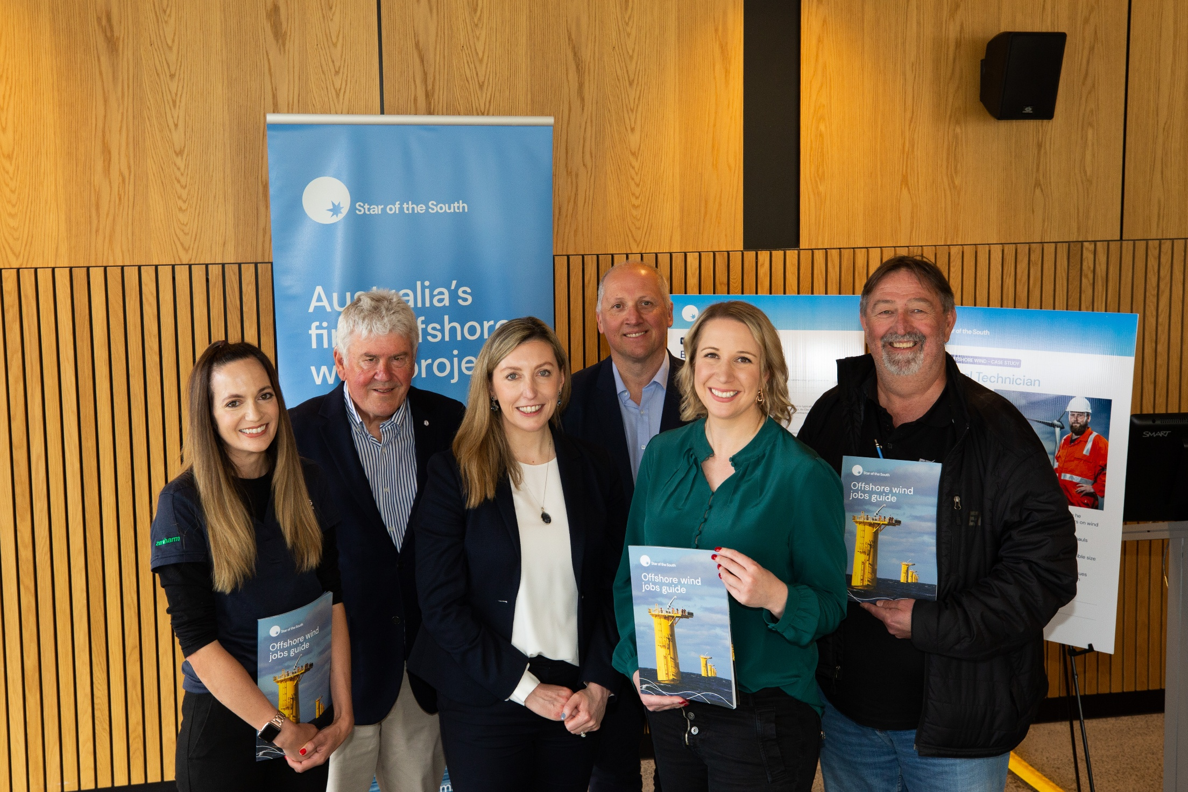

Community and stakeholder support for the project
Independent market research conducted in late 2024 has identified high awareness of and strong support for the project among the coastal and local communities near the offshore project area. Of the 400 local residents randomly selected and surveyed, 65 per cent agree that the project would be beneficial for Gippsland because it will lower carbon emissions as part of a cleaner energy system, create local jobs and manage visual amenity impacts well.

In expressing their support for the project, survey participants noted:
‘It’s central to the future of Gippsland. Consistent with a future based on renewables.’
‘I think if we do want renewables and to achieve renewable energy quickly, offshore wind is the only option. My opinion is based on what I have witnessed in Europe, where it [offshore wind] is prevalent.’
‘It brings more jobs to the community.’
‘We need to transition as we won’t have coal or gas soon, so we need alternatives now.’
‘Offshore wind is a great thing for the earth and great for the area. The project will employ locals, and it is a good spot to do it, as there is already transmission infrastructure. It makes sense as they phase out oil and gas, as it will create employment.’
Over the past eight years, the project has built genuine, enduring relationships and earned the trust of the local community. The project’s approach is centred on transparent information sharing, maintaining a dedicated local team and supporting local economic, employment and skills development initiatives.
A project office was established in Yarram in 2020, alongside a project-specific Community Advisory Group that provides a trusted and credible forum for two-way dialogue and information sharing with the local community. Since 2019, the project has also actively supported more than 60 community-based initiatives and is recognised for its ongoing commitment to the local community.
The three local shire councils – Wellington, South Gippsland and Latrobe City – recognise climate change as a critical priority and support the development of offshore wind as a means to help achieve Commonwealth and Victorian renewable energy targets while securing long-term benefits for the region.
Wellington Shire Council’s Council Plan 2021-25 (Wellington Shire Council, 2021) highlights the following key priorities:
- Become one of the leading best practice renewable energy and sustainability hubs in Australia
- Use our region’s competitive advantage in access to energy transmission capacity and energy related workforce to drive uptake of large-scale renewable energy.
The South Gippsland and Latrobe Renewable Energy Impact and Readiness Study (Urban Enterprise Pty Ltd, 2024) provides an economic and land use evidence base and action plan to guide renewable energy readiness over the next 10-20 years.
In August 2025, Wellington Shire Council, in partnership with South Gippsland Shire Council and Gunaikurnai Land and Waters Aboriginal Corporation, secured $4.73 million funding from the Federal Government to deliver a Renewable Energy Land and Infrastructure Plan (Wellington Shire Council, 2025). The plan will open up land for development in the south of Wellington Shire and South Gippsland Shire identifying critical infrastructure, to ensure the region is prepared to welcome large-scale workforce and industry investment linked to offshore wind.

Consideration of feasible alternatives
The transition to a low-carbon energy system can be achieved through various pathways, each with different implications for reliability, emissions reduction and economic outcomes. The EIS guidelines and EES scoping requirements require the evaluation of feasible alternatives to the project. For the project’s assessment process, feasible alternatives have been assessed.
The purpose of the alternatives assessment is not necessarily to determine a single preferred option, but rather to evaluate how different approaches align with or diverge from the need for decarbonisation and a secure energy supply, as well as project objectives. In some instances, specific alternatives may emerge as more viable than others, but multiple approaches can also play a role in achieving energy transition objectives.
To assess how different strategies contribute to meeting these objectives, the following reasonable and potentially feasible alternatives have been considered:
- Option 1: Do nothing
- Option 2: Extend coal-fired power generation
- Option 3: Expand onshore renewable energy resources
- Option 4: Increase reliance on interstate electricity imports
- Option 5: Construct an offshore wind farm.
Further discussion of the alternative project design options considered for the project is provided in Chapter 3 – Project development.

Option 1: Do nothing
Under this option, no additional measures would be taken to support Australia’s energy transition, including the construction of Star of the South. This would mean continuing to rely on ageing and increasingly unreliable coal-fired power stations, with no new large-scale renewable generation coming online to replace retiring capacity. While this approach would avoid short-term environmental impacts, such as disturbance to marine and terrestrial ecosystems and matters of national environmental significance protected by the Environment Protection and Biodiversity Conservation Act 1999 (Cth), it would result in significant long-term consequences, such as:
- Failure to meet net-zero targets: Without continued investment in clean energy, the Commonwealth’s legislated emissions reduction targets of 62 – 70 per cent below 2005 levels by 2035 and achieve net-zero emissions by 2050 would be at risk, dependence on fossil fuels would be prolonged and emissions would increase.
- Risks to energy security: Continued reliance on ageing coal-fired power stations would leave Victoria vulnerable to supply disruptions and reliability challenges, leading to greater reliance on interstate energy imports and increased electricity price volatility.
- Higher energy costs: A lack of large-scale, cost-competitive renewable generation would limit opportunities to reduce electricity costs, increasing financial pressure on households and businesses.
- Lost economic opportunities: Without the clean energy transition, Australia and Victoria would miss out on significant economic benefits, including regional job creation and supply chain development.
All coal-fired power stations in the NEM – currently more than 20 GW of capacity, equivalent to roughly half of Australia’s electricity consumption – are expected to retire by 2051 at the latest. Without new generation capacity, supply may fail to meet demand, further straining the electricity network and driving up wholesale power prices. While investment in new coal-fired power generation could theoretically address this gap, it would fatally undermine the Commonwealth’s and Victoria’s renewable energy and greenhouse gas emission reduction targets.
By adopting a ‘do nothing’ approach, Australia would be unable to meet its climate and renewable energy commitments and forgo the opportunity to build a more secure, affordable and sustainable energy system for the future. For these reasons, this option is not a viable solution.

Option 2: Extend coal-fired power generation
The scheduled retirement of Victoria’s and New South Wales’s coal-fired power stations over the next two decades is driven by ageing infrastructure and reliability challenges. While extending the operational life of the coal fleet could provide a short-term solution to the projected electricity supply shortfall, it is not a sustainable long-term option. Ageing power stations are increasingly prone to breakdowns, which risks compromising the electricity network’s stability and reliability. For example, between 2017 and 2019, the Loy Yang A Power Station and Yallourn Power Station recorded the highest failure rates in the country.
Extending coal-fired power generation also carries significant social, environmental and economic costs, with substantial government subsidies required to prolong operations. For instance, the New South Wales Government has committed up to $450 million to keep the Eraring Power Station open for an additional two years, despite independent estimates placing its annual social, environmental and economic costs at $1.7 billion (Whitson, R. 2023).
Globally, there is a strong global shift away from coal, with owners of existing infrastructure committing to decarbonisation and accelerated power station closures. The Commonwealth and Victorian Governments' emissions reduction policies also prioritise renewable energy. While carbon capture technologies exist, they are not yet deployed at scale, nor are they a key policy focus.
Overall, extending coal-fired generation would not be economically competitive in the long term compared to renewable energy, and it would present higher social and environmental impacts, including increased carbon emissions, reduced air quality, groundwater impacts and landscape changes.

Option 3: Expand onshore renewable energy resources
This option considers whether Victoria’s clean energy transition could be achieved solely through additional onshore wind and solar projects, rather than offshore wind. While investment in onshore renewables is well underway, a secure and reliable electricity network requires a diverse mix of sources. Relying exclusively on onshore wind and solar presents challenges in meeting future demand, particularly during peak periods such as evenings when solar generation decreases, and onshore wind output may be lower.
To meet Victoria’s 2035 renewable energy targets without offshore wind, onshore wind would need to more than triple, requiring an additional 5.2 GW of projects, an amount that far exceeds the state’s current installed capacity, as shown in Figure 2-4. Notably, it has taken 22 years to install 4.3 GW of onshore wind, and an additional 1.3 GW are currently under development. Land availability, environmental considerations and social licence issues would constrain expansion at this scale. In addition, most of Victoria’s existing onshore wind farms are concentrated in the western and southwestern regions, making them dependent on the same weather patterns, which reduces diversification benefits and electricity network reliability.
Figure 2-4 Additional onshore wind required to meet 2035 capacity
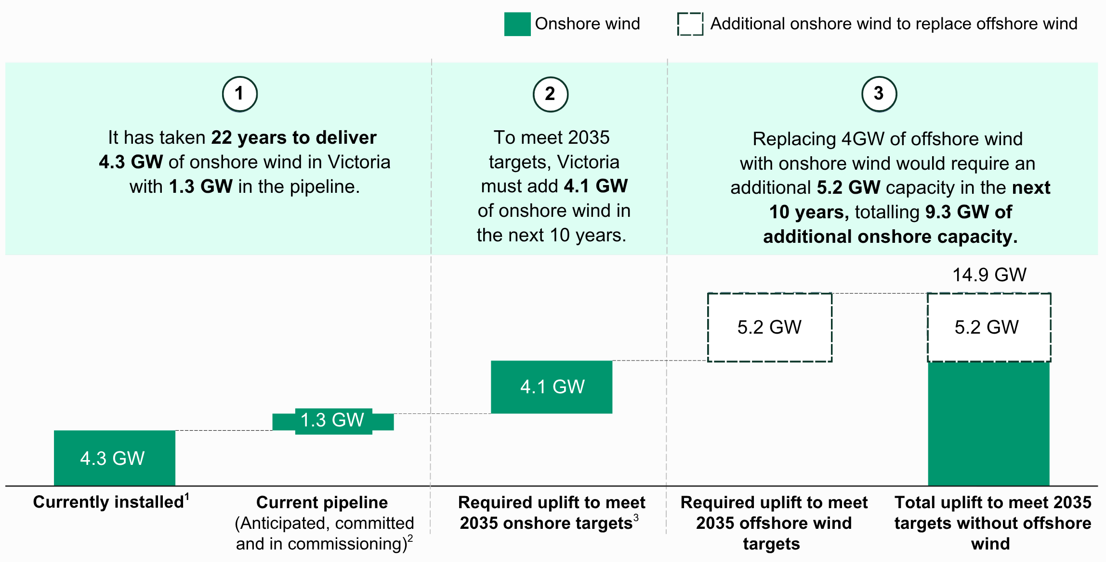
Notes: Data is based on AEMO NEM generation data. 1 Currently installed = ‘In Service’; 2 Current pipeline =
‘Anticipated’, ‘Committed’, ‘In Commissioning’. ‘Publicly announced’ projects not included in ‘current pipeline’ as they
have not been formally progressed; 3 Onshore targets refer to AEMO 2024 ODP step change scenario targets
(AEMO, 2024).
Figure 2-5 shows that replacing the 4 GW of planned offshore wind capacity by 2035 with solar would require an additional 8 GW of utility-scale solar, which is ten times Victoria’s current installed capacity. Over the last 18 years, 1.1 GW of solar energy has been delivered, and only 1.1 GW are currently under development. Land availability, transmission infrastructure gaps and a greater investment focus in Queensland and New South Wales would limit this level of expansion.

Figure 2-5 Additional solar required to meet 2035 capacity
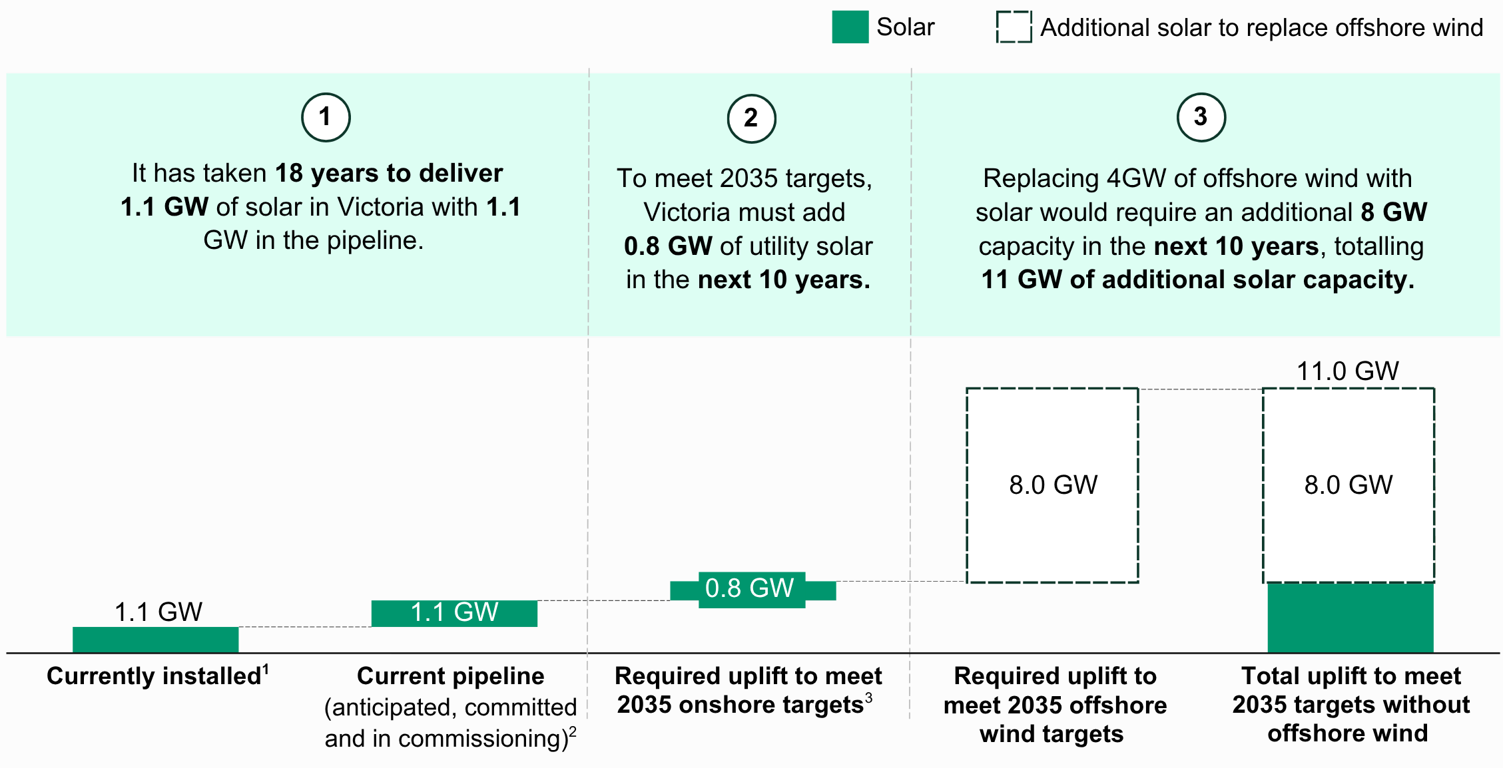
Notes: Chart data based on AEMO NEM generation data. 1 Currently installed = ‘In Service’; 2 Current pipeline
‘Anticipated’, ‘Committed’, ‘In Commissioning’. ‘Publicly announced’ projects not included in ‘current pipeline’ as they
have not been formally progressed; 3 Solar targets refer to AEMO 2024 ODP step change scenario targets
(AEMO,2024; Aurora, 2023, Clean Energy Council, 2023)
Onshore renewables will continue to be pivotal in Victoria’s energy transition. However, this option alone is not a viable solution for achieving government targets or maintaining energy security.
While geographically diversifying onshore wind within eastern Victoria is an option, large-scale onshore projects in this part of the state already face social licence challenges, with many areas identified as inappropriate for development due to other uses and conservation values. Importantly, winds onshore are also typically not as strong as those recorded offshore along the coast.
Additionally, the Clean Energy Council reported that relying solely on onshore renewables would require significant infrastructure development (Clean Energy Council, 2025). Offshore wind’s unique advantage comes from its magnitude and location, and large-scale projects built near demand centres, such as coastal cities and industrial hubs facilitate efficient energy generation, minimising the need for extensive transmission infrastructure development. AEMO’s identification of four transmission projects in (T4 in Tasmania, N10 and N11 in New South Wales, and V7 in Victoria) highlights this opportunity. These projects would connect the offshore wind areas in New South Wales, Victoria, and Tasmania, delivering the most energy capacity for the shortest transmission distances of any new transmission project (Clean Energy Council, 2025).
Figure 2-6 (T4 in Tasmania, N10 and N11 in New South Wales, and V7 in Victoria) highlights this opportunity. These projects would connect the offshore wind areas in New South Wales, Victoria, and Tasmania, delivering the most energy capacity for the shortest transmission distances of any new transmission project (Clean Energy Council, 2025).
Figure 2-6 Megawatt (MW) capacity unlocked per kilometre of transmission line easement length
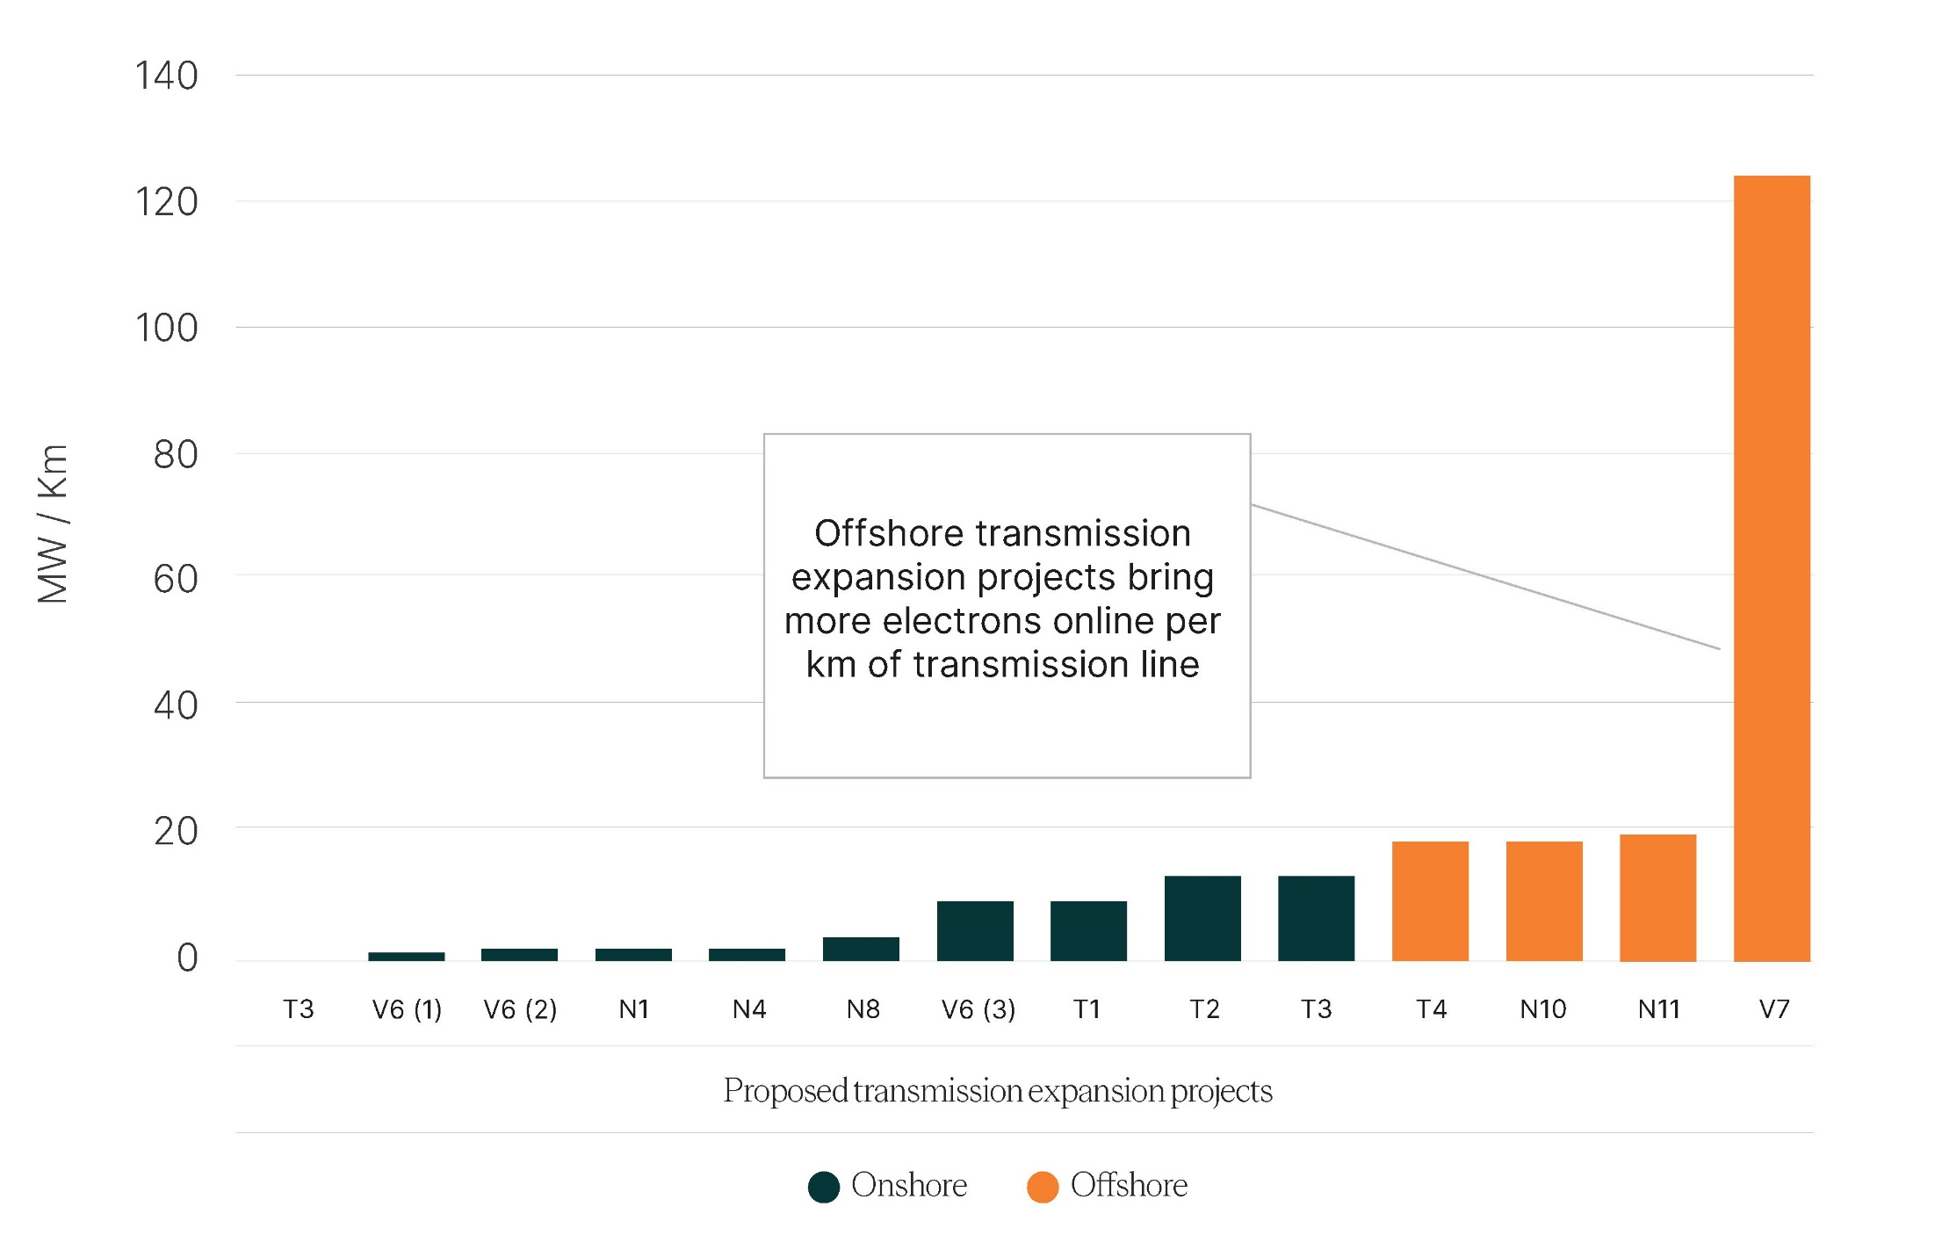
Source Clean Energy Council, 2025

Option 4: Increase reliance on interstate electricity imports
This option considers increasing Victoria’s reliance on interstate electricity imports through expanded transmission infrastructure. The NEM allows electricity to be shared between Australia’s eastern states, which could enable Victoria to import surplus power as coal-fired power stations retire.
While interstate imports could help meet Victoria’s energy needs, this approach carries uncertainties regarding reliability and affordability. Other states are also phasing out coal-fired generation, meaning excess supply may not be available without large-scale investment outside Victoria. Expanding transmission infrastructure would also require significant funding and long lead times, delaying the transition to a clean energy system.
Key issues with this option include:
- Energy security risks: Greater reliance on imports leaves Victoria vulnerable to supply shortages and price volatility, particularly if other states experience generation shortfalls or extreme weather events.
- Limited control over the clean energy transition: Victoria’s renewable energy mix would be dictated by external market conditions rather than state-led planning, making it harder to meet the legislated 2025 and 2030 renewable energy targets.
- Limited regional economic benefits: Interstate imports would not result in long-term jobs or investments in Victoria, particularly in regions affected by coal-fired power plant closures. Instead, economic benefits would be shifted to other states where generation projects are located.
Figure 2-7 Net imports and exports of energy in Victoria with and without offshore wind
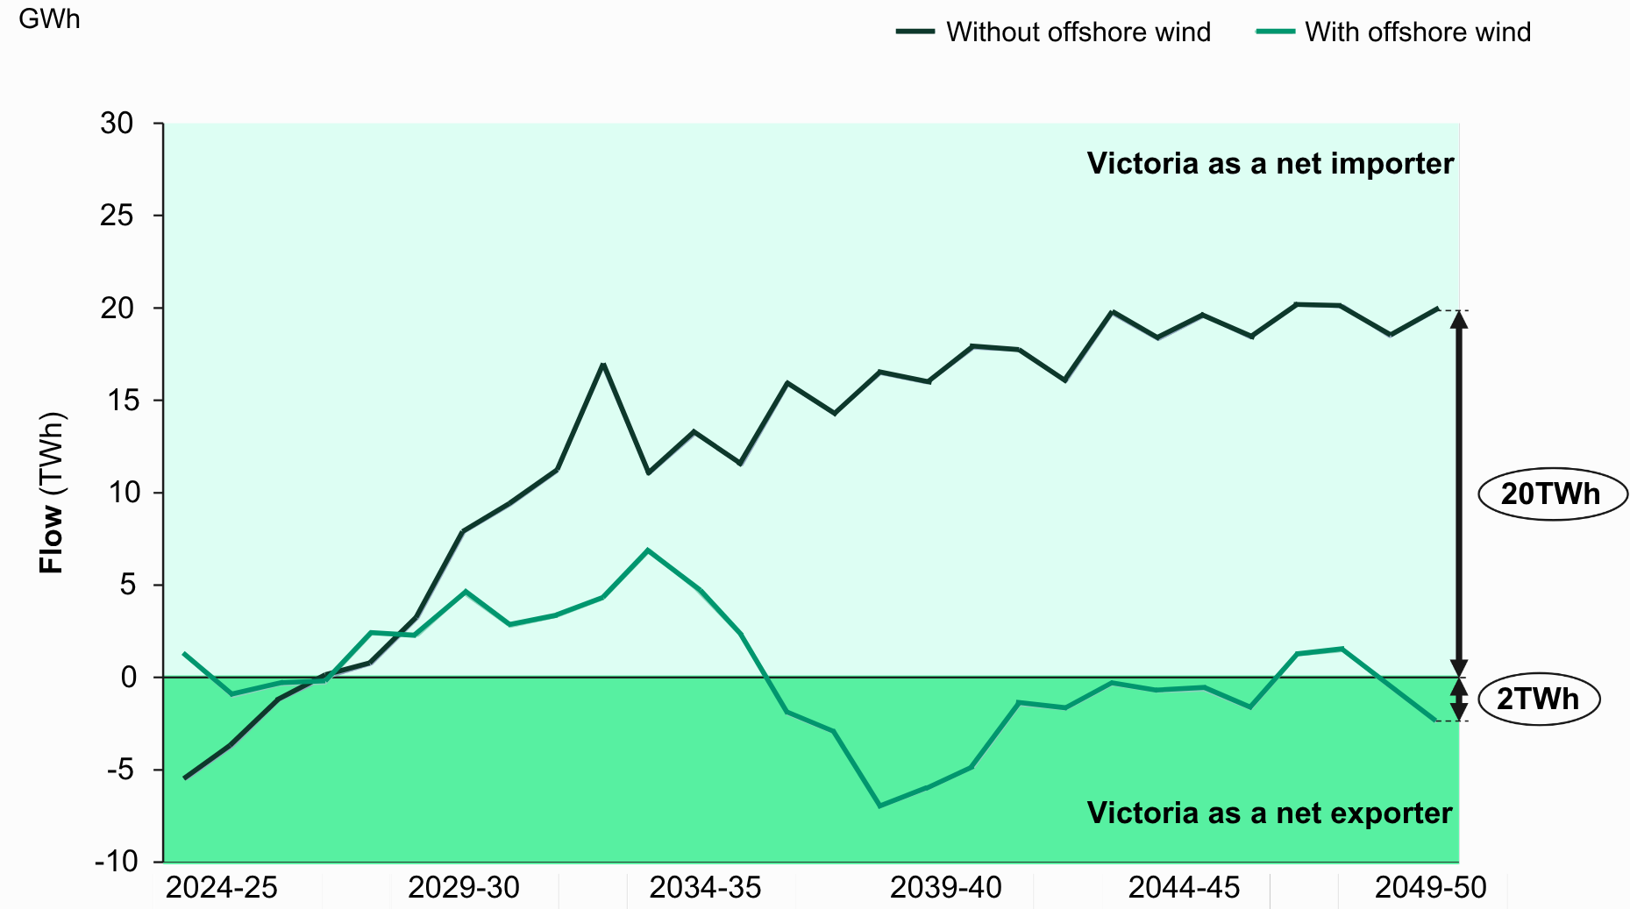
Figure 2-7 compares Victoria’s net energy import from 2022 and 2024 where 2022 does not include offshore wind and 2024 includes offshore wind. Additional factors that have changed between 2022 and 2024 include seven transmission projects progressing to ‘actionable’ status, increased uptake of household solar, batteries and electric vehicles, and updated cost assumptions (Australian Energy Market Operator, 2022, 2024).
Without offshore wind, Victoria may need to import up to 20 per cent of the NEM’s total generation by 2049/2050, increasing its dependence on external supply. By contrast, with offshore wind, Victoria would remain a net energy exporter, supplying around two terawatt-hours of electricity to the network within the same timeframe.
While interstate imports may play a supporting role in balancing the electricity network, this option alone does not provide a viable, long-term solution for Victoria’s clean energy transition. It fails to deliver on critical needs, including ensuring energy security and meeting emission reduction commitments. At the same time, it would also forgo the local job creation and economic benefits associated with offshore wind. For these reasons, this option is not considered a feasible response.

Option 5: Construct an offshore wind farm
Australia, particularly Victoria, has vast, untapped offshore wind resources. A study by the Blue Economy Cooperative Research Centre (Briggs et al, 2021) confirms that Bass Strait has some of the world’s best conditions for offshore wind, with strong, consistent wind speeds and expansive areas of shallow seabed ideal for large-scale offshore wind projects using fixed-bottom turbines.
Bass Strait is also home to the ‘Roaring Forties’ – powerful westerly winds that blow across the Southern Hemisphere between the latitudes of 40 to 50 degrees. These winds are known for their strength and remarkable year-round consistency. An analysis of additional weather data and 30 years of Bureau of Meteorology data indicates that these Bass Strait winds are highly correlated with peak electricity demand periods in Victoria, such as hot days with temperatures above 35 degrees Celsius. This high-pressure system over the Tasman Sea was present on every hot day over the 30-year analysis period.
Capturing these offshore winds complements onshore renewables by providing energy when other sources are unavailable or produce less, such as during nighttime or periods of low wind.
Beyond energy generation, offshore wind represents a major economic opportunity. Research estimates that by 2032, the industry could create between 3,000 and 6,500 full-time jobs, with continued growth projected to 2050 (Briggs et al, 2021). Offshore wind would revitalise regions like Gippsland, where coal plant closures threaten local employment, by creating new career pathways for workers from the coal, oil and gas sectors through skill transfer and upskilling programs. This would allow Gippsland to continue its long tradition of energy generation into the future.
With Victoria’s legislated offshore wind targets and the NEM’s growing demand for renewable energy, offshore wind is essential to ensuring energy security and stabilising electricity prices. As Australia’s most advanced offshore wind project, Star of the South is uniquely positioned to deliver lasting economic, energy and environmental benefits for Victoria.

Conclusion
Offshore wind aligns with the Commonwealth’s and Victoria’s net-zero commitments, supports emissions reduction targets and secures reliable, large-scale renewable energy for the long term. Establishing Australia’s first offshore wind project would kick-start a new industry, build supply chains, create local expertise and drive ongoing investment to decarbonise the country further.
Diversification is necessary to strengthen system resilience, spread job opportunities across regions and avoid the concentration of community impacts. Only a combination of technologies can achieve this outcome. By pursuing Option 5: Construct an offshore wind farm, the project complements the positive effects of Option 3: Expand onshore renewable energy resources, thereby enhancing the overall net benefit of the project for Victorians.

