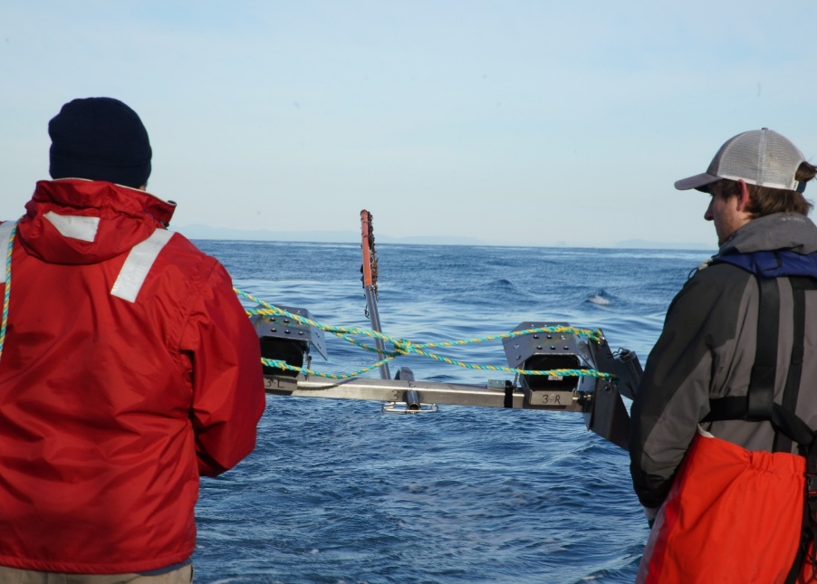

Commonwealth Environmental Impact Statement
Chapter 21 – Business and tourism

Table of Contents
Chapter 21 Business and tourism 21-1
21.1 Introduction 21-1
21.2 Assessment scope 21-2
21.2.1 Commonwealth matters 21-2
21.3 Evaluation framework 21-3
21.3.1 Key legislation, policy, guidelines and standards 21-3
21.3.2 Assessment criteria 21-3
21.4 Methods 21-3
21.5 Existing environment 21-8
21.5.1 Population and housing 21-8
21.5.2 Jobs and industry 21-9
21.5.3 Tourism 21-11
21.6 Construction impacts 21-13
21.6.1 Key impacts 21-13
21.6.2 Other impacts 21-21
21.6.3 Potential risks 21-26
21.7 Operation impacts 21-28
21.7.1 Key impacts 21-28
21.7.2 Other impacts 21-31
21.7.3 Potential risks 21-32
21.8 Decommissioning impacts 21-33
21.8.1 Onshore decommissioning 21-33
21.8.2 Offshore decommissioning 21-33
21.9 Cumulative impacts 21-34
21.10 Summary of mitigation, monitoring and contingency measures 21-37
21.10.1 Mitigation measures 21-37
21.10.2 Monitoring and contingency measures 21-38
21.11 Conclusion 21-39

Figures
Figure 21-1 Local study area (incorporating Foster, Longford-Loch Sport, Wilsons Promontory and Yarram) 21-6
Figure 21-2 Regional study area (incorporating the Latrobe-Gippsland Statistical Area 4) 21-7
Figure 21-3 Monthly unemployment rate, regional study area and Victoria, 1998 to 2023 21-10

Tables
Table 21-1 Key legislation, policy, guidelines and standards 21-3
Table 21-2 Jobs by industry in local and regional study area 21-9
Table 21-3 Residual construction noise impacts on coastal tourism 21-14
Table 21-4 Residual construction impacts on Reeves Beach campground 21-16
Table 21-5 Residual construction impacts from changes to regional employment 21-18
Table 21-6 Residual construction impacts from disruption to the local and regional labour markets 21-19
Table 21-7 Residual construction impacts on disruption to the local housing and accommodation market 21-21
Table 21-8 Residual construction disruption impact on existing businesses and tourism routes as a result of road closures and congestion from construction traffic 21-22
Table 21-9 Residual impacts on loss of primary production for regional processors as a result of land taken out of production 21-23
Table 21-10 Residual construction impacts from construction on recreational diving industry 21-24
Table 21-11 Residual offshore construction impacts on recreational fishing and boating 21-25
Table 21-12 Residual construction underwater noise impact on marine fauna, disrupting marine tourism 21-26
Table 21-13 Residual construction oil spill risks on tourism 21-27
Table 21-14 Residual operational impacts to employment 21-29
Table 21-15 Residual operational disruption to housing market 21-30
Table 21-16 Residual operational visual impacts on visitation and tourism revenues 21-31
Table 21-17 Residual operation oil spill risk to tourism 21-32
Table 21-18 Summary of cumulative impact assessment for business and tourism 21-34
Table 21-19 Summary of mitigation measures relevant to business and tourism 21-37
Table 21-20 Monitoring and contingency measures relevant to business and tourism 21-38

Business and tourism

Introduction
This chapter summarises the existing conditions related to the business and tourism sectors within the local and regional study areas in Gippsland and assesses associated impacts and risks from the construction, operation and decommissioning of the Star of the South Offshore Wind Farm (the project) within the Commonwealth jurisdiction. The chapter describes how impacts will be avoided, minimised or managed.
This chapter is based on the impact assessment presented in Technical Report Q – Business and Tourism.
Other chapters that relate to or inform the business and tourism assessment include:
Chapter 15 - Commercial and Recreational Fisheries
Chapter 20 – Social
Chapter 22 - Seascape, Landscape and Visual

Assessment scope
The study objective for business and tourism is to predict the impacts of the project on the economy of the project area and the Gippsland region in which it is located.
All detailed technical methodologies and assessment on business and tourism can be found in Technical Report Q – Business and Tourism.

Commonwealth matters
The Environmental Impact Statement (EIS) guidelines for the project inform the preparation of the EIS to enable the Commonwealth Minister for the Environment to make an informed decision on whether or not to approve the project under the Environment Protection and Biodiversity Conservation Act 1999 (EPBC Act).
The aspects of the EIS guidelines that are directly relevant to business and tourism are:
- Section 2.3 – Description of the environment
- Section 2.6.3 – Commonwealth marine area. The whole of the environment must be considered in the assessment of the impacts of the action on the Commonwealth marine area, including social, economic and cultural aspects of the environment.
- Section 2.7 – Relevant impacts on existing users of the marine environment including marine tourism
- Section 2.17 – Economic and social matters, including:
  - projected economic costs and benefits of the project, including the basis for their estimation through cost/benefit analysis or similar studies
  - information on the amount of domestic and/or overseas investment for capital infrastructure (versus alternatives) (not part of this assessment)
  - employment opportunities expected to be generated by the project (including construction and operational phases).
Further information about the EIS guidelines is listed in Attachment V – EIS Guidelines Checklist.

Evaluation framework

Key legislation, policy, guidelines and standards
Table 21-1 lists key legislation, policy, guidelines and standards relevant to business and tourism within the Commonwealth jurisdiction.
Table 21-1 Key legislation, policy, guidelines and standards
Type | Applicable legislation, policy, guideline or standard
Commonwealth government | Environment Protection and Biodiversity Conservation Act 1999 (EPBC Act)
Commonwealth government | Navigation Act 2012
Commonwealth government | Offshore Electricity Infrastructure Act, 2021
Commonwealth government | Gippsland Regional Plan, 2020-2025

Assessment criteria
To assess the project, predicted impacts and risks are compared to criteria that set required environmental performance outcomes (refer to Chapter 6 – Assessment Framework).
The criteria for business and tourism are derived from legislation and policy, relevant standards and guidelines, stakeholder feedback and industry best practice. The assessment criteria used to measure impacts on business and tourism are:
- The net income of directly affected businesses is not unduly adversely affected by the project
- Regional output and employment are not reduced by the project
- Where opportunities exist, regional output and employment are maximised where possible
- Visitor numbers and their distribution are not adversely affected by the project
- The capacity of the region to host further investment and jobs is not diminished by the project.

Methods
The purpose of the business and tourism impact assessment is to assess the potential impacts and risks of the project on business and tourism.
Impacts refer to the consequences of planned project actions, which are given a rating determined by combining the magnitude of the impact and the sensitivity of the receptor (receptor types such as visitors/visitation, visitor attractions, businesses, industries, employment levels).
Risks are an unexpected (accidental) event and are determined by combining the likelihood of an event occurring and the consequences that would result if the event were to occur.
The technical chapters consider key impacts and risks with a residual consequence rating of moderate to severe. Other impacts and risks are those with a residual consequence rating of negligible to minor.
Refer to Chapter 6 – Assessment Framework for more detail on how impact and risk ratings are derived.
Local study area
An area defined for this study comprising contiguous Australian Bureau of Statistics areas through which the transmission corridor will pass or from which the wind farm will be seen. These statistical areas are Foster, Longford-Loch Sport, Wilsons Promontory and Yarram.
Regional study area
An area defined for this study which comprises the region in which the project would be located. This region would experience the main impacts on business, tourism and employment and has been defined as the Latrobe -Gippsland Australian Bureau of Statistics statistical area.
This was achieved by undertaking the following key tasks:
- Defining two study areas based on Australian Bureau of Statistics (ABS) areas - a local study area comprising the Foster, Longford-Loch Sport, Wilsons Promontory and Yarram Statistical Areas (refer to Figure 21-1), and a regional study area consisting of the Latrobe-Gippsland Statistical Area (refer to Figure 21-2).
- Reviewing national, state and local legislation relevant to protection of business and tourism
- Characterising existing conditions and identifying sensitive assets, values and uses
- Reviewing the project description to determine the location, type, timing, extent, intensity, and duration of potential project interactions with sensitive receptors
- Defining the maximum design scenario(s) based on project design envelope parameters that provide the basis for impact assessment. These are defined in Technical Report Q – Business and Tourism.
- Consulting with stakeholders from a variety of state and local government agencies
- Reviewing Australian Maritime Safety Authority (AMSA) automatic identification system data that describes the nature and travel patterns of vessels
- Reviewing data from field surveys of boat ramp users and visual aerial surveys conducted for the project
- Conducting a proportional assessment of risks and impacts based on the outcomes of the initial assessment of issues and consultation insights that examines the potential severity, extent and duration of identified issues
- Evaluating predicted outcomes against performance benchmarks and assessment criteria derived from applicable legislation, policy and standards
- Identifying mitigation measures where necessary to address potentially significant environmental impacts
- Evaluating residual environmental impacts and risks against assessment criteria, taking into account the proposed mitigation measures and likely effectiveness.

Figure 21-1 Local study area (incorporating Foster, Longford-Loch Sport, Wilsons Promontory and Yarram)
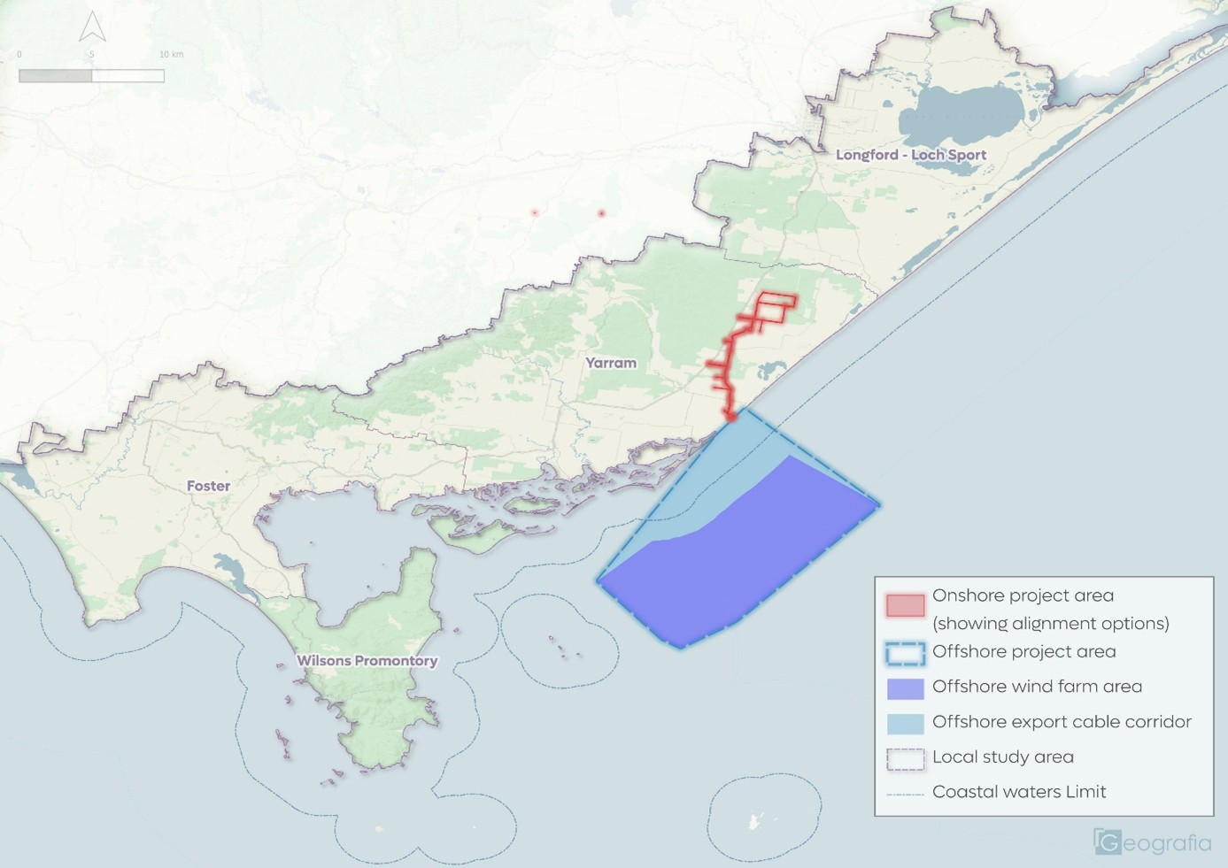
Figure 21-2 Regional study area (incorporating the Latrobe-Gippsland Statistical Area 4)
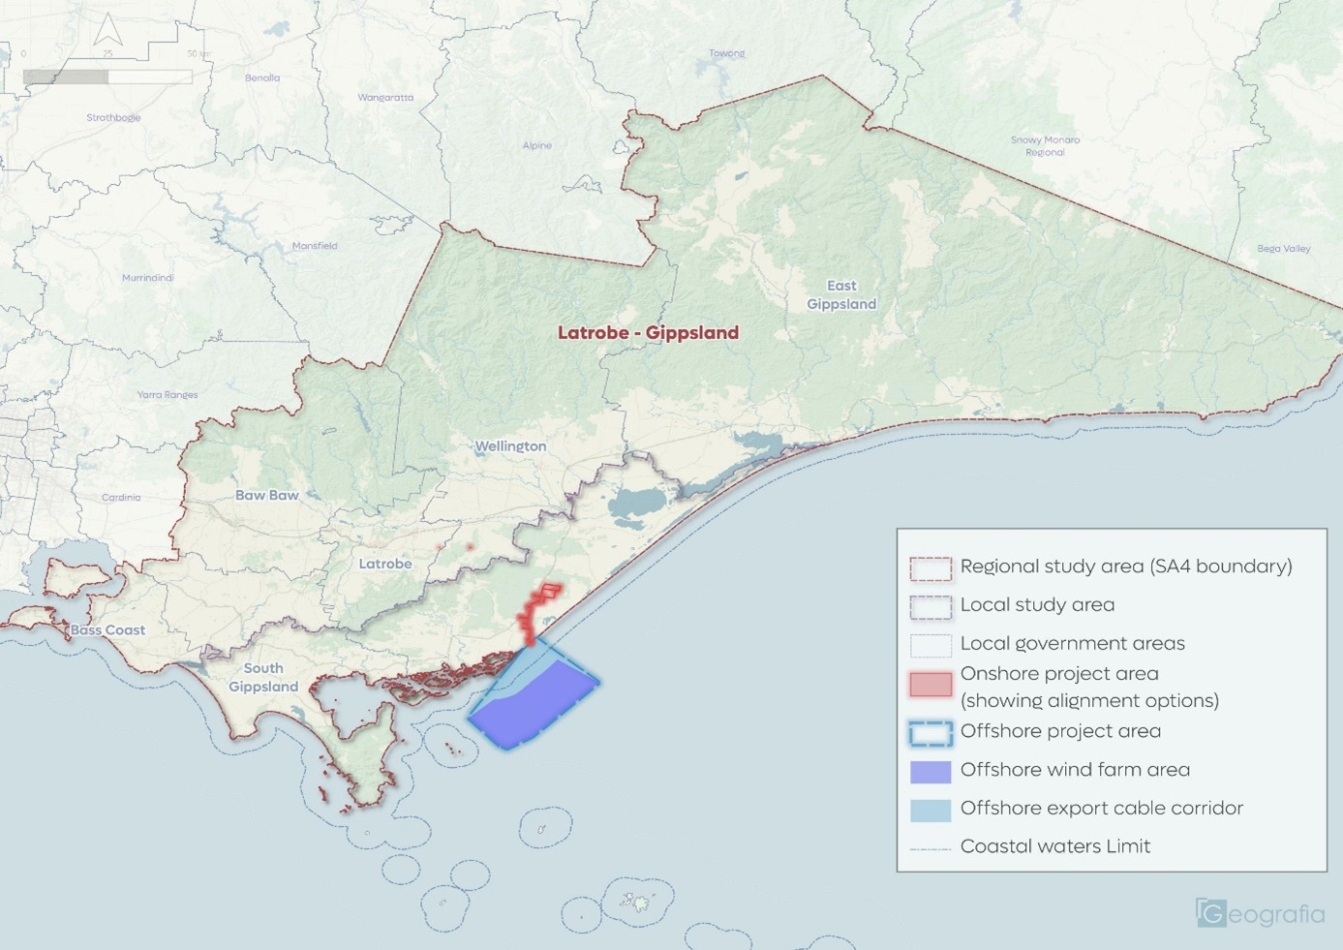

Existing environment
This section describes the existing conditions within the local and regional study area, as they relate to business and tourism, including population, housing, jobs, industry and tourism. The local study area is characterised by farming, forestry, small towns, and nature reserves, with a relatively slow population growth rate.

Population and housing

Population
The Census of Population and Housing conducted by the ABS identifies the population of settlements within the study areas. In 2024 the following populations were recorded for the respective study areas:
- Local study area – 20,259
- Regional study area – 311,434
The rate of growth in the study areas over the seven-year period 2016 to 2024 has been:
- Local study area – 1.0 per cent per year
- Regional study area – 1.5 per cent per year.
This compares with a growth rate in Victoria of 1.5 per cent per year over the same period.
Key aspects of the Victorian State Government’s 2023 population forecast include:
- Both study areas are expected to have lower rates of growth than the state as a whole
- The local study area is expected to have a lower rate of growth than its region and continue to be affected by low growth in farming, forestry and fishing
- Population growth in the period 2023 to 2036 is expected to be approximately:
  - 2,500 in the local study area
  - 49,700 in the regional study area.

Housing
In the 2021 Census the local study area had approximately 15,244 dwellings. Around 6,142 or 43 per cent were unoccupied, a high percentage compared to the state average of five to 19.7 per cent, which typically indicates that the area is a holiday destination. Around 33 to 38 per cent of all dwellings in the local study area are holiday homes, mostly concentrated in beachside communities such as Venus Bay, Sandy Point, Port Albert, Seaspray and Loch Sport.
Existing long-term and short-term accommodation options are available within key townships within a 60-minute drive of project work sites located at:
- Gippsland Ports
- Between Reeves Beach and the VicGrid common connection point in Giffard for construction of transmission infrastructure.
Further details of accommodation availability within the region is provided within the draft Workforce Accommodation Strategy (refer to Appendix A of the Technical Report R – Social.

Jobs and industry

Industry
In the 2021 Census there were 7,400 jobs in the local study area and 113,100 in the regional study area. A summary of the top four jobs by industry local study area is provided in Table 21-2.
Table 21-2 Jobs by industry in local and regional study area
Industry | Jobs in the regional study area | Jobs in the local study area | Jobs in the regional study area | Share of jobs in the local study area
Agriculture, forestry and fishing | 9,198 | 1,592 | 8.1% | 21.6%
Public administration and safety | 7,728 | 948 | 6.8% | 12.9%
Health care | 18,761 | 635 | 16.6% | 8.6%
Construction | 9,795 | 593 | 8.7% | 8.0%
Other jobs by industries within the local study area range across many types, with the top four within the local area followed by education and training, retail trade, and accommodation and food services.

Unemployment
In 2023 there were 4,100 unemployed people (2.4 per cent) in the regional study area, down from 4,700 in October 2019, based on ABS Labour Force data. The monthly rate of unemployment is shown in Figure 21-3, which illustrates unemployment rates in both the regional study area and Victoria following the same trend, with the exception of periods when key local industries were experiencing structural change (such as privatisation in the electricity section in 1990s, and with timber industry reform and the closure of the Hazelwood mine and power plant in the mid-2010s)
Figure 21-3 Monthly unemployment rate, regional study area and Victoria, 1998 to 2023

Businesses
Small businesses (those with fewer than five employees) make up 92 per cent of business types in the local study area and 89 per cent in the regional study area, compared to 90 per cent in Victoria as a whole. The local study area has a slightly higher proportion of small businesses because of the high proportion of farming businesses, with most farms being family-owned and operated enterprises.
Local and regional study area businesses have a turnover of between $200,000 and $2 million per year, slightly higher than for Victoria as a whole. Less than one per cent of businesses across both study areas (eleven enterprises in the local study area and 255 enterprises in the regional study area) have a turnover of $10 million or more. This is a little less than in the state as a whole, where nearly two per cent of enterprises have an annual turnover of $10 million or more. This is likely because of the high proportion of family farm businesses and construction tradespeople operating their own business in the study areas.
The industrial structure in the study areas is quite different to the state, with many farming, forestry and fishing enterprises – especially in the local study area. The regional study area has a similar proportion of manufacturing and construction enterprises as the state, and it is these sectors that could construct the project.

Tourism

Tourism assets
Gippsland is a strong and varied tourism region with important natural assets in its national parks, coastlines, marine area and alpine areas. Visitors are drawn to the region for its natural places such as Wilsons Promontory, Nooramunga, Ninety Mile Beach and Tarra Bulga Parks and facilities that provide opportunities for outdoor recreation – camping, hiking, fishing, hunting, boating, water sports, cycling, skiing, four-wheel driving and sight-seeing. The region also has a growing food, wine and cultural offering, and these assets are becoming important in expanding visitation to the area.
The marine environment of the local study area is used for recreational activities including fishing, cruising, and scuba diving. Recreational vessels used within the local study area include recreational sailing (yachts), motor cruising, jet skis, kayaks and canoes. Recreational vessels use both the Commonwealth and Victorian marine areas. The foreshore areas of Nooramunga / Corner Inlet, including the barrier islands, are used for fishing and beach activities in parts, although much of this part of the coast is fringed with mangrove and relatively inaccessible without a boat. Ninety Mile Beach is a continuous sandy beach and hosts fishing and traditional beach activities, with surf lifesaving clubs at Woodside Beach and Seaspray.
Reeves Beach is one of the closest points on land to the wind farm and would be the landfall for the offshore transmission cable. The foreshore in this location is part of the McLoughlins Beach – Seaspray Coastal Reserve, the south-eastern extent of Ninety Mile Beach. This is a free camping area at Reeves Beach that is managed by Parks Victoria and has room for up to 30 informal camp sites. There is one toilet at the site but no other services. The campground is one of many free and commercial caravan and camping grounds on the coast of Ninety Mile Beach, Nooramunga and Corner Inlet.

Tourism economic contribution
In 2023-24, the tourism industry contributed approximately $1,333 million (7.0 per cent), directly and indirectly, to the gross regional product of the Gippsland region. In the same year, the industry employed 14,100 people directly and indirectly, providing around 9.7 per cent of the region’s jobs.
The local study area is estimated to account for 20 per cent of the region’s visitors. This means the gross regional product generated by tourism in the local study area was, on a pro rata basis, $270 million. The accommodation sector accounts for six per cent of jobs in the local study area and tourism accounts for 10 to 15 per cent of jobs directly and indirectly, making the industry one of the key economies of the area.
For context within the local study area, the number of visitor nights in the local study area is estimated broadly at 1.6 million per year, with around 0.5 million overnight visitors.

Construction impacts
This section discusses impacts and risks associated with the project’s construction that relate to business and tourism and the respective receptor groups.

Key impacts

Construction noise impacts on coastal tourism (BTM-I003)

Potential impact
Construction of the project has the potential to impact noise levels at the following tourism sensitive receptor locations:
- Nature reserves – the McLoughlins Beach–Seaspray Coastal Reserve, Woodside Bushland Reserves, Mullungdung State Forest, Warrigal Creek Streamside Reserve, Darriman Bushland Reserve
- Campground – Reeves Beach campground (see BTM-I04)
- Townships – Woodside and Woodside Beach townships
- Individual non-farm businesses – Woodside Ranch Luxury Farmstay, Barooma Homestead and any other home-based businesses in the area.
The onshore noise impacts will be generally limited to normal day-time construction hours, except for shore crossing works at Reeves Beach. Noise from shore crossing works is likely to impact amenity of the Parks Victoria managed Reeves Beach campground and may deter visitors from using this free camp area.
Onshore noise impacts from offshore piling may occasionally be heard from the shore and be disturbing. However, the nearest onshore receptors are 10 km from the closest foundation and the majority of the foundations are more than 20 km from the nearest receptor. The noise will be progressively attenuated from the source such that, in the great majority of cases, is unlikely to be heard from the shore.
The general noise and disturbance created by the construction of the onshore transmission is expected to be relatively limited in scale and duration. The noise will be noticeable up to two kilometres from the area of work for approximately four weeks in any one location (refer to Technical Report W – Onshore Noise and Vibration for further details). Details of the impacts to the Reeves Beach campground are addressed in Section 21.6.1.2.

Mitigation
Mitigations proposed to manage construction noise are set out in Technical Report W – Onshore Noise and Vibration and Chapter 20 – Social. Mitigations include a Stakeholder Engagement Plan (BTM-M001) which will ensure the coastal tourism sector is informed ahead of any potentially noisy construction activities, a community benefit fund (BTM-M003) to mitigating the construction impacts on coastal tourism, and a Workforce Accommodation Strategy (BTM-M006) to ensure that the workforce does not overwhelm the local accommodation sector.

Residual impact
While residual construction noise impacts will be temporary and localised, and mitigations such as a Stakeholder Engagement Plan will be implemented, this impact cannot be fully avoided at all times. Accordingly, the residual impacts remain consistent with the pre-mitigation impact of moderate (refer to Table 21-3).
Table 21-3 Residual construction noise impacts on coastal tourism
Potential impact | Receptor group | Receptor sensitivity | Magnitude | Initial consequence | Mitigations | Residual consequence
Construction noise impact on coastal tourism | Accommodation providers  Tourism service industry  Visitors | Medium | Medium to | Moderate | BTM-M001  BTM-M003  BTM-M006 | Moderate

Adverse impacts on Reeves Beach campground (BTM-M004)

Potential impact
The project's shore crossing will be constructed at Reeves Beach, with periods of work occurring within a 27-month timeframe, including up to seven months from onshore activities and up to six months of offshore activities. This work site is located approximately 250 metres from the Reeves Beach campground and associated construction noise and traffic may cause temporary disturbance to campground users.
The shore crossing involves trenchless drilling of up to eight boreholes which will contain the cables carrying electricity generated offshore to the onshore transmission system.
It is likely that construction noise will be experienced at Reeves Beach from:
- Drilling of the eight boreholes, with each carried out as a continuous activity (over a 24-hour period) to maintain borehole stability during the drilling operations
- Cable pulling activities requiring a vessel offshore and temporary small support structures in the near-shore waters.
- Trenching and concrete batching to the north west of the Reeves Beach dunes.

Mitigation
Consultation with Parks Victoria on the Reeves Beach campground (BTM-M004) will be undertaken to identify and support management options for the Reeves Beach free campground during construction of the project. Appropriate resources will be provided to notify potential campground users of upcoming construction noise or activity and to promote alternative free camping available in Gippsland.
Any impacts on visitation may be ameliorated to some degree through projects that enhance the visitor experience that may be agreed through the Community Benefit Fund (BTM-M003).

Residual impact
Even with the mitigation measures in place, some people may be deterred from visiting the Reeves Beach area, either postponing their visit or travelling elsewhere. The consequent losses of tourism revenue to local and regional businesses would be small and restricted to the construction period around the campground. The residual impacts remain consistent with the pre-mitigation impact of moderate (refer to Table 21-4).
Table 21-4 Residual construction impacts on Reeves Beach campground
Potential impact | Receptor group | Receptor sensitivity | Magnitude | Initial consequence | Mitigations | Residual consequence
Decline in visitation because of construction impacts on Reeves Beach campground | Visitors  Tourism service industry | Medium | Medium | Moderate | BTM-M004 | Moderate

Changes to regional employment during construction (BTM-I008)

Potential impact
The generation of employment for the Gippsland region and elsewhere in Victoria and Australia is a major positive impact of the project. The project will directly and indirectly generate a significant number of jobs during the installation of the offshore wind farm and associated transmission infrastructure. The project will directly generate, on average, between 215 and 683 additional annual full time equivalent jobs in Gippsland over the construction period (up to seven years), with the final number depending mainly on the location of the selected contractors and their construction methodology and approach, as well as the extent to which a Gippsland-based port is used for the transfer of offshore workers.
These jobs would be for a range of skill areas including:
- Electricians and electrical engineers
- Construction trades including marine construction workers
- Mariners
- Logistics experts, warehouse workers and dockworkers
- Civil engineers and project managers
- Administrative workers
- General labourers.
In addition, there will be a need for a many different workers engaged indirectly in servicing the project, including people skilled in manufacturing, infrastructure, construction, transport, wholesaling, consultancy services, retailing and hospitality. This is estimated between 76 and 204 additional annual full time equivalent jobs in Gippsland.

Mitigation
Mitigations (initiatives) to capitalise on this positive impact from the project centre around the development of a Workforce Development Strategy (BTM-M005) which will identify project labour needs and how to maximise participation by Gippsland firms and Gippsland workers. This will include:
- Continuing to support the establishment of the Wind Worker Training Centre in Gippsland and developing programs to maximise the number of people trained by the centre
- Working with other stakeholders to develop a strong offshore wind workforce in the region
- Establishing procurement processes that have a weighting towards existing Gippsland firms or to firms which will establish a management and operational presence in the region for the project
- Encouraging participation in procurement by Gippsland firms by holding local briefings
- Working with other stakeholders to support local component manufacturing, service provision and research
- Working with local and regional stakeholders to ensure that those disadvantaged in the local labour-market – including aboriginal workers and people with disabilities - have access to jobs on the project
- Ensuring sufficient attractive accommodation is also a key to attracting skilled workers.

Residual impact
The project will generate large numbers of additional jobs for Gippsland through the construction period, deepening the regional skills base in the emerging renewable energy sector and providing continuity of energy jobs in the region as the coal, oil and gas sectors decline. The mitigation measures identified seek to maximise participation by Gippsland firms and Gippsland workers to benefit to the region. With measures in place, the residual impact is a major positive for the region related to regional employment during construction.
Table 21-5 Residual construction impacts from changes to regional employment
Potential impact | Receptor group | Receptor sensitivity | Magnitude | Initial consequence | Mitigations | Residual consequence
Changes to regional employment during construction | Regional industries | Medium | High | Major (positive) | BTM-M005 | Major (positive)

Disruption to the local and regional labour markets (BTM-I009)

Potential impact
The project will require the equivalent of up to 13 per cent of the region’s entire construction workforce at some points during the construction period. The availability of this amount of regional workforce is very unlikely, given the wide range of other significant projects and usual construction demands requiring local workers. Subsequently, some workers would need to come from beyond the region. Workers from the local labour market however may be enticed from their existing local employment resulting in a moderate-major impact to the local and regional labour markets.

Mitigation
To mitigate the impacts associated with the local labour markets and workers potentially being enticed from their existing local employment, Star of the South will need to consider strategies associated with attracting capable workers from other industries or from outside the region, upskilling workers within the region and re-deploying workers from declining industries. Star of the South proposes to manage this through a Workforce Development Strategy (BTM-M005) to connect suppliers, fossil fuel companies, local employment agencies and local labour pools, to meet the labour demand.

Residual impact
Considering the Star of the South's strategies to manage labour markets, paired with the Victorian and Commonwealth Government’s support to develop an offshore wind industry, residual impacts to local and regional labour markets are expected to be moderate.
Table 21-6 Residual construction impacts from disruption to the local and regional labour markets
Potential impact | Receptor group | Receptor sensitivity | Magnitude | Initial consequence | Mitigations | Residual consequence
Disruption to the local and regional labour markets | Regional industries | Medium | Medium to High | Moderate to | BTM-M005 | Moderate
 |  |  |  | Major | BTM-M005 | Moderate

Disruption to the local housing and accommodation market (BTM-I010)

Potential impact
The project will require a significant number of workers through the construction phase. This substantial generation of employment has the potential to increase demand on the local housing and accommodation market. If sufficient accommodation is not available, regional employment benefits associated with the local housing market may not be fully realised.
For this assessment, project work sites are assumed to located:
- Between Reeves Beach and Giffard West for the onshore transmission work
- At a Gippsland-based port (Barry Beach Marine Terminal or Port Anthony) for offshore wind farm work
- Elsewhere in Gippsland, including the Latrobe Valley towns or Sale, for other land-based offshore management, design and administration workers.
Given the scale of the project and the size of the local and regional workforce, even with retraining of existing workers, significant numbers of workers will be required from beyond an acceptable commuting distance which will require short and medium-term accommodation close to work areas. While the large towns along the Princes Highway corridor from Warragul to Sale have thriving housing markets and a range of urban growth areas, the towns of the local study area have much smaller housing markets, with limited urban growth opportunities.
The pressures on the housing market resulting from a large construction project would likely see a minor growth followed by a minor decline. The consequence of this price growth could increase costs for all new renters and purchasers in the area during the construction period.

Mitigation
Star of the South will further develop and implement a Workforce Accommodation Strategy (BTM-M006) that seeks to meet the accommodation needs of the workforce and mitigate potential impacts as the housing requirements increase. In broad terms, depending on the scope of the project and anticipated worker numbers, the strategy follows a hierarchy approach of:
            - Minimising demand for accommodation through local hiring practices
            - Securing access to existing housing supply
            - Developing temporary accommodation (only if required based, following the first two steps).
Star of the South acknowledges that if the development temporary accommodation is required, this will require separate approvals through a subsequent planning process.

Monitoring
In addition to the Workforce Accommodation Strategy, Star of the South also proposes two monitoring measures to manage potential disruptions to local housing and accommodation markets. These include workforce housing monitoring (BTM-M008) and accommodation surveys (BTM-M009). The purpose of the monitoring measures is to enable continuous evaluation of the effectiveness of the Workforce Accommodation Strategy and update the strategy as required.

Residual impact
With implementation of the Workforce Accommodation Strategy, regional tourism industry impacts are reduced and the local study area is expected to maintain its underlying level of growth. There would still likely be some impact on the cost and availability of rental accommodation during high demand periods like holidays. Following implementation of the mitigation and monitoring measures, the residual impacts to the local housing and accommodation market are expected to be minor to major. The wide range of potential consequences reflects a number of uncertainties including the extent to which local workers can be recruited; the level of existing vacant dwellings that can be brought into the market and the willingness and capacity of local and regional property investors to develop new stock.
Table 21-7 Residual construction impacts on disruption to the local housing and accommodation market
Potential impact | Receptor group | Receptor sensitivity | Magnitude | Initial consequence | Mitigations | Residual consequence
Disruption to the local housing and accommodation market: Shortage of commercial accommodation | Accommodation providers  New renters | High | High | Severe | BTM-M006  BTM-M008  BTM-M009 | Minor to
 |  |  |  |  |  | Major

Other impacts
Other potential construction impacts with minor to negligible residual effects on business and tourism once mitigation measures have been implemented include:
- Disruption of existing businesses and tourism routes as a result of road closures and congestion from construction traffic (BTM-I001)
- Loss of primary production for regional processors as a result of land taken out of production (BTM-I002)
- Underwater noise impacts from construction on recreational diving industry (BTM-I005)
- Offshore construction impacts on recreational fishing and boating (BTM-I006)
- Offshore construction impacts on marine fauna, disrupting marine tourism (BTM-I007).

Disruption of existing businesses and tourism routes as a result of road closures and congestion from construction traffic (BTM-I001)

Potential impact
Road closures, lane closures, speed restrictions and additional traffic caused by construction may increase travel times for local and regional businesses with the potential to increase their costs. Any traffic delays would also affect visitors to the area. The impacts of delays on local businesses and visitors would be elevated during the busy holiday periods. In addition, there will be an increase in freight movements and worker traffic across central Gippsland that will marginally increase road-user safety risks.

Mitigation
A Stakeholder Engagement Plan (BTM-M001) will be developed and implemented prior to construction in line with mitigation measures TTP-M001 and SOC-M003. A Traffic Management Plan (BTM-M002) will also be prepared in line with TTP-M002, including the programming of construction works to avoid any major planned traffic changes during key holidays, where possible.

Residual impact
With mitigation measures in place, impacts on the local and regional economy remain as negligible.
Table 21-8 Residual construction disruption impact on existing businesses and tourism routes as a result of road closures and congestion from construction traffic
Potential impact | Receptor group | Receptor sensitivity | Magnitude | Initial consequence | Mitigations | Residual consequence
Disruption of existing businesses and tourism routes as a result of road closures and congestion from construction traffic | Accommodation providers  Tourism services industry  Tourism businesses  Visitors | Low to | Low | Negligible | BTM-M001  BTM-M002 | Negligible

Loss of primary production for regional processors as a result of land taken out of production (BTM-I002)

Potential impact
Losses in farm production experienced during construction of the project would be unlikely to have a significant impact on regional processors (such as timber mills and abattoirs). This is because of the ability of the regional farm sector to make up for any shortfall in supply from the project area.
Forestry losses from the creation of a transmission line easement would be less than 0.1 per cent of the total annual plantation forestry production for Victoria across the life of the project (refer to Technical Report S – Agriculture and Forestry). Given the negligible impact on regional processors, further mitigations are not proposed.

Residual impact
Residual impacts will be temporary, with alternative sources likely covering shortfalls due to project construction and have been assessed as negligible to minor.
Table 21-9 Residual impacts on loss of primary production for regional processors as a result of land taken out of production
Potential impact | Receptor group | Receptor sensitivity | Magnitude | Initial consequence | Mitigations | Residual consequence
Loss of primary production for regional processors as a result of land taken out of production | Agriculture and forestry operators | Low | Low to | Negligible to | N/A | Negligible to
 | Agriculture and forestry operators | Low | Medium | Minor | N/A | Minor

Underwater noise impacts from construction on recreational diving industry (BTM-I005)

Potential impact
Underwater noise generated by offshore construction vessels and piling activity could potentially impact amenity (in terms of audibility of underwater construction activities) for recreational divers at a small number of dive sites on the eastern side of Wilsons Promontory and close to the entrances to Corner Inlet for small periods during piling (including limited exclusion).

Mitigation
Noise abatement systems will be used to reduce underwater noise impacts for marine mammals (refer to Chapter 11 – Marine Mammals and Turtles), which will also reduce the potential impact to divers. Stakeholder communications (OFF-M02) will provide regular updates and advanced notice of planned activities throughout the project’s construction.

Residual impact
The residual impacts remain consistent with the pre-mitigation impact of minor (refer to Table 21-10).
Table 21-10 Residual construction impacts from construction on recreational diving industry
Potential impact | Receptor group | Receptor sensitivity | Magnitude | Initial consequence | Mitigations | Residual consequence
Underwater noise impacts from construction on recreational diving industry | Recreational divers  Local visitor industry | Medium | Low | Minor | UWN-M03  OFF-M02 | Minor

Offshore construction impacts on recreational fishing and boating (BTM-I006)

Potential impact
During project construction, offshore recreational fishing and boating may be affected by:
- Temporary displacement from construction zones within the offshore project area
- Potential temporary changes in fish availability due to construction disturbance
- Reduced amenity of the offshore experience because of construction noise and due to visual changes to the seascape
- Increase in the demands on fishing and boating infrastructure as a result of use by project workers.
- Potential reductions in the number of fishers and boaters may contribute to loss of income for local accommodation providers and the small number of dining and retail outlets at Port Albert and surrounds. The lost income may shift from one part of the region to another, or it may be lost to the region altogether, resulting in a pre-mitigation impact of minor.

Mitigation
Stakeholder communications (OFF-M02) will provide regular updates and advanced notice of planned activities throughout the project’s construction, so that recreational boaters and charter operators can plan their activities accordingly. This will include the distribution of Notice to Mariners (OFF-M10) and other communications. Refer also to Chapter 15 – Commercial and Recreational Fisheries.
A Workforce Accommodation Strategy (BTM-M006) will be developed and implemented to place project workers in short term accommodation where trade might otherwise be affected by construction activity. This may offset, to some extent, any losses of existing fishing and boating clientele.
No further mitigation measures are proposed; however, recreational fishing and boating may be the subject of projects decided with the community through the Community Benefit Fund (BTM_M003).

Monitoring
The Stakeholder Engagement Plan will provide will gauge how the project is affecting the preferences of boat users and recreational fishers at boat ramps for evidence for potential infrastructure improvements or demand management measures (BTM-M007)
A monitoring program proposed for fish assemblages (MEMP-M07) will provide greater confidence in the predictions of negligible consequence for commercially and recreationally important fish species (refer to Chapter 10 – Fish and Invertebrates).

Residual impact
The economic impact of extended disruptions to offshore recreational fishing and boating would be localised to the coastal settlements from Port Albert to Woodside Beach and their service centres. For the most part, people could participate in these activities from elsewhere in the region. Business impacts may be offset, to some extent, by additional accommodation demand from project workers. Any impacts on the Gippsland region would be minor and should dissipate following the construction period. The residual impacts remain consistent with the pre-mitigation impact of minor (refer to Table 21-11).
Table 21-11 Residual offshore construction impacts on recreational fishing and boating
Potential impact | Receptor group | Receptor sensitivity | Magnitude | Initial consequence | Mitigations | Residual consequence
Offshore construction impacts on recreational \ fishing and boating | Fishers and boaters | Medium | Medium | Minor | OFF-M02  OFF-M10  BTM-M003  BTM-M007 | Minor

Offshore construction impacts on marine fauna, disrupting marine tourism (BTM-I007)

Potential impact
Marine tourism businesses, such as charter fishing and sightseeing and wildlife cruises, typically operate close to Wilsons Promontory and nearby islands and within Corner Inlet. As such, these businesses will not be displaced from the offshore project area.
The potential for disturbance or displacement of marine life outside the immediate offshore project area and its surrounds is not expected and so the project's construction is not likely to reduce the opportunity for tourism vessels to view marine life. Tours operating out of Corner Inlet, along Ninety Mile Beach or the ocean entrance adjacent to the Gippsland Lakes are not likely to be impacted, with marine life still expected to be present in and/or migrate through the area.

Residual impact
Given the initial assessment of negligible to minor impacts on marine tourism, no specific business and tourism mitigations are proposed.
Table 21-12 Residual construction underwater noise impact on marine fauna, disrupting marine tourism
Potential impact | Receptor group | Receptor sensitivity | Magnitude | Initial consequence | Mitigations | Residual consequence
Underwater noise impact on marine fauna, disrupting marine tourism | Marine tourism operators  Regional workers | Low | Low to | Negligible to | N/A | Negligible to
 | Marine tourism operators  Regional workers |  | Medium | Minor | N/A | Minor

Potential risks
One potential risk on business and tourism identified from the construction phase has a residual risk rating of low or very low. This includes:
- Oil spill impact on tourism (BTM-R001).

Oil spill risks on tourism (BTM-R001)

Potential risk
An accidental oil spill, which could reduce visitation to the local study area, affecting the turnover and employment in tourism businesses.

Mitigation
In line with Chapter 9 – Benthic Ecology, a Spill Response Plan (SPL-M02) will be developed for accidental hydrocarbon release from project activities within the marine environment.

Residual risk
In the very unlikely event of a noticeable oil spill during project construction, there could be impacts on visitation in the local study area. However, given the likely scale of any spill and the mitigation measures in place, any adverse impacts on business and tourism would be low.
Table 21-13 Residual construction oil spill risks on tourism
Potential risk | Receptor group | Receptor sensitivity | Magnitude | Initial risk | Mitigations | Residual risk
Oil spill impacts on tourism | Tourism operators | Medium | Medium | Low | SPL-M02 | Low

Operation impacts
This section discusses the impacts and risks associated with the operation of the project that relate to business and tourism and the respective receptor groups.

Key impacts

Changes to regional employment during the operational period (BTM-I011)

Potential impact
The project will have a positive impact on the availability of work in Gippsland. The port facility will employ some administrative or labour workers. However, most workers would be specialised port logistics workers, marine workers and wind farm maintenance workers. The majority of these would either be trained to take up the roles or travel from elsewhere to live in the area. Estimated ongoing employment in Gippsland (direct and indirect full time equivalent roles) is forecast at 316 full time equivalent roles.
Any negative impact on the supply of key workers to other enterprises and industries in the region is low.
The operational phase of the project will generate a wide range of jobs in supporting industries and as a result of the spending of direct employees. It is likely that these would grow over time, especially if the offshore wind industry continues to expand.
The number of indirect workers will depend on the capacity of local enterprises and the infrastructure to support them and any new entrants that might be required.

Mitigation
Mitigations (initiatives) to capitalise on this positive impact will flow from the Workforce Development Strategy (BTM-M005) which will identify project labour needs and how to maximise participation by Gippsland firms and Gippsland workers.

Residual impact
The ongoing employment based around the operations and maintenance port will provide a substantial boost to the economy of the local study area, providing a range of jobs requiring new and extended skills for the area. The project will have a major positive impact to employment during the operational phase.
Table 21-14 Residual operational impacts to employment
Potential impact | Receptor group | Receptor sensitivity | Magnitude | Initial consequence | Mitigations | Residual consequence
Ongoing employment | Regional industry | Medium | High | Major (positive) | BTM-M005 | Major (positive)

Disruption to housing and accommodation market (BTM-I012)

Potential impact
The project anticipates up to 214 new direct full-time jobs. Up to five of these will be in maintaining the transmission line between Reeves Beach and Giffard West. These jobs are likely to be based locally or in the Latrobe Valley as part of a wider cable maintenance contract. A Gippsland-based port will be the work location for up to 209 people, including maintenance workers who travel out to sea to work on the wind farm. These people will require housing within reasonable commuting distance of the port.
The majority of workers are likely to live within one hour of the site and many would live within 30 minutes travel time.
More housing may be required to accommodate permanent project workers in areas close to the port. Foster and Yarram are likely to be favoured locations because of the presence of key services such as hospitals, primary and secondary schools and supermarkets.

Mitigation
As detailed in Section 21.6.1.5, Star of the South will further develop and implement a Workforce Accommodation Strategy (BTM-M006) that seeks to meet the accommodation needs of the workforce and mitigate potential impacts.

Residual impact
The project may increase housing demand in the local study area, especially in the towns of Foster and Yarram. With a Workforce Accommodation Strategy in place this should provide a positive local development benefit without creating general housing shortages or price rises. Holiday rentals may still be in unusually short supply during busy periods until new housing supply is available. The impact would be felt principally at the beginning of the operational period, with a balance achieved in the housing market over several years. With the implementation of the Workforce Accommodation Strategy, the residual impact is moderate.
Table 21-15 Residual operational disruption to housing market
Potential impact | Receptor group | Receptor sensitivity | Magnitude | Initial consequence | Mitigations | Residual consequence
Disruption to housing market | Accommodation providers  New renters | Medium | High | Major | BTM-M006 | Moderate

Changed seascape impacting visitation and tourism (BTM-I013)

Potential impact
The proposed wind farm will be visible, on a clear day, from a long section of the coast from the lighthouse at Wilsons Promontory to east of Seaspray on Ninety Mile Beach. It will also be visible from certain vantage points in the hills surrounding the coast, some remote locations in Wilsons Promontory and the Strzelecki Ranges. Some aviation lights on the turbines will be visible at night.
Whether views of the wind farm influence visitation to the area would depend largely on existing attitudes and intended activity of the individual or group. The locations most likely to be affected by the appearance of the wind farm are those which are closest and where the principal attraction is the unspoilt nature of the coast. This applies to Woodside Beach but could be felt to a lesser extent by the villages of Mann’s Beach, Robertsons Beach and McLoughlins Beach, and Seaspray further along the coast.
Coastal tourism has a wide variety of influences which need to be taken into account when assessing net changes in visitation. It would not be possible to look at a pre- and post-project figure for visitation and say that the scale of the difference was due to one factor. Therefore, these other influences are also referenced in discussing the potential net change in coastal tourism.
Visitation may change in the beachside towns and campsites that are closest to the wind farm due to its appearance and visitors may choose to find alternative beachside destinations in the region or elsewhere. Any effects would be most pronounced for Woodside Beach, McLoughlins Beach and the Reeves Beach campground, and may affect other settlements such as Manns Beach, Robertsons Beach and Seaspray, although to a lesser extent as these places are either further away or are not reliant on the beach as their principal drawcard. It should be noted that there are only a very small number of businesses located in these towns. A loss of visitors to these settlements may affect the nearby service towns of Woodside, Yarram and Foster.

Mitigation
Recreation and tourism initiatives could be supported through the Community Benefit Fund (BTM-M003), funded directly by the project. Initiatives will be decided in collaboration with the community, councils and other key stakeholders.

Residual impact
There is potential for visitation to decline if sufficient people react adversely to the view of the wind turbines, particularly in the small coastal settlements closest to the wind farm. This may be more than offset by the additional workers and associated economic activity, visitation from those interested in the wind farm, the increase in recreational fishing opportunities, as well as any investment in recreation and tourism initiatives that may be decided in conjunction with the community. Overall, the residual impact is minor to major (refer to Table 21-16).
Table 21-16 Residual operational visual impacts on visitation and tourism revenues
Potential impact | Receptor group | Receptor sensitivity | Magnitude | Initial consequence | Mitigations | Residual consequence
Visual impacts on visitation and tourism revenues | Tourism providers  Tourism service industry  Accommodation providers | Low -  Medium | Medium to | Minor to | BTM-M003 | Minor to
Visual impacts on visitation and tourism revenues |  | Low -  Medium | High | Major | BTM-M003 | Major

Other impacts
There are no other potential operational impacts with minor to negligible residual effects on business and tourism once mitigation measures are applied.

Potential risks

Oil spill risk to tourism (BTM-R002)

Potential risk
An accidental oil spill, which could reduce visitation to the local study area, affecting the turnover and employment in tourism businesses. An assessment of impacts due to an oil spill from collision of a project vessel during the operation phase uses the same spill scenario and modelling as that for the construction phase (Section 21.6.3.1).
While the duration of the operation phase would be much longer than the construction phase, maintenance vessels used during the operation phase would be smaller, fewer in number and more manoeuvrable than construction vessels. Operational vessels are also expected to have smaller fuel carrying capacity. The risk profile for oil spills during operations is expected to be similar to that of the construction phase.

Mitigation
In line with Chapter 9 – Benthic Ecology, a Spill Response Plan (SPL-M02) will be developed for accidental hydrocarbon release from project activities within the marine environment.

Residual risk
In the very unlikely event of a noticeable oil spill during project operation, there could be impacts on visitation in the local study area. However, given the likely scale of any spill and the mitigation measures in place, any adverse impacts on business and tourism would be low (refer to Table 21-17).
Table 21-17 Residual operation oil spill risk to tourism
Potential risk | Receptor group | Receptor sensitivity | Magnitude | Initial risk | Mitigations | Residual risk
Oil spill impact to tourism | Marine tourism providers  Tourism service industry  Accommodation providers | Medium | Medium | Low | SPL-M02 | Low

Decommissioning impacts
At the end of the project’s life, decommissioning activities will begin. The main objective of decommissioning is to leave a safe, stable and non-polluting environment, and to minimise impacts during the removal of infrastructure.

Onshore decommissioning
Decommissioning will be planned and carried out in accordance with regulatory and landholder requirements current at the time. The decommissioning approach is expected to be agreed with regulators before project operations cease. The assessment of the project assumes current industry practices will be adopted.
To minimise disturbance, most below-ground infrastructure is expected to be left in place, with cable ends cut, sealed and securely buried. Surface infrastructure such as signage, markers, link and fibre pits may be removed if required by landholders or if environmental impacts arise.

Offshore decommissioning
Decommissioning is expected to involve similar types and numbers of vessels and equipment as the construction phase. Requirements at the time will determine the scope of decommissioning activities and impacts. The anticipated duration is up to three years. Indicative activities include:
- Removing offshore substation topsides and foundations to just below the seabed
- Removing offshore wind turbines, transition pieces and monopiles to just below the seabed
- Removing scour protection where possible and appropriate to do so
- Retaining offshore cables in situ
- Returning the seabed to baseline conditions as far as reasonably practicable.
- Decommissioning will be managed under approved management plans, prepared in accordance with relevant laws and policies in place at the time of decommissioning.

Cumulative impacts
This section provides an assessment of the potential for cumulative impacts of the project with other proposed developments in the region. The method to consider cumulative impacts is described in Chapter 6 – Assessment Framework.
Potential cumulative impacts arise when the effects of a single project on a receptor are considered along with the effects of other projects on the same receptor. Projects that are operational are part of the baseline environment, and the cumulative impact assessment focuses on future developments following the tiered assessment methodology.
The projects identified in the cumulative assessment for business and tourism is summarised in Table 21-18.
Table 21-18 Summary of cumulative impact assessment for business and tourism
Project | Project Description | Findings of Assessment
Golden Beach Gas Project | GB Energy’s proposed project includes construction and operation of a pipeline and gas plant to produce gas from the Golden Beach gas field (in Victorian waters) for provision to the Victorian Transmission System.  The gas pipeline would be designed to flow in both directions which will allow for the Golden Beach gas field to be used as a gas reservoir or storage facility with a 40 year design life. | The EES for this project has been completed and assessed. The project has been approved is progressing towards investment and construction. The timing of the project remains uncertain; it may overlap with the anticipated construction of the project towards the end of the decade. Several aspects of the project are likely to require similar construction methods and there will probably be an overlap in the demand for the relevant construction skills and enterprises. This workforce may be competing for housing with those working on the project, especially with those engaged in the onshore transmission system component.
Loy Yang Battery Energy Storage System | AGL has received planning permission for the development of a 200MW four-hour grid scale battery at the existing Loy Yang Power Station. A final investment decision is expected by 2026 (Renew Economy, 2023). This is one of several batteries being proposed around the country by AGL and others at key nodes in the electricity network. The battery will be able to store electricity made by renewable energy generators. | No details are available about the workforce required for the project, but civil construction and electrical contractors will be the main sources of labour. This project will pull from the same regional labour pool that the project will also draw from.
Hazelwood Rehabilitation Project | The purpose of the Hazelwood Rehabilitation Project is to rehabilitate the land disturbed by open cut mining operations and deliver a safe, stable, sustainable and non-polluting site.  The Hazelwood Rehabilitation Project involves decommissioning of remaining buildings, roads and infrastructure, earthworks to reprofile steep slopes, reinstating some water courses to a more natural alignment, and the proposed creation over time of a mine lake.  A full mine lake would help make the site safe and stable in the long term as well as provide significant potential economic, recreational and flood mitigation benefits to local communities and the region. (Engie, 2022) | The Environment Effects Statement process for the Hazelwood mine rehabilitation project is currently being completed. The construction process may overlap with the project towards the end of the decade. There is no indication at the time of writing about the scale of the workforce anticipated for the Hazelwood mine rehabilitation. Nevertheless, there may well be an overlap of general construction labour and civil design expertise between the projects.
Decommissioning of Bass Strait oil and gas fields | Esso has planned and undertaken preparatory work to cap the oil and gas wells and remove the associated on-sea infrastructure. The major removals work is to commence in 2027 and continue for a number of years (beyond 2032). Barry Beach Marine Terminal has been chosen to receive and undertake initial processing of the infrastructure. | Several hundred jobs are likely to be involved in this project including mariners and marine engineers. The Esso project will compete for labour, local accommodation and port space.
Marinus Link | Marinus Link is a proposed 1,500 megawatt capacity undersea and underground electricity connection to further link Tasmania and Victoria as part of Australia’s future electricity grid. The increased transmission capacity may be delivered in two 750 MW developments. (Marinus Link, 2022) | The timing of the project is not certain but, “The current target date for commissioning and commercial operation of the first 750 MW stage is 2027-28, with the commissioning and commercial operation of the second 750 MW stage currently scheduled for 2029-30.” (Marinus Link, 2025) This would place the later stages in broadly the same timeframe as the project.  Marinus Link would require large lengths of high-capacity electricity transmission cable and, assuming the onshore cable is buried in the same way as proposed by the project, it will need the same kind of skilled contractors. It would also have an overlapping worker’s housing catchment, drawing particularly on accommodation in Foster and surrounds.
Gippsland Offshore Wind Transmission Project | This VicGrid project will provide a common connection for the proposed offshore windfarms in the Gippsland Offshore Wind Zone to the national electricity grid. From a connection point at Giffard, 6km from the coast, a 500kW transmission line will be constructed to link to Loy Yang power station in the Latrobe Valley and the national grid. This project is required for all the other proposed offshore wind farms. It represents a significant reduction in the potential resources required for the offshore wind industry – sharing the connection to the grid will remove the need for the construction of multiple transmission lines to the Latrobe Valley. | The project is in the process of undertaking an Environment Effects Statement. No estimate of employment requirements are available but, judging from earlier work, peak employment is likely to be in the hundreds. These will include civil construction and electrical contractors, with some overlap with the project's onshore workforce.
Great Eastern Offshore Wind Farm | The Great Eastern Offshore Wind Farm would be positioned along the southern boundary of the project. If the construction timetable overlaps, it would create strong cumulative impact. | The projects will be using a similar construction and operational workforce, both onshore and offshore, and will be competing for workers with existing and transferable skills. The following potential cumulative impacts were identified:  - physical disruptions to traffic that may affect the same communities  - draw on overlapping housing and accommodation resources for their temporary workforce, especially if Corner Inlet is the port through which most offshore workers access their worksites  - potential to affect the visual amenity of the coast in similar ways, particularly those wind farms that are closest to the coast  - potential impacts to offshore recreational fishing and will displace non-project vessels during construction and operation.
Construction of the seven projects identified above could result in various cumulative changes to aspects of business and tourism in the region hub such as traffic congestion and disruption; impacts on offshore recreation and tourism; competition for workers; competition for accommodation and housing; and visual impact on visitation and tourism.
Effective cooperation will be needed to reduce these cumulative impacts; and to maximise the beneficial aspects of projects on employment, skills and visitor infrastructure.

Summary of mitigation, monitoring and contingency measures

Mitigation measures
The following section outlines the mitigation measures developed to avoid and minimise impacts on business and tourism within the project area. The focus of these mitigation measures is:
- Avoiding impacts where reasonably practicable; and
- Developing, preparing and implementing project-specific measures to minimise impacts.
The mitigations below have been developed for the impacts and risks discussed in detail within Technical Report Q – Business and Tourism. Detailed descriptions of each measure can be found in Chapter 23 – Commonwealth Environmental Management Framework and are listed in Table 21-19.
Table 21-19 Summary of mitigation measures relevant to business and tourism
ID | Mitigation measure
BTM-M001 | Stakeholder Engagement Plan – business and tourism
BTM-M002 | Traffic Management Plan – business and tourism
BTM-M003 | Develop and implement a Community Benefit Fund
BTM-M004 | Consultation with Parks Victoria on Reeves Beach campground
BTM-M005 | Workforce Development Strategy
BTM-M006 | Workforce Accommodation Strategy

Monitoring and contingency measures
The monitoring and contingency measures that are proposed to assess business and tourism impacts associated with the project are described in Table 21-20. Detailed descriptions of each monitoring measure can be found in Chapter 23 – Commonwealth Environmental Management Framework.
Table 21-20 Monitoring and contingency measures relevant to business and tourism
ID | Monitoring measure
BTM-M007 | Stakeholder Engagement Plan - boat ramps
BTM-M008 | Workforce Housing Monitoring
BTM-M009 | Accommodation Surveys

Conclusion
The business and tourism assessment has examined the existing environment, which is characterised by a sparsely populated district with primary production, natural gas production, and small town services as pivotal economic components.
Overall, the project will generate substantial benefits in the form of new jobs and business opportunities within the Gippsland region, especially during the construction phase when regional jobs in coal energy and oil and gas exploration and extraction will be declining. Regional skills and jobs will be expanded and diversified in the long term, with the operations and maintenance based at a port located within the region. Benefits from new regional employment directly on the project and indirectly through supporting industries will help offset any disruption from construction of the project on business and tourism.
In the longer term, the presence of the wind farm will change the character of the coast as a visitor destination somewhat. There are opportunities to strengthen this part of the coast as a visitor destination, including using the new offshore wind farm (Australia's first) as an attraction.
Key impacts which may result from the project include the demands for labour and accommodation on the local and regional economy. There is recognition of the workforce requirements for the project may potentially increase demand for housing and public services in both the immediate and broader regions. Mitigation measures, including workforce development and workforce accommodation strategies, have been proposed to minimise adverse effects and enhance benefits to the community and local businesses, supplemented by monitoring and contingency measures for effective management of social, land use, and economic outcomes.
Overall, the project may bring both opportunities and challenges to the business and tourism sectors within the local and regional areas. By implementing the proposed design and mitigation measures, as well as adhering to the relevant legislation, policies, and guidelines, the project will achieve a balanced and beneficial outcome for the community and industries involved.

