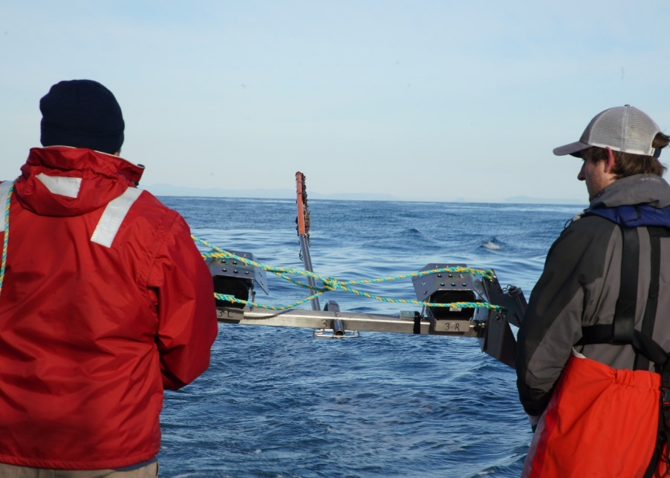

Commonwealth Environmental Impact Statement
Chapter 22 – Seascape, landscape and visual
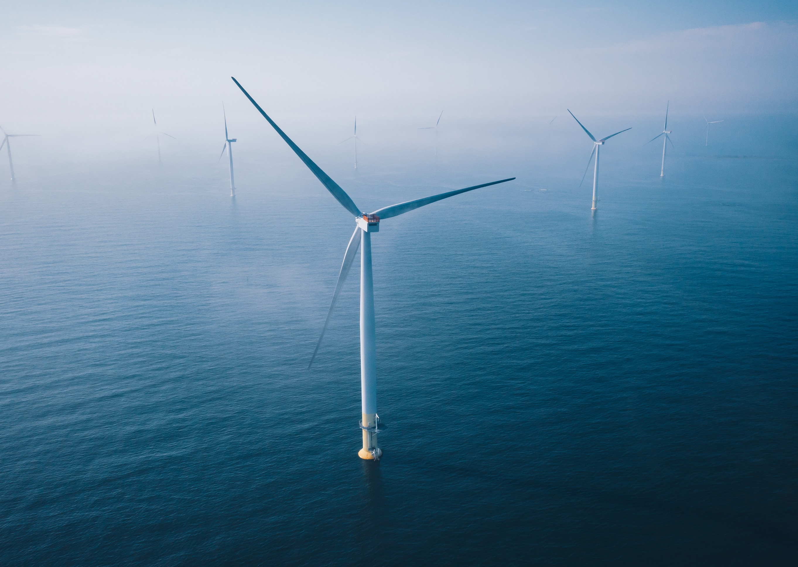
Table of Contents
Chapter 22 Seascape, landscape and visual 22-1
22.1 Introduction 22-1
22.2 Assessment scope 22-2
22.2.1 Commonwealth matters 22-2
22.3 Evaluation framework 22-2
22.3.1 Key legislation, policy, guidelines and standards 22-2
22.3.2 Assessment criteria 22-3
22.4 Methods 22-5
22.5 Existing environment 22-6
22.5.1 Landscape features 22-8
22.5.2 Landscape character areas and values 22-11
22.5.3 Seascape character areas and values 22-21
22.6 Construction impacts 22-25
22.6.1 Key impacts 22-25
22.6.2 Other impacts 22-25
22.6.3 Potential risks 22-25
22.7 Operation impacts 22-26
22.7.1 Key impacts 22-29
22.7.2 Other impacts 22-49
22.7.3 Potential risks 22-51
22.8 Decommissioning assessment 22-52
22.9 Cumulative Impact Assessment 22-53
22.10 Summary of mitigation, monitoring and contingency measures 22-55
22.10.1 Mitigation measures 22-55
22.11 Conclusion 22-56

Figures
Figure 22-1 Seascape, landscape and visual assessment study area 22-7
Figure 22-2 View from Wills Road towards the Nooramunga Marine and Coastal Park 22-10
Figure 22-3 View to saltmarsh wetland vegetation at Foreshore Road at McLoughlins Beach 22-11
Figure 22-4 Landscape character areas associated with the offshore wind farm and offshore transmission infrastructure 22-12
Figure 22-5 Typical view at Landscape Character Area 1 22-13
Figure 22-6 Typical view of Landscape Character Area 2 22-14
Figure 22-7 Typical view of Landscape Character Area 3 22-16
Figure 22-8 Typical view of Landscape Character Area 4 22-17
Figure 22-9 Typical view of LCA 5 22-18
Figure 22-10 Typical view of LCA 6 22-19
Figure 22-11 Typical view of Landscape Character Area 7 22-20
Figure 22-12 Typical view of Landscape Character Area 8 22-21
Figure 22-13 Seascape Character Areas within the study area 22-22
Figure 22-14 Viewpoint locations 22-30
Figure 22-15 View location 03 – existing view 22-32
Figure 22-16 View location 03 – potential project view (350 metre wind turbine) 22-32
Figure 22-17 View location 03 – existing view 22-34
Figure 22-18 View location 03 – potential project view (350 metre wind turbine) 22-34
Figure 22-19 View location 17 – existing view 22-36
Figure 22-20 View location 17 – potential project view (350 metre wind turbine) 22-36
Figure 22-21 View location 17 – existing view 22-38
Figure 22-22 View location 17– potential project view (350 metre wind turbine) 22-38
Figure 22-23 View location 13 – existing view 22-40
Figure 22-24 View location 13 – potential project view (350 metre wind turbine) 22-40
Figure 22-25 View location 13 – existing view 22-42
Figure 22-26 View location 13 – potential project view (350 metre wind turbine) 22-42
Figure 22-27 View location 23 – existing view 22-44
Figure 22-28 View location 23 – potential project view (350 metre wind turbine) 22-44
Figure 22-29 View location 19 - existing view 22-46
Figure 22-30 View location 19 – potential project view (350 metre wind turbine) 22-46
Figure 22-31 View location 16 - existing view 22-48
Figure 22-32 View location 16 – potential project view (350 metre wind turbine) 22-48

Tables
Table 22-1 Key legislation, policy, guidelines and standards 22-2
Table 22-2 Summary of assessed impacts at all view locations for 350 metre turbine height scenario 22-27
Table 22-3 Residual visual impacts from project infrastructure at 24 North Street, Port Albert 22-32
Table 22-4 Residual visual impacts from project infrastructure at 24 North Street, Port Albert at night 22-34
Table 22-5 Residual visual impacts from project infrastructure at McLoughlins beach 22-36
Table 22-6 Residual visual impacts from project infrastructure at McLoughlins beach at night 22-38
Table 22-7 Residual visual impacts from project infrastructure at Woodside Beach 22-40
Table 22-8 Residual visual impacts from project infrastructure at Woodside beach at night 22-42
Table 22-9 Residual visual impacts from project infrastructure at Johnny Souey Cove 22-44
Table 22-10 Residual visual impacts from project infrastructure at Seaspray Surf Lifesaving Club 22-46
Table 22-11 Residual visual impacts from project infrastructure at McLoughlins Beach Car Park 22-48
Table 22-12 Projects assessed for cumulative impacts 22-53
Table 22-13 List of mitigation measures relevant to seascape, landscape and visual 22-55

Seascape, landscape and visual

Introduction
This chapter summarises the existing conditions related to seascape, landscape and visual and assesses the potential associated impacts and risks from the construction, operation and decommissioning of the Star of the South Offshore Wind Farm Project (the project). The chapter describes how impacts will be avoided, minimised or managed.
Seascape, landscape and visual impact assessment refers to how changes to the natural or built environment caused by the project may affect the visual character, scenic quality, and perceived values of land and seascapes from various public and private viewpoints.
While project activities will be undertaken both on and offshore, this chapter relates only to the visible infrastructure which all occurs offshore, and its impacts on onshore receptors.
This chapter is based on the impact assessment presented in Technical Report U – Seascape, Landscape and Visual.
Other chapters that relate to or inform the seascape, landscape and visual assessment include:
Chapter 14 – Non-Aboriginal Underwater Cultural Heritage
Chapter 15 – Commercial and Recreational Fisheries
Chapter 17 – Shipping and Navigation
Chapter 20 – Social
Chapter 21 – Business and tourism

Assessment scope
The study objective for seascape, landscape and visual is to minimise and manage potential adverse effects on landscape and visual amenity. All detailed methodologies, assessment, high resolution report figures and visualisations can be found in Technical Report U – Seascape, Landscape and Visual.

Commonwealth matters
The project's EIS guidelines inform the preparation of the EIS to enable the Commonwealth Minister for the Environment to make an informed decision on whether to approve the project under the EPBC Act. The aspects of the EIS guidelines relevant to seascape, landscape and visual amenity are:
- Section 2.7.6 – Potential adverse effects for the community.
See Attachment V – EIS Guidelines Checklist for more detail about the EIS guidelines.

Evaluation framework

Key legislation, policy, guidelines and standards
Table 22-1 lists the key legislation, policy, guidelines and standards relevant to seascape, landscape and visual. Refer to Chapter 5 – Commonwealth Legislative Framework for further details.
Table 22-1 Key legislation, policy, guidelines and standards
Type | Applicable legislation, policy, guideline or standard
Commonwealth legislation | Environment Protection and Biodiversity Conservation Act 1999 (EPBC Act)
Victorian legislation | Marine and Coastal Act 2018
Victorian legislation | Planning and Environment Act 1987
Victorian legislation | National Parks Act 1975
Victorian legislation | Heritage Act 2017
Victorian policy | 12.02-1S Protection of Coastal Areas
Victorian policy | 12.05-1S Coastal Crown Land
Victorian policy | 12.05-1S Environmentally Sensitive Areas
Victorian policy | 12.05-2S Landscapes
Victorian policy | 19.01-2S Renewable energy
Victorian policy | 52.17 Native Vegetation Precinct Plan
Victorian policy | 52.08 Earth and Energy Resources Industry
Victorian policy | Local planning policy framework - South Gippsland Shire
Victorian policy | Local planning policy framework - Wellington Shire

Assessment criteria
To assess the project, predicted impacts and risks are compared to criteria that set required environmental performance outcomes (refer Chapter 6 – Assessment Framework).
The criteria for seascape, landscape and visual impacts are derived from legislation and policy, relevant standards and guidelines, stakeholder feedback and industry best practice.
The assessment criteria relevant to seascape, landscape and visual are outlined as follows:
- Identifying and describing a series of representative view locations from which the proposed project would be visible
- Preparing a series of photomontage images as a means of demonstrating the anticipated visual presence of the proposed project from each of the view locations.
Assessing impacts at each representative view location are based on three variables:
- Landscape/seascape value (determined by existing statutory designations, landscape preference indicators and community perceptions)
Magnitude of visibility
The extent to which project infrastructure is visible from a particular viewpoint. It indicates how much the view is altered by the project and helps determine whether visual mitigation measures are needed.
- Magnitude of visibility of the proposed infrastructure (as depicted within the photomontage views from representative view locations)
- Receptor sensitivity (the nature, number, frequency and length of stay of visual receptors).
The assessment criteria that informs the evaluation of the significance of impacts are:
- Any adverse impacts on distinctive areas or landscapes declared under the Planning and Environment Act 1987
- An impact which would trigger a permit requirement under the Planning and Environment Act 1987 in relation to significant landscape overlays
- An impact that meets the ‘Significant Impact Criteria’ as defined within the Matters of National Significance – Significant Impact Guidelines 1.1 (2013).

Methods
The purpose of the seascape, landscape and visual impact assessment is to assess the potential impacts and risks of the project on visual amenity.
Impacts refer to the consequences of planned project actions, which are given a rating determined by combining the magnitude of the impact and the sensitivity of the receptor.
Risks are an unexpected (accidental) event and are determined by combining the likelihood of an event occurring and the consequences that would result if the event were to occur.
The technical chapters consider key impacts and risks with a residual consequence rating of moderate to severe. Other impacts and risks are those with a residual consequence rating of negligible to minor. Refer to Chapter 6 – Assessment Framework for more detail on how impact and risk ratings are derived.
The seascape, landscape and visual impact assessment involved:
- Reviewing national, state and local legislation and applicable land use planning policies
- Characterising existing conditions of seascape and landscape character through desktop review and site inspection
- Reviewing the project description to determine the location, type, timing, extent, intensity, and duration of potential project visibility
- Establishing the project design envelope parameters that provide the basis for impact assessment, as listed in Technical Report U – Seascape, Landscape and Visual
- Undertaking a proportionate assessment of impacts detailing the potential severity, extent and duration of identified impacts
- Selecting view locations that effectively characterise impacts to seascape, landscape and visual amenities, including through community consultation
- Collecting existing conditions photographs and preparing photomontages to visualise the change in landscape and seascape with the project
- Identifying mitigation measures where necessary to address environmental impacts
- Evaluating residual environmental impacts against assessment criteria, considering the proposed mitigation measures.

Existing environment
This section describes the existing conditions within the study area as they relate to seascape, landscape and visual values including both the offshore and onshore components of the project, as shown in Figure 22-1.
The study area is based on the maximum distance beyond which visual impacts are expected to be insignificant and not require assessment and characterisation of the existing environment in that area. The study area extents are determined by the Theoretical limit of viewshed extent (TLVE). This is a standard measure that determines the distance from proposed project infrastructure at which the vertical height of the proposed project infrastructure occupies a specified percentage of the vertical field of view.

Figure 22-1 Seascape, landscape and visual assessment study area
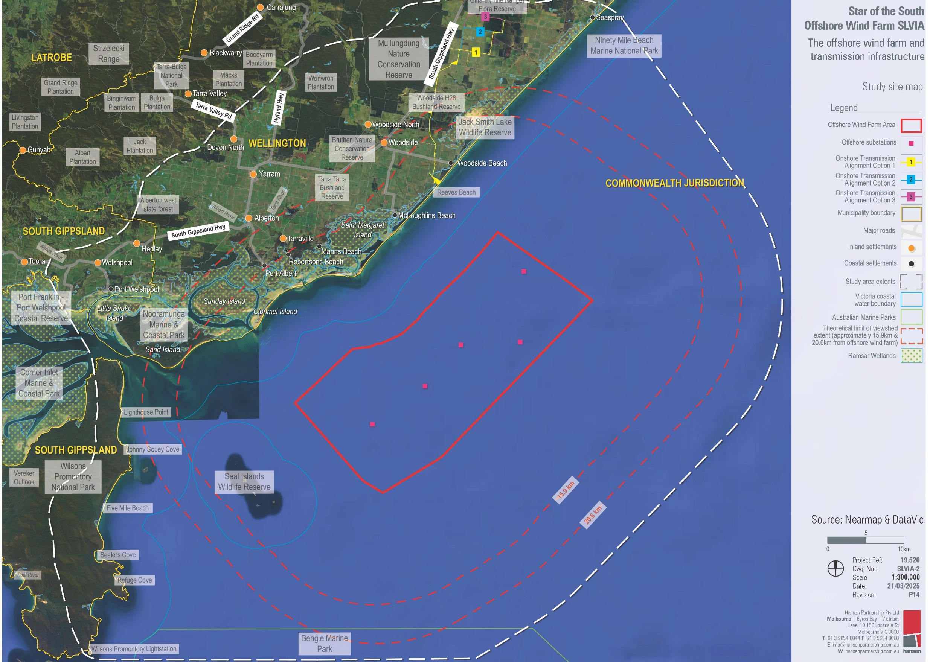

Landscape features
A large portion of the landscape within the study area has been modified by human activity, largely through agriculture and forestry. There are also significant areas within the onshore landscape, particularly to the west of the study area, that have more natural features, with minimal human activity.
Visually, the study area is mainly characterised by natural landscapes and rural scenes, such as patches of bushland within fields and pastures. The most prominent natural features include Wilsons Promontory National Park (Wilsons Promontory) and Ninety Mile Beach and associated coastal reserves. These areas are known for their coastal and wetland habitats, unique geological features, and abundant native vegetation. While the natural values are less noticeable in more developed settlements due to higher building density, they are still present.
The key landscape features have been classified into five main categories:
- Settlements
- Infrastructure
- Vegetation
- Elevation and hydrology
- Features relating to existing land use.
These are discussed further below.

Existing land use
The onshore study area comprises a mix of land uses including industrial, rural living, township and recreational. This area also supports a range of industries including energy resources, agriculture and forestry, manufacturing and tourism.
The offshore study area is primarily used for shipping to and from nearby ports and oil and gas platforms, with low-intensity recreational and commercial fishing and boating activity. The Seal Islands Group, a marine reserve, is located off the eastern coast of Wilsons Promontory, with minimal development. Wilsons Promontory also includes designated wilderness areas under the National Parks Act 1975. The wilderness areas seek to minimise development and maximise the extent to which they are undisturbed by the influences of European settlement in Australia. Most recreational fishers on private vessels fishing in the study area launch from Port Albert, Port Welshpool or McLoughlins Beach boat ramps. Fishing within and around the study area is further covered in Chapter 15 – Commercial and Recreational Fisheries.

Infrastructure
There is limited existing infrastructure within the onshore study area. It includes a variety of landscape character types and vistas which encompass both natural and modified landscapes, townships and rural settings.
There is no existing visible marine infrastructure within the offshore study area, other than the lighthouse on Cliffy Island, which is part of the Seal Islands Group and other features such as navigational buoys with lighting.

Elevation and hydrology
The study area is relatively flat to gently undulating, with low elevations. There are few topographic features to break up the expansive plains such as scattered native vegetation, avenues of trees along roadsides and timber plantations. To the north-west, the Strzelecki Ranges reach relatively high elevations along the study area boundary creating prominent landscape features adjoining the flat plains.
Numerous waterways intersect with the study area, including Warrigal Creek, Sunville Creek, Morris Creek, and Hoddinott Creek. The collection of lakes and wetlands from the Corner Inlet Marine and Coastal Park and Nooramunga Marine and Coastal Park shown in Figure 22-2 are recognised as an internationally significant Ramsar wetland site.
Figure 22-2 View from Wills Road towards the Nooramunga Marine and Coastal Park
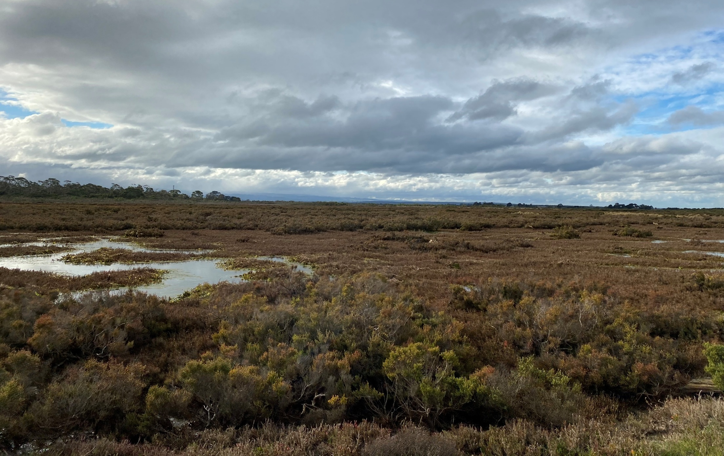

Vegetation
The existing vegetation within the study area is characterised as follows:
- Bushland consisting of remnant indigenous and other native vegetation
- Timber plantations producing non-native pine and native eucalyptus species
- Pasture and cropping grasses with scattered native trees along agricultural property boundaries
- Saltmarsh wetland vegetation (see Figure 22-3)
- Roadside vegetation consisting of shrubs, grasses and native trees
- Dense coastal heath and bushland
- Windbreak vegetation along roads and land parcel boundaries.
Vegetation types and ecological values identified within the study area are described in Technical Report G - Onshore Ecology.
Figure 22-3 View to saltmarsh wetland vegetation at Foreshore Road at McLoughlins Beach
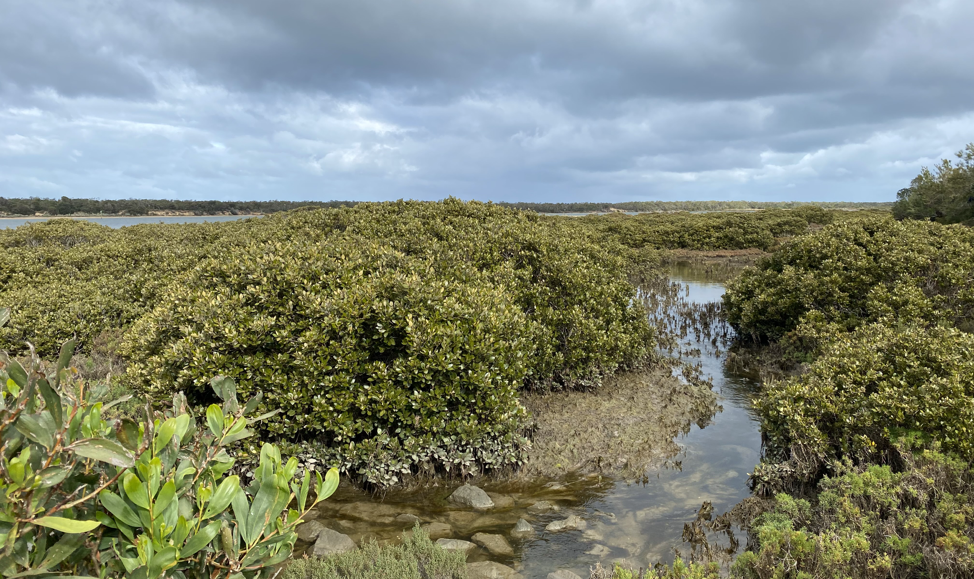

Landscape character areas and values
The study area has been assessed to identify landscape character areas which are areas with similar patterns or elements in the landscape such as landform, vegetation, water bodies and land use. Separating the study area into landscape character areas is the first step in identifying areas of relative significance and leads into determining landscape values.
The study area has been divided into eight landscape character areas, each with a distinct, recognisable and consistent pattern of elements that occur in the landscape. The landscape character areas identified within the study area are shown in Figure 22-4 and are described in the following sections.

Figure 22-4 Landscape character areas associated with the offshore wind farm and offshore transmission infrastructure
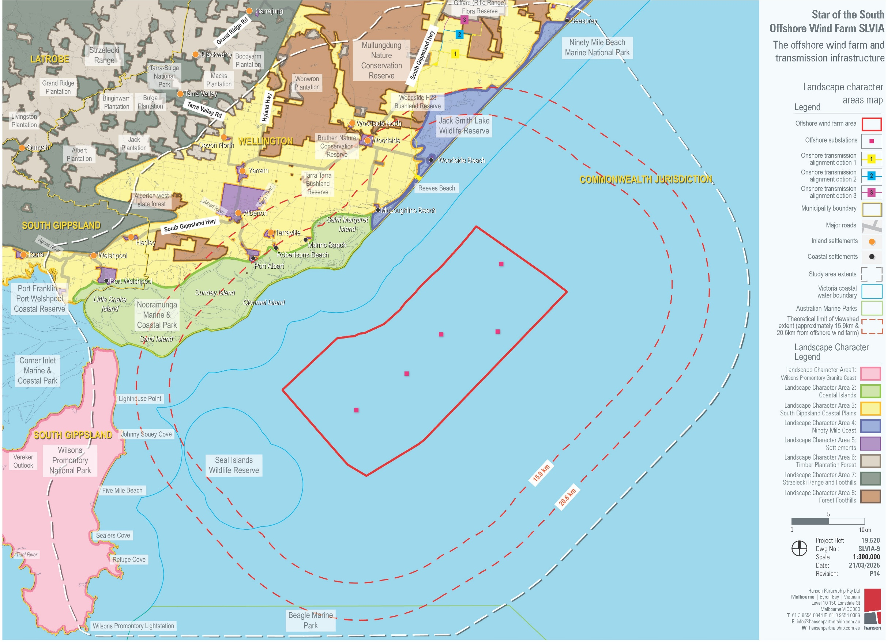

Landscape Character Area 1: Wilsons Promontory Granite Coast
The Wilsons Promontory National Park projects into Bass Strait and is almost an island being linked to the mainland by beach ridges. The natural coastal wilderness landscape setting of Wilsons Promontory National Park includes a mountainous interior, forests and fern gullies fringed by granite headlands, sandy beaches and sheltered coves backed by coastal dunes, heathlands and swamps. The landscape also features a network of walking tracks. Its topography and unique position within Bass Strait also cater to a diverse array of marine habitats within the waters of Victoria’s first marine national park.
There is a significant landscape overlay associated with the northern sections of Wilsons Promontory. The significant landscape overlay does not intersect the project and occurs beyond the theoretical limit of viewshed extent.
A typical view of this landscape character area is shown in Figure 22-5. The overall landscape value of Landscape Character Area 1 is considered high to very high.
Figure 22-5 Typical view at Landscape Character Area 1
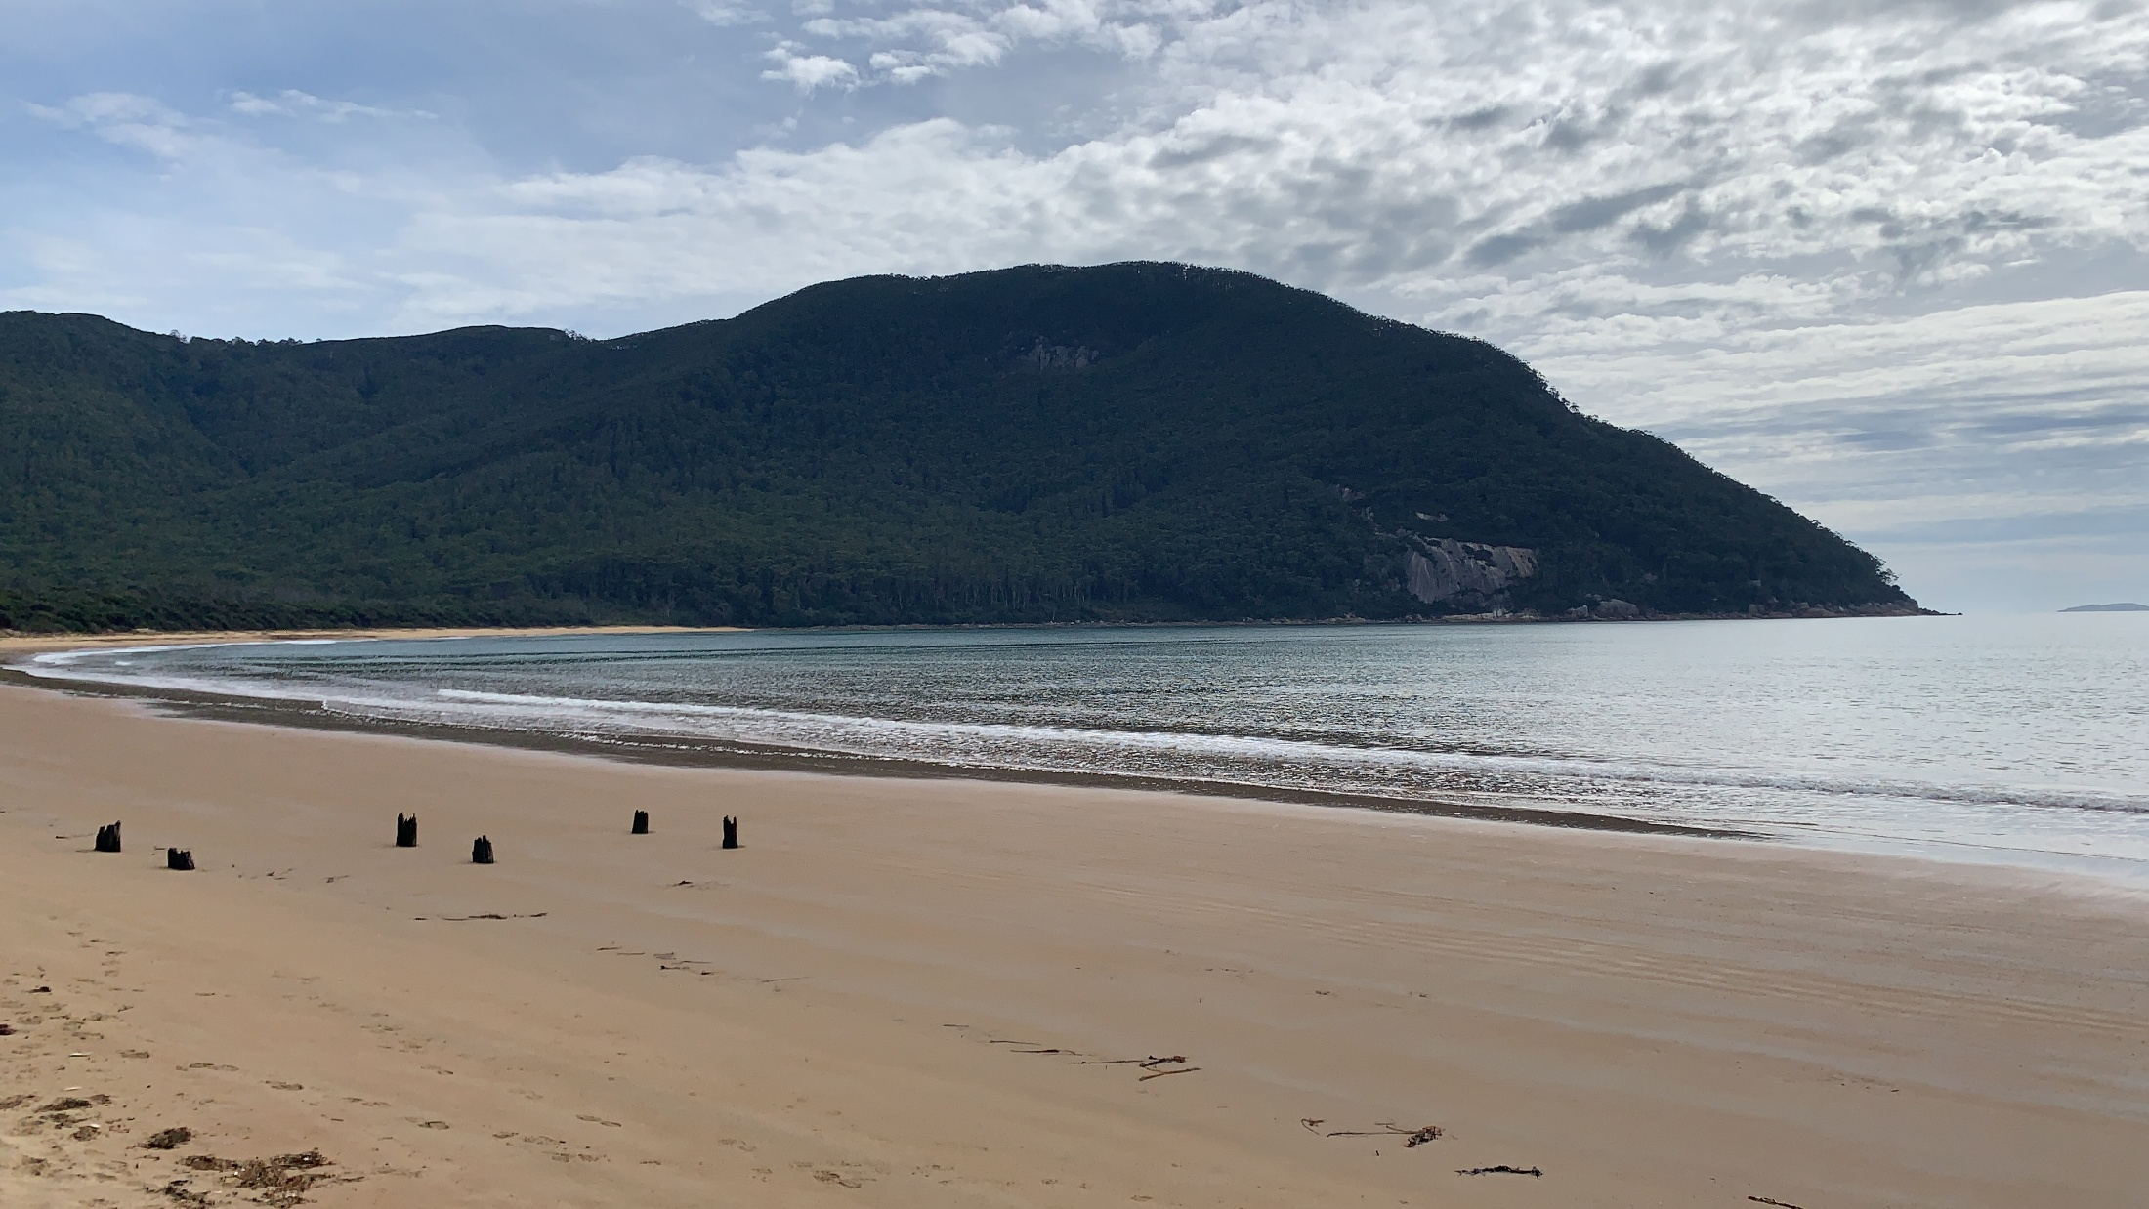

Landscape Character Area 2: Coastal Islands
This low-lying, flat character area covers a long stretch of varied coastline from the gateway to Wilsons Promontory to the southern end of Ninety Mile Beach. It includes the Nooramunga Marine and Coastal Park.
The area exhibits a strong and open natural character comprised of an intricate network of quiet waterways and islands, framed by the visual backdrop of Wilsons Promontory. The dispersed settlements of Port Welshpool, Port Albert, Manns Beach and Robertsons Beach are all located at the interface between this character area and Landscape Character Area 3 (South Gippsland Coastal Plains), and all settlements offer expansive views of the Coastal Islands.
There is a significant landscape overlay associated with the Corner Inlet Amphitheatre that applies to limited areas of this landscape character area around Port Welshpool. The significant landscape overlay does not intersect the project and occurs beyond the theoretical limit of viewshed extent.
A typical view of this landscape character area is shown in Figure 22-6. The overall landscape value of Landscape Character Area 2 is considered high.
Figure 22-6 Typical view of Landscape Character Area 2
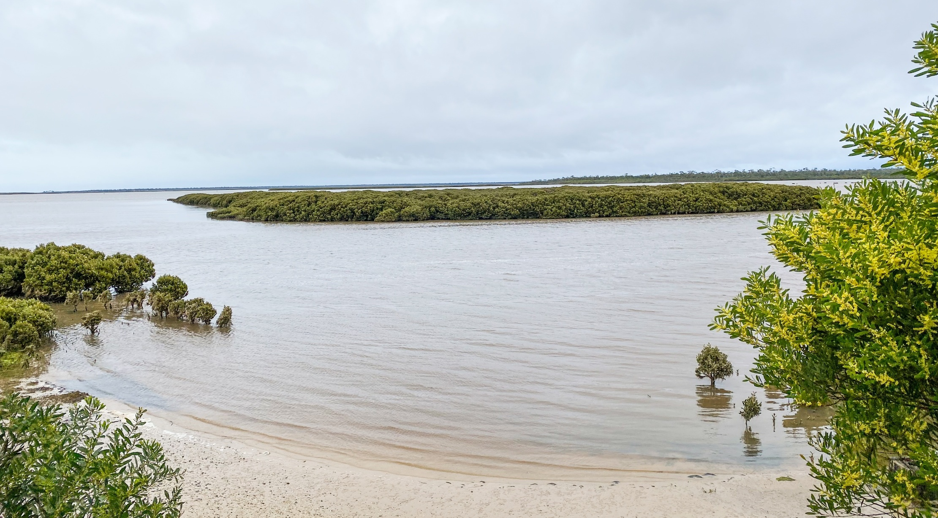

Landscape Character Area 3: South Gippsland Coastal Plains
This is a flat to gently undulating mostly pastoral character area, with flat topography providing open and expansive views along roads and through gaps in dense roadside vegetation.
The relatively flat and open landscape allows for clear views of the Strzelecki Ranges which form the prominent backdrop to the northwest. Where there is little roadside vegetation, motorists can see across paddocks and toward timber plantations. Although there are few topographic features to break up the expansive plains, scattered outcrops of native vegetation, avenues of trees along roadsides and timber plantations create points of visual interest within the area.
There is a significant landscape area associated with the Corner Inlet Amphitheatre that applies to limited areas of this landscape character area around Port Welshpool. The significant landscape overlay does not intersect the project and occurs beyond the theoretical limit of viewshed extent.
A typical view of this landscape character area is shown in
Figure 22-7. The overall landscape value of Landscape Character Area 3 is considered high within limited areas affected by the significant landscape overlay and low in areas unaffected by the significant landscape overlay.
Figure 22-7 Typical view of Landscape Character Area 3
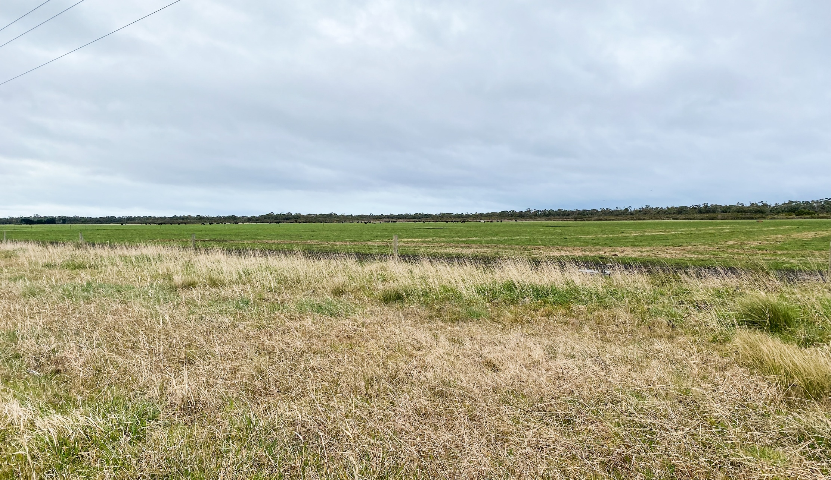

Landscape Character Area 4: Ninety Mile Coast
This area is defined by a series of narrow spits (sandbars), peninsulas and long stretches of unbroken beach sand and vegetated coastal dunes which separate Bass Strait from the pastoral rural Gippsland coastal plains. An extensive inland lake system of the Gippsland Lakes is located further east.
This landscape is broadly considered an unspoilt, natural environment where extensive indigenous coastal vegetation dominates. There are some small coastal townships within the area, namely McLoughlins Beach, Woodside Beach and Seaspray.
There is a significant landscape overlay associated with the Gippsland Lakes near Golden Beach. The significant landscape overlay does not intersect the project and occurs beyond the theoretical limit of viewshed extent.
A typical view of this landscape character area is shown in Figure 22-8. The overall landscape value of Landscape Character Area 4 is considered high.
Figure 22-8 Typical view of Landscape Character Area 4
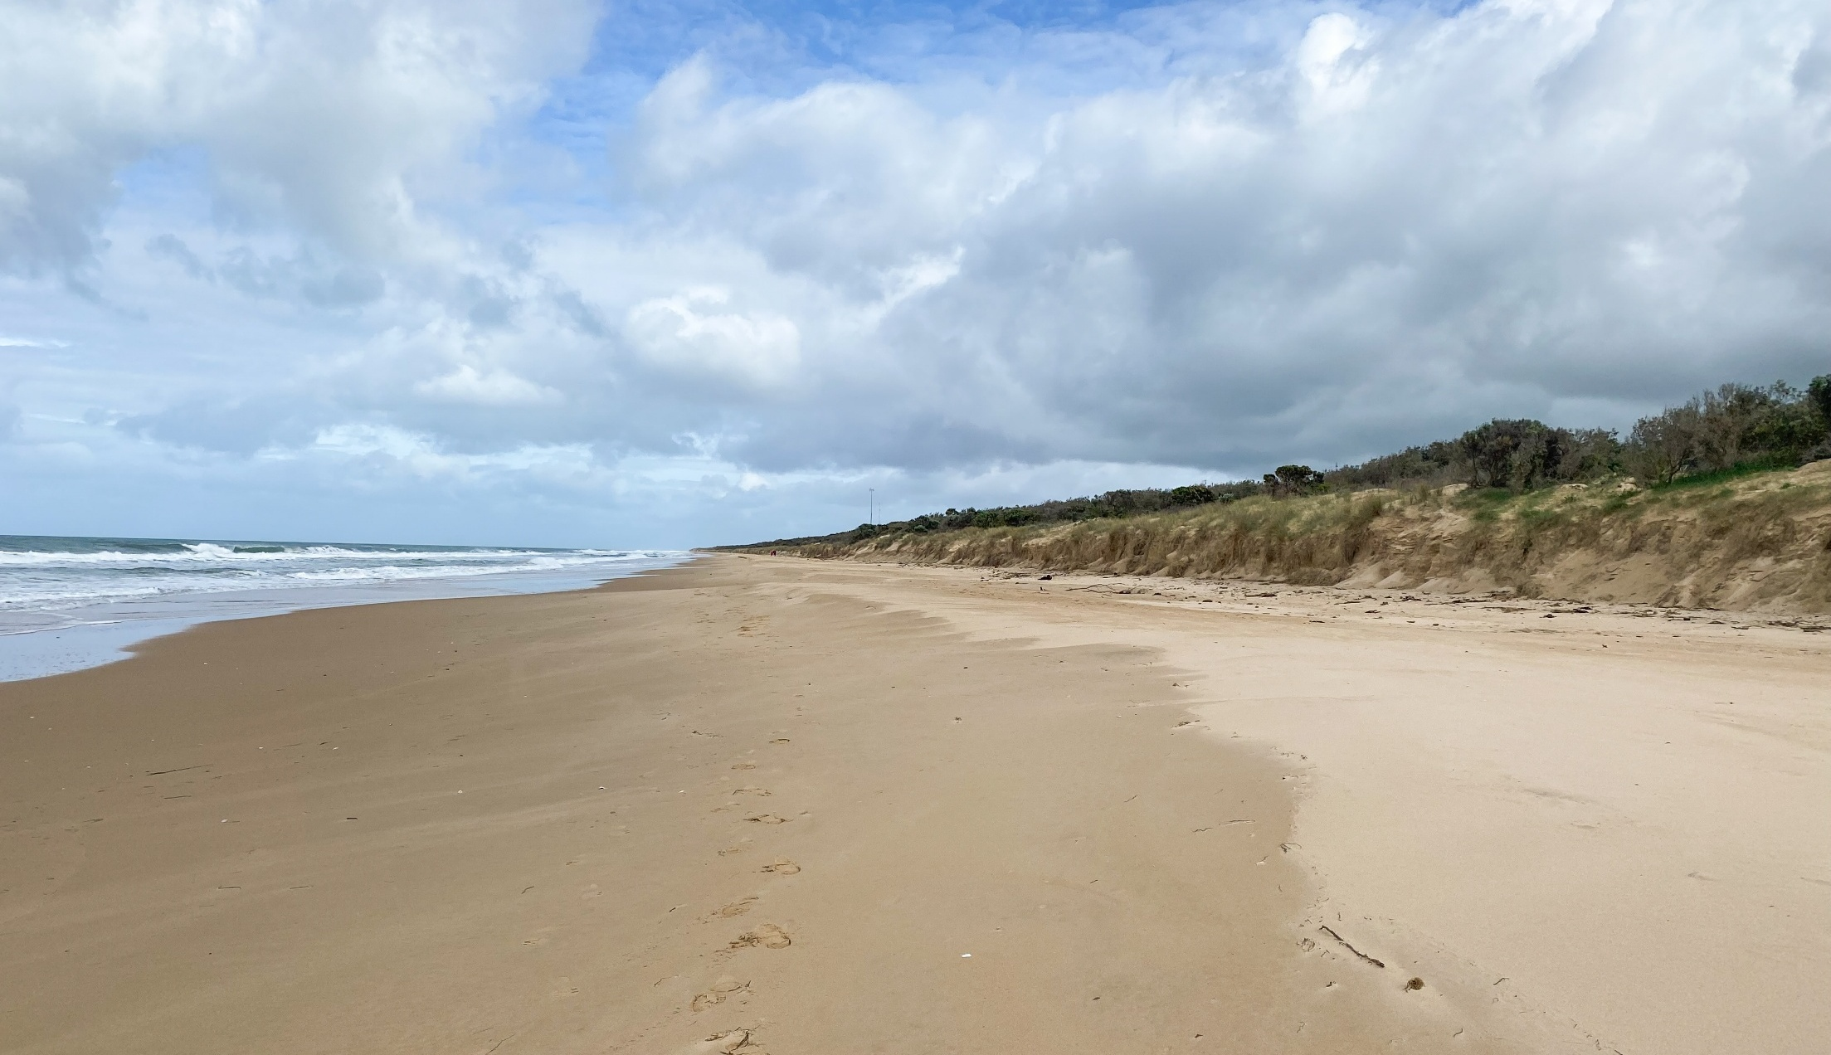

Landscape Character Area 5: Settlements
This area includes townships that range from small coastal settlements with private, low-density, and sparse residential development, to larger townships with well-defined commercial centres.
The larger townships are often connected by main arterial roadways and have infrastructure that caters to tourism such as information signage, public artwork, car parking, accommodation, restaurants and recreational activities. The small coastal settlements are often located at the end of unsealed roads. Dwellings are predominantly 1 to 2 stories in height and are tucked in amongst the coastal vegetation.
There are significant landscape, heritage, vegetation protection and environmental significance overlays that apply to areas of this landscape character overlay.
There is a significant landscape overlay associated with the Corner Inlet Amphitheatre that applies to limited areas of this landscape character area around Port Welshpool. The significant landscape overlay does not intersect the project and occurs beyond the theoretical limit of viewshed extent.
A typical view of this landscape character area is shown in Figure 22-9. The overall landscape value of Landscape Character Area 5 is considered high within limited areas affected by the significant landscape overlay and low in areas unaffected by the significant landscape overlay.
Figure 22-9 Typical view of LCA 5
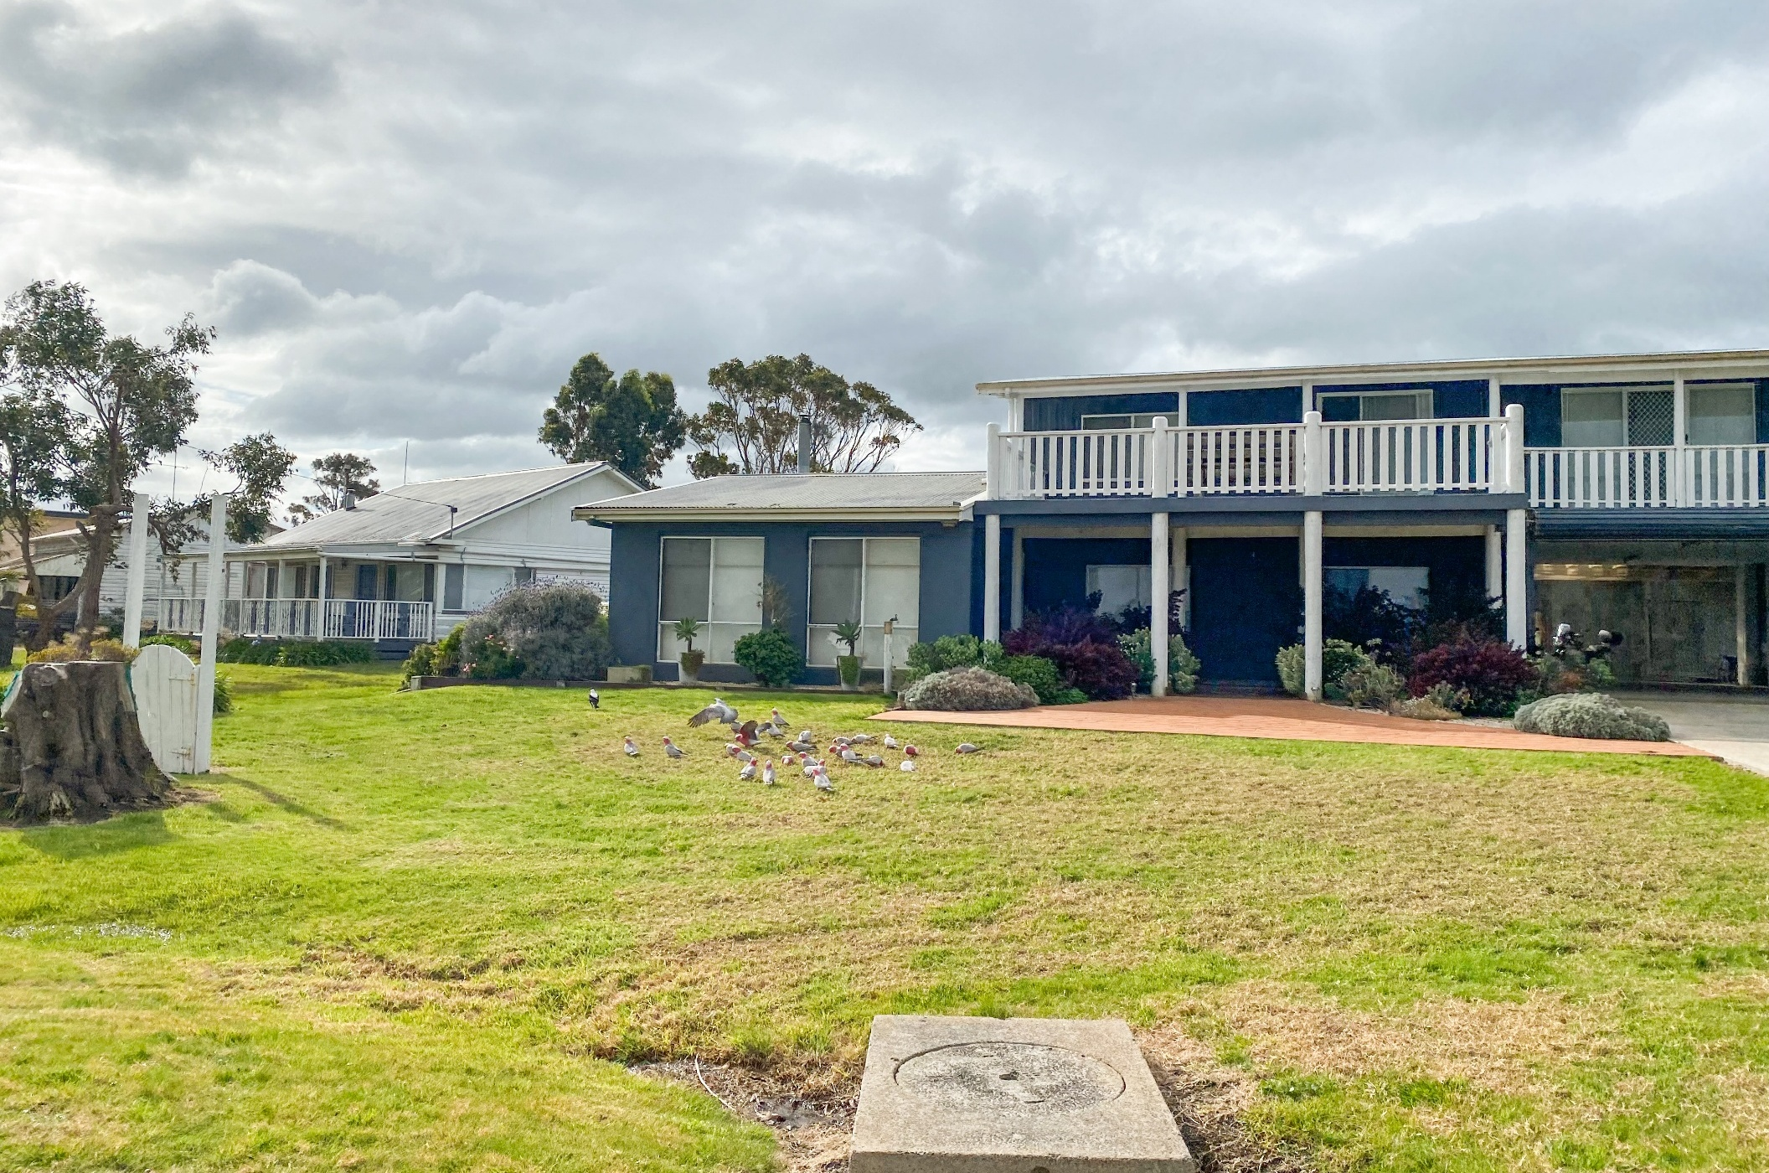

Landscape Character Area 6: Timber Plantation Forest
This area consists of planted forests defined by the grid formation of the trees, clean linear trunks often with lifted canopies and minimal to no understorey vegetation growth.
The commercial forests contain rows of both native and non-native species and at varying stages of maturity; or the areas are cleared land from which plantation-grown timber has recently been felled and harvested. No significant landscape overlays are associated with this landscape character area.
A typical view of this landscape character area is shown in Figure 22-10. The overall landscape value of Landscape Character Area 6 is considered low.
Figure 22-10 Typical view of LCA 6
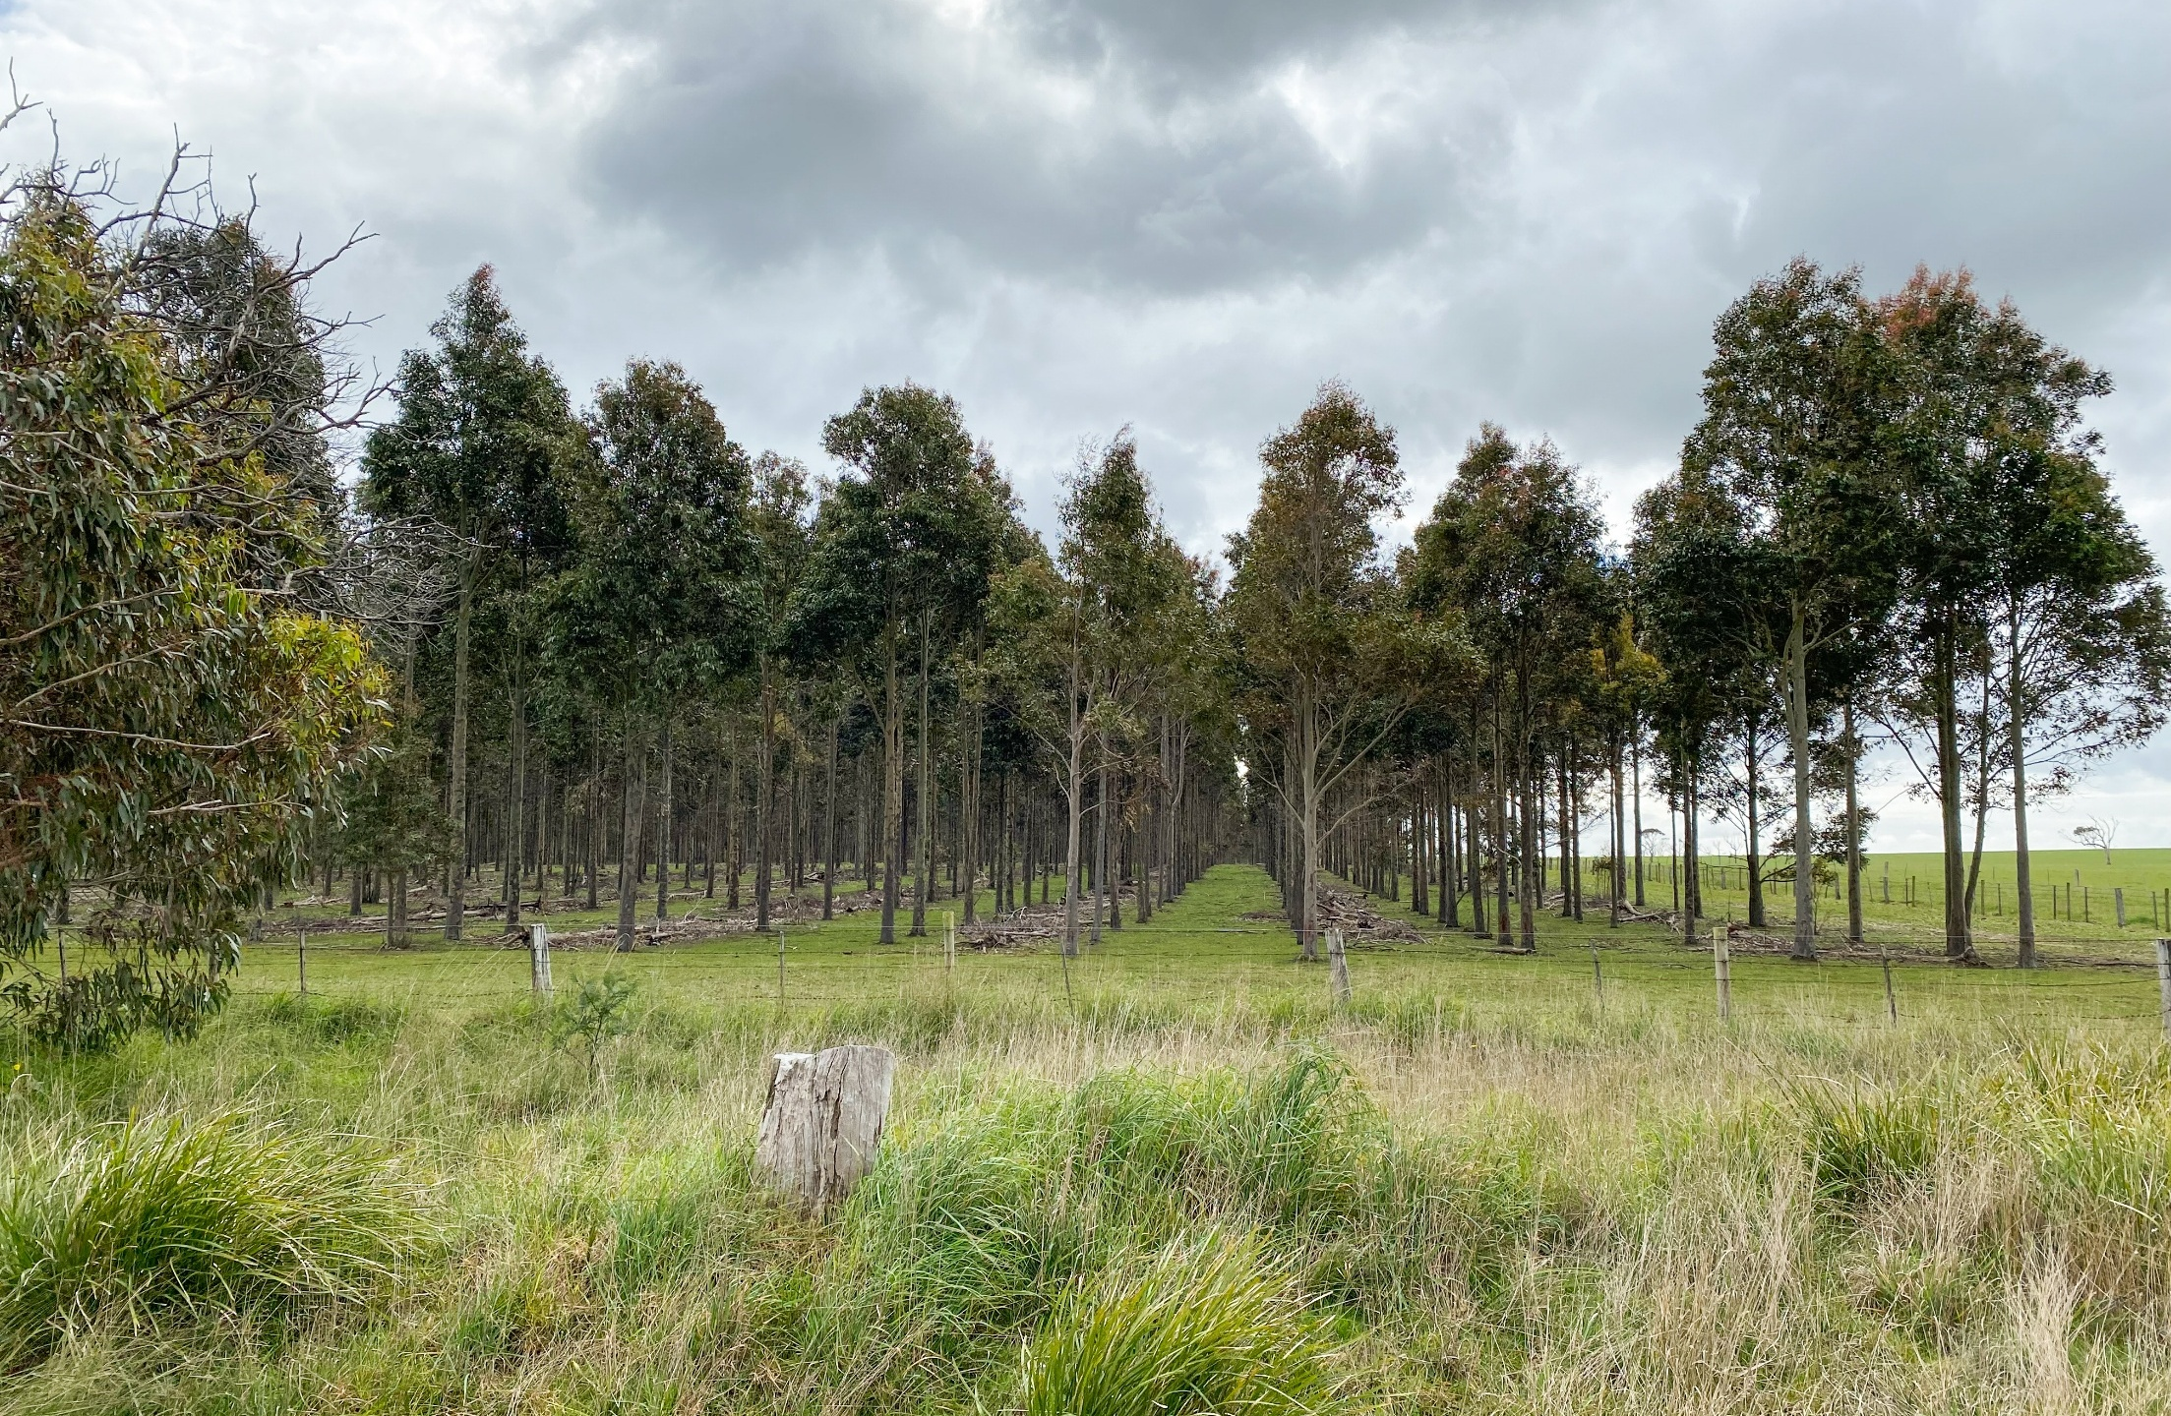

Landscape Character Area 7: Strzelecki Ranges and foothills
This hilly character area stretched from Toora at the southeast end of the study area north through Tarra Valley and beyond as part of the Strzelecki Ranges. While much of the foothills have an agricultural landscape quality, contributed to by a pattern of cleared land and non-native vegetation, there is a distinct absence of built elements in prominent locations and along ridge lines, except for a wind energy facility north of Toora. The higher peaks become densely forested.
There is a significant landscape overlay that applies to Corner Inlet Amphitheatre within this landscape character area. The significant landscape overlay does not intersect the project and occurs beyond the theoretical limit of viewshed extent. A typical view of this landscape character area is shown in Figure 22-11.
The overall landscape value of Landscape Character Area 7 is considered high within areas affected by the significant landscape overlay and moderate in areas unaffected by the significant landscape overlay.
Figure 22-11 Typical view of Landscape Character Area 7
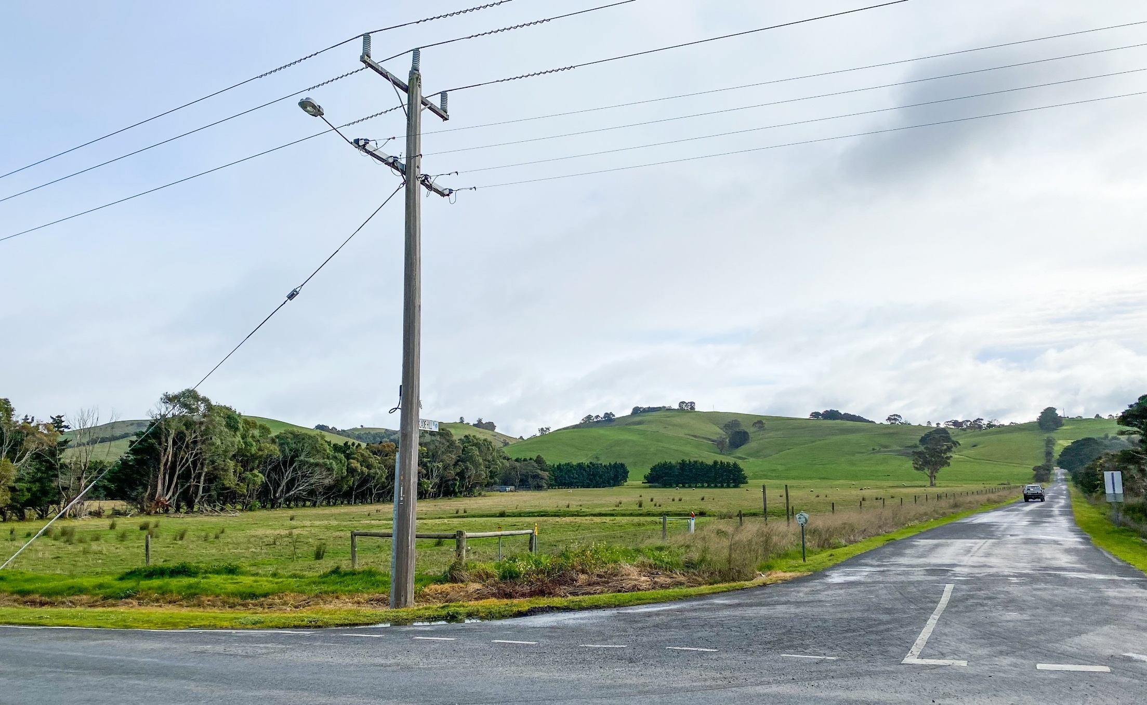

Landscape Character Area 8: Forest Foothills
This area comprises of hilly agricultural forested land situated at the foothills of the Strzelecki Ranges. Small townships are situated within the hills, however they generally blend into the natural landscape. The Forest Foothills form a distinctive backdrop to views looking west from the Gippsland Coastal plains and coastal islands areas.
No significant landscape overlays are associated with this landscape character area.
A typical view of this landscape character area is shown in Figure 22-12. The overall landscape value of Landscape Character Area 8 is considered low.
Figure 22-12 Typical view of Landscape Character Area 8
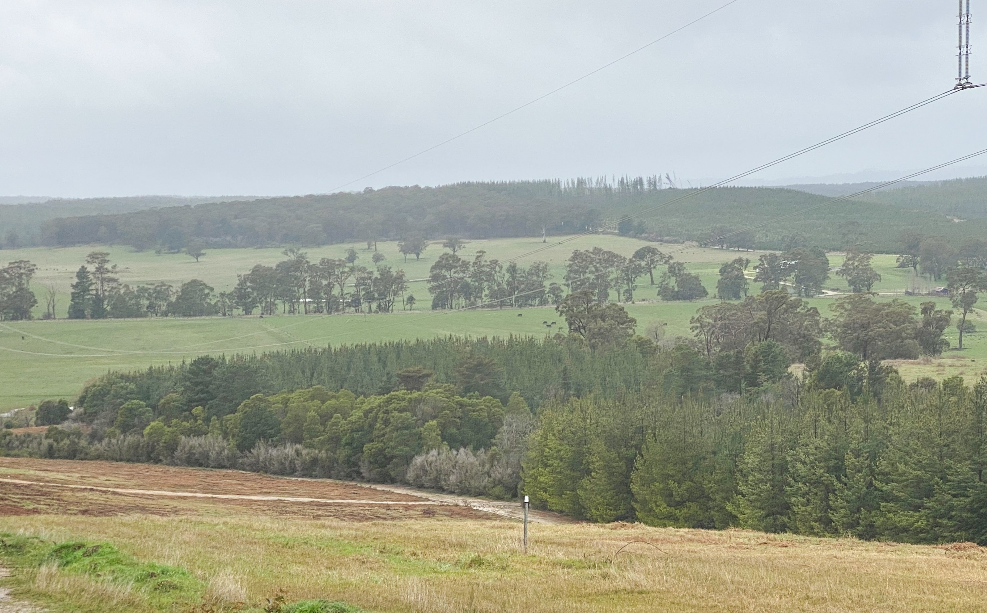

Seascape character areas and values
Seascape character areas can be described as areas of similar patterns or elements in the seascape such as landform, vegetation, water bodies and individual features. Separating the study area into seascape character areas is the initial step in identifying areas of relative significance and leads into determining seascape values.
Seascape features in the marine environment are limited, with the Seal Islands Group being the main feature off the eastern coast of Wilsons Promontory. The marine environment within the study area is mainly used for transportation and some recreational activities, with offshore oil and gas exploration and extraction also present in the broader area.
The study area has been divided into five seascape character areas, each with a distinct, recognisable and consistent pattern of elements that occur in the seascape. The seascape character areas identified within the study area are shown in Figure 22-13.

Figure 22-13 Seascape Character Areas within the study area
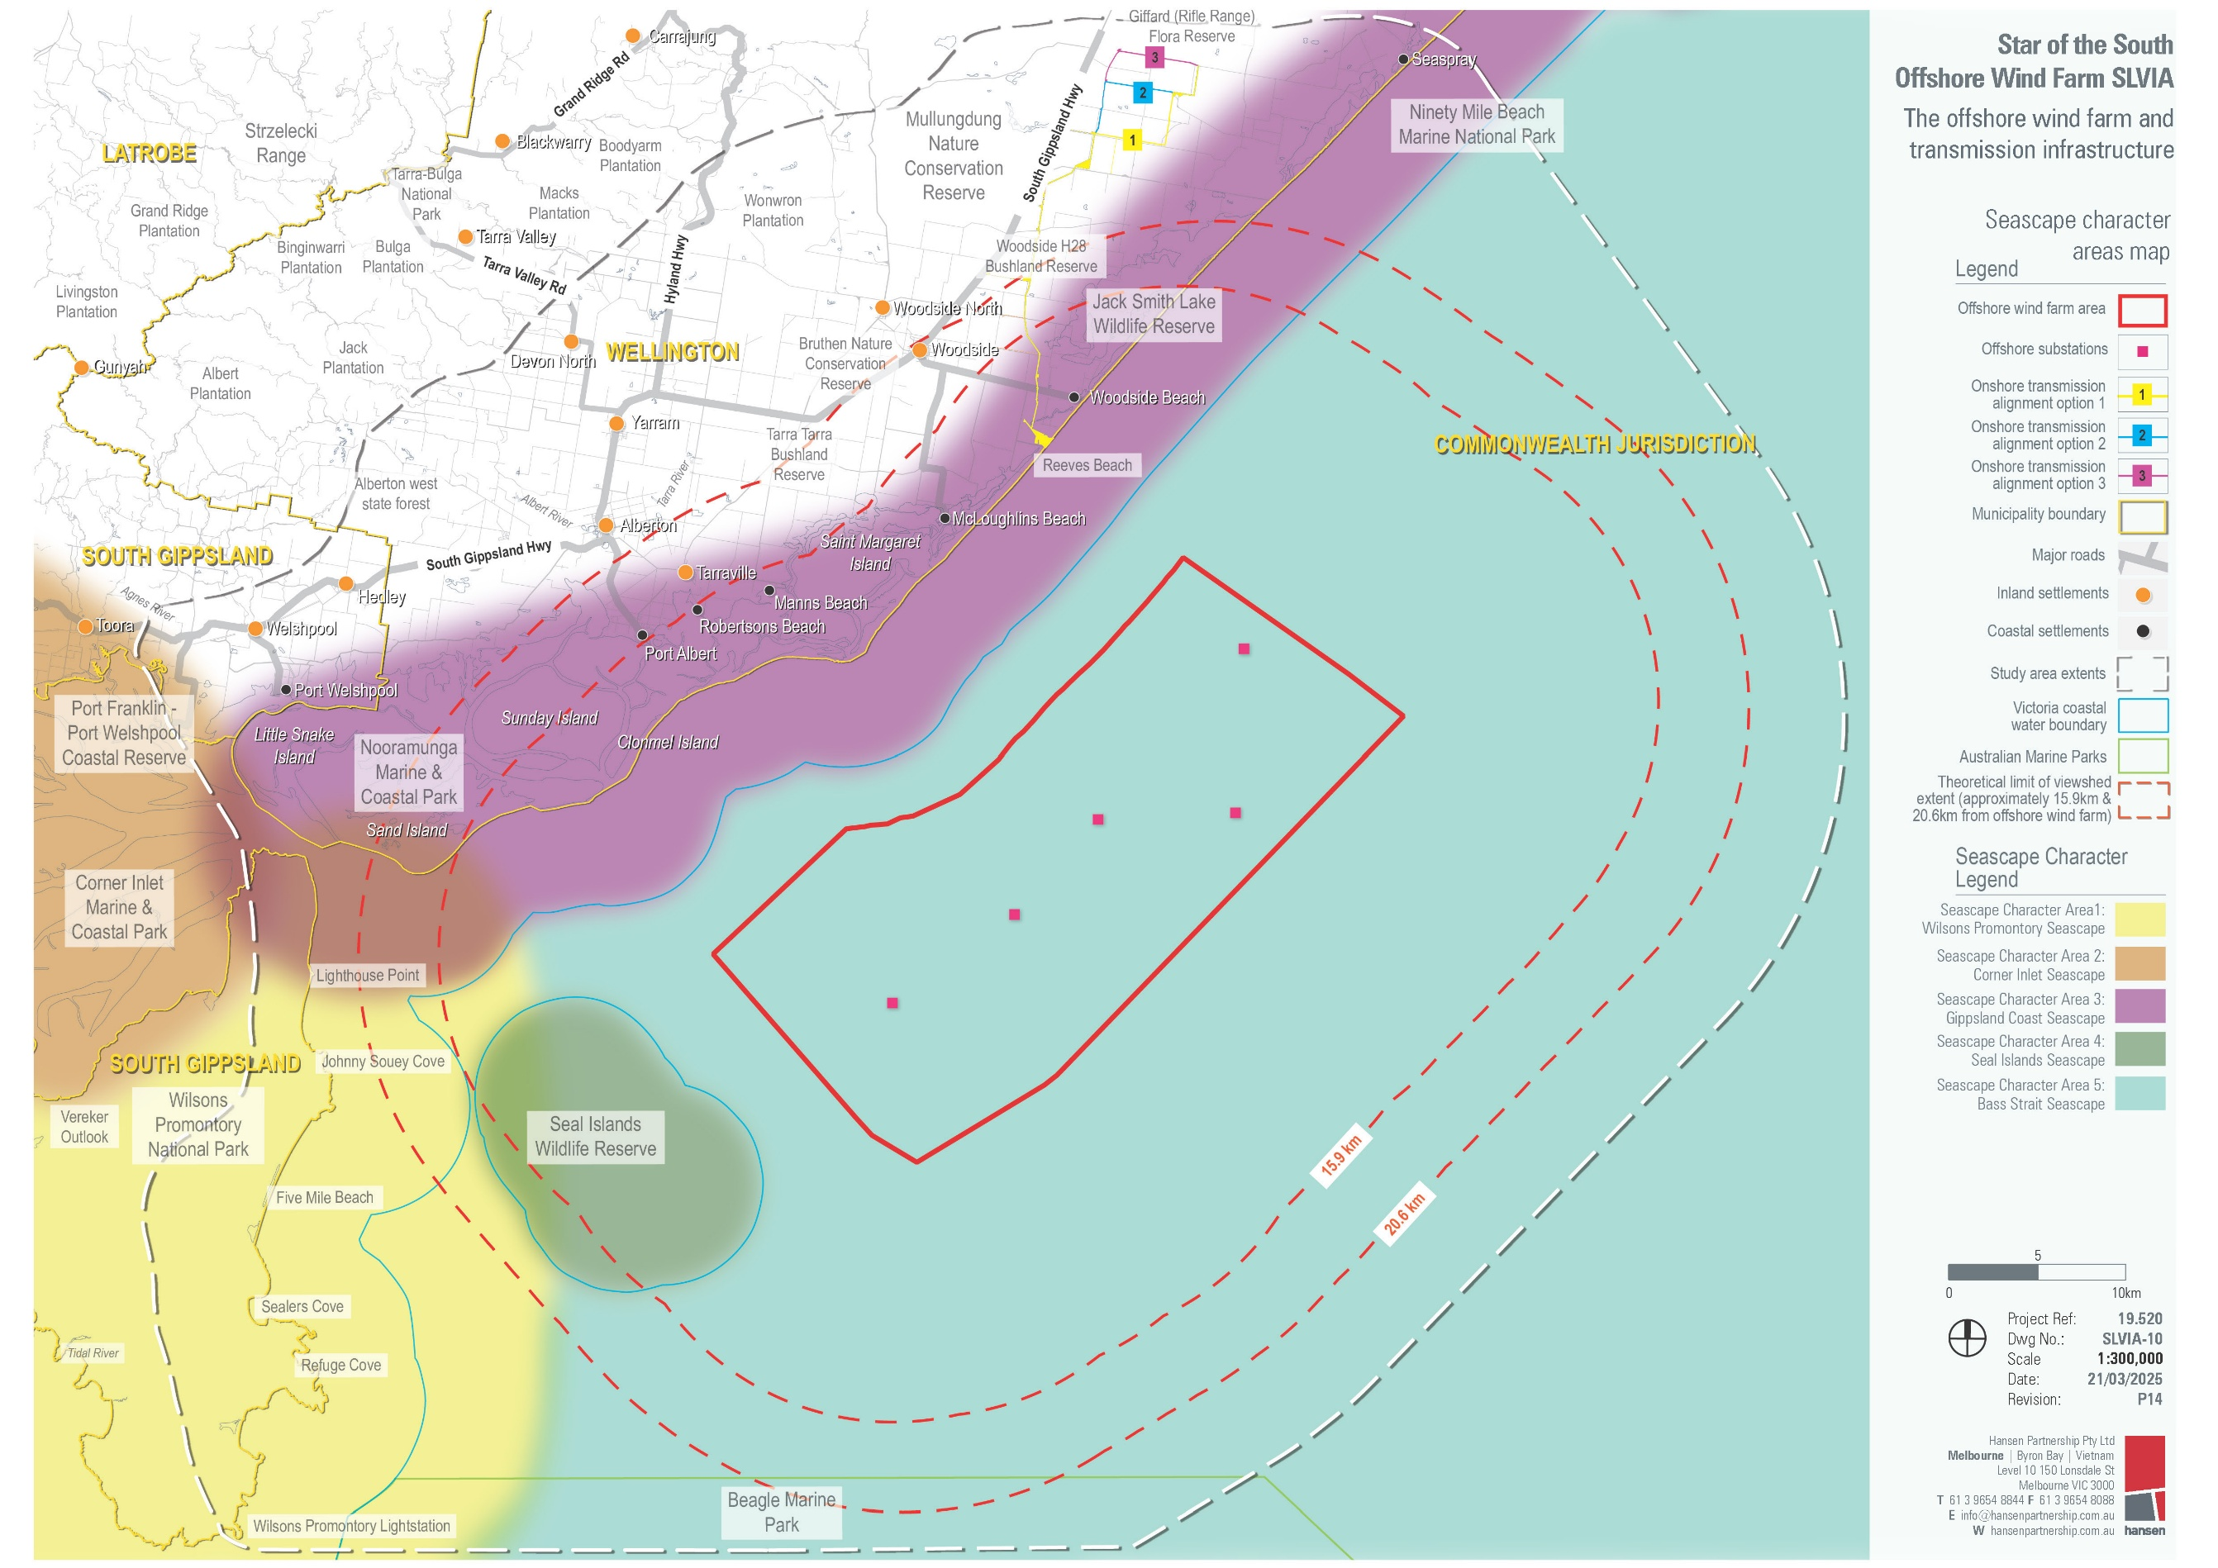

Seascape Character Area 1: Wilsons Promontory
The majority of the Wilsons Promontory seascape character area sits within Victorian Coastal Waters. The Wilsons Promontory National Park projects into Bass Strait and is almost an island, being linked to the mainland by beach ridges.
The natural coastal wilderness landscape setting of Wilsons Promontory comprises granite headlands, sandy beaches and sheltered coves backed by coastal dunes, heathlands and swamps. Its topography and unique position within Bass Strait also cater to a diverse array of marine habitats within the waters of Victoria’s first national marine park.
There is a significant landscape overlay that applies to the northern sections of Wilsons Promontory and Corner Inlet Amphitheatre. The significant landscape area does not intersect the project and occurs beyond the theoretical limit of viewshed extent.
The overall seascape value of Seascape Character Area 1 is considered very high to high.

Seascape Character Area 2: Corner Inlet
This area is a sheltered bay comprised of low-lying flat areas of varied coastline and waterways at the gateway to Wilsons Promontory with expansive views of the coastal plains.
The area exhibits a strong and open rural character wedged between the lower Strzelecki Ranges and Wilsons Promontory. The area is also a marine park that caters to a diverse bird and plant life.
There is a significant landscape overlay that applies to the Corner Inlet Amphitheatre, and an environmental significance overlay within this seascape character area. The significant landscape overlay does not intersect the project and occurs beyond the theoretical limit of viewshed extent.
The overall seascape value of Seascape Character Area 2 is considered high within areas affected by overlays and moderate in areas unaffected by overlays.

Seascape Character Area 3: Gippsland Coast
The majority of this area sits within Victorian coastal waters. This low-lying, flat area covers a long stretch of varied coastline from the gateway to Wilsons Promontory to the southern end of Ninety Mile Beach.
The area features a strong and open natural character with an intricate network of quiet waterways and islands, white sandy beaches, narrow spits and peninsulas framed by Wilsons Promontory. Shallow marine waters, isolated granite islands, intertidal mudflats, mangroves and sand barrier islands are present within the area. There are low-density developments, with several dispersed campgrounds and small residential settlements along the coast and on larger islands. The area is broadly considered an unspoilt, natural environment.
There is a significant landscape overlay and environmental significance overlays within this seascape character area. The significant landscape overlay does not intersect the project and occurs beyond the theoretical limit of viewshed extent.
The overall seascape value of Seascape Character Area 3 is considered high within areas affected by overlays and moderate in areas unaffected by overlays.

Seascape Character Area 4: Seal Islands
This area sits within the Victorian Coastal Waters and is comprised of small granite islands approximately 15 kilometres east of Wilsons Promontory. The area is a safe place for seabirds to breed and offers a healthy, untouched environment for marine life. There are no signs of development, and the natural seascape appears undisturbed.
No significant landscape overlays are associated with this seascape character area. The overall seascape value of Seascape Character Area 4 is considered high.

Seascape Character Area 5: Bass Strait Offshore Waters
This area is primarily open ocean and comprises the southern and eastern seaward limits of the study area. The seas are accessed by recreational and commercial fishing vessels and vessels transiting to oil and gas fields further east. Uninterrupted views of the coastline and the profile of the Strzelecki Ranges and Wilsons Promontory are provided with minimal noticeable development.
The southern section of this character area is the Beagle Marine Park which was once part of a land bridge to Tasmania. It now comprises of clear waters, rocky reeds and diverse marine life and is an important foraging area for sea birds that breed on the islands.
No significant landscape overlays are associated with this seascape character area. The overall seascape value of Seascape Character Area 5 is considered low.

Construction impacts
This section discusses impacts and risks associated with the project’s construction that relate to seascape, landscape, and visual amenity and the respective receptor groups.
Seascape, landscape, and visual impacts during construction of the project would be due to onshore and offshore infrastructure construction. During onshore construction, mobile cranes, piling rigs, wheeled and tracked construction vehicles, demountable buildings and ancillary structures will be visible. During construction offshore, a mobile jack-up rig and barge transportation for turbine components will be visible.
Construction activities are temporary and, accordingly, the magnitude of visibility of construction infrastructure would be lower than operational infrastructure. Noting the anticipated scale of construction-related plant and infrastructure, the distance from the shoreline of construction activities and the temporary nature of the construction phase, impacts are expected to be low during construction works, and non-existent once construction works are complete. There will be no residual impact in relation to the construction phase.

Key impacts
The construction impact assessment identified no impacts on seascape, landscape and visual receptor groups with an impact rating of moderate or higher once mitigation measures have been implemented.

Other impacts
The construction impact assessment identified no impacts on seascape, landscape and visual receptor groups with an impact rating of low or negligible once mitigation measures have been implemented.

Potential risks
The construction impact assessment identified no risks to seascape, landscape, and visual receptor groups.

Operation impacts
This section details impacts and risks associated with the project’s operation that relate to seascape, landscape, and visual amenity at selected locations within the study area. These view locations were chosen based on the theoretical limit of viewshed extent.
Opportunities to mitigate seascape, landscape and visual impacts associated with the project infrastructure are greatest during the early design development phase.
Theoretical limit of viewshed extent
The distance beyond which a structure is unlikely to have a noticeable visual impact. While the project may still be visible past this point, it would take up such a small part of a person’s field of view that it’s not considered significant.
For the project, this involved:
- locating the wind farm at least 10 kilometres from shore where low lying islands shield views from the coast in some areas
- selecting a site away from major population centres or towns (reducing the number of receptors)
- reducing the number of turbines from a referred 400 to a maximum of 147
- undergrounding the onshore transmission cables.
The impact assessments below identify residual impacts following avoidance and minimisation during design development.

Summary of impacts
The potential visual impacts of the project have been assessed at a range of representative view locations across an extensive study area. The potential for visual impacts varies across the view locations depending on distance from the proposed infrastructure and view location sensitivity based on its use and visitation.
Individual view locations were selected to consider potential impacts on public and private views. Private view locations were based on the residence closest to the proposed wind turbines, to provide a conservative assessment for each area.
Public vantage point locations were also assessed to address public views. View locations were also assessed from Wilsons Promontory National Park because of its high landscape value.
The impact of the proposed offshore wind farm was assessed as being high in some sensitive coastal locations including Port Albert (view location 3), Robertsons Beach (view location 7), Manns Beach (view location 10) and McLoughlins Beach (view location 17), this is due to a combination of high ratings for either:
- Existing landscape character value
- Magnitude of visibility
- Sensitivity to change from project infrastructure.
This results in high overall impacts to receptors at each location.
Night time impacts were assessed as being moderate or less, largely due to the absence features which are best appreciated visually at night time.
Table 22-2 Summary of assessed impacts at all view locations for 350 metre turbine height scenario
Viewpoint location | Relevant Impact IDs | Location | Distance to project infrastructure (km) | Day time impact | Night time impact
1 | R01 | South Gippsland Highway, Alberton | 21.8 from wind farm | Nil | Not assessed
2 | R02, R05 | 60 Tannery Road, Alberton | 21.3 from wind farm | Nil | Nil
3 | R02, R05 | 24 North Street, Port Albert | 15.5 from wind farm | High | Moderate
4 | R01, R04 | 40 Wharf Street, Port Albert | 15.3 from wind farm | Moderate | Low
5 | R02, R04 | 57 Lindsay Street, Tarraville | 17.0 from windfarm | Nil | Nil
6 | R02 | Barry Place, Tarraville | 17.6 from wind farm | Nil | Not assessed
7 | R02, R04 | 36 Sarena Parade, Robertsons Beach | 15.1 from wind farm | High | Moderate
8 | R01, R05 | 58 Sarena Parade, Robertsons Beach | 15.4 from wind farm | Moderate | Low
9 | R01, R05 | Car park at David Street, Manns Beach | 14.9 from wind farm | High | Low
10 | R02, R04 | 1 David Street, Manns Beach | 15.0 from wind farm | High | Moderate
11 | R01 | Victoria Street, Woodside | 20.1 from wind farm | Nil | Not assessed
12 | R02, R05 | 39 Woodside Beach Road, Woodside | 19.1 from wind farm | Moderate | Low
13 | R01, R07, R04, R08 | Woodside Beach lookout | 13.5 from wind farm | Moderate | Moderate
14 | R02 | 1 Rebecca Street, Woodside Beach | 13.5 from wind farm | Nil | Not assessed
15 | R02, R05 | 2 Beach Drive, McLoughlins Beach | 11.6 from wind farm | Moderate | Moderate
16 | R01, R07, R04, R08 | McLoughlins Beach Car Park at the end of Foreshore Road | 11.1 from wind farm | Moderate | Low
17 | R01, R07, R04, R08 | McLoughlins Beach (across to bridge and trail to the beach) | 10.3 from wind farm | High | Moderate
18 | R02, R05 | Seaspray Public Purposes Reserve (at Trood Street, Seaspray) | 32.1 from wind farm | Moderate | Low
19 | R01, R04 | Seaspray Surf Life Saving Club | 32.3 from wind farm | Moderate | Low
20 | R09 | Foster North Lookout | 54.5 from wind farm | Low | Not assessed
21 | R03 | Kersops Peak Track (Wilsons Promontory) | 33.8 from wind farm | Moderate | Not assessed
22 | R03 | Refuge Cove (Wilsons Promontory) | 33.1 from wind farm | Nil | Not assessed
23 | R03 | Johnny Souey Cove (Wilsons Promontory) | 23.2 from wind farm | Moderate | Not assessed
24 | R03 | Five Mile Beach (Wilsons Promontory) | 25.8 from wind farm | Moderate | Not assessed
25 | R03 | Vereker Outlook (Wilsons Promontory) | 36.9 from wind farm | Moderate | Not assessed
26 | R03 | Mt Oberon (Wilsons Promontory) | 41.1 from wind farm | Moderate | Not assessed
27 | R03 | Wilsons Promontory Lightstation | 42.1 from wind farm | Moderate | Not assessed
28 | R09, R11 | Reeves Beach Road, Woodside | Adjacent to underground cable corridor infrastructure | Moderate | Not assessed
Note - bold text indicates the representative viewpoints that are presented below in section 22.7.1

Key impacts
The operation assessment identified 26 viewpoints out of 43 as having a residual impact rating of moderate of higher once mitigation measures are implemented (Table 22-2).
In this chapter, a representative sample of the assessed view locations (boldened viewpoints in Table 22-2) are presented including both day time and night time examples, including the closest receptors and Wilsons Promontory. The locations of all view locations assessed are shown in Figure 22-14 and the assessed impacts summarised in Table 22-2. Photomontages of all view locations can be found in Technical Report U – Seascape, Landscape and Visual. For the wind farm, photomontages were prepared for 147 wind turbines at 271 metres high and 113 wind turbines at 350 metres high to show the range of possible wind farm configurations.
Only the 350 metre design is shown in this chapter providing a conservative assessment as the impacts for this scenario were assessed to be the same or higher than the 271 metre scenario at all view locations.
The photomontages are developed for assessment purposes at this stage of the project. Star of the South will continue to provide visual representations of the project once further detailed design work is progressed and subject to final wind farm layout considerations.
Figure 22-14 Viewpoint locations
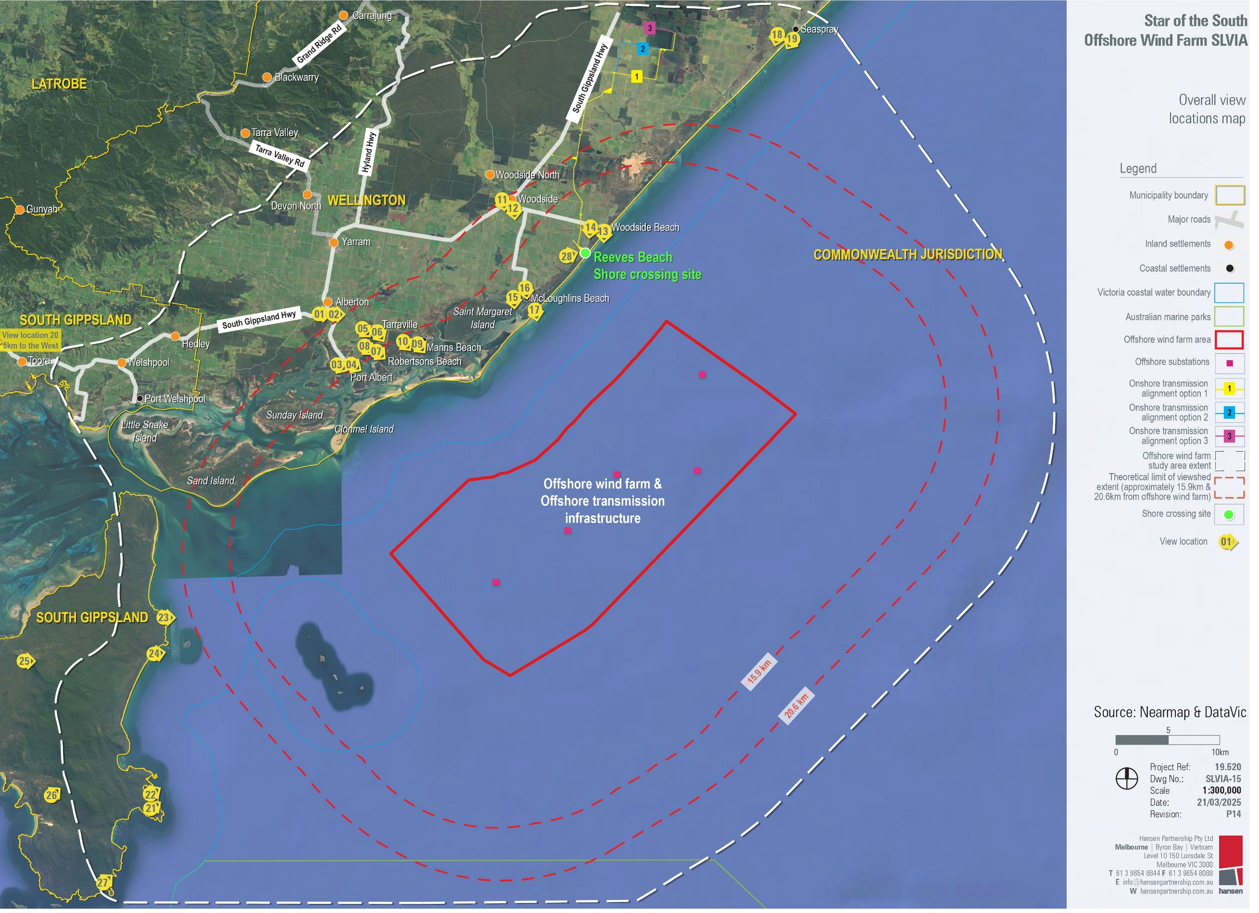

Visual impacts (SLV-I01 – SLV-I11)

24 North Street, Port Albert (view location 03) – day

Potential impact
This view location is around 15.5 kilometres from the proposed wind farm site and has low visual exposure to project infrastructure.
Landscape value at this view location is assessed to be high, on the basis that it is a state-significant landscape. The view location is adjacent to private property at 24 North Street, Port Albert, and is considered to be representative of views from proximate private residences. North Street is a local street used primarily for access to adjacent property and at the 2021 census, Port Albert had a population of 349. The number of receptors is assumed to be very low, however the frequency of visitation from these receptors is considered to be very high and assumed to have a very high duration of visitation. The existing view from this location is shown in Figure 22-15, and the potential project view is shown in Figure 22-16.
The changes to views of the sea and the introduction of offshore turbines and substations as a new physical element will alter the character of that part of the seascape within which the proposed offshore wind farm is located.

Mitigation
To reduce visual impacts to sensitive receptors, the project will:
- Select turbine colours which maximise the absorption of project infrastructure into the receiving environment (SLV-M001).

Residual impact
Following implementation of proposed mitigations, the overall visual impact at 24 North Street, Port Albert during the day is assessed to be high.
Figure 22-15 View location 03 – existing view
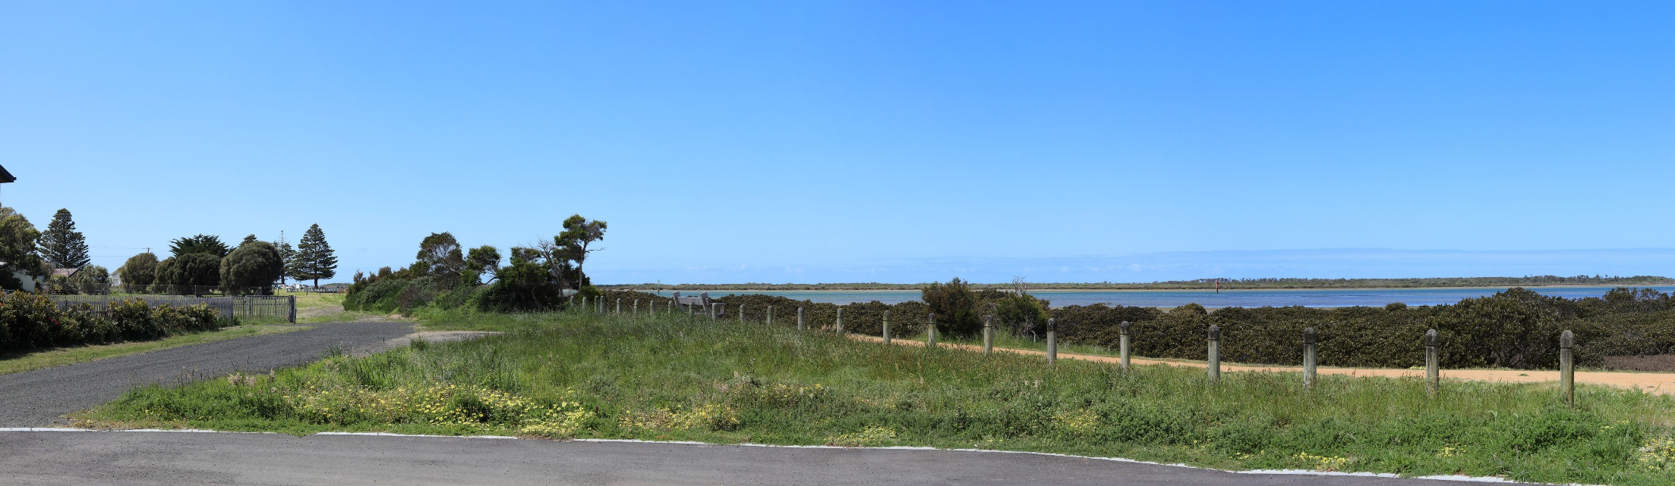
Figure 22-16 View location 03 – potential project view (350 metre wind turbine)
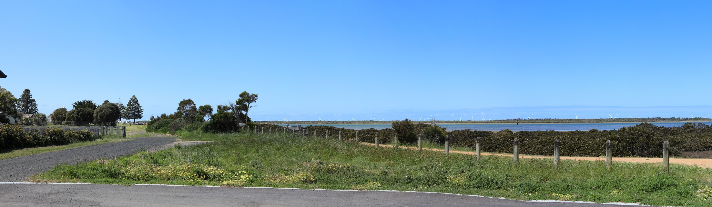
Table 22-3 Residual visual impacts from project infrastructure at 24 North Street, Port Albert
Potential Impact | Landscape value / Seascape value | Magnitude of visibility | Receptor sensitivity | Overall impact assessment
24 North Street, Port Albert | High (state  significance) | Moderate | High | High

24 North Street, Port Albert (view location 03) – night

Potential impact
The view location value attached to night time views is low unless there is a particular feature that can be best appreciated at night. The view location is assumed to attract a very low number of visitors at night, given its residential location. The existing view from this location at night is shown in Figure 22-17, and the potential project view is shown in Figure 22-18.
The changes to views of the sea and the introduction of offshore turbines and substations as a new physical element will alter the character of that part of the seascape within which the proposed offshore wind farm is located.

Mitigation
To reduce visual impacts to sensitive receptors, the project will:
- Adopt minimum illumination requirements for maritime and aviation safety (SLV-M002).

Residual impact
Following implementation of proposed mitigations, the visual impact at 24 North Street, Port Albert during the night is assessed to be moderate.

Figure 22-17 View location 03 – existing view
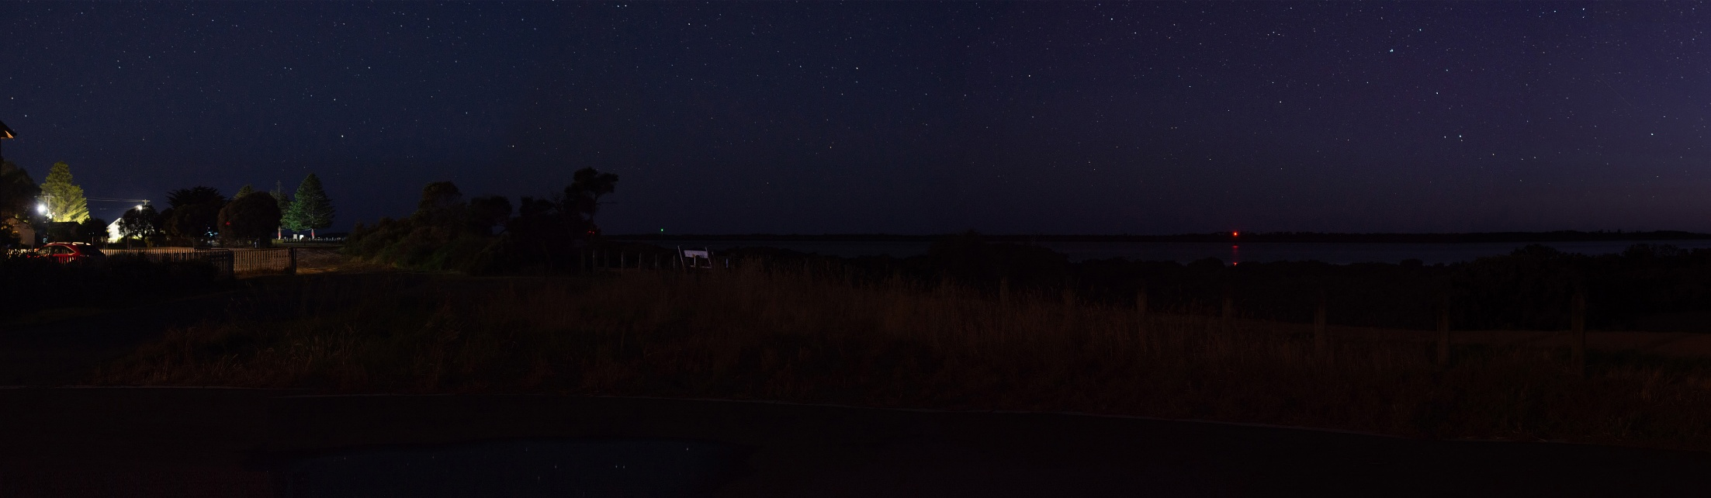
Figure 22-18 View location 03 – potential project view (350 metre wind turbine)
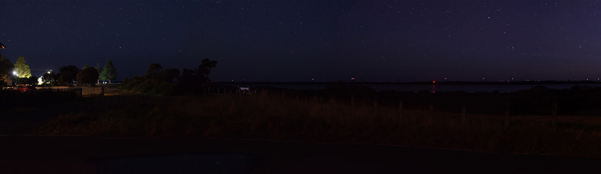
Table 22-4 Residual visual impacts from project infrastructure at 24 North Street, Port Albert at night
Potential Impact | Landscape value / Seascape value | Magnitude of visibility | Receptor sensitivity | Overall impact assessment
24 North Street, Port Albert (night time) | Low | Moderate | High | Moderate

McLoughlins Beach (view location 17) – day

Potential impact
This view location is around 10 kilometres from the proposed wind farm site and therefore has very high visual exposure to project infrastructure.
Landscape value at this view location is assessed to be high, on the basis that it is a regionally significant landscape. Given the view location is set within the Nooramunga Marine and Wildlife Park, receptors would typically be residents and visitors visiting recognised landscapes or attractions. However, reaching this location requires crossing a bridge and navigating a sand dune. Consequently, it is assumed that the number and frequency of receptors at this location is low, and the duration of their stay would be moderate. The existing view from this location is shown in Figure 22-19, and the potential project view is shown in Figure 22-20.
The changes to views of the sea and the introduction of offshore turbines and substations as a new physical element will alter the character of that part of the seascape within which the proposed offshore wind farm is located.

Mitigation
To reduce visual impacts to sensitive receptors, the project will:
- Select turbine colours which maximise the absorption of project infrastructure into the receiving environment (SLV-M001).

Residual impact
Following implementation of proposed mitigations, the overall visual impact at McLoughlins beach during the day is assessed to be high.
Figure 22-19 View location 17 – existing view
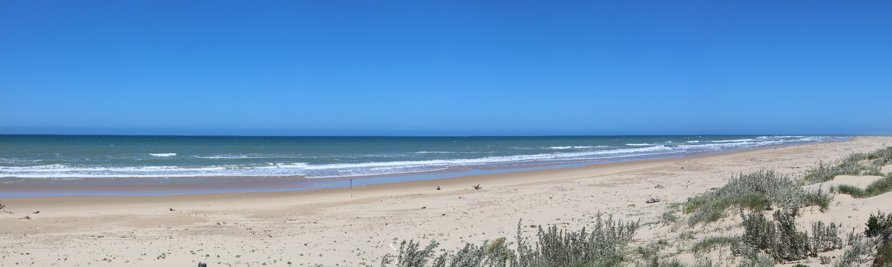
Figure 22-20 View location 17 – potential project view (350 metre wind turbine)
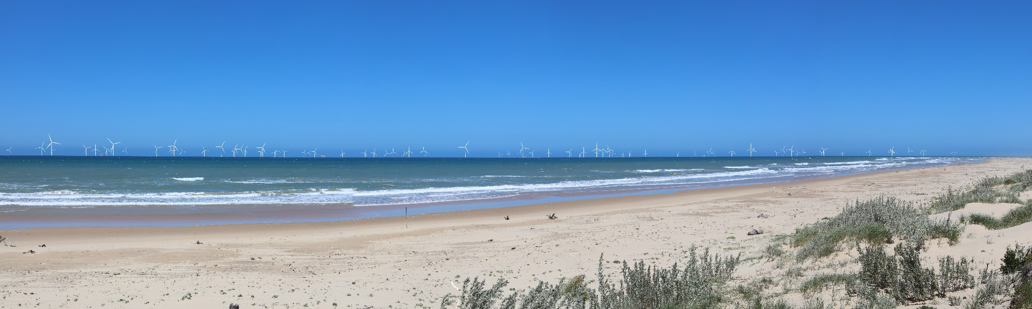
Table 22-5 Residual visual impacts from project infrastructure at McLoughlins beach
Potential Impact | Landscape value / Seascape value | Magnitude of visibility | Receptor sensitivity | Overall impact assessment
McLoughlins Beach | High (regional  significance) | Very high | Moderate | High

McLoughlins Beach (view location 17) – night

Potential impact
The value attached to night time views is low as there is no particular feature that is best appreciated at night, with a low number of visitors. Most visitors that frequent the location during the night are assumed to be engaging in activities unrelated to the visual amenity (for example, night fishing). The existing view from this location at night is shown in Figure 22-21, and the potential project view is shown in Figure 22-22.
The changes to views of the sea and the introduction of offshore turbines and substations as a new physical element will alter the character of that part of the seascape within which the proposed offshore wind farm is located.

Mitigation
To reduce visual impacts to sensitive receptors, the project will:
- Adopt minimum illumination requirements for maritime and aviation safety (SLV-M002).

Residual impact
Following implementation of proposed mitigations, the visual impact at McLoughlins beach during the night is assessed to be moderate.

Figure 22-21 View location 17 – existing view
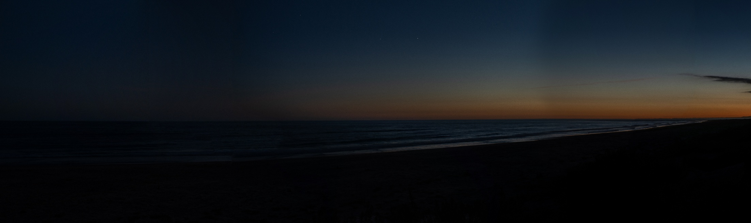
Figure 22-22 View location 17– potential project view (350 metre wind turbine)
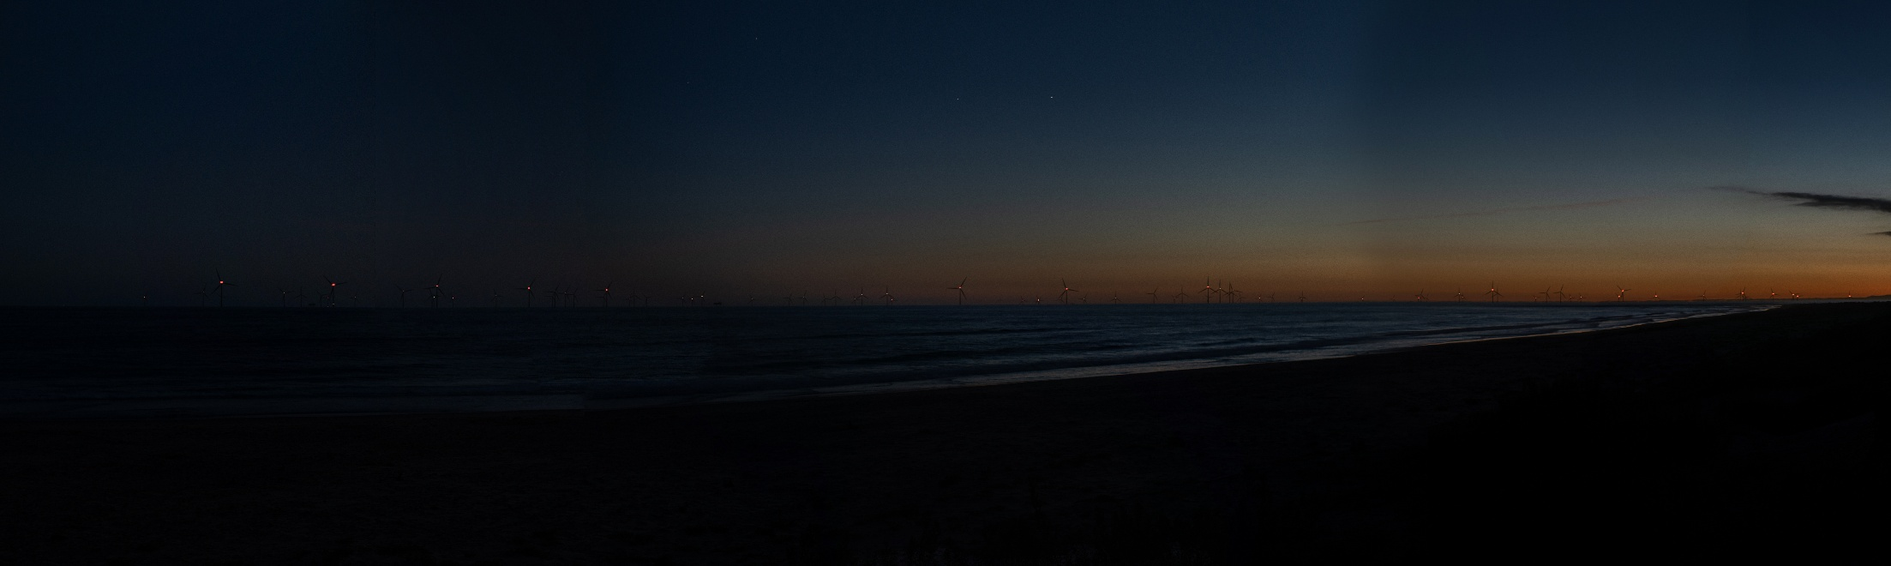
Table 22-6 Residual visual impacts from project infrastructure at McLoughlins beach at night
Potential Impact | Landscape value / Seascape value | Magnitude of visibility | Receptor sensitivity | Overall impact assessment
McLoughlins Beach (night time) | Low | High | Low | Moderate

Woodside Beach (view location 13) – day

Potential impact
Landscape value at this location is assessed to be high on the basis that it is a regionally significant landscape. The view location is at the Woodside Beach lookout, which provides access to Ninety Mile Beach and is around 13 kilometres from the proposed wind farm site. Receptors would typically be residents and visitors visiting the beach and surrounds. The number of receptors and receptor sensitivity is assessed to be moderate as the location is within a recognised scenic destination. The existing view from this location is shown in Figure 22-23, and the potential project view is shown in Figure 22-24.
The changes to views of the sea and the introduction of offshore turbines and substations as a new physical element will alter the character of that part of the seascape within which the proposed offshore wind farm is located.

Mitigation
To reduce visual impacts to sensitive receptors, the project will:
- Select turbine colours which maximise the absorption of project infrastructure into the receiving environment (SLV-M001)

Residual impact
Following implementation of proposed mitigations, the overall visual impact at Woodside Beach during the day is assessed to be moderate.
Figure 22-23 View location 13 – existing view
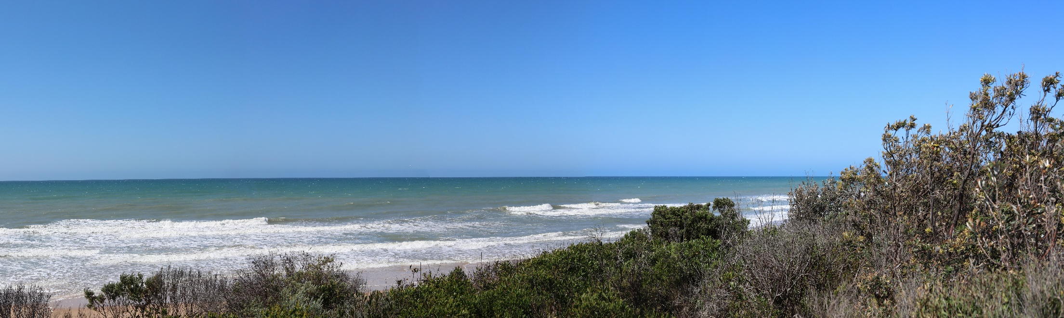
Figure 22-24 View location 13 – potential project view (350 metre wind turbine)
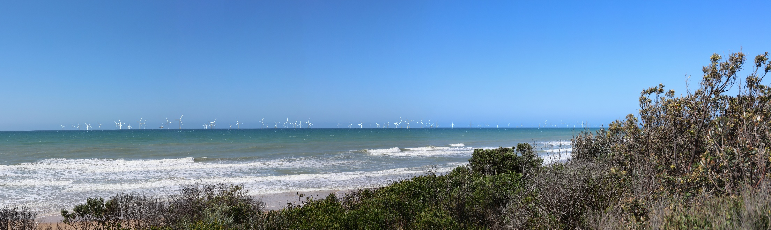
Table 22-7 Residual visual impacts from project infrastructure at Woodside Beach
Potential Impact | Landscape value / Seascape value | Magnitude of visibility | Receptor sensitivity | Overall impact assessment
Woodside Beach (day time) | High (regional  significance) | High | Moderate | Moderate

Woodside Beach (view location 13) – night

Potential impact
The value attached to night time views is low as there is no particular feature that is best appreciated at night, with an expectation of low numbers of visitors. Most visitors that frequent the location during the night are assumed to be engaging in activities unrelated to the visual amenity (for example, night fishing).
The changes to views of the sea and the introduction of offshore turbines and substations as a new physical element will alter the character of that part of the seascape within which the proposed offshore wind farm is located.
The existing view of this view location at night is shown in Figure 22-25, and the potential project view is shown in Figure 22-26.

Mitigation
To reduce visual impacts to sensitive receptors, the project will:
- Adopt minimum illumination requirements for maritime and aviation safety (SLV-M002).

Residual impact
Following implementation of proposed mitigation, the visual impact at Woodside Beach during the night is assessed to be moderate.

Figure 22-25 View location 13 – existing view
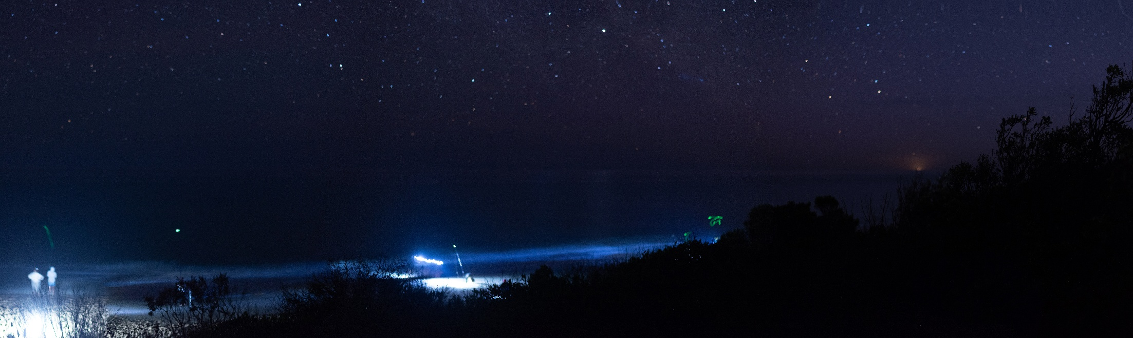
Figure 22-26 View location 13 – potential project view (350 metre wind turbine)
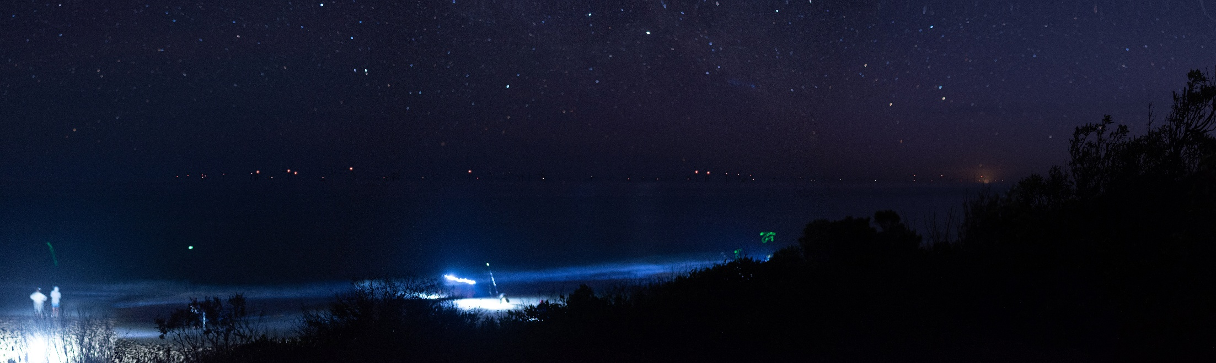
Table 22-8 Residual visual impacts from project infrastructure at Woodside beach at night
Potential Impact | Landscape value/Seascape  value | Magnitude of visibility | Receptor sensitivity | Overall impact assessment
Woodside beach (night time) | Low | High | Low | Moderate

Johnny Souey Cove - Wilsons Promontory (view location 23)

Potential impact
While this view location is more than 20 kilometres from the proposed wind farm site, it has high visual exposure to project infrastructure. Landscape value at this view location is assessed as being very high given its location within the Northern Wilderness Zone of Wilsons Promontory National Park. Receptor sensitivity at this view location is assessed as low, given it is a recognised scenic destination although because of the remoteness of the location, visitor numbers are very low. The existing view from this view location is shown in Figure 22-27, and the potential project view is shown in Figure 22-28.
The changes to views of the sea and the introduction of offshore turbines and substations as a new physical element will alter the character of that part of the seascape within which the proposed offshore wind farm is located.

Mitigation
To reduce visual impacts to sensitive receptors, the project will:
- Select turbine colours which maximise the absorption of project infrastructure into the receiving environment (SLV-M001)
- Adopt minimum illumination requirements for maritime and aviation safety (SLV-M002) (night time).

Residual impact
Following implementation of proposed mitigations, the overall visual impact at Johnny Souey Cove is assessed to be moderate.
Figure 22-27 View location 23 – existing view
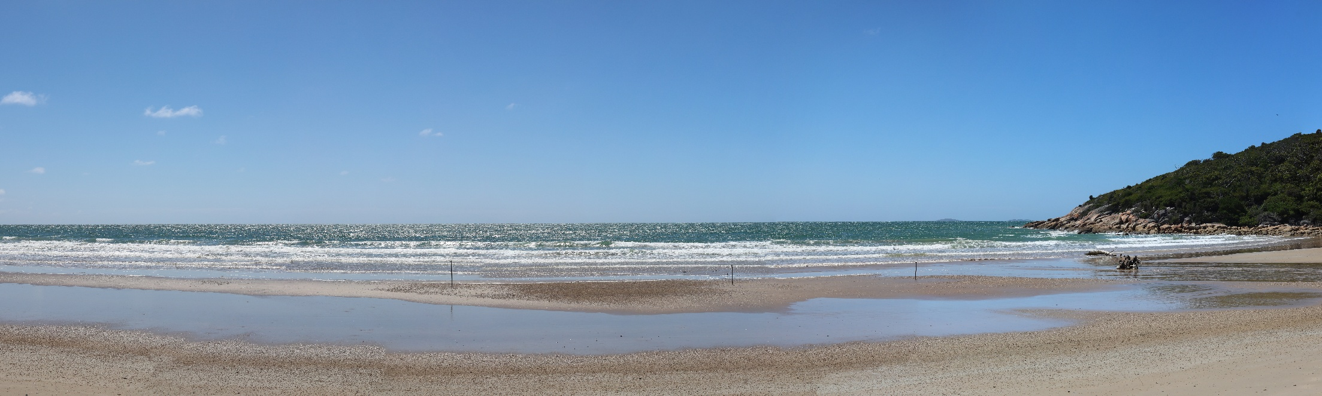
Figure 22-28 View location 23 – potential project view (350 metre wind turbine)
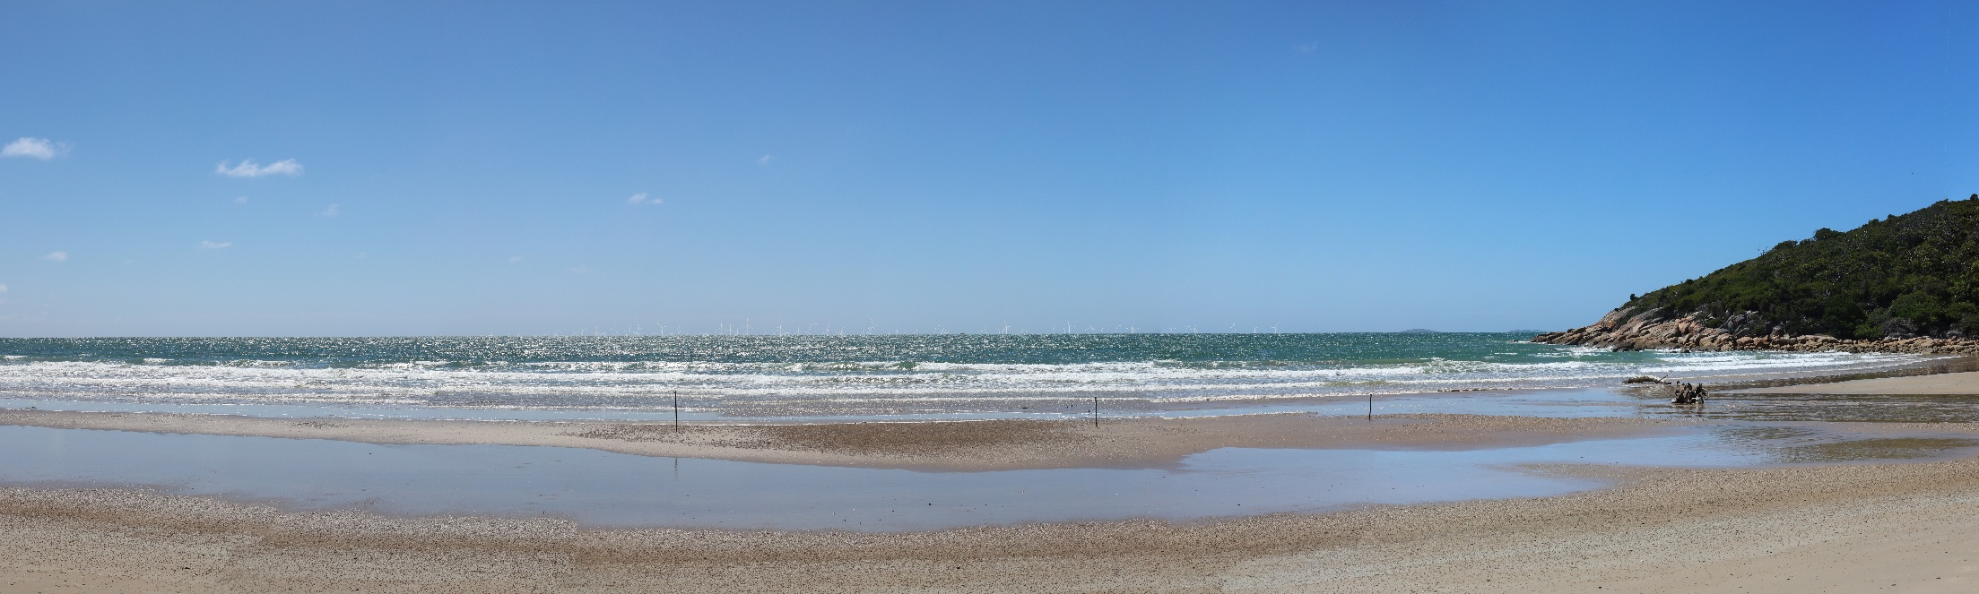
Table 22-9 Residual visual impacts from project infrastructure at Johnny Souey Cove
Potential Impact | Landscape value / Seascape value | Magnitude of visibility | Receptor sensitivity | Overall impact assessment
Johnny Souey Cove | Very high | Moderate | Low | Moderate

Seaspray Surf Lifesaving Club (view location 19)

Potential impact
This view location is more than 30 kilometres from the proposed wind farm site and therefore would have low visibility of project infrastructure. Given the view location adjacent to a surf lifesaving club, receptors would typically be the public visiting the beach and surrounds and participating in related activities. The number of receptors and receptor sensitivity are therefore assessed to be high and moderate respectively. The existing view from this location is shown in Figure 22-29, and the potential project view is shown in Figure 22-30.
The changes to views of the sea and the introduction of offshore turbines and substations as a new physical element will alter the character of that part of the seascape within which the proposed offshore wind farm is located.

Mitigation
To reduce visual impacts to sensitive receptors, the project will:
- Select turbine colours which maximise the absorption of project infrastructure into the receiving environment (SLV-M001)
- Adopt minimum illumination requirements for maritime and aviation safety (SLV-M002) (night time).

Residual impact
Following implementation of proposed mitigations, the overall visual impact at Seaspray Surf Lifesaving Club is assessed to be moderate.
Figure 22-29 View location 19 - existing view
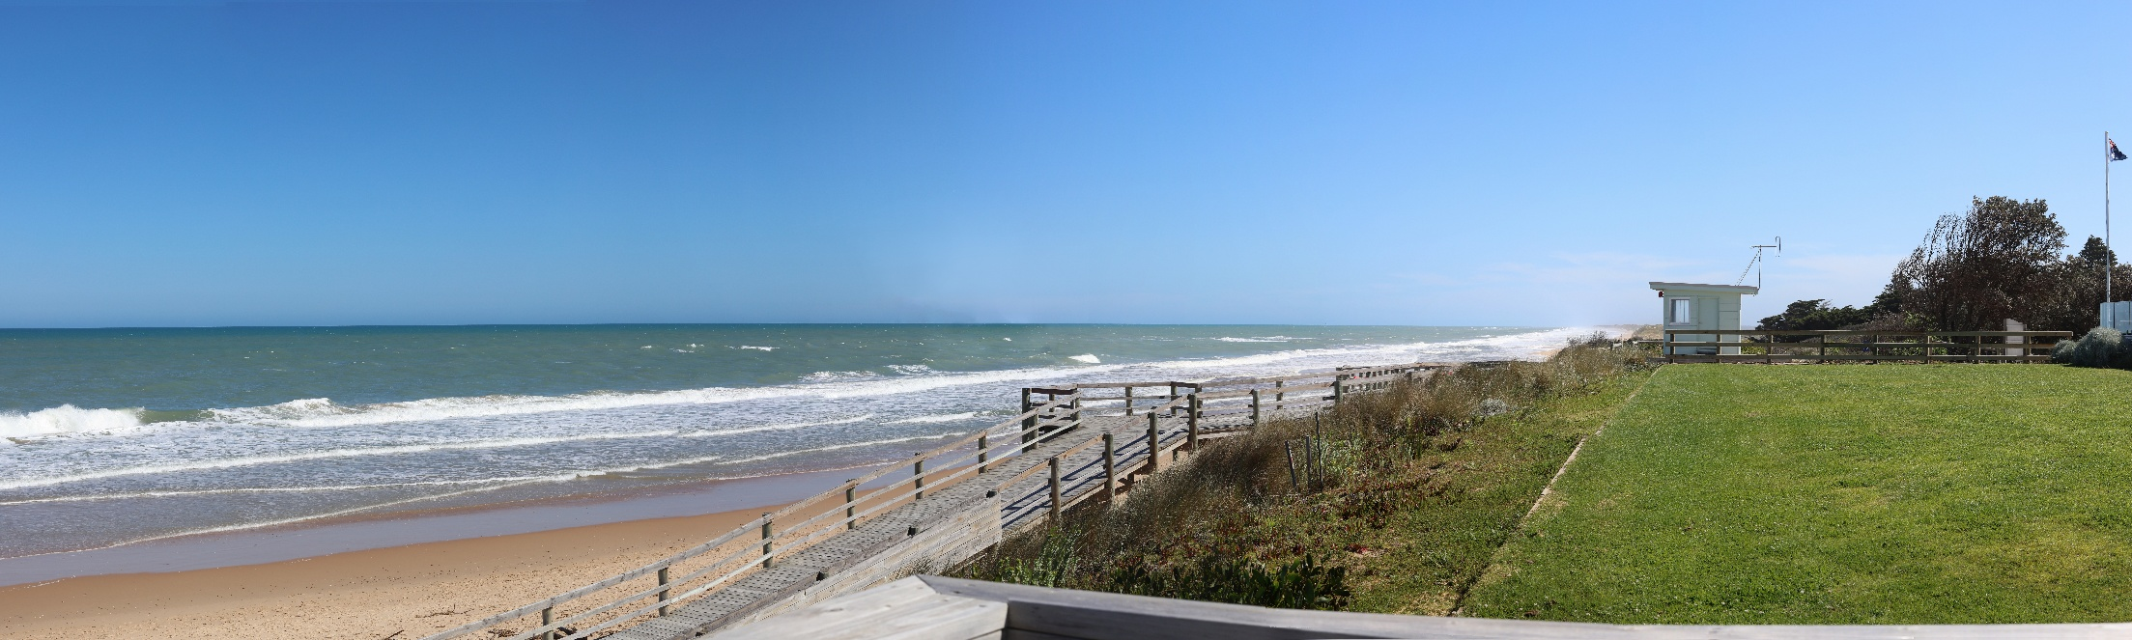
Figure 22-30 View location 19 – potential project view (350 metre wind turbine)
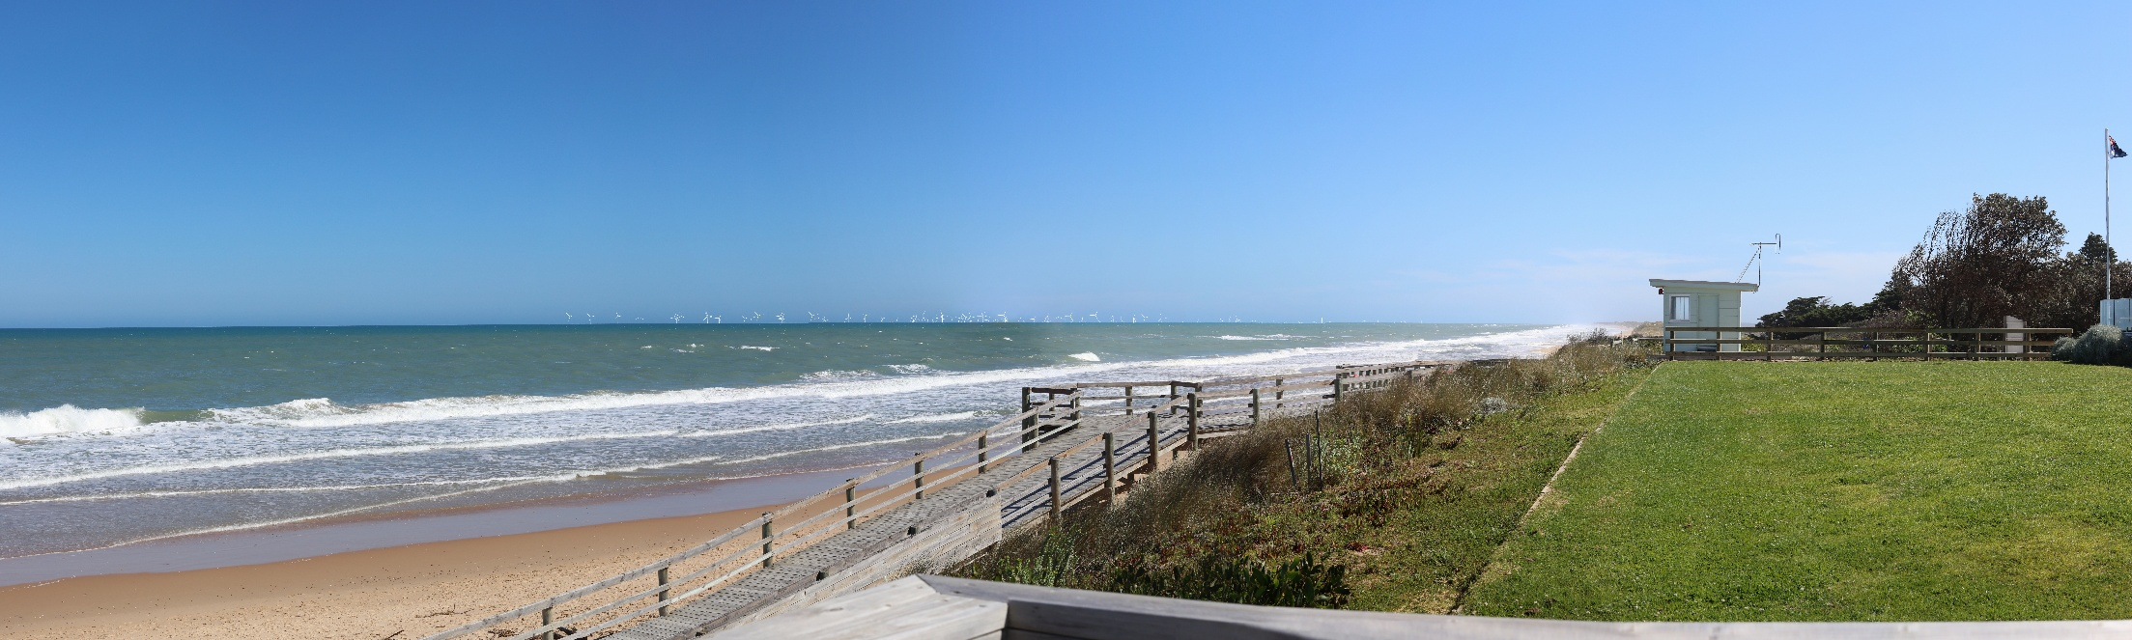
Table 22-10 Residual visual impacts from project infrastructure at Seaspray Surf Lifesaving Club
Potential Impact | Landscape value / Seascape value | Magnitude of visibility | Receptor sensitivity | Overall impact assessment
Seaspray Surf Lifesaving Club | High (state significance) | Moderate | Moderate | Moderate

McLoughlins Beach Car Park (view location 16)

Potential impact
This view location is around 11 kilometres from the proposed wind farm site but because of the intervening natural landscape, would have a very low visual exposure to project infrastructure. However, landscape value at this view location is assessed to be high due to the association with Ninety Mile Beach. Given the view location is a boat dropping jetty, receptors would typically be residents and jetty users. The number of receptors and receptor sensitivity is therefore assessed to be low. The existing view from this location is shown Figure 22-31, and the potential project view is shown in Figure 22-32.
The changes to views of the sea and the introduction of offshore turbines and substations as a new physical element will alter the character of that part of the seascape within which the proposed offshore wind farm is located.

Mitigation
To reduce visual impacts to sensitive receptors, the project will:
- Select turbine colours which maximise the absorption of project infrastructure into the receiving environment (SLV-M001)
- Adopt minimum illumination requirements for maritime and aviation safety (SLV-M002) (night time).

Residual impact
Following implementation of proposed mitigations, the overall visual impact at McLoughlins Beach Car Park is assessed to be moderate.
Figure 22-31 View location 16 - existing view
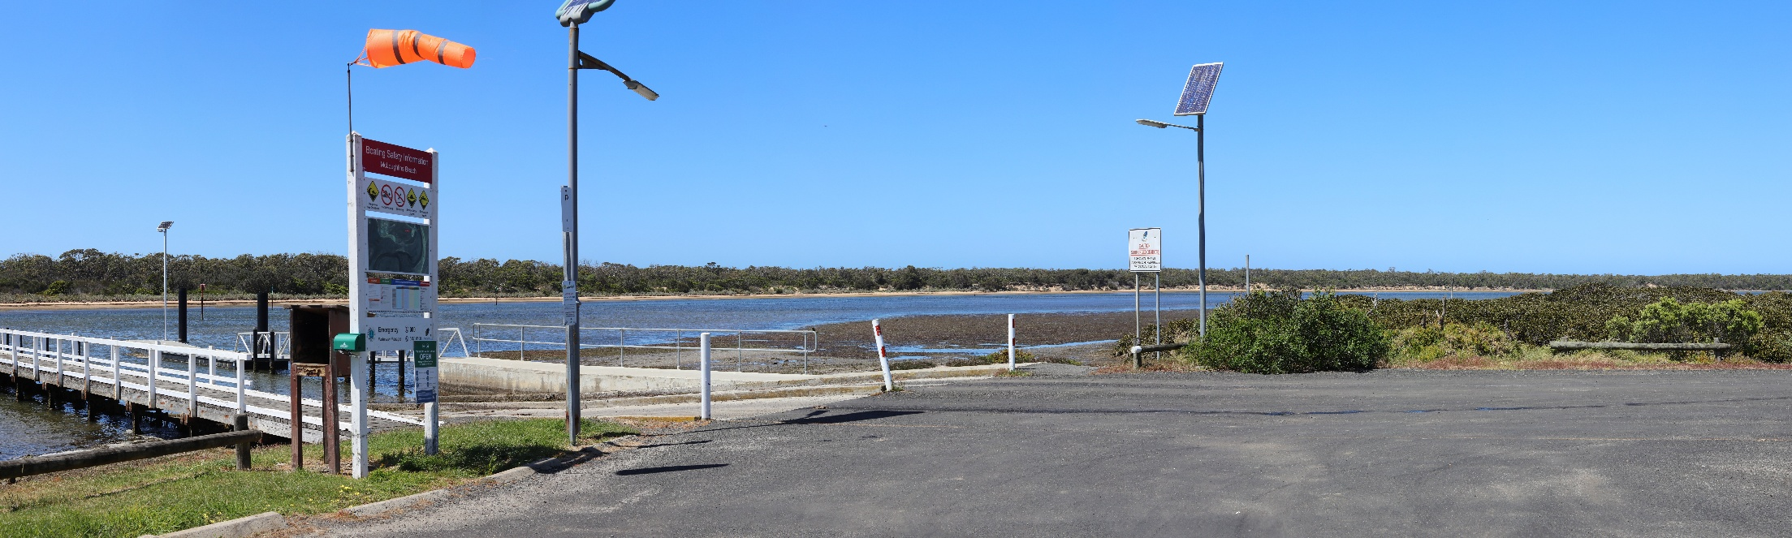
Figure 22-32 View location 16 – potential project view (350 metre wind turbine)
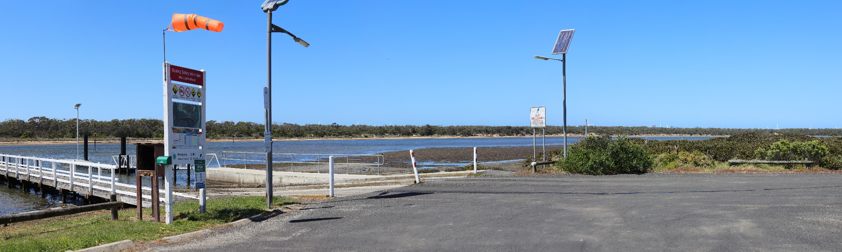
Table 22-11 Residual visual impacts from project infrastructure at McLoughlins Beach Car Park
Potential Impact | Landscape value / Seascape value | Magnitude of visibility | Receptor sensitivity | Overall impact assessment
McLoughlins Beach Car Park | High (regional significance) | Low | Low | Moderate

Other impacts
Of the 43 viewpoints assessed, 17 were assessed as having low or nil impact ratings once initial mitigation measures have been implemented. These 17 viewpoints are not summarised in the chapter, however they can be reviewed in Technical Report U – Seascape, Landscape and Visual.
Landscape and seascape character impacts were also assessed as having low to negligible impacts, once mitigation measures have been implemented. Landscape and seascape character impacts are discussed in sections 22.7.2.1 and 22.7.2.2.

Landscape character impacts

Potential impact
The project would result in the greatest changes to the character of:
- Landscape Character Area 1: Wilsons Promontory Granite Coast
- Landscape Character Area 2: Coastal Islands
- Landscape Character Area 4: Ninety Mile Coast, and
- Landscape Character Area 5: Settlements.
Landscape Character Area 4: Ninety Mile Coast is likely to be subject to the greatest level of change, with the visual presence of offshore turbines reducing the perceived level of naturalness where this is influenced by views of the sea. Typically, where views of the sea are not available, changes are negligible.
Landscape Character Area 1: Wilsons Promontory Granite Coast, Landscape Character Area 2: Coastal Islands and Landscape Character Area 5: Settlements are anticipated to be impacted to a lesser degree, largely due to the mitigating influence of coastal vegetation and greater distances between the offshore turbines and these landscape character areas.
Landscape Character Area 6: Timber Plantation Forest, Landscape Character Area 7: Strzelecki Ranges and Foothills and Landscape Character Area 8: Forest Foothills would experience negligible levels of change to the elements which define their landscape character.

Mitigation
To reduce landscape character impacts, the project will:
- Select turbine colours which maximise the absorption of project infrastructure into the receiving environment (SLV-M001)
- Adopt minimum illumination requirements for maritime and aviation safety (SLV-M002)
- Revegetate vegetation removed as part of the onshore transmission corridor (in alignment with onshore ecology revegetation mitigation (FFM13)) (SLV-M003).

Residual impact
Following implementation of proposed mitigations, the landscape character impact for Landscape Character Areas 1, 2, 4, 5, 6, 7 and 8 is limited, however perceived impacts to the naturalness of the character areas would be present.

Seascape character impact

Potential impact
The project would result in the greatest impacts to:
- Seascape Character Area 3: Gippsland Coast
- Seascape Character Area 4: Seal Islands, and
- Seascape Character Area 5: Bass Strait Offshore Waters.
Seascape Character Area 5: Bass Strait Offshore Waters would be impacted for both views of the sea and the introduction of offshore turbines and substations that would alter the character of that part of the seascape that the project is located.
The impacts would include changes to views of the sea for Seascape Character Area 3: Gippsland Coast and Seascape Character Area 4: Seal Islands.
For Seascape Character Area 1: Wilsons Promontory, impacts are limited to a reduction in the openness and ‘wild’ character of seascape views due to the distant presence of offshore infrastructure and a change in views toward the open sea and Seal Islands.
As visual exposure to project infrastructure is low to very low, minimal impacts to the seascape character of Seascape Character Area 2: Corner Inlet are anticipated.

Mitigation
To reduce seascape character impacts, the project will:
- Select turbine colours which maximise the absorption of project infrastructure into the receiving environment (SLV-M001)
- Adopt minimum illumination requirements for maritime and aviation safety (SLV-M002).

Residual impact
Following implementation of proposed mitigations, the seascape character impact for Seascape Character Areas 3, 4 and 5 includes an alteration of character of the seascape, for both views of the sea and the introduction of offshore turbines and substations.

Potential risks
The operation impact assessment identified no risks to seascape, landscape, and visual receptor groups.

Decommissioning assessment
It is assumed that decommissioning activities would involve activities similar to the construction phase of the project, including complete vegetative and other relevant landscape and seascape rehabilitation, and the removal of all onshore and offshore structures (including sub-surface footings, and re-establishment of pre-construction ‘natural’ ground levels).
With effective rehabilitation including revegetation of onshore areas where required, residual impacts are not anticipated on the basis that all visible infrastructure would be removed.
As such, decommissioning activities have not formed part of the scope of the seascape, landscape and visual assessment.

Cumulative Impact Assessment
This section provides an assessment of the potential for cumulative impacts of the project with other proposed developments in the region. The method to consider cumulative impacts is described in Chapter 6 – Assessment Framework.
Potential cumulative impacts arise when the effects of a single project on a receptor are considered along with the effects of other projects on the same receptor. Projects that are operational are part of the baseline environment, and the cumulative impact assessment focuses on future developments following the tiered assessment methodology.
The Great Eastern Offshore Wind project was identified within the cumulative impact assessment relevant to seascape, landscape and visual is summarised in Table 22-12
Table 22-12 Projects assessed for cumulative impacts
Project | Project Description | Findings of Assessment
Great Eastern Offshore Wind | The wind turbines would be located within the Feasibility Licence Area awarded for the project.  The project has up to 172 turbines with a maximum tip height of 375m.  Received a feasibility licence for the development of a fixed-bottom offshore wind farm with a capacity of up to 2.5 GW, located approximately 22 km off the Gippsland coast. | Spatial relevance: located adjacent and south-east of the Star of the South Offshore Wind Farm Area and wind turbines from both projects are anticipated to be visible together from some viewpoints on the Victorian coast, and there is therefore potential for cumulative visual impact.  Temporal relevance: According to the project schedule depicted on the project website it is possible that the construction and operations phase of the project may overlap with those of the Star of the South project.
Based on the available information, the Great Eastern Offshore Wind project is located adjacent and south-east of the project. There is potential for cumulative visual impacts with both projects anticipated to be visible together from some viewpoint.
No other projects within the project's zone of influence were carried forward for further cumulative impact assessment due to insufficient data. While there is potential for other projects to impact similar receptors and the possibility of both spatial and temporal overlap with other developments, the current lack of certainty makes any meaningful assessment speculative.
Star of the South will incorporate mitigation measures to minimise the potential for cumulative impacts to arise, as detailed in Section 22.10

Summary of mitigation, monitoring and contingency measures

Mitigation measures
The following section outlines the mitigation measures developed to avoid and minimise seascape, landscape and visual impacts within the study area. The focus of these mitigation measures is:
- Avoiding impacts where possible
- Developing, preparing and implementing project-specific measures to minimise impacts.
The mitigations below have been developed for the impacts and risks discussed in detail within Technical Report U – Seascape, Landscape and Visual. Detailed descriptions of each measure can be found in Chapter 23 – Commonwealth Environmental Management Framework and are listed in Table 22-13.
Table 22-13 List of mitigation measures relevant to seascape, landscape and visual
ID | Mitigation measure and description | Phase
SLV-M001 | Selection of Colour that Minimises Visual Impacts | Construction
SLV-M002 | Adoption of Minimum Illumination for Maritime and Aviation Safety | Construction
SLV-M003 | Revegetation within the Onshore Transmission Corridor | Construction

Conclusion
The potential seascape, landscape and visual impacts have been assessed for the construction, operation and decommissioning phases of the project. The project involves installation of between 113 to 147 wind turbines offshore, within an area more than ten kilometres from the central Gippsland coast.
Although the Gippsland coast has relatively low population levels, it is sensitive to visual changes, particularly when visible from coastal settlements and highly valued natural areas such as the Wilsons Promontory National Park, including designated wilderness areas under the National Parks Act 1975, valued for remote and natural values. The project does not affect any distinctive areas or landscapes declared under the Planning and Environment Act 1987 or any areas subject to a significant landscape overlay.
The assessment is based on a wind turbine layout with the most visible presence, a 350-metre tip height turbine.
The project will result in changes to the character of seascapes and landscapes within the project study area. The most affected of these will be the Bass Strait offshore waters, where project infrastructure is proposed to be located. Other landscapes and seascapes will be affected to the extent that views of the sea from these locations will change.
The potential visual impacts of the project have been assessed at a range of representative view locations across an extensive study area. The project will result in visual impacts, which vary across the view locations. These impacts have been minimised primarily through siting and design measures, including a reducing the number of turbines from a referred 400 to a maximum of 147 and selecting a wind farm site a significant distance from the coastline, Wilsons Promontory National Park, and major population centres. This has reduced the number of receptors affected by potential visual impacts.
The impact of the proposed offshore wind farm was assessed as being high in some sensitive coastal locations including Port Albert, Robertsons Beach, Manns Beach and McLoughlins Beach. Impacts at night were assessed as being moderate or less. The wind farm would be visible from Wilsons Promontory National Park under certain conditions and impacts were assessed to be moderate or less from view locations within the park.
In relation to the onshore transmission infrastructure, the decision to underground transmission cables rather than installing above ground transmission lines has avoided significant landscape and visual impacts.
The assessment has found that high impacts on seascape, landscape, or visual values are confined to a small number of specific locations, and the overall impact on the region is much lower. As such, the project is not expected to have significant impacts.
Proposed mitigation measures which have informed the project design address the need for minimisation and management of potential adverse effects on landscape and visual amenity, as described above. Additional measures to further mitigate the visual impacts are proposed as follows:
- Selection of a colour from the colour palette available for wind turbine generators that maximises the absorption of the infrastructure into the receiving environment
- Adoption of the minimum illumination for maritime and aviation safety lights
- Revegetating the onshore transmission corridor.
The Commonwealth EIS guidelines have been addressed and the assessment found there would be no significant seascape, landscape and visual impacts.

