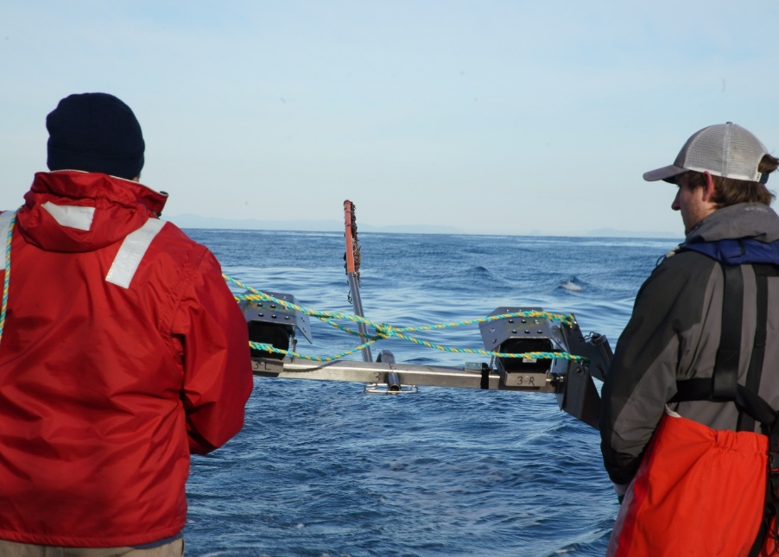
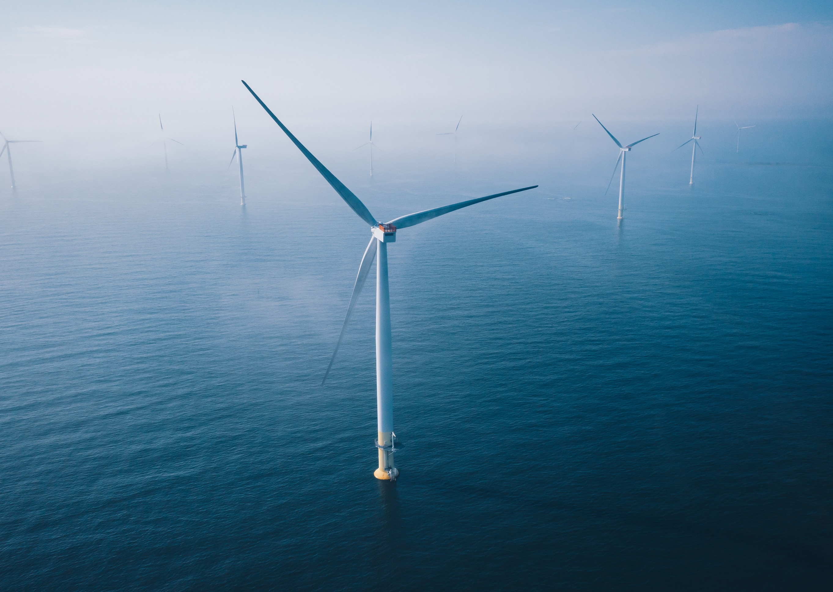

Appendix A – Foundation options assessment
Commonwealth Environmental Impact Statement

Table of Contents
1 Introduction 1-1
1.1 Overview 1-1
1.2 Purpose of this report 1-1
1.3 Scope 1-2
1.4 Project objectives 1-3
1.4.1 Star of the South project objectives 1-3
2 Options assessment methodology 2-4
2.1.1 Options identification 2-4
2.1.2 Screening 2-4
2.1.3 Evaluation of feasible options 2-5
2.1.4 Detailed technical report (appended) 2-7
3 About offshore wind turbine foundations 3-8
3.1 Monopile (impact piling or vibro-piling) 3-10
3.1.1 Fabrication of monopiles 3-11
3.1.2 Installation of monopiles 3-11
3.2 Jacket (piled, vibro-piled or suction caisson) 3-12
3.2.1 Fabrication and piling of jackets 3-12
3.2.2 Suction caisson jacket 3-13
3.3 Gravity-based foundations 3-14
3.4 Tri-suction pile caisson 3-16
3.5 Floating 3-17
4 Screening 4-20
4.1 Screening 4-20
4.2 Rationale for ‘screening in’ of options 4-21
4.3 Rationale for ‘screening out’ of options 4-22
4.3.1 Suction caisson jacket 4-22
4.3.2 Gravity-based foundation 4-24
4.3.3 Tri-suction pile caisson 4-26
4.3.4 Floating 4-27
5 Evaluation of feasible options – monopiles and jackets 5-29
5.1 Evaluation of options against key criteria 5-29
5.2 Environment criteria 5-29
5.2.1 Underwater noise 5-30
5.2.2 Installation of the foundations 5-30
5.2.3 Installation vessels 5-31
5.2.4 Seabed disturbance 5-31
5.2.5 Criteria that did not affect outcome of evaluation 5-31
5.2.6 Environment summary 5-32
5.3 Other users’ criteria 5-34
5.3.1 Shipping and navigation (small vessels) 5-34
5.3.2 Commercial fisheries 5-35
5.3.3 Other users’ summary 5-36
5.4 Sustainability criteria 5-36
5.4.2 Embodied energy and carbon 5-37
5.4.3 Criteria considered but excluded from detailed evaluation 5-38
5.4.4 Sustainability criteria summary 5-38
5.5 Constructability criteria 5-39
5.5.1 Site suitability / geotechnical considerations 5-39
5.5.2 Driven pile installation 5-39
5.5.3 Seabed mobility 5-40
5.5.4 Provision of lateral and vertical support 5-40
5.5.5 Remaining constructability criteria 5-41
5.5.6 Constructability criteria summary 5-43
5.6 Commercial criteria 5-45
5.7 Supply chain / procurement criteria 5-48
5.7.1 Criteria considered but excluded from detailed evaluation 5-48
6 Summary of evaluation results 6-51
6.1 Monopiles (impact piling) 6-51
6.2 Monopiles (vibro-piling) 6-52
6.3 Jackets (impact piling) 6-52
6.4 Jackets (vibro-piling) 6-53
7 Conclusion 7-55
8 References 8-57

Figures
Figure 3-1 Evolution of offshore wind turbine technology 3-8
Figure 3-2 Different designs of offshore wind farm turbine foundations 3-9
Figure 3-3 Number of foundation concepts up to 2022 3-10
Figure 3-4 Monopile wind turbine foundation 3-11
Figure 3-5 Jacket wind turbine foundation (left) and suction bucket foundation (right) 3-14
Figure 3-6 Gravity wind turbine foundation 3-16
Figure 3-7 Tri-suction pile caisson wind turbine foundation 3-17
Figure 3-8 Floating wind turbine foundation - spar-buoy structure 3-18
Figure 3-9 Floating wind turbine foundation - semi-submersible 3-19
Figure 3-10 Floating wind turbine foundation - tension leg platform 3-19
Figure 5-1 Installation schedule 5-35

Tables
Table 2-1 Criteria for evaluation of feasible foundation options 2-6
Table 2-2 Qualitative scoring system for feasible alternatives 2-7
Table 4-1 Feasibility assessment for identified of turbine foundation options 4-20
Table 4-2 Embodied energy comparison 4-25
Table 4-3 Principal global floating offshore wind projects 4-27
Table 5-1 Assessment of feasible foundation options – Environment criteria 5-33
Table 5-2 Assessment of feasible foundation options – Other users’ criteria 5-36
Table 5-3 Embodied energy and carbon for each foundation concept per WTG 5-38
Table 5-4 Assessment of feasible foundation options – sustainability criteria 5-38
Table 5-5 Assessment of feasible foundation options – constructability criteria 5-44
Table 5-6 Assessment of feasible foundation options – commercial criteria 5-47
Table 5-7 Assessment of feasible foundation options – supply chain / procurement criteria 5-49
Table 6-1 Summary of evaluation results for feasible foundation options 6-54

Introduction

Overview
This report is an Appendix to Chapter 3 – Project Development. It provides an overview of the wind turbine foundation evaluation process that has been carried out for the Star of the South Offshore Wind Farm Project (the ‘project’), and the results and outcomes of that process.
Foundation selection is often guided by the proposed project location and associated seabed conditions. Located within a feasibility licence area off the coast of Gippsland, Victoria, the project site features water depths ranging from 15 - 50 metres, with an average depth of 30 metres.

Purpose of this report
The purpose of this report is to describe Star of the South’s process to identify feasible foundation options for the project, assess their suitability against a range of relevant criteria, and explain the rationale for determining which options to progress through environmental assessment and detailed design.
Assessment of feasible alternatives for key project components is an integral part of the environmental impact assessment process. The EIS Guidelines (Section 2.4) state that the EIS needs to provide:
- if relevant, the alternative of taking no action (refer to Chapter 2 – Project Rationale and Chapter 3 – Project Development)
- a comparative description of the impacts of each alternative on the matters of national environmental significance (MNES) protected by controlling provisions of Part 3 of the EPBC Act for the action
- where there are likely to be different environmental impacts associated with the options, sufficient detail to make clear why any alternative is preferred to another
- how the choice of alternatives or options ensures impacts to MNES are appropriate, minimised and managed to an acceptable level (refer to relevant technical assessments such as Marine Mammals and Turtles, Seabirds and Shorebirds, Terrestrial Ecology and Benthic Environment).
To meet the EIS Guidelines, the key objectives of this report are to:
- Identify all design and installation options for wind turbine foundations and determine which options are feasible within known project parameters and objectives e.g. water depth, geotechnical conditions, commercial viability and constructability
- Apply consistent criteria to undertake a qualitative evaluation of all feasible design and installation options for wind turbine foundations to:
  - Describe environmental impacts and allow comparison between alternative foundation types
  - Evaluate technical feasibility of foundation design and alternative installation methods relevant to the project location and project objectives
  - Determine short, medium and long-term advantages and disadvantages of the options.
- Document the design development process leading to the selection of the preferred foundation design.

Scope
This report summarises the foundation options available for the project’s wind turbine generator, in response to the EIS Guidelines, and demonstrates the rationale and process for selecting a foundation type to be used for the project turbines.
The report describes the options assessment methodology in Section 2 and each of the turbine foundation options under consideration in Section 3.
The report then outlines the foundation options assessment, which consisted of two key phases:
- Screening – the process for identifying available foundation types (and installation methods) and screening them for project feasibility. The turbine foundation options that are not feasible are screened out of further assessment, while the shortlisted feasible options proceed to the next phase. The screening of the turbine foundation options is described in Section 4.
- Evaluation – the shortlisted feasible turbine foundation options are evaluated based on a broad suite of relevant criteria to determine relative suitability for the project. The evaluation of the shortlisted turbines is presented in Section 5, and summarised in Section 6.
This report is not an assessment of potential impacts to MNES associated with turbine foundation installation. This is detailed in the assessment’s relevant technical reports and chapters.
Other elements of project development are described in Chapter 3 – Project Development.

Project objectives

Star of the South project objectives
Project objectives are considered in all aspects and stages of project development to guide outcomes and help to maintain a consistent approach to design and assessment. As such, they were also a consideration in the screening and evaluation of foundation options.
The key objectives of the project are to:
            - Deliver a significant, secure, and reliable source of large-scale renewable electricity to meet Victoria’s legislated offshore wind target of 2 GW by 2032 and progress towards Australia's legislated net-zero emissions by 2050 target
            - Adapt proven offshore wind technologies to local conditions while avoiding and minimising significant risks of harm to the environment, so far as reasonably practicable
            - Develop and deliver the project in consultation with Traditional Owners and local communities.
Developing and delivering a project that aligns with these objectives will help achieve the following:
- Supply approximately 20 per cent of Victoria’s electricity needs, enough to power up to 1.2 million homes
- Support Victoria’s renewable energy generation targets – including offshore wind targets legislated in March 2024 of at least 2 GW by 2032, 4 GW by 2035 and 9 GW by 2040
- Support initiatives within the Climate Change Act 2017 (Vic) to meet greenhouse gas emissions reduction target of net zero emissions by 2050
- Support the Commonwealth Government’s commitment to achieve its 2035 climate change target to reduce greenhouse gas emissions by 62-70 per cent on 2005 levels
- Support the Victorian Government Local Jobs First Policy and other initiatives to provide opportunities for Gippsland energy workers and businesses through the creation of thousands of direct and indirect jobs.

Options assessment methodology

Options identification
Foundation options were identified by literature review and workshopping with subject matter experts, including the Star of the South team and specialist consultants with extensive experience in developing offshore wind projects in Europe and Asia.
The turbine foundation options identified for screening were:
- Monopiles
- Jackets
- Suction caisson jackets
- Tri-suction pile caisson
- Gravity-based
- Floating foundations.

Screening
Each foundation design option is screened to determine which option/s are feasible for the project site while meeting project objectives. Multiple factors are considered:
- Water depth: Water depth is important, as foundation design options are suited to different ranges of water depths of a particular site. For example, floating foundations are best suited to deep offshore waters and are typically installed in water depths greater than 100 metres. Gravity-based foundations are most suitable for shallow water depths of less than 30 metres. Jacket foundations are generally proposed in water depths greater than 40 metres and monopile foundations are typically feasible in water depths up to approximately 50 metres.
- Suitability of seabed: An understanding of the geotechnical and environmental conditions can determine foundation type and installation method/s most suited to the soil structure and environmental conditions.
- The ability to achieve project objectives: Project objectives consider meeting government policy objectives, environmental factors, constructability and health and safety.
- Logistics / supply chain considerations: Australia is located far from existing offshore wind markets and supply chains. Logistics, port capacity and supply chain considerations are important factors when considering foundation selection.
Following the screening analysis, feasible foundation options are carried through to the next phase of assessment – detailed evaluation. Other foundation options that do not meet the screening criteria are not evaluated further.

Evaluation of feasible options
Following the screening process, a multidisciplinary evaluation of the feasible foundations and installation methods for the project is undertaken against the criteria and sub-criteria outlined in Table 2-1 to understand the merits of each feasible option.
Decisions around feasible foundation options need to consider a range of factors. Subject matter experts assist in developing the criteria through multi-disciplinary workshops covering environmental, engineering, procurement, commercial and stakeholder matters.
Where sufficient information is available, workshop participants assign preliminary rankings while identifying areas where further information is required to complete an evidence-based evaluation. Where further information is required, the respective discipline lead takes actions to further investigate and provide this information. Where required, this includes re-screening foundation option suitability based on the latest geotechnical data. The evaluation criteria include:
- Environment: underwater noise, seabed disturbance
- Other users: shipping and navigation, commercial fishers
- Sustainability: biodiversity benefits, energy ratio (embodied carbon)
- Constructability: site suitability, timing and certainty, health and safety, decommissioning
- Commercial: construction costs, operation costs, bankability i.e. able to secure finance
- Supply chain / procurement: suppliers, vessel availability, port quayside and landside storage
- Project objectives: ability to meet project objectives.
More detail on the evaluation criteria is provided in Table 2-1.
Table 2-1 Criteria for evaluation of feasible foundation options
Criteria | Sub-criteria | Key considerations
Environment | Underwater noise | Nature, duration and intensity of expected underwater noise emissions during construction from the option as an indicator of potential impact on marine fauna.
Environment | Seabed disturbance | Expected extent of seabed disturbance as an indicator of potential impacts on benthic habitats.
Other users | Shipping and navigation | Turbine spacing has greatest influence on shipping and will be the same for all foundation types. Key consideration will be duration of construction activities with larger exclusion zones.
Other users | Commercial fishing | Relative habitat value of different foundation options for targeted species.
Sustainability | Biodiversity benefits | Potential for the foundation to provide benefits for biodiversity (increased species diversity and abundance) in the longer term.
Sustainability | Energy ratio (embodied carbon) | The energy ratio is derived using a rough estimate of the lifetime energy generation for a project and divides that by a rough estimate of the lifetime energy inputs for a project. Overall tonnages of steel and concrete multiplied by material specific factors, are used as proxy indicators of embodied energy when evaluating alternative foundation concepts.
Constructability | Site suitability | Ability to install the option based on known site conditions, e.g. water depth and geotechnical conditions.
Constructability | Timing and certainty | Schedule implications of the option in relation to construction and installation times including level of certainty on schedule assumptions.
Constructability | Health and safety | Level of health and safety risks to personnel during manufacturing and construction of foundation structure.
Constructability | Decommissioning | Ease with which the foundation design can be removed from the marine environment at the end of its operating life.
Commercial | OPEX | Relative expected operating expenses for the option.
Commercial | CAPEX | Relative expected expenses for constructing the option.
Commercial | Bankability | The ability to secure finance for the option. This primarily considers how proven the concept is, based on international experience.
Supply chain/ procurement | Suppliers | Number of suppliers and certainty that a suitable supplier can be engaged.
Supply chain/ procurement | Vessel logistics | Relative type and size of vessels required and availability in the international market.
Supply chain/ procurement | Quayside logistics/ storage | The dimensions and mass of the foundation relative to the available construction area, quayside length and width, load bearing capacity and minimum available water depth at quayside.
Meets project objectives |  | 1. Deliver a significant, secure, and reliable source of large-scale renewable electricity to meet Victoria’s legislated offshore wind target of 2GW by 2032 and progress towards Australia's legislated net-zero by 2050 target.  2. Adapt proven offshore wind technologies to local conditions while avoiding and minimising significant risks of harm to the environment, so far as reasonably practicable.  3. Develop and deliver the Project in consultation with Traditional Owners and local communities.
The evaluation of the feasible options is undertaken using the qualitative scoring system shown in Table 2-2.
Table 2-2 Qualitative scoring system for feasible alternatives
Score | Descriptor
1 | Worst outcome
2 | Negative outcome
3 | Neutral / no difference
4 | Positive outcome
5 | Best outcome

Detailed technical report (appended)
A substantiating technical report comparing the feasible options evaluated (monopiles and jackets) is appended to this report. This report is referred as Attachment 1 – Technical Information Document.

About offshore wind turbine foundations
Offshore wind turbine foundations have different shapes, dimensions, footprints and installation methods which can lead to different impacts on the marine environment. With more than 13,000 offshore wind turbines and over 80 GW of offshore wind now in operation globally (RenewableUK, 2025) there is a large pool of data available to determine which foundation types are largely preferred internationally. The selection of foundation type is driven mostly by the technical and commercial feasibility for each individual project site.
As turbine size (including rotor diameter) has increased over the years there has been a corresponding need for foundation designs to be adapted to accommodate the greater load demand of larger turbines. By the end of the decade, wind turbines up to 20 MW with rotor diameters of up to 300 metres are expected to be on the market.
Figure 3-1 Evolution of offshore wind turbine technology
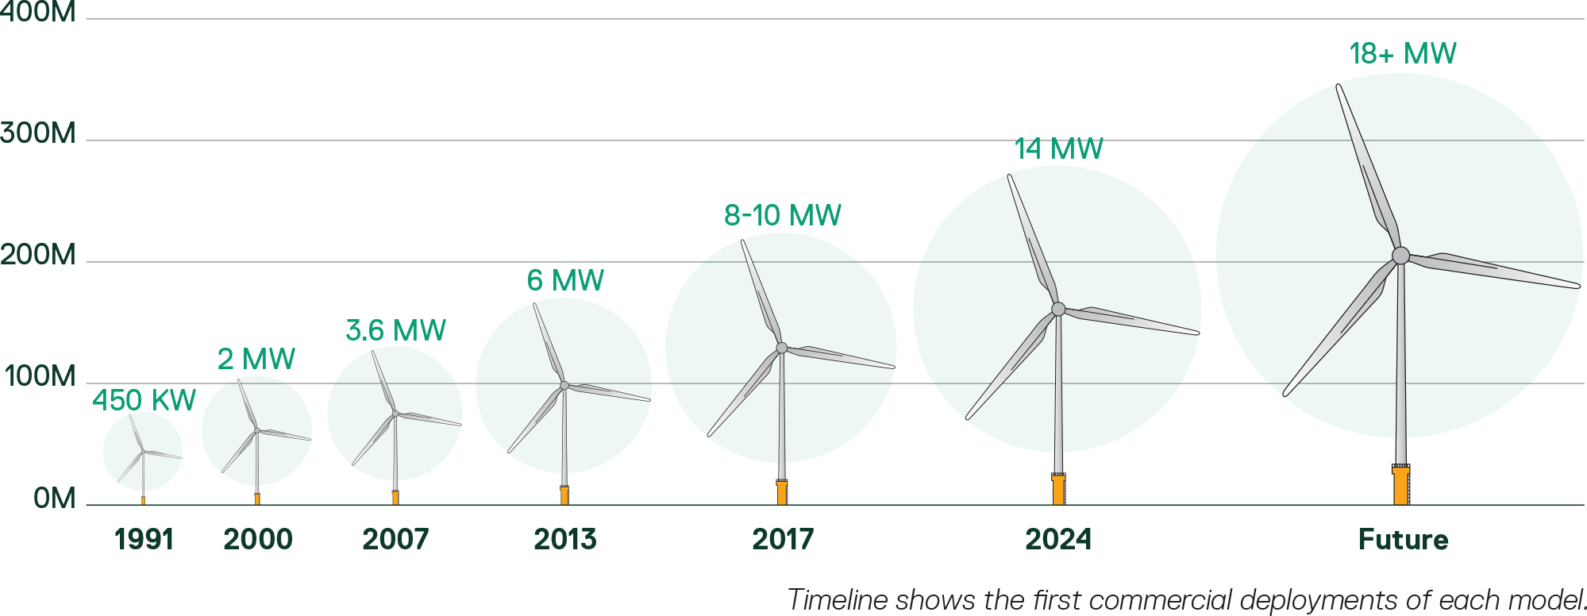
There are a range of wind turbine foundation design options available. Each option has different advantages and disadvantages in relation to suitability for different site conditions, costs, supply chain and potential for environmental impacts. The primary design concepts include monopiles, jackets, gravity based and floating foundations (Figure 3-2) with some additional specific design alternatives described further below.
Star of the South’s initial selection of foundation options for screening was based on:
- Water depths across the project site
- Seabed conditions e.g. sand or rocky substrate
- Metocean conditions, such as wind load and hydrodynamic load on the foundations
- Environmental sensitivities, e.g. marine mammals, benthic ecology
- Topside weight (turbine size and associated infrastructure weight)
- Space and logistical requirements at ports
- Cost, construction timeframes, logistics and procurement.
Figure 3-3 illustrates the relative use of different foundation types globally as of 2022.
Figure 3-2 Different designs of offshore wind farm turbine foundations
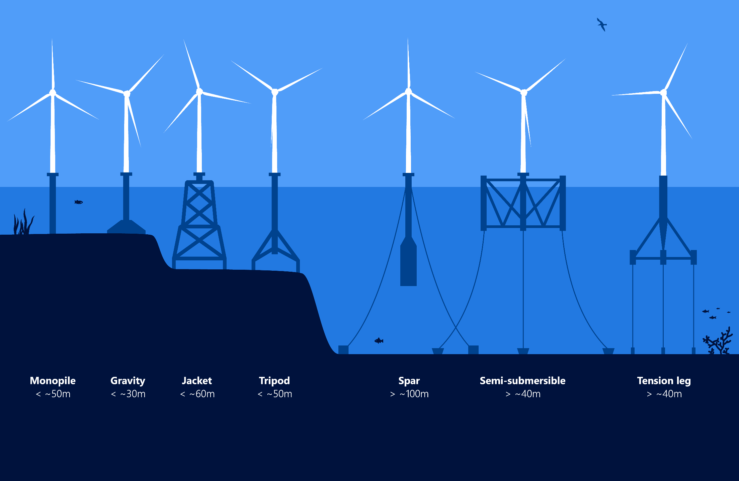
Source DHI 2024
Figure 3-3 Number of foundation concepts up to 2022
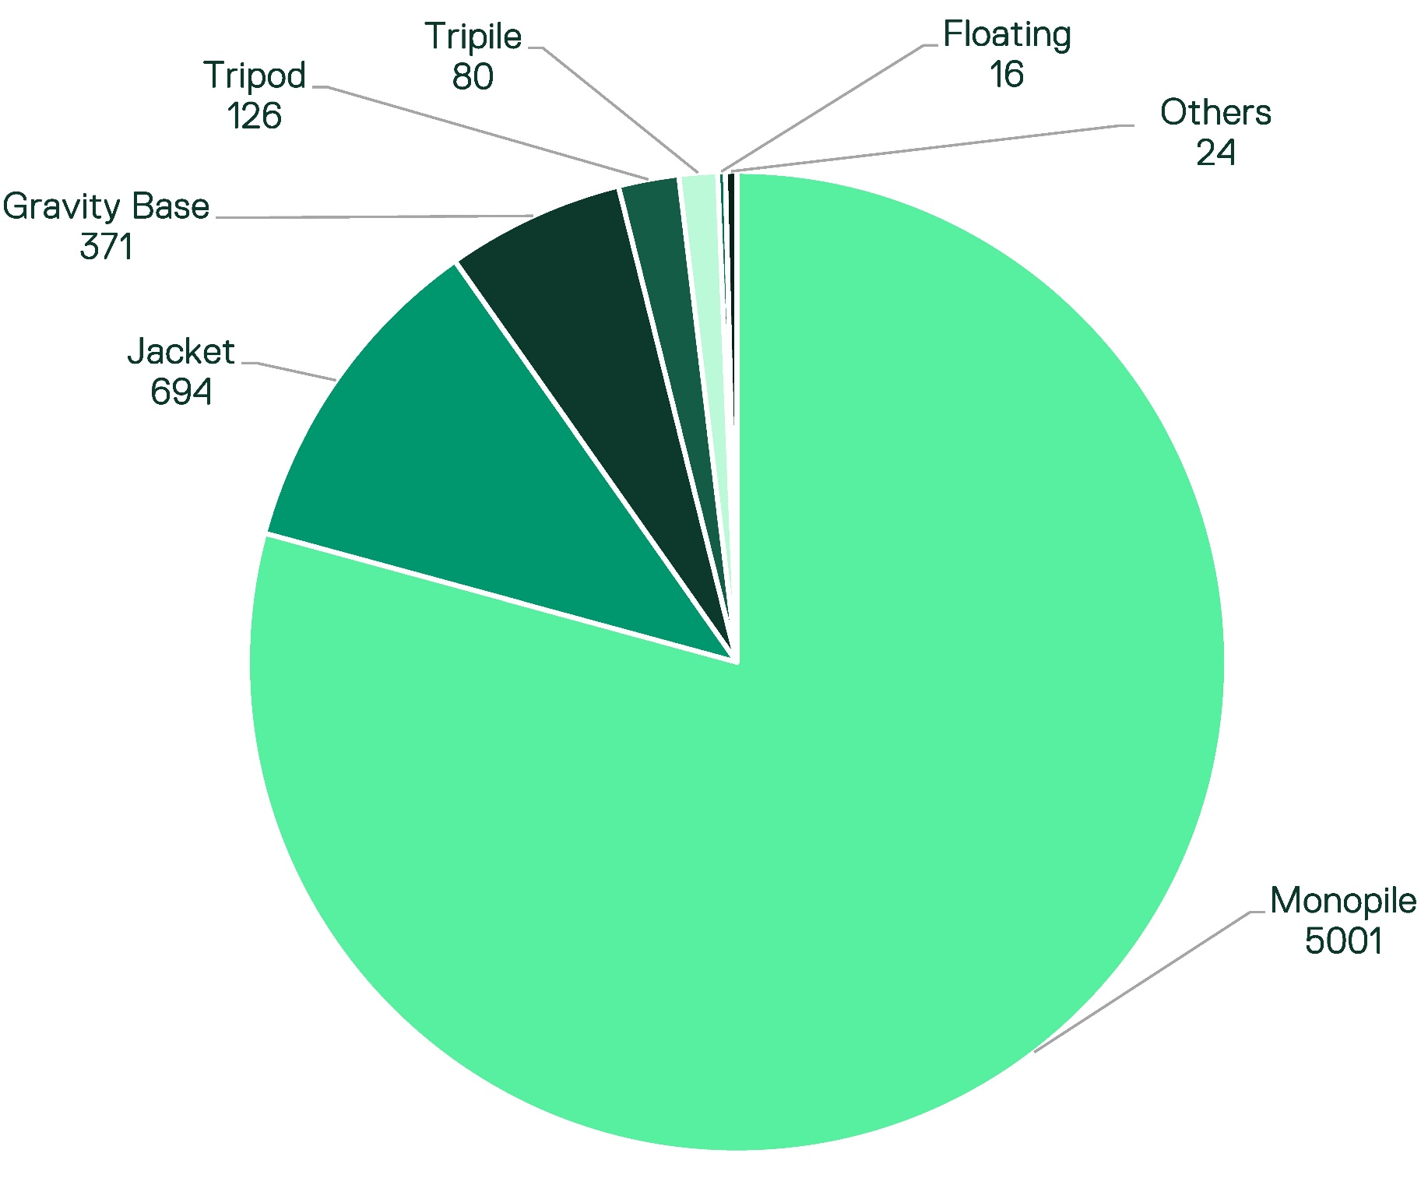
Source WindEurope: Brussels, Belgium, 2023. [Google Scholar]

Monopile (impact piling or vibro-piling)
Monopiles are the most widely used offshore wind turbine foundation globally (Figure 3-3), accounting for 72 per cent of installed foundations (ERM, 2024). They have a simple, proven design and low manufacturing costs. Water depth is the primary driver for selection of monopiles.
Monopiles comprise a single large diameter steel pipe, known as a pile, that is driven into the seabed to provide vertical and lateral support (Figure 3-4). Monopiles are typically feasible in water depths up to approximately 50 metres and are suitable for installation in soft and stiff soils (refer to Attachment 1 – Technical Information Document for more details).
Figure 3-4 Monopile wind turbine foundation
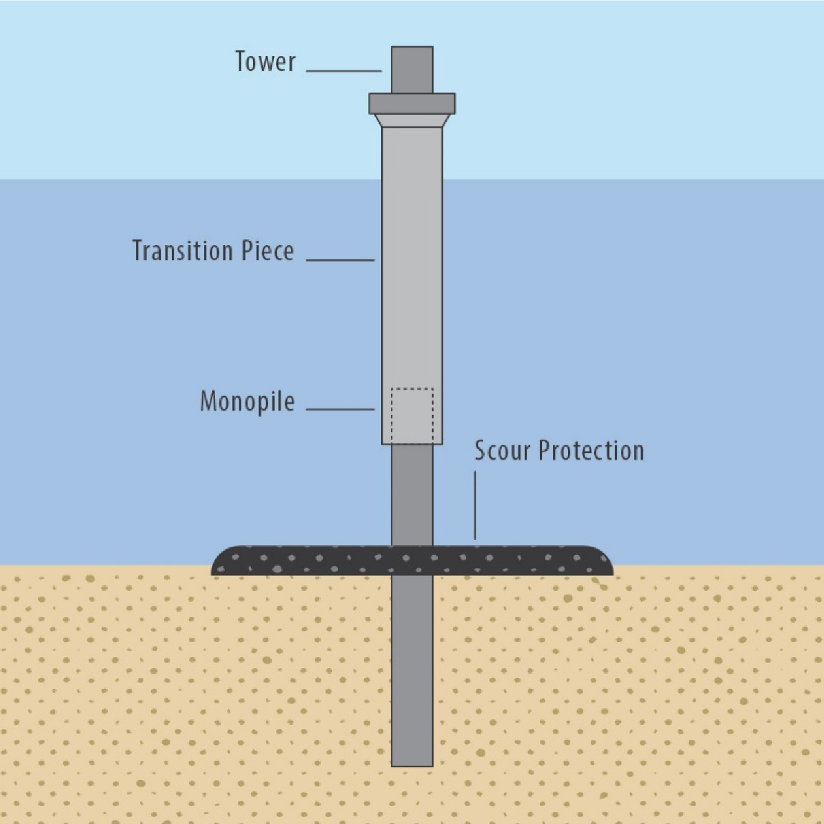
Source Bureau of Ocean Energy Management (BOEM), “Comparison of Environmental Effects from Different Offshore Wind Turbine Foundations.”

Fabrication of monopiles
Monopile fabrication is an ever increasingly automated process involving automated handling, rolling and welding of steel using machinery. The welding heights for monopiles is limited to the diameter of the piles, or completely avoided in many cases due to rolling technology which ensures work occurs at floor level only.

Installation of monopiles

Direct impact hammer
Typically, monopiles are installed using impact hammer construction technology. Impact-driving has been used to install piles for more than 70 years, including since the early 2000s for the installation of the first offshore wind turbines in the United Kingdom.
This provides greater certainty and surety of delivery based on significant evidence and strong track record of performance, which reduces development and financing risks.
Furthermore, the weight of the impact hammer equipment may be similar to (or less than) the weight of the monopile, which means a single vessel with a crane capable of lifting and deploying this weight can be used. This is a far simpler prospect than needing to use multiple vessels / cranes that could be required to deal with piling equipment and monopiles of different weights.
Pile driving with a direct impact hammer generates strong impulsive underwater noise. The typical duration of installation of monopiles using impact hammer is 1.5 to three hours per pile.

Vibro-piling
Installation by vibro-piling is an emerging technology in the offshore wind sector. It has generally been used as a methodology in combination with impact piling on projects completed to date, where the vibro hammer has been used to lift and upend the monopile to a vertical position and install it through the initial stages of installation. An impact hammer is then installed to complete the driving of the pile to sufficient depth.
Vibration piling driving generates a non-impulsive, continuous noise (Matuschek and Betke 2009). The typical duration of vibro-piling installation is 0.5 to one hour per pile, however this technique may also require some level of impact piling to complete the installation.
A vibratory hammer may also have a comparable weight to that of an impact hammer, but it’s fastened to the top of the monopile before the two items are lifted together (the vibratory hammer acts as a lifting tool).

Jacket (piled, vibro-piled or suction caisson)
Jacket foundations are lattice-truss structures that typically have three or four legs, with tubular legs at the corners and smaller-diameter horizontal cross pieces and diagonal struts welded between the legs to provide rigidity. The diameters of the tubular steel members that form the legs, often 1-3 metres, are much smaller than those of monopiles (Figure 3-5). Jackets account for 15 per cent of offshore wind turbines installed to date (ERM, 2024).

Fabrication and piling of jackets
Jackets are fabricated in external fabrication yards and shipyard facilities that enable bespoke lifting, handling and utilisation of high manual labour for welding.
Jacket installation is possible in a variety of geological conditions, including stiff clay, medium to dense sands, softer silts and clay, and very soft sediments overlaying stiffer soils or bedrock (Horwath et al. 2020). The piles (one per leg) are smaller in diameter than monopiles and are typically installed using impact piling with smaller driving equipment than required for monopiles. This means that peak noise levels are typically lower than impact driving of monopiles, but the need to drive many piles (three or four per structure) results in longer noise durations with higher cumulative noise levels.
The transport and installation of jacket foundations carries greater risks than transporting monopiles. Jacket structures require pin piles to be handled and installed in addition to the jacket structure. This typically requires separate transport of pin piles, which are offloaded at a marshalling port and stored, before being loaded out for installation. This increases the amount of storage and movement equipment at the marshalling port compared to monopiles.

Suction caisson jacket
Suction caisson jacket is a type of watertight retaining structure anchored to the seabed using suction caissons (Figure 3-5). Suction caissons are similar to large-diameter pipe piles, but instead of being hammered or vibrated into position, they are pushed below the seabed by reducing the pressure within the caisson and leveraging the pressure of the ocean to force the caissons into the soil. The use of suction caissons requires specific geological conditions with medium stiff clay and / or fine to medium sand being preferred (Horwath et al. 2020). A jacket support structure with suction caisson foundations can be used in water depths of approximately 15 - 65 metres.

Figure 3-5 Jacket wind turbine foundation (left) and suction bucket foundation (right)
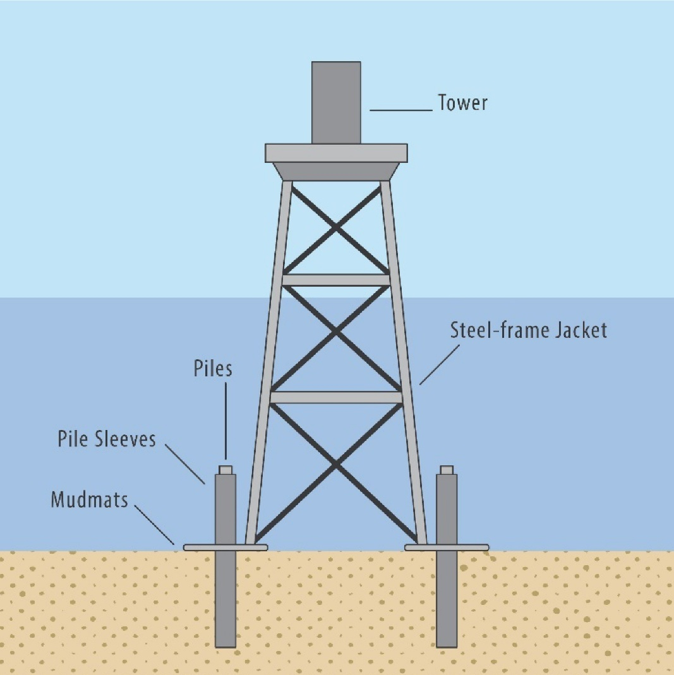 | 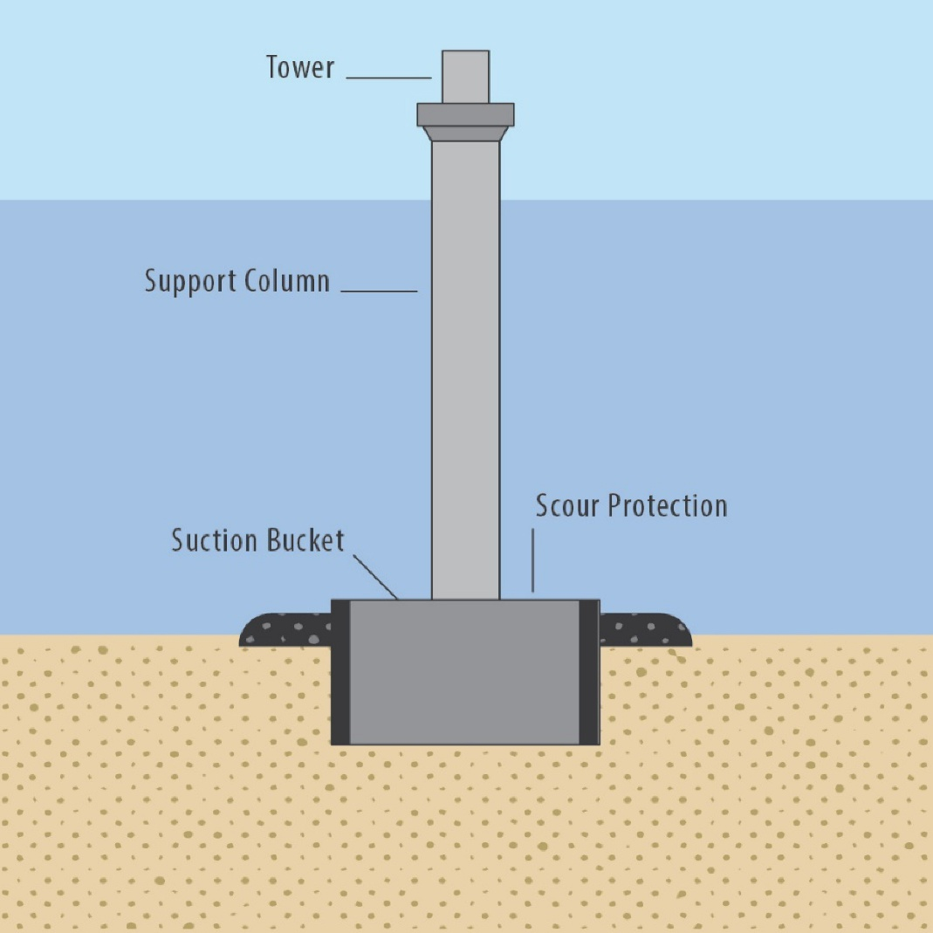
Source Bureau of Ocean Energy Management (BOEM), “Comparison of Environmental Effects from Different Offshore Wind Turbine Foundations.” | Source Bureau of Ocean Energy Management (BOEM), “Comparison of Environmental Effects from Different Offshore Wind Turbine Foundations.”

Gravity-based foundations
Gravity-based foundations are structures with wide, heavy bases that are typically made of reinforced concrete and filled with a dense ballast material. They sit on the seafloor and support a cylindrical central column that rises above the waterline (Figure 3-6).
Design of gravity-based foundations is primarily based on their weight and width being sufficient to resist extreme oceanographic forces. As a result, the required foundation diameters are around four to seven times larger than for monopiles and approximately two times larger than jackets.
Gravity based foundations are most suitable for shallow water depths of less than 30 metres (Lavanya and Kumar 2020). Such depths are encountered across some, but not all, of the project site, indicating they would likely be unsuitable for at least part of the project.
The geological conditions of the seabed where the foundation is to be placed are significantly limited, requiring a high load bearing capacity at the surface (Horwath et al. 2020, Manzano-Agugliaro et al. 2020). Gravity-based foundations often require ground preparation to protect the structures from tidal and current effects and for this reason they are not suitable for soft soils or weak clays (Horwath et al. 2020). The foundation itself may require large quantities of concrete and ballast for effective transmission of wind turbine loads to the seabed and a suitable degree of stability, making the cost of gravity foundations very high (Zhang and Wang 2022). In addition, the huge weight of these structures requires appropriate lifting and installation equipment, while the large diameter of the base can interrupt current flow and therefore needs a large amount scour protection (Horwath et al. 2020).
Gravity-based foundations require the seafloor to be flat and level. This may be achieved by dredging several metres below the seabed to remove weak or undulating material. In the project area, this could be in the order of 660,000 cubic metres. By contrast, the use of monopile and jacket foundations would avoid the need for dredging.
An alternative is to install a level gravel pad to support the base. A steel skirt may be built into the base to provide additional overturning support and to prevent the base from being undermined (Horwath et al. 2020).
This foundation type requires significantly different logistics to the other foundation options. Construction is either in a dry dock, whereby the dock can be flooded and the structure towed to site, or cast in-situ at the port, moved via a self-propelled modular transporter to the quayside and transferred to a semi-submersible installation vessel to be taken to site.
Figure 3-6 Gravity wind turbine foundation
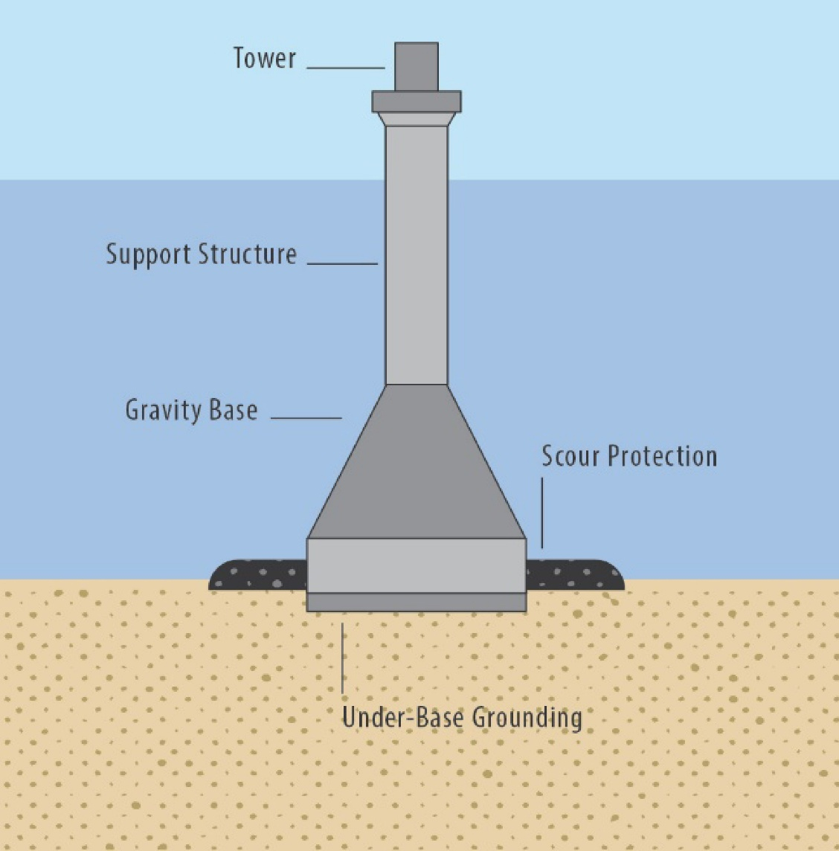
Source Bureau of Ocean Energy Management (BOEM), “Comparison of Environmental Effects from Different Offshore Wind Turbine Foundations.”

Tri-suction pile caisson
The tri-suction pile caisson has a similar design to the monopile with a single steel pipe as the central column. However, the base has a suction pile to column interface with three suction piles that anchor the foundation to the seabed (Figure 3-7).
This foundation is installed by being driven / sucked / pumped into the seabed using pumps and hydrostatic pressure (DEME Offshore, 2023). This emits minimal noise, however the large installation vessel required for installation will produce continuous noise during dynamic positioning.
The tri-suction pile caisson is suited for water depths less than 60 metres and in a variety of geological conditions including loose to dense sands, soft to stiff clays, layered soils and sediments over rock (SPT Offshore, 2020). It is not suitable where gravelly materials are present in significant quantities.
The whole foundation is completely removable at time of decommissioning, leaving no structures embedded into the seafloor.
The tri-suction pile caisson is relatively new technology compared to other foundation types. Therefore, it has technical and commercial readiness challenges (DEME Offshore, 2023) not faced by gravity-based foundations, jacket foundations and monopiles, making it extremely difficult to finance. More knowledge may be needed to explore the behaviour of this foundation in different geological conditions and under different environmental stressors (Christantonis, 2022).
Figure 3-7 Tri-suction pile caisson wind turbine foundation
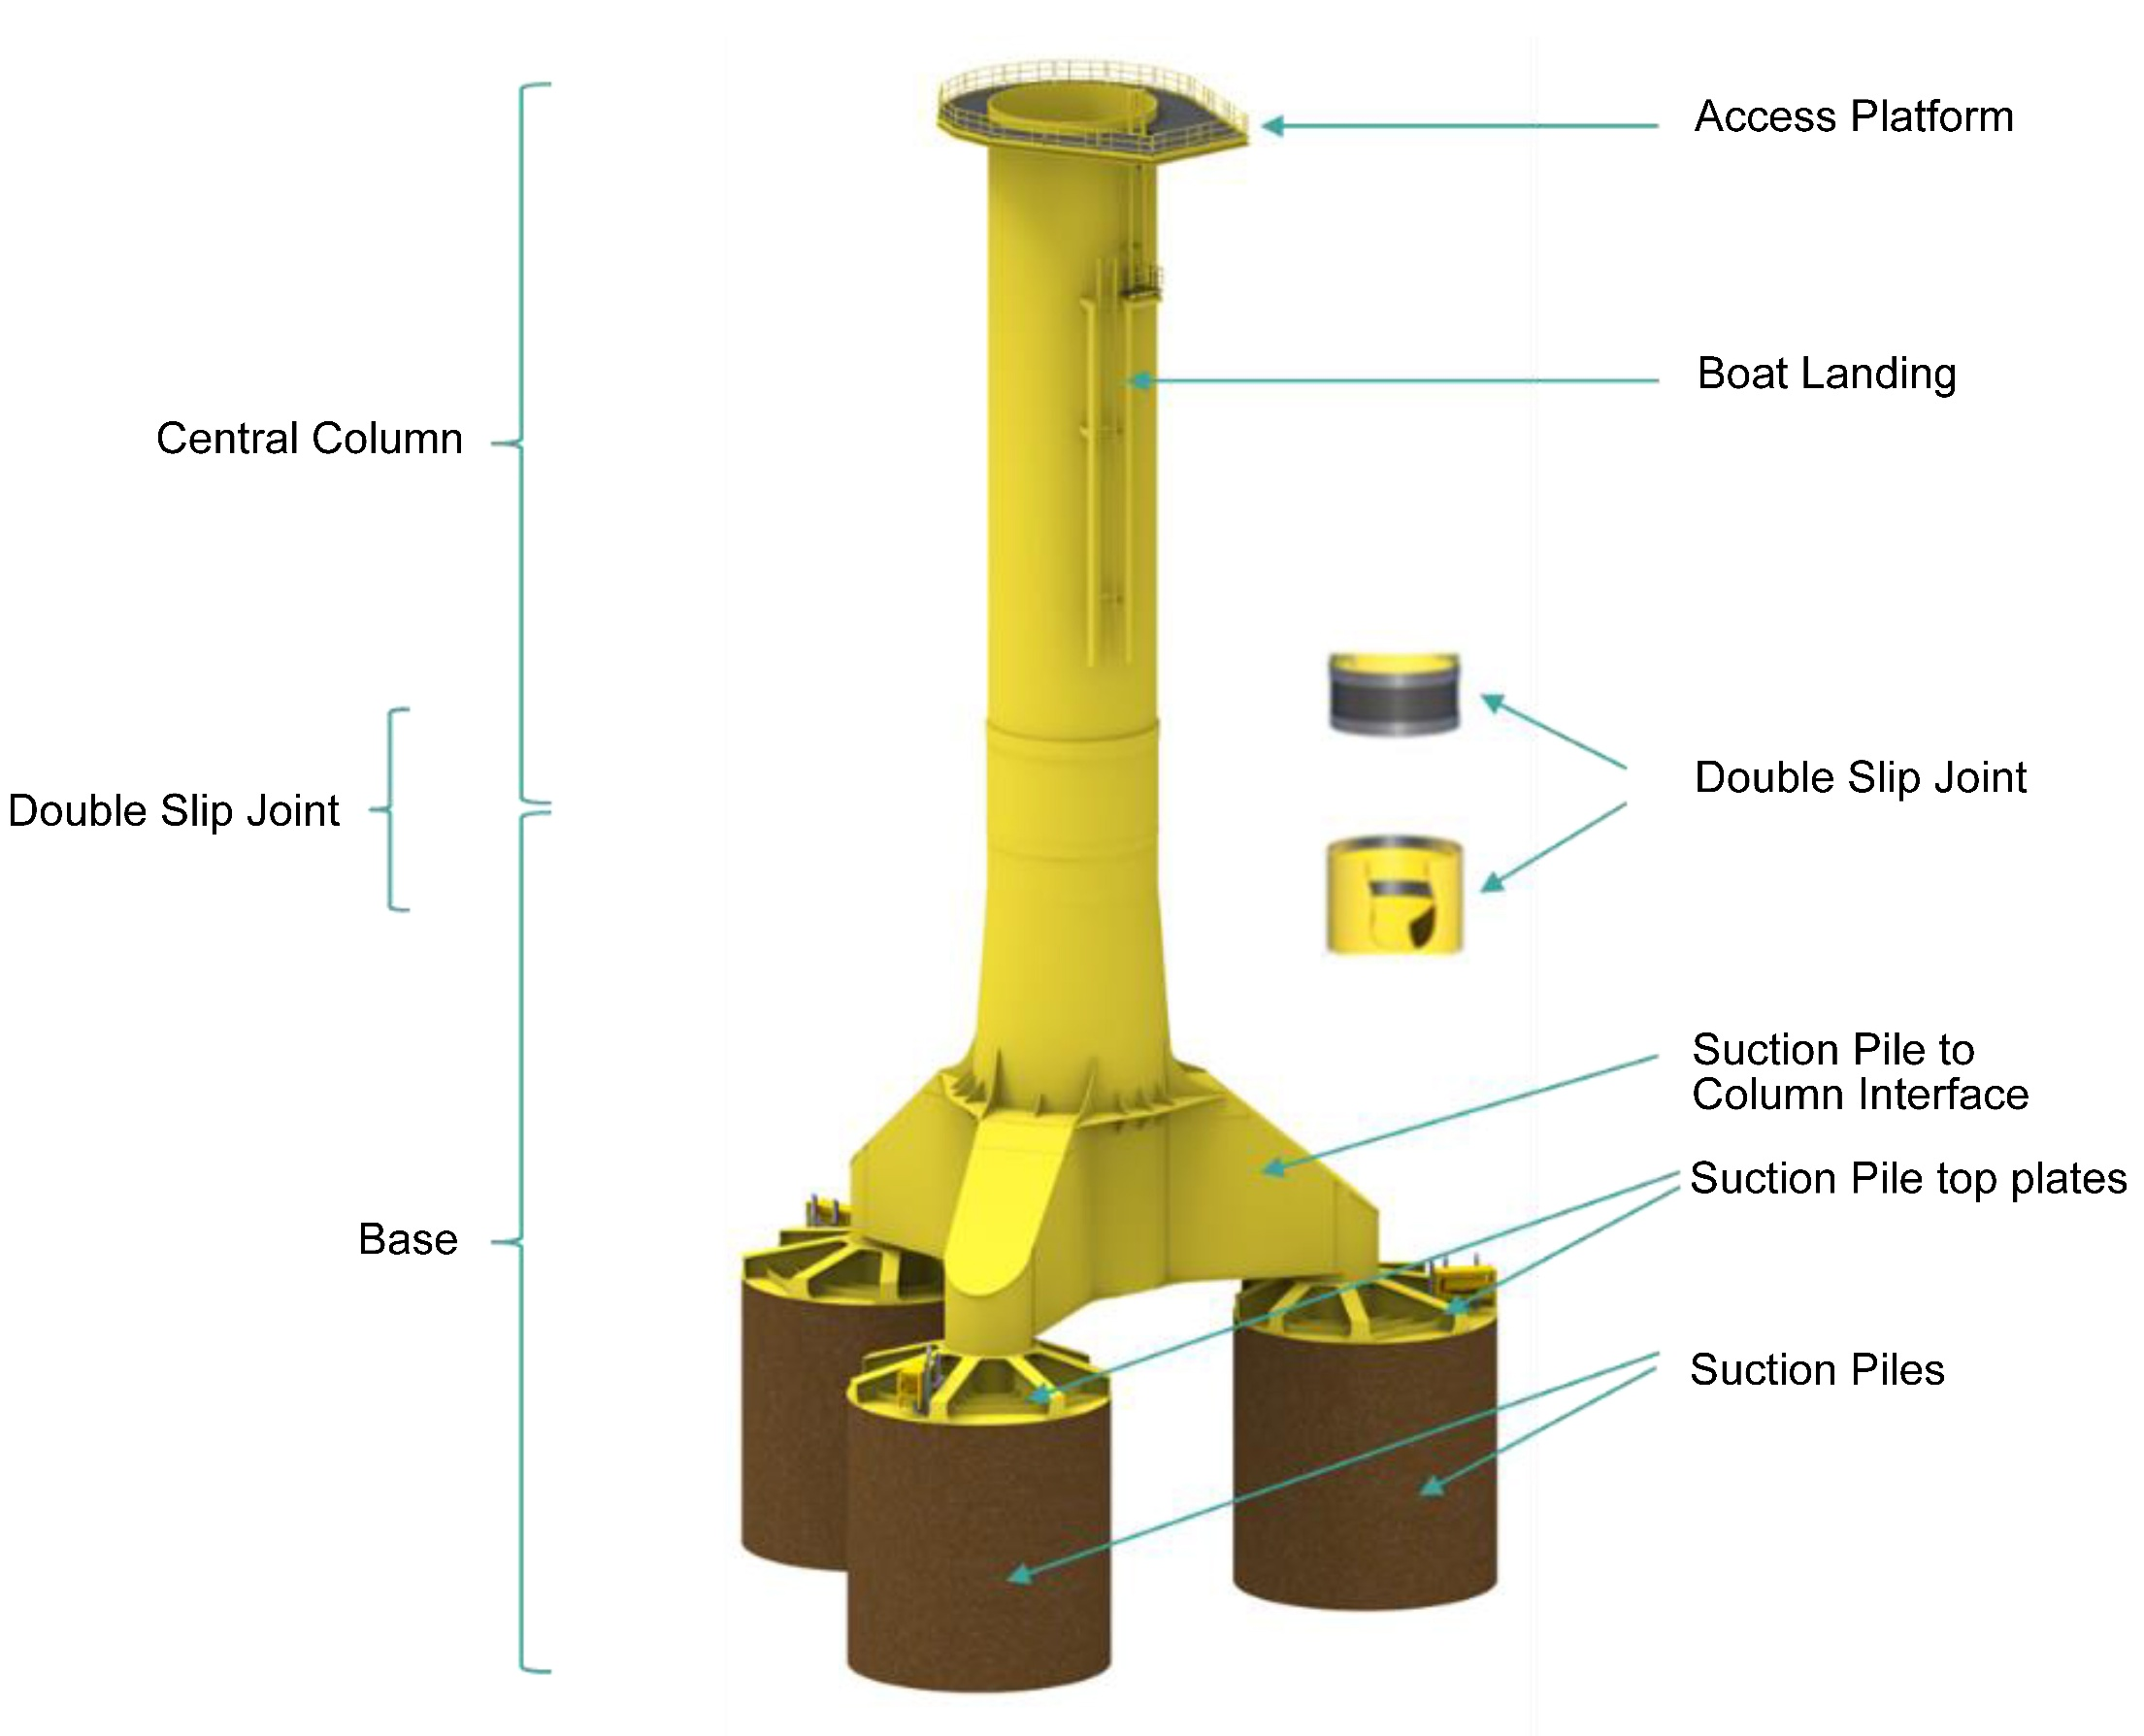
Source DEME Offshore 2023

Floating
There are different types of floating foundations, including a spar-buoy structure, semi-submersible and tension leg platform (Figure 3-8). Anchors attach to the seabed with mooring lines or tension legs to secure each platform in position.
Both spar-buoy and semi-submersible structures are anchored to the seabed with mooring lines, with spar-buoy lines being a lighter but longer structure with a lower centre of gravity (Manzano-Agugliaro et al., 2020). Tension leg platforms consist of submerged arms that are anchored to the seabed through tension legs. Anchor types vary and include deadweight anchors, drag anchors, embedded anchors, driven piles or suction caissons (Horwath et al., 2020). Deadweight anchors made from concrete or steel have the greatest mass and the largest footprint, drag anchors lie largely or entirely under the seafloor and tension leg platforms use piles or suction caissons. Drag anchors, piles and suction caissons can cause seafloor disturbance during installation and operations.
Floating foundations are best suited to deep offshore waters and are typically installed in water depths greater than 100 metres and hence are unsuitable for the shallower (<50 metres) waters within the project area. In addition, floating offshore wind farms have not yet been built at scale, presenting some technical and commercial readiness challenges that are not confronted by monopile or jacket foundations.
Figure 3-8 Floating wind turbine foundation - spar-buoy structure
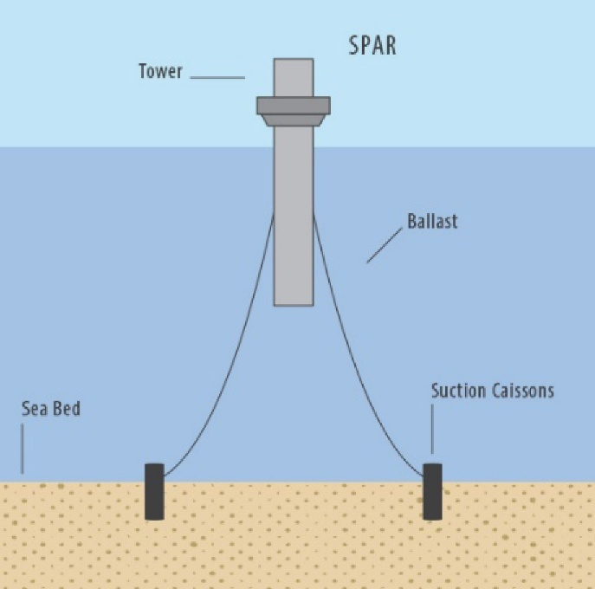
Source Bureau of Ocean Energy Management (BOEM), “Comparison of Environmental Effects from Different Offshore Wind Turbine Foundations.”
Figure 3-9 Floating wind turbine foundation - semi-submersible
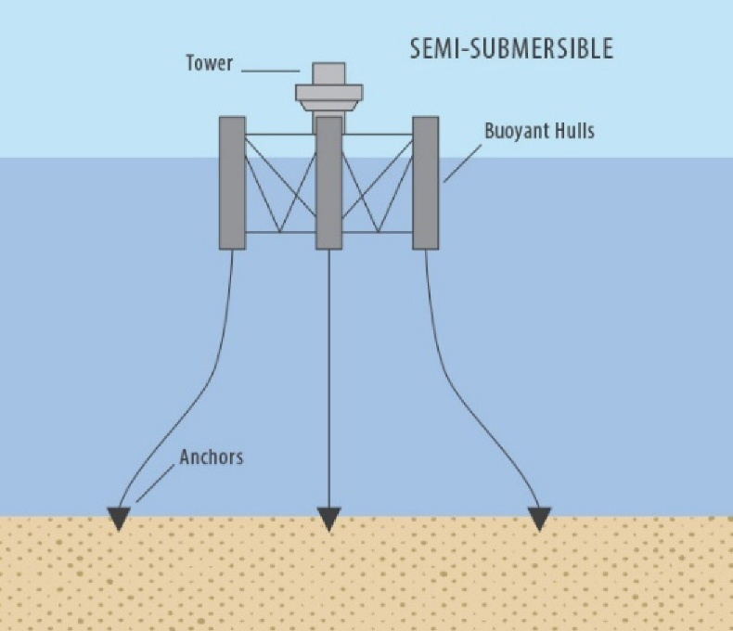
Source Bureau of Ocean Energy Management (BOEM), “Comparison of Environmental Effects from Different Offshore Wind Turbine Foundations.”
Figure 3-10 Floating wind turbine foundation - tension leg platform
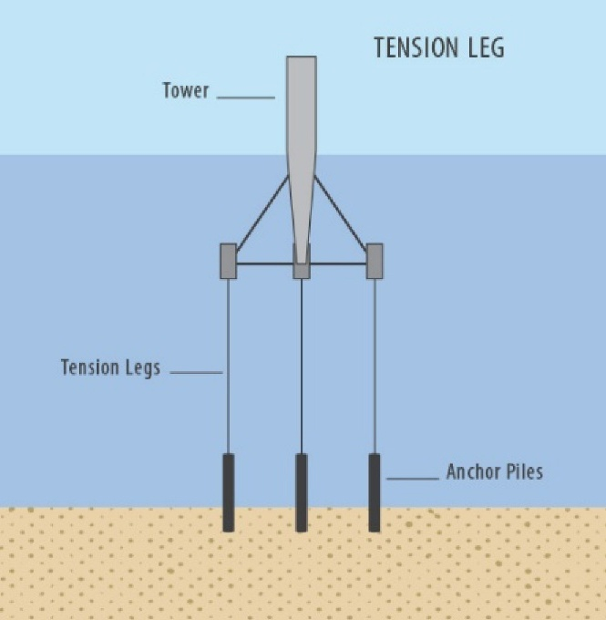
Source: Bureau of Ocean Energy Management (BOEM), “Comparison of Environmental Effects from Different Offshore Wind Turbine Foundations.”

Screening

Screening
A summary of the outcomes of the screening process is presented in Table 4-1 with a detailed explanation and supporting information provided in Section 4.3 where a particular foundation option was not found to be feasible.
It is important to note that while some foundation options may not be feasible for the project, other sites within the Gippsland Declared Area or other declared areas may have a different outcome against the same criteria due to different water depths, site-specific geotechnical considerations, project objectives and environmental context.
Table 4-1 Feasibility assessment for identified of turbine foundation options
Design options | Criteria for determining feasibility |  |  |  | Outcome
Design options | Water depth | Suitability of seabed | Project objectives | Logistics/ Supply chain | Outcome
Monopile  (impact piling) |  |  |  |  | Feasible, carried through to Section 5
Monopile  (vibro-piling) |  |  |  |  | Feasible, carried through to Section 5
Jacket  (impact piling) |  |  | x |  | Feasible, while not meeting project objectives, it is still considered feasible and warrants carrying though to section 5
Jacket  (vibro-piling) |  |  | x |  | Feasible, while not meeting project objectives, it is still considered feasible and warrants carrying though to section 5
Suction caisson jacket |  | x | x |  | Not feasible. The presence of gravel identified during geotechnical investigations would prevent installation of suction caissons (Section 3.2.2).
Gravity base | x | Subject to dredging and/or installation of gravel pad | x | x | Not feasible. Port capacity is insufficient to support the size and mass required. The significant size of structures creates substantial logistical and cost challenges that prevent project objectives from being met, as well as environmental impacts associated with dredging (Section 3.3).
Tri-suction pile caisson |  | x | x |  | Not feasible. This foundation type has no track record, has not been used in any existing projects and is not sufficiently proven. Geotechnical data also indicates that the seabed may not be suitable for suction caissons at all locations (Section 3.4).
Floating | x |  | x |  | Not feasible. Technology not yet sufficiently proven for water depths less than 50 m (Xu et al., 2021). High wave energy in shallow waters create substantial engineering challenges for mooring system and associated increased costs will not enable project objectives to be met (Section 3.5).

Rationale for ‘screening in’ of options
The screening process for determining which turbine foundation options are feasible considered:
- water depth
- suitability of seabed / geotechnical factors
- meeting project objectives (which include meeting Victorian and Commonwealth Government targets)
- logistics / supply chain considerations.
Of the foundation options screened, only monopiles and jackets meet all, or most, of the screening criteria.
A single cross in Table 4-1 does not automatically eliminate a foundation type from further consideration in the next evaluation phase. The decision to progress an option for evaluation is based on an overall assessment that considers the significance of the criteria. For example, the foundation options that receive more crosses or have significant issues in critical criteria (water depth) are less likely to proceed to the evaluation phase.

Rationale for ‘screening out’ of options

Suction caisson jacket
Project offshore wind farm engineers undertook an assessment of feasibly installing suction caissons based on preliminary design parameters and known geotechnical conditions in the offshore wind farm area. This assessment determined that the presence of gravels and other obstructions such as hard layers, are likely to prevent suction caissons being installed at some locations.
Gravel can directly interfere with penetration or create an inability to achieve a seal within the caisson, preventing required suction pressures being generated to allow penetration. Hard layers in the granular soils present can also prevent installation. It should be noted that each foundation will have three to four suction caissons, and refusal of a single caisson may prevent installation of the foundation.
The soils in parts of the site are an intermediate case between gravelly and slightly gravelly and there is a risk that these soil conditions will prevent suction caisson installation.
The available methods to resolve this uncertainty include full scale field trials and centrifuge testing in a geotechnical laboratory. Field trials are the best way to confirm feasibility, especially for a project of this scale, but they have very long lead times which would prevent many of the project objectives being achieved - such as safe, reliable, and timely project delivery to support Victoria’s energy transition - and would require their own specific approvals. Centrifuge testing is possible, but these tests also have a very long lead time and will likely be inconclusive due to the absence of proven reliability in the field, at the project site.

Suction caisson refusal
Measures to overcome refusal issues were investigated and although there are a range of potential mitigations available, their effectiveness is uncertain. A summary of identified mitigations and some of their limitations is outlined below:
- The spatial presence of gravels and hard layers could be further investigated through additional geophysical and geotechnical surveys, with interpretation of data used to adjust the layout of turbine foundations to avoid areas of identified gravel and hard layer presence. However, based on the preliminary geophysical and geotechnical surveys carried out on the in the offshore wind farm area, these additional surveys are unlikely to identify the presence of gravels across the site with sufficient confidence to rule out the possibility of gravels preventing the installation of some turbines. Consequently, the risk of suction caisson refusal during installation cannot be successfully mitigated even with additional survey data.
- The design of the suction caissons can be refined to reduce the wall thickness, which reduces tip resistance and resistance to penetration. However, the wall thickness is often governed by the risk of shell buckling when applying required pressures to drive installation, so it may not be possible to reduce the tip thickness.
- Another design option is to introduce additional ballast to the structure to try to help push the caisson through the gravels. This may require adaptation of the suction caisson lid to allow weights to be placed here, which is an additional offshore construction operation that presents greater health and safety risks than the other foundations options considered in this evaluation.
Unsuccessful installation of suction caissons due to soil refusal can present a substantial health and safety risk. A suction caisson jacket is installed along with the associated suction caissons as part of a single operation, i.e. the caissons are integral with the jacket structure. This means there is a single lift to place the jacket and its connected caissons on the seabed before the suction pumps are activated. This keeps offshore operations simple but requires an installation vessel with a significant hook height and lifting capacity and radius. If the jacket installation refuses with the caissons partly installed, it can be hazardous to attempt to 'pull' the structure back out from the seabed due to the potential for extremely variable load on the crane and boom.
Typically, a reversal of the suction operation will be attempted to push the caissons out from the seabed, although this may not succeed if gravels within the soil prevent sufficient differential pressure from building beneath the suction caisson lids. In this scenario, if the jacket can be removed from its partial penetration in the seabed without damage, it would need to be re-located to another position for a second attempt at installation. This approach is referred to as micro-siting and would require a large micro-siting zone or spare turbine locations which may not be practical.
There are limited options to mitigate the potential for refusal during suction caisson installation when compared to pin-piles or monopiles, with significantly more offshore construction risks associated with suction caissons than the other foundation options. It is therefore typical to proceed with a suction caisson jacket design only if installation refusal risks are extremely small for all the turbine locations across the site. This is not the case for the project site, so it was not selected for further evaluation.

Gravity-based foundation
The gravity-based foundation option was evaluated by creating a design for two representative water depths across the project site at 25 metres and 45 metres. Project engineers determined that slab diameters of 36 metres and 70 metres were required respectively. The total concrete mass of these structures is estimated to be 19,100 tonnes for the smaller diameter and 66,600 tonnes for the larger diameter.
This geometry and mass information was then used to evaluate the capacity of available commercial ports within Victoria and Tasmania to support the manufacture and storage of gravity base foundations and transfer to installation vessels.
Challenges and limitations with the gravity-based foundation alternative include:
- Technical considerations: Gravity bases for the project would be almost three time larger than any commercial scale gravity-based foundation deployed to date. As a benchmark, the Fecamp offshore wind farm was constructed in France using gravity-based foundations that weighed less than 7000 tonnes - the largest commercial scale use of these foundations to date. In comparison, a mass of between 19,100 and 66,600 tonnes would be required for the project. This results in considerable uncertainty regarding the viability of this foundation type associated with the very large structures required and the considerable logistics / installation challenges with a need for very large, specialised installation vessels and quayside infrastructure.
- Space and logistics requirements at ports: The port capacity evaluation found that all the port options had insufficient area available to support the construction of gravity-based foundations. Specifically, an area of more than 24 hectares is required and the largest area available, subject to future development and remediation, is 20 hectares within GeelongPort and 12.6 hectares within the Port of Bell Bay. It may be possible to construct and deploy gravity-based foundations within a smaller area by constructing them in smaller batches, but this would add substantial time to the construction campaign and undermine achievement of the project objectives.
- Protracted construction period: The Fecamp offshore wind farm was used as a guide to estimate how long it would take to construct gravity-based foundations for the project. To account for the larger size of gravity-based foundations, the timeframe was estimated based on m3 of concrete per day and assuming construction can be completed at twice the pace of Fecamp with a larger workforce. Based on these assumptions, the estimated construction duration was 134 months, or 11 years.
- Lack of dry dock facilities: The quietest and most feasible method of gravity-based foundation installation is construction in dry dock. This allows structures to be floated and towed to site with a smaller vessel and avoids the need for a large, dynamically positioned installation vessel. The sheer weight of these structures would prevent alternative crane handling methods. This floating and towing method is not possible for the project due to a lack of available dry dock facilities in the vicinity of the project. In addition, the large dimensions of the gravity-based foundations required makes towing difficult.
- Seabed disturbance: The need for significant seafloor preparation to ensure a firm and level seabed. Seafloor preparation would likely include a combination of dredging, installation of a gravel bed and levelling of the gravel bed, with associated benthic habitat disturbance. In the project area, this could be in the order of 660,000 cubic metres.
- Carbon footprint: A significant carbon footprint (using embodied energy as a proxy measurement) around ten times greater than other foundation alternatives due to the high volume of concrete used. Specifically, the embodied energy estimate for gravity-based foundations was 400,000 GJ per WTG compared to up to 40,000 GJ per turbine for all other foundation options assessed. See Table 4-2 below.
Based on a 15 MW wind turbine and a capacity factor of 50 per cent, no losses, and 100 per cent availability, the energy payback for the gravity-based foundations are far greater than other options, as shown in Table 4-2.
Table 4-2 Embodied energy comparison
 | Embodied energy (per location) | Energy payback
 | GJ | days
Monopile | 30,000.00 | 46
Jacket (pin piles) | 36,000.00 | 56
Gravity-based | 400,000.00 | 617
Based on the preliminary calculations, it can be seen that ‘energy payback’ for the gravity base foundation option would be achieved in just under two years, whereas energy payback for the monopile or jacket support options would be achieved in 1.5 to two months. For the project to be considered as effective in achieving its objectives, energy payback for all assets within the wind farm and the transmission system should be achieved within one to two years.
Given the gravity base support structure alone would take almost two years of project output to achieve energy payback, and because of all the other limitations with this option canvassed above, it is not considered viable for the project.

Tri-suction pile caisson
Tri-suction pile caissons have not been used on any existing offshore wind project, nor in any pilot / demonstrator projects. This lack of track record presents a significant barrier to financing and bankability, as financiers are typically reluctant to fund untried and untested technology at this scale, especially when there are practical and tried-and-tested alternatives. Consequently, the project would be unlikely to obtain the required financing and therefore achieve project objectives if the tri-suction pile caisson alternative was adopted.
Moreover, there is limited data available to confidently predict whether this alternative is capable of being installed across the project site. An installation assessment was undertaken for an indicative suction caisson geometry of 12-metre diameter by 12 metre embedment depth at 22 positions across the project site. The assessment concluded that there was a risk of refusal across 21 of the 22 positions for the upper bound soil conditions. This refusal risk was due to a combination of low permeability sand layers restricting hydraulic flow and the presence of gravel, which created resistance to caisson embedment and/or inability to create a seal and generate the required suction pressures.
In the case of refusal or suction failure there are limited mitigation options, and re-location of the turbine would likely be necessary. This would increase the duration of the construction campaign and disturbance period for marine fauna. It is possible but not certain that detailed engineering and design could overcome some of these issues using position specific caisson geometries at substantially increased costs, which would limit the ability to achieve project objectives.
For these reasons, the tri-suction caisson alternative was not progressed through to evaluation.

Floating
Floating turbines have not been implemented on commercial-scale projects to date and are unsuitable in water depths less than 50 metres. The weight of floating support structures is typically three to four times that of fixed support structures at these depths to handle higher wave heights. These higher wave heights, and the dynamic nature of the floating structure, can also create risks of damage to electrical cables used to export power from the wind turbine if they interact with the floating structure and / or moorings.
This alternative was screened out as unfeasible due to the shallower water depths at the project site, so a detailed assessment of embodied energy and port capacity requirements was not undertaken. However, floating turbines would use considerably more steel that monopile or jacket pin structures, and as a result have a corresponding embodied energy. There are also likely to be port capacity constraints for handling this larger and heavier infrastructure, compared to most of the other foundation options considered in this evaluation.
It is acknowledged that floating support structures for offshore wind are becoming more widespread and diverse, although the largest projects are still considered to be pre-commercial due to their size, and their economics. On a per megawatt basis, floating support structures are expensive and are typically complex and material intensive (e.g. the tension leg concept for Provence Grand Large), or are larger, with greater mass and simplicity (e.g. the spar structure for Hywind Scotland, or the damping pool barge for EoleMed in France).
Table 4-3 Principal global floating offshore wind projects
Name | Country | Depth | Wind turbine | Project capacity | Year | Status | Floater type
Hywind | UK | 90-120 m | 6 MW | 30 MW | 2017 | Operating | Catenary spar
Kincardine | UK | 60-80 m | 9.5 MW | 47.5 MW | 2021 | Operating | Semi-submersible
Provence Grand Large | France | ~100 m | 8.4 MW | 25 MW | 2023 | Operating | Tension leg space frame
Floatgen | France | 33 m | 2 MW | 2 MW | 2018 | Operating | Damping pool barge
Hibiki | Japan | 55 m | 3 MW | 3 MW | 2018 | Operating | Damping pool barge
Eolmed | France | 55 m | 10 MW | 30 MW | 2025 | Construction | Damping pool barge
WindFloat Atlantic | Portugal | 100-120 m | 8.4 MW | 25 MW | 2020 | Operational | Semi-submersible
There are no floating wind projects with wind turbines in the 10MW class in waters shallower than 55 metres (the deepest water in the project’s offshore wind farm area). Shallower water is not only more economical for fixed wind turbines, but also less economical for floating wind turbines, as waves get steeper, and stability of the floating support structure becomes more challenging, requiring more material, and inducing higher loads in the mooring cables and anchors.
There are no floating support structures of any kind considered feasible to support wind turbines in the 15 or 20 MW size categories, or in the shallower water depths at the project site.

Evaluation of feasible options – monopiles and jackets

Evaluation of options against key criteria
Table 5-1 through to Table 5-7 outline the performance of each feasible foundation option (monopiles and jackets) against relevant criteria set out in Table 2-1.
The evaluation is based on the best available information, including:
- Published information on the engineering and design of the various concepts
- Marine baseline study results
- Geotechnical data from project site investigations
- Contemporary understanding of existing nearby construction port facilities
- Current information on the supply chain and availability of materials.
The evaluation considered environmental criteria, including alternatives that may reduce underwater noise emissions. It was also important to consider criteria relating to constructability, commerciality and supply chain considerations to ensure that the project is viable and capable of meeting the project objectives set out in Section 1.4.1.
It is important to note that the evaluation is specific to the project site and cannot be applied to other offshore wind farm developments due to potential differences in water depths, geotechnical characteristics, environmental and other factors. Over time, works and upgrades to ports may also enable future projects to consider other foundation options.

Environment criteria
The environmental criteria evaluated in Table 5-1 are based on a robust understanding of the impact pathways from the installation of foundations and the environment of the offshore wind farm area. This understanding has been developed through extensive desktop research, comprehensive marine baseline surveys and the development of marine environmental impact assessment reports. The key environmental criteria are underwater noise impacts on marine mammals (including from vessels) and seabed / benthic environmental values.

Underwater noise
The comparative assessment of underwater noise has considered noise from the installation of the foundations (e.g. impact hammer and vibro to install monopiles) as well as noise associated with the installation vessels that are a necessary part of the installation process for all foundation types.
Underwater noise modelling has also been conducted for the offshore substations which are constructed with up to four ‘pin piles’ similar in diameter to a jacket type structure pin pile. Technical advisers Jasco and RPS advise that such results can be extrapolated for a jacket turbine structure, and this modelling has formed the basis of the evaluation prepared in this section.
The comparative assessment of underwater noise from monopiles and pin piles used for jackets also considers the duration, character and intensity of the activity (piling) and the underwater noise impacts to marine mammals and fish.
Both jacket structures and monopiles require the use of a dynamic positioning vessel, so this aspect of the underwater noise criteria is given the same ranking for both foundation types.
See Technical Report D – Marine Mammals and Turtles and Attachment I – Underwater Noise Modelling for a detailed analysis of underwater noise impacts and mitigations.

Installation of the foundations
The underwater noise emissions associated with impact piling of monopiles was ranked equal worst as, if unmitigated, this intense, impulsive noise source results in large temporary threshold shift effect (or injury) ranges for low frequency cetaceans. However, as monopiles are the most common offshore wind turbine foundations installed, there is extensive research and development in noise abatement systems to mitigate impacts.
Underwater noise modelling has also been undertaken for vibratory piling of monopiles which indicates similar impacts overall to marine mammals due to the continuous noise of vibro-piling, even though the intensity of noise emissions is lower than impact piling. It is noted that the noise modelling for vibro-piling does not consider any mitigations as this is not yet available for modelling. The vibro-piling installation method will likely require some use of impact hammer as well, so the ranking for vibratory piling was ranked equal with impact piling in the evaluation.
Although the intensity of noise emissions is lower than impact piling of monopiles owing to the smaller diameter of jacket pin piles, the longer duration of impact piling to install three to four smaller piles for each jacket results in higher cumulative noise exposure.

Installation vessels
It is assumed that both jackets and monopiles would be fabricated internationally, likely to be within the Asia Pacific region, and transported to Australia.
The installation of either monopile or jacket foundations will require a large installation vessel with dynamic positioning thrusters to maintain vessel position during the installation process. Dynamic positioning systems are used to control a vessel's position with propellers and thrusters for maintaining position over a specific seafloor location, and other precise manoeuvring operations. Jack-up vessels may also be used. Jack-up vessels are a type of vessel with legs that are lowered onto the seabed and are used to lift the vessel above sea level providing a stable platform for work.
There will be noise emissions generated by the dynamic positioning of vessels during the installation of both jackets and monopiles. The potential impacts from vessels on marine mammals is presented in the Technical Report D – Marine Mammals and Turtles.

Seabed disturbance
The benthic habitats of the project site are not considered sensitive to potential impacts due to the area predominantly being soft sediment habitat. However, there are some patchy, isolated areas of reef and seagrass. The disturbance potential to these habitats is greater for the jacket foundations due to four legs for each turbine being in contact with the seabed, all requiring scour protection, creating a larger overall disturbance footprint than the single monopile configuration.
Jackets have a significantly larger seabed footprint (approximately 25 - 35 metres from leg to leg) than monopiles and therefore require a greater area of scour protection.

Criteria that did not affect outcome of evaluation
There were several sub-criteria that formed part of the preliminary evaluation but were subsequently removed because there was no material difference between monopiles and jackets and they were not informative for the comparative assessment. The results of these preliminary evaluations for the excluded criteria are outlined below.

Invasive marine species introduction
The evaluation found there is no material difference in the risk of invasive marine species introduction between monopile and jacket foundations. This is because each alternative will involve the mobilisation of a large installation vessel from an international port and there are no other differences that will influence the level of risk.

First Nations cultural values
The evaluation considered the potential for impacts on Aboriginal cultural heritage. The Gunaikurnai Cultural Values Assessment (Spark, 2023) prepared for the project did not identify any significant First Nations cultural values that would be directly affected by the offshore installation of foundations for the project and therefore no further evaluation against this criterion was considered. A thorough assessment of land and sea Aboriginal cultural values and submerged Aboriginal cultural values are included in Technical Report K – Aboriginal Cultural Heritage and Technical Report Z – Submerged Aboriginal Cultural Heritage.

Environment summary
The best performing foundation based on environment criteria was the monopile (vibro-piling) (Table 5-1). This was largely driven by the lower peak noise emissions associated with installation. The available data on noise emission profiles for vibratory pile driving suggests that peak noise levels and injury ranges for cetaceans will be lower than impact piling.
However, as highlighted above, all foundation types are likely to require a large, heavy lift installation vessel using dynamic positioning thrusters to hold position during the installation process. As a result, there is no option that eliminates all sources of underwater noise but there is potential to substantially reduce noise from installation of foundations using a range of mitigations.

Table 5-1 Assessment of feasible foundation options – Environment criteria
Evaluation criteria | Feasible foundation options
Evaluation criteria | Monopile (impact piling) |  | Monopile (vibro-piling) |  | Piled jackets |  | Vibro-piled jackets
Evaluation criteria | Score | Rationale | Score | Rationale | Score | Rationale | Score | Rationale
Underwater noise – installation of foundation | 1 | Pile driving of large diameter monopiles is an intense noise source with large effect ranges for marine fauna. | 1 | Produces non-impulsive continuous noise sources, compounding vessel noise. Likely to require some impact piling to complete installation process for many piles. | 1 | Greater duration of piling, multiple pin piles installed in a day (up to 4) resulting in large cumulative noise levels and acoustic injury ranges for low frequency cetaceans. Injury (temporary threshold shift) ranges based on 4 pin piles / day is estimated at ~7 km with double bubble curtain, but over a longer period than for a single monopile. | 1 | Produces non-impulsive continuous noise sources, compounding vessel noise. Multiple piles will increase the overall duration of noise impacts. Likely to require some impact piling to complete installation process for many piles.
Underwater noise – installation vessels (continuous noise) | 2 | Large installation vessels required – large noise ranges associated with holding position with dynamic positioning thrusters. Continuous noise may create greater behavioural disturbance. | 2 | Large installation vessels required – large noise ranges associated with holding position with dynamic positioning thrusters. Continuous noise may create greater behavioural disturbance. | 2 | Large installation vessels required – large noise ranges associated with holding position with dynamic positioning thrusters:  Longer installation time than monopiles. Continuous noise may create greater behavioural disturbance. | 2 | Large installation vessels required – large noise ranges associated with holding position with dynamic positioning thrusters  Longer installation time than monopiles. Continuous noise may create greater behavioural disturbance.
Seabed disturbance | 3 | Monopile reduces footprint but likely need for substantial scour protection. | 3 | Monopile reduces footprint but likely need for substantial scour protection. | 2 | Jackets have a wider footprint than monopiles and three or four legs in contact with seabed per wind turbine generator which will also require scour protection, increasing footprint. | 2 | Jackets have a wider diameter than monopiles and three or four legs in contact with seabed per wind turbine generator which will also require scour protection, increasing footprint
Total score | 6 |  | 6 |  | 5 |  | 5

Other users’ criteria

Shipping and navigation (small vessels)
Differences between foundation types in terms of small vessel safety and navigation is minimal, as the main influencing factor is turbine spacing which will be the same for all identified foundations. The different scores attributed in Table 5-2 are based on the expected duration of construction and associated exclusion zones for third party vessels. Larger vessels were excluded from the assessment as they are expected to use existing shipping channels and avoid the offshore wind farm area regardless of foundation type.
The installation schedule for pin piled and jacket foundation involves considerably more time compared to monopiles. A like for like program comparison (refer to Attachment 1 – Technical Information Document), which does not optimise either foundation methodology, results in over two years additional time being required for a jacket installation compared to a monopile installation for a 2.2 GW project.
Figure 5-1 Installation schedule
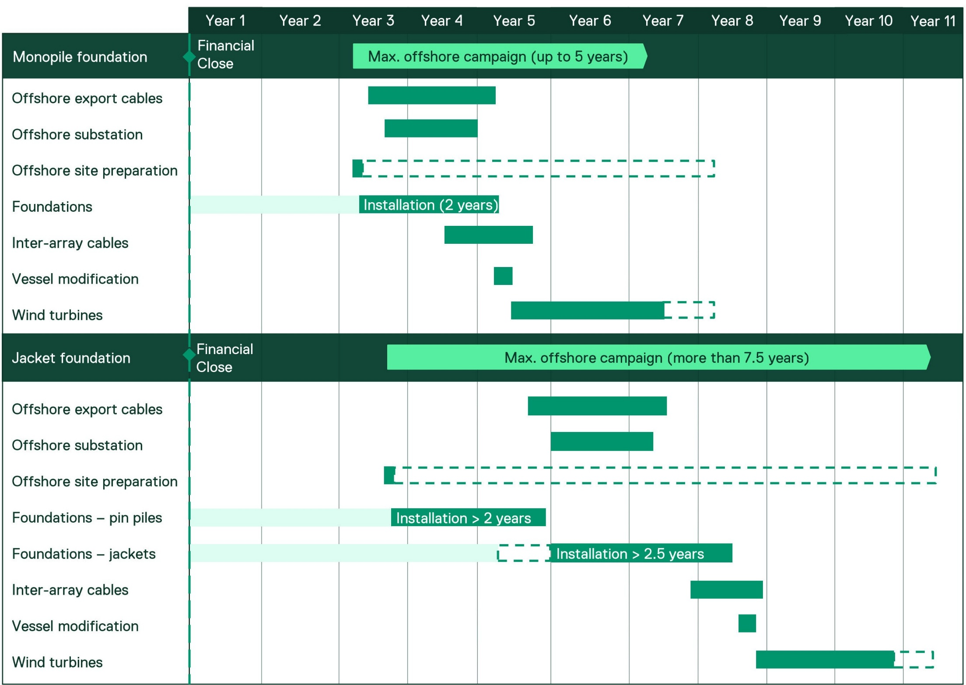

Commercial fisheries
The criteria considers the extent to which each foundation type might create habitat that could affect the numbers of fish within the project area. Underwater noise emissions associated with installation of the foundations may result in some temporary behavioural avoidance by fish, however this will be limited to the construction period for each turbine when fishers will be excluded from the area to ensure safe operations.
As mentioned above, the installation schedule for pin piled and jacket foundation involves considerably more time compared to monopiles, resulting in over two years additional time being required for a jacket installation compared to a monopile installation for a 2.2 GW project.

Other users’ summary
The ratings for other users’ criteria were relatively even for the different foundation types with some alternatives better from the perspective of navigation for small vessels and others better for creating habitat that may benefit commercially targeted fish species.
Table 5-2 Assessment of feasible foundation options – Other users’ criteria
Evaluation criteria | Feasible foundation options
Evaluation criteria | Monopile (impact piling) |  | Monopile (vibro-piling) |  | Piled jackets |  | Vibro-piled jackets
Evaluation criteria | Score | Rationale | Score | Rationale | Score | Rationale | Score | Rationale
Shipping and navigation | 4 | Efficient installation process reduces duration of exclusion zones during construction. | 4 | Efficient installation process reduces duration of exclusion zones during construction. | 1 | Longer construction time, exclusion zones in place for longer | 1 | Longer construction time, exclusion zones in place for longer
Commercial fishing methods | 3 | Monopile is a simple structure with small surface area but together with scour protection provides some new habitat for commercially important species. | 3 | Monopile is a simple structure with small surface area but together with scour protection provides some new habitat for commercially important species. | 2 | Jackets potentially create more habitat for commercially important species with greater surface area. Greater disturbance due to longer duration | 2 | Jackets potentially create more habitat for commercially important species with greater surface area. Greater disturbance due to longer duration
Total score | 7 |  | 7 |  | 3 |  | 3

Sustainability criteria

Biodiversity benefits
The assessment for this criterion considered the surface area and complexity of the structures resulting in a higher rating for structures with a larger area available for settlement and colonisation of marine fauna (Horwath et al., 2020). As a result, the jacket structure rated highest for this criterion (Table 5-4).

Embodied energy and carbon
Monopiles have lower embodied carbon than jacket and pin pile foundations. Monopiles rated higher than jackets because the total weight of a jacket foundation is approximately 1.8 times the weight of a monopile foundation (refer to refer to Attachment 1 – Technical Information Document).
Lifecycle embodied energy in this context is an estimate of the total energy required to manufacture, install, operate and decommission each component of the offshore wind turbine. It can be used as a proxy measurement of the carbon footprint to evaluate the climate change impact of the component during its manufacture. It is critical that the offshore wind industry considers embodied energy as a key project input if the industry is to achieve net zero carbon and maximise the climate benefits they are built to achieve.
Most of the embodied energy for offshore wind projects is produced in the initial stages through production of raw materials, transportation of these materials for fabrication of turbine components and finally transportation to site for installation.
Overall tonnages of steel and concrete are used as proxy indicators of embodied energy when evaluating foundation options. This is because steel and concrete are the primary materials forming the structure, and are also the largest contributors to embodied energy. It is estimated that between 2.4 and 2.6 tonnes of CO2 (Institute of Civil Engineers, 2019) are produced per tonne of primary steel (excluding fabrication, transportation and installation), highlighting the significant potential to reduce embodied energy through efficient design.
The embodied energy in using monopiles and jacket pin pile foundations has been evaluated based on the principles and methods set out in IStructE’s guidance document on how to calculate embodied carbon (Institute of Structural Engineers, 2020). The results of this evaluation are set out in Table 5-3, which reveals the embodied carbon for a jacket with pin pile foundation is over 25 per cent greater than the embodied carbon for a monopile.
The evaluation demonstrates there is a significant difference in the embodied energy and carbon intensity between monopiles and jacket pin piles. The overall tonnage of steel and concrete were the major factor in this difference, as greater amounts of steel and concrete are used for jacket pin pile foundations.
Table 5-3 Embodied energy and carbon for each foundation concept per WTG
Foundation Type | Embodied energy (GJ per wind turbine generator) | Embodied carbon (tCO@e per wind turbine generator)
Monopile | 30,000 | 1,900
Jacket with pin-piles | 36,000 | 2,400

Criteria considered but excluded from detailed evaluation
While material circularity was considered during the screening of the turbine foundation options, it was not factored into the evaluation phase because all of the foundations are primarily constructed of steel with high potential for recycling. It is not therefore a differentiating factor between monopile and jacket turbine foundations.

Sustainability criteria summary
Table 5-4 Assessment of feasible foundation options – sustainability criteria
Evaluation criteria | Feasible foundation options
Evaluation criteria | Monopile (impact piling) |  | Monopile (vibro-piling) |  | Piled jackets |  | Vibro-piled jackets
Evaluation criteria | Score | Rationale | Score | Rationale | Score | Rationale | Score | Rationale
Biodiversity benefits | 2 | Simplest structure with low surface area and low complexity | 2 | Simplest structure with low surface area and low complexity | 4 | Creates complex habitat for colonisation by fish and invertebrates | 4 | Creates complex habitat for colonisation by fish and invertebrates
Embodied energy and carbon | 5 | Lowest steel volume and lightest structure | 5 | Lowest steel volume and lightest structure | 3 | Medium steel volume and weight | 3 | Medium steel volume and weight
Total score | 7 |  | 7 |  | 7 |  | 7

Constructability criteria

Site suitability / geotechnical considerations
The assessment of site suitability was informed by a detailed understanding of geotechnical characteristics across the offshore wind farm area, developed through:
- A preliminary geophysical survey carried out in 2020
- A preliminary geotechnical survey comprising exploratory holes at 22 locations completed in May 2023, with laboratory testing completed in March 2024.

Driven pile installation
The seabed composition / geology in the offshore wind farm area is well suited to monopiles. The geology of the area is known to include carbonate sands which have a risk of cementation (grains becoming stuck together to act like rock), which in turn raises the risk of pile driving refusal during installation. However, the extensive geotechnical and geophysical work carried out have shown no evidence of cemented sands within the offshore wind farm area. Extrapolation of this geotechnical observation using the geophysical data acquired has shown there is a low risk of soil particle cementation leading to pile driving refusal occurring within the offshore wind farm area.
Pin-piled jacket structures would also benefit from reduced risk of refusal on the same basis, although a greater number of longer piles, as required for jacket structures, increases the pile driving refusal risk when considering the project as a whole.
Pile driving assessments were based on optimal monopile base diameters for 15 MW offshore wind turbines across four water depth ranges, with diameters ranging from 8.6 metres at the shallowest sites to 11.4 metres at the deepest sites. The assessment of impact driving for monopiles indicates it will be possible to drive to full penetration depth for 95 -100 per cent of locations, with potential need for relief drilling prior to impact drive to final penetration depth at a small number of foundation locations (up to six locations). It is expected that similar results would be achieved for 19 MW offshore wind turbines given the similar, albeit slightly larger diameters.
For vibro-piling it is estimated that full penetration depth can be reached at 50 - 75 per cent of locations, with potential need for impact driving, or other emerging technologies such as water jetting, to achieve final penetration depth at remaining sites.
The assessment outcome outlined above for impact or vibro-piling of monopiles applies equally to jacket pin piles, with perhaps less risk of refusal due to shallower penetration depths required.

Seabed mobility
High levels of seabed mobility can present a challenge to both construction and design for jackets and monopiles.
Due to the wider footprint of a jacket compared to a monopile, the challenges during construction are typically greater for jackets, as they require a larger area that is within the flatness requirement, to place the seabed template to facilitate the pre-piling activity. Monopiles are placed directly on the seabed, so are less sensitive to local seabed slopes during construction.
During the operations phase, both monopiles and pin-pile jackets must be designed to withstand the expected amounts of seabed level change, which may be achieved by designing for the highest and lowest expected seabed levels, or by providing scour protection to maintain the initial seabed level throughout the operational life.
For both options, the expected seabed mobility, and seabed slope across the project site is within normal limits, and is therefore not a differentiating factor between these alternatives.

Provision of lateral and vertical support
A monopile foundation type predominantly resists the applied horizontal loading on the structure through the lateral resistance of the ground. The medium dense sands present in the offshore wind farm area are ideal for resisting these lateral loads, and the resulting monopile structures will be some of the most efficient across the offshore wind industry globally, when considering the applied loading, the water depths, and the harvested energy from the wind. The dead load of the wind turbine is resisted by the monopile as vertically acting skin friction of the ground against the pile, and the direct effect of ‘end bearing’ of the pile against the material below the pile toe. This vertical load resistance is considered acceptable.
Jacket structures turn the applied lateral loading into a vertical downwards push in the downwind pile(s), and vertical upwards pull in the upwind pile(s). Because the sands in the offshore wind farm area are medium dense, pile driving is relatively straightforward, as described in the above section. However, generating enough resistance to vertical loading in the monopile and in the pin piles is more challenging, as a large surface area of each foundation is required to generate the requisite resistance. This means that jacket pin-piles are longer than they would be in ideal conditions, making a pin-pile jacket a second preference choice for this site, compared to a monopile which is a first choice.

Remaining constructability criteria
The geotechnical considerations outlined above are the most important differentiating factor from a constructability perspective. In addition to this, the greater complexity of the jacket foundation structures mean that this option is generally less favourable than monopiles when it comes to manufacturing and installation times and health and safety considerations. The larger, more complex jacket structures also mean that decommissioning is more complex than for monopiles and will require a longer decommissioning campaign.

Timing and certainty
Installation of jackets is usually performed in two separate campaigns with an objective of installing all pin piles first before the jackets are installed. This approach is taken due to the significant commercial risks associated with contracting vessels, jacket delivery and port supplies for jacket installation, when each of these factors is contingent on pin pile installation being completed. The commercial exposure of having jacket installation delayed is too significant to risk concurrent installation schedules. This risk is compounded by historical evidence of projects having challenging pin pile installation campaigns due to unexpected soil conditions or poor performing foundation installation.
Jacket pin pile installation also requires the use of a subsea template which is lowered onto the seabed prior to pile installation to ensure that the piles are installed in the correction positions for future jacket lowering. This adds an extra logistical step in the piling operation for jacket foundations that does not exist with monopile foundation installation. Furthermore, if piles have been installed for several months prior to jacket installation, they may have started to have marine growth occurring on them and movements in seabed sediments. To prepare the pre-installed piles for jacket installation, the piles may need cleaning, and the seabed may need dredging.
Monopile installation by comparison is simpler. Once monopiles are transported to the site, the installation crew typically upends the monopile from the installation vessel and drives the monopiles into the seabed with a hydraulic pile hammer.
These differences are evidenced by the significant different amount of production time required for each, with monopiles being approximately four times faster to manufacture than jacket foundations which is reflected in their lower cost. The complexity and extended duration associated with jacket fabrication is associated with a significantly increased HSE risk profile, (refer to refer to Attachment 1 – Technical Information Document).
Using data from completed offshore windfarms, and taking a sequential approach to ensure like for like comparison, a 2.2 GW windfarm using jackets compared to monopiles would have at least a two year longer delivery schedule.

Health and safety
During fabrication of jackets, several subcomponents (braces, nodes, supports) need to be assembled and welded together. The weight of these subcomponents ranges from several tonnes to hundreds of tonnes, and the components are connected at various angles to create the 3D structural strength that a jacket lattice provides. This results in complex lifting operations, often including multiple cranes, that involves rotating structures into vertical, horizontal or angled positions for welding the components together. These complex heavy lifts present a risk of lifting incidents, which is further increased as they are undertaken outdoors and with limited space.
By contrast, monopile fabrication is an ever increasingly automated process involving automated handling, rolling and welding of steel using machinery.
Jacket foundations are more complex to fabricate, handle, install and maintain. This introduces greater health and safety risks across all phases of project construction and operation than monopile foundations.

Decommissioning
The approach to decommissioning will be subject to the project approval requirements, and the laws and regulations in force at the time of decommissioning. While much of the wind farm infrastructure may be removed during decommissioning, it is possible some foundation components may be allowed to remain in situ if they prevent no environmental or navigational risk.
For example, if offshore structures and scour protection have been well colonised by marine flora and fauna, there may be a legitimate argument that such structures can remain in place.
Notwithstanding the above, monopiles having one pile versus multiple piles for jackets mean that any offshore decommissioning is expected to be easier for monopiles, and less disturbing to the offshore environment, than for jackets.
Monopiles may be cut off close to the seabed and removed in a single lift (after the transition piece is removed), or cut down into pieces, so that a smaller vessel can do the removal over a longer time. Jackets may also be cut off close to seabed, and removed as one or in smaller pieces.
There is a possibility that total removal of monopiles could be achieved. This would be best achieved with flanged monopiles, whereby the transmission piece could be unbolted and removed, and the monopile could be pulled from the ground using a large vibro-driving hammer. Jacket pin-piles could be theoretically removed in the same way, although their termination level close to seabed, and the grouted connection into the jacket stab-in, would be complicating factors.
In general, jackets will likely require more intensive and complex transport operations given the structure sections (i.e. more segmented scrap metal).

Constructability criteria summary
Monopile (impact piling) was the highest rating foundation option for constructability (Table 5-5). This was largely due to high confidence in the suitability of geotechnical conditions, the availability of proven mitigation methods to overcome penetration refusal (if experienced) and a long history globally of successful use of monopiles resulting in an efficient and safe installation process. Monopile (vibro-piling) rated lower than impact piling as there is less confidence based on the geotechnical data on reaching full penetration depth.
By contrast, the impact piling and vibro-piling options of jacket pin pile foundations achieved a much lower score than monopiles. This is due in part to the water depth at the project site, which to a significant degree is shallower than the 40 m threshold above which jacket foundations are usually considered suitable (see Section 2.1.2).
The larger number of pin piles also presents a higher risk of installation failure, and the complexity of the structures installed across two phases results in longer manufacturing and installation times, longer decommissioning times, and a greater health and safety risk, compared to the monopile.
Table 5-5 Assessment of feasible foundation options – constructability criteria
Evaluation criteria | Feasible foundation options
Evaluation criteria | Monopile (impact piling) |  | Monopile (vibro-piling) |  | Piled jackets |  | Vibro-piled jackets
Evaluation criteria | Score | Rationale | Score | Rationale | Score | Rationale | Score | Rationale
Site suitability/ geotechnical conditions | 5 | Proven, high certainty of suitability for geotechnical conditions across entire project area. Refusal can be mitigated with relief drilling. | 4 | Possible option for majority of site conditions. Refusal can be mitigated impact piling or other emerging techniques such as water jetting at some locations to reach full penetration. | 2 | Proven, high certainty of suitability for geotechnical conditions across entire project site. More piles = longer installation time. Depth is not suitable for much of the site (shallow) | 2 | Possible option for most site conditions but scored lower than vibro-piling monopiles as there is less space available for relief drilling and more time and complexity with mitigating refusal for the larger number (×3/4) of pin piles.  Depth is not suitable for much of the site (shallow)
Timing and certainty | 5 | Efficient and proven installation and manufacturing process | 4 | Efficient installation process, less proven than impact piling. | 1 | More piles and multiple fabricators = longer construction time (> 2 years longer than monopiles) | 1 | More piles and multiple fabricators = longer construction time (> 2 years longer than monopiles)
Health and safety | 5 | Less people, more automation, simpler fabrication – safest option. | 5 | Less people, more automation, simpler fabrication – safest option. | 2 | Larger structure, less automated, manual construction and working at height. | 2 | Larger structure, less automated, manual construction and working at height.
Decommissioning | 5 | Simple structure reduces decommissioning complexity. Monopiles can be cut below seabed | 5 | Simple structure reduces decommissioning complexity. May be able to fully remove vibro-piles. | 2 | More difficult to remove than monopiles – more pieces. May be able to fully remove pin piles. | 2 | More difficult to remove than monopiles – more pieces. May be able to fully remove vibro-piles.
Total score | 20 |  | 18 |  | 7 |  | 7

Commercial criteria
Monopiles are widely recognised for their overall cost efficiency across various stages of design, manufacturing, and deployment. Their simpler structure and streamlined processes contribute significantly to lower expenses compared to jacket foundations.
The lower cost of monopiles compared to jackets is attributed to the following:
- Steel weight: Monopiles require less steel compared to jacket foundations due to their simpler design. This reduction in material use directly lowers the overall cost.
- Fabrication cost: The straightforward design of monopiles reduces fabrication complexity, leading to lower production costs. This includes savings on labour and equipment used in manufacturing. Jacket foundations often require multiple fabricators working in parallel due to their complex design and limited supply capability, increasing logistical coordination and overall production expenses.
- Coating and surface treatment costs: Monopiles have fewer surfaces and joints requiring protective coatings and treatments compared to jacket foundations. This minimises costs associated with corrosion protection and maintenance. A generic jacket costs 1.3 times the cost of a monopile in coating and surface treatment. Overall, total supply cost for a generic jacket foundation is approximately 1.7 times the supply cost of a monopile.
- Installation and logistics costs: Jacket foundations, being larger and heavier, often require specialised vessels and more complex logistics, which can significantly increase transportation expenses and add complexity and cost to the supply chain. Monopiles are installed using simpler and faster techniques, such as pile driving, which requires less time and specialised equipment compared to the multi-step process needed for jacket foundations. Jackets often demand additional preparation, including pre-installing anchors and securing multiple legs, which increases costs. The installation process for monopiles is less weather-dependent, allowing for greater flexibility and fewer delays, further enhancing cost efficiency. This is further amplified in a constrained installation vessel supply chain where projects are competing globally to secure vessels in the most efficient way.
- Reduced maintenance requirements: While both monopile and jacket foundations require relatively low maintenance, the simpler design of monopiles involves fewer structural elements, which means fewer components are exposed to marine conditions. This results in lower maintenance and inspection requirements for monopiles as well as expected corrective maintenance (i.e. repair) events compared to the more intricate jacket foundations, which have multiple nodes and joints susceptible to additional corrosion and wear.
- Proven track record: Monopiles have been successfully deployed in numerous offshore wind projects worldwide, demonstrating their reliability and performance. This proven track record builds confidence among investors and lenders making monopiles a safer and more predictable choice. Additionally, the reduced logistical complexity and improved reliability lower insurance costs and enhance the bankability of projects, making them more attractive to financiers.
The differences in ratings for the commercial criteria are largely driven by the relative complexity of the structures, with the more complex jacket structures resulting in both a higher initial CAPEX for manufacturing and installation as well as ongoing operational expenses associated with insurance, inspection and maintenance (Table 5-6).
The differences in bankability are largely associated with the strength of the track record for the foundation installation method. As a result, the impact piling scores highest as it is the most common installation method for comparable water depths, and the less proven method of vibro-piling scores relatively lower due to perceived uncertainty regarding its performance and reliability as an installation approach.
Monopile (impact piling) was the highest rating alternative due to the extensive track record of installations in similar conditions and the simpler structure reducing OPEX and CAPEX. Monopile (vibro-piling) was the second highest rating alternative as OPEX and CAPEX remain low due to simple structure, but a higher perceived risk for this less proven installation method results in a lower bankability rating.

Table 5-6 Assessment of feasible foundation options – commercial criteria
Evaluation criteria | Feasible foundation options
Evaluation criteria | Monopile (impact piling) |  | Monopile (vibro-piling) |  | Piled jackets |  | Vibro-piled jackets
Evaluation criteria | Score | Rationale | Score | Rationale | Score | Rationale | Score | Rationale
OPEX | 5 | Simpler structure and fewer components reduce maintenance and insurance costs (insurance ~15% of total OPEX). | 5 | Same as monopile (impact piling) | 3 | Higher insurance costs, resulting from the increased perceived risk, lead to higher OPEX for jackets. Additionally, higher costs expected for inspection, maintenance and corrosion management for more complex structure with larger surface area. | 3 | Same as piled jackets.
CAPEX | 5 | Impact driven monopiles have lower CAPEX due to their widespread use and the simplicity of their single-piece structural arrangement. | 4 | Increased CAPEX due to the larger foundation size and the longer, more complex installation process | 1 | Jackets are 50% more expensive than monopiles, primarily because their complex design and construction process demand more materials, labour and time. | 1 | Vibro-piled jackets incur higher CAPEX due to specialised installation requirements, larger pile designs, and a cost uncertainty premium.
Bankability | 5 | Proven concept, high certainty | 3 | Little track record for monopile sites installed exclusively with vibro-piling, increase perceived risks likely to result in lower bankability compared to impact piling installation of monopiles. | 4 | Proven track record, albeit not as extensive as monopiles. Limited use of jackets in this depth. | 3 | Increased perceived risk due to installation methods and limited experience. Limited use of jackets in this depth.
Total score | 15 |  | 12 |  | 8 |  | 7

Supply chain / procurement criteria
Supply chain considerations include initial procurement of materials and longer-term considerations such as availability of installation vessels and quayside logistics and storage. The main differentiating factors between monopiles and jackets are the number of experienced providers for key materials, and the implications of the size and mass of foundation structures on the installation vessel requirements and availability, and quayside strength, length and storage.
Jacket and pin pile transport requires increasingly complex handling equipment compared to monopiles, and higher transport movements due to the need to transport pin piles separately to jackets.
Monopiles (impact piling) was the highest rating option due to the proven supply chain and multiple suppliers in the market. Monopiles (vibro-piling) was the second highest rating option, with the single experienced provider for the vibro hammer reducing the rating for this option (Table 5-7). The jacket alternatives were rated lower mainly due to the greater size and mass resulting in a need for larger and more installation vessels (with fewer available).
There is no key difference for port space between jackets and monopiles (refer to Attachment 1 – Technical Information Document).

Criteria considered but excluded from detailed evaluation
There were several sub-criteria that formed part of the screening phase but were subsequently removed from the evaluation phase because there was no material difference between the monopile and jacket options and they were not informative for the comparative assessment. The results of the preliminary evaluation for the excluded criteria are outlined below.

Availability of materials
There is very limited difference between the monopile and jacket alternatives when it comes to material availability, as they are all primarily constructed of steel. There is a high degree of certainty around the availability of steel.

Local content
A preliminary assessment was undertaken of opportunities for local content. The following options were identified as requiring further investigation:
- Potential for local manufacture of pin piles for jacket foundations.
- Potential for local manufacture of internal / external steel platforms for all foundation types.
Table 5-7 Assessment of feasible foundation options – supply chain / procurement criteria
Evaluation criteria | Feasible foundation options
Evaluation criteria | Monopile (impact piling) |  | Monopile (vibro-piling) |  | Piled jackets |  | Vibro-piled jackets
Evaluation criteria | Score | Rationale | Score | Rationale | Score | Rationale | Score | Rationale
Suppliers | 5 | Impact hammer  Two principal suppliers globally of impact hammers  Monopiles  5+ suppliers in APAC which can manufacture 10-12 m monopiles. Relatively easy to design and manufacture.  Known technology – good performance track record.  Possible procurement delays due to high demand. | 2 | Vibro hammer  Only one experienced supplier– increased supplier risk.  Monopiles  Refer to monopile (impact piling) | 5 | Impact hammer  Two principal suppliers globally of impact hammers  Jacket  At least 5-6 jacket suppliers with track record in APAC  Pin piles  Approx. 10 suppliers of pin piles in APAC | 2 | Vibro hammer  Only one experienced contractor – increased supplier risk.  Jacket  Refer to piled jackets  Pin piles  Refer to piled jackets
Vessel logistics | 4 | Simpler, smaller structure results in more vessels available on market that are suitable for installation | 4 | Simpler, smaller structure results in more vessels available on market that are suitable for installation | 3 | Larger, more complex structure – fewer suitable vessels available on market.  Longer time on site to install. | 3 | Larger, more complex structure – fewer suitable vessels available on market.  Longer time on site to install.
Quayside logistics/ storage | 4 | Smallest quayside footprint. May need space for critical spares (impact hammer). Largest monopiles are approx. 11.8 m diameter x 86 m length | 4 | Smallest quayside footprint. May need space for critical spares (vibro hammer). Largest monopiles are approx. 11.8 m diameter x 86 m length | 3 | Jacket approx. 35m x 35m – more storage required than monopile due to larger structure, pin piles and space required for operational logistics.  May need space for critical spares (impact hammer) | 3 | Jacket approx. 35m x 35m – more storage required than monopile due to larger structure, pin piles and space required for operational logistics.  May need space for critical spares (vibro hammer)
Total score | 13 |  | 10 |  | 11 |  | 8

Summary of evaluation results
This section summarises findings for each of the foundation options evaluated, as shown in Table 6-1. Although the evaluation criteria were not weighted, the discussion focuses on the criteria which had the greatest influence in differentiating between options and the environment criteria, which is the key focus of the EIS Guidelines and EES Scoping Requirements for the project. As the evaluation indicates, monopiles were consistently better in all criteria evaluated.
Overall, monopiles (impact piling) had the highest ranking overall with a total score of 68 and monopiles (vibro piling) came in second with a total score of 60. Jackets (both impact and vibro piling) scored lowest with total scores of 41 and 37 respectively.

Monopiles (impact piling)
Installing monopiles with impact piling receives a low rating for underwater noise and this criterion has a high relative importance due to the project area overlapping with biologically important areas for listed threatened whales. Star of the South has committed to using a double big bubble curtain) to reduce water borne noise, and is investigating other mitigation measures (refer to Technical Report D – Marine Mammals and Turtles).
Monopiles receive the highest (most positive) rating for constructability criteria. This is largely due to high confidence in the suitability of geotechnical conditions and water depth, the availability of proven mitigation methods to overcome penetration refusal (if experienced) and a long history of successful installation of monopiles resulting in an efficient and safe construction and installation process. The timeframes for installing monopiles are considerably shorter than for jackets.
The installation timeframe and therefore the overall construction program for the project is a critical factor in meeting the project objectives, which in turn are related to meeting the Victorian Government’s own objectives of 2 GW by 2032.
Monopiles (impact piling) rate well for commercial criteria due to their proven track record, simple design and accordingly lower initial capital outlay and ongoing operating expenses.
Supply chain considerations are another important consideration, particularly given the offshore wind industry is not yet established in Australia. Monopiles score well for all supply chain criteria as there are well established international supply chains, and their streamlined design results in a larger number of suitable vessels available to support installation.
In summary, monopiles (impact piling) are a highly suitable foundation, acknowledging the higher underwater noise emissions from impact piling are a potentially significant environmental factor and will require effective mitigation, management and monitoring measures, which are detailed in Technical Report D – Marine Mammals and Turtles.

Monopiles (vibro-piling)
This option uses the same foundation design as monopiles (impact piling) but uses a vibratory hammer for installation. As a result, the summary largely applies equally to monopiles (impact piling), except for the criteria discussed below.
The use of a vibratory hammer may reduce the intensity of noise emissions, and in turn the potential for injury to cetaceans. However, vibro-piling creates a continuous noise source during installation as well as being a source of continuous noise in combination with vessels. There is a high likelihood that many piles would also require a certain duration of impact piling to complete the installation process. Refer to Technical Report D – Marine Mammals and Turtles for further detail on predicted impacts and proposed monitoring and management measures to reduce underwater noise impacts to listed threatened whales.
Monopiles (vibro-piling) rate lower for bankability and supply chain criteria. For bankability, this is largely due to the lack of a proven track record of installation in similar geotechnical conditions. For supply chain, this is associated with a more constrained supply chain (one experienced contractor) for vibratory hammers.

Jackets (impact piling)
As with monopiles (impact piling), this option receives a lower rating for underwater noise. Although the pin piles are substantially smaller than monopiles, the consecutive piling of three to four pin piles per structure results in similar effect ranges due to cumulative noise exposure.
As a result, the ratings for underwater noise are equivalent to monopiles (impact piling). The only environmental benefit of piled jackets over monopile options is the greater habitat complexity for commercially important species and potential indirect benefits for commercial fishing. However, this is offset by a longer construction period (and disturbance to marine fauna over a longer period) and associated longer displacement of other marine users.
Differences in other criteria for piled jackets are largely associated with the larger size and complexity of the structure. This results in more health and safety risks, a more complex decommissioning campaign, larger CAPEX (more complex manufacturing) and OPEX due to more intensive requirements for inspection and maintenance and the need for more space quayside and on installation vessels. The greater complexity of jackets requires more steel than monopiles, resulting in greater embodied carbon in the foundations and a longer time to achieve 'energy payback.'
Jackets take an additional two years or more additional installation timeframe which would make meeting project objectives and government targets extremely difficult.

Jackets (vibro-piling)
The summary provided above for piled jackets is largely applicable to vibro-piled jackets, as the only difference is the installation method (vibratory hammer). Exceptions to this are discussed above with regard to monopile (vibro-piling).

Table 6-1 Summary of evaluation results for feasible foundation options
Evaluation criteria |  | Feasible foundation options
 |  | Monopile (impact piling) | Monopile (vibro-piling) | Piled jackets | Vibro-piled jackets
 |  | Score | Score | Score | Score
Environment | Underwater noise – installation of foundation
Environment | Underwater noise – installation vessels (continuous noise)
Environment | Seabed disturbance
Other users | Shipping and navigation
Other users | Commercial fishing methods
Sustainability | Biodiversity benefits
Sustainability | Embodied energy and carbon
Constructability | Site suitability / geotechnical conditions
Constructability | Timing and certainty
Constructability | Health and safety
Constructability | Decommissioning
Commercial | OPEX
Commercial | CAPEX
Commercial | Bankability
Supply chain / procurement | Suppliers
Supply chain / procurement | Vessel logistics
Supply chain / procurement | Quayside logistics/ storage
Total score |  | 68 | 60 | 41 | 37

Conclusion
There are several offshore wind turbine foundation options available to developers, with varying degrees of suitability for the project site. Fundamentally, the selection of foundation type is driven mostly by the technical and commercial feasibility for each individual project site, provided the impact of installing the foundation is acceptable and permitted by the relevant government approvals. Meeting project objectives is also important.
An initial feasibility assessment screened out several foundation options and identified four feasible options (monopiles installed with impact driving, monopiles installed with vibro-piling, jackets installed with impact driving and jackets installed with vibro-piling) for further evaluation.
The initial screening assessment considered water depth, suitability of seabed, project objectives and logistics / supply chain considerations. It determined that floating support structures, tri-suction pile caisson, suction caisson jackets and gravity-based foundations are not feasible for the project and did not meet project objectives (see Section 3.2). In addition, the tripod foundation was screened out from further assessment because it does not provide any additional environmental benefits over monopiles or a 3-leg jacket, but would add additional costs.
A further detailed evaluation of the four feasible options identified monopiles (impact piling) as the most suitable foundation overall. Higher underwater noise emissions generated during the installation process reduced the score of this foundation type, however not by considerably more than jackets. The use of monopiles (impact piling) would require effective monitoring and management measures for noise sensitive marine fauna and are detailed in Technical Report D – Marine Mammals and Turtles.
Monopiles (vibro-piling) rated lower than impact driven monopiles for constructability, commercial and supply chain criteria. This option may be feasible and provide some advantages in terms of reducing peak underwater noise levels, while recognising continuous, non-impulsive noise emissions will occur and impact piling will likely still be required at certain penetration depths.
Monopiles are a mature technology with well-established supply chains. They are straightforward to fabricate and relatively inexpensive to manufacture. Jackets are more complex and labour intensive to fabricate.
Monopiles are set to remain the dominant foundation choice for developers worldwide. They represent over 75 per cent (equivalent to around 54 GW) of the global pipeline which have been announced publicly. Jacket foundations represent 8.8 per cent of the future potential project pipeline announced.
This dominance of monopiles has been driven by their technical suitability in certain water depths and soil conditions as well as their commercial advantages over jackets. The track record for monopiles, having been around for longer and including more units than jackets, has also allowed time for the processes involved in their manufacture, installation and operation to be refined, more than for any other foundation type. This refinement has resulted in better health and safety statistics, in lower costs per unit, in a wider range of installation tools and vessels, and in a well-understood cradle to grave methodology. Very few windfarms at the project’s average depth have used jackets. Those that have are not comparable to the project due to their much smaller size project.
Jackets (impact piling) are capable of being installed in the deeper parts of the project’s offshore wind farm area, but would have a longer piling duration, meaning this option does not reduce the overall impacts of underwater noise emissions to marine mammals relative to monopiles while also presenting several disadvantages. While there are some minor benefits (e.g. biodiversity), these are not of sufficient magnitude to offset other disadvantages and risks associated with using jacket foundations for the project. Jackets are an acknowledged foundation technology appropriate for deeper water projects or for poor soil conditions. In contrast, the project has shallow waters and good soil conditions suitable for monopile foundations.
The overall cost differential for the supply and installation of jacket foundations compared to monopile foundations is estimated to be over $500 million per GW. For Victoria to meet its offshore wind target of 9 GW by 2040, this would mean an additional cost of approximately $4.7 billion to the end consumers / taxpayers. Furthermore, the lengthier timeline for fabrication and installation of jacket foundations would result in significant risk of not meeting the Victorian Government’s offshore wind target of 2 GW by 2032.
Based on the above considerations the overall installation process for monopiles is typically of lower complexity, shorter duration, and less weather-dependent, allowing for greater flexibility in offshore operations and fewer delays (refer to Attachment 1 – Technical Information Document).
Considering all criteria, monopiles (impact piling) are the most suitable foundation option compared with other feasible foundation types.

References
https://www.energy.gov/sites/default/files/2022-09/offshore-wind-market-report-2022-v2.pdf
Christantonis, E. (2022) Tri-Suction Pile Caisson-Analysis of Soil-Structure Interaction. Master Thesis at Delft University of Technology, Netherlands.
DEME Offshore (2023) Tri-suction pile caisson foundation concept. Final report prepared for National Offshore Wind Research and Development Consortium. Boston, Massachusetts.
DHI, (2024) Decode offshore wind engineering challenges at every stage. Available from: https://blog.dhigroup.com/decode-offshore-wind-engineering-challenges-at-every-stage/. Accessed 11 March 2024.
ERM, (2024) Global Supply Chain Study.
Horwath, S., Hassrick, J., Grismala, R., Diller, E., Krebs, J., & Manhard, R. (2020) Comparison of environmental effects from different offshore wind turbine foundations. Bureau of Ocean Energy Management, Fairfax, VA, USA, OCS Study BOEM, 41.
Institute of Civil Engineers, (Nov 2019) ICE Database V3.0 https://circularecology.com/embodied-carbon-footprint-database.html
Institution of Structural Engineers, (2020) How to calculate embodied carbon, Version 1.0.
Jawalageri, S.; Bhattacharya, S.; Jalilvand, S.; Malekjafarian, A. A Comparative Study on Load Assessment Methods for Offshore Wind Turbines Using a Simplified Method and OpenFAST Simulations. Energies 2024,17,2189. https:// doi.org/10.3390/en17092189
Jiang, Z. (2021) Installation of offshore wind turbines: A technical review. Renewable and Sustainable Energy Reviews, 139, 110576.
Lavanya, C., & Kumar, N. D. (2020) Foundation types for land and offshore sustainable wind energy turbine towers. In E3S Web of Conferences (Vol. 184, p. 01094). EDP Sciences.
Manzano-Agugliaro, F., Sánchez-Calero, M., Alcayde, A., San-Antonio-Gómez, C., Perea-Moreno, A. J., & Salmeron-Manzano, E. (2020) Wind turbines offshore foundations and connections to grid. Inventions, 5(1), 8.
Marmo, B., & Roberts, I. (2014) Modelling of Noise Produced By Offshore Wind Turbines with Different Foundations and Effects on the Marine Environment. In Proc Int Conference on Engineering Consultants, Edinburgh, Scotland, UK.
Matuschek, R., & Betke, K. (2009, March) Measurements of construction noise during pile driving of offshore research platforms and wind farms. In Proc. NAG/DAGA Int. Conference on Acoustics (pp. 262-265).
Passon, P., Branner, K., Larsen, S. E., & Rasmussen, J. H. (2015) Offshore Wind Turbine Foundation Design. DTU Wind Energy.
Plodpradit, P., Dinh, V. N., & Kim, K. D. (2019) Coupled analysis of offshore wind turbine jacket structures with pile-soil-structure interaction using FAST v8 and X-SEA. Applied Sciences, 9(8), 1633.
Shonberg, A., Harte, M., Aghakouchak, A., Brown, C. S. D., Andrade, M. P., & Liingaard, M. A. (2017, September) Suction bucket jackets for offshore wind turbines: applications from in situ observations. In Proc. TC209 Workshop, 19th International Conference on Soil Mechanics and Geotechnical Engineering, Seoul, South Korea (pp. p65-77).
RenewableUK, (2025) Global operational offshore wind capacity grows by 15% in 12 months to 80 gigawatts
SPT Offshore. (2020) Tri-suction pile caisson (TSPC). Available from: https://www.sptoffshore.com/wp-content/uploads/2020/03/Tri-Suction-Pile-Caisson-TSPC-rev-28012020.pdf. Accessed 12 March 2024.
Star of the South Technical Report, (2024) Southerly Ten.
Xu, K., Larsen, K., Shao, Y., Zhang, M., Gao, Z. & Moan, T. (2021) Design and comparative analysis of alternative mooring systems for floating wind turbines in shallow water with emphasis on ultimate limit state design. Ocean Engineering, 219, 108377.
Zhang, J., & Wang, H. (2022) Development of offshore wind power and foundation technology for offshore wind turbines in China. Ocean Engineering, 266, 113256.

