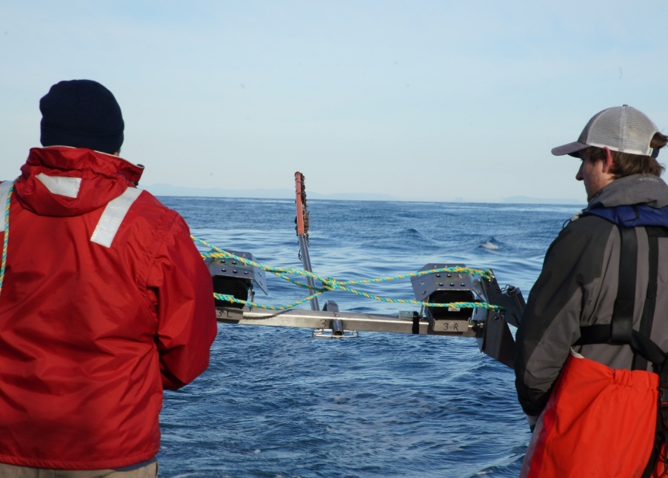
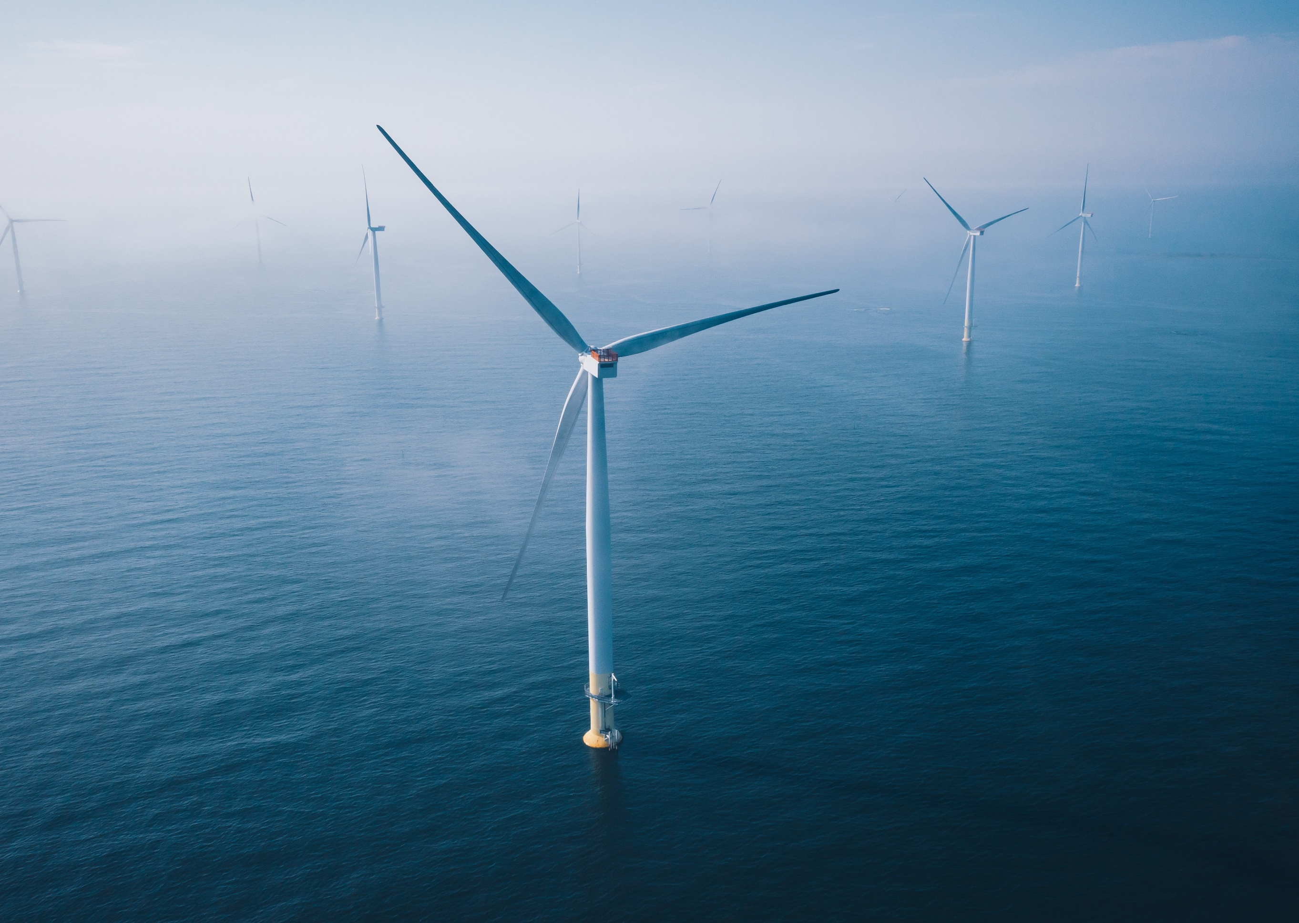

Attachment 1 – Technical information document
Foundations options assessment

Table of Contents
1 Overview 1-1
1.1 Purpose and context 1-1
1.2 Summary 1-1
2 Assessment 2-2
2.1 Health, safety and environment 2-2
2.1.1 Fabrication 2-2
2.1.2 Transport and installation 2-5
2.1.3 Operations and maintenance 2-6
2.2 Technical suitability 2-7
2.2.1 Track record 2-7
2.2.2 Water depth 2-8
2.3 Fabrication and supply chain 2-11
2.3.1 Fabrication process and capabilities 2-11
2.3.2 Local content 2-13
2.3.3 Vessel and equipment limitations 2-14
2.3.4 Installation vessel consideration 2-16
2.4 Fabrication and transport schedule comparison 2-17
2.4.1 Fabrication process and capabilities 2-17
2.5 Installation and schedule 2-19
2.5.1 Installation sequence and complexity 2-19
2.5.2 Comparative data 2-21
2.5.3 Installation schedule basis 2-22
2.6 Ports 2-24
2.6.1 Storage considerations 2-24
2.6.2 Port logistics 2-25
2.7 Operations and maintenance and decommissioning 2-26
2.7.1 Operations and maintenance 2-26
2.7.2 Decommissioning 2-27
2.8 Carbon footprint 2-27
2.8.1 Embodied carbon 2-27
2.9 Cost and business case 2-28
2.9.1 Cost-effectiveness 2-29
3 References 3-32

Figures
Figure 2-1 Complex assembly process for Jackets 2-3
Figure 2-2 2022-2023 Fabrication incidents in Taiwanese project 2-4
Figure 2-3 Manufacturing of monopiles 2-5
Figure 2-4 Water depth ranges at which offshore wind foundations might operate 2-8
Figure 2-5 Water depth vs foundation type 2-9
Figure 2-6 A monopile is made up of a series of flat sheets that are rolled and welded forming ‘cans’. These cans are then welded together to form a monopile. 2-12
Figure 2-7 Jacket transportation vessel 2-15
Figure 2-8 Comparison of construction techniques 2-16
Figure 2-9 Fabrication and transport schedule 2-18
Figure 2-10 Foundation Installations 2-20
Figure 2-11 On-position installation duration by foundation type 2-21
Figure 2-12 Installation schedule 2-23

Tables
Table 1-1 Summary of assessment comparing monopile and jacket foundations 1-1
Table 2-1 Embodied energy and carbon for each foundation option 2-28

Overview

Purpose and context
This document further outlines the technical and logistical differences between the use of monopile and jacket foundations for the Star of the South Offshore Wind Farm Project (‘the project) site.
It should be read in conjunction with Chapter 3 – Project Development, Appendix A - Foundation Options Assessment, which provides a comprehensive overview of the nine foundation options Star of the South considered and screened for the project. This screening process identified foundation options through a multi criteria assessment to determine the preferred option.
Unless otherwise stated, comparisons of the two foundation options are made based on 2.2 GW project size using 147 x 15 MW offshore wind turbine generators.

Summary
Table 1-1 lists the criteria each foundation option was assessed against in this technical assessment, noting the monopile performed higher than the jacket foundation. Each of these criteria are discussed in more detail in Section 2.
Consideration | Monopile preferred | Jacket preferred
HSE | 
Technical suitability
Fabrication
Transport
Installation
Schedule
Ports
O&M
Decommissioning
Carbon footprint
Commercial / cost
Table 1-1 Summary of assessment comparing monopile and jacket foundations

Assessment

Health, safety and environment
The monopile performs more strongly on the Health, Safety and Environment (HSE) criterion. Jacket foundations are more complex to fabricate, handle, install and maintain. This introduces increased health and safety risks across all phases of project construction and operations when compared to monopile foundations.

Fabrication
The fabrication of monopiles contains fewer complexities compared to jacket structures.
Monopiles, because of their relatively simple tubular shape, can be rolled and welded in production line type facilities, enabling high use of automation equipment for handling and robotic welding.
In contrast, jackets are fabricated in external fabrication yards and shipyard facilities that enable bespoke lifting, handling and high levels of manual labour for welding.
These fabrication differences are evidenced by the significant difference in production time required for each, with monopiles being approximately four times faster (and accordingly less expensive) to manufacture than jacket foundations. The complexity and extended duration associated with jacket fabrication means there is a significantly increased HSE risk profile.
During fabrication of jackets, several subcomponents (braces, nodes, supports) are assembled and welded together. Each of these subcomponents can weigh up to hundreds of tonnes and are connected at various angles to create the 3D structural strength for the lattice design.
Accordingly, this requires complex lifting operations often with multiple cranes rotating structures into vertical, horizontal or angled positions. These complex heavy lifts significantly increase the risk of lifting incidents. This risk is further exacerbated when lifting occurs in an outdoor environment (due to environmental uncontrolled factors such as wind) or in confined spaces.
Following the welded assembly and up-righting of the jacket structure, jacket fabrication requires significantly more work at height, manual hot works (welding), painting and electrical fit out work.
During assembly, works are carried out using temporary scaffolding which presents a set of HSE risks. On a completed structure, works can occur at significant heights of up to 70 metres.
Figure 2-1 Complex assembly process for Jackets
Jacket assembly at Samkang shipyard Korea requiring considerable temporary scaffold, multiple cranes and large numbers of subcomponents. | Subcomponents of jackets laid out at the SamKang fabrication yard in South Korea.
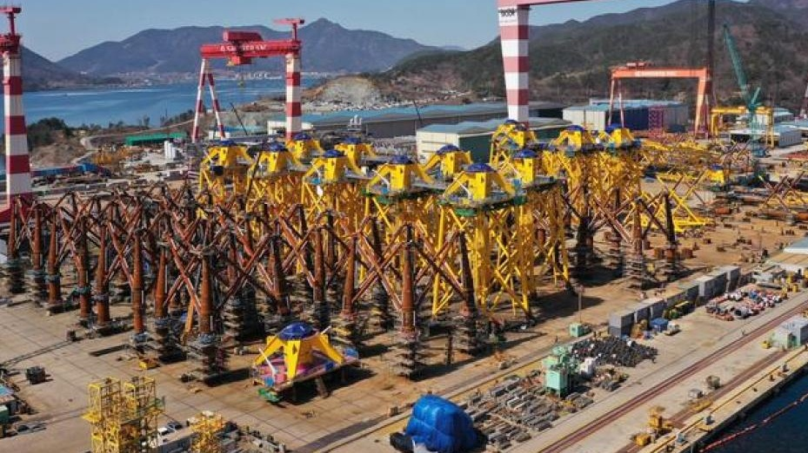 | 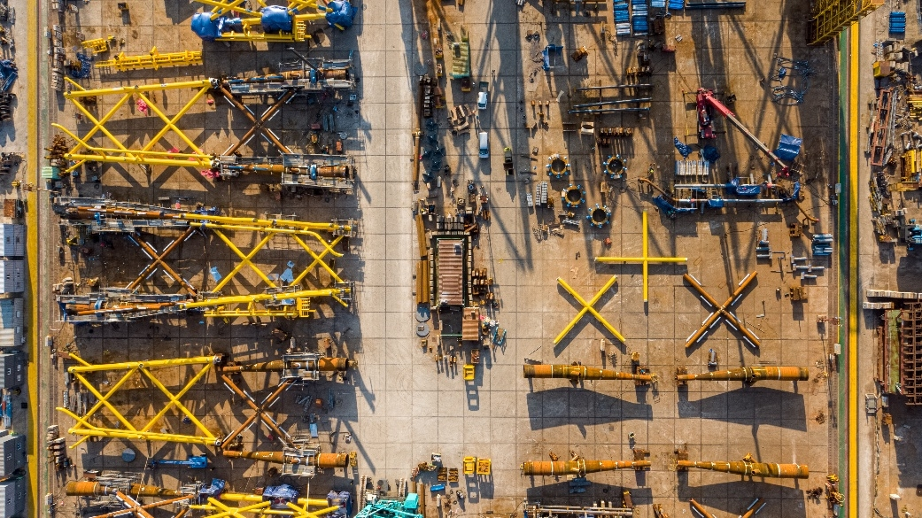
There have been numerous HSE incidents involving work at height and dropped objects from these activities in the industry to date.
In recent years, there has been an uptick in serious incidents including fatalities in the fabrication of jacket structures as shown from incident statistics from G+ Offshore Wind Health and Safety Organisation.
A case study from a recently completed offshore wind project in Taiwan shows the fabrication of jackets was the main source of HSE incidents (see Figure 2-2).

Figure 2-2 2022-2023 Fabrication incidents in Taiwanese project
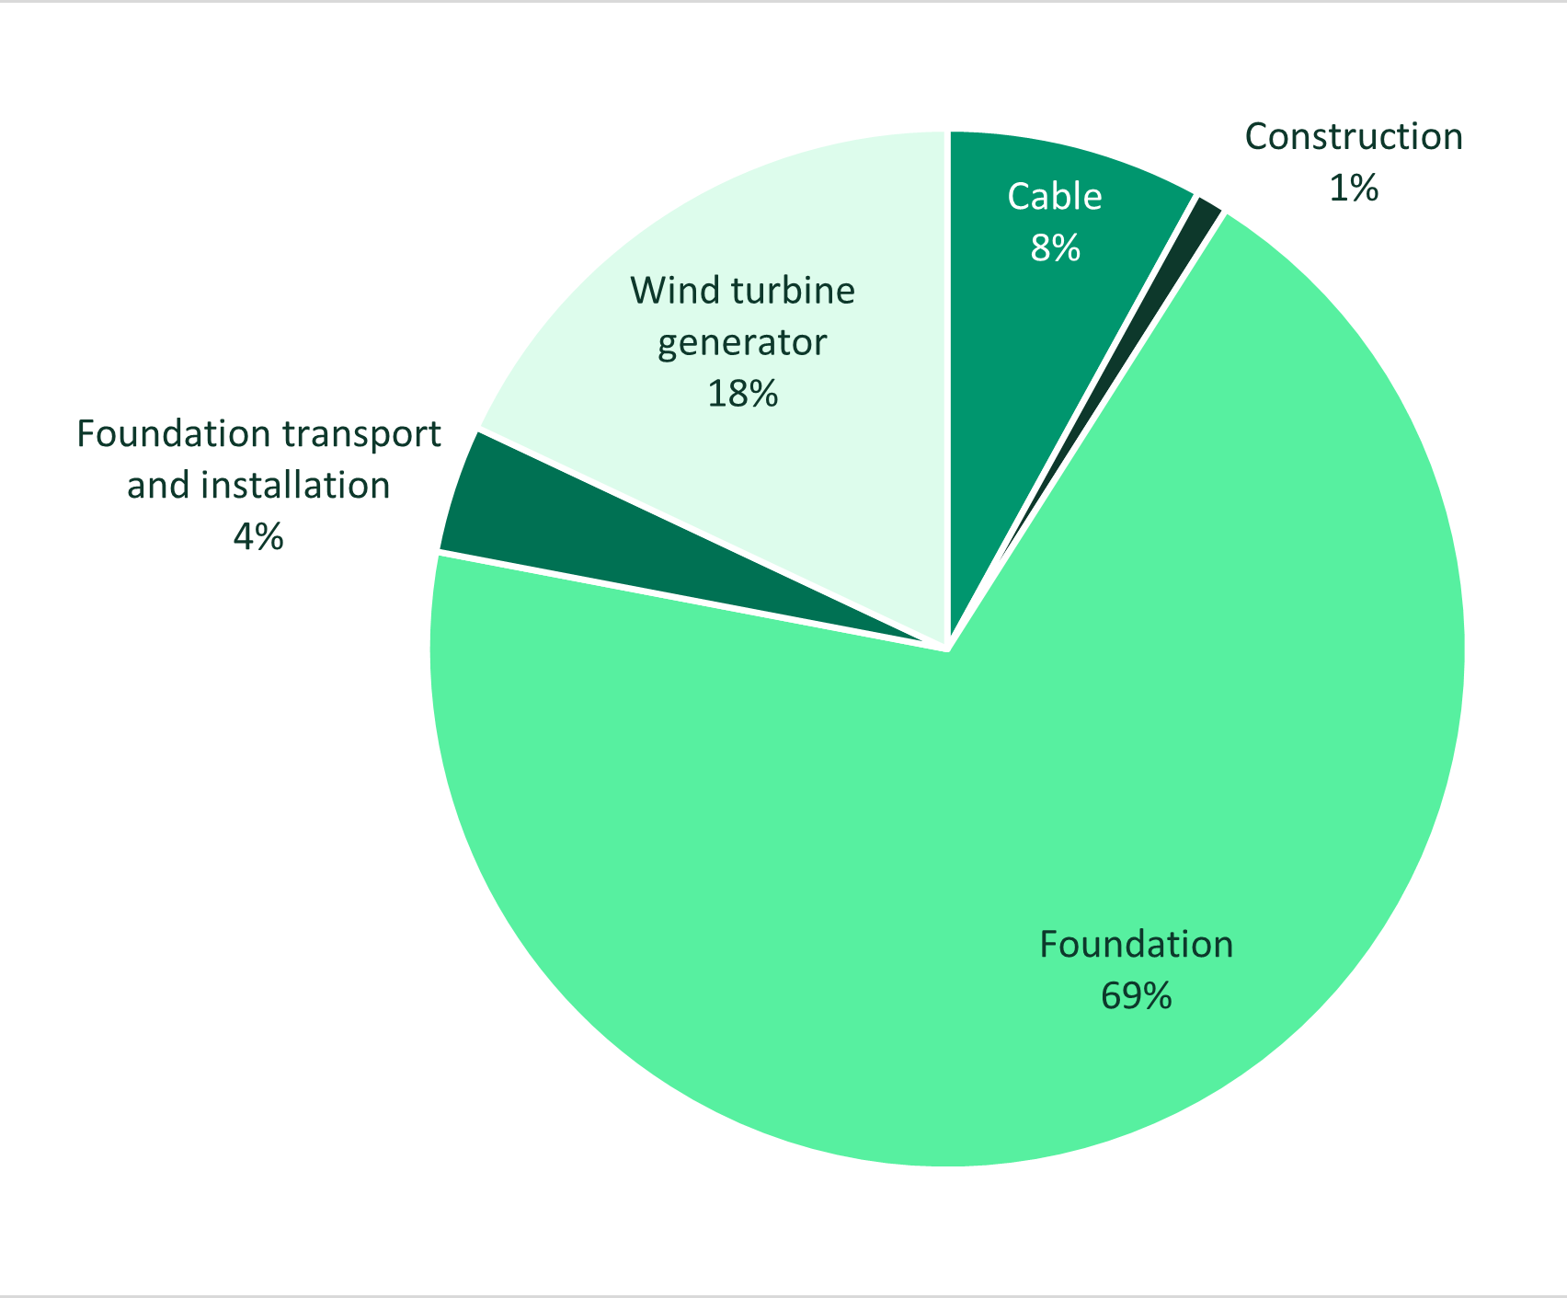
Note: Construction relates to other assets (e.g. non-project related incident on vessel, typhoon)
In contrast, monopile fabrication is an ever increasingly automated process involving automated handling, rolling and welding of steel using machinery. The work at heights for welding is limited to the diameter of the piles, or completely avoided in many cases due to rolling technology which ensures work occurs at floor level only.
Monopiles are not upended (stood up vertically) during the fabrication process, meaning that lifting activities are less complex and mainly comprise lifting pile cans into position for welding via factory internal overhead cranes with simple slinging arrangements.

Figure 2-3 Manufacturing of monopiles
Production line manufacturing associated with monopile production including automated rolling and cranes. | Steel automated rolling machine creating monopile cans
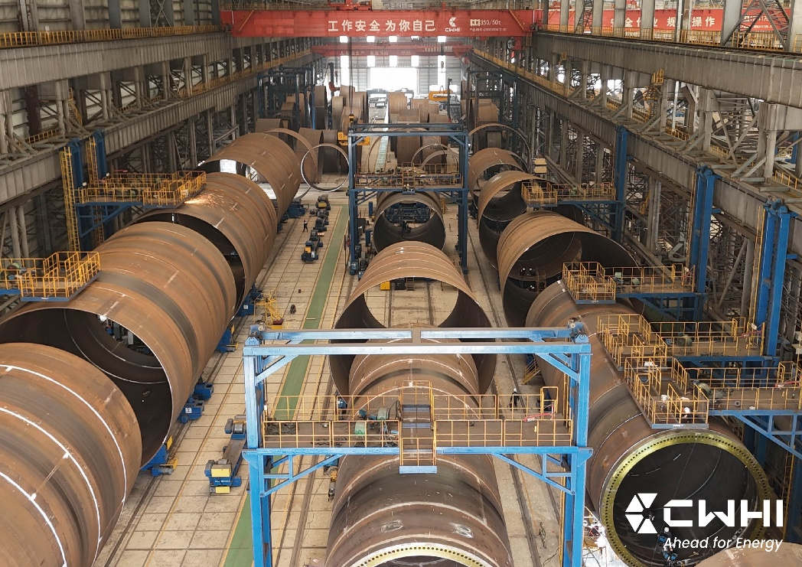 | 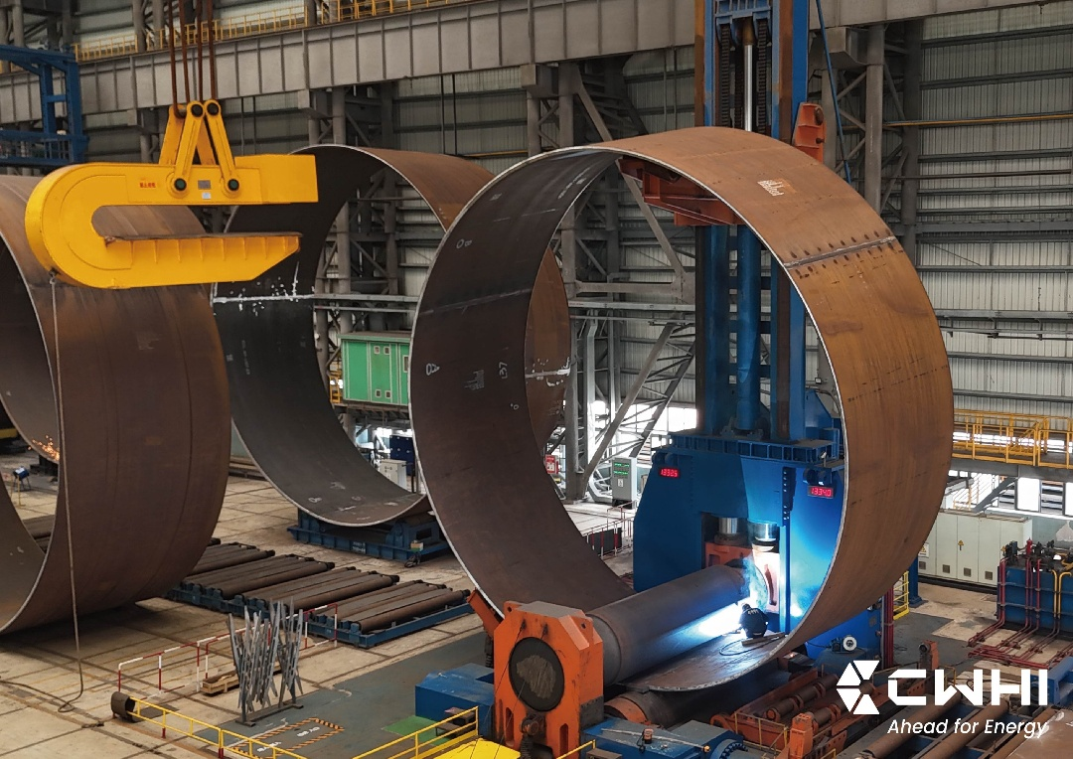
Transition pieces, which connect the monopile foundation with the turbine tower, if used, do have increased complexity compared to monopiles, however the main structure is fabricated in a similar process to the monopile, and the transition piece is only upended once fully fabricated and painted in the horizontal position.
Once upended, the structures are accessible by cherry picker or internal scaffolding, and subcomponent lifts are simplified and use modular assembly approaches. There is also the potential to eliminate the transition piece through design.
The reduced complexity combined with shorter fabrication duration and factory setting of monopile fabrication results in less resources being used, significantly less working hours and, accordingly, reduced exposure to HSE risk.

Transport and installation
The transport and installation of jacket foundations requires higher risk activities offshore. In addition to installation of the actual jacket structures, smaller pin piles are installed into deeper ground to act as a structural support for the jacket footings, creating further complexity in the offshore environment.
The pins need to be transported separately and are required to be offloaded at a marshalling port and stored, before being loaded out for installation. This increases the amount of storage equipment and movement equipment at the marshalling port compared to monopiles.
The jackets are also loaded out for storage before being installed. This can include the use of significantly larger cranes, such as ring cranes, which themselves require a high amount of assembly and intensive labour to prepare. For example, a large crawler crane requires over 80 truck trips to bring the crane subassemblies to site, with ring cranes requiring a considerable number more including ballast.
For installation of every jacket foundation (with three supporting pin piles) there are ten heavy lift operations to be carried out by the installation vessel to load and install the equipment, including the use of the seabed piling template. For a monopile foundation with transition piece there are only four heavy lift operations.
This greater number of operations for jacket installation results in an increased number of vessels and operation hours, exposing a larger number of personnel to HSE risks working offshore.

Operations and maintenance
During operations and maintenance, having more complex and broader foundation structures (e.g. 3 or 4 legged jackets) poses an increased risk of service vessel collisions with the structures compared with the single foundation structure of monopiles.
The inspections, repair and re-painting of jacket structures are also higher risk, requiring specialist rope access technicians, and / or more complex drone inspections. Similarly, any underwater operations e.g. marine growth removal and inspections via remote operated vehicles (ROVs) or divers are generally associated with higher risks of damage and accidents due to more complex underwater structure of jackets.
Overall, jacket maintenance requires higher person-hours compared with monopile maintenance. For example, during scheduled maintenance campaigns the person-hours for inspection of the external structure and the corrosion protection systems may take more than twice as long compared with a monopile (25-30h vs. 10-12 person-hours of work). This reduction of person-hours required for monopiles results in overall fewer offshore working days for technicians, reducing the HSE risk exposure further.

Technical suitability
The monopile performs more strongly against the technical suitability criterion. Monopiles are the globally preferred offshore wind foundation where seabed conditions and water depths allow, with 72 per cent of all installations in oceans around the world being monopiles. The project site has water depths and seabed conditions suitable for monopile foundations. Monopile design and fabrication are simpler for monopiles than jackets, improving quality and reducing cost.

Track record
With over 80 GW of offshore wind now in operation globally there is a large pool of data available to determine which foundation types are largely preferred. The selection of foundation type is driven mostly by the technical and commercial feasibility for each individual project site. Globally, monopiles are the most common foundation type for installed offshore wind projects, accounting for 72 per cent of installed foundations while jackets account for 15 per cent.
Monopiles are set to remain the dominant foundation choice for developers worldwide. They represent over 75 per cent (equivalent to around 54 GW) of the global pipeline which have been announced publicly. Jacket foundations represent 8.8 per cent of the future potential project pipeline announced, generally at sites with deeper waters.
This dominance of monopiles has been driven by their technical suitability in certain water depths and soil conditions, as well as the commercial advantages over jackets. The track record for monopiles being around for longer and including more units, has also allowed time for the processes involved in their manufacture, installation and operation, to be refined, more than for any other foundation concept. This applies to the design process, to fabrication, to transport, installation and operation. This refinement has resulted in better health and safety statistics, in lower costs per unit, in a wider range of installation tools and vessels, and in a well-understood whole of life methodology.

Water depth
Jackets are an acknowledged foundation option for deeper water or for poor soil conditions. The project site in Bass Strait has shallow waters and good soil conditions, suitable for monopiles.
The broad foundational base of a jacket structure can effectively withstand and transfer metocean (wind and wave) pressure loads in deeper waters (greater than 50 metres) into the ground via its multiple footings. The forces are transferred into the soil through pin piles at the pile soil interface.
In contrast, singular monopile foundations / footings withstand and transfer these metocean pressure loads into the ground by way of horizontal earth pressures against the piles at depth. This design limits monopiles by water depth, making them suitable for water depths up to 50m where the metocean pressure loads are not as intensive and monopiles are not as long. The average depth of the project site is just over 30 metres, which means monopiles are well suited.
The limits for maximum water depth for monopiles continues to increase. A Parkwind project in 2022 installed monopiles at 45 metres depth in 2022. The Vineyard Wind project installed monopiles in 47 metres in 2024. The Inch Cape project in Scotland is progressing towards construction with planned monopiles in depths up to 55 metres and there is industry anticipation, including supply chain preparation, of 60-70 metre depths being designed for future projects.
Figure 2-4 Water depth ranges at which offshore wind foundations might operate
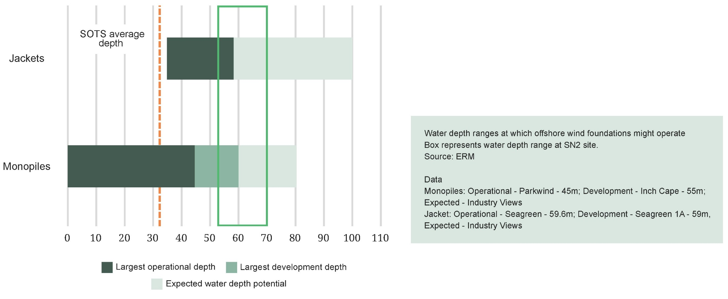

Water depth – primary technical driver
Offshore wind analytics provider Sea Impact, which assessed over 100 offshore windfarms, including over 5000 foundations, found only five small projects have used jacket foundations at water depths below the average water depth for the project (Figure 2-5).
Figure 2-5 Water depth vs foundation type
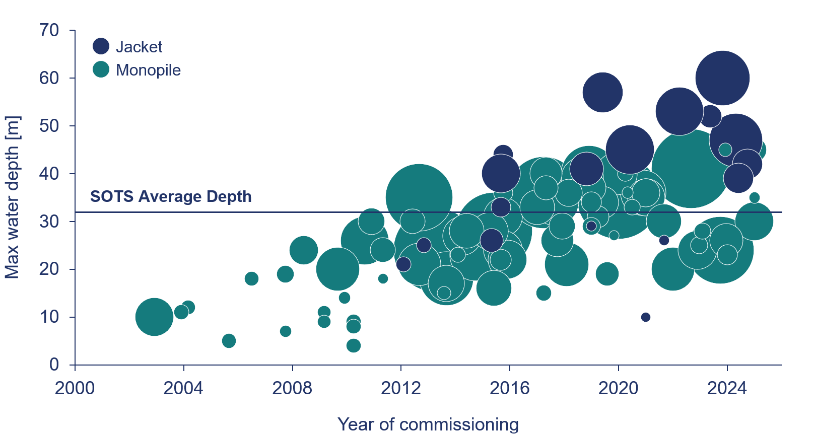
Three of these projects were early 5 MW deployments for heavier turbine models that are no longer available (RePower and Areva turbines) installed in 2012 and 2015. They also were developed at a time when an extra-large monopiles (diameters over seven metres) were not available or only emerging. The remaining two projects were demonstrator projects.
This data set confirms water depths are a primary driver for technical consideration of foundations. Where projects have water depths similar to the project, monopiles are the selected foundation.

Seabed

Driven pile installation
The project’s seabed composition / geology is well suited to pile-driven structures, including both monopiles and jackets.
Star of the South’s extensive geotechnical and geophysical investigations show no evidence of cemented sands (grains becoming stuck together which can increase the risk of pile driving refusal) within the project area. Extrapolation of this geotechnical observation using the geophysical data acquired has shown cementation and subsequent pile driving refusal is a low risk for the project.
However, the risk of pile driving refusal is relative to the number of longer piles, of which a greater number are required for jacket structures making monopiles a more attractive option.

Seabed mobility
High levels of seabed mobility can present a challenge to both construction and design for jackets and monopiles. Due to the wider footprint of a jacket compared to a monopile, the challenges during construction are typically greater for jackets, as they require a larger area that is within the flatness requirement to place the seabed template for the pre-piling activity.
Monopiles are placed directly on the seabed, so are less sensitive to local seabed slopes during construction. During the operational phase, both monopiles and pin-pile jackets must be designed to withstand the expected amounts of seabed level change, which may be achieved by designing for the highest and lowest expected seabed levels, or by providing scour protection to maintain the initial seabed level throughout the project’s operational life.
For both options, the expected seabed mobility, and seabed slope across the project area is considered as within normal limits, and both foundation options are suitable.

Provision of lateral and vertical support
A monopile foundation type predominantly resists the applied horizontal loading from wind and waves on the structure through the lateral resistance of the ground. The sands in the project’s offshore wind farm area are ideal for resisting these lateral loads and the resulting monopile designs are expected to be some of the most efficient when considering the applied loading, the water depths, and the harvested energy from the wind.
Jacket structures turn the applied lateral loading into a vertical downwards push in the downwind pile(s), and vertical upwards pull in the upwind pile(s). The sands in the project area make pile driving relatively straightforward, as described in the previous section. However, generating enough resistance to vertical loading from the weight of the pin piles is considered as more challenging. This means that jacket pin-piles are longer than they would be in ideal conditions, making a pin-pile jacket a second preference choice for this site, compared to a monopile which is a first choice.

Fabrication and supply chain
Monopiles performed more strongly against the fabrication and supply chain criterion. Monopile fabrication is completed in factory type conditions allowing economies of scale, improved quality control and stable supply chains. This is preferred to jacket fabrication which is generally completed in shipbuilding facilities or general marine fabrication yards that do not specialise in supplying offshore wind foundations.

Fabrication process and capabilities
Monopiles are a mature technology with well-established supply chains. They are straightforward to fabricate and relatively inexpensive to manufacture and, as described in Section 2.1.1. Jackets are more complex and labour intensive to fabricate.
Typically, when designing monopiles for a project, each individual monopile location gets a location-specific design to match its precise geotechnical condition and water depth. Due to the relative simplicity of monopile fabrication, these changes can be made by adjusting the number or size of “cans” or the steel plate thickness included within the cans. This ability to design based on location specific ground and water conditions, means that monopiles can be designed to have the minimum amount of steel for its design location.
Figure 2-6 A monopile is made up of a series of flat sheets that are rolled and welded forming ‘cans’. These cans are then welded together to form a monopile.
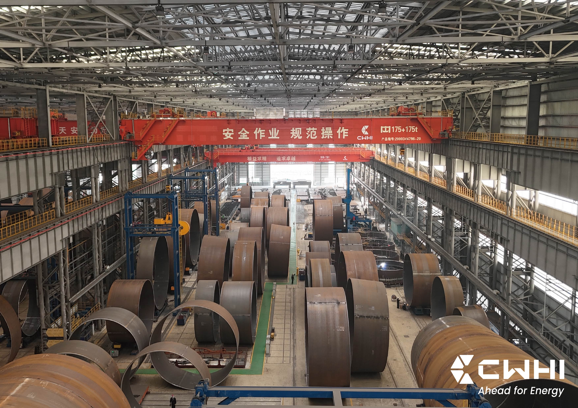
Source: CWHI
Jackets are typically designed in ‘clusters’ whereby a number of jacket designs (heights) are used, with a variable ‘stick up’ for the pin piles, above seabed. That way, a common ‘Interface level’ can be maintained, such that all parts of every jacket are visible above water and look the same. This generic approach to jacket design and fabrication is necessary to keep the fabrication complexity manageable. This however also results in inefficiency in having some jacket locations using higher amounts of steel than if location specific designs could be applied.
Due to their simple construction, monopiles are around four times faster (and accordingly, less expensive) to manufacture than jacket foundations.
As turbine sizes increase, so do the sizes of the foundations. The number of suppliers able to supply these larger foundations is limited, both for jackets and for larger diameter monopiles.
For jackets, based on current capacity globally, suppliers can produce an estimated 440 units / year.2 The Asia-Pacific region (excluding China and India) can produce 130 jacket units per year across the supply chain.
For monopiles, there are currently four suppliers in the Asia-Pacific region with capabilities to produce monopiles and transition pieces with a maximum diameter over 10.5 meters. Each supplier can supply between 50-100 monopiles per year (a total of up to 400 monopiles per year in the region).
Based on the above, the supply chain for both components is limited. However, monopile fabrication does have an increased level of stability in output (400 monopile units produced annually in the region compared to 130 jacket units) due to the production nature of establishing factory conditions with investment in handling and welding equipment. Jacket fabrication sees more cyclical output due to most of the industry being established around fabrication or shipyards which may take on projects other than jacket fabrication (e.g. ship building, oil and gas jackets, topside platforms).

Local content
Rolling capacity, volume constraints and fabricator proximity to deep water port infrastructure limit opportunities for monopiles to be produced in Australia. Australian steel mills do not yet produce the plate sizes and steel grades required to meet global manufacturing specification requirements for monopiles.
However, secondary structure components for the monopiles including internal / external platforms and boat landings are identified as local content opportunities with significant value-added content due to the labour intensive and intricate nature of the welding and fabrication required to produce these components.
The plate, tubulars, rails and hollow section steel products required for fabrication of these components is also readily available from Australian steel mills or through local steel distributors.
Currently, Australian steel manufacturers cannot produce the primary steel grades that would be required for jacket components. Limitations of Australian rolling capacities and maximum plate lengths (currently at 6.2m) would be unsuitable. Jacket components could be free issued from overseas and assembled in Australia, but this limits local content input and output constraints would still exist. Additionally, jacket fabrication is labour intensive, and the cost of Australian wages would significantly increase CAPEX and overall project costs.
There are several specialised local suppliers who fabricate large bespoke structures for the mining and oil gas industries which would have capacity / capability of producing a limited number of jacket foundations for the project’s five offshore substations. However, these suppliers are not set up at a scale large enough to effectively fabricate the high-volume outputs required for an offshore wind farm comprising up to 147 turbines.

Vessel and equipment limitations
It is assumed that both jackets and monopiles would be fabricated internationally, likely within the Asia-Pacific region and transported to Australia. This is due to the current limitations in Australian manufacturing, with a focus on secondary steel local content opportunities or extremely small volumes of foundations.
The most optimised vessel deck layout depends on the exact dimensions of the monopiles, order variation, production schedule, installation schedule, port restrictions and vessel availability. This cannot be determined accurately at this time, however analysis was undertaken on monopiles ranging from 8.6 meters diameter and 50.6 metres long in shallow waters to 11.8 diameters and 91.3 metres in deep water for the project site.
Star of the South examined 107 vessels including Heavy Transport Vessels (HTV) and Semi-submersible Heavy Transport Vessels (SSHTV) available internationally to generate the following estimates:
- 94 vessels could transport at least six shallow water monopiles at a time.
- 12 vessels could transport at least six deep water monopiles at a time.
- 30 vessels can transport at least eight shallow water monopiles at a time.
- Five vessels could transport at least eight deep water monopiles at a time.
The base case assumption, pending vessel availability, would be eight shallow water monopiles per vessel trip and six deep water monopiles per vessel trip. Of these 107 vessels, 50 vessels would likely be capable of transporting at least eight jacket foundations at a time. However jackets are typically transported in a vertical position, which reduces stability of the vessel and accordingly impacts the workability and efficiency of the vessel with speed and weather limitations likely.
Figure 2-7 shows an indicative configuration of a vessel transporting eight jackets allowing five metres between the corners of the jackets and 10 metres between the sides of the jackets. For a jacket foundation the required pin piles would need to transit separately on a different vessel.
Figure 2-7 Jacket transportation vessel
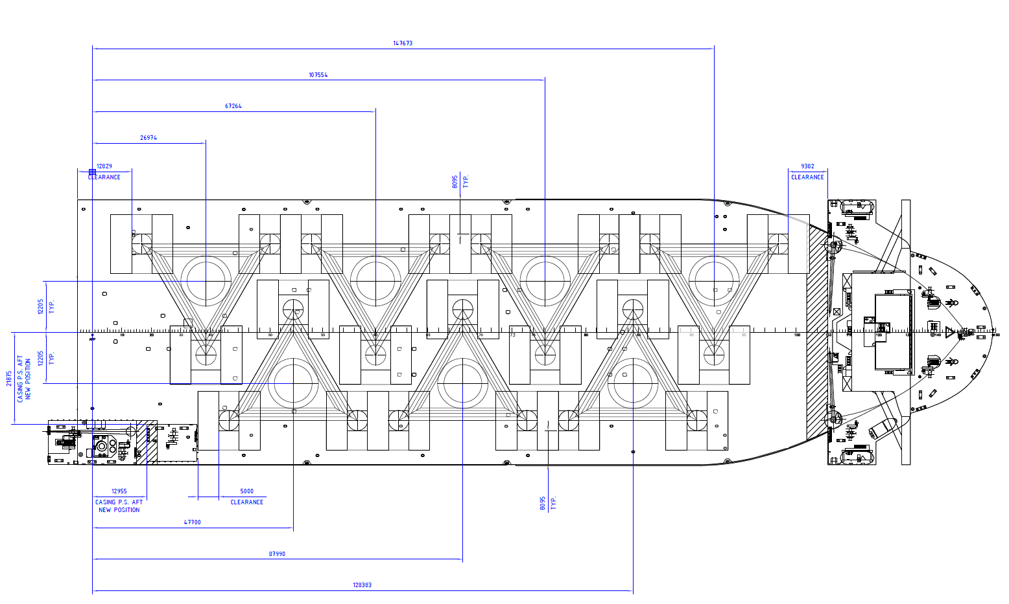
It is assumed both jackets and piles will be transported to a marshalling port for storage prior to installation. Pin piles are normally installed prior to jackets and need separate vessel transport and marshalling. Monopiles do not have this complexity and transition pieces can be transported and installed from the same vessel as the monopile.
Jacket foundations, being both bulkier and more delicate, often require specialised equipment and more complex logistics, which can significantly increase handling and transportation time and expense. Where roll-roll off shipping is not available, cranes for lifting jacket structures require increased heights, which can result in the need for large ring cranes to be installed.
Figure 2-8 Comparison of construction techniques
A ring crane loading out a jacket for Seagreen transport to site | Self-Propelled Modular Transporters (SPMT) moving a monopile from a transport barge on the Jeonnam project
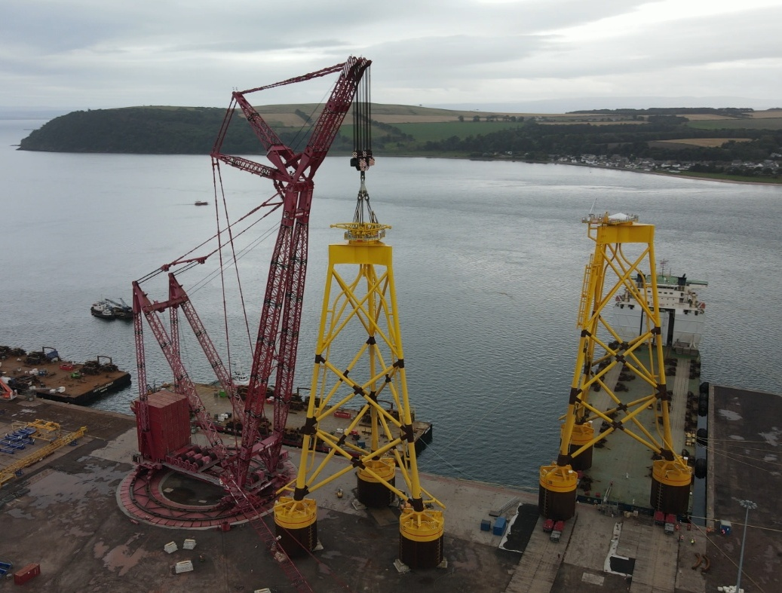 |  | 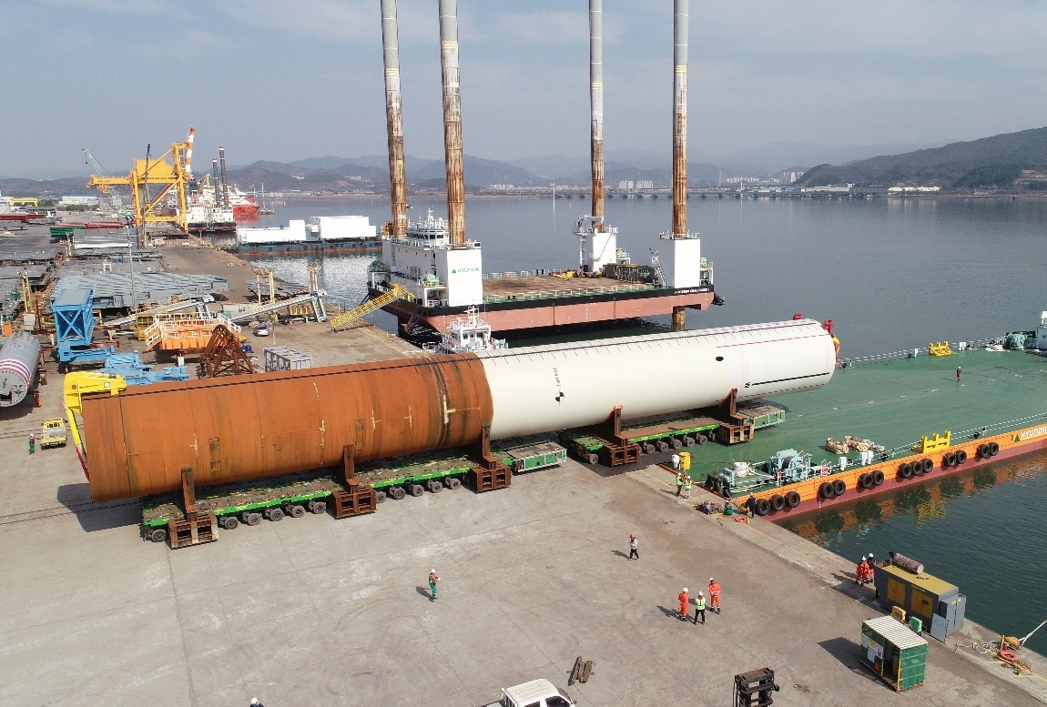

Installation vessel consideration
Installation vessel requirements are similar for jackets and monopiles. Required lifting capacities are up to 2068 tonnes for deep water monopiles and 2280 tonnes for jackets assuming dynamic amplification factors (which consider the impact of lifting dynamic loads rather than static). Crane hook heights for lifting jacket structures would be 73.8 metres compared to 77.8 metres for monopiles if upending via crane is used (monopile can be partly submerged during upending).
Analysis of vessel data shows 18 vessels currently on the market that are feasible for jacket installation. The same analysis shows there are 71 vessels capable of installing shallow depth monopiles and 34 that could install deep water monopiles, noting that the project would likely secure the same vessel to install all monopiles.
This analysis does not consider the availability of vessels at the time when they would be needed for the project. Having more vessels to select from will be an important factor in an Australian context where projects are competing globally to secure vessels in a constrained market.

Fabrication and transport schedule comparison
Monopiles performed more strongly against the fabrication and transport schedule criterion. Using data from completed offshore windfarms, and taking a sequential approach to ensure like-for-like comparison, the fabrication and delivery schedule for a wind farm using jackets would be twice as long as a monopile-based project.

Fabrication process and capabilities
For schedule scenario modelling, the following transport and fabrications assumptions were made:

Monopiles
Fabrication / transport activity | Duration / rate of fabrication
Steel order to first monopile | 6 months (lead time for the production and delivery of steel to the fabrication yard including buffer)
Rate of fabrication | 7 days per 2 monopiles  Assuming 2 fabricators, includes transition piece
Transportation to construction port | 6 months  8 monopiles per trip  Assuming 2 vessels
Project Reference:
Jeon Nam 1, Korea: 10 MP; 3 months steel order to first MP and then 1 MP / week (1 fabricator); Monopile Load-Out 3 months
Vineyard Wind 1, USA: 62 MP; 5 months steel order to first MP and then 0.92 MP / week (including TP); Transportation 4 months (from EU)

Pin piles for jackets (3 pin piles per jacket foundation)
Fabrication / transport activity | Duration / rate of fabrication
Steel order to first pin pile | 6 months (lead time for the production and delivery of steel to the fabrication yard including buffer)
Rate of fabrication | 3 days per 2 pin piles  Assuming 2 fabricators
Transportation to construction port | 6 months
Project Reference:
Zhong Neng, Taiwan: 31 Jackets; Approx. 3 days per pin pile fabrication.

Jackets
Fabrication / transport activity | Duration / rate of fabrication
Steel order to first jacket | 9 months (lead time for the production and delivery of steel to the fabrication yard including buffer)
Rate of fabrication | 7 days per 2 jackets  Assuming 2 fabricators
Rate of jacket assembly | 14 days per 2 jackets (assuming 2 fabricators)  Assembly starts 3 months after fabrication starts
Transportation to construction port | 6 months  8 Jackets per trip  Assuming 2 vessels
Project Reference:
Zhong Neng: 31 Jackets; 2 jackets per month fabrication and assembly (local supplier); 6-month lead time for steel.
When applying sequential activities without optimisations, the overall fabrication and transport program is significantly longer for jackets compared with monopiles, as shown in Figure 2-9.
Figure 2-9 Fabrication and transport schedule
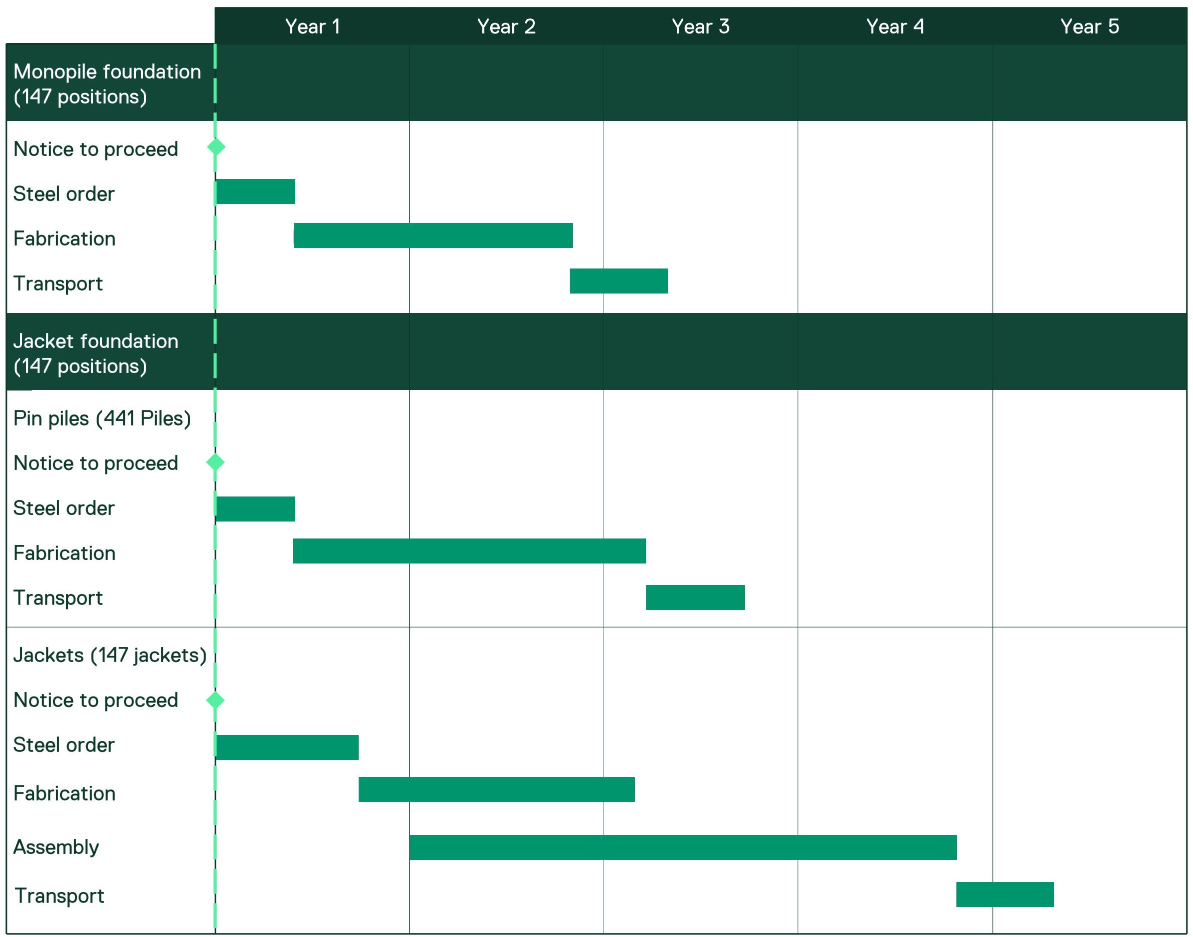

Installation and schedule
Monopiles performed more strongly against the installation and schedule criterion. Monopile installation is less complex than jacket installation and accordingly is significantly shorter in duration. Jacket installation requires coordination of pin pile installation as well as the jackets, introducing additional environmental impacts, costs, risk and time to the project schedule.

Installation sequence and complexity
There are various installation methods for jackets and monopiles. The optimal installation method will depend on the specific site conditions and availability of vessels.
There is an option for jackets and pin piles or monopiles to be transported to site on barges and then transferred to the offshore installation vessel. Depending on the barge size, two to three jackets or monopiles can be transported per trip. There is also possibility that monopiles, as hollow tubes, can be floated out, which is common practice for Baltic Sea projects.
Another option is to have the installation vessel transit to port and pick up foundation components. This option has been assumed as the optimal solution for the project as it will be less exposed to weather than a barge and avoids the need for high-risk transfer operations in open waters.
This approach has been used at the Hai Long Project (Taiwan), where the Green Jade installation vessel undertook piling activities during a first season and could transport and install two jackets at a time during the jacket installation season (Figure 2-10 - left). Depending on the ultimate jacket weight and hook height only certain installation vessels can do jacket installation. However, analysis completed on the Deme Orion (sister vessel to the Green Jade), shows that it is capable of installing four monopiles and four transition pieces per trip, or six monopiles per trip as done for Coastal Virginia project (Figure 2-10 - right).

Figure 2-10 Foundation Installations
Bokalift 1 installing jackets at Changfang and Xidao Offshore Wind Project | Orion installing monopiles at Vineyard Wind
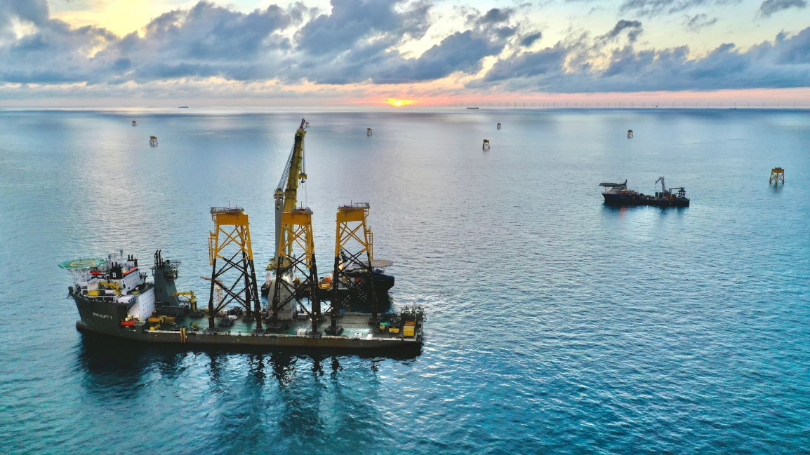 | 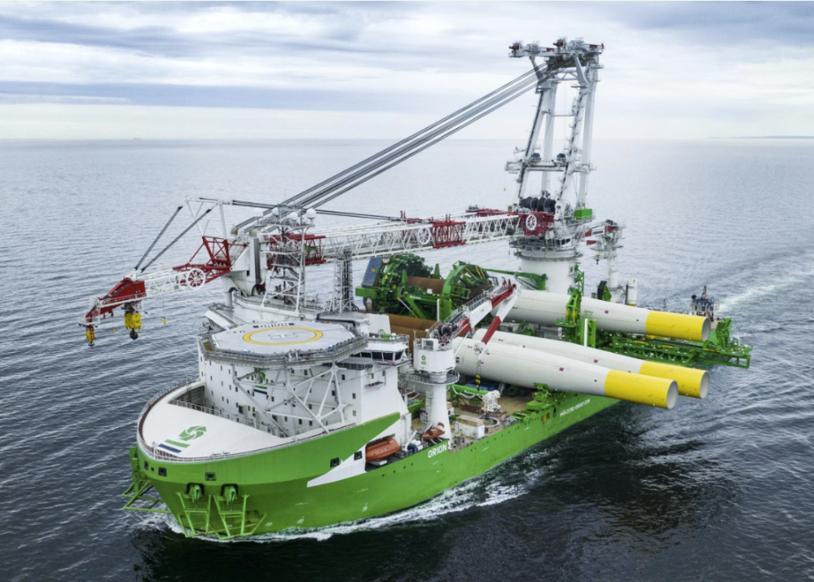
Installation of jackets and pin piles is usually performed in two separate campaigns. Pin piles will typically be installed in the first campaign to avoid significant commercial risks (associated with contracting vessels, jacket delivery and port supplies) to the jacket installation campaign should the pin pile installation campaign encounter unexpected delays.
The commercial exposure of having jacket installation delayed is too significant to risk concurrent pin pile and jacket installation campaigns. This risk is evidenced by track records of projects having challenging pin pile installation campaigns due to unexpected soil conditions or poor performing foundation installation. Projects such as Neart na Gaoithe (Scotland) have experienced significant delays requiring three seasons to install pin piles for 54 jackets due to difficult seabed conditions.
Adding to the installation logistics, jacket pin piles require the use of a subsea template which is lowered onto the seabed to ensure that the piles are installed in the correct positions. If there is a significant lapse in time between installation of the pin piles and the jackets, further work may be required to clean the piles, remove any marine growth and undertake any necessary seabed dredging to deal mitigate sediment movement.
Monopile installation by comparison is simpler, once monopiles are transported to the site, the installation crew typically upends the monopile from the installation vessel and drives the monopiles into the seabed with a hydraulic pile hammer. This means the installation process that is shorter, simpler and less weather-dependent, allowing for greater flexibility in offshore operations and fewer delays.

Comparative data
Sea Impact has analysed more than 5000 foundation installations in over 100 projects to understand average installation duration times, as shown in Figure 2-11. This shows that jacket foundations require double the mean time on site from vessels, and the duration for jacket installations have higher uncertainties associated with the risks for installing multiple piles and the jacket structure.
Figure 2-11 On-position installation duration by foundation type
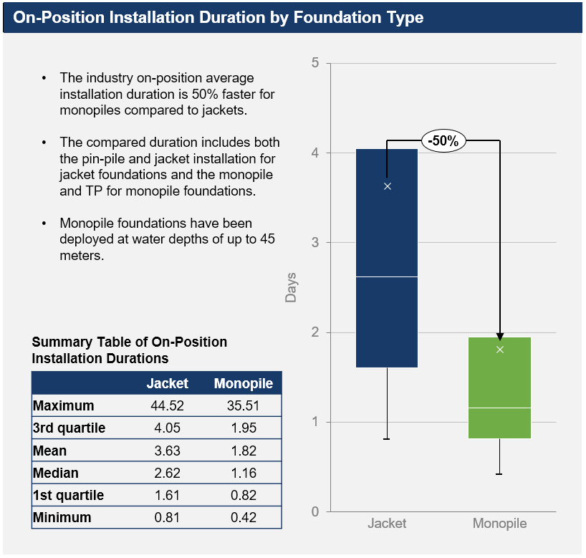

Installation schedule basis
The installation schedule for pin piled and jacket foundation involves considerably more time compared with monopiles. A like-for-like program comparison for a 2.2 GW offshore wind project shows an additional 2.5 years required for a jacket offshore installation compared to a monopile.
For schedule scenario modelling, the following assumptions are made:

Monopiles average installation rate = 4.92 days per Monopile
- One vessel available for monopiles and wind turbine installation
- Two months for vessel modification after monopile installation before moving on to turbines
- One month before foundation installation starts for seabed preparation of offsite works
- Three monopiles installed per vessel trip
- Contingency allowances (i.e. environmental impact mitigations, inclement weather etc).
Project Reference:
Jeon Nam 1, Korea: 4 – 6 days average Monopile installation duration (without drilling – for 8 Monopiles)
Vineyard Wind 1, USA: 2 days average Monopile installation (for 62 Monopiles)

Jackets
- One vessel for jacket foundations and wind turbines
- Separate vessel for pin pile installation
- Two months for vessel modification after jacket installation before moving on to turbines
- One month before foundation installation start for seabed preparation of offsite works
- Assume jacket installation to begin after completion of pin pile installation campaign to de-risk vessel idling and allow for soil ageing.

Pin piles average installation rate = 5.5 days per position (3 pin piles)
- Assume two times three pin piles installed per trip
- Contingency allowances (i.e. environmental impact mitigations, inclement weather etc).
Project Reference:
Zhong Neng, Taiwan: 2.9 days per position (3 pin piles); allowed for double bubble curtain & noise monitoring; no night-time restrictions

Jacket average installation rate = 6.58 days per jacket
- Assume two times jackets installed per trip
- Contingency allowances (i.e. environmental impact mitigations, inclement weather etc).
Project Reference:
Zhong Neng, Taiwan: 4.3 days per jacket; no marine mammal monitoring; no night-time restrictions
From the above assumptions, the timeline in Figure 2-12 shows the comparison between monopile and jacket foundation installation campaigns for a 2.2 GW offshore wind farm scenario under comparative conditions / assumptions.
Figure 2-12 Installation schedule
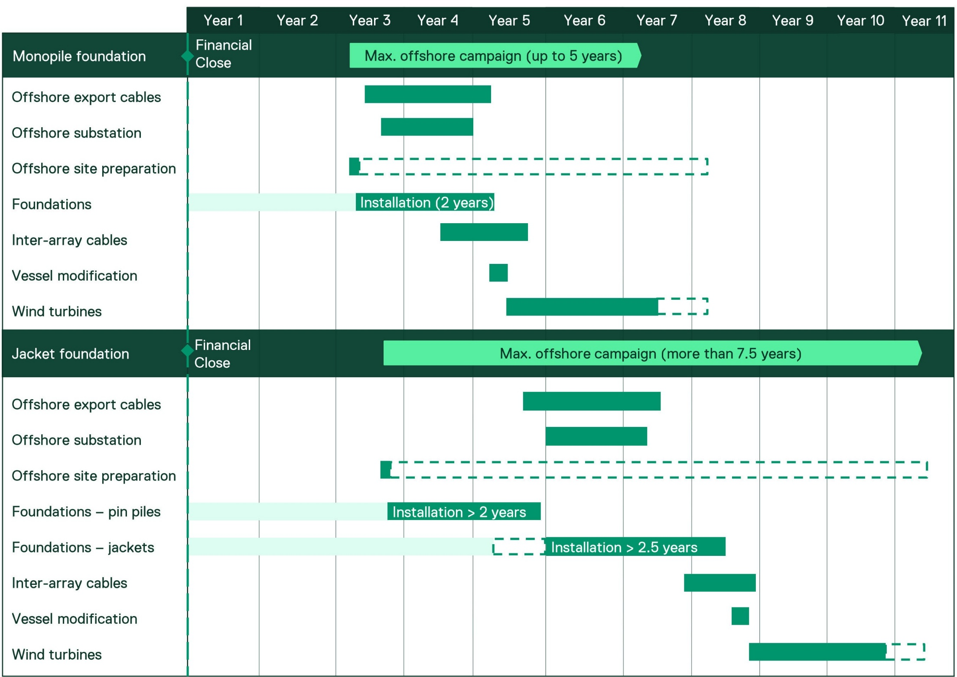
Installation
Supply (fabrication and transport)
Legend:
As shown, the installation campaign for jackets will take longer than monopiles due to the additional time needed to install pin piles and the long lead times for jackets fabrication.
There are options available for both monopiles and jackets to expediate delivery times and accelerate offshore activities in various ways, with the above table providing a relative comparison between the two foundation types only on a sequential basis for like-for-like comparison.
The longer overall timeframes for jackets expose the project to increased risks such as increased weather delays, environmental mitigations, contracting strategy and HSE risks.

Ports
Monopiles performed more strongly against the port’s criterion. Despite the geometrical differences between monopiles and jackets, the storage and handling requirements are reasonably similar from a port perspective, with the potential for jackets to require increased crane capacity if no roll on / roll off facility is possible.
However, pin pile and jacket foundations require considerably longer port lease durations which prevents the project from using a single port approach, increases port costs for the project and increases project risks in the event of delays (i.e. port space is no longer available). There is limited ability to accelerate a combined pin pile and jacket port due to port berths being constrained by the number of transport and installation vessels attempting to access in parallel.

Storage considerations
Star of the South assumes multiple ports will be required to support the project’s construction and operations. For the construction phase, the preferred approach is to use two separate ports for the foundation components and the wind turbine generator components.
Typically, foundation components will be offloaded in the marshalling port, transported to the storage area, stored, preserved, commissioned and pre-assembled where required before being loaded out onto the offshore installation vessel. The navigability, quayside, equipment, ground bearing and general port requirements are very similar for either monopiles or jacket foundation types.
Due to the distance of the project to global supply chains, the project has high port storage requirements. To ensure a continuous, uninterrupted flow during the installation of foundations, Star of the South assumes that storage space requirements for a 2.2 GW project will be approximately 7.5 hectares for monopiles or jackets. This includes enough storage for components, service corridors and ancillaries.
Component storage is assumed to be:
- Jackets = 530 m2
- Three x pin piles (144 m2 each) = 432 m2
- Monopile horizontal footprint = 1156 m2
- Transition piece = 96 m2
Jackets have a smaller storage footprint when compared to monopiles which are stored horizontally. However, jackets are heavier and require additional space for pin piles. The height of transition pieces are typically around 30 meters, and jackets in storage are around 70-90 m.
A ring crane may be needed to lift jacket structures on or off transport vessels but otherwise the equipment requirements are similar for both foundation types, and it is expected contractors would supply suitable cranes and lifting equipment. Suitable ground bearing conditions are similarly required for both monopiles and jackets.

Port logistics
The largest difference between monopiles and jackets is the logistic flows and the duration of port access. It is expected monopiles would require two-year port access duration for foundation scope.
As described in Section 2.5.1, pin piles and jackets are normally installed in two campaigns. This can be considered in two scenarios:
              - Completely separate installation campaigns, with a break between to avoid any overlapping logistics (i.e. jacket deliveries while pin piles are being loaded out). However, under this scenario the required port duration would be significantly extended. For a 2.2.GW project (without any optimisation) this would require over five years of port lease for foundation scope only.
Concurrent installation of pin piles and jackets so that the two scopes can operate out of a single port. This could significantly reduce the duration of the port lease by around 2.5 years however will require sufficient berths that allow for concurrent vessel operations for pin pile transport, jacket transport, pin pile installation and jacket installation.

Operations and maintenance and decommissioning
Monopiles performed more strongly against the operations and maintenance and decommissioning criterion. The complexity of the jacket structure increases the operations and maintenance and decommissioning considerations to a greater extent than required for the monopile foundation.

Operations and maintenance
While both monopile and jacket foundations require relatively low maintenance compared with the actual wind turbine generators, the simpler design of monopiles involves fewer structural elements, which means fewer components are exposed to marine conditions. This results in lower maintenance and inspection requirements, as well as expected corrective maintenance (i.e. repairs) compared with the more intricate jacket foundations, which have multiple nodes and joints susceptible to additional corrosion and wear.
There is increased inspection complexity for jackets, with monopiles having less components that are easier to access (both below and above water). Easier access of components increases repair speed for repainting, marine growth removal etc, as a result. Jackets have an overall increased inspection time and rely more heavily on remote operated vessels and drones for inspections.
Anti-corrosion systems are applied to foundations that rely upon ‘sacrificial anodes,’ which are highly active metals included to protect the critical structural steel components in the structure. The sacrificial anodes will corrode instead of the parts of the foundation that are critical to maintaining structural integrity.
It is easier to create an even corrosion protection field within a jacket structure, however due to the complexity with many critical joints / welds, it is more challenging to design anti-corrosion systems than for a simpler monopile structure where anodes can typically be attached to secondary members (anode cages or transition piece skirts). Accordingly, associated maintenance regimes are more complex for jackets than monopiles and inspections will typically take longer and may require more detailed inspections.

Decommissioning
When the decommissioning period is reached, commitments made at the permitting stage should be reviewed and updated to ensure the best overall outcome for the natural world. If offshore structures and scour protection have been well colonised by marine flora and fauna, there may be a legitimate argument that the extent of decommissioning and removal of offshore infrastructure is limited.
Notwithstanding the above, monopiles having one pile compared to multiple piles for jackets means any offshore decommissioning is expected to be more straightforward for monopiles, and less impactful to the offshore environment, than for jackets.
Monopiles may be cut off close to the seabed and removed in a single lift (after the transition piece is removed), or they may be cut down into pieces, so that a smaller vessel can do the removal over a longer time. Jackets may also be cut off close to seabed, and removed as one or in smaller sections.
There is a possibility that total removal of monopiles could be achieved. This would be best achieved with flanged monopiles, whereby the transition piece could be unbolted and removed, and the monopile could be pulled from the ground using a large vibro-driving hammer. Jacket pin piles could be theoretically removed in the same way, although their termination level close to seabed, and the grouted connection into the jacket stab-in are complicating factors.
In general, jackets will likely require more intensive and complex transport operations given the structure sections (i.e. more segmented scrap metal).

Carbon footprint
Monopiles performed more strongly against the carbon footprint criterion. Monopiles have lower embodied carbon than jacket and pin pile foundations.

Embodied carbon
The evaluation conducted a lifecycle embodied energy assessment for the manufacturing, installation, operation and decommissioning of each component based on a 15 MW wind turbine generator. The assessment can be used as a proxy measurement of carbon footprint to evaluate climate impacts of the component during its manufacture.
It is critical that the offshore wind industry considers embodied energy as a key project input if the industry is to achieve net zero carbon emissions.
Most of the embodied energy for offshore wind projects is produced in the initial stages through production of raw materials, transportation of these materials for fabrication of components and finally transportation to site for installation.
Overall tonnages of steel and concrete are used as proxy indicators of embodied energy when evaluating foundation options. This is because steel and concrete are the primary materials forming the structure and the largest contributors to embodied energy. It is estimated that between 2.4 and 2.6 tonnes of CO2 are produced per tonne of primary steel (excluding fabrication, transportation and installation) highlighting the potential to reduce embodied energy through efficient design. A generic jacket foundation total weight is approximately 1.8 times the weight of a monopile foundation.
An evaluation of embodied energy is carried out, following the principles and methods set out in IStructE’s guidance document on how to calculate embodied carbon.
Table 2-1 Embodied energy and carbon for each foundation option
Foundation type | Embodied energy (GJ per wind turbine generator) | Embodied carbon (tCO@e per wind turbine generator)
Monopile | 30,000 | 1,900
Jacket with pin piles | 36,000 | 2,400

Cost and business case
Commercial in Confidence
Monopiles performed more strongly against the cost and business case criterion. Monopile foundations are the preferred choice in the offshore wind industry, offering distinct commercial advantages over jacket foundations where they are technically viable.

Cost-effectiveness
Monopiles are recognised for their overall cost efficiency across various stages of design, manufacturing, and deployment. Their simpler structure and streamlined processes contribute significantly to lower expenses compared to jacket foundations. These can be grouped into the following main drivers:
            - Steel weight
  - Monopiles require less steel compared to jacket foundations due to their simpler design. This reduction in materials directly lowers the overall cost. While exact weight is subject to final design that considers multiple factors, a generic jacket foundation total weight is approximately 1.8 times the weight of a monopile foundation for a 30-metre water depth and average soil conditions.
  - Monopiles are generally designed specifically for each turbine location, allowing the steel weight to be adjusted based on water depth and ground conditions for each location.
  - Jackets are designed as clusters, resulting in many locations having additional steel to the required steel weight due to the complexity of designing and fabricating location specific structures for jackets.
            - Fabrication cost
  - The straightforward design of monopiles reduces fabrication complexity, leading to lower production costs. This includes savings on labour and equipment used in manufacturing.
  - Jacket foundations often require multiple fabricators working in parallel due to their complex design and limited supply capability, increasing logistical coordination and overall production expenses.
  - Due to the complexity of jacket fabrication processes, suppliers and contractors typically add-on additional premiums to cover for potential variation orders and cost overruns.
  - For a generic turbine in 30 metres water depth, jacket fabrication costs are double the cost of a monopile.
            - Coating and surface treatment costs
  - Monopiles have fewer surfaces and joints requiring protective coatings and treatments compared to jacket foundations. This minimises costs associated with corrosion protection and maintenance.
  - A generic jacket costs 1.3 times a monopile in coating and surface treatment.
  - Overall, total supply cost for a generic jacket foundation is approximately 1.7 times the supply cost of a monopile.
            - Installation and logistics costs
  - Jacket foundations, being larger and heavier, often require specialised vessels and more complex logistics, which can significantly increase transportation expenses and add complexity and cost to the supply chain.
  - Monopiles are installed using simpler and faster techniques, such as pile driving, which requires less time and specialised equipment compared with the multi-step process needed for jacket foundations. Jackets often demand additional preparation, including pre-installing anchors and securing multiple legs, which increases costs.
  - The installation process for monopiles is less weather-dependent, allowing for greater flexibility and fewer delays, further enhancing cost efficiency. This is further amplified in a constrained installation vessel supply chain where projects are competing globally to secure vessels in the most efficient way.
  - For the same 2.2 GW project with 15 MW turbines, a non-optimised schedule for monopile installation could be completed in 2.5 years shorter compared to jackets, resulting in substantial savings.
  - Depending on weather conditions, availability and proximity to vessels, direct installation costs for jacket foundations can range between two to 2.5 times those for monopiles. This is due to longer installation timeline, additional campaigns (pin pile and jacket vs monopile), and longer exposure to high vessel day rates.
            - Reduced maintenance requirements
  - While both monopile and jacket foundations require relatively low maintenance, the simpler design of monopiles involves fewer structural elements, so fewer components are exposed to marine conditions. This results in lower maintenance and inspection requirements and expected repairs compared with more intricate jacket foundations, which have multiple nodes and joints susceptible to additional corrosion and wear.
            - Proven track record
  - Monopiles have been successfully deployed in numerous offshore wind projects worldwide, demonstrating their reliability and performance. This proven track record builds confidence among developers and investors, making monopiles a safer and more predictable choice. Additionally, the reduced logistical complexity and improved reliability lowers insurance costs and enhances the bankability of projects, making them more attractive to financiers.

Overall
The overall cost differential for the supply and installation of jacket foundations compared with monopile foundations is over $500 million per GW. For Victoria to meet its offshore wind target of 9 GW by 2040, this would mean an additional cost of approximately $4.7 billion to the end consumers / taxpayers. Furthermore, the lengthier timeline for fabrication and installation of jacket foundations would result in significant risk of not meeting the Victorian Government’s offshore wind target of 2 GW by 2032.

Conclusion
This technical report provides further details and empirical data in relation to the evaluation of monopiles and jacket foundations. It demonstrates how and why the monopile was selected as the preferred foundation option for the project against a range of criteria including health and safety requirements, technical suitability, fabrication, transport and logistics, installation, schedule, ports, operation and maintenance, decommissioning, carbon footprint and commercial / cost. The monopile performed more highly for all criteria than jackets.

References
ERM, Global Supply Chain Study, 2024.
Global Offshore Wind Health and Safety Organisation, Steel Fabrication in the Offshore Wind Industry- A good practice guidance for Developers, December 2024, https://www.gplusoffshorewind.com/__data/assets/pdf_file/0003/1604136/G-Steel-fabrication-in-the-offshore-wind-industry.pdf
Global Offshore Wind Health and Safety Organisation, G+ White paper Steel fabrication for the offshore wind industry – safety, practices, and opportunities, March 2024, https://www.gplusoffshorewind.com/__data/assets/pdf_file/0012/1497648/414608a0a8ab44c75cda06286bb34204ad09137d.pdf
Global Wind Energy Council, Mission Critical: Building The Global Wind Energy Supply Chain For A 1.5°C World, 2023, https://gwec.net/supplychainreport2023/
Institute of Civil Engineers, ICE Database V3.0. 10 November 2019, https://circularecology.com/embodied-carbon-footprint-database.html
Institution of Structural Engineers, How to calculate embodied carbon, Version 1.0, 2020.
Sea Impact, Foundation Market Insights Foundation Data: Insights on Foundation Usages & Installation Durations, 2024, https://sea-impact.com/market-intelligence-platform/

Smulders, Offshore Wind Foundations
Sif Offshore Foundations, Monopiles and Transition Pieces
Taiwan jacket assembly at Samkang, Jan De Nul nears completion of fabrication of foundations for Taiwan’s Changhua Offshore Wind Farm | Jan De Nul
Image supplied by CWHI
Image supplied by CWHI
RenewableUK, 2025, Global operational offshore wind capacity grows by 15% in 12 months to 80 gigawatts
ERM, Global Supply Chain Study. Dated 2024.
Based on projects which have publicly announced foundation choices - 16% of global pipeline capacity.
Parkwind 45m water depth, 2022 Parkwind | Monopile installation completed at Arcadis Ost 1 offshore…
SIF expansion plans for 60m water depth, 2023 Sif-group | Expansion
Sea Impact, Foundation Market Insights Foundation Data: Insights on Foundation Usages & Installation Durations. Dated 2024. [Available online] https://sea-impact.com/market-intelligence-platform/
Smulders, Offshore Wind Foundations
Sif Offshore Foundations, Monopiles and Transition Pieces
Global Wind Energy Council, Mission Critical: Building The Global Wind Energy Supply Chain For A 1.5°C World. Dated 2023. [Available online] https://gwec.net/supplychainreport2023/
Ring crane for the Seagreen project 2023, Offshore wind jacket lift via ring crane | Mammoet case study
Sea Impact, Foundation Market Insights Foundation Data: Insights on Foundation Usages & Installation Durations. Dated 2024. [Available online] https://sea-impact.com/market-intelligence-platform/
Institute of Civil Engineers, ICE Database V3.0. Dated 10 November 2019. [Available online] https://circularecology.com/embodied-carbon-footprint-database.html
Institution of Structural Engineers, How to calculate embodied carbon, Version 1.0. Dated 2020.

