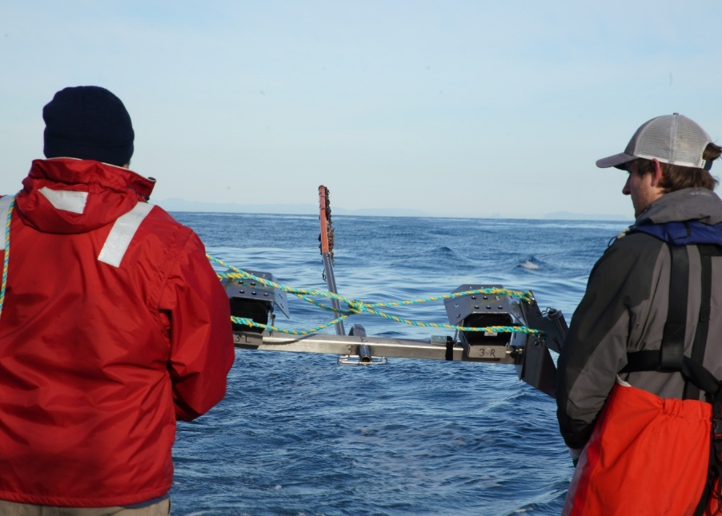

Commonwealth Environmental Impact Statement
Chapter 3 – Project development
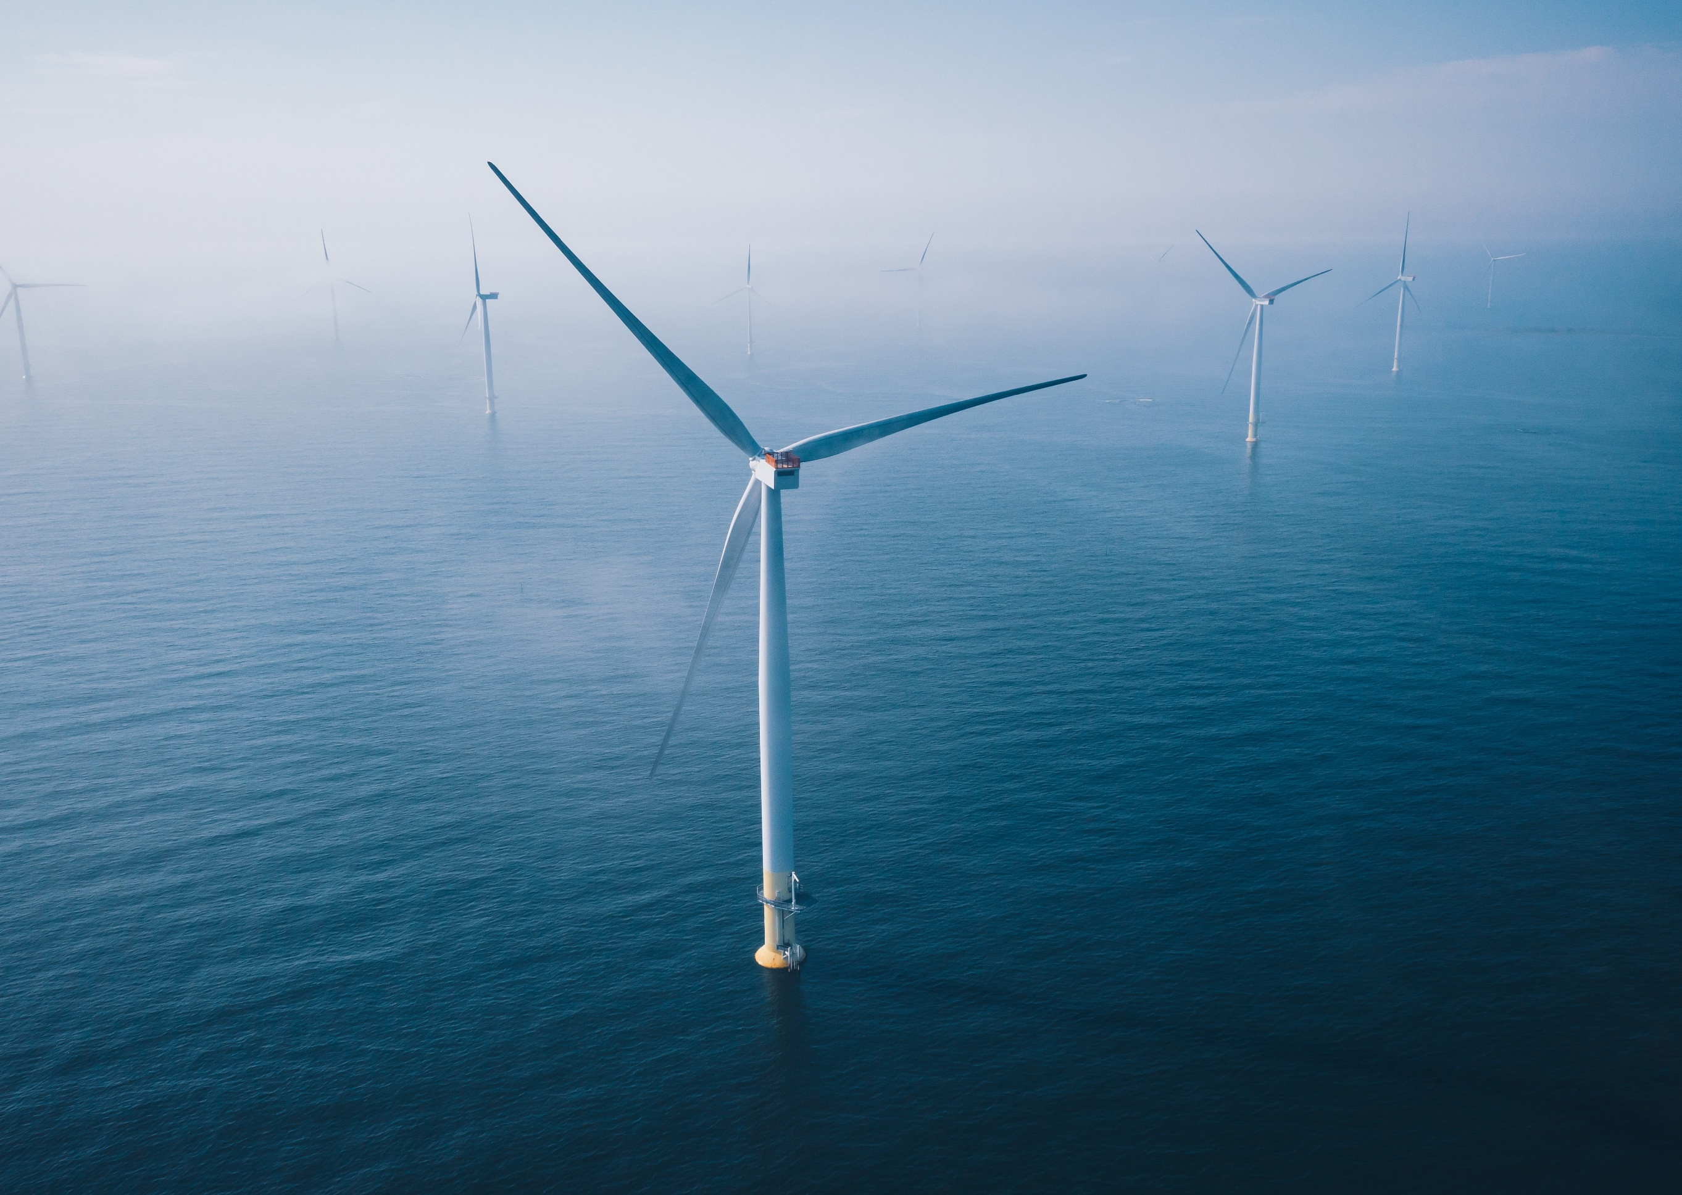
Table of Contents
Chapter 3 Project development 3-1
3.1 Introduction 3-1
3.1.1 Overview 3-1
3.1.2 Relevant EIS guidelines 3-1
3.1.3 Assessment of alternatives 3-2
3.2 Offshore wind farm alternatives 3-9
3.2.1 Site selection 3-9
3.2.2 Wind farm capacity 3-15
3.2.3 Wind farm layout 3-16
3.3 Turbine alternatives 3-17
3.3.1 Turbine type 3-17
3.3.2 Turbine size and capacity 3-17
3.3.3 Turbine number 3-18
3.3.4 Turbine foundation type and installation method 3-18
3.4 Transmission system alternatives 3-18
3.4.1 Transmission system technology 3-19
3.4.2 Offshore substation requirement and type 3-20
3.4.3 Offshore substation size, capacity, number and location 3-20
3.4.4 Offshore substation foundation type and installation method 3-20
3.4.5 Offshore cable alignments, protection and installation method 3-21
3.4.6 Offshore export cable number 3-23
3.4.7 Shore crossing location and installation method 3-23
3.4.8 Onshore transmission type and installation method 3-25
3.4.9 Onshore transmission alignment 3-25
3.4.10 Onshore substation location 3-32
3.5 Port alternatives 3-33

Figures
Figure 3-1 Exploration and feasibility licence areas 3-11
Figure 3-2 Project area overview 3-22
Figure 3-3 Shore crossing and onshore transmission corridor options (pre-referral) 3-27
Figure 3-4 Original EIS referral area 3-28
Figure 3-5 Onshore transmission system alignment options 3-31

Tables
Table 3-1 Summary of project components and alternatives considered 3-4
Table 3-2 Offshore wind turbine foundation options evaluated 3-18

Project development

Introduction
The Star of the South Offshore Wind Farm Project (the project) is Australia’s most advanced offshore wind project. The development process has involved identifying and evaluating a range of design options and alternatives considering environmental, technical, stakeholder and commercial factors.
This chapter outlines how the project design has evolved and explains the reasons behind key design decisions within the Commonwealth jurisdiction. It also discusses the alternatives considered and discarded, and future decisions to be confirmed in the detailed design phase, post environmental approval.

Overview
The project’s assessment process requires Star of the South to discuss and explain alternative design approaches and their potential adverse environmental effects.
Key project elements for which alternative design options were considered are:
- The offshore wind farm layout, location and capacity
- Offshore wind turbine configurations
- Offshore and onshore transmission infrastructure and locations
- Construction and operation port locations.
Where relevant, each alternative was evaluated against environmental, socio-economic, technical / constructability, commercial, procurement and logistical factors.

Relevant EIS guidelines
The EIS guidelines require the project’s EIS to discuss any feasible alternatives to the proposed action to the extent reasonably practicable, including:
- The alternative of taking no action (refer to Chapter 2 – Project Rationale)
- A comparative description of the impacts of each alternative on matters of national environmental significance protected under Part 3 of the Environment Protection and Biodiversity Conservation Act 1999 (Cth) (EPBC Act) (where applicable, impacts have been assessed in the technical reports, which inform the EIS)
- Where environmental impacts are likely to differ, sufficient detail to make clear why any one alternative is preferred to another
- How the choice of alternatives or options ensures impacts on matters of national environmental significance are appropriately minimised and managed to an acceptable level
- Discussion of the short, medium and long-term advantages and disadvantages of the options considered.

Assessment of alternatives
The selection of key project elements, such as components, design and installation methods, involves a series of decisions which consider of environmental and other factors. These decisions fall into three categories: confirmed, iterative and deferred.
- Confirmed: Made early, often dictated by technical and regulatory requirements. For example, the project must be located within a Commonwealth declared offshore wind area.
- Iterative: Made as environmental and social values become better understood, allowing avoidance and minimisation principles to be applied. For example, adjusting turbine design in response to bird survey data and modelling to reduce risks to birds.
- Deferred: Made post approval during detailed design, when project capacity, supply chain and component availability are certain, in accordance with approval conditions. For example, selecting a turbine size during procurement.
Design flexibility is essential for offshore wind projects due to rapid technological advances and long development timelines. To maintain this flexibility while ensuring a robust assessment, the project has adopted a project design envelope approach. A description is provided in Chapter 4 - Project Description.
Deferring some design decisions does not constrain the assessment of alternatives. Where project elements are undecided, the assessment outlines feasible alternatives and the evaluation approach, while comparing potential environmental impacts. The evaluation approach for alternatives is summarised in Table 3-1.
Assessing alternatives often involves balancing competing project priorities. Avoidance and minimisation principles are incorporated into decision-making on alternatives at all stages of project development.

Table 3-1 Summary of project components and alternatives considered
Project component | Decision timeframe | Type of alternatives | Reason for decision | Section providing further information
Offshore wind farm alternatives
Site selection | Confirmed: The offshore wind farm site was selected before applying for an exploration licence and updated during feasibility licencing. | Alternative locations were considered before applying for an exploration licence. The Gippsland coast has the strongest offshore wind fundamentals in the country. The project site offers a robust wind resource, shallow sea depths, avoids social and environmental features and habitats, and is in proximity to existing grid infrastructure which helps reduce potential land-based impacts. | The awarded feasibility licence confirms the offshore wind farm area. As it differs slightly from the earlier exploration licence area, an update was made to the original EPBC referral area in 2025 to reflect this. | Section 3.2.1
Wind farm capacity | Confirmed: A maximum capacity of up to 2.2 gigawatts (GW) was selected before referral. | Capacity is based on the development potential of the original exploration area and Victoria's electricity needs. A project of this capacity is needed to achieve economies of scale and attract international investment and supply chain interest, given Australia’s distance from established offshore wind markets. | Determining wind farm capacity at an early stage is critical as it guides project design and commercial decisions and enables the definition of parameters for the project's assessment. | Section 3.2.2
Wind farm layout | Deferred: The location of wind farm components will be further evaluated and finalised post approval. | The project has undergone several layout updates as more information becomes available regarding the wind resource, environmental investigations and technological advancements in turbine size.  The final siting of infrastructure will depend on the size, number and best locations to maximise wind farm productivity and minimise impacts. | Finalising the layout depends on several factors including turbine selection, the transmission concept (such as offshore substation station size and number), project approval conditions and detailed design. Commercial optimisation will also guide final decisions. | Section 3.2.3
Offshore wind turbine alternatives
Turbine type | Confirmed: Conventional horizontal-axis, three-blade rotor, selected before referral. | Alternative turbine types are not suitable for the project due to market readiness. | The turbine type was selected early in the development process, based on adopting proven technology with a mature supply chain. | Section 3.3.1
Turbine size and capacity | Deferred: Turbine size and model will be selected post approval.  Iterative: The turbine air gap parameter was decided during the assessment in response to avian collision risk modelling. | The assessment considers turbines with a maximum blade tip height between 271 m and 350 m. Turbine generation capacity and component size vary depending on the model selected. | Flexibility in the turbine selection process accommodates rapidly evolving offshore wind technology and supply chains. Turbine selection will be influenced by the models available in the market at the time of procurement.  However, the air gap between the turbine blades and the surface of the water will not be less than 35 m. | Section 3.3.2
Turbine number | Deferred: The final number of turbines will be determined post approval. | The assessment considers scenarios with between 113 and 147 turbines, refined down from an initial estimate of 400 turbines. The final number of turbines will depend on the selected turbine's capacity, overall design approach and size of the project. | Flexibility in the turbine selection process accommodates rapidly evolving technology and supply chains. Turbine selection will be influenced models available at the time of procurement. | Section 3.3.3
Turbine foundation type and installation method | Confirmed: Monopile foundation.  Iterative: Feasible foundation installation options were assessed and refined during EIS development. | Several turbine foundation alternatives were evaluated. Monopiles have been selected due to suitable water depths and seabed conditions, constructability and safety considerations, available port infrastructure and supply chain maturity. | Turbine foundation selection is fundamental to the project’s feasibility, requiring early selection. | Section 3.3.4 and Appendix A – Foundation Options Assessment
Transmission system alternatives
Transmission system technology | Confirmed: High voltage alternating current (HVAC) technology, selected before referral.  Deferred: Export voltages ranging from 220 to 275 kV are being assessed and will be finalised post approval. | Both high voltage direct current (HVDC) and HVAC technologies were considered, with HVAC identified as the most suitable option.  Feasible transmission system voltage alternatives range from 66 to 275 kV. Higher voltage options do not have the same proven performance in offshore export cable applications. | Early selection of transmission system technology is essential to determine project feasibility. When the project’s connection point changed during development, the technology choice was re-evaluated and HVAC reconfirmed as the most suitable option.  The voltage will be selected during detailed design, based on factors such as turbine selection, optimal substation and cable configurations, and grid requirements. | Section 3.4
Offshore substation requirements and type | Confirmed: Multiple offshore substations are required.  Confirmed: Fixed-bottom, HVAC offshore substations, selected before referral. | An alternative to using substations is to connect turbine inter-array cables directly to shore.  Alternatives to fixed-bottom offshore substations include floating and subsea options, neither of which are considered feasible for the project. | Connecting inter-array cables directly to shore was deemed unfeasible due to the project’s capacity, distance from the grid, and the larger offshore and onshore footprint it would require.  Early selection of the offshore substation type is necessary to confirm project feasibility. | Section 3.4.2
Offshore substation size, capacity, number and location | Deferred: Size, location and capacity will be finalised post approval.  The maximum number of substations being considered is five. | Alternatives include either fewer, larger offshore substations or more, smaller substations.  Larger capacity substations typically have a bigger seabed footprint and different foundation options. | Finalising offshore substation size, location and capacity are key design decisions which will be made post approval. | Section 3.4.3
Offshore substation foundation type and installation method | Deferred: Preferred offshore substation foundations will be determined post approval.  Deferred: The installation method will be confirmed when a foundation type is selected. | Options include jacket or monopile foundations. Larger offshore substations require jackets, while smaller substations can use either jackets or monopiles. | Substation foundation type will depend on the final number and size of the offshore substations, detailed geotechnical survey and supply chain availability. | Section 3.4.4
Offshore cable alignments, protection and installation method | Deferred: Alignments and configuration of inter-array, interlink and export cables will be finalised post approval.  Deferred: Installation method and cable protection type will be finalised post approval. | The final offshore export cable alignments will depend on the final offshore substation locations, the shore crossing site and any environmental or site constraints.  An offshore export cable area is being assessed. Export cables will be located within this area.  Final inter-array cable alignment will depend on the wind farm layout.  Offshore cables will be buried under the seabed and / or protected by mechanical means.  Installation methods include pre- and post-lay burial using different equipment or placement of rock, mattresses or other engineered solutions. A mix of cable protection types could be used. | To allow for flexibility in the final number of turbines and offshore substations, up to eight offshore export cables have been assessed to transfer electricity from the offshore substations to the onshore transmission system. | Section 3.4.5
Offshore export cable number | Deferred: The number of offshore export cables has been reduced from a maximum of 13 to eight. The final number will be determined post approval. | To export the electricity from an up to 2.2 GW offshore wind farm, up to eight offshore export cables are required. | The number of offshore export cables is subject to the final, optimised transmission system design. | Section 3.4.6
Shore crossing location and installation method | Confirmed: Reeves Beach has been selected as the project’s shore crossing site.  Confirmed: Trenchless installation methods. | McGaurans Beach was considered as an alternative location.  Alternative installation methods include variants of open trench installation. Trenchless is considered the only feasible technique for Reeves Beach to minimise impacts. | Shore crossing site selection was key to refining the offshore and onshore assessment areas. | Section 3.4.7
Onshore transmission type and installation method | Confirmed: Government policy is for all offshore wind transmission in the proposed Gippsland shoreline REZ to be installed underground.  Confirmed: Open trench with trenchless installation methods deployed in select locations. | Early transmission design alternatives included overhead or underground transmission. An underground transmission system was selected.  Underground installation methods include types of direct burial and ducted cable systems. Trenchless methods can also be used in required locations. | VicGrid has stipulated that onshore transmission systems for offshore wind projects connecting to the proposed VicGrid connection hub in Giffard must be installed underground.  An installation method will be chosen based on the final, optimised transmission system design post approval. | Section 3.4.8
Onshore transmission alignment | Confirmed: Preferred alignment selected. Includes three options to reach the VicGrid connection hub study area. | A wide range of alignment alternatives were evaluated to determine a preferred alignment. Creation of the VicGrid Gippsland Offshore Wind Transmission 2 GW project resulted in a reduced alignment length and the addition of three potential alignment options between the preferred (common) alignment and the VicGrid connection hub. | The alignment was selected prior to the VicGrid project and remains suitable. The alignment has been assessed for potential impacts and been subject to landholder and community consultation. | Section 3.4.9
Onshore substation location | Confirmed: To be located within the VicGrid connection hub study area. | No alternatives are being considered. | Location will be determined by the VicGrid Gippsland Offshore Wind Transmission 2 GW project. | Section 3.4.10
Port alternatives
Ports | Deferred: Preferred construction and O&M ports will be selected post approval, depending on port availability and commercial agreements. | Star of the South is considering a range of existing ports to support the project. Other ports were discounted due to not meeting requirements i.e. unsuitable depths or lack of quayside availability. | Existing ports provide a flexible range of options close to the offshore wind farm area to support construction and operation activities. | Section 3.5

Offshore wind farm alternatives

Site selection
The offshore wind farm area offers some of the strongest fundamentals for offshore wind development in Australia.
A range of factors were considered during initial site selection to help avoid and minimise potential impacts from the outset. Primary factors influencing site selection included:
- High-quality wind resource: Bass Strait provides strong and consistent winds that align with peak electricity demand periods in Victoria on a daily and seasonal basis
- Water depths and geotechnical conditions: Suitable for fixed-bottom turbines
- Proximity to the grid: The site is close to one of the strongest grid connection points in Victoria with adequate transmission capacity, making use of existing infrastructure and reducing the need for new transmission infrastructure
- Avoidance of sensitive ecological features: The site avoids sensitive ecological features such as marine national parks, marine mammal breeding grounds and critically endangered migratory bird paths
- Co-existence with other marine users and industries: The site avoids shipping lanes, oil and gas fields, highly productive fishing grounds, and popular recreational areas
- Socio-economic opportunities: The site provides access to a skilled local workforce, supporting job and investment continuity in the region as traditional industries retire
- Access to ports: The site’s proximity to suitable port facilities to support efficient construction and operation
- Visual impacts: The coastline in this area is characterised by lightly populated townships and low-lying islands which shield some views of the offshore wind farm area from shore.
Based on an initial wind resource study, transmission options analysis and consideration of key socio-economic factors and environmental features (including through early consultation), Star of the South sought Commonwealth approval to study the site's offshore wind potential.
At the time, no specific legislation for offshore wind energy existed. The Commonwealth Government issued a bespoke exploration licence in 2019, allowing site investigations for an offshore wind farm with up to 400 turbines. The licence area covered 496 square kilometres in water depths up to 55 metres, located approximately seven to 26 kilometres off the Gippsland coast (refer to Figure 3-1).
In parallel with project investigations, the Offshore Electricity Infrastructure Act 2021 (Cth) was established. In December 2022, the Commonwealth Government declared ‘Bass Strait off Gippsland’ as Australia's first offshore wind zone, which added a 10 kilometre setback from the Victorian coastline following public consultation.
Star of the South secured a feasibility licence for the project in May 2024 for a 586 square kilometre area starting 10 kilometres offshore, within the declared area (refer to Figure 3-1). This is the boundary within which the project must be located.
Figure 3-1 Exploration and feasibility licence areas
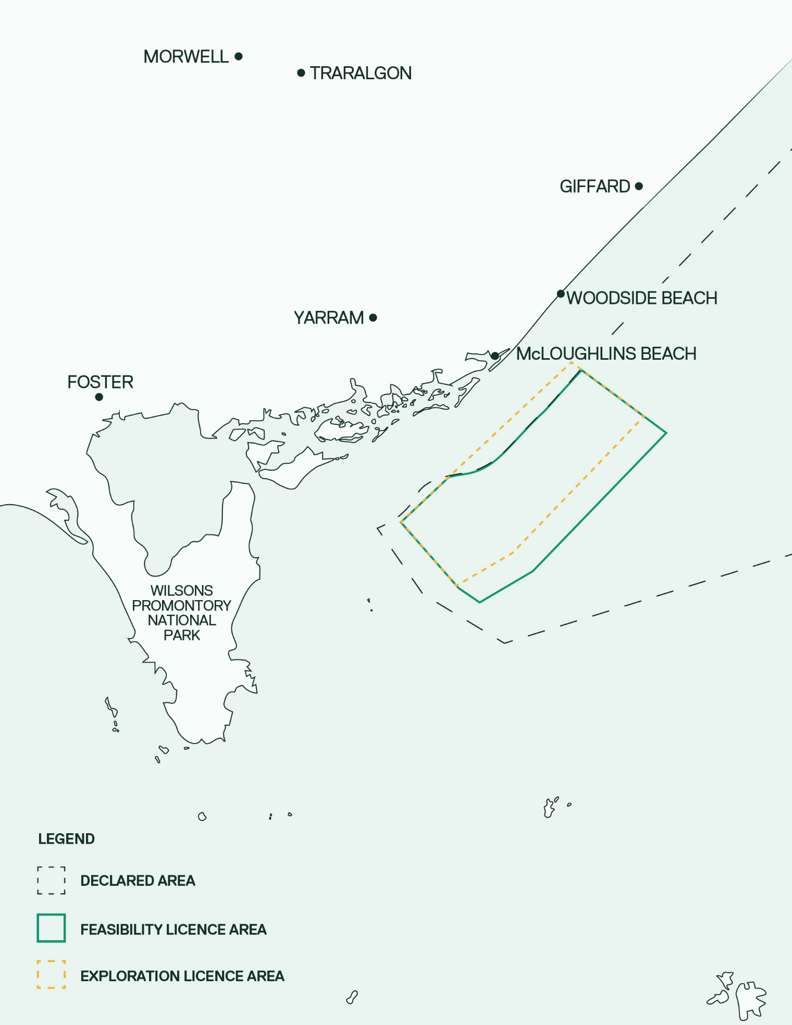

High-quality wind resource
As outlined in Chapter 2 – Project Rationale, the wind resource in Bass Strait is comparable to that in the European North Sea, where offshore wind was first established and average wind speeds at 100 metres above sea level are around nine to 10 metres per second.
Offshore wind resources in the Bass Strait show strong and consistent performance, with gross capacity factors exceeding 55 per cent (Briggs et al, 2021). This means that, on average, turbines could generate about 55 per cent of their maximum possible energy output before accounting for losses.
Bass Strait lies within the ‘Roaring Forties’, powerful westerly winds that blow year-round across the Southern Hemisphere. Analysis of 30 years of Bureau of Meteorology data shows that Bass Strait winds are highly correlated with Victoira's peak electricity demand periods, particularly on hot days (above 35 degrees) when a high-pressure system over the Tasman Sea consistently generates strong winds.
The generation profile of offshore wind in Bass Strait complements Victoria's existing renewable energy portfolio by generating at different times, such as in the evening when solar generation dips. It adds technological and geographical diversity for a more resilient and reliable system.
These factors make Bass Strait an ideal location for large-scale offshore wind farm development.

Water depths and geotechnical conditions
Most commercial-scale offshore wind farms worldwide use fixed-bottom foundations for turbines and offshore substations in water depths up to 40-60 metres, which is the same range found in the project’s offshore wind farm area.
Star of the South completed an offshore geotechnical campaign in May 2023 to better understand seabed conditions within the exploration licence area. Borehole sampling and pressure testing confirmed that the geological conditions are suitable for fixed-bottom foundations. Refer to Appendix A – Foundation Options Assessment for a detailed analysis of foundation feasibility.

Proximity to the grid
The project is located close to the existing high voltage transmission network in the Latrobe Valley, a strong connection point with sufficient capacity that will increase as coal power stations retire.
Star of the South originally identified the Latrobe Valley as the project's preferred grid connection point. This changed when VicGrid, a Victorian Government agency, was tasked with developing shared transmission to connect offshore wind farms to the grid. VicGrid's Gippsland Offshore Wind Transmission 2 GW Project extends from the Latrobe Valley to Giffard, where the project will connect at a shared connection hub. The VicGrid project is subject to a separate EES process.
Recent analysis by the Clean Energy Council (2025) shows how offshore wind can deliver more gigawatts of electricity per kilometre of transmission, reducing land-based impacts and the number of landholders required to host infrastructure. This is particularly evident when shared transmission, such as that being developed by VicGrid, is used to realise efficiencies.

Avoidance of sensitive ecological features
Protecting biodiversity and ecological integrity is a key focus in the project’s design in relation to the offshore wind farm. Star of the South has undertaken offshore ecological surveys to understand baseline conditions, identify potential impacts, and guide the selection of design measures that avoid or minimise effects on threatened marine flora and fauna.
The project’s offshore location avoids:
- National, marine, state and conservation parks, reserves and registered heritage places
- Marine mammal breeding grounds
- Critically endangered migratory bird paths.
In addition, Star of the South has adopted measures that avoid, minimise and mitigate impacts to biological diversity and ecological integrity, including:
- Construction management plans to protect and manage interactions with marine values
- Light pollution management measures to minimise the impacts of artificial light on marine fauna
- Increasing the air gap between the turbine blades and the surface of the water from 25 to 35 metres to significantly reduce bird collision risk
- Minimum spacing of 1,062 metres between turbines to minimise potential displacement and barrier effects on marine and bird life
- Noise abatement systems, active monitoring and marine mammal observers aboard vessels to maintain precaution zones and minimise underwater noise impacts on marine fauna during construction
- The use of vessel propeller guards, speed restrictions and no-approach and caution zones to avoid and minimise vessel collision risks with birds and mammals
- Selecting a site with very few areas of rocky reefs, which are higher in biodiversity.

Co-existence with other marine users and industries
Initial site screening identified existing infrastructure, industries and other uses of the Bass Strait, and sought to avoid these where possible.
The project’s offshore location avoids:
- Offshore oil and gas fields and decommissioning projects
- Shipping lanes
- Subsea communications cables.
Early engagement with commercial and recreational fishers identified that, while both types of fishing do occur in the project area, other locations in the Bass Strait hold greater value. Highly productive commercial fishing grounds are typically located closer to ports and further east, while Corner Inlet and the islands near Wilsons Promontory are more popular for recreational fishers.
Following site selection, Star of the South has engaged extensively with other marine users and industries to build a comprehensive understanding of how the area is used and guide the selection of design measures that support co-existence. This includes engagement with other marine infrastructure users, such as the Basslink cable and CarbonNet project, which remains ongoing.

Socio-economic opportunities
The project represents a significant economic opportunity for Australia, with the potential to create high-quality, long-term jobs and contribute billions to the national economy, primarily in Victoria and the Gippsland region, over the project’s lifetime.
Industries including coal-fired power generation, coal mining, petroleum exploration and forestry have made a significant contribution to Gippsland's economy for many years. As these industries start to slow down, job losses and reduced economic activity are impacting the region. The project's Gippsland location represents an opportunity to harness the skilled local workforce and supply chain, and support job and investment continuity as these traditional industries retire.
By developing a reliable pipeline of sustainable jobs of a similar standard, the project will provide viable transition opportunities. A workforce study conducted by Star of the South (2023) identified around 70 per cent of Gippsland’s coal power, mining and gas workers, as well as 85 per cent of the local maritime workforce, have a good or high overlap of skills and training for a career in offshore wind. Trade and engineering-based roles in both coal and offshore petroleum already require the same fundamental skillsets. This means a large subset of workers will require minimal upskilling or re-training to work on the project.

Access to port facilities
Offshore wind farm construction and operation requires access to ports with water depths of up to 12 metres. During construction, deep water ports with plenty of quayside space are needed to accommodate large vessels and components. During operations, proximity to the wind farm site is important as it minimises transit distance and time, which in turn reduces potential impacts and improves efficiency.
Initial scoping investigations identified a variety of existing commercial ports in suitable proximity that can meet these requirements. Port selection is further discussed in Section 3.5.

Visual impacts
Star of the South acknowledges the visual landscape changes because of the project. To minimise impacts, early site selection involved identifying an area of coastline with lightly populated townships with some featuring low-lying islands to help shield the visual effects of the wind farm.

Wind farm capacity
The project’s capacity of up to 2.2 GW was determined based on energy market analysis, and the project area's generation potential. Defining project capacity at an early stage is critical for both commercial and technical reasons. For example, wind farm capacity guides the project design and allows definition of the technical envelope for impact assessment.

Wind farm layout
The layout of the turbines, offshore substations and cables within the offshore wind farm area influences how efficiently a project captures the wind, generates electricity and exports power to the grid. Key factors influencing wind farm layout include seabed conditions, environmental features, wind resource, turbine size and overall wind farm capacity.
Star of the South has developed a set of principles to guide layout development that considers technical, environmental, socio-economic, commercial and regulatory factors. The principles are to:
Buffering / wake effect
Turbines extract kinetic energy from the wind, creating reduced wind speed and increased turbulence downstream. The lower wind speeds in a turbine's wake can result in reduced energy production for nearby turbines and increase mechanical stress.
- Optimise the layout for wind conditions, seabed conditions and turbine size
- Position turbines to minimise environmental impacts
- Position turbines to minimise impacts to infrastructure and other uses of the marine environment
- Meet safety, approval, regulatory and legal requirements.
The final wind farm layout will be determined during the detailed design phase. Deferring this decision will enable the project to incorporate emerging regulatory guidance and final turbine selection, which is typically done at a later stage based on supply chain availability.
Finalising the layout will require consultation with relevant stakeholders, including the Australian Maritime Safety Authority, the Commonwealth Department of Defence, the Civil Aviation Safety Authority, as well as other government departments and marine users, post approval.
Indicative layout concepts are presented in Chapter 4 – Project Description.

Turbine alternatives
Offshore wind turbine technology is advancing rapidly. Increases in turbine efficiency and size enable higher energy output, reducing the number of turbines needed to generate a specific amount of electricity. Star of the South has sought to maintain flexibility in turbine selection to accommodate ongoing technological development and potential supply chain constraints, ensuring the project can use the best technology available when the turbines are procured.

Turbine type
A conventional horizontal-axis, three-blade rotor turbine was chosen early in the project’s development and forms the basis of the project’s assessment. Horizontal-axis turbines are a proven technology, supported by decades of research and development and extensive global deployment onshore and offshore. They are a reliable and well-understood option, with mature supply chains and standardised components. While alternative turbine types exist, they are not suitable for the project due to their limited market readiness at the scale required for the project. As such, they were not assessed as viable alternatives.

Turbine size and capacity
As turbine technology continues to evolve, larger and more efficient models are entering the market. Turbine design parameters included in the assessment are broad enough to allow flexibility for technological advancements while also enabling a comprehensive assessment.
Smaller turbines (outside the lower range currently under consideration) were explored and considered suitable early in the project's development but are no longer being pursued due to these models are being discontinued and because fewer, larger turbines will generate electricity more efficiently.
The air gap parameter (distance between the turbine blades and the surface of the water) was increased from 25 metres up to 35 metres during the assessment because bird collision risk modelling showed this will significantly reduce risks to birds (refer to Chapter 4 – Project Description and Technical Report E – Offshore Ornithology and Bats). The maximum turbine blade tip height of 350 metres was not increased.

Turbine number
The number of turbines is directly correlated with turbine size and project capacity. During the project’s development, the number of turbines required to achieve a 2.2 GW project capacity has been reduced from 400 down to between 113 and 147 turbines. This number was based on a smaller turbine size at the time the project was referred under the EPBC Act and the Environment Effects Act 1978 (Vic) (EE Act).

Turbine foundation type and installation method
The preferred turbine foundation type was selected following a screening and multi-criteria analysis (MCA) assessment process (refer to Appendix A – Foundations Options Assessment). A summary of the options evaluated, including installation methods, is provided in Table 3-2.
Table 3-2 Offshore wind turbine foundation options evaluated
Design option | Screened out | Progressed to MCA assessment | Progressed to impact assessment
Monopile (impact piling) |  | ü | ü
Monopile (vibro-piling) |  | ü | ü
Piled jacket |  | ü
Vibro-piled jacket |  | ü
Suction caisson jacket | ü
Gravity-based foundation | ü
Tri-suction pile caisson | ü
Floating | ü
Tripod | ü
Monopiles are the most suitable foundation option for the project based on factors including technical suitability, fabrication, health and safety, transport and logistics, installation methods, ability to meet project and government objectives, operational requirements, decommissioning, carbon footprint and commercial factors (refer to Appendix A – Foundations Options Assessment).

Transmission system alternatives
An offshore wind project’s transmission system functions as an integrated network, comprising both offshore and onshore components. Key factors considered during its development include:
- Transmission system technology type and voltage
- Offshore substation size, capacity, number, location, foundation type and installation method
- Offshore cable (inter-array and export) type, number, location, protection and installation methods
- Shore crossing location and construction method
- Onshore transmission infrastructure type, alignment and construction method
- Onshore substation site.
The following sections describe these elements and alternatives considered for the project.

Transmission system technology
Star of the South selected a high voltage alternating current (HVAC) transmission system and a range of potential system voltages before starting the assessment process. High voltage direct current (HVDC) technology was assessed as an alternative early in project development, considering a range of factors including commercial, environmental and land-use impacts, constructability and supply chain risk and technical aspects such as grid integration.
For shorter distances, HVAC systems are more efficient and cost-effective, while HVDC is better suited to long-distance connections such as the Basslink and Marinus Link interconnectors. Both are suitable for overhead or underground use.
HVDC was deemed unfeasible based on the original transmission length. A reduction in the length of the project's transmission system due to the VicGrid Gippsland Offshore Wind Transmission 2 GW Project makes HVDC even less suitable.
Star of the South has selected an HVAC voltage of either 220 or 275 kilovolts. While alternative high-voltage configurations may become viable in the future, the chosen range represents proven, reliable technology for offshore wind farms and aligns with current development timelines and project capacity.
A 66 kV system was also considered, allowing cables to connect directly to shore without offshore substations, potentially lowering costs and complexity. This option was not pursued as it would result in higher transmission losses and require many more export cables with a significantly greater seabed footprint.

Offshore substation requirement and type
The selected HVAC transmission system requires fixed-bottom offshore substations to efficiently export electricity over the required distance to shore.
Alternatives considered included transmitting some electricity directly from turbines, which could reduce the number of substations required. This option was not pursued as it would result in higher transmission losses and require more export cables with a greater seabed footprint.
Alternatives to fixed-bottom offshore substations include floating and subsea options. Fixed-bottom substations were found to be the only feasible option for the project due to site conditions.

Offshore substation size, capacity, number and location
The assessment of the project is based on the maximum potential size, capacity and number of offshore substations, with final details to be confirmed post approval.
Alternatives include using fewer large substations, or more smaller substations. Larger-capacity substations typically have a bigger footprint and may involve different foundation designs.
During preparation of the EIS, the maximum number of substations was increased from four to five to accommodate the potential use of smaller substations.
Determining whether to install fewer large substations or more smaller ones is a key design consideration, as each option presents trade-offs in terms of cost, constructability, reliability, environmental impact and grid integration. The final location of the offshore substations will depend on these design choices, as well as wind farm layout, as offshore substations are sited to optimise energy collection and minimise export distances. These design decisions will be finalised in line with project approval conditions.

Offshore substation foundation type and installation method
The installation of jacket foundations using conventional methods has been evaluated as part of the impact assessment. Monopile foundations may also be suitable if smaller substations are used.
As the final size and number of offshore substations will be determined during the detailed design phase, the preferred foundation type will also be selected at that stage.

Offshore cable alignments, protection and installation method
Final inter-array and offshore export cable alignments, installation and protection methods will be determined post approval.
The inter-array cable layout will depend on the final wind farm layout, turbine size and the project's electrical design, as well as any environmental constraints and cable crossings. All inter-array cables will be located within the offshore wind farm area shown in Figure 3-2, in Commonwealth waters. The project’s assessment is based on the cable type, length and installation footprint with the greatest potential impact.
The offshore export cables will be installed within one or more corridors within the offshore export cable area shown in Figure 3-2, traversing Commonwealth waters and Victorian coastal waters. Corridor locations depend on the offshore substation locations, the shore crossing location, and any constraints or obstacles in between. The impacts from any potential corridor options have been assessed.
The original offshore export cable area encompassed two potential shore crossing locations. Following the selection of a preferred crossing point (see Section 3.4.7), the offshore export cable area was substantially reduced. The final location of the offshore export cable corridor(s) within this area will be determined post approval, once the wind farm layout is finalised.
All cables will need to be protected and stabilised. Cable protection types encompass a range of installation methods and impact considerations. Based on site conditions, it is anticipated that most offshore cables will be buried within the seabed, which will also reduce electromagnetic field intensity at the seabed surface.
Figure 3-2 Project area overview
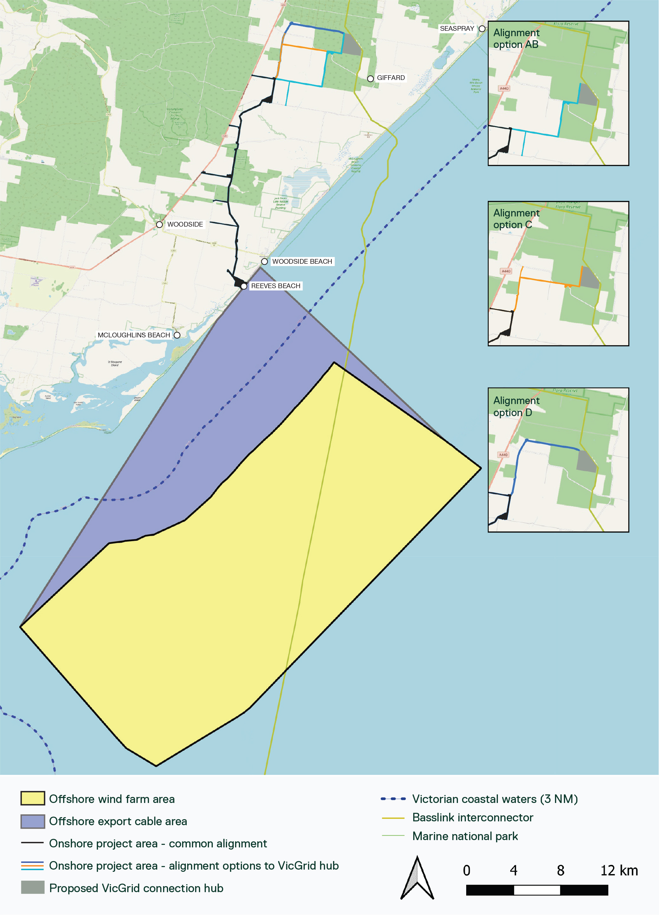

Offshore export cable number
To allow for variation in the final electrical design, up to eight offshore export cables have been evaluated as adequate for transmitting the project’s maximum generation capacity. The maximum number has been reduced from 13 to eight during the design development process, due to the factors outlined in Section 3.1.4. The final number will be determined post approval, following the completion of the offshore wind farm layout and detailed electrical design.

Shore crossing location and installation method
A multi-criteria analysis of Reeves Beach and McGaurans Beach undertaken in 2020 identified Reeves Beach as the preferred shore crossing location. This decision enabled the refinement of other project elements such as the offshore export cable area and the onshore transmission alignment.
There are several environmental constraints along the Ninety Mile Beach coastline that limit suitable shore crossing options, including:
- Corner Inlet Ramsar Site and tributary of Bruthen Creek
- Nooramunga Marine and Coastal Park
- Ninety Mile Beach Marine National Park
- Jack Smith Lake Wildlife Reserve
- Woodside Beach and Lake Denison wildlife reserves
- Woodside Beach township
- Extensive coastal wetlands, waterways and dune systems, including the Ninety Mile Beach barrier lake system
- A high-profile nearshore reef (to be avoided)
- Existing infrastructure: the Basslink Interconnector and a Saline Wastewater Outfall Pipeline.
The coastline also contains significant Aboriginal cultural heritage values and registered sites, particularly around Jack Smith Lake Wildlife Reserve and the nearby Warrigal Creek massacre site, which holds strong cultural significance.
The areas around Reeves Beach and McGaurans Beach were found to be the least constrained and suitable for further investigation. Based on these shore crossing options, potential onshore transmission corridors were also identified: Eastern, Northern and Western (refer to Figure 3-3).
Reeves Beach was ultimately selected as the preferred shore crossing location as it:
- Requires a shorter offshore export cable
- Avoids complex shore crossing design requirements and construction congestion associated with the existing Basslink Interconnector and Gippsland Saline Wastewater Outfall Pipeline infrastructure at McGaurans Beach
- Avoids a high-profile reef near the Basslink Interconnector shore crossing, registered Aboriginal heritage sites and Jack Smith Lake
- Supported the feasibility of the Eastern and Western onshore transmission corridors, which both provided shorter routes to the grid connection location anticipated at the time.
Following the announcement of VicGrid's Gippsland Offshore Wind Transmission 2 GW Project, only minor modifications were required to align the project's onshore transmission corridor, so it was not considered necessary to relocate the shore crossing location.
The Reeves Beach shore crossing also aligns with the proposed shoreline renewable energy zone identified in the Victorian Transmission Plan (VicGrid, 2025), which defines a limited area between the Gippsland coast and South Gippsland Highway in which offshore wind transmission infrastructure may be located.
Cables will be installed under the beach and dune system at the shore crossing location using trenchless construction methods.
Both trenching and trenchless construction methods were evaluated. Trenchless methods have been selected to minimise potential impacts on the sensitive dune systems and coastal habitats, Aboriginal cultural heritage and recreational land use. The specific trenchless technique will be confirmed during detailed design and as part of ongoing consultation with the Gunaikurnai Land and Waters Aboriginal Corporation.

Onshore transmission type and installation method
Star of the South selected underground cables for the onshore transmission system, with open trenching as the primary installation method.
Overhead transmission was ruled out early in the project development process due to factors including potential land and visual impacts, resilience, and regional precedents. VicGrid has since stipulated that all offshore wind farms must use underground transmission to connect to the grid at its proposed connection hub in Giffard.
Open trench installation methods are included in the project’s assessment. A final method(s) will be selected during detailed design based on technical factors. Trenchless installation methods are also assessed as alternatives for specific road and waterway crossings.

Onshore transmission alignment
The onshore transmission alignment has undergone considerable study and evaluation to determine an appropriate, functional and commercially viable solution which avoids and minimises environmental, social, land use and Aboriginal cultural heritage impacts.
The onshore transmission alignment extends from the Reeves Beach shore crossing to the VicGrid connection hub study area. As the final connection hub location is yet to be confirmed, three potential alignment options have been retained for the last few kilometres to reach the hub. These options are further described in Chapter 4 – Project Description.
The following sections describe how Star of the South identified and refined the alignment over the following phases:
- 2018: Initial corridor options identified
- 2019 to 2020: Options analysis (pre-referral under the EPBC Act)
- 2020 to 2021: Options assessment and consultation (post-referral)
- 2021 to 2023: Preferred corridor refinement
- 2023 onwards: Updates following the announcement of VicGrid’s Gippsland Offshore Wind Transmission 2 GW Project.

Initial options identification
This phase involved identifying all potential shore crossing and onshore corridor options.

Options analysis (pre-referral)
This phase refined the number of shore crossing options down to three potentially feasible corridors for investigation and consultation. This refinement was done by mapping constraints, including engineering factors, environmental features (topography, geology, waterways), biodiversity values, registered Aboriginal cultural heritage sites, and social values.
Constraints were categorised as follows:
- No-go areas: Avoid disturbance
- Highly-constrained areas: Avoid or minimise disturbance through design, choice of construction method or co-location with existing infrastructure
- Moderately-constrained areas: Site-specific construction methods may be required
- Low-constrained areas: Standard construction methods.
In particular, the Strzelecki Ranges presented a significant constraint based on steep terrain unsuitable for construction, unstable geological layers and environmental values.
This process identified the following three broad corridors, between two and six kilometres wide, in which the project's transmission system could be sited (refer to Figure 3-3):
- Eastern: From Reeves Beach to the Loy Yang Power Station via the Basslink Interconnector
- Northern: From McGaurans Beach to the Loy Yang Power Station via the Basslink Interconnector
- Western: From Reeves Beach to the Loy Yang Power Station via Old Rosedale Road.
These corridors were presented in the project’s EPBC Act referral (Figure 3-4).

Figure 3-3 Shore crossing and onshore transmission corridor options (pre-referral)
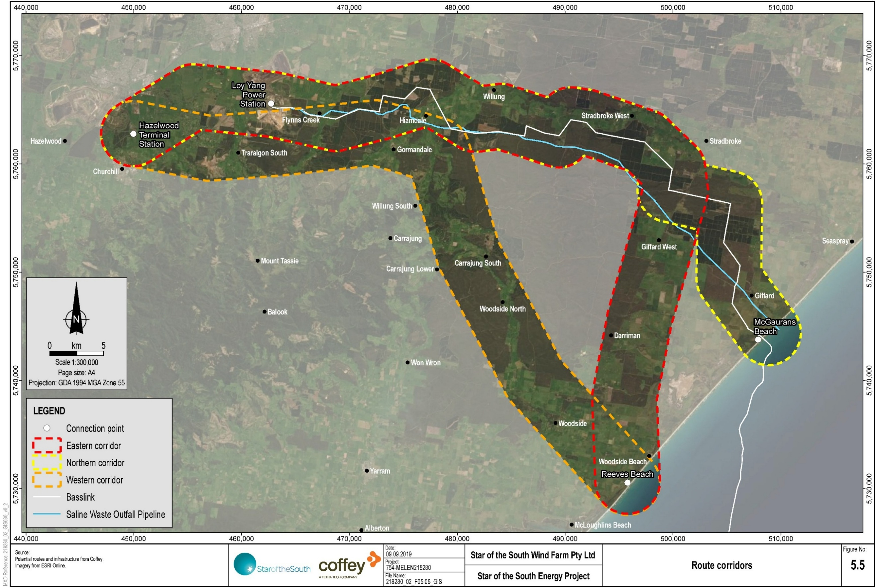
Figure 3-4 Original EIS referral area
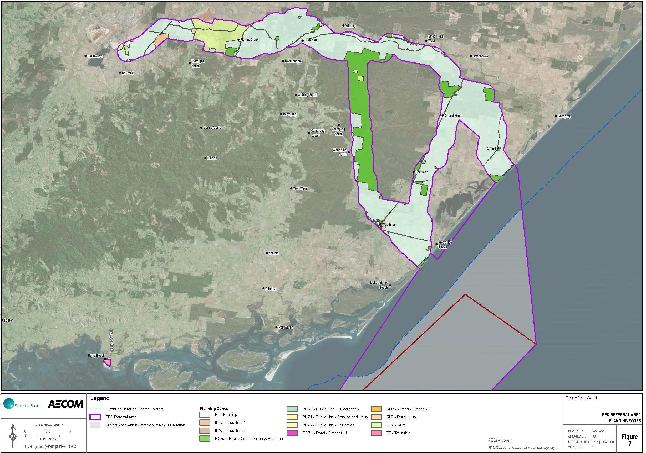

Options assessment and consultation (post referral)
The three shortlisted options were then studied in further detail, including through site visits and surveys (waterway, feature, soil, flora, fauna), engagement with landholders along all three corridors, and broad community and stakeholder consultation.
Upon completion of these studies, Star of the South undertook a multi-criteria analysis to assess the relative strengths and flaws of each option, considering a range of factors including technical and constructability, landholder feedback, community and stakeholder feedback, environment and heritage, and commercial.
The Eastern alignment was deemed the preferred option, based on:
- Strong community support for following the Basslink Interconnector
- Avoiding highly vegetated areas, reducing the potential vegetation removal
- Fewer constraints providing flexibility for system design and construction
- Fewer community concerns raised
- A shorter offshore cable route, reducing the potential marine disturbance
- Best safety outcomes expected.
This area became the focus for the next stages of the assessment.

Refinement of the preferred corridor
Selection of a preferred corridor enabled the start of detailed environmental assessments and on-site surveys (including geotechnical and cultural heritage), and in-depth landholder engagement.
Data obtained through these processes resulted in the refinement of the broad, preferred corridor down to an optimal route. Avoid and minimise principles were applied to adjust the footprint, alignment location and construction techniques to reduce impacts on discrete ecological, soil and water sensitivities, and landholders.

Updates due to VicGrid project
Following announcement of the Gippsland Offshore Wind Transmission 2 GW Project in 2023, VicGrid released a proposed study area in April 2024. The study area encompasses a broad corridor between Loy Yang Power Station and Giffard, and a connection hub in Giffard where up to 2 GW of offshore wind capacity is anticipated to connect. VicGrid is responsible for the assessment, approval, and procurement of this project
VicGrid’s Gippsland Options Assessment Report (VicGrid, 2024) stipulates that ‘Offshore wind projects will have to connect to these (connection) hubs as a condition of the Victorian Government’s offshore wind generation procurement process’. To align with this policy, Star of the South adjusted its transmission alignment (the Eastern alignment) to terminate in Giffard at the proposed connection hub.
The exact point of connection is yet to be confirmed, however a smaller refined area for the connection hub was announced by VicGrid in October 2025. As such, Star of the South has identified and assessed three alignment options to reach the connection hub study area, as shown in Figure 3-5. Each option branches out from the common alignment and terminates at a point within or at the boundary of the study area. These options were selected through desktop research and site validation, landholder engagement, alignment with property boundaries and avoidance of houses and vegetation. A small additional area was also incorporated into the project's referral area to account for the area required to get to the VicGrid connection hub.
The alignment options will be further refined once a specific point of connection within the study area is defined, site-specific constraints are confirmed, and in consultation with landholders.
Figure 3-5 Onshore transmission system alignment options
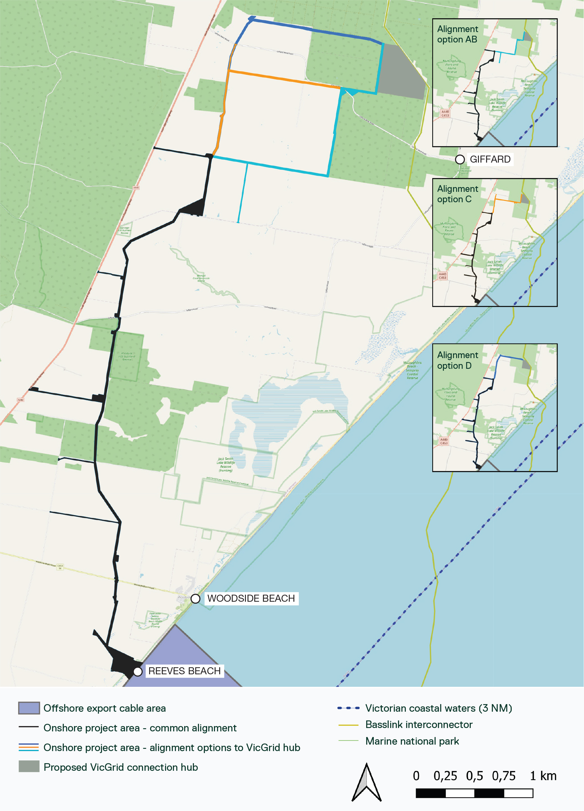

Onshore substation location
Star of the South undertook a site selection process for potential onshore substation locations during early development of the onshore transmission alignment. Since that time, Star of the South has determined the project’s substation will be co-located within the VicGrid connection hub area. As a result, alternative substation locations are no longer being considered.
Infrastructure contained within the VicGrid hub will be assessed separately by VicGrid as part of the Gippsland Offshore Wind Transmission 2 GW project EES.

Port alternatives
Star of the South defined port requirements in 2020 and a high-level screening exercise identified candidate ports for construction and operation of the project. The different types of ports and the requirements for each are described in Chapter 4 - Project Description.
The following existing ports were identified for further investigation:
- Construction feeder ports: Port of Bell Bay (Tasmania), GeelongPort, Port of Hastings, Port of Melbourne and Port of Newcastle (New South Wales).
- Operations and maintenance (O&M) port: Barry Beach Marine Terminal, Port Anthony, GeelongPort, Port of Hastings and Port of Melbourne.
The Port of Bell Bay (Tasmania) and GeelongPort (Victoria) have been used to estimate vessel trips for assessment purposes, although other ports such as the proposed Victorian Renewable Energy Terminal at the Port of Hastings may be used in their place or in addition, pending its approval and development timing. The assessment of O&M vessel trips is based on the use of Barry Beach Marine Terminal or Port Anthony, both of which are located close to the offshore wind farm area, already service the offshore oil and gas industry and have available land.
Overall, the identified ports offer an adequate and flexible range of options proximate to the offshore wind farm area to support the project’s construction and operation. Port selection will depend on a range of factors including capacity, availability / timing, and commercial terms.
Any port development or upgrade is the responsibility of the port operator and is subject to separate planning and approval processes.

