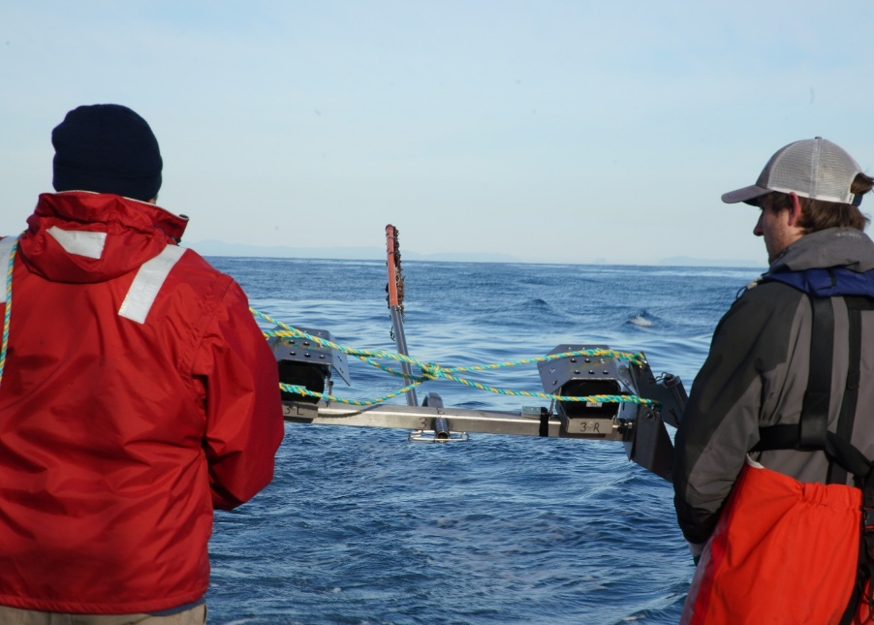

Commonwealth Environmental Impact Statement
Chapter 4 – Project description
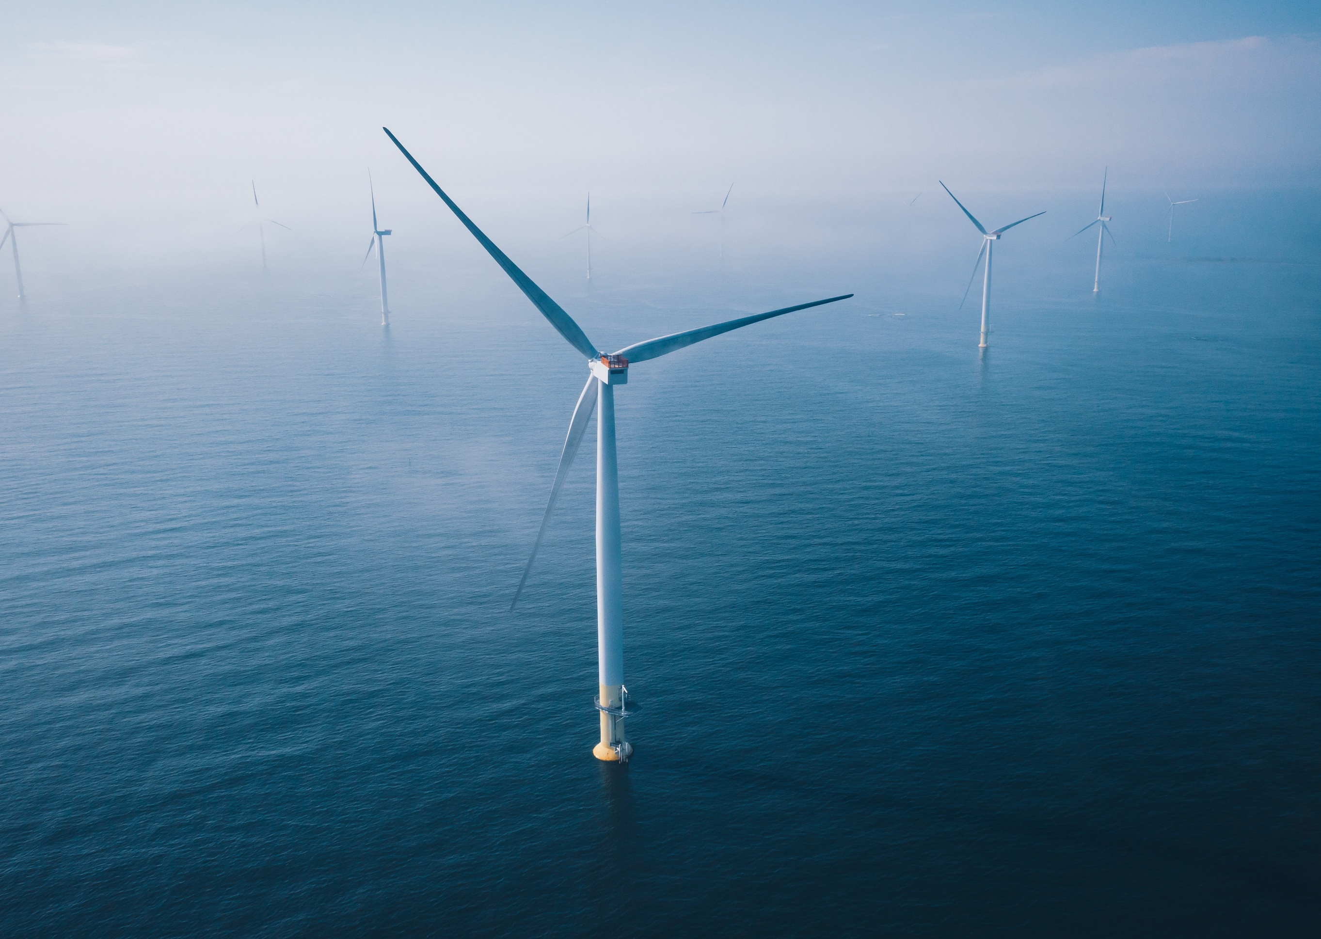
Table of Contents
Chapter 4 Project description 4-1
PART A – INTRODUCTION AND OVERVIEW 4-1
4.1 Introduction 4-1
4.1.1 Chapter structure 4-1
4.1.2 Commonwealth and Victorian project components 4-2
4.2 Project area 4-2
4.3 Project components 4-4
4.4 Project implementation 4-5
4.4.1 Project timeline 4-5
4.4.2 Construction schedule 4-5
4.5 Project design envelope 4-7
4.5.1 Purpose 4-7
4.5.2 Application - maximum design scenario 4-8
PART B – OFFSHORE 4-9
4.6 Offshore infrastructure 4-9
4.6.1 Offshore wind turbines 4-9
4.6.2 Offshore transmission infrastructure 4-14
4.6.3 Foundations and support structures 4-17
4.7 Offshore construction 4-21
4.7.1 Offshore construction schedule 4-21
4.7.2 Offshore construction staging 4-21
4.7.3 Site preparation activities 4-22
4.7.4 Offshore export cable installation 4-24
4.7.5 Foundation installation 4-26
4.7.6 Offshore substation installation 4-29
4.7.7 Inter-array and interlink cable installation 4-29
4.7.8 Offshore wind turbine installation 4-29
4.7.9 Construction vessels 4-30
4.7.10 Construction ports 4-33
4.7.11 Lighting, marking and navigation aids 4-35
4.8 Offshore operations and maintenance 4-36
4.8.1 Operations and maintenance activities 4-36
4.8.2 Operations and maintenance vessels 4-38
4.8.3 Operations and maintenance port 4-39
4.8.4 Lighting, marking and navigational aids 4-39
4.9 Offshore decommissioning 4-41
4.10 Repowering 4-42
4.11 Waste 4-42
PART C – SHORE CROSSING 4-44
4.12 Shore crossing design 4-44
4.12.1 Offshore interface 4-45
4.12.2 Onshore interface 4-45
4.13 Shore crossing construction 4-47
4.13.1 Shore crossing construction schedule 4-47
4.13.2 Drilling and duct installation 4-47
4.13.3 Cable pulling 4-52
4.14 Shore crossing operations and maintenance 4-53
4.15 Shore crossing decommissioning 4-53
PART D – ONSHORE TRANSMISSION 4-54
4.16 Onshore project area and VicGrid interface 4-54
4.17 Onshore transmission infrastructure 4-56
4.17.1 Underground cable system 4-56
4.17.2 Onshore substation 4-63
4.18 Onshore construction 4-64
4.18.1 Onshore construction schedule 4-64
4.18.2 Site establishment 4-65
4.18.3 Cable system construction 4-67
4.18.4 Commissioning 4-74
4.18.5 Demobilisation and rehabilitation 4-74
4.19 Onshore transmission operations and maintenance 4-75
4.19.1 Operations and maintenance activities 4-75
4.20 Onshore decommissioning 4-76
4.21 Waste 4-76

Figures
Figure 4-1 Project area overview 4-3
Figure 4-2 Project components 4-4
Figure 4-3 Typical offshore wind project timeline 4-5
Figure 4-4 Indicative project construction schedule 4-6
Figure 4-5 Offshore wind turbine 4-10
Figure 4-6 Indicative 147 turbine layout for assessment 4-12
Figure 4-7 Indicative 113 turbine layout for assessment 4-13
Figure 4-8 Transition piece ready for turbine installation 4-18
Figure 4-9 Piled jacket foundation for an offshore substation 4-19
Figure 4-10 Scour protection options schematic 4-20
Figure 4-11 Indicative offshore construction schedule 4-21
Figure 4-12 Typical pre-lay grapnel run arrangement 4-23
Figure 4-13 An illustration of scour protection being installed around a monopile 4-28
Figure 4-14 Offshore wind turbine installation via jack-up vessel 4-30
Figure 4-15 Heavy lift dynamic positioning vessel 4-32
Figure 4-16 Potential construction feeder and management ports 4-34
Figure 4-17 Typical service operation vessel 4-40
Figure 4-18 Typical crew transfer vessel 4-40
Figure 4-19 Shore crossing cross-section 4-45
Figure 4-20 Transition joint bay internals 4-46
Figure 4-21 Transition joint bay cable concept layout 4-46
Figure 4-22 Shore crossing construction schedule 4-47
Figure 4-23 Pilot hole drilling 4-49
Figure 4-24 Pilot hole reaming 4-50
Figure 4-25 Shore crossing drilling operation, Vinyard Wind USA 4-50
Figure 4-26 Shore crossing duct being towed to site Vinyard Wind, USA 4-51
Figure 4-27 Duct installation 4-52
Figure 4-28 Offshore export cable pulling 4-53
Figure 4-29 Onshore transmission system alignment 4-55
Figure 4-30 Typical underground cable circuits (two circuits shown) 4-57
Figure 4-31 Example cable easement cross-section (eight circuits shown) 4-58
Figure 4-32 Onshore cable cross-section (single core) 4-58
Figure 4-33 Example joint bay arrangement (double circuit arrangement shown) 4-59
Figure 4-34 Joint bay locations within the underground cable system (five circuits shown) 4-60
Figure 4-35 Cable jointing underway in a controlled environment (Australia) 4-61
Figure 4-36 Indicative construction schedule – underground cable system 4-65
Figure 4-37 Typical onshore construction corridor cross-section 4-67
Figure 4-38 Cable trench excavation (Australia) 4-69
Figure 4-39 Installation of conduit in a trench 4-69
Figure 4-40 Thermal fill installation (Australia) 4-70
Figure 4-41 Cable being fed from a cable spool into conduit (Australia) 4-72
Figure 4-42 Example of a caterpillar pit (Australia) 4-73
Figure 4-43 Joint bay ready for backfill (Australia) 4-73

Tables
Table 4-1 Design scenarios and parameters - offshore wind turbines 4-9
Table 4-2 Parameters – substation topside 4-14
Table 4-3 Parameters – inter-array cables 4-15
Table 4-4 Parameters – interlink cables 4-15
Table 4-5 Parameters – offshore export cables 4-16
Table 4-6 Parameters – cable protection and cable crossings 4-17
Table 4-7 Parameters – wind turbine monopile foundations 4-18
Table 4-8 Parameters – substation monopile foundations 4-18
Table 4-9 Parameters – substation piled jacket foundations 4-19
Table 4-10 Parameters – scour protection for monopile and jacket foundations 4-20
Table 4-11 Cable installation methods 4-24
Table 4-12 Parameters for monopile pile refusal 4-27
Table 4-13 Scour and cable protection installation methods 4-28
Table 4-14 Parameters – jack-up vessel operations 4-31
Table 4-15 Operation and maintenance activities 4-36
Table 4-16 Recyclable offshore wind infrastructure 4-42
Table 4-17 Parameters – trenchless shore crossings 4-44
Table 4-18 Parameters – underground cable system 4-56
Table 4-19 Cable easement controls 4-75

Project description

PART A – INTRODUCTION AND OVERVIEW

Introduction
This chapter describes the Star of the South Offshore Wind Farm Project (the project) and the main components and activities associated with its construction, operation and decommissioning. It provides project details to inform the assessment of environmental impacts for the Environmental Impact Statement (EIS) and Environment Effects Statement (EES) (Volume 2 – EIS and Volume 3 – EES).
The project description includes:
- The defined project area where works will occur (also refer to Attachment I – EIS Map Book)
- The scale and extent of physical infrastructure
- Construction activities, methods and timing
- Operation and maintenance of the project, including infrastructure that will be in place.
- Decommissioning activities.
The project’s design evolution and consideration of alternatives is discussed in Chapter 3 – Project Development.

Chapter structure
This chapter has been structured to follow the project’s physical layout – offshore, shore crossing, and onshore – and consists of four parts:
- Part A – Introduction: Introduces the project’s key features.
- Part B – Offshore: Describes the offshore project area and infrastructure, including ports that may be used to support the project’s construction and operation.
- Part C – Shore crossing: Describes the area where offshore export cables transition to land.
- Part D – Onshore: Describes the onshore project area and transmission system.

Commonwealth and Victorian project components
The Commonwealth EIS considers all project elements offshore and onshore, including the shore crossing. The Victorian EES considers only project elements within Victorian Coastal waters (three nautical miles from shore), the shore crossing, and onshore. It does not assess the offshore wind farm or other elements of the project in Commonwealth waters.

Project area
The project area is shown in Figure 4-1 has been broken down into three main sections - offshore, shore crossing, and onshore areas.
- Offshore project area, comprising:
  - Offshore wind farm area: A 586 square kilometre area extending approximately 10 to 40 kilometres offshore from the shore crossing. Includes offshore wind turbines installed on foundations, offshore substations and offshore transmission cables. This area is in Commonwealth waters.
  - Offshore export cable area: A 232 square kilometre area extending from the offshore wind farm area to the shore crossing. Includes offshore export cables to connect the wind farm to land. This area traverses Commonwealth waters and Victorian coastal waters.
- Shore crossing: Located at Reeves Beach, this is where the offshore export cables will transition to land and connect to the underground cable system onshore.
- Onshore project area: An approximately 30 kilometre corridor extending from the shore crossing to the proposed VicGrid connection hub (also referred to as ‘proposed Giffard terminal station area’). Includes an underground cable system within a (common) alignment to Giffard, at which point there are three alignment options (AB, C and D) to reach the VicGrid connection hub.
Figure 4-1 Project area overview
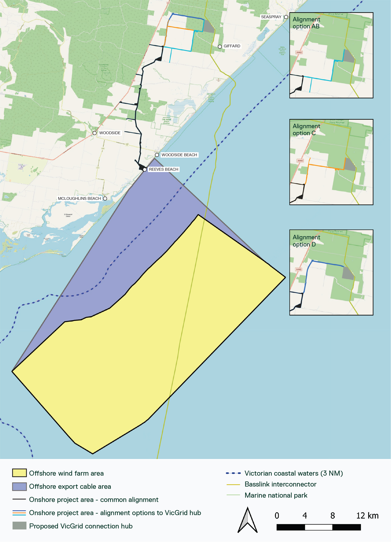

Project components
Key components are shown in Figure 4-2 and include:
- Offshore wind farm and transmission infrastructure (refer to Section 4.6):
    - Up to 147 offshore wind turbines installed on foundations with connecting inter-array cables
    - Up to five offshore substations and three interlink cables
    - Up to eight offshore export cables.
- Shore crossing infrastructure (refer to Section 4.12):
    - Up to eight trenchless crossings containing the offshore export cables.
- Onshore transmission infrastructure (refer to Section 4.16), which consists of:
    - An underground cable system connecting to the proposed VicGrid connection hub.
Figure 4-2 Project components
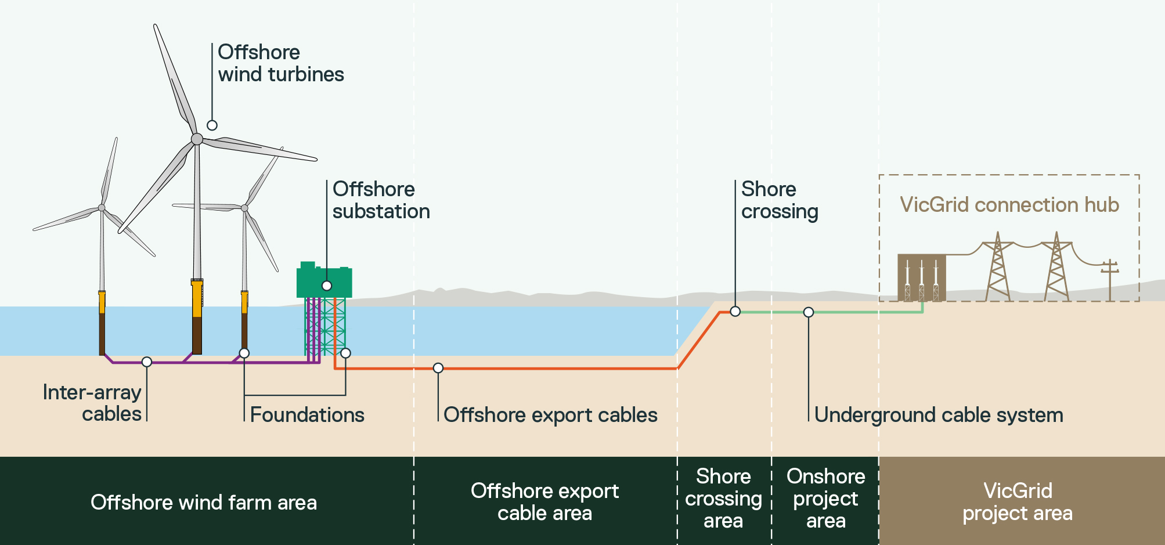

Project implementation

Project timeline
The project has been under development for approximately seven years. If approvals are obtained in the next few years, construction could start around 2030 and electricity generation from 2032. The operational life of the project is approximately 30 years, with the possibility of repowering to extend its life, if deemed appropriate by Star of the South and regulators closer to the time.
Figure 4-3 shows a typical range for the duration of each major project phase.
Figure 4-3 Typical offshore wind project timeline
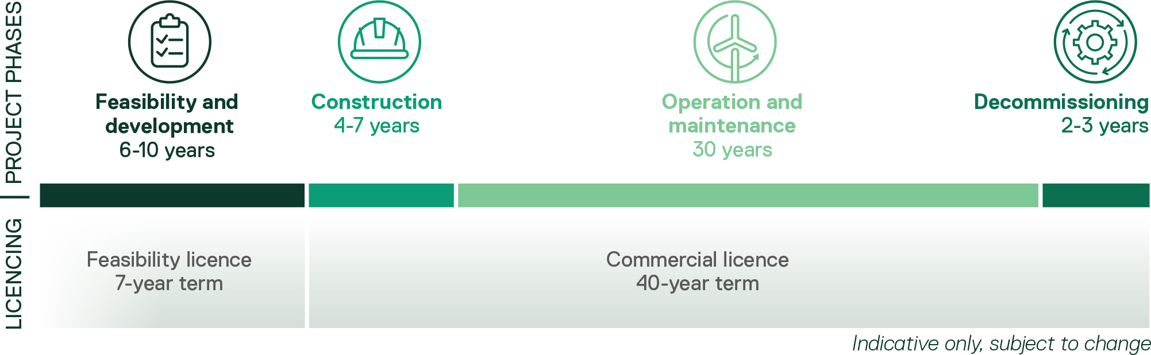

Construction schedule
The project is expected to take up to seven years to construct, if built to its full capacity in a single stage. The project could also be built in two stages, depending on energy market and government requirements and timing. Figure 4-4 shows the order and maximum duration of construction for key components.
Figure 4-4 Indicative project construction schedule
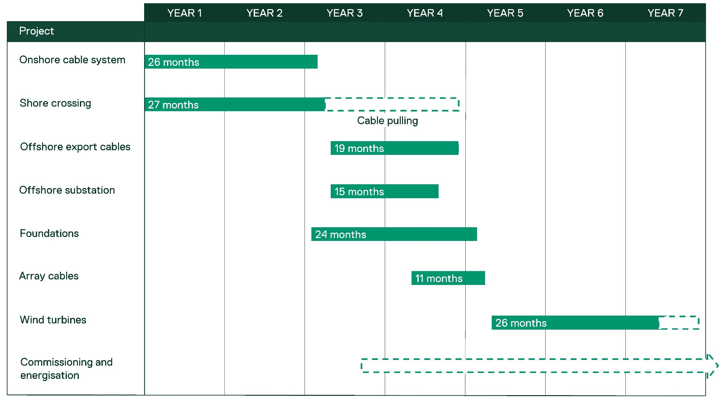
More detailed construction schedules for the offshore project area, shore crossing and onshore project area are found in Section , Section 4.13.1 and Section 4.18.1 respectively.

Project design envelope

Purpose
Project design envelope
A flexible project definition that sets clear upper and lower limits for design, construction, operation and decommissioning to inform environmental assessment.
The project has been assessed using a ‘project design envelope’ approach. This allows for the assessment of a range of design options, rather than a single, fixed proposal. It ensures that the impacts of all options are considered, while maintaining flexibility for ongoing project refinement and innovation.
This is a suitable approach for complex infrastructure projects, like offshore wind, that have long development timeframes and often continue evolving during detailed design, procurement and construction.
The design envelope is an internationally recognised approach for offshore wind farm assessment and is used in the United Kingdom, United States, European Union and Taiwan. It is included in the United Kingdom Overarching National Policy Statement for Energy (EN-1) and the National Policy Statement for Renewable Energy Infrastructure (EN-3).
The project adopted the design envelope approach as it:
- Provides sufficient information for assessments to respond to EIS and EES requirements
- Results in a conservative assessment and confidence that actual impacts will not exceed those predicted
- Enables continued project refinement post approval, allowing key decisions to be made at an appropriate time
- Allows for the adoption of future technology and innovations to achieve desired project and environmental outcomes.

Application - maximum design scenario
The range of options in the project design envelope are used to define a maximum design scenario for each assessment topic. The maximum design scenario is the combination of design parameters that would result in the greatest potential impact. It represents a ‘worst case’ configuration within the range of project options still being considered.
Maximum design scenario
The combination of parameters within the project design envelope that represents the greatest potential (worst case) impacts.
Technical specialists have identified the maximum design scenario applicable for each impact assessment.
For example, the project design envelope allows for a range of turbine sizes. The smallest turbine represents the maximum design scenario for disturbance to benthic habitats as more turbines are needed to meet the project’s capacity, resulting in a larger overall footprint on the seabed. Conversely, the largest turbine represents the maximum design scenario for impacts to aviation, as the turbines are taller and therefore more likely to affect controlled airspace.
The maximum design scenario for each assessment is detailed in relevant chapters and each technical report.

PART B – OFFSHORE
This section describes the infrastructure and construction, operation and decommissioning activities in the offshore wind farm area and offshore export cable area, as shown in Figure 4-1.

Offshore infrastructure

Offshore wind turbines
The project will use offshore wind turbines to harness the kinetic energy of the wind to generate electricity. The turbines consist of a tower, nacelle and blades, as shown in Figure 4-5, and will be installed on foundations called monopiles, as detailed in Section 4.6.3. Turbines will be located within the offshore wind farm area.
The range of turbines under consideration has been refined through the project’s feasibility and development phase. The assessment of the project is based on the upper and lower design parameters of remaining options, as detailed in Table 4-1.
- Smaller turbine scenario: The maximum number of the smallest turbines - up to 147 turbines with a rotor diameter of up to 236 metres.
- Larger turbine scenario: The maximum number of the largest turbines - up to 113 turbines with a rotor diameter of up to 285 metres.
The turbines will be similar in appearance to onshore turbines used in Australia, with a three-blade rotor design and horizontal rotor axis.
The final turbine design will be confirmed during detailed design, post approval, in accordance with any approval conditions and taking advantage of the best technology available at that time.
Table 4-1 Design scenarios and parameters - offshore wind turbines
Design parameter | Unit | Smaller turbines | Larger turbines
Maximum number of turbines | No. | Up to 147 | Up to 113
Maximum hub height (above lowest astronomical tide (LAT)) | m | 153 | 207.5
Maximum number of blades | No. | 3 | 3
Maximum rotor diameter (blade tip to blade tip) | m | 236 | 285
Blade tip height (above LAT) | m | 271 | 350
Maximum swept area (per turbine) | m³ | 43,744 | 63,794
Minimum blade tip clearance (above LAT) | m | 35 | 35
Minimum turbine spacing | m | 1,062 | 1,282.5
Figure 4-5 Offshore wind turbine
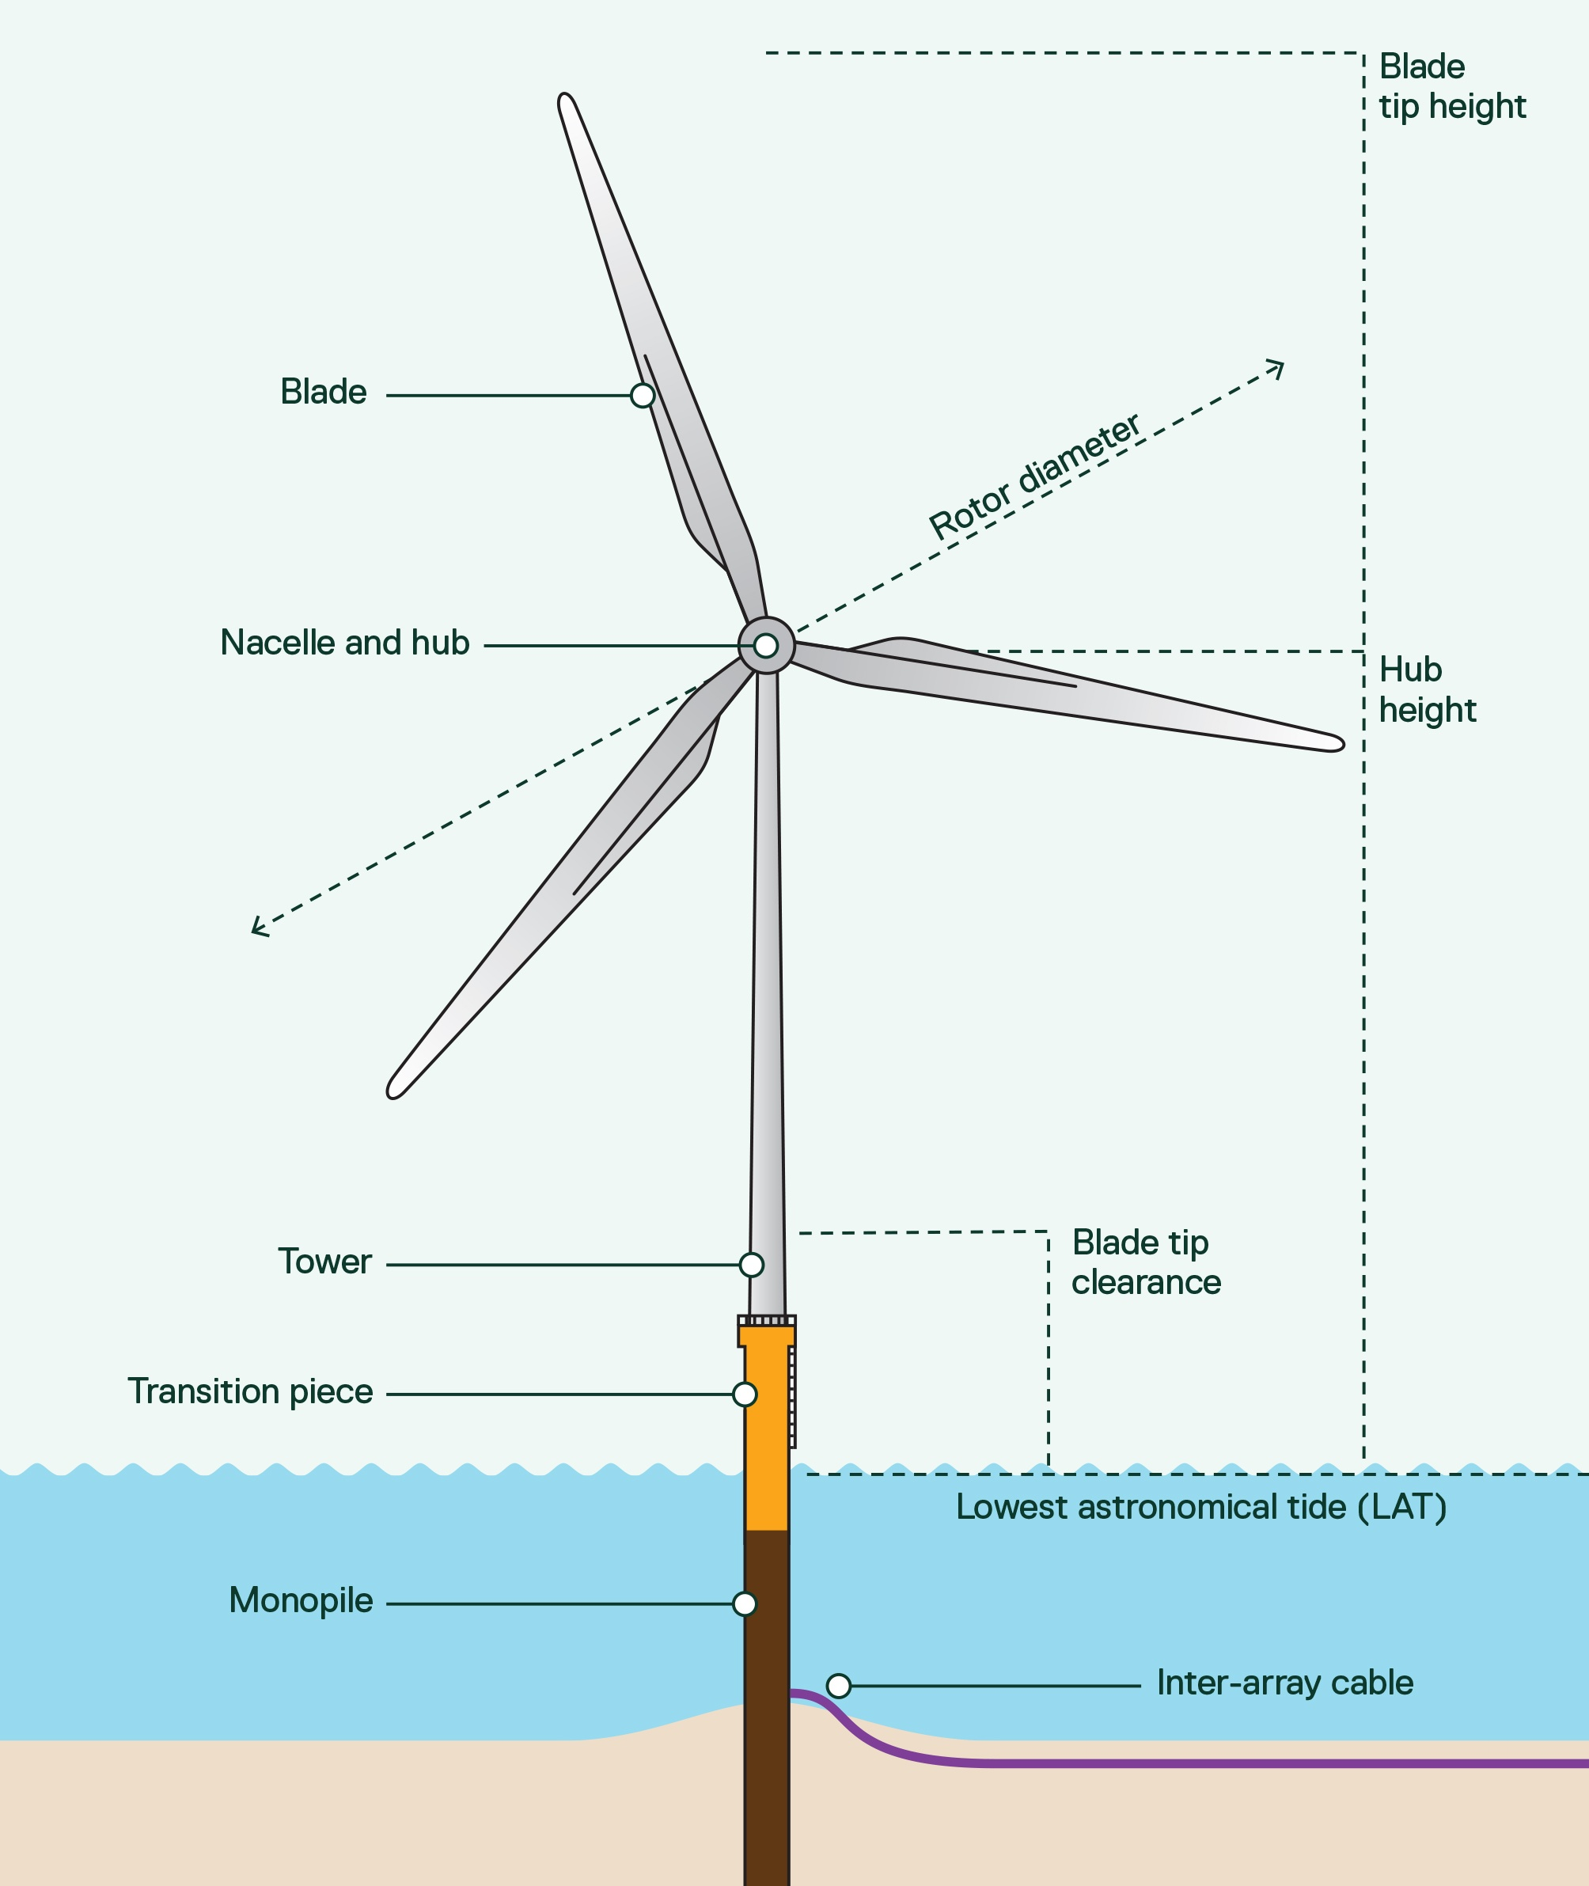

Layout
Indicative layouts for the smaller turbine scenario (147 turbines) and larger turbine scenario (113 turbines) are shown in Figure 4-6 and Figure 4-7.
The minimum distance between turbines is 1062 metres.
A final layout will be confirmed during detailed design, post approval, following turbine selection and detailed site surveys. The layout will:
- Be optimised to maximise electricity production
- Comply with all approval and regulatory requirements
- Seek to avoid and minimise impacts on the environment, other infrastructure, and other ocean users, where possible.

Lighting and marking
Turbine towers, blades and nacelles are typically painted light grey to minimise their visual presence and help them blend into a cloudy sky.
Lighting is required for marine navigation and aviation safety. The assessment of the project assumes that:
- Aviation lighting is required for all turbines, consisting of 2 low or medium intensity lights flashing red, installed on the nacelle.
- Navigation lighting is used on all boundary turbines, consisting of 3 yellow static lights visible from 5 NM (120 degrees apart) for corner turbines and from 2 NM (120 degrees apart) for boundary turbines, installed on the transition piece.
The lighting design will be confirmed during detailed design, post approval. Lighting will adhere to, but not exceed, aviation and marine navigation safety regulations.

Figure 4-6 Indicative 147 turbine layout for assessment
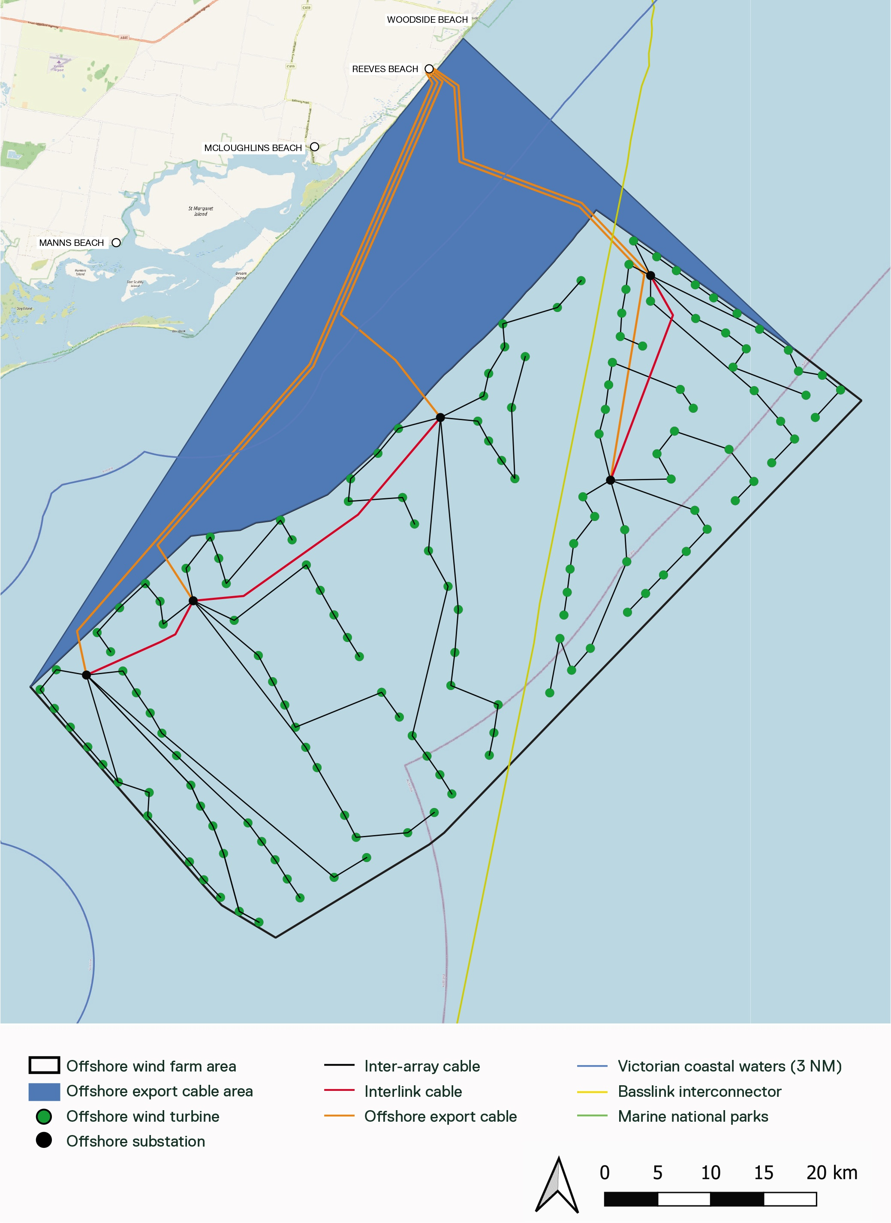
Figure 4-7 Indicative 113 turbine layout for assessment
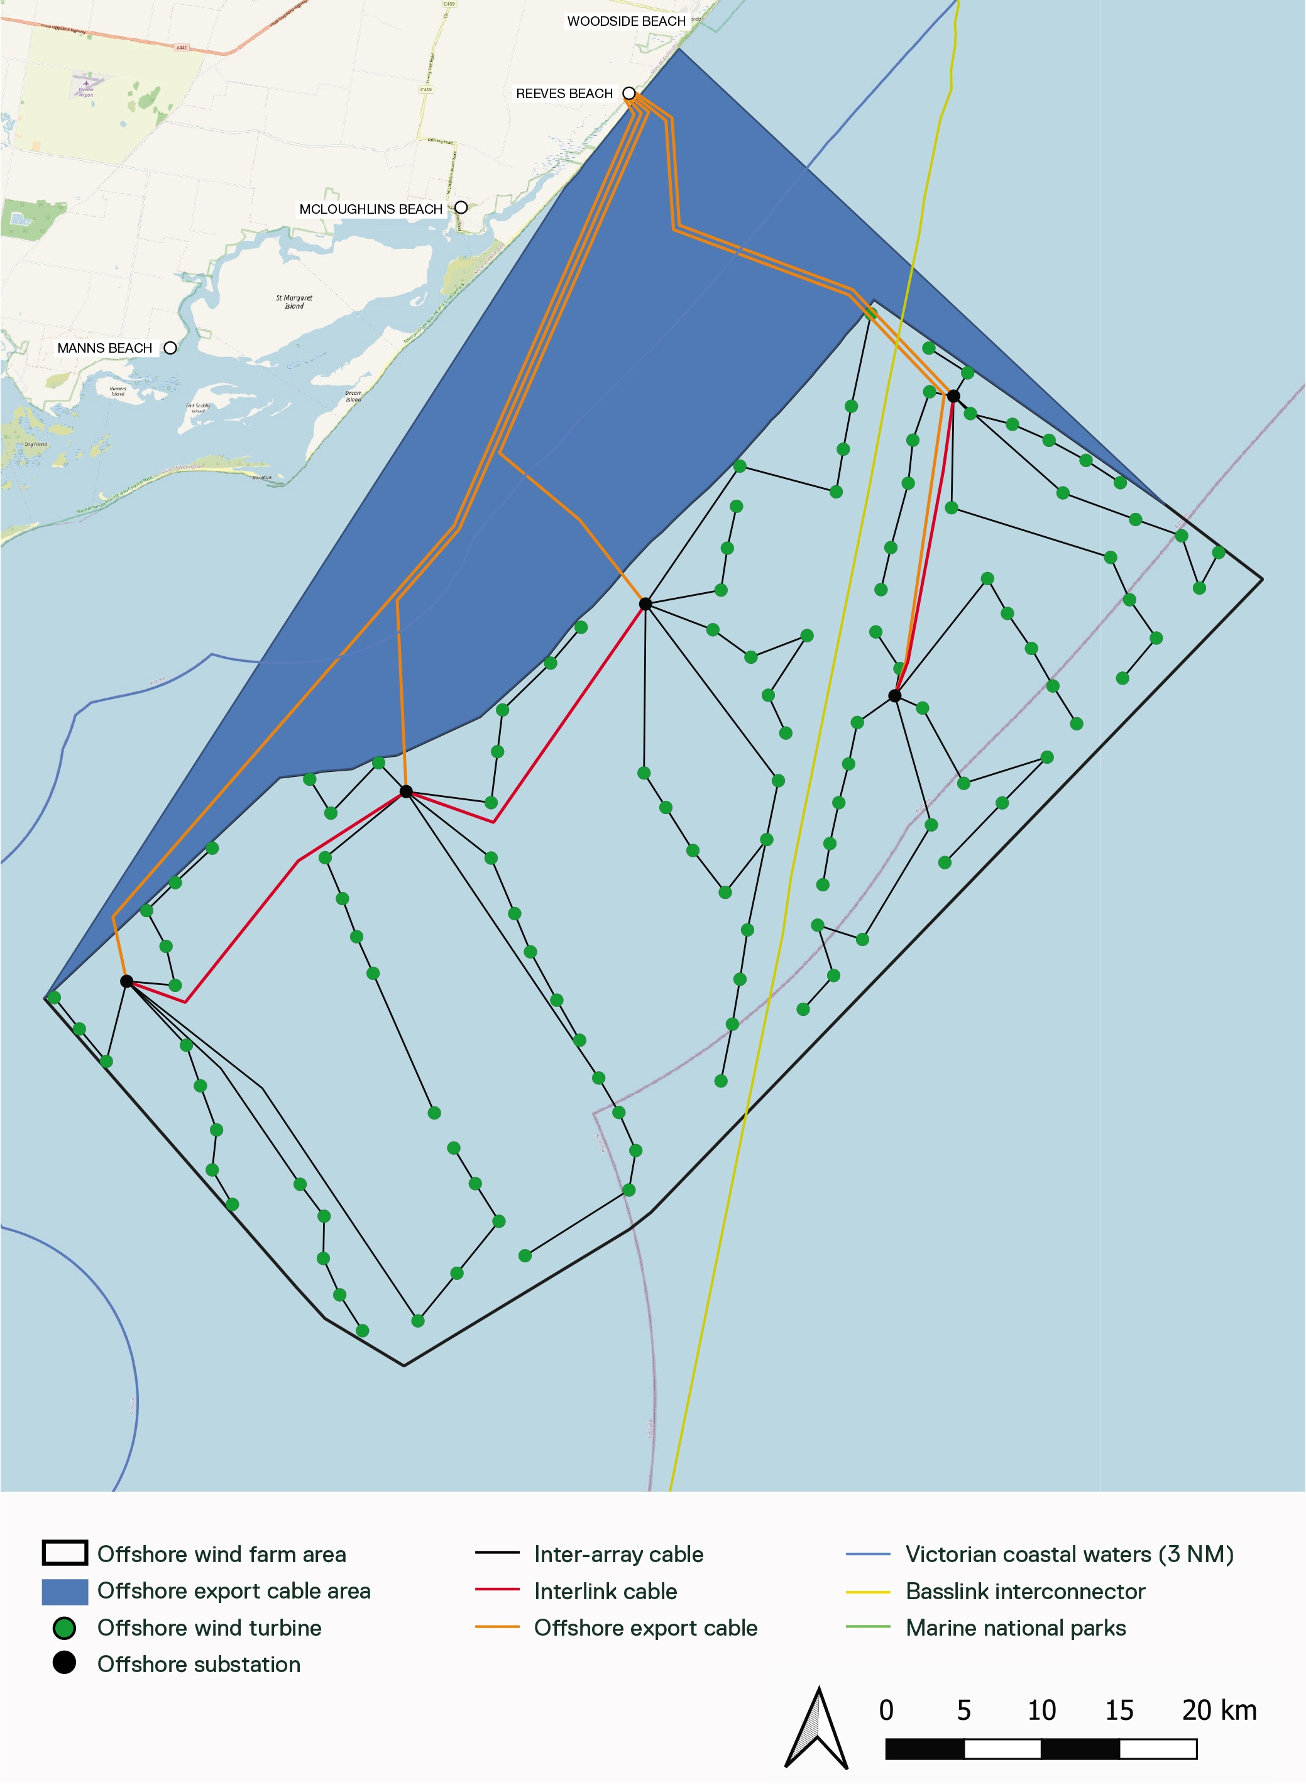

Offshore transmission infrastructure
The offshore transmission infrastructure comprises offshore substations, inter-array cables, interlink cables and offshore export cables. Together, this infrastructure will transmit electricity generated by the turbines to shore using high voltage alternating current (HVAC) technology.

Offshore substations
Up to five offshore substations will collect and transform electricity to a higher voltage so it can be exported to shore. Substations consist of a topside installed on a foundation and will be located within the offshore wind farm area.
The topside sits above the water and typically contains a platform with one or more decks and equipment to switch and transform power. It may also house auxiliary equipment and facilities for operating, maintaining and controlling the substation, such as communication systems. Although not typically used as service facilities or permanently crewed, offshore substations can have a modestly equipped workshop and emergency accommodation facilities.
The foundations are described in Section 4.6.3.
Table 4-2 Parameters – substation topside
Design parameter | Unit | Parameters
Maximum number of substations | No | 5
Maximum topside length | M | 70
Maximum topside width | m | 50
Maximum topside height | m | 30
Maximum topside height (above LAT) | m | 63

Lighting and marking
The foundation is painted yellow from the waterline up to the topside structure (for navigational safety), and the topside painted predominantly light grey (similar to the offshore wind turbines).
Lighting is required for marine navigation and aviation safety and will be designed in accordance with marine navigation safety regulations.

Inter-array cables
Inter-array cables connect offshore wind turbines and offshore substations, either in radial strings or in a series of loops. The number of turbines connected in each string primarily depends on turbine generation capacity and cable sizing. Inter-array cables will be located within the offshore wind farm area. Indicative cable layouts for assessment of the project are shown in Figure 4-6 and Figure 4-7.
Inter-array cables are lowered onto the seabed and buried. The construction methods for cable burial, including the area of seabed disturbance, are described in Section . The parameters for inter-array cables are provided in Table 4-3.
Table 4-3 Parameters – inter-array cables
Design parameter | Unit | Parameters
Inter-array cable voltage | kV | 66
Maximum inter-array cable route length | km | 418
Maximum cable trench width | m | 5
Minimum target cable depth (depth of lowering) | m | 0.6
Maximum target cable depth (depth of lowering) | m | 2

Interlink cables
Interlink cables connect the offshore substations to each other, providing backup power for the offshore wind turbines and/or transmission redundancy in the event of an electrical transmission system failure. The parameters for interlink cables are provided in Table 4-4.
Table 4-4 Parameters – interlink cables
Design parameter | Unit | Parameters
Interlink cable voltage | kV | 66 - 275
Maximum cable route length | km | 40
Maximum cable trench width | m | 5
Minimum target cable depth (depth of lowering) | m | 0.6
Maximum target cable depth (depth of lowering) | m | 2

Offshore export cables
Offshore export cables are high-voltage subsea electrical cables that transmit electricity from the offshore substations to the onshore transmission system. They have a higher capacity and are larger than inter-array cables. Export cables will be located within the offshore wind farm area and offshore export cable area.
Although an offshore export cable area has been identified, the exact location of each export cable corridor(s) within the area is yet to be determined. This will be determined based on information from future geophysical and geotechnical surveys, as well as the location of environmental sensitivities, such as reefs, and the location of the offshore substations. Indicative cable layouts for assessment of the project are shown in Figure 4-6 and Figure 4-7.
The parameters for the offshore export cables are provided in Table 4-5. Parameters for the shore crossing and connection to the onshore transmission system is contained in Part C – Shore crossing.
Table 4-5 Parameters – offshore export cables
Design parameter | Unit | Parameters
Offshore export cable voltage | kV | 275
Maximum number of offshore export cables | No. | 8
Maximum total offshore export cable route length | km | 286
Minimum target cable depth (depth of lowering) | m | 1
Maximum target cable depth (depth of lowering) | m | 2

Cable protection and crossings
Where physical constraints prevent cables from being buried to a sufficient depth, they will be covered by protective materials such as rock, concrete mattresses and mats. It is anticipated that up to five per cent of the project’s cables may need to be protected in this way. The parameters for cable protection are provided in Table 4-6.
Cable protection is also required for crossings (where cables cross other existing infrastructure, such as the Basslink Interconnector). The parameters for cable crossings are provided in Table 4-6.
Cable protection is also used to protect cables where they are more susceptible to movement or potential damage, for example, where they enter offshore wind turbine foundations, shore crossing ducts or an offshore substation.
Table 4-6 Parameters – cable protection and cable crossings
Design parameter | Unit | Parameters
Maximum extent of cable length requiring remedial protection | % | 5
Maximum area with remedial protection | m² | 186,000
Maximum volume of rock to be used for remedial protection | m³ | 279,000
Maximum number of cable crossings that require protection | No. | 12
Maximum protection area for each cable crossing | m² | 200
Maximum total volume of rock to be used for cable crossings | m³ | 3,600

Foundations and support structures
Foundations provide a stable footing for the turbines and substations. The assessment of the project is based on the use of monopile foundations for the turbines, and either piled jackets or monopile foundations for the substations. These foundation types were selected following a detailed analysis of available foundation options, described in Chapter 3 – Project Development.

Monopiles
Monopile foundations are large steel tubes that are driven into the seabed and are typically topped with a transition piece. The transition piece provides an interface for mounting the turbine or substation (topside). Secondary structures on the transition piece provide safe access to the turbine, including boat landing fenders, ladders, an external working platform with a crane and other ancillary components. A transition piece is shown in Figure 4-8.
The parameters for monopile foundations are provided in Table 4-7. The installation methodology, including piling durations, is described in Section 4.7.5.

Table 4-7 Parameters – wind turbine monopile foundations
Design parameter | Unit | Parameters
Maximum number of monopile foundations | No. | 147
Maximum pile diameter | m | 11.8
Maximum pile penetration depth into the seabed | m | 41.95
Maximum pile diameter at water line | m | 10
Minimum spacing of monopiles | m | 1,062
Table 4-8 Parameters – substation monopile foundations
Design parameter | Unit | Parameters
Maximum number of monopile foundations | No. | 5
Maximum pile diameter | m | 11.8
Maximum pile penetration depth into the seabed | m | 48
Maximum pile diameter at water line | m | 11.8
Figure 4-8 Transition piece ready for turbine installation
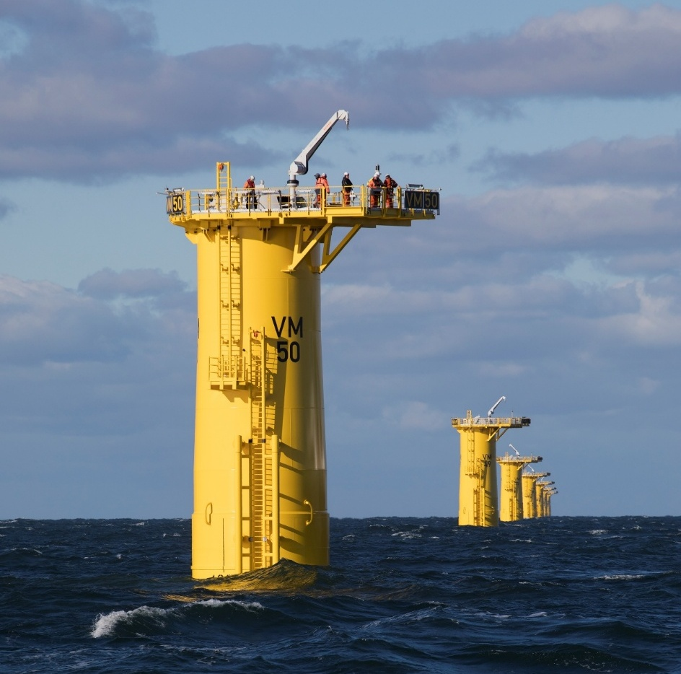

Piled jackets
The jacket foundation is typically a multi-tube steel frame, built with a lattice construction and fixed to the seabed by several legs. Each leg is fixed to the seabed via steel pin piles. The pin piles are driven into the seabed like monopiles, but smaller in diameter. A representative schematic of a jacket foundation is provided in Figure 4-9.
The parameters for piled jacket foundations are provided in Table 4-9. The installation methodology, including piling durations, is described in Section 4.7.5.
Table 4-9 Parameters – substation piled jacket foundations
Design parameter | Unit | Parameters
Maximum number of piled jacket foundations | No. | 5
Maximum number of jacket legs | No. | 6
Maximum number of piles per leg | No. | 2
Maximum pile diameter | m | 3.25
Maximum seabed footprint per jacket foundation | m² | 4,800
Figure 4-9 Piled jacket foundation for an offshore substation
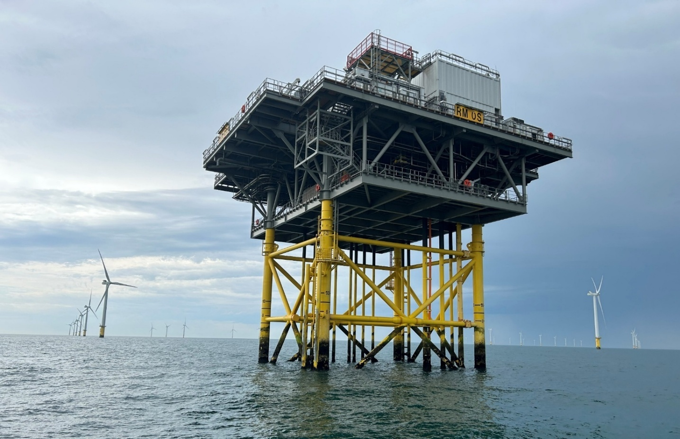

Scour protection for foundations
Foundations are vulnerable to seabed erosion and instability, known as scour, caused by natural hydrodynamic and sedimentary processes. Scour development is influenced by the foundation shape, seabed sediment type, and site-specific metocean conditions, such as waves, currents and storms. Scour protection may be used to protect foundations. Commonly used types include:
- Rock armour (most common): Layers of rock or rock-filled bags are placed on and/or around structures.
- Concrete mattresses: Concrete blocks linked by rope lattice, typically several metres wide and long, are placed on and/or around structures.
- Artificial fronds: Mats made of high tensile strength polypropylene, typically several metres wide and long, that resemble seaweed and slow water flow around the foundation.
- Concrete tetrapods: Wave-dissipating concrete blocks.
- Structural solution: The use of bearing plates or thicker steel in the foundation at the seabed.
Table 4-10 Parameters – scour protection for monopile and jacket foundations
Design parameter | Unit | Upper limit
Wind Turbine Foundations
Maximum scour protection footprint (per monopile) | m² | 2,341
Maximum scour protection footprint | m² | 344,127
Maximum scour protection volume | m³ | 292,236
Offshore Substation Foundations
Maximum scour protection footprint (per monopile) | m² | 2,341
Maximum scour protection footprint (per jacket) | m² | 15,425
Maximum total scour protection footprint | m² | 47,945
Maximum total scour protection volume | m³ | 95,897
Figure 4-10 Scour protection options schematic
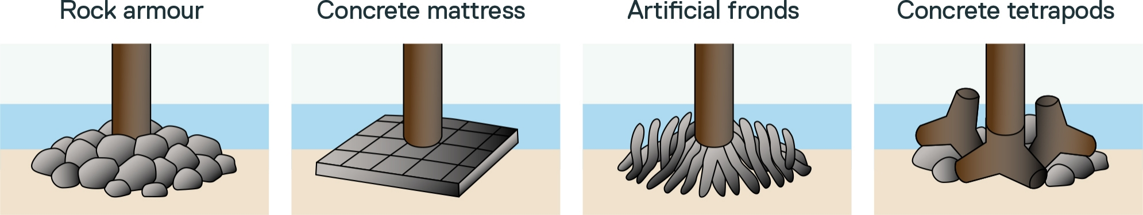

Offshore construction

Offshore construction schedule
An indicative timeline for offshore construction is shown in Figure 4-11. This schedule represents the longest potential duration, spanning up to 59 months (4 years and 11 months). It assumes that only one vessel is used to install both the foundations and turbines.
Working hours may vary by component. The assessment of the project assumes that offshore construction, although weather-dependent, would typically be undertaken 24 hours a day, seven days a week.
Figure 4-11 Indicative offshore construction schedule
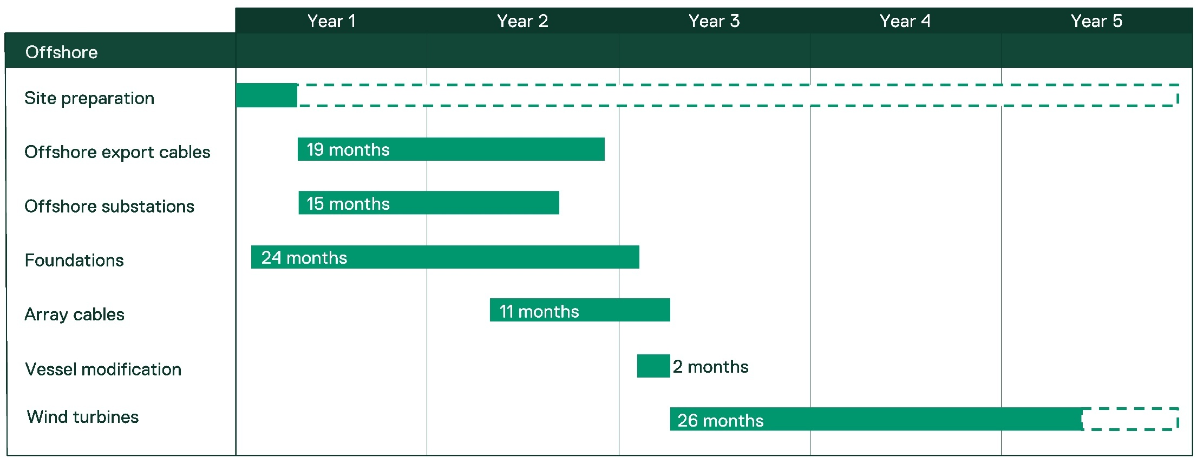

Offshore construction staging
Offshore construction is likely to occur in the following order:
- Site preparation activities
- Offshore export cable installation
- Foundation installation
- Offshore substation topside installation
- Inter-array and interlink cable installation
- Offshore wind turbine installation
Further detail for each step is outlined in the following sections.
The project would be constructed in either one or two stages. The following construction staging principles have been adopted for the assessment of the project:
- The total duration of active offshore construction across all stages would be no more than 59 months (four years and 11 months).
- The minimum construction gap between stages one and two would be at least 12 months.

Site preparation activities
Site preparation may include pre-construction survey, seabed clearance and pre-installation of foundation scour protection. These activities are expected to start before offshore installation activities and continue throughout the construction program, as needed.

Pre-construction survey
Pre-construction, foundation sites, installation vessel footprints and cable routes will be surveyed for obstacles or hazards prior to works commencing. Survey methods include side-scan sonar or a multibeam echo-sounder from a vessel. Data is used to inform micro-siting or seabed clearance methods if required.

Seabed clearance
Seabed clearance methods are described below.

Pre-lay grapnel run
Following the pre-construction survey, a pre-lay grapnel run and clearance survey of the cable corridors may be undertaken. This involves using a multipurpose vessel equipped with a series of grapnels and chains and a recovery winch. The pre-lay grapnel run clears the site of loose items, such as ropes, chains and nets, that could impede the installation and burial of cables. Figure 4-12 shows an example of a typical pre-lay grapnel run arrangement.
Figure 4-12 Typical pre-lay grapnel run arrangement
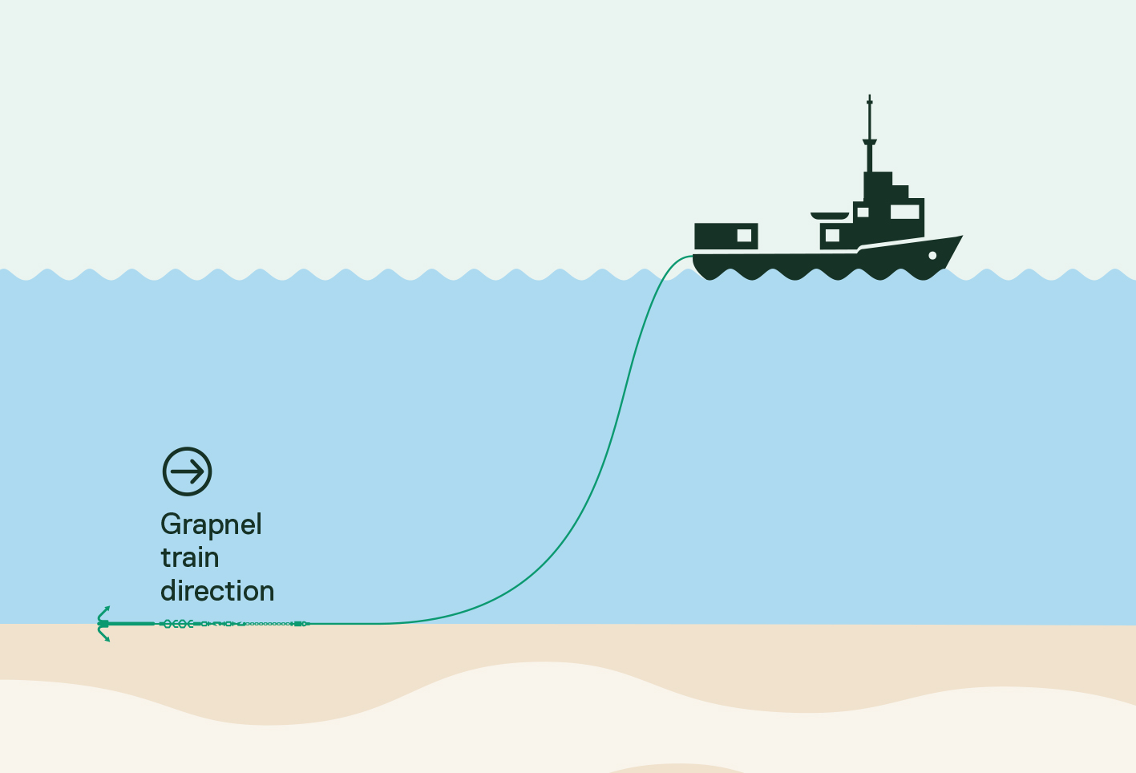

Seabed levelling and pre-trenching
In limited cases, sand ridges, sand waves and other obstacles may need to be levelled or cleared to create a flat surface for construction or jacking up an installation vessel on its legs. Levelling can be undertaken using ploughs, grabs, jetting tools and other excavation methods.
Pre-trenching may be required to prepare an area for cable installation using ploughs or other trenching tools.

Vessels for site preparation activities
A range of specialist vessels will be used for site preparation activities, including survey vessels, service operation vessels (SOVs), trenching vessels, remotely operated vehicles (ROVs) and guard vessels. These highly specialised commercial vessels are typically small to medium-sized and would be mobilised for specific scopes of work.
The number of vessels involved in site preparation is provided in Section .

Offshore export cable installation
Offshore export cable installation begins at the shore crossing, where the cable is pulled from an installation vessel to shore via pre-installed pipes and secured at the transition joint for later termination into the onshore transmission system. The installation vessel then proceeds towards an offshore substation, installing cable along the pre-defined, pre-cleared cable corridor. At the substation, the cable is set down on the seabed for wet storage or pulled into the substation and terminated. This process is repeated for each cable. Post lay survey is undertaken to confirm the burial depth and precise installation route.
Cables will be buried using one of the following methods:
- Simultaneous lay and burial (plough)
- Post-lay burial (jet trenching)
- Trenching prior to cable lay (mechanical trenching).
A plough is typically used for export cable burial; however, any one or more of the methods described in Table 4-11 can be used. Method/s will be selected based on their effectiveness for the target burial depth and soil type.
Table 4-11 Cable installation methods
Tool | Description
Plough  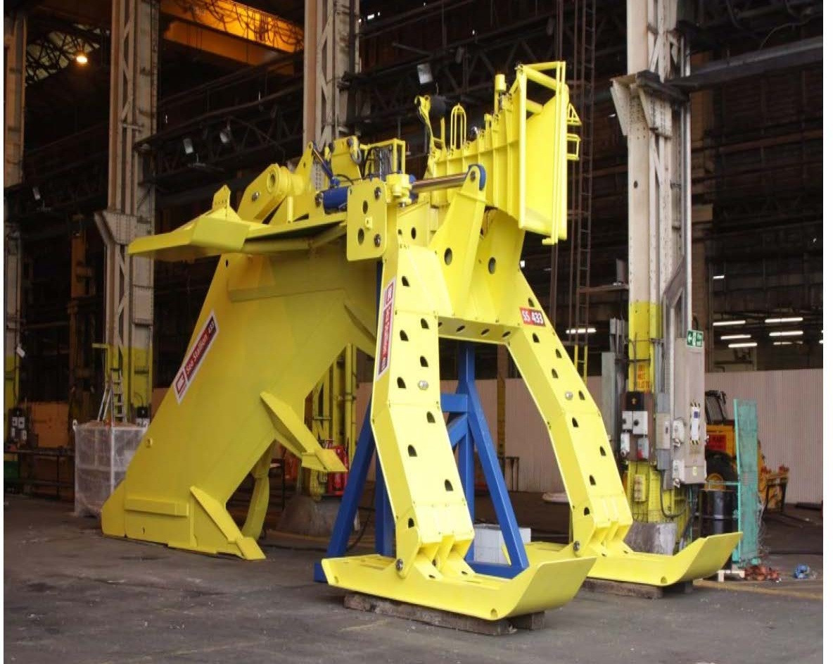 | Cable ploughs are passive tools that cut through the seabed and create a narrow trench in which the cable is simultaneously inserted. Ploughs are usually towed by a vessel or ROV on the seabed.
Jet trencher  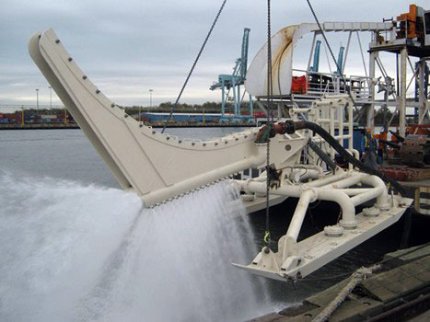 | Jetting tools excavate a trench by directing a high-pressure jet of water at the trench face to fluidise the seabed, allowing the cable to sink to the required burial depth.  Jet trenching tools are most effective in soft, fine-grained sediments (sands and soft clays) and can be towed, free-swimming or tracked.
Mechanical trenching  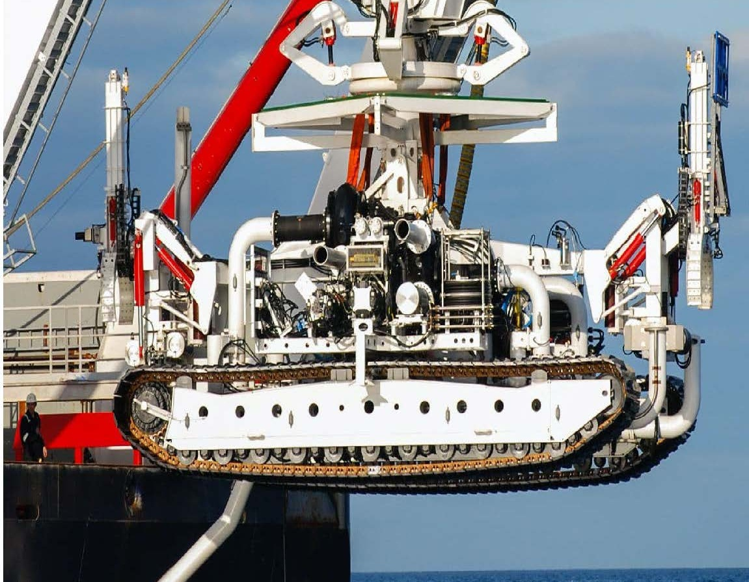 | Mechanical trenching machines use a series of picks or scoops mounted on a chain or on a wheel to excavate a trench in which the cable is then laid. Trenches are usually mounted on tracked vehicles.

Cable and crossing protection installation
In areas where cables are not buried sufficiently, cable protection materials like rock or concrete mattresses and matts will be transported to site via installation vessels and placed over the installed cables with cranes or fall pipes, sometimes with the aid of ROVs. Materials and methods are described in Section 4.7.5.3

Foundation installation
The installation process for monopile and pile jacket foundations is described in Section 4.7.5.1 and Section 4.7.5.2.

Monopile foundations
Monopiles are transported to their installation position and piled or drilled into the seabed, and a transition piece is installed, if used. The installation vessel then proceeds to the next foundation position and repeats the process.
The exposed foundation section is marked to aid safe navigation until the turbine is installed. Scour protection is installed separately, if not already pre-installed during site preparation.

Piling
After positioning the installation vessel, the monopile is lifted into a pile gripper on the vessel’s side. A hydraulic hammer is then placed on top of the monopile and used to drive it into the seabed to the required depth.
Piling will begin with a ‘soft start’ at approximately 10-20 per cent of peak hammer energy for 30 minutes, followed by a ramp-up to a maximum energy of 4,000 kJ until the target penetration depth is reached.
Only one monopile will be installed at a time. The average piling time per monopile is estimated at two to 2.5 hours, with a maximum of four hours assessed per monopile. Over the entire construction period this results in a maximum of 608 hours of piling activity.

Drilling
Geotechnical data from site investigations indicates there is a low likelihood of encountering hard seabed conditions that would require drilling. If unsuitable ground is encountered, and piling cannot achieve the required penetration depth (known as refusal), relief drilling may be used. This involves drilling out material inside the monopile with a hydraulic drill, then restarting pile driving. The parameters for monopile pile refusal are provided in Table 4-12.
Table 4-12 Parameters for monopile pile refusal
Design parameter | Unit | Upper limit
Maximum number of monopiles requiring drilling | No. | 8 (5%)
Maximum drilling diameter (per location) | m | 10
Maximum drilling duration (per location) | days | 5.2
Maximum drilling duration for the offshore wind farm | days | 36.4
Maximum volume of drill cuttings (per location) | m³ | 2,513

Transition piece installation
If used, the transition piece is prepared and lifted onto the monopile, then aligned and levelled before being grouted or bolted in place. This is often done from the same vessel that installed the monopile, though two-vessels may be used.

Piled jacket foundations
Piled jacket foundations may be used for the offshore substations. Installation typically involves:
- Lowering the jacket foundation onto the seabed
- Piling the pin piles by driving them into the seabed
- Installing scour protection.
Pin pile installation is similar to monopile piling; however, as pin-piles are smaller in diameter, the maximum hammer energy is typically lower (3,500kJ). Piling will begin with a ‘soft start’ at approximately 10-20 per cent of peak hammer energy for 30 minutes.

Scour and cable protection installation
Scour and cable protection are installed using similar methods, as detailed in Table 4-13. The amount of scour protection required depends on the foundation type (monopile or jacket) and cable type, location and seabed conditions. Scour and cable protection materials may include rock placement, rock bags, concrete mattresses, cast-iron or high-density polyethylene shells and sleeving. Installation is carried out using specialist installation vessels, assisted by remote operation vessels.
Table 4-13 Scour and cable protection installation methods
Protection type | Description | Installation method
Concrete mattresses | High-strength concrete blocks bound with ultraviolet-stabilised polypropylene rope. | Mattresses can be installed around the foundations and cables with a standard dynamic positioning vessel and a swimming installation frame. The mattresses are first lowered to the seabed. Once in the correct position, a frame release mechanism is triggered, allowing the mattress to fall onto the seabed.
Rock placement | A layer of rocks placed around foundations or over cable crossings. | Rock placement is achieved by using a vessel that installs rock close to the seabed via chutes.
Rock bags | Pre-filled rock bags that consist of various-sized rocks contained with a rope or wire net. | Pre-filled rock bags can be placed around foundations or above cables using specialist installation beams deployed from vessel cranes. Bags would be lowered to the seabed in a manner similar to concrete mattresses.
Cable crossing | The crossing of existing subsea cables by the formation of ‘bridges’ or piped protection to provide separation between cables. | Cable crossings will be comprised of ducting, concrete mattresses or rock, as described above. A crossing angle of approximately 90º relative to the existing cable is preferred; however, the angle will depend on the final design.
An example of rock placement around a monopile is shown in Figure 4-13.
Figure 4-13 An illustration of scour protection being installed around a monopile
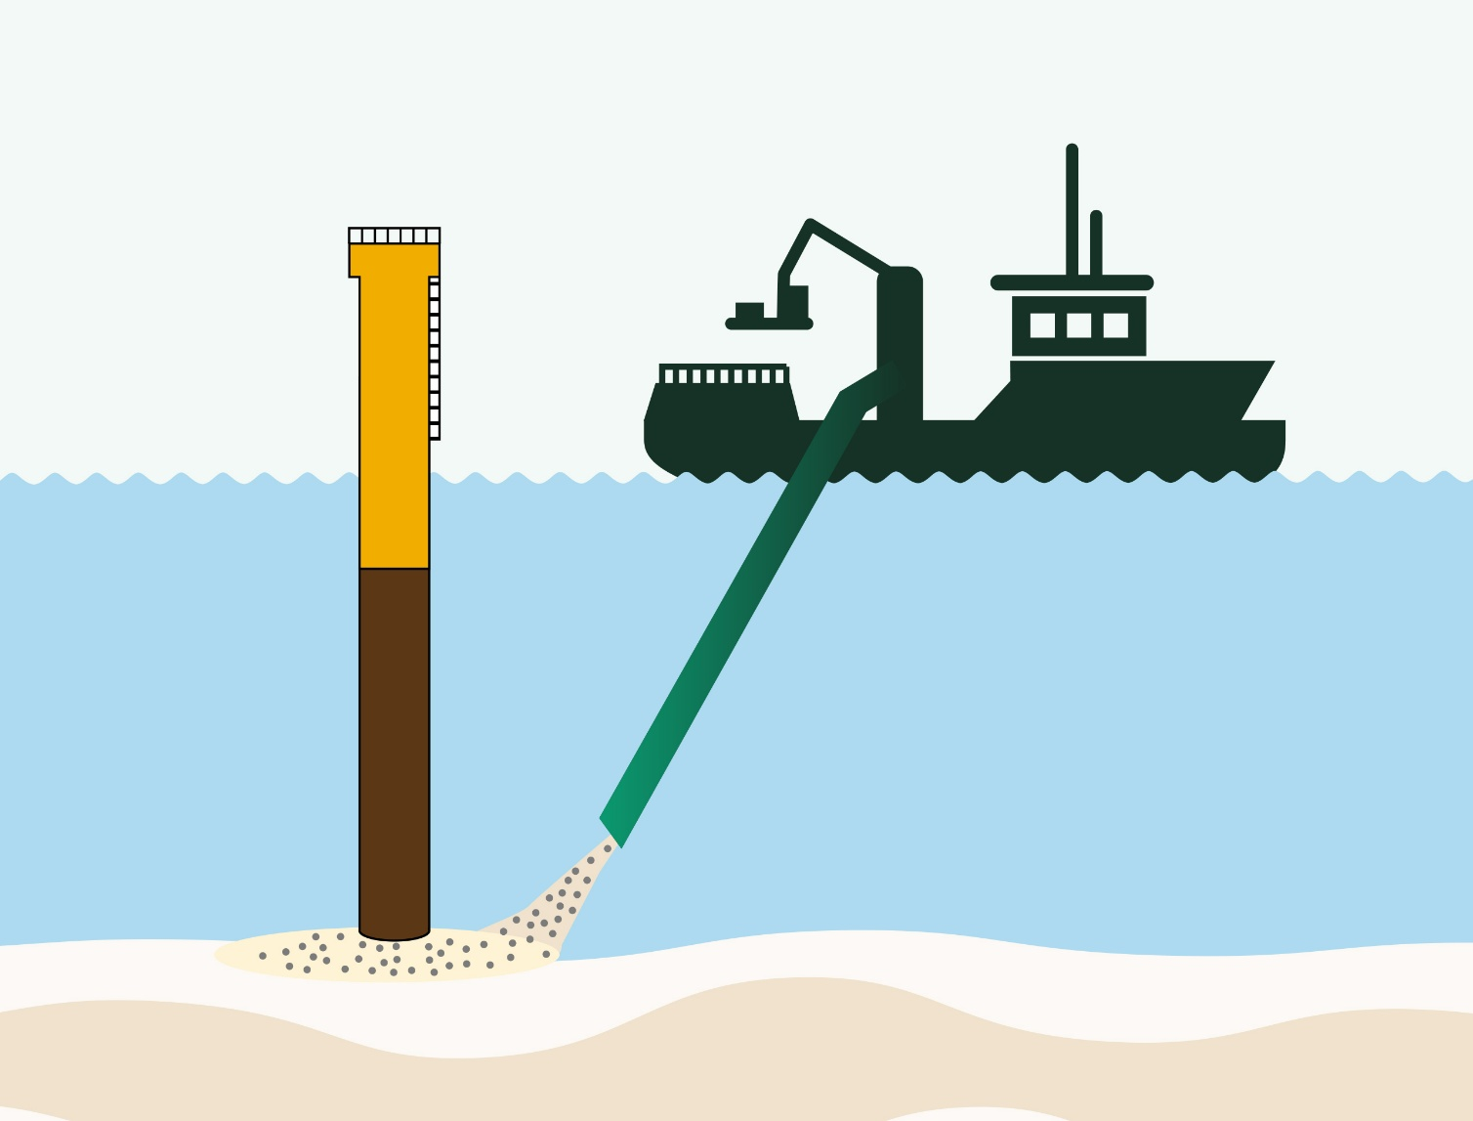

Offshore substation installation
Substation topsides will be pre-assembled at a fabrication yard or port then transported to site using a heavy-lift installation vessel or transportation barge. Installation is carried out either by a jack-up vessel or dynamic positioning vessel (refer to Section for descriptions of vessel types).
At site, the installation vessel is positioned and the topside lifted and welded or bolted onto the foundation. Once installed, the topside is ready to receive cables for termination and commissioning activities.

Inter-array and interlink cable installation
Inter-array and interlink cable installation begins once foundations are in place and typically occurs at the same time as other offshore wind farm construction activities.
Installation starts with the first end pull-in at the turbine or substation. The installation vessel then moves to the next position, where the cable is either laid and wet-stored on the seabed or immediately pulled into the structure. This process is repeated for all cable runs in the turbine array. Divers or ROV’s may be used to assist with cable pull-in if required.
Installation methods are similar to those used for offshore export cables, as shown in Table 4-11.

Offshore wind turbine installation
The installation of fixed-bottom turbines typically involves:
- Delivery and pre-assembly of turbine components at the construction port
- Load out and transport to site using an installation vessel or a transportation barge
- Installation using a jack-up or dynamic positioning vessel.
Installation vessels carry components directly to the site for installation. If using a transportation barge, components are transferred to an installation at sea, near the installation area. Vessel trip numbers are described in Section 4.7.7.1.
Once the installation vessel is positioned and jacked up (if using a jack-up vessel), turbine components are lifted by via crane onto the foundation. The tower is installed first, followed by the nacelle, hub, and blades. Assembly technicians fasten components together as they are lifted into place. Figure 4-14 shows turbine installation in progress.
Figure 4-14 Offshore wind turbine installation via jack-up vessel
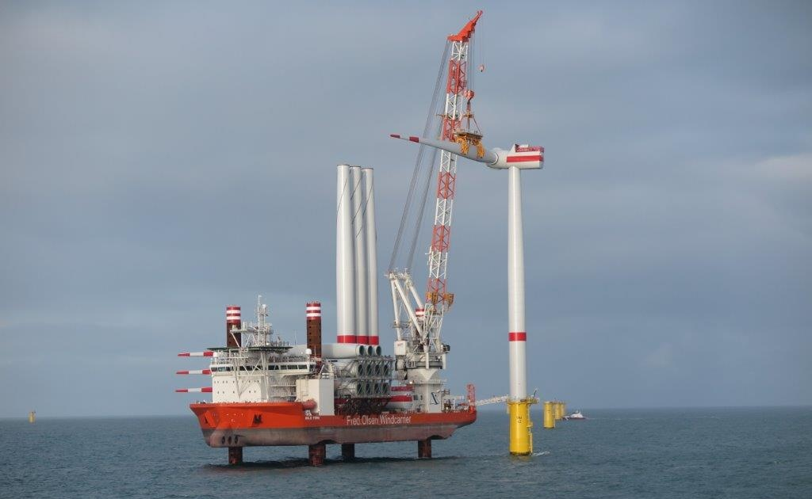
Source Veja Mate Offshore Wind Farm
Once a turbine is installed, commissioning activities are carried out including mechanical completion, electrical completion, energisation and high-voltage commissioning.
Turbine installation is expected to take up to 26 months, with an additional six month contingency allocated to account for potential delays.

Construction vessels

Type of vessels
A range of vessels will be used to construct the project, including:
- Large transportation vessels that deliver components to the construction feeder port (including from international locations)
- Large installation vessels such as jack-up vessels and / or heavy lift dynamic positioning vessels to install foundations, turbine components and substations (refer to Section 4.7.9.1.1 and 4.7.9.1.2 for details)
- Cable installation vessels
- Installation support vessels that supply equipment and support construction activities, including service operation vessels, tugs, escort vessels, remote operated vessels, survey vessels and crew transfer vessels
- Scour protection installation vessels
- An accommodation jack-up vessel may be used to house the commissioning crew during construction, positioned in the offshore wind farm area as needed. Alternatively, service operation vessels could accommodate crew for weeks at a time
- Impact mitigation equipment and vessels, such as seabed-based double big bubble curtains or other noise mitigation equipment, may be deployed during construction.
Helicopters may also be used for emergency response, vessel transfers, and to winch personnel directly onto and off turbines or substations.
Vessel selection is typically the responsibility of the construction contractor and will depend on availability, technical suitability, health and safety considerations and price.

Jack-up
Jack-up vessels form a stable platform for lifting and positioning infrastructure such as turbines and substation topsides, by lowering legs to the seabed and lifting the vessel above the water (refer to Figure 4-14).
Large jack-up vessels may be used to install monopiles, turbines and substations. Smaller jack-ups can be used for shore crossing construction, offshore export cable pulling, and accommodation.
The parameters for jack-up vessel operations are provided in Table 4-14.
Table 4-14 Parameters – jack-up vessel operations
Design parameter | Unit | Upper limit
Maximum number of legs per vessel | No. | 6
Maximum individual spud can area | m² | 250
Maximum seabed footprint per vessel | m² | 1,500
Maximum number of vessel location jack-ups | No. | 312
Total maximum footprint | m² | 468,000

Heavy lift
Heavy-lift dynamic positioning vessels are equipped with a large crane capable of lifting substantial loads. Unlike a jack-up, they do not make contact with the seabed. Instead, they use a dynamic positioning system with thrusters to maintain position without anchoring or jacking up. An example of a heavy lift vessel is shown in Figure 4-15.
The assessment assumes that multiple vessels may use dynamic positioning at the same time.
Figure 4-15 Heavy lift dynamic positioning vessel
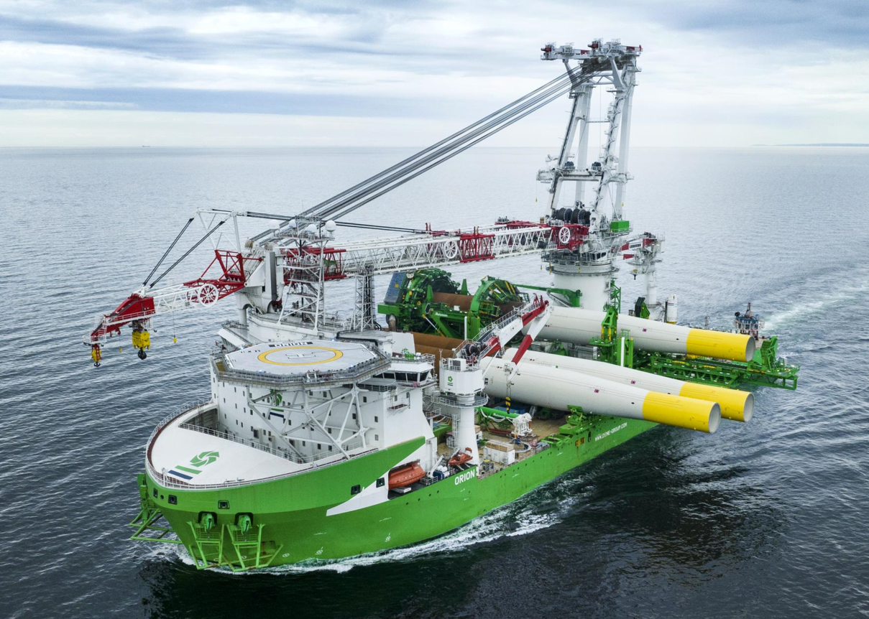
Source Deme Orion

Round trips and movements
The maximum number of construction vessels and vessel movements is based on the highest number of turbines.
Up to 8,320 round trips may be made during the construction phase, of which 7,520 are crew transfer vessels. A ‘round trip’ refers to a vessel departing from an Australian port, travelling to the offshore project area, and returning to port.
Up to 8,390 vessel movements may be made during the construction phase. A ‘vessel movement’ refers to a vessel moving from one location to another within the offshore project area. For example, from one turbine to the next.
In addition, heavy transport vessels may deliver equipment directly to the offshore project area from an overseas manufacturer’s yard.

Construction ports

Construction feeder ports
Construction feeder ports serve as a primary hub for unloading, storing and loading large turbine and foundation components. These must be deep water commercial ports with available land and a dedicated berth.
The assessment assumes that multiple construction feeder ports are required. The Port of Bell Bay (Tasmania) and Geelong Port (Victoria) have been used to estimate vessel round trips for assessment of the project, although other ports such as the proposed Victorian Renewable Energy Terminal at the Port of Hastings may be used in their place or in addition.
The location of potential construction feeder ports in proximity to the project is shown in Figure 4-16.
Any port development or upgrade is the responsibility of the port operator and is subject to separate planning and approval processes.

Construction management port
A construction management port will cater to smaller vessels supporting construction activities, such as those transporting crew and supplies to the offshore project area on a day-to-day basis. This port must have marine facilities for crew transfer vessels, and some land-based warehouses, offices, hardstands and car parking.
Barry Beach Marine Terminal and Port Anthony have been used to estimate vessel round trips to the construction management port for assessment of the project. Located within Corner Inlet approximately 35 kilometres from the edge of the offshore wind farm area, these established commercial ports already service the offshore oil and gas industry and have available land.
Any port development or upgrade is the responsibility of the port operator and is subject to separate planning and approval processes.
Figure 4-16 Potential construction feeder and management ports
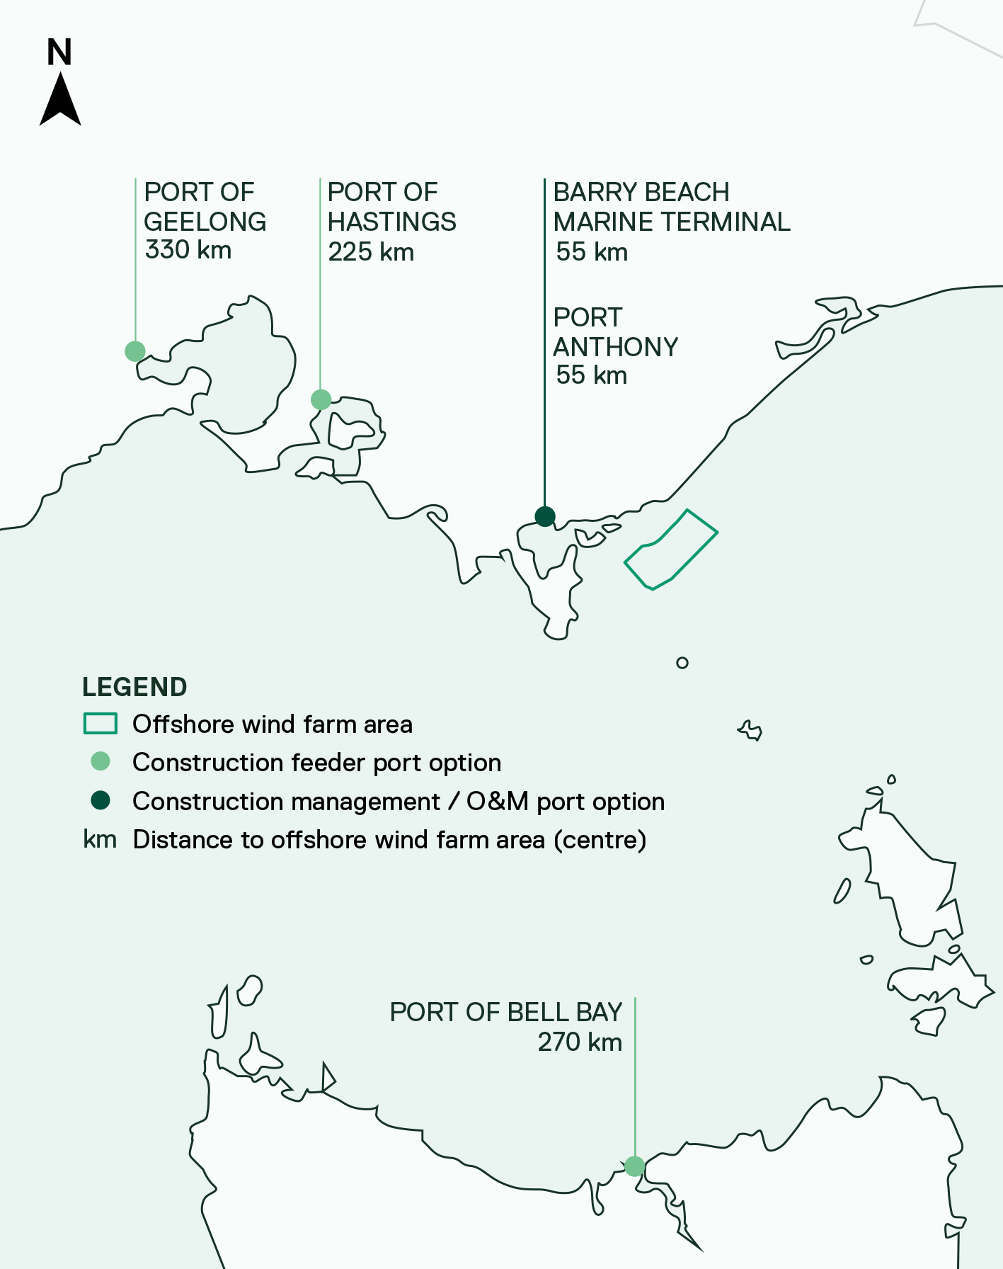

Lighting, marking and navigation aids
The construction area/s will be marked in line with Australian Maritime and Safety Authority requirements. These are referred to as demarcation areas. This is likely to consist of a combination of temporary cardinal buoys and special marks around the perimeter of construction areas. Select cardinal buoys may transmit their position via Automatic Identification System to appear on vessel navigation systems if required. All structures above the water level, regardless of their construction status, will be marked. All vessels will be marked and lit in accordance with the Convention on the International Regulations for Preventing Collisions at Sea, 1972.

Other safety measures and coordination
A range of measures may be employed to protect infrastructure and ensure the safety of workers and marine users during the construction phase. These include:
- Safety zones: A safety zone temporarily prohibits vessel access to a specific area, unless authorised, extending up to 500 metres around eligible infrastructure such as foundations and cables. Safety zones may be considered during construction, maintenance, or decommissioning activities.
- Protection zones: A protection zone restricts or prohibits certain activities in a specific area longer term, extending up to 1,852 metres (one nautical mile) from eligible infrastructure such as cables. Protection zones may be considered during operation to prevent interactions with installed infrastructure.
- Escort vessels: Escort vessels will be used to monitor the offshore project area during construction, communicate with and support the safety of third-party vessels, and avoid disruption to construction activities.
- Marine coordination centre: A marine coordination and construction management centre will manage vessel movements during construction and operations, including providing direction to escort vessels and issuing communications to mariners. The marine coordination and construction management centre is not a part of the assessment of the project.
Construction activity, demarcation areas, safety zones and other updates or alerts will be communicated through channels including Notices to Mariners, emails, text messages and website updates, to ensure marine users are aware of access and use restrictions within the offshore project area.

Offshore operations and maintenance
The project is expected to have an operational life of approximately 30 years. An operations and maintenance (O&M) strategy will be confirmed once the project’s technical specifications are finalised.

Operations and maintenance activities
The offshore wind turbines will be available to operate continuously during the operations phase. Infrastructure will be monitored and operated remotely from a local O&M facility located at either Barry Beach Marine Terminal or Port Anthony, supported by a service operation vessel (SOV) and/or crew transfer vessel (CTV) logistics strategy.
O&M activities will be both preventative (planned) and corrective (unplanned). Preventative activities are carried out as part of regular scheduled services, such as removing marine growth. Corrective maintenance covers unexpected repairs, component replacement and breakdowns.
Table 4-15 provides a list of planned and unplanned O&M activities.
Table 4-15 Operation and maintenance activities
Activity |  | Parameter
Offshore wind turbine foundations | Description | Expected method and vessel type | Expected frequency
Routine inspections | Inspection of foundations, transition pieces and ancillary structures above and below sea level. | Small team access via SOV or CTV. | Once per year per foundation.
Minor repairs and replacements | - Painting / other coatings to protect foundations from corrosion.  - Replacement of ancillary structures (for example, boat landings).  - Replacement of the anodes required for corrosion protection.  - Repair and replacement of electrical equipment such as lighting. | - Small team access via SOV or CTV.  - Divers or remote operation vessels (ROVs) may be used for the replacement of anodes. | As required. Minor repairs are likely to occur once per year per foundation (for example, replacing a fall arrest system or repairing TP cranes).
Removal of marine growth | Removal of marine growth from foundations, transition pieces and ancillary structures. | Small team access via SOV or CTV.  Divers may be deployed for the removal of marine growth. | Once per year per foundation.
Operational monitoring – marine surveys | Subject to regulator requirements. | Survey vessel, ROV or installed technology (non-invasive). | Subject to regulator requirements.
Offshore wind turbines | Description | Expected method and vessel type | Expected frequency
Routine inspections | Component inspections within the turbines and on the exterior (for example, blades). | Service technician access via SOV or CTV. Drones may also be used. | Once per year per turbine.
Minor repairs and replacements | Painting.  Minor repairs and replacement within the turbine (electric equipment, circuit breakers, motors). | Service technician access via SOV or CTV. | Up to 6 times per year.
Replacement of consumables | Replacement of oils, lubricants and filters within the turbine. | Service technician access via SOV or CTV. | Once per year per turbine (bundled with the turbine inspections mentioned above).
Major component replacements | Replacement of blades and gearboxes. | Jack-up barge. | Approximately once per lifetime per turbine.
Offshore substation foundations and topside | Description | Expected method and vessel type | Expected frequency
Routine inspections | Component inspection within the offshore substation and on the exterior. | Small team access via SOV or CTV. | Once per year.
Minor repairs and replacements | Painting / other coatings to protect foundations from corrosion.  Replacement of ancillary structures (for example, boat landings).  Modifications to/replacement of J-tubes (where the cable enters the offshore substation).  Remove and replace the anodes required for corrosion protection. | Small team access via SOV or CTV.  Divers or ROVs may be used for the replacement of anodes and J-tubes. | Several times per year.
Replacement of consumables | Replacement of oils and lubricants within the offshore substation. | Small team access via SOV or CTV. | Once per year.
Major repairs and replacements | Replacement of transformers, switchgear and other components. | Jack-up barge. | Once per lifetime.
Removal of marine growth and bird guano | Removal of marine growth and bird guano from foundations, offshore substations and ancillary structures. | Small team access via SOV or CTV.  Divers may be deployed for the removal of marine growth. | Once per year per foundation.
Operational monitoring – marine surveys | Subject to regulatory requirements. | Survey vessel, ROV or installed technology (non-invasive). | Subject to regulatory requirements.
Inter-array cables | Description | Expected method and vessel type | Expected frequency
Routine inspections | Inspections of the cable and cable protection, including where they enter foundations. | Survey vessel or ROV (non-invasive). | Every 3 to 5 years.
Cable repair | Repair and replacement of inter-array cable sections. | Cable vessel. | Replacement of approximately 4 inter-array cable sections during the lifetime.
Surveys (geophysical) | Survey of seabed and cable protection. | Survey vessel or ROV (non-invasive). | Every 3 to 5 years.
Offshore export cables | Description | Expected method and vessel type | Expected frequency
Routine inspections | Inspections of the cable and cable protection, including where they enter foundations. | Survey vessel or ROV (non-invasive). | Every 3 to 5 years.
Cable repair | Repair and replacement of offshore export cable sections. | Cable vessel or shallow barge (inshore). | Not expected during a 30-year lifetime as per failure rates.
Surveys (geophysical) | Survey of seabed and cable protection. | Survey vessel or ROV (non-invasive). | Every 3 to 5 years.
Cable reburial | Reburial of exposed offshore export cable section. | Cable vessel/SOV or shallow barge (inshore). | Every 3 to 5 years.

Operations and maintenance vessels
Up to 1,202 round trips may be made each year during the operations phase. A ‘round trip’ refers to a vessel departing from an Australian port, travelling to the offshore project area, and returning to port.
Most of these vessels will be crew transport vessels, which are small in scale (average draft of 2.5 metres). When metocean conditions allow, these vessels will typically travel from the O&M port to the offshore project area every day to transfer technicians to an average of three turbines per day, per vessel. The assessment assumes up to six crew transport vessels operating daily during peak periods. Alternatively, crew transport vessels may remain offshore and transfer technicians from a service operation vessel to the turbines. In this case, both vessels would typically visit the site and return to port on a bi-weekly schedule.
Helicopters may also be used for crew transfers during unplanned maintenance or emergency response.
Larger installation vessels, such as jack-up vessels, may be used for component replacement (for example, blades) from time to time.

Operations and maintenance port
Barry Beach Marine Terminal and Port Anthony have been used to estimate vessel round trips to the O&M for assessment of the project. These ports may also play a role in the project’s construction, as outlined in Section .
The O&M port will serve as a base for smaller maintenance vessels, crew transfers and operational activities. It will provide sheltered quayside facilities for SOVs and CTVs, berthing areas and have land available for:
- Warehouses and hardstand areas
- Offices with crew facilities
- Refuelling and spare part storage
- Staff facilities, including a car park.
Port land and facilities will be leased or licenced from the port operators during the project’s operations phase. Any modifications required to support the project’s O&M activities will be proposed and undertaken by the port operator and is subject to separate planning and approval processes.

Lighting, marking and navigational aids
Offshore wind turbines and substations will be lit and marked during operations according to operational and regulatory requirements, as described in Section 4.7.11.

Other safety measures and coordination
A range of measures may be employed to protect installed infrastructure and ensure the safety of operations and maintenance workers and marine users during major maintenance activities and daily operations. These measures are likely to be similar to those used during construction (refer to Section 4.5.12).

Figure 4-17 Typical service operation vessel
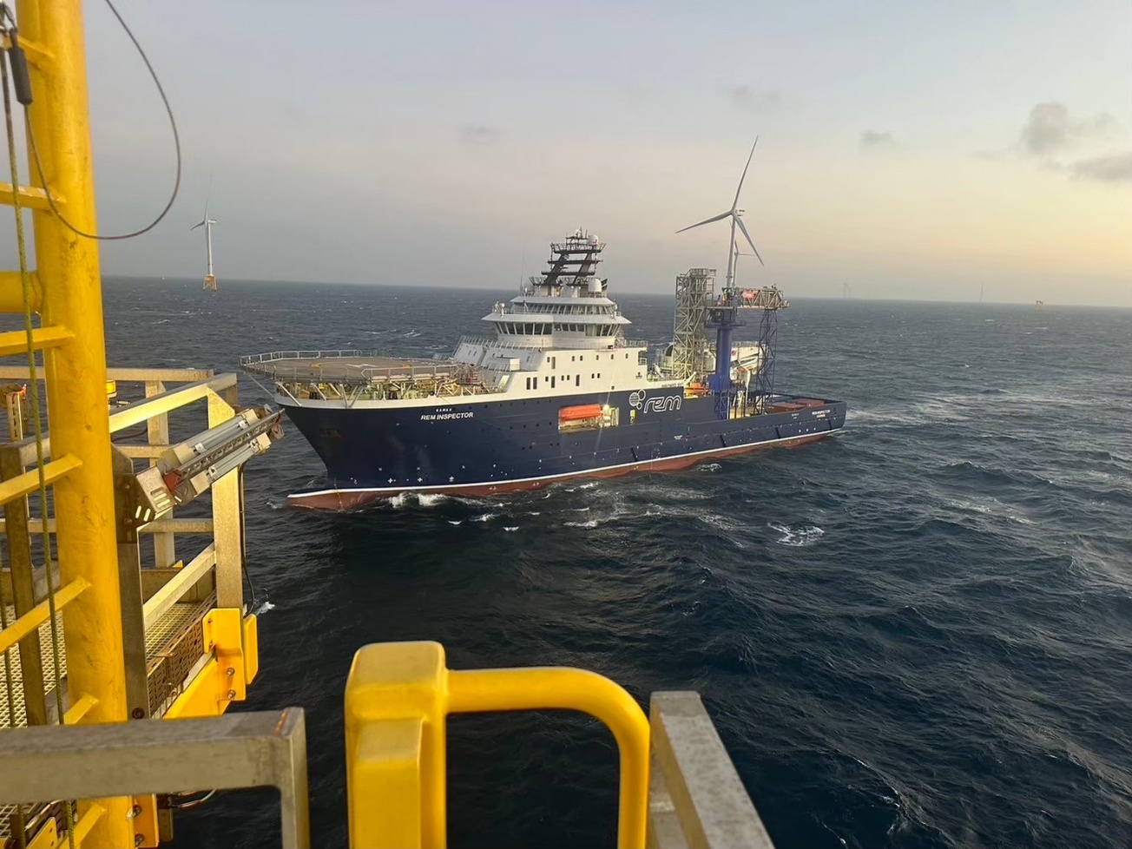
Figure 4-18 Typical crew transfer vessel
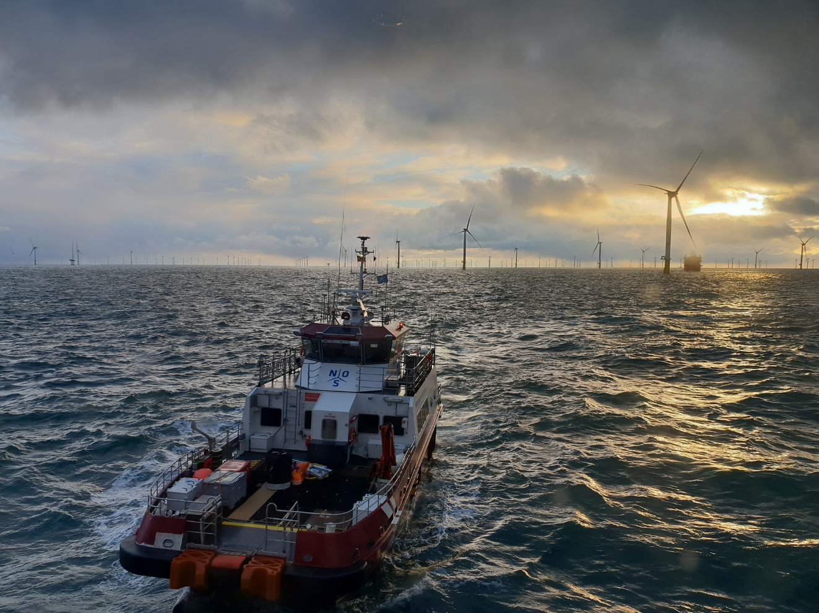

Offshore decommissioning
At the end of the project’s life, decommissioning activities will begin. The main objective of decommissioning is to leave a safe, stable and non-polluting environment, and to minimise impacts during the removal of infrastructure.
Key principles that will apply to decommissioning include:
- Planning and budgeting for decommissioning, as required under the Offshore Electricity Infrastructure Act 2021 (Cth)
- Considering environmental conditions and stakeholder interests when developing decommissioning plans
- Returning the seabed to baseline conditions as far as practicable.
Decommissioning plans for offshore infrastructure will be prepared in accordance with approvals conditions prior to the planned end of service and decommissioning of the project. These plans will describe the proposed activities, methods, potential impacts and management measures, as outlined in the project’s Commonwealth Environmental Management Framework (Chapter 23 – Commonwealth Environmental Management Framework).
Decommissioning is expected to involve similar types and numbers of vessels and equipment as the construction phase. Requirements at the time will determine the scope of decommissioning activities and impacts. The anticipated duration is up to three years. Indicative activities include:
- Removing offshore substation topsides and foundations to just below the seabed
- Removing offshore wind turbines, transition pieces and monopiles to just below the seabed
- Removing scour protection where possible and appropriate to do so
- Retaining offshore cables in situ
- Returning the seabed to baseline conditions as far as reasonably practicable.
Decommissioning will be managed under approved management plans, prepared in accordance with relevant laws and policies in place at the time of decommissioning.

Repowering
In sectors such as oil and gas, removing seabed structures at the end of a project’s life is standard practice as the resource has been fully extracted and the infrastructure serves no future use. For offshore renewable energy projects, repowering may be considered as an alternative.
Repowering involves replacing turbines and / or foundations to extend the project’s operational life and take advantage of technological advances. If the specifications or design of the new components falls outside the scope of this assessment, additional approvals may be required. For this reason, repowering is not considered in this assessment.

Waste
End-of-life infrastructure will be managed in accordance with the waste management hierarchy principles of avoid, reduce, reuse and recycle. The feasibility of continuing to use infrastructure beyond the project’s expected lifespan will be assessed (avoid / reduce) before decommissioning begins.
If reuse is not feasible on site, some components may be suitable for use in other offshore projects in other jurisdictions. Where reuse is not possible, project components will be recycled, with the separation and processing of recyclable materials carried out in local facilities where possible.
A high proportion of offshore wind project components can be recycled. Commonly recyclable materials are summarised in Table 4-16.
Table 4-16 Recyclable offshore wind infrastructure
Project component | Material | Parts
Offshore wind turbines | Steel | Structural parts of the nacelle, hub, transformer, and  mechanical moving parts
Offshore wind turbines | Fibreglass and resins | Blades, nacelle cover, hub, electrical boards
Offshore wind turbines | Cast iron | Nacelle and hub
Offshore wind turbines | Copper | Nacelle parts, electrical connections
Offshore wind turbines | Aluminium | Nacelle parts, auxiliaries
Offshore wind turbines | Rubber and plastic | Nacelle and electrical and hydraulic cables
Offshore wind turbines | Hydraulic oil | Mechanical parts
Offshore wind turbines | Rare metals/magnets | Generator
Offshore wind turbine towers | Steel | Turbine tower, bolted connections, connection flanges
Offshore wind turbine towers | Aluminium and copper | Electrical cables, ladders, auxiliaries
Offshore wind turbine towers | Zinc and other metals | Electrical components
Offshore wind turbine monopiles | Steel | Monopile
Offshore wind turbine monopiles | Inert (rock/gravel) | Scour protection
Cables | Aluminium, Copper | Cables and connections
Cables | Plastic materials | Insulation and wiring
Cables | Inert (rock/gravel) | Cable protection

PART C – SHORE CROSSING
This section describes the infrastructure and construction, operation and decommissioning activities at the shore crossing – the point where offshore export cables transition underground from sea to land and are connected (jointed) to the onshore cable system.

Shore crossing design
The preferred shore crossing location is Reeves Beach, a publicly accessible beach and basic campground at the southern end of the Ninety Mile Beach, approximately three kilometres south-west of Woodside Beach and approximately 10 kilometres from the offshore wind farm area (Refer to Figure 4-1).
Up to eight individual shore crossings may be required to accommodate up to eight offshore export cables. The shore crossings are between 600 and 1,400 metres long (underground), running perpendicular to the shoreline and parallel to one another.
The exact size, profile and path of the shore crossings will depend on the final size and quantity of cables being used. Key design considerations include ground conditions, environmental constraints, adequate cover and separation between bores, and efficient duct and cable installation.
Parameters for the shore crossings are provided in Table 4-17.
Table 4-17 Parameters – trenchless shore crossings
Design parameter | Unit | Upper limit
Maximum number of ducts installed | No. | 8
Maximum trenchless shore crossing horizontal length | m | 1,400
Maximum bore depth from entry elevation | m | 35
Minimum onshore export cable/bore separation | m | 10
Minimum offshore export cable/bore separation | m | 100
Maximum bore diameter | mm | 1,350
Maximum duct diameter | mm | 900

Figure 4-19 Shore crossing cross-section
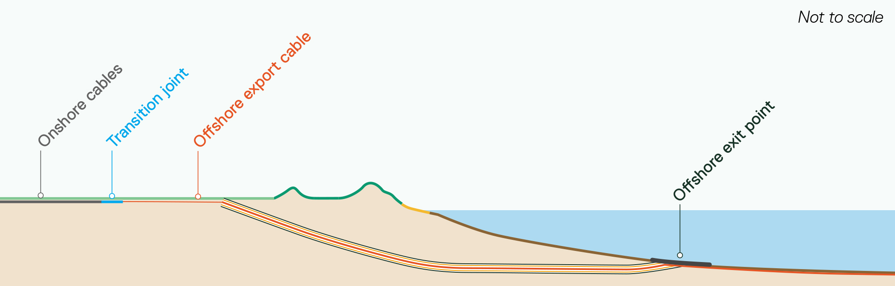

Offshore interface
Offshore, each shore crossing ends at an offshore exit point located in water deep enough to avoid the intertidal and shallow wave zone and allow safe operation of the installation vessel, at least five to 10 metres deep.
Installed cables may require additional protection from currents, scour and vessel activity around the offshore exit point. This protection is typically achieved by burying the cables in the seabed and / or covering them with a rock mattress or other mechanical protection systems. Cable burial and protection options are detailed further in Section 4.6.2.5.

Onshore interface
Onshore, each shore crossing ends in a temporary construction compound located in farmland on the landward side of Reeves Beach. From this point, cables run a short distance underground to the transition joint, which connects the offshore export cable and the onshore cable system (including communications cables).
Because offshore and onshore cables are designed differently, one offshore cable (containing three separate cores) transitions to three single-core onshore cables at the transition joint.
The transition joint is housed within a transition joint bay, a concrete-lined pit that provides a clean and dry environment for cable jointing. Up to eight joint bays (one per offshore export cable) may be required, each approximately 10 metres wide, 30 metres long and five metres deep. These bays also have link pits for earth bonding and fibre pits for fibre connections which can be accessed via surface lids for periodic maintenance and testing. During operation, only these lids and safety signage are visible above ground, as shown in Figure 4-21.
The inside of a typical 220 kilovolt transition joint bay with joints is shown in Figure 4-20, and a concept layout of the transition joint bays at Reeves Beach is shown in Figure 4-21.
Figure 4-20 Transition joint bay internals
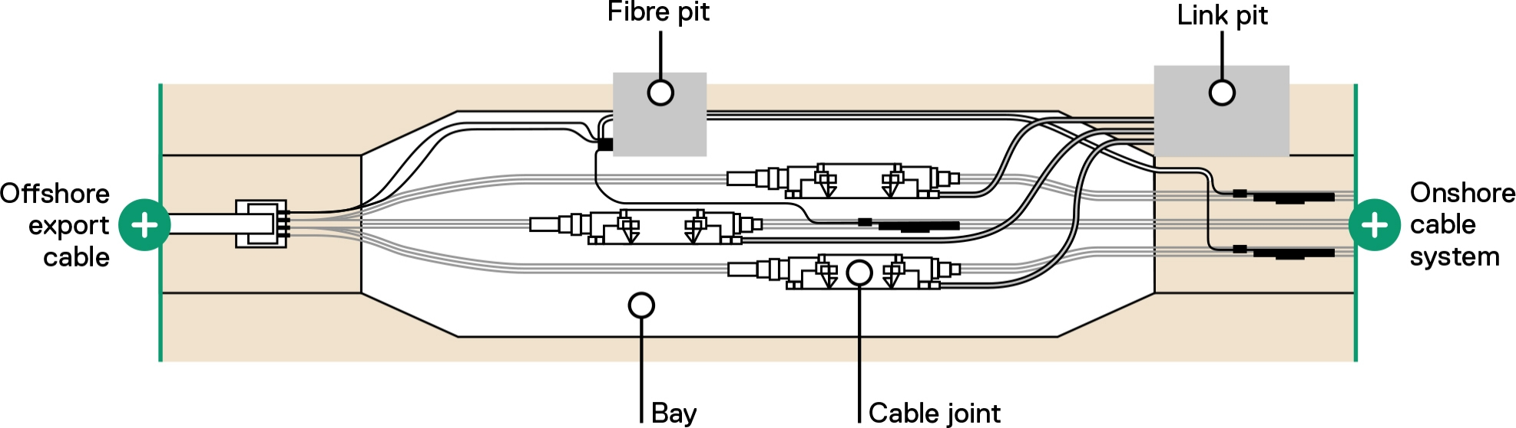
Figure 4-21 Transition joint bay cable concept layout
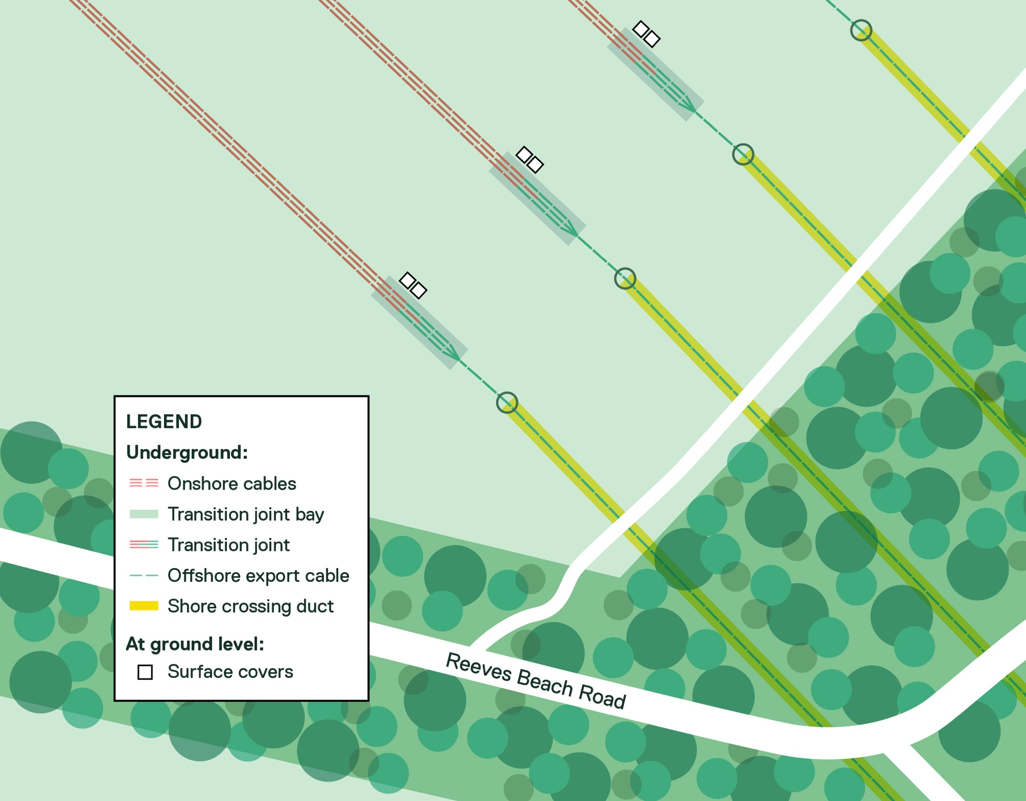

Shore crossing construction

Shore crossing construction schedule
An indicative timeline for shore crossing construction is shown in Figure 4-22. This schedule represents the maximum duration, and assumes all eight shore crossings are required.
Construction occurs in two main phases:
- Drilling and duct installation: Activities include site establishment (up to six months), bore drilling and duct installation (10 to 18 months, with each bore requiring four to six weeks of active drilling which typically runs 24 hours a day, seven days a week), and demobilisation (up to three months).
- Cable pulling: Each offshore export cable pull is expected to take up to one week, within the maximum 19 month export cable installation window, including setup and demobilisation. There will a gap between each cable pulling operation while the cable vessel installs the offshore export cables or re-supplies.
Figure 4-22 Shore crossing construction schedule
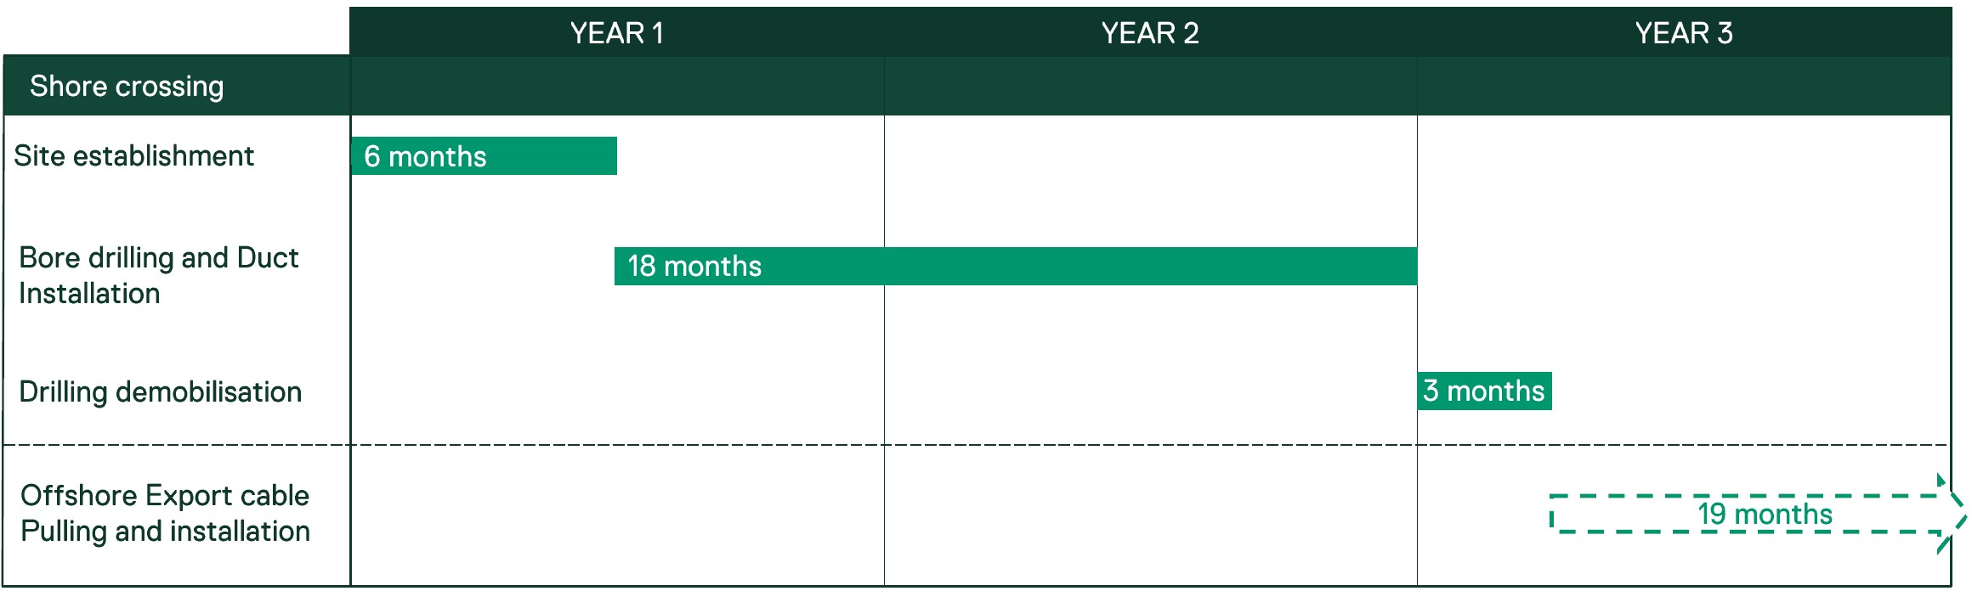

Drilling and duct installation
A trenchless installation method is proposed to avoid open-cut trenching in the sensitive nearshore and coastal location. This involves drilling bores and installing ducts underground, through which the offshore export cables can be pulled, housed and later removed (if necessary).
There are trenchless crossings present along the Gippsland coastline, including at McGaurans Beach for the Basslink Interconnector, and in Wonthaggi for the desalination plant brine discharge pipe.
Based on the current understanding of the Reeves Beach area, nearshore features and target water depths, horizontal directional drilling is the method most likely to be used.

Onshore site establishment
Duct construction is initiated onshore within a temporary construction area. This area typically includes:
- A temporary construction compound at each bore location, containing the drilling rig and associated equipment
- Construction compounds for material storage, duct handling and assembly
- Temporary access tracks into the construction area and compounds.
Figure 4-25 shows a typical trenchless shore crossing construction compound.
Other works within the construction area include:
- Establishment of a temporary causeway over unnamed waterway - UFI:42824681 to allow materials and personnel to cross during construction
- Installation of a transition joint bay for each crossing to house the transition joints
- Open-cut trenching between each duct its corresponding transition joint bay to house the offshore export cable.

Offshore site establishment
Preparation works offshore may include seabed pre-clearance activities similar to those described in Section . Depending on the seabed condition, offshore exit points may be pre-excavated.

Bore drilling
Horizontal directional drilling uses a land-based rig to drill a borehole that exits offshore. The bore is drilled using rotation, thrust and water-based drilling fluids (such as bentonite or xanthan gum) which cool the drill bit, remove cuttings and prevent the bore from collapsing. The bore is typically drilled along a smooth, parabolic path with gentle inclines and declines to aid duct and cable installation.
The process begins with drilling a pilot hole, which is then enlarged through reaming to the required diameter for the cables. The drill bit exits the seabed at the offshore exit point, located beyond the wave zone in water deep enough for safe vessel access.
Medium to large vessels assist with drill head change out, duct feed in, and offshore export cable installation. Jack-up, dynamic positioning, moored, and smaller support vessels may also be used to support installation activities.
Figure 4-23 and Figure 4-24 provide schematic overviews of pilot hole drilling and reaming.
Figure 4-23 Pilot hole drilling
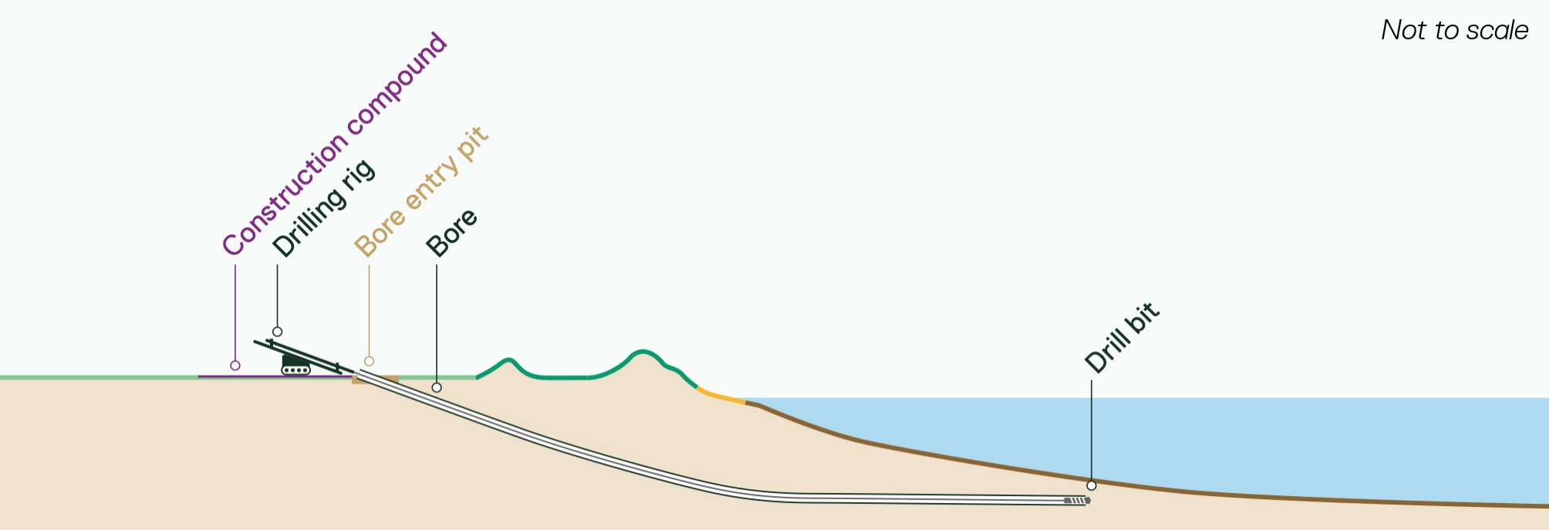
Figure 4-24 Pilot hole reaming
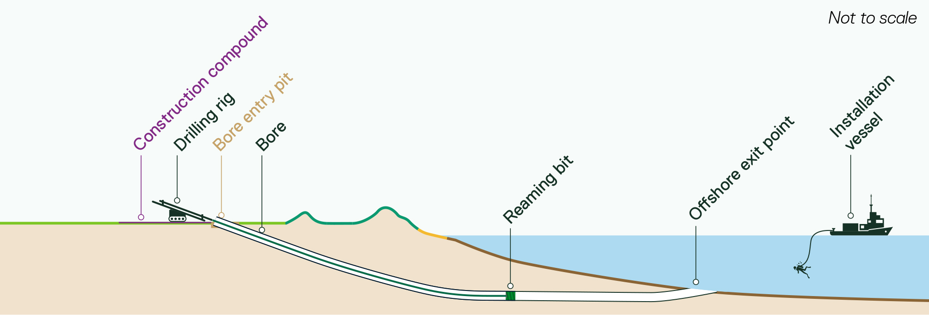
Figure 4-25 Shore crossing drilling operation, Vinyard Wind USA
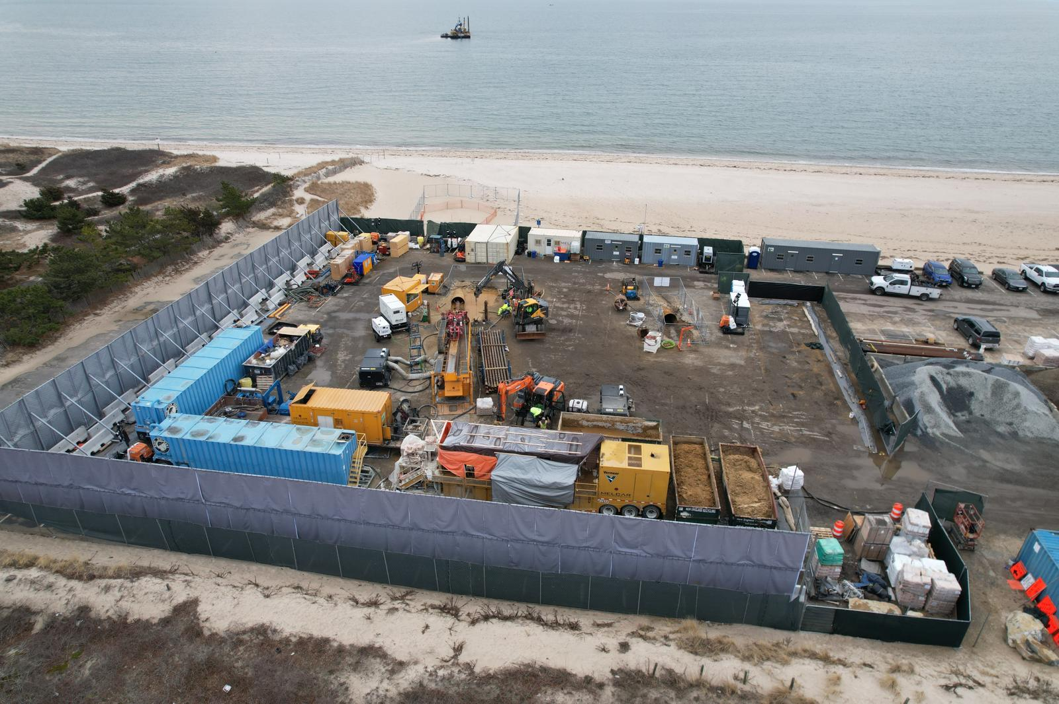

Duct installation
Once the bore is enlarged to the required diameter, a pre-assembled duct string is installed. This may be done by thrusting it from land or pulling it in from offshore using the land-based drilling rig.
For thrust installation, duct assembly and handling will occur behind the drilling operations and across the pre-installed causeway. For offshore pull-in, the duct will be pre-assembled, towed to the shore crossing site and pulled through the bore with the same drill string used for drilling (refer to Figure 4-26 and Figure 4-27).
Once a bore has been drilled and the duct installed, the drilling rig is moved to the next position, and the process is repeated until all ducts are installed.
A combination of smaller, jack-up, and conventional vessels may be used to support duct installation activities.
Figure 4-26 Shore crossing duct being towed to site Vinyard Wind, USA
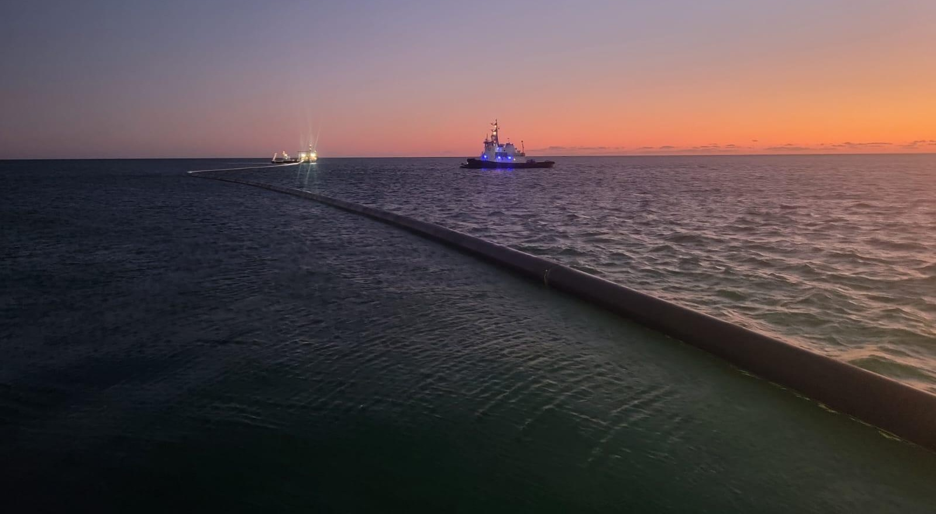
Figure 4-27 Duct installation
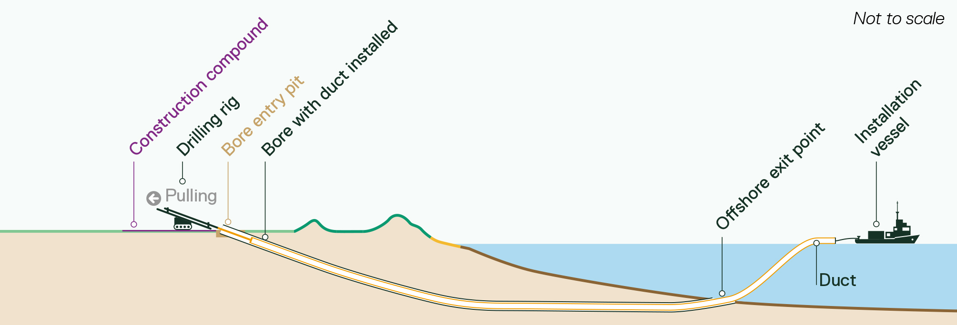

Drilling demobilisation
Once the last duct is installed, the drilling rig and associated equipment will be demobilised. Access tracks and temporary work sites will remain in place for cable pulling and jointing activities. A gap of several months may occur between the final duct installation and the beginning of cable pulling operations.

Cable pulling
Pulling the offshore export cable ashore from a cable laying vessel involves the following steps:
- Exposing and preparing the duct at the offshore exit point
- Positioning the cable laying vessel next to the pre-installed duct
- Pulling a winch cable through the duct from the onshore construction compound to the cable laying vessel and connecting it to the export cable
- Using the winch to pull the cable through the duct to shore
- Pulling the cable through an open trench to the pre-prepared transition joint bay, where it is secured ready for jointing to the onshore cable system.
A bentonite mix or equivalent material may be installed in the ducts to fill voids around the cables and maintain thermal performance during operations.
Onshore export cable pulling typically takes one day per cable, excluding preparation activities and any mechanical failures or weather delays. Once each cable is pulled in, the cable laying vessel lays the rest of the offshore export cable between the shore crossing and the offshore wind farm area (refer to Section 4.7.4). This process is then repeated for each crossing.
Smaller, jack-up, and conventional vessels may support cable pulling activities, including guidance, cable tensioning and monitoring, with additional support from remotely operated vessels and/or divers if required.
A representative schematic of offshore export cable pulling is provided in Figure 4-28.
Figure 4-28 Offshore export cable pulling
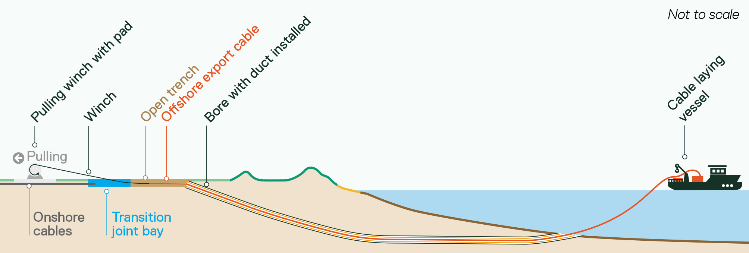

Shore crossing operations and maintenance
Operations and maintenance activities for the shore crossing are minimal. Periodic condition inspections are expected to coincide with offshore cable burial surveys and routine inspections of the onshore transmission system.

Shore crossing decommissioning
Underground infrastructure, including ducts and offshore export cables, is expected to remain in place at the end of the project’s life. Removal and remediation of the transition joint bays and onshore infrastructure would be carried out in accordance with the onshore transmission decommissioning plans outlined in Section .

PART D – ONSHORE TRANSMISSION
This section describes the infrastructure and construction, operation and decommissioning activities in the onshore project area.

Onshore project area and VicGrid interface
The project’s underground cable system and all associated infrastructure and activities for its construction, operation and decommissioning are contained within the onshore project area (Refer to Figure 4-29). This includes the permanent cable easement, temporary construction corridor, and temporary construction facilities such as compounds and access tracks.
The onshore project area comprises the following alignments:
- Common alignment: Extends from the shore crossing at Reeves Beach to Giffard.
- Alignment options AB, C and D: Feasible options to reach the proposed VicGrid connection hub, which enable a comprehensive assessment of the project’s potential impacts, pending confirmation of the final location of the hub and grid connection infrastructure within it.
The alignment option taken forward for the project will depend on the location of the final location of the VicGrid connection hub, as well as ongoing engagement with landholders. Once this location is known, project alignment options within the connection hub study area may require modification. Alignment options shown within the connection hub study area are therefore indicative.
The first 2 GW of offshore wind energy developed in Gippsland must connect to the grid at the VicGrid hub, which forms part of the VicGrid Offshore Wind Transmission 2 GW Project. VicGrid has released a study area in which the hub will be located, shown as grey in Figure 4-29. The hub will include provisions for cable approach areas, substations and associated infrastructure required to connect offshore wind projects to the grid.
As the VicGrid Offshore Wind Transmission 2 GW Project (including the hub) is subject to a separate assessment and approval process, this assessment of the Star of the South project does not consider any infrastructure or works within the connection hub study area.
Figure 4-29 Onshore transmission system alignment
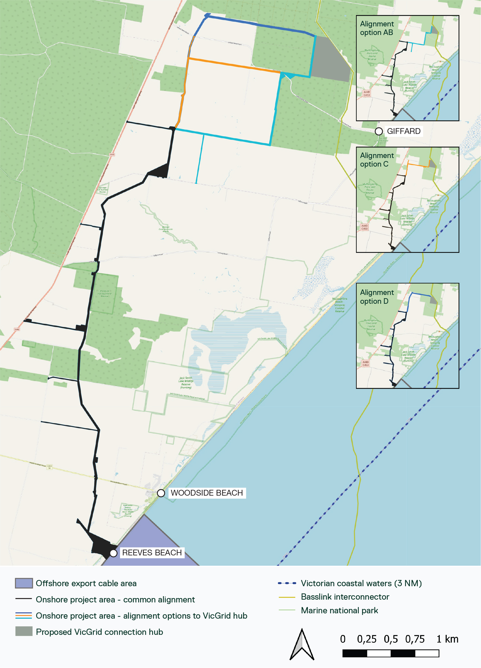

Onshore transmission infrastructure

Underground cable system
The underground cable system will be installed within an up to 40-metre-wide operational easement, widening up to 60 metres at select onshore trenchless crossing locations. The easement width at the shore crossing interface will taper down from the maximum width of the cable crossing footprint of 580m to up to 40m. The cable system will be installed within an up to 60-metre wide construction easement with widths increasing at select locations to account for laydown areas or access. The underground cable system extend approximately 30 kilometres, from the shore crossing to the proposed VicGrid connection hub at Giffard. It includes:
- Transmission cables to carry electricity
- Joints bays where sections of cable are jointed together
- Communications cables to transmit signals and data between the offshore wind farm and the cable system for performance monitoring.
The final design will be refined to reflect project capacity, site conditions and constraints (including landholder agreements), approval conditions, and National Electricity Market generation and transmission requirements.
Table 4-18 Parameters – underground cable system
Design parameter | Unit | Upper limit
Maximum cable voltage | kV | 275
Maximum number of circuits | No. | 8
Maximum number of trenches | No | 4
Maximum number of circuits per trench | No | 2
Maximum number of joint bays | No. | 370
Maximum trench depth | m | 2
Maximum joint bay depth | m | 3
Maximum cable easement width (excluding select trenchless crossing locations and provision for directional change) | m | 40
Maximum cable easement width at trenchless crossing locations and provision for directional change | m | 60
Maximum construction easement width (excluding select trenchless and other crossing locations) | m | 60

Transmission cables
Up to eight high voltage alternating current (HVAC) circuits may be required. Each circuit consists of three single-core cables that each carry an electrical phase. The final number and configuration of circuits will depend on the final offshore wind farm’s electrical design, project capacity and grid connection requirements.
Cables will be installed approximately one metre below ground in parallel trenches. Up to four trenches may be required to accommodate eight circuits. Figure 4-31 provides a representative schematic of trenches within the cable easement.
Warning tape and other mechanical protection and markings systems will be installed above the circuits in accordance with standard electrical practice. Figure 4-30 provides a representative schematic of the underground cable circuits.
The components of a typical single-core onshore cable are shown in Figure 4-32. The conductor is expected to be either aluminium or copper and will be sized to meet the operating capacity of the system.
Figure 4-30 Typical underground cable circuits (two circuits shown)
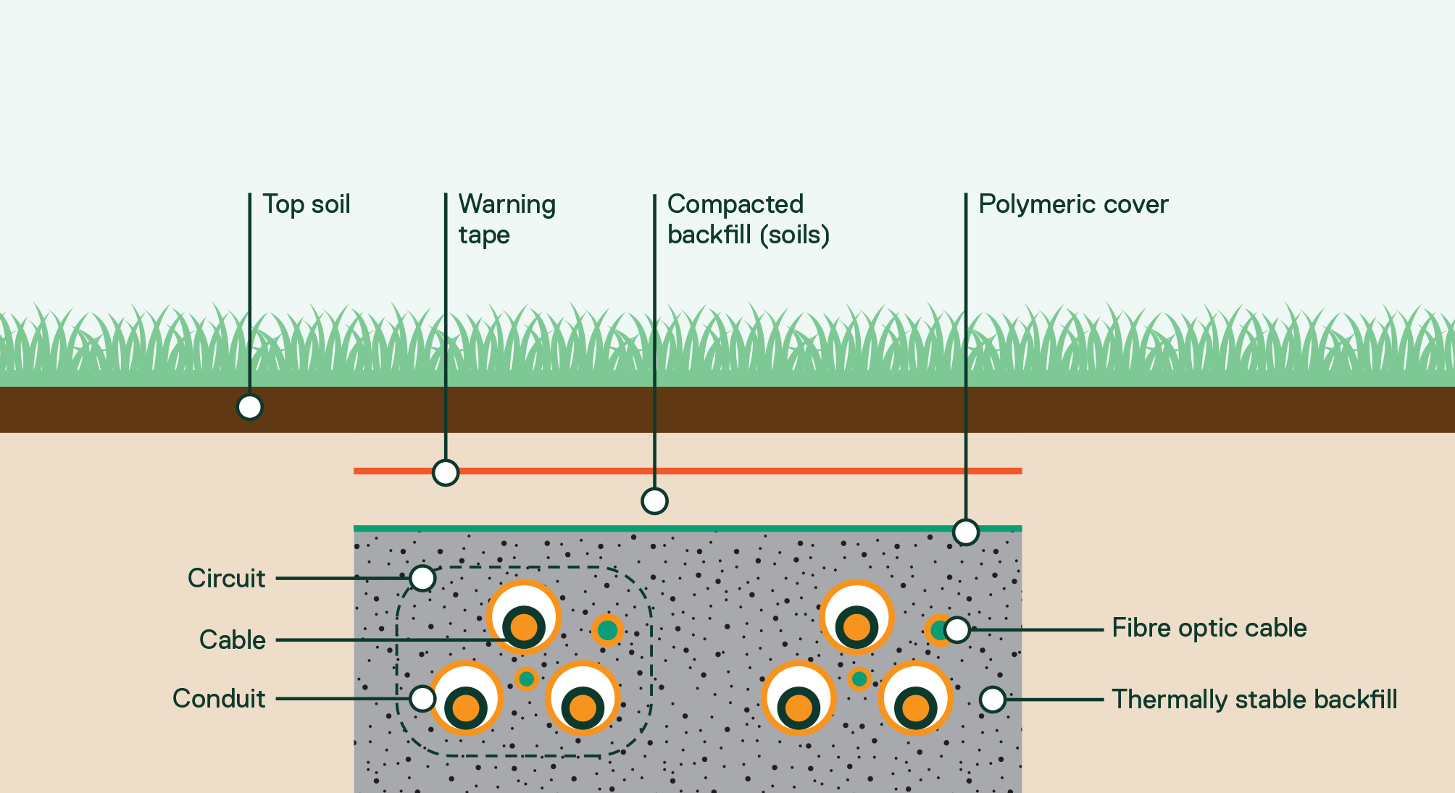

Figure 4-31 Example cable easement cross-section (eight circuits shown)
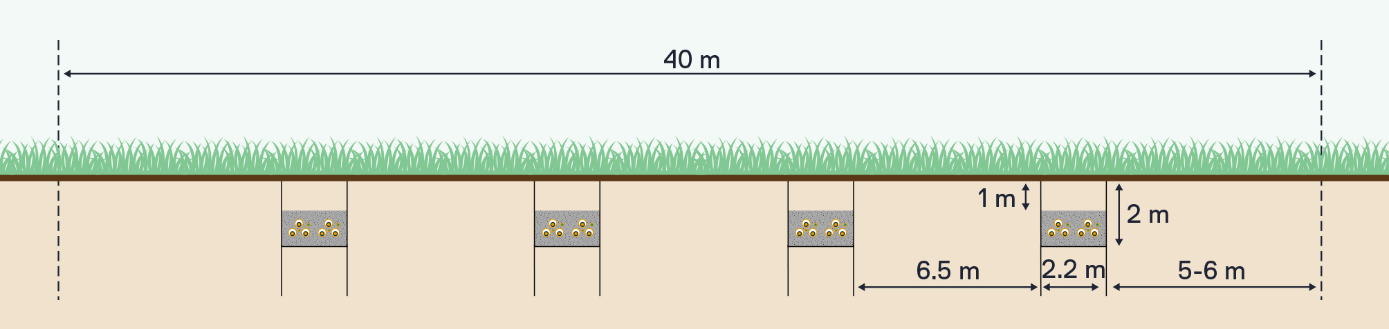
Figure 4-32 Onshore cable cross-section (single core)
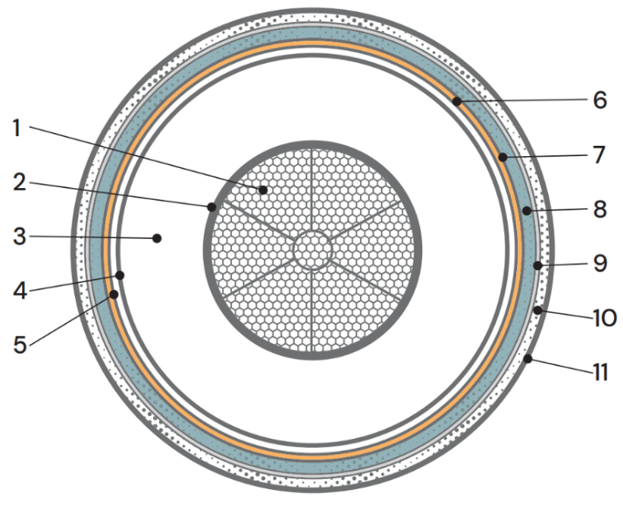
No. | Description | Material
1 | Conductor | Copper wires with water blocking tape
2 | Conductor screen | Semi-conductive polymer
3 | Insulation | XLPW cross linked polyethylene
4 | Insulation screen | Semi-conductive polymer
5 | Longitudinal water barrier | Semi-conductive water blocking tape
6 | Metallic sheath | Smooth aluminium
7 | Bonding material | Bonding compound
8 | Non-metallic bedding | Medium destiny polyethylene
9 | Anti-termite covering | Nylon
10 | Outer sheath | High destiny polyethylene
11 | Extruded semiconducting layer | Semi-conductive polymer

Joints and joint bays
Cable sections are connected using specialised in-line cable joints housed within joint bays. These are pre-cast, concrete-lined pits that provide a clean, dry environment for cable jointing and protection.
Up to 370 joint bays may be required, with a maximum size of 5 metres wide, 15 metres long and 3 metres deep, and spaced 0.8-1.2 kilometres apart along the cable corridor.
Joint bays are installed as open-topped assemblies, then backfilled with thermal fill and soil. They also contain link pits for earth bonding and fibre pits for fibre connections. These have surface access points and are typically only accessed during routine maintenance and testing, or in the event of a cable fault.
An example double circuit joint bay arrangement is provided in Figure 4-33. An image of cables being jointed is provided in Figure 4-.
Figure 4-33 Example joint bay arrangement (double circuit arrangement shown)
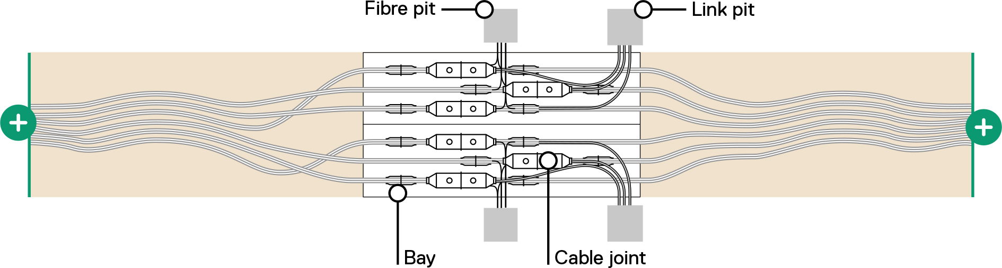
Figure 4-34 Joint bay locations within the underground cable system (five circuits shown)
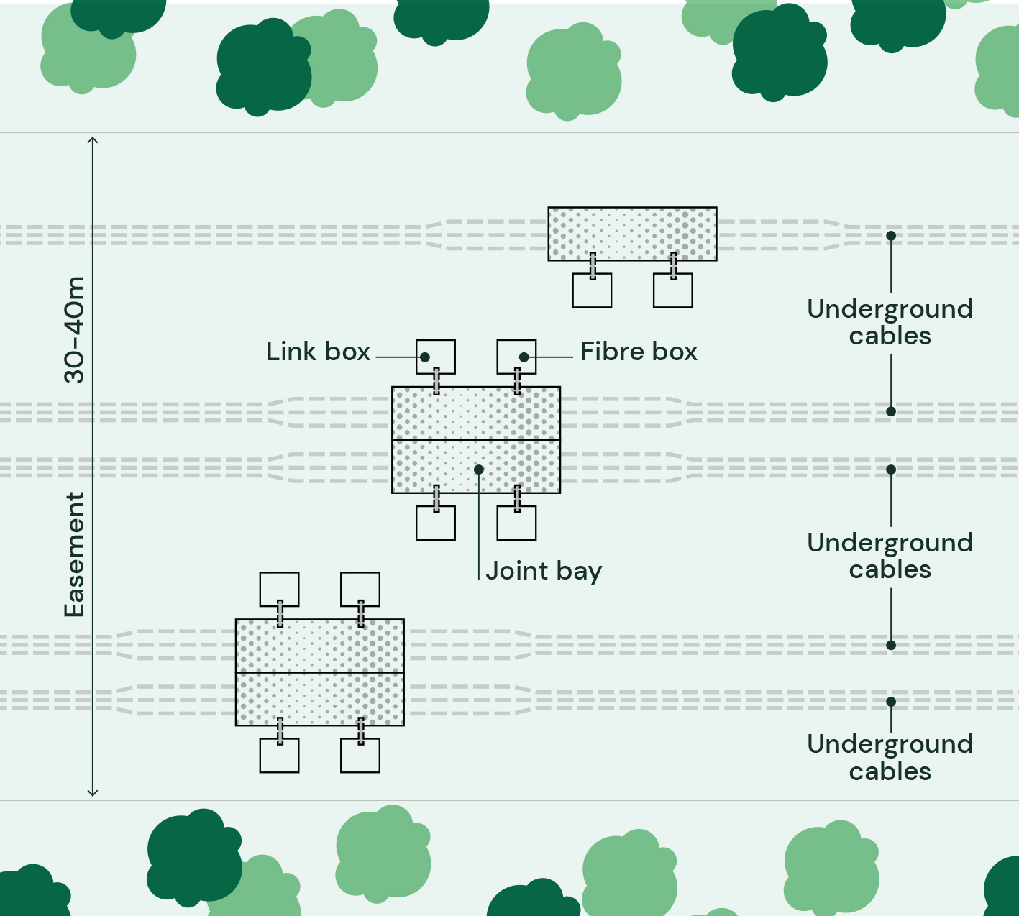

Figure 4-35 Cable jointing underway in a controlled environment (Australia)
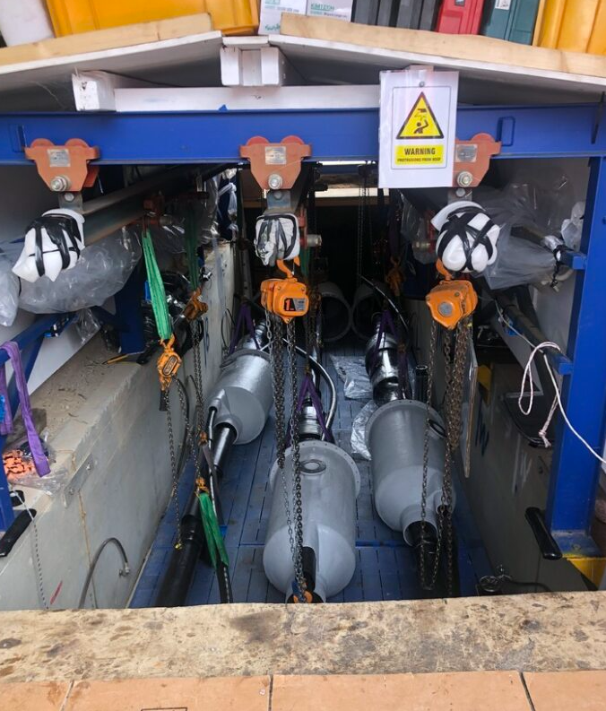
Source Cable System Engineering

Communications cables
Fibre optic cables will be integrated into the system to enable data transfer and communication with the offshore wind farm. They may also be used for transmission system condition monitoring during operation.
The fibre optic cables are expected to run in parallel with each electrical circuit, underground.

Thermally stable backfill
Thermally stable backfill is an engineered material commonly used in high voltage cable systems to improve thermal conductivity and achieve reliable thermal performance during operation. Backfill materials vary from thermal sands compacted around cables to fluidised thermal fill - a specifically engineered mixture of aggregates, cement and additives that can flow and set around the cables.
For a conduit system, fluidised thermal fill is expected to be used as it can flow around the duct configuration to provide consistent thermal performance. The fill will be batched locally or within the project area and transported in concrete agitator trucks to be poured directly into the trench. Once set, it forms a product similar to low-strength concrete and can be backfilled with soil and compacted above.
Thermal sands may be used in addition or as an alternative to fluidised thermal fill.
Installation of thermal backfill displaces topsoil. Up to 488,400 cubic metres may be required for an eight circuit system.

Cable easement
The underground cable system will be contained within a single easement that will be established, controlled and maintained where necessary to limit the growth of vegetation and prevent damage to the installed cables.
The easement will be up to 40 metres wide along most of the alignment, but it may narrow or widen in some areas to accommodate installation methods or constraints (for example, to avoid sensitive vegetation). The assessment of the project assumes the maximum potential easement width of 40 metres, with the following exceptions, as shown in Attachment I- EIS Map Book:
- At the shore crossing interface where the larger width of 580 metres allows for variability in cable crossing locations, to be refined through detailed design
- A reduction to 6 metres as an option to avoid impacts on a farm dam to the south of Darriman H33 Bushland Reserve, though this is limited to a single circuit option.
- Up to 50 metres for the provision for alignment directional change just southeast of Darriman H33 Bushland Reserve
- A reduction to 30 metres for a section of Options C and D of approximately 1.5 kilometres north of Carstairs Road, though assumed to be a compact circuit configuration with constructability impact.
- Up to 60 metres at select trenchless crossing locations at Giffard West Road and the saline wastewater outfall pipeline.

Onshore substation
An onshore substation is required to connect the project to the electricity grid, located within the proposed VicGrid connection hub in Giffard. The VicGrid hub will include provisions for cable approach areas, substations and other infrastructure required to connect approved offshore wind farms to the grid and is subject to a separate assessment and approval process. The onshore substation is therefore not assessed.

Onshore construction
Construction of the underground cable system involves installing electrical cables, fibre optic cables, and cable joint bays within a temporary construction corridor, extending from the shore crossing at Reeves Beach to the proposed VicGrid connection hub in Giffard. It is planned as a single continuous activity, with multiple crews working simultaneously in parallel.
The primary construction activities would occur in the following stages:
- Site establishment
- Cable system construction (including trenching, installation and jointing)
- Pre-commissioning and commissioning of the cable system
- Demobilisation and rehabilitation of areas disturbed by construction.

Onshore construction schedule
An indicative timeline for construction of the underground cable system is shown in Figure 4-36. This schedule represents the longest potential duration, spanning up to 26 months (2 years and 2 months).
Onshore construction is expected to be primarily undertaken during regular working hours, from 0700 to 1800 hours, Monday to Friday, and from 0700 to 1300 hours on Saturday. Some works may be required outside regular working hours, where unavoidable or for safety reasons. In these instances, Star of the South will coordinate with relevant authorities and stakeholders prior to these activities occurring where this is possible to do so.
Figure 4-36 Indicative construction schedule – underground cable system
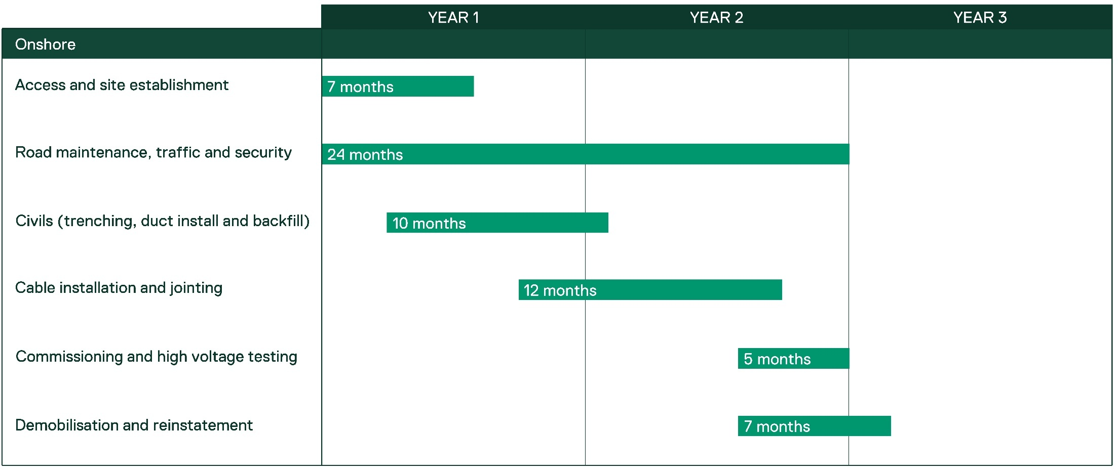

Site establishment
Initial site establishment activities include gaining access to work sites, installing environmental controls and fencing and setting up workforce amenities. The works area will be divided into sections or nodes and several work fronts established.
Temporary facilities required to support construction include:
- Staging nodes (large laydown areas): Staging nodes are temporary construction compounds (also known as laydown areas) that serve as central hubs for workforce mobilisation, managing equipment and materials logistics. Each node would occupy up to one hectare and are likely to include paved areas or hardstands that are accessible in all weather conditions. Staging nodes will be evenly distributed along the construction corridor, with sites selected for construction efficiency, accessibility, and to avoid and minimise impacts on land, the environment and residents. Up to ten staging nodes are required for any one alignment option.
- Batch plants: Up to five temporary batch plants will be sited along the construction corridor to provide local batching of thermally stable backfill and structural concrete. Each plant will occupy up to one hectare, with paved areas or hardstands that are accessible in all weather conditions. Temporary batch plants will be sited next to or in close proximity to staging nodes.
- Site offices, worker parking and amenities: These temporary facilities may be sited within staging nodes or along the onshore construction corridor.
- Satellite compounds: Smaller compounds may be required for specific activities, like trenchless crossings. In most instances, these will fit within the construction corridor, although additional space may be required in some locations.
Pre-construction activities to prepare the staging nodes and satellite compounds will include:
- Installing security fencing to define compound boundaries
- Removing vegetation where required
- Stripping and stockpiling topsoil and subsoil within the compounds
- Undertaking civil works, including drainage, as required
- Applying crushed stone to create suitable working surfaces.

Access
The construction corridor will be accessed at road crossings, along the corridor itself, or via temporary access tracks.
Existing private, local and regional roads will be used where possible and may require maintenance, vegetation trimming, and in some cases, upgrades or modifications depending on their use. Access will be planned to minimise impacts on the local road network and road users as much as possible.
Temporary access tracks will be constructed within the onshore project area to enable construction vehicles to reach construction compounds from the public road network and to travel along the construction corridor. They will be constructed using suitable materials and maintained for the duration of the construction phase, then removed and reinstated.

Onshore construction corridor
The construction corridor will serve as a temporary workspace for constructing the underground cable system. It spans the length of the cable (up to 30 kilometres long) and a width of up to 60 metres (including the 40 metre cable easement, plus additional workspace adjacent to the easement). It will include fencing, environmental controls and exclusion zones. haul roads, temporary construction areas, drainage, and spoil management (refer to Figure 4-37).
Once environmental controls are in place, the construction corridor will be cleared and stripped in preparation for trench excavation.
Figure 4-37 Typical onshore construction corridor cross-section
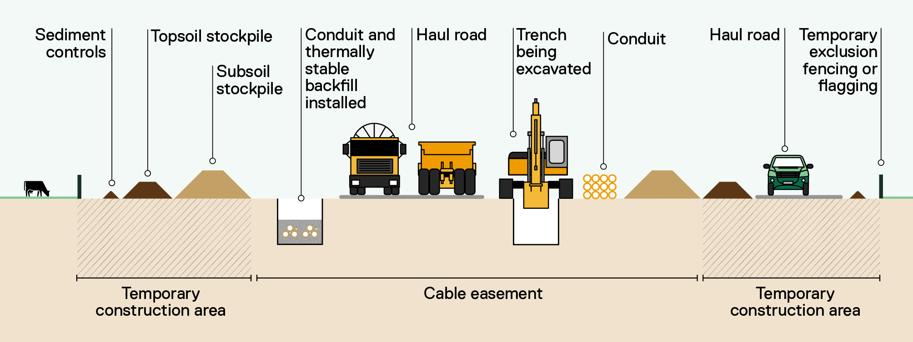

Cable system construction
Construction of the underground cable system occurs in three main stages:
- Trenching and conduit installation (if used)
- Crossings installation
- Cable installation, jointing and testing.
Two installation methods are being considered for the underground cable system: conduit (ducted) and direct bury.
A conduit system involves pre-installing lengths of conduit in open trenches or via trenchless methods then pulling the cables through. The conduit is typically made of polyvinyl chloride (PVC) and is sized to fit the cable. Conduit systems use pre-moulded spacers to ensure uniform spacing and hold cables in place prior to backfilling.
Direct bury involves opening trenches and installing cables directly in the ground at a depth that provides adequate protection from external interference. Compacted thermal sand may be used to bed and backfill direct buried cables to improve thermal performance.
The following descriptions relate to a conduit system. Direct burial may involve fewer steps.

Trenching and conduit installation
Trenching and conduit installation is the first stage, allowing large sections of civil works to be completed before the cables arrive for installation.
Trenches will be excavated using typical civil construction equipment such as excavators, chain trenchers and haul trucks, as shown in Figure 4-38, and made safe for access including the use of shoring where required. Excavated material may be temporarily stored adjacent to the trench or immediately carted away for stockpiling or disposal.
Up to four trenches may be open at one time. Each trench would be up to 2.2 metres wide and two metres deep, accommodating two circuits. The number and length of trenches open at any one time depends on a range of variables such as the number of active work fronts and crew size.
Once excavated, conduit sections are assembled within the trenches and coupled to form continuous runs between joint bays (refer to Figure 4-39).
Thermally stable backfill (refer to Figure 4-40 and Section 4.17.1.4) is then installed around the conduit. Once it hardens, polymeric covers, warning tape, and any additional mechanical protection is installed. The trenches are then backfilled and compacted with subsoil and topsoil is reinstated, ready for revegetation.
Where the onshore construction corridor traverses sensitive areas, such as native vegetation, potential impacts will be avoided or minimised by reducing the construction footprint, micro-siting infrastructure, and, in some cases, using trenchless construction methods.
Once trenching is completed, the joint bay is installed and prepared to align with cable installation activities.

Figure 4-38 Cable trench excavation (Australia)
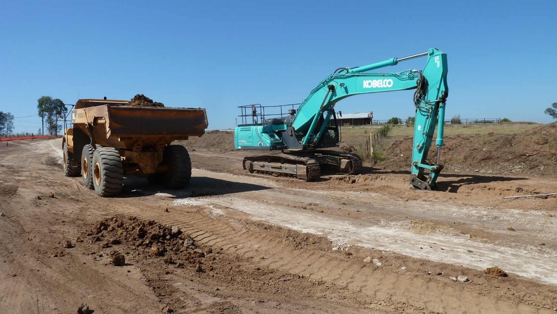
Source Cable System Engineering
Figure 4-39 Installation of conduit in a trench
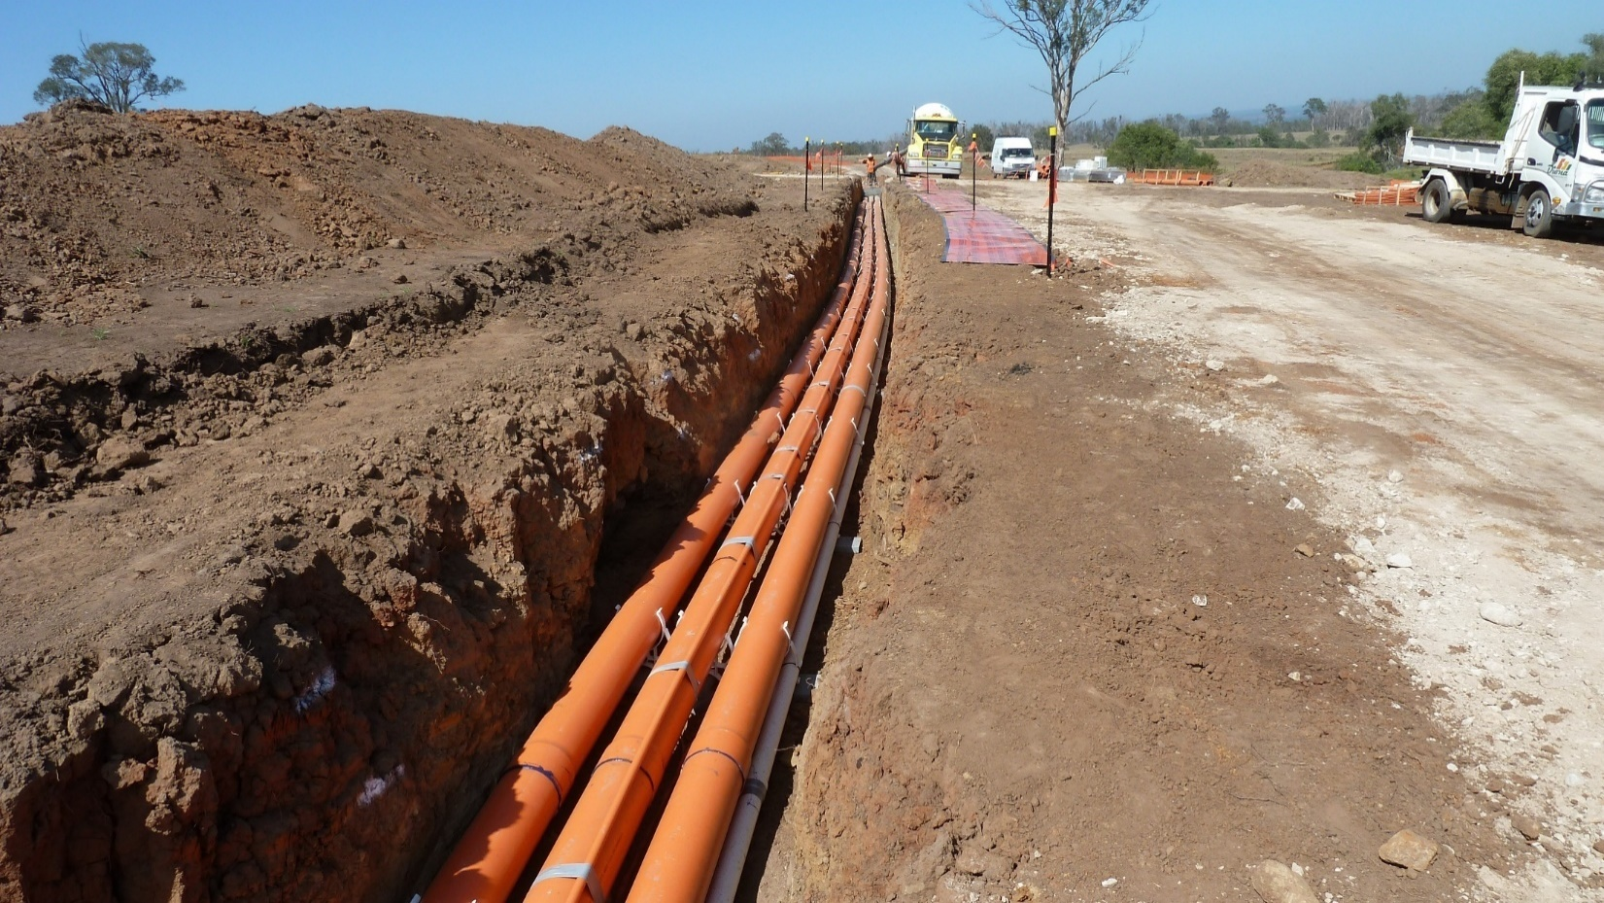
Source Cable System Engineering
Figure 4-40 Thermal fill installation (Australia)
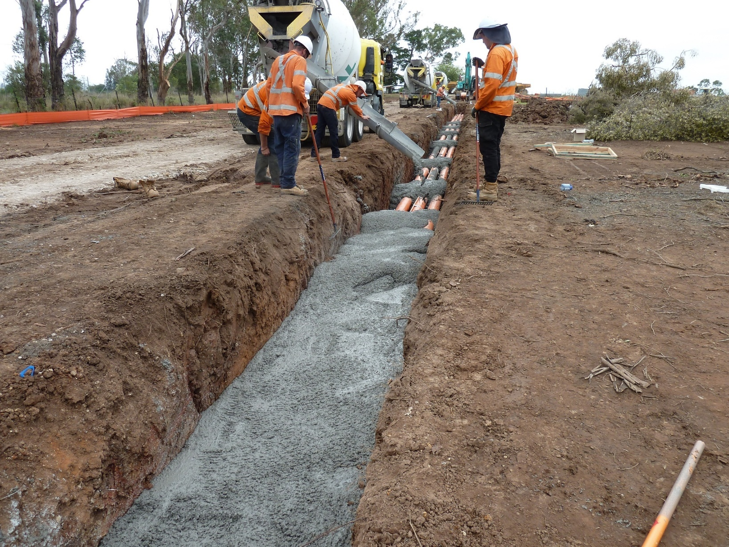
Source Cable System Engineering

Crossings installation
Construction of the underground cable system will require crossings of existing infrastructure and natural features such as waterways, roads and utilities. In most cases, open trench crossings are suitable and will be used where the project crosses features with relatively low sensitivity, such as minor watercourses, minor roads, tracks and service roads. Trenchless crossings will be used where open trenching would cause unacceptable disruption or environmental impact.

Open trench crossings
The approach proposed for the main types of open trench crossings is provided below:
- Road crossings: Traffic management will be used to maintain traffic flow on one half of the road while works occur on the other half. After excavating the first half, steel plates are placed across the trench for traffic to pass over while the second half is excavated. Pipe is then threaded through the trench under the steel plates before the trench is backfilled and the road re-surfaced.
- Watercourse crossings: Most minor watercourse crossings will be constructed using open-cut trenching. If needed, dry open-cut methods may be used, maintaining water flow through temporary dams, bypass pumping or diversion pipes.

Trenchless crossings
Two locations have been identified for trenchless crossings:
            - Unnamed waterway – UFI:42824681 at Reeves Beach, to reduce ecological impacts.
            - Woodside Beach Road, to reduce disruption to Woodside Beach residents, the road pavement and avoid roadside vegetation impacts.
Additional trenchless crossings may be considered as design progresses; however, these methods can affect cable ratings are not suitable in all locations.
Trenchless crossing methods include:
- Horizontal directional drilling (HDD): Similar to the shore crossing method (refer Section 4.13.2), onshore HDDs involve drilling bores and pulling through ducting.
- Micro-tunnelling: Micro-tunnelling installs straight sections of pipe between entry and receiving pits on either side of the crossing. These pits are excavated to the required depth and at a suitable distance from the feature being crossed. A micro-tunnel boring machine drills from the entry pit to the receiving pit, pushing pipe sections forward as it advances. Once the bore reaches the reception pit, the cutting head is removed and reinforced concrete jacking pipes installed to case the tunnel. Conduits are then installed through the casing.
- Auger-boring: Auger-boring follows a similar approach to micro-tunnelling but employs a rotating screw-type drill head. As the head advances, it cuts through the ground and moves spoil back through the casing pipe for removal.

Cable installation and jointing
Once a trench section is ready, cable drums are delivered to joint bay locations and cables are fed into the conduit using specialised pulling equipment. At each joint bay, the cable is jointed with the next section of cable (refer to Figure 4). Depending on the length and complexity of each section, intermediate pulling pits (also known as caterpillar pits) may be required to assist with pulling cables through the conduit.
This installation process is then repeated along the entire alignment until all cable is installed. Fibre optic cables are installed within their own conduit at the same time.
Finally, link and fibre pit lids are installed, the trenches and joint bays backfilled, and the area revegetated.
Figure 4-41 Cable being fed from a cable spool into conduit (Australia)
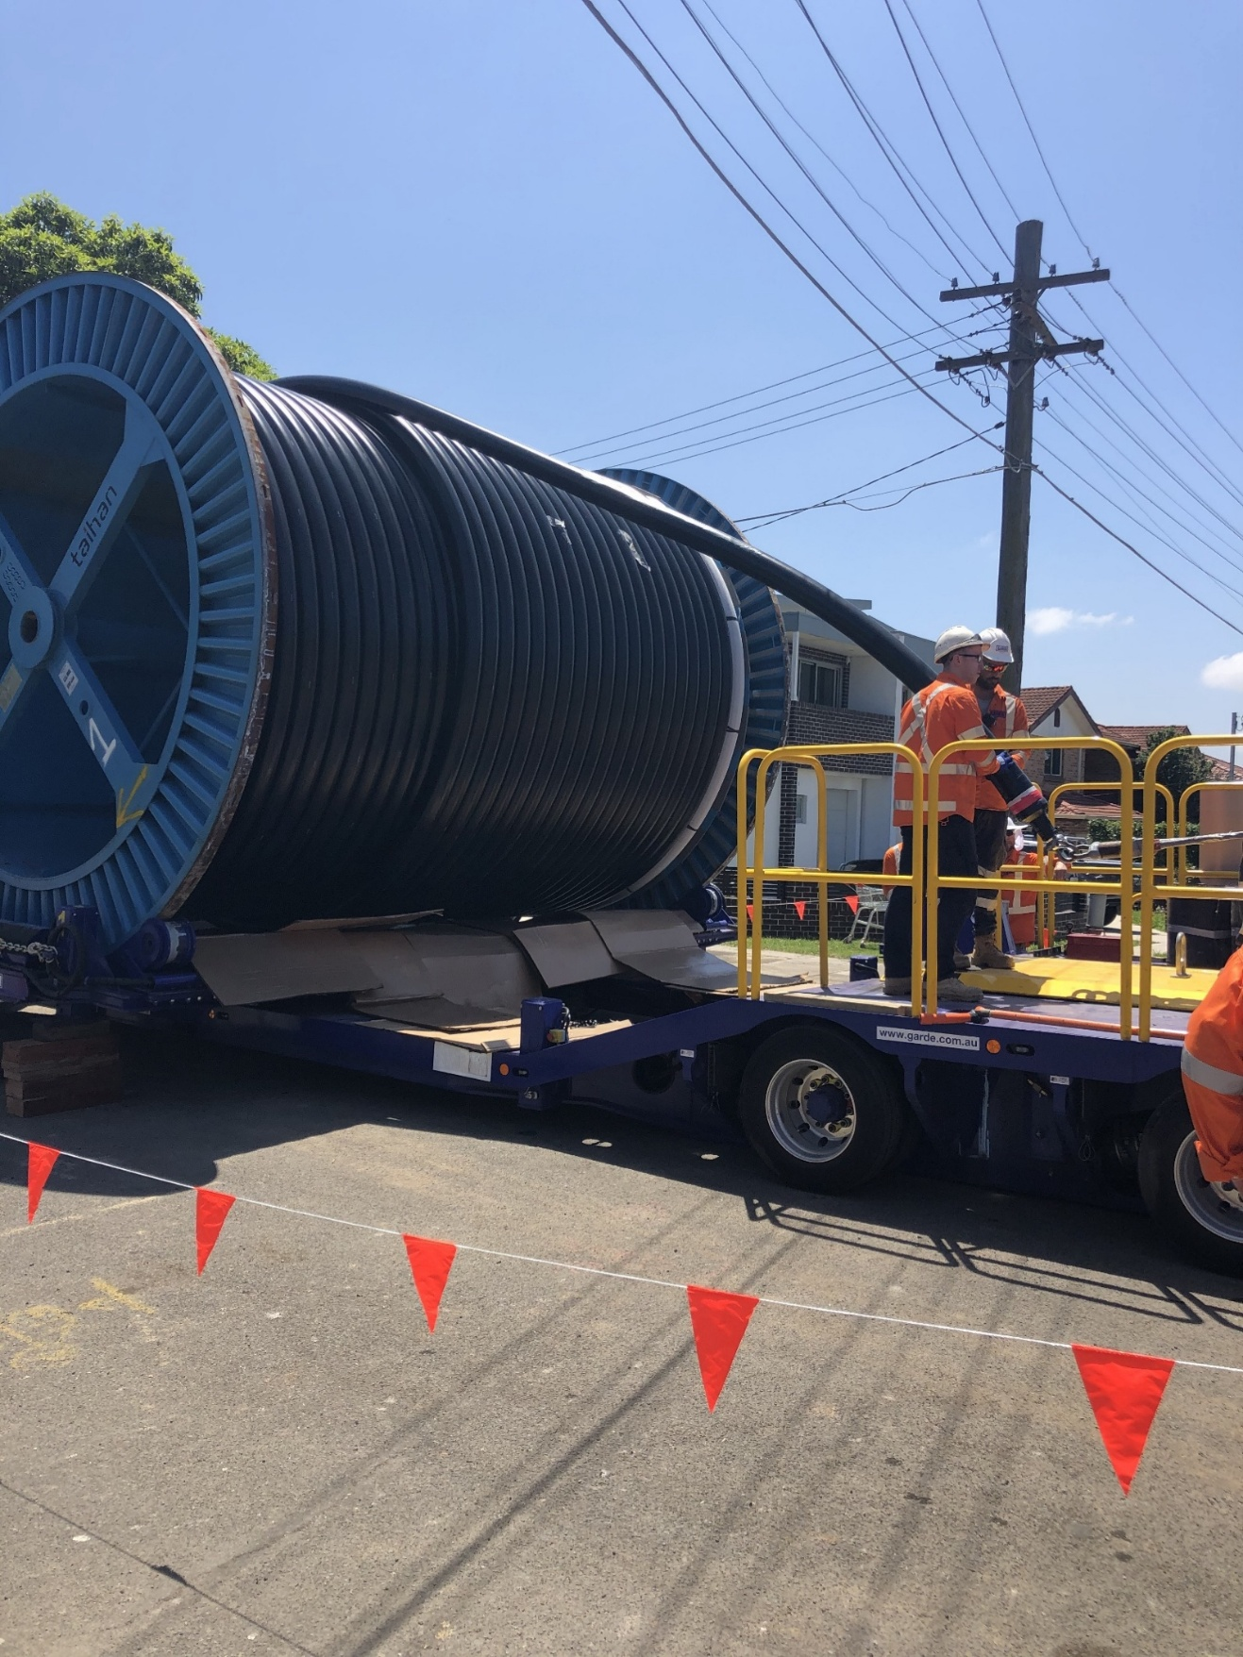
Source Cable System Engineering
Figure 4-42 Example of a caterpillar pit (Australia)
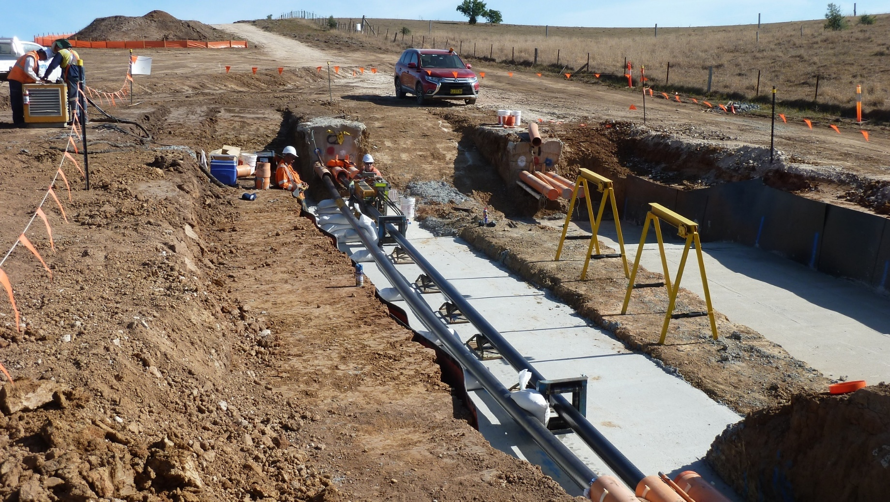
Source Cable System Engineering
Figure 4-43 Joint bay ready for backfill (Australia)
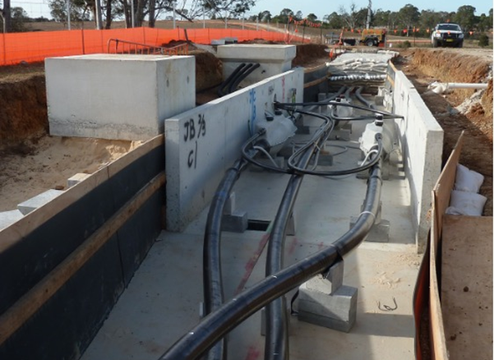
Source Cable System Engineering

Commissioning
All major project components, including onshore transmission infrastructure, will undergo a commissioning and testing process. System tests will be completed as the project is connected to the grid in stages. Typical commissioning checks and tests include:
- Site acceptance tests to verify that equipment has not been damaged during transport, loading or unloading
- Pre-commissioning tests to confirm that installation meets design requirements and that equipment interfaces correctly with other parts of the system
- Commissioning tests to verify that equipment operates as designed and interfaces correctly with other parts of the system
- First energisation
- Grid acceptance tests to demonstrate that the new infrastructure meets technical performance standards agreed during the grid application process
- Performance testing to verify the availability and reliability of the infrastructure, and any other performance criteria commercially agreed.

Demobilisation and rehabilitation
All construction areas will be rehabilitated as soon as practicable after construction activities are completed. Rehabilitation will occur progressively, where feasible, and will include the removal of temporary construction facilities and civil works, the application and grading of subsoil and topsoil, and revegetation.
Land will be handed back to landholders as soon as practicable following demobilisation and rehabilitation, and in accordance with landholder agreements.

Onshore transmission operations and maintenance
The following section describes operations and maintenance (O&M) activities for the underground cable system.

Operations and maintenance activities

Underground cable system
The underground cable system will be remotely monitored through control and condition monitoring systems. Routine access will be minimal, with testing required once or twice a year at the link pits located at each joint bay. This involves accessing the easement via light vehicle and opening the pit covers to access the system.
An O&M base is expected to be established at either the onshore substation or a separate location in the Gippsland region.
A small workforce will undertake periodic inspections and routine maintenance of the cable system using light service vehicles, including cable easement inspections to monitor and control vegetation and confirm compliance with easement terms (refer to Table 4-19).
Table 4-19 Cable easement controls
Activity | Within easement
Aerial activities such as crop dusting and water bombing | Permitted
Agricultural activities:
- Ploughing and cropping (up to 300mm penetration, excluding at fibre and link pits) | Permitted
- Grazing | Permitted
- Deep ripping | Prohibited
- Spray irrigation | Permitted
Buildings (temporary or permanent) | Prohibited
Boring, digging or quarrying | Prohibited
Driving, parking or unloading vehicles and farm machinery | Permitted
Fencing | Restricted (may require prior approval)
Installation of underground services | Restricted (may require prior approval)
Landscaping and paving | Restricted (may require prior approval)
Pipelines (above ground) | Restricted (may require prior approval)
Storing and stockpiling (soil, hay, large equipment) | Restricted (may require prior approval)
Trees, shrubs, orchards and plantations | Restricted (may require prior approval)
Water storage (dams, tanks, troughs) | Prohibited
Anticipated land use restrictions, changes may occur through the design process.

Onshore substation
As outlined in Section 4.17.2, parameters and impacts associated with the construction, operation and decommissioning of the onshore substation will be assessed by the VicGrid Offshore Wind Transmission 2 GW Project EES and are not considered as a part of this assessment.

Onshore decommissioning
Decommissioning will be planned and carried out in accordance with regulatory and landholder requirements current at the time. The decommissioning approach is expected to be agreed with regulators before project operations cease. The assessment of the project assumes current industry practices will be adopted.
To minimise disturbance, most below-ground infrastructure is expected to be left in place, with cable ends cut, sealed and securely buried. Surface infrastructure such as signage, markers, link and fibre pits may be removed if required by landholders or if environmental impacts arise.

Waste
Waste generated by onshore construction may include vegetation, surplus soil, excavated rock and general construction waste. Where practicable, excess soil will be reused on site or given to landholders. The volumes of soil expected to be reused on site or sent offsite are provided in Technical Report J: Soil and Waste.
Water will be used for earthworks, civil foundation construction, and steelworks, however significant wastewater production or disposal is not expected to be required

