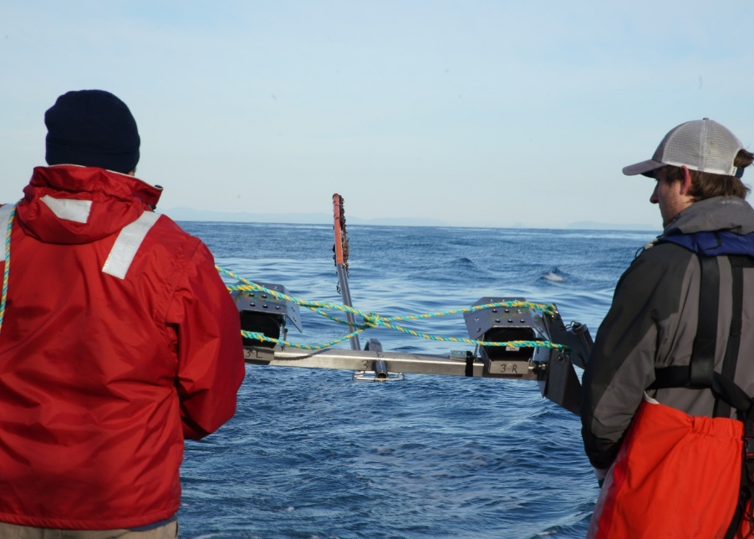

Commonwealth Environmental Impact Statement
Chapter 6 – Assessment framework

Table of Contents
Chapter 6 Assessment framework 6-1
6.1 Introduction 6-1
6.2 Evaluation framework 6-3
6.2.1 Terms of reference 6-3
6.2.2 Legislation, policies, guidelines and standards 6-4
6.2.3 Assessment criteria 6-4
6.3 Environmental assessment 6-5
6.3.1 Overview 6-5
6.3.2 Determining impacts and risks 6-6
6.3.3 Existing conditions 6-7
6.3.4 Project description 6-7
6.3.5 Impact assessment 6-8
6.3.6 Risk assessment 6-12
6.3.7 Avoidance, mitigation and management 6-14
6.4 Environmental Management Framework 6-15
6.5 Cumulative impact assessment 6-16

Figures
Figure 6-1 Assessment evaluation framework overview 6-2
Figure 6-2 Mitigation hierarchy 6-14
Figure 6-3 Cumulative impact assessment process 6-19

Tables
Table 6-1 Receptor sensitivity ratings (example receptor group: marine mammals and turtles) 6-10
Table 6-2 Magnitude criteria (example receptor group: marine mammals and turtles) 6-10
Table 6-3 Magnitude level description (example receptor group: marine mammals and turtles) 6-11
Table 6-4 Consequence level matrix 6-11
Table 6-5 Likelihood levels 6-13
Table 6-6 Risk assessment matrix 6-13

Assessment framework

Introduction
This chapter details the approach to developing the Environmental Impact Statement (EIS) (the assessment) for the Star of the South Offshore Wind Farm Project (the project). The assessment approach was undertaken for the entire project (i.e across both Commonwealth and Victorian jurisdictions), and therefore both Commonwealth and Victorian requirements have informed the approach and are described within this chapter.
Figure 6-1 provides an overview of the assessment evaluation framework. This framework is responsive to existing legislation and policies, as well as the assessment criteria and terms of reference set out by the Commonwealth Department of Climate Change, Energy, the Environment and Water through the EIS guidelines, and the Victorian Minister for Planning through the EES scoping requirements.
The project’s assessment process generally aligns with the guidance issued by the Australian National Offshore Petroleum Safety and Environmental Management Authority for the environmental assessment of major offshore infrastructure (NOPSEMA, 2020), as well as the Offshore Petroleum and Greenhouse Gas Storage (Environment) Regulations 2009. These resources have been used in lieu of the Offshore Electricity Infrastructure Act 2021 (Cth) Regulations, which do not prescribe an assessment process.
Star of the South adopted this approach because these resources provide the most comprehensive and authoritative guidance on assessing offshore infrastructure currently available in Australia. They include a best practice environmental impact and risk assessment methodology that is flexible enough to be applied to offshore wind and transmission infrastructure.
Star of the South has identified the impacts and risks to the existing environment through topic-specific assessment methods. This process is iterative, with assessments informed by stakeholder consultation, and the project design refined in response to assessment findings. Further details regarding the project’s environmental assessment framework and process are provided in the sections that follow.

Figure 6-1 Assessment evaluation framework overview
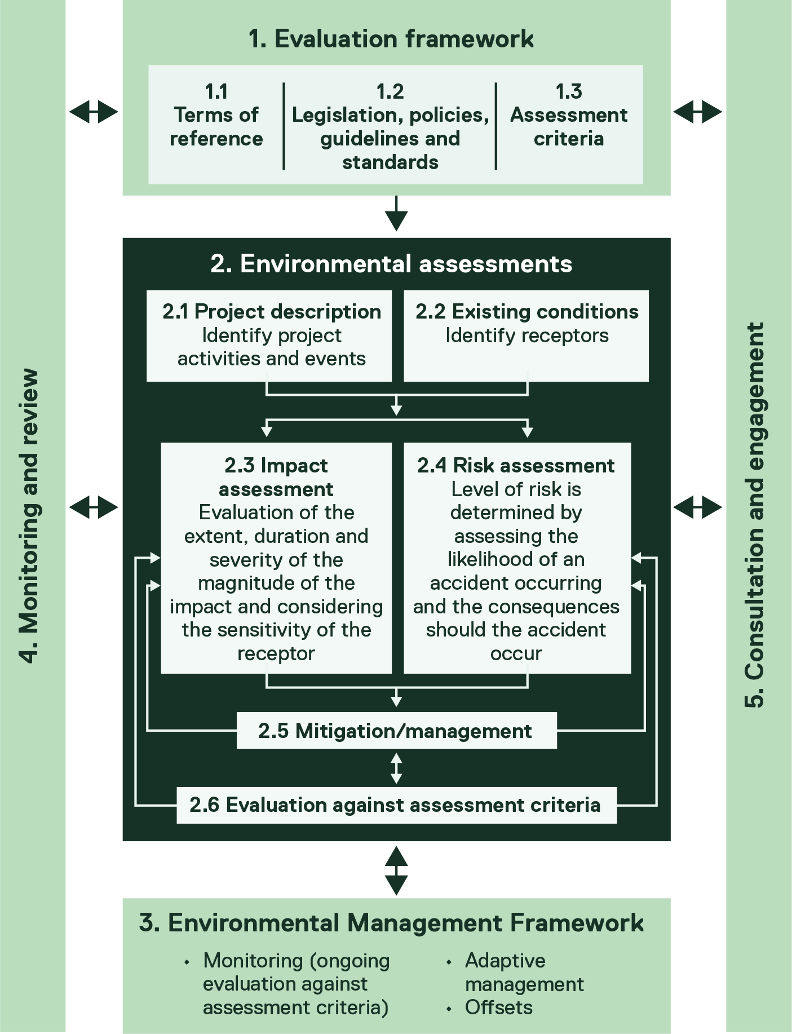

Evaluation framework
The assessment evaluation framework, shown in Figure 6-1, sets out how the project was assessed to determine impacts and risks to environmental assets, values and uses. As further described below, the key components of the evaluation framework are:
- Terms of reference
- Legislation, policies, guidelines and standards
- Assessment criteria.

Terms of reference
The assessment is responsive to requirements outlined in the EIS guidelines and EES scoping requirements, which together serve as the project’s terms of reference. The EIS guidelines, prepared by the Commonwealth Department of Climate Change, Energy, the Environment and Water, specify the relevant project information to be included in the EIS and the impacts to be assessed. The EES scoping requirements, issued by the Victorian Minister for Planning, set out the specific matters to be investigated and documented in the EES.
The terms of reference include assessment requirements for topics that encompass ecological, social, economic and heritage aspects. Based on the terms of reference, Star of the South is required to address the following matters in the assessment documentation:
- Description of the project and proposed action
- Consideration of project alternatives
- Investigations and research to characterise the existing environment
- Assessment of how the project would change the existing environment and an evaluation of effects
- Commitments to avoidance, minimisation and management (including offsetting)
- The proposed Environmental Management Framework (EMF) to manage environmental effects during project implementation
- Stakeholder and public consultation processes, including how stakeholder feedback is considered and addressed in the assessments.

Legislation, policies, guidelines and standards
A range of Commonwealth and Victorian legislation applies to the project’s assessment. Further details on the planning and environmental approvals requirements mandated by legislation are provided in Chapter 5 – Commonwealth Legislative Framework. The specific legislation, policies, guidelines and standards used in each impact assessment are described in the assessment’s technical reports.

Assessment criteria
Star of the South has measured the project’s impacts and risks against pre-defined assessment criteria to assess the acceptability of the project’s impacts and risks, refine the project design and identify further mitigation and management measures.
These criteria, which may be quantitative or qualitative, define the environmental performance outcomes that must be achieved. They vary across the technical studies undertaken for the project and have been derived from:
- Legislation and policies, including the objectives of the Environment Protection and Biodiversity Conservation Act 1999 (Cth) (EPBC Act) and the principles of ecologically sustainable development as defined in the Ministerial guidelines for assessment of environmental effects (DTP, 2023) and section 3A of the EPBC Act
- Mandatory considerations under Part 9 of the EPBC Act, including recovery and conservation management plans for threatened species and environments
- Relevant standards and guidelines
- Stakeholder feedback
- Industry best practice.
The assessment criteria used in the impact assessments are specified within each technical report. Where applicable, these criteria have been developed in accordance with the general environmental duty requirements of the Environment Protection Act 2017 (Vic).
The assessment criteria are aligned with the ‘environmental performance outcome’ definition set out in the Offshore Petroleum and Greenhouse Gas Storage (Environment) Regulations 2023. The criteria are also aligned with the EIS guidelines and EES scoping requirements to develop performance criteria and evaluation objectives.

Environmental assessment
To address the key issues identified in the EIS guidelines and EES scoping requirements, environmental assessments have been completed for 26 technical disciplines to evaluate the potential environmental effects associated with the project’s construction, operation and decommissioning. These assessments were completed in line with the assessment evaluation framework shown in Figure 6-1.

Overview
Each of the assessment’s technical disciplines follows a consistent approach:
- Existing conditions: Characterising the existing environmental conditions and identifying sensitive receptors (environmental assets, values and uses) that may be affected during construction, operation and / or decommissioning of the project.
- Project description: Describing the project, including key components and activities, to identify potential interactions with sensitive receptors (events). This involves defining maximum design scenarios based on the project design envelope. The design envelope allows for the assessment of a range of design options, rather than a single, fixed proposal. It ensures that the impacts of all options are considered, while maintaining flexibility for ongoing project refinement and innovation. The maximum design scenario is the combination of design parameters that would result in the greatest potential impact. It represents a ‘worst case’ configuration within the range of project options still being considered, ensuring a conservative approach to the assessment (refer to Section 6.3.4 and Chapter 4 – Project Description).
- Impact assessment: Evaluating the consequences of proposed activities, considering the magnitude (duration and extent), sensitivity and significance of the affected receptors and the mitigation hierarchy of avoid, minimise and manage. The impact assessment methodology is described in Section 6.3.5.
- Risk assessment: Evaluating accidents and unexpected events based on the likelihood and consequences of an accident / unexpected event occurring. The risk assessment methodology is described in Section 6.3.6.
- Mitigation and management: Identifying mitigation and management measures to avoid or minimise potentially significant impacts or risks that do not meet the assessment criteria identified in Section 6.3.7.
- Evaluation against assessment criteria: Evaluating residual impacts or risks against the assessment criteria following an initial impact or risk assessment. If an assessment indicates that the assessment criteria would not be met, project design changes are made, or additional mitigation and management measures are introduced. Residual impacts and risks are then described as those that are likely to remain after the implementation of mitigation measures.
- Monitoring and review: Regularly reviewing and revising the project description, impact / risk assessments and proposed mitigation measures to ensure they remain current. Modifications to the project design envelope (PDE) and any changes to legislation are considered and re-assessed as necessary.
- Consultation and engagement: Continually considering feedback from local communities, stakeholders and regulators to ensure the assessment process addresses concerns and meets expectations, where possible. Consultation will continue throughout the project’s lifespan.

Determining impacts and risks
For impacts (expected events), the likelihood of occurrence is considered certain. Therefore, only the consequences to the existing environment need to be evaluated in an impact assessment. For risks (accidents or unexpected events), both the likelihood of the event occurring and its consequences need to be evaluated as part of the risk assessment. In both cases, the evaluation of consequences considers several factors, including:
- The extent, duration and severity of the impact or risk
- The confidence in the predictive assessments
- The effectiveness of proposed measures to mitigate consequences
- The characteristics of the receptor.
An example of an expected event is where the ‘project activity’ is piling. The ‘event’ is the underwater noise emitted into the water column and the ‘consequence’ may be injury or disturbance to marine mammals. Underwater noise is an expected event, as underwater noise emissions are a known outcome of construction activities that cannot be entirely avoided. Underwater noise will be detectable where marine fauna are expected to be present.
In contrast, an example of an unexpected event is where the ‘project activity’ is vessel presence. The ‘event’ is collision with marine fauna and the ‘consequence’ may be injury or disturbance to marine mammals. This event is unexpected and unlikely to occur, though it remains possible.

Existing conditions
The primary purpose of the existing conditions assessment is to identify and characterise the environmental assets, values and uses relevant to each technical discipline within a defined study area. Each technical report and its corresponding chapter describes the existing environment for that discipline within the relevant study area. The study area is defined as the area of investigation for existing environmental conditions, and it varies between technical disciplines based on the assets, values and uses being investigated. The assets, values and uses identified through the existing conditions assessment are used to inform the subsequent impact and risk assessments.
The existing conditions assessment also establishes the key components, characteristics and status of the existing environment for each technical discipline. Desktop reviews, field surveys and monitoring are used to help understand and describe the existing environment. Where relevant, the characterisation of existing conditions considers known trends affecting physical and biological environments, such as those associated with climate change. The resulting description of the existing environment serves as the environmental baseline for the impact and risk assessments.
The outcomes of the existing conditions assessment for each technical discipline have been documented in the respective technical reports and summarised in corresponding chapters.

Project description
The project description is based on a project design envelope. A PDE outlines reasonable ranges for key design parameters (for example, minimum and maximum turbine heights) and installation techniques (such as different cable installation methods). This allows for flexibility in the final project design, which is necessary given offshore wind technologies are rapidly changing.
As described in Chapter 4 – Project Description, technical specialists have identified the maximum design scenario applicable to each impact assessment, based on the design envelope. For example, the design envelope allows for a range of turbine sizes. The smallest turbine represents the maximum design scenario for disturbance to benthic habitats as more turbines are needed to meet the project’s capacity, resulting in a larger overall footprint on the seabed. Conversely, the largest turbine represents the maximum design scenario for impacts to aviation, as the turbines are taller and therefore more likely to affect controlled airspace. Where ranges are provided, the parameter likely to cause the most significant adverse impact is used, to ensure a conservative approach to the assessment.

Impact assessment

Impact assessment method
An impact occurs when a project activity or activities in any project phase result in a change to the existing environment. Impacts can be positive or negative, and they can be direct or indirect. Impacts are described after applying mitigation measures and are referred to as residual impacts.
Whether an impact results in a consequence to an environmental receptor depends on the sensitivity of the receptor and the magnitude of the impact, defined as:
- Sensitivity: The ability of a receptor to tolerate and / or adapt to change or disturbance from an external factor and the time required for recovery if it is harmed
- Magnitude: The severity, extent and duration of an impact.
As environmental assets, values and uses are interconnected, some impacts may give rise to secondary or indirect impacts. The assessment considers the potential for these follow-on impacts.
The assessment identifies the magnitude of changes to the environment that may result from the project. The assessment methods used are specific to each technical discipline and align with relevant guidelines and standards. Each technical report includes a description of the assessment approach, including modelling or analysis undertaken to predict changes because of the project.
The impact assessments consider the following factors:
- Severity, extent and duration
- Sensitivity of the affected receptors
- Assessment criteria
- Principles of ecologically sustainable development as defined in the Ministerial guidelines for assessment of environmental effects under the Environment Effects Act of 1978 (DTP, 2023) and section 3A of the EPBC Act
- Mandatory considerations under Part 9 of the EPBC Act, including relevant recovery and threat abatement plans
- Stakeholder input and feedback
- The likely effectiveness of measures to avoid, minimise and manage impacts
- Assumptions and uncertainties associated with the assessment.
The impact assessments also consider the potential for the project to result in combined impacts and risks on a single receptor from different project events. For example, shorebirds and seabirds are potentially affected by the loss of habitat due to the location of project components, and they may also be vulnerable to collision risk during the operations phase (referred to as inter-related impacts in the technical reports). The combined effect of these impacts and risks is evaluated within the shorebird and seabird assessment. The cumulative impact assessment approach is outlined in Section 6.5.

Assignment of a sensitivity level
To assign a sensitivity level, the existing environmental conditions are first described, and receptors (environmental assets, values and uses) are then identified. Examples of receptors (or a group of similar receptors) include whales and seals in the offshore environment, and residential areas and native vegetation in the onshore environment.
Once identified, a sensitivity level is assigned to each receptor based on the environmental baseline characterisation process. This involves assigning either a high, medium or low sensitivity rating in accordance with the descriptions for the relevant receptor sensitivity rating. An example of this is presented in Table 6-1.
Assigning a receptor sensitivity level considers the following factors:
- Adaptability
- Tolerance to disturbance of reproduction and survival rates
- Recoverability from impact on reproduction and survival rates
- Protection status.
Sensitivity rankings classify the sensitivity of species to a particular impact. In the absence of species-specific data on impact sensitivity, threatened species – matters of national environmental significance and Flora and Fauna Guarantee Act 1988 (Vic) species such as the Adelaide Pygmy Blue-tongue Skink (Tiliqua adelaidensis) and the Southern Right Whale (Eubalaena australis) – are used as a proxy for high-sensitivity species; other matters of national environmental significance species (for example, non-threatened migratory whale species) are used as a proxy for medium-sensitivity species; and other EPBC Act-listed marine species (non-matters of national environmental significance species) are used as a proxy for low-sensitivity species.
Table 6-1 Receptor sensitivity ratings (example receptor group: marine mammals and turtles)
Sensitivity (to impact) | Description
High | Limited ability to adapt behaviour; therefore, survival and reproduction rates may be affected.  Limited tolerance; therefore, disturbance may cause a change in both reproduction and survival rates.  Limited ability for the animal to recover from any impact on reproduction and survival rates.
Medium | Ability to adapt behaviour; therefore, reproduction rates may be affected, but survival rates are unlikely to be affected.  Some tolerance; therefore, disturbance is unlikely to cause a change in both reproduction and survival of individuals.  Ability for the animal to recover from any impact on reproduction and survival rates.
Low | Ability to adapt behaviour; therefore, survival and reproduction rates are not affected.  Tolerant; therefore, disturbance will not cause a change in reproduction and survival rates.  The animal can return to its previous behavioural state once the impact has ceased.

Assignment of a magnitude level
Determining the magnitude level of an impact on existing conditions includes the following factors:
- Extent of the event: Site-specific, local, regional or widespread
- Duration of event or impact: Short, medium or long term (also considering frequency and permanence)
- Severity of the impact: The degree of change from the existing condition.
The magnitude level of a specific impact is based on clear criteria determined by the technical specialist undertaking the assessment. An example is provided below in Table 6-2 and Table 6-3.
Table 6-2 Magnitude criteria (example receptor group: marine mammals and turtles)
Factor | Magnitude | Description
Extent of the event | Localised | Within 2 to 3 km
Extent of the event | Medium scale | Within the offshore project area
Extent of the event | Large scale | Eastern Bass Strait (Wilsons Promontory to New South Wales border)
Extent of the event | Regional | South East Marine Bioregion
Duration of event or impact | Short-term | Days to weeks
Duration of event or impact | Medium-term | Less than five years
Duration of event or impact | Long-term | Greater than five years
Severity of the impact | Permanent | Irreversible change, substantial change to the value
Severity of the impact | Reversible | Changes are reversible once the activity has ceased
Severity of the impact | Unlikely to be detectable | Changes are within natural variability
Table 6-3 Magnitude level description (example receptor group: marine mammals and turtles)
Level | Description
Negligible | The impact is localised and short-term, and changes to the receptor are unlikely to be detectable above natural conditions.
Low | The impact is within the offshore project area (medium scale) and is medium-term, and results in reversible changes to the receptor once the activity has ceased.
Medium | The impact extends to the offshore project area (large scale) and is medium-term, and results in reversible changes to the receptor once the activity has ceased.
High | The impact extends to the offshore project area (large scale) and long-term, and results in reversible changes to the receptor once the activity has ceased.
Very high | The impact is regional and long-term, and results in substantial and possibly irreversible (permanent) change to the receptor.

Assignment of a consequence level
A consequence is the potential outcome of an event affecting a receptor. It is determined by combining the magnitude of an impact with the sensitivity of the receptor. Using the matrix in Table 6-4, the impact assessments assign a consequence level based on receptor sensitivity and magnitude levels, given the maximum credible impact for each pathway. Where uncertainty exists, a conservative approach is adopted to assess consequences.
Table 6-4 Consequence level matrix
 | Sensitivity
Magnitude | Low | Medium | High
Negligible | Negligible | Negligible | Minor
Low | Negligible | Minor | Moderate
Medium | Minor | Moderate | Major
High | Moderate | Major | Severe
Very high | Major | Severe | Severe
The level of detail in each impact pathway assessment is proportionate to the identified consequence level. Where consequences are rated as moderate or higher, the impact pathways are assessed in greater detail, with potential mitigation measures considered to reduce the overall impact.

Residual impacts
The impact assessment process is iterative, ensuring impacts are continually evaluated as the technical studies progress, mitigation measures are added, and new information becomes available. This iterative process ensures the predicted residual impacts are within allowable limits. The residual impact assessment assigns a consequence level based on both initial and final mitigation measures. It also describes any uncertainties in the assessment, as well as the expected effectiveness of the mitigation measures.

Risk assessment

Risk assessment method
A risk arises when a project activity or activities could result in an unexpected event, such as an accident, in any project phase that causes a change to the existing environment.
The level of risk is determined by combining the likelihood of an event occurring with the consequences that would result if the event were to occur. Consequence levels are assigned using a similar methodology as described above for impact assessment.
The following steps are taken to identify, analyse and evaluate risks for the project:
- Develop a risk matrix based on the likelihood and consequences of an unexpected event
- Identify controls and requirements to mitigate identified risks
- Assign likelihood and consequence ratings for each risk to determine overall risk ratings, considering project design, proposed activities and mitigation measures.

Assignment of likelihood level
Likelihood is the probability of an unexpected event occurring. Likelihood levels range from ‘rare’, where the event may occur only in exceptional circumstances, to ‘almost certain’, where the event is expected to occur in most circumstances. The risk assessments assign likelihood levels to unexpected events, considering mitigation and management measures, using the levels presented in Table 6-5.
Table 6-5 Likelihood levels
Level | Description
Rare | The event may occur only in exceptional circumstances.
Unlikely | The event could occur but is not expected.
Possible | The event could occur.
Likely | The event will probably occur in most circumstances.
Almost certain | The event is expected to occur in most circumstances.

Risk matrix
Risk ratings are assigned by combining the likelihood of an event occurring (using the definitions in Table 6-5) and the consequence of that event occurring. The risk assessment then determines a risk rating based on these factors using the risk matrix presented in Table 6-6.
Table 6-6 Risk assessment matrix
Consequence rating
Likelihood rating |  | Negligible | Minor | Moderate | Major | Severe
Likelihood rating | Rare | Very Low | Very Low | Low | Medium | Medium
Likelihood rating | Unlikely | Very Low | Low | Low | Medium | High
Likelihood rating | Possible | Low | Low | Medium | High | High
Likelihood rating | Likely | Low | Medium | Medium | High | Very High
Likelihood rating | Almost certain | Low | Medium | High | Very High | Very High
The level of detail in each risk pathway assessment is proportionate to the identified level of risk (risk ranking). Pathways with risks rated medium or higher are assessed in greater detail, with potential mitigation measures considered to reduce the overall impact.

Residual risks
While the risk assessment process follows a defined set of steps, it is not always linear. Assessments typically require multiple iterations of risk evaluation, considering assessment criteria and mitigation measures as the technical studies progress and new information as it becomes available. Completed risk assessments are based on the final mitigation measures and therefore describe the residual risks.

Avoidance, mitigation and management
Over several years of project development, Star of the South has identified and incorporated opportunities to avoid and minimise environmental impacts in line with the mitigation hierarchy shown in Figure 6-2. The assessment framework has also enabled further avoidance and minimisation measures as part of the planning and environmental approvals process.
Once avoidance and minimisation measures are exhausted, residual impacts and risks are managed. In the case of risks, mitigation measures can be applied both before and after an event occurs. Residual impacts and risks are then evaluated against the assessment criteria to ensure they are at an acceptable level.
Figure 6-2 Mitigation hierarchy
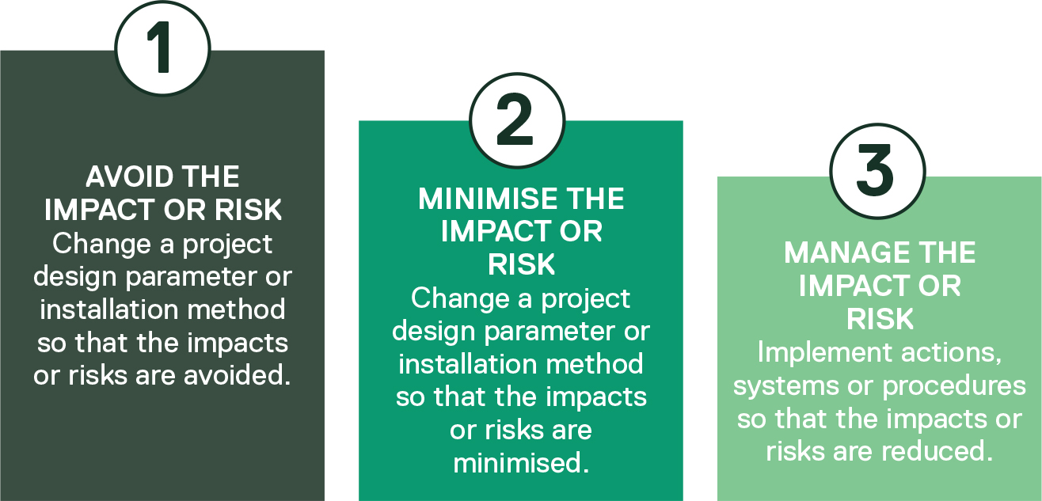

Environmental Management Framework
Star of the South has developed an EMF in response to the findings of the environmental assessments to monitor and control the project’s environmental performance. Monitoring will include ongoing evaluation against the assessment criteria. The EMF sets out the actions, systems and procedures necessary to effectively manage environmental issues during project implementation. Further information is provided in Chapter 23 – Commonwealth Environmental Management Framework.
The EMF specifies the committed mitigation measures identified through the impact and risk assessments to avoid, minimise and manage impacts, as well as contingency measures, adaptive management options and offset commitments. Significant residual impacts or risks that cannot be avoided, minimised or managed will be offset in accordance with the EPBC Act’s Environmental Offsets Policy (2012). The EMF also describes the roles and responsibilities for implementing mitigation measures during the project’s construction, operation and decommissioning.

Cumulative impact assessment
The project assessment considers the potential for cumulative impacts associated with other proposed projects or future actions. This excludes operational projects which are considered part of the baseline environment.
Cumulative impact assessments are receptor-based assessments, whereby the residual effect of two or more projects or actions affects the same receptor and results in a cumulative impact or effect. Therefore, if a project or action does not affect a receptor or group of receptors, it cannot have a cumulative impact with another project or action. The only exception is where a potential project undermines a mitigation or management measure to the point where a residual impact or risk becomes significant again. For this reason, cumulative impact assessments focus on a project’s residual impacts and risks.
The project’s cumulative impact assessment method is based on Advice Note 17: Cumulative effects assessment relevant to nationally significant infrastructure projects (UK Planning Inspectorate, 2019). As these guidelines highlight, cumulative impact assessments should be proportionate to the scale of the project and the potential significance of the cumulative effects of the project with the impacts of other relevant projects.
In line with Advice Note 17, Star of the South has adopted a staged approach to cumulative impact assessment, as shown in Figure 6-3. The four stages are as follows:
- Stage 1: Identify the zone of influence and potentially cumulative projects or actions
- Stage 2: Create a short list of identified projects or actions
- Stage 3: Gather information on the short-listed projects and actions
- Stage 4: Assess cumulative impacts.
This approach focuses on assessing potential cumulative adverse effects on receptors or similar receptor groups, as relevant. A sufficient level of information on the proposed project or future action is required to conduct a meaningful cumulative impact assessment. Accordingly, a certainty level is assigned to each project or action based on the information available:
- Tier 1: High certainty - project planning application or EIS / EES has been submitted to regulators, or the project has been approved, or the project is under construction.
- Tier 2: Medium certainty - project referrals have been submitted to the regulators.
- Tier 3: Low certainty - project is in the proposal stage, little information is publicly available.
Using the staged approach described above and shown in Figure 6-3, the project’s cumulative impact assessments are undertaken as follows:
- Stage 1: Identify the zone of influence and potentially cumulative projects or actions.
In this stage, a ‘long list’ of projects or actions that have the potential to result in an adverse cumulative effect when combined with the project is created, and the level of certainty for each potential project or action is determined.
Applying a precautionary approach, a zone of influence is defined based on the spatial extent of receptors potentially impacted by the project. Projects within this zone are identified through a review of EPBC Act Public Portal referrals, the EES referrals and decisions portal, the Australian National Offshore Petroleum Safety and Environmental Management Authority project register, council planning applications and proposed developments discussed in the community and reported in the media.
Potential projects within the zone of influence form the long list of projects and actions that progress to Stage 2.
- Stage 2: Create a short list of identified projects or actions.
In this stage, the long list of projects and actions is reviewed against criteria designed to identify projects suitable for a proportionate assessment, based on the likelihood of significant cumulative effects. The criteria include:
    - Data confidence: A sufficient level of data is required to enable a meaningful assessment. Projects or actions that do not meet the Stage 3 data requirements, including Tier 3 projects, are screened out.
    - Scale of the project or action: Small-scale projects with low-level adverse impacts unlikely to result in cumulative impacts are screened out. This typically includes small-scale residential or commercial developments within the zone of influence.
    - Receptor impact: To result in a cumulative effect, the residual impacts of two projects or actions need to materially affect the same receptor, either directly or indirectly. Projects or actions unlikely to materially affect the same receptors are screened out.
    - Temporal overlap: For cumulative effects to occur, the residual impacts of the multiple projects or actions would need to affect a receptor at the same time, or within the recovery period. Where there is no overlap, these projects or actions are screened out.
The remaining projects or actions form the ‘short list’ of projects and actions subject to further assessment.
- Stage 3: Gather information on the short-listed projects and actions.
In this stage, the short list of projects and actions is examined in greater detail to understand potential impacts. Information gathered includes, but is not limited to:
    - Proposed design and location information
    - Proposed program of construction, operation and decommissioning
    - Environmental assessments that set out baseline data and effects arising from the potential cumulative projects or actions.
- Stage 4: Assess cumulative impacts.
In this stage, cumulative impacts are assessed by reviewing and analysing the residual impacts of the project alongside those of the short-listed projects and actions. The assessment is based on the level of information available for other proposals at the time of the assessment, which varies depending on the impact assessment method used for each technical discipline.
For Tier 1 projects or actions, where more data is available, qualitative and / or quantitative assessment approaches are used. For Tier 2 projects or actions, where less data was available, the assessment is generally qualitative.
Figure 6-3 Cumulative impact assessment process
