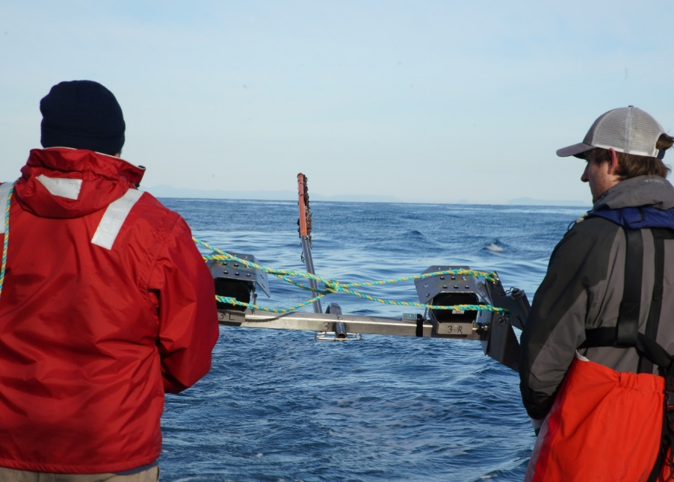

Commonwealth Environmental Impact Statement
Chapter 7 – Communication and engagement
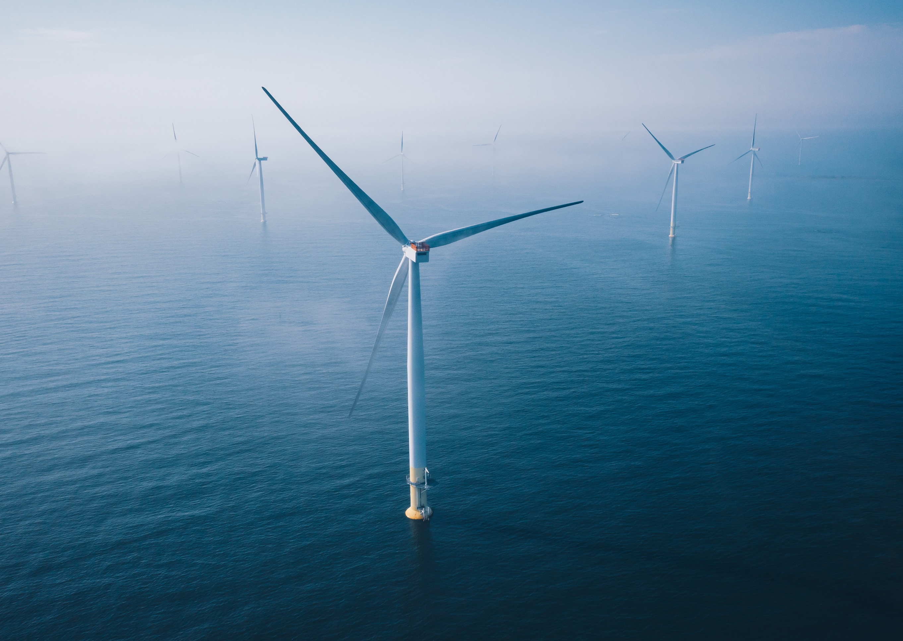

Table of Contents
Chapter 7 Communication and engagement 7-1
7.1 Introduction 7-1
7.1.1 Overview 7-1
7.1.2 EIS guidelines 7-2
7.2 Engagement approach 7-3
7.2.1 Engagement principles 7-3
7.2.2 Engagement objectives 7-4
7.3 Stakeholders 7-5
7.3.1 Stakeholder groups 7-5
7.3.2 Government 7-5
7.3.3 First Nations 7-6
7.3.4 Landholders 7-7
7.3.5 Communities 7-8
7.3.6 Fishing 7-10
7.4 Communication and engagement methods 7-12
7.4.1 Print and digital communication 7-13
7.4.2 Community Advisory Group 7-15
7.4.3 Technical Reference Group 7-16
7.4.4 Briefings, meetings, presentations and workshops 7-16
7.4.5 Information sessions, pop ups and webinars 7-17
7.4.6 ‘Get involved’ online consultation hub 7-18
7.4.7 Gippsland office 7-18
7.4.8 Community research 7-18
7.4.9 Youth and schools’ engagement 7-19
7.4.10 Enquiry channels 7-19
7.5 Engagement phases 7-20
7.5.1 Phase 1: Project inception 7-21
7.5.2 Phase 2: Project development and investigation 7-22
7.5.3 Phase 3: Project refinement and assessment 7-23
7.5.4 Phase 4: Public review and approval decisions 7-24
7.5.5 Phase 5: Detailed design and procurement 7-25
7.5.6 Phase 6: Construction 7-25
7.5.7 Phase 7: Operation 7-25
7.5.8 Phase 8: Decommissioning 7-25
7.6 Feedback 7-26
7.6.1 How feedback has been used to date 7-26
7.6.2 Key topics of interest 7-27
7.6.3 Feedback as it relates to the assessment 7-29
7.7 Monitoring and evaluation 7-41
7.8 Ongoing engagement 7-42

Figures
Figure 7-1 Community information session held in Yarram, 2022 7-2
Figure 7-2 Project communications materials 7-4
Figure 7-3 Engagement with GLaWAC 7-7
Figure 7-4 Engagement with Gippsland communities 7-9
Figure 7-5 Star of the South's Gippsland team leading community and fishing engagement 7-9
Figure 7-6 Engagement with commercial and recreational fishing stakeholders 7-11
Figure 7-7 Snapshot of key communication and engagement methods and statistics 7-12
Figure 7-8 Communications tool - newsletter 7-14
Figure 7-9 Communication tool - visual aids 7-14
Figure 7-10 Communication tool - video 7-14
Figure 7-11 Community Advisory Group 7-15
Figure 7-12 Community information sessions and webinars 7-17
Figure 7-13 Gippsland office 7-18
Figure 7-14 Schools engagement 7-19
Figure 7-15 Consultation phases - overview 7-20
Figure 7-16 Examples of communications and consultation activities from 2019 7-21
Figure 7-17 Key topics of interest 7-27
Figure 7-18 Community sentiment towards the project (November 2024) 7-41
Tables
Table 7-1 Engagement principles 7-3
Table 7-2 Key communications tools 7-13
Table 7-3 Phase 1: project inception 7-21
Table 7-4 Phase 2: Project development and investigation 7-22
Table 7-5 Phase 3: Project refinement and assessment 7-23
Table 7-6 Phase 4: Public review and approval decisions 7-24
Table 7-7 How feedback is used 7-26

Communication and engagement

Introduction
This chapter describes how Star of the South has communicated and engaged communities and stakeholders during the project’s development and assessment for project activities within the Commonwealth jurisdiction. It also outlines how communication and engagement will be managed across construction and operation of the project.
Further detail about communication and engagement activities and outcomes is provided in Attachment II – Consultation Report. Specific consultation undertaken and feedback received during the assessment is also summarised in the technical reports.

Overview
Community and stakeholder engagement has played an important role in shaping the Star of the South Offshore Wind Farm Project (the project) since its inception in 2017.
Star of the South's commitment to early, respectful and inclusive communication and engagement has ensured wide awareness of the project and participation in consultation, resulting in more than 16,000 interactions with a broad cross-section of stakeholders. This has enabled community and stakeholder views and knowledge to be considered in project decision making from the outset.
Community engagement has revealed a strong appetite for new, large-scale energy projects to continue Gippsland's history of powering Victoria, provide continuity of energy jobs and economic opportunities in the region, and transition to clean electricity generation to help abate the effects of climate change. As new technology to Australia, there is a strong interest in how offshore wind projects are constructed, operated and decommissioned to avoid and minimise impacts to the local environment, heritage values, communities, and other uses of the ocean and land.
During preparation of the EIS, targeted engagement for each study topic helped identify and understand issues for consideration in the assessment, as well as ideas for avoiding and reducing potential impacts.
Star of the South thanks everyone, particularly those in Gippsland, who have participated in the development of the project and its assessment.

EIS guidelines
Consultation is central to the assessment process. The Commonwealth EIS guidelines require Star of the South to inform and consult with First Nations peoples, communities, and relevant stakeholders about the project and technical studies which inform the assessment.
Star of the South prepared an EIS Consultation Plan in consultation with government, published on the project website in 2021 and subsequently updated as required. This plan sets out Star of the South's approach to communication and engagement during preparation of the assessment in line with best practices and in compliance with government requirements.
Attachment II – Consultation Report details how the EIS Consultation Plan was implemented and outcomes achieved.
Figure 7-1 Community information session held in Yarram, 2022
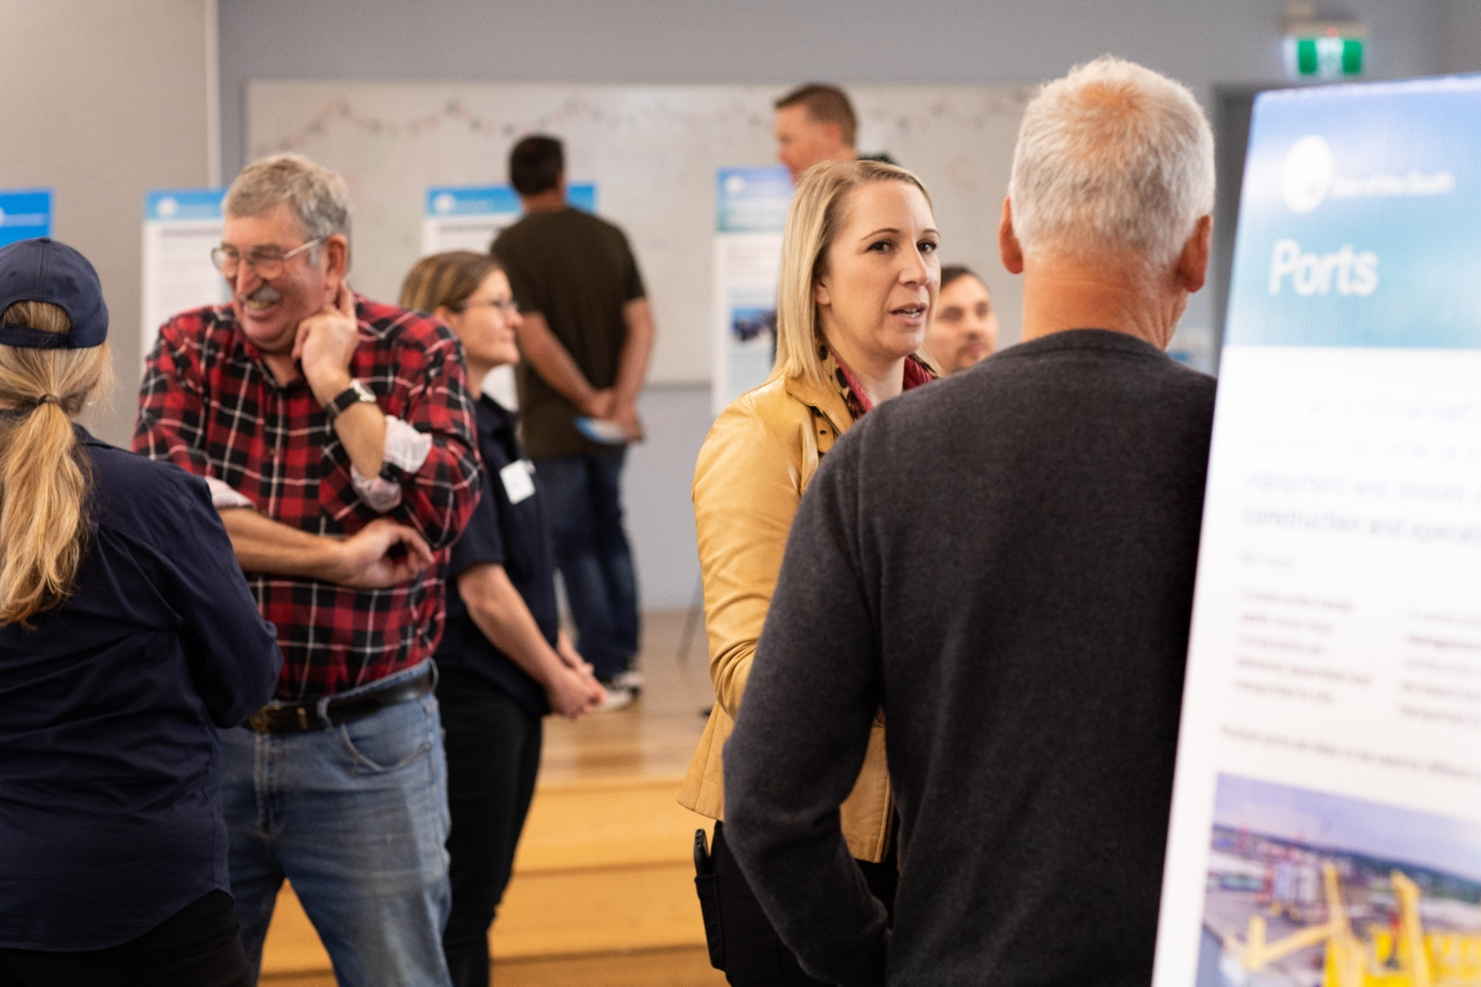

Engagement approach

Engagement principles
Star of the South's engagement philosophy is grounded in the belief that involving people early and meaningfully leads to better project, community and environmental outcomes. All engagement is underpinned by the principles set out in Table 7-1.
Table 7-1 Engagement principles
Principle | What this means during the assessment preparation and public review
Open and transparent | Star of the South listens with an open mind and is upfront about considerations, impacts and opportunities.  - Information is clear, accurate, timely and easy to find.  - Decision making processes, including how feedback is used, are clearly explained.  - Sufficient time is provided to consider and respond to information.  - Opportunities to participate are communicated widely.  - Work with Traditional Custodians to understand their aspirations.
Responsive | Star of the South responds promptly to feedback, no matter how big or small.  - Feedback and issues are managed effectively and promptly.  - Continually improve the process for responding to feedback and issues.  - Appropriate resources are available to engage effectively.
Flexible and inclusive | Star of the South remains flexible about how it does things so that stakeholder inputs can shape the project.  - Provide opportunities for community members to identify themselves as interested stakeholders and participate in engagement activities.  - Seek to include all interested parties.  - Provide different ways and times for people to participate.  - Provide flexibility so that feedback can genuinely influence decisions.
Act with integrity | Star of the South is respectful and honest in all interactions with communities and stakeholders.  - Follow through on commitments.  - Follow legal and legislative requirements.  - Rights-based engagement with First Nations peoples.  - Consult and cooperate Traditional Custodians in good faith to obtain free, prior and informed consent.
Accountable | Star of the South takes ownership of issues and provides access to leadership and decision makers.  - Take ownership for issues that may arise, particularly those affecting local communities or stakeholders.  - Senior and specialist team members are accessible to all stakeholders.

Engagement objectives
Communication and engagement objectives during the project’s development and assessment are to:
- Inform communities and stakeholders about the project, the assessment process and opportunities to participate
- Actively involve communities and stakeholders in the project’s development and planning to improve outcomes
- Encourage participation and seek input during the preparation of the assessment to identify issues of potential concern, obtain local insight and gain feedback on measures to address concerns
- Help people understand the project and participate in its development by ensuring communication materials are clear and accessible
- Demonstrate how community and stakeholder feedback and issues are being captured and used to inform the project’s development and assessment.
These objectives are underpinned by the five engagement principles set out in Table 7-1.
Figure 7-2 Project communications materials
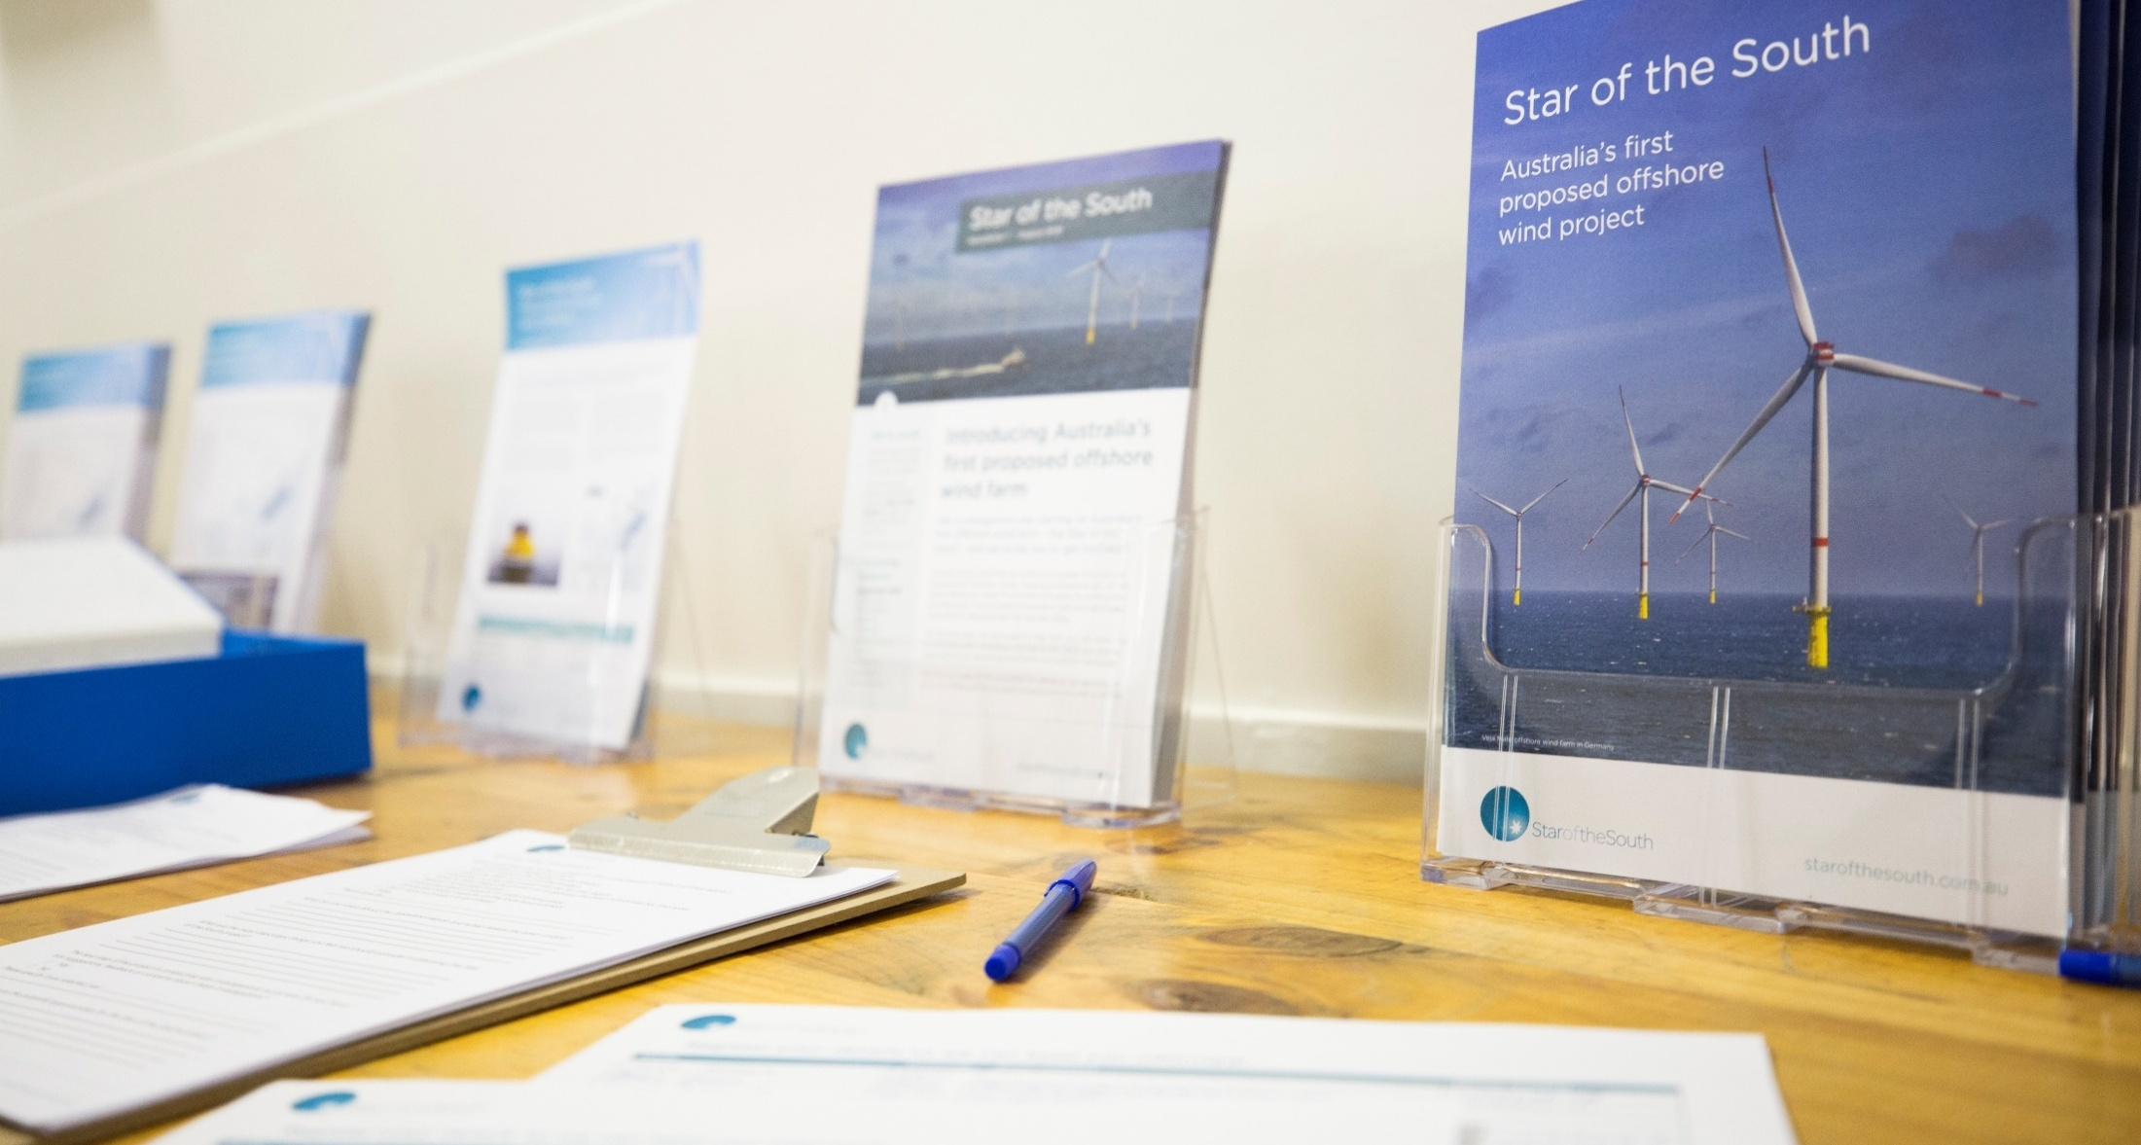

Stakeholders

Stakeholder groups
As a major infrastructure project that is the ‘first of its kind’ in Australia, the project has attracted interest from a broad range of stakeholders, recording more than 16,000 interactions with stakeholders since 2017.
Stakeholder groups engaged in project development and assessment are:
- Commonwealth Government  - Victorian Government  - Local governments  - First Nations  - Landholders  - Local communities and groups  - Local and regional businesses  - Environment and climate interest groups  - Education and training providers | - Commercial fishing industry  - Recreational fishers, boaters and divers  - Local and regional ports  - Shipping industry  - Energy industry  - Unions  - Peak bodies and associations  - Other infrastructure and licence holders
Thirty-two per cent of all stakeholder interactions have been with community members and groups, 23 per cent with landholders, 13 per cent with the supply chain (including local businesses), 12 per cent with government and six per cent with fishing stakeholders. Remaining groups represent between one to four per cent of all interactions.
The following sections provide an overview of key stakeholder cohorts. Detailed stakeholder identification of all interests and categories is provided in Attachment II - Consultation Report.

Government
All levels of government have a role in the assessment, approval, and regulation of various aspects of the project. The Commonwealth government is however responsible for the EIS assessment and approval process under the EPBC Act.
Consultation with key Commonwealth and Victorian government departments and statutory agencies, including those responsible for energy, planning, environment, maritime safety, aviation safety, defence, and transport, is ongoing. Elected representatives are also briefed as appropriate.
The onshore project area is located within the Wellington Shire local government area, and the offshore project area is located off the coast of Wellington Shire and South Gippsland Shire. Star of the South has engaged extensively with both shire councils, and is in regular contact with surrounding councils Latrobe City, Baw Baw Shire, Bass Coast Shire and East Gippsland Shire.

First Nations
Star of the South is committed to delivering a responsible project in partnership with Gippsland's Traditional Custodians and other First Nations peoples, with a focus on minimising impacts to Country and creating opportunities.
A First Nations engagement advisor was embedded in the project team during early project development to lead culturally appropriate engagement with First Nations peoples and groups.
The Traditional Custodians of the project area are the Gunaikurnai people, represented by the Gunaikurnai Land and Waters Aboriginal Corporation (GLaWAC). Star of the South first met with GLaWAC in 2017 and has since engaged with its representatives on a range of topics including site investigations, cultural education for project personnel, future workforce and procurement planning, and agreement-making.
GLaWAC has shared knowledge and participated in project activities during the Star of the South Offshore Wind Farm's assessment, with further information provided in Technical Report K - Aboriginal Cultural Heritage.
Star of the South entered into an Engagement Agreement with GLaWAC in March 2025 which will support ongoing engagement, including on management plans, agreement-making and community benefits.
The project may also be of interest to other First Nations people outside the immediate project area. Star of the South is committed to open and meaningful engagement with individuals and Registered Aboriginal Parties (RAPs) across Australia whose communities have an interest.
The Bunurong Land Council Aboriginal Corporation (BLCAC) is a Traditional Owner organisation that represents the Bunurong people of the South-Eastern Kulin Nation. BLCAC is the Registered Aboriginal Party for the Mornington Peninsula, Westernport and a portion of south-west Gippsland.
Recognising the proximity of the project to Bunurong Country, Star of the South has provided briefings to BLCAC representatives and shared updates as appropriate. Further engagement with BLCAC will be undertaken according to their preferences.
Recognising First Nations peoples and communities are best placed to advise on appropriate protocols for respectful and effective engagement, Star of the South will work with GLaWAC and other RAPs to ensure communication and consultation methods are useful and appropriate.
Figure 7-3 Engagement with GLaWAC
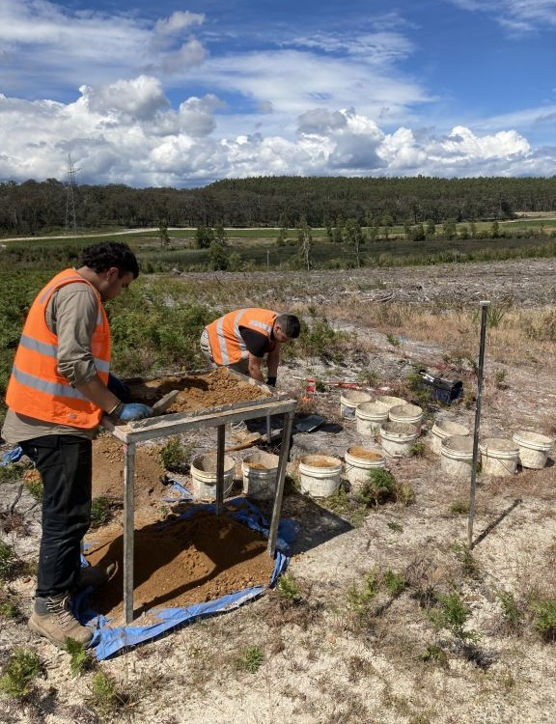
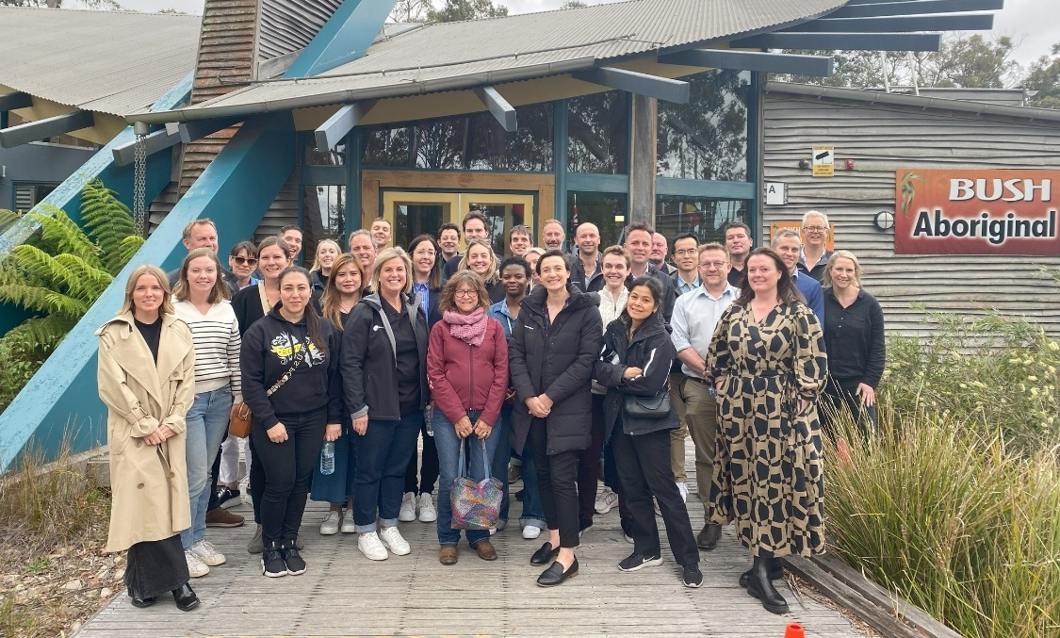
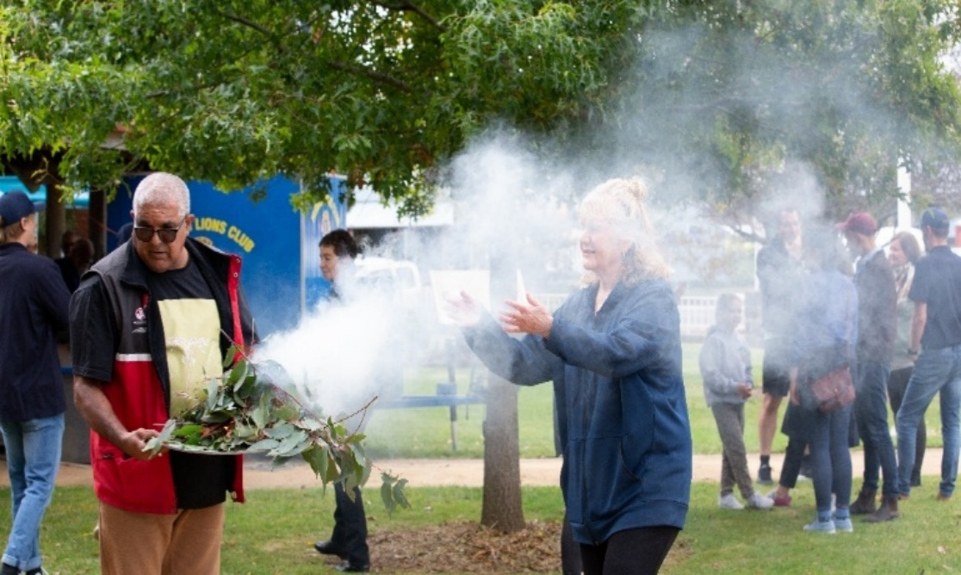

\

Landholders
A dedicated Gippsland-based lands engagement team was established in 2020 to provide a consistent point of contact for landholders whose property may be suitable to host project transmission infrastructure.
Star of the South started landholder engagement in 2020 to obtain feedback on three onshore cable corridor options being considered. This involved sending hundreds of letters, making phone calls, follow up emails and text messages, and holding 70 meetings and site visits.
Once a preferred corridor was announced in 2021, all landholders were updated and engagement with landholders within the selected corridor continued. Engagement supported land access for site investigations, technical assessments, and refinement of the corridor to avoid and minimise impacts to property, land uses, and existing infrastructure wherever possible.
Tailored landholder information materials provide detailed information relevant to their interests and questions at every stage.

Communities
Communities with an interest in the project are diverse and unique. Star of the South has a strong focus on working with coastal communities in proximity to the project area and those from across the broader Gippsland region. Other Victorians and Australians have also been involved.
Engagement and communication are tailored to community needs and interests to encourage and support participation in the project’s development and assessment. An early and consistent focus on consultation has provided the time, sufficient information, and required expertise needed to support informed community participation.
Star of the South has a strong local presence with a Gippsland office and dedicated Gippsland-based community engagement team who lead all local consultation, including community information sessions, pop ups, community presentations, and stakeholder meetings and briefings.
Community engagement has helped Star of the South to understand what is important to consider in the project’s development and assessment, to draw on local knowledge, and identify issues and opportunities early so they can be addressed.

Figure 7-4 Engagement with Gippsland communities
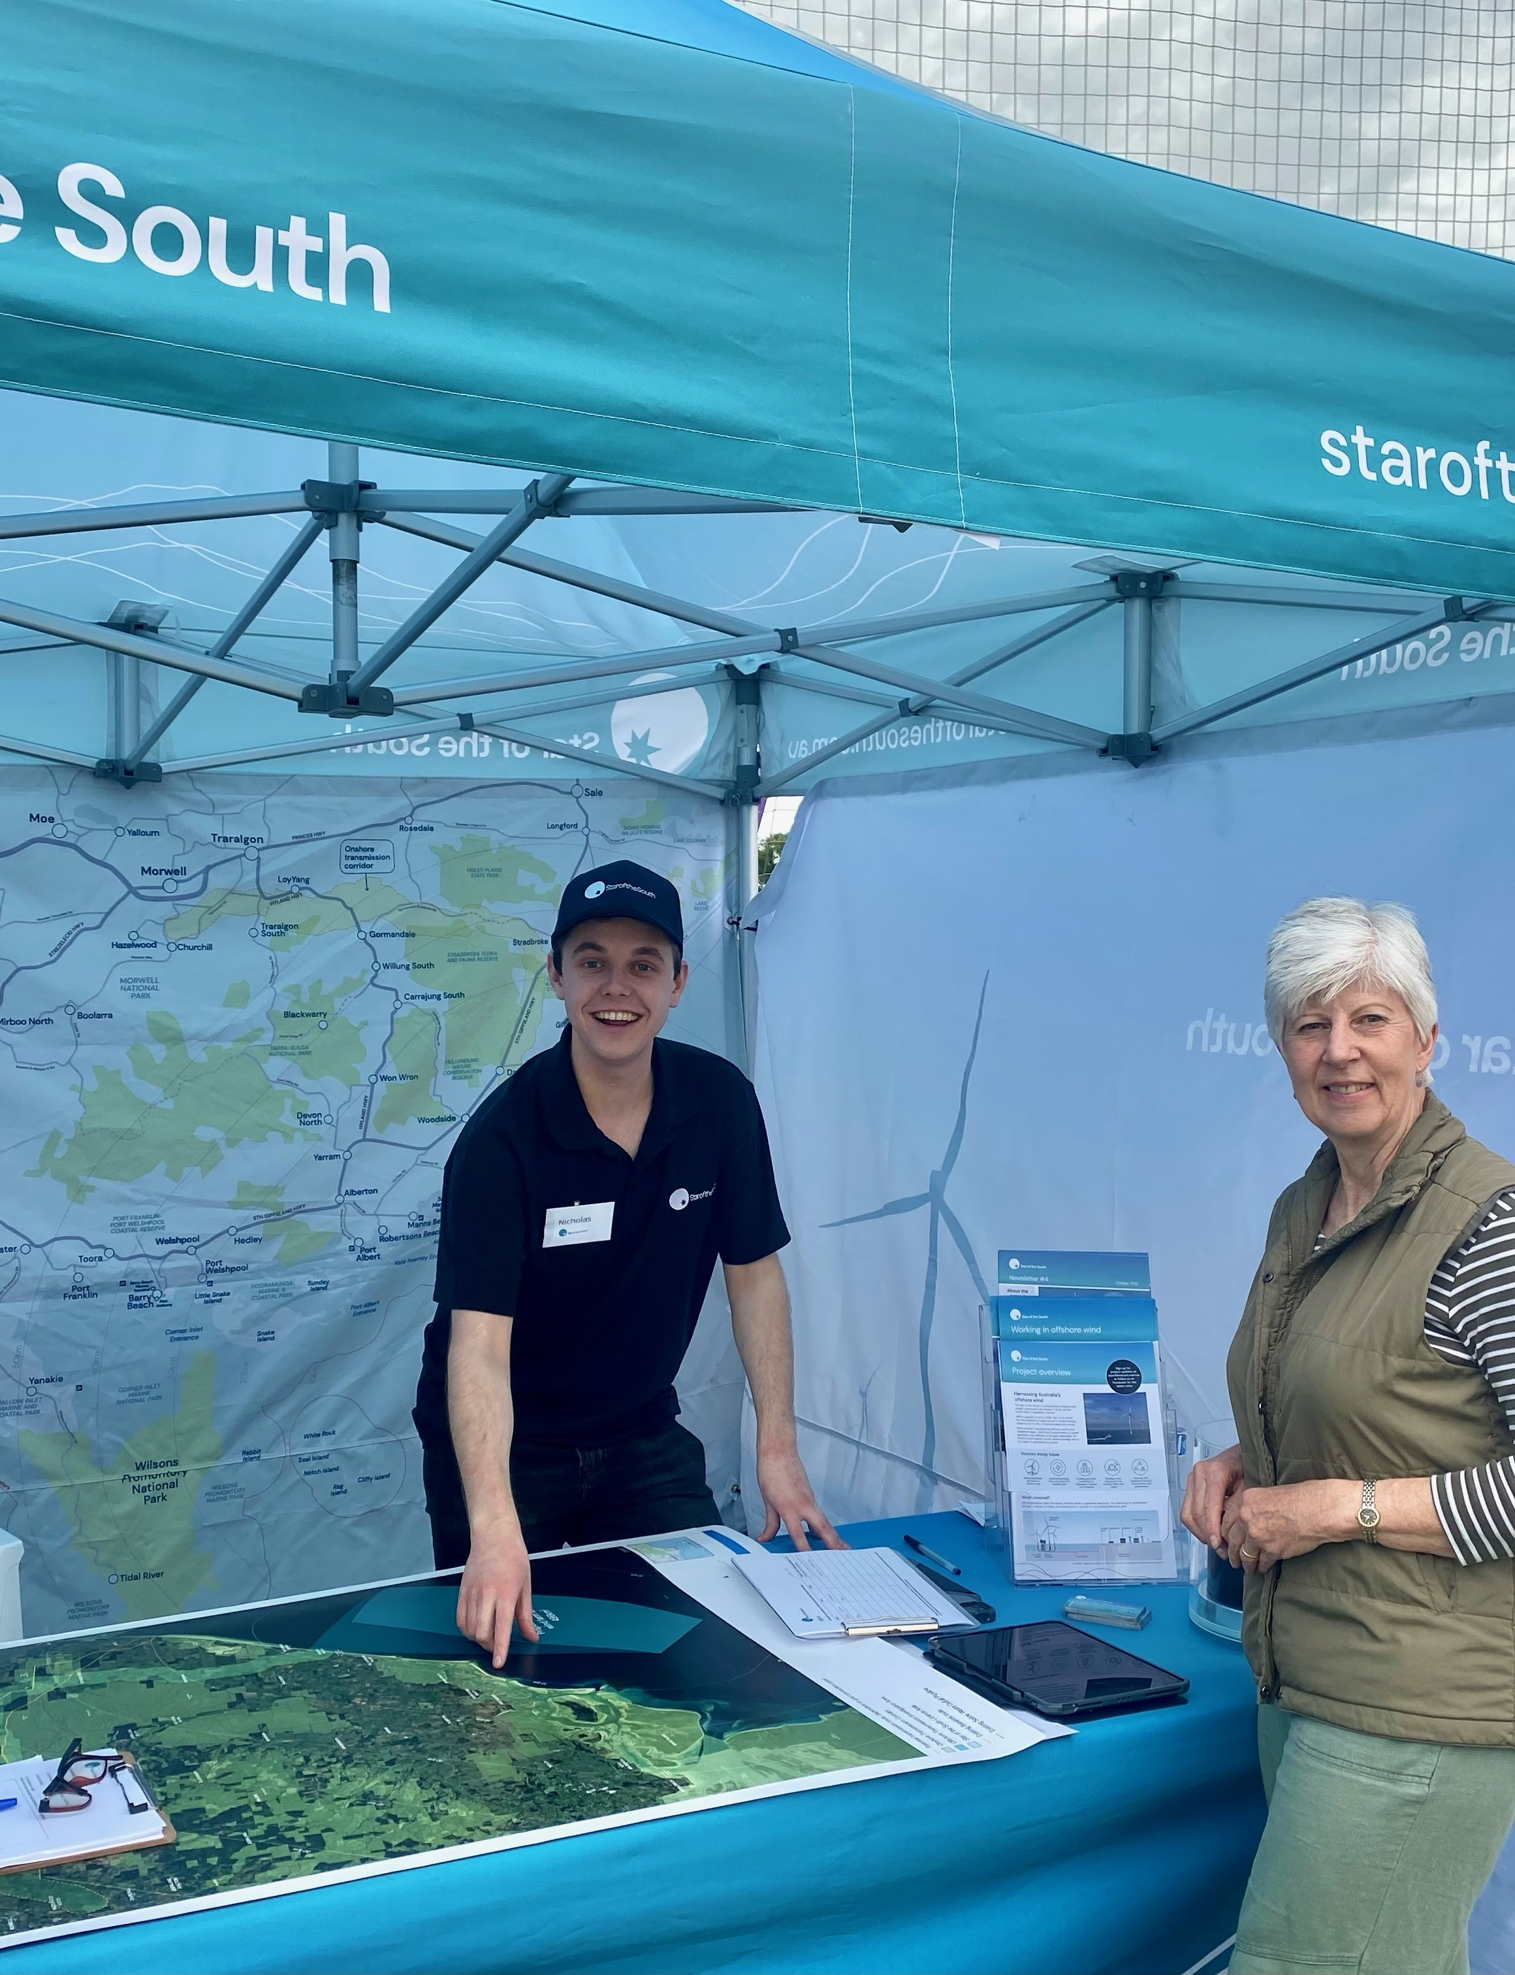
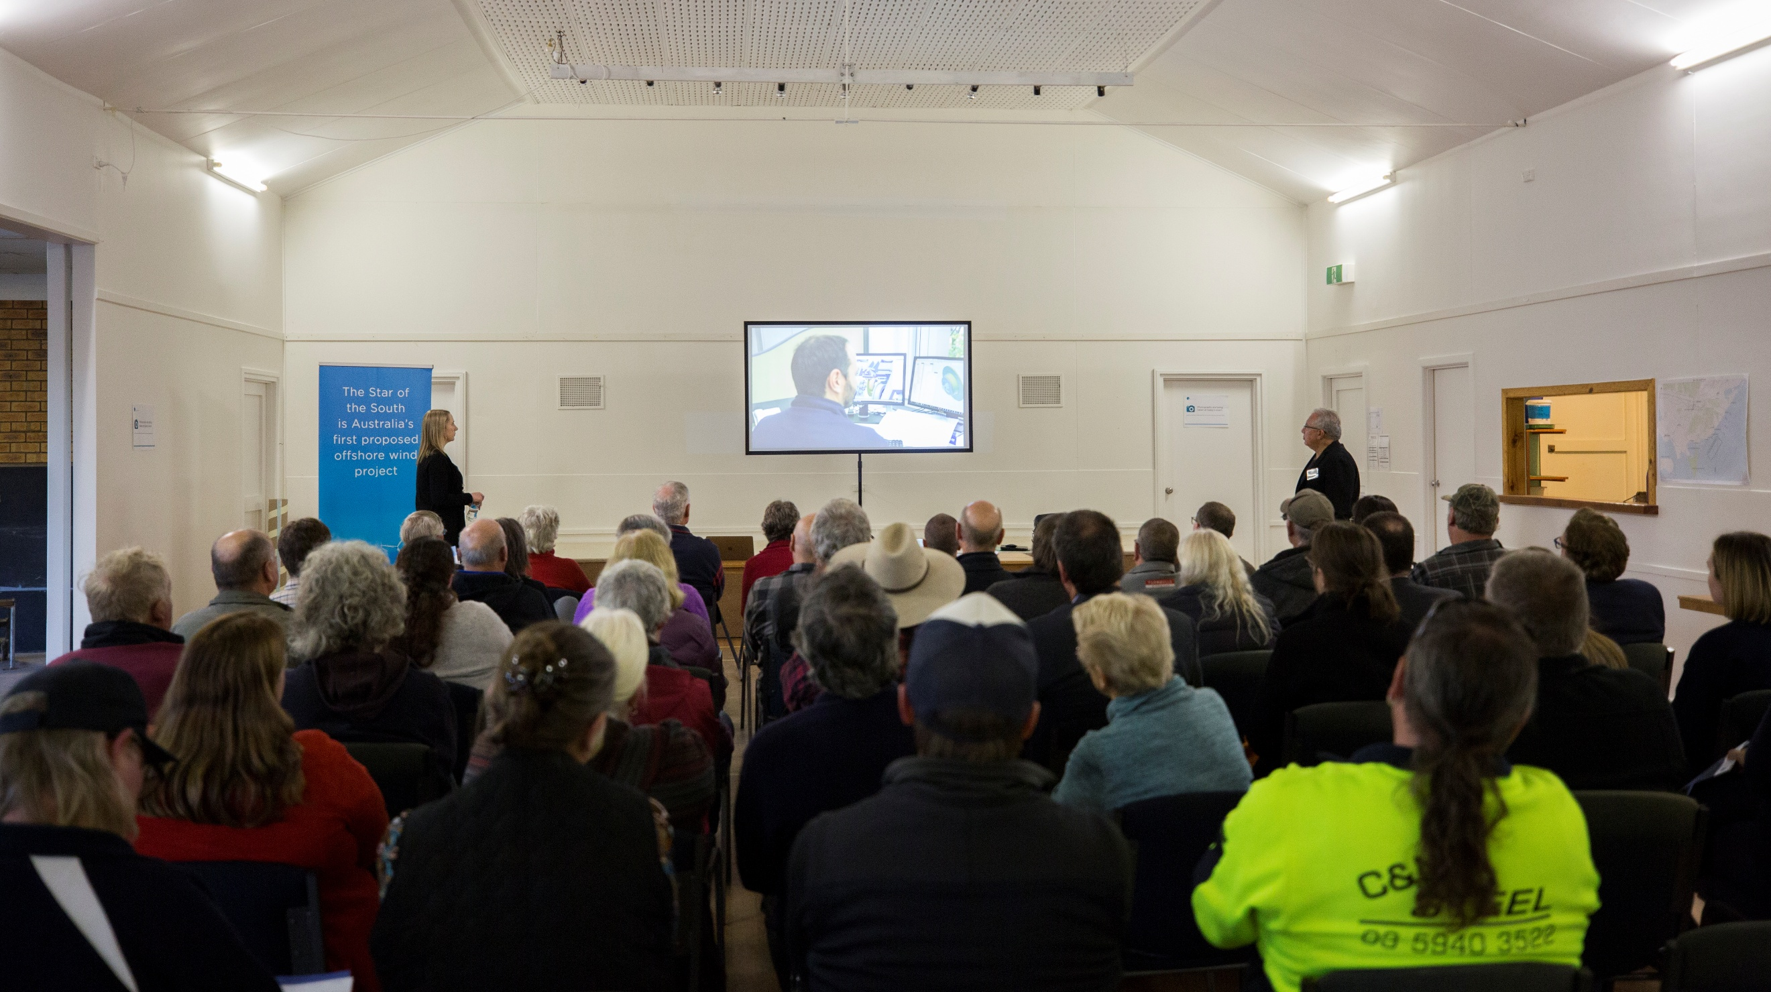
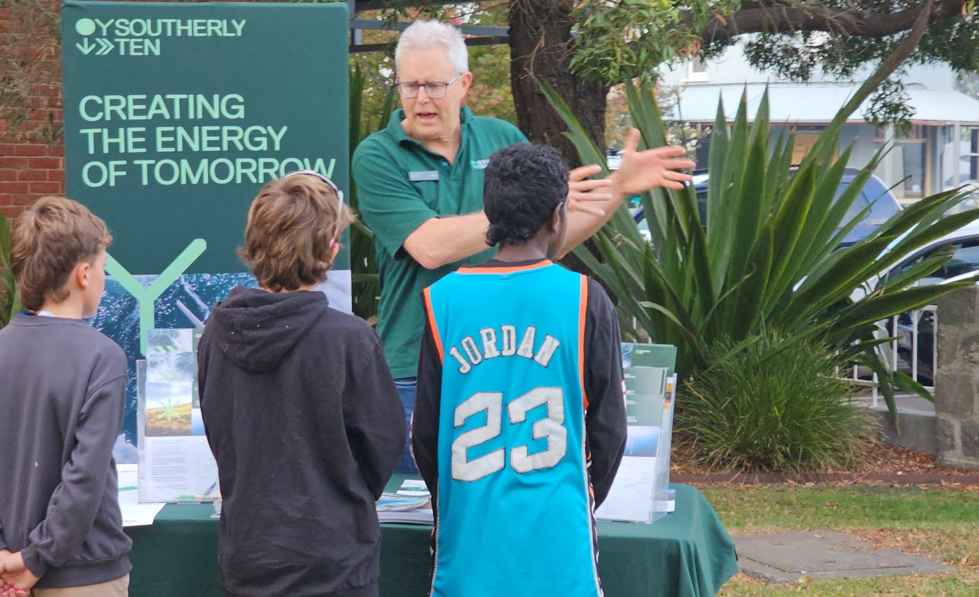
collage

Figure 7-5 Star of the South's Gippsland team leading community and fishing engagement
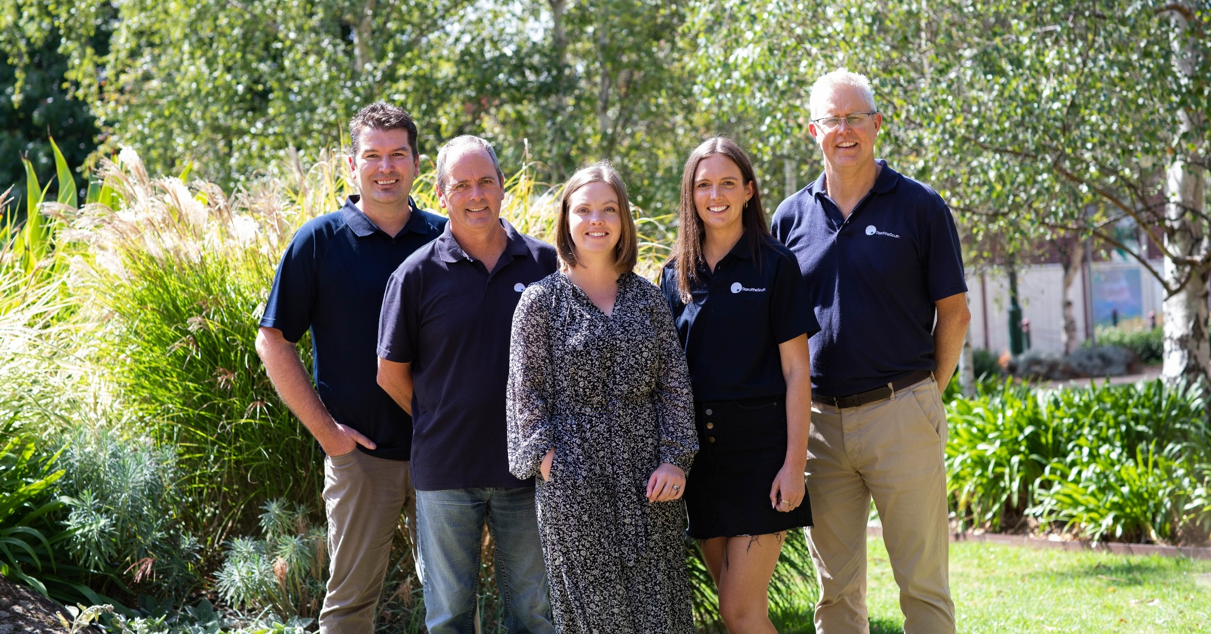

Fishing
The Offshore Electricity Infrastructure (OEI) Act framework operates under the principle of shared use of the offshore marine environment, recognising all users and balancing competing interests.
Star of the South started engaging with commercial and recreational fishers in 2018. Recognising the importance of working with the fishing sector, Star of the South appointed a dedicated Fishing Liaison Officer in 2021 to provide a knowledgeable, consistent point of contact and lead proactive engagement with a focus on safe coexistence.
Star of the South has engaged directly with individual commercial fishers, individual recreational fishers, industry representatives, fishing clubs, fishing regulators and research agencies. This has been done through individual meetings, information sessions, workshops, participation in seafood industry events, boat ramp surveys, and a Seafood Industry Victoria member survey.
Engagement with fishers has been undertaken to:
- Provide information about the project and project activities through a range of channels
- Collect data and feedback to understand fishing activities that occur in project area
- Identify and proactively consult with commercial fishing concession holders currently operating in the project area
- Consult on site investigations timing, methods and locations
- Consult on baseline environment survey methods, EIS scope and assessments
- Identify opportunities for local vessels and crews to work on the project
- Discuss key considerations for fishing in wind farm design, construction and operation
- Discuss potential opportunities for collaboration.
Further information is provided in Chapter 15 – Commercial and Recreational Fishing.

Figure 7-6 Engagement with commercial and recreational fishing stakeholders
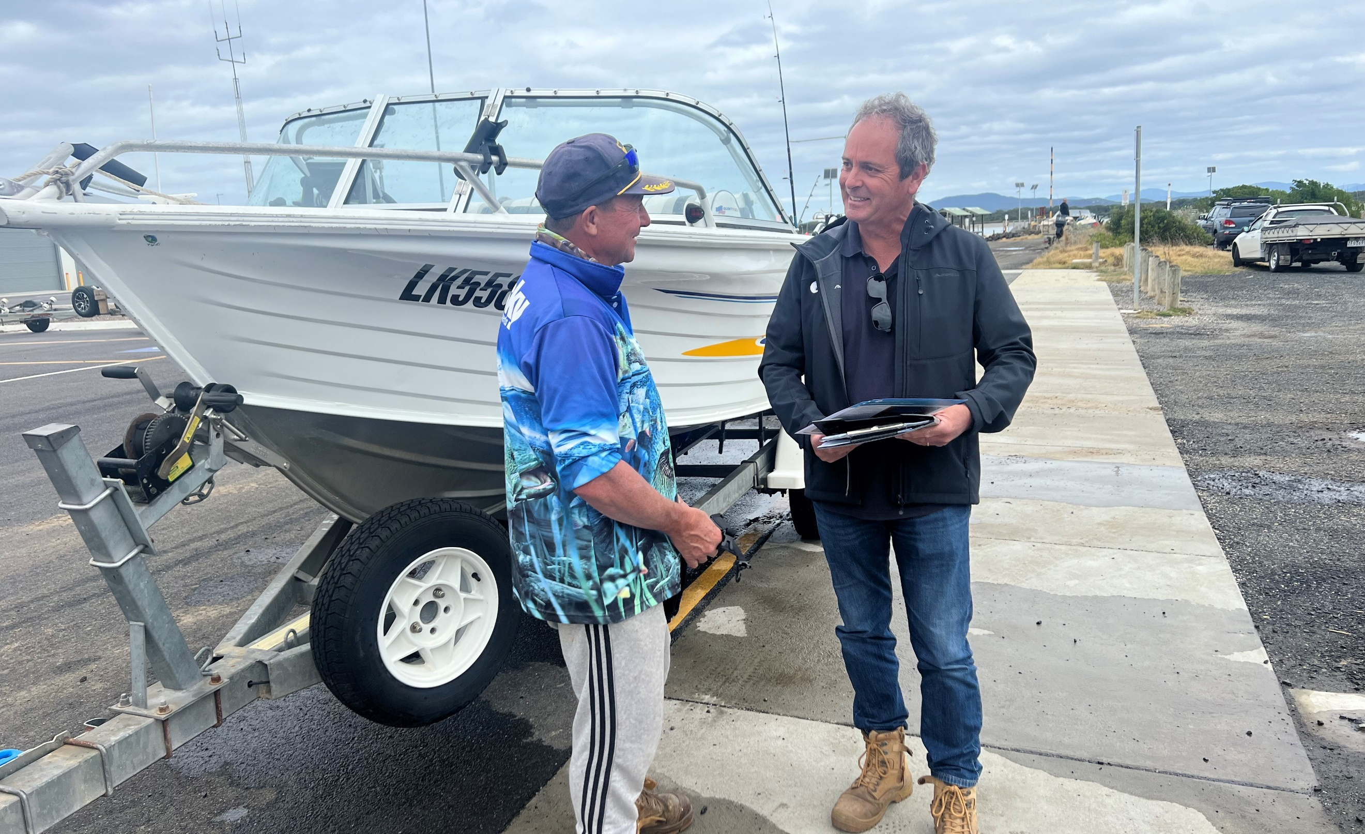
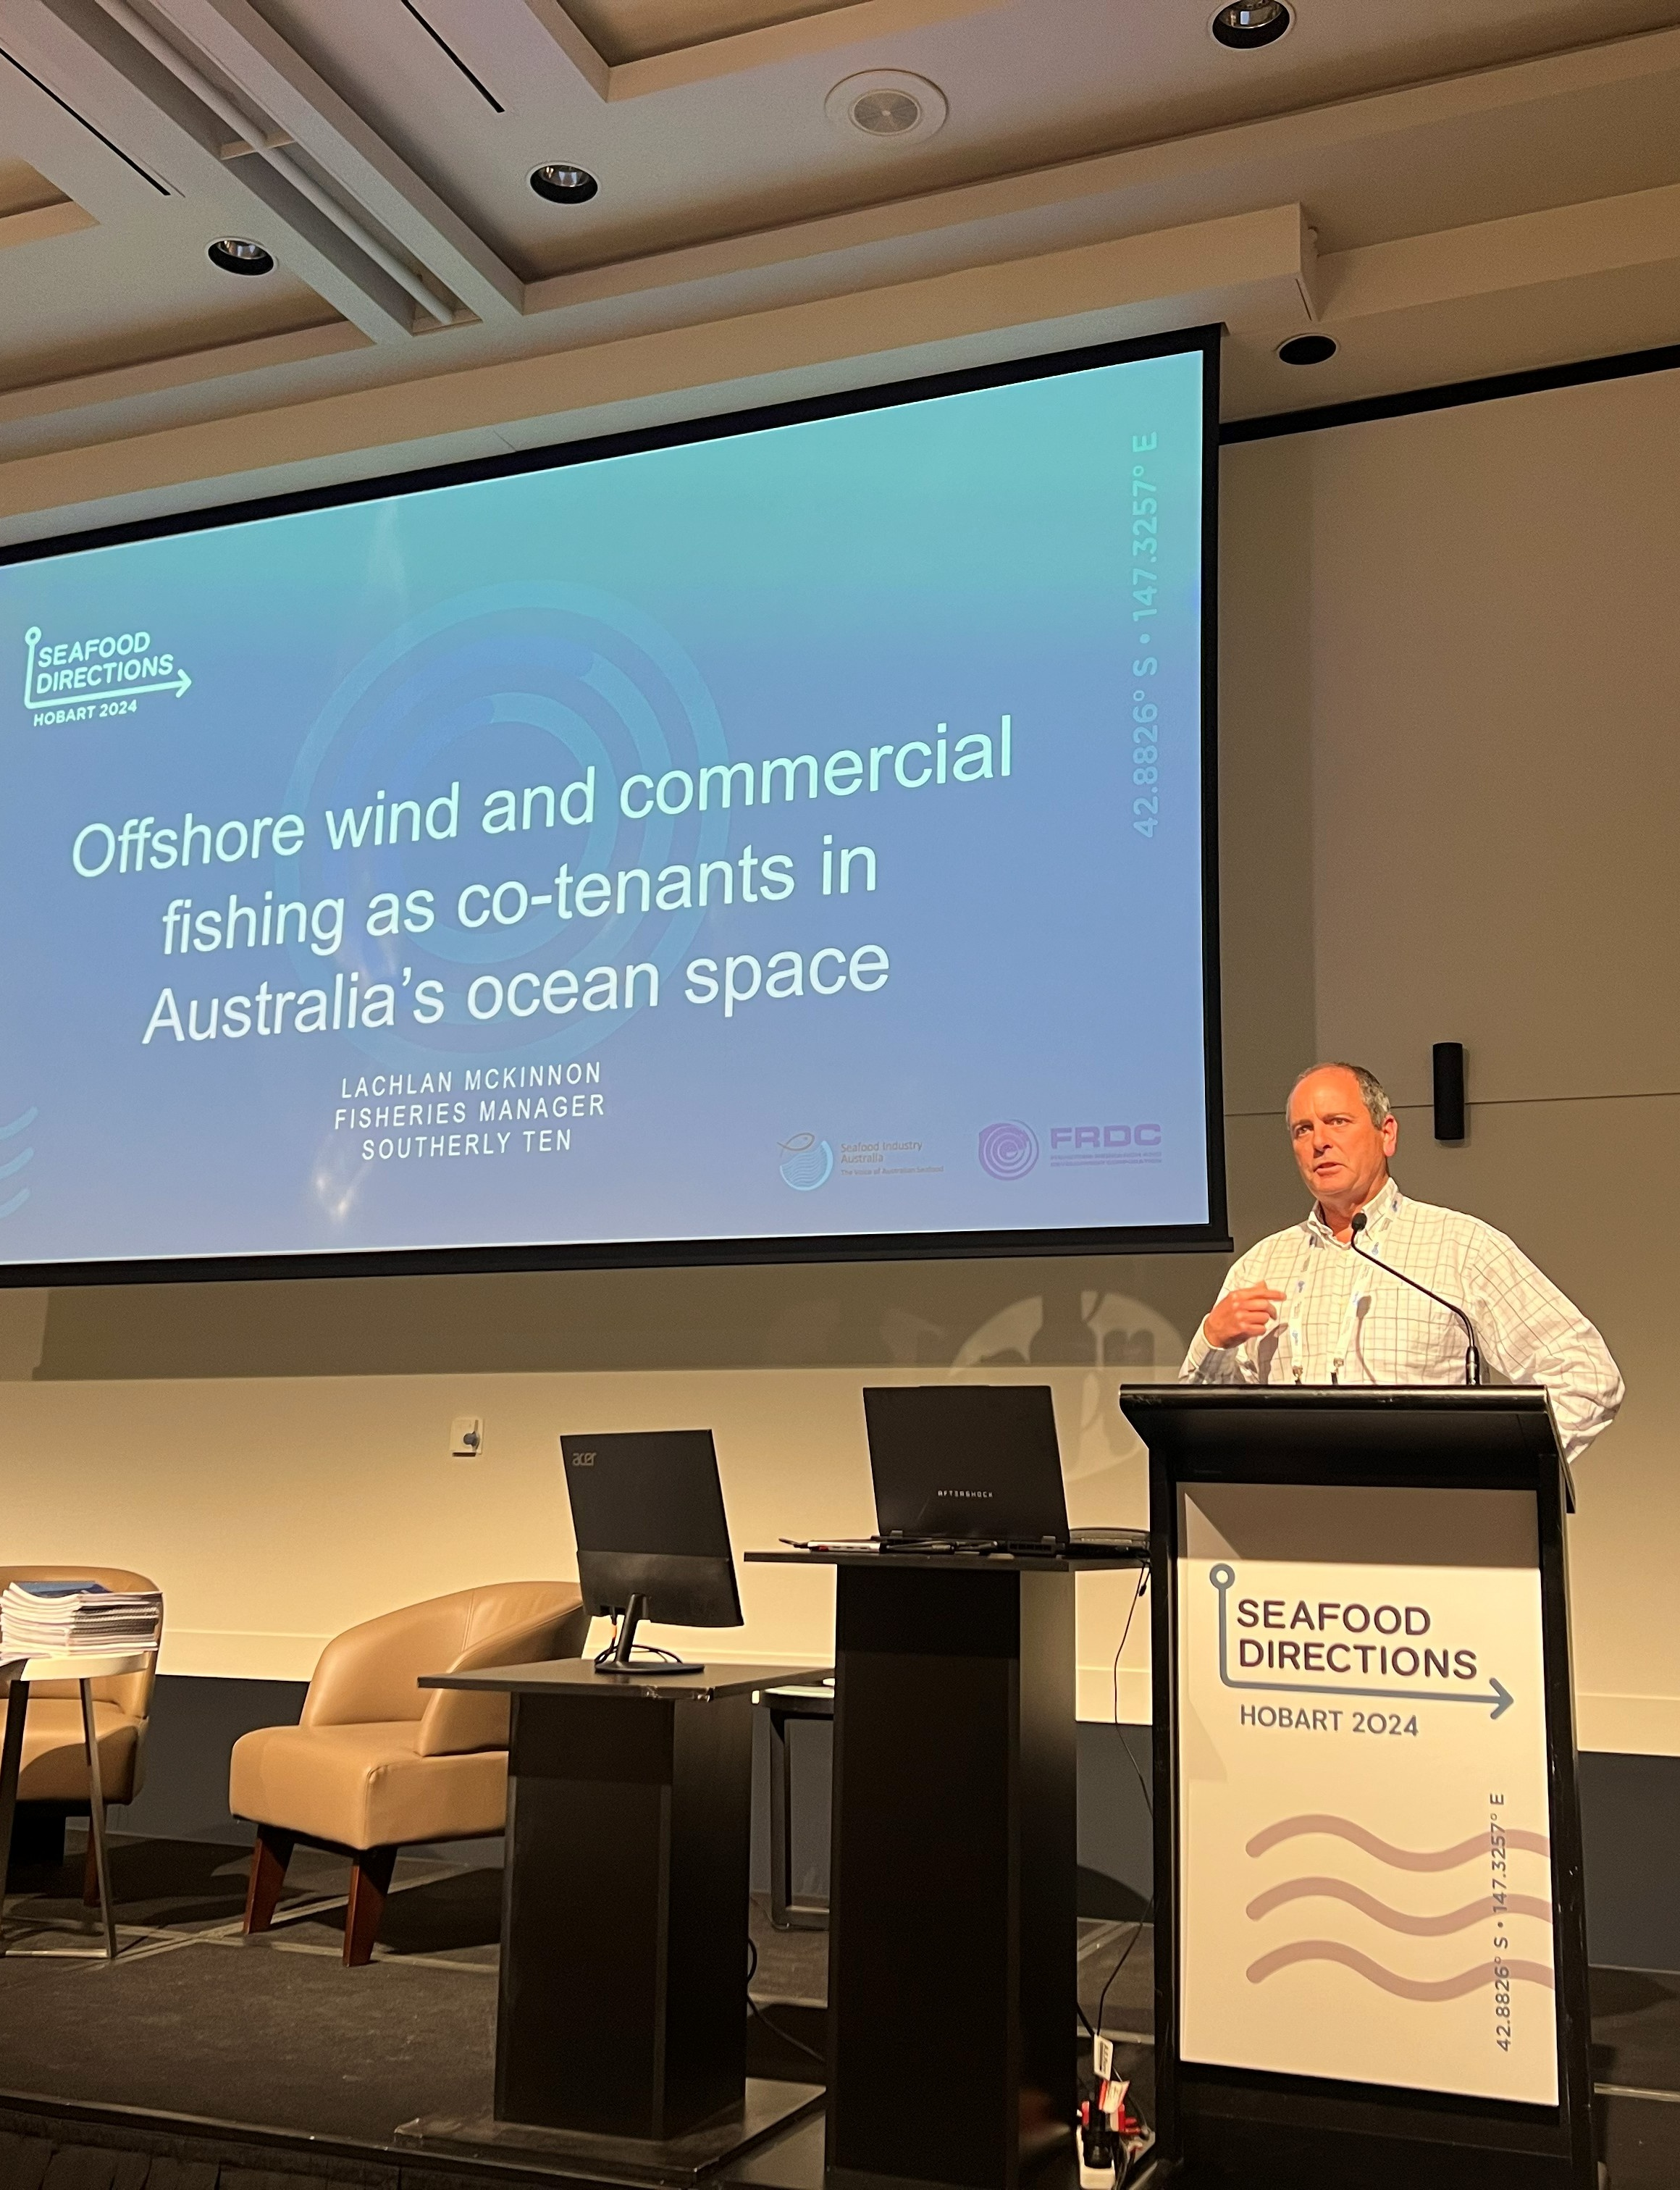

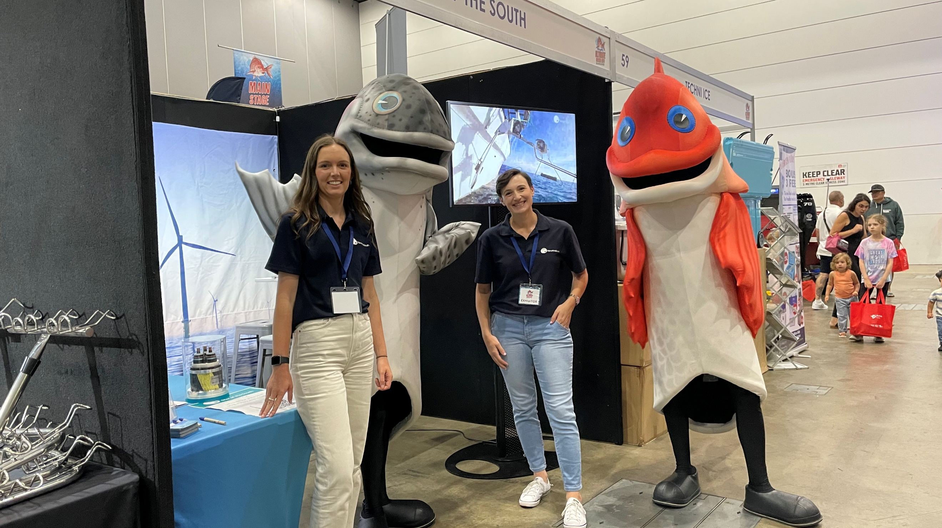

Communication and engagement methods
Recognising the diversity of stakeholders and communities interested in the project, a wide range of communication and engagement methods are used to build awareness and understanding of the project, support participation in consultation opportunities, and elicit informed feedback. A snapshot of these methods is shown in Figure 7-7.
Figure 7-7 Snapshot of key communication and engagement methods and statistics
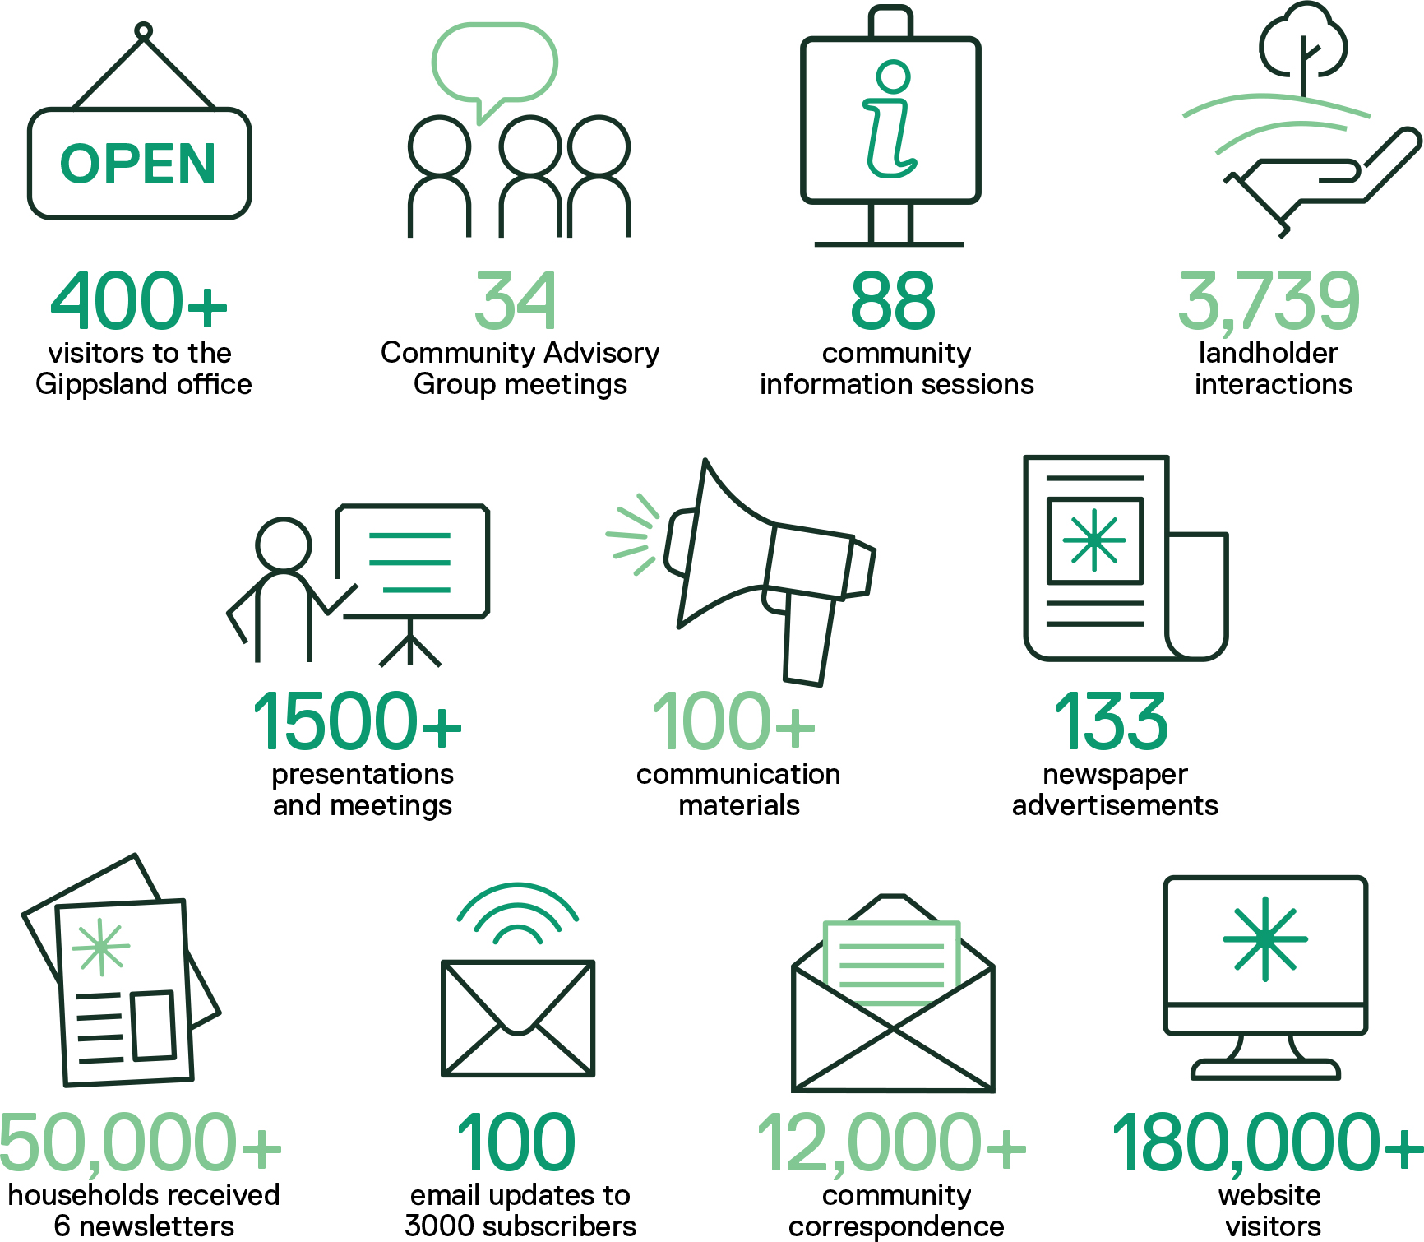

Print and digital communication
A variety of traditional and digital tools are used to communicate information about the project. Every piece of communication is developed with its intended audience and purpose in mind. Plain language and graphic design are used to create accessible and engaging materials, in line with the Victorian Government accessible communications policy.
Table 7-2 Key communications tools
Method | Description | Key statistics
Advertising and media | Advertisements, news coverage and interviews in the local media help inform a broad audience about the project and consultation opportunities. Advertising in major daily newspapers is also used at major milestones in the assessment process to promote consultation. | 133 advertisements in eight Gippsland newspapers
Email updates | An email update is distributed monthly to share the latest project news and resources, and to promote events and consultation opportunities. | 100 email updates sent to 3,000 subscribers
Fact sheets | Fact sheets covering a range of topics are available online and in hard copy at the project’s Gippsland office, community events, local venues, and via post (on request). | 29 fact sheets published
Maps and visual aids | Maps and other visual aids are used to illustrate the project location, components and processes in an easy to understand way. | 20 maps and visual aids published
Newsletters | Printed newsletters are delivered directly to households across the Wellington, South Gippsland and Latrobe local government areas annually to ensure all residents have access to project information. | Six newsletters, each distributed to more than 50,000 households
Photomontages | Technical photomontages are shared on the project website and printed for display in local venues to show how the project could appear from coastal townships and other important places. | 14 photomontages from nine locations published online
Posters and display materials | Posters are displayed on community notice boards, at community venues and local shops to promote consultation opportunities. Display materials are used at events and the project’s Gippsland office to provide information on key topics of interest. | 26 posters and display boards created
Social media | Facebook, LinkedIn are used to communicate project information and updates, and to promote consultation opportunities. | 3,700 Facebook followers and 19,000 LinkedIn followers
Videos | Videos are used to share project updates and explain complex information in an engaging and accessible format. | 26 videos created
Website | The project website provides a central location for information and updates, including an online engagement hub and resource library. | More than 180,000 unique visitors
3D model and interactive map | A 3D digital model provides a way to explore the project virtually, including seeing views of the offshore wind farm in a range of weather conditions, times of day and times of year. It is accessible via a touch screen kiosk in the project’s Gippsland office or via an interactive map on the project’s website. | More than 13,000 views

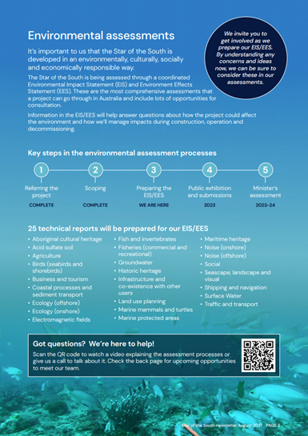
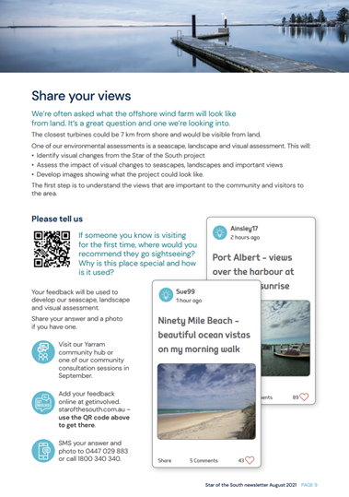
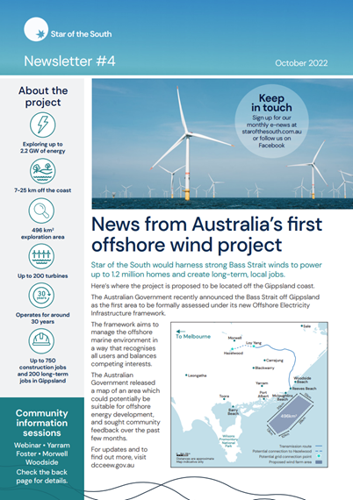
Figure 7-8 Communications tool - newsletter

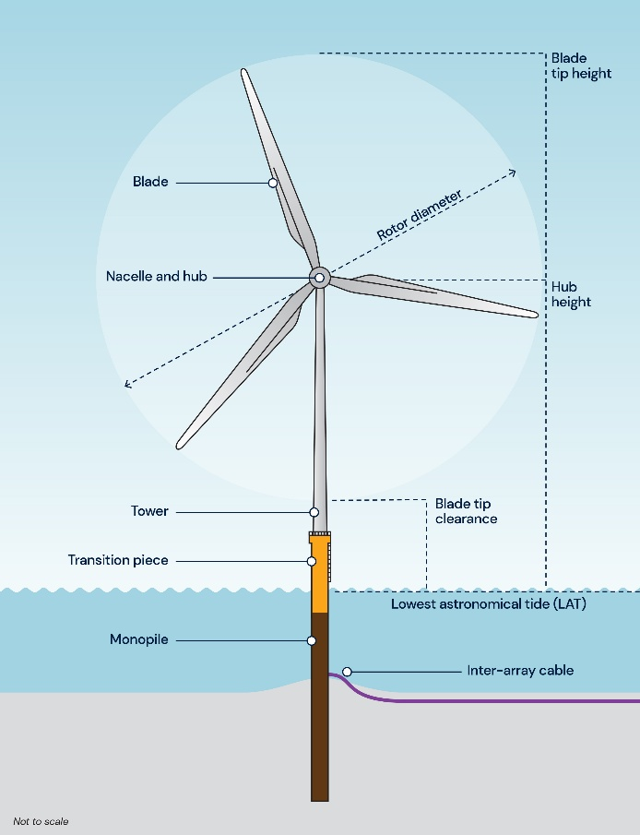
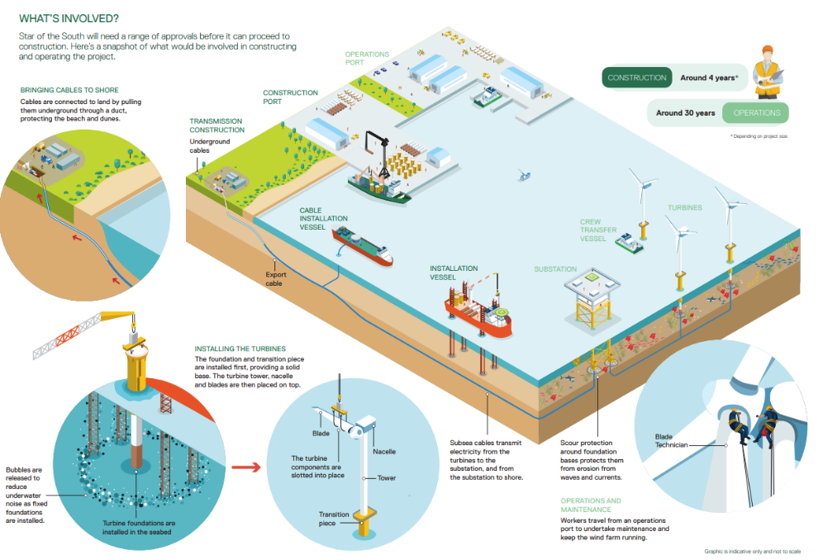
Figure 7-9 Communication tool - visual aids

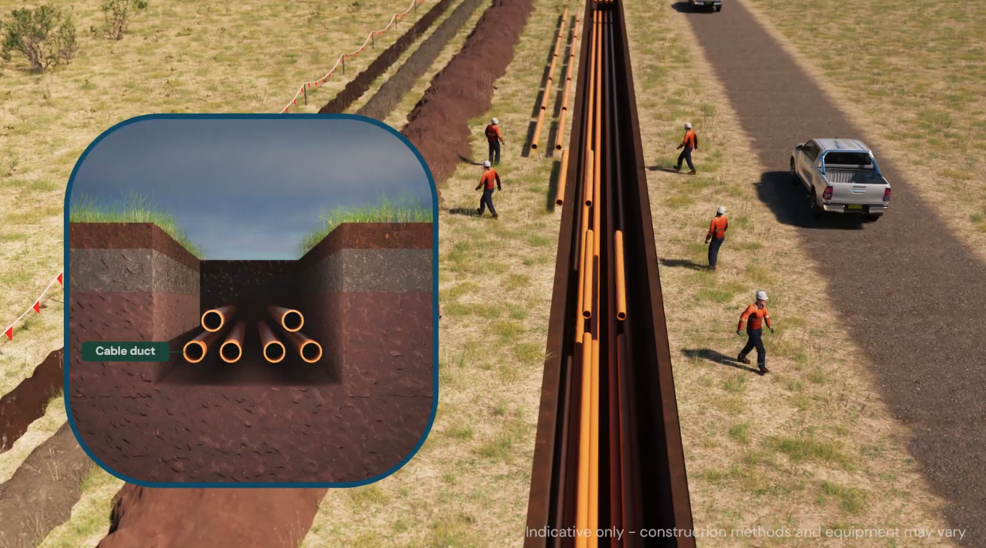
Figure 7-10 Communication tool - video

Community Advisory Group
Star of the South established a Community Advisory Group in October 2020 to provide a forum for two-way communication with local communities and organisations, and to seek local advice on the project’s development, assessment and engagement activities. The group is overseen by an independent chairperson in accordance with agreed terms of reference. For transparency, meeting agendas, minutes and presentations are available on the project’s website.
Thirty-four meetings have been held, including site visits and workshops to obtain advice on subjects such as the project’s social impact assessment and Consultation Plan.
The group has 20 members, comprising representatives from:
- Wellington Shire Council  - South Gippsland Shire Council  - Latrobe City Council  - GLaWAC  - Gippsland Climate Change Network  - Voices of the Valley  - Committee for Gippsland  - Gippsland Trades and Labour Council  - Birdlife | - Port Albert  - Yarram  - McLoughlins Beach  - Woodside Beach  - Giffard / Darriman  - Toora / Agnes  - Foster  - Sale  - Lakes Entrance
Figure 7-11 Community Advisory Group
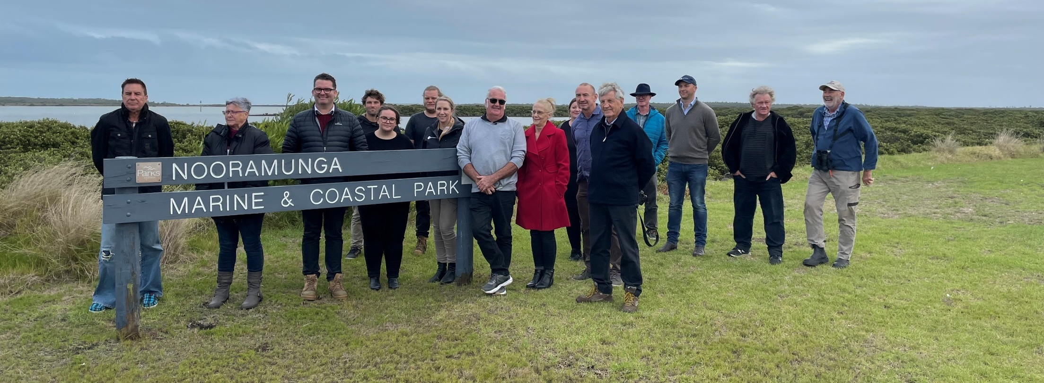
Members are asked to disseminate project information, support locals seeking information, and identify issues and opportunities for consideration. Star of the South coordinates regular meetings, supplies information, leads discussions about topical issues, and facilitates site visits and guest speakers to explore specific subject matters.

Technical Reference Group
The Victorian Department of Transport and Planning convened an inter-agency Technical Reference Group to advise Star of the South and the Department on the scoping and adequacy of studies for the project’s assessment.
The government organisations represented on the Technical Reference Group are:
- Department of Transport and Planning
- Department of Energy, Environment and Climate Action
- Department of Climate Change, Energy, the Environment and Water (Cth)
- Environment Protection Authority Victoria
- First Peoples – State Relations
- Gunaikurnai Land and Waters Aboriginal Corporation
- Heritage Victoria
- Wellington Shire Council
- West Gippsland Catchment Management Authority
Representatives are supported by internal experts on specific aspects of the technical studies.

Briefings, meetings, presentations and workshops
More than 1,500 briefings, meetings, presentations and workshops have been recorded to date. This includes in-person and online meetings with a broad range of stakeholders and community members. Around 200 community presentations have been delivered to groups such as Rotary, Landcare, ratepayer and progress groups, and fishing clubs.
Star of the South has held targeted and specific briefings for environmental groups and other non-government organisations during the assessment process ahead of the public review period to introduce findings, impact / risk areas and proposed mitigation measures.

Information sessions, pop ups and webinars
More than 30 information sessions have been held in local townships to provide an opportunity for residents and visitors to speak directly with project personnel and technical specialists, obtain information and provide feedback. These events typically comprise a presentation, information and maps on display, provision of information materials, and the use of feedback forms. They are promoted widely, including through newspaper and radio advertisements, letterbox drops, social media, email, and posters.
During the COVID-19 pandemic, alternatives were provided in the form of live webinars, telephone or online meetings, postal packs (comprising information materials and feedback form), and small group community meetings. These options were retained after pandemic restrictions eased due to ongoing demand for flexible engagement options.
Star of the South also regularly holds ‘pop ups’ across Gippsland at local festivals, markets, shopping hubs and sporting events. Around 55 pop ups have been held to date in major regional centres and small coastal townships.
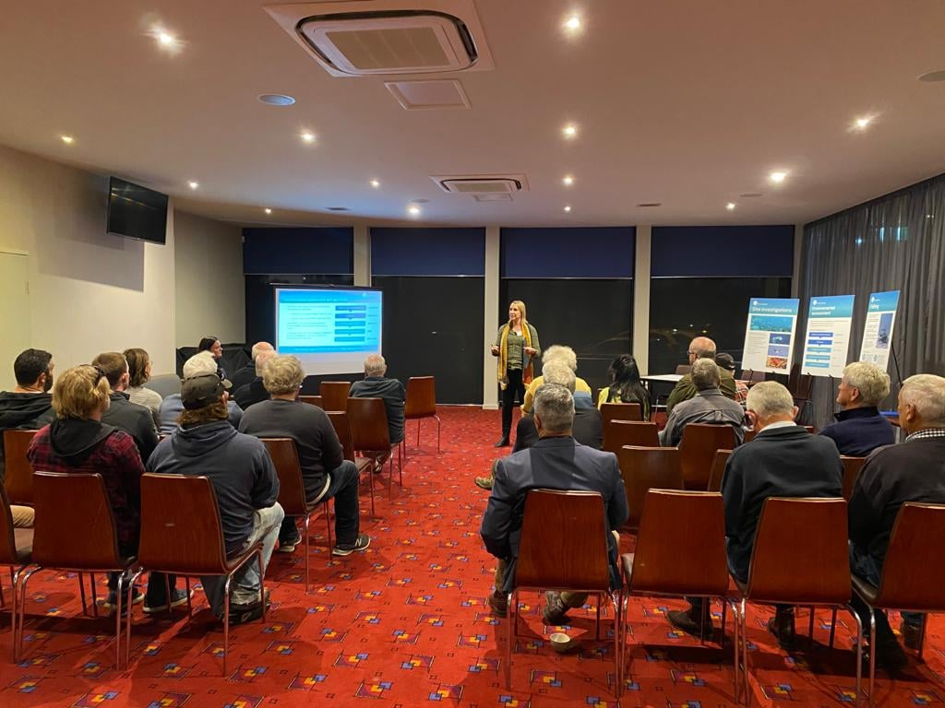
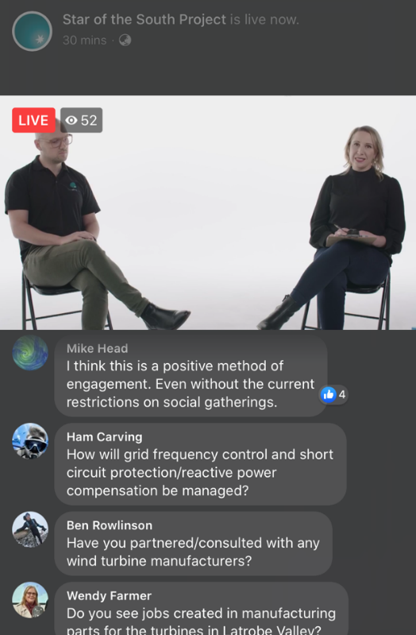
Figure 7-12 Community information sessions and webinars

‘Get involved’ online consultation hub
An online consultation hub on the project’s website provides a way for all stakeholders to participate at a time and place of their choosing. A suite of consultation tools has been employed on the hub to elicit feedback on various topics, including an interactive map, public Q&A, quick poll, ideas board and survey form.

Gippsland office
More than 400 people have visited the project’s office in Yarram since it opened to the public in 2020. The office is staffed by a local team and open to the public two days per week or on request. It provides a place where people can drop in to find information, ask questions and provide feedback, and to host community presentations and groups.
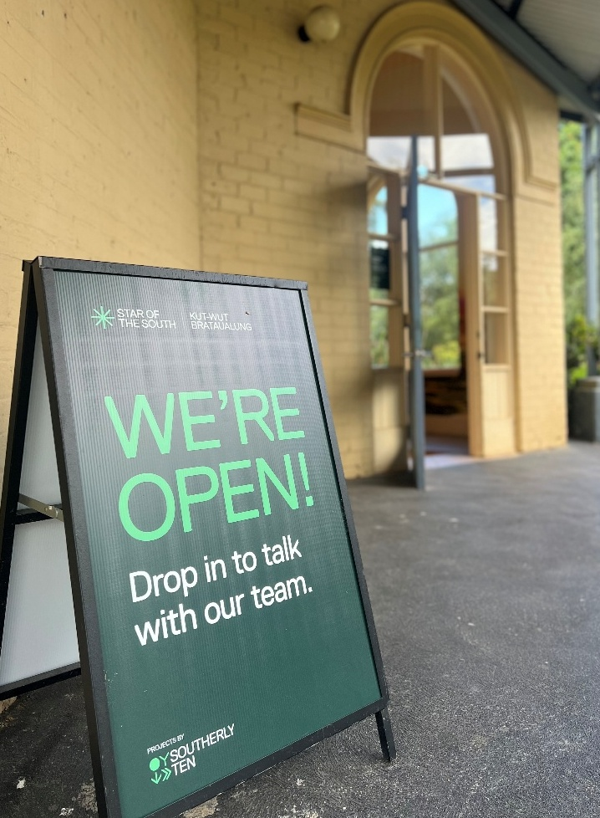
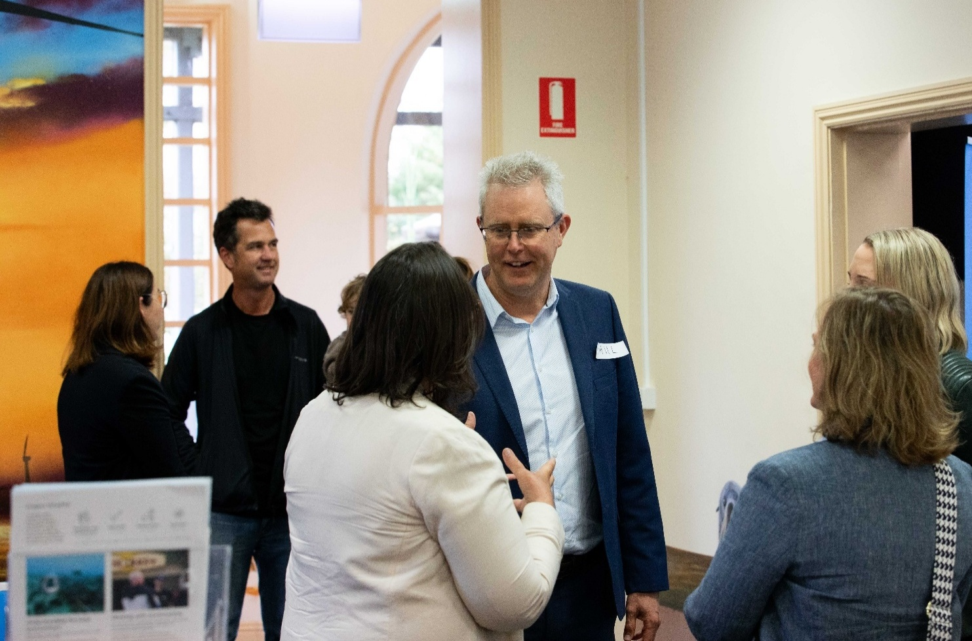
Figure 7-13 Gippsland office

Community research
A representative sample of Gippsland communities is surveyed every 12 to 24 months to understand community awareness, sentiment, issues, and communication and engagement preferences. This helps Star of the South hear from a broad cross-section of the region, including those who may not participate in other consultation forums. Results are used to design communication and engagement tools which address topics of interest and align with local preferences.

Youth and schools’ engagement
Star of the South creates opportunities for young people to be involved in discussions about the project and Gippsland’s future. Engagement with youth and schools has included:
- Participation in school-based inquiry programs such as Broadening Horizons with Yarram Secondary College and science week with Gippsland Tech School
- Delivering 48 presentations to primary, secondary and tertiary students
- Participation in jobs and careers fairs
- Supporting tertiary students to participate in energy industry events
- Hosting school, cub and scout, and student club visits to the project’s Gippsland office.
Figure 7-14 Schools engagement
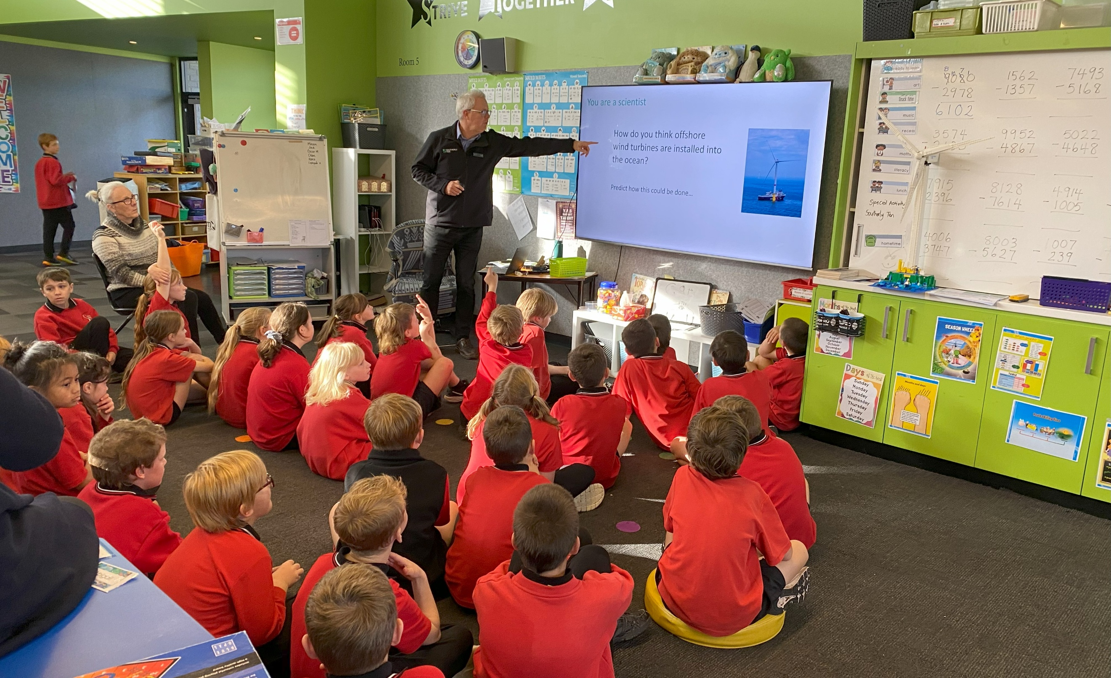
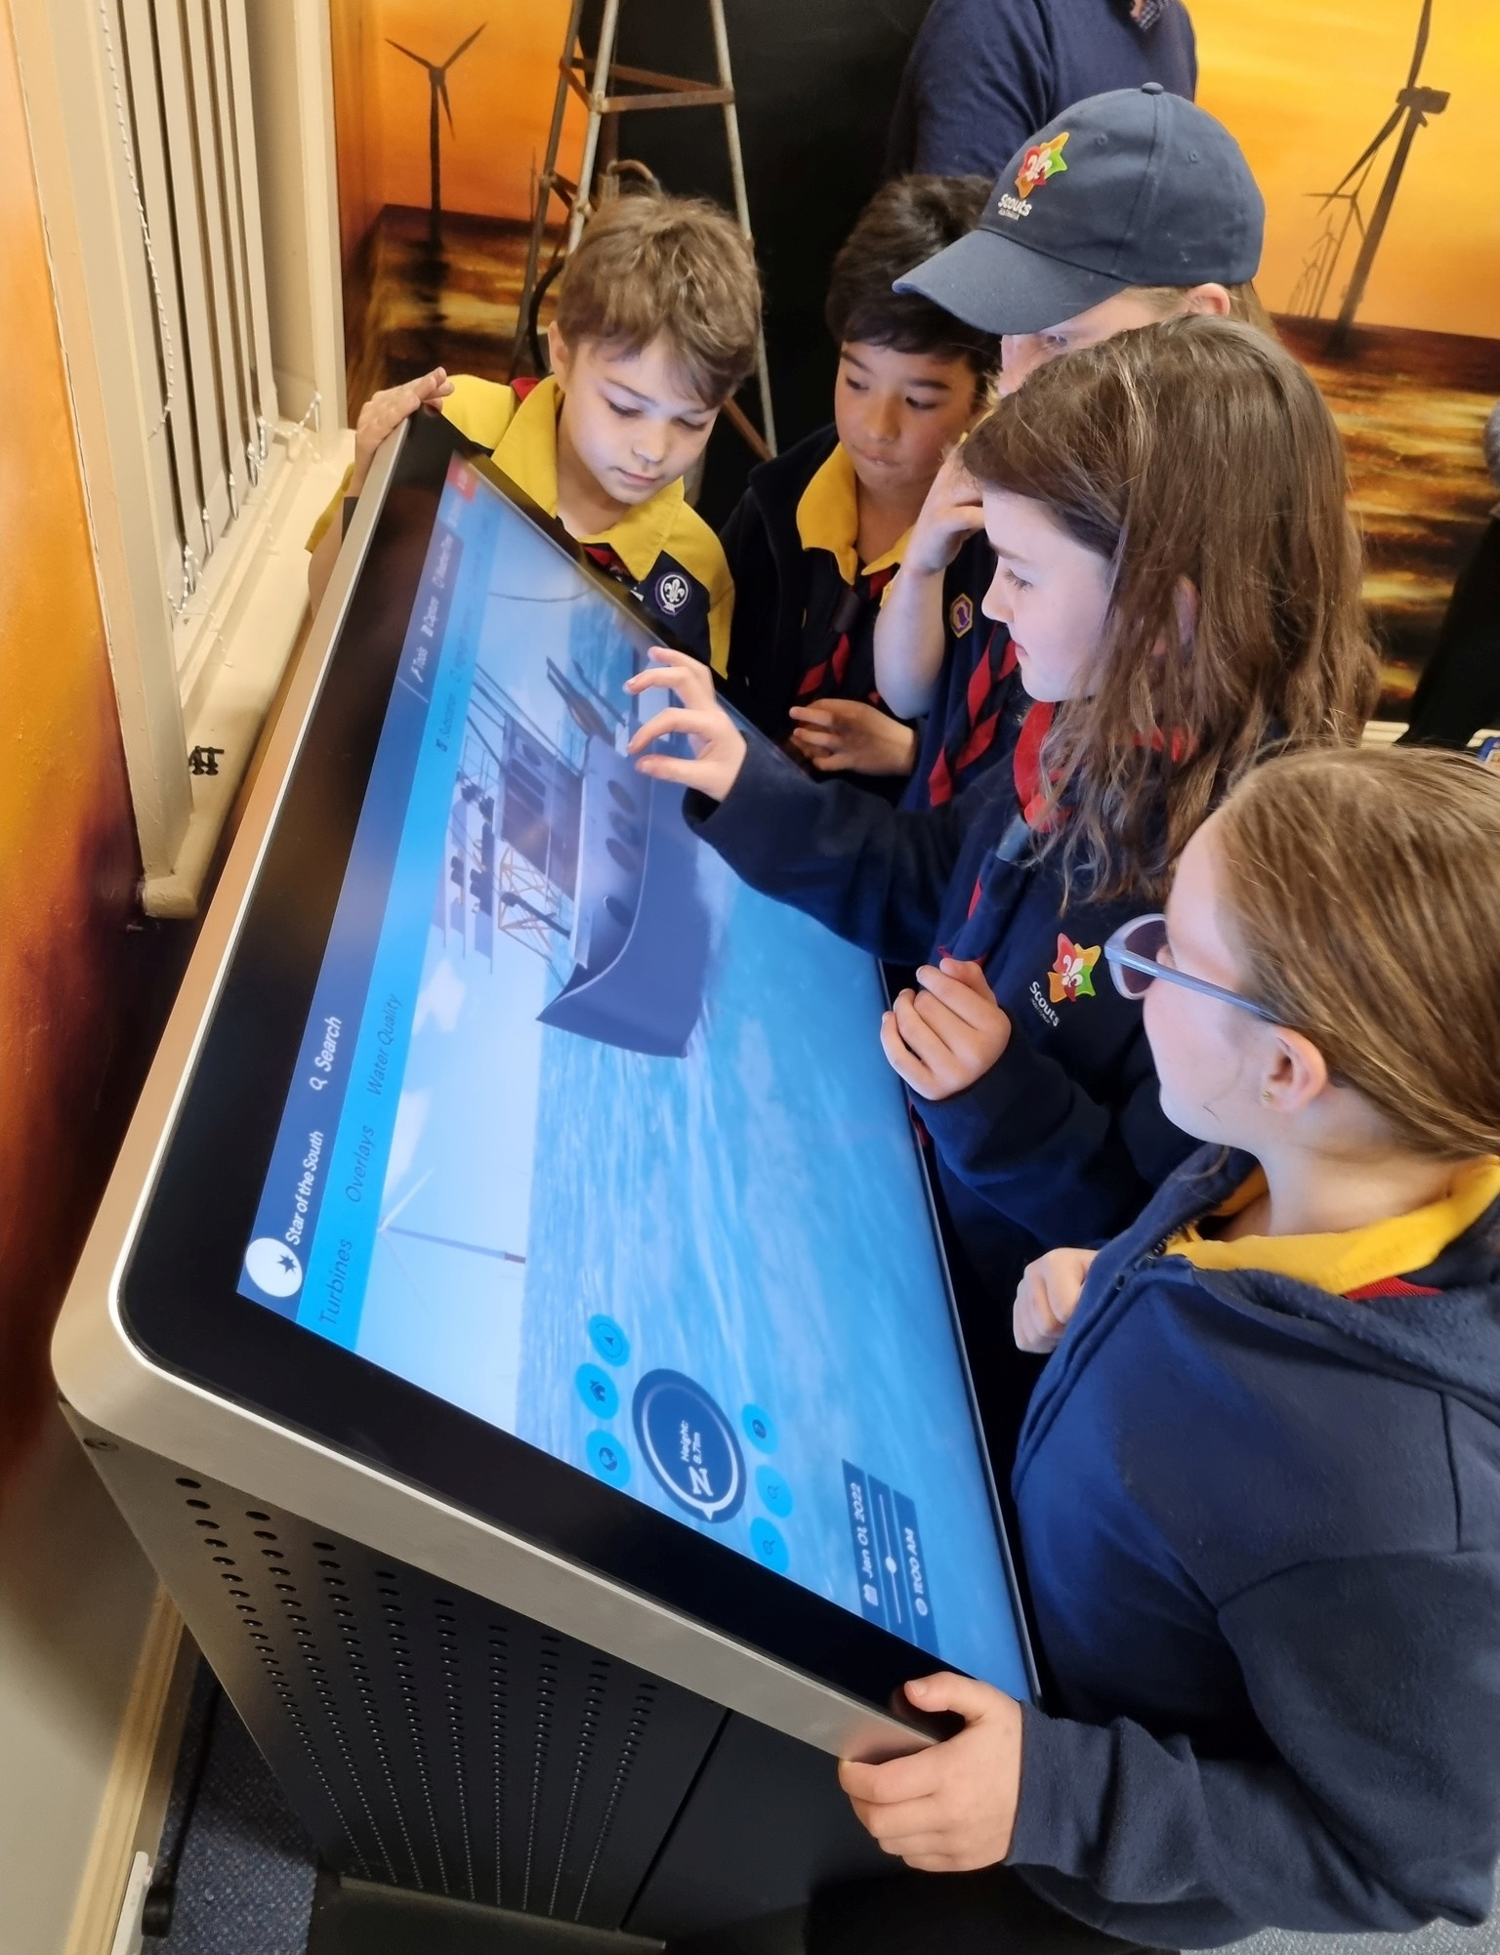

Enquiry channels
Star of the South provides a range of ways for people to make enquiries: phone, email, website form, and social media. To date, the project has responded to more than 1,600 phone calls, 8,500 emails and 430 social media comments.

Engagement phases
Engagement is carried out in phases linked to project development and assessment milestones. This approach involves people at each stage of the project development process and ensures that the right feedback is obtained at the right times to inform project decisions and assessments.
As the first offshore wind project proposed in Australia, Star of the South has not only engaged communities and stakeholders on the project; it has also been responsible for introducing them to the concept of offshore wind energy generation. Interactions with Star of the South are often the first time people have heard of or engaged in conversations about offshore wind energy. As such, building awareness and understanding of this new energy technology for Australia has been a priority at every phase to support informed participation.
Figure 7-15 summarises the project’s engagement phases and timeline. Further detail is provided in Attachment II – Consultation Report.
Figure 7-15 Consultation phases - overview
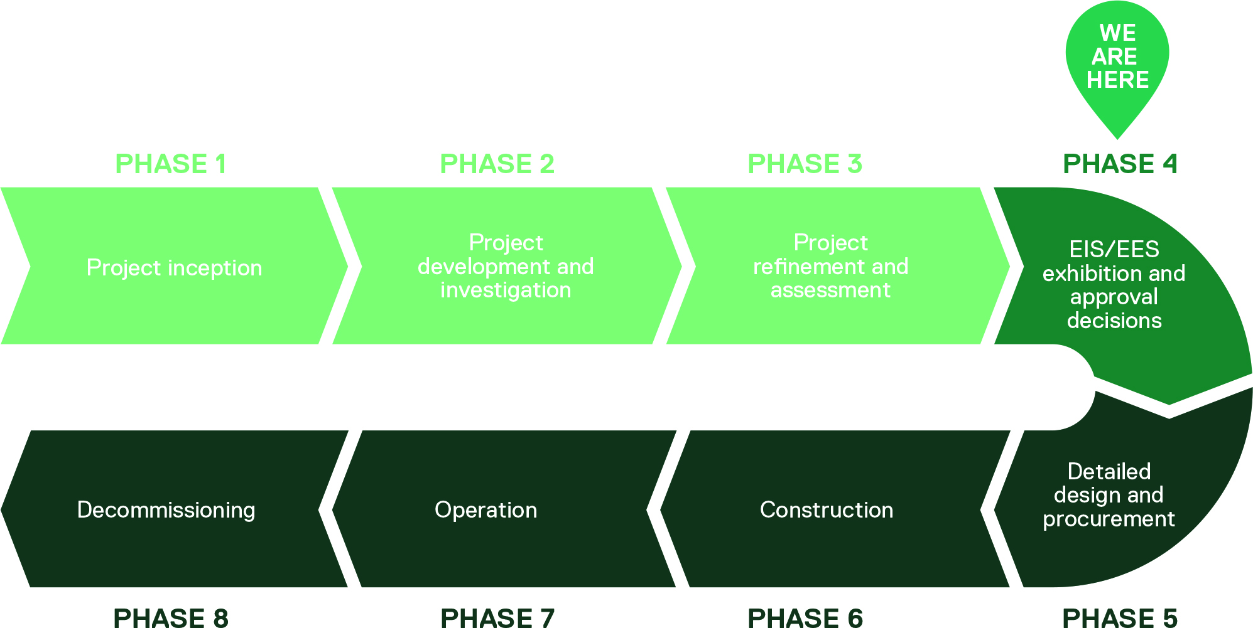

Phase 1: Project inception
Phase 1 engagement focused on introducing the concept of offshore wind energy and the potential for Gippsland to host Australia’s first offshore wind project. During this phase, Star of the South established relationships with local stakeholders to inform early decision making about the project’s location and next steps.
Phase 1: Project inception
Timeframe: | 2017-2019
Project activities / milestones: | - Desktop feasibility studies  - Wind farm site identification  - Obtained exploration licence  - Transmission corridor options identification
Engagement purpose: | Build awareness and understand what’s important  - Create awareness of offshore wind energy  - Understand local values and issues  - Establish connection with local leaders and key stakeholders  - Identify consultation and communication preferences  - Obtain feedback on site investigations timing, location and methodologies
Key engagement activities undertaken: | - Introductory meetings, briefings and presentations  - Community information sessions  - Community survey to identify key local interests, issues and opportunities  - Website established  - Community research
Outcomes: | - Selection and refinement of offshore wind farm site for further investigation  - Decision to use underground cables for onshore transmission  - Engagement plan and communication methods adapted in response to feedback  - Planning for site investigations and environment surveys informed by feedback
Table 7-3 Phase 1: project inception
Figure 7-16 Examples of communications and consultation activities from 2019
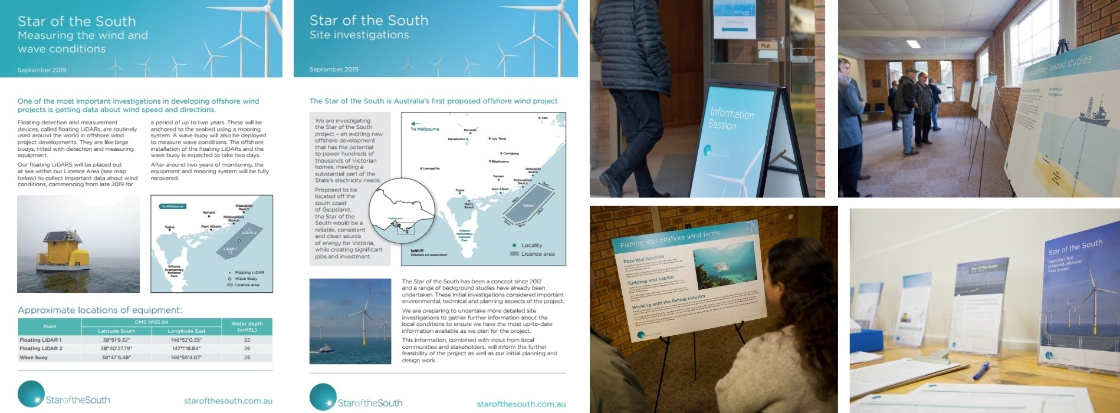

Phase 2: Project development and investigation
Phase 2 engagement helped inform the design and delivery of site investigations to test the project’s technical feasibility. This phase marked the start of formal EIS consultation, with a focus on understanding existing conditions in the project area and identifying potential issues. Selection of a preferred onshore transmission corridor was informed by significant consultation with landholders, communities and other Gippsland stakeholders. Communication and engagement tools were expanded and new options made available during the COVID-19 pandemic to enable participation from across the community.
Table 7-4 Phase 2: Project development and investigation
Phase 2: Project development and investigation
Timeframe: | 2020-2022
Project activities / milestones: | - Site investigations (offshore and onshore)  - Baseline environmental surveys (onshore and offshore)  - Transmission corridor options assessment and selection  - Project referred under EPBC Act  - EIS guidelines confirmed.
Engagement purpose: | Seek feedback to inform project investigation, development and EIS studies  - Continue building awareness and understanding of offshore wind energy  - Provide information about the assessment process and invite participation  - Deepen understanding of community values, issues, priorities and interests  - Obtain feedback and local knowledge to inform technical reports and project decisions  - Support the smooth delivery of site investigations and environment surveys  - Establish a clear understanding of current fishing activities and stakeholders.
Key engagement activities undertaken: | - GLaWAC engagement and involvement in onshore investigations  - Landholder meetings and site visits to inform transmission corridor selection  - Broad community consultation, including the use of a survey, information sessions, webinars and pop ups to encourage discussion and obtain feedback  - Targeted community and stakeholder consultation on key assessment study topics  - Commercial fishing industry meetings, briefings, information sessions and survey  - Recreational fishing boat ramp and online survey  - Community Advisory Group and Technical Reference Group established  - Opened Gippsland office in Yarram  - ‘Get involved’ online engagement hub established  - Community research.
Outcomes: | - Selection of preferred transmission corridor for further investigation  - Design and delivery of site investigations and environment surveys informed by feedback  - Community and stakeholder input obtained to inform technical reports  - Expansion of engagement and communication channels in response to feedback.

Phase 3: Project refinement and assessment
During phase 3, the project scope was refined in response to the outcomes of the feasibility licence process, developments in government policy, and findings from the site investigations, environment surveys, technical assessments, and consultation undertaken in phase 2. Engagement focused on communicating and explaining changes and sharing what Star of the South had heard, learnt and its proposed response to issues raised. Further targeted consultation on assessment findings and proposed measures to avoid and minimise impacts was an important part of finalising all assessment documentation.
Table 7-5 Phase 3: Project refinement and assessment
Phase 3: Project refinement and assessment
Timeframe: | 2023-2025
Project activities / milestones: | - Feasibility licence obtained  - All site investigations and baseline environmental surveys completed  - Alignment of project transmission planning with VicGrid shared transmission  - Design refinements made and final project scope for assessments confirmed  - Finalise and submit assessment documentation.
Engagement purpose: | Seek feedback to inform project refinement and the completion of technical studies  - Provide information about the assessment process and invite participation  - Share outcomes of the feasibility licencing process, project refinement and updates  - Explain how feedback is being used in project development and assessment  - Involve communities and stakeholders in discussions to thoroughly understand issues and identify suitable mitigations  - Examine potential fishing coexistence issues and opportunities  - Identify and implement improvements to the consultation approach.
Key engagement activities undertaken: | - GLaWAC engagement and involvement in Aboriginal cultural heritage assessment  - Signed Engagement Agreement with GLaWAC  - Landholder engagement to adapt project transmission plans to align with VicGrid project  - Community information sessions, pop ups, briefings and presentations to communicate project updates  - Targeted stakeholder engagement to discuss assessment topics, preliminary findings and proposed approaches to avoid and mitigate impacts  - Participation in fishing industry forums and direct discussions with fishers in Gippsland  - All communication materials refreshed to reflect project updates  - All communication and engagement channels from previous phases maintained  - Community research.
Outcomes: | - Project scope refinements and mitigation measures informed by feedback and scientific data  - Introduction of coordinated Gippsland offshore wind communication and engagement with other licence holders to reduce the risk of consultation fatigue.

Phase 4: Public review and approval decisions
Phase 4 commences with the public review of the EIS. Public review will give communities and stakeholders the opportunity to learn more about project plans, potential impacts and how they will be managed, and to provide feedback through a formal submission process managed by government.
Submissions on the EIS will be considered by the Commonwealth Department of Climate Change, Energy, Environment and Water (DCCEEW) and used to inform the Minister for the Environment's assessment and approval of the project under the EPBC Act.
Table 7-6 Phase 4: Public review and approval decisions
Phase 4: Public review and approval decisions
Timeframe: | 2026-2027
Project activities / milestones: | - Public review of assessment documentation  - Public submissions  - Independent inquiry to review submissions and make recommendations to government (Vic)  - Ministers’ assessment / decisions.
Engagement purpose: | Engage in accordance with the EIS guidelines  - Present and explain assessment documentation  - Provide information about how to make a submission  - Explain how feedback has helped inform assessment of the project  - Respond to submissions as required  - Communicate outcomes of the assessment process including approval decisions  - Explain next steps.
Key engagement activities undertaken: | - Meetings, briefings and presentations  - Community information sessions and pop ups  - Community Advisory Group briefings  - Advertising to promote the public review and submission process  - Formal submission process (managed by government)  - Communication materials to share information newsletters, website, social media, advertising, media, fact sheets and visual aids.

Phase 5: Detailed design and procurement
Subject to planning and environmental approvals, Star of the South will continue to engage with local communities and stakeholders as it finalises the design and prepares to deliver the project. Consultation will be critical to the development of effective management plans which document how the project will be delivered responsibly and safely, including a Stakeholder Engagement Plan (SC03) to guide communication and consultation throughout construction and operation. The project’s community benefit program and commercial fishing coexistence and compensation scheme will be developed in detail during this phase, and agreements with GLaWAC, landholders and other third parties finalised.

Phase 6: Construction
Phase 6 engagement will help ensure construction is managed in accordance with approval conditions and management plans. The focus in this phase is on minimising construction impacts through early and proactive engagement and optimising economic benefits and outcomes for local communities.

Phase 7: Operation
Phase 7 engagement will focus on communicating and consulting on operations and maintenance activities, managing enquiries and complaints, and administering the project’s community benefit program. Local communities, other marine users and other infrastructure and licence holders will be key stakeholders during this phase.

Phase 8: Decommissioning
Engagement supporting the project’s decommissioning will be managed and overseen in accordance with approval conditions and management plans, with a focus on minimising any impacts through early and proactive engagement.

Feedback

How feedback has been used to date
At each phase, Star of the South has sought to be clear about which aspects of project development and assessment can be shaped by community feedback, and how feedback received will be used.
Following consultation, Star of the South shares a summary of feedback themes and explains how feedback has (or has not) influenced project decisions and why. In instances where feedback received relates to future project phases and decisions, it is recorded in a database for consideration at an appropriate time.
Table 7-7 outlines ways feedback has been used to inform project development and assessment to date.
Table 7-7 How feedback is used
Principle | What this means during EIS preparation and public review
Design | Informs options development and assessment  Considered in project scope refinement  Considered in locating infrastructure
Planning and environmental assessment | Enhances our understanding of the local environment, potential issues and opportunities  Considered in preparing impact assessments  Considered in developing measures to avoid or minimise potential impacts  Informs communication and consultation approach  Informs performance requirements for construction, operation and decommissioning
Construction and operations | Considered in construction methodology, timing and impact mitigation  Informs communication and consultation approach.

Key topics of interest
The topics most frequently discussed during engagement with communities and stakeholders are presented in Figure 7-17 and described below.
Figure 7-17 Key topics of interest
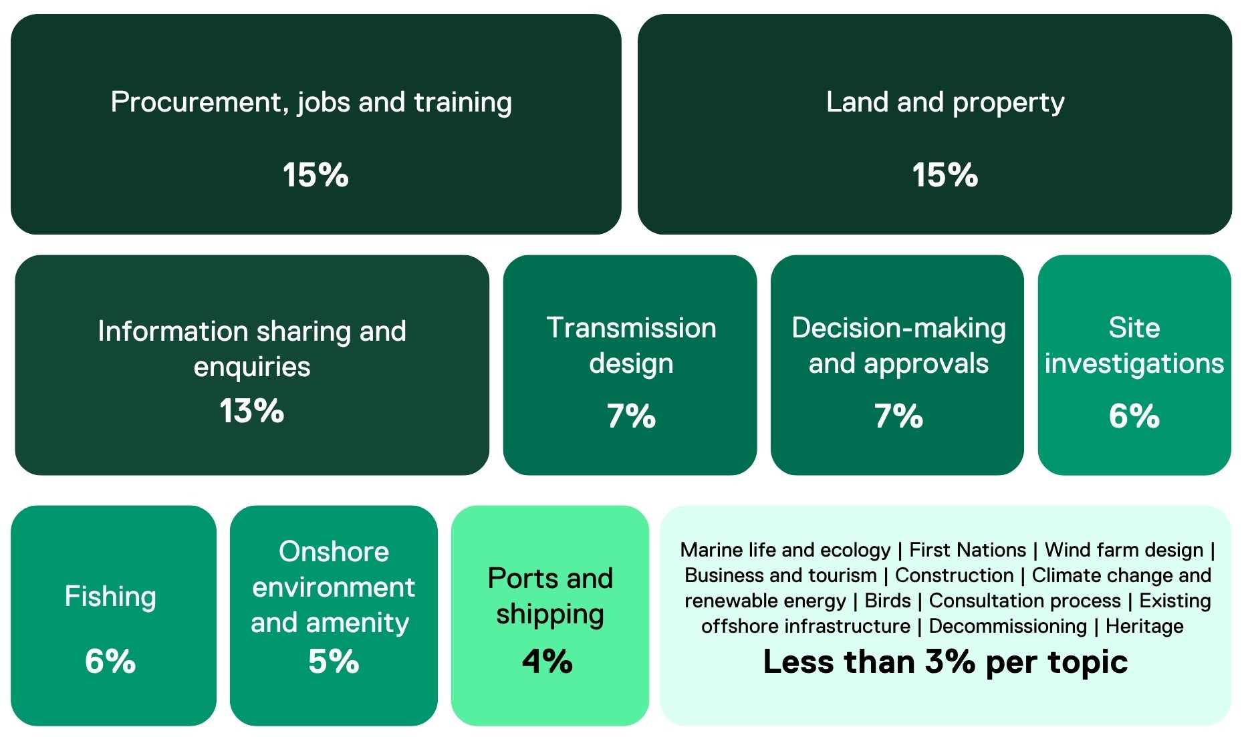

Procurement, jobs and training
There is a high degree of interest in potential job and supply opportunities on the project and in the offshore wind industry more broadly. This category covers engagement with schools and training providers, workers, and the local supply chain.

Land and property
Extensive landholder engagement to support the selection and refinement of an onshore cable corridor generated almost 3,800 interactions in which a range of matters were discussed, including land access, easement requirements, property management, ownership and caveats, and proximity of infrastructure dwellings.

Information requests and general enquiries
This category takes in information requests and general project enquiries on topics such as timing, funding, scope and benefits. Enquiries about project timing are particularly common, often linked to interest in employment during construction and operation, or to a desire to understand when the project can be ready to offset the loss of retiring coal power stations in the Latrobe Valley.

Transmission design
There is strong interest in the location, technology and infrastructure associated with the project’s transmission system, both onshore and offshore. Early feedback and enquiries related to the use of underground vs overhead infrastructure, cable routes, aspects of the electrical design and the burial of subsea cables. More recently, discussions have focused on updates to the project’s transmission plans to align with VicGrid’s Gippsland Offshore Wind Transmission 2 GW project.

Decision making and approvals
Questions about the policies and regulations relevant to offshore wind projects are sometimes raised by community members and stakeholders. In some cases, these questions relate to the assessment and approvals process, including a desire to understand the key steps who is responsible for granting approvals.

Site investigations
Star of the South has carried out a range of site investigations and widely consulted with and informed communities and stakeholders about these activities. Accordingly, this topic has attracted a significant number of enquiries, such as interest in what was found, and feedback, such as advice on the timing or location for surveys.

Onshore environment and visual features
Feedback relating to management of onshore environmental impacts (including ecology, vegetation removal, and changes to local parks) made up five per cent of all feedback provided. This feedback also included changes to the visual seascape and landscape character of the local coastline communities.

Ports and shipping
The topics of ports and shipping contributed four per cent of all feedback raised with Star of the South. This feedback was primarily raised by ports, water and shipping-based stakeholders with an interest in how the project would interface with their operations.

Other topics
A range of special-interest topics contributed between 0.2 and three per cent of all feedback raised with Star of the South. This is likely due to the very specific or localised nature of the topic and included marine life and ecology, First Nations (heritage and engagement), wind farm design (turbines and foundations), business and tourism, construction, climate change and renewable energy, birds, the project’s consultation process, existing offshore infrastructure (oil and gas), decommissioning and heritage.

Feedback as it relates to the assessment
Community and stakeholder feedback has informed various aspects of the assessment. Feedback specific to an assessment topic is documented in the relevant technical report and outlined in summary form in Tables 7-8 to 7-12.
Attachment II – Consultation Report also provides a summary of consultation activities, key feedback and Star of the South’s response.
In the context of all feedback raised with Star of the South over the life of the project, potential environmental impacts and risks of the project have been raised significantly less frequently than other topics including jobs and procurement, land and property and general project information.

Marine environment – summary of key issues
The marine environmental studies include coastal processes and sediment transport, benthic ecology, fish and invertebrates, marine mammals and turtles, offshore ornithology and bats, marine protected areas and electromagnetic field exposure.
Table 7-8 Marine environment studies
Study | What we heard | Star of the South response | References
Benthic ecology | Minimise potential impacts to fish habitat, reefs and seagrass from location of turbines /cables or construction process | Star of the South has surveyed, sampled and filmed the seabed to understand what it is made of and what lives there. The project area has a mostly sandy and gravelly bottom, with some areas of reef habitat. Turbines will be positioned to avoid high profile reefs. | Technical Report B – Benthic Ecology, Section 8 To 13
Benthic ecology | Potential opportunity for habitat restoration / creation (leading to increased fish species) | Underwater structures and scour protection can create new habitat for fish and may lead to increased fish species around project infrastructure. | Technical Report B – Benthic Ecology, Section 10
Coastal processes and sediment transport | Protection of Reeves Beach during construction of the shore crossing | Cables from the offshore wind farm would come to shore at Reeves Beach. Star of the South will use a no-trench construction method to pull the cables in underground, to protect the beach and dune system above. | Technical Report A – Coastal Processes and Sediment Transport, Sections 8 To 10
Coastal processes and sediment transport | Effects on tides and currents from the project’s construction or operations | Coastal processes modelling has confirmed no significant impacts. | Technical Report A – Coastal Processes and Sediment Transport, Sections 5.52 And Section 10
Coastal processes and sediment transport | Sediment transport impacts to Corner Inlet, key fish species fished and seagrass restoration projects | Coastal processes modelling has confirmed no significant impacts. | Technical Report A – Coastal Processes and Sediment Transport, Sections 5.52 And Section 10  Technical Report F – Marine Protected Areas
Coastal processes and sediment transport | Contribution to coastal erosion | Coastal processes modelling has confirmed no significant impacts. | Technical Report A – Coastal Processes and Sediment Transport, Section 10.2 And 10.4
Fish and invertebrates | Underwater noise during construction could cause decline or displacement of fish | Star of the South identified around 160 different fish species in and around the project area during the three-year marine ecology survey program.  During construction, noise might cause some fish to leave the area. Once turbines are installed, fish are expected to come back, and potentially in increased numbers once new ecosystems are formed. | Technical Report C – Fish and Invertebrates, Sections 8 To 12
Fish and invertebrates | Potential impacts from electromagnetic fields and vibration to threatened species | Undersea export cables would be buried up to 1 m under the seabed. Where they can’t be buried, they will be protected by a rock ‘mattress.’  This provides a protecting distance between the electromagnetic field source and fish in the area. | Technical Report C – Fish and Invertebrates, Sections 8 To 12
Fish and invertebrates | Potential opportunity for increased fish species around wind turbines | Underwater structures and scour protection can create new habitat for fish and may lead to increased fish species around project infrastructure. | Technical Report C – Fish and Invertebrates, Section 10.4  Technical Report B – Benthic Ecology, Section 10
Marine mammals and turtles | Underwater noise from construction and vessel operations could affect marine mammals, fish and turtles (including migration and breeding patterns) | Star of the South studied the marine environment for three years, collecting more than 50,000 data points on species that move through the project area.  Using this data, Star of the South assessed potential risks and ways to avoid or reduce them, adopting successful methods used overseas.  This includes the wind turbine foundation selection, the construction methodology and the use of sound attenuation systems such as double bubble curtains which reduce noise. | Technical Report D – Marine Mammals and Turtles, Sections 8 To 13
Marine mammals and turtles | Wind turbine foundation selection | Star of the South has selected fixed-bottom monopile foundations. This is the most commonly used foundation type worldwide, with nearly 80 per cent of offshore wind turbines installed on monopiles. The project site has optimal water depths suitable for monopile foundations.  The project’s EIA has evaluated pile driving and vibropiling installation methods, along with different sound attenuation systems to reduce underwater noise during construction. | Technical Report D – Marine Mammals and Turtles
Marine mammals and turtles | Increase in vessel movements and potential for strikes / collisions with marine mammals and turtles | Star of the South’s construction methodology will prioritise using as few vessel movements as practical. A vessel management plan will be in place to guide the safe navigation and management of construction and operational vessel movements. | Technical Report D – Marine Mammals and Turtles
Offshore ornithology and bats | Collision risk to birds, particularly Australian seabirds of which there is limited to no data available on their behaviours around offshore wind farms | Working with leading scientists, Star of the South collected three years of data on seabirds and shorebirds to understand their behaviours, populations, migration patterns and flight heights.  Using this data, Star of the South carried out early modelling and identified that by increasing the ‘air gap’ between the ocean and the wind turbine blades by 10 m (from 25 m to 35 m), the risk of collision was significantly reduced. This mitigation measure has been adopted and incorporated into the wind turbine design. | Technical Report D – Offshore Ornithology and Bats
Offshore ornithology and bats | Potential impacts to Corner Inlet Ramsar site and the habitat it provides for migratory birds | Star of the South carried out surveys within Corner Inlet to understand bird species presence, movements and behaviours. These surveys confirmed that migratory birds accessing Corner Inlet travelled in a westerly to south-westerly direction, and all flights were contained within the inlet. This data demonstrates there is a very low likelihood of migratory shorebirds interacting with the offshore wind farm which is located further north-east from Corner Inlet. | Technical Report D – Offshore Ornithology and Bats, Sections 8 To 11
Offshore ornithology and bats | Potential impact to shorebird habitat | Cables from the offshore wind farm would come to shore at Reeves Beach. Star of the South’s bird surveys identified this location as having fewer and lower-value habitat for shorebirds. A no-trench construction method will be used to pull the cables in underground, to protect the beach, dune system above and shorebird habitat above. | Technical Report D – Offshore Ornithology and Bats, Sections 8 To 11
Marine protected areas | Potential impact to Corner Inlet Ramsar Site and Beagle Australian Marine Park | Project vessels will pass through Commonwealth marine protected areas when transiting to and from port facilities but no construction activities will occur in these areas. | Technical Report F - Marine Protected Areas
Electromagnetic field exposure | Potential impacts from transmission cabling and electrical circuits on human or livestock health. | Star of the South’s underground transmission cabling will be buried to an extent that it will not have any impact on the health of humans or livestock in the project area. | Technical Report V – Electromagnetic Field Exposure

Onshore environment studies – summary of key issues
Onshore environment studies include onshore ecology ground water, surface water, soil and waste and onshore noise and vibration and air quality.
Table 7-9 Onshore environment studies
Study | What we heard | Star of the South response | References
Onshore ecology | Clearing of vegetation and associated impacts to habitat and biodiversity. | The project’s underground route is now shorter – around 30 km from the Reeves Beach shore crossing to the shared transmission hub near Giffard. This reduces the amount of vegetation that could be impacted by the project.  Where possible, Star of the South will design the transmission corridor to avoid significant areas of native vegetation. Any loss of native vegetation will be offset once construction has finished. | Technical Report G – Onshore Ecology, Sections 7 And 8.
Onshore ecology | Impacts to native fauna, such as Gang Gang Cockatoo, Southern Toadlet and ‘Strezlecki’ koala. | Star of the South’s flora and fauna studies have identified where key fauna habitats occur. Star of the South has prioritised avoidance and mitigation to reduce impacts to native fauna. | Technical Report G – Onshore Ecology, Sections 8, 10, 11 And 12.
Ground water | Reinstate any disturbed private or public areas to existing conditions | Once construction is complete, all modified areas will be returned to pre-construction conditions in consultation with the landholders and in line with an approved Construction Environment Management Plan. | Technical Report H – Groundwater, Section 9.
Ground water | Contamination or biohazards to waterways from construction materials and disposal of waste | Any contaminated soils, including potential or actual Acid Sulfate Soils will be managed in line with best practice guidelines, and located away from waterways and flood plains. | Technical Report H – Groundwater, Section 9.
Ground water | Installed infrastructure could impede groundwater flow. | Star of the South undertook significant onshore geotechnical investigations in 2022, including measuring groundwater depth along the proposed transmission route.  Transmission infrastructure will be installed above the groundwater table and will not influence flow under the surface. | Technical Report H – Groundwater
Surface water | Potential construction impacts to waterways and wetlands, including Corner Inlet | Any contaminated soils, including potential or actual Acid Sulfate Soils will be managed in line with best practice guidelines. Planned spoil locations will be determined prior to construction and will avoid known flood plain areas or other areas of concern. All potentially polluting materials and equipment will be also stored outside of the floodplain. These measures will be detailed in the project’s Construction Environment Management Plan. | Technical Report I – Surface Water
Surface water | Potential impacts of flooding or changed flood characteristics | Project infrastructure, construction compounds, material storage and other construction materials will be located outside areas that are subject to flooding and. These measures will be detailed in the project’s Construction Environment Management Plan. | Technical Report I – Surface Water
Soil and waste | Management and removal of construction waste | Construction waste will be removed in line with best practice guidelines. This will be detailed in the project’s Construction Environment Management Plan. | Technical Report O – Soil and Waste, Section 9.22
Soil and waste | Concern over potential contamination impacting private land | Any identified contaminated soils, including Acid Sulfate Soils will be disposed of in line with EPA best practice guidelines. Property will be returned to existing conditions once construction is complete. These measures will be detailed in the project’s Construction Environment Management Plan. | Technical Report O – Soil and Waste, Section 9.22
Air quality | Management of dust during construction | Star of the South will use best practice dust suppression measures during the construction period. This will be specified in a Construction Environment Management Plan, and could include mitigations such as use of water carts, covering loads on trucks and dust monitors. | Technical Report Y – Air Quality
Onshore noise and vibration | Potential for disruptive noise from offshore construction activities | Depending on highly variable factors such as weather and time of day, low levels of noise from offshore construction activities may be heard onshore. Given the offshore wind turbines will be installed more than 10 km from the shoreline, this noise is not expected to be frequent or disruptive for beach users or nearby neighbours. | Technical Report W – Onshore Noise
Onshore noise and vibration | Impact of onshore construction noise, particularly around Reeves Beach | There will be construction noise associated with the shore crossing at Reeves Beach. Star of the South will work closely with Parks Victoria around management of Reeves Beach campground during the construction period. | Technical Report W – Onshore Noise

Heritage studies – summary of key issues
Heritage studies include Aboriginal cultural heritage, historic heritage, non-Aboriginal underwater cultural heritage and submerged Aboriginal cultural heritage.
Table 7-10 Heritage studies
Study | What we heard | Star of the South response | References
Aboriginal cultural heritage | Potential harm to Aboriginal archaeological sites | Star of the South is preparing a Cultural Heritage Management Plan (CHMP) in consultation with GLaWAC. The CHMP is a primary approval under the Aboriginal Heritage Act 2006 for the project. The CHMP will set out the conditions and arrangements for the management of any Aboriginal cultural heritage that might be affected.  Star of the South will prioritise construction methodologies that avoid or minimise impacts to Aboriginal cultural heritage. | Technical Report K – Aboriginal Cultural Heritage
Aboriginal cultural heritage | Potential impact to the Reeves Beach dune system, which is a place of Aboriginal cultural significance | Recognising the cultural significance of the dune system at Reeves Beach, Star of the South will use an underground trenching method to bring the cables under the beach and dune system protecting the dune system above. | Technical Report K – Aboriginal Cultural Heritage
Historical heritage | Potential impacts of the project development on historic character of Gippsland towns | The project area does not intersect with townships in Gippsland and accordingly does not have any impact to township character. | Technical Report L – Historical Heritage, Section 6.0
Historical heritage | Potential impacts of the project on local heritage places with the region | With measures such a heritage awareness training and management plans in place, the potential impacts to heritage places in Gippsland were assessed as negligible. | Technical Report L – Historical Heritage, Section 7.2
Non-Aboriginal underwater cultural heritage | Interest in whether the shipwreck ‘Glenelg’ is located in the project area | A registered dive site, the shipwreck SS Glenelg is located outside of the project area. | Technical Report M – Non-Aboriginal Underwater Cultural Heritage
Submerged Aboriginal cultural heritage | Potential harm to Aboriginal archaeological sites | Star of the South is preparing a CHMP in consultation with GLaWAC. The CHMP is a primary approval under the Aboriginal Heritage Act 2006 for the project. The CHMP will set out the conditions and arrangements for the management of any Aboriginal cultural heritage that might be affected.  Star of the South will prioritise construction methodologies that avoid or minimise impacts to Aboriginal cultural heritage. | Technical Report Z - Submerged Aboriginal Cultural Heritage
Submerged Aboriginal cultural heritage | Intangible submerged Aboriginal cultural heritage values may be affected by the project | Star of the South engaged Dr Seumas Spark (ALA, Historian) to document intangible heritage values that may be affected by the project. | Technical Report Z - Submerged Aboriginal Cultural Heritage, Section 7.4

Social, economic and visual studies – summary of key issues
Social, economic and visual studies include social, business and tourism, commercial and recreational fisheries, agriculture, land use planning and seascape, landscape and visual.
Table 7-11 Social, economic and visual studies
Study | What we heard | Star of the South response | References
Social | Pressure on housing supply in the region to accommodate construction workers and forcing up rent / property prices for locals. | The construction workforce is likely to include a mix of locals and people who travel for work. Crews typically work and stay offshore for set periods of time. The project has developed a Worker Accommodation Strategy in consultation with stakeholders to identify how workers will be accommodated when they’re onshore, without putting pressure on local housing and accommodation. | Technical Report R – Social Impact Assessment
Social | Use of and impacts to local road network for project construction traffic | Star of the South is working with Wellington Shire Council and the Department of Transport and Planning to choose the right roads and safety measures for heavy vehicles going to and from the construction areas. A Traffic Management Plan will be developed and implemented to ensure road accessibility and safety. | Technical Report T – Land Use Planning
Business and tourism | Impact to local businesses and tourism in the region during the construction period | The project would contribute around $8 billion to the Australian economy, including $3 billion in Gippsland, over its lifetime. Hundreds of Gippsland businesses that could supply goods and services that offshore wind projects will need has been identified by the project. The project has developed a 100-page Supplier Showcase booklet as a critical resource or the offshore wind sector to engage and involve local suppliers and businesses. | Technical Report Q – Business and Tourism
Business and tourism | Potential impacts on recreational and camping destinations such as Reeves Beach, Seaspray and Wilsons Promontory | There is the potential for visitor numbers to decrease during the construction of the project, but this would be short-term and would likely return to normal once the project is up and running.  Star of the South will work closely with Parks Victoria on the management of Reeves Beach Campground prior to and during the construction period. | Technical Report Q – Business and Tourism
Fishing (commercial and recreational) | Potential loss of commercial fishing grounds, potential reduction of available fish stocks and temporary or permanent access restrictions | Star of the South is committed to co-existence, sharing the waters with fishers and avoiding access restrictions.  Many types of fishing can continue in an offshore wind farm. During construction temporary safety zones will be in place around the work sites and fishers will need to avoid these areas until safe to access. Some activities, like anchoring, are typically avoided around cable routes.  Where there is a valid claim of impact, fair compensation will be available to commercial fishers. | Technical Report N – Commercial and Recreational Fisheries
Fishing (commercial and recreational) | Potential exclusion for recreational fishers and boaters from the offshore wind farm area | Star of the South is committed to co-existence, sharing the waters with fishers and avoiding access restrictions for recreational fishers. Some temporary safety zones will be in place around the works sites during construction.  Fishers will be notified of all offshore works via direct communication channels, project website and Notice to Mariners. | Technical Report N – Commercial and Recreational Fisheries
Agriculture | Potential impact of transmission easement on private agricultural land and livestock safety | The transmission route crosses farmland which is typically used for grazing, cropping and forestry. Star of the South is working directly with individual landholders to understand farming activities and design a route that reduces disruption. During operations, most farming activities can continue above the transmission easement. | Technical Report S - Agriculture
Agriculture | Easements and infrastructure co-existence with forestry operations | The project’s designs have prioritised avoidance and mitigation to forest plantations as much as possible. Given the scale of plantation forestry in the region, the project’s impact is less than 0.01 per cent of the value of plantation forestry for Victoria. | Technical Report S - Agriculture
Agriculture | Biosecurity impacts including weeds, pests, pathogens or diseases on farming production | A Biosecurity Management Plan will be prepared for the construction phase of the project, in line with industry standards and in consultation with agricultural specialists, landowners and/or the Department of Agriculture.  Mitigations could include vehicle washdowns, cleaning and inspection of equipment, minimising of vehicles movements through wet soil and use of formed tracks wherever possible. | Technical Report S - Agriculture
Land use and planning | Pressure on housing supply in the region to accommodate construction workers and forcing up rent / property prices for locals. | Star of the South proposes a Workforce Accommodation Strategy which details a Workforce Accommodation Mitigations Framework developed to minimise the potential impacts of the increased workforce and worker accommodation on the local community associated with construction, operation and maintenance of the Project. | Technical Report T - Land Use and Planning
Land use and planning | Use of and potential impacts to local road network, Reeves Beach campground or private land | Construction of the onshore transmission system is anticipated to occur over two to three years and where possible will be staged and sequential, limiting the duration of local construction works, land use and planning impacts to other land uses. | Technical Report T - Land Use and Planning
Seascape, landscape and visual | Visibility of the turbines, and change to the natural landscape | The project has been relocated a further 3 km from the shore with the closest turbines 10 km at the nearest point. At this distance, the turbines would be visible from some locations along the coast, including Port Albert, McLoughlins Beach and Woodside Beach. | Technical Report U – Seascape, Landscape and Visual
Seascape, landscape and visual | Difficulty in understanding potential change to the seascape and natural character of the coastline | To help people visualise the turbines, Star of the South has produced a 3D interactive model which provides different perspectives of the turbines along the coastline and the ability to change weather conditions and time of day. | Technical Report U – Seascape, Landscape and Visual

Transport and infrastructure studies – summary of key issues
The transport and infrastructure studies included infrastructure and co-existence with other users, shipping and navigation and traffic and transport.
Table 7-12 Transport and infrastructure studies
Study | What we heard | Star of the South response | References
Infrastructure and other users | Construction disruption to other offshore infrastructure and operations (such as offshore oil and gas). | Star of the South has identified and engaged with other offshore licence holders and operators on future co-existence agreements and, where applicable, exclusion zones. | Technical Report O – Infrastructure Co-existence With Other Users
Infrastructure and other users | Potential impact of / interference from, the location of offshore infrastructure to critical government operations and services | Star of the South will continue to work closely with government stakeholders through the detailed design phase when the final wind farm layout is determined. | Technical Report O – Infrastructure Co-existence With Other Users
Shipping and navigation | Safe coordination and management of vessel traffic and concentration of vessels transiting the project area, particularly during construction | The project area avoids major shipping lanes. Turbines would be charted, lit, numbered and positioned at least 1 km apart, providing plenty of space for smaller local boats to navigate through safely. | Technical report P – Shipping and Navigation
Shipping and navigation | Inclusion of search and rescue and emergency aids on the offshore infrastructure | Offshore infrastructure would be charted, lit and numbered in accordance with internationally recognised ocean safety and navigational regulations (IALA and COLREGs). | Technical Report P – Shipping and Navigation
Traffic and transport | Increased truck traffic on local roads during the construction period | Star of the South will prepare and implement a Traffic Management Plan in consultation with relevant road authorities, including emergency services. Traffic modelling and studies will be completed closer to construction commencing to help the project identify how to avoid and manage impacts to local traffic. | Technical Report X – Transport
Traffic and transport | Damage or impact to local roads by construction traffic | Star of the South will complete pre-condition (dilapidation surveys) prior to using any local roads as construction routes. Any damage or impact will be rectified by the project, with roads to be reinstated to existing (or better) conditions. | Technical Report X – Transport

Monitoring and evaluation
Star of the South continually monitors and evaluates community preferences and the effectiveness its communication and engagement methods, to ensure consultation is fit-for-purpose, inclusive and responsive to stakeholder needs.
Community research is one way to measure success and monitor changes to awareness, sentiment and preferences. Data from the latest research undertaken with 200 coastal residents (Foster through to Seaspray) and 200 broader Gippsland residents (Latrobe Valley, Leongatha, Sale) in November 2024 provided the following key insights:
- Awareness: There is high awareness of the project across all respondents (64 per cent), with higher awareness recorded amongst coastal residents (81 per cent). When prompted with a basic explanation of the project, awareness increases to 82 per cent overall and to 94 per cent of coastal residents.
- Sentiment: Overall, 81 per cent of all respondents said they either support or are neutral towards the project. This number increases when focusing in on coastal communities close to the project, where 86 per cent are either supportive or neutral, as shown in Figure 7-18.
- Preferences: 51 per cent of all respondents said they are interested in learning more about the project. Of those, the top five methods cited for receiving information are email (36 per cent), local newspapers (30 per cent), Facebook (28 per cent), letterbox drop (24 per cent) and website (19 per cent).
Figure 7-18 Community sentiment towards the project (November 2024)
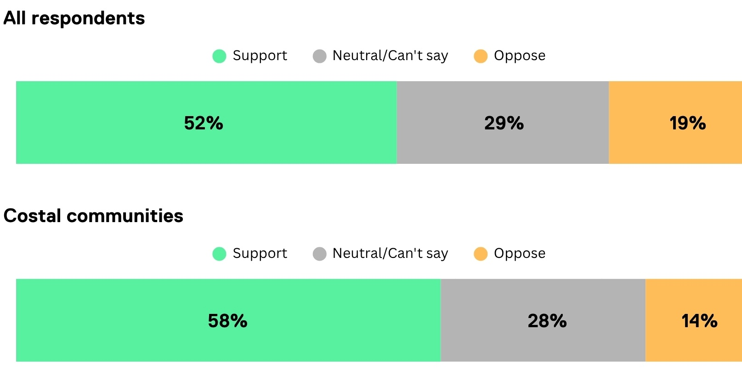
This quantitative data is used alongside other evaluation measures, such as the number of enquiries, website and social media statistics relating to reach and engagement, and feedback, to support continuous improvement.

Ongoing engagement
Star of the South is committed to ongoing and comprehensive communication and engagement across all remaining phases of the project, as outlined in Section 7.5.
During public review, a wide range of communication and engagement methods will be used to make information widely accessible and to support participation. Project personnel will be available at the Gippsland office, at dedicated events, and through established communication and enquiry channels to provide information and respond to queries. Proactive communication will make local communities and stakeholders aware of the formal submissions process.
Ongoing community and stakeholder involvement will be critical to the project’s successful delivery and its ability to support local aspirations. Star of the South will continue to engage with communities and stakeholders and provide regular updates at the conclusion of the assessment process and throughout the project’s construction, operations and decommissioning phases.
A Stakeholder Engagement Plan (SOC-M003) will be developed to guide communication and consultation with all identified stakeholders across future phases. Further details are provided in Attachment II – Consultation Report.

