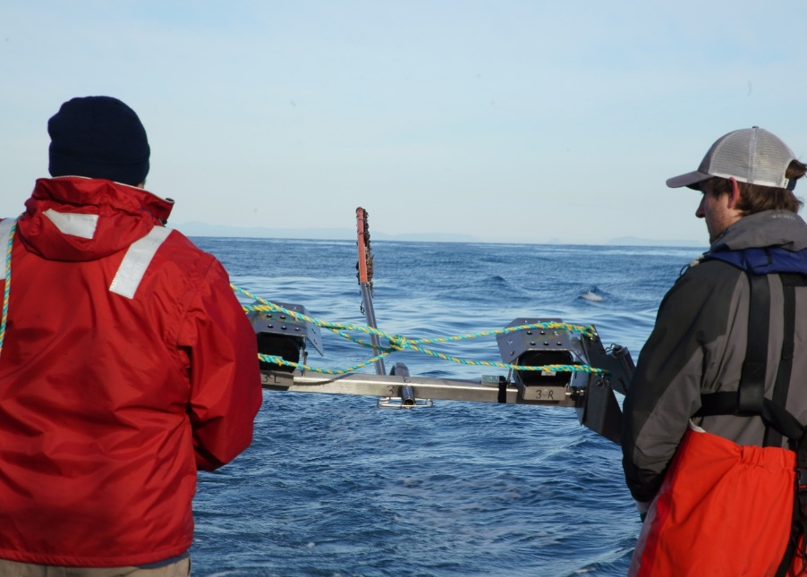

Commonwealth Environmental Impact Statement
Chapter 8 – Coastal processes and sediment transport
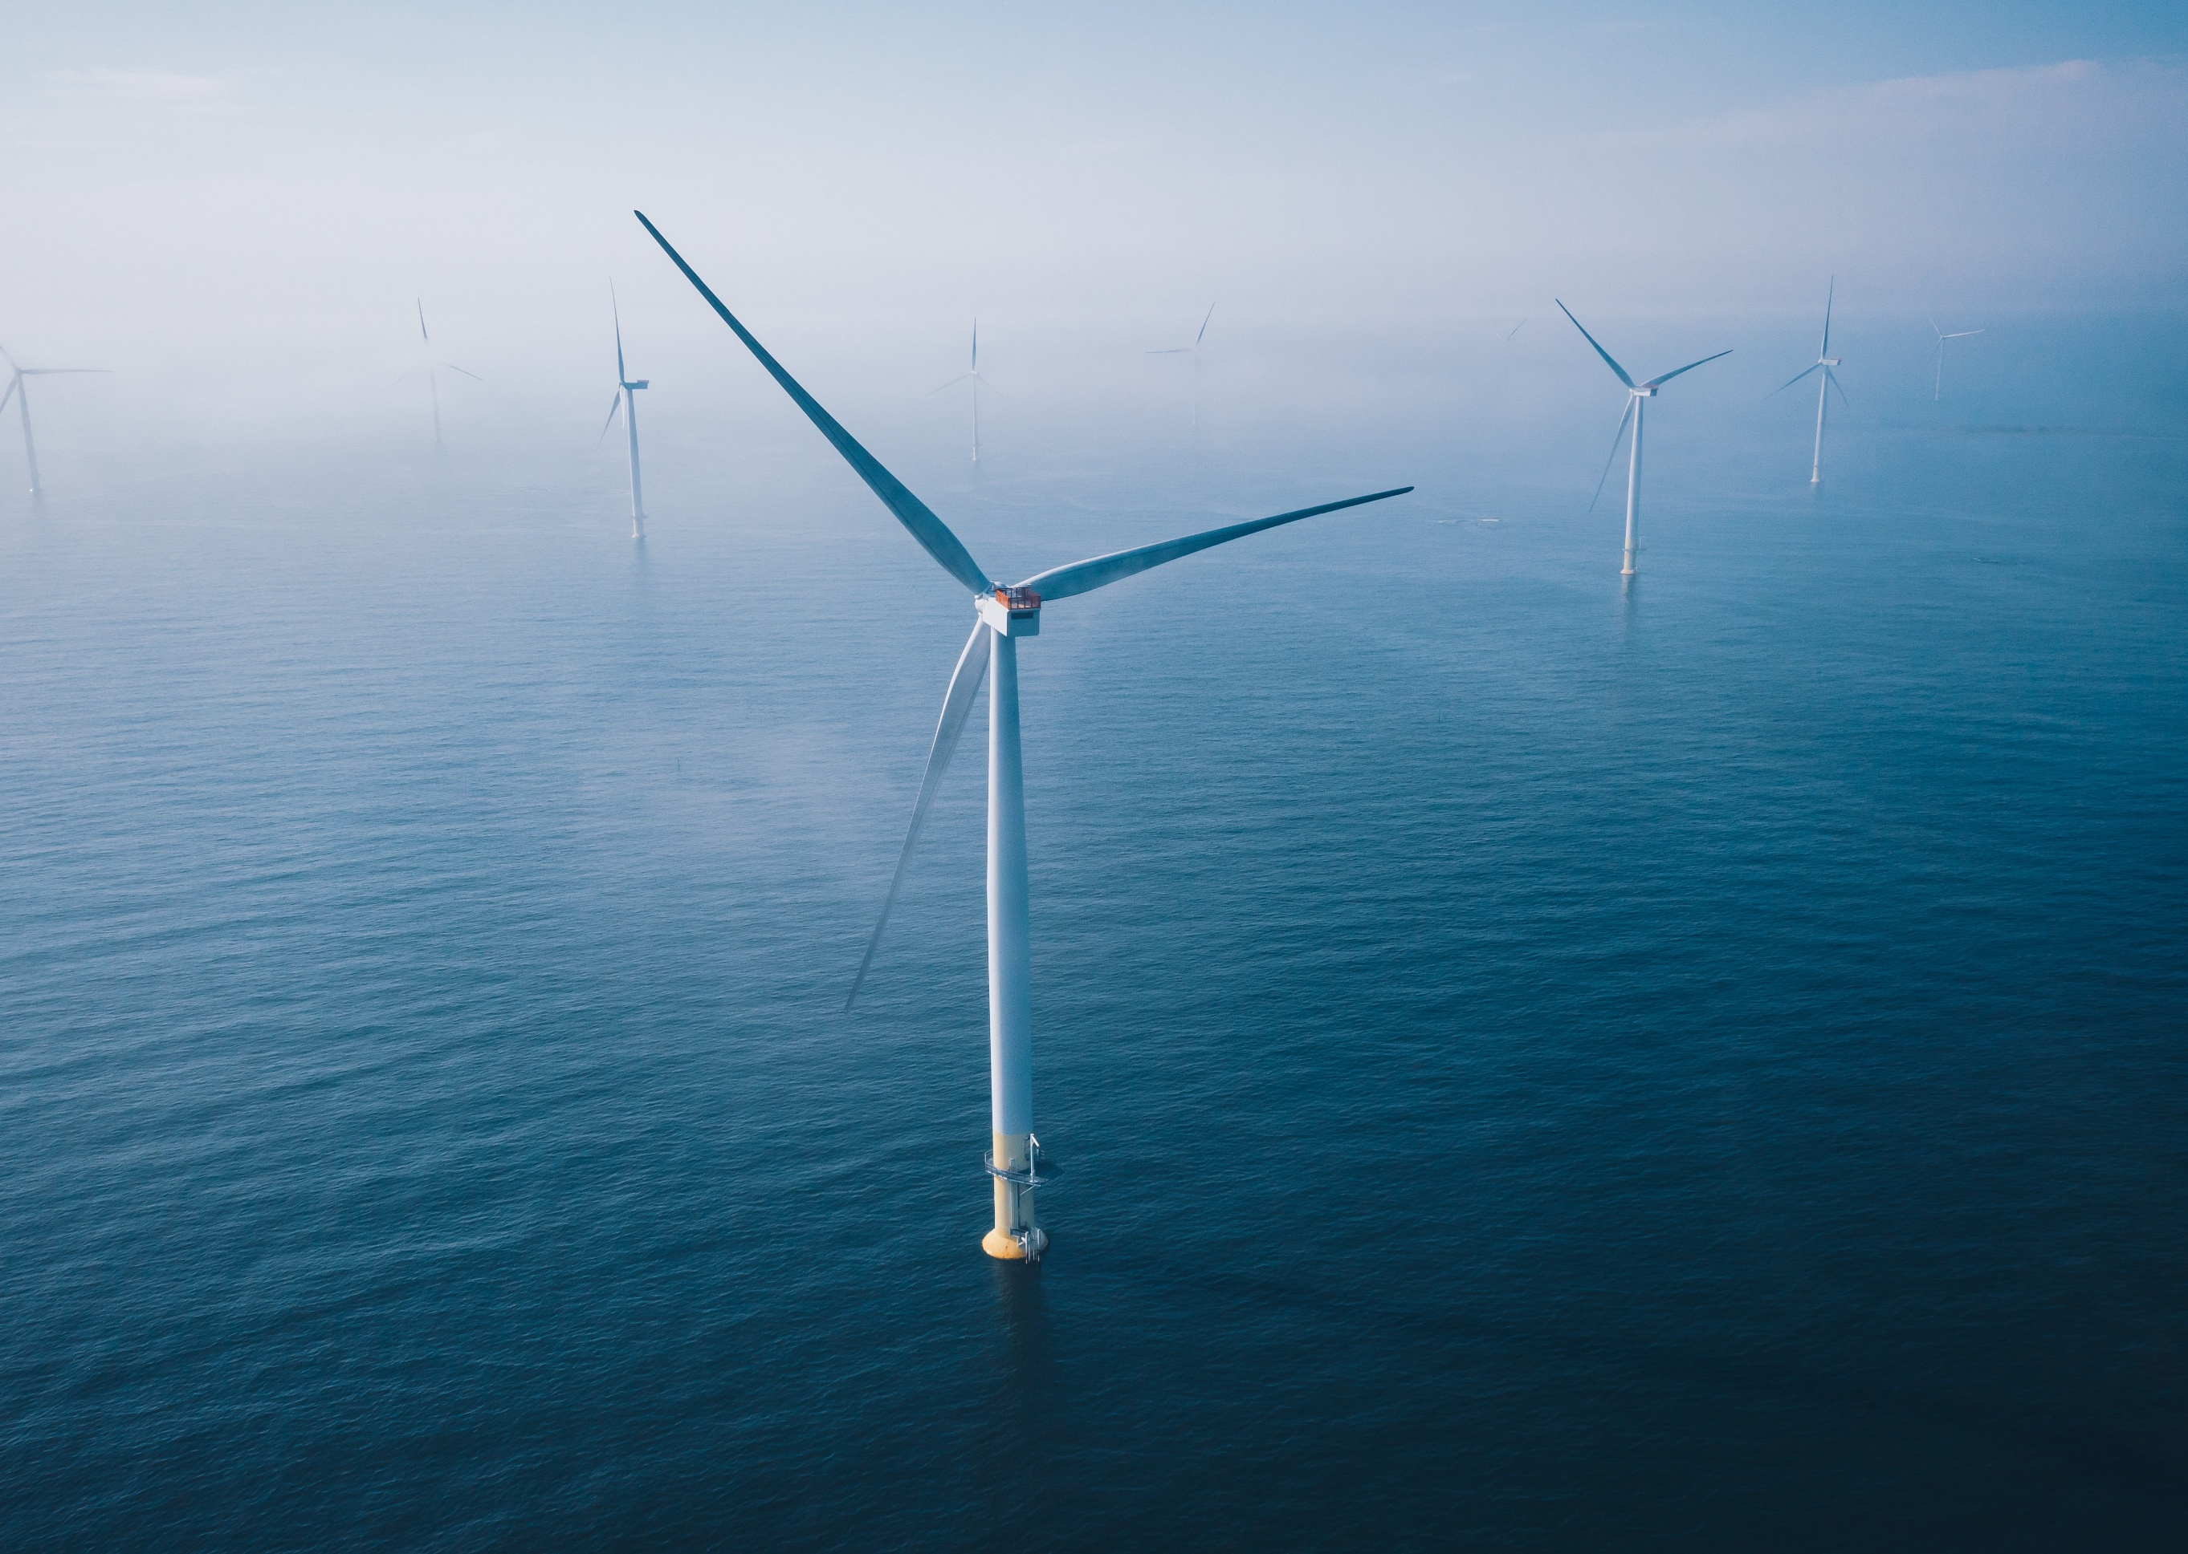
Table of Contents
Chapter 8 Coastal processes and sediment transport 8-1
8.1 Introduction 8-1
8.2 Assessment scope 8-2
8.2.1 Commonwealth matters 8-2
8.3 Evaluation framework 8-3
8.3.1 Key legislation, policy, guidelines and standards 8-3
8.3.2 Assessment criteria 8-3
8.4 Methods 8-4
8.4.1 Assessment approach - modelling 8-7
8.5 Existing environment 8-8
8.5.1 Physical environment 8-8
8.5.2 Conservation values and receptor groups 8-16
8.6 Construction impacts 8-20
8.6.1 Key impacts 8-20
8.6.2 Other impacts 8-20
8.7 Operation impact assessment 8-22
8.7.1 Key impacts 8-22
8.7.2 Other impacts 8-22
8.8 Decommissioning impact assessment 8-29
8.8.1 Potential impacts and risks 8-29
8.9 Cumulative impacts 8-30
8.10 Summary of mitigation, monitoring and contingency measures 8-32
8.10.1 Mitigation measures 8-32
8.10.2 Monitoring and contingency measures 8-32
8.11 Conclusion 8-33

Figures
Figure 8-1 Coastal processes and sediment transport study area including profile locations for which model outputs were generated. 8-6
Figure 8-2 Wind roses for the modelled wind fields at the centre of the offshore wind farm area from 1991 to 2020, and during years of intensified south-west storms (2004) and south-east storms (1999). Wind direction is from where the wind is blowing. 8-10
Figure 8-3 Current direction and magnitude inshore of the project area at the western AWAC (left) and eastern AWAC (right), respectively, that were deployed from September 2020 to September 2021. Current direction is where the current is flowing toward. 8-11
Figure 8-4 Wave roses for the modelled wind fields at the centre of the offshore wind farm area from 1991 to 2020, and during years of intensified south-west storms (2004) and south-east storms (1999). Wave direction is where the wave is coming from. 8-12
Figure 8-5 Predicted annual average longshore sediment-transport across specified profiles for model results from 1991 to 2020 8-13
Figure 8-6 Predicted annual average accumulation of sediment between specified profiles for model results from 1991 to 2020 8-13
Figure 8-7 Profile locations in the context of the offshore wind farm area footprint 8-14
Figure 8-8 Total shoreline changes from Corner Inlet to Seaspray since 1988, as determined by satellite imagery. Red areas indicate a decrease in shoreline while blue areas indicate an increase in shoreline. 8-15
Figure 8-9 Receptor groups for the coastal processes and sediment transport impact assessment 8-19

Tables
Table 8-1 Key legislation, policy, guidelines and standards 8-3
Table 8-2 Geographic locations of modelled output profiles for the operation impact assessment 8-7
Table 8-3 Receptor groups for the impact assessment along with their respective jurisdiction, description and sensitivity to changes in coastal processes and sediment transport. 8-16
Table 8-4 Residual impacts from excavation of HDD exit pits and cable trenching resulting in changes to coastal processes and sediment transport 8-21
Table 8-5 Residual impacts (consequence ratings) from changed wind climate including under climate change conditions 8-23
Table 8-6 Residual impacts (consequence ratings) from changes to waves including under climate change conditions 8-25
Table 8-7 Residual impacts (consequence ratings) from changes to currents and tidal regime including under climate change conditions 8-26
Table 8-8 Residual impacts (consequence ratings) from changes to coastal sediment transport and coastal landforms including under climate change conditions 8-28
Table 8-9 Projects assessed for cumulative impacts 8-30
Table 8-10 Monitoring and adaptive management relevant to coastal processes and sediment transport 8-32

Coastal processes and sediment transport

Introduction
This chapter summarises the existing conditions related to coastal processes and sediment transport and assesses the impacts and risks associated with the construction, operation and decommissioning of the Star of the South Offshore Wind Farm Project (the project) on coastal processes. The chapter describes how impacts will be avoided, minimised or managed.
Coastal processes and sediment transport refers to the natural forces and interactions that shape coastlines over time which are primarily driven by waves, tides, currents and wind.
This chapter is based on the impact assessment presented in Technical Report A – Coastal Processes and Sediment Transport.
Other chapters that relate to or inform the costal processes and sediment transport assessment include:
Chapter 9 – Benthic ecology
Chapter 10 – Fish and invertebrates
Chapter 11 – Marine mammals and turtles
Chapter 12 – Offshore ornithology and bats
Chapter 13 - Marine protected areas
Chapter 14 – Non-Aboriginal underwater cultural heritage
Chapter 15 – Commercial and recreational fisheries
Chapter 17 – Shipping and navigation
Chapter 21 – Business and tourism

Assessment scope
The study objective for coastal processes and sediment transport is to identify the existing conditions related to coastal processes and sediment transport and assess impacts and risks associated with the construction, operation and decommissioning of the project.
All detailed methodologies and assessment on coastal processes and sediment transport can be found in Technical Report A – Coastal Processes and Sediment Transport.

Commonwealth matters
The project's EIS guidelines inform the preparation of the EIS to enable the Commonwealth Minister for the Environment to make an informed decision on whether or not to approve the project under the Environment Protection Biodiversity Conservation Act 1999 (EPBC Act).
The aspects of the EIS guidelines directly relevant to coastal processes and sediment transport are:
- Section 2.5 – Description of the environment
- Section 2.6.1 – Description of the ecological character
- Section 2.7 – Provision of technical data and other information
- Section 2.7 – Predictions of changes to physico-chemical status.
Further information about the EIS guidelines is listed in Attachment V – EIS Guidelines Checklist.

Evaluation framework

Key legislation, policy, guidelines and standards
Table 8-1 lists the key legislation, policy, guidelines and standards relevant to coastal processes and sediment transport.
Table 8-1 Key legislation, policy, guidelines and standards
Type | Applicable legislation, policy, guideline or standard
International conventions / guidance | International convention on the conservation of wetlands, especially as waterfowl habitat.
Commonwealth Government | Environment Protection and Biodiversity Conservation Act 1999

Assessment criteria
To assess the project, predicted impacts and risks are compared to criteria that set required environmental performance outcomes (refer Chapter 6 – Assessment Framework).
The criteria for coastal processes and sediment transport are derived from legislation and policy, relevant standards and guidelines, stakeholder feedback and industry best practice.
The assessment criteria relevant to coastal processes and sediment transport are:
- No changes to Corner Inlet Ramsar site sand barrier islands and tidal delta systems outside natural variability due to construction, operation or decommissioning of the project
- No areas of the Corner Inlet Ramsar wetland will be destroyed or substantially modified by construction, operation or decommissioning of the project
- No modification, destruction, fragmentation, isolation or disturbance of an important or substantial area of habitat (seabed) due to project activities causing an adverse impact on marine ecosystem functioning or integrity in a Commonwealth marine area
- No change to coastal processes due to project activities that can be measured outside the range due to natural variation, climate change and sea level rise.

Methods
The purpose of the coastal processes and sediment transport impact assessment is to assess the potential impacts and risks of the project on coastal processes.
Impacts refer to the consequences of planned project actions, which are given a rating determined by combining the magnitude of the impact and the sensitivity of the receptor.
Risks are an unexpected (accidental) event and are determined by combining the likelihood of an event occurring and the consequences that would result if the event were to occur.
The technical chapters consider key impacts and risks with a residual consequence rating of moderate to severe. Other impacts and risks are those with a residual consequence rating of negligible to minor.
Refer to Chapter 6 – Assessment Framework for more detail on how impact and risk ratings are derived.
The coastal processes and sediment transport impact assessment involved:
- Defining a study area which includes all areas that may be subject to impacts on coastal processes and sediment transport, such as the offshore project area and selected locations along the Gippsland coast from Wilsons Promontory, past Corner Inlet to Golden Beach
- Reviewing national, state and local legislation relevant to protection of conservation values
- Undertaking a literature review on the potential changes in wave climate of the general Bass Strait area and the coastal geomorphology east of Seaspray (Figure 8-1)
- Collecting data associated with coastal processes and sediment transport over 12 in the nearshore location to 18 months offshore to provide baseline information to inform modelling studies (also see Figure 8-1):
  - Waves: using a wave buoy and a multi-parameter buoy (floating LiDAR 1)
  - Currents: using two acoustic wave and current (AWAC) instruments and two multi-parameter buoys (floating LiDAR 1 and 2)
  - Sea level and tides: using the two acoustic wave and current instruments
  - Sampling of sediments from 100 millimetres deep near the centre of the intertidal zone at McLoughlins Beach and Woodside Beach (profile location 21 and 24 in Figure 8-1) to measure intertidal particle sizes
- Modelling data from other resources to provide long term baseline (1991-2021) and forecast conditions of wind, wave, sea level, bathymetric and sediment transport processes in the study area
Forecast modelling uses computers and data to predict how waves and currents will behave in the future.
- Modelling baseline conditions for the years 1999 and 2004 as these were representative years of two extreme weather events off the coast of Gippsland
- Collecting data on waves, currents and water levels to accurately reproduce the offshore-onshore transformation of waves and currents. The measured data was used to validate the hindcast models used
Hydrodynamic forecast modelling uses computers to simulate water movements (such as waves, tides, and currents) to understand and predict how the ocean behaves in different conditions.
- Undertaking numerical hydrodynamic forecast modelling to quantify the potential impacts from the presence of infrastructure in the offshore project area and nearby coastal waters
- Characterising existing conditions and identifying sensitive assets, values and uses
- Reviewing the project description to determine the location, type, timing, extent, intensity, and duration of potential project interactions with sensitive receptors
- Defining the maximum design scenario(s) based on project design envelope parameters that provide the basis for impact assessment. Refer to Chapter 4 – Project Description for more detail on the maximum design scenario(s) and project design envelope parameters
- Undertaking a proportional assessment of risks and impacts based on the outcomes of the initial assessment of issues and consultation insights that examines the potential severity, extent and duration of identified issues
- Evaluating predicted outcomes against performance benchmarks and assessment criteria derived from applicable legislation, policy and standards
- Identifying mitigation measures where necessary to address potentially significant environmental impacts
- Evaluating residual environmental impacts and risks against assessment criteria, taking into account the proposed mitigation measures and likely effectiveness
Figure 8-1 Coastal processes and sediment transport study area including profile locations for which model outputs were generated.
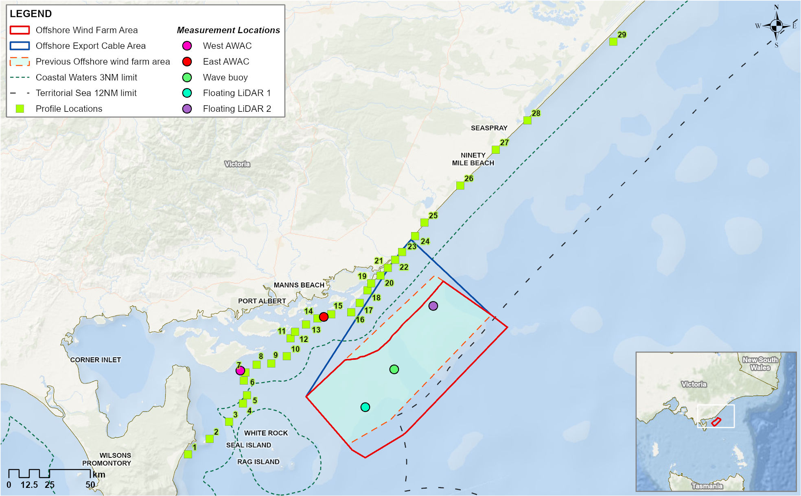

Assessment approach - modelling
The construction assessment takes a qualitative approach because the spatial and time scale of construction activities are relatively small. This makes modelling meaningful impacts on coastal processes and sediment transport challenging, as impacts to these processes are generally long term by nature.
The operation assessment takes a quantitative approach using numerical hydrodynamic forecast modelling to show potential impacts from the presence of project infrastructure in the offshore project area and nearby coastal waters. The details of these models can be found in Technical Report A – Coastal Processes and Sediment Transport.
Modelled outputs were produced at five, ten and/or 15 metre depths for the profile locations listed in Table 8-2 and Figure 8-1. Before and after modelling, scenarios were compared to show if and how the project may impact different coastal processes.
For ‘after’ scenarios, models also incorporated climate change projections of altered coastal conditions by the end of century (2080-2099) under worst-case carbon emissions rates.
Table 8-2 Geographic locations of modelled output profiles for the operation impact assessment
Geographic location | Profile number
Five Mile Beach, Wilsons Promontory | 1
Rabbit Island | 2
Entrance to Corner Inlet | 4
Snake Island | 7
Clonmel Island | 12
Off East Scrubby Island | 17
New Entrance | Between 19 and 20
McLoughlins Beach | 21
South-west of Reeves Beach | 22
Reeves Beach | 23
Woodside Beach | 24
Jack Smith Lake Wildlife Reserve | Between 25 and 26
McGaurans Beach | 26
Seaspray | Between 27 and 28
North-east of Seaspray | 28
Golden Beach | 29

Existing environment
This section describes the existing conditions within the study area, as they relate to coastal processes and sediment transport, including specific conservation values. The study area is defined as the offshore project area and selected profile locations along the Gippsland coast between Wilsons Promontory and Golden Beach.

Physical environment

Bathymetry, seabed and sediments
The seabed in the offshore project area is mostly soft sediment with sparse patches of rocky reef and seagrass. Overall depths range from zero to 53 metres. Within the offshore wind farm area, the bathymetry varies from east to west, with a shallower seabed profile from the shoreline to the southern boundary of the offshore wind farm area in the east (depths ranging from 35 to 39 metres) and a steeper profile in the west (40 to 49 metres). See Chapter 9 – Benthic Ecology for details of the offshore project area’s bathymetry, seabed and sediments.

Sea level
Spring tide - occurs on the full / new moon and has a bigger tidal range (greater difference between high and low tide).
Neap tide - occurs on the first / third quarter moons and has less extreme tides.
Within the offshore wind farm area, there are approximately two tidal-cycles each day with a range of around 1.5 metres at spring tides and up to 0.9 metres at neap tides.
In Bass Strait, the main water movements are caused by the tides, which get stronger from east to west as they flow into the offshore project area. As such, the mean high-water spring tidal plane was 0.70 metres at the eastern acoustic wave and current instrument compared to 0.83 metres at the western acoustic wave and current instrument (Figure 8-1).

Regional storm climate
There are three main storm types which can generate severe wave conditions in the offshore project area – southeast, southwest and southerly storms.
Southeast storms are derived from east-coast low-pressure systems that develop rapidly near northern Australia and move southward, bringing strong winds and heavy rainfall. While these storms occur infrequently, they have the greatest potential to generate extreme wave conditions in eastern Bass Strait.
Southwest storms result from low-pressure systems moving west to east across the Southern Ocean, often bringing strong shifting winds as cold fronts pass over Bass Strait. These storms occur frequently, but they are unlikely to generate maximum wave conditions.
Southerly storms originate from low-pressure systems in the western Tasman Sea, forming through various mechanisms and producing strong southerly winds in Bass Strait. While their fetch is limited, any south-east wave component remains unrestricted, giving them a greater potential than south-west storms for generating extreme wave conditions.
Fetch is how far the wind can blow across without being blocked - the farther it blows in the ocean, the bigger the waves.

Wind
The key findings from hindcast modelling and field analyses of baseline wind conditions in the project area were:
- Prevailing winds in the offshore wind farm area are predominantly parallel to the coast or in an offshore direction (Figure 8-2)
- The strongest winds mainly come from a westerly or south-westerly direction (Figure 8-2)
- Wind directions are consistent during years of intensified weather conditions, and at inshore locations (for example, at profile location 17 in Figure 8-1)
A wind shadow is an area where the wind is weaker because something, like a wind turbine, blocks or slows it down.
- As prevailing winds are predominantly parallel to shore, adjacent coastline would rarely be in the wind shadow of the project.

Figure 8-2 Wind roses for the modelled wind fields at the centre of the offshore wind farm area from 1991 to 2020, and during years of intensified south-west storms (2004) and south-east storms (1999). Wind direction is from where the wind is blowing.
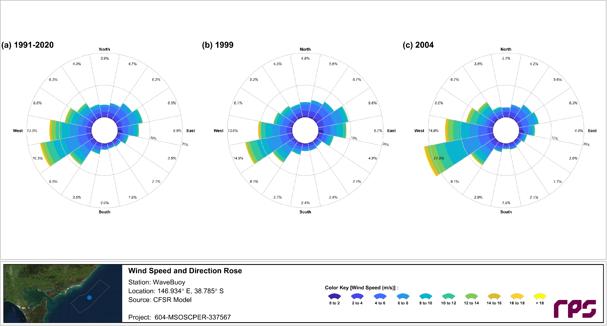
A wind rose is a circular chart that summarises strength, direction and frequency of winds in a specific location.

Currents
Currents in the offshore wind farm area generally remain below 0.5 metres per second but increase in strength with depth (see Technical Report A – Coastal Processes and Sediment Transport).
Field data from the acoustic wave and current instruments indicates that current direction tends to run parallel to the coast (Figure 8-3), which is consistent with both the tidal direction (see Figure 6-8 in Technical Report A – Coastal Processes and Sediment Transport) and overall wind direction (Figure 8-2).

Figure 8-3 Current direction and magnitude inshore of the project area at the western AWAC (left) and eastern AWAC (right), respectively, that were deployed from September 2020 to September 2021. Current direction is where the current is flowing toward.
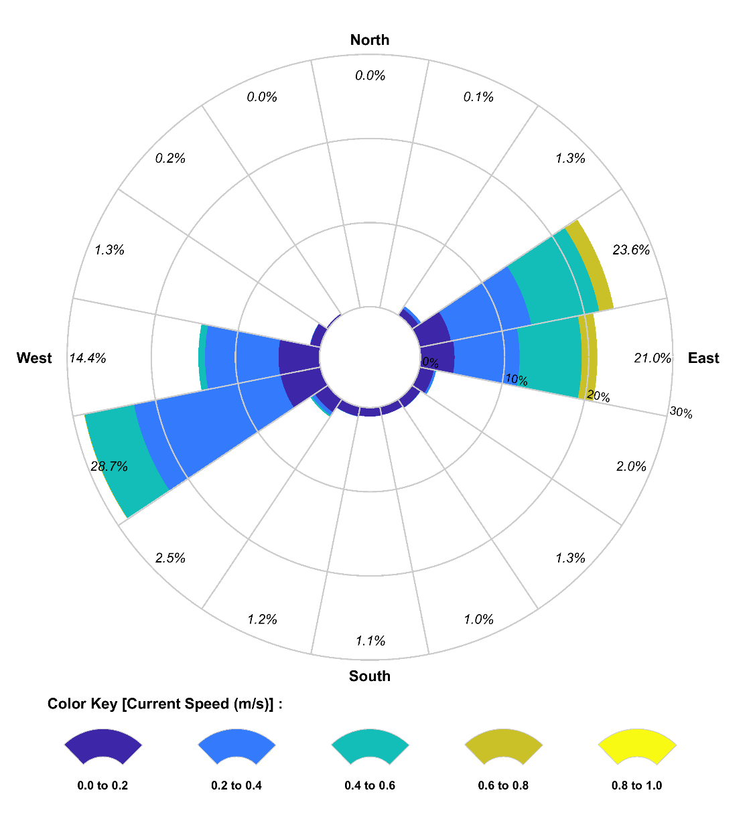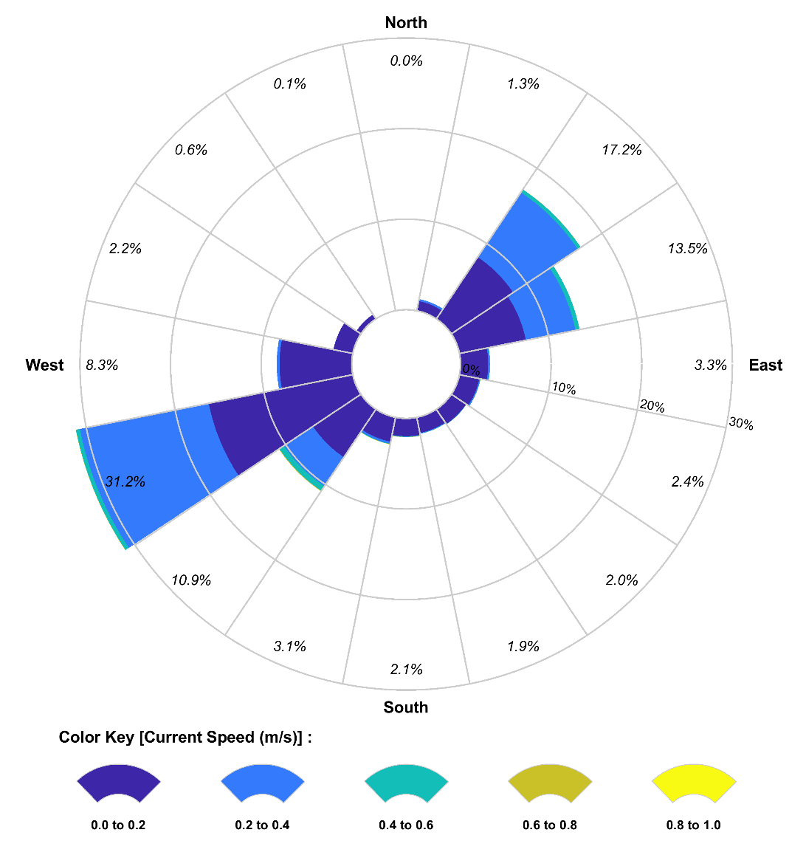

Waves
The key findings from hindcast modelling (1991-2020) and field analyses of baseline wave conditions were:
- Within the offshore wind farm area, the strongest and most frequent waves tend to come from a southerly direction (Figure 8-4)
Significant wave height is a measure of how big waves usually are, based on the tallest ones (for example, the top third).
- Inshore of the offshore wind farm area (at profile location 17 in Figure 8-1), the strongest and most frequent waves come from a south easterly direction with significant wave heights of less than 1 metre approximately 62 per cent of the time
These differences in wave direction illustrate the sheltering effect of Wilson’s Promontory - waves tend to approach the project area from the southwest before the wave path “bends” (or refracts) causing the waves to approach the coast more perpendicularly .
Figure 8-4 Wave roses for the modelled wind fields at the centre of the offshore wind farm area from 1991 to 2020, and during years of intensified south-west storms (2004) and south-east storms (1999). Wave direction is where the wave is coming from.

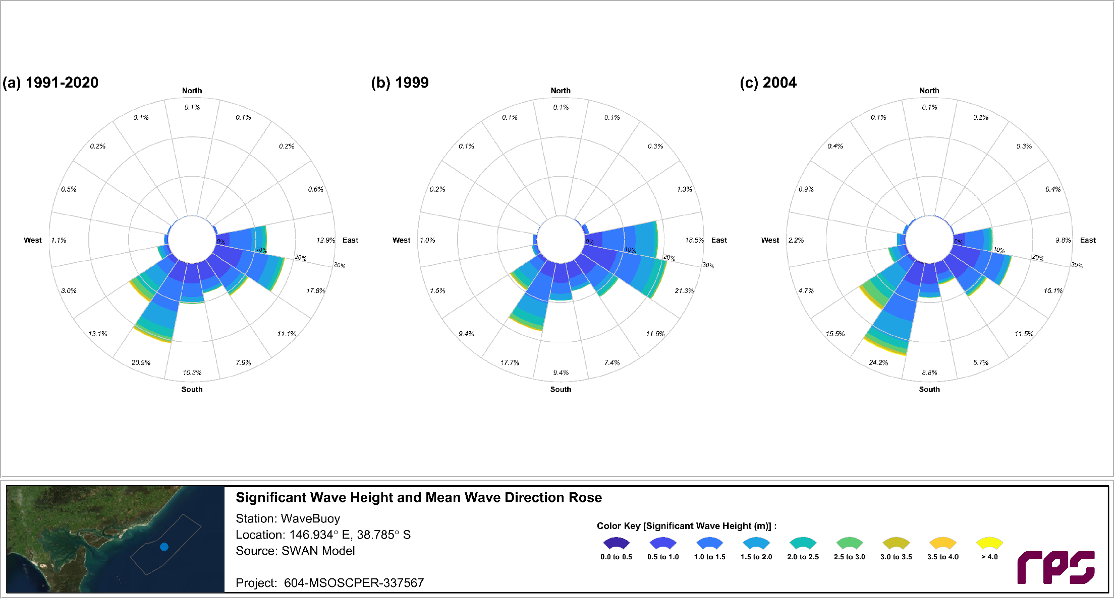
A wave rose is a circular chart that summarises the typical sea conditions at a specific location.

Wave energy and longshore sediment transport
The dominant driver of coastal processes in this environment is wave energy. Waves often approach the beach at an angle, with the wave crests not parallel to the shore and the wave energy direction not perpendicular to the shoreline. This results in a component of wave energy directed along the coast and can result in the development of longshore currents and the transport of sand along the beach – a key coastal process termed ‘longshore transport’.
Modelling allowed the estimation of wave energy directions at the different profile locations (shown in Figure 8-7) in relation to the shore direction. A positive difference between the angle of wave energy and the angle of the shoreline indicates an eastward movement (up the coast) of energy, whereas a negative difference indicates a westward movement (down the coast).
Identifying these differences in angles allowed for the modelling of longshore sediment transport in the area and sediment accumulation – shown in Figure 8-5 and Figure 8-6. Sediment transport is generally in the eastward direction, except from profile locations four to ten, and 15, where sediment is transported towards Corner Inlet (Figure 8-5). Areas of sediment accumulation or erosion vary along the profile transect.
Figure 8-5 Predicted annual average longshore sediment-transport across specified profiles for model results from 1991 to 2020
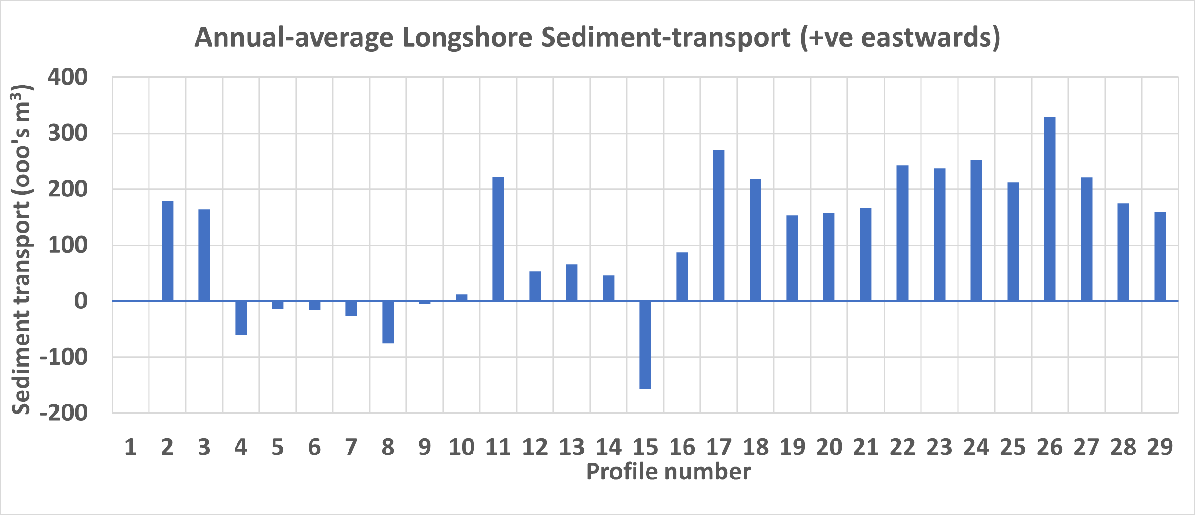
Figure 8-6 Predicted annual average accumulation of sediment between specified profiles for model results from 1991 to 2020
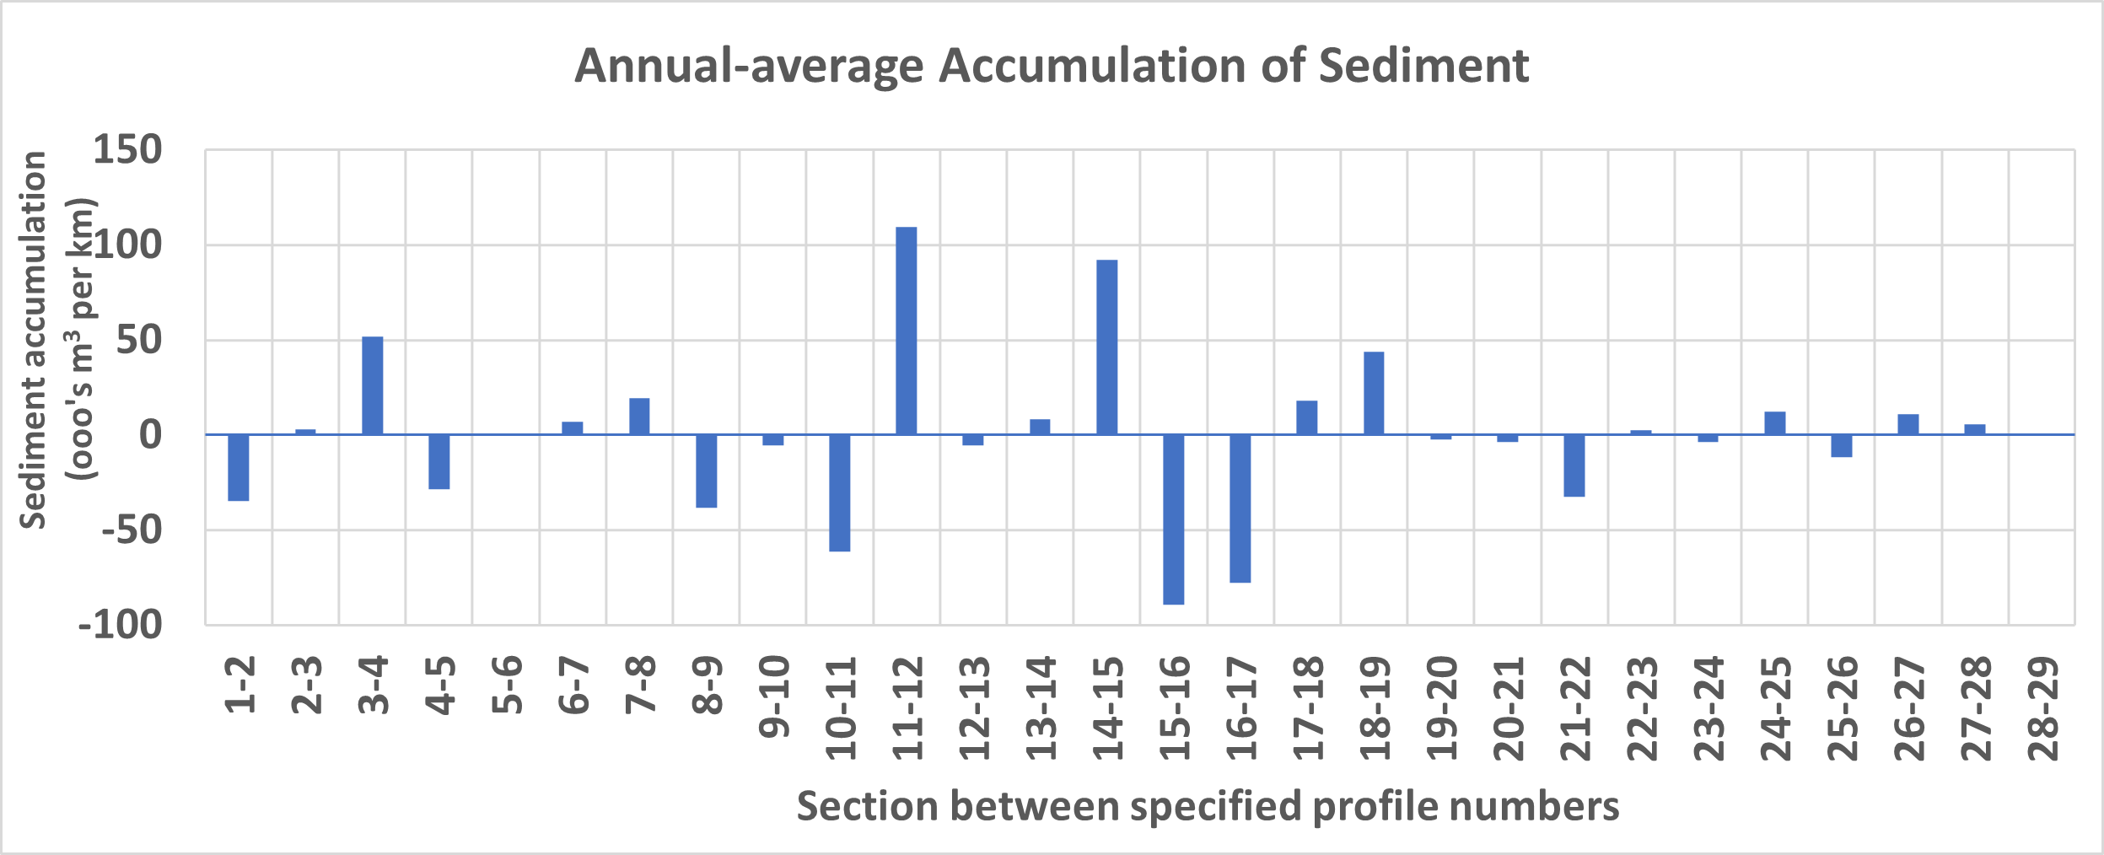
Figure 8-7 Profile locations in the context of the offshore wind farm area footprint
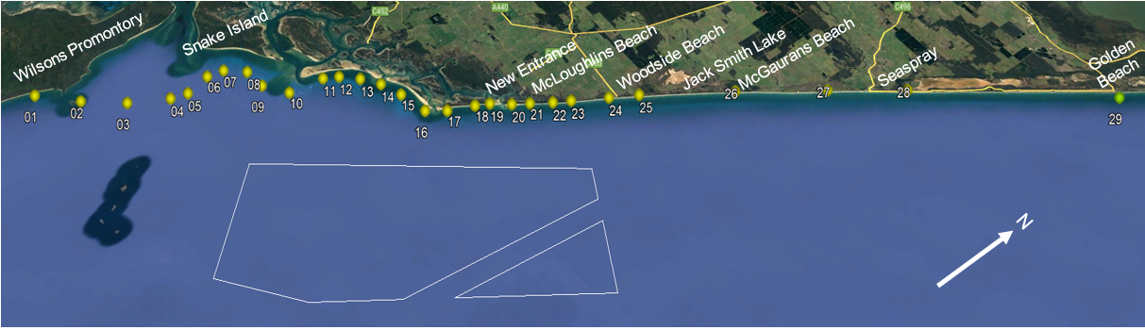

Coastal geomorphology
Accretion is the opposite of erosion, whereby sand or other sediments gradually build up in an area, on a beach or along a shoreline, causing the land grow or extend seaward over time.
The shorelines of Ninety Mile Beach and Corner Inlet are highly dynamic, shaped by natural processes and abundant sediment supply. Key landforms include a prograded (seaward expanding) beach-barrier plain, a beach-barrier spit, and barrier islands, all influenced by the Corner Inlet sediment system. The region remains broadly stable to accreting, with isolated erosion events linked to inlet changes. High sediment availability provides resilience to climate change, though gradual shoreline reorientation and landward migration of barrier islands may occur with shifting wave directions and rising sea levels. Detailed results of the geomorphological assessment can be found in Technical Report A – Coastal Processes and Sediment Transport.
The key geoforms, defined as landforms shaped by geological and environmental processes, that the assessment took into consideration are listed and described in Table 8-3.

Shoreline changes over decades
The shorelines from the mouth of Corner Inlet to McLoughlins Beach are some of the most dynamic in Victoria and have changed considerably over the past 30 years, reflecting high rates of sediment transport (Figure 8-8). There has been an overall accretionary trend for most of the islands, with the highest recession occurring at the northern tip of Wilsons Promontory, where the sandy plain is adjacent to the main channel of Corner Inlet. The shoreline to the north-east is generally stable where the beach and dune systems are shore-attached, with areas of recession occurring at Jack Smith Lake, the town of Seaspray and McLoughlins Beach.
Figure 8-8 Total shoreline changes from Corner Inlet to Seaspray since 1988, as determined by satellite imagery. Red areas indicate a decrease in shoreline while blue areas indicate an increase in shoreline.
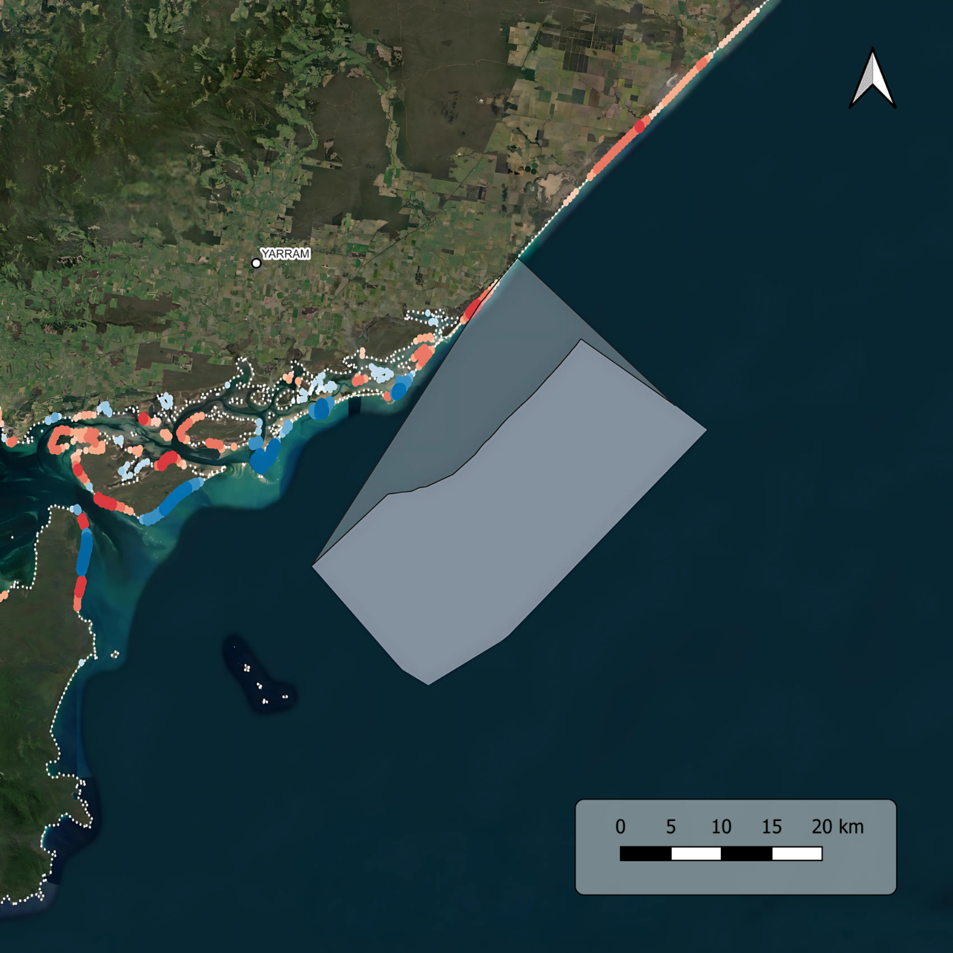
Figure adapted from Digital Earth Australia 2021, see Technical Report A - Coastal Processes and Sediment Transport

Climate change impacts
The assessment considered the implications of climate change by modelling conditions that are representative of 2081 to 2100 under a climate change trajectory. Predicted variations in coastal processes from climate change within the area are summarised as follows:
- Wind
  - Models indicated a general decrease in wind speeds, with an increased frequency of winds from the east south-east through south to the south-west.
- Currents
  - Generally reduced current speeds are forecasted under future-climate forcing.
- Waves
  - There is a predicted decrease in wave heights with a slight counterclockwise rotation in direction.
- Sediment transport
  - Models predict a reduction in longshore transport for all profiles. The reduction is especially marked in the eastern profiles. This reduction appears to be associated with the overall reduction in wave heights.

Conservation values and receptor groups
The conservation values / receptor groups for the coastal processes impact assessment are listed in Table 8-3 and mapped in Figure 8-8. These are derived from areas of high conservation value, significant geomorphological features and significant habitats.
Table 8-3 Receptor groups for the impact assessment along with their respective jurisdiction, description and sensitivity to changes in coastal processes and sediment transport.
 | Receptor group | Description | Sensitivity
Commonwealth | Corner Inlet  Ramsar site | - Wetland of international importance, especially as waterfowl habitat listed under the Ramsar convention.  - 67,000 hectares area of saltmarsh, mangrove, seagrass, mudflats and tidal channels, rocky islands and sand barrier islands.  - Includes Corner Inlet and the Nooramunga Marine & Coastal Park.  - Includes Victorian marine protected areas and the Port of Corner Inlet and Port Albert. | The sand barrier islands and associated delta systems play a substantial role in the natural functioning of the Ramsar site by protecting the extensive tidal channel network and mudflats and sandflats from oceanic swells. Changes to the sand barrier islands and associated tidal delta systems are likely to change the structure and function of the Ramsar site.
Commonwealth | Commonwealth  marine area | - The Commonwealth marine area includes waters, seabed and airspace within Australia’s territorial sea and exclusive economic zone, excluding State and Territory waters, that is from 3 NM to up to 200 NM from the coast. | Changes to coastal and sediment transport processes may adversely affect habitat in the Commonwealth marine environment resulting in adverse ecological impacts.
Victoria | Marine and Coastal Protected Areas
Victoria | Wilsons Promontory Marine Park | - Nearshore coastal waters on the west and east side of Wilsons Promontory.  - On the east side of Wilsons Promontory the Marine Park extends from Refuge Cove in the south to Entrance Point (Corner Inlet) in the north and includes waters from the high-tide mark to around 300 metres offshore. | Changes to coastal and sediment transport processes may adversely affect geomorphological features and habitats within Victorian marine protected areas.
Victoria | Corner Inlet Marine and Coastal Park | - Includes all marine areas of Corner Inlet except Port of Corner Inlet and Corner Inlet Marine National Park.  - Includes the sand barrier islands and tidal channels.  - Does not extend offshore beyond low tide mark.
Victoria | Nooramunga Marine and Coastal Park | - Includes all marine areas of the Nooramunga Marine & Coastal Park.  - Includes the sand barrier islands and tidal channels (excludes privately held/leased islands).  - Does not extend offshore beyond low tide mark.
Victoria | McGaurans Beach to Seaspray coastal reserve | - Includes the beaches and dunes from Reeves Beach in the south to Seaspray in the north.
Victoria | Ninety Mile Beach Marine National park | - Includes all areas from the low tide mark to 3 NM offshore between (approximately) Lake Denison and Seaspray.
Victoria | Significant geoforms (reference number)
Victoria | Five Mile Beach  (WL55) | Extremely well-developed beach cusps form along Five Mile Beach. Cusp width averages 3-4 metres and length is up to two metres. | Changes to incident wave energy and direction may adversely affect the geoform.
Victoria | Snake Island  (GSS082) | Extensive sequence of parallel and converging beach ridges. | Changes to sea level, incident wave energy and direction, coastal and tidal currents may adversely affect the geoform.
Victoria | Nooramunga Tidal Entrance & Tidal Delta  (GSS083, 085, 086, 087) | Classic example of tidal channels, inlets and deltas. | Changes to sea level, incident wave energy and direction, coastal and tidal currents may adversely affect the geoform.
Victoria | Clonmel Island  (GSS084) | Classic example of barrier island formation. | Changes to sea level, incident wave energy and direction, coastal and tidal currents may adversely affect the geoform.
Victoria | Outer Barrier - Shallow Inlet to Reeves Beach  (GSS002) | Major example of the formation and modification of barrier systems. | Changes to sea level, incident wave energy and direction, coastal and tidal currents may adversely affect the geoform.  NB: this assessment only considers areas to the east of Wilsons Promontory (Shallow Inlet is west of Wilsons Promontory).
Victoria | Woodside Beach – Barrier & Lagoons  (GSS003) | Important sectors in understanding barrier evolution. | Changes to sea level, incident wave energy and direction, coastal currents may adversely affect the geoform.
Victoria | Jack Smith Lake  GSS004) | Large coastal lagoon. | Changes to sea level, incident wave energy and direction, coastal currents may adversely affect the geoform.
Victoria | McGaurans Beach - Lagoon Sediments  (GSS005) | Lagoon sediments indicating barrier formation and retreat. | Changes to sea level, incident wave energy and direction, coastal currents may adversely affect the geoform.
Victoria | Habitats of importance
Victoria | Corner Inlet Deep Channels (Victorian Marine and Coastal Features Atlas) | Deep channel (30–35 metres) at the entrance to Corner Inlet and deep channel basins within Corner Inlet: sublittoral sediment features of biogenic reefs consisting of sponge clumps. | Not described, but likely sensitive to changes to tidal current flows and may be sensitive to coastal sediment transport.
Victoria | Woodside and McGauran Beach offshore sediments (Victorian Marine and Coastal Features Atlas) | Bare sediments – biodiversity hotspot (infauna). | May be sensitive to changed offshore sediment transport processes. Feature refers to Woodside and McGaurans Beach offshore sediments, noting that all sublittoral sediments along Ninety Mile Beach are known to support high infauna biodiversity.

Figure 8-9 Receptor groups for the coastal processes and sediment transport impact assessment
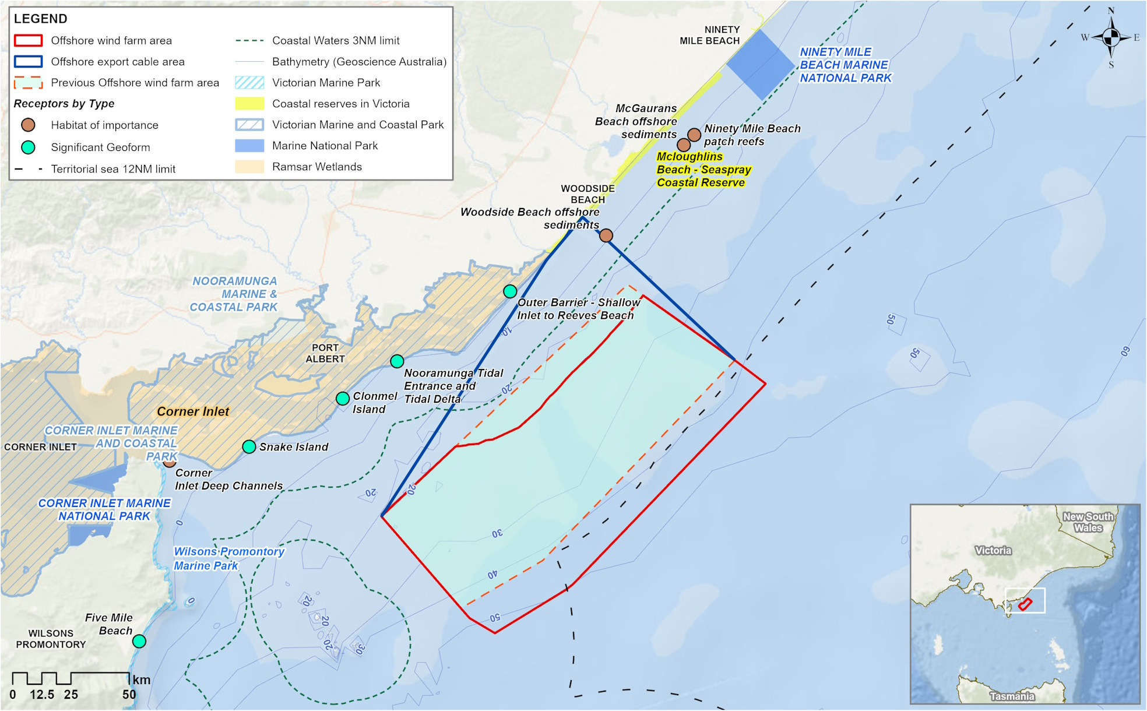

Construction impacts
This section discusses the impacts and risks associated with the project’s construction that relate to coastal processes and sediment transport and the respective receptor groups.

Key impacts
The construction impact assessment identified no impacts to coastal processes and sediment transport receptor groups with a residual impact rating of moderate or higher once mitigation measures are implemented.

Other impacts
The only potential construction impact with minor to negligible residual impacts on coastal processes included once mitigation measures have been implemented is:
- Excavation of Horizontal Directional Drilling (HDD) exit pits and cable trenching (CPS-IC01)

Excavation of horizontal directional drilling exit pits and cable trenching (CPS-IC01)

Potential impact
During construction, the horizontal directional drilling exit pits require excavation of 1,000 cubic metres per borehole and the dimensions of the exit pits will be approximately 50 metres long, ten metres wide and two metres deep. The assessment considered the potential for these activities to cause localised changes in wave direction and energy, leading to altered processes.
To change the wave energy arriving at the coast, the trenching or excavation would need to have a width comparable with the wavelength of the waves, which is typically more than ten metres and would also have to remain in place for an extended period.
Due to the planned construction pits being a maximum of 10m wide and being in place for a short duration, it is anticipated that they would not impact wave energy arriving at the coast and would be rapidly filled by natural processes within months or even days during storms.

Residual impact
As any potential impacts will only lead to localised disturbance of sediments at the seabed, with a short-term recovery, no flow-on effects on broader coastal processes and sediment transport are expected and owing to this, impacts to relevant receptors have been assessed as having a negligible magnitude and consequence (Table 8-4).
Table 8-4 Residual impacts from excavation of HDD exit pits and cable trenching resulting in changes to coastal processes and sediment transport
Potential Impacts | Receptor Group | Receptor Sensitivity | Magnitude | Initial Consequence | Mitigation | Residual Consequence
Excavation of horizontal directional drilling exit pits and cable trenching | Commonwealth marine area | Low | Negligible | Negligible | - | Negligible
 | Woodside and McGauran Beach offshore sediments | Low | Negligible | Negligible | - | Negligible
 | All other receptors | N/A – no impact pathway due to localised and temporary scale of impact

Operation impact assessment
This section discusses the impacts and risks associated with the operation of the project that relate to coastal processes and sediment transport and the respective receptor groups.

Key impacts
The operation impact assessment identified no impacts to coastal processes and sediment transport receptor groups with an impact rating of moderate or higher once mitigation measures are implemented.

Other impacts
Other potential operation impacts with minor to negligible residual impacts on coastal processes and sediment transport are:
- Physical presence of turbines and infrastructure - changes to the wind climate (CPS-IO01)
- Physical presence of turbines and infrastructure - changes to waves (CPS-IO02)
- Physical presence of turbines and infrastructure - changes to currents and tidal regime (CPS-IO03)
- Physical presence of turbines and infrastructure - changes to coastal sediment transport and coastal landforms (CPS-IO04).

Physical presence of turbines and infrastructure - changes to the wind climate (CPS-IO01)

Potential impact
The lee (or leeward) side of something is the sheltered side, where the wind is weaker because it’s blocked or slowed by an object.
Since wind turbines extract energy from the wind, the assessment considered the potential for project infrastructure to lead to changes in the local wind climate, possibly resulting in changes to waves, wind-driven currents and aeolian (wind-driven) sediment transport altering the formation of sand dunes.
Wind wake effects are where less wind energy is available to support the growth of waves in waters on the leeward side of an obstruction (in this case, an offshore wind farm). As the prevailing wind direction is alongshore (north – north-westerly through south – south-westerly) rather than onshore (south – south-easterly), wind wake effects will rarely occur at the coastline (see Figure 8-2). Key findings from the modelling assessment include:
- The presence of project turbines may only reduce typical wind speeds by less than 1 per cent at the coastline, accounting for wind speed reductions from all directions and the frequency distribution of wind directions
- On the rare occasion that winds blow directly onshore from the offshore wind farm area (towards profile location 1, 17 and 28), wake effects may only reduce wind speeds by 4, 7.5 and 3 per cent at the coast, respectively
- These differences are expected to be less under climate change conditions due to a predicted decrease in overall wind speeds.

Residual impact
As the wind rarely comes from a direction that would impact the beach east of the offshore wind farm area, the project is very unlikely to result in meaningful changes to coastal sand transport, wind-driven currents or waves and owing to this, impacts to relevant receptors have been assessed as having negligible magnitude and consequence (Table 8-5).
Table 8-5 Residual impacts (consequence ratings) from changed wind climate including under climate change conditions
Potential impacts | Receptor Group | Receptor Sensitivity | Magnitude | Initial Consequence | Mitigation | Residual Consequence
Physical presence of turbines and infrastructure - changed wind climate including under climate change conditions | Commonwealth Marine Area
 | Corner Inlet Ramsar site | Low | Negligible | Negligible | - | Negligible
 | Commonwealth marine area | Low | Negligible | Negligible | - | Negligible
 | Victorian Marine Area
 | Marine Protected Areas
 | Wilsons Promontory Marine Park | Medium | Negligible | Negligible | - | Negligible
 | Corner Inlet Marine and Coastal Park | Low | Negligible | Negligible | - | Negligible
 | Nooramunga Marine and Coastal Park | Low | Negligible | Negligible | - | Negligible
 | Ninety Mile Beach Marine National Park | Medium | Negligible | Negligible | - | Negligible
 | McGaurans Beach to Seaspray coastal reserve | Medium | Negligible | Negligible | - | Negligible
 | Significant geoforms
 | Five Mile Beach (WL55) | Medium | Negligible | Negligible | - | Negligible
 | Snake Island (GSS082) | Low | Negligible | Negligible | - | Negligible
 | Nooramunga Tidal Entrance & Tidal Delta (GSS083, 085, 086, 087) | Low | Negligible | Negligible | - | Negligible
 | Clonmel Island (GSS084) | Low | Negligible | Negligible | - | Negligible
 | Outer Barrier – Shallow Inlet to Reeves Beach (GSS002) | Medium | Negligible | Negligible | - | Negligible
 | Habitats of importance
 | Corner Inlet Deep Channels | Low | Negligible | Negligible | - | Negligible
 | Woodside and McGauran Beach offshore sediments | Low | Negligible | Negligible | - | Negligible

Physical presence of turbines and infrastructure - changes to waves (CPS-IO02)

Potential impact
The assessment considered the potential for the physical presence of offshore turbines and substations to obstruct or refract both local and distant waves, modifying the magnitude and direction of wave energy reaching the coast which could impact coastal processes. Key findings from the modelling assessment were:
- A small overall reduction in wave height (up to 0.05 metre difference) and a general increase in wave period near the coast
- Peak wave heights during storms may decrease by no more than 3 per cent at the coast
- Mean wave-energy direction at the coast may be deflected by 1 to 3 degrees in a clockwise direction at the western profiles and an anticlockwise direction in the eastern profiles
- Onshore-offshore and longshore wave energy at the coast may decrease by less than 2 per cent. This impact is expected to be even less under a changing climate.

Residual impact
As these predicted changes to waves are small and fall within the natural variability that occurs in the area from year to year, impacts will be minor and localised with a negligible magnitude, and consequences to receptor groups are assessed as negligible to minor (Table 8-6).
Table 8-6 Residual impacts (consequence ratings) from changes to waves including under climate change conditions
Potential Impacts | Receptor Group | Receptor Sensitivity | Magnitude | Initial Consequence | Mitigation | Residual Consequence
Physical presence of infrastructure resulting in changes to waves | Commonwealth Marine Area
 | Corner Inlet Ramsar site | High | Negligible | Minor | - | Minor
 | Commonwealth marine area | Low | Negligible | Negligible | - | Negligible
 | Victorian Marine Area
 | Marine Protected Areas
 | Wilsons Promontory Marine Park | Low | Negligible | Negligible | - | Negligible
 | Corner Inlet Marine and Coastal Park | Medium | Negligible | Negligible | - | Negligible
 | Nooramunga Marine and Coastal Park | High | Negligible | Minor | - | Minor
 | McGaurans Beach to Seaspray coastal reserve | Medium | Negligible | Negligible | - | Negligible
 | Significant geoforms
 | Five Mile Beach (WL55) | Low | Negligible | Negligible | - | Negligible
 | Snake Island (GSS082) | High | Negligible | Minor | - | Minor
 | Nooramunga Tidal Entrance & Tidal Delta (GSS083, 085, 086, 087) | High | Negligible | Minor | - | Minor
 | Clonmel Island (GSS084) | High | Negligible | Minor | - | Minor
 | Outer Barrier - Shallow Inlet to Reeves Beach (GSS002) | Low | Negligible | Negligible | - | Negligible
 | Habitats of importance
 | Corner Inlet Deep Channels | Low | Negligible | Negligible | - | Negligible
 | Woodside and McGauran Beach offshore sediments | Low | Negligible | Negligible | - | Negligible

Physical presence of turbines and infrastructure - changes to currents and tidal regime (CPS-IO03)

Potential impact
The assessment considered the potential for the physical presence of offshore turbines and substations to obstruct the natural flow of water and alter currents and tides. Key findings from the modelling assessment were:
- Currents within the offshore wind farm area may decrease by no more than four per cent, and any changes do not extend more than 1.5 kilometres from the perimeter of the offshore wind farm area
- No changes in longshore currents are expected in the shore zone or within five kilometres of the shore, including under climate change conditions (no modelled changes exceeded 0.1 per cent)
- There is no feasible pathway for the project to have any impact on tidal levels including in Corner Inlet.

Residual impact
Considering any changes to currents and tidal regimes are anticipated to be small and localised, impacts to relevant receptors are assessed as having a negligible to minor consequence (Table 8-7).
Table 8-7 Residual impacts (consequence ratings) from changes to currents and tidal regime including under climate change conditions
Potential Impacts | Receptor Group | Receptor Sensitivity | Magnitude | Initial Consequence | Mitigation | Residual Consequence
Physical presence of infrastructure resulting in changes to the currents and tidal regime | Commonwealth Marine Area
 | Corner Inlet Ramsar site | Medium | Negligible | Negligible | - | Negligible
 | Commonwealth marine area | Medium | Low | Minor | - | Minor
 | Victorian Marine Area
 | Marine Protected Areas
 | Wilsons Promontory Marine Park | Low | Negligible | Negligible | - | Negligible
 | Corner Inlet Marine and Coastal Park | Low | Negligible | Negligible | - | Negligible
 | Nooramunga Marine and Coastal Park | Medium | Negligible | Negligible | - | Negligible
 | McGaurans Beach to Seaspray coastal reserve | Medium | Negligible | Negligible | - | Negligible
 | Significant geoforms
 | Five Mile Beach (WL55) | Low | Negligible | Negligible | - | Negligible
 | Snake Island (GSS082) | Medium | Negligible | Negligible | - | Negligible
 | Nooramunga Tidal Entrance & Tidal Delta (GSS083, 085, 086, 087) | Medium | Negligible | Negligible | - | Negligible
 | Clonmel Island (GSS084) | Medium | Negligible | Negligible | - | Negligible
 | Outer Barrier - Shallow Inlet to Reeves Beach (GSS002) | Low | Negligible | Negligible | - | Negligible
 | Habitats of importance
 | Corner Inlet Deep Channels | Low | Negligible | Negligible | - | Negligible
 | Woodside and McGauran Beach offshore sediments | Low | Negligible | Negligible | - | Negligible

Physical presence of turbines and infrastructure - changes to coastal sediment transport and coastal landforms (CPS-IO03)

Potential impact
The assessment considered the potential for the physical presence of offshore infrastructure to alter waves and currents and consequently impact coastal sediment transport and coastal landforms. Key findings from the modelling assessment were:
- There may be a small change in some coastal sediment transport, with slight sediment accumulation immediately inshore (the lee) of the offshore wind farm area, but these changes are unlikely to be detectable against natural variation
- There are no anticipated changes to sand barrier islands or tidal deltas that could impact the critical components or ecological character of Corner Inlet and the Corner Inlet Ramsar site
- The magnitude of predicted change in sediment transport and accumulation is even less under climate-change conditions.
The Commonwealth marine area is not considered sensitive to changes in coastal processes, falling outside the zone where any modelled changes occurred.

Residual impact
Considering changes are anticipated to be very small and localised, impacts to relevant receptors are assessed as having a negligible to low magnitude and a resulting negligible to minor consequence (Table 8-8).
Table 8-8 Residual impacts (consequence ratings) from changes to coastal sediment transport and coastal landforms including under climate change conditions
Potential Impacts | Receptor Group | Receptor Sensitivity | Magnitude | Initial Consequence | Mitigation | Residual Consequence
Physical presence of infrastructure resulting in changes to coastal sediment transport and coastal landforms | Commonwealth Marine Area
 | Corner Inlet Ramsar site | Medium | Low | Minor | - | Minor
 | Commonwealth marine area | Low | Negligible | Negligible | - | Negligible
 | Victorian Marine Area
 | Marine Protected Areas
 | Wilsons Promontory Marine Park | Low | Negligible | Negligible | - | Negligible
 | Corner Inlet Marine and Coastal Park | Medium | Negligible | Negligible | - | Negligible
 | Nooramunga Marine and Coastal Park | Medium | Low | Minor | - | Minor
 | McGaurans Beach to Seaspray coastal reserve | Medium | Low | Minor | - | Minor
 | Significant geoforms
 | Five Mile Beach (WL55) | Low | Negligible | Negligible | - | Negligible
 | Snake Island (GSS082) | Medium | Low | Minor | - | Minor
 | Nooramunga Tidal Entrance & Tidal Delta (GSS083, 085, 086, 087) | Medium | Low | Minor | - | Minor
 | Clonmel Island (GSS084) | Medium | Low | Minor | - | Minor
 | Outer Barrier – Shallow Inlet to Reeves Beach (GSS002) | Low | Negligible | Negligible | - | Negligible
 | Habitats of importance
 | Corner Inlet Deep Channels | Low | Negligible | Negligible | - | Negligible
 | Woodside and McGauran Beach offshore sediments | Low | Negligible | Negligible | - | Negligible

Decommissioning impact assessment

Potential impacts and risks
At the end of the project’s life, decommissioning activities will begin. The main objective of decommissioning is to leave a safe, stable and non-polluting environment, and to minimise impacts during the removal of infrastructure.
Decommissioning is expected to involve similar types and numbers of vessels and equipment as the construction phase. Requirements at the time will determine the scope of decommissioning activities and impacts. The anticipated duration is up to three years.
A Marine Decommissioning Management Plan (DEC-M01) will be developed prior to decommissioning to assess the potential impacts from the final agreed methodologies of removing offshore infrastructure.
Note that following the removal of turbines, substations and foundations at decommissioning, any modification of the winds, waves and currents (assessed for the operation phase) would cease.

Cumulative impacts
This section provides an assessment of the potential for cumulative impacts of the project with other proposed developments in the region. The method to consider cumulative impacts is described in Chapter 6 – Assessment Framework.
Potential cumulative impacts arise when the effects of a single project on a receptor are considered alongside the effects of other projects on the same receptor. Projects that are operational are part of the baseline environment, and the cumulative impact assessment focuses on future developments following the tiered assessment methodology.
The projects identified in the cumulative impact assessment for coastal processes and sediment transport is summarised in Table 8-9.
Table 8-9 Projects assessed for cumulative impacts
Project | Project description | Findings of assessment
Great Eastern Offshore Windfarm, Corio Generation | The Great Eastern Offshore Wind Farm is a referred offshore windfarm located immediately adjacent to the southeast of the offshore wind farm area, 25-45 kilometres from Reeves Beach  The project includes up to 172 fixed foundation wind turbines with a maximum blade tip height of 375 metres, eight offshore substations and associated infrastructure in operation, generating up to 2.5 GW of electricity.  Construction is expected to occur from 2028 to 2032, followed by a 30-year operational period. | Impact pathways assessed for CIA on benthic ecology receptor groups were:  - Changes to winds  - Changes to waves  - Changes to currents  - Changes to coastal sediment transport.  Changes to winds  - The Great Eastern Offshore Wind Farm could reduce wind speeds and wind energy from directions travelling through the project towards the coast.  - For winds from the southwest through east the average cumulative reduction in wind speeds from these directions will be potentially up to 1%.  - A reduction in wind speed may conservatively be estimated at 2%.  - A smaller reduction in wind speeds could be expected given the weaker winds under climate change conditions.  - No significant impacts on sensitive receptors due to changes in aeolian sand transport, wind-driven currents or waves are expected and likely to be within the range of natural variation.  - There is no change in predicted residual impacts, which were assessed as negligible in the project’s assessment.  Changes to waves  - A reduction in offshore wave heights may occur over a larger area and be of greater magnitude as the area and number of turbines are approximately doubled. The greatest reduction in offshore wave heights is still likely to be in the northeast portion of the two wind farm areas.  - The small overall reduction in wave heights and general increase in wave period near the coast is likely to be of greater magnitude and occur over a greater area with the addition of Great Eastern Offshore Wind.  - The reduction in peak wave heights will be of greater magnitude and may occur over a greater area with the addition of Great Eastern Offshore Wind.  - The project alone would reorient wave energy clockwise to the west of the wind farm and anticlockwise to the east of the wind farm. The cumulative impact of the two projects under climate change conditions will be similar to, but proportionally smaller than under current day conditions.  - There is no change in predicted residual impacts, which were assessed as negligible to minor in the project’s assessment.  Changes to currents  No cumulative impact on currents is expected.  Changes to coastal sediment transport  - The greater reduction in storm wave energy at the coast with both wind farms may result in a larger reduction in onshore-offshore sediment transport, but this is unlikely to be detectible against natural variation.  - With both wind farms this effect of sediment transport along the coast will be of greater magnitude and may affect a longer section of coast.  - With both projects, the change is likely to be larger, but still much smaller than natural annual variability in long-shore sediment transport, and unlikely to be significantly different to zero.  There is no change in predicted residual impacts on coastal sediment transport along the Nooramunga-Ninety Mile Beach coastline, which were assessed as negligible to minor in the project’s impact assessment.

Summary of mitigation, monitoring and contingency measures

Mitigation measures
The assessment determined that mitigation measures are not required for the construction and operation phases as all impacts to coastal processes and sediment transport were assessed to be negligible to minor.
Detailed descriptions of the marine decommissioning management plan (DEC-M01) can be found in Chapter 23 – Commonwealth Environmental Management Framework.

Monitoring and contingency measures
Precautionary monitoring and contingency measures proposed for coastal processes and sediment transport impacts associated with the project are listed in Table 8-10. Detailed descriptions of each measure can be found in Chapter 23 – Commonwealth Environmental Management Framework.
Table 8-10 Monitoring and adaptive management relevant to coastal processes and sediment transport
Measure ID | Monitoring
MEMP-05 | Coastal monitoring

Conclusion
This chapter identifies the existing conditions related to coastal processes and sediment transport and has assessed impacts and risks associated with the construction, operation and decommissioning of the project on the respective receptor groups.
The residual impacts associated with the construction, operation and decommissioning of the project on coastal processes and coastal landforms are assessed as negligible to minor. This is because the project will result in minimal changes to the wind climate, waves and currents, and hence to the sediment transport processes on the coast. While potential changes have been identified, their magnitude is significantly less than the natural annual variability that is present in the area. Under climate-change conditions, impacts were similar to those assessed under present-day conditions, but with reduced magnitude due to the predicted reduction in wind and wave strength.
The potential for cumulative impacts from the proposed Great Eastern Offshore Wind project were assessed. There are likely cumulative impacts during operations on winds, waves and coastal sediment transport processes in the lee of the two wind farms. Effects on coastal processes and sediment transport from each project on the Nooramunga to Ninety Mile Beach coastline will overlap. The nature of cumulative impacts is similar to impacts from the project alone, but of greater magnitude. Nevertheless, the magnitude of likely cumulative impacts remains small relative to natural variation and the assessment found no change in residual impacts on relevant receptors.
Precautionary monitoring using satellite imagery resources of coastal topography (coastal landforms and geoforms) will be undertaken on an adaptive schedule to identify and account for annual and interannual variability and identify long-term changes in shoreline position and beach volume.
The EIS guidelines have been met for coastal processes and sediment transport.

