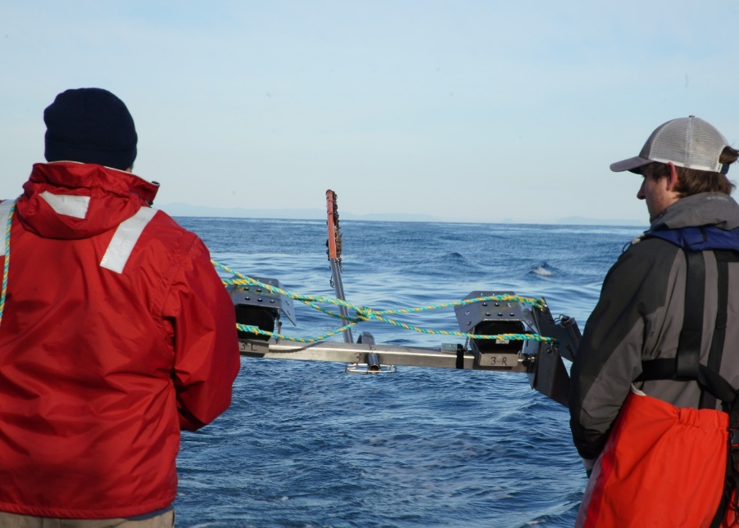

Commonwealth Environmental Impact Statement
Chapter 9 – Benthic ecology
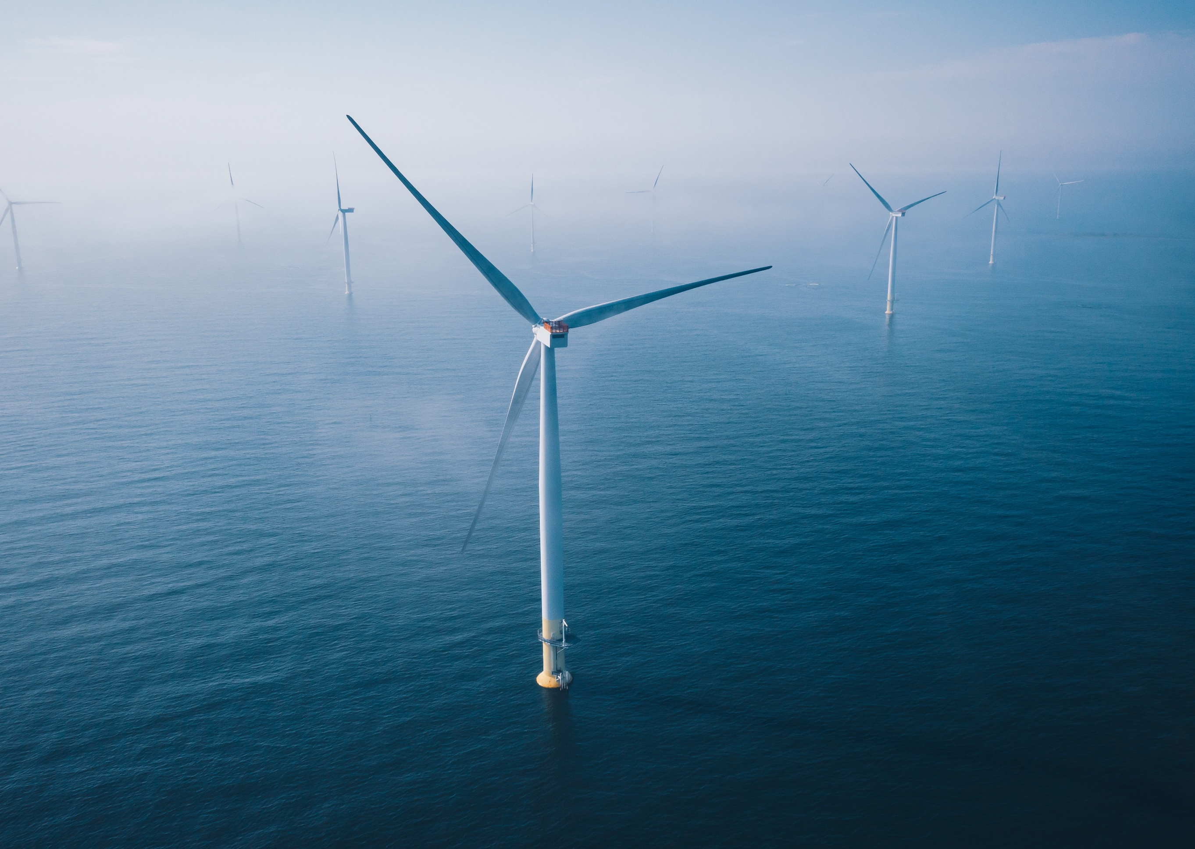
Table of Contents
Chapter 9 Benthic ecology 9-1
9.1 Introduction 9-1
9.2 Assessment scope 9-2
9.2.1 Commonwealth matters 9-2
9.3 Evaluation framework 9-3
9.3.1 Key legislation, policy, guidelines and standards 9-3
9.3.2 Assessment criteria 9-3
9.4 Methods 9-5
9.5 Existing environment 9-6
9.5.1 Physical environment 9-8
9.5.2 Biological environment 9-10
9.5.3 Protected species and communities 9-14
9.5.4 Receptor groups for benthic ecology assessment 9-14
9.6 Construction impacts 9-15
9.6.1 Key impacts 9-15
9.6.2 Other impacts 9-15
9.6.3 Potential risks 9-18
9.7 Operation impacts 9-21
9.7.1 Key impacts 9-21
9.7.2 Other impacts 9-21
9.7.3 Potential risks 9-25
9.8 Decommissioning impacts 9-26
9.8.1 Potential impacts and risks 9-26
9.9 Cumulative Impacts 9-27
9.10 Summary of mitigation, monitoring and contingency measures 9-28
9.10.1 Mitigation measures 9-28
9.10.2 Monitoring and contingency measures 9-28
9.11 Conclusion 9-29

Figures
Figure 9-1 Benthic ecology study area 9-7
Figure 9-2 Water temperature (degrees Celsius) versus seabed depth (metres) of the offshore project area during summer and winter ecological surveys 9-10
Figure 9-3 Benthic habitat map of the offshore project area and surrounds 9-13

Tables
Table 9-1 Key legislation, policy, guidelines and standards relevant to benthic ecology 9-3
Table 9-2 Receptor groups for the impact and risk assessment on benthic ecology 9-14
Table 9-3 Residual impacts from seabed disturbance on benthic habitats and species 9-16
Table 9-4 Residual impacts from changes to water quality on benthic habitats and communities 9-18
Table 9-5 Consequence, likelihood and residual risk ranking for the introduction and establishment of invasive marine species during the construction phase 9-19
Table 9-6 Consequence, likelihood and residual risk ranking associated with an oil spill from the collision of a project vessel during the construction phase 9-20
Table 9-7 Residual impacts from altered hydrodynamics and coastal processes on benthic habitats and species 9-22
Table 9-8 Residual impacts associated with the permanent loss of benthic habitat 9-22
Table 9-9 Residual impacts associated with the presence of artificial substrate 9-23
Table 9-10 Residual impacts associated with changes to water quality from routine vessel discharge 9-24
Table 9-11 Residual impacts associated with the disturbance to seabed from vessel anchoring 9-25
Table 9-12 Summary of cumulative impacts on benthic ecology 9-27
Table 9-13 Summary of mitigation measures relevant to benthic ecology 9-28
Table 9-14 Monitoring and contingency measures relevant to benthic ecology 9-28

Benthic ecology

Introduction
Benthic habitats are the seabed environments that are available for colonisation by flora and fauna at the seafloor. Benthic communities consist of groups of flora and/or fauna which interact with each other or share habitat at the seafloor.
This chapter summarises the existing conditions related to benthic ecology and assesses impacts and risks associated with the construction, operation and decommissioning of the Star of the South Offshore Wind Farm Project (the project) on benthic ecology. The chapter describes how impacts will be avoided, minimised or managed.
Benthic ecology refers to the study of all organisms living on the ocean floor, including sub-surface layers, and how these interact with one another and the environment around them.
This chapter is based on the impact assessment presented in Technical Report B – Benthic Ecology.
Other chapters that relate to or inform the benthic ecology assessment include:
Chapter 8 – Coastal Processes and Sediment Transport
Chapter 10 – Fish and Invertebrates
Chapter 15 – Commercial and Recreational Fisheries
Chapter 17 – Shipping and Navigation

Assessment scope
The study objective for benthic ecology is:
To identify the existing conditions related to benthic ecology and assess the potential impacts and risks associated with the construction, operation and decommissioning of the project on benthic habitats and communities.
All detailed technical methodologies and assessment on benthic ecology can be found in Technical Report B - Benthic Ecology.

Commonwealth matters
The Environmental Impact Statement (EIS) guidelines for the project inform the preparation of the EIS to enable the Commonwealth Minister for the Environment to make an informed decision on whether or not to approve the project under the EPBC Act.
The aspects of the EIS guidelines that are directly relevant to benthic ecology are:
- Section 2.7 Relevant impacts, particularly 2.7 i) predictions of the extent, severity and persistence of impacts of the action on existing marine benthic habitats and communities and the biota they support (e.g. mammals, reptiles, marine plants, fish and invertebrates), and evaluating how these impacts affect marine ecological integrity and functioning, for the Commonwealth marine area as well as any marine protected areas that may be affected.
Further information about the EIS guidelines is listed in Attachment V – EIS Guidelines Checklist.

Evaluation framework

Key legislation, policy, guidelines and standards
Table 9-1 lists the key legislation, policy, guidelines and standards relevant to benthic ecology.
Table 9-1 Key legislation, policy, guidelines and standards relevant to benthic ecology
Type | Applicable legislation, policy, guideline or standard
International conventions/guidance | International Convention for the Prevention of Pollution from Ships 1973 (MARPOL)
International conventions/guidance | Ramsar Convention on Wetlands
Commonwealth Government | Biosecurity Act 2015
Commonwealth Government | Environment Protection and Biodiversity Conservation Act 1999
Commonwealth Government | Key Factors Guidance – Key environmental factors for offshore windfarm environmental impact assessment under the EPBC Act 1999
Commonwealth Government | Matters of National Environmental Significance – Significant impact guidelines 1.1 under the EPBC Act 1999
Commonwealth Government | Offshore Electricity Infrastructure Act 2021
Commonwealth Government | Protection of the Sea (Prevention of Pollution from Ships) Act 1983
Commonwealth Government | Sea Installations Act 1987
Commonwealth Government | Underwater Cultural Heritage Act 2018

Assessment criteria
To assess the project, predicted impacts and risks are compared to criteria that set required environmental performance outcomes (refer Chapter 6 – Assessment Framework).
The criteria for benthic ecology are derived from legislation and policy, relevant standards and guidelines, stakeholder feedback and industry best practice.
The assessment criteria relevant to benthic ecology are:
- Project and monitoring activities will not result in invasive species becoming established that are harmful to benthic habitats and communities
- The project will not modify, destroy, fragment, isolate or disturb an important or substantial area of benthic habitat such that an adverse impact on marine ecosystem functioning or integrity in a Commonwealth marine area results
- There will be no predicted impacts to ecological function or integrity of benthic habitats and communities
- There will be no net loss of biodiversity for benthic habitat and communities
- Project and monitoring activities do not impact taxa so that:
  - Capacity is retained to adapt to environmental changes
  - Taxa and communities do not become threatened, and recovery of threatened taxa and communities is not prevented
- Project and monitoring activities will:
  - Not result in habitat fragmentation to the detriment of benthic habitat and communities
  - Be managed to reduce the risk of petroleum or related products entering the marine and estuarine environment
  - Be managed to reduce the risk of introducing exotic organisms into marine waters
- Project activities maintain and do not compromise the health, diversity and productivity of benthic habitats and communities.

Methods
The purpose of the benthic ecology impact assessment is to assess the potential impacts and risks of the project on benthic ecology.
Impacts refer to the consequences of planned project actions, which are given a rating determined by combining the magnitude of the impact and the sensitivity of the receptor.
Risks are an unexpected (accidental) event and are determined by combining the likelihood of an event occurring and the consequences that would result if the event were to occur.
The technical chapters consider key impacts and risks with a residual consequence rating of moderate to severe. Other impacts and risks are those with a residual consequence rating of negligible to minor. Refer to Chapter 6 – Assessment framework for more detail on how impact and risk ratings are derived.
The assessment was achieved by undertaking the following key tasks:
- Reviewing relevant national, state and local legislation (see Table 9-1)
- Undertaking a desktop review including the identifying matters of national environmental significance under the EPBC Act using the Department of Climate Change, Energy, Environment and Water’s protected matters search tool, Commonwealth and Victorian management plans and policies, published scientific and grey (non-peer reviewed) literature
- Conducting a set of field studies from 2021 to 2023 which aimed to characterise the environmental and biological features of seabed types, identify relevant habitats and their spatial distributions, and refine the understanding of habitat distributions, particularly reef habitats and seagrass presence in the shallower regions of the study area. These studies covered a total of ten square kilometres of seabed using the following methods:
  - Drop cameras for imagery of seafloor habitats (in addition to footage from baited remote underwater videos, see Chapter 10 – Fish and Invertebrates)
  - Sediment grabs for physical, chemical and infauna assemblage assessments
- Consultation with government, regulatory authorities and fishers to inform the description of the existing environment
- Drawing on information provided in the sediment dispersion modelling report in Technical Report B – Benthic Ecology and Attachment II – Oil Spill Modelling Summary.
See Technical Report B – Benthic Ecology for more detail on methodologies and assessment.

Existing environment
This section describes the existing conditions within the study area as they relate to benthic ecology. The study area is defined as:
- The offshore project area made up of the offshore export cable area and the offshore wind farm area (Figure 9-1)
- Baseline marine ecology survey program area which generally extended the borders of the offshore project area by five kilometres, except in extremely shallow and deep zones (Figure 9-1). Two reference areas were also incorporated as a potential means of comparison for monitoring conditions before construction and during operation.
At a regional scale, the offshore project area lies within the Gippsland basin which comprises a variety of seabed substrates including highly mobile sands, shallow seagrass patches, consolidated and unconsolidated shell beds, mixed sediments, pavements with sediment veneer and rocky reefs. The majority of seabed consists of more durable, soft sediment with some areas of high-profile, rocky reef.
The following section describes the existing conditions within the offshore project area and nearby surroundings as they relate to benthic ecology, including specific fauna and flora values.

Figure 9-1 Benthic ecology study area
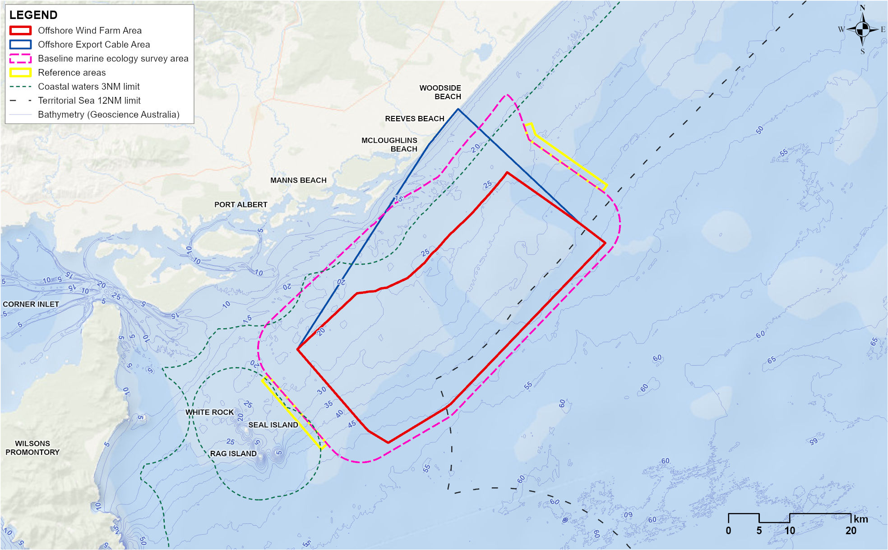

Physical environment
The physical features of the marine environment within and around the offshore project area that can influence benthic ecology are discussed below.

Bathymetry (water depths)
The water depths range from zero to 15 metres in the inshore area and 15 to 53 metres in the offshore wind farm area. Within the offshore wind farm area, the bathymetry varies from east to west, with a shallower seabed profile from the shoreline to the southern boundary in the east (depths ranging from 35 to 39 metres) and a steeper profile in the west (40 to 53 metres). See bathymetry contours in Figure 9-1.

Currents and tides
The eastern Victorian coastline is impacted by the East Australian Current, which is a warm, saline current that is strongest in summer, flowing south and often deflecting westward off Gippsland. In winter, the South Australian Current transports dense, salty water eastward from the Great Australian Bight through Bass Strait, aided by prevailing westerly and south-westerly winds. Eastern Bass Strait currents are shaped by tides, winds, and density-driven flows, with tidal phases varying by several hours across the region. Along the Gippsland coastline, currents tend to flow parallel to the coast, but strong north-easterly winds can occasionally stop or reverse coastal flow. Details related to currents and tides in the study area can be found in Chapter 8 – Coastal Processes and Sediment Transport.

Waves
Bass Strait is a high-energy environment frequently exposed to storms and significant wave heights, driven mainly by strong west to south-west winds. Storms can occur several times a month, typically producing waves of three to four metres, and occasionally exceeding six metres. The offshore wind farm area is exposed to swell from the south-west through southeast and locally generated wind waves from all directions. Wave disturbance to the seabed would be frequent in the shallow, inshore parts of the offshore wind farm area but may only occur during extreme storm conditions in deeper offshore areas. Further details of waves can be found in Chapter 8 – Coastal Processes and Sediment Transport.

Water quality
Water quality in the area is influenced by the open ocean environment of Bass Strait and the Tasman Sea, with strong tidal currents and swells resulting in well-mixed waters. Nutrient levels are generally low but increase in winter due to upwelling which can cause less light to penetrate through the water column than in central Bass Strait, limiting the depth of benthic vegetation. Turbidity and suspended sediments are likely to be low but may spike from occasional flooding, runoff, and tidal currents.

Sedimentology and sediment quality
Sediment samples were collected across the offshore project area during the benthic ecology surveys and ranged from clean, well-sorted sand to poorly sorted mixed sediment. Particle size distribution data identified that sediment types across the offshore project area ranged from sand to gravelly sands to sandy gravels. Sediments were finest in the north-east, with rough shell and mixed coarse sediment distributed across the flat/low profile seabed in the deeper areas (less than 35 metres). Sediments in depth ranges less than 35 metres were dominated by sands. Sediment quality results indicated clean sediments with little anthropogenic influence such as elevated nutrient or metal levels.

Water temperature
Water temperature was measured during fish ecology studies (Chapter 10 – Fish and Invertebrates) which showed that at the seabed, water temperatures during winter were lower and more variable in shallow water (12.0 to 13.8 degrees Celsius) compared to deeper water (14.0 to 14.4 degrees Celsius). This pattern reversed in summer with seabed temperature in shallow water becoming considerably warmer (15.5 to 18.2 degrees Celsius) compared to deeper areas (15.0 to 16.0 degrees Celsius). See Figure 9-2 for a visual representation of these trends.
Figure 9-2 Water temperature (degrees Celsius) versus seabed depth (metres) of the offshore project area during summer and winter ecological surveys
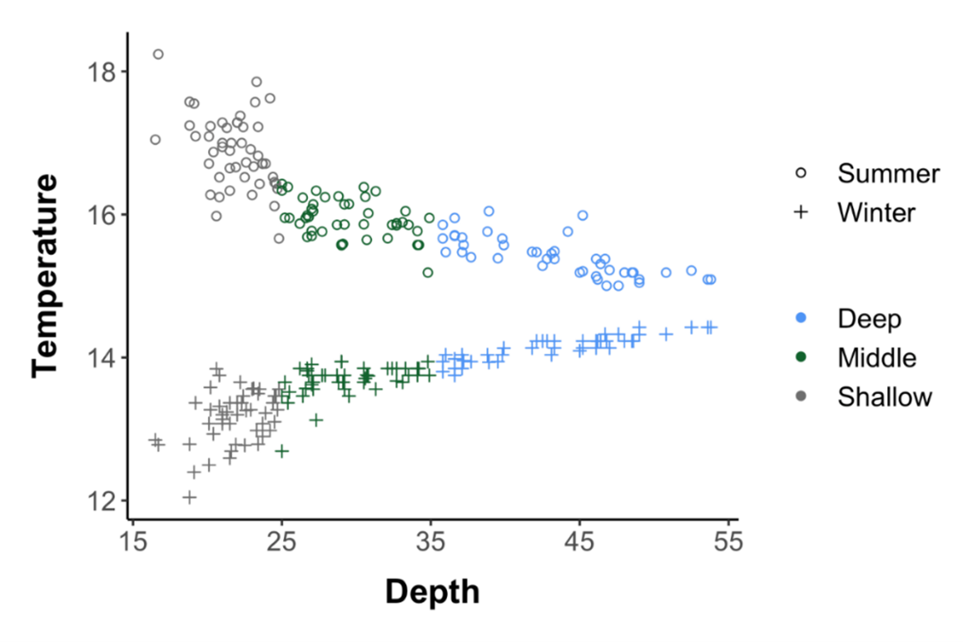

Biological environment

Seagrass
Seagrass forms a key habitat for a range of biological communities and is most abundant in protected, subtidal regions like bays but can also occur in shallow, open coastal areas.
The benthic field surveys identified the presence of Tasman Grass-wrack (Heterozosetra tasmanica) in the offshore project area at depths of 18 to 25 metres. The coverage of Tasman Grass-wrack was sparse and patchy, with continuous growth rarely exceeding a few metres. This patchiness provides a fragmented habitat that is unlikely to produce the same ecological benefits as extensive seagrass meadows (which were not identified in the offshore project area). Such fragmentation suggests the patches are not necessarily permanent and may be subject to regular disturbance by weather events and wave / current energy that is relatively high in the region.

Macroalgae
Macroalgae, categorised into brown, red or green seaweeds, generally attach to hard substrates like rocky reefs and provide a broad range of ecological services. Macroalgae were recorded relatively frequently in field surveys and were strongly associated with rocky reefs. Red seaweeds were the most common although their presence was substantially lower in winter. Giant kelp (Macrocystis pyrifera) forests, considered a threatened ecological community in Victoria, were not observed in the field studies and are considered unlikely to occur within the offshore project area.

Epifauna
Epifauna refers to animals living on the seabed, which are typically dominated by a diverse range of invertebrates that can move or are fixed in place. Field surveys detected areas of medium to high epifaunal diversity and abundance, that were mostly associated with rocky reef and complex substrates. Sponges, bryozoans and ascidians were most prevalent, followed by a lesser presence of cnidarians, crustaceans, echinoderms, molluscs and annelids. No species or communities of concern were detected but two commercially relevant species (doughboy scallop (Mimachlamys asperrima) and commercial scallop (Pecten fumatus)) were observed in low numbers and confined areas which are considered further in Chapter 10 – Fish and Invertebrates.

Infauna
Although mostly out of sight, organisms living within the seafloor sediments (infauna) are important prey items and assist with several ecosystem services including nutrient recycling. The highest diversity of infauna found in the offshore project area were in pavement sediments at depths of 35 to 40 metres. Infauna was dominated by crustaceans and annelid worms, and no species or communities of concern were detected.

Mapped benthic habitats and communities
Data from the benthic field surveys were combined to create an overall habitat map of the offshore project area. In total there were 14 refined habitat classifications associated with five overarching seabed types (see Technical Report B – Benthic Ecology for their details and distribution). These were simplified and categorised into the following three main habitats with their respective distributions shown Figure 9-3:
            - Soft sediment habitat which incorporates multiple categories of soft sediments including sand, coarse sediment, mixed sediment and pavement. Soft sediment habitat is by far the dominant habitat type within the project area, constituting 89.2 per cent of the offshore project area.
            - Soft sediment seagrass habitat that has a patchy presence within the offshore project area and consists of a single species, Heterozostera tasmanica, which is sparsely distributed. Soft sediment seagrass habitat constituted 2.9 per cent of the habitats mapped in the offshore project area, with the highest occurrence overlapping the south-west border.
            - Rocky reef habitat which includes low and high-profile rocky reefs that are distributed patchily across the offshore project area. Rocky reef habitat constitutes 7.9 per cent of the offshore project area, of which 4.3 per cent is high profile rocky reef and 3.6 per cent is low profile rocky reef. The majority of the high-profile rocky reef occurs in the offshore export cable area. Communities associated with rocky reef habitat within the offshore project area are characterised by diverse epibiota including filter feeders, such as bryozoans, hydroids, sponges and ascidians and macroalgae, as well as infauna.
Figure 9-3 Benthic habitat map of the offshore project area and surrounds
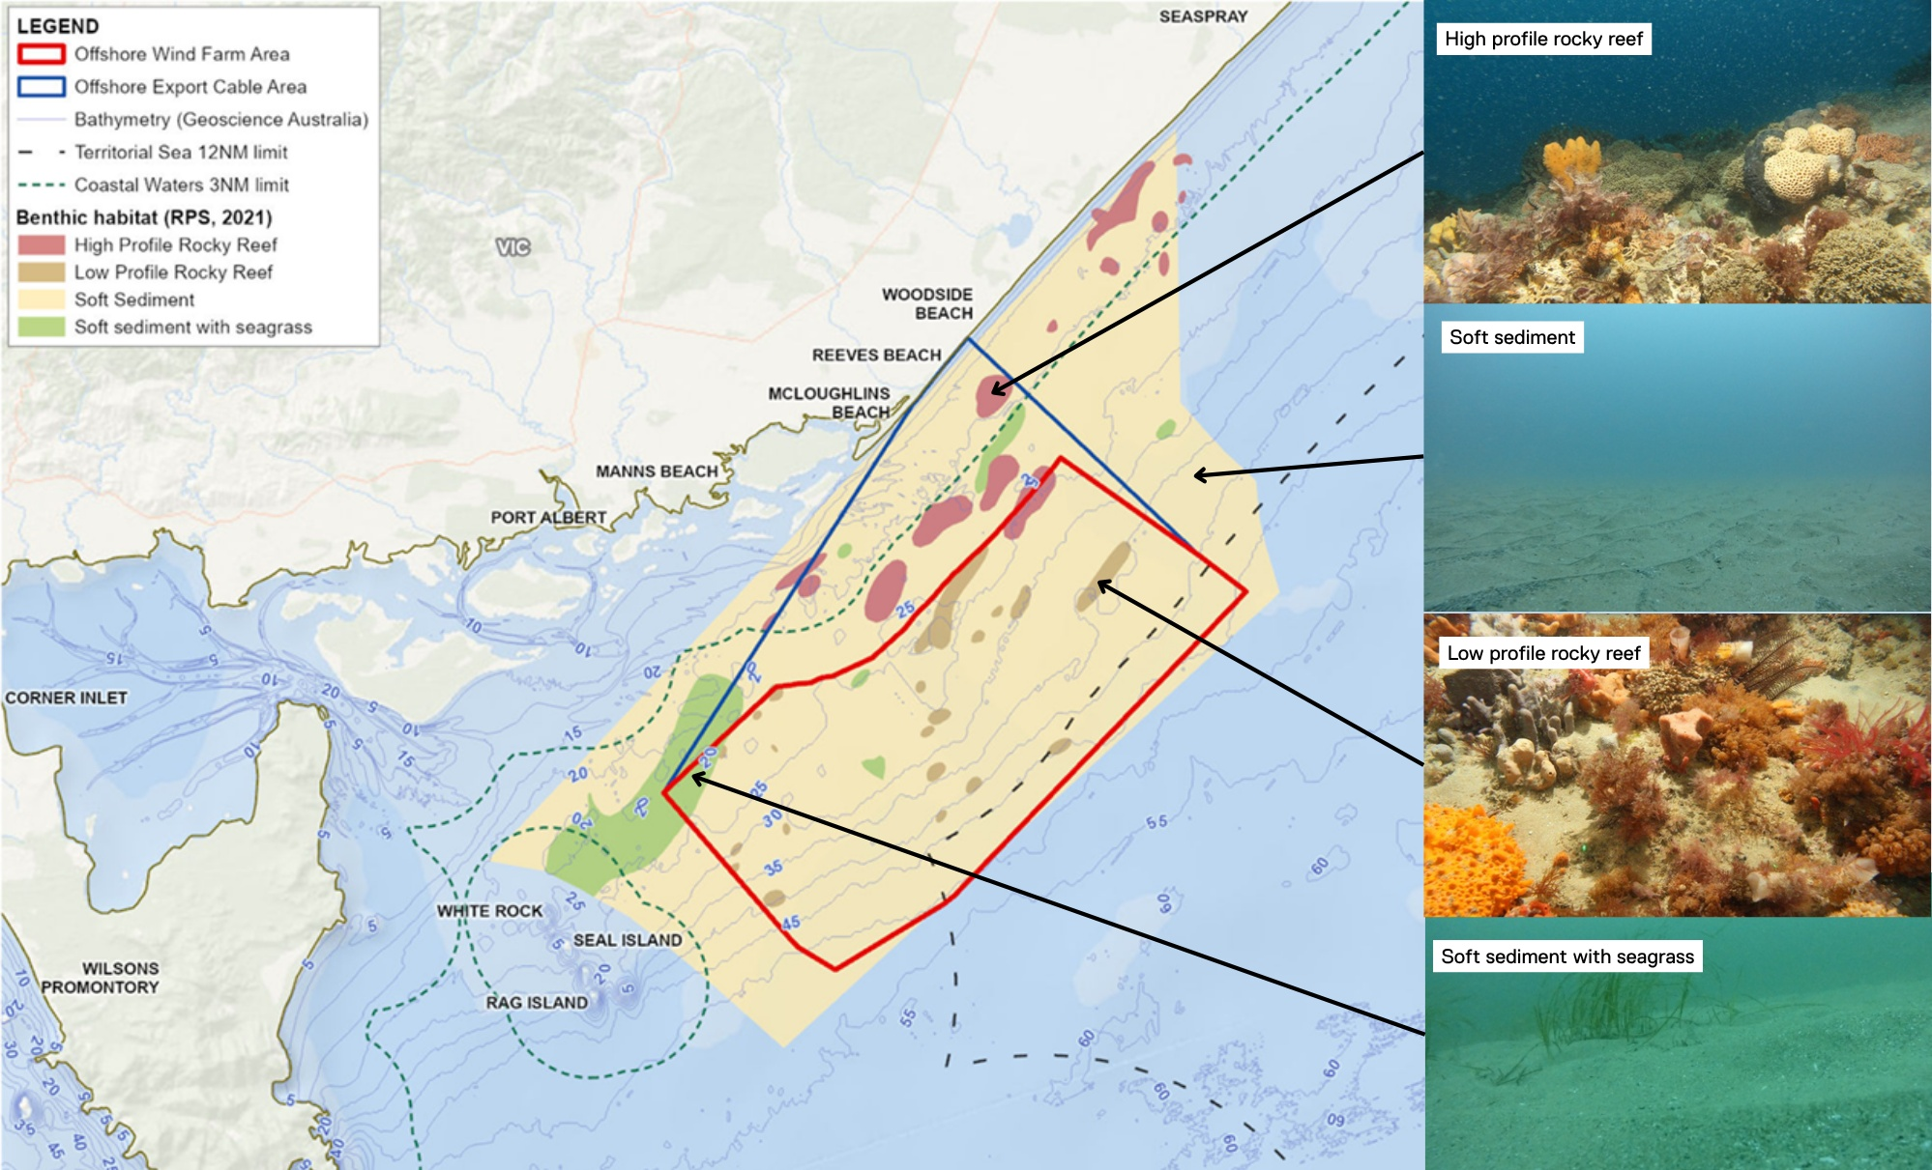

Protected species and communities

EPBC Act
The protected matters search tool identified one matter of national environmental significance overlapping the offshore project area including the ten-kilometre buffer, being the Commonwealth marine area. The Commonwealth marine area consists of all waters beyond state coastal waters, three nautical miles out to 200 nautical miles, and is protected under Part 3 of the EPBC Act.
The protected values of the Commonwealth marine area off the eastern Victorian coastline are captured in the south-east marine region profile. The assessment identified no EPBC Act listed benthic taxa or communities and no key ecological features in or close to the offshore project area. Therefore, impacts to aspects of the Commonwealth marine area are inferred using the outcomes of the impact assessments for each defined receptor group.

Receptor groups for benthic ecology assessment
Derived from all data gathered to describe the existing benthic environment, three key receptor groups were classified for the impact and risk assessments on benthic ecology. These receptor groups are listed in Table 9-2.
Table 9-2 Receptor groups for the impact and risk assessment on benthic ecology
Receptor group | Description
Soft sediment habitat | Soft-sediment habitat and communities that have a higher abundance of mobile and sessile infauna and form most of the offshore project area.
Soft sediment seagrass habitat | Benthic habitat and community of high social, ecological and conservation importance.
Rocky reef habitat | Low- and high-profile reef assemblages of ecological value including habitat for fish and mobile invertebrates.

Construction impacts
This section discusses the impacts and risks associated with the project’s construction that relate to benthic ecology and the respective receptor groups.

Key impacts
The construction impact assessment identified no impacts to benthic ecology receptor groups with a residual consequence rating of moderate or higher.

Other impacts
Other potential construction impacts with minor to negligible consequence to benthic habitats once mitigation measures are implemented include:
- Seabed disturbance (BEC-I01)
- Changes to water quality (BEC-I02).

Seabed disturbance (BEC-I01)

Potential impact
Construction activities including site preparations, cable installations, shore crossing works, foundation piling and vessel activities may drive a temporary loss or alteration of benthic habitats and communities from physical disturbance of the seabed.
It is estimated the maximum footprint of impact from these activities, in terms of temporary seabed disturbance, could equate to 1.48 per cent of the offshore project area. Approximately 1.29 per cent of the offshore wind farm area and 1.93 per cent of the offshore export cable area could be temporarily disturbed.
Activities like foundation piling and cable installation can also cause sediment to disperse across adjacent seabed. To address this, sediment dispersion modelling was conducted and results indicated that, based on the maximum design scenario, combined construction activities may lead to the deposition of 0.8 millimetres of sediment across a total seabed area of 48.9 square kilometres in the offshore wind farm area and 28.9 square kilometres in the offshore export cable area. These modelling scenarios are highly conservative as studies suggest that harm to benthic macrofauna from sediment deposition may only start to occur when deposition thickness is greater than 6.5 millimetres.

Mitigation and monitoring
The majority of habitat type that may be disturbed is soft sediment which is less sensitive to sediment deposition and disturbance compared to habitats like rocky reefs. To minimise impacts to sensitive habitats, and as part of the wind farm layout principles, a non-destructive geophysical survey (BHC-M01) prior to construction will enable micro-siting and assist with the avoidance of sensitive benthic habitats including high-profile rocky reefs. A monitoring program (MEMP-06) will assess seabed disturbance impacts and detect benthic habitat recovery over time.
Micro-siting is the process of selecting the exact spot within a project area to place infrastructure.

Residual impact
Following mitigation measures, most of the benthic habitat temporarily disturbed will likely be soft-sediment and impacts will be of a low to negligible magnitude as they are localised and the majority of seabed will not be affected at all. Considering this, residual impacts to all receptor groups are considered minor to negligible (Table 9-3).
Table 9-3 Residual impacts from seabed disturbance on benthic habitats and species
Potential impact | Receptor group | Receptor sensitivity | Magnitude | Initial consequence | Mitigation | Residual consequence
Seabed disturbance | Soft sediment (seagrass) habitat | Medium | Negligible | Negligible | BHC-M01  VES-M01 | Negligible
Seabed disturbance | Rocky reef habitat | Medium | Low | Minor | BHC-M01  VES-M01 | Minor
Seabed disturbance | Soft sediment habitat | Low | Negligible | Negligible | BHC-M01  VES-M01 | Negligible

Changes to water quality (BEC-I02)

Potential impact
A sediment plume is a visible cloud of fine particles (like sand, silt, or mud) suspended in water.
Shore crossing works, foundation piling, foundation drilling (if required), trenching cables and routine vessel discharges may drive changes in water quality that could impact benthic habitats and communities, particularly organisms that prefer clearer waters such as seagrasses and filter feeding invertebrates that are mostly associated with rocky reefs. Piling, foundation drilling and trenching cables can also cause changes to water quality through suspended sediment plumes, with the impacts of drilling being more widespread and therefore the maximum design scenario.
Sediment dispersion modelling was used to estimate how far suspended sediment would travel from construction activities. Modelling indicated that if foundation drilling is required, suspended sediment concentrations of five milligrams per litre may occur up to approximately 9.5 kilometres from the drilling activity, encompassing a swept area of approximately 16.6 square kilometres. The direction of travel of these modelled plumes was mainly parallel to the coast because of metocean conditions, travelling further in the northeast direction than to the southwest. Suspended sediment concentrations of five milligrams per litre may occur up to approximately 0.7 kilometres from export cabling trenching, encompassing a swept area of approximately 5.1 square kilometres. Overall, these plumes will likely dissipate after a maximum of four subsequent tidal cycles, with conditions shortly returning to pre-disturbance levels.
A one litre water bottle with five milligrams per litre of suspended sediment is transparent and one would still be able to see through the bottle.

Mitigation
Impacts associated with altered water quality will be reduced by using water-based drilling fluids that reduces the introduction of synthetic chemicals to the marine environment (OFF-M04) during construction and through the implementation of a vessel operations framework (VES-M01) that manages vessel activity to reduce the risk of vessel collisions, spills and discharges.

Residual impact
Following these mitigation measures, impacts on water quality from construction and routine vessel discharge will be localised and temporary and therefore residual impacts to all receptor groups are considered minor to negligible (Table 9-4).
Table 9-4 Residual impacts from changes to water quality on benthic habitats and communities
Potential Impact | Receptor  Group | Receptor sensitivity | Magnitude | Initial consequence | Mitigation | Residual Consequence
Source: Seabed disturbance | Soft sediment (seagrass) habitat | Medium | Negligible | Negligible | BHC-M01  VES-M01 | Negligible
Source: Seabed disturbance | Rocky reef habitat | Medium | Low | Minor | BHC-M01  VES-M01 | Minor
Source: Seabed disturbance | Soft sediment habitat | Low | Negligible | Negligible | BHC-M01  VES-M01 | Negligible
Source: Routine vessel discharges | Soft sediment (seagrass) habitat | Medium | Negligible | Negligible | VES-M01 | Negligible
Source: Routine vessel discharges | Rocky reef habitat | Medium | Negligible | Negligible | VES-M01 | Negligible
Source: Routine vessel discharges | Soft sediment habitat | Low | Negligible | Negligible | VES-M01 | Negligible

Potential risks
All potential risks to benthic ecology that could arise from the project’s construction have a risk rating of low, and include:
- Introduction and establishment of invasive marine species (BEC-R01)
- Oil spill resulting from collision of a project vessel (BEC-R02).

Introduction and establishment of invasive marine species (BEC-R01)
The introduction and establishment of invasive marine species have the potential to modify benthic habitats and communities due to displacement of existing benthic habitats and communities. Ballast water and biofouling of vessels travelling from foreign areas are the key vectors for the spread of invasive species, but vessels travelling from domestic locations should not be discounted. The increased vessel activity during construction presents a risk of introducing non-indigenous species, especially considering the monopile foundations and scour protection would provide bare substrate for introduced species to colonise and establish.
This risk will be mitigated through vessels complying with relevant biosecurity legislation and guidelines (VES-M05) that manages discharges of ballast water, ensures vessels are confirmed to be a low biosecurity risk before entering Australia or commencing work on the project.
After implementation of mitigation measures, the likelihood of invasive species being introduced and establishing in the offshore project area is rare. Residual risk rankings are considered low for all habitat-type receptor groups (Table 9-5).
Table 9-5 Consequence, likelihood and residual risk ranking for the introduction and establishment of invasive marine species during the construction phase
Potential Risk | Receptor  Group | Receptor sensitivity | Consequence | Initial likelihood | Initial risk ranking | Mitigation | Residual risk ranking
Introduction and establishment of invasive marine species | Soft sediment (seagrass) habitat | Medium | Moderate | Rare | Low | VES-M05 | Low
Introduction and establishment of invasive marine species | Rocky reef habitat | Medium | Moderate | Rare | Low | VES-M05 | Low
Introduction and establishment of invasive marine species | Soft sediment habitat | Low | Moderate | Rare | Low | VES-M05 | Low

Oil spill resulting from collision of a project vessel (BEC-R02)
A surface oil spill from the collision of vessels during construction presents a risk of hydrocarbons reaching benthic habitats and species at concentrations above accepted thresholds. Hydrocarbon release modelling (see Attachment II – Oil Spill Modelling Summary) from two inshore sites in the offshore wind farm area demonstrated considerable variability in the direction and extent of a spill because of prevailing weather and oceanographic conditions. Modelling at these inshore sites indicated a less than two percent probability of an oil spill in the offshore wind farm area entering Corner Inlet.
This risk will be mitigated through a range of procedures that regulate vessel activity (VES-M01, SPL-M02 and SNV-M05), reducing the likelihood of any vessels colliding with one another. In the rare event that a spill occurs, impacts would be minimised by spill response plans (SPL-M02), developed to ensure rapid and effective response to a hydrocarbon release.
After implementation of mitigation measures, the likelihood of a collision occurring is rare and residual risk rankings are considered low for all receptor groups (Table 9-6).
Table 9-6 Consequence, likelihood and residual risk ranking associated with an oil spill from the collision of a project vessel during the construction phase
Potential Risk | Receptor  Group | Receptor sensitivity | Consequence | Initial likelihood | Initial risk ranking | Mitigation | Residual risk ranking
Oil spill resulting from a vessel collision | Soft sediment (seagrass) habitat | Medium | Moderate | Rare | Low | VES-M01  SPL-M02  SNV-M05 | Low
Oil spill resulting from a vessel collision | Rocky reef habitat | Medium | Moderate | Rare | Low | VES-M01  SPL-M02  SNV-M05 | Low
Oil spill resulting from a vessel collision | Soft sediment habitat | Low | Negligible | Rare | Low | VES-M01  SPL-M02  SNV-M05 | Low

Operation impacts
This section discusses the impacts and risks associated with the operation of the project that relate to benthic ecology and the respective receptor groups.

Key impacts
The operation impact assessment identified no impacts with a residual consequence to benthic ecology receptor groups of moderate or higher.

Other impacts
Other potential operation impacts with minor to negligible consequence to benthic habitats included:
- Altered hydrodynamics and coastal processes (BEC-I03)
- Permanent loss of benthic habitat (BEC-I04)
- Physical presence of artificial substrate (BEC-I05)
- Changes to water quality from vessel discharge (BEC-I06)
- Disturbance to seabed from vessel anchoring (BEC-I07).

Altered hydrodynamics and coastal processes (BEC-I03)
Once installed, the physical presence of offshore wind turbines and substations have potential to cause turbulence by changing water flow around the foundations. In turn, this could impact surrounding benthic habitats, particularly those that are more sensitive to changes in sediment deposition such as seagrass and rocky reefs.
Hydrodynamic modelling indicated that currents immediately downstream of individual monopile foundations may be reduced by up to seven per cent in the surface and bottom layers (see Chapter 8 – Coastal Processes and Sediment Transport). Overall, these changes are considered to be localised and are likely to be spatially inconsistent, depending on the location of the monopile.
As impacts are likely to be small and localised to the near vicinity of each monopile, residual impacts to benthic habitats and communities are considered minor to negligible (Table 9-7).
Table 9-7 Residual impacts from altered hydrodynamics and coastal processes on benthic habitats and species
Potential Impact | Receptor  Group | Receptor sensitivity | Magnitude | Initial consequence | Mitigation | Residual Consequence
Altered hydrodynamics and coastal processes | Soft sediment (seagrass) habitat | Medium | Low | Minor | - | Minor
Altered hydrodynamics and coastal processes | Rocky reef habitat | Medium | Low | Minor | - | Minor
Altered hydrodynamics and coastal processes | Soft sediment habitat | Low | Low | Negligible | - | Negligible

Permanent loss of benthic habitat (BEC-I04)
Over the operational life of the project, the physical presence of wind turbines and offshore substations, scour protection and cable protection may replace existing habitat and cause a permanent loss of some benthic habitat. The total footprint of this permanent infrastructure, and therefore the associated loss of benthic habitat, is estimated to be a maximum of 0.584 square kilometres equating to 0.06 percent of the offshore project area.
As the micro-siting mitigation measure discussed for the construction phase (BHC-M01) will allow the avoidance of high-profile reef, the majority of lost habitat will be soft sediment which is the most prevalent habitat type in the region. Given this, no net loss of biodiversity is expected. Residual impacts to benthic habitats and communities are therefore considered negligible (Table 9-8) and the monitoring program (MEMP-06) will detect benthic habitat recovery over time.
Table 9-8 Residual impacts associated with the permanent loss of benthic habitat
Potential Impact | Receptor  Group | Receptor sensitivity | Magnitude | Initial consequence | Mitigation | Residual Consequence
Permanent loss of habitat due to installed project infrastructure | Soft sediment (seagrass) habitat | Medium | Negligible | Negligible | BHC-M01 | Negligible
 | Rocky reef habitat | Medium | Negligible | Negligible | BHC-M01 | Negligible
 | Soft sediment habitat | Low | Negligible | Negligible | BHC-M01 | Negligible

Physical presence of artificial substrate (BEC-I05)
During the operation phase of the project, artificial substrates will be created by installed infrastructure, with a maximum footprint of 0.584 square kilometres, made up of the wind turbines and offshore substation foundations and their scour protection, cable remedial protection, cable crossings and shore crossing protection.
This artificial substrate will be colonised by attached organisms which may form artificial reefs and alter local benthic habitats or communities. The colonising species are likely to be consistent with those in the surrounding area, as was documented in the 80 species that settled on the scientific equipment moorings during the marine ecology survey program.
While a change in the composition and structure of benthic habitats and communities may occur, particularly in soft-sediment areas, due to the presence of new artificial substrate. The relatively small footprint of artificial structures and their potential to form artificial reefs is not expected to drive biodiversity loss and the magnitude of the impact is therefore considered negligible. Residual impacts to benthic habitats and communities are considered negligible (Table 9-9) and the monitoring program (MEMP-06) will detect benthic habitat change over time.
Table 9-9 Residual impacts associated with the presence of artificial substrate
Potential Impact | Receptor  Group | Receptor sensitivity | Magnitude | Initial consequence | Mitigation | Residual Consequence
Artificial habitat due to exposed infrastructure | Soft sediment (seagrass) habitat | Medium | Negligible | Negligible | - | Negligible
Artificial habitat due to exposed infrastructure | Rocky reef habitat | Medium | Negligible | Negligible | - | Negligible
Artificial habitat due to exposed infrastructure | Soft sediment habitat | Low | Negligible | Negligible | - | Negligible

Changes to water quality from vessel discharge (BEC-I06)
Offshore vessels routinely discharge small volumes of liquid and solid waste which can alter water quality and potentially impact benthic habitats. Operational and maintenance vessel activity will occur over the operation phase which may lead to impacts on benthic habitats through altered water quality from discharge.
These discharge impacts will be mitigated by the vessel operations framework (VES-M01) that includes compliance with the International Convention for the Prevention of Pollution from Ships 1973 (MARPOL) which provides regulations around vessel discharge. The high energy nature of the currents within the offshore project area means that rapid mixing and dilution of any potentially harmful substances from vessel discharge would likely occur before reaching the seabed.
As the presence of vessels will be temporary, localised and any waste substances will be rapidly diluted by the high energy nature of the offshore project area, residual impacts to benthic habitats and communities are considered negligible (Table 9-10).
Table 9-10 Residual impacts associated with changes to water quality from routine vessel discharge
Potential Impact | Receptor  Group | Receptor sensitivity | Magnitude | Initial consequence | Mitigation | Residual Consequence
Changes to water quality from vessel discharges during operations | Soft sediment (seagrass) habitat | Medium | Negligible | Negligible | VES-M01 | Negligible
 | Rocky reef habitat | Medium | Negligible | Negligible | VES-M01 | Negligible
 | Soft sediment habitat | Low | Negligible | Negligible | VES-M01 | Negligible

Disturbance to seabed from vessel anchoring (BEC-I07)
Vessel anchoring may occur during routine operations which can physically disturb benthic habitats and communities.
The majority of vessels used during operations will be crew transfer vessels that do not require anchoring. This impact will be further mitigated by the vessel operations framework (VES-M01) that includes the avoidance of anchoring on seagrass and rocky reef habitats if possible.
As such, seabed disturbance caused by anchoring of project vessels is expected to be infrequent, small in scale and incidental. Residual impacts to benthic habitats and communities from anchoring are considered negligible (Table 9-11).

Table 9-11 Residual impacts associated with the disturbance to seabed from vessel anchoring
Potential Impact | Receptor  Group | Receptor sensitivity | Magnitude | Initial consequence | Mitigation | Residual Consequence
Seabed disturbance from anchoring during routine operations | Soft sediment (seagrass) habitat | Medium | Negligible | Negligible | VES-M01 | Negligible
Seabed disturbance from anchoring during routine operations | Rocky reef habitat | Medium | Negligible | Negligible | VES-M01 | Negligible
Seabed disturbance from anchoring during routine operations | Soft sediment habitat | Low | Negligible | Negligible | VES-M01 | Negligible

Potential risks
The potential risks associated with the operation phase are:
- Introduction and establishment of invasive marine species (BEC-R01)
- Oil spill resulting from collision of a project vessel (BEC-R02).
These risks have been conservatively assessed the same as those described for the construction phase, but with a lesser likelihood of occurrence because of the lower levels of vessel activity during operations. See Section 9.6.3 for the assessment and mitigations, and Technical Report B – Benthic Ecology for further detail.

Decommissioning impacts

Potential impacts and risks
Decommissioning is expected to involve similar types and numbers of vessels and equipment as the construction phase. Requirements at the time will determine the scope of decommissioning activities and impacts. The anticipated duration is up to three years.
A Marine Decommissioning Management Plan (DEC-M01) will be developed prior to decommissioning to assess the potential impacts from the final agreed methodologies of removing offshore infrastructure.

Cumulative Impacts
This section provides an assessment of the potential for cumulative impacts of the project with other proposed developments in the region. The method to consider cumulative impacts is described in Chapter 6 – Assessment framework.
Potential cumulative impacts arise when the effects of a single project on a receptor are considered alongside the effects of other projects on the same receptor. Projects that are operational are part of the baseline environment, and the cumulative impact assessment focuses on future developments following the tiered assessment methodology.
The projects identified in the cumulative impact assessment for benthic ecology are summarised in Table 9-12.
Table 9-12 Summary of cumulative impacts on benthic ecology
Project | Project description | Findings of assessment
Great Eastern Offshore Wind Farm, Corio Generation | The Great Eastern Offshore Wind Farm is a referred offshore windfarm located immediately adjacent to the southeast of the offshore wind farm area, 25-45 kilometres from Reeves Beach.  The project includes up to 172 fixed foundation wind turbines with a maximum blade tip height of 375 metres, eight offshore substations and associated infrastructure in operation, generating up to 2.5 GW of electricity.  Construction is expected to occur from 2028 to 2032, followed by a 30-year operational period. | Impact pathways assessed for cumulative impacts on benthic ecology receptor groups, based on Great Eastern offshore Wind Farm project EPBC Act referral were:  - Temporary seabed disturbance  - Changes to water quality  - Invasive marine species  - Oil spill from a vessel  - Altered hydrodynamics  - Permanent loss of benthic habitat  - Addition of artificial hard substrate  Given Great Eastern Offshore Wind Farm is very similar in scope to the project, it is assumed that impacts to benthic ecology receptors will be broadly comparable. It is expected that similar habitat types will be present within Great Eastern Offshore Wind Farm area, including widespread soft sediment and the potential for low- and high-profile reef, but less potential for seagrass given the depths of the project area.  As demonstrated in the project’s assessment, impacts to benthic ecology are likely to be very localised and/ or temporary and any cumulative impacts are therefore unlikely to be greater than negligible to minor due to limited scope for spatial overlap between the projects. See Technical Report B – Benthic Ecology for further detail.

Summary of mitigation, monitoring and contingency measures

Mitigation measures
The following section outlines the mitigation measures developed to avoid and minimise impacts on the benthic environment in the offshore project area.
The focus of these mitigation measures is:
- Avoiding impacts where reasonably practicable
- Developing, preparing and implementing project-specific measures to minimise impacts.
The mitigations below have been developed for the impacts and risks discussed in detail within Technical Report B – Benthic Ecology. Detailed descriptions of each measure can be found in Chapter 23 – Commonwealth Environmental Management Framework and are listed in Table 9-13.
Table 9-13 Summary of mitigation measures relevant to benthic ecology
ID | Mitigation measure
VES-M01 | Vessel operations framework
SPL-M02 | Spill response plan
VES-M05 | Vessel biosecurity control
OFF-M04 | Low toxicity marine drilling fluids
SPL-M03 | Maintenance of offshore substation transformers
SNV-M05 | Project vessel safety requirements
BHC-M01 | Pre-construction geophysical survey - avoidance of high-profile reef
DEC-M01 | Marine decommissioning management plan

Monitoring and contingency measures
The monitoring and contingency measures that are proposed to assess benthic ecology impacts associated with the project are described in Table 9-14.
Table 9-14 Monitoring and contingency measures relevant to benthic ecology
ID | Monitoring measure
MEMP-M06 | Monitoring of benthic habitats

Conclusion
This chapter identifies the existing conditions related to benthic ecology and assesses the impacts and risks associated with the construction, operation and decommissioning of the project.
Benthic habitats in the offshore project area mainly consist of soft sediments, with sparse patches of seagrass and rocky reefs. The assessment identified no EPBC Act listed benthic taxa or communities and no key ecological features in the offshore project area.
The assessment considered impacts from the project to benthic ecology as those that may result from the disturbance to and loss of seabed, changes in water quality, the presence of artificial substrate and changes in hydrodynamics and coastal processes. Residual consequences of these impacts on benthic habitats and communities were all assessed as negligible to minor given either their temporary or localised nature and following mitigations that include pre-construction surveys to inform micro-siting and the avoidance of direct impacts to key habitats such as high-profile reef.
Residual risks to benthic ecology across all phases of the project include the introduction and establishment of non-indigenous marine species and oil spills from vessel collision. The mitigation measures include tightly controlled vessel activity and biosecurity making the likelihood of these risks occurring extremely rare. Residual risk rankings were considered low for all benthic ecology receptor groups.
No adverse effects to ecological function and integrity of any benthic ecology receptors are expected as a result of the cumulative impacts of the project and other activities in the area.
Precautionary monitoring will be undertaken to assess the impact and recovery of seabed disturbance on benthic habitats from project construction activities and to inform management decisions.
Overall, the respective EIS guidelines have been met for benthic habitats and communities.

