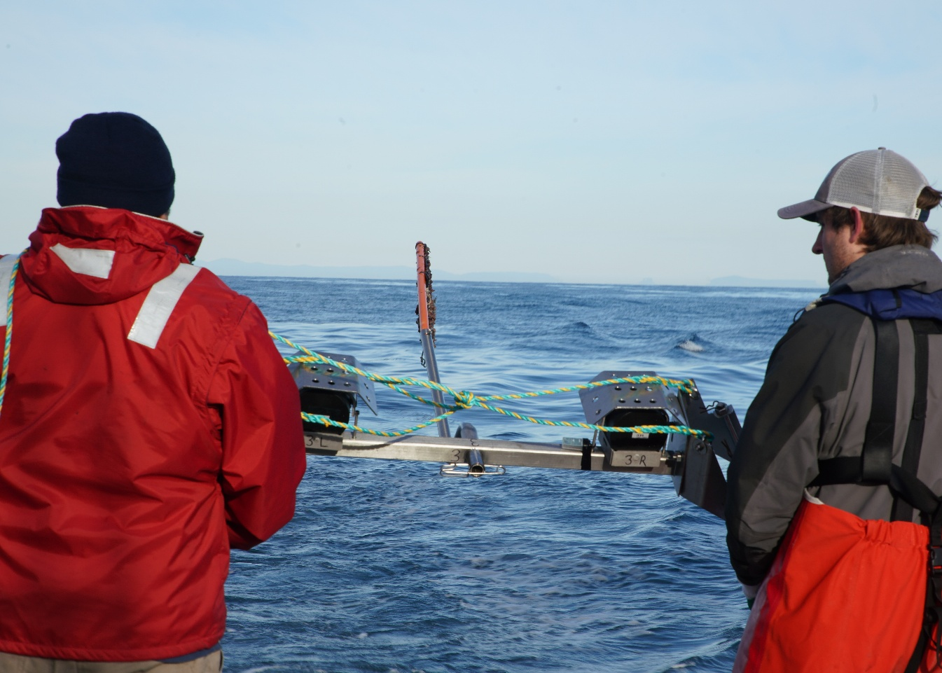
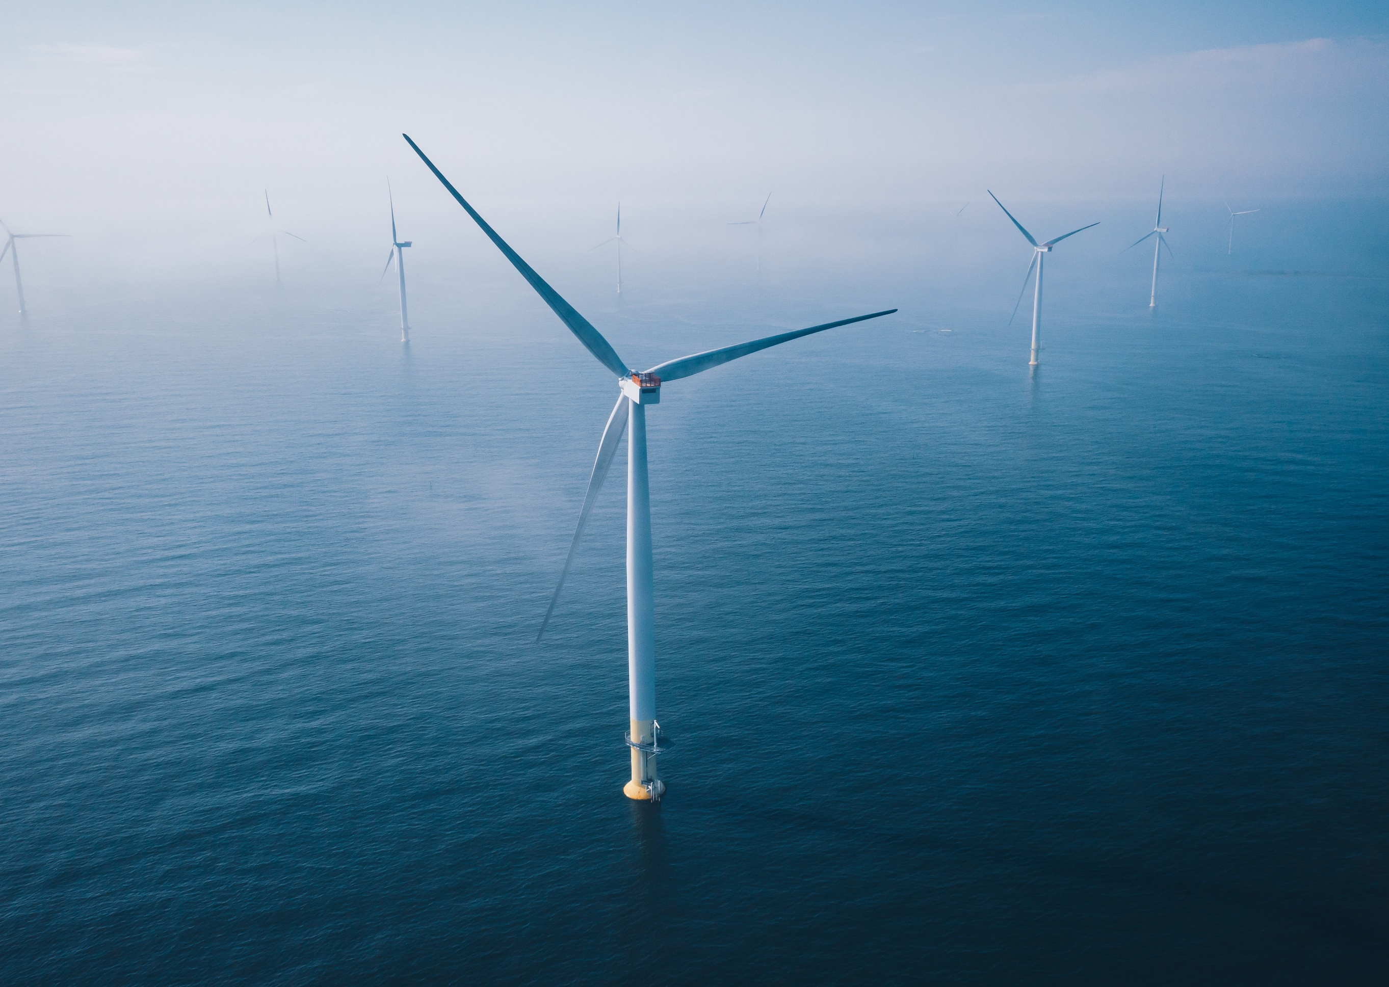

Commonwealth Environmental Impact Statement
Glossary and abbreviations

Glossary
Term | Description
Aboriginal place | An Aboriginal place is a location that holds cultural, spiritual, or historical importance to Aboriginal people. It could be a natural feature like a rock formation or waterhole, an archaeological site with artefacts, or a place where ceremonies, stories, or significant events took place.
Accretion | Accretion is the opposite of erosion, whereby sand or other sediments gradually build up in an area, on a beach or along a shoreline, causing the land grow or extend seaward over time.
Acidic leachate | Water that becomes acidic after passing through certain soils or rocks, and it can pick up harmful substances along the way. If not properly managed, it can affect plants, animals, and nearby waterways.
Acid sulfate soils | Naturally occurring soils that contain chemicals that can produce mild acidity when exposed to air and water. If disturbed, they may require management to prevent impacts on water quality, the environment, and infrastructure.
Action management plans | Plans that describe how, where and when potential impacts will be avoided, mitigated and/or compensated in accordance the EPBC Act approval for the project.
Air gap | Air gap refers to the space between the water level and the tip of the turbine blade (or start of the rotor swept area).
Ambient noise | The average sound level across a given time interval. This is referred to as the A-weighted, equivalent (average) sound level or L_{Aeq}. A-weighting is an adjustment applied to noise measurements to reflect how it is perceived by the human ear.
Anchor snag | Refers to when an anchor of a vessel gets caught on the seabed or on an object.
Annual Exceedance Probability | The probability of a particular sized event being exceeded in any given year.
Aquifer | Permeable underground layers of rock or sand that allow groundwater to flow.
Aquitard | Less permeable layers like clay that restrict groundwater movement.
Background noise | Generally refers to the aggregated background sound from all sources typically audible in a particular location. It is usually measured using statistical level (L_{A90}), which represents the noise level exceeded 90% of the time across the measurement time period.
Basslink Interconnector | The Basslink Interconnector traverses the offshore wind farm area and is a bundled high-voltage direct current power cable that connects Victoria and Tasmania.
Batching | The process of mixing materials like sand, gravel, water, and cement to create a strong, stable material that can be used to fill in excavated areas or support underground structures.
Bathymetry | The measure of water depth in oceans.
Batch plants | Sites to provide local batching of thermally stable backfill and structural concrete.
Benthic habitats | The seabed environments that are available for colonisation by flora and fauna at the seafloor.
Benthopelagic | Describes species that live and feed near the seabed, in the midwaters or near the surface.
Biologically important area | Spatially defined areas where aggregations of individuals of a species are known to display a biologically important behaviour such as breeding, foraging, resting or migration.
Bore drilling | Creating a narrow, deep hole in the ground using a land-based rig to reach offshore.
Cable burial risk assessment | Risk assessment to determine suitable burial depths for cables, based upon hazards such as anchor strike, fishing gear interaction and seabed mobility.
Cable crossing | The crossing of existing subsea cables by the formation of ‘bridges’ or piped protection to provide separation between cables.
Cable easement | The underground cable system will be installed within a 40-metre-wide easement.
Cardinal Buoy | A cardinal buoy is a sea marker that indicates the position of a hazard and direction of safe travel.
Cetacean | A marine mammal of the order Cetacea; a whale, dolphin, or porpoise.
Combined sound power level | The total sound energy emitted by a source, measured in decibels (dB) with a frequency weighting (A-weighting) that adjusts for the sensitivity of human hearing. It combines the contributions of all relevant noise sources (for example tools, vehicles, construction plant) to provide a comprehensive measure of their overall impact.
Communications cables | Fibre optic cables will be integrated into the system to enable data transfer and communication with the offshore wind farm.
Concrete mattress | Scour or cable protection using high-strength concrete blocks bound with ultraviolet-stabilised polypropylene rope.
Cone of depression | The area where groundwater levels drop due to dewatering.
Construction works | Main construction works required for the foundations, turbines, array cables, export cables, offshore substation and onshore cables. Construction includes commissioning of all project components.  Construction excludes preparatory works.
Crew transfer vessel | Port-based vessel used to transport offshore wind farm technicians and staff to site during the construction and operation phases.
Commonwealth waters | Any waters of the sea beyond three nautical miles (state waters) to the boundary of the exclusive economic zone (EEZ). Jurisdiction over the water column and the subjacent seabed is vested to the Commonwealth.
Contractor | Contractor directly engaged by Star of the South for a works package. Contractors may engage sub-contractors for the delivery of a works package.
Copenhagen Infrastructure Partners | A multinational fund management company headquartered in Denmark, specialising in investments into greenfield energy infrastructure projects globally, including Star of the South.
Cumulative impact | The resultant impact of the project, in combination with one or more other existing or proposed projects in the area, on the same environmental asset. The total impact from the contributing projects is the cumulative impact.
Daub style | An ancient construction technique used for building walls, that involves weaving a lattice of wooden strips (wattle) and then covering it with a sticky material (daub) made from a combination of wet soil, clay, sand, and straw.
Declared area | Declaring suitable areas for offshore wind is a decision for the Minister for Climate Change and Energy. Sucha areas are Declared Areas.
Deep ripping | Deep ripping is a process that involves breaking up compacted soil layers using specialised equipment.
Decommissioning | The process of safely removing an offshore wind farm and associated infrastructure once it reaches the end of its operational life.
Deposit | Layers of soil, sand, or other sediments that have been naturally laid down over time by processes like wind, water, or geological activity.
Dewatering | The process of removing groundwater that seeps into excavations through its base and sides. Dewatering is performed to ensure construction work can continue safely.
Double Big Bubble Curtain uses | A Double Big Bubble Curtain uses two rings of bubbles to surround an activity and act like a sound shield. When loud construction noise tries to travel through the water, the bubble walls scatter and reduce the noise before it extends further into the ocean.
Drawdown | Construction dewatering to lower the groundwater level in areas immediately adjacent to excavations.
Dry sheep equivalent | This a standard unit used in Australia to compare the feed requirements of different classes of stock and to assess the carrying capacity and potential productivity of a given farm or area of grazing land. The unit represents the amount of feed required by a two-year-old, 45 kilograms merino sheep (wether or non-lactating, non-pregnant ewe) to maintain its weight.
Dynamic positioning thrusters | Dynamic positioning thrusters are like underwater fans that help a ship stay in one spot or move precisely, even when wind, waves, or currents try to push it around.
Ecology | Refers to native flora (plants) and fauna (animals) and their supporting environments.
Ecosystem | An ecosystem is a group of interconnected organisms (animals, plants and microbes) and their physical environment found in a particular area.
Ecosystem resilience | Ecosystem resilience is the capacity of ecosystems to deal with disturbances, either by resisting them, recovering from them or adapting to them, while retaining their ability to deliver services and benefits now and in the future. The common attributes of ecosystems that make them resilient include diversity, connectivity, extent (spatial) and condition.
Electricity network | A coordinated system of transmission and distribution infrastructure that delivers electrical energy from generators to end users across the national electricity market.
Electromagnetic fields | Electromagnetic fields are invisible areas of energy, often referred to as radiation that are associated with the use of electrical power. Electromagnetic field is an umbrella term that refers to both electric fields and magnetic fields, which are interrelated.
Endemic | Endemic means that an organism is only found and/ or breeds in a specific place and nowhere else in the world.
Ensonified area | The part of the ocean in which underwater noise may be heard at specific levels from activities like piling.
Environment | Consistent with the Environment Protection and Biodiversity Conservation Act 1999 and the Environment Effects Act 1978, the definition of environment encompasses physical, biological, heritage, cultural, social, health, safety and economic aspects.
Environmental value | An aspect of the environment that is important, including natural resources and ecosystems, in terms of their ability to support life, maintain ecological balance, and provide benefits to humans and other living organisms.
Environment Effects Statement | The Victorian Environment Effects Statement (EES) is the State of Victoria’s comprehensive environmental impact assessment process. It is used to evaluate the potential environmental, social, cultural and economic impacts of projects before they can proceed.
Environmental Impact Statement | The Commonwealth Environmental Impact Statement (EIS) is the Australian Government’s formal environmental impact assessment process prepared for projects that are likely to have an impact on matters of national environmental significance under the Environment Protection and Biodiversity Conservation Act 1999 (EPBC Act).
Environmental management plans | Plans required to implement mitigation measures and comply with approval conditions, but does not include Action Management Plans to be approved under the EPBC Act.
Ephemeral waterway | Watercourses that are typically dry or have very limited flow for most of the year
Escort vessels | Escort vessels will be used to monitor the offshore project area during construction, communicate with and support the safety of third-party vessels, and avoid disruption to construction activities.
Exploration licence | Bespoke licence issued by the Commonwealth Government allowing site investigations to study the site's offshore wind potential.
Feasibility licence | Licence issued by the Commonwealth Government that allows licence holders to begin the assessment work needed to determine the feasibility of their proposed offshore wind projects.
Fetch | How far the wind can blow across without being blocked.
Foundation | The load-carrying support structure for the wind turbine generator or offshore substation.
Forecast modelling | Forecast modelling uses computers and data to predict how waves and currents will behave in the future.
Freshwater lens | Due to density differences in coastal areas, fresher (less saline) groundwater forms a layer above more saline water
General public (in ICNIRP guidelines) | The general public are defined as individuals of all ages and of differing health statuses, which may include particularly vulnerable groups or individuals, and who may have no knowledge of or control over their exposure to electric and magnetic fields.
Geotechnical surveys | Geotechnical surveys are an investigation of the seabed. This entails methods like digging, drilling and testing soil and rock to understand the seabed's underlying properties.
Gippsland Declared Area | The approximately 15,000 square kilometre area of seabed offshore of Gippsland declared under the Offshore Electricity Infrastructure Act 2021 (Cth) that can be developed for offshore renewable energy.
Groundwater-dependent ecosystems | Ecosystems that rely on groundwater to support its plants, animals, or overall functioning, either directly through groundwater flowing to the surface (like springs or wetlands) or indirectly through the presence of groundwater below the surface (like deep-rooted vegetation).
Groundwater wells | Structures created to access water stored underground in aquifers.
Hammer energy | The amount of force an impact hammer delivers to drive foundation piles into the seabed.
High-voltage alternating current | Alternating current is a type of electrical flow where the direction of the current reverses many times per second.
Horizontal directional drilling | A method used to install pipes or cables underground, or underneath dune systems, without digging an open trench.
Hydraulic conductivity | The ease with which a fluid, usually water, can move through spaces between soil and rocks or cracks / breaks in soil or rock.
Hydrodynamic forecast modelling | Hydrodynamic forecast modelling uses computers to simulate water movements (such as waves, tides, and currents) to understand and predict how the ocean behaves in different conditions.
Hydro Sound Dampener | A Hydro Sound Dampener is a physical curtain made of certain materials that absorb or block some of the sound before it spreads through the water.
Impact | A positive or negative change to an environmental asset (including physical, ecological and socio-economic assets) that is caused by a project activity.
Inter-array cable | High-voltage cable connecting wind turbine generators to each other and offshore substations.
Interlink cable | High voltage cable connecting offshore substations to each other.
Jet trencher | Jetting tools excavate a trench by directing a high-pressure jet of water at the trench face to fluidise the seabed, allowing the cable to sink to the required burial depth.
Lee/Leeward | The lee (or leeward) side of something is the sheltered side, where the wind is weaker because it’s blocked or slowed by an object.
Liming | The process of adding lime to acidic soils to neutralise the acid.
Lowest Astronomical Tide | The lowest level that tide can be predicted to fall to under average meteorological conditions.
Lowest safe altitude | The lowest altitude at which it is considered safe to fly within a certain area.
Magnitude | The severity, extent and duration of an impact.
Magnitude of visibility | The extent to which project infrastructure is visible from a particular viewpoint. It indicates how much the view is altered by the project and helps determine whether visual mitigation measures are needed.
Marine coordination centre | A marine coordination and construction management centre will manage vessel movements during construction and operations, including providing direction to escort vessels and issuing communications to mariners.
Maximum design scenario | The combination of parameters within the project design envelope that represents the greatest potential (worst case) impacts.
Mechanical trenching | Mechanical trenching machines use a series of picks or scoops mounted on a chain or on a wheel to excavate a trench in which the cable is then laid.
Micro-siting | The process of selecting the exact spot within a project area to place infrastructure
Milligauss | A milligauss measures the strength of a magnetic field produced by electrical appliances and power lines.
Mitigation measure | Actions, commitments or measures that are implemented to avoid, minimise or manage potential impacts. These include boundaries around project design parameters (including construction), as well as the implementation of actions, systems and procedures to avoid, minimise and manage impacts (including monitoring).
Modified hammer system | A modified hammer system is a new feature that cushions the hammers impact and thereby reduces noise
Monitoring | Methods used to review the environmental performance and effectiveness of mitigation measures and to determine if project activities are within defined acceptable levels of impact.
Monopiles | Monopiles are large steel tube foundations that are driven into the seabed by an impact hammer. They are made up of two key components – the monopile and a transition piece.
Mysticetes | Baleen whales that have baleen plates (instead of teeth) in their mouths to strain tiny food like krill and plankton from the water.
National energy market | Australia’s wholesale electricity market that coordinates the generation, transmission, and supply of electricity across the eastern and southern states.
National Pollutant Inventory | An internet database that provides the community, industry and government with free information about the emissions of 93 substances in Australia. The inventory is implemented cooperatively by the Federal Government, the EPA Victoria and other state and territory governments.
Neap tide | Occurs on the first/ third quarter moons and has less extreme tides.
Non-Aboriginal underwater cultural heritage | Includes values such as shipwrecks, unknown historical lost vessels, human remains and historical ordnance.
Occupational staff (in ICNIRP guidelines) | Occupational staff are defined as healthy adults who are exposed to electric and magnetic fields through their occupational duties. Occupational staff are trained to be aware of potential electric and magnetic field risks and understand how to employ appropriate harm-mitigation measures to reduce exposure risk.
Odontocetes | Toothed whales that include species like dolphins, Killer Whales, and Sperm Whales. Unlike baleen whales, odontocetes have teeth for catching prey like fish and squid, and they use echolocation (sound-based navigation) to find food and move around underwater.
OEI Act | Offshore Electricity Infrastructure Act 2021 (Cwth)
OEI Act Management Plan | Management Plan approved by the OIR under Section 114 of the OEI Act.
OEI Regulations | Offshore Electricity Infrastructure Regulations 2022 (Cwth).
Offshore export cable | High-voltage cable used for exporting power from the offshore substations to the onshore export cables.
Offshore export area | A 232 km2 area extending from Reeves Beach to the offshore wind farm area, in which the offshore cable corridor will be located.
Offshore export cable corridor | The area between the offshore wind farm area and the shore crossing, within which up to eight offshore export cables will be installed.
Offshore infrastructure | The offshore infrastructure includes the offshore wind farm (the wind turbine generators and their foundations) and the offshore transmission infrastructure (the inter-array, interlink and offshore export cables as well as the offshore substations and their foundations.
Offshore project area | The area encompassing the offshore wind farm area and the offshore export cable area.
Offshore substation | An offshore substation is a platform used to collect the electricity from the wind turbine generators via inter array cables and convert it to high voltage for transmission to shore. The offshore substation houses transformers, switchgear, control equipment and auxiliary infrastructure to manage power flow.
Offshore wind farm area | The area within which wind turbine generators, inter-array cables, interlink cables and offshore substations will be located, extending approximately 10 to 40 kilometres offshore. The offshore wind farm area is 586 square kilometres.
One-way mid-block capacity of an undivided road | Refers to the maximum number of vehicles that can travel in one direction along a straight section of road, without intersections, during a given time. It depends on factors like lane width, speed, and how closely vehicles follow each other.
Onshore export cable | High-voltage cable used for exporting power on land to the connection hub.
Onshore project area | The area encompassing the onshore transmission system, construction and access areas.
Onshore transmission system | A system consisting of underground cables, fibre and joints, within an easement extending between the shore crossing at Reeves Beach, Woodside and the proposed VicGrid connection hub in Giffard.
Palaeochannel | An ancient, now inactive river/stream channel that is often preserved as a buried deposit of sediments or a visible feature on the landscape, such as on a floodplain or terrace.
Palaeocoastline | An ancient coastline that existed in the past but has since been submerged, eroded, or shifted due to changes such as sea level.
Palaeolandscape | A palaeolandscape is an ancient landscape that existed thousands or even millions of years ago, shaped by natural forces like rivers, glaciers, or sea-level changes.
Particulate matter | A mix of tiny solid particles and liquid droplets in the air, like dust, soot, smoke, and pollution, categorized by size PM10, PM2.5.
Pastoral runs | Land arrangements where government-owned Crown land is leased out to graziers for livestock grazing.
PAWSA method | A structured, expert-driven process for identifying waterway risks and evaluating solutions, involving maritime professionals and stakeholders in collaborative workshops to improve navigation safety and management,
Pelagic | Describes species that live in the open ocean waters, the area close to the seabed through to the surface.
Permanent Threshold Shift | Permanent Threshold Shift refers to a hearing threshold shift that does not return to the pre-exposure level and is considered an injury from noise exposure.
Piled jackets | Jacket foundation is typically a multi-tube steel frame, built with a lattice construction and fixed to the seabed by several legs.
Pilling | Pilling is a foundation installation method where a hydraulic hammer is placed on top of the monopile and used to drive it into the seabed.
Plough | Cable ploughs are passive tools that cut through the seabed and create a narrow trench in which the cable is simultaneously inserted. Ploughs are usually towed by a vessel or ROV on the seabed.
Preparatory works | Preparatory works include establishment works undertaken prior to construction such as, but not limited to, design development, site investigations, and site establishment and access.
Project design envelope | A flexible project definition that sets clear upper and lower limits for design, construction, operation and decommissioning to inform environmental assessment.
Protected flora | Flora species not necessarily at risk of extinction, but subject to the same protections as threatened species
Protection zones | A protection zone restricts or prohibits certain activities in a specific area longer term, extending up to 1,852 metres (one nautical mile) from eligible infrastructure such as cables.
Quaternary deposits | Layers of soil, sand, gravel, and other loose materials that have built up on the earth's surface during the last 2.6 million years (the quaternary period).
Quaternary aquifer | The uppermost (shallowest) aquifer in the Victorian Aquifer Framework. The quaternary aquifer is a groundwater system derived from the quaternary geological age (2.6 million years to present day)
Radar | Radar (radio detection and ranging) involves ships emitting invisible radio waves, and when those waves hit something, like another ship, land, or a buoy, they bounce back (echo). By timing how long it takes for the echo to return, the radar reveals how far and in what direction the object is.
Ramsar site | Wetlands of international importance, designated under the Ramsar Convention.
Reef effect | The creation of new habitats for marine life, similar to natural reefs, from the introduction of artificial structures in the ocean.
Riparian vegetation | The plants growing on the water's edge, the banks of rivers and creeks and along the edges of wetlands.
Rock bags | Scour and cable protection using pre-filled rock bags that consist of various-sized rocks contained with a rope or wire net.
Rock placement | Scour and cable protection using a layer of rocks placed around foundations or over cable crossings.
The project | The Star of the South Offshore Wind Farm Project.
Safety zone | A statutory marine zone (under the Offshore Electricity Infrastructure Act 2021 (Cth)) demarcated for the purposes of safety around installed infrastructure and/or works area.
Salt wedge | Saline groundwater beneath coastal areas is in connection with seawater.
Scattered tree | A tree in isolation of other native vegetation
Scoping requirements | Define the specific matters, boundaries and investigations needed for a project to be assessed in the Victorian EES.
Scour | Foundations are vulnerable to seabed erosion and instability, known as scour, caused by natural hydrodynamic and sedimentary processes. Scour development is influenced by the foundation shape, seabed sediment type, and site-specific metocean conditions, such as waves, currents and storms.
Sediment plume | A visible cloud of fine particles (like sand, silt, or mud) suspended in water.
Seismic data | The use of sound waves and the way these waves reflect off the seabed can reveal the layers of sediment and rock hidden below.
Seismic unit | A seismic unit is a body of rock that can be distinguished and mapped in seismic data because it has consistent internal reflection patterns and is bounded above and below by seismic horizons (surfaces where the reflection character changes noticeably).
Sensitive receptors | Defined by EPA Victoria as locations where the land use requires a particular focus on protecting the beneficial uses of the air environment relating to human health and wellbeing, local amenity and aesthetic enjoyment.
Sensitivity | The ability of a receptor to tolerate and / or adapt to change or disturbance from an external factor and the time required for recovery if it is harmed
Shell midden | A shell midden is an ancient pile of discarded shells left by Aboriginal people, showing where they gathered and ate shellfish in the past.
Shore crossing | The location where the offshore export cables are brought to shore to connect the offshore and onshore infrastructure, via trenchless crossings.
Significant wave height | A measure of how big waves usually are, based on the tallest ones.
Spring tide | Occurs on the full/ new moon and has a bigger tidal range (greater difference between high and low tide).
Staging nodes | A staging node, or access node, is a main entry point where construction vehicles and workers access a project area.
Star of the South | The proponent.
Swim bladder | A swim bladder is a gas filled organ in bony fish (not found in sharks and rays) that primarily assists with controlling buoyancy but is also used for hearing in some species
Temporary Threshold Shift | Temporary Threshold Shift refers to a hearing threshold shift that is temporary and recoverable.
Terrestrial archaeological sensitivity model | A tool to predict where important cultural sites might be found.
Theoretical limit of viewshed extent | The distance beyond which a structure is unlikely to have a noticeable visual impact. While the project may still be faintly visible past this point, it would take up such a small part of a person’s field of view that it’s not considered significant.
Threatened species | A species recognised as being at risk of extinction in the wild.
Thermally stable backfill | Thermally stable backfill is an engineered material commonly used in high voltage cable systems to improve thermal conductivity and achieve reliable thermal performance during operation.
Transition joint bay | A concrete-lined pit that provides a clean and dry environment for cable jointing.
Transition piece | The component that connects the turbine tower to its foundation.
Tributaries | Small freshwater streams that flow into larger rivers.
Upwelling | When cold, nutrient-rich water from the depths of the ocean rises to the surface. This increases productivity as the nutrients support the growth of plankton, which form the base of the ocean food web.
VicGrid | A Victorian government agency responsible for planning and coordinating development of the state’s electricity network and renewable energy zones.
VicGrid connection hub (also referred to as 'proposed Giffard terminal station area’) | The VicGrid connection hub is a central point for managing the connection process for renewable energy projects to the Victorian transmission network. Star of the South will connect to the VicGrid connection hub.
Victorian Heritage Inventory | Statutory list of known historical cultural archaeological significance protected under the Heritage Act 2017.
Victorian Heritage Register | Statutory list of heritage places of cultural heritage significance under the Heritage Act 2017.
Wind rose | A wind rose is a circular chart that summarises strength, direction and frequency of winds in a specific location.
Wind shadow | An area where the wind is weaker because something, like a wind turbine, blocks or slows it down.
Wind turbine generator | A machine that converts kinetic energy from the wind into electricity, comprising the following main parts: nacelle, hub, blades, tower and drivetrain.

Abbreviations
Term | Description
AAQ NEPM | National Environment Protection (Ambient Air Quality) Measure
ABS | Australian Bureau of Statistics
ACAP | Agreement on the Conservation of Albatross and Petrels
AEMO | Australian Energy Market Operator
AEP | Annual Energy Production
AEP | Annual Exceedance Probability
AH | Aboriginal Heritage
AHD | Australian Height Datum
AHO | Australian Hydrographic Office
AIMD | Active implantable medical device
AIS | Automatic identification system
AMP | Australian Marine Parks
AMSA | Australian Maritime Safety Authority
ATBA | Area To Be Avoided
AWAC | Acoustic wave and current
BCA | Bird Collision Avoidance
BIA | Biologically important area
BLCAC | Bunurong Land Council Aboriginal Corporation
BMO | Bushfire Management Overlay
BOEM | Bureau of Ocean Energy Management
BW | Blue Whale
CASA | Civil Aviation Safety Authority
Cbus | Construction and Building Unions Superannuation Fund
CEMP | Construction Environmental Management Plan
CHMP | Cultural Heritage Management Plan
CI IV | Copenhagen Infrastructure IV
CIP | Copenhagen Infrastructure Partners
CMA | Commonwealth marine areas
CMS | Conservation of Migratory Species
CO | Carbon monoxide
CO2 | Carbon dioxide
CR | Critically endangered
CSRIO | Commonwealth Scientific and Industrial Research Organisation
Cth | Commonwealth
CTS | Commonwealth Trawl Sector
CTV | Crew transfer vessel
dB | Decibel
DBBC | Double big bubble curtain
DCCEEW | Department of Climate Change, Energy, Environment and Water
DEECA | Department of Energy, Environment and Climate Action
DELWP | Department of Environment, Land, Water and Planning
DEWHA | Department of the Environment, Water, Heritage and the Arts
DEWR | Department of Employment and Workplace Relations
DP | Dynamic positioning
DSE | Dry sheep equivalent
DTP | Department of Transport and Planning
EAAF | East Asian-Australasian Flyway
EE Act | Environment Effects Act 1978 (Vic)
EMF | Environmental Management Framework
EES | Environment Effects Statement
EIA | Environmental impact assessment
EIS | Environmental Impact Statement
EMC | Electromagnetic compatibility
EMS | Environmental Management System
EMS | Environmental management system
EN | Endangered
EN-1 | United Kingdom Overarching National Policy Statement for Energy
EN-2 | National Policy Statement for Renewable Energy Infrastructure
EO | Environmental outcomes
EPA | Environment Protection Authority
EPBC | Environment Protection and Biodiversity Conservation
ERS | Environment Reference Standard
ESO | Environmental Significance Overlay
ESTF | Eastern Skipjack Tuna Fishery
ESV | Energy Safe Victoria
ETBF | Eastern Tuna and Billfish Fishery
FFG | Flora and Fauna Guarantee Act 1988
FFM | Flora and Fauna Management
FZ | Farming Zone
GED | General Environment Duty
GLaWAC | Gunaikurnai Land and Waters Aboriginal Corporation
GP | General Practitioner
GRP | Gross regional product
GW | Gigawatts
GWEC | Global Wind Energy Council
HCTS | Habitat Critical to Survival
HDD | Horizontal directional drilling
HF | High frequence
HSD | Hydro Sound Dampener
HVAC | High-voltage alternating current
HVDC | High-voltage direct current
Hz | Hertz
IAP2 | International Association of Public Participation (now Engagement Institute)
IAQM | Institute of Air Quality Management
ICNIRP | International Commission on Non-Ionizing Radiation Protection
IMO | International Maritime Organisation
IPCC | Intergovernmental Panel on Climate Change
IRENA | International Renewable Energy Agency
ISP | Integrated System Plan
IUCN | International Union for Conservation of Nature
kJ | Kilojoules
km | Kilometres
kV | Kilovolt
LAeq | Ambient noise
LA90 | Background noise
LAT | Lowest astronomical tide
LCA | Landscape character areas
LF | Low frequency
LiDAR
LSALT | Lowest safe altitude
m | Metres
Ma | Marine
MAC Act | Marine and Coastal Act 2018 (Vic)
MARPOL | International Convention for the Prevention of Pollution from Ships 1973
MCA | Multi-criteria analysis
MDS | Maximum design scenario
MESP | Marine ecology survey program
MFO | Marine fauna observers
mG | Milligauss
Mi | Migratory
mm | Millimetre
MMTMMP | Marine Mammal and Turtles Monitoring and Management Plan
MNES | Matters of national environmental significance
NAS | Noise abatement systems
NEM | National Electricity Market
NM | Nautical miles
No. | Number
NOAA | National Oceanic and Atmospheric Administration
NOPSEMA | National Offshore Petroleum Safety and Environmental Management Authority
NtMs | Notice to Mariners
NZS | New Zealand Standard
OIR | Offshore Infrastructure Regulator
OECA | Offshore Export Cable Area
OEI | Offshore Electricity Infrastructure
OEMP | Operations Environmental Management Plan.
O&M | Operation and maintenance
OWFA | Offshore wind farm area
PAB | Protected Aquatic Biota
PAM | Passive acoustic monitoring
PANS-OPS | Procedures for Air Navigation Services – Aircraft Operations
PAWSA | Ports and Waterways Safety Assessment
PCRZ | Public Conservation and Resource Zone
P&E Act | Planning and Environment Act 1987
PDE | Project design envelope
PK | Peak sound pressure level
PM | Particulate matter
PNR | Principal Road Network
PPRZ | Public Park and Recreation Zone
PSA | Planning scheme amendment
PTS | Permanent Threshold Shift
RAP | Registered Aboriginal Party
ROV | Remotely operated vehicle
SAR | Search and rescue
SA2 | Statistical Area 2
SBTF | Southern Bluefin Tuna Fishery
SCA | Seascape character areas
SEC | State Electricity Commission
SESSF | Southern and Eastern Scalefish and Shark Fishery
SETFIA | South East Trawl Fishing Industry Association
SIA | Social impact assessment
SIV | Sesafood Industry Victoria
SEL24h | Sound exposure level
SLO | Significant Landscape Overlay
SMMF | Seabird Monitoring and Management Framework
SMMP | Seabird Monitoring and Management Plan
SOTS | Star of the South
SOV | Service operation vessel
SPF | Small Pelagic Fishery
SRP | Spill Response Plan
SWR | Southern Right Whale
TACC | Total allowable commercial catch
TLVE | Theoretical limit of viewshed extent
TRG | Technical Reference Group
TRZ | Transport Zone
TSS | Traffic Separation Schemes
TTS | Temporary Threshold Shift
UAV | Unmanned aerial vehicles
UNMF | Underwater Noise Management Framework
USV | Uncrewed surface vessel
VBD | Victorian Biodiversity Atlas
VHI | Victorian Heritage Inventory
VHR | Victorian Heritage Register
Vic | Victoria
VMS | Variable Messaging Signs
VU | Vulnerable
WAS | Workforce Accomodation Strategy
3D | Three dimensional

