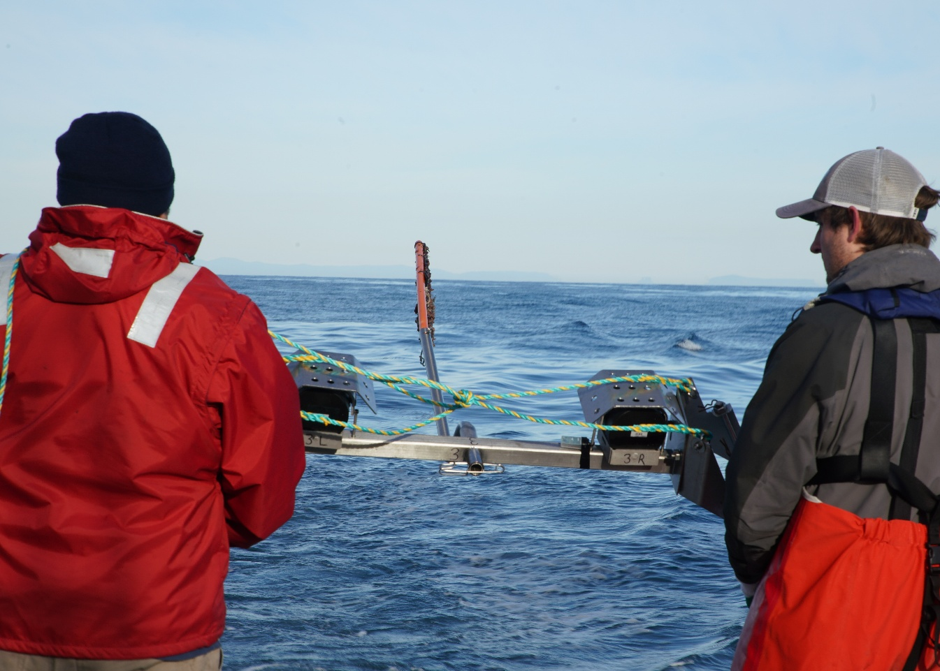
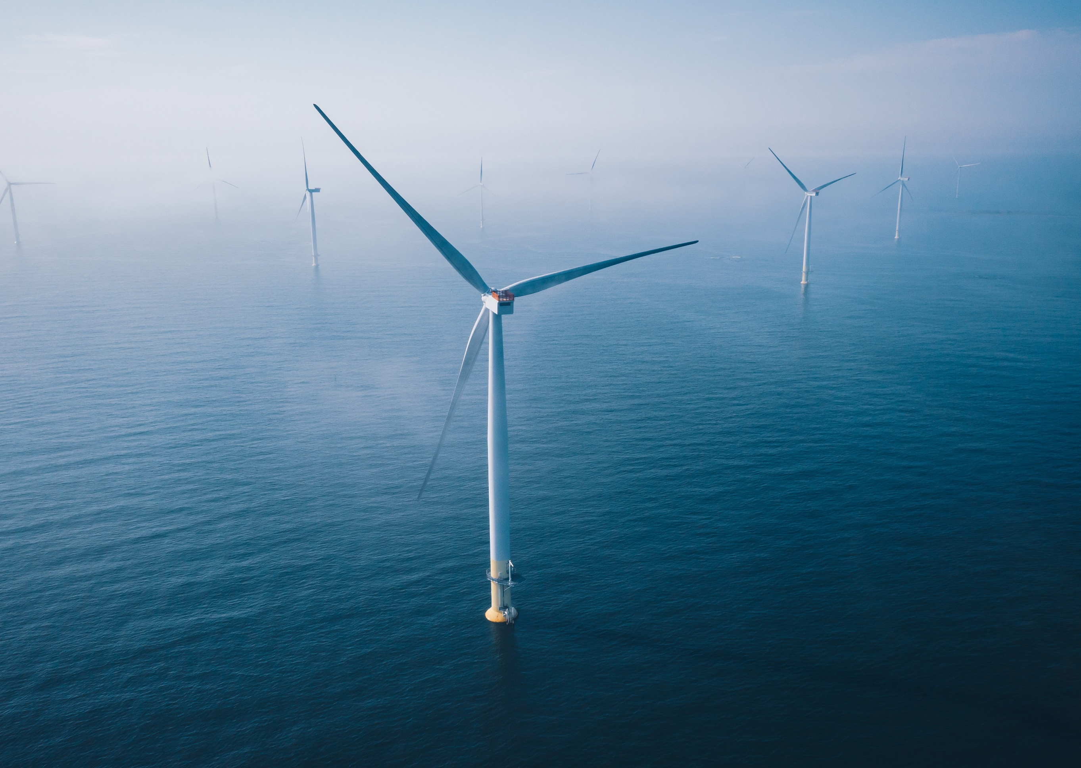

Commonwealth Environmental Impact Statement
References

References
ACS 2025. Australia's first National Climate Risk Assessment. Australian Climate Service. Canberra, ACT. Accessed 6 November 2025 <https://www.acs.gov.au/pages/national-climate-risk-assessment>
Aurora Energy 2023. Annual Report 2022-2023. Aurora Energy Pty Ltd. Hobart, Tasmania. Accessed 7 November 2025 <https://www.auroraenergy.com.au/sites/default/files/2023-10/Annual%20Report%202022-23.pdf>
AEMO 2024a. 2024 Integrated System Plan (ISP). Australian Energy Market Operator. Accessed 7 November 2025 <https://www.aemo.com.au/energy-systems/major-publications/integrated-system-plan-isp/2024-integrated-system-plan-isp>
AEMO 2024b. Integrated System Plan for the National Electricity Market, Appendix 3: Renewable Energy Zones. Australian Energy Market Operator. Accessed 7 November 2025 <https://www.aemo.com.au/-/media/files/major-publications/isp/2024/appendices/a3-renewable-energy-zones.pdf?la=en%20%20Electricity%20Market>
AEMO 2024c. Integrated System Plan for the National Electricity Market, Supporting Materials, 2024 ISP generation and storage outlook. Australian Energy Market Operator. Accessed 7 November 2025 <https://www.aemo.com.au/-/media/files/major-publications/isp/2024/supporting-materials/2024-isp-generation-and-storage-outlook.zip?rev=986359059f934cc0bbbd94d0b5280e68&sc_lang=en>
AEMO 2024d. Generation information. Australian Energy Market Operator. Accessed 6 November 2025 <https://www.aemo.com.au/energy-systems/electricity/national-electricity-market-nem/nem-forecasting-and-planning/forecasting-and-planning-data/generation-information>
Briggs, C, Hemer, M, Howard, P, Langdon, R, Marsh, P, Teske, S & Carrascosa, D 2021. Offshore Wind Energy in Australia. Blue Economy Cooperative Research Centre. Launceston, TAS. Accessed 7 November 2025 <https://blueeconomycrc.com.au/wp-content/uploads/2022/07/BECRC_OWE-in-Aus-Project-Report_P.3.20.007_V2_e190721.pdf>
Clean Energy Council 2023. Clean Energy Australia Report 2023. Clean Energy Council. Melbourne, VIC. Accessed 7 November 2025 <https://assets.cleanenergycouncil.org.au/documents/Clean-Energy-Australia-Report-2023.pdf>
Clean Energy Council 2024a. Clean Energy Australia 2024. Clean Energy Council. Melbourne, VIC. Accessed 7 November 2025 <https://cleanenergycouncil.org.au/getmedia/0cb12425-37ab-479e-9a4b-529622cc9c02/clean-energy-australia-2024.pdf>
Clean Energy Council 2024b. Renewable Projects Quarterly Report (Q4 2023). Clean Energy Council. Melbourne, VIC. Accessed 7 November 2025 <https://cleanenergycouncil.org.au/getmedia/d570a146-4a09-4920-a29e-9e43110d312b/clean-energy-council-renewable-projects-quarterly-report-q4-2023.pdf>
Clean Energy Council 2025. Winds of opportunity: Powering Australia’s clean energy future with offshore wind. Clean Energy Council. Melbourne, VIC. <https://cleanenergycouncil.org.au/news-resources/winds-of-opportunity>
DAWE 2021. National Climate Resilience and Adaptation Strategy 2021 – 2025. Department of Agriculture, Water and the Environment. Canberra, ACT. Accessed 7 November 2025 <https://www.dcceew.gov.au/sites/default/files/documents/national-climate-resilience-and-adaptation-strategy.pdf>
DCCEEW 2025a. Gippsland, Victoria declared offshore wind area. Department of Climate Change, Energy, the Environment and Water. Accessed 6 November 2025 <https://www.dcceew.gov.au/energy/renewable/offshore-wind/areas/gippsland>
DCCEEW 2025b. Net Zero Plan. Department of Climate Change, Energy, the Environment and Water. Canberra, ACT. Accessed 7 November 2025 <https://www.dcceew.gov.au/sites/default/files/documents/net-zero-report.pdf>
DEECA 2024. Wind energy. Department of Energy, Environment and Climate Action. Accessed 7 November 2025 <https://www.energy.vic.gov.au/renewable-energy/wind-energy>
DEECA 2025a. Offshore Wind Energy Victoria Implementation Statement 4. Department of Energy, Environment and Climate Action. Accessed 7 November 2025 <https://www.energy.vic.gov.au/__data/assets/pdf_file/0026/745235/Offshore-Wind-Energy-Victoria-Implementation-Statement-4.pdf>
DEECA 2025b. Victoria's Investment Prospectus: Onshore Wind. Department of Energy, Environment and Climate Action. Accessed 7 November 2025 <https://www.energy.vic.gov.au/__data/assets/pdf_file/0029/721397/CS-1531-Victorias-Investment-Prospectus_Onshore-Wind_5_DIGITAL.pdf>
DELWP 2022a. Victorian Offshore Wind Implementation Statement 1. Department of Environment, Land, Water and Planning. Accessed 7 November 2025 <https://www.energy.vic.gov.au/__data/assets/pdf_file/0030/603399/The-Victorian-Offshore-Wind-Implementation-Statement-1.pdf>
DELWP 2022b. Offshore Wind: Policy Directions Paper. Department of Environment, Land, Water and Planning. Accessed 7 November 2025 <https://www.vgls.vic.gov.au/client/en_AU/search/asset/1304450/0>
DEWR 2025. Supporting worker transition through energy system changes. Department of Employment and Workplace Relations. Accessed 6 November 2025 <https://www.dewr.gov.au/supporting-worker-transition-through-energy-system-changes>
DTP 2023. Ministerial guidelines for assessment of environmental effects under the Environment Effects Act 1978. 8th edn. Department of Transport and Planning. Accessed 7 November 2025 <https://www.planning.vic.gov.au/environmental-assessments/environmental-assessment-guides/ministerial-guidelines-for-assessment-of-environmental-effects#:~:text=These%20guidelines%20set%20out%20the%20detail%20of%20processes,the%20Environment%20Effects%20Act%201978.%20Eighth%20edition%2C%202023>
GWEC 2025. Global Offshore Wind Report 2025. Global Wind Energy Council. Lisbon, Portugal. Accessed 7 November 2025 <https://www.gwec.net/reports/globaloffshorewindreport>
Invest Victoria, 2020, International Investment Strategy, https://www.invest.vic.gov.au/__data/assets/pdf_file/0009/958014/Invest-Victoria-International-Investment-Strategy.pdf
IPCC 2022. Climate change: a threat to human wellbeing and health of the planet. Taking action now can secure our future. Intergovernmental Panel on Climate Change. 28 February. Accessed 6 November 2025 <https://www.ipcc.ch/2022/02/28/pr-wgii-ar6/>
IRENA 2021. Tracking the Impacts of Innovation: Offshore Wind as a Case Study. International Renewable Energy Agency. Abu Dhabi, UAE. Accessed 6 November 2025 <https://www.irena.org/-/media/Files/IRENA/Agency/Publication/2021/Jun/IRENA_Impacts_Innovation_2021.pdf>
UK Planning Inspectorate 2019. Advice Note 17 Cumulative effects assessment - cumulative effects assessment relevant to nationally significant infrastructure projects. Vol. 2. UK Planning Inspectorate. Bristol, UK.
NOPSEMA 2020. Guidance Note: Offshore project proposal content requirements. National Offshore Petroleum Safety and Environmental Management Authority. 10 August. Accessed 6 November 2025 <https://www.nopsema.gov.au/sites/default/files/documents/2021-03/A473026.pdf>
Star of the South 2023. Making the move to offshore wind – a guide for worker. Star of the South. Accessed 6 November 2025 <https://www.starofthesouth.com.au/s/Making-the-move-to-offshore-wind-a-guide-for-workers-r54d.pdf>
Ainsaar, K, Ombiga, J & Barry 2024. Renewable Energy Impact and Readiness Study. Urban Enterprise. Brunswick, VIC. Accessed 6 November 2025 <https://www.southgippsland.vic.gov.au/downloads/file/4891/south_gippsland_and_latrobe_city_renewable_energy_impact_and_readiness_study>
VicGrid 2024. Offshore Wind Energy Transmission: Gippsland Options Assessment Report. VicGrid. Werribee, VIC. Accessed 7 November 2025 <https://nla.gov.au/nla.obj-3632611350/view>
VicGrid 2025. Victorian Transmission Plan. VicGrid. Accessed 7 November 2025 <https://www.vicgrid.com.au/transmission-planning/victorian-transmission-plan>
Wellington Shire Council 2021. 2021-25 Council Plan. Wellington Shire Council. Sale, VIC. Accessed 6 November 2025 <https://www.wellington.vic.gov.au/publications/2021-25-council-plan>
Wellington Shire Council 2025. Wellington wins a huge $4.7 Million for renewable energy growth, media release. 13 August. Accessed 7 November 2025 <https://www.wellington.vic.gov.au/media-releases/wellington-wins-a-huge-4-7-million-for-renewable-energy-growth>
Whitson, R 2023. ‘Analysis find extending Eraring’s lifespan could cost $1.7 billion in damages a year’, ABC News. 28 September. Accessed 7 November 2025 <https://www.abc.net.au/news/2023-09-28/analysis-eraring-lifespan-1-7-billion-damages-annual-coal-730/102901044>

