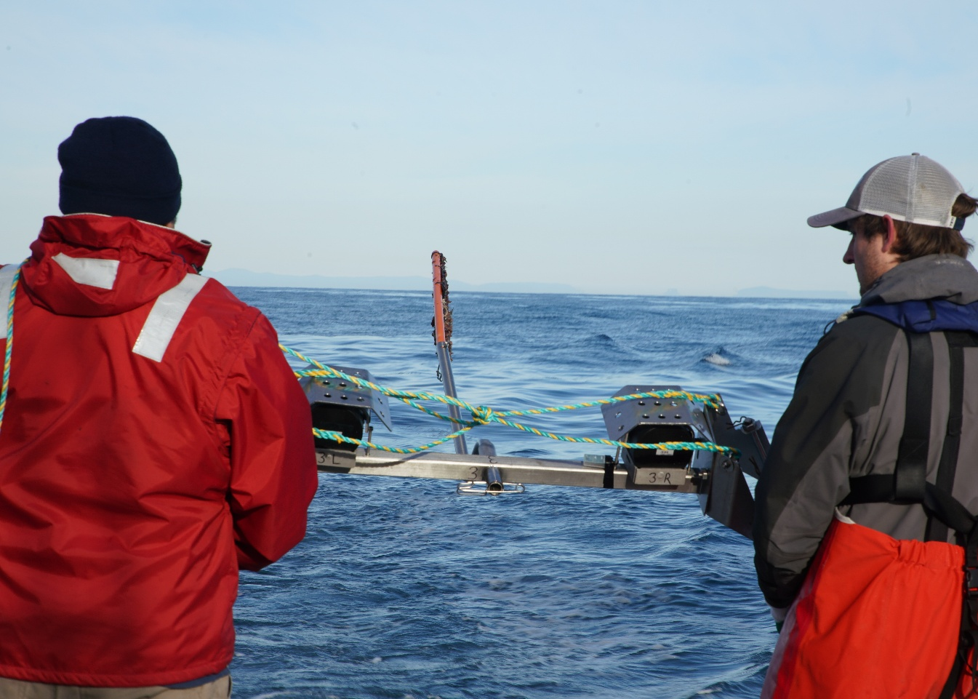
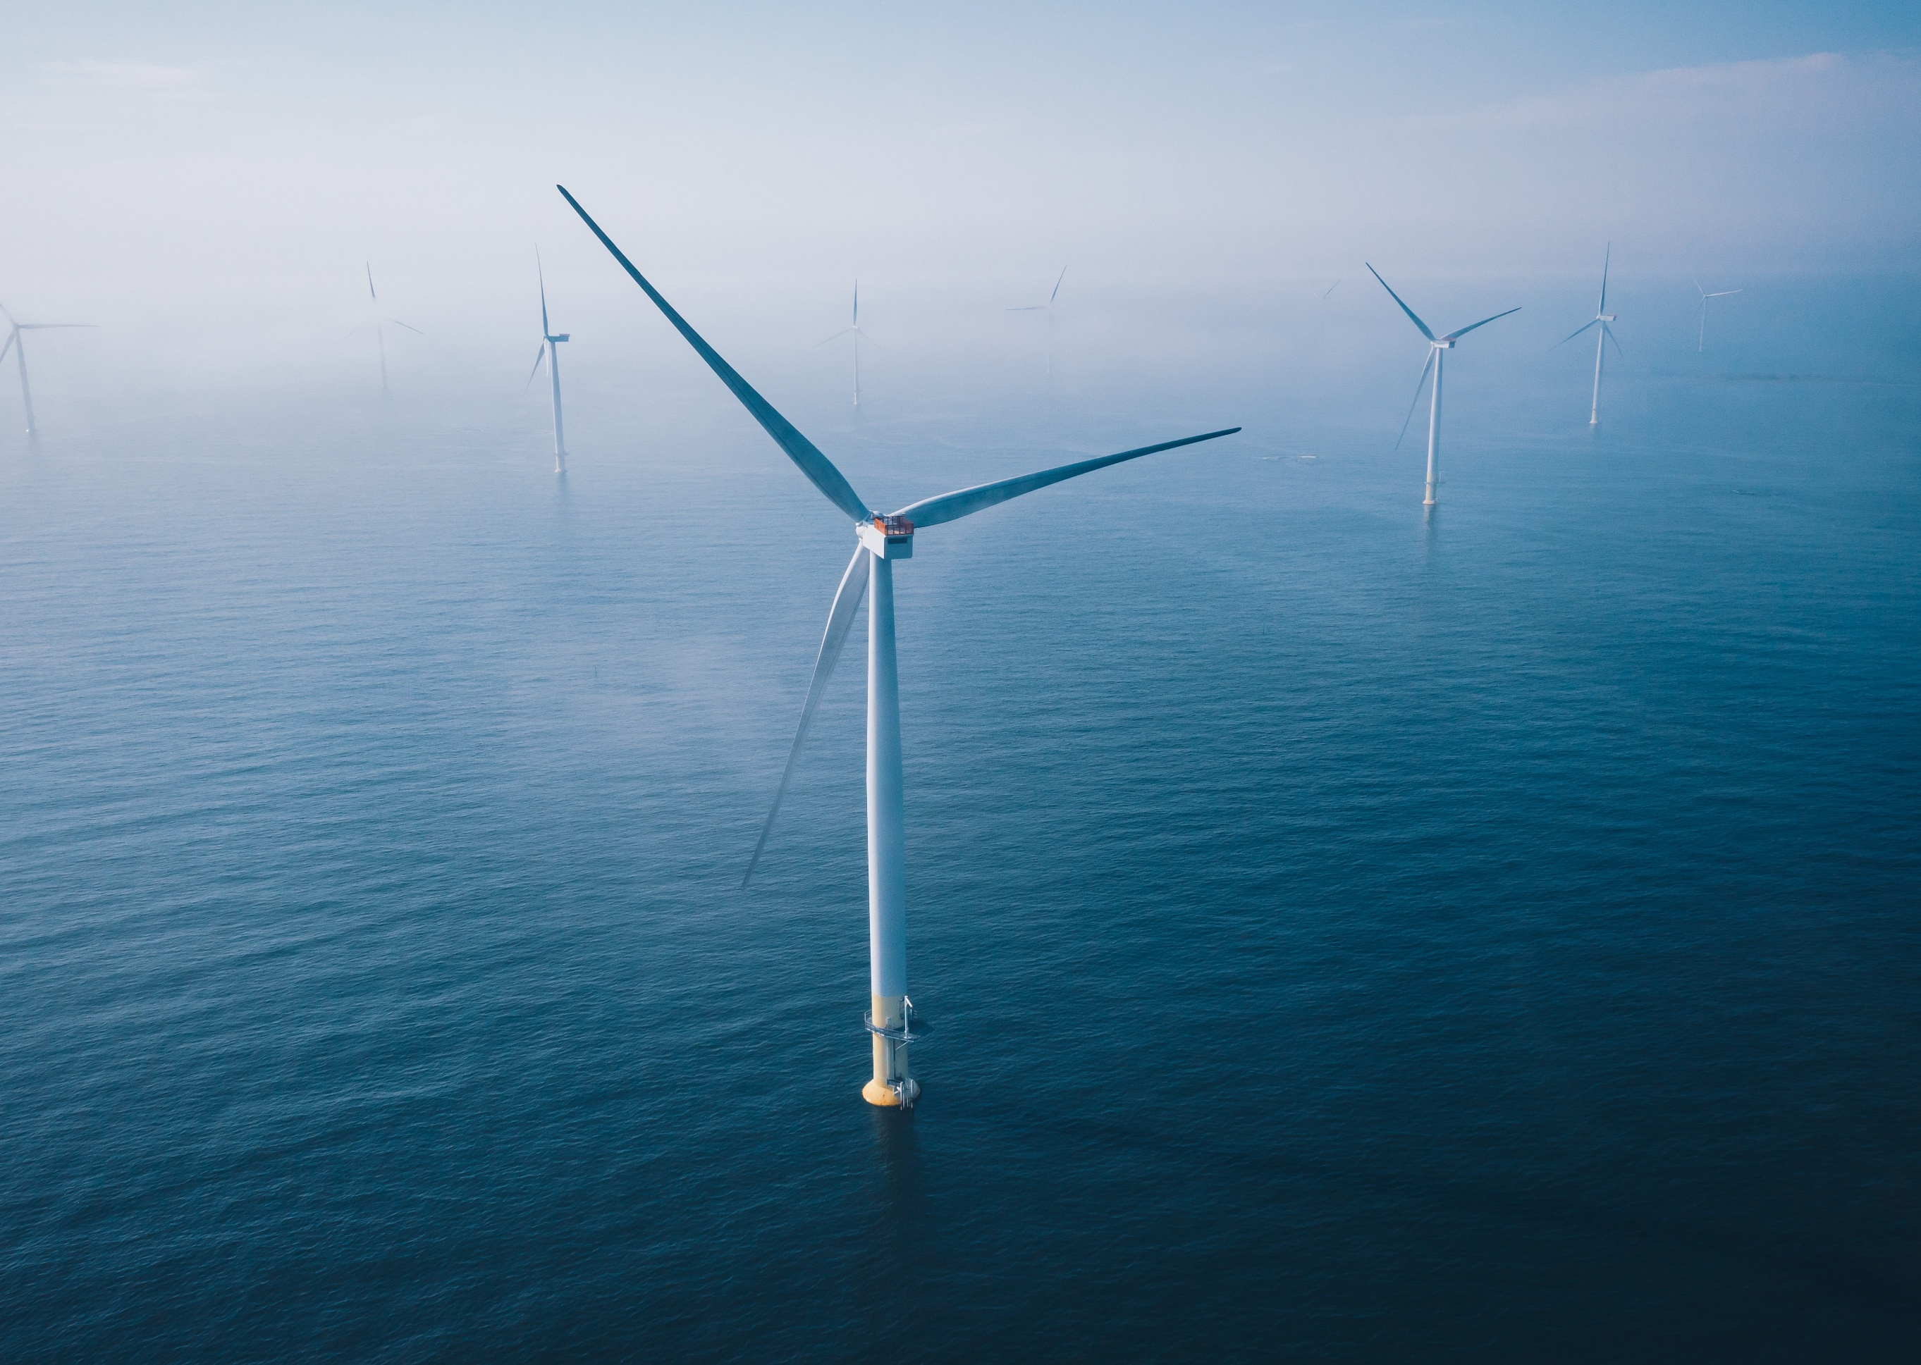

Commonwealth Environmental Impact Statement
Table of contents

Table of contents

Chapter 1 - Environmental Impact Statement introduction
1.1 Project context 1-4
1.2 Project overview 1-7
1.3 Project delivery 1-9
1.4 Assessment and approvals pathway 1-11
1.5 Assessment overview and mitigations 1-14
1.6 Assessment structure 1-15

Chapter 2 - Project rationale
2.1 Introduction 2-1
2.2 The need for offshore wind 2-4
2.3 Government policies and objectives 2-9
2.4 Project objectives 2-14
2.5 Project benefits 2-15
2.6 Consideration of feasible alternatives 2-22

Chapter 3 – Project development
3.1 Introduction 3-1
3.2 Offshore wind farm alternatives 3-9
3.3 Turbine alternatives 3-17
3.4 Transmission system alternatives 3-18
3.5 Port alternatives 3-33

Chapter 4 - Project description
PART A – INTRODUCTION AND OVERVIEW 4-1
4.1 Introduction 4-1
4.2 Project area 4-2
4.3 Project components 4-4
4.4 Project implementation 4-5
4.5 Project design envelope 4-7
PART B – OFFSHORE 4-9
4.6 Offshore infrastructure 4-9
4.7 Offshore construction 4-21
4.8 Offshore operations and maintenance 4-36
4.9 Offshore decommissioning 4-41
4.10 Repowering 4-42
4.11 Waste 4-42
PART C – SHORE CROSSING 4-44
4.12 Shore crossing design 4-44
4.13 Shore crossing construction 4-47
4.14 Shore crossing operations and maintenance 4-53
4.15 Shore crossing decommissioning 4-53
PART D – ONSHORE TRANSMISSION 4-54
4.16 Onshore project area and VicGrid interface 4-54
4.17 Onshore transmission infrastructure 4-56
4.18 Onshore construction 4-64
4.19 Onshore transmission operations and maintenance 4-75
4.20 Onshore decommissioning 4-76
4.21 Waste 4-76

Chapter 5 - Commonwealth legislative framework
5.1 Introduction 5-1
5.2 Primary planning and environmental approvals and assessment pathway 5-3
5.3 Secondary planning and environmental approvals 5-7
5.4 Key legislation relevant to assessment 5-9

Chapter 6 - Assessment framework
6.1 Introduction 6-1
6.2 Evaluation framework 6-3
6.3 Environmental assessment 6-5
6.4 Environmental Management Framework 6-15
6.5 Cumulative impact assessment 6-16

Chapter 7 - Community engagement
7.1 Introduction 7-1
7.2 Engagement approach 7-3
7.3 Stakeholders 7-5
7.4 Communication and engagement methods 7-12
7.5 Engagement phases 7-20
7.6 Feedback 7-26
7.7 Monitoring and evaluation 7-41
7.8 Ongoing engagement 7-42

Chapter 8 - Coastal processes and sediment transport
8.1 Introduction 8-1
8.2 Assessment scope 8-2
8.3 Evaluation framework 8-3
8.4 Methods 8-4
8.5 Existing environment 8-8
8.6 Construction impacts 8-20
8.7 Operation impact assessment 8-22
8.8 Decommissioning impact assessment 8-29
8.9 Cumulative impacts 8-30
8.10 Summary of mitigation, monitoring and contingency measures 8-32
8.11 Conclusion 8-33

Chapter 9 - Benthic ecology
9.1 Introduction 9-1
9.2 Assessment scope 9-2
9.3 Evaluation framework 9-3
9.4 Methods 9-5
9.5 Existing environment 9-6
9.6 Construction impacts 9-15
9.7 Operation impacts 9-21
9.8 Decommissioning impacts 9-26
9.9 Cumulative Impacts 9-27
9.10 Summary of mitigation, monitoring and contingency measures 9-28
9.11 Conclusion 9-29

Chapter 10 - Fish and invertebrates
10.1 Introduction 10-1
10.2 Assessment scope 10-2
10.3 Evaluation framework 10-3
10.4 Methods 10-5
10.5 Existing environment 10-7
10.6 Construction impacts 10-20
10.7 Operation impacts 10-32
10.8 Decommissioning impacts 10-43
10.9 Cumulative impacts 10-44
10.10 Summary of mitigation, monitoring and contingency measures 10-46
10.11 Conclusion 10-48

Chapter 11 - Marine mammals and turtles
11.1 Introduction 11-1
11.2 Assessment scope 11-2
11.3 Evaluation framework 11-4
11.4 Methods 11-6
11.5 Existing environment 11-8
11.6 Construction impacts 11-41
11.7 Operation impacts 11-67
11.8 Decommissioning impacts 11-74
11.9 Cumulative Impacts 11-75
11.10 Summary of mitigation, monitoring and contingency measures 11-78
11.11 Conclusion 11-80

Chapter 12 - Offshore ornithology and bats
12.1 Introduction 12-1
12.2 Assessment scope 12-2
12.3 Evaluation framework 12-4
12.4 Methods 12-6
12.5 Existing environment 12-9
12.6 Construction impacts 12-37
12.7 Operation impacts 12-50
12.8 Decommissioning impacts 12-85
12.9 Cumulative Impacts 12-85
12.10 Summary of mitigation, monitoring and contingency measures 12-88
12.11 Conclusion 12-91

Chapter 13 - Marine protected areas
13.1 Introduction 13-1
13.2 Assessment scope 13-2
13.3 Evaluation framework 13-4
13.4 Methods 13-5
13.5 Existing environment 13-6
13.6 Corner Inlet Ramsar site impact assessment 13-11
13.7 Beagle Australian Marine Park impact assessment 13-18
13.8 Decommissioning impacts 13-22
13.9 Cumulative impact assessment 13-23
13.10 Summary of mitigation, monitoring and contingency measures 13-26
13.11 Conclusion 13-28

Chapter 14 - Non-Aboriginal underwater cultural heritage
14.1 Introduction 1
14.2 Assessment scope 2
14.3 Evaluation framework 3
14.4 Methods 5
14.5 Existing environment 7
14.6 Construction impacts 17
14.7 Operation impacts 24
14.8 Decommissioning impacts 28
14.9 Cumulative impact assessment 29
14.10 Summary of mitigation, monitoring and contingency measures 30
14.11 Conclusion 31

Chapter 15 - Commercial and recreational fisheries
15.1 Introduction 1
15.2 Assessment scope 2
15.3 Evaluation framework 3
15.4 Methods 5
15.5 Existing environment 9
15.6 Assessment context 30
15.7 Construction impacts 33
15.8 Operation impact assessment 42
15.9 Decommissioning assessment 53
15.10 Cumulative Impacts 54
15.11 Summary of mitigation, monitoring and contingency measures 56
15.12 Conclusion 58

Chapter 16 - Infrastructure and co-existence with other users
16.1 Introduction 16-1
16.2 Assessment scope 16-2
16.3 Evaluation framework 16-3
16.4 Methods 16-5
16.5 Existing environment 16-6
16.6 Construction impacts 16-17
16.7 Operation impacts 16-23
16.8 Decommissioning impacts 16-27
16.9 Cumulative impact assessment 16-28
16.10 Summary of mitigation, monitoring and contingency measures 16-30
16.11 Conclusion 16-32

Chapter 17 - Shipping and navigation
17.1 Introduction 17-1
17.2 Assessment scope 17-2
17.3 Evaluation framework 17-3
17.4 Methods 17-6
17.5 Existing environment 17-10
17.6 Construction impacts 17-21
17.7 Operation impacts 17-31
17.8 Decommissioning impacts 17-39
17.9 Cumulative impact assessment 17-40
17.10 Summary of mitigation, monitoring and contingency measures 17-43
17.11 Conclusion 17-45

Chapter 18 - Onshore ecology (EPBC matters)
18.1 Introduction 18-1
18.2 Assessment scope 18-2
18.3 Evaluation framework 18-1
18.4 Methods 18-1
18.5 Existing environment 18-4
18.6 Construction impacts 18-9
18.7 Operation impact assessment 18-20
18.8 Decommissioning assessment 18-24
18.9 Cumulative impacts 18-25
18.10 Summary of mitigation, monitoring and contingency measures 18-27
18.11 Offsets 18-28
18.12 Conclusion 18-28

Chapter 19 - Submerged Aboriginal cultural heritage
19.1 Introduction 19-3
19.2 Assessment scope 19-4
19.3 Evaluation framework 19-4
19.4 Methods 19-7
19.5 Existing environment 19-9
19.6 Construction impacts 19-22
19.7 Operation impacts 19-25
19.8 Decommissioning assessment 19-28
19.9 Cumulative impact assessment 19-29
19.10 Summary of mitigation, monitoring and contingency measures 19-31
19.11 Conclusion 19-33

Chapter 20 - Social
20.1 Introduction 20-1
20.2 Assessment scope 20-2
20.3 Evaluation framework 20-3
20.4 Methods 20-4
20.5 Existing environment 20-7
20.6 Construction impacts 20-14
20.7 Operation impacts 20-28
20.8 Decommissioning impacts 20-34
20.9 Cumulative impacts 20-35
20.10 Summary of mitigation, monitoring and contingency measures 20-37
20.11 Conclusion 20-38

Chapter 21 - Business and tourism
21.1 Introduction 21-1
21.2 Assessment scope 21-2
21.3 Evaluation framework 21-3
21.4 Methods 21-3
21.5 Existing environment 21-8
21.6 Construction impacts 21-13
21.7 Operation impacts 21-28
21.8 Decommissioning impacts 21-33
21.9 Cumulative impacts 21-34
21.10 Summary of mitigation, monitoring and contingency measures 21-37
21.11 Conclusion 21-39

Chapter 22 - Seascape, landscape and visual
22.1 Introduction 22-1
22.2 Assessment scope 22-2
22.3 Evaluation framework 22-2
22.4 Methods 22-5
22.5 Existing environment 22-6
22.6 Construction impacts 22-25
22.7 Operation impacts 22-26
22.8 Decommissioning assessment 22-32
22.9 Cumulative Impact Assessment 22-53
22.10 Summary of mitigation, monitoring and contingency measures 22-55
22.11 Conclusion 22-56

Chapter 23 - Commonwealth Environmental Management Framework
23.1 Introduction 23-2
23.2 Statutory context 23-4
23.3 Roles and responsibilities 23-9
23.4 Environmental Management System 23-11
23.5 Environmental management documents 23-14
23.6 Change management 23-30
23.7 Evaluating compliance 23-32
23.8 Mitigation measures 23-38
23.9 References 23-86

Chapter 24 - EIS summary and conclusions
24.1 Introduction 24-1
24.2 Impacts on matters of national environmental significance 24-3
24.3 Principles of ecologically sustainable development 24-20
24.4 Objects of the EPBC Act 24-21
24.5 Summary of cumulative effects 24-23
24.6 Environmental Management Framework 24-34
24.7 Conclusion 24-34

Attachments
Attachment I: EIS map book
Attachment II: Consultation report
Attachment III - Construction underwater noise management framework
Attachment IV – Seabird monitoring and management framework
Attachment V: EIS guidelines checklist

Technical reports
Technical report A - Coastal processes and sediment transport
Technical report B - Benthic ecology
Technical report C - Fish and invertebrates
Technical report D - Marine mammals and turtles
Technical report E – Offshore ornithology and bats
Technical report F - Marine protected areas
Technical report G - Onshore ecology
Technical report H – Groundwater
Technical report I - Surface water
Technical report J - Soil and waste
Technical report K - Aboriginal cultural heritage
Technical report L - Historical heritage
Technical report M - Non-Aboriginal underwater cultural heritage
Technical report N - Commercial and recreational fisheries
Technical report O - Infrastructure and co-existence with other users
Technical report P - Shipping and navigation
Technical report Q - Business and tourism
Technical report R - Social
Technical report S – Agriculture and forestry
Technical report T - Land use and planning
Technical report U - Seascape, landscape and visual
Technical report V - Electromagnetic field exposure
Technical report W - Onshore noise and vibration
Technical report X - Traffic and transport
Technical report Y - Air quality
Technical report Z - Submerged Aboriginal cultural heritage
Attachment I- Underwater noise modelling
Attachment II - Oil spill modelling summary

